Airworthiness Assurance R&D Branch
1996 Research Accomplishments

John M. Fabry, Branch Manager
US Department of Transportation
FAA William J. Hughes Technical Center
Atlantic City Airport, NJ 08405
Table of Contents

Title Page
Advanced Materials Research
Certification Methodology for Stiffener Terminations
Effects of Stiffener/Rib Separation on Damage Growth and Residual Strength
Structural Integrity Evaluation of the Lear Fan 2100 Aircraft
The Effect of Preloading on Fatigue Damage in Composite Structures: Part 1
Comparative Evaluation of Failure Analysis Methods for Composite Laminates
Crashworthiness
Survey and Analysis of Rotorcraft Flotation Systems
Transport Water Impact and Ditching Performance
Transport Water Impact, Part II
Propulsion Systems and Fuels
Spin Synchronous X-Ray Sinography for Nondestructive Imaging of Turbine Engines under Load
Aging Aircraft
Characterization of Early Stages of Corrosion Fatigue in Aircraft Skin
Antisymmetric Buffet Loads on Horizontal Stabilizers
An Analysis of Ground-Flight Loads Measured on a B-727
Incorporating the Dripless Bubbler with a Scanner for Ultrasonic C-Scan Imaging of Defects in Bonded Aircraft Structures
An Overview of the Engine Titanium Consortium
An Overview of the Contaminated Billet Study
An Element-Free Galerkin Method for Three-Dimensional Crack Growth Modeling
The Effects of Beam Distortion On The Strength Of Ultrasonic Signals
Transducer Design for High Sensitivity Ultrasonic Inspection of Titanium
Eddy Current Probe Design for Edge Effect Reduction
Air-Coupled C-Scan of Boeing Repair Coupon
Modeling the Relationship between Microstructure and Backscattered Noise
Ultrasonic Microscopy of Synthetic Spherical TiN Inclusions in Forged Ti-6Al-4V
Development of Ultrasonic Models to Guide the Design and Evaluation of Inspection Systems for Titanium Rotating Components
Modeling Ultrasonic Inspectability in Forgings
Improved Methodology for Predicting Probability of Detection (POD) of Synthetic Hard Alpha Inclusions in Titanium
Hand-Held, Flexible Eddy Current Probe for Inspection of Curving Surfaces
Eddy Current Probe Design
Fatigue Crack Initiation and Growth in Riveted Specimens
A Study of Fatigue Crack Generation and Growth in Riveted Aluminum Clad 2024-T3 Specimens
Economical Eddy Current
Eddy Current Methods for Crack Detection
Eddy Current Methods for Corrosion Detection
Frequency-Shifted Sagnac Interferometer for Ultrasound Measurement
Self-Compensating Ultrasonic Technique
Self-Focusing Ultrasonic System
Quantitative Thermal Wave Imaging of Corrosion Thinning
Nondestructive Evaluation Parameters - Failure Property Relationships of Adhesive Bonds
Feasibility Study of a Rotorcraft Health and Usage Monitoring System (HUMS): Usage and Structural Life Monitoring Evaluation
Feasibility Study of a Rotorcraft Health and Usage Monitoring System (HUMS): Results of Operator's Evaluation
Corrosion and Corrosion Fatigue of Airframe Materials
Stochastic Modeling of Antisymmetric Buffet Loads on Horizontal Stabilizers in Massively Separated Flows
Fracture Testing Of Large-Scale Thin Sheet Aluminum Alloy
Development Of A D Sight Aircraft Inspection System: Phase II
Light Shaping Diffusers For Improved Visual Inspection Of Aircraft
Investigation of Fuselage Structure Subject to Widespread Fatigue Damage
Automated Inspection of Aircraft
Validation of the Magneto-Optic/Eddy-Current Imager
A Methodology For The Economic Assessment Of Nondestructive Evaluation Techniques Used In Aircraft Inspection
Tire Test Correlation: Radial Versus Bias-Ply Tires
Flight Loads Data For A Boeing 737-400 In Commercial Operation
Axial Crack Propagation and Arrest in a Pressurized Fuselage
Implications of Corrosion Pillowing on the Structural Integrity of Fuselage Lap Joints
Introduction of Bonded Composite Doublers to Commercial Aircraft
Corrosion of Aluminum Alloys in the Presence of Fire-Retardant Aircraft Interior Materials
Maintenance Resource Management (MRM) Training and Crew Resource Management (CRM) Training: Analysis, Prescriptions, and Proscriptions
Visual Inspection Research Project Report on Benchmark Inspections
Variation in Load Factor experience of Fokker F27 and F28 Operational Acceleration Exceedance Data
Engineering Approach to Damage Tolerance Analysis of Fuselage Skin Repairs
The Role of Fretting Fatigue on Aircraft Rivet Hole Cracking
Catastrophic Failure Prevention
Fiber-Reinforced Structures for Small Turbine Engine Containment

Document Compiled by H. R. Marek
FAA William J. Hughes Technical Center
Airworthiness Assurance R&D Branch
Atlantic City Airport, NJ 08405

Advanced Materials Research

Certification Methodology for Stiffener Terminations
C. H. Shah, H. P. Kan, and M. Mahler

Research Objective
Document the results of a combined experimental and analytical effort that leads to the formulation of a recommended structural certification approach for stiffener terminations.

Approach
An experimental program was conducted to determine the static strength and fatigue life of a typical stiffener termination configuration for commercial aircraft composite structure. The test specimen was analyzed to predict both the global structural response and the local failure initiation. Statistical analyses were also conducted to assess the scatter in static strength and fatigue life.
The test specimen design was based on the results of comprehensive technology assessment and a detailed stress analysis. An I-section stiffener cocured to a soft skin was selected based on the design concept of the Boeing’s B-737 composite horizontal tail. The dimensions used for the test specimens were determined from the finite element analysis used to simulate the actual structural response.

Accomplishment Description
The mode of the initial failure was, as expected, stiffener separation from the skin caused by interfacial stresses. Similar initial failures were observed in the static compression test specimens with proper constraints to prevent overall specimen buckling as well as local buckling. The fatigue behavior of the test specimens was observed to be typical of composites, which exhibit relatively high threshold and high life scatter.
The effect of stiffener termination angle, when changed from baseline 75° to 45°, on static strength as well as fatigue life was determined to be insignificant. The flange fasteners had no effect on the failure initiation but retarded the growth of the delamination under fatigue load.
An analysis was conducted to predict the overall specimen response as well as the failure initiation. The finite element method was used to determine the relationship between the applied load and the strain response of the specimen. The predicted strains were compared with the measured strains at various strain gage locations. Excellent correlation was found between the measured and predicted strains at key locations. A local elasticity model was used to predict the initiation of stiffener/skin separation at the stiffener termination site. The analytical results were conservative, compared to the test data for all specimen configurations and loading conditions.
A statistical method was employed to assess the scatter in the static strength and fatigue life data. The scatter parameters obtained from the results of this program were comparable to those of composites and bolted joints.
Significance
From the results of this program, a certification approach was formulated which did not exist previously. In this approach the static strength of composite structures with a properly designed stiffener termination can be certified based on a B-basis design allowable derived from final failure data.

Expected Results
The experimental data generated in this program provide useful data that is needed to define a certification procedure for composite structures with stiffener terminations.

Reference: Shah, C.; Kan, H.; Mahler, M: Certification Methodology for Stiffener Terminations, DOT/FAA/AR-95/10, April 1996.

Point of Contact: P. Shyprykevich, AAR-431, FAA William J. Hughes Technical Center, Atlantic City International Airport, NJ 08405, Phone: (609) 485-4967, FAX: (609) 485-4004, e-mail: pshyprykevich@admin.tc.faa.gov

Effects of Stiffener/Rib Separation on Damage Growth and Residual Strength
H. P. Kan and M. Mahler

Research Objective
To define the type, extent, and location of discrete source damage which would meet the requirements for composite structures in commercial aircraft similar to those in Federal Aviation Regulation (FAR) 25.571 for metal structures.

Approach
Two existing composite aircraft structures were selected to demonstrate the certification methodology developed. Both structures were designed to satisfy the damage tolerance requirements. These structures are basically soft wing skins with bonded stringers. This design feature makes skin/stiffener separation a potential damage mode that threatens the integrity of the structure. A transport wing was selected as a representative structure for a large airplane, and a military aircraft wing was selected as a representative structure for small airplane.
Three competing discrete source damage types were considered: impact damage, delaminations, and skin/stiffener disbonds. The influence of these damage types on the residual strength of the two existing composite structures was analytically determined. The severity of impact damage and delaminations were analytically compared with that of skin/stiffener disbonds. Critical disbond sizes were determined as a function of residual strength and compared to FAR 25.571 in terms of design limit load for immediately obvious damage.

Accomplishment Description
For typically designed composite wing structures, a completely disbonded stringer represented the most severe damage scenario among the damage types considered. This type of damage mainly affects bonded or cocured structures under predominantly compression loads. The local strength at the damaged location, depending on the design details of the structure, may be significantly lower than the residual strength due to impact damage. Because of the large strength reduction, damage tolerance design based on such a damage scenario would impose a significant weight penalty to the structure, if the rib spacing is large.

Significance
Compliance with Federal Aviation Regulations FAR 25.571 for fail safety in commercial aircraft is typically demonstrated by analysis and test of stiffened metal panels with a two-bay crack extending through the stiffener separating the two bays. A similar compliance methodology for composite aircraft structures did not exist before this study. This research will aid in the development of such a methodology.

Expected Results
Guidance for compliance to FAR 25.571 for composite aircraft structure including type and location of damage to be evaluated by analysis and verified by testing.

Reference: Kan, H. P.; Mahler, M.: Effects of Stiffener/Rib Separation on Damage Growth and Residual Strength, DOT/FAA/AR-95/12, May 1996.

Point of Contact: P. Shyprykevich, AAR-431, FAA William J. Hughes Technical Center, Atlantic City International Airport, NJ 08405, Phone: (609) 485-4967, FAX: (609) 485-4004, e-mail: pshyprykevich@admin.tc.faa.gov

Structural Integrity Evaluation of the Lear Fan 2100 Aircraft
H. P. Kan and T. A. Dyer

Research Objective
Conduct a systematic structural integrity evaluation of the damage prone components of the Federal Aviation Administration (FAA)-owned Lear Fan 2100 aircraft using the methodology developed under the FAA/Navy programs.

Approach
A Lear Fan 2100 aircraft was inspected using nondestructive techniques. The inspection was conducted on aircraft serial number E009, the third flying prototype manufactured. FAA personnel indicated that the aircraft had experienced approximately 230 hours of flight time. The upper wing skins and the upper fuselage skin, areas considered most likely to suffer damage during manufacturing and maintenance operations, were evaluated using ultrasonic and thermographic techniques. A total of 19 defects around the fastener heads in the upper wing skins were identified by the MAUS (Mobile Automated Ultrasonic System developed by McDonnell Douglas). In addition, one area of mild porosity in the wing skin and one area of possible disbond between mating fuselage skins were also detected. Analytical results showed that these defects are not severe enough to impose a threat to the integrity of the wing structure. After an extensive review of the structural configurations, flight loads, and the full-scale test articles, a damage tolerance evaluation was conducted for the upper wing skins. The capability of the structure to tolerate impact damage and assembly induced defects was systematically evaluated. The upper wing skin was divided into small regions, based on the arrangement of the substructures and the distribution of the skin thickness, for the damage tolerance evaluations.

Accomplishment Description
Damage tolerance capability of the upper wing skins against assembly/manufacturing induced damage was analytically evaluated. The baseline damage scenario used was defined based on the results of a recently completed FAA/Navy sponsored program, which generally produced damage more severe than the defects detected for the E009 aircraft. Margin of safety and reliabilities of the upper wing skins with the baseline damage were obtained analytically. In addition, allowable damage sizes were defined for various damage scenarios.

Significance
The certification methodology for composite aircraft structures developed under a series of FAA/Navy sponsored programs was successfully demonstrated on military aircraft components. However, the effects of this methodology on structural design and certification requirements of general aviation and commercial aircraft had not been examined. This research initiates the examination for non-military components.

Expected Results
Upper wing skins are capable of tolerating damage induced under properly controlled assembly procedures. However, poor assembly processes can induce more severe damage in the structure, which may impose a threat to the structural integrity. Therefore, assembly standards must be established to minimize damage. Nondestructive inspection (NDI) after final structural assembly should be performed if such standards do not exist.

Reference: Kan, H.; Dyer, T.: Structural Integrity Evaluation of the Lear Fan 2100 Aircraft, DOT/FAA/AR-95/13, May1996.

Point of Contact: P. Shyprykevich, AAR-431, FAA William J. Hughes Technical Center, Atlantic City International Airport, NJ 08405, Phone: (609) 485-4967, FAX: (609) 485-4004, e-mail: pshyprykevich@admin.tc.faa.gov

The Effect of Preloading on Fatigue Damage in Composite Structures: Part 1
H. Hahn, J. Timmer, J. Barley-Cho, S. Lee, and S. Lim

Research Objective
Systematically separate the loading environment into component parts to understand the interactions between each of the elements of the spectrum on damage initiation, growth, and residual strength.

Approach
Two types of tension-tension fatigue tests were conducted on quasi-isotropic laminates and damage was measured in the form of ply cracks. Baseline fatigue tests were run at constant amplitudes ranging from 20% to 60% of the ultimate tensile strength (UTS) while specimens with preloads of 50% to 80% UTS were tested in fatigue at the same amplitudes. The ply crack densities determined from edge replications in preloaded specimens were compared to those without preload.

Accomplishment Description
The effect of a preload on subsequent fatigue damage growth depended on the combination of both the preload level and the subsequent fatigue stress level. Since the tension preload was always higher than the tension-tension fatigue stress level, damage in preloaded specimens was more severe in the low-cycle region than nonpreloaded specimens. However, this preload induced damage did not grow any more if the fatigue stress level was kept low. Preloads just above levels that cause significant damage (70% UTS and above here) appeared to retard fatigue damage development. At the highest tension-tension fatigue stress level of 40% UTS, the high cycle damage in the form of matrix cracking decreased with increasing preload level.

Significance
This report is the first of a series of reports that will provide comprehensive documentation of damage induced by spectrum fatigue loading in composite laminates. The effect of preloads on fatigue damage in composite laminates has been examined in order to better understand the modes of damage development and to assess the effect of proof testing for airframe composite structures.

Expected Results
The results for this simplest form of variable loading will be used as a building block with other data to eventually predict damage due to fatigue spectrum loading for airframe composite structures.

Reference: Hahn, H.; Timmer, J., Bartley-Cho, J.; Lee, S.; Lim, S.: The Effect of Preloading on Fatigue Damage in Composite Structures: Part 1, DOT/FAA/AR-95/79, April, 1996.

Point of Contact: P. Shyprykevich, AAR-431, FAA William J. Hughes Technical Center, Atlantic City International Airport, NJ 08405, Phone: (609) 485-4967, FAX: (609) 485-4004, e-mail: pshyprykevich@admin.tc.faa.gov

Comparative Evaluation of Failure Analysis Methods for Composite Laminates
C. T. Sun, B. J. Quinn, and J. Tao , and D. W. Oplinger

Research Objective
To objectively study lamina and laminate failure criteria.

Approach
Comparisons among the commonly used failure criteria were made for failure in unidirectional composites under various loading cases. From these comparisons, the characteristics of these criteria were identified and discussed.

Accomplishment Description
Over the last three decades, there have been continuous efforts in developing failure criteria for unidirectional fiber composites and their laminates. Currently, there exist a large number of lamina failure criteria and laminate failure analysis methods. This effort furthered the research on these subjects.

Significance
It was found that those lamina failure criteria which separate fiber and matrix failure modes most accurately predict lamina and laminate strength. Analytical methods that will accurately predict composite laminate strength are needed for the design and certification of composite aircraft structures.

Expected Results
With the aid of some limited experimental lamina and laminate strength data available in the literature and new data generated by the authors, failure criteria and laminate analysis methods that are mechanistically sound and are capable of accurately predicting lamina and laminate strengths for states of combined stresses will be developed.

Reference: Sun, C. T.; Quinn, B. J.; Tao, J; Oplinger, D. W.: Comparative Evaluation of Failure Analysis Methods for Composite Laminates, DOT/FAA/AR-95/109, May 1996.

Point of Contact: Donald Oplinger, AAR-431, FAA William J. Hughes Technical Center, Atlantic City International Airport, NJ 08405, Phone: (609) 485-4914, FAX: (609) 485-4569, e-mail: Donald_Oplinger_at_ct27@admin.tc.faa.gov

Crashworthiness

Survey and Analysis of Rotorcraft Flotation Systems
Mark Muller and Richard Greenwood, Marvin Richards and Lindley Bark

Research Objective
Evaluate rotorcraft flotation system performance in water-related incidents and accidents and identify areas of potential improvement with regard to rotorcraft flotation system operation and occupant fatality reduction.

Approach
Four tasks were conducted: a survey of civilian and U.S. Navy rotorcraft flotation technology, a review of civilian flotation accident and incident data, definition of generic flotation system improvements, and evaluation of available analytical methods for assessing flotation system performance.

Accomplishment Description
After review of the performance data and state-of-the-art system technology, four complexities associated with analytical modeling of the ditching sequence were identified. These were buoyancy and stability, wave action, water entry, and structural damage. Various existing analytical methods were investigated for their treatment.

Significance
The design improvements are intended to address areas identified in the performance data review and include use of auxiliary floats as well as a refined arming and activation system for rotorcraft.

Expected Results
Generic design improvements to current flotation systems were suggested. Updates to current FAA regulations were suggested.

Reference: Muller, M.; Greenwood, R.; Richards, M.; Bark, L.: Survey and Analysis of Rotorcraft Flotation Systems, DOT/FAA/AR-95/53, May 1996.

Point of Contact: Gary Frings, AAR-431, FAA William J. Hughes Technical Center, Atlantic City International Airport, NJ 08405, Phone: (609) 485-4494, FAX: (609) 485-5785, e-mail: Gary_Frings_at_ct27@admin.tc.faa.gov

Transport Water Impact and Ditching Performance
Amit A. Patel and Richard Greenwood

Research Objective
Review and analyze worldwide transport accident data relative to water impacts and ditching performance, compare the results of this study with current FAA requirements to determine their adequacy and relevancy, and conduct a survey of major worldwide airports to determine their proximity to water.

Approach
The data were analyzed with respect to the airplanes’ structural integrity, breakup patterns, subsystem performance, cabin integrity, and airline procedures that were or could be contributors to injuries and fatalities. The current methods by which airframe manufacturers certify their aircraft's ditching behavior were presented.

Because of the infrequency of unplanned water contacts and ditching (planned) occurrences, a case study approach was taken in analyzing the accident data. Eleven worldwide water impact accidents were identified between the years 1959 and 1979. Of these, only one was classified as a ditching occurrence. For the years 1980 to the present, three U.S. water-related occurrences were identified. There were no ditching occurrences identified during these years. All three occurrences involved runway overruns.

Accomplishment Description
In deep water accidents, it was found that when the flight crew had at least some degree of preparedness, trauma-caused injuries were minimized while the majority of fatalities resulted from drowning. When the impact was unexpected, however, the forces on the airplane were generally much higher, resulting in a higher proportion of injuries and fatalities caused by trauma. In shallow water incidents, usually occurring as a result of runway overruns, drowning was not as common.

Significance
Injuries and fatalities in runway overruns are more likely to result from excessive localized forces caused by the airplane’s impact with obstructions located in the area immediately beyond the end of the runway. These localized forces were concentrated at the nose section of the airplane and often led to fuselage breaks and separations. Investigation of the incidents and understanding the force patterns may help save passenger lives.
Expected Results
A survey of worldwide transport category airports was performed to identify those airports located near significant bodies of water and to analyze the operations at these airports. The airport database consisted of 156 U.S. airports and 100 foreign airports. This information did not exist prior to this research and will be incorporated into a Federal Aviation Administration safety database.

Reference: Patel, A; Greenwood, R: Transport Water Impact and Ditching Performance, DOT/FAA/AR-95/54, March 1996.

Point of Contact: Gary Frings, AAR-431, FAA William J. Hughes Technical Center, Atlantic City International Airport, NJ 08405, Phone: (609) 485-5781, FAX: (609) 485-5785, e-mail: Gary_Frings_at_ct27@admin.tc.faa.gov

Transport Water Impact, Part II
J. Tahliani and M. Muller

Research Objective
Document the over-water operating environment of jet transport aircraft and is comprised of three sections: aircraft accident analysis, airport water rescue, and emergency flotation devices.

Approach
Selected land accidents were placed in a hypothetical analysis to predict their outcome had they impacted a body of water. A mathematical model was used to capture the relative importance of various survival factors in water impact accidents. Two impact scenarios were identified, surface to ground (ditching) and runway overrun.
A survey of water rescue facilities, equipment, personnel, and operations at twenty-three domestic airports was conducted.
The regulations pertaining to the design, certification, and use of onboard emergency flotation devices including seat cushions, life preservers, life rafts, and evacuation slides were studied. A technology survey of commercially available devices was also conducted.

Accomplishment Description
The fatality rate for ditching accidents was 44 percent and for runway overruns was 10.1 percent. Drowning was the major cause of death in water impacts in both ditching and overrun scenarios. Postcrash fires, deaths due to asphyxia, smoke inhalation, and thermal injuries were the major postimpact hazards in land accidents in contrast to drowning from entrapment, flotation device performance, and post evacuation exposure in water impacts. Postimpact fatalities were almost two and a half time higher in water accidents than in land accidents. However, there were a greater number of impact fatalities in land accidents.

Larger airports were more likely to have on-site water rescue capabilities. Among airports surveyed, 75 percent of large, 43 percent of medium, and 25 percent of small airports had on-site water rescue capability. Airports immediately adjacent to bodies of water were more likely to have water rescue capabilities than those located within 5 miles of water. Airports that had provisions to keep rescue vessels docked in the water had a significantly lower response time than airports that do not have such provisions. The number, type, and capabilities of water rescue vessels as well as the water rescue equipment, personnel, and training varies greatly from airport to airport. There are no regulations that require airports to operate and maintain facilities, equipment, and personnel dedicated to water rescue situations. No standardized requirements are in place for the number, quantity, or type of water rescue vessels and equipment.

The hazard of hypothermia from water immersion is a major concern in aircraft water impact. Emergency flotation devices are essential to reducing this hazard. The use of technical standard order TSO C-13 life preservers in place of the comparatively inferior TSO C-72 is desirable in all aircraft. Improved designs should incorporate increased protection from hypothermia. Although the performance of flotation seat cushions has been debated, they are still highly essential on all aircraft. In unplanned water accidents, they are likely to be the only available means of flotation. The stowage location, retrievability, and ease of unpacking and donning still remain the main causes of concern for inflatable personal flotation devices (PFDs) and life preservers. Basic regulatory amendments to improve field testing and demonstration of PFDs were identified. Review of flotation equipment indicates that raft stability, canopy design, packaging valise, and stowage location may be improved.

Significance
Current federal regulations and National Transportation Safety Board (NTSB) recommendations regarding airport water rescue were reviewed and may be updated due to this research.

Expected Results
Recommendations on improving the existing regulations and incorporating new features into the devices to improve performance and reliability of the devices.

Reference: Tahliani, J.; Muller, M: Transport Water Impact, Part II, DOT/FAA/AR-95/112, May 1996.

Point of Contact: Gary Frings, AAR-431, FAA William J. Hughes Technical Center, Atlantic City International Airport, NJ 08405, Phone: (609) 485-5781, FAX: (609) 485-5785, e-mail: Gary_Frings_at_ct27@admin.tc.faa.gov

Propulsion Systems and Fuels

Spin Synchronous X-Ray Sinography for Nondestructive Imaging of Turbine Engines under Load
T. Kirchner, P. Burstein, and J. Youngberg

Research Objective
To develop and demonstrate a system for the early detection of subcritical flaws in turbine engine components.

Approach
The Synchronous X-Ray Sinography (SXS) allows high resolution imaging inspection of the interior of the rotating engine, particularly the turbine disks and associated components, without engine disassembly. A feasibility demonstration was conducted using a second stage turbine section of a Lycoming T53 turboshaft engine.

Accomplishment Description
The second stage turbine engine was spun at 1800 rpm and a freeze-frame, cross-sectional image was produced from the data. The SXS approach, which is based on variations of computed tomography, demonstrated a spatial resolution consistent with the detection of a 0.008-inch crack. The first stage fan disk of a GE F101 engine was computer modeled to show the effect of engine speed on crack opening. It was predicted that a 0.3-inch long by 0.15-inch deep crack would open by 0.0015 inches under load, an opening that would be detected by the SXS.

Significance
The SXS inspection can be conducted without engine disassembly, therefore, allowing inspections to be done at much more frequent intervals than tests that require dismantling the engine. The SXS could also study regions of the engine that are far from the surface and that are otherwise unobservable under load.

Expected Results
The demonstration showed the basic concepts of the SXS were feasible. Such a system could detect cracks as small as 0.001 inches in turbine engine components without disassembly of the engine.

Reference: Kirchner, T.; Burstein, P.; and Youngberg, J.: Spin Synchronous X-Ray Sinography (SXS) for Nondestructive Imaging of Turbine Engines Under Load, DT/FAA/AR-95/90, March 1996.

Point of Contact: Bruce Fenton, AAR-432, FAA William J. Hughes Technical Center, Atlantic City International Airport, NJ 08405, Phone: (609) 485-5158, FAX: (609) 485-4569, e-mail: Bruce_Fenton_at_ct27@admin.tc.faa.gov

Aging Aircraft

Characterization of Early Stages of Corrosion Fatigue in Aircraft Skin
C. G. Schmidt, J. E. Crocker, J. H. Giovanola, C. H. Kanazawa, and D. A. Shockey

Research Objective
To characterize the early stages of corrosion fatigue of the skin of commercial aircraft fuselages.

Approach
An experimental technique was developed to produce corrosion fatigue cracks in the laboratory in a manner that allowed examination of crack nucleation and growth kinetics in both a statistical and deterministic manner. A range of environments, material conditions, and loading conditions were investigated experimentally to assess their effect on the crack nucleation and growth rate.

Accomplishment Description
It was found that crack nucleation in bare material was slower than crack nucleation in clad material. Crack nucleation from crystallographic pits in the clad did not always occur at the largest pit. For the factors considered within this study, it was found that in aircraft skins, the crack nucleation mechanism that dominates depended upon environment (e.g., pH) and the presence or absence of a clad layer. The results suggest that corrosion fatigue in Aluminum clad 2024-T3 involves two competing mechanisms: hydrogen effects in the cladding layer and pitting at constituent particles in the core alloy.

Significance
Corrosion fatigue in difficult-to-access areas of an aircraft fuselage is an occasional problem in commercial aircraft and has the potential to affect the structural integrity and the useful life of aircraft structures. The research will address the synergistic effects of fatigue and corrosion and quantitatively investigate the interaction of corrosion and fatigue.

Expected Results
An improved deterministic understanding of the transition from corrosion pit to short crack to long crack will result.

Reference: Schmidt, C. G.; Crocker, J. E.; Giovanola, J. H.; Kanazawa, C. H.; and Shockey, D. A.: Characterization of Early Stages of Corrosion Fatigue in Aircraft Skin, DOT/FAA/AR-95/108, February 1996.

Point of Contact: Dr. Thomas Flournoy, AAR-433, FAA William J. Hughes Technical Center, Atlantic City International Airport, NJ 08405, Phone: (609) 485-5327, FAX: (609) 485-4569, e-mail: Thomas_Flournoy_at_ct27@admin.tc.faa.gov

Antisymmetric Buffet Loads on Horizontal Stabilizers
Saeed Farokhi, Clay S. Mauk, and James E. Locke

Research Objective
To develop a method to model antisymmetric buffet design loads on horizontal stabilizers with a known probability.

Approach
An experimental-computational method was developed using a rigid wind tunnel model. The surface pressure was measured for a large number of test conditions, including the most severe buffeting environment for this type of aircraft: the tail immersed in the massively separated wake of the wind. Modifications to a Beech King Air 200 one-sixth scale wind tunnel model included the construction of a new horizontal stabilizer instrumented with 12 miniature pressure transducers.

Accomplishment Description
Structural characteristics of the full-scale aircraft were estimated using the Automated Structural Optimization System ASTROS program. ASTROS, while not directly supporting buffet calculations, is written in a flexible, high-level language and thus is easily adaptable. Motion-dependent aerodynamics (stiffness and damping) were computed using the proven doublet lattice method, which was incorporated into ASTROS. The current method was validated using buffet pressure power spectral densities from an existing reference. Based on the results, the method was shown to be sound.

Significance
Under Federal Aviation Regulation 25-305(e), aircraft manufacturers are required to demonstrate that the cumulative probability of an aircraft encountering dangerous levels of buffet-induced rolling moment is below the prescribed level. The current accepted method of meeting this requirement involves a great deal of full-scale flight testing, which can be very expensive. The new method would allow the design rolling moment load to be estimated before the full-scale aircraft is constructed. A standardized method would expedite the certification process and produce consistent and repeatable results.

Expected Results
A method was developed to predict, with a known probability, the antisymmetric buffeting of horizontal stabilizers in massively separated flows for use in the design and certification of aircraft.

Reference: Farokhi, S.; Mauk, C. S.; and Locke, J. E.: Stochastic Modeling of Antisymmetric Buffet Loads on Horizontal Stabilizers in Massively Separated Flows, DOT/FAA/AR-95/7, March 1996.

Point of Contact: Thomas DeFiore, AAR-431, FAA William J. Hughes Technical Center, Atlantic City International Airport, NJ 08405, Phone: (609) 485-5009, FAX: (609) 485-4569, e-mail: Thomas_DeFiore_at_ct27@admin.tc.faa.gov

An Analysis of Ground-Flight Loads Measured on a B-727
William M. Cavage, Thomas DeFiore, and Terrence Barnes

Research Objective
To analyze some recent, high quality, independent data with high sample rates to measure and correlate landing gear internal and external loads experienced during takeoff, landing, and some selected abrupt ground maneuvers.

Approach
The study used existing high speed B-727 data to compile the flight acceleration, aircraft system, and force data for each maneuver into data files. The flight information was analyzed to provide a typical picture of each aircraft maneuver. Relationships describing takeoff, landing, exits, braking, S-turn, and minimum radius turn aircraft maneuvers were examined.

Accomplishment Description
Multiple time trace data plots of all maneuvers illustrated variable relationships as expected. Pitch rate was calculated to be 3.43 degrees per second, while the maximum was 4.63 degrees per second. Histograms were plotted and mean, median, and standard deviation were calculated for all takeoff and landing critical parameters although the small number of samples caused a large amount of uncertainty. Measured values were compared with calculated ones; there was good agreement between the two although a great deal of scatter was found for the measured and calculated braking drag shear. Measured accelerations agreed well wit measured forces. Relationships between braking acceleration and drag shear, lateral acceleration and side shear, and normal acceleration and vertical shear were determined for the braking, exiting, and landing tests, respectively. A linear relationship was found between side shear and axle differential load.

Significance
These relationships provide some directly measured internal loads information not available in previous research efforts.

Expected Results
The data will provide an understanding of the relationship between the external conditions (e.g., runway exit speed) and the internal loads (e.g., individual main gear loads) which may be of value in understanding service problems on older airframes and will assist in the development of the design loads and operating loads on new designs.
Reference: Cavage, W. M.; DeFiore, T.; Barnes, T.: An Analysis of Ground-Flight Loads Measured on the Instrumented B-727 N40, DOT/FAA/AR-95/82, October 1995.

Point of Contact: Thomas Defiore, AAR-431, FAA William J. Hughes Technical Center, Atlantic City International Airport, NJ 08405, Phone: (609) 485-5009, FAX: (609) 485-4569, e-mail: Thomas_DeFiore_at_ct27@admin.tc.faa.gov

Incorporating the Dripless Bubbler with a Scanner for Ultrasonic C-Scan Imaging of Defects in Bonded Aircraft Structures
D. K. Hsu and D. J. Barnard

Research Objective
To develop a focused beam, water coupled scanning method to detect corrosion and disbonds in adhesively bonded structures and riveted lap splices in an airline hangar environment.

Approach
A second generation Dripless Bubbler has been designed for use with a commercial scanner, with improvements made to ensure a more compact and portable system. Laboratory and field trials have been used to evaluate design changes aimed at enhancing durability, operator ease of use, and data interpretation.

Accomplishment Description
The new Dripless Bubbler design has been adapted to a Tektrend Panda II® scanner that is both light (8 lb.) and capable of conforming to fuselage curvatures. A new couplant (water) handling system has been developed that uses the compressed air readily available in a hangar environment to power a diaphragm pump and venturi vacuum. This unit is compact, light weight (7 lb.) , and operates on only 1-1.5 gallons of water. Significant improvements to the durability and scanning action of the Dripless Bubbler are due to the brush cup seals incorporated into this second generation design. A recent change from nylon to polypropylene brushes has made for increased wet bristle stiffness which aides in maintaining a constant stand-off distance for the focused immersion probes used. Tests on sample corrosion panels have shown that c-scan images produced by this system offer the resolution and sensitivity of immersion scans. The system has to date been on the following aircraft: Beechcraft King Air at Iowa State University Flight Service, Boeing 737 at Federal Aviation Administration Aging Aircraft Nondestructive Inspection Validation Center (in Albuquerque, NM), DC-9-30 at Midwest Express Airlines (Milwaukee, WI) and Boeing 747-200 at Northwest Airlines (Minneapolis, MN).

Significance
The Dripless Bubbler is a patented technology, licensed to a commercial nondestructive testing equipment manufacturer. To date, more than 60 inquiries from industry, government, and academia have been received. This device provides a durable, easy to use method to detect corrosion and disbonds in aircraft structures.

Expected Results
A functioning prototype for conducting beta-site testing at the airlines and for evaluation by airline inspection staff.

Reference: Barnard, D.; Hsu, D.: “Development and Testing of the Dripless Bubbler Ultrasonic Scanner.” Review of Progress in Quantitative Nondestructive Evaluation, Vol. 16, presented in Brunswick, ME, July 28-August 2, 1996.

Point of Contact: David Galella, AAR-433, FAA William J. Hughes Technical Center, Atlantic City International Airport, NJ 08405, (609) 485-5784, FAX (609) 485-4005, e-mail: galellad@admin.tc.faa.gov

An Overview of the Engine Titanium Consortium
Bruce Thompson and Lisa Brasche, Kevin Smith, and Jon Bartos

Research Objective
The Engine Titanium Consortium (ETC) was established to provide reliable, cost-effective methods for the inspection of engine materials, components, and hardware. A university and industry consortium, the ETC brings together the fundamental support of university research with the engineering talents of industry. Iowa State University, General Electric, Pratt & Whitney, and Allied Signal have established a strong team to develop and transfer inspection technology throughout the engine life cycle.

Approach
The ETC accomplishes its objective in performance of four primary tasks: ultrasonic inspection in production; fundamental studies in titanium; probability of detection; and eddy current inspection inservice.

Significance
The Engine Titanium Consortium has brought together fundamental understanding of university research with the engineering talents of industry to address generic, technology base issues related to inspection of engines. The ETC works closely with the engine lifing community, the airlines, and the FAA New England Engine and Propeller Directorate to ensure that the highest priority issues are addressed. Because the end users have been involved in the planning, prioritization, and development, implementation is facilitated.

Expected Results
Comprehensive, cost effective tools for inspection throughout the life cycle of titanium.

References: Brasche, L: “Improving Safety of Aircraft Engines: A Consortium Approach” Proceedings of the 1996 SPIE Conference, Nondestructive Evaluation of Aging Infrastructure.

Point of Contact: Dr. Christopher Smith, AAR-433, FAA William J. Hughes Technical Center, Atlantic City International Airport, NJ 08405, 609-485-5221, FAX, 609-485-4569, e-mail: smithc@admin.tc.faa.gov

An Overview of the Contaminated Billet Study
Lisa Brasche, Kevin Smith, and Jon Bartos

Research Objective
To use a contaminated heat of Ti-6Al-4V billet to better understand the effect of defects, namely hard alpha, and inspectability on engine materials and components.

Approach
A 6300 pound heat of Ti-6Al-4V billet is being used by the Engine Titanium Consortium (ETC) and the Turbine Rotor Materials Design programs to assess the inspectability of hard alpha and the morphological changes that occur with processing from billet to final forging shape. A comprehensive program that includes destructive characterization of 10 indications removed from the billet and 10 indications removed at various points in further processing to final forged component is planned. As part of the development of the probability of detection (POD) for billet inspection, additional studies will be completed to assess if misses occurred.

Accomplishment Description
The heat has been inspected using multizone and conventional inspection (5 MHz longitudinal focus and 5 MHz refracted longitudinal) transducers at the RMI titanium facility in Niles, Ohio. Six of the 12 billets were also inspected using a phased array inspection system at RMI. Analysis of the results led to 64 indications detected with the multizone inspection technique compared to 31 indications with the conventional technique. Comparison of the two zoned inspection approaches, phased array and multizone, indicated that the same indications were detected. Destructive analysis of select indications is under way to determine if indications were hard alpha or whether there were false calls.

Significance
The contaminated billet study provides a unique opportunity to understand the effect of morphology and location of hard alpha defects on inspectability. Portions of the heat are also being used to ascertain the movement of defects during processing from billet to pancake forging to final forging shape. Verification of deformation models is under way as part of the FAA-funded Turbine Rotor Materials Design Program.

Expected Results
Comprehensive understanding of naturally occurring hard alpha defects available in the public domain.

References: Brasche, L.; Smith, K.; Bartos, J.: “Overview of the Contaminated Billet Study,” Review of Progress in Quantitative Nondestructive Evaluation, 1996.

Point of Contact: Dr. Christopher Smith, AAR-433, FAA William J. Hughes Technical Center, Atlantic City International Airport, NJ 08405, 609-485-5221, FAX, 609-485-4569, e-mail: smithc@admin.tc.faa.gov

An Element-Free Galerkin Method for Three-Dimensional Crack Growth Modeling
B. Moran, T. Belytschko, N. Sukumar, and T. Black

Research Objective
To explore the application of the Element-Free Galerkin (EFG) method to three-dimensional linear elastic fracture mechanics, with particular emphasis on stress-intensity factor (SIF) determination for stationary as well as growing cracks.

Approach
The Element-Free Galerkin method requires only nodal data - no element connectivity is required to describe the domain. The shape functions are constructed using moving least square interpolation (MLS). Essential boundary conditions are satisfied by choosing finite element nodes on the boundaries where displacement is prescribed. In order to adapt the method for crack problems, enriched basis functions, which include the terms in the asymptotic expansion of the near-tip displacement field, are used. A Galerkin procedure on the weak form results in the discrete system of equations: Kd = f. A sparse iterative solver is used to solve the linear system of equations. Domain integral methods are used to evaluate the stress intensity factor along the three-dimensional (3D) crack front. The EFG method allows for higher order continuity in the displacements which facilitates the use of the surface as well as volume forms of the domain integral.

Accomplishment Description
Two benchmark three-dimensional crack problems were considered in order to assess the accuracy of the method and to establish settings for EFG parameters. Firstly, a 3D edge-crack specimen under tension was considered. The stress intensity factors obtained by, both, the volume and surface forms of the domain integral were found to be in good agreement with reported values in the literature. Secondly, the problem of a penny-shaped crack in an infinite domain was considered (Figure 1a). The nodal discretization on the crack plane is shown in Figure 1b. The SIF values obtained by the volume form of the domain integral were compared to the exact solution (Figure 1c). Excellent agreement between the numerical and exact solution was obtained.

Significance
Provides guidance for service life prediction of aging aircraft.

Expected Results
EFG method for crack growth modeling of planar as well as non-planar crack fronts.
Reference: Sukumar, N.; Moran, B.; Black, T.; Belytschko, T.: An Element-Free Galerkin Method for Three-Dimensional Fracture Mechanics. Computational Mechanics, accepted for publication.

Point of Contact: Dr. Christopher Smith, AAR-433, FAA William J. Hughes Technical Center, Atlantic City International Airport, NJ 08405, 609-485-5221, FAX, 609-485-4569, e-mail: smithc@admin.tc.faa.gov

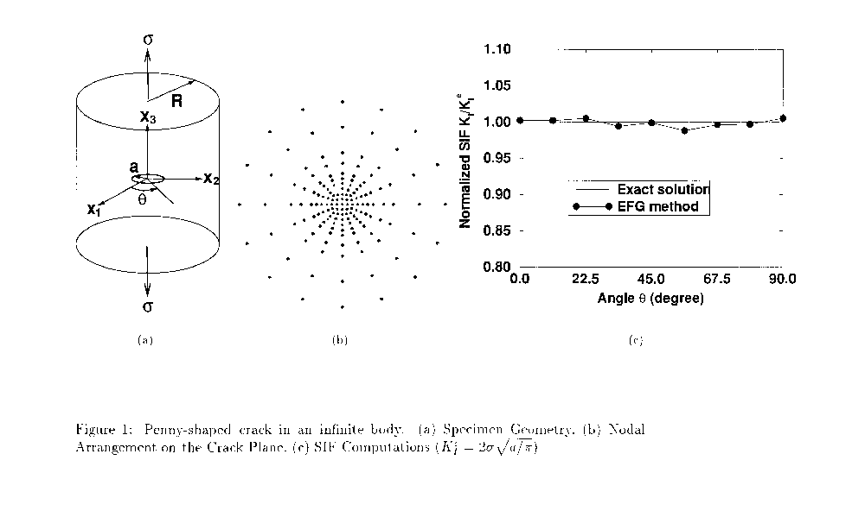

The Effects of Beam Distortion On The Strength Of Ultrasonic Signals
P. D. Panetta, F. J. Margetan, I. Yalda, and R. B. Thompson

Research Objective
To gain an understanding of a variety of unusual, microstructurally controlled, wave propagation phenomena in titanium alloys which cause flaw signals to fluctuate, decreasing the reliability of flaw detection, and back surface signals to fluctuate, adding errors to attenuation corrections.

Approach
As a first step, the simple problem of fluctuations in back surface signals, as occurs in measurements of attenuation, has been considered. This problem is of interest because (a) the back surface signal can be considered as an approximation to the signal from a very large flaw and (b) these signals are used in titanium inspection as part of a correction for sample specific attenuation. Fluctuations in these signals render both the attenuation correction and flaw detection less reliable than would be desired. To understand the origins of these fluctuations, the results of classical attenuation measurements, based on the amplitude of back surface echoes, have been compared to point-probe measurements of attenuation, in which the energy transmitted through a sample is directly measured, independent of phase, with a very small probe.

Accomplishment Description
The results show that the attenuation measured in the classical technique can be much higher than the attenuation inferred from the point-probe measurements of transmitted energy. These are explained in terms of significant distortions of the phase and amplitude of the beam when it propagates through titanium, particularly in certain directions, as compared to the behavior in homogeneous materials such as fused quartz. The existence of these distortions will obviously influence the response of small flaws in ways, which will be more fully determined in future work.

Significance
The understanding of the wave propagation phenomena will lead to less distortions and more accureate measurement of small flaws using ultrasonic methods.

Expected Results
New more accurate techniques for inspection of aircraft engine components.
References: Panetta, P. D.; Margetan, F. J.; Yalda, I.; Thompson, R. B.: “Observation and Interpretation of Microstructurally Induced Fluctuations of Back-Surface Signals and Ultrasonic Attenuation in Titanium Alloys,” Presented at the Twenty First Review of Progress in Quantitative Nondestructive Evaluation, Brunswick, Maine, July 28-August 2, 1996.

Panetta, P. D.; Thompson, R. B.; Margetan, F. J.; Yalda, I.: “Ultrasonic Microstructural Characterization and Modeling of Attenuation in Ti-17 and Ti-6Al-4V Alloys,” Presented at American Society of Materials - Titanium Materials Society Materials Week ‘96, Cincinnati, Ohio, October 7-10, 1996.

Point of Contact: Dr. Christopher Smith, AAR-433, FAA William J. Hughes Technical Center, Atlantic City International Airport, NJ 08405, 609-485-5221, FAX, 609-485-4569, e-mail: smithc@admin.tc.faa.gov

Transducer Design for High Sensitivity Ultrasonic Inspection of Titanium
P. J. Howard, D. C. Copley, and R. S. Gilmore

Research Objective
Investigate transducer design parameters such as frequency and beam diameter to determine their affect on inspection sensitivity in titanium (Ti) alloys. Develop a methodology for designing transducers to produce a high sensitivity C-scan image based inspection in Ti-6Al-4V (Ti-6-4) and Ti-Al5-Sn2-Zr2-Mo4-Cr4 (Ti-17) parts with flat sound entry surfaces.

Approach
A set of transducers spanning a wide range of transducer design parameters was acquired from a single commercial manufacturer. These transducers were used to collect C-scan images of small (1/64”) flat-bottom holes, tungsten-carbide inclusions, uncracked, unvoided synthetic Ti-N (hard-alpha) inclusions, and grain noise data from eight separate Ti alloy sample blocks. The images were analyzed statistically and the results compared to measured transducer parameters.

Accomplishment Description
Each of the transducers was characterized experimentally by measuring the frequency, half-amplitude beam diameter and pulse length. These parameters were used to estimate the volume of the ultrasonic pulse. The amplitude and signal-to-noise ratio (SNR) of each target and the maximum amplitude of Ti grain noise images were extracted and plotted versus the measured parameters. Plots of the target SNR vs. measured design parameters are shown in the accompanying figure. These plots demonstrate that the SNR from flat bottom holes and inclusions increased as the volume of the ultrasonic pulse decreased.

Significance
Results demonstrate a method for increasing the sensitivity of ultrasonic C-scan image based inspections of Ti alloys based on using transducers with the smallest pulse volume practicable.

Expected Results
A methodology, validated by experiments, for selecting a transducer to produce a given sensitivity for an ultrasonic nondestructive test.

Reference: Howard, P. J. and Gilmore R. S.: “Transducer Design for High Sensitivity Ultrasonic Inspection of Titanium,” Review of Progress in Quantitative Nondestructive Evaluation, Vol. 16, (Plenum Publishing, New York), June 1997.

Point of Contact: Dr. Christopher Smith, AAR-433, FAA William J. Hughes Technical Center, Atlantic City International Airport, NJ 08405, 609-485-5221, FAX, 609-485-4569, e-mail: smithc@admin.tc.faa.gov
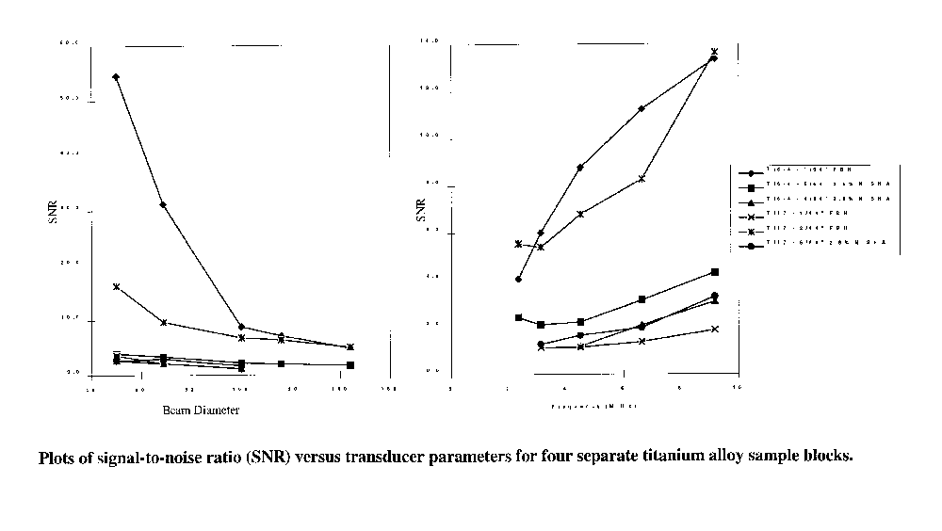

Eddy Current Probe Design for Edge Effect Reduction
S. Sharma, I. Elshafie, L. Udpa

Research Objective
To investigate alternate eddy current probe designs for reducing edge effects in multilayer geometries.

Approach
A finite element (FE) model was generated for simulating multilayer aircraft geometries and predicting the flux distribution and impedance plane trajectories of various probe configurations. The probe configurations were selected to reduce edge signal by shaping the flux of the probe coil using auxiliary coils with appropriate currents.

Accomplishment Description
The two dimensional finite element model was used to visualize the magnetic flux distribution of various probe geometries. Model results were used to design a probe with a concentric flux shaping auxiliary coil. The magnitude and phase of the current in the auxiliary coil was optimized to reduce the spreading of flux inside the conductor and thereby reduce the edge contribution to the signal. The probe design was also tested using three dimensional FE model to predict the impedance plane trajectory due to a crack in the vicinity of an edge. The model results validate the feasibility of the flux shaping approach for edge effect reduction. A prototype of the probe is currently being built for experimental validation.

Significance
By reducing edge effects in multilayer geometries, eddy current methods can more accurately characterize flaws in aircraft structures.

Expected Results
A candidate eddy current probe design for detecting defects close to edges in multilayer geometries.

Reference: Sharma, S.; Elshafie, I.; Udpa, L.: “Finite Element Modeling of Eddy Current Probes for Edge Effect Reduction,” Presented at the 21st Review of Progress in Quantitative Nondestructive Evaluation, Brunswick, Maine, July 1996.

Sharma, S.; Elshafie, I.; Udpa, L: “Probe Design for Edge Effect Reduction in Eddy Current Inspection,” Presented at the SPIE Conference on Nondestructive Evaluation of Aging Infrastructure, Scottsdale, Arizona, December 1996.
Point of Contact: Dr. Christopher Smith, AAR-433, FAA William J. Hughes Technical Center, Atlantic City International Airport, NJ 08405, 609-485-5221, FAX, 609-485-4569, e-mail: smithc@admin.tc.faa.gov
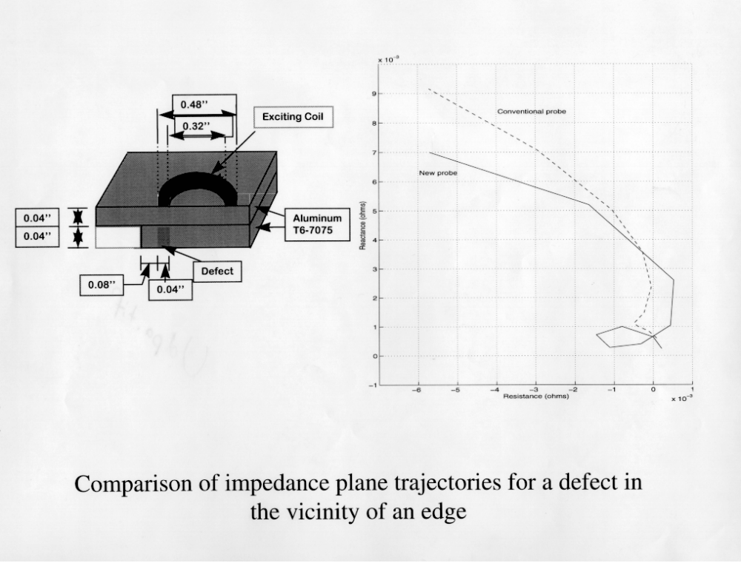

Air-Coupled C-Scan of Boeing Repair Coupon
D. E. Chimenti and O. I. Lobkis

Research Objective
To adapt, develop, and improve air-coupled ultrasonic inspection methods for in-service defect detection and aircraft manufacturing inspections of composite components.

Approach
Assess resolution and sensitivity limits of air-coupled ultrasonics and defect detection versus several measurement parameters. Emphasize composites and subsurface impact damage, internal delaminations, lack of substrate adhesion, lay-up ply orientation defects, and material property variations will be studied. Explore feasibility of development of field-implementable inspection devices using air-coupled technology.

Accomplishment Description
Transmission air-coupled C-scans of a Boeing composite sample have been performed and compared to conventional scans. The B-777 specimen was cut from the tail section and repaired, in a dished, scarf-joint circular area using Boeing methods and included several simulated defects; the repair was complicated by a tapered bond zone. This sample was scanned at 0.5 MHz with a higher-order plate mode in an optimized transmission C-scan with the receiver placed to observe the directly transmitted signal, monitored as a function of transducer position. Despite the structural complexity, the air-coupled inspection yields an excellent map of the defective area, showing all significant internal features. The repaired area is a large circular feature transected by diagonal lines of the prepreg tape borders. The inner circle shows the bond zone of the second of two tapered repair inserts. Within this inner circle are two clear areas (light gray scale) showing damage in the repaired zone. These correlate almost perfectly with the Boeing sample fabrication drawings and with water-coupled scans.

Significance
The feasibility of the air-coupled ultrasonic method for disbonds in realistic aircraft structures.

Expected Results
Development of methods and procedures for air-coupled inspection and materials characterization; system specifications for practical air-coupled ultrasonic inspection system.
References: Lobkis, O; Chimenti, D: “Anisotropic Materials Characterization Using Air-coupled Ultrasound,” Review of Progress in Quantitative Nondestructive Evaluation, Vol. 16, Eds. D. O. Thompson and D. E. Chimenti (Plenum Press, New York), 1997.

Point of Contact: David Galella, AAR-433, FAA William J. Hughes Technical Center, Atlantic City International Airport, NJ 08405 (609) 485-5784, FAX (609) 485-4005, e-mail: galellad@admin.tc.faa.gov

Modeling the Relationship between Microstructure and Backscattered Noise
Y. K. Han and R. B. Thompson

Research Objective
To gain a fundamental understanding of the relationship between microstructure and backscattered ultrasonic noise, in particular the dependence of noise on frequency, propagation direction, and microstructure, and to use this to provide feedback to the billet producers regarding microstructures which would have low noise characteristics and thus improved inspectability.

Approach
The approach builds on previous work of in which backscattered noise was predicted based on the Born approximation. For single-phase, equiaxed polycrystals, his predictions of noise as a function of grain size and frequency were found to be good agreement with experiment. In the new work, this technique has been applied to a more complex microstructure, typical of titanium alloys, consisting of macrograins containing colonies with crystallographically related orientations.

Accomplishment Description
Results have been obtained showing how the backscattering is controlled by the relative values of frequency, macrograin size and shape, and colony size and shape. At sufficiently long wavelengths, the backscattering is found to be isotropic. At wavelengths approaching the colony size, the anisotropy of the backscattering is controlled by the colony elongation. At intermediate wavelengths, the anisotropy of the backscattering is a complex function of the elongation of the macrograins and colonies. These results represent a significant step in understanding the relative role of texture and microstructure size and shape in determining the noise. Although numerical results have only been developed for certain idealized microstructures and macrostructures, the tools used in the computations have sufficient generality to be applied to the microstructures developed in real engine alloys.

Significance
Provides technical information to modify processing for reducing ultrasonic noise in the inspection of aircraft engine components.

Expected Results
New nondestructive evaluation techniques for aircraft.

Reference: Han, Y. K. and Thompson, R. B.: “Ultrasonic backscattering in duplex microstructures: theory and application to titanium alloys,” Metallurgical and Materials Transactions. To be published in January, 1997.

Point of Contact: Dr. Christopher Smith, AAR-433, FAA William J. Hughes Technical Center, Atlantic City International Airport, NJ 08405, 609-485-5221, FAX, 609-485-4569, e-mail: smithc@admin.tc.faa.gov
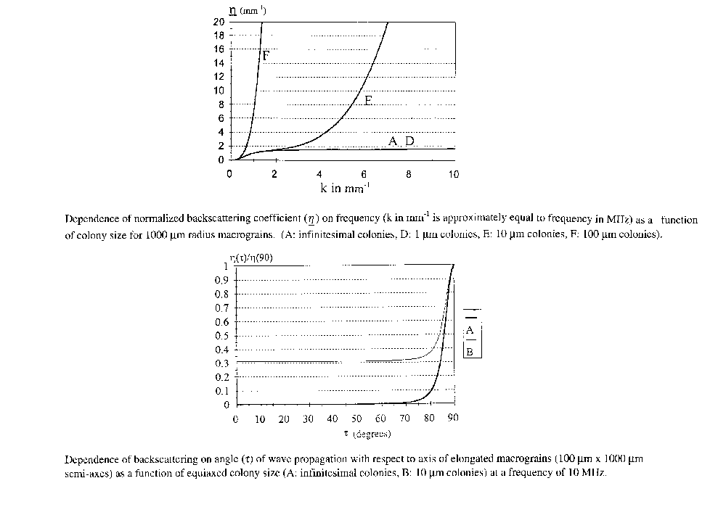

Ultrasonic Microscopy of Synthetic Spherical TiN Inclusions in Forged Ti-6Al-4V
J. B. Deaton, Jr., M. F. X. Gigliotti, L. C. Perocchi, R. S. Gilmore, and E. J. Nieters

Research Objective
Fabricate Ti-6-4 test standards containing embedded 4/64” (#4) spherical Ti-2.9 wt. % N inclusions, and evaluate the ultrasonic detectability of these #4 spherical Ti-2.9 wt. % N inclusions at a 1” depth in the Ti-6-4 standards.

Approach
Synthetic Ti-2.9 without N inclusions were prepared by arc-melting and bonding Ti sponge and TiN powder. Spherical seeds were machined to shape from the TiN ingot and bonded between two Ti-6-4 forged blocks to create the final test standard. Ultrasonic C-scan images were collected of both spherical and flat-faced inclusions at a depth of 1” beneath the ground surfaces of the respective Ti-6-4 test standards. Images were acquired using 5 and 10 MHz f/4 and 5, 10, and 20 MHz f/7 focused beam immersion transducers.

Accomplishment Description
Ti-6-4 test standards were produced with embedded #4 Ti-2.9 wt. % N inclusions that were uncracked and unvoided and which remained nominally spherical after the HIP bonding. The signal-to-noise ratio (SNR) was calculated for the various inclusion geometries and transducer parameters to estimate detectability of the spherical inclusions as compared with the detectability of flat-faced inclusions of similar nitrogen content, as shown in the attached figure.

Significance
The highest SNR for all inclusion geometries was achieved with a 20 MHz f/7 transducer. The higher material noise levels near the diffusion bond line must be corrected for when predicting the detectability of these synthetic TiN inclusions.

Expected Results
Estimates of detectability of naturally occurring TiN inclusions of varying geometries in Ti-6-4.

References: Deaton, J; Gigliotti, M; Perocchi, L; Gilmore, R; Nieters, E: “Ultrasonic Microscopy of Synthetic Spherical TiN Inclusions in Forged Ti-6Al-4V,” presented at the 23rd Annual Review of Progress in Quantitative Nondestructive Evaluation, Brunswick, ME, August 1996.

Point of Contact: Dr. Christopher Smith, AAR-433, FAA William J. Hughes Technical Center, Atlantic City International Airport, NJ 08405, 609-485-5221, FAX, 609-485-4569, e-mail: smithc@admin.tc.faa.gov

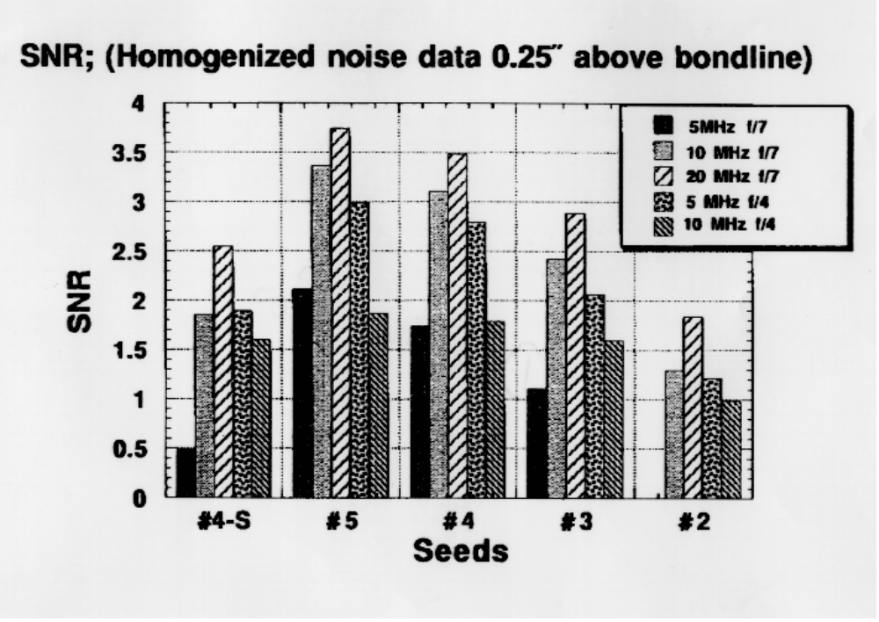

Development of Ultrasonic Models to Guide the Design and Evaluation of Inspection Systems for Titanium Rotating Components
R. B. Thompson, F. J. Margetan, I. Yalda, and C. P. Chiou

Research Objective
To develop an integrated set of models to guide the design and evaluation of inspection systems for titanium rotating components. These should include the effects of microstructure on both flaw response and competing noise.

Approach
The complex microstructure of titanium alloys influences the ultrasonic detection of flaws in a variety of ways. Backscattered noise competes with flaw signals and material inhomogeneties distort the beam, leading to fluctuations in flaw signals and potential errors in standard corrections for attenuation. These effects must be taken into account in designing inspection systems and evaluating their performance. Models, based on the scattering of ultrasound from hard-alpha inclusions and microstructure are being developed to simulate inspections and thereby guide these tasks. These models are all based on the same formal framework, Auld’s electromechanical reciprocity relation, and use various approximations to predict signal and noise under different conditions.

Accomplishment Description
Three classes of models are in varying states of development. Most complete are models for backscattered noise, which can predict root mean square (RMS) noise and gated peak-to-peak noise distributions from knowledge of the details of the measurement system and the noise generating capacity of the materials (described by factors that can be determined experimentally or predicted from knowledge of the microstructure). Additional models are under development to predict the signals reflected from naturally occurring hard-alpha inclusions, including the independent contributions of pores, cracks and the diffusion zone, and how these flaw signals are modified by microstructural inhomogeneties. These models are finding application in assessing probabilities of detection and selecting probes for optimum flaw detectability.

Significance
Models which simulate inspections will guide the design and evaluation of inspection systems without expensive fabrication costs.

Expected Results
Inspection systems for titanium rotating components.
Reference: Thompson, R. B.: “Use of UT Models in Titanium Inspection Development,” Presented at the Twenty First Review of Progress in Quantitative Nondestructive Evaluation, Brunswick, Maine, July 28-August 2, 1996.

Point of Contact: Dr. Christopher Smith, AAR-433, FAA William J. Hughes Technical Center, Atlantic City International Airport, NJ 08405, 609-485-5221, FAX: 609-485-4569, e-mail: smithc@admin.tc.faa.gov

Modeling Ultrasonic Inspectability in Forgings
T. A. Gray

Research Objective
To use ultrasonic measurement modeling capabilities to define inspectability of small defects in near net-shaped forgings, such as are used in the manufacture of jet engine turbine disks.

Approach
Ultrasonic inspectability, defined as signal amplitude or as percent screen height relative to a distance-amplitude-curve (DAC), is simulated using the Gaussian-Hermite ultrasonic beam model and the Kirchoff approximation for elastic wave scattering from planar or spheroidal scatterers within the volume of a forging. A geometrical description of the forging, including surface curvatures, normal vectors, etc., is obtained from computer-aided design (CAD) representations of the component. Signal amplitude maps for assumed ultrasonic scans of the forging are simulated and the results are converted either to raw binary image files or to Microsoft Windows bitmap files.

Accomplishment Description
Pratt & Whitney Aircraft supplied a CAD file containing the geometry of a titanium forging. The inspectability simulation software was used to compute #1 (1/64 inch diameter) flat-bottomed hole (FBH) signal amplitudes as a function of position within the forging cross-section for an assumed set of scanned parameters. Results were computed both with and without an assumed DAC compensation.

Significance
Visualization technique will enhance usability of these techniques.

Expected Results
A method to predict and visualize internal defects in forgings using ultrasonic techniques.

Reference: Gray, T. A.: “Application of Measurement Models to Specification of Ultrasonic Inspections,” Review of Progress in Quantitative Nondestructive Evaluation, vol. 16, D. O. Thompson and D. E. Chimenti, eds., Plenum Press, New York.

Point of Contact: Dr. Christopher Smith, AAR-433, FAA William J. Hughes Technical Center, Atlantic City International Airport, NJ 08405, 609-485-5221, FAX, 609-485-4569, e-mail: smithc@admin.tc.faa.gov

Improved Methodology for Predicting Probability of Detection (POD) of Synthetic Hard Alpha Inclusions in Titanium
William Q. Meeker, Shuen-Lin Jeng, Chien-Ping Chiou, R. Bruce Thompson

Research Objective
Develop methodology to estimate probability of detection (POD) for detecting synthetic hard alpha inclusions in titanium. The methodology will be used to predict POD, probability of false alarm (PFA) and receiver operating characteristic (ROC) function curves.

Approach
The methodology is based on estimating distributions of signals from flaws in noise and of the distribution noise alone. The methodology uses combinations of physical modeling of an inspection process (based on the theory of ultrasonic wave scattering), along with laboratory and production data, to estimate nondestructive evaluation (NDE) capability. A physical prediction model is used to predict the effect of making specific changes to the inspection setup (e.g., probe characteristics). Using the model-specified signal distribution (e.g., signal strength as a function of distance of the flaw from the beam center), probability theory is used to describe variabilities that can be modeled mathematically (e.g., the random position of a flaw relative to scan lines and, correspondingly, the effect of changing scan increment and gate width). A statistical prediction model is used to quantify that part of the scatter observed in actual inspection data that is not accounted for by the physical model.

Accomplishment Description
We have used available experimental data to assess the adequacy of the model predictions and to characterize the unexplained variability. We used a statistical model for the generalized deviations between the actual data and the physical model. These deviations are for a parametric distribution in the Box-Cox family of distributions. Interestingly, the Box-Cox transformation parameter seems to be remarkably constant (at about .3) over different experimental situations. This distribution, along with model signal predictions, can be used to generate POD curves. For a given noise distribution, ROC curves can also be generated.

Significance
This research provides an important step in the development of the Engine Titanium Consortium POD methodology for titanium billet inspection. The next step is to combine the results of this study with current research on signal response from real flaws obtained in the Contaminated Billet Study.
Expected Results
A methodology to predict POD, PFA, and ROC of titanium inspection techniques.

Reference: Meeker, W. Q.; Jeng, S. L.; Chiou, C. P.; Thompson, R. B.: “Improved Methodology for Predicting POD of Detecting Synthetic Hard Alpha Inclusions in Titanium,” Review of Progress in Quantitative Nondestructive Evaluation 16, Plenum Press.

Point of Contact: Dr. Christopher Smith, AAR-433, FAA William J. Hughes Technical Center, Atlantic City International Airport, NJ 08405, 609-485-5221, FAX, 609-485-4569, e-mail: smithc@admin.tc.faa.gov

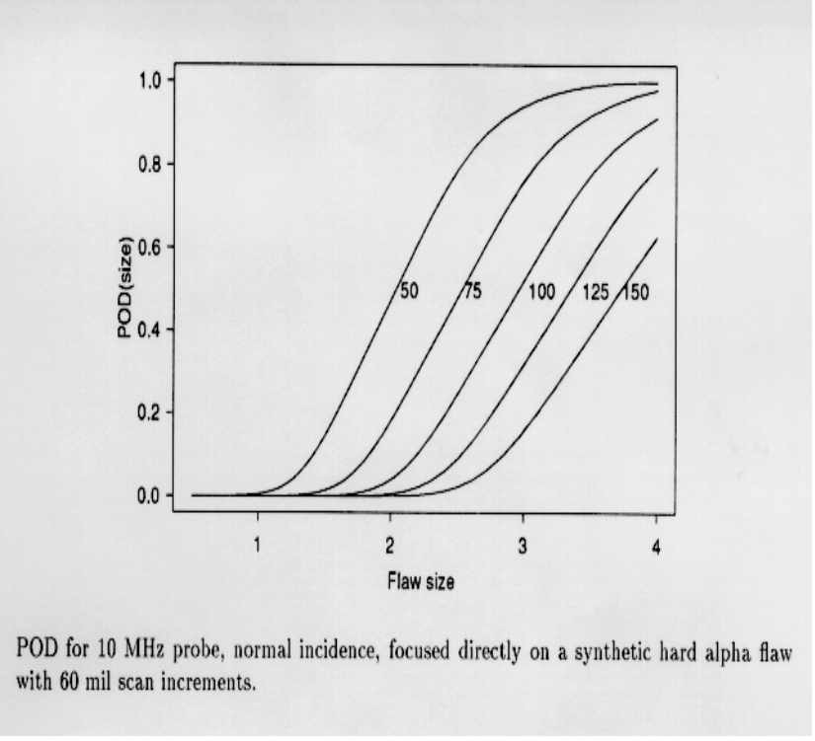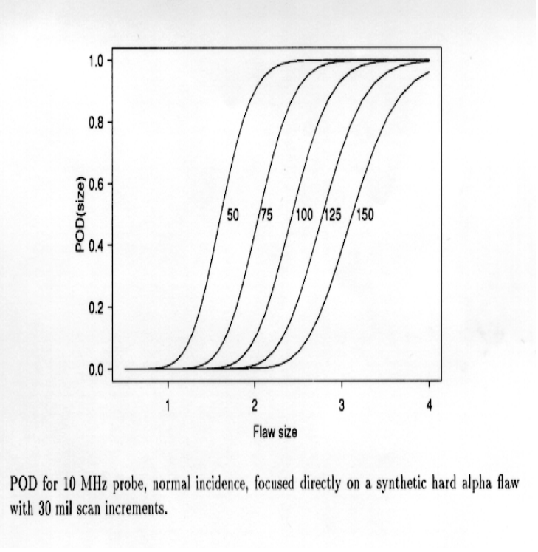

Hand-Held, Flexible Eddy Current Probe for Inspection of Curving Surfaces
Thadd C. Patton, Robert Filkins, James Fulton, John Young, Kristina Hedengren, Carl Granger, and Tom Hewton

Research Objectives
Develop single coil derivatives of the Eddy Current Array Probe (ECAP) for manual and automatic scanning applications that can be used with conventional, single-channel, eddy scope instruments, such as the Nortec 19. The new single element eddy current sensors, designated (SECAP) were designed to cover an area previously covered by an array of sensors.

Approach
The single element eddy current sensors, are similar to the original ECAP sensors and have the following properties: (1) multiple eddy current coil elements are replaced by a single larger eddy current coil element; (2) the layout and design of the drive and sense coils are optimized for single coil detection sensitivity; (3) preamplification and signal conditioning are provided to the differential sense output to improve signal-to-noise ratio; and (4) the shape of the flexible circuit is modified to promote bending flexibility over curving surfaces. The new sensor elements were incorporated into a hand-held probe with internal preamplification; and used to demonstrate wide area inspection coverage by hand scanning.

Accomplishment Description
The differential, reflection style, SECAP sensor elements were incorporated into a hand-held probe with internal preamplification to demonstrate wide area hand scanning. The probe housing is built around the preamplification circuitry; and serves to shield and protect the internal components of the probe while providing an ergodynamic hand grip for manual positioning of the probe. The sensor elements of the SECAP probe are interchangeable within the same probe holder, thus providing adaptation to a wide range of inspection conditions. The probe as shown was demonstrated at the 1996 Airline Transportation Association Nondestructive Testing Forum, held in Seattle, Washington.

Significance
Results demonstrate the feasibility of detecting 0.030” fatigue cracks in titanium using a single large detector, whereby reducing part inspection times by greater than four times. Upon completion, a family of wide-area scanning probes for the inspection of smoothly curving engine components will be available for commercialization.

Expected Results
Presently, the SECAP probe is a developmental prototype designed for the inspection of generally smooth, curving engine surfaces. Future versions of the prototype will be designed for tight convex and concave surfaces as well as for radius corner geometries. Also of consideration are a reduction in the size of the probe body and preamplification board, the design optimization of the SECAP coil elements, as well as an improvement in its ergodynamic design and ruggedness. The general surface SECAP probe is currently planned for beta-site testing in 1997.

References: Hurley, D; Hedengren, K; Howard, P; Kornrumpf, W; Sutton, G;Young, J: “An Eddy Current System for Aircraft Engine Inspection,” Review of Progress in Quantitative Nondestructive Evaluation, Vol. 13A, eds. D. O. Thompson and D. E. Chimenti (Plenum Press, New York, 1994), p. 1111.

Fulton, J; Hedengren, K; Young, J; Filkins, R; Patton, T: “Optimizing the Design of Multilayer Eddy Current Probes - A Theoretical and Experimental Study,” Review of Progress in Quantitative Nondestructive Evaluation, Vol. 16, eds. D. O. Thompson and D. E. Chimenti (Plenum Press, New York, 1997, - to be published).

Patton, T.; Filkins, R.; Fulton, J.: Hedengren, K.; Young, J.; Granger, C.; Hewton, T.: “Development of a Hand-Held, Flexible Eddy Current Probe for Inspection of Curving Surfaces,” Review of Progress in Quantitative Nondestructive Evaluation, Vol. 16, eds. D. O. Thompson and D. E. Chimenti (Plenum Press, New York, 1997, - to be published).

Point of Contact: Dr. Christopher Smith, AAR-433, FAA William J. Hughes Technical Center, Atlantic City International Airport, NJ 08405, 609-485-5221, FAX, 609-485-4569, e-mail: smithc@admin.tc.faa.gov

Eddy Current Probe Design
Norio Nakagawa, David Raulerson and Joe Chao,

Research Objective
To improve the detection capability of nondestructive evaluation inspections used on field hardware.

Approach
An electromagnetic field modeling capability which accepts input from a standard computer aided design (CAD) package will be developed based on the boundary element method (BEM). Modeling techniques such as BEM and finite element method (FEM) will be utilized to determine electromagnetic field characteristics for conventional element designs. This will include applications of the modeling data to design elements with controlled field shapes in an effort to increase sensitivity to key flaw features while reducing effects from geometry. To test the accuracy of the model, validation will be performed which includes correlation of predicted and measured data for artificial as well as real flaws.

Accomplishment Description
The key feature added this year is the crack modeling capability. Specifically, progress has been made in two areas: First, the core BEM code has been enhanced so that it now includes crack modeling capability. Second, additional geometry pre-processing software that assists model users to create cracks and their mesh interactively has been developed. The overall procedure is now established, which guides a user to follow a stream-lined processes, starting with part and probe designs on CAD, generating a crack and scan plans, and then running the BEM code. In addition, the code validation effort has been continued. For solenoid coils, the code has been validated against edge signals and some crack signals. Similar validation efforts with ferrite-core probes are in progress.

Significance
The resulting software simulation capability to examine field eddy current inspections has a significant potential to improve element designs, inspection strategies, and overall performance of safety-critical inspections. In particular, the computer model provides this capability without incurring excessive costs, thus reducing expensive empirical prototyping requirements.

Expected Results
The entire package, namely the general 3-D BEM code with crack modeling capability plus the geometry pre- and post-processing procedure, is expected to become available in 1998.
References: Chao, J; Raulerson, D; Nakagawa, N: “Boundary Element Method Based Probe Design Model Validation,” Review of Progress in Quantitative Nondestructive Evaluation, 1996.

Chao, J; Nakagawa, N; Raulerson, D.; Moulder, J: “A General Boundary Integral Equation Approach to Eddy Current Crack Modeling,” Review of Progress in Quantitative Nondestructive Evaluation, 1996.

Point of Contact: Dr. Christopher Smith, AAR-433, FAA William J. Hughes Technical Center, Atlantic City International Airport, NJ 08405, 609-485-5221, FAX, 609-485-4569, e-mail: smithc@admin.tc.faa.gov

Fatigue Crack Initiation and Growth in Riveted Specimens
Z. M. Connor, W. Li., M. E. Fine, and J. D. Achenbach

Research Objective
To compare fatigue crack development in riveted Aluminum clad aluminum alloy specimens using an optical microscope and a scanning acoustic microscope.

Approach
Riveted specimens were cycled in fatigue until cracks of various lengths were observed using a microscope which was mounted to the testing machine. A scanning acoustic microscope was used to obtain a C-scan of each specimen in the area containing the fatigue crack. These specimens were then carefully examined at various magnifications using high resolution metallographic optical microscopes. Micrographs were taken of areas containing fatigue cracks.

Accomplishment Description
With optical microscopy, surface rumpling consisting of microcracks and roughness was an early indication of fatigue cracking on the flush surface of the riveted lap joint specimens. Propagating cracks grew out of the rumpled region. While the optical microscope reveals only surface cracks, the scanning acoustic microscope in the C-scan mode images subsurface cracks projected onto a plane. Such two-dimensional images reveal subsurface cracks prior to their observance on the specimen surface

Significance
A much better understanding of how fatigue cracks develop at rivets was obtained. This will be an aid to inspection with current hardware as well as an aid to improving nondestructive evaluation hardware.

Expected Results
Data on fatigue crack initiation and growth at rivets to aid in development of inspection techniques and life prediction methodologies.

Reference: Connor, Z. M; Li, W.; Fine, M. E.; Achenbach, J. D.: “Fatigue Crack Initiation and Growth in Riveted Specimens,” Presented at First International Conference on Fatigue Damage in Structural Materials, Hyannis, Massachusetts, September 22-27, 1996.

Point of Contact: Dr. Christopher Smith, AAR-433, FAA William J. Hughes Technical Center, Atlantic City International Airport, NJ 08405, 609-485-5221, FAX, 609-485-4569, e-mail: smithc@admin.tc.faa.gov

A Study of Fatigue Crack Generation and Growth in Riveted Aluminum Clad 2024-T3 Specimens
Z. M. Connor, M. E. Fine, and B. Moran

Research Objective
To investigate microscopically the initiation and propagation of fatigue cracks in riveted specimens as a function of fatigue cycles. To prepare specimens with characteristic cracks for nondestructive evaluation studies and calibration.

Approach
Specimens were fabricated under carefully controlled conditions endeavoring to keep the specimens as nearly identical as possible. Each lap joint specimen was assembled from two Aluminum clad 2024-T3 aluminum alloy panels using three 2017-T4 aluminum alloy rivets. Specimens were loaded in uniaxial tension with an R ratio of 0.1 and a maximum load of 4.0 kN. Cracks were viewed at a magnification of 40x with an optical microscope mounted on an X-Y micrometer stage. Crack length measurements were taken from the edge of the rivet head using the X-Y micrometer stage.

Accomplishment Description
Crack growth measurements were obtained on five specimens at intervals of every 10,000 cycles. The results of these measurements were plotted as crack length vs. number of cycles as shown in the attached figure. The number of cycles until a crack approximately 2 mm in length was seen in the plate near the rivet head was defined as N_{i}. The average N_{i} was 310,000 cycles with a standard deviation of 80,000 cycles. With in situ optical microscopy, microcracks were found to be the earliest indication of fatigue cracking on the surface of lap joint panels riveted with flathead chamfered rivets. The propagating crack emerged from the microcracks.

Significance
A much better understanding of how fatigue cracks develop at rivets was obtained. This will be an aid to inspection with current hardware as well as an aid to improving nondestructive evaluation hardware.

Expected Results
A method for producing in situ controlled damage, cracked riveted specimens for nondestructive evaluation research and development.

Reference: Connor, Z. M.; Fine, M. E. ; Moran, B.: “A Study of Fatigue Crack Generation and Growth in Riveted Alclad 2024-T3 Specimens,” Presented at FAA-NASA Symposium on Continued Airworthiness of Aircraft Structures, Atlanta, Georgia, August 28-30, 1996.

Point of Contact: Dr. Christopher Smith, AAR-433, FAA William J. Hughes Technical Center, Atlantic City International Airport, NJ 08405, 609-485-5221, FAX, 609-485-4569, e-mail: smithc@admin.tc.faa.gov
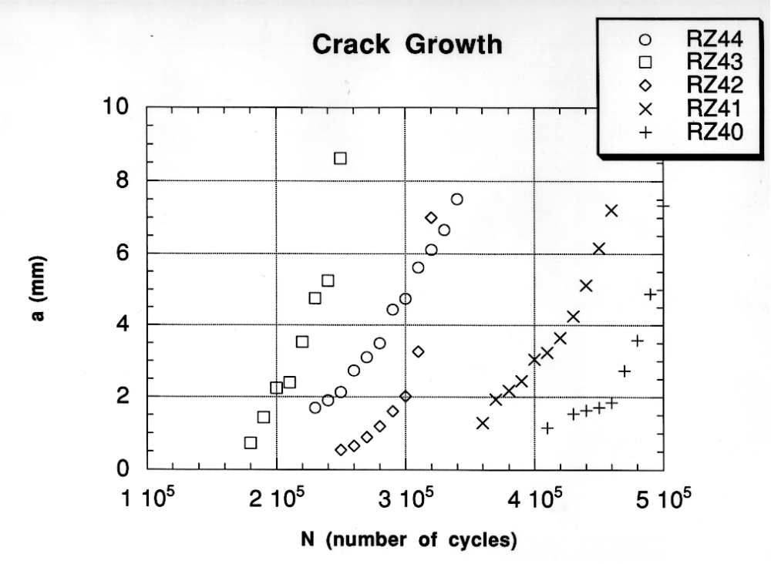

Economical Eddy Current
Kevin Smith, Rob Stephan, and Dave Raulerson

Research Objective
Provide generic tools applicable across engine make and model for engine shop use. Design goals include low cost to capability ratio; portability; use in on-wing, module, and detail part levels.

Approach
Inspection technology in the commercial aviation industry has traditionally been developed to address known problems (reactive approach). The Engine Titanium Consortium (ETC) has worked with the airlines to define common needs that occur across manufacturers and across engine models. With the problem definition in hand, generic tools, which allow controlled scanning and digital data acquisition, have been developed. The ETC has developed a portable scanner and data acquisition system for use in airline overhaul and maintenance shops. The portable scanner consists of generic motor control and motion hardware with application specific tooling for probe positioning and manipulation. Adapter plates are used to mate the scanner to a variety of engine disks by matching the bolt hole patterns for a given disk. A lunch box computer has been used for data acquisition. The system communicates with a variety of commercially available instruments.

Accomplishment Description
To date, bore scans (axial motion), web scans (radial motion), and bolt hole scans have been demonstrated on engine hardware from all three Original Equipment Manufacturers (OEMs) involved in ETC. Betasite testing has been completed at United Airlines were efforts focused on inspection of the 14th and 15th stages of the JT9D compressor disks. Betasite testing is under way with Northwest Airlines and Allied Signal, and is planned in 1997 with American Airlines. In addition to the intended jet engine applications, minimal adaptation has enabled the technology to be applied to inspection of propeller blades, reportedly saving the industry over $10M.

Significance
Cost effective tooling that can be used on multiple applications enhances the potential for controlled scanning in an airline maintenance environment. This has the potential to increase the sensitivity, reliability, and productivity of engine inspection.

Expected Results
Generic, cost effective tools for inservice inspection of aircraft engines.

Reference: Raulerson, D. A.; Smith, K. D.; Stephan, R. R.: “Economical Approach to Automated Eddy Current Inspection,” Presented at the SPIE conference, Scottsdale, Arizona, December 3-5, 1996.

Point of Contact: Dr. Christopher Smith, AAR-433, FAA William J. Hughes Technical Center, Atlantic City International Airport, NJ 08405,609-485-5221, FAX, 609-485-4569, e-mail: smithc@admin.tc.faa.gov

Eddy Current Methods for Crack Detection
J. C. Moulder

Research Objective
Develop new methods for detection and characterization of small fatigue cracks in layered aircraft structures using pulsed eddy current techniques.

Approach
A novel scanned, pulsed eddy-current instrument developed for use in detection of hidden corrosion in lap splices is being adapted for detecting small fatigue cracks in layered aircraft structures. The advantages of pulsed eddy current techniques include the wide bandwidth attainable, which permits a single probe and a single measurement to provide information over a broad frequency range. Pulsed eddy current signals can be used to characterize cracks and locate them in the depth of the material. Time gating of the pulsed eddy-current signals provides a means to discriminate against interfering signals from lift off, air gaps, and fasteners.

Accomplishment Description
The pulsed eddy current instrument has been significantly improved by the addition of scanning capability and the ability to select pulse repetition rate and amplitude under computer control. Now, two-dimensional scans of surface areas can be performed and data presented in a pseudo-color, C-scan format. Commercial probes of many different designs can be used easily, since the amplitude and timing of the excitation pulse have been brought under software control. The ability to discriminate crack signals from interfering signals caused by lift off, air gaps, and fasteners has been demonstrated on simulated lap splice specimens with electro-discharge machine (EDM) slots in the second layer. Slots as small as 60 mils can be detected in the second layer of 65-mil lap splices. A reference standard for the DC-9 rudder rib structure provided by Northwest Airlines has also been examined with the instrument to evaluate potential applications to field inspection of this complicated, 4-layer structure. Potential eddy current (PEC) measurements were able to detect all the simulated defects in the standard and to determine the location of each of the flaws by using the time-gating feature to isolate individual flaws. The instrument has been licensed to Sierra-Matrix, a California-based company, for commercialization.

Significance
The principal advantage of the instrument developed in this program, as compared to the commercially available pulsed eddy current instrument, is that our instrument can be adapted for use with any commercial probe and used in any type of geometry normally inspected with eddy currents. The commercial instrument employs a rotating Hall-effect sensor and is designed specifically for fastener inspection. The ability to scan and image areas up to 8 x 20 inches in size is a considerable advantage. The time-gating feature included in this instrument is a unique capability that has no parallel in commercial instrumentation.

Expected Results
Pulsed eddy current methods to detect small fatigue cracks in layered structures.

References: Bieber, J. A.; Shaligram, S. K.; Rose, J. H.; Moulder, J. C.: “Time-Gating of Pulsed Eddy Current Signals for Defect Characterization and Discrimination in Aircraft Lap-joints,” Review of Progress in Quantitative Nondestructive Evaluation Vol. 16, edited by D. O. Thompson and D. E. Chimenti, Plenum, New York, in press.

Moulder, J. C.; Bieber, J. A.; Ward, W. W.; Rose, J. H.: “Scanned Pulsed-Eddy-Current Instrument for Non-Destructive Inspection of Aging Aircraft,” Proceedings of SPIE Conference on Nondestructive Evaluation of Aging Aircraft, Airports, and Aerospace Hardware, Vol. 2945, SPIE, Bellingham, WA, 1996, p. 2.

Point of Contact: David Galella, AAR-433, FAA William J. Hughes Technical Center, Atlantic City International Airport, NJ (609) 485-5784, FAX (609) 485-4569, e-mail: galellad@admin.tc.faa.gov

Eddy Current Methods for Corrosion Detection
J. C. Moulder

Research Objective
Develop and evaluate eddy current inspection methods for the quantitative determination of metal skin thickness in lap joints. Techniques will be sought that provide quantitative information on the amount of metal thinning induced by corrosion in multi-layer lap joints.
Approach
Eddy current techniques are being developed to characterize corrosion-induced thinning of aircraft skin in lap joints. Two methods have been developed: a swept-frequency method using conventional instruments and a new technique using pulsed eddy currents. The first method is based on multi-frequency measurements of probe impedance. A pulsed eddy current method based on a newly developed prototype instrument provides similar results in a faster, more economical field instrument. Development of a theoretical model for the pulsed eddy current technique was carried out in a related program funded by Air Force Office of Scientific Research (AFOSR).
Accomplishment Description
Development and testing of the scanned pulsed eddy current instrument has been completed this year. A new feature, time-gating, has been added to the software that permits discrimination against interfering signals from lift off, air gaps, or fasteners. Time-gating also provides a means to determine the location of detected corrosion in multi-layered structures. A number of field demonstrations have been carried out, including demonstrations at the Aging Aircraft Nondestructive Inspection Validation Center (AANC), at the Air Transport Association (ATA) Nondestructive Testing Forum in Seattle, WA, at United Airlines Maintenance Facility in Oakland, CA, and at Kelly Air Force Base, McClellan Air Force Base, and Robins Air Force Base. A round-robin test on a Boeing-supplied corrosion specimen was carried out to compare quantitative results from ultrasound, x-ray, thermal wave, and eddy current methods. The instrument has been licensed to Sierra-Matrix, a California-based company, for commercialization
Significance
Both of these new techniques are capable of quantitatively determining the thickness of both layers in a lap splice and discriminating between loss of metal and larger than normal gaps in the lap joint. This is in contrast to the techniques presently in use, which are qualitative rather than quantitative and do not provide information about corrosion in the second layer. The swept frequency technique, when implemented with available commercial equipment, is a difficult and time-consuming measurement. The new pulsed eddy current instrument is fast and portable, and provides essentially the same amount of information.
Expected Results
Improvements to both hardware and software are in progress. A new electronics card is being designed that will incorporate a DSP board and constant current excitation. A major upgrade in the software is also underway, with the major goal being added flexibility in use of different scanners and data acquisition boards, as well as improved imaging. A technology transfer program is planned in collaboration with AANC, the Center for Aviation Systems Reliability, a commercial vendor, original equipment manufacturers and commercial airlines to develop practical field applications for the new scanned pulsed eddy current instrument.
References:. Bieber, J. A.; Shaligram, S. K.; Rose, J. H.; Moulder, J. C.: “Time-Gating of Pulsed Eddy Current Signals for Defect Characterization and Discrimination in Aircraft Lap-Joints,” Review of Progress in Quantitative Nondestructive Evaluation Vol. 16, edited by D. O. Thompson and D. E. Chimenti, Plenum, New York, in press.

Moulder, J. C.; Bieber, J. A.; Ward, W. W.; Rose, J. H.; “Scanned Pulsed-Eddy-Current Instrument for Non-Destructive Inspection of Aging Aircraft,” Proceedings of SPIE Conference on Nondestructive Evaluation of Aging Aircraft, Airports, and Aerospace Hardware, Vol. 2945, SPIE, Bellingham, WA, 1996, p. 2.

Point of Contact: David Galella, AAR-433, FAA William J. Hughes Technical Center, Atlantic City International Airport, NJ (609) 485-5784, FAX (609) 485-4569, e-mail: galellad@admin.tc.faa.gov

Frequency-Shifted Sagnac Interferometer for Ultrasound Measurement
Pavel Fomitchov, Sridhar Krishnaswamy, and J. D. Achenbach

Research Objective
Develop equipment and a technique for laser-based ultrasonics to detect small cracks and to characterize other defects in aircraft structures. In particular, develop a robust frequency-shifted Sagnac interferometer to detect and measure pzt- and laser-generated ultrasonic signals.

Approach
The Sagnac interferometer is a truly path-matched device and it is a more robust alternative to the heterodyne or path-stabilized Michelson interferometer. The interferometer is suitable for the measurement of ultrasonic surface and plate waves arising from laser- or pzt-generated sources or from acoustic emissions. The device will form part of a complete laser-based ultrasonic nondestructive evaluation system. This system can be used to detect and characterize discrete defects such as fatigue cracks as well as distributed regions of reduced material properties.

Accomplishment Description
We have developed a frequency-shifted Sagnac interferometer to measure ultrasonic signals. The main advantage of the proposed interferometer is improved signal-to-noise ratio, which has been achieved using an optical frequency shifting technique for biasing to quadrature and for elimination of parasitic interference between sampling beams and other beams in the interferometer. The results of application of the Sagnac sensor for artificial crack detection and detection of laser generated ultrasonic waves are shown in Fig. 1, 2. A first prototype of the interferometer was demonstrated at the Air Transport Association meeting, Sept. 30-Oct. 1, 1996, Seattle, Washington.

Significance
The measurement of ultrasonic signals by laser interferometric techniques has many advantages for applications to nondestructive evaluation. These include noncontact point detection, remote placement of equipment using fiber-optics, easy scanning, absolute displacement calibration, both broad band and narrow band signal detection, wide frequency band measurements, and applicability to curved surfaces.

Expected Results
A robust low-cost frequency-shifted Sagnac interferometer suitable for field applications to detect and measure pzt- and laser-generated ultrasonic signals in aircraft structures.
References: Fomitchov, P.; Krishnaswamy, S.; Achenbach, J.: “Fiberized Sagnac Interferometer for Ultrasound Measurement,” Program Quantitative NDE, vol. 15, edited by D.O. Thompson and D.E. Chimenti, p. 645-650 (Plenum Press, New York, 1996).

Fomitchov, P.; Steckenrider, J.; Krishnaswamy, S.; Achenbach, J.: “Frequency-shifted low-noise Sagnac sensor for ultrasonic measurements,” Review of Progress in Quantitative NDE, vol. 16.

Fomitchov, P.; Krishnaswamy, S.; Achenbach, J.: “Compact Phase-Modulated Sagnac Interferometer for Ultrasound Detection,” submitted to Optics and Laser Technology (Nov. 1996).

Point of Contact: David Galella, AAR-433, FAA William J. Hughes Technical Center, Atlantic City International Airport, NJ (609) 485-5784, FAX (609) 485-4569, e-mail: galellad@admin.tc.faa.gov
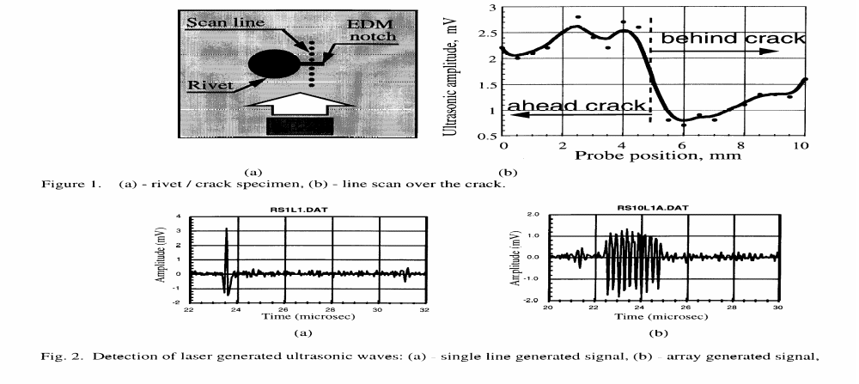

Self-Compensating Ultrasonic Technique
I. N. Komsky and J. D. Achenbach

Research Objective
To adapt a self-compensating ultrasonic technique that has been developed at Northwestern University to detect and characterize defects in aircraft structures.

Approach
An ultrasonic self-compensating technique has been further developed. The approach does not require a separate calibration for each test. The measuring device as a unit can be placed on the structure. The technique requires the transducers to be fired in a specific sequence. An appropriate combination of the measurements then yields data that is uncoupled from the measurement device. Work is in progress on the detection and characterization of radial cracks emanating from fastener holes. The careful selection of frequencies, insonification angles, and transducer spacing optimizes the penetration of ultrasound into second layers. Applications to crack detection in a second layer are specifically directed to the detection and characterization of fatigue cracks in the second layer of a bolted spar-cap/strap connection of the DC-10, the rear spar of a DC-9/MD-80 wing, and the second layer of a Boeing 767 multilayered structure. A related technique developed on this task has been used for detection of material loss by corrosion and detection of stress corrosion cracks in a tee cap of the DC-9 wing box.

Accomplishment Description
The self-compensating ultrasonic technique has been utilized to detect and image fatigue cracks, beneath the repair angle, in the rear spar aft flange in the wings of DC-9 and MD-80 aircraft. Work was carried out to image flaws in the second layer of a multilayered configuration with PR1422 sealant in between the doubler and the rear spar. Two sets of specimens with notches (0.062” - 0.125” in lengths, 0.032” - 0.064” in depths) have been machined to model fatigue cracks around fasteners. The transducer configuration has been developed to detect and characterize cracks underneath the tapered doubler in the area covered by the fastener nut. A prototype search unit was developed and fabricated. Images of the artificial flaws were successfully generated in laboratory tests and the results have been presented to Nondestructive evaluation (NDE) engineers at DAC, Northwest Airlines, and Midwest Express. Initial modifications of the first design have been made to fit the actual spacing in the DC-9/MD-80 wing (upon request of DAC and Northwest Airlines). The unit has been demonstrated.

A set of calibration specimens to model a DC-10 spar-cap/strap connection was fabricated. This calibration set included specimens with artificial cracks of different sizes and orientations as well as specimens with implanted fatigue cracks. The first prototype of a rotational scanning system was manufactured and integrated with the data acquisition system and the ultrasonic probes. The inspection system has been tested on the calibration specimens. Images of rectangular and triangular artificial cracks (0.050” - 0.250” in lengths, 0.050” - 0.0250” in depths) as well as implanted fatigue cracks on the top and at the bottom of the second layer have been successfully generated. The ultrasonic technique developed for the DC-9 wing box inspection has also had successful spin-offs to other applications.

Significance
The self-compensating ultrasonic technique makes it possible to detect and size fatigue cracks, stress corrosion cracks, and material corrosion loss in internal layers of airplane structures. The inspection can be accomplished from the outside of the structure. Ultrasonic waves penetrate from the external layers of a multilayered structure through the sealant to the internal layer.

Expected Results
An ultrasonic inspection technique to replace the current procedure for ultrasonic testing of a spar-cap/strap connection of the DC-10 with a procedure for crack sizing. After review by the staff and approval by the Federal Aviation Administration (FAA) the new procedure for an ultrasonic inspection of the DC-10 spar-cap/strap connection will be available as a Supplemental Inspection Document for nondestructive inspection of the DC-10. Work will be continued on the ultrasonic procedure for application of the self-compensating technique to ultrasonic inspection of the DC-9/MD-80 rear spar, and Boeing 767 structures.

References: Komsky, I. N.: “Ultrasonic Scanning of Airplane and Bridge Structures,” Paper summaries of the first U.S.-Japan Symposium on Advances in NDT, June, 1996.

Komsky, I. N.; Achenbach, J. D.: “Ultrasonic Imaging of Corrosion and Fatigue Cracks in Multilayered Airplane Structures,” Proceedings of the SPIE Conference on Nondestructive Evaluation Techniques for Aging Infrastructure and Manufacturing, December, 1996.

Komsky, I. N.; Achenbach, J. D.: “Optimization of an Imaging Procedure for Ultrasonic Inspection of Airplane and Bridge Structures,” Proceedings of the SPIE Conference on Nondestructive Evaluation Techniques for Aging Infrastructure and Manufacturing, December, 1996.

Point of Contact: David Galella, AAR-433, FAA William J. Hughes Technical Center, Atlantic City International Airport, NJ (609) 485-5784, FAX (609) 485-4569, e-mail: galellad@admin.tc.faa.gov

Self-Focusing Ultrasonic System
J. D. Achenbach and W. A. K. Deutsch

Research Objective
Develop a technique for self-focusing of a linear array on internal defects, surface defects and small cracks in thin sheets.

Approach
Focused transducers are frequently used to increase the amplitude of ultrasonic signals. Since a focused transducer has a fixed focal point, mechanical movement of the transducer in both the normal and lateral directions is generally required to focus on a defect, resulting in long inspection times and extra costs for a scanning system. Alternatively a transducer array together with a phased array technique can be used to focus ultrasound with the advantage that the focal point can be moved electronically without mechanical motion of the transducer array. In this work a simple idea for electronic self-focusing of a linear array, previously developed at Northwestern University, has been extended to Rayleigh and Lamb Waves. The self-focusing procedure first measures the backscattered signals for a first transmission by a single element of the array. A cross correlation technique is used to determine the time-of-flight differences of the back scattered signals to the elements of the array. These time delays are subsequently used to adjust the times of excitation of the elements for transmission focusing on the defect. Using the differences in arrival times once more the backscattered signals after transmission focusing are aligned for reception focusing.

Accomplishment Description
A prototype system consisting of a linear array, together with the required electronics has been built, and the necessary software has been developed. Experimental results have demonstrated the ability of the system to self-focus surface waves on a defect. For the case that there is more than one defect, the technique has been extended to focus on the defect that produces the largest backscattered signal. The technique has also been used for Lamb wave focusing. Experiments have been successfully performed to focus the first antisymmetrical Lamb mode on a small crack-like (100 µm) defect in an aluminum sheet.

Significance
Development of self-focusing ultrasonic systems will offer the aviation industry improved capability to detect small cracks, high density inclusions, hard interstitial defects, and stress induced porosity in aircraft structures and engine components.

Expected Results
A prototype and a methodology, validated by experiments, for self-focusing of body waves, surface waves and Lamb waves on small defects whose location is not known a-priori.

References: Deutsch, W.; Cheng, A.; Achenbach, J.: “Self-Focusing Surface Wave Array,” presented at Review of Progress in Quantitative Nondestrucive Evaluation, MA, July 28-August 2, 1996.

Point of Contact: Dr. Christopher Smith, AAR-433, FAA William. J. Hughes Technical Center, Atlantic City International Airport, NJ 08405, 609-485-5221, FAX = 609-485-4569, e-mail: smithc@admin.tc.faa.gov

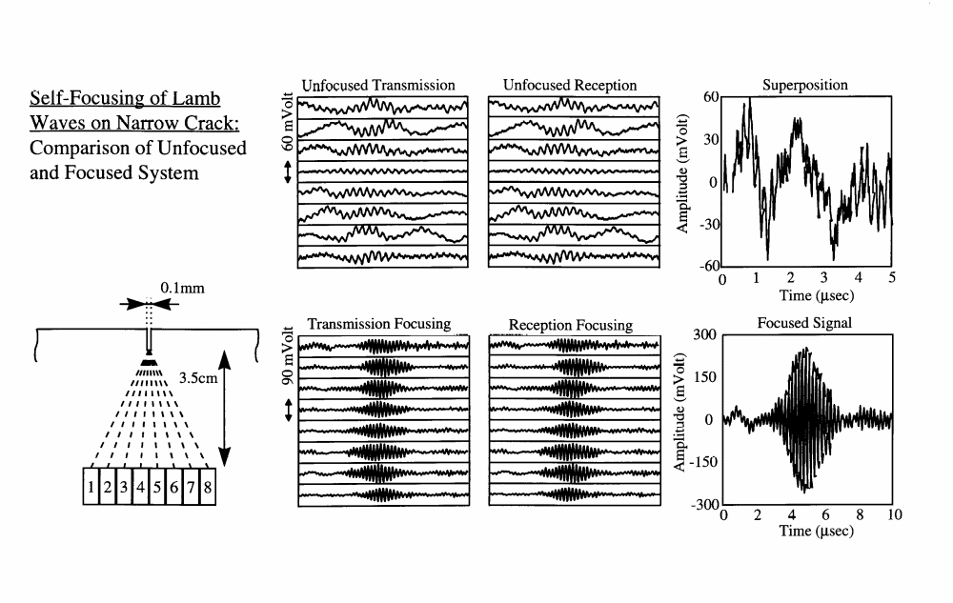

Quantitative Thermal Wave Imaging of Corrosion Thinning
R.L. Thomas, L.D. Favro, and P.K. Kuo

Research Objective
To establish the usefulness of thermal wave imaging (TWI) as a noncontacting, large area nondestuctive inspection technique for the evaluation of material defects, corrosion and damage in adhesively bonded and composite structures, and to determine the applicability of TWI to the inspection of adhesive bonds in tear strap geometry’s, rear surface skin corrosion, bonded composite joints, and bonded boron-epoxy composite doublers on aircraft.

Approach
To investigate TWI for inspection of adhesive bonds in tear strap geometries, rear surface skin corrosion, as well as several common composite defects, in close collaboration with manufacturers and maintenance departments of air carriers.

Accomplishment Description
We have developed a real-time algorithm for quantitative measurement of the percentage material loss from the rear surface of an aircraft skin. The algorithm is capable of measuring corrosion loss of less than a percent. This sensitivity and quantitatively checked by comparison with ultrasonic time-of-flight and profilometer/micrometer measurements on a series of corrosion test panels.

Significance
The thermal wave technique has excellent potential for rapid, wide-area detection, imaging, and quantitative measurement of rear surface skin corrosion on aircraft, either through the use of the uncorroded skin itself as a calibration, or an external calibration thickness standard. If the latter is used, the method provides absolute thickness measurements.

Expected Results
Thermal wave imaging and measurement methodology and instrumentation.

References: Han, X.; Favro, L.; Ahmed, T.; Ouyang, Z.; Wang, L.; Wang, X.; Zhang, F.; Kuo, P.; Thomas, R.: “Quantitative Thermal Imaging of Corrosion on Aircraft,” Review of Progress in Quantitative Nondestructive Evaluation, Vol. 16, Ed. D.O. Thompson and D.E. Chimenti, Plenum Press, New York, to be published (1997).

Point of Contact: David Galella, AAR-433, FAA William J. Hughes Technical Center, Atlantic City International Airport, NJ (609) 485-5784, FAX (609) 485-4569, e-mail: galellad@admin.tc.faa.gov

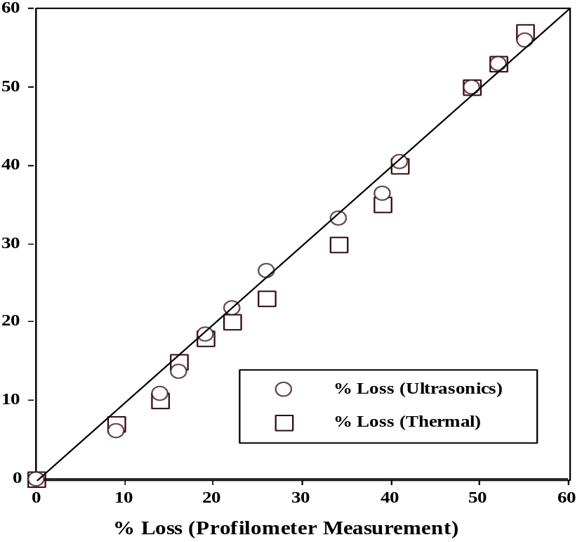

Comparison of thermal and ultrasonic measurements of
a corrosion test panel with direct, profilometer measurement
of rear surface material loss.

Nondestructive Evaluation Parameters - Failure Property Relationships of Adhesive Bonds
H. A. Aglan

Research Objective
To correlate parameters detectable by nondestuctive evaluation (NDE) techniques (thermal and ultrasonic) with critical failure properties, mainly the residual strength and fatigue lifetime of industry standard bonded boron/epoxy repair patches. The effect of the number of plies on the critical failure properties is also to be investigated.

Approach
Mechanical fatigue aging of adhesive joints is to be performed. Boron/epoxy doublers with various number of plies will be fabricated and used to repair pre-cracked aluminum substrates. The extent of adhesive and doubler damage induced by the mechanical cyclic aging is to be assessed.

Accomplishment Description
Monotonic and fatigue tension tests were conducted on multiple cracked aluminum substrates bonded with boron/epoxy patches of different number of plies (2, 4, and 6) to evaluate their residual strength and fatigue behavior. Analysis of the results revealed that the 4 and 6 ply boron/epoxy doublers can bring up the residual strength of the pre-cracked aluminum substrate to the ultimate strength of the aluminum. Post failure examination of specimens indicated that the failure is always in the aluminum away from the boron/epoxy patch. A considerable retardation in the crack growth was observed in the repaired pre-cracked substrates with 4 and 6 plies. The repaired substrates with 4 and 6 plies exhibit considerable crack retardation without catastrophic failure. Fatigue induced damage in the form of disbond between the boron/epoxy doubler and the aluminum substrate has been captured using thermal wave imaging. The size of the disbond tapered down in the direction of the propagating crack in the aluminum substrate, forming a triangular shaped disbond.

Significance
Boron/epoxy doublers with 4 plies or more increase the residual strength of pre-cracked aluminum substrate to a value equal to the strength of uncracked aluminum substrate. A considerable enhancement of the fatigue lifetime was observed due to the crack arrest nature of the boron/epoxy doublers with more than 4 plies.

Expected Results
Construct the relationship between the residual strength as well as fatigue lifetime and the number of plies in the boron/epoxy doublers. In addition, the mechanisms by which the boron/epoxy doublers arrest flaws and defects in aluminum substrate will be established in view of the fatigue crack propagation kinetics of the joints.

References: Aglan, H.; Abdo, Z.: “An Innovative Approach to Fatigue Disbond Propagation in Adhesive Joints,” Journal of Adhesion Science and Technology, Vol. 10, No. 3 (1996), 183-198.

Aglan, H.; Abdo, Z.: “Effect of Surface Treatment on the Fatigue Failure Behavior of Structural Adhesive Joints,” Journal of Materials Science Letters, Vol. 15 (1996), 469-472.

Aglan, H.; Allen, C.; Rowell, T.; Elleithy, R.; Ahmed, T.; Thomas, R.: “Fatigue Failure Evaluation of Boron/Epoxy Patches Using Thermal Wave Imaging” submitted for publication in Vol. 16, Review of Progress in Quantitative Nondestructive Evaluation.

Point of Contact: David Galella, AAR-433, FAA William J. Hughes Technical Center, Atlantic City International Airport, NJ (609) 485-5784, FAX (609) 485-4569, e-mail: galellad@admin.tc.faa.gov

Feasibility Study of a Rotorcraft Health and Usage Monitoring System (HUMS): Usage and Structural Life Monitoring Evaluation
B. Dickson, J. Cronkhite, S. Bielefeld, L. Killian, and R. Hayden

Research Objective
To evaluate two techniques, Flight Condition Recognition (FCR) and Flight Load Synthesis (FLS), for usage monitoring and assess the potential benefit of extending the retirement intervals of lifelimited components, thus reducing the operator's maintenance and replacement costs. Both techniques involve indirect determination of loads using measured flight parameters and subsequent fatigue analysis to calculate the life expended on the lifelimited components. To assess the potential benefit of usage monitoring, the two usage techniques were compared to current methods of component retirement. In addition, comparisons were made with direct load measurements to assess the accuracy of the two techniques.

Approach
The data that was used for the evaluation of the usage monitoring techniques was collected under an independent HUMS flight trial program, using a commercially available HUMS and data recording system. The usage data collect from the HUMS trial aircraft was analyzed off-line using PC based software that included the FCR and FLS techniques. In the future, if the technique prove feasible, usage monitoring would be incorporated into the onboard HUMS. The benefit of usage monitoring was identified under work accomplished during the first phase of this activity.

Accomplishment Description
For the selected dynamic components analyzed, the results of the evaluation of the FCR and FLS techniques indicate a potential for
extending retirement lives. This is due to the damage accumulation rate for the FCR and FLS techniques being slower (“slow clock”) than the current method using actual flight hours as the basis for retirement times. Of course, the benefits of usage monitoring are dependent on how the rotorcraft is operated. Based on the mission flown for this rotorcraft, which flew work crews to offshore oil platforms, the flight hours charged against retirement times could be reduced by 50% or greater.

Significance
The operator would gain a considerable payback in reduced maintenance costs due to extension of retirement intervals.

Expected Results
The FCR technique, which only modifies the helicopter maneuver spectrum relative to the manufacturer's baseline, was considered more practical and lower risk to implement compared to the FLS technique. However, the FLS technique could be refined to overcome shortcomings found and benefit rotorcraft.

Reference: Dickson, B; Cronkhite, J.; Bielefeld, S.; Killian, L.; Hayden, R.: Feasibility Study of a Rotorcraft Health and Usage Monitoring System (HUMS): Usage and Structural Life Monitoring Evaluation, DOT/FAA/AR-95/9, February 1996.

Point of Contact: William Emmerling, AAR-432, FAA William J. Hughes Technical Center, Atlantic City International Airport, NJ 08405, Phone: (609) 485-4009, FAX: (609) 485-8846, e-mail: william_emmerling@admin.tc.faa.gov

Feasibility Study of a Rotorcraft Health and Usage Monitoring System (HUMS): Results of Operator's Evaluation
Raylund Romero and Harold Summers, James Cronkhite
Research Objective
To evaluate the feasibility of a state of the art health and usage monitoring system (HUMS) to provide monitoring of critical mechanical systems on the helicopter, including motors, drive train, engines and lifelimited components.

Approach
The implementation of HUMS and cost integration with current maintenance procedures was assessed from the operator’s viewpoint in order to achieve expected benefits from these systems, such as enhanced safety, reduced maintenance cost and increased availability. An operational HUMS was used as a basis for this study that was installed and operated under an independent flight trial program. The HUMS equipment and software were commercially available.

Accomplishment Description
The HUMS used in the flight trial program generally demonstrated a high level of reliability in monitoring the rotor system, engines, drive train and lifelimited components. The system acted as a sentinel to warn of impending failures. A worn tail rotor pitch bearing was detected by HUMS, which had the capability for self testing to diagnose system and sensor faults.

Significance
Examples of potential payback to the operator with HUMS were identified, including reduced insurance cost through enhanced safety, lower operating costs derived from maintenance credits, increased aircraft availability and improved operating efficiency.

Expected Results
The success in realizing the potential benefits from HUMS technology was found to depend on the operator, helicopter manufacturer, regulator (FAA), and HUMS supplier working together. The interfacing of HUMS with current operational procedures was assessed to require only minimal revisions to the operator’s maintenance manuals.

Reference: Romero, R.; Summers H.; Cronkhite, J.: Feasibility Study of a Rotorcraft Health and Usage Monitoring System (HUMS): Results of Operator's Evaluation, DOT/FAA/AR-95/50, February 1996.

Point of Contact: William Emmerling, AAR-432, FAA William J. Hughes Technical Center, Atlantic City International Airport, NJ 08405, Phone: (609) 485-4009, FAX: (609) 485-8846, e-mail: william_emmerling@admin.tc.faa.gov

Corrosion and Corrosion Fatigue of Airframe Materials
Robert P. Wei and D. Gary Harlow

Research Objective
The development of basic understanding of the processes of localized corrosion and corrosion fatigue crack nucleation and growth in high strength aluminum alloys used in airframe construction, the formulation of kinetic models for these elemental processes, and the integration of these models into probabilistic models that can provide guidance in formulating methodologies for service life prediction.

Approach
In support of the National Aircraft Research Program of the Federal Aviation Administration (FAA), Lehigh University undertook a multidisciplinary program of research to study corrosion and corrosion fatigue of airframe materials. The program is complemented by the Air Force Office of Scientific Research (AFOSR).

Accomplishment Description
Summarizes research performed under the FAA sponsored (Phase 1) program for the period from 15 June 1992 to 14 June 1995. Experimental efforts during this period were focused upon (1) characterizations of the chemical, microstructural and statistical aspects of pitting corrosion and upon the kinetics of pitting of 2024-T3 aluminum alloy in aqueous environments; (2) establishment of the criteria for the transition from pitting to corrosion fatigue crack growth (i.e., crack nucleation); and (3) studies of corrosion fatigue crack growth particularly in its early stage.

Significance
The development and demonstration of a mechanistically based probability approach for service life prediction and the formulation of a probability model for particle induced corrosion pit growth that pertains to multiple-site-damage (MSD) analysis in aircraft.

Expected Results
Methodologies to provide guidance for service life prediction of aging aircraft.

Reference: Wei, R.; Harlow, G.: Corrosion and Corrosion Fatigue of Airframe Materials, DOT/FAA/AR-95/76, 1996.

Point of Contact: Dr. Thomas Flournoy , AAR-433, FAA William J. Hughes Technical Center, Atlantic City International Airport, NJ 08405, Phone: (609) 485-5327, FAX: (609) 485-4569, e-mail: Thomas_Flournoy_at_ct27@admin.tc.faa.gov

Stochastic Modeling of Antisymmetric Buffet Loads on Horizontal Stabilizers in Massively Separated Flows
Saeed Farokhi, Clay S. Mauk, and James E. Locke

Research Objective
Identify buffet loading as a structural design load.

Approach
The surface pressure was measured for a large number of test conditions, including the most severe buffeting environment for this type of aircraft: the tail immersed in the massively separated wake of the wing. Modifications to the Beech King Air 200 one-sixth scale wind tunnel model included the construction of a new horizontal stabilizer instrumented with 12 miniature pressure transducers. Structural characteristics of the full-scale aircraft were estimated using the ASTROS (Automated STRuctural Optimization System) program. Motion-dependent aerodynamics (stiffness and damping) were computed using the proven doublet lattice method, which is incorporated into ASTROS. Due to difficulties with the data acquisition system, the current approach was validated with buffet pressure power spectral densities from an existing reference.

Accomplishment Description
A modern method was developed to model antisymmetric buffet design loads on horizontal stabilizers with a known probability, utilizing a rigid wind tunnel model.

Significance
Provides technical information concerning stabilizer antisymmetric buffet loads.

Expected Results
Aircraft manufacturers will be able to predict stabilizer antisymmetric buffet loads early for use in the certification program.

Reference: Farokhi, S.; Mauk, C.; Locke, J.: Stochastic Modeling of Antisymmetric Buffet Loads on Horizontal Stabilizers in Massively Separated Flows, DOT/FAA/AR-95/7, March 1996.

Point of Contact: Thomas DeFiore, AAR-432, FAA William J. Hughes Technical Center, Atlantic City International Airport, NJ 08405, Phone: (609) 485-5009, FAX: (609) 485-4569, e-mail: Thomas_DeFiore_at_ct27@admin.tc.faa.gov

Fracture Testing Of Large-Scale Thin Sheet Aluminum Alloy
R. DeWit, R. J. Fields, S. R. Low III, D. E. Harne, T. Foeke

Research Objective
Characterize the process by which cracks propagate and link up on large-scale, precracked aluminum alloy panels.

Approach
Extended grips and test fixtures were specially designed to tension load the panel specimens in a 1780-kN capacity universal testing machine. Ten single sheets of bare 2024-T3 aluminum alloy, approximately 4 m high, 2.3 m wide, and 1 mm thick were fabricated with simulated through cracks oriented horizontally at midheight. Using existing information, a test matrix was set up to explore regions of failure controlled by fracture mechanics, with additional tests near the boundary between plastic collapse and fracture. In addition, a variety of multiple site damage (MSD) configurations were included to distinguish between various proposed linkage mechanisms. All tests but one used antibuckling guides. Three specimens were fabricated with a single central crack, six others had multiple cracks on each side of the central crack, and one had a single crack but no antibuckling guides.

Accomplishment Description
The data were analyzed by two different procedures: (1) the plastic zone model based on the residual strength diagram and (2) the R-curve. The first three tests determined the basic material properties; these results were used in the analysis of the subsequent tests with MSD cracks. The two analyses procedures provided good predictions of the residual strength , linkups stress, and fracture stress of the panels with MSD. The critical fracture stress predicted by both procedures are virtually the same.

Significance
The large panels were used in this test to avoid net section control failure. The two analyses procedures: (1) which is analytically based and (2) experimentally based, produce the same results.

Expected Results
Experimental data for use in the verification of models for service life prediction of aluminum alloy on aging aircraft.

Reference: DeWit, R.; Fields, R.; Low III, S.; Harne, D.; Foeke, T.: Fracture Testing Of Large-Scale Thin Sheet Aluminum Alloy, DOT/FAA/AR-95/11, February 1996.

Point of Contact: Dr. Paul Tan, AAR-433, FAA William J. Hughes Technical Center, Atlantic City International Airport, NJ 08405, Phone: (609) 485-6665, FAX: (609) 485-4569, e-mail: Paul_Tan_at_ct27@admin.tc.faa.gov

Development Of A D Sight Aircraft Inspection System: Phase II
F. Karpala and O. L. Hageniers

Research Objective
Summarize the results of the second phase of development for a nondestructive inspection (NDI) system based on D Sight.

Approach
Field trips were made to Northwest Airlines, in Minneapolis-St. Paul, Air Canada, in Montreal, and United Airlines, in San Francisco A field trip to the Royal Air Force in England is also summarized to include the experience of corrosion detection with the original prototype developed in Phase 1. The new hardware performed well in the field trials with the exception of connectors. The new software philosophy using a turtle diagram (planar surface drawing) graphical user interface was particularly well received by NDI personnel.

Accomplishment Description
The accelerated corrosion testing continued from the first phase and provided additional support for the high sensitivity of D Sight to pillowing in corroded lap splices down to the 2 to 3 percent level.

Significance
The computer modeling and D Sight simulation provides a useful way to study the potential of D Sight on new joint configurations as well as draw attention to configurations that may be unacceptable for visual inspection due to the low levels of pillowing that develop. The fact that D Sight is measuring the extent of pillow deflections rather than material loss also draws attention to techniques that may be reporting false material loss simply because of aircraft manufacturing tolerances especially at low corrosion levels.

Expected Results
A nondestructive inspection (NDI) system for aircraft based on D Sight.

Reference: Karpala, F.; Hageniers, O. L.: Development Of A D Sight Aircraft Inspection System: Phase II, DOT/FAA/AR-95/15, March 1996.

Point of Contact: David Galella, AAR-433, FAA William J. Hughes Technical Center, Atlantic City International Airport, NJ 08405, Phone: (609) 485-5784, FAX: (609) 485-4569, e-mail: galellad@admin.tc.faa.gov

Light Shaping Diffusers For Improved Visual Inspection Of Aircraft
Richard N. Shagam

Research Objective
Study representative flashlights available to inspectors of commercial aircraft and description of the Light Shaping Diffuser (LSD), which significantly improves the quality of the illuminating beam.

Approach
A review of the many different styles and varieties of flashlights on the market today. Metal or plastic cases and reflectors, environmentally sealed, adjustable or fixed beam spread, switch activated or twist-on/twist-off, the battery size and number, and the type of bulb are just some of the various differences to be found in flashlights. Many share a common problem however, that of uneven illumination. A flashlight beam having a high peak illumination value may also contain areas of relatively brighter and dimmer intensities spread throughout the beam.

Accomplishment Description
Tests of the LSD at aircraft inspection facilities demonstrated that the LSD is a positive improvement to inspection flashlights. Ninety percent of inspectors that responded to a survey distributed during the 1994 Air Transport Association Nondestructive Testing Forum said the LSD-equipped flashlight was an improvement over their standard flashlight.

Significance
The LSD is an inexpensive optical component, which is an improvement over existing aircraft inspection flashlights.

Expected Results
LSD-equipped flashlights may replace present available commercial models for aviation maintenance technicians.

Reference: Shagam, R.: Light Shaping Diffusers For Improved Visual Inspection Of Aircraft, DOT/FAA/AR-95/32, April 1996.

Point of Contact: David Galella, AAR-433, FAA William J. Hughes Technical Center, Atlantic City International Airport, NJ 08405, Phone: (609) 485-5784, FAX: (609) 485-4569, e-mail: galellad@admin.tc.faa.gov

Investigation of Fuselage Structure Subject to Widespread Fatigue Damage
M. L. Gruber, C. J. Mazur, K. E. Wilkins, and R. E. Worden

Research Objective
Focus on developing representative data on the effects of widespread fatigue damage (WFD) on fuselage lap joints using unique Boeing testing capabilities and expertise in airplane analysis and design.

Approach
The program was divided into three technical tasks: Task I consisted of six tests conducted to characterize the 2024-T3 sheet material that was used for the skins of the two curved fuselage pressure test panels fabricated for Task II. Static, crack growth rate, and fracture toughness data were generated. Task II involved curved pressure panel tests conducted in the Boeing 127-inch-radius pressure test fixture. Two panels representative of typical wide-body crown fuselage construction were fabricated and tested. The testing focused on the outer skin lap joint upper fastener row with and without simulated multiple site damage (MSD). Lead cracks were grown in the lap joints by pressure cycling from an initial 5-inch sawcut to two frame bays (40 inches). Task III consisted of performing analyses to predict the crack growth and residual strength of the pressure test panels. Stress intensity factors were obtained from a material and geometric nonlinear finite element model developed using standard Boeing practices. Crack growth rate and residual strength predictions were made and correlated with test results from the pressure tests.

Accomplishment Description
Test results indicated that the crack growth rate was faster in the presence of MSD. The frame spanning the 40-inch crack was then cut and residual strength tests conducted by gradually increasing the pressure until dynamic panel failure occurred. Test results indicated that panel residual strength was reduced 20 percent in the presence of MSD for the panel geometry tested. The crack growth predictions correlated very well with test results for small and no MSD cases.

Significance
The development of analytical prediction capability would be a major step forward in developing an understanding of structures susceptible to WFD.

Expected Results
Data for aging aircraft that can realistically simulate airplane pressure loading.
Reference: Gruber, M.; Mazur, C.; Wilkins, K.; Worden, R.: Investigation of Fuselage Structure Subject to Widespread Fatigue Damage, DOT/FAA/AR-95/47, February 1996.

Point of Contact: Dr. Paul Tan, AAR-433, FAA William J. Hughes Technical Center, Atlantic City International Airport, NJ 08405, Phone: (609) 485-6665, FAX: (609) 485-4569, e-mail: Paul_Tan_at_ct27@admin.tc.faa.gov

Automated Inspection of Aircraft
C. J. Alberts, C. W. Carroll, W. M. Kaufman, and M. W. Siegel

Research Objective
Develop robotic tools to assist aircraft inspectors by automating the collection, archiving, and postprocessing of inspection data.

Approach
Studied the task of aircraft inspection, compiled the functional requirements for an automated system to inspect skin fastener rows, and developed a conceptual design of an inspection robot. The system was designed to be sufficiently flexible to allow for the incor-poration of new sensor technologies, including those being developed by other organizations participating in the FAA’s National Aging Aircraft Research Program. A prototype of the robotic inspection system, (the Automated Nondestructive Inspector or ANDI), was developed. The first phase of system development resulted in a laboratory system that demonstrated the ability to adhere to the surface of an aircraft panel and deploy a standard eddycurrent sensor.

Accomplishment Description
Several operational limitations of the robotic inspection system were exposed during the laboratory testing and field demonstration. Specific problems include this prototype robot’s speed, absence of a high-level of operator control, and mechanical reliability.

Significance
As a result of these experiments, insight has been gained into means for improving speed, ease of operation, and mechanical performance.

Expected Results
Establish the technical feasibility of using robotic nondestructive inspection (NDI) systems in major aircraft maintenance facilities.

Reference: Alberts, C.; Carroll, C.; Kaufman, W.; Siegel, M.: Automated Inspection of Aircraft, DOT/FAA/AR-95/48, June 1996.

Point of Contact: David Galella, AAR-433, FAA William J. Hughes Technical Center, Atlantic City International Airport, NJ 08405, Phone: (609) 485-5784, FAX: (609) 485-4569, e-mail: galellad@admin.tc.faa.gov

Validation of the Magneto-Optic/Eddy-Current Imager
Vanessa J. Brechling, Floyd Spencer

Research Objective
Validate the MagnetoOptic/EddyCurrent Imager (MOI).

Approach
The MOI was used for inspections as part of an experiment designed to assess the reliability of detecting a crack originating within fastener holes in thin aluminum structures. Nondestructive test (NDT) personnel performed the inspections in aircraft maintenance facilities. The resultant probabilities of detection as a function of crack length for the MOI were comparable to the values obtained for sliding probe eddy current inspections.
The angle that a crack emanates from the rivet hole influences detection rates. A 90 percent detection rate was achieved for 0.079 inch cracks that were horizontal (in the direction of scan). The same detection rate was achieved for 0.095 inch cracks, when the cracks were as much as 22° off-horizontal. The stated crack lengths are as measured from the rivet shank. There is no indication that the noted effect of the angle direction on detection rates is a limitation of the MOI technology as opposed to an inspector “bias” that could be addressed in procedures and training.
The economic analysis considers the effects of individual factors that contribute to the cost-effectiveness of the MOI. The possible returns to the investment for a representative maintenance facility are calculated using the net present value methodology. Specific characteristics are defined for the representative facility, and then they are varied to account for the differences in the maintenance community.

Accomplishment Description
In the sensitivity analysis, it is discovered that the most influential factor on the economics of the MOI is the proportion of the inspection time savings that can be transferred to decreasing aircraft downtime. If the time savings achieved with the MOI can be implemented in the inspection schedule to achieve at least a 10 percent decrease in aircraft downtime, then the investment in the MOI is cost-effective for the representative facility. This assumes that there is no need to strip paint on the aircraft.

Significance
Productivity improvements and decreased aircraft downtime will result from faster inspection techniques.
Expected Results
Even if inspection time savings are not transformed to decreased aircraft downtime, if the MOI allows for the elimination of the requirement to strip paint on one or more aircraft then it would be a cost-effective investment for aviation maintenance.

Reference: Brechling, V.; Spencer, F: Validation of the Magneto-Optic/Eddy-Current Imager, DOT/FAA/AR-95/100, November 1995.

Point of Contact: Dr. Christopher Smith, AAR-433, FAA William J. Hughes Technical Center, Atlantic City International Airport, NJ 08405, Phone: (609) 485-5221, FAX: (609) 485-4569, e-mail: smithc@admin.tc.faa.gov

A Methodology For The Economic Assessment Of Nondestructive Evaluation Techniques Used In Aircraft Inspection
Vanessa J. Brechling

Research Objective
Addresses the cost implications of: Nondestructive Evaluation (NDE) techniques used for inspecting aircraft and a methodology is provided for the economic evaluation of emerging NDE methods.

Approach
A model is described for the evaluation of the financial benefits net of costs that an individual aircraft operator may expect to receive if it employs a specific NDE technique. The calculation of the net present value (NPV) of an investment in a new NDE technique to an aircraft carrier or maintenance facility is described.
The net benefits to society were assessed upon the adoption of the new technique. This analysis is particularly appropriate to investment decisions that may be mandated by Federal Aviation Administration rule. A social assessment of the costs and benefits of a new NDE technique requires the assessment of all costs and benefits to society. The net benefits to all aircraft operators in the industry are included in the social calculation. In addition, costs to the government or any other public institution, as well as any benefits that may accrue to members of society from the airline industry’s use of the new technique, are included.

Accomplishment Description
Issues such as the measurement of benefits, the economic impact of an improvement of the probability to detect flaws, heterogeneity in aircraft maintenance facilities, estimation in the presence of uncertainty, and the practical problem of obtaining the data necessary to apply the methodology are addressed. It acknowledges that some of the relevant factors are not measurable and that some subjective data may have to be examined regarding the impact of these factors.

Significance
The availability of a formal cost benefit analysis for capital investment decisions in inspection technology will facilitate the introduction cost-effective inspection technology, and prevent the expenditure of funds on the development and application inappropriate or ineffective technologies.

Expected Results
A methodology to assess the economic benefit of nondestructive inspection methods.

Reference: Brechling, V.: A Methodology For The Economic Assessment Of Nondestructive Evaluation Techniques Used In Aircraft Inspection, DOT/FAA/AR-95/101, November 1995.

Point of Contact: Dr. Christopher Smith, AAR-433, FAA William J. Hughes Technical Center, Atlantic City International Airport, NJ 08405, Phone: (609) 485-5221, FAX: (609) 485-4569, e-mail: smithc@admin.tc.faa.gov

Tire Test Correlation: Radial Versus Bias-Ply Tires
Rich Anderson

Research Objective
Correlate the temperature performance of a radial tire with a bias-ply tire of identical size under controlled laboratory dynamometer conditions.

Approach
The general effects of increases in load and ground speed on the temperature profiles of each tire were compared.

Accomplishment Description
The results indicated that the bias-ply tire used during the tests was more adversely affected by increases in load and speed than the radial tire.

Significance
Inspection and retreading intervals for radial tires have been identified.

Expected Results
The data contained in this report could be used to review radial tire inspection and retreading criterion.

Reference: Anderson, R.: Tire Test Correlation: Radial Versus Bias-Ply Tires, DOT/FAA/AR-TN95/97, March 1996.

Point of Contact: William Nissley, AAR-432, FAA William J. Hughes Technical Center, Atlantic City International Airport, NJ 08405, Phone: (609) 485-4147, FAX: (609) 485-8846, e-mail: William_Nissley@admin.tc.faa.gov

Flight Loads Data For A Boeing 737-400 In Commercial Operation
D. Skinn, P. Miedlar, and L. Kelly

Research Objective
Provide information that will enable the Federal Aviation Administration (FAA) to better understand and control those factors that influence the structural integrity of commercial transport aircraft.

Approach
During this prototype data collection program, 593 flights of operational flight loads were collected. Of these, 535 flights representing 817.7 hours, provided usable data. The National Aeronautics and Space Administration (NASA) developed the specifications for the recording system, defined the recording format, reduced the data to time histories of engineering units, and tested and evaluated the algorithms for data reduction and statistical reporting. The University of Dayton Research Institute (UDRI) received the flight loads data and data review software from NASA. UDRI developed software to reduce the flight loads data and obtain additional parameters such as derived gust velocity and continuous turbulence gust intensity.

Accomplishment Description
The data reduction includes, but is not limited to, analysis of c.g., accelerations, airspeeds, altitudes, flaps usage, and takeoffs and landings. Data are typically presented in cumulative distribution function or cumulative counts normalized to nautical mile or 1000 hours.

Significance
The data collection program is part of a joint FAA/NASA effort to develop a flight recorder to obtain statistical loads data on commercial transport (FAR Part 25) aircraft during routine operations.

Expected Results
Comparisons of typical usage with published Federal Aviation Regulations.

Reference: Skinn, D.; Miedlar, P.; Kelly, L.: Flight Loads Data For A Boeing 737-400 In Commercial Operation, DOT/FAA/AR-95/21, April 1996.

Point of Contact: Thomas Defiore, AAR-431, FAA William J. Hughes Technical Center, Atlantic City International Airport, NJ 08405, Phone: (609) 485-5009, FAX: (609) 485-4569, e-mail: Thomas_DeFiore_at_ct27@admin.tc.faa.gov

Axial Crack Propagation and Arrest in a Pressurized Fuselage
M. Kosai, A Shimamoto, and A. S. Kobayashi

Research Objective
Establish a practical crack kinking criterion that will account for the presence of multiple site damage (MSD) in a pressurized airplane fuselage.

Approach
The Ramulu-Kobayashi crack kinking criterion was modified to predict self-similar crack propagation along a line of MSD and subsequent kinking near a tear strap. Instrumented biaxial test specimens and small-scale fuselage rupture experiments were conducted to generate the crack kinking and crack velocity data which were then input to a large deformation, elastodynamic, finite element model of the fracture specimen. The computed mixed mode I and II stress-intensity factors and large axial stress preceding the propagating crack were used to evaluate the self-similar crack extension and the crack kinking criterion along the crack trajectory.

Accomplishment Description
The biaxial specimen tests showed that in spite of the presence of plane strain mode II stress-intensity factor and the large axial stress ahead of the propagating crack, axial crack extension continued in the axial direction if the skin is weakened by MSD. The crack propagated through the tear strap in the presence of a continuous MSD and kinked when the MSD terminated at the tear strap. However, if there is a short secondary crack under the tear strap, the lead crack kinked at the long groove end but reconnected to the secondary crack. The small-scale fuselage rupture tests showed that the pre-existing axial through crack along the stringer immediately kinked upon propagation due to the mixed mode I and II state caused by the one-sided opening of the crack flap. The diagonally running crack subsequently turned circumferentially along the tear straps or the two cylinder ends.

Significance
A practical crack kinking criterion was developed and verified for use in predicting crack behavior in pressurized aircraft fuselages. Such a criterion can be used in predicting residual strength in aircraft structures.

Expected Results
A validated criteria for predicting axial crack propagation and arrest in an aging aircraft.

Reference: Kosai, M.; Shimamoto, A.; Kobayashi, A. S.: Axial Crack Propagation and Arrest in a Pressurized Fuselage, DOT/FAA/AR-95/43, September 1996.

Point of Contact: Dr. Paul Tan, AAR-431, FAA William J. Hughes Technical Center, Atlantic City International Airport, NJ 08405, Phone: (609) 485-6665, FAX: (609) 485-4569, e-mail: Paul_Tan_at_ct27@admin.tc.faa.gov

Implications of Corrosion Pillowing on the Structural Integrity of Fuselage Lap Joints
Nicholas C. Bellinger and Jerzy P. Komorowski

Research Objective
Determine the effect that pillowing, caused by the presence of corrosion products, has on fuselage lap joints.

Approach
Finite element techniques were utilized for analyses.

Accomplishment Description
The stress in a fuselage lap joint increases as the pillowing caused by the corrosion by-products increases. Depending on the location of the corrosion and severity of the pillowing, the maximum stress in a joint could shift to other skins (i.e. second or third layers) causing premature crack initiation. The high aspect ratio cracks would make detection difficult thus decreasing the probability of detection and increasing the risk of premature failure.

Significance
Even a relatively small amount of pillowing can lead to yielding around the rivet which must be accounted for in any analyses.

Expected Results
Verification of the model for service life prediction of corrosion pillowing in an aging aircraft.

Reference: Bellinger, N. C.; Komorowski: “Implications of Corrosion Pillowing on the Structural Integrity of Fuselage Lap Joints,” FAA-NASA Symposium on Continued Airworthiness of Aircraft Structures, August 28-30, 1996.

Point of Contact: Dr. Paul Tan, AAR-431, FAA William J. Hughes Technical Center, Atlantic City International Airport, NJ 08405, Phone: (609) 485-6665, FAX: (609) 485-4569, e-mail: Paul_Tan_at_ct27@admin.tc.faa.gov

Introduction of Bonded Composite Doublers to Commercial Aircraft
Dennis Roach, Aubrey Carter and John Marshall

Research Objective
Research and validate doubler applications on the commercial aircraft fleet.

Approach
By focusing on a specific commercial aircraft application-reinforcement of the L-1011 door frame and encompassing all application issues such as design, analysis, installation, and nondestructive inspection, this program is designed to prove the capabilities of composite doublers. In addition to the L-1011 project, a series of fatigue and strength tests have been conducted on coupons and subsize test articles. Tension-tension fatigue and residual strength tests attempted to grow engineered flaws in coupons with composite doublers bonded to aluminum skin. Also, structures that modeled key aspects of the door corner installation were subjected to extreme tension, shear, and bending loads. In this manner it was possible to study the performance of the Lockheed-designed composite doubler using realistic aircraft load scenarios.

Accomplishment Description
The data acquired was used to validate finite element models and associated damage tolerance analyses.

Significance
The use of bonded composites may offer the airframe manufacturers and airline maintenance facilities a cost effective technique to extend the lives of their aircraft. Repairs and reinforcing doublers using bonded composites have numerous advantages over mechanically fastened repairs including corrosion resistance, light weight, high strength, elimination of rivets, and installation time savings.

Expected Results
This research will provide technical data and service experience to promulgate the use of composite doublers by U. S. operators.

Reference: Roach, D.; Carter, A.; Marshall, J: “Introduction of Bonded Composite Doublers to Commercial Aircraft,” Submitted for the 11th Technical Conference on composite Materials, American Society for Composites, October 7-9, 1996.

Point of Contact: Peter Versage, AAR-433, FAA William J. Hughes Technical Center, Atlantic City International Airport, NJ 08405, Phone: (609) 485-5816, FAX: (609) 485-4569, e-mail: Peter_Versage_at_ct27@admin.tc.faa.gov

Corrosion of Aluminum Alloys in the Presence of Fire-Retardant Aircraft Interior Materials
J. E. Talia and J. Chaudhuri

Research Objective
Evaluate the potential for fire-retardant materials used in aircraft interiors to cause corrosion of aluminum structural alloys.

Approach
Service Difficulty Reports (SDR) data were studied to measure the magnitude of the problem. Corrosion incidences were reviewed for several aircraft types, and the most frequent locations for corrosion were identified as fuselage, windows, and frames.

Laboratory experiments were designed and conducted for corrosion testing of common aircraft structural alloys (Al 2024-T3 and Al 7075-T6) in the presence of aircraft interior materials. Tests were conducted for Ultrasuede, Glenlivit, and Highland Wool, common interior materials. Accelerated corrosion test conditions included ambient and high temperatures and high-humidity conditions. Control specimens of the aluminum alloys were tested as a baseline without exposure to the fire retardants.

Accomplishment Description
For most test conditions, corrosion was increased for all three fire-retardant materials compared to the baseline tests without fire retardants. Chemical composition from studies of the fire-retardants revealed substantial halogens in Ultrasuede and Glenlivit, but negligible halogens in Highland Wool. Thus the corrosion results cannot be attributed solely to halogens.

Significance
This work was initiated based on evidence of some corrosion problems in general aviation, small business jets, and commuter aircraft in areas near fire-retardant interior fabrics and will provide data in order to alleviate those problems.

Expected Results
Data will be utilized to alleviate corrosion problems in general aviation, small business jets, and commuter aircraft in areas near fire-retardant interior fabrics.

Reference: Talia, J. E.; Chaudhuri, J.: Corrosion of Aluminum Alloys in the Presence of Fire-Retardant Aircraft Interior Materials, DOT/FAA/AR-95/81, October 1995.

Point of Contact: Dr. Thomas Flournoy, AAR-433, FAA William J. Hughes Technical Center, Atlantic City International Airport, NJ 08405, Phone: (609) 485-5327, FAX: (609) 485-4569, e-mail: Thomas_Flournoy_at_ct27@admin.tc.faa.gov

Maintenance Resource Management (MRM) Training and Crew Resource Management (CRM) Training: Analysis, Prescriptions, and Proscriptions
Ronald J. Lofaro

Research Objective
Examine the history and current status of CRM and the current efforts and status of MRM. Provide an analysis of the similarities and differences between MRM and CRM and will proceed to extract those principles and practices of CRM that are relevant and appropriate for developing and implementing MRM training. Present a prescription for MRM training development, with proscriptions.

Approach
It has become an accepted fact that MRM training can-and,-should-be developed using CRM training as its paradigm. On a higher level, it has also been accepted that MRM, as a guiding philosophy and working set of principles, should be based on CRM. While this last statement may be accurate, the use of CRM training as a model for MRM training is replete with serious problems. These problems are addressed.

Accomplishment Description
CRM and MRM are much less similar than has been realized and the unquestioned use of CRM training as a paradigm for MRM training can, has, and will lead to inappropriate and ineffective MRM training.

Significance
Recent developments and changes to CRM at both American and Delta airlines are troublesome because they are using CRM to develop MRM.

Expected Results
This human factors research provides the groundwork for alerting the airlines to the dangers of using CRM to develop MRM.

Reference: Lofaro, R.: “Maintenance Resource Management (MRM) Training and Crew Resource Management (CRM) Training: Analysis, Prescriptions, and Proscriptions,” Aircraft Maintenance Technology, Vol. 7, No. 6, Ft. Atkinson, WI, September 1996.

Point of Contact: Dr. R. Lofaro, AAR-433, FAA William J. Hughes Technical Center, Atlantic City International Airport, NJ 08405, Phone: (609) 485-4501, FAX: (609) 485-4569, e-mail: Ronald_Lofaro_at_ct27@admin.tc.faa.gov

Visual Inspection Research Project Report on Benchmark Inspections
Floyd W. Spencer

Research Objective
Provide a benchmark measure of capability for visual inspections performed under conditions that are realistically similar to those usually found in major airline maintenance facilities.

Approach
Neither completely a laboratory study nor completely field observations. A link between field and laboratory is provided by using visual inspection tasks on a real airplane combined with other more controlled tasks.
Twelve inspectors from four different airlines served as the subjects of the experiment. Each subject spent two days at the Aging Aircraft Nondestructive Inspection Validation Center (AANC) performing 10 different inspection tasks. Data collection consisted both of notes taken by monitors and videotaping of the inspection tasks.

Accomplishment Description
Substantial inspector-to-inspector variation in performance was observed. This observation has direct bearing on determining sample sizes necessary to study the impact of visual inspection factors or the effectiveness of specific interventions. On a specific task of looking for cracks from beneath rivet heads the 90 percent detection rate crack length for 11 inspectors ranged from 0.16 to 0.36 inch, with the 90 percent detection rate for the twelfth inspector being 0.91 inch. Similar variations were observed in other inspection tasks.
Performance levels were task specific. Thus, an inspector’s good performance (relative to other inspectors) on one task does not necessarily indicate a relatively good performance on other tasks. The search component, as opposed to the decision component, of visual inspection was the larger factor in determining performance levels for most of the inspectors.
Major factors associated with performance in this research were the use of job cards, thoroughness as reflected by total time, peripheral visual acuity, and general aviation experience. Specifically, some of the inspectors used job cards only to define the inspection task area. Others used the information contained within the job card to direct their attention to likely flaw locations The inspectors with lower peripheral visual acuity scores showed a decline in performance on certain tasks. Better performances were observed among inspectors with more aviation experience as well as those that were more deliberate in their inspections as reflected by the time taken on all tasks.

Significance
Visual inspection is the first line of defense for safety-related failures on aircraft and provides the least expensive and quickest method of assessing the condition of an aircraft and its parts. As such, its reliability should be high and well-characterized.

Expected Results
Most of the research related to visual inspection has been in the area of visual search conducted for industrial products and medical images. This research targets aircraft specific visual inspections over a variety of tasks. The tasks chosen represent different accessibility levels, as well as different visual complexity levels. The benchmark study is the first step in determining and characterizing the reliability of visual inspection.

Reference: Spencer, F.: Visual Inspection Research Project Report on Benchmark Inspections, DOT/FAA/AR-96/65, October 1996.

Point of Contact: Dr. Christopher Smith, AAR-433, FAA William J. Hughes Technical Center, Atlantic City International Airport, NJ 08405, Phone: (609) 485-5221, FAX: (609) 485-4569, e-mail: smithc@admin.tc.faa.gov

Variation in Load Factor experience of Fokker F27 and F28 Operational Acceleration Exceedance Data
J. B. de Jonge and P. A. Hol

Research Objective
Provide information that will enable the Federal Aviation Administration (FAA) to better understand and control those factors that influence the structural integrity of commercial transport aircraft.

Approach
Analyses and statistical summaries of normal acceleration data collected from Fokker F27 and F28 aircraft representing 470,000 flights, which were made by 101 aircraft belonging to 51 different operators.

Accomplishment Description
This activity supports the overall objectives of the FAA transport flight loads data collection program which are (a) to determine whether the loading spectra being used or developed for the design and test of both small and large aircraft are representative of operational usage and (b) to develop structural design criteria for future generations of small and large aircraft.

Significance
This report demonstrated that even with limited flight parameters, in this case only vertical acceleration, it is possible to identify significant differences in aircraft operational usage. If aircraft maintenance and inspection actions could be scheduled on actual usage, considerable time and operating expense could be saved with no degradation in safety.

Expected Results
Structural design criteria for future generations of small and large aircraft.

Reference: de Jonge, J. B.; Hol, P. A.: Variation in Load Factor experience of Fokker F27 and F28 Operational Acceleration Exceedance Data, DOT/FAA/AR-96/114, December 1996.

Point of Contact: Thomas DeFiore, AAR-431, FAA William J. Hughes Technical Center, Atlantic City International Airport, NJ 08405, Phone: (609) 485-5009, FAX: (609) 485-4569, e-mail: Thomas_DeFiore_at_ct27@admin.tc.faa.gov

Engineering Approach to Damage Tolerance Analysis of Fuselage Skin Repairs
J. Bakuckas, P. Tan, and C. Bigelow C. Chen and J. Yu

Research Objective
Develop a new user-friendly software tool, Repair Assessment Procedure and Integrated Design (RAPID), capable of static strength and damage tolerance analyses of simple fuselage skin repairs.

Approach
A simplified engineering approach to static and damage tolerance analyses of riveted fuselage skin repairs has been incorporated in RAPID. In this study, the damage tolerance analysis methodology in RAPID was evaluated in terms of the fastener loads, stress-intensity factor solutions, crack growth, residual strength, and inspection schedule calculations. Three example problems, each representing a typical fuselage skin repair configuration, were analyzed. The analysis results obtained from RAPID were compared with results generated using a Representative Original Equipment Manufacturer (ROEM) method and a special purpose finite element program for fracture mechanics analysis and crack growth simulation in layered two dimensional structures.

Accomplishment Description
In general, results generated using RAPID were in good agreement with results generated using the ROEM method and the finite element code.

Significance
A critical issue identified by the aviation industry is the need to examine the effects of repairs on the structural integrity of aircraft. The incorporation of damage tolerance methodologies in the maintenance and repair practices of aging aircraft is required in order to insure their continued airworthiness and operational safety. In December 1978, the Federal Aviation Administration (FAA) amended their Fatigue Evaluation Requirements to include a damage tolerance philosophy. However, the majority of the current aircraft repairs are still designed using static strength approaches. The resources needed for damage tolerance designs of repairs are lacking, particularly for small operators and independent repair facilities.

Expected Results
New user-friendly software tool, Repair Assessment Procedure and Integrated Design (RAPID), capable of static strength and damage tolerance analyses of simple aircraft fuselage skin repairs.

Reference: Bakuckas, J.; Chen, C.; Yu, J.; Tan, P.; Bigelow, C.: Engineering Approach to Damage Tolerance Analysis of Fuselage Skin Repairs, DOT/FAA/AR-95/75, November 1996.

Point of Contact: John Bakuckas, AAR-431, FAA William J. Hughes Technical Center, Atlantic City International Airport, NJ 08405, Phone: (609) 485-4784, FAX: (609) 485-4569, e-mail: John_Bakuckas@admin.tc.faa.gov

The Role of Fretting Fatigue on Aircraft Rivet Hole Cracking
D. Heoppner, C. Elliot III, and M. Moesser

Research Objective
Investigate the role of fretting corrosion and fretting fatigue on aircraft rivet hole cracking.

Approach
A sensitivity study was conducted to determine the effects of fretting on the fatigue lives of 2024-T3 clad sheet aluminum alloy riveted joint specimens prepared with either FV or CE rivets using either C-squeeze riveting or a rivet gun with bucking bar riveting procedures. A method was developed to predict coefficient of friction characteristics within a fretted contact during the nucleation of a crack. This required development of a system capable of determining the coefficient of friction at controllable slip amplitudes as small as 80 microinches and a verification test system. A finite element method was used to calculate the state of stress at CE rivet locations where fretting-nucleated cracks were observed during the sensitivity study portion of this grant program.

Accomplishment Description
It was found that fretting damage led to crack nucleation in all failed specimens. It also was concluded that with respect to fretting fatigue lives, based only on the results of this research program, the better overall rivet is the 7050 FV rivet. In spite of the previous conclusion, seven of eight specimens riveted by FV/C-squeeze procedures had rivet heads crack. This was concluded to have caused a reduction in specimen lives.

Significance
A lap joint panel removed from an aircraft used in service was investigated for evidence of fretting induced cracking in and adjacent to the rivet holes. Cracks were found in all of the rivet holes that were inspected. Generally, they had nucleated in regions where there was evidence of fretting. This is significant because it indicates a potential for multiple-site damage occurring more rapidly than might be anticipated from a fatigue analysis or testing that did not consider fretting.

Expected Results
Fretting in riveted joints is a potentially major cause of crack nucleation in aircraft skin structure. Its role in crack nucleation was characterized in this work.

Reference: Heoppner, D.; Elliot, C.; Moesser, M.: The Role of Fretting Fatigue on Aircraft Rivet Hole Cracking, DOT/FAA/AR-96/10, October 1996.

Point of Contact: Dr. Thomas Flournoy, AAR-433, FAA William J. Hughes Technical Center, Atlantic City International Airport, NJ 08405, Phone: (609) 485-5327, FAX: (609) 485-4569, e-mail: Thomas_Flournoy_at_ct27@admin.tc.faa.gov

Catastrophic Failure Prevention

Fiber-Reinforced Structures for Small Turbine Engine Containment
Pepin Associates

Research Objective
To design two fiber-reinforced structures for lightweight containment of turbine rotor failures.

Approach
The first design was a hybrid core sandwich panel that can be used a part of the airframe or nacelle structure and as a containment panel, if required. The second was a collar or ring place close to the turbine case wall of a turbofan, turboprop, or turboshaft engine.

Accomplishment Description
The program was focused on the design of structures to contain a 1-million in-lb. T053 tri-hub rotor burst using the lowest weight containment structure possible. A combination of design, test article fabrication, and spin pit testing were used. Design modification and subsequent testing developed an understanding of the relationship between reinforcement architecture, static elastic behavior, and dynamic impact behavior of the ring and the panel. Additional spin pit testing was done to evaluate changes in geometry and panel-to-panel joint designs. Program results showed the potential of the hybrid sandwich panel for application to containment barrier structures on aircraft and helicopters.

Significance
Design characteristics were developed that can guide engine and airframe structure designs to minimize weight and space requirements for containment of internal turbine engine failures.

Expected Results
Design characteristics for structures to contain small rotor disk bursts.

Reference: Fiber Reinforced Structures for Small Turbine engine Fragment Containment (Phase II), DOT/FAA/AR-95/110, July 1996.

Point of Contact: Robert Pursel, AAR-432, FAA William J. Hughes Technical Center, Atlantic City International Airport, NJ 08405, Phone: (609) 485-6343, FAX: (609) 485-8846, e-mail: Robert_Pursel@admin.tc.faa.gov

Military Aircraft Division, Northrop Grumman Corporation, One Northrop Avenue, Hawthorne, CA 90250
Military Aircraft Division, Northrop Grumman Corporation, One Northrop Avenue, Hawthorne, CA 90250
Military Aircraft Division, Northrop Grumman Corporation, One Northrop Avenue, Hawthorne, CA 90250
Mechanical, Aerospace and Nuclear Engineering Dept., UCLA, Los Angeles, CA 90024
School of Aeronautics and Astronautics, Purdue University, West Lafayette, IN 47907
AAR-431, FAA William J. Hughes Technical Center, Atlantic City International Airport, NJ 08405
Galaxy Scientific Corporation, 2500 English Creek Ave., Bldg. 11 Egg Harbor Township, NJ 08234
Simula, Inc., 2500 English Creek Ave., Bldg. 11 Egg Harbor Township, NJ 08234
Galaxy Scientific Corporation, 2500 English Creek Ave., Bldg. 11 Egg Harbor Township, NJ 08234
Galaxy Scientific Corporation, 2500 English Creek Ave., Bldg. 11, Egg Harbor Township, NJ 08234
Foster-Miller, Inc., 350 Second Avenue, Waltham, MA 02154-1196
SRI International, 333 Ravenswood Avenue, Menlo Park, CA 94025-3493
Aerotech Engineering and Research Corporation, 3125 W. 6th Street, Suite C, Lawrence, KS 66049-3101
Galaxy Scientific Corporation, 2500 English Creek Avenue, Building 11, Pleasantville, NJ 08232
FAA William J. Hughes Technical Center, AAR-431, Atlantic City International Airport, NJ 08405
FAA Northwest Mountain Directorate, AMN-105N, 1601 Lind Ave., S.W., Renton, WA 98055
Center for Nondestructive Evaluation, Iowa State University, Ames, IA 50011
Center for Nondestructive Evaluation, Iowa State University, Ames, IA 50011
Pratt & Whitney Engines, West Palm Beach, FL 33410
General Electric Aircraft Engines, Cincinnati, OH 45215
Center for Nondestructive Evaluation, Iowa State University, Ames, IA 50011
Pratt & Whitney Engines, West Palm Beach, FL 33410
General Electric Aircraft Engines, Cincinnati, OH 45215
Department of Civil Engineering, Northwestern University, Evanston, IL 60208
Center for Nondestructive Evaluation, Iowa State University, Ames, Iowa 50011
General Electric Aircraft Engines, Cincinnati, OH 45215-6301
Center for Nondestructive Evaluation, Iowa State University, Ames, IA 50011
Center for Nondestructive Evaluation, Iowa State University, Ames, IA 50011
Center for Nondestructive Evaluation, Iowa State University, Ames, Iowa 50011
GE Corporate Research & Development, P. O. Box 8, Schenectady, NY 12301
Center for Nondestructive Evaluation, Iowa State University, Ames, Iowa 50011
Center for Nondestructive Evaluation, Iowa State University, 1915 Scholl Road, Ames, IA 50011
Center for Nondestructive Evaluation, Iowa State University, Ames, Iowa 50011
General Electric Aircraft Engines, Cincinnati, OH 45215-6301
Center for Nondestructive Evaluation, Iowa State University, Ames, IA 50011
Pratt & Whitney Engines, West Palm Beach, FL 33410
Northwestern University, Evanston, IL 60208-3020
Northwestern University, Evanston, IL 60208-3020
Pratt & Whitney Engines, West Palm Beach, FL 33410
Center for Nondestructive Evaluation, Iowa State University, Ames, IA 50011
Center for Nondestructive Evaluation, Iowa State University, Ames, IA 50011
Center for Quality Engineering and Failure Prevention, Northwestern University, Evanston, IL 60208-3020
Center for Quality Engineering and Failure Prevention, Northwestern University, Evanston, IL 60208-3020
Center for Quality Engineering and Failure Prevention, Northwestern University, Evanston, IL 60208-3020
Institute for Manufacturing Research and Department of Physics, Wayne State University, Detroit, MI 48202
Department of Mechanical Engineering , Tuskegee University, Tuskegee, AL 36088
Bell Helicopter Textron Inc., 600 E. Hurst Blvd., Fort Worth, Texas, 76101
Petroleum Helicopters Inc., P.O. Box 90808, Lafayette, Louisiana, 70509
Bell Helicopter Textron Inc., 600 E. Hurst Blvd., Fort Worth, Texas, 76101
Lehigh University Department of Mechanical Engineering and Mechanics, 19 Memorial Drive West, Bethlehem, PA 18015
Aerotech Engineering & Research Corporation, 3125 W. 6th St. Suite C, Lawrence, KS 66049-3101
National Institute of Standards and Technology Metallurgy Division, Gaithersburg, MD 20899
Diffracto Ltd. Windsor, Ontario N8T 3B7
Sandia National Laboratories, Albuquerque, New Mexico 87185
Boeing Commercial Airplane Group, Seattle Wash. 98124
Carnegie Mellon Research Institute, Pittsburgh, PA 15230-2950
Northwestern University, 1936 Sheridan Road, Evanston, Illinois 60208-4040
Sandia National Labs, Albuquerque, NM 87185
Northwestern University, Evanston, Illinois 60208-4040
Galaxy Scientific Corporation, Egg Harbor Township, NJ 08234-5562
University of Dayton Research Institute, Dayton Ohio 45469-0120
University of Washington, Seattle WA. 98195
Structures, Materials, and Propulsion Laboratory, Institute for Aerospace Research, Ottawa, Ontario, Canada
Sandia National Laboratories, Albuquerque, NM 87185
Delta Air Lines, Hartsfield Atlanta Airport, Atlanta, Ga. 30320
National Institute for Aviation Research, Mechanical Engineering Department, Wichita State University, Wichita, KS 67260-0035
William J. Hughes Technical Center, AAR-433, Atlantic City Airport, NJ 08405
Sandia National Laboratories, P. O. Box 5800 Albuquerque, NM 87185
National Aerospace Laboratory, P. O. Box 90502 1006 BM Amsterdam The Netherlands
Federal Aviation Administration, William J. Hughes Technical Center, Atlantic City International Airport, NJ 08405
McDonnell Douglas Aerospace, 1510 Hughes Way, Long Beach, CA 90810
Department of Mechanical Engineering University of Utah, 3209 Merrill Engineering Center Salt Lake City, UT 84112
Pepin Associates, 15 Holly Street, Scarborough, ME 04074

