This section to be integrated into the barrel section

The surface integration {Ref 5} activity toke place in an assembling building close to the ATLAS pit which was shared with the other two sub-detector of the Inner Detector [ID]: TRT and SCT. The working area is a clean-room class 10000 [to check] equipped with ESD safe mats to protect electronics during the integration.

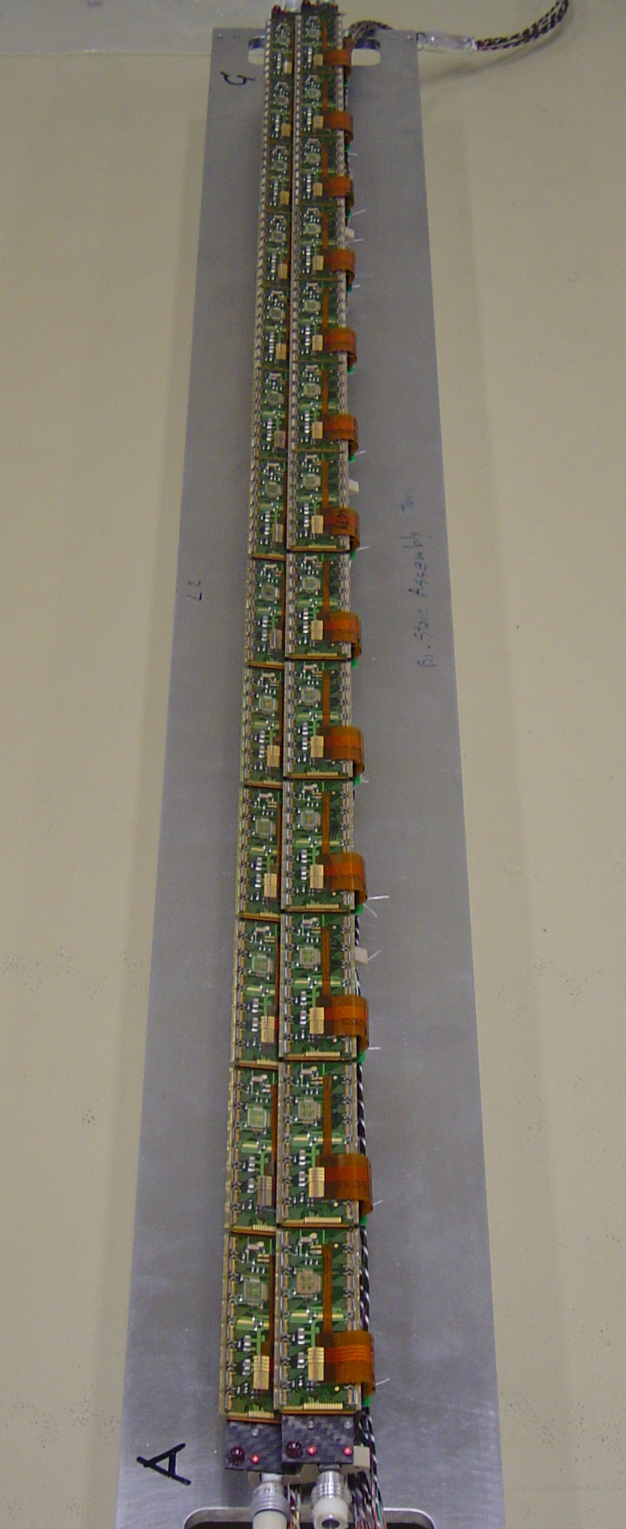
The integration activity begins at CERN with assembling of the Bi-stave. Two staves, loaded respectively with 13 pixel modules, come together in an assembly sharing a single cooling line. Cable bundles that will connect each single module to the correspondence location at PP0 are connected to the module and properly routed along the staves. A rigorous Quality Assurance Plan (QA) has been set up for the Bi-stave assembling to exclude electrical, mechanical failures as well the leaks {Ref 4}. Specifically the leak tightness of the cooling loop has been guaranteed better than 1x10⁻⁷ atm.cc/s.
A systematic failure in the micro-cables for the barrel modules was discovered soon after bi-stave integration and half-shell loading started. This led to additional quality control tests on all existing micro-cables and manufacture of new cables with a revised process. Approximately 50% of the original micro-cables and >95% of the new ones passed the final quality control. To minimize delay, the accepted original cables were used for layer 2, while layers 0 and 1 were assembled with new cables. The disk micro-cable design is different and was not subject to this failure mode. Accidental damage to random micro-cables during handling affected 9 modules. The damage was accessible and could be repaired in 5 cases, and could be bypassed to recover full module operation for 3 of the inaccessible cases, leaving only 1 module lost for operation due to an open sensor bias line. Electrical contact failures were also detected in 7 service panel connections, but the exact point of the fault could not be isolated. These were all bypassed using spare connections or by adding single wires.

Staves, and consequently Bi-staves, have three different flavors. This is due to the repair plan that has been set up to recover from a dangerous corrosion problem that affected the pipes of the first assembled stave [see 7.xx.xx]. One of the repairing scenarios has foreseen to insert a smaller diameter pipe in the corroded one. The consequence is a degradation of the thermal properties with an increase of the temperature of the module. This temperature depends linearly upon the power generated in the module that is also function of the integrated fluence on the module. Since the irradiation decreases with the square of the radius from the interaction point, the benefit of confining the staves with poor thermal properties at the outermost layer becomes evident.

Bi-staves are integrated into the HalfShells starting with the layer 2 and proceeding down to the B-Layer. Picture shows one of two HalfShells with all the bi-staves installed. An electrical test is again performed once a single bi-stave is loaded in order to detect failures along the cable bundles or in the module wire-bonds.
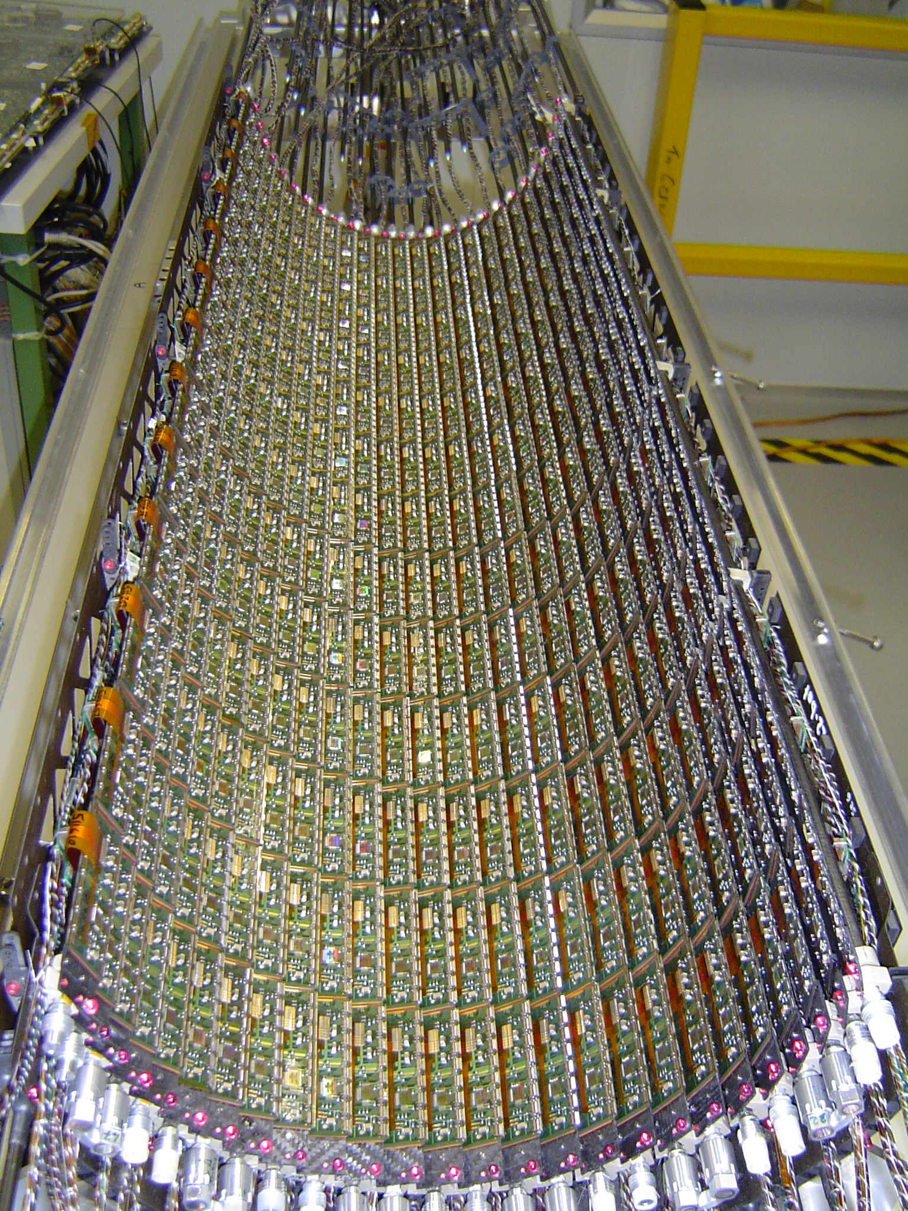
Once the HalfShells were completed they underwent the geometrical survey. The stave reference point provided by two ruby balls glued at the ends of each stave are surveyed with respect to the HalfShell reference points. Since each module has been surveyed during the modules loading respect to the same references, the location of the modules in a HalfShell are known. (picture on the side shows the L2 HalfShell with the ruby balls at the end of the staves). It’s worth to mention that although the modules position is know in Z with the typical accuracy of a CMM (around 10μm) the inaccuracy in Φ and in R is significantly worse. In fact stave can bow in HalfShell during fastening up to 200 μm in Φ on the central support (Z=0). The induced deformation is predictable only in term of deformation “modes” but not in amplitude because module could not be surveyed directly on the HalfShell.

