Proceedings

The President’s Conference on

FIRE
PREVENTION



May 6-8, 1947 . Departmental Auditorium

Washington, D.C.

THE WHITE HOUSE
WASHINGTON

JANUARY 3, 1947.

DEAR GENERAL:

The serious losses in life and property resulting annually from fires cause me deep concern. I am sure that such unnecessary waste can be reduced. The substantial progress made in the science of fire prevention and fire protection in this country during the past forty years convinces me that the means are available for limiting this unnecessary destruction.

Accordingly, I am calling a national conference on fire prevention to be held in Washington within the next few months to bring the ever-present danger from fire to the attention of all our people and to devise additional methods to intensify the work of fire prevention in every community in the Nation.

I would like to have you, as Administrator of the Federal Works Agency, head up this conference and I suggest, as a first step in the program, that you call into consultation in the near future appropriate representatives of the interested involved, both private and public, with a view to laying the ground work and preparing the agenda for the conference.

Very sincerely yours,
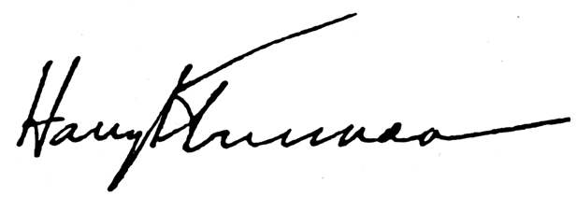

Major General Philip B. Fleming,
Administrator,
Federal Works Agency,
Washington 25, D.C.

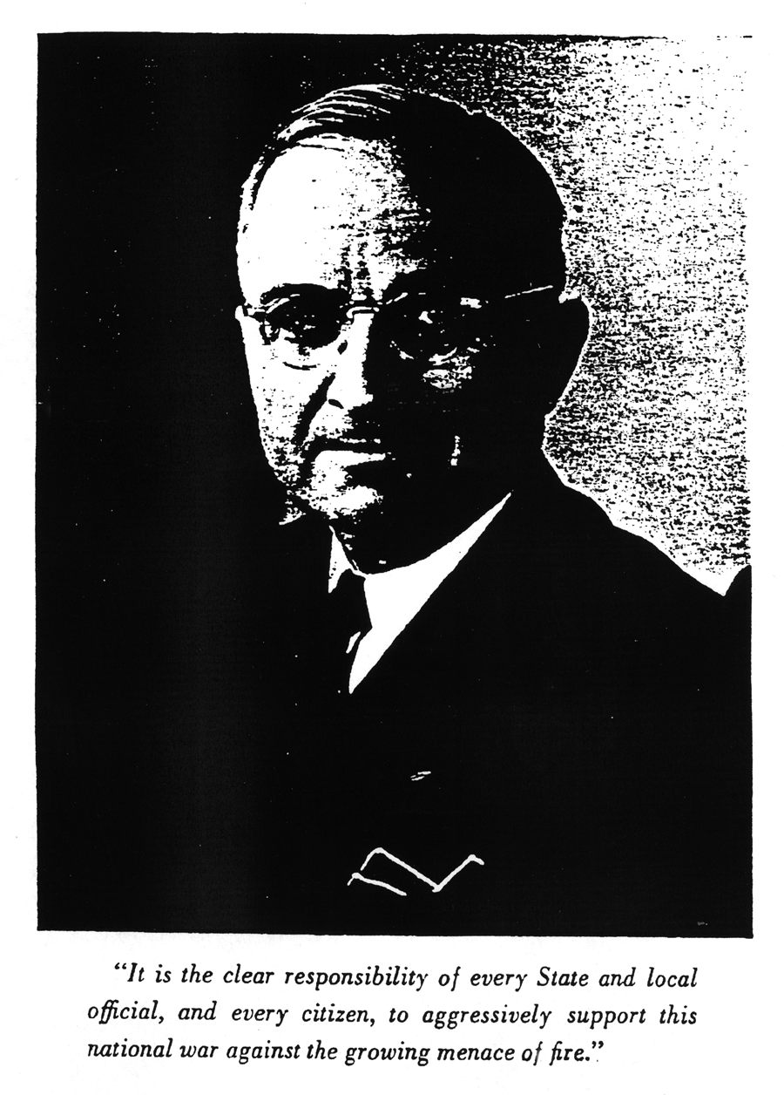
Table of Contents

Tuesday Morning Session, May 6, 1947.
PAGE
Invocation by the Right Reverend Monsignor John J. Russell 1

Address of Welcome by Hon. Russell Young 3

Address by the President of the United States 4

Remarks by the General Chairman 7

Roll Call of States 11

Introduction of Committee Chairmen 12

Wednesday Morning Session, May 7, 1947.

Invocation by the Reverend Fredrick Brown Harris 16

Address by Mr. Arch N. Booth 17

Address by Hon. Robert E. Dinnen 21

Address by Hon. Tom C. Clark 24

Address, “The Schools and Fire Prevention,” by Dr. Frank W. Cyr 27

Address by Dr. E. B. Norton 30

Report of Committee on Fire Prevention Education by Dr. H. C. Byrd 32

Address by Mr. Sherman K. Ives 34

Address by Mr. Percy Bugbee 37

Address, “The Architect and Fire Safety,” by Mr. Walter A. Taylor 39

Report of Committee on Building Construction, Operation, 41
and Protection by Alfred C. Fuller

Wednesday Afternoon Session, May 7, 1947.
PAGE
Address by Mr. Charles A. Delaney 44

Address, “the Firefighter of Today,” by Mr. George J. Richardson 46

Address by Maj. Gen. Harold R. Bull 49

Address by Mr. Lyle F. Watts 52

Report of Committee on the Firefighting Services by Horatio Bond 55

Address, “The Red Cross Role in Fire Prevention,” 57
by Mr. James T. Nicholson
Address, “What an Opportunity,” by Mr. W. E. Mallalieu 60

Address by Mr. O. J. Arnold 63

Report of Committee on Research, Discussion by Mr. S. H. Ingberg 65

Thursday Morning Session, May 8, 1947.

Invocation by Rabbi Norman Gerstenfeld 69

Address, “Enforcement of Fire Prevention Laws,” by Mr. John H. Craig 70

Address by Mr. Herman C. Wilson 72

Address by Hon. George Neuner 74

Report of Committee on Laws and Law Enforcement 76
by Hon. John C. Knox
Address by Mrs. Oswald Bates Lord 78

Report of Committee on Organized Public Support 81
by W. Walter Williams
Cooperation of Tobacco Companies by Howard Welty, Birthday
Greetings to the President of the United States by Leroy Gates 85

Presentation of Action Program by Hon. Louis Johnson 87

Address by Hon. George W. Welsh 88

Address by Hon. Clarence W. Meadows 92
Tuesday Morning Session

May 6, 1947

THE President’s Conference on Fire Prevention convened at 10:30 o’clock at the Departmental Auditorium, Washington, D.C., Maj. Gen. Philip B. Fleming, General Chairman, presiding.

Chairman Fleming. Will the meeting please come to order?

I shall ask the Right Reverend Monsignor John J. Russell, Pastor of St. Patrick’s Church of Washington, to offer the invocation. Monsignor Russell!

Rt. Rev. Monsignor John J. Russell. O Lord God, our Creator, Who gave to mankind the element of fire to afford light and heat on the earth, give us the grace to use this precious gift with care and caution, lest it wreak destruction and cause misery, suffering, and death. Let us remember that this element is spoken of in sacred Scriptures both as a symbol of Thy holiness and justice and also as a symbol of Thy wrath.

O heavenly Father, from Whom comes every good and perfect gift, let us use all Thy gifts according to Thy will so that Thy justice will not require that we suffer from Thy wrath. We beg Thy divine blessing on all who are here gathered on the call of our Chief Executive to consider ways and means to prevent suffering and loss from fire. We beg Thy divine wisdom to direct their deliberations, that their plans and purposes prove fruitful and beneficial to all the people of our nation.

Grant that we who humbly call upon Thy aid may so live as to have a claim upon Thy fatherly care and understanding mercy. Let our claim upon Thy mercy be the fact that we try to live as Thy creatures, observant of Thy laws, obedient to Thy commands, submissive to Thy will.

We ask Thy blessing upon this first session and those that are to follow. In the name of our divine Saviour, Jesus Christ, our Lord. Amen

Chairman Fleming. Thank you, Monsignor Russell.

We benighted citizens of the Nation’s Capital, as you doubtless know, like convicted criminals, lunatics, and imbeciles elsewhere, are denied the right to vote. Our city ordinances are enacted by a city council up on the Hill, which is elected by everybody in the United States but ourselves and governed, very efficiently, I might say, by a Board of Commissioners appointed by the President and confirmed by the Senate.

So, while we have no mayor, we have something just as good in the person of the President of that Board, and I dare say that if, like the rest of you, we could actually vote, the gentleman would be overwhelmingly elected to head the District Government by those of us who are

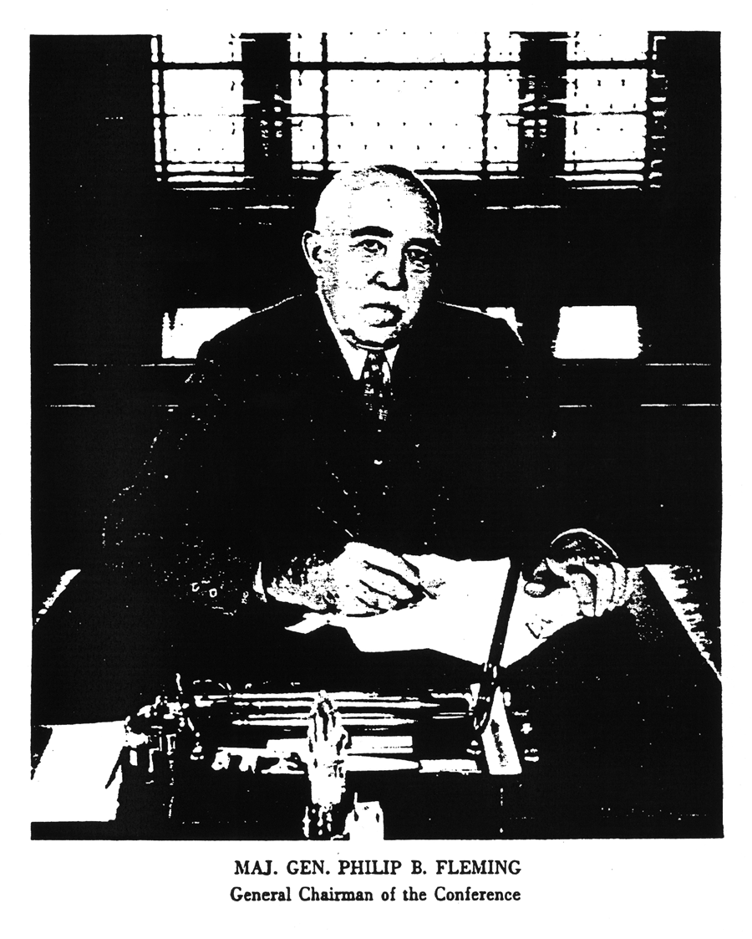

neither crooks, idiots, or imbeciles. It is not any person we object to, but the principle of the thing.

I have the honor to present the Honorable John Russell Young. [Applause.]

Hon. John Russell Young. The way General Fleming worded his introduction sounded like he was opening a political convention here instead of opening a fire conference.

General Fleming and distinguished guests, and ladies and gentlemen, as the President of the Board of District Commissioners, it gives me real honor and pleasure to welcome you to the Capital city. The stated objectives of your Conference are to emphasize to the public the ever-present danger of fire to human life and material resources and to intensify the work of fire safety in every community. To these I subscribe most heartily, and I wish your Conference every success.

We in your Nation’s Capital share with the President of the United States his deep concern over the fact that America’s fire losses are increasing. The death toll is mounting steadily, and according to fire experts, if losses follow the same trend as they did after World War I, the destruction will reach, I am informed, at least $1,000,000,000 a year by 1953.

I might say that we in Washington have spent considerable time amending our fire laws regarding office and public buildings and theaters, and they have not yet been promulgated. They have been studied by citizens’ committees, representative citizens’ organizations, and real estate authorities, as well as our experts in fire safety, the police and fire departments.

For the 12-month period, April 1, 1946, to March 31, 1947, the District of Columbia had a reduction in fire loss of 35.9 percent over the previous 12 months, whereas the country as a whole had approximately a 40 percent increase over the same period. We are very proud of those figures; not only do we feel proud of our own fire department, but we cannot take all the credit, because I really believe that the early fathers of this National Capital had vision enough to give us wide streets and sprinkled around enough reservations throughout the city to give what we call fire breaks and to keep down the size of the buildings. So we think that the physical layout of the city has had a great deal to do with our good luck and good fortune regarding fire losses.

This Conference which our President has called is the first organized national effort to combat the great scourge of fire. We, in Washington, took particular pains to improve conditions following the Boston fire and the recent Atlanta fire, as I imagine all other cities have done. We hope that the lesson learned in those tragedies will serve us well.

Your delegates are experts in their fields. Their experience and background will enable the Conference to proceed with the highest degree of accuracy, and its decisions and recommendations will be forged in the minds of your trained experts. I know that I speak not only for the District of Columbia but for every section of the Nation when I say that it is the fervent prayer of every American citizen that the results of your deliberations and the final answer of your Conference will prove beneficial to our nation in protecting the lives and property of its citizens from the devastation of fire.

Ladies and gentlemen, again, on behalf of the Commissioners of the District of Columbia, I wish you success in your vital undertaking and assure you cooperation and hospitality during your stay in Washington.

So, Mr. Chairman, ladies and gentlemen, it has been a pleasure to have addressed you and welcomed you to our city. [Applause.]

Chairman Fleming. Thank you, Commissioner Young.

The President will be here to speak to us at 11 o’clock. I will ask you to remain seated until then, and I think maybe the Marine Band will give us a little entertainment while we are waiting.

{The Marine Band played an interlude of selection}

Chairman Fleming. Ladies and gentlemen, the President of the United States! [Applause.]

{The President entered and was photographed}

The PRESIDENT. It is a pleasure for me to have the privilege to come over here and discuss with you this morning some things in which I am intensely interested.

The Nation has been shocked by a long series of spectacular fires in the last few years – particularly in the last few months – which have resulted in such great loss of life and such widespread misery. Just the other day, the Texas City disaster drove home anew the lesson that we must find ways and means to combat the ever-present danger of fire and explosion. The great hotel fires of last year again showed that we cannot afford to entrust our citizens’ lives to unsafe buildings.

But these fires which make the headlines are only a small fraction of the total. Thousands of lives are lost annually and tens of thousands of people are injured in the many less spectacular fires which occur hour after hour, day after day, throughout the year.

This Conference brings together for the first time the highest officials of municipalities, States, the Federal Government and national groups interested in fire prevention and in saving lives from fires. We are approaching the fire problem on a truly national basis.

Our first concern is for the lives of our people, especially those of young people. Fire strikes hardest at youth. Two thousand children, on the average, die every year from burns, and thousands of others are scarred and injured for life. This toll must be reduced.

Next in importance is the fact that we as a nation cannot continue to ignore the staggering destruction of goods, natural resources, buildings and other property by fire. During the last 12 months fires destroyed more than $560,000,000 worth of our wealth. The loss for 1947 will be more than three-fourth of a billion dollars unless we can reduce the present fire rate.

No dollar value can ever be put on the irreplaceable things which fire destroys. Who can account the value of a human life destroyed by fire? Who can say what a fire costs when it destroys thousands of tons of food sorely needed here and abroad? What is the value of a house, the burning of which makes a family homeless during this housing shortage? Who can put a dollar value on a burning forest?

The fire loss, in lives and in property, which occurs annually in our forests and rural areas makes up a highly important part of the annual toll. Such destruction of our precious natural resources is of concern to each of us.

Who can say what fire costs the Nation when a single fire in one factory can result in lost jobs and lost wages for hundreds of workmen, reduced savings, and reduced volume of trade throughout a community?

These are some of the tragic consequences of more than 830,000 fires that occur annually in the United States. It is for this Conference to determine the causes of this destruction and map out a program of preventive action. We must use all our experience, knowledge, and organizational facilities to solve our fire problems.

Great advance has been made in the technical methods of prevention and protection. The concerted effort of all our people is needed in order to make effective the known methods of preventing fires and preventing large losses where fire occurs.

A contributing factor to our fire death toll is our legacy of old construction. Also, we have a complexity of building laws and codes in some communities, and too few in others. In many communities, these laws are outdated, and the responsibility for safety from fire is not clearly defined.

We have wide areas in the Nation with inadequate fire protection. Our forests need to be safeguarded against the thousands of fires - most of them set by human carelessness – that sweep over millions of acres annually. Our rural areas must have improved and better coordinated protection.

We also have entered upon a new era of scientific and industrial development, with the accompanying special hazards of new chemicals and industrial processes. Many of these hazards are not yet widely understood. For the protection of our industrial plants, we must see that fire prevention keeps pace with scientific research.

The recent war showed us that we had grave shortages of experienced firefighters both in our armed forces and in our civilian life. The question of using some of the training methods developed during the war and the National Guard facilities for the training of firemen is certainly to be considered if we are to provide our cities and our armed forces with the skilled firemen we need.
I want to pay a tribute to our firemen. Were is not for their bravery and their willingness to sacrifice, our death toll would be much higher and our losses even more appalling than they are today. I hope that this conference will help to produce conditions that will make our firemen’s dangerous work less necessary, and their services, when needed, of even greater effectiveness.

There is also to be considered the matter of personal responsibility for fires. This is not a new problem, for it is recorded in the Book of Exodus more than 3,000 years ago:

“If a fire break out and catch in thorns so the stacks of corn, or the standing corn, or the field, be consumed therewith, he that kindled the fire shall surely make restitution.”

The conference might well consider the strengthening of the present laws having to do with negligence.

These are but a few of the problems that face us. I know that you will try to find practical solutions that will save lives and resources.

Safety from fire should not be a topic for discussion during only one or two weeks of the year. It is definitely a year-round public responsibility. I believe that the highest State and municipal officials must assume greater responsibility for leadership in this field. We in the Federal government can give aid within the framework of existing agencies. But the impetus must come from the States and from every community and every individual in the land.

Your public officials at homes are going to need the expert help which you in attendance at this Conference can give them. And you must provide part of the leadership in your own communities for any public support to be given to your local officials and fire departments.

Just a year ago, I called a similar national conference to consider the shocking toll of highway traffic accidents and to work out an effective program to meet that problem. General Fleming was also Chairman of that Conference. Since then we have seen a reduction in deaths and injuries from traffic accidents that has more than justified all our efforts. We can fight the fire problem in exactly the same way.

I deeply appreciate your acceptance of my invitation to come here. In working out a plan which will reduce the fire menace and cut down the toll of death and destruction, you will be making a most valuable contribution to the welfare of our Nation. You may have my pledge of help, during the period of this Conference, and in the days to come.

I would like to call your attention further to just a few things in which you should be vitally interested. We have an appalling situation in this country, brought about by negligence and carelessness for the most part. There are 23 million people in this country who have been physically injured in some manner, either in automobile wrecks, in fires, in the home, or in other places, and most of these people were unnecessarily injured.

Now, we are trying to start at the source to see if we can’t cut down the immense toll which negligence and accidents take from the citizens of this country. Imagine 23 million people with eyes out, arms off, legs off. It is terrible. We are rehabilitating our soldiers who were injured in the war. We are teaching those without legs how to walk, and we have legs invented that are almost equal to the natural article. Nothing is ever equal to that, but these are almost. They have artificial arms for those men.

But the 23 million are the cares of the local communities. They are the cares of their families. You can help prevent that, you can help cure that awful situation. As the result of the conference on automobile accidents last year, we estimate we have saved 6,000 lives in this past year. It was well worth the effort, but it still isn’t enough. [Applause.]

I sincerely hope that you will earnestly go to work on this other phase, this unnecessary loss of life by fire, and will make a contribution at least equal to the one that was made by the effort to stop automobile accidents. Lots of these things are absolutely unnecessary, in fact most of them are. Most of them are due to carelessness. Most of them are due to the fact that people are ignorant of what to do in an emergency. Let’s teach them. Let’s cure this situation.

With this organization, and with the one we have been working with on the automobile situation, and with others which we intend to call in, I think we can cut that 23 million down, instead of increasing it. I want to see all of these people rehabilitated and given their places back in society. We can do that too, and that is partly up to you.

I am immensely interested in the health and welfare of the people of this country, and you will find that this all fits in a pattern which is covered in the health message which I sent to the Congress last year, and which fits in with these meetings to prevent accidents which we have been having. I appreciate very much, more than I can tell you, your interest and your help in trying to get this awful situation cured. Thank you very much. [Applause.]

{The President left the room.}

Chairman Fleming. Ladies and gentlemen, that was a very inspiring message from our President. I am sure you will all take it to heart.

On Thursday of this week it will have been exactly a year since there assembled in this auditorium some 2,000 men and women representing ever State in the Union, who had been called together by the President of the United States. That gathering was not quite as handsome as this one, but I am sure it was no less zealous. It was an assembly called to devise ways and means to cut down the enormous loss of life in traffic accidents, which at that time was rising sharply.

The most tragic year in the history of motoring was 1941, when the death toll exceeded 37,500. During the war, largely because of gasoline rationing, traffic fatalities declined, but just as soon as gasoline rationing was terminated with the surrender of Japan, the death curve started up again. By the end of 1945 people were being killed at such a rate that it was apparent that the toll of 1941 would be exceeded in 1946 unless heroic steps were taken in time.

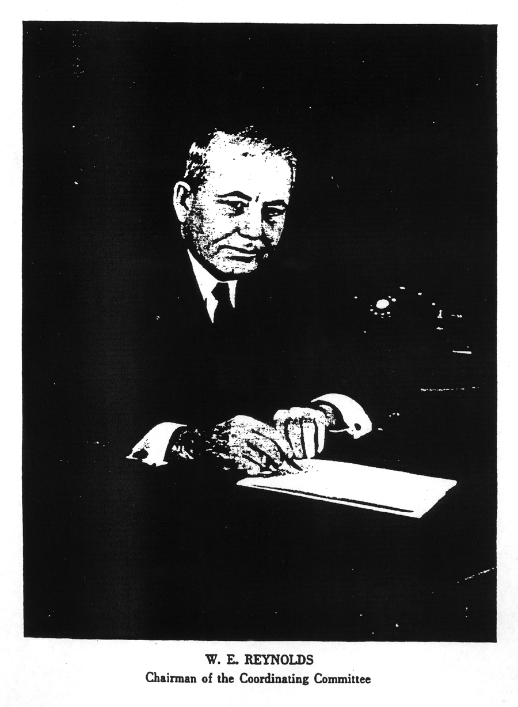

The President was appalled. He realized that there was very little the Federal Government could do to check the loss of life except, perhaps, to provide some needed leadership. The problem, though it has its national aspects, was a local one. The people were being killed in the cities and towns and on the rural roads, and it was obvious that the remedy, if any were possible, would have to be applied in the local communities.

So the President called a Nationwide conference, bringing together the best minds in the highway safety field, to meet just at this time of year at the start of the touring season, when the danger would be greatest.

In advance of the Conference, committees were appointed to consider specific aspects of the problem. For example, there was the problem of the licensing of automobile drivers. These regulations were most diverse, varying from State to State, so that a man denied a license to drive in one State as totally unfit usually had no trouble getting a license in some other State.

There was the problem of traffic laws and regulations, which also were most diverse. Some of them has been adopted back in the horse-and-buggy days and never revised to meet the necessities of an automotive age.

There was also the problem of traffic law enforcement, the problem of education for safety in the schools, the problem of engineering. Many of our highways developed from old Indian trails and will have to be rebuilt to make them capable of moving today’s vastly greater volume of traffic at requisite speeds and do it in safety.

The various committees brought in their recommendations, which were considered by the conference and adopted with some minor modifications. The recommendations were then consolidated into an action program, which each of the delegates took home with a resolution to apply it in his own State and in his home community.

Within a month the effects of the program were beginning to be felt. As one community after another mobilized its police forces, its courts, its schools, its lawmakers, its civic groups, the traffic death toll began to go down all over the country, and when the year ended, six thousand men, women, and children, who would have perished if the fatality rate of the early months had persisted, were still alive. We will do even better this year, as more and more communities put the action program into effect.

But while we were making these very respectable gains with respect to traffic fatalities, deaths by fire, unquestionably the most horrible of all deaths, continued unabated. Last year more than 10,000 persons were killed by fire in the United States, to say nothing of a property loss of more than half a billion dollars. The alarming thing is that these losses have been increasing year by year for more than a decade.

The other evening in a radio broadcast I tried to lift those figures from the realm of cold statistics and drape them with their moving significance. I pointed out that the lives lost by fire in 1946 were 20 times as many as were snuffed out in the Texas City disaster, which stunned the Nation less than a month ago. Statistically, the 1946 fire toll was equivalent to the destruction of such a city as Jamestown, N.Y., and the loss of every man, woman, and child in it, or as great as though an atomic bomb had wiped out a city the size of Shelbyville, Ind.

Or take that $560,000,000 property loss. That is a lot of money. It is enough to build for 56,000 of our war veterans and their families a $10,000 home apiece.

Incidentally, while we worry about the housing shortage, we stand complacently aside while tens of thousands of existing homes go up in smoke every year. It is a sum that would go far toward equalizing educational opportunities for all the children of America. If equally apportioned, it would be enough to give every teacher in the country a $500 raise. It would pay the entire bill for our assistance to Greece and Turkey, with enough left over to feed 1,000,000 hungry people for 2 years. In the first few months this year the loss has been running above even the record-breaking destruction that occurred in the early months of last year.

The results of his Highway Safety Conference were such as to encourage the President to believe that a similar attack on the fire menace would yield corresponding benefits, and he called this Conference into being.

In the attack upon traffic accidents we found that there are three “E’s” that seem to hold the keys to success. They are Education, Enforcement, and Engineering: Education of the motorists and the pedestrians to a point where each will accept the full consequences of his actions; Enforcement of existing traffic rules and regulations without fear or favor; better Engineering of our motor vehicles and of our highways.

We shall, I think, fine the three “E’s” of Education, Enforcement, and Engineering pointing the way to success in the fire prevention field also: Education of the people and especially of the children with respect to the best methods of fire prevention and control, better Enforcement of fire-safety rules and regulations, and better Engineering of our buildings.

In the latter connection we are going to have to review our existing building codes. The only purpose that any building code can serve is to safeguard the public health and safety. Yet existing codes are most diverse, varying among the States from the unnecessarily rigid to the criminally lax. Most of the codes are at least a quarter of a century old, and few have been revised to take account of new materials and construction techniques.

I have no doubt that the Winecoff Hotel in Atlanta conformed to the code requirements at the time it was built. But the procession moved on, and the Winecoff did not.

We have learned a great deal in the last twenty-five years about fire prevention, and all over the country we face the problem of bringing thousands of older buildings – hotels, hospitals, theaters, apartments and rooming houses – up to the standards of safety we now know to be essential if we are not to have more and more Winecoff disasters as time goes on.

The President has given us our instruction, and we know the nature and importance of the job ahead of us. We have assembled here from all parts of the country, and although many of us came as strangers to one another, I am sure that we shall leave here on Thursday as fast friends, linked together in a great humanitarian undertaking.

I wish time permitted me to introduce every one of you to the Conference individually. Since that is manifestly impossible, I am going to de the next best thing; I am going to call the names of the States in alphabetical order, and when the name of your State is called, will you please stand up so that we can get a good look at you and express our appreciation for your presence?

{Chairman Fleming called the roll of the States.}

Chairman Fleming. You will observe that in planning the present Conference we have followed rather closely the same pattern that was used for the President’s Conference on Highway Safety last year. Just as the traffic problem naturally divided itself into separate, but still related, phases of education, engineering, law enforcement, and so on, the fire prevention problem also called for expert study in the fields of law enforcement, building construction, firefighting services, education, research, and organized public support. The various committees that have jurisdiction over these matters have long been at work, and it is our hope that before the Conference ends they will have completed their deliberations and will be ready to report their recommendations to us.

Up here on the platform you see a few of us who happen to be identified with the Federal Government in one way or another, but I hope you will not be misled on that account into thinking that this is a United States Government Conference. In reality it is your Conference, the people’s Conference, and we are here only to be of such assistance as we can in your deliberation.

If fire could be prevented by presidential fiat or by an act of Congress, that would have been done long ago. They can only be prevented by coordinated effort of all the people acting through the various agencies of State and local governments. We realize, therefore, that any program we adopt here will be of little avail unless the people of the country take it to heart and apply it in their own communities. When we have done our work, we shall have to turn to our legislators, city councilmen, mayors, police and fire chiefs, and civic leaders to carry on from there.

We are using about the same pattern for this Conference as we did for last year’s, because we have found it convenient and expeditious and also, I think, because the problem of preventing automobile accidents and the problem of preventing fires have much in common. Both fire and traffic accidents are due in the first analysis either to human carelessness or to ignorance of the means by which they may be prevented; both involve the matter of effective legislation and intensive law enforcement; both must be combated by education, and neither can be eliminated without broad public support.

The chairmen of our committee are the real mainsprings of the Conference; it is they who make it tick.

The Committee on Laws and Law Enforcement has been exploring the question of State laws that will provide minimum standards for fire safety and which will facilitate the adoption of municipal ordinances to augment such minimum standards. The legality of so-called retroactive features of laws and ordinances pertaining to fire safety has also been carefully considered. In other words, how can we require the owner of a building, which conformed to the building code in existence at the time it was erected, make such alterations as are necessary to meet the higher code requirements of today.

The chairman of this important committee is a native of Pennsylvania, who was graduated from Waynesburg College in 1902, studied law at the University of Pennsylvania and Columbia University. He served as assistant United States District Attorney for the Southern District of New York from 1913 to 1918 and has been Judge of the United States District Court of the Southern District of New York since 1918.

He is widely known in the legal profession as a writer and lecturer on legal ethics and medical jurisprudence, and is the author of; “A Judge Comes of Age” and “Order in the Court.” The Honorable John Clark Cox. [Applause.]

{Judge Knox stood and acknowledged the introduction.}

Chairman Fleming. When I was a boy, I was taught, both at home and in school, that it can be very dangerous to play with fire, and I think that in a great many schools today some instructions is still given in fire prevention with more or less regularity. I do not know how widespread such instructions is or how effective it is. It would seem that if it were as effective over the last 25 or 30 years as it ought to have been, we would not today be witnessing the roasting to a crisp of some 10,000 of our fellow citizens every year.

In any event, the exploration of the facilities in our schools in our schools and colleges for teaching fire prevention is the province of your Committee on Fire Prevention Education.

The chairman of the Committee is a native Free Stater, a graduate of the University of Maryland, an outstanding athlete, and a football coach of considerable attainments, as I discovered when I was at West Point. He has been a professor of history, holds honorary degrees from Washington College, Dickinson College, and Western Maryland College. He is a member of various learned societies, too numerous to mention, and of various fraternities. Since 1936 he has been president of the University of Maryland.

Dr. Harry Clifton Byrd. [Applause.]

Appropriately enough, the chairman of the Committee on the Firefighting Services is a fighter himself from ’way back. A native of Buffalo, a lawyer by profession, once United States District Attorney for the Western District of New York, candidate for Governor of New York in 1932, former Assistant Attorney General of the United States, Chief of Staff of the Twenty-seventh Division in the First World War, he holds the Congressional Medal of Honor for valorous conduct in action, the Distinguished Service Medal, the Decoration of the Legion of Honor, and the Croix de Guerre with palm and silver star. In the Second World War he served as Director of the Office of Strategic Services, whose contribution to victory is one of the most amazing and stirring chapters in our military annals.
Maj. Gen. William Joseph Donovan, unfortunately cannot be here this morning. He was here yesterday but was called unexpectedly to Rochester, but will be back later this afternoon and certainly will be here for tomorrow’s sessions. [Applause.]

Research has an important part to play in any attack upon the fire menace. We need research not only into the fire-resistant qualities of various materials and into the safest possible construction techniques, but we also need research into the problem of why human beings behave as they so often do when a fire breaks out. We are all familiar with the story of the absent-minded professor who, when his house caught fire, threw his wife into the wastepaper basket and saved a bottle of ink instead.

We shall never know how many people dashed themselves to death on the pavement below because of the sudden wave of hysteria that swept through the Winecoff Hotel with even greater speed than the flames themselves, but we know of a number who owe their lives to the fact that they kept their heads and used the precautions dictated by ordinary common sense.

The chairman of our Committee on Research is an outstanding banker, and if this fire prevention problem has been researched with as much cautious care as bankers use in researching your resources when you go to apply for a loan, we may be sure that the job has been thoroughly done. The fact that he comes from my own native State of Iowa is not the least of his recommendations.

Born at Dallas Center, Iowa, he is a graduate of Iowa State College; former president of Iowa-Des Moines National Bank & Trust Co.; at present president of Brenton Brothers, Inc.; a director of eight Iowa banks; president, treasurer, and director of Wood Brothers Thresher Co.; and trustee of Grinnell College.

Mr. Woodward Harold Brenton. [Applause.]

Our Committee on Building Construction, Operation and Protection was assigned a task with which we in the Federal Works Agency have had some experience. Our Public Building Administration has constructed and it maintains and operates thousands of buildings for the United States Government, so I think we can claim to be the world’s biggest landlord.

I might say in passing that we have not had a really destructive fire in any of our Government buildings within my recollection, nor has a single life been lost due to fire for many years. We profess to be good housekeepers. We do not clutter up our basements with waste paper, and we do not leave oil-soaked rags lying around in the furnace room. But while we very modestly think we are pretty good, we know that we shall pick up some useful ideas from the Committee on Building Operation, Construction, and Protection.

The chairman of the Committee is known to all of us by name, and our wives and daughters have made the pleasant acquaintance of his representatives at our front doors from time to time, and it has been a mutually profitable acquaintanceship, I understand.

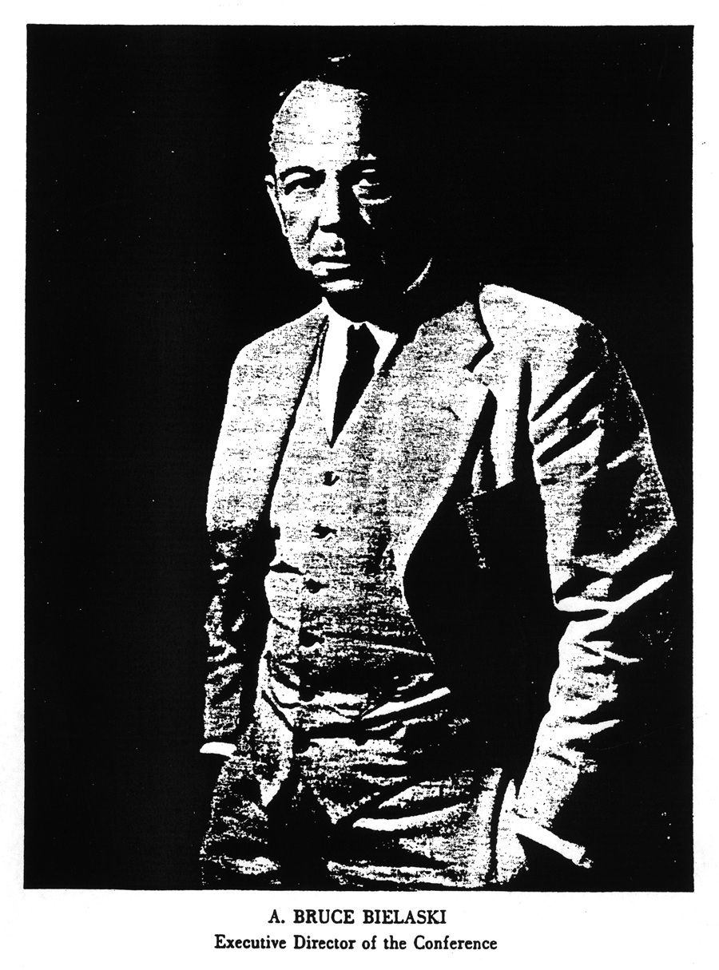

He was born in Kings County, Nova Scotia, and has been a citizen of the United States since 1918. He established the Fuller Brush Co. at Somerville, Mass., in 1906 and is now its president and chairman of the board. He is a director of the National Better Business Bureau, a member of the board of trustees of the Committee on Economic Development, and a member of the American Society of Sales Executives.

Mr. Alfred Carl Fuller. [Applause.]

I have already emphasized the importance of public support for our activities. I believe it is true to say that any success we may attain in cutting down the national fire loss will be due to the kind of support we get from the press, the radio, from civic groups, and other representatives of the public. A poor plan of fire prevention might succeed if it were given adequate public support; even a perfect plan will fail if the public is not solidly behind it.

The Chairman of our Committee on Organized public Support is Mr. W. Walter Williams. He is en route to Washington and will arrive tomorrow morning. He regrets, as I am sure we all do, that he was not able to be here for this opening session. Mr. Williams is known throughout the West as “the first citizen of the State of Washington.”

He is a graduate of the University of Washington and is president of Continental, Inc., of Seattle. That is probably important, but it is rather in the field of public service that he has won outstanding distinction.

Mr. Williams is a member of the board of trustees of the Committee on Economic Development, has been president of the Seattle Chamber of Commerce and of the Rotary Club, was chairman of the Washington State Defense Council, headed the Washington State Branch of the National Foundation for Infantile Paralysis, was president of the Washington State War Fund Organization, and is a past president of the Mortgage Bankers Association of America.

Now, Mr. Bielaski, I believe you have a couple of announcements to make.

{Announcements.}

Chairman Fleming. Thank you, Mr. Bielaski.

The Conference stands adjourned, then, until 10 o’clock tomorrow morning in this room.

{The Conference adjourned at 11:45 A.M.}

Wednesday Morning Session

May 7, 1947

THE Conference reconvened at 10:05 A.M., Chairman Fleming presiding.

Chairman Fleming. The Conference will please come to order. I will ask the Reverend Fredrick Brown Harris, pastor of the Foundry Methodist Episcopal Church of Washington, to lead us in prayer.

The Reverend Fredrick Brown Harris. Our Father, God, Who hath made and preserved us a Nation, our fathers trusted in Thee and were not confounded; in Thee we trust. Thou hast taught us to love truth and beauty and goodness. May Thy truth make us free, free from littleness and pettiness and from pride and prejudice and from all the ugly sins of disposition. Lift us, we pray Thee, above the modern storm of material things into the holiness of Thy beauty so that even the common task and the trifling round may be edged with crimson and gold. Lead us in the paths of righteousness for Thy name’s sake.

Enrich us, we pray Thee, with those durable satisfactions of life so that the multiplying years many not find us bankrupt in those things that matter most, the golden currency of faith and hope and love. And in these crucial and creative days help us, we pray Thee, to give the best that is in us against the wrong that needs resistance and for the rights that need assistance and for the future in the distance and the good that we may do. In Thy name we ask it. Amen.

Chairman Fleming. Thank you, Dr. Harris.

We have a rather crowded program this morning, and there are a good many gentlemen who have much to contribute to our deliberations and from whom we wish to hear. I shall ask, therefore, that our speakers limit themselves to about 10 minutes. I am sure that will be easy for them, for they are all busy men, who are accustomed to make their words count.

I believe there is a kind of truism, among the clergy anyway, that few souls are saved after the first fifteen minutes of exhortation. There is an old story about Mark Twain, who for the first 5 minutes of a sermon was so powerfully moved that he decided to put a $5 bill on the collection plate. After the first 15 minutes he began to feel that perhaps a $1 contribution would be sufficient. After 20 minutes he had cut down the size of his offering to a half dollar, and when the minister had spoken 45 minutes and the collection plate came around, instead of putting in his half dollar, Mark took out a dime. [Laughter.]

We are not going to pass any collection plate here, but we will appreciate brevity.

The Chamber of Commerce of the United States has a vital interest in fire prevention. Fire is one of the greatest potential enemies of any business enterprise. I am told that more than 50 percent of any business concerns that suffer a fire loss of $1,000 or more are entirely out of business in a year. Man-hour loss because of a fire is a terrific drain upon production, and in these days we very badly need production.

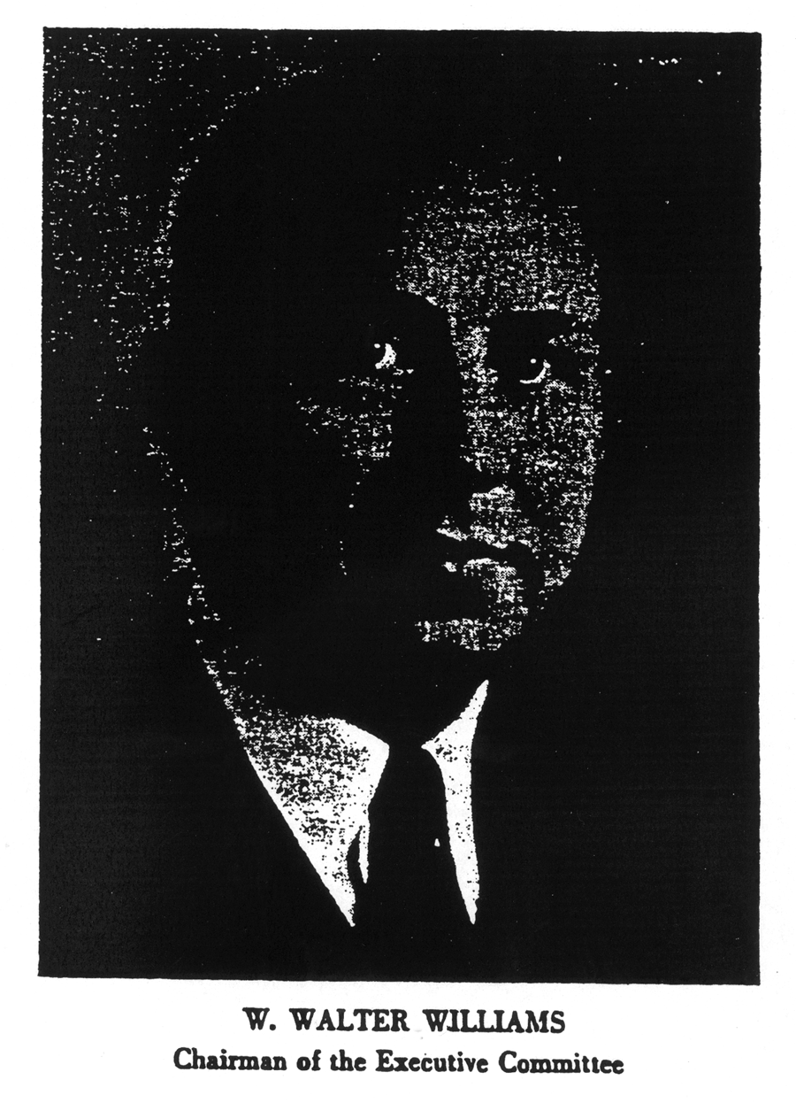

I have the honor to introduce Mr. Arch N. Booth, manager of the Chamber of Commerce of the United States. Mr. Booth is a native of Wichita, Kans., and has been active in the Chamber of Commerce work for 17 years.

Mr. Booth. [Applause.]

Mr. Arch N. Booth. General Fleming, ladies and gentlemen, what can we say this morning to rededicate ourselves to this important responsibility and to stimulate ourselves to greater vigilance and better efforts in every community in America.
Perhaps I could win your interest and come to the crux of the subject with a picture. The “Picture of the Week” in last week’s Life Magazine dramatizes the wretched story of human carelessness and of preventable fires. It was a picture of what was left of the luxurious French liner, Normandie. Standing at the foot of West Forty-sixth Street in New York – one of the largest and most palatial ships ever built flounders in the mud of the North River. The wreckage has stood there since that grievous day 5 years ago when this great ship became the victim of one man’s careless disregard for elementary fire hazards.

Today the Normandie’s insides are bared as wreckers hack her to pieces for scrap. A life span of almost inestimable value was brought to a quick and tragic end by a man with a blowtorch. A $55,000,000 loss is represented in this great hulk – a loss made inestimably more costly because it deprived this Nation of troop transportation facilities throughout the war, and because of the countless hundreds of thousands of man hours of labor diverted from critical war jobs, wasted, trying to salvage and rehabilitate her. All caused by the astounding carelessness of one man using an acetylene torch in the presence of inflammables after he had temporarily discarded an asbestos protective curtain.

The story of the Normandie is a tragedy compounded out of sheer human perversity. It portrays graphically the problem that we have met to reduce.

Man’s early discovery that fire generated by a lightning bolt could be used for human comfort started the human race on its way to civilized living. Man soon discovered, too, that fire has its destructive as well as its constructive uses. We are here today to talk about means to checkmate this modern Moloch which devours our people and devastates our property.

For more than 25 years the Chamber of Commerce of the United States has taken an active part in promoting fire prevention in the cities, towns, and countryside of America. Our meeting today had its predecessor 25 years ago. The forerunner of this conference which you are here attending was the decision of the National Conference of Governors at that time to enlist the support of local business leaders in a Nationwide fire prevention effort.

Do you remember the situation at war time? Many of you in this audience will recall that following the close of World War I, fire losses throughout the country were mounting rapidly. The rise was quite comparable to that which has taken place in the last several years, and by 1922 it had passed the $500,000,000 mark. The governors of the various States, the Mayors, the State Fire Marshals, the Fire Chiefs, and other State and City Officials were alarmed. What could be done about it?

The Conference of Governors studied preventive measures, but in all their plans two basic weaknesses stood out. First, was the rapid turnover in the official life of public officials. Second, was the difficulty of obtaining general public support for the needed far-reaching measures, such as the amendments to building codes, the financing on increased firefighting facilities, the extension of fire prevention education, and other similar projects.

After careful study and consideration of what could be done, the Governors’ Conference asked the President of the United States Chamber of Commerce to call a meeting of all national organizations which had a direct interest in fire prevention work and were willing to join with businessmen in implementing a program. The national chamber was asked to try to persuade every local chamber of commerce to set up a permanent fire prevention committee to carry out a year-around campaign to reduce fire losses.

So a new organization was set up. Thirty-six national organizations joined with the national chamber in forming the National Fire Waste Council.

The national chamber does not endeavor to originate technical knowledge or to establish standards of fire safety. Those functions are supplied by its cooperating organizations which are joined with it the National Fire Waste Council. The chamber’s job is an organizing, stimulating job to put this vast store of technical information into use.

The businessmen’s organization in each community is the local chamber of commerce. In the local chambers throughout the country the businessmen concentrate their interest in the broad projects for the good of the community. Fire prevention is an important one of these. More than 2,100 local chambers of commerce are banded together in the Chamber of Commerce of the United States. It was to these local chambers, therefore, that the national chamber turned in 1922 to put into effect plans started by the Governors’ Conference.

Twenty-five years is a long time in a rapidly growing country. Let’s see what’s happened during that time: First of all, the population of the United States grew from 109,000,000 to 142,656,000.

Secondly, the number of cities having more than 50,000 population grew from 144 to well over 200.

Third, the cities having more than 100,000 population grew from 68 to well over 100.

The Census figures for 1947 are not available. During that period the number of local chambers in the local membership of the United States Chamber more than doubled. This is only a bird’s eye view of what has happened but it illustrates how the problem of fire prevention has grown as the country has grown.

Fire prevention is not a theoretical idea. On the contrary, it is intensely practical. The experience of community after community demonstrates that the application of certain well-established techniques will sharply reduce the number and severity of fires.

The cooperation of municipal authorities, particularly fire department officials, is, of course, a prime requisite. But in my experience that has been the easiest part of the job. There are good public officials and bad ones in this country. The good ones are cooperative, responsible, dependable, and easy to work with because of their deep sense of public responsibility. There have been some woefully bad examples of the handling of public responsibilities with respect to the preventing of fires. There is only one way to handle public officials who are faithless to their trust; namely – get rid of them, and rapidly.

More then 1,300 of these local chambers of commerce have fire prevention committees and are carrying out year-around fire prevention programs. As a further stimulant, as well as to encourage and reward meritorious effort on the part of the local chamber committees, the National Fire Waste Council conducts an Annual Inter-chamber Fire Waste Contest.

Only last week at the annual meeting of the United States Chamber, awards were made to the winners in last year’s contest. The winners were Chicago, Cincinnati; Tulsa, Okla.; Newton, Mass.; Mansfield, Ohio; and Beatrice, Nebr. The grand award for the best all-year-around local fire prevention program put on by any city was won by Mansfield, Ohio.

I would like to point out that Mansfield, Ohio, reduced its fire losses from $4 for each resident to about 80 cents per capita. This reduction was made by businessmen and city officials working together in the chamber of commerce.

The improvement of building codes and their administration is one fire prevention field in which the national chamber has been active. The control of building construction to protect the public safety is traditionally a local function. It is amazing how many different paths have been followed by municipal officials in attempting to reach a common goal. A building code is a complex instrument, and the amount of time and expense involved in revising it has a distinct tendency to discourage its frequent modernization. Efforts to promote greater uniformity and flexibility among building codes have been carried on for many years. Progress has been made, but much still remains to be done.

Last November the national chamber was host to a meeting of the Construction Industry Advisory Council made up of over 100 national trade and professional organizations with a direct interest in construction. The discussion at the meeting disclosed that any attempt to evolve a single model code applicable and acceptable to all parts of the country is difficult.

Nevertheless, we believe that the effort to bring about more uniformity will get results, and the national chamber now has a continuing committee working along these lines.

I have given you something of the background, objectives, and methods of operation of the national chamber’s fire prevention activities. After 25 years in this work the results in individual cities, where a conscientious effort has been put forth, have been most encouraging. It proves to us quite conclusively that where public interest is aroused and where a definite program is carried out under competent leadership and backed up by broad public support, the number of fires can be reduced.

We in the Chamber of Commerce of the United States are heartened by the interest which the President of the United States has shown in this critical national problem. We were glad to see him call this national conference with its committees to review again our standards of fire protection and fire prevention and the machinery through which they are being made effective. It is my understanding that this conference is not to create any new organization or to try to bring the existing ones under control of the Federal Government, but rather to assist them to get better results.

The national chamber and the National Fire Waste Council will continue, in fact will give renewed impetus to their efforts in this direction. I want to assure you of our deep interest and our very sympathetic cooperation. Fires, like certain diseases that plague the human race, can never be entirely prevented. But that does not mean that we are to accept them with complacency. We must fight them as Churchill said England would fight the dictator enemies – wherever they appear and as long as they persist. Thanks you. [Applause.]

Chairman Fleming. That you, Mr. Booth.

Chairman Fleming. Yesterday, when I was calling the roll, I neglected to call our neighbor from the North. We have a delegation here from Canada headed by Mr. Claremont, who is the Fire Commissioner of the Dominion of Canada. I am going to ask, if they are here, if they will please arise. [Applause.]

{The delegation from Canada stood.}

Chairman Fleming. A wise man takes out insurance on his home or business, but only a foolish man would boast that such a policy alone had completely protected him against fire. There is no sure protection against fire, except to see that fire does not start in the first place. For most of us fire prevention is something that we only occasionally think about, but I am sure it must be uppermost in the minds of our State Insurance Commissioners at all times.

I have the honor to present the Honorable Robert E. Dineen, president of the National Association of Insurance Commissioners. Mr. Dineen. [Applause.]

Hon. Robert E. Dineen. General Fleming and ladies and gentlemen, as the representative at this Conference of the National Association of Insurance Commissioners, I should like to tell you something about the interest which the members of our association have in fire prevention.

In our official contacts with the public the after effects of fire are brought to our notice in compelling ways. The loss of life and human suffering which are so often present make demands upon our life, accident, and workmen’s compensation insurance companies. We are made aware of the further loss which the public sustains by fire directly through the waste of its wealth and indirectly through loss of services which the destroyed property has rendered to the community.

In our official capacity as supervisors of insurance in our respective States many of us are required by statute to pass upon the rates charged for fire insurance. We do so, of course, as the representative of the public, and we must measure fire insurance rates against standards established by law. The standards of the individual States are essentially the same in intent but vary in form.

In my own State of New York the rates may not be inadequate, excessive, unfairly discriminatory, or otherwise unreasonable. This responsibility makes us, as administrators, keenly aware of the steadily increasing loss from fire which must be spread over all policyholders. I wonder whether policyholders are equally aware that every loss by fire inevitably is reflected in the rate structure, increased by the expense required to transact the fire insurance business.

The most graphic description of insurance is that it spreads the losses of the few among the many. Fire insurance companies are not equipped, as so many think, with magical power to absorb the losses of others. Common sense tells us that they are simply a means by which private enterprise, by paying a premium, is relieved of the individual risk of economic destruction by fire. That premium represents the policyholder’s share of the aggregate fire loss and the cost of carrying on the business of insurance. Just as surely as every loss tends to raise the cost of fire insurance, every fire prevented tends to reduce the cost.

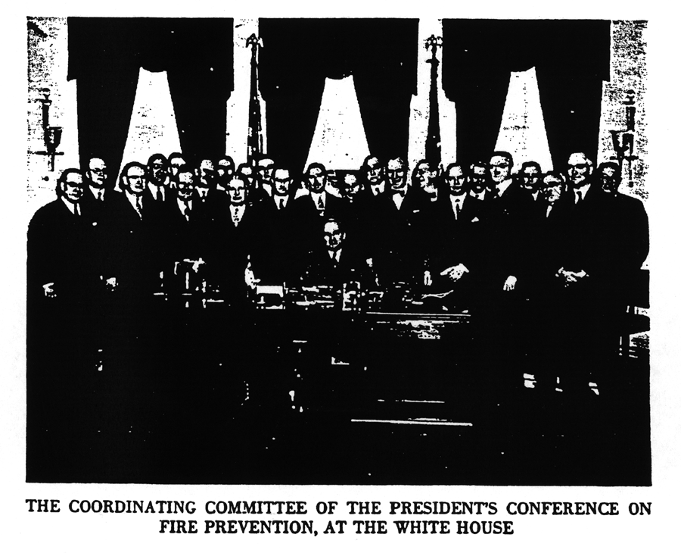

The logic of this statement is deeply impressed upon Insurance Commissioners, who must see that justice is served in distributing losses among insurers. It must be equally impressed upon the insured, who pays the bill and will most benefit from loss prevention.

The opportunity to save money on fire insurance premiums by taking steps to prevent or minimize fire losses has long been directly extended to industry. Practically all business properties are rated according to the particular hazards of the operations performed, the construction of the building, its exposure to other structures, the quality of house keeping in the plant, and other factors which increase or reduce the hazard.

Insurance agents and brokers in cooperation with their policyholders have for scores of years made great efforts to improve the physical characteristics of their risks, recognizing that in so doing they were making direct savings in insurance premiums while reducing the possibility of a destructive fire.

The widespread installation of automatic sprinkler systems is an illustration of an improvement which has come about, it seems, as much because of the sizable savings in insurance premiums as through recognition of its effectiveness in preventing small fires from becoming big ones.

The granting of an economic reward for fire prevention measures and good experience is today as implicit in the regulation of fire insurance rates as it is in rate making. This reward cannot be achieved by horizontal rate increases or decreases.

Over 30 years ago the late Mr. Justice Brandies in a railroad rate case, commenting on a horizontal increase therein sought, described the method of revising rates horizontally as “unsound, largely illegal, and undesirable.” Speaking for the New York Insurance Department, it is our philosophy that rate structures should be responsive, flexible, and geared to the extent possible to the classified loss experience. There is general acceptance of this principle, I believe, among State insurance departments.

The horizontal rate change does not and cannot do justice to the individual loss experience of the separate classes. We know that as a rule rate levels follow broad general trends, but the suggestion that all classes rise and fall comparably is unfounded. Tying the rates directly to the losses serves as a continuing reminder to the public that they pay the bill.

The system makes certain demands on the fire insurance industry in the keeping of detailed statistical records and in the periodic readjustment of rate manuals. The industry has willingly undertaken these tasks in the interest of placing a proper share of the load on each class.

It should be noted that the important classification of occupancy hazards on which fire insurance loss statistics are based has been completely revised within the last year as a result of parallel studies by the National Association of Insurance Commissioners and the industry. There are projects under way with the purpose, in part, of effecting a further improvement of rate structures, including the establishment of uniform accounting classifications of expenses, improvements of the statement form, and a reconsideration of the formula for determining underwriting profit.

Many States have already had extensive experience in the supervision of fire insurance rates, and the impetus given to the enactment of rate regulatory bills for the last two years will add to the already large number of Insurance Commissioners who have this responsibility. Congress itself has taken action in this direction in connection with its ward in the District of Columbia, having enacted in 1944 Public Law 327 of the Seventy-eight Congress, which calls for the regulation of fire insurance and related rates in the District of Columbia.

The public is entitled to the most scientific approach to the spreading of fire insurance costs that can be devised. It continues to be the function of Insurance Commissioners to represent the public in rating matters and to be moved only by the highest considerations of equity and fair dealing. It is my sincere hope that the painstaking effort put into this Conference by those who have planned and participated in it will stimulate the process of education by which the public is informed as to the rewards in lives and money saved which will flow from fire prevention.

The value of impressing upon the public the benefit of fire prevention has long been understood by the fire insurance industry. The principle has been accepted by our legislatures in the enactment of wise rate-regulatory laws which make possible the rewarding of loss prevention and by the States in their administration of these laws. It is in the continuation and development of our educational efforts, I believe, that the public will best be served, and this Conference should contribute notably to that endeavor. Thank you. [Applause.]

Chairman Fleming. Thank you, Mr. Dineen. Ladies and gentlemen, it is my privilege to present the Honorable, the Attorney General of the United States. [Applause.]

Hon. Tom C. Clark. General Fleming, ladies and gentlemen, I do not know whether I was introduced or not. I just had a meeting with the Commissioner here. He and I are old friends, and I had not seen him for some time.

When I started over here this morning, I was told a very fine series of speeches had been prepared for me and for you by my office. I looked over the front page of one and it started out about Mrs. O’Leary’s cow. [Laughter.]

Bruce Bielaski, who by the way is a fraternity brother of mine, is here and I notice another fraternity brother, in fact, he is the vice president of my college fraternity. So it is sort of old home week here for me today.

In one speech the writer mentioned Mrs. O’Leary’s cow being responsible for the Chicago fire. It was prepared by a graduate from the University of Chicago. As I read it a little further, I though perhaps we had made quite an advancement since Mrs. O’Leary’s day, but we have not progressed too much with reference to fire prevention. We have not held enough conferences and meetings; therefore the national spotlight has not been trained on fire prevention as it has on health and other safety measures.

Then there is another speech that was prepared by a Californian, and he started out with the San Francisco fire. I suppose that if I had a writer from Texas, he would have started with the Texas catastrophe last month.

But after chatting with Bruce and seeing Brother Brenton here and hearing Mr. Dineen, I preferred to talk with you informally this morning. If any of you want to read these speeches, come up after the meeting and I will leave them here with Bruce. [Laughter.] I will assure you that they are pretty dry. I read one of them while riding over in the car.

Seriously, I think that the President in calling the first National Conference on Fire Prevention has rendered a great service to our country. We have much talk with reference to the holocaust of war. We hear about World War I, and we hear about World War II, but we do not hear so much about the battles of the fire and smoke and of the catastrophes that strike us every day in these United States.
Oh, we read about them possibly in the local newspaper. If a disaster reaches such proportions as the one that hit Texas City last month, then, we read about it throughout the United States. But we never think of the 10,000 souls who lost their lives last year by reason of this battle, although we think very often of the Battle of the Bulge, or of Guadalcanal, and we think of the other battles around the world. We think not enough of the battles of the firemen and the others who have done all they can and are doing all they can each day trying to prevent this enormous loss of life occurring in America by reason of the negligence of its citizens.

We hear little of those who are maimed or are injured in fires. The reason is that we have never given the problem our attention on a national basis. For example, one drives down the street and has had a drink or two and he is a little tipsy – nearly every State in the United States has a law that he may be prosecuted under, not only for driving while intoxicated, but if he were to hit someone and it would result in the latter’s death, he may be prosecuted for negligent homicide.

Under the Federal Fugitive Felon Act anyone charged with the crime of arson within a State would not be subject to that act, as that particular crime is not mentioned or spelled out in that law. As to whether it should be spelled out, is a matter for the Congress to decide. I think that you ladies and gentlemen who are most familiar with this subject and who have evidenced such interest in it by coming here should give this your very serious consideration.

I well remember, when I was civil District Attorney in Dallas, Tex., I though a very fine plan to prevent fires was inaugurated there. An Assistant District Attorney was assigned to the fire

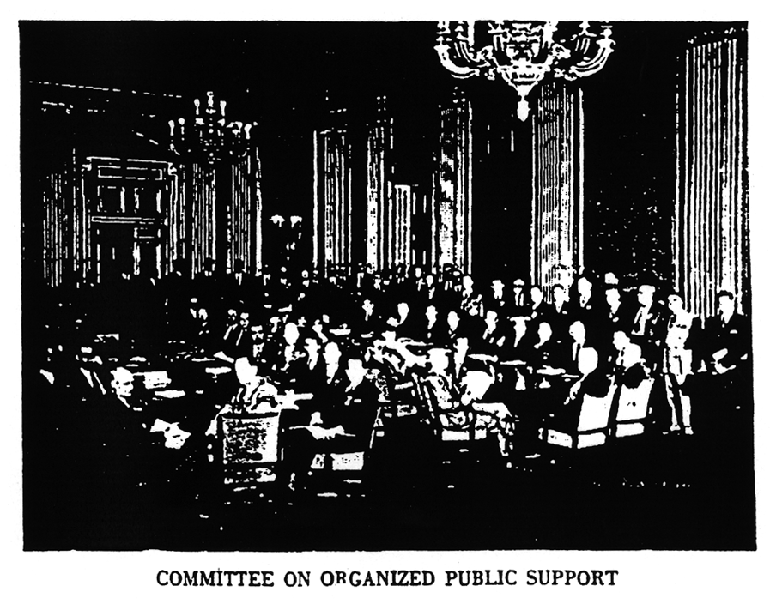
department. He was a young, energetic, unmarried man, and he lived at the central fire station. Whenever an alarm sounded, Owen George was very often on the fire truck going out, and he was one of the first to arrive at the scene of the fire. He was able in the case of arson to see personally what the condition of those burned premises were. He was able, perhaps, to contact someone who might have been connected with the fire, or contact witnesses who lived in an adjoining building or who were passing by at the time.

We found that through Owen George’s activities in Dallas, arson was practically obliterated in the county. The reason was that he was there on the spot almost when such an offense was committed, and by piecing together the evidence he was able to secure convictions. Potential arsonists feared the law.

Perhaps that method is used in other sections of the country. If not, I think that it would serve as a very fine practice throughout the United States, particularly in the larger cities, because you will find that if you have someone who really is on the job with reference to this type of crime, you can bring those to justice who violate that law. There is no better way tp prevent such operations than through strict enforcement of the law.

As you well know, it is difficult to win an arson case. It is hard to win it because most of the evidence is burned up. But if you had someone there on the job who had that specific task to perform, I think you would find that it would be most helpful.

As Attorney General, I think that you should also turn toward securing stricter laws with reference to fires – laws that may deal with those who are negligent in causing fires, because most fires, I am sure, are caused by the negligence of some person. If you could devote your attention to educational campaigns to point out the enormous loss that is occasioned by reason of fires, it would be most helpful.

I am told that every man, woman, and child in the United States lost $4 last year by reason of damages in fires. In December every man, woman, and child lost 40 cents in that month by reason of fires. I am sure that last month it must have been heavier than that by reason of the unfortunate catastrophe in Texas City.

If we could avert these disasters, it would not only be a great saving in money, but it would be a great saving in lives and a great saving in the physical handicaps that follow. And so this morning I wish to concentrate on three things:

One. Education: If you could educate the public, educate the children in the schools – there is no better place in all America to focus the attention on this problem than in the school systems of America.

Two. The tightening up of State and local laws. Fire prevention is a community problem. If you could, through the Council of State Governments, bring about a strengthening of State laws and municipal ordinances with reference to fire prevention, it would help immensely.

Three. Give study to that aid the Federal Government might render by reason of the Fugitive Felon law or any other Federal statute.

Let me say that the office of the Attorney General stands ready to assist you in any way possible. Of course, we handle only Federal laws. However, we would be happy to talk with your representatives at any time with a view to trying to help in this great undertaking started here yesterday by the President of the United States.

Let me say that I am glad to be here to lend my support to this very worthy cause. I wish you well, and I do hope that if I can serve, or if the Department of Justice can serve, you will call upon me without any hesitation. Bless your hearts and goodbye. [Applause.]

Chairman Fleming. We are greatly indebted, I am sure, to the Attorney General for that inspiring talk, and I think we are all glad that he threw away those two speeches and made his own.

A particularly tragic aspect of our staggering national fire loss is the large number of persons burned to death in rural areas, especially the children who have died in flames. Rural schools present a particularly difficult problem. They are usually situated beyond the reach of the organized firefighting forces, and all too many of them are structurally so unsafe as to be a menace in themselves.

Our next speaker is a native of Nebraska and has been a county school superintendent; now professor of education at Teachers College, Columbia University, he is internationally recognized as authority on rural education.

Ladies and gentlemen, Dr. Frank W. Cyr. [Applause.]

Dr. Frank W. Cyr. General Fleming and members of the President’s Fire Prevention Conference, I feel particularly favored this morning in talking to you about fire prevention in the schools immediately following the emphasis of the Attorney General of the United States on the importance of education in the schools in solving this problem of fire prevention, and on the importance of fire prevention in rural areas.

We have a long way from the time when men fist discovered fire. At first it must have been considered an almost supernatural power, to be used with care and yet to be preserved at all costs. Uncontrolled fire was a brutal force, but we learned to control it, and it became a servant of mankind.

A servant? Yes – but one that assumes many new and varied forms. New inventions, new chemicals, new technical processes, even new types of clothing and house furnishings, have often amazed us by their capacity in turning a docile servant into a roaring maniac. It takes greater alertness, deeper understanding, and wiser precautions to live in the modern world. The human qualities of alertness and understanding, the sentinels of safety, can be developed and improved through education.

If one were to take the title of my talk, “The Schools and Fire Prevention,” at face value, he would probably get the impression that I am advocating a campaign for preventing school fires, but this is not my purpose. Although several destructive fire tragedies in this country have involved schools, nearly all the major school fires occurred years ago.

Most of the loss of life from these fires was caused by the poor structural or even freakish designs of the school buildings themselves. Believe it or not, those early school buildings often had several stairways leading down to a single central hall or doors and exits were hinged to open inward instead of outward. Of all the fires that occur in the United States each year, less than 1 percent are public school fires. This fine record not only means saving lives but can also mean substantial saving of public funds in fire losses and in insurance costs.

This safety record of the schools is no accident. The supervision of State departments of education over the construction of school buildings and the professional progress of school architects, who year after year have produced designs that have improved school buildings both in simplicity and safety, have played important parts in achieving this record. Also, there has been excellent cooperation between school authorities and fire departments for the elimination of fire hazards.

Improved training of teachers and administrators has resulted in a recognition of the importance of fire drills and of teaching children how to behave in case of a panic. In fact, practically all of the formal training that any of us here today has ever received in how to evacuate a building was given to us through school fire drills. It is because of the public schools’ excellent record that I speak today on the Schools and Fire Prevention.

In what better place could we give the youth of today a program of fire prevention education than in the relative safety of the school environment. In view of the importance of public school education in Nationwide fire prevention, what are the major responsibilities of the schools in the years ahead?

First, the public must join with school administrators and boards of education in providing the funds necessary to put our present school buildings in first-class condition. During the war years it was necessary to postpone many repairs and replacements, which hastened deterioration of many school buildings. These conditions must be corrected, and soon.

Second, educators, architects, builders, and fire departments should continue to cooperate toward the end that every new school building will be constructed in accordance with the best practices foe safety and fire prevention. If new building materials or methods of construction are to be used, they should be thoroughly tested in advance so that schools will not be serving as guinea pigs. The place to test materials is in the testing laboratory and not in the construction of school buildings. It is equally important that school custodians be trained to keep these new buildings free from fire hazards.

Third, the schools, all schools, must undertake a program of teaching children and youth about fire prevention and fire protection. This instruction should not be in terms of the school environment alone but should deal with lifelike situations in homes, factories, and public places. The crowded conditions in many of our fast-growing suburban areas have placed thousands of people in housing situations in which they need and should have a practical knowledge of fire prevention and the ability to behave wisely under panic conditions.

On the other hand, the great losses from forest fires in sparsely populated areas demonstrate another need for fire prevention education. Forest fires in the United States burn over an area nearly as large as the State of New York every year, destroying timber and property, watersheds and water supplies, ranges and wildlife, and scenic and recreation areas. Of the 210,000 forest fires annually, 9 out of 10 are caused by man. This is but one illustration of the fact that the education of people in essential to the prevention of fires.

Fourth, the organized teaching profession has a responsibility through such organizations as the National Commission on Safety Education of the National Educational Association to bring together the best materials, thought, and practice in fire prevention education and to make these materials available to teachers in communities the country over. Particular effort should be made to reach teachers in rural communities who lack means to develop their own materials. There are several types of national organizations, official and unofficial, which have active working programs and materials on fire prevention education available to teachers.

Fifth, the schools can built community understanding and appreciation of fire hazards and preventive measures. Schools are the logical community centers where citizens may convene to discuss the local needs for firefighting equipment and services, procedures in enforcing sound building codes, and the development of public understanding and support needed for sound fire prevention measures.

Many of you are primarily interested in the technical phases of fire prevention and fire protection. You have a responsibility to assist educators in developing the most effective programs. It is principally the job of the educator to decide how fire prevention should be taught as part of the school program, but he needs your technical assistance and support.

It is equally important that you seek the assistance of educators in planning and organizing your own fire prevention programs on the State and local levels. Today, as never before, the cooperation of all groups concerned is essential to the successful solution of our problems.

What all citizens need to gain through education is the down-to-earth working knowledge of the techniques and procedures of effective fire prevention. We need to gain the necessary skills, habits, and attitudes to enable us to control the innumerable fire hazards in modern life.

In the area of firefighting services the training or education of firefighting personnel has made tremendous strides forward. Perhaps in many communities the school laboratories and other facilities could be used in advancing still further the technical skill and knowledge of the public firefighter. In building construction and operation and protection education plays a strategic part in training the trained personnel needed for these specialized activities.

The development of sound fire prevention laws and the enforcement of these laws depend almost entirely for their effectiveness on an informed public. Here, again, education will be a dominant factor in enlightening the public. The role of education in fire prevention is indeed a major one demanding the serious attention of school teachers, administrators, and the public. What the school teaches us will in many instances be carried into the home by the pupils. The day-in and day-out education of our children, 25 million of them, in school about 6 hours daily can be depended upon to create in the American public an acute awareness of essential facts about fire prevention.

Through no single group can the whole job be done. To reduce our national fire losses substantially will require the combined efforts of all. In these combined efforts the public schools can and should play a major part, both in the education of each generation of children and in the education of our adult population.

I wish to make a special plea for the needs of that half of our school children who live in rural America. Too often our national programs neglect consideration of rural life. In these areas where building codes and firefighting services are less well developed, and often absent, the need for fire prevention education is greatest, and I was delighted yesterday with the emphasis on the importance of this problem in rural areas in the speech of the President of the United States.

It is because of the desperate need in rural areas for educational services of all kinds that many of us are fighting for adequate Federal aid for education which will equalize educational opportunities for all American children.

Only through education, and lots of it, in the years ahead, will we be able to raise human knowledge and understanding to a level equal to that of our incredible technological advance. [Applause.]

Chairman Fleming. Thank you very much, Dr. Cyr.

Now we shall continue on this subject of education from another point of view by hearing from Dr. E. B, Norton, Deputy Commissioner of the United States Office of Education. Dr. Norton. [Applause.]

Dr. E. B. Norton. General Fleming, members of the Conference, while experiencing the most critical shortage of materials, manpower, and housing facilities of all kinds, we learned that our fire losses in 1946 topped the record of recent years and that of 1947 moves rapidly toward the tragic prospects of exceeding 1946 in losses from fire. Careless people cause destructive fires! People can learn to be careful!

The implication for education are unmistakable and inescapable. Without delay widespread, concerted, intelligent, and vigorous effort must be put into programs of instruction that will develop fire hazard consciousness, fire prevention habits, firefighting skills, and fire safety knowledge and practices.

To those who hold that the primary function of the school is to teach the so-called fundamentals – reading, writing, and arithmetic – and who fear the schools will neglect these essential subjects by paying too much attention to the study of such problems as fire prevention, let me say that I , too, believe that there must be no neglect, but rather than an ever-increasing efficiency in teaching the fundamentals and in their mastery by students.

I know of no better way, however, to teach reading, writing, and arithmetic than by a frontal attack problems of significance to the individual learner and of the importance of his family, community, and Nation. To an alert teacher, who really wants to teach her pupils to read and to write and to calculate, an unsolved important problem is a godsend. Able, imaginative, resourceful teachers use personal, family, and community problems to motivate the learning process and make it purposeful. Let us give our children something about which to read and write and calculate with a purpose. Fire prevention education offers a dramatic opportunity to that end.

I shall not take the time here to describe or even to enumerate the very many ways in which the United States Office of Education is rendering technical service in this field of education. Its valuable services are channeled through State education agencies to the local school systems of the Nation. They are provided without any attempt to control or prescribe the educational program, which is a State and local responsibility and must remain so.

The Office of Education is definitely opposed to any idea of Federal control of education. We are concerned with assistance in the vocational training of firemen and other public service employees, who aid in the planning of safe school plants and equipment, with improved plans for maintenance and operation of school facilities, with increasing degrees of safety, and with consultative services to those who are responsible for the development of adequate courses of study.

Today this Conference will receive an excellent report from its Committee on Fire Prevention Education. That report is challenging in its point of view, replete with suggestions, and forthright in recommendations for action at all levels of education in all kinds of schools, school systems, and educational institutions.

This Conference will undoubtedly conclude and state in strong and definite terms that education is a vital factor in the solution of this national problem of fire prevention. Education is recognized as a vital factor in the solution of every problem that is of such magnitude and national significance as to justify the calling of a President’s Conference for its consideration.

That leads me to say that if education is to function effectively as a vital factor in the solution of this and other vexing national problems of this complex age, national financial support must become a vital factor in the development of the kind of education demanded by these times.

In the area of excess population and little taxable wealth in this country thousands upon thousands of children are out of school, and thousands upon other thousands of them are taught by inadequately paid, poorly trained, and generally unqualified teachers with little equipment in buildings that are themselves hazardous firetraps.

Moved by economic pressures as destructive fire is driven by the wind, people from these areas of excess population and meager educational opportunity migrate throughout the Nation. Here, also, the implications are unmistakable and inescapable. Let’s recognize our national stake in education.

Our World War II enemies demonstrated the tremendous power of the educative process misdirected to evil purposes. Long before they could threaten the security of the world with their
mechanized might, they had to condition the thinking of generations of their youth. By a system of education lavishly supported, effectively organized and misdirected to evil purposes, they regimented the minds, militarized the spirit, warped the purposes, fixed the ideals, and determined the loyalties of whole generations of their youth toward ill will and hatred and aggression and warfare. They distorted the facts of history and geography and biology to teach false ideals of racial superiority and to teach their idea of their divine mission to conquer and rule the world.

Thus it was largely by the process of education that they came to threaten the security and freedom of the free peoples of the world. When we rose in our might to check the aggressor and to win a military victory, we had to depend largely upon the education of our people for national security. Our armed forces became primarily training forces. We were inclined to think of them largely as fighting forces, but, I repeat, they were primarily training forces, millions of men women undergoing hour after hour, week after week, month upon month of intensive and often grueling educational experiences to train themselves for a relatively few hours of combat duty.

Without counting the cost, during the war we made all of the financial investments necessary to a successful total war effort. The national stake was survival. That investment involved pouring increased millions upon millions of dollars into an intensive educational program designed to achieve military victory, victory that would have been impossible without a full utilization of the power of the educative process.

This Nation has never yet tried the full power of the educative process in the achievement of the countless nonmilitary peace-time victories that are essential to the preservation of a virile democracy. Are we concerned with education for the prevention of disastrous fires? Of course, we are; and for the prevention of juvenile delinquency and for the prevention of disease epidemics and for the prevention of crime and for the prevention of poverty and ignorance.

Then let us enlist in another prevention program, the prevention of the threatened breakdown of our public school system due to inadequate financial support. [Applause.]

Chairman Fleming. Now that we have these two excellent talks from eminent educators, this seems to be a particular good point on the program to hear the report of the Committee on Fire Prevention Education. With that purpose I introduce Dr. H. C. Byrd, chairman of the committee, and president of the University of Maryland. Dr. Byrd. [Applause.]

Dr. H. C. Byrd. Mr. Chairman, members of the Conference, it, of course, is manifestly impossible to read this entire report. Copies of it were sent to members of the committee sometimes ago, and copies of it were distributed yesterday to members of the Conference.

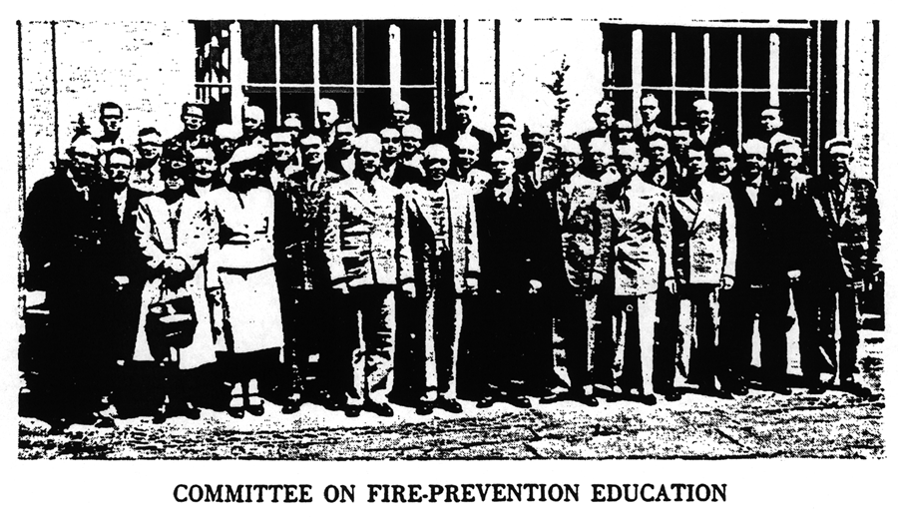

When this committee was organized, it was first broken into subcommittees. Each of these subcommittees had a certain job to do. After these subcommittees had prepared their reports, after days and weeks of intensive study, we called a general meeting of the committee. That committee met 2 or 3 weeks ago and for the better part of the whole day tried to coordinate and brief as much as possible the report of the subcommittees.

Yesterday, another meeting of the committee was called to go over the work of the previous meeting of the committee. Yesterday, in addition to members of the committee, about 140 members of this Conference attended that meeting. The report was thrown open to general discussion. I suppose that the great majority of those present made talks. We did not change materially the report as it was presented to you in writing yesterday. We did, however, amplify some of the expressions in the report of a more or less inconsequential nature.

For instance, where it said “heating systems,” we changed that to read “heating, ventilating, and air conditioning systems.” Where it says, for instance, that “thousands of farms go up in smoke every year,” we thought it was a little difficult to understand how a farm could go up in smoke, and we changed that to read “farm buildings and produce go up in smoke every year.”

There were three emphases placed in the report yesterday that were not present before to the extent that the committee felt, and all those others present felt, should be. We emphasized in a sentence or two, and by making another paragraph, the need for the schools to keep the closest kind of liaison with the firefighting agencies or fire protection agencies in their communities.

We emphasized further that the school systems of the States and the counties and the schools individually should make every endeavor possible to ally themselves with all of those organizations: the fire chiefs, the insurance educational organizations, the educational organizations connected with industry, and all sources which prepare materials of this nature of an educational value.

We emphasized further the need for adult education, how to reach out into industry, how to reach out to the people out of the country, to acquaint them with these facts.

Then, after that motion was made for the adoption of the report, the 175 or 180 or so men and women who were present and who took part in the discussion yesterday unanimously passed the report and adopted it.

Now, Mr. Chairman , on that basis I move you, sir, that this Conference adopt the report of the Committee on Fire Prevention Education. [Applause.]

MR. Clarence J. Muth (Milwaukee Association of Commerce). Mr. Chairman, in offering a second to that motion may I also express the confidence of this Conference in Dr. Byrd and his excellent committee for its very fine support.

{The question was put to a vote and was carried unanimously.}

Chairman Fleming. We have had some discussion of the rural scene from the educational standpoint, and we shall continue by hearing from another authority on rural life, Mr. Sherman K. Ives of the National Grange.

Mr. Ives comes to us from Thomaston, Conn. He is a member of the board of directors of the National Grange Monthly, a member of the executive committee of the Connecticut State Grange, and secretary-treasurer of the National Federation of Grangers Insurance Companies. Mr. Ives. [Applause.]

Mr. Sherman K. Ives. General Fleming, ladies and gentlemen it is indeed an honor and a privilege to speak a few minutes to you today on behalf of the National Grange, America’s oldest farm organization, as well as being one of the largest and most active of such organizations.

The Grange was founded a little over 80 years ago, and one of the objectives, as stated in its declaration of purposes, is buying together, selling together, and in general acting together for the mutual benefit and protection of its members.

One of the first things that the Grangers started acting together on was in fire insurance. We have today 36 State Grange organizations, as well as members in other States and Alaska. In those 36 States we have 65 Grange-operated fire insurance companies. It is, therefore, a subject, this matter of fire prevention, that is of vital interest to our organization, and we are very glad to participate in this Conference and contribute anything we can from our experience.

A few years ago I was listening to the radio, and Eddie Cantor and Jimmy Wallington were discussing fire insurance. Eddie said, “If I had a house worth $5,000 and I inured it today for $10,000 and it burned up tomorrow, what would I get?” Jimmy Wallington said, “You would get about 10 year.” [Laughter.]

The matter of arson has already been spoken of, and it is probably more successful in rural areas, due to the lack of fire protection, than in other areas. However, we do have in most States pretty good laws on arson and also laws that no one can collect more than the actual value of his property, and for these reasons arson is not a frequent cause of fire losses.

One of the frequent causes of fire losses in rural areas is lightning. There is an old saying, which you have all heard, that lightning never strikes twice in the same place. I have good personal reason to know that that saying is not true and never was.

My father and mother operated a dairy farm at Goshen, Conn., for 30 years, where I was born and raised, and during those 30 years lightning struck the buildings on that farm seven times. On one of those occasions it struck and burned the main barn at 3 o’clock in the morning. I was only 4 years old at the time, but it made an impression on me that I shall never forget, because it was only by the feverish activity of a bucket brigade of neighbors that our home was saved from burning also, as it caught on fire several times before the barn fell. And I wish to say, if you want to know how fast fire works, that it was just 20 minutes from the time lightning struck until the frame of the main barn fell.

Fortunately, there is something we can do about lightning losses. Twenty-five years ago, when I was a student at the University of Connecticut, our farm engineering professor used to say that lightning rod properly constructed and properly installed were 95 percent efficient. I think that may have been improved now. Only last week I talked with a man who has been in the business of installing lightning rods for many years, and he made this statement – I do not vouch for it, only he told me so, and I know he believed it – that right now Connecticut is the first and only State where all the fire insurance companies writing insurance in that State insist on approved lightning rods being installed before they will grant a premium reduction in insurance and where all companies writing insurance grant a uniform reduction for such installations.

When I speak of approved installations, I mean installations which bear the master label number of the New England Fire Insurance Rating Association, which number is on file with that association, which certifies to the insurance companies that those rods were properly constructed and were properly installed.

He further stated that so far the records do not disclose a single instance of a lightning loss where such installations were in existence. I do know that in our own fire insurance company in over 20 years we have had no record of a lightning loss where such rods are on the buildings.

The evidence seems clear that lightning losses can be practically eliminated by properly constructed and properly installed lightning rods. There is still one item that has to be worked out, and that is some method of periodic re-inspection of these installations, for in time they do become defective.

The most frequent losses, however, even in rural areas, are not lightning. The National Board of Fire Underwriters have stated that loss generally can be put into four classes, and that these four causes constitute 76 percent of all fire losses, and this is true in rural areas as well as anywhere else. I am not using their words, but these four causes are mainly carelessness with matches and when smoking; poor installation or care of cooking and heating equipment; carelessness with inflammables; and poor installation or care of electrical wiring and equipment.

How can we correct these items? Some of our companies have attacked the problem by hiring specially trained men to go to the individual farm and try to find these hazards and point them out to the owners and, diplomatically or otherwise, try to have them correct them I know we have one company in Connecticut that has several men so employed. I know the Grange company of Kansas and one in the State of Washington have done considerable work along this line, and it has prevented a great many fires.

But even this has its limitations. First, the cost of getting the type of man necessary to do this kind of work is heavy. Also, the item of travel in rural areas costs a great deal; and third, and not least important, is the mental attitude of the insured, who in this case are mostly farmers.

The farmers of America have gone along for a long time without being subject too much to building codes or regulations regarding their equipment. They do not take kindly to any uninvited outsider coming onto their place and telling them how their buildings should be constructed or cared for or what equipment they should have or how it should be handled.

Is there any better way, any more effective way, that this work can be done? I believe that there is, and it certainly fits in very well with this report on education. In New York State a few years ago several of the insurance companies, the majority of them Grange companies, decided to try something new there in the way of fire prevention, and I am going to speak to Niagara County, where the most extensive work was done. This information was given to me by R. M. Stanton of Albany, N. Y., who is the secretary of the New York Central Organization of Cooperative Insurance of New York State.

They enlisted there the aid of the schools, 4-H clubs, and various organizations, and they put up prizes for contests. I understand that each child had to inspect at least three farms, and many inspected a lot more. They were given an inspection blank, which listed a great many of the hazards they were to look for, and after they had completed these inspections they had to write an essay telling what they found, what was done to correct them, and what they had learned about fire hazards.

I understand that about 15,000 inspections were made in that county that year. Many of them were duplications, but it was estimated that at least 10,000 different places were inspected.

The insurance companies put up the money for the prizes and printing the inspection blanks, and so forth, and in all, I think, about $2,500 was spent. But to me this is the most impressive. That year in Niagara County the fire losses were over 35 percent less than they had been the year before; whereas in neighboring counties, where none of this work was carried on, that same year the fire losses increased 2 percent over the year before.

To me this indicates a proven method of fire prevention. I attended the committee meeting yesterday afternoon on fire prevention education and was very much interested in the remarks that were made. Several people indicated that they were in favor of this education of fire prevention in the schools but wondered just how it was going to be done. Here is one way that it can be done.

I also was impressed with one man who was afraid that if you did not use the radio and the moving pictures in this program, all your effort was going to be lost. I am not in disagreement with him; I think we should use those methods of disseminating this information all we can. But you will lose a lot of effectiveness if you do not have these actual inspections, and you will also lose a very important factor in cooperation of both the children and the adults if you do not have this matter of a contest.

All America loves a contest. We need this fire prevention medicine, although the medicine does not have to be bitter to be good. The contest is a sugar coating, if you please. My recommendation is simply that we do everything possible to learn the details of these proven methods of fire prevention, which I have been telling you about, and try to get them to the areas of this country which do not now enjoy them. [Applause.]

Chairman Fleming. Thank you very much, Mr. Ives.

I now have the pleasure of introducing a man who began working for fire prevention when some of us here were still in short pants or pigtails. For many years he has traveled throughout the United States and Canada, organizing local fire prevention committees and lecturing and writing on fire prevention. He served as consultant on fire education to the International City Managers’ Association, is a member of the executive committee of the International Fire Waste Council, is an honorary life member of seven fire chief organizations. Mr. Percy Bugbee, general manager of the National Fire Protection Association. [Applause.]

Mr. Percy Bugbee. The National Fire Protection Association is grateful to the President of the United States for his recognition of the seriousness of the loss of life and destruction of property by fire and his action in calling public attention to the importance of fire prevention by creating this National Conference.

Fires, like epidemics of disease or crime, can be stamped out successfully only through the collective will and action of society as a whole. The failure of society to prevent fires has been due to the fact that up to now the average American citizen has not appreciated that nearly all fires are due to simple, easily understood acts of carelessness or neglect. Once every man, woman, and child realizes and accepts in daily life the responsibility for simple fire prevention measures, death, injury, and destruction by fire will be substantially reduced. It is worth emphasizing that the failure of society to prevent fires is not due to any mysterious and unknown action of fire. There is hardly any field of scientific investigation where more work has been done than in the field of fire protection and fire prevention. The knowledge as to the causes of fires and how to prevent them and protect against them is available.

Let me pay tribute here to the remarkable accomplishments that have been registered over the years by fire protection engineers and fire preventionists throughout industry, throughout the fire insurance business, in many of our municipal fire departments, and in numerous Federal and State agencies. The work of these men is not spectacular and seldom reaches the public consciousness. Big fires are front page, but a fire prevented is not news.

While it is the worth-while purpose of this Conference to focus attention upon the need for more fire prevention interest and activity, we should recognize and applaud the work that has been done and we should realize that while we are in a period of rising fire losses, the losses have not actually risen in proportion to the tremendous increase in values of burnable goods created during the recent war period. Perhaps the most practical evidence of the effectiveness of the long-range attack upon the fire waste is the steady downward trend in the over-all cost of fire insurance which has been in evidence for the past five decades. We of the National Fire Protection Association feel that a vast amount of constructive fire prevention effort has already been accomplished and we stand ready to increase and intensify our efforts and to cooperate with all other agencies in carrying out the action program developed here in this Conference.

I have two specific proposals to make to this Conference that in my opinion would result in substantial reduction of fire losses. If we examine the record, we find that there are approximately from 700,000 to 800,000 fires a year in the United States and that nearly half of these occur in homes. The majority of deaths and injuries in fires occurs in homes. If every home in the United States could be subjected to a periodical inspection for common fire hazards, these home fires could be cut in half in a year’s time. It has been demonstrated over and over again that when home inspections are made by fire departments a very substantial reduction in home fires is secured. Such home inspections can be carried out at no extra cost whatsoever to the taxpayers, and the fire departments that have carried on home inspections have found that they not only reduce the fire losses in homes in their city but that they bring a tremendous amount of good will to their departments. Home inspections by firemen work in large cities and in small ones, and in every city where there is an organized fire department such home inspection procedures, if carried out, would cut this measured source of fire.

Experience also has clearly demonstrated that simple inspections of homes for fire hazards by school children, by Boy Scouts, by Girl Scouts, and by 4-H Club boys and girls, are effective in reducing home fires. Here again there is nothing difficult, expensive, or mysterious to be done. Whenever boys, and girls have been asked to undertake this sort of work, there has been no evidence of reluctance on their part. Why not utilize the spirit and effort of the young people in this great campaign that we are talking about at this Conference? Every boy and girl should be given this opportunity. A concentrated campaign of home inspections along the lines indicated above will reduce home fires, and home fires are our greatest number of fires.

What is the principal cause of fires? Of the 590,000 fires of known cause, on the average we find that 120,000 of them are due to careless smoking. People burning to death because of smoking in bed has become all too prevalent. Every hotel owner will testify to his fire experience with the careless smoker. The evidence clearly indicates that the disastrous LaSalle and Winecoff Hotel fires and the Texas City holocaust of last year were started by the careless disposal of cigarettes.

Up to now we have not attacked successfully this principal cause of fires. The cigarette companies spend tremendous sums of money on radio programs, on magazine and newspaper advertising, on billboard advertising, and the like. Have you ever seen in any of this advertising any words of advice or caution as to the safe disposal of lighted matches and cigarettes? I for one feel that the cigarette companies have an obligation and a public responsibility to help educate smokers in careful action. I believe that an educational campaign on fire prevention by the cigarette companies would substantially reduce fires and deaths by fires without hurting the sale of their product. Last year President Truman sponsored a National Conference on Highway Safety. The great automobile companies have supported with their interest and with their money that campaign. I suggest that this Conference take action to induce the cigarette manufacturers to accept some responsibility for the education of the public in careful smoking habits so that this principal cause of fires may be reduced.

Chairman Fleming. Thank you, Mr. Bugbee.

More than we commonly realize, our health, even our very lives, depends upon the kind of buildings in which we live and work and seek our recreation. Once we thought of the architect as the man whose business it was to design buildings that would be pretty to look at, but he was not always too successful, even in that endeavor, as amply illustrated by some of the older buildings around Washington. Take the old State, War, and Navy Building, for instance.

We now recognize in the architect one whose job it is to build for us structures that will not only be pleasing to look at, but in which we can live and work in comfort and safety.

At this point I must note a slight change in our program. James R. Edmunds, Jr., of Baltimore, until just recently president of the American Institute of Architects, who was to have addressed us this morning, was unfortunately not able to be present. The paper he would give if he were here will instead be read by Mr. Walter A. Taylor, director of the Department of Education and Research of the American Institute of Architects, whom we are very happy to have with us. Mr. Taylor. [Applause.]

Mr. Taylor (representing Mr. James R. Edmunds, Jr., past president, the American Institute of Architects). The American Institute of Architects welcomes the opportunity to support and participate in the President’s fire prevention campaign.

The American Institute of Architects has collaborated for many years with a number of the technical agencies here represented, Mr. Bugbee’s organization and others, in the study and development of standards and codes for fire prevention and safety.

Since the inception of this campaign, our organization has urged the broadest scope and interpretation and an emphasis upon safety for human life as the ultimate criterion of codes and actions.

Everyone is of course concerned, at least indirectly, about human casualties and loss of life due to fires. However, it would seem that many codes and proposed standards have been framed primarily to preserve buildings and their contents, rather than human lives. The architect shares fully the concern of the owners, the technicians, and economists over the stupendous financial losses due to fires.

But the architects, among the technicians and design professions, in his approach to any problem, usually gives greater weight to the direct effect upon human beings.

Even with perfectly incombustible structures, we shall probably always have some inflammable contents. Even if the spread of fire could be controlled, unless additional precautions are taken there would still be the danger of loss of life by panic and suffocation, which cause many more casualties and deaths than does actual contact with fire.

Therefore, in our efforts to aid and abet this most necessary and commendable campaign, we shall include and stress all precautions toward prevention of loss of life due to fires. Buildings and contents may be called expendable and may be recoverable; human life is not expendable and not recoverable. The architect, as coordinator of the work of many technicians and specialists, has responsibilities in all technical and design phases of fire safety.

Among the many complex requirements of modern building which he must completely coordinate and specify in advance of construction, he must include fire safety considerations in plan, structure, construction, escapes, alarms, fire proofness or fire-resistance, controls for fire, smoke and gas, built-in firefighting equipment, and so forth.

There is no lack of technical data, as Mr. Bugbee has indicated. Architects and practitioners of some of the other design professions may know quite well what should be done, but these precautions cost the owners money, due either to large dimensions, or better quality of building, or additional equipment.

If, in buildings for competitive use, such as hotels and restaurants, the precautions are not legally required, or are not strictly enforced, the urgings of the architects, or even the conscience of the owner, may not prevail, and the hazards will get by for the reasons of economy.

This is obvious, and it is therefore also obvious that the importance and potential success of this campaign lies in the participation of many large and influential groups outside the architectural and engineering professions, whose interests are solely humanitarian and civic.

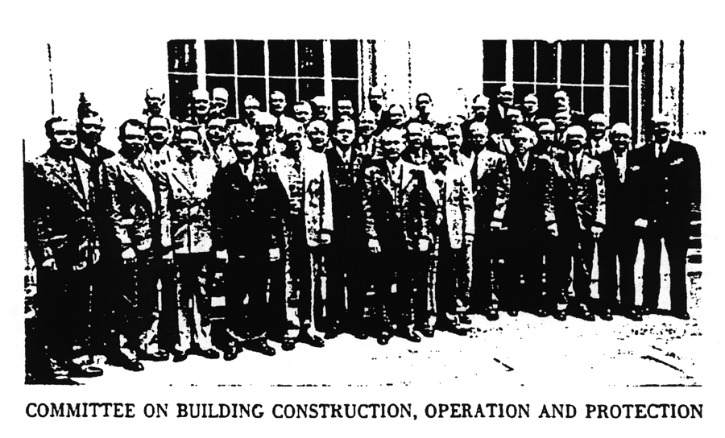
Government agencies which are guiding and setting standards for various types of buildings can do a great deal to improve fire safety by strengthening and emphasizing their requirements.

The officers, directors, and staff of the American Institute of Architects pledge their best efforts to the continuing support of the President’s campaign. Individual architects, as citizens and in their professional practice, may be relied upon to use their skill and persuasion in the interest of fire safety; but in many large and important public and semipublic buildings we shall be powerless unless by united effort of all who are here represented, public opinion is aroused to a demand for clarification, enactment, and enforcement of codes which are ready and available in the form of standards and recommendations, awaiting your moral support and legal implementation. [Applause.]

Chairman Fleming. Thank you, Mr. Taylor. I think that excellent presentation has put us in a receptive mood to hear the report of the Committee on Building Construction, Operation, and Protection, which will be presented by Alfred C. Fuller. Mr. Fuller! [Applause.]

Mr. Alfred C. Fuller. General Fleming and ladies and gentlemen of the Conference, the report which this committee is presenting today is the product of three subcommittees which were commissioned to deal with different phases of the subject. The membership of these subcommittees was scattered throughout the country. The time available for the work was short, and the opportunities for getting together in committee meetings were few. Nevertheless, the work was carried forward with great energy and enthusiasm.

Much credit is due the subcommittee section whose job it was to assemble and digest a large number of suggestions and draft the report. I have reason to be particularly thankful to Mr. George Thompson of the Bureau of Standards, the secretary of this committee.

After the subcommittee made its report, received the approval, it was all combined into one report, which was submitted to the full committee for final action. At a meeting held yesterday afternoon, which was attended by about 150 of the committee and others attending this Conference, a critical review of the report was made, and some final touches were added. It now comes before you for final approval of the work of the committee.

I might say further that there were certain suggestions for editorial refinements and changes and additions, some of which were left to the committee for further work after a stenographer had taken notes of the various changes and suggestions made.

In brief, the committee recommends that greater attention be given by designers of buildings to the recognized standards of construction and strict compliance to established codes and regulations; that governmental officials review the adequacy and extent of existing regulations; that owners and managers of buildings adhere to safe practices and observe standard rules of fire safety; that aggressive action be taken to accelerate the installation of automatic fire protection in new and existing buildings, particularly where safety to life is a compelling factor; that designers, owners, public officials, and the public in general assume their full obligation for the elimination of fire hazards.

In reaching these conclusions, which are supported by further detailed recommendations giving specific measures to be applied, the committee has investigated the part that building design, provisions for fire extinguishment, and arrangement for good housekeeping can play in reducing fire hazards. It has recognized that the problem may be quite different in the case of a new building and an existing one. In the case of the new building it emphasizes that the mistakes of the past should not be allowed to be repeated. In the case of existing ones it points out that measures should be taken to correct major deficiencies, even though they were not recognized as such and were even permitted by law when the structure was originally erected.

Throughout the report emphasis is placed upon the increased sense of responsibility that should be felt by everyone. Needless waste of human life and property values would be stopped. This responsibility rests with designers with owners and managers of premises, with governmental authorities charged with the enforcement of building regulations, and with the public itself.

It is pointed out that there are well-developed standards of construction which, if properly applied, would go far toward cutting down losses. Effective firefighting appliances are available for use. Safe methods of handling building contents, even those of a hazardous nature, are being developed. Thus the means for providing adequate safety are at hand but indifference and carelessness still exist. It is in this field that much remains to be done if we are to have real progress in fire protection.

The committee does not confine its report to generalities. It singles out specific points in building construction that have contributed in the past to fire losses and which will continue to be a menace unless corrected. These include unprotected open stairways and elevator shafts, concealed places, the lack of adequate barriers to spreading a fire in the form of fire-resistive walls and partitions.

In the matter of provisions for fire protection and extinguishment it is equally specific. Special emphasis is placed upon the advantages of automatic sprinklers as a means of dealing with fire before it has a chance to assume serious proportions. The usefulness in old buildings is made evident. Certain fundamentals in operation and maintenance of buildings from the standpoint of fire safety are stressed. These include supervision, organization, education, and training of personnel; good housekeeping; precautions against smoking; care and restrictions in the use of inflammable liquids, open flames, and lights; and the maintenance of building service, equipment, and fire protection appliances. All these things must be done if we are to make progress, but the report comes back again and again to the principle of individual responsibility. If this principle can be fostered, and if the will is created to use the means for fire safety already at hand but too often neglected, we can look forward with confidence to a better record in the coming years.

Mr. Chairman, I recommend and move the adoption of the report.

Chairman Fleming. Thank you, Mr. Fuller.

You have all received copies of the report, and Mr. Fuller has very ably told you what it contains and what changes were made in it yesterday. Is there any comment from the floor?
Mr. Arthur Benline (representing the Building Officials Council of America and the Building Officials Foundation). Mr. Chairman we wish to second the motion.

{The question was put to a vote and was carried unanimously.}

Chairman Fleming. We now recess until 2 o’clock this afternoon.

{The Conference adjourned at 11:50 A.M.}

