



Special for MAQC Test site use
Hybridization Protocol for CustomArray™12K Chips
&
Preparation for Scanning

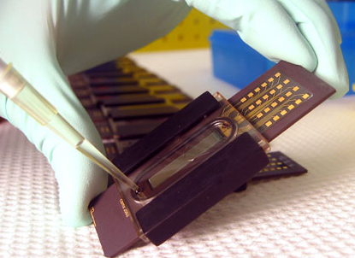

CustomArray assay workflow
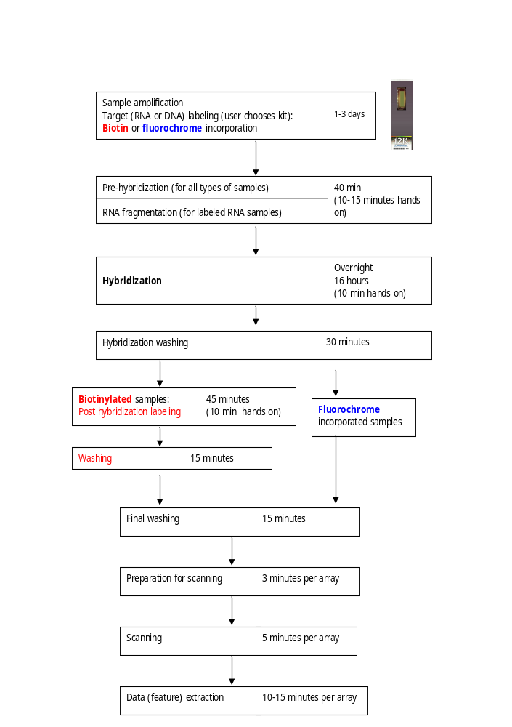
Hybridization and Imaging Protocol
Table of Contents

CustomArray assay workflow i
Table of Contents ii
Introduction 1
Materials provided 1
Materials required but not supplied 1
Assemble chips with hybridization caps, gaskets and clamps 2
Preparation of solutions 3
(MAQC Test Sites will be provided with a complete buffer kit) 3
Solutions common for all types of samples (biotinylated and fluorochrome incorporated) 3
Solutions required only for biotinylated samples 5
Pre-Hybridization 5
RNA Fragmentation (RNA target samples only)(provided) 6
Hybridization 6
Hybridization Washing 7
Post-hybridization labeling and washing for biotinylated samples 7
Final Washing 8
Preparing the CustomArray12K Chip for Scanning 8

Hybridization and Imaging Protocol

Introduction

This guide explains how to hybridize a labeled target sample (DNA or RNA) to the CombiMatrix CustomArrayTM12K chip, and prepare the array for scanning. Preparing the labeled target samples is the user’s responsibility. We recommend usage of 5 μg of a labeled target sample per one array. If two labeled samples are hybridized to the same array (a two-color hybridization scheme), use 5 μg of each sample (totally 10 μg). This protocol is optimized for gene expression analysis. Other applications, such as comparative genome hybridization and genome tiling, may require the user to optimize hybridization conditions. Both biotin-streptavidin detection system (biotin-labeled nucleic acid targets and streptavidin-conjugated fluorochrome) and fluorochrome-labeled nucleic acid targets could be used with CustomArrayTM12K chips. Arrays are scanned with a high-resolution fluorescent microarray scanner that is compatible with a 1”x3” slide format and has a minimum resolution of 5μm and adjustable focus.

Materials provided

CustomArrayTM 12K chip
IMPORTANT! Do not touch the chip surface. Keep in a dry cool place. Store up to 4 months.
Hybridization cap
Gasket (O-ring)
Clamps
LifterSlipTM coverslip for imaging
Imaging Solution

Materials required but not supplied

Labeled target (DNA or RNA) samples.
Pipettors and tips
Sterile plastic ware
Gloves (powder-free)
Adhesive tape (Scotch tape)
Water (RNase and DNase-free)
50x Denhardt’s solution
EDTA
Tween-20
20x SSPE buffer
10 mg/ml sonicated salmon sperm DNA
1% SDS
Deionized (DI) Formamide (if working with labeled RNA)
Phosphate buffered saline (PBS)
Acetylated Bovine Serum Albumin (BSA)
Reagents for RNA fragmentation (if working with labeled RNA)
Reagents for biotin-streptavidin detection system (if working with biotinylated samples)
Rotisserie oven or rotating incubator for array hybridization
CustomArray™ holders for rotisserie oven (rotating incubator)
Standard, high-resolution fluorescent microarray scanner (CombiMatrix recommends the Axon Instruments Genepix® 4000B and 4200A microarray scanners, Applied Precision arrayWoRx® Biochip Reader, and the Perkin Elmer ScanArray® microarray scanner).

Assemble chips with hybridization caps, gaskets and clamps
IMPORTANT! Hybridization Cap, Gasket, and Clamps are intended for single use only. Dispose of these items upon completion of this protocol.
- Place the gasket into groove on hybridization cap.
- Position the hybridization cap over the slide so that the bottom edge of the slide is resting against the stop on the hybridization cap and centered over slide.
- Secure the hybridization cap in place with clamps provided (see Figure 1).

CustomArray 12K
Hybridization Cap
Clamp
Gasket (O-ring)

Figure 1 CustomArrayTM12K and accessory components.
NOTE: Throughout this protocol, use a 200 μl micropipettor with RNase-free pipet tip to add or remove solutions through the hybridization cap portals. Hold the chip with the assembled hybridization cap at a 45 degree angle (as shown on the cover photograph) and add/remove solutions through the lower portal.

IMPORTANT! Do not allow the array to become dry at any step in the protocol. Proceed rapidly when changing solutions during the pre-hybridization, hybridization, and washing steps. Do not leave the hybridization chamber empty for any significant length of time (have it filled).

Preparation of solutions

(MAQC Test Sites will be provided with a complete buffer kit)
IMPORTANT! The solution set is different for biotinylated and fluorochrome incorporated target samples. Usage of biotinylated samples requires additional post-hybridization labeling and extra washing steps (see the Assay workflow). Thus, the user will need three additional solutions (not required for fluorochrome-incorporated samples).
NOTE: The hybridization buffer composition depends on the type of nucleic acids used as labeled targets. For RNA (but not DNA) targets, it should include 25% formamide.

Solutions common for all types of samples (biotinylated and fluorochrome incorporated)

1. Prepare the 2X Hyb Solution Stock (see Table). This stock will be used for preparation of the Pre-hybridization and Hybridization Solutions. All reagents should be RNase and DNase-free. The prepared 2x Hyb Solution Stock should be filter-sterilized and stored at room temperature.

2X Hyb Solution Stock (all types of samples) (Provided)
Reagent | Volume for 10 ml | Final Concentration
20X SSPE | 6 ml | 12X
10% Tween-20 | 100 μl | 0.1%
0.5M EDTA | 560 μl | 40mMª
RNase-free water | to 10 ml
Total Volume | 10 ml

ªFinal concentration includes the EDTA from the SSPE.

2. Prepare the Pre-hybridization Solution, 100 μl per one array (see Table).

Pre-hybridization Solution (all types of samples)
(Provided – Salmon Sperm separately to be added prior to pre hybe)
Reagent | Volume per CustomArray12K Chip (μl) | Final Concentration
2X Blocking/Hybridization solution | 50 | 6X SSPE, 0.05% Tween-20, 20mM EDTA
RNase-free water | 34
50X Denhardt’s solution | 10 | 5X
Salmon sperm DNA (10mg/ml)ª | 1 | 100 ng/μl
1% SDS | 5 | 0.05%
Total Volume | 100 μl
ªSalmon sperm DNA should be heated to 95°C for at least 5 min and then placed on ice for at least 1 minute before use.

This solution should be prepared fresh each time you hybridize arrays.

3. Prepare the Hybridization Solution (see Table). We recommend using approximately 5 μg of labeled DNA or RNA per array, thus, the initial concentration of a labeled sample prior to addition to the Hybridization Solution should be at least 0.25 μg/μl. For best results, labeled RNA should be fragmented to 50-200 base length prior to adding to the Hybridization Solution (see the section “RNA Fragmentation”).

Hybridization Solution (all types of samples)
Reagent | Volume per CustomArray12K Chip (μl) | Final Concentration
2X Blocking/Hybridization solution | 50 | 6X SSPE, 0.05% Tween-20, 20mM EDTA
DI Formamide (RNA targets) | 25 | 25%
fragmented RNA | 5ug(up to 20 μl) | 50 ng/μl recommended
Salmon sperm DNA (10mg/ml) | 1 | 100 ng/μl
1% SDS | 4 | 0.05%
RNase-free water | to 100
Total Volume | 100 μl

NOTE : Replace formamide with water when working with the labeled DNA targets.

4. Prepare the Hybridization Wash (HW) Solutions (see Table). The prepared HW Solutions should be filter-sterilized and stored at room temperature.

Hybridization Wash Solutions & Incubation Times (all types of samples)
Solution | Temperature (°C) | Incubation Time (min)
Wash 1 (HW1): 6x SSPE, 0.05% Tween-20 | Pre-heat to hybridization temperature | 5
Wash 2 (HW2): 3x SSPE, 0.05% Tween-20 | RT | 5
Wash 3 (HW3): 0.5x SSPE, 0.05% Tween-20 | RT | 5
Wash 4 (HW4): 2x PBS, 0.1% Tween-20 | RT | 5

5. Prepare the Final Wash (FW) Solution (see Table). The prepared FW Solution should be filter-sterilized and stored at room temperature.

Final Wash (all types of samples)
Solution | Temperature (°C) | Incubation Time (min)
Final Wash (FW): 2X PBS | RT | Twice 5

Solutions required only for biotinylated samples

If working with fluorochrome-labeled targets, skip this step. If working with biotinylated targets, prepare additional Post-hybridization Blocking (BB), Labeling (BL) and Wash (BW) Solutions (see Table). The prepared BB and BW Solutions should be filter-sterilized and stored at room temperature. BL Solution should be prepared fresh each time you hybridize arrays.

Post-hybridization Blocking, Labeling and Wash Solutions (biotinylated samples)
Solution | Temperature (°C) | Incubation Time (min)
Biotin Blocking solution (BB): 2X PBS, 0.1% Tween-20, 1% BSA | RT | 15
Biotin Labeling solution (BL): 1 μg/ml streptavidin-conjugated fluorochrome, 2X PBS, 0.1% Tween-20, 1% BSA | RT | 30
Biotin Wash (BW): 2X PBS, 0.1% Tween-20 | RT | Twice 5

NOTE: To prepare the Biotin Labeling Solution (BL), dilute streptavidin-conjugated fluorochrome with the Biotin Blocking Solution (BB). For example, if you use FluorolinkTM Cy5-labeled streptavidin from Amersham (cat # PA45001, 1 mg of dry powder), dissolve it to 1 mg/ml stock, store as aliquots in a freezer, thaw an aliquot and dilute 1:1000 in the BB Solution (1 μl per 1 ml of BB, discard the used aliquot).

Pre-Hybridization
NOTE : The Combimatrix CustomArray 12K chips are supplied dry, they need to be re-hydrated prior to hybridization, and then pre-hybridized to block non-specific binding of nucleic acid targets.
- Thaw provided aliquot of pre hybridization buffer @ 37oC
- Place Aliquot of Salmon Sperm at 95oC for 5min place on Ice for 1 min
- Add 10ul of Salmon Sperm to the Pre Hybridization solution, place on ice

- Pre-heat an incubator to 65ºC. Set a hybridization (rotisserie) oven to 45ºC hybridization temperature. See Table for suggestions on hybridization temperatures for different sample types and buffers. These temperatures are recommended for standard oligonucleotide lengths (35-40mers) and have been optimized for gene expression applications, thus, they should be used only as a guide and may be optimized empirically.

Hybridization Temperature
Sample | Hybridization Solution | Hybridization Temperature (°C)
RNA | Hybe solution + 25% Formamide | 45

- Fill hybridization chamber with room temperature RNase- and DNase-free water (approximately 100 ul). Make sure not to introduce air bubbles. Cover the hybridization cap portals with non-permeable adhesive tape (for example, Scotch tape) to prevent evaporation and air bubble formation.
- Incubate at 65ºC for 10 min in the pre-heated incubator.
- Remove array from the incubator and bring to room temperature.
- Remove the tape and pipet water out of hybridization chamber.
- Fill hybridization chamber with the prepared Pre-hybridization Solution. Mix gently by pipetting. Make sure not to introduce air bubbles. Cover the hybridization cap portals with non-permeable adhesive tape.
- Incubate at 45ºC hybridization temperature for 30 min in the pre-heated hybridization oven.

RNA Fragmentation (RNA target samples only)(provided)

NOTE: Labeled RNA target samples should be fragmented to maximize binding specificity and detection sensitivity. We have found that 50 to 200-base fragments work best. You could use either the protocol described below, or a protocol that is established in your laboratory.

- Prepare the 5x RNA Fragmentation Solution (see Table). Filter sterilize the prepared solution and store at room temperature

5x RNA Fragmentation Solution (RNA samples only)
Reagent | Volume for 10 ml | Final Concentration
1 M Tris Acetate pH 8.1 (adjust pH with glacial acetic acid) | 2 ml | 200 mM
KOAc | 0.49 g | 500 mM
MgOAc | 0.32 g | 150 mM
Water | To 10 ml
Total volume | 10 mlª

- Take 5 μg of the labeled RNA dissolved in 16 μl of water (thus, the initial concentration of labeled RNA samples should exceed 0.3 μg/μl). Add 4ul of 5x RNA Fragmentation Solution.
- Incubate at 95ºC for 20 min. Place on ice.
- Use the whole volume (20 μl) to add to the Hybridization Solution.

Hybridization

- Denature the Hybridization Solution at 95ºC for three minutes, and then cool briefly on ice.
- Spin at maximum speed in a microcentrifuge for one minute.
- Remove Pre-hybridization Solution from the hybridization chamber.
- Add 100 μl of Hybridization Solution and mix gently with repeated pipetting. Make sure not to introduce air bubbles if the arrays are incubated without rotation. A small air bubble can be introduced to improve the mixing process if the arrays are rotated in the hybridization rotisserie oven.
- Carefully wipe excess solution from the surface of the hybridization cap with a lint-free tissue and cover the hybridization cap portals with non-permeable adhesive tape.
- Incubate at the 45ºC hybridization temperature for 16 hours in the hybridization rotisserie oven.
NOTE: To improve array performance, usage of a rotisserie oven or a rotating incubator is recommended to ensure mixing during hybridization. You can introduce a small air bubble into the hybridization chamber to improve the mixing process during rotation. CustomArray chips can be attached to standard rotisseries using various models of holders manufactured by Combimatrix.

Hybridization Washing
IMPORTANT! Do not allow the array to become dry at any step in the protocol. Proceed rapidly when changing solutions during the washing steps. Do not leave the hybridization chamber empty for any significant length of time.

NOTE 1: Keep the hybridization cap in place during all wash steps. Hold the chip with the assembled hybridization cap at a 45 degree angle (as shown on the cover photograph) and add/remove solutions through the lower portal by using a 200 μl micropipette with RNase-free pipet tip.
NOTE 2: For every wash step, we recommend to rinse the hybridization chamber with the corresponding Wash Solution prior to the wash incubation. Add Wash Solution into the chamber, gently mix by pipetting, remove it, and fill the chamber again with the same solution.
NOTE 3: Except for the first wash step, all subsequent wash incubations could be reduced to 1 min. However, if processing multiple arrays, you could extend the wash incubation time until you rinse and fill all hybridization chambers.
NOTE 4: Keep the chips protected from light during all long (more than 5 min) incubations (cover with foil).

- Prior to starting the wash procedure, preheat the HW1 Solution to the hybridization temperature.
- Remove the Hybridization Solution and rinse the hybridization chamber with HW1 Solution.
- Add HW1 Solution to the hybridization chamber and incubate the hybridization chamber at the hybridization temperature for 5 minutes.
- Remove HW1 Solution and rinse the hybridization chamber with HW2 Solution.
- Add HW2 Solution to the hybridization chamber, mix gently by pipet, and incubate at room temperature for 1-5 minutes (see NOTE 3).
- Remove HW2 Solution and rinse the hybridization chamber with HW3 Solution.
- Add HW3 Solution to the hybridization chamber, mix gently by pipet, and incubate at room temperature for 1-5 minutes (see NOTE 3).
- Remove HW3 Solution and rinse the hybridization chamber with HW4 Solution.
- Add HW4 Solution to the hybridization chamber and mix gently by pipet.

Biotinylated samples: Retain HW4 Solution in the hybridization chamber until you are ready to perform the blocking and labeling procedures.

Fluorochrome-labeled samples: Proceed to the final wash.

Post-hybridization labeling and washing for biotinylated samples

1. Remove HW4 Solution from the hybridization chamber.
2. Add Biotin Blocking (BB) Solution to the hybridization chamber and gently mix by pipet.
3. Incubate at room temperature for 15 minutes (protect from light), and then remove the BB Solution.
4. Add the Biotin Labeling (BL) Solution to the hybridization chamber, gently mix by pipet, and cover the hybridization cap portals with non-permeable adhesive tape.
5. Incubate at room temperature for 30 minutes (protect from light).
6. Remove BL Solution from the hybridization chamber.
7. Rinse the hybridization chamber with the Biotin Wash (BW) Solution.
8. Add BW Solution, mix gently by pipet, and incubate at room temperature for 1-5 min.
9. Repeat washing with BW Solution one more time.

Final Washing

- Remove the HW4 (fluorochrome-labeled samples), or BW (biotin-labeled samples) Solutions from the hybridization chamber.
- Rinse the hybridization chamber with the final wash (FW) solution.
- Add the FW solution and incubate for 1-5 minutes.
- Repeat washing with FW solution one more time. Keep array hybridization chambers filled with FW solution until you are ready to prepare them for scanning.

Preparing the CustomArray12K Chip for Scanning

The CustomArray chip must be scanned wet using the Imaging Solution supplied. The LifterSlip™ coverslip (supplied) retains buffer on the chip without damaging the chip surface. Due to its specially designed edges, the LifterSlip™ coverslip does not contact the chip surface.
IMPORTANT! Do not use a standard coverslip with the CustomArray chip. Only use the LifterSlip™ coverslip, otherwise the chip may be damaged.
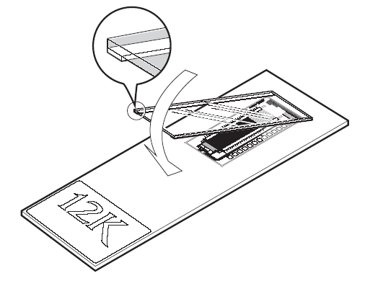

Figure 2 CustomArray™12K with LifterSlip™ coverslip.

- Remove the FW solution from the hybridization chamber.
- Add Imaging Solution (supplied with arrays) to the hybridization chamber.
- Carefully remove the hybridization chamber from the array by removing clamps and lifting the hybridization cap off the slide surface, being careful to retain Imaging Solution on the surface of the array (be ready to add more using a micropipette if array is not completely covered).
- Use thin-tipped forceps to hold the LifterSlip™ coverslip so that the raised edges face the slide (the side with edges could be detected by rubbing with forceps, the edges feel rough).
- Lay the LifterSlip™ coverslip at an angle onto the slide so that it is centered over the array (see Figure 2). First touch the imaging solution covering the array with one side of the LifterSlip, then slowly lower it down, taking care not to introduce air bubbles. If the bubbles still form, lift one side of the LifterSlip with forceps (or a razor blade) to let the bubbles out, and lower it down again.
- Carefully remove any excess Imaging Solution from the edge of the LifterSlip using a lint-free tissue until the it is resting on its raised edges.
- Load the CustomArray chip into the scanner taking care not to disturb the LifterSlip™ coverslip.

