Improving Reading Performance: Key Practices from the 2004 No Child Left Behind - Blue Ribbon Schools

Exemplary schools, such as the NCLB-Blue Ribbon Schools, manage the complex task of weaving the essential elements of good education into coherent, sustained learning experiences for their students. This year we have grouped the schools’ descriptions of how they improved student reading performance into four themes:
- Organizational Support
- Teaching
- Assessment
- Student Support



Organizational Support
- Staff/teamwork
- Professional Development
- Practice/cross curricula
- Expectations
No Child Left Behind - Blue Ribbon Schools organize themselves to ensure student success. Staff members collaborate to implement literacy curricula and integrate reading across subject areas. Teachers have high expectations for students. Schools provide teachers with professional development opportunities, helping the entire school perform at its best.
McNeil Canyon Elementary School Homer, AK
We work as a complete team, making instructional and intervention decisions as a team. Those decisions are than followed through with all available resources including Special Services and other programs. Early intervention based on current assessment data is the key to improvement of students’ reading performance.
Highland High School Gilbert, AZ
Practice, practice, practice. Reading and understanding is encouraged in every class. Teachers collaborate with each department on teaching techniques and strategies.
Midway Elementary School Lexington, SC
Our students are immersed in a literature-rich environment. We encourage reading in a variety of settings. Students read every morning as soon as they arrive at school. Teachers instruct students using a balanced literacy approach. Teachers teach phonemic awareness, phonics, fluency, vocabulary, and comprehension. Our media specialist supports our balanced literacy program by providing a flexible scheduling, purchasing books, and inviting guest authors. She plans activities in conjunction with our county library. Students are encouraged to have library cards and to use the county library.
Conners Emerson School Bar Harbor, ME
Professional development in the area of literacy is strongly supported. Teachers are trained in literacy theory and practice. The primary teachers have taken coursework to support best practices in literacy, as well as attending the Teachers College Reading and Writing Project at Columbia University. Teachers are encouraged to attend workshops, conferences, and seminars to stay abreast of best literacy practices. There is an expectation of sharing knowledge. . . teachers become instructional leaders for fellow staff members.
The development of specific standards and strategies to be used during the literacy block has given teachers a clear understanding of the literacy continuum. They are able to address the varying levels of their students with confidence and expertise.
Stoddard Elementary School Beatrice, NE
We allow the time necessary for uninterrupted reading instruction [and instruction is] direct, highly structured, sequential, and provided at the appropriate level for the students. Children cannot learn to read unless we as educators provide them with the necessary skills. The time has been set aside building-wide. Everyone has reading together in grades two through five. This allows the staff to performance-group the children so that all students are being instructed at the appropriate level. Classroom teachers, paras, and specialists work together.
Suncrest Middle School Morgantown, WV

Horizontal and vertical teaming provides a variety of opportunities to support reading and reading skill improvement at Suncrest. [We use] a strong independent reading program in the 6th grade [that] carries over to the 7th and 8th grades. Having an in-house reading specialist who is part of the academic teams allows collaboration and cross-curricular modifications in reading instruction. Multiple strategies are used to enhance reading skills for targeted groups with special needs.

Teaching
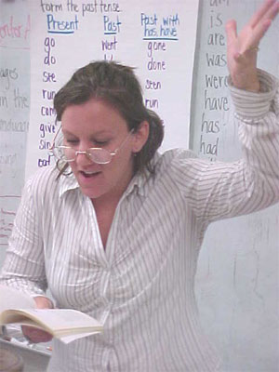
- Reading program
- Small groups/selective grouping
- Literacy coach/reading specialist
- Multiple strategies
Balanced literacy forms the core of many Blue Ribbon Schools’ reading strategies. Teachers use many techniques, such as shared and guided reading, with a variety of materials to engage students and induce a love of reading. Students’ skill levels are identified and addressed in small group instruction. Literacy coaches and specialists work with students and teachers to improve performance.
Eagle Rock Elementary School Los Angeles, CA
[We have] a full time Literacy Coach. In the 2000-01 School Year the Los Angeles Unified School District instituted a common reading program across the district. . . .The superintendent recommended that our board fund Literacy Coaches for all elementary schools. The coach does not evaluate teachers but rather facilitates the implementation of the reading program. Coaches may simply visit classrooms and give feedback to teachers or present a demonstration lesson to the class while the teacher observes. In addition, the coach meets with individual teachers to go over periodic assessment results and with grade level dialogue groups to help create "action plans" for student improvement.
Washington Elementary School Quincy, IL
Guided reading [is] the heart of our reading instruction. . . . Our students have greatly benefited from experiencing print-rich and language-rich classrooms every day. Teachers routinely take and analyze running records – as well as assessment for fluency, retelling and comprehension – using the results to plan the next instructional steps (including guided reading prompts and clues) for each
student. . . . Because guided reading utilizes authentic trade books (not basals), our students are very engaged readers. Another factor has [been] the conscious balance of fiction and nonfiction made available to every reader--whether at the Emergent, Early, Transitional, or Fluent stage. Students are also involved in daily writing experiences, and reading and writing are considered complementary processes.
Claxton Elementary School Asheville, NC

Guided reading [is] one of five components of our Balanced Reading program. At each grade level, students are placed. . . into flexible reading groups based on their instructional level. A specific time is allocated daily for each grade for guided reading instruction. Additional school personnel such as reading teachers, special education teachers, Advanced Learner teachers, and paraprofessionals are used during the grade level guided reading block to help reduce group sizes. Having smaller groups for students reading below grade level is especially helpful to. . . to target students’ reading deficiencies to help bring students up to grade level. During this block of time, students receive focused instruction at their instructional level. Ongoing assessments like running records help teachers monitor students’ progress, providing information for teachers to adjust instruction and adjust reading groups. Staff training and modeling by the school’s curriculum facilitator provide teachers’ with tools to meet the reading needs of students in the various reading groups. A book room with leveled readers provides adequate books for all grades at all reading levels.
C. Hunter Ritchie Elementary School New Baltimore, VA
Most important [is having] teachers who truly know and understand their craft and are determined and willing to commit to the work that is required to develop a thoughtfully planned, research-based, and well-balanced reading program. The "teacher factor" is the one critical element [in] a balanced diet of sound quality instruction, including the direct, indirect, explicit, and implicit components for creating and maintaining a successful learning environment. A determined and persistent teacher. . . never gives up on any student and justly believes that all children can learn.
West Louisville Elementary School Owensboro, KY
There is a Master Teacher in every classroom who believes that every child can achieve at high reading levels. The skills of that teacher are more important than the square footage of the classroom, the type of basal reader used, the availability of supplemental materials or the degree of technology available. Nothing surpasses the dynamics of a qualified, caring individual
Corral Drive Elementary School Rapid City, SD
[We use] a research-based learning approach, including a balanced literacy framework. Finding children’s “just right” reading levels and scaffolding their learning from a “strength perspective” has enabled teachers to have a high percentage of students reading in the proficient or advanced range. Instructional practices include shared reading, guided reading, and literature circles. Assessment profile sheets are kept on each student which track children’s progress in fluency (timed reading probes), concepts about print, text reading level, including comprehension, STAR (which gives an approximate independent reading zone) and writing. We also do a dictation assessment which checks phoneme awareness and conventional spelling in grades K-3.
James L. Wright Elementary School Perryton, TX

Students at Wright Elementary are instructed in flexible [reading] groups. . . a portion of each school day. Frequent assessment (with instruments aligned to the reading curriculum) of students to determine skill levels is essential to the flexible grouping format. After skill levels are determined, a variety of intervention models are used: 1:1 with the teacher, 1:1 with a paraprofessional, small group instruction with the teacher or paraprofessional, as well as drill and practice using technology. At each grade level, students are assessed at a minimum of each six weeks in order to group them according to skill acquisition. The primary reading class in third grade is grouped by skill acquisition each six weeks, and students may be moved to different groups more frequently if the need arises. Assessment and flexible grouping provides targeted reading instruction that helps provide the greatest improvement possible.
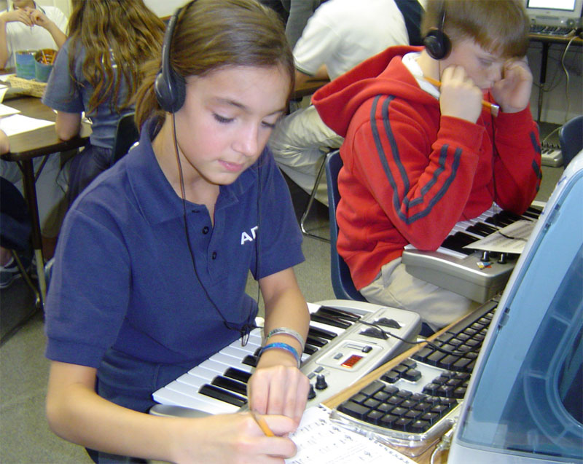
Assessment
- Continuous evaluation
- Assessment informs planning
- Targeting skill and developmental levels
Blue Ribbon Schools believe in ongoing formative and evaluative assessments. Teachers use data to plan lessons and target appropriate skill and developmental levels.
St. Anne School Laguna Niguel, CA
The single most important factor is determining student benchmarks. Quality instruction cannot take place until the needs of each child are identified and addressed. St. Anne teachers go to great efforts to determine where each child is in terms of his or her reading performance. On a daily basis, teachers use a variety of assessment tools to gauge their students’ performance. These include, but are not limited to, quizzes, tests, reports, and teacher-created rubrics designed to evaluate each student’s reading performance.
Teachers use this assessment data to: (1) tailor their curriculum to address any specific individual needs of their students; (2) home in on areas of strength and areas in need of improvement within their curriculum, and (3) share data with staff to determine if the curricular programs are aligned across the grade levels.
Lafayette Elementary School Washington, DC
[We conduct] continuous assessment of student progress and implementation of enrichment or remediation activities using that information. Each first grade student is evaluated three times during his or her year at Lafayette by the reading specialist to determine progress. This is in addition to the assessments the classroom teacher does as a matter of course. Our oldest students are provided copies of their testing histories to allow them to become full partners in improving achievement. Students who fall on the edges of different performance ranges are carefully monitored to make sure they do not fall back while other students are encouraged to stretch themselves and reach a higher level.
Stanley Elementary School Overland Park, KS
[We] identif[y] each child's instructional level and provid[e] books and materials at that level for children to work with each day. This is accomplished by teachers administering authentic assessments often and then planning both skill lessons and activities using materials appropriate for the various student levels. The principal, classroom teachers, and specialists work together to meet each child's needs. We keep sight of the fact that we are teaching children not just programs.
Smith Valley Elementary School Kalispell, MT
[We ensure that a] high level of individualized support [is] given students. Students are regularly assessed and then provided with high quality, rigorous instructional support tailored to their individual needs. This individualization is particularly evident in the lower primary grades of kindergarten through second.
Meadow Drive Elementary School Albertson, NY
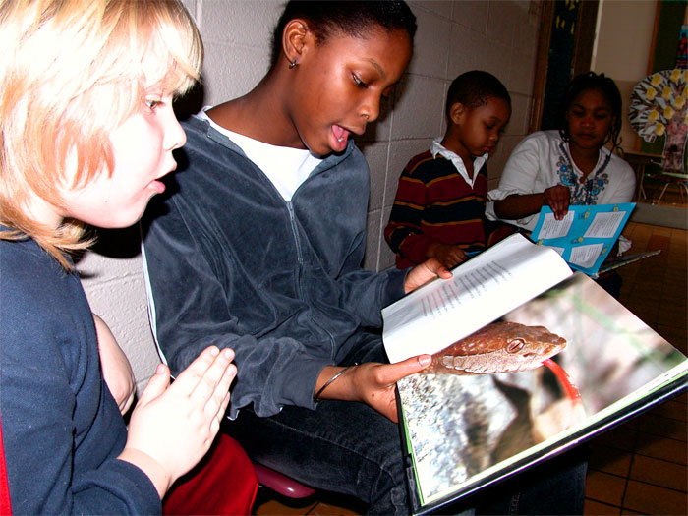
[We] use. . . disaggregated data from various assessments to plan instruction. The assessment data is analyzed and examined systematically in order to provide valuable information for decision-making, establishing priorities, and comprehensive planning that will result in improving student achievement and school performance. Using data that reflect the strengths and weaknesses of each student enables teachers to implement strategies and best practices to strengthen skills and concepts and/or to intervene with successful research based techniques.
Carolina Forest Elementary School Myrtle Beach, SC
The single biggest factor. . . is disaggregating data and differentiating instruction based on the data. We use our state assessment, Measures of Academic Progress (MAP) data, and standards-based assessments to pinpoint the areas of strength and weakness for every student. Once we have identified these areas we are able to differentiate our instruction to meet the needs of all children in our school. By using these data sources throughout the year we can be proactive and forward-thinking. Our teachers meet weekly with our two curriculum specialists to study trends in the data and make adjustments in our instruction and practices.
Arlington Traditional School Arlington, VA
ATS has focused on reading as the key to acquiring knowledge. We firmly believe that all students must learn to read, so that they can read to learn. We feel that daily assessment, formal and/or informal, should drive instruction in our comprehensive, balanced program. Because each student’s developmental needs are assessed throughout the reading process, we are able to provide the appropriate teacher-directed instruction necessary to further each individual’s learning. Specialists and classroom teachers work collaboratively to implement instruction that meets student needs. We focus on early phonemic awareness and teacher-directed phonics instruction.

Student Support
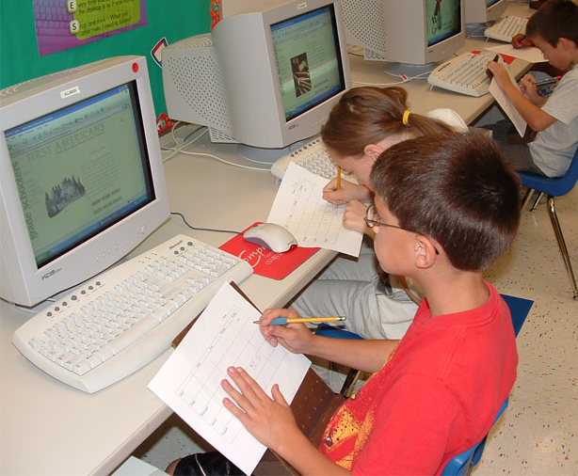
- Additional support
- Early identification
- Parental support
Blue Ribbon Schools support all students. Early intervention is key and additional programs help students during and after school. Parental involvement is encouraged. Students are expected to read at home.
Esparto Middle School Esparto, CA
We know the reading scores/level of each and every student and develop a program of instruction AND support for every student. Seventy two percent of our 6th graders enter EMS reading below grade level (over 1/2 of them read 3 or more years below). As a result, every 6th grader has a "reading" support class within his/her regular school days in addition to his/her regular language arts class. This is done without sacrificing any other subjects or without pulling students out of a class due to our "block schedule."
All migrant students and EL learners receive additional assistance during the regular school day in the reading lab where they are taught reading and language English by a bilingual teacher. All Title 1 students receive pull-out assistance (without sacrificing class [time]). They are also invited to an after-school intervention reading class at least once during the school year. Over 69% of our students attend some type of after-school class. Classes are offered 4 days a week.
Northwood Elementary School San Jose, CA
[We use] individual student test data from district literacy tests K thru 3rd and STAR Testing results to immediately tag those children who need supplemental instruction and individual tutoring. All Northwood students scoring below 30% on standardized tests, showing specific weaknesses in K-3 literacy testing, or through teacher recommendation are by the end of September in supplemental instructional support programs before or after school. In addition, those students scoring below 30% receive an additional 15 minutes daily of individual tutoring in reading with a Title 1 reading tutor trained in remedial reading support. We believe that children struggling academically need more academic instruction. . . not
less. . . early rather than later. . . and for as long as testing shows it is needed.
Handley Elementary School LaPorte, IN
Early interventions in grades Kindergarten through third support the students from grade level to grade level so that [entering] the intermediate grades they are able to read to learn rather than learn to read. . . Kindergarten teachers plan and teach 30 minute literacy groups using parent volunteers and support personnel to keep the groups no larger than six students per adult. At the first grade level, small groups of students in the lowest quartile are in a pull-out program with the Title I teacher. The first grade teacher and the Title I teachers also co-teach reading lessons. In the second and third grade levels, students in the second quartile benefit from the research-based HOSTS (Helping One Student To Succeed) mentoring program with support from the Title I reading teacher. Those in the lowest quartile work directly with the Title I teacher.
Eagle Valley Elementary School Clarissa, MN
Students are asked to read 20 minutes each night at home and parents are asked to sign the assignment notebook saying that this has been accomplished. The reading takes place regularly with topics the children choose so they are interested in what they are reading. Most of the reading is done at their grade level, and with the help of our “Star Reading” and “Accelerated Reading” programs, we can help students find books that are at their reading level. Reading is the key to becoming a good reader, so anything one can do to get students to read more will help their reading.
Highland Acres Elementary School Bismarck, ND
[Our] teachers use a core reading curriculum with a concentrated approach of direct, intensive and systematic instruction. There are many efforts made to diversify the materials used for supplementing the basal series in order to offer what is needed by each of the students. Parents and families are an integral support to the enrichment of reading instruction by lending a hand with at-home practice in such endeavors as reading aloud, spelling, and written reports. Both for home use and classroom use, there is marvelous involvement in “real” reading through high circulation of library and technology resources.
Yeshiva of North Jersey River Edge, NJ
Our Special Needs Resource Room [has been] most important. The staff tests the children, engages in early intervention, offers support in small group settings and consistently monitors the children's progress. They advise the mainstream classroom teachers and help them design modifications to meet individual needs. The Resource Room's vigilance and efforts are the main contributing factors in preventing student failure and improving student performance.
In addition, the Yeshiva also provides self-contained classes for students who are not yet ready for a traditional classroom setting. Specially trained teachers utilize varied educational techniques to provide for the individual needs of the students. Class size is limited to eight students, who are supervised by at least two staff members. Many of these pupils are able to successfully participate in a variety of mainstream classroom activities.
Perrysville Elementary School Pittsburgh, PA
Collaboration and teamwork [are] the biggest factor[s]. Perrysville School has a full day kindergarten program that stresses the basic skills necessary for reading. In addition, each student K-3 is assessed using the DIBELS to monitor skill acquisition. Students who are having difficulty are given intervention and assistance immediately. The school is fortunate to have a remedial reading teacher available to work with students individually or in small groups. In addition, the District has an Instructional Support Team headed by an instructional support teacher. The parent is included in this team, and as children have difficulties they are referred to this team for intervention and assistance.



