Pu`uhonua o Honaunau National Historical Park
47th Establishment Day Annual Cultural Festival

Saturday, June 28, 2008
9:00AM – 3:00PM

The community is invited to join the park for “Na Mea Hana Lima na Kupuna” (the Working Hands of Our Ancestors). This annual event is in celebration of the park’s 47th Anniversary and Annual Establishment Day.

The festival is a special time when children, kupuna, and visitors come together for two days of fun, laughter, sharing, and learning. Visitors can experience, interact with, and be inspired by a “living culture.” The Festival has become a tradition for the local community, an event where the younger generation can learn about their culture and experience their heritage. As our kupuna leave this world, it becomes more important that they have the opportunity to share their knowledge. This Festival provides a time and place where cultural demonstrators and artisans can practice their craft and train a new generation of practitioners.

This event is free to the public; park entrance fees are waived. The Festival is sponsored by The Council for Native Hawaiian Advancement, the Keomailani Hanapi Foundation, and the Hawaii Natural History Association.

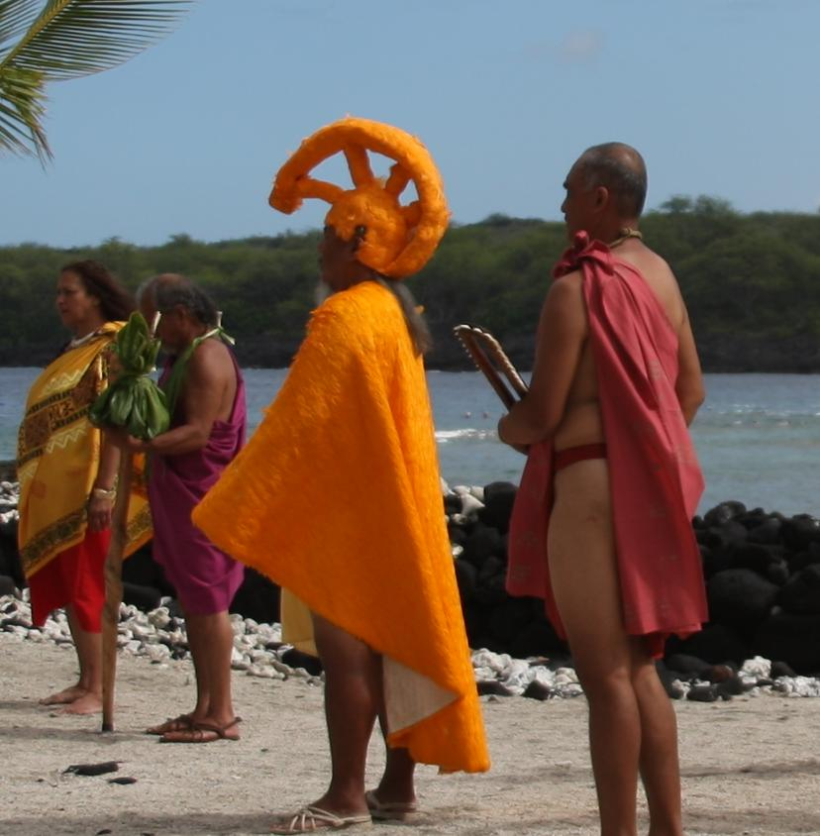
9:00 Royal Court (opening procession)

10:00AM – 3:00PM Arts/Crafts on the Palace Grounds:
Hula Dancing Coconut frond-weaving
Lauhala weaving Canoe rides
Hawaiian games Awa tasting
La`au Lapa`au Feather kahili-making
Hawaiian story telling Pulumi Ni`au
Ohe kapala Wood carving
Haku lei-making Native Hawaiian plants
Fish Hook making Ni`ihau Ipu carving
Pahu Drum making Kalo demonstration
Kapa making
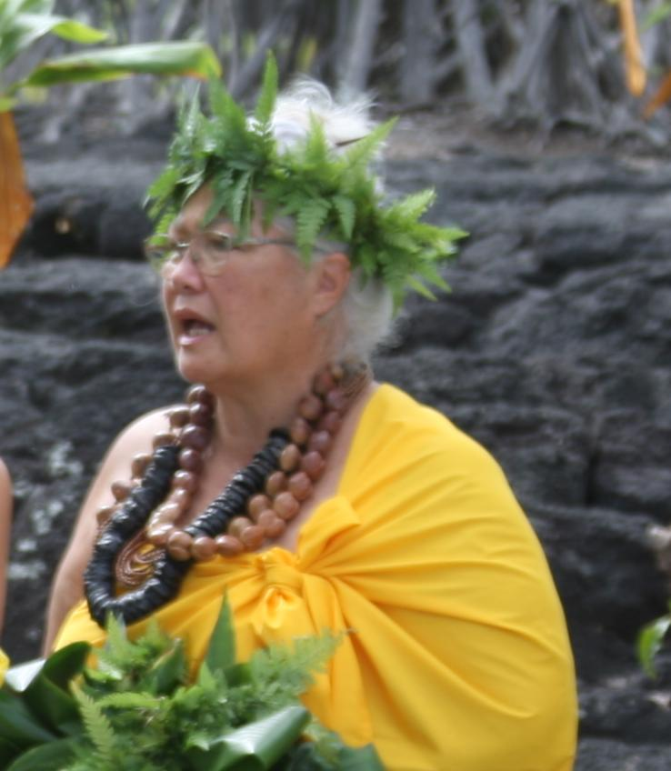
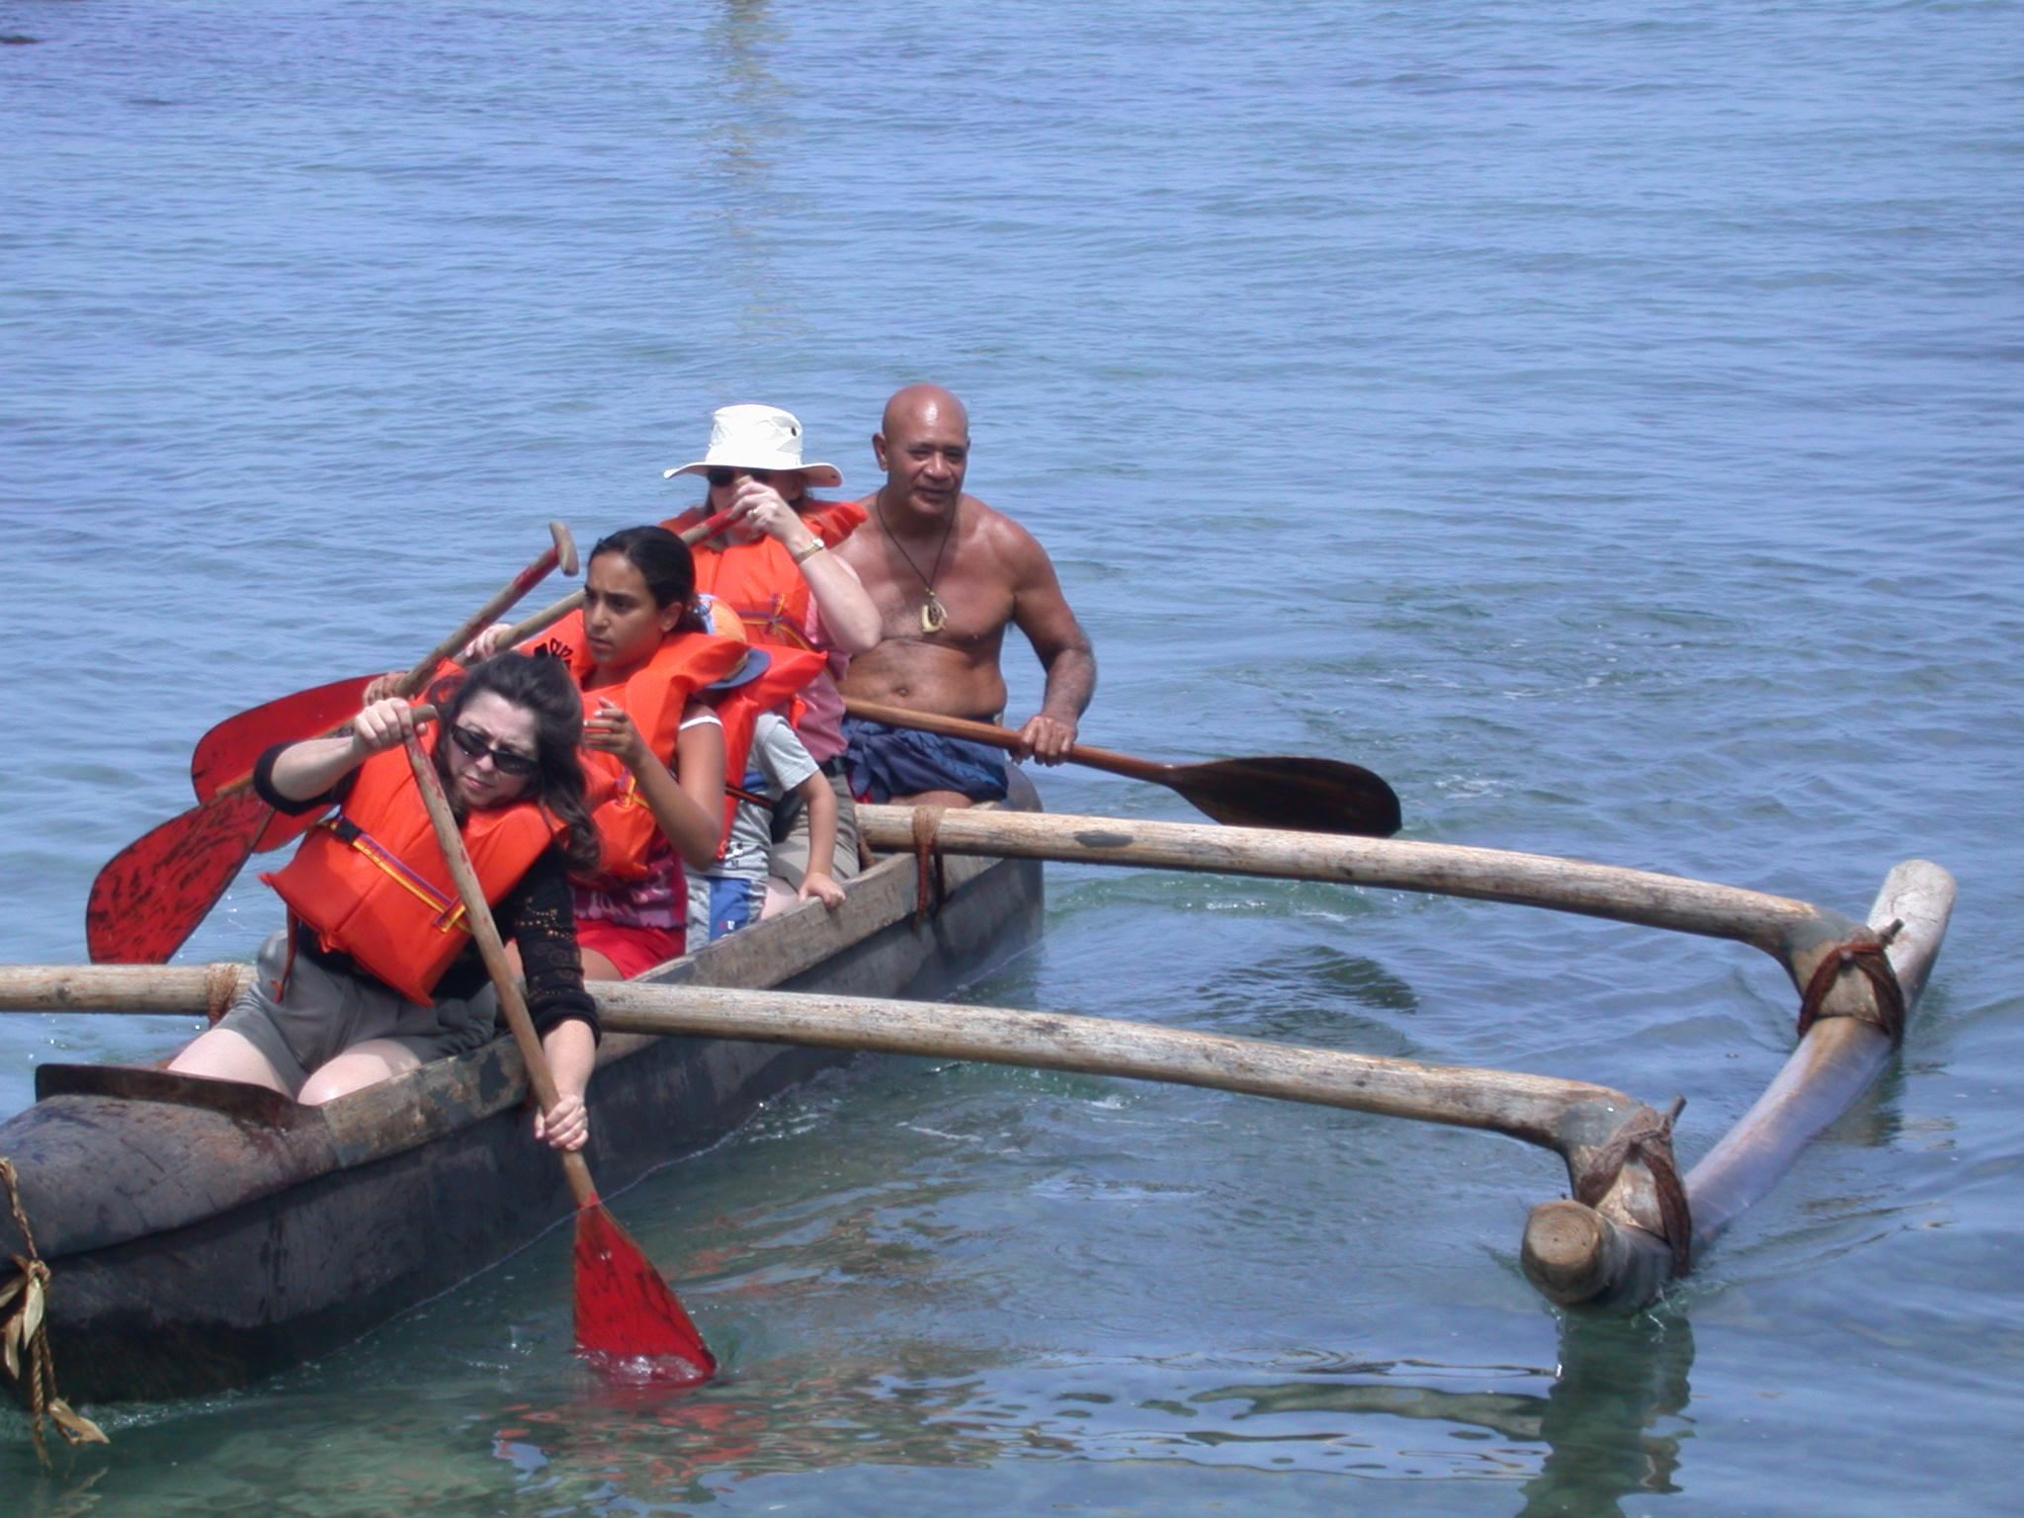
Pu`uhonua o Honaunau National Historical Park
47th Establishment Day Annual Cultural Festival

Sunday, June 29, 2008
9:00AM – 3:00PM

Arts/Crafts on the Palace Grounds:
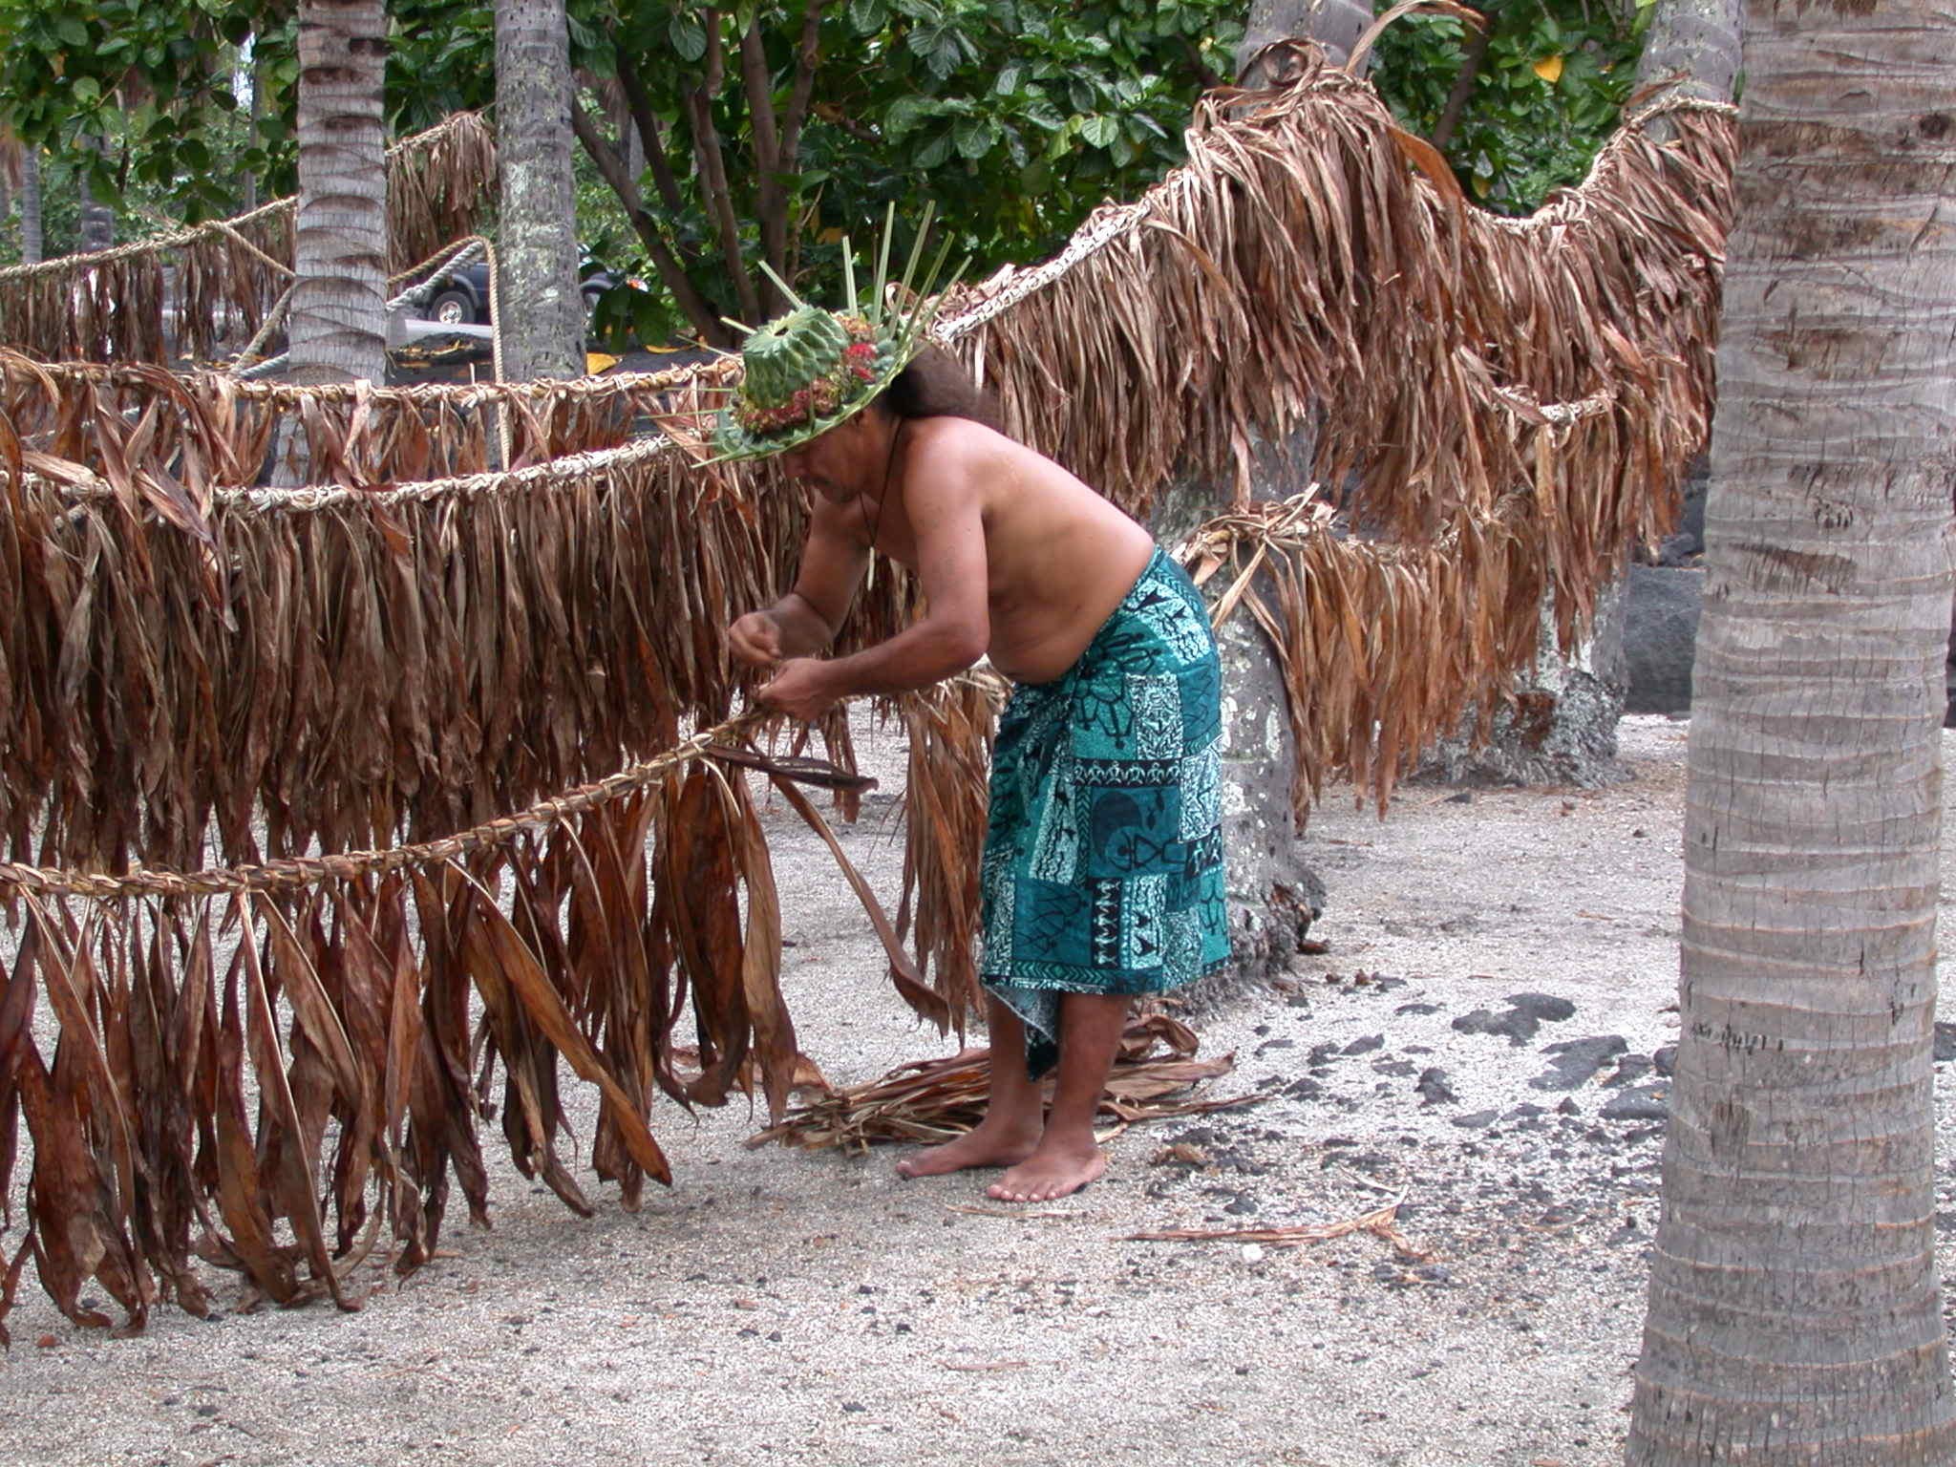
Hula dancing
Coconut frond-weaving
Lauhala weaving
Hawaiian games
Awa tasting
La`au Lapa`au
Feather kahili-making
Hawaiian story telling
Pulumi Ni`au
Hawaiian implements display/ohe kapala
Wood carving
Native Hawaiian plants
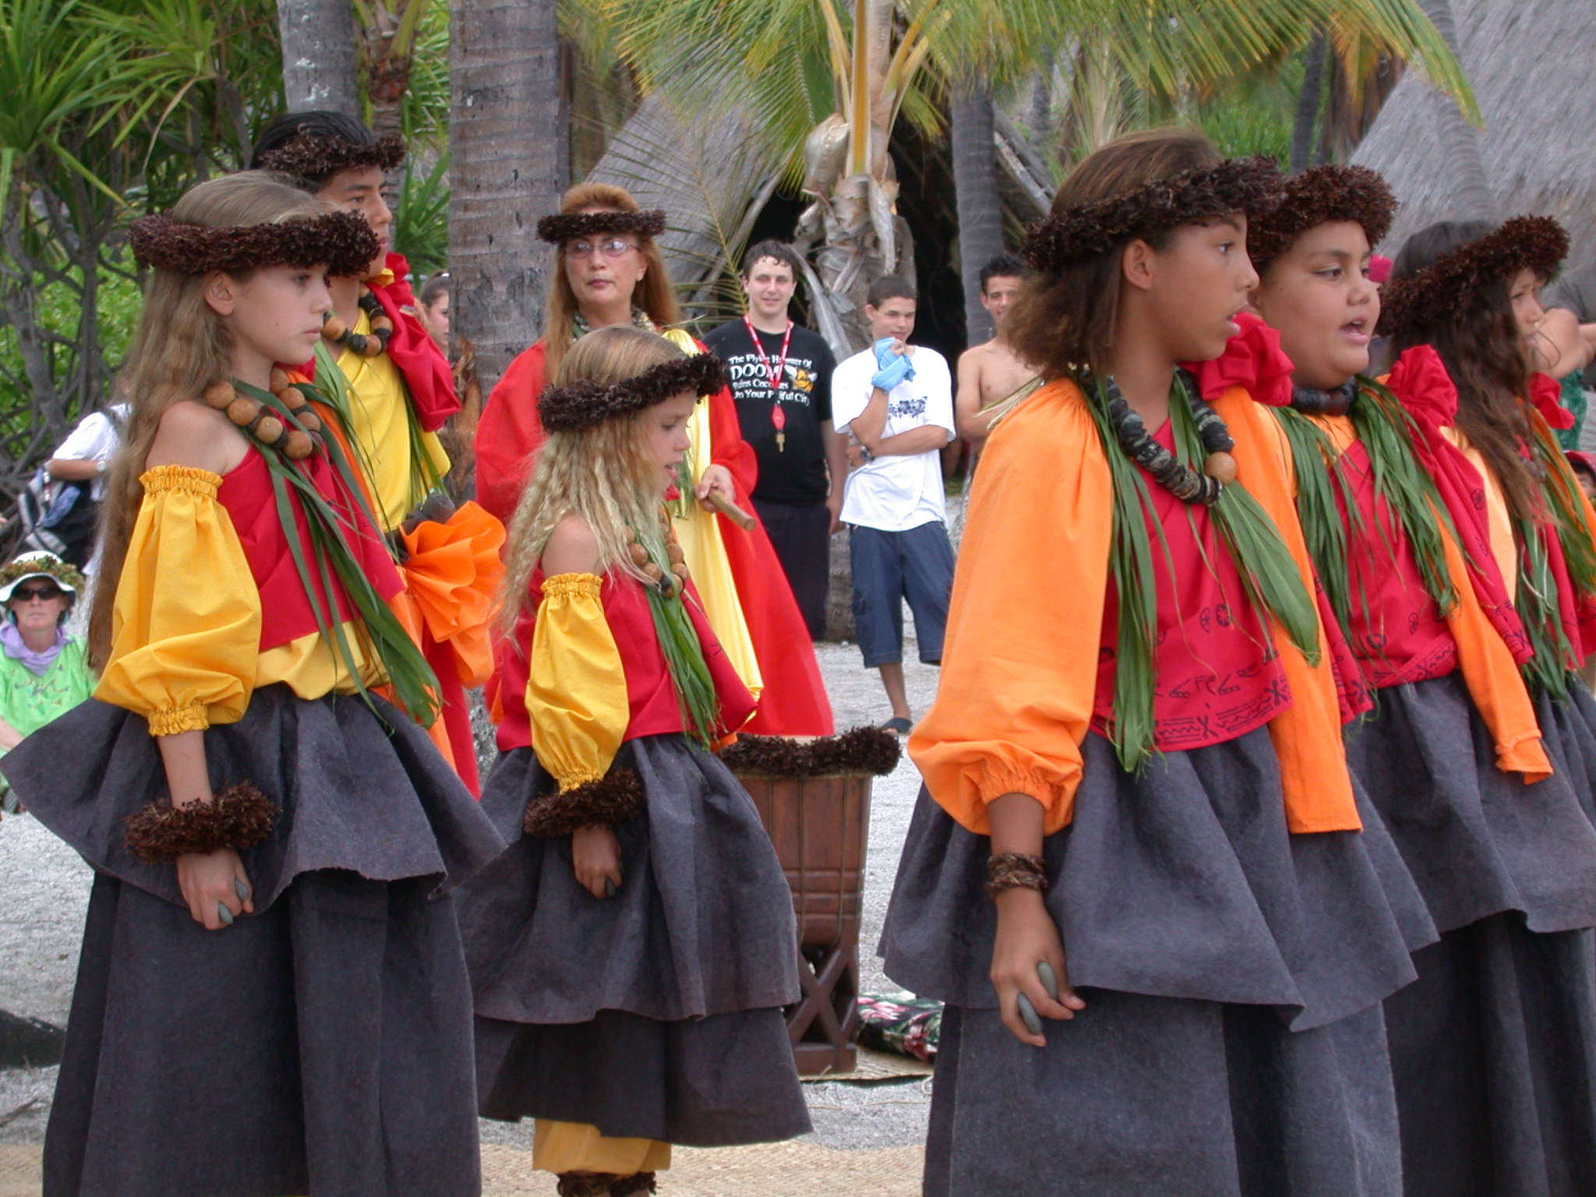
Fish Hook making
Ni`ihau Ipu carving
Pahu Drum making
Kalo demonstration
Kapa making

10:00 – 12:00 Hawaiian food tasting

1:15PM Hukilau demonstration

2:00PM Royal Court (closing)


