POLAR Spacecraft Status As of: Weds 25 June 03 15:00 EST
(changes from last week in bold border)
Subsystem/  Component | NOAA-11H  Standby PM  STIP data only | NOAA-12D  Standby AM  STIP data only | NOAA-14J  Standby AM  STIP data only | NOAA-15K  BACKUP AM  GAC data only | NOAA-16L  PRIMARY PM  GAC&LAC data | NOAA-17M  PRIMARY AM  GAC&LAC data
LAUNCHED | 09/23/88 | 05/14/91 | 12/30/94 | 05/13/98 | 09/21/00 | 6/24/02
CNTL OBP | OBP2 | OBP2 | OBP2  OBP1 inoperative | OBP2 | OBP2 | OBP2
BUS | A-BUS  XSU-1 | B-BUS  XSU-1 | B-BUS  XSU-2  XSU-1 inoperative | B-BUS  XSU-1 | B-BUS  XSU-1 | B-BUS  XSU-1
BUS VETO | NO | NO | NO | NO | NO | NO
ADACS | DEGRADED  (Y, Z- Gyros Failed) Reduced Gyro S/W | NOMINAL  RGmode=Monitor Normal mode | NOMINAL  Rgmode=Disabled  SS check Disabled when mode=YGC | OK  Rgmode=Monitor  Normal mode  Gyro-3 Off/Anom | NOMINAL  Rgmode=Disabled  Normal Mode  Gyro investigation | NOMINAL  Rgmode=Disabled  YGC-Rwheel swap & return 6/1&2
RXO | PRI  BU random enables  ETCUP +70 mSecs | PRI  BU random enables | PRI  BU random enables ETCUP –7.3 Msec  -150 ms on 6/10 | PRI  ETCUP -8 mSec  +100 ms on 6/10 | PRI  ETCUP –5.1 mSec  -100 ms on 6/10 | PRI  ETCUP -1 msec  -100 ms on 6/10
CLOCK DIV | 2 | 2 | 2 | 2 | 2 | 2
MIRP | ON | ON | ON  External Sync.  Rephase Disable  Rephased Daily | ON  External Sync, Rephase Disable.  Rephased Daily | ON  External Sync,  Rephase Enabled | ON  Internal Synch  Rephase Enabled
TIP SIDE | 1 | 1 | 1 | 2  Since 4/24/03 | 1  Analog telem drifting | 1
DTRs | 1A, 2B, 3, 4A Safestate - 2B, | 1, 3, 4, 5B  Safestate- 1B | 1, 2B, 3A, 5 Safestate- 1B | 1, 2, 3, 4 Safestate 1B EOT | 1,2,3,4A  Safestate 3A  4B TOAR 418  (STIP only) | 1,2,3,4  Safestate=1B  DTR2-SSR  DTR5 TOAR 420
VTX | OFF | 1  since 4/20/03 | OFF  Since 8/14/02 | 1 | INOP  OFF since 11/15/00 | 2
BTX | 2 | 1 | 2 | 1 | 1 | 2
STX | 3 – TIP  1,2 - Playback | 1 – HRPT;  2,3 - Playback | 3 – HRPT  2, 1 – Playback | 1, 2, 3 - degraded;  2 Omni–HRPT; 4- Playback | 1 – HRPT;  2– Playback;  4 – Playback  3 low power unused | 3 – HRPT  TOAR424 low power  1&2 Playback  4 – TIP  TOAR423 low power
POWER  (Array offset, charge and eclipse states, sun angle) | Array Off -30°  Since 6/19/02  Eclipse all year  Sun angle 79  Steady Trend  Batts 1-3= LRC  VT1,2=6/8  VT3 = 8/11  Charge state safe  trip disabled | Array Off 0°  SA Move to –30 deg offset planned for 6/26 @ 13:30Z  Eclipse Season  Peaked 22 Jun 03  Sun Angle at 38 TOPPED OUT Steady Trend  Batts 1&2=LRC  V/T=4 | Array Off -45°  Since 6/19/03  Sun Angle at 36  steady trend  Batts 1-3= LRC  Batt 1&3V/T=8/11  Batt2 VT=9/11 )  Eclipse Season  PEAKED 6/16  Shunt Degradation TOAR 425 | Array Off -45°  Since 1/25/01  Sun Angle at 35 steady trend  Batts 1-3= LRC  V/T=7/9  Eclipse Season  Peaked 6/15 | Array Off -40°  Since 7/16/02  Eclipse all year  Sun Angle 68 TOPPED OUT Steady Trend  Batt2A TOAR 403  Batts 1-3= LRC  V/T=4/8 | Array Off. –35  Since 7/1/02  Eclipse all year  Sun Angle at 70 Steady Trend  Batts 1-3= LRC  V/T=4/8  TOAR 416 on Batt2A temp
AVHRR | OFF  Failed Power Supply | ON  Nominal | ON  Scan Motor degraded 5/1/03 STATUS=RED | ON  Rare Scan motor surges. Last  Incident 6/15/02 | ON  Nominal (3B)  3A-B switch disabled | ON  Nominal (3A&B)  3A-B switch enabled
AMSU-A1 |  |  |  | ON  Ch14 inoperative  Ch11 inoperative | ON  TOAR 415 on primary PLLO chans 9-14 bias shift.  TOAR 417 on Backup PLLO  Status=Yellow | ON  TOAR 413 Chan-3 popcorn noise  TOAR 414 on PLLO chans 9-14 bias shift.  TOAR 421 on Channel-7 elevated NEDT’s noise
AMSU-A2 |  |  |  | ON | ON  Space Position-2 | ON
AMSU-B |  |  |  | ON  Bias in All Channels.  Motor current surge 6/8/03 | ON  Space Position-3 | ON
HIRS | OFF  Filter Wheel Anomaly | INOP  Filter Wheel turned OFF 10/17/02. Electronics On | ON  Operational | ON  Operational  FW in Hi power,  FW Heaters OFF  Filter Motor current surges. Last incident 6/21 | ON  Nominal | ON  1 Pixel cross track misalignment .
MSU | INOP  OFF, Antenna Failed | INOP  Scan Motor OFF since 3/12/03  Electronics ON. | ON  Scan motor and antenna problems
SSU | ON |  | ON
DCS | ON | ON | ON | ON | ON  Nominal | ON  Nominal
SARR | ON  Low signal |  | ON | ON-A  All AGC Mode  Intermittent failures for 243MHz A&B | ON-A  All AGC Mode  (B-side Receiver in FG mode)  243 MhZ INOPERATIVE. | ON-A  Nominal  All AGC Mode
SARP | ON  Nominal |  | OFF  Failed Power Supply | ON  Nominal  RCVR B/W = 2 | ON  Nominal  RCVR B/W = 2 | ON  Nominal
SEM |  | ON  Elec-CH-HVPS=4  Prot-CH-HVPS=0 | ON  Elec-CH-HVPS=0  Prot-CH-HVPS=0  1 of 4 Telescopes inoperative | ON  Nominal  E-CDEM-HVPS=2  Since 1/14/03  P-CDEM-HVPS=0 | ON  Nominal  E-CDEM-HVPS=4  P-CDEM-HVPS=4  since 4/15/03 | ON  Nominal  E-CDEM-HVPS=2  P-CDEM-HVPS=3  since 2/18/03
SBUV | INOP  Grating motor OFF since 5/29/03  Electronics and Heater remain ON |  | ON  Occasional  Reduced Grating Drive Motion  Reduced operations profile started 6/5/03 |  | ON  Backup Diffuser in use since 6/16/03. Primary diffuser has antenna deploy anomaly, TOAR 426  AMSU EMI causing erratic Behavior from PMT cathod, in range 3 No corrective action possible | ON  Nominal  Anode Mode
SADPOS |  |  |  | N/A | ON  ENABLED  MFactor =50% | ON  ENABLED
 | N11 | N12 | N14 | N15 | N16 | N17

COMMENTS/CHANGES:
NOAA-11 No changes since previous report.

NOAA-12. Analysis by EMOSS engineers detected bus voltage “instabilities” similar to those noticed on N14 which preceded that
spacecrafts autonomous switch to its backup mode controller and boost regulator on 29 Apr. This bus voltage instability is indicative of possible shunt stress or degradation. Therefore, to reduce this stress, the charge current will be reduced by moving the solar array offset from its current position of zero degrees to a –30 degree offset with the sun. This operation is planned for implementation on 26 Jun at 13:30Z

N12 maximum eclipse duration (22% darkness per orbit) was reached on 22 Jun. This percentage darkness value should remain steady until the second week of July after which will begin to decrease steadily until the spacecraft goes back into full light on the 3rd week of August. No power problems have been detected during this eclipse season but as the percentage light time increases toward 100%, so to would the amount of battery charging which reinforces the decision NOAA has made to move the solar array to reduce shunt stress.

NOAA-14: To increase the efficiency of battery charging, on 12 Jun the N14 Solar Array offset was changed to –50 degrees (from –55). Subsequent analysis indicated that this did enhance battery charging but not to maximum efficiency. Since bus voltage remained nominal and steady since the move it indicated that the shunts have not been unduly stressed because of increased charging resulting from the move. Therefore, to maximize battery charging efficiency, a second adjustment of the solar array offset was implemented on Thursday, 19 June at 18:15Z to an offset of –45 degrees. This move has achieved the optimum balance of maximum charge current vs minimum shunt stress (Illustration 1) while have a relatively insignificant influence on payload thermal profiles (Illustration 2).

N14 maximum eclipse duration (20% darkness per orbit) was reached on 18 Jun. This percentage darkness value should remain steady until the first week of July after which will begin to decrease steadily until the spacecraft goes back into full light on the 2nd week of August. Other than the shunt anomaly of 29 Apr (which is not attributed to eclipse season) no power problems have been detected during this eclipse season. However, as the percentage light time increases toward 100%, so to would the amount of battery charging which may ultimately require yet another move of the solar array to reduce charging and shunt stress, perhaps back to –55 degrees, in mid to late July.

AVHRR scan motor current generally improved during the past week as it has for the past 3 weeks. However, its scan motor current remains relatively elevated with imagery still anomalous (illustration 3, and 4).

NOAA-15: N15 maximum eclipse duration (19% darkness per orbit) was reached on 18 Jun. This percentage darkness value
should remain steady until the last week of June after which will begin to decrease steadily until the spacecraft goes back into full light on the 1st week of August. No power or thermal problems have resulted on N15 from this eclipse season.

The HIRS filter motor current surged on 15 Jun and returned back to nominal on 20 July then surged again on on 21 June and has since returned to nominal (illustration 5). These surges appears to be similar to others which have become a feature on N15 HIRS in the past two years. The effect of this surge on imagery quality is inconclusive (illustration 6) and EMOSS engineers have not received word of any imagery degradation from users.

Both AMSU-B motor current and AVHRR scan motor current on N15 remained nominal throughout the past reporting period.

NOAA-16: The N16 SBUV diffuser position encoder remains on the backup unit since being commanded there by EMOSS
engineer Will Kent on 16 Jun. On 17 and 18 June the diffuser position and solar irradiance values showed the same anomalous readings that originally caused the switch to be implemented. However, starting on 19 June, the diffuser has been getting to the correct position and solar irradiance data is back within specs. Will Kent is investigationg this situation for EMOSS. The backup diffuser is expected to remain in use at least through the end of the month.

No additional testing on STX-3 has occurred since the previous report.

NOAA-17: RF testing at Svaalbard will re-commence starting 28 June. These tests will dump GAC data over the Svalbard site
twice a day using N17 and a variable combination of S-band transmitters and frequencies. These tests are being conducted to validate the Svaalbard ground station capabilities ability to support METOP. This testing will continue out of the schedule until August 23rd.

NOAA-N Level 2 Data base validation is progressing well and expected to be completed in time for the 25 Jul delivery date to
NASA. Azi Dinat is overseeing this effort for EMOSS.

MISC: Meetings supported by EMOSS included PACS CDR at ISI, MOWG, and Data Base Delivery meeting at NASA.

Illustration 1: N14 EPS Analysis relative to solar array movements
Battery 1,2 and 3 charge currents, Shunt driver and shunt partial voltage, Bus voltage.

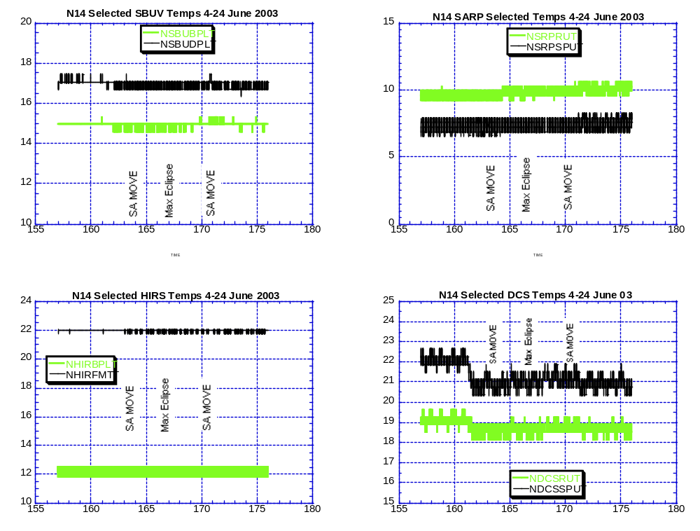

Illustration 2: N14 Payload Thermal Analysis relative to solar array movements

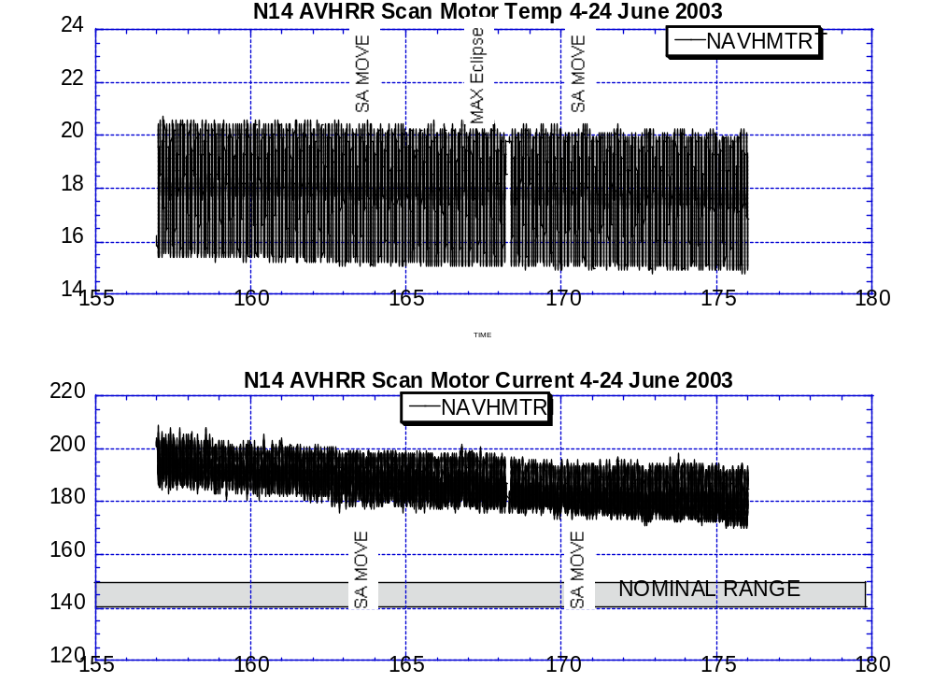
Illustration 3: N14 AVHRR Scan Motor Health Analysis

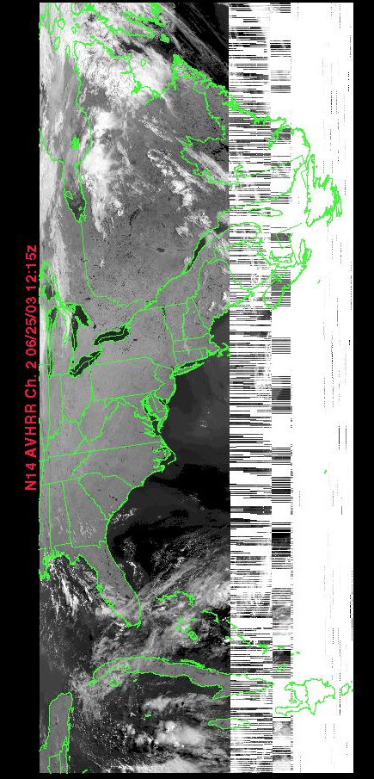

Illustration 4 N14 AVHRR Imagery Analysis, 25 June 2003

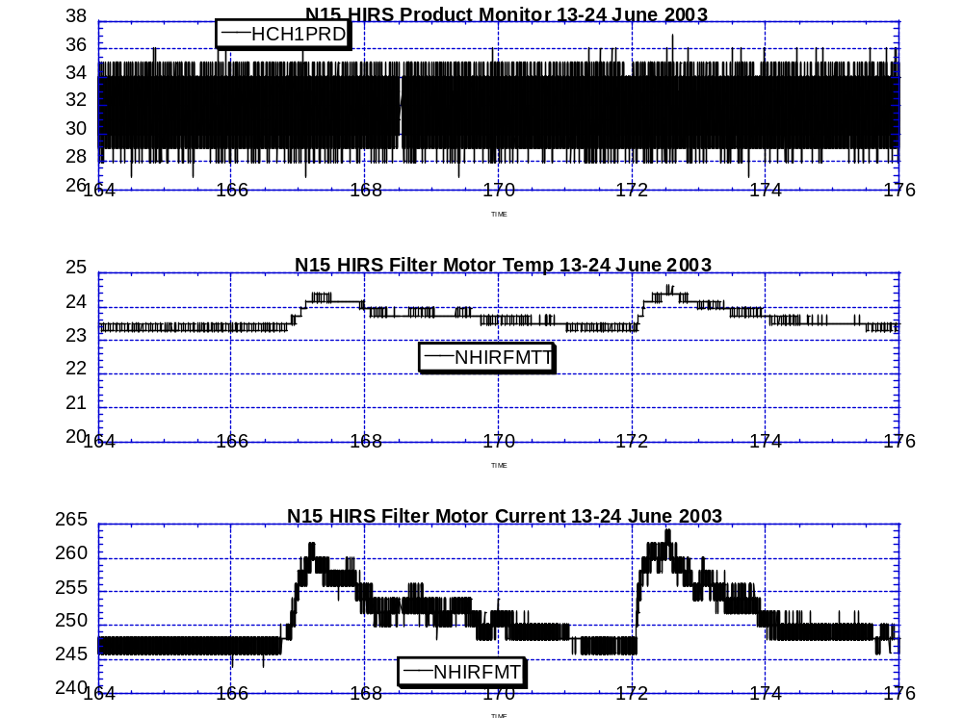

Illustration 5: N15 HIRS Filter Motor Health

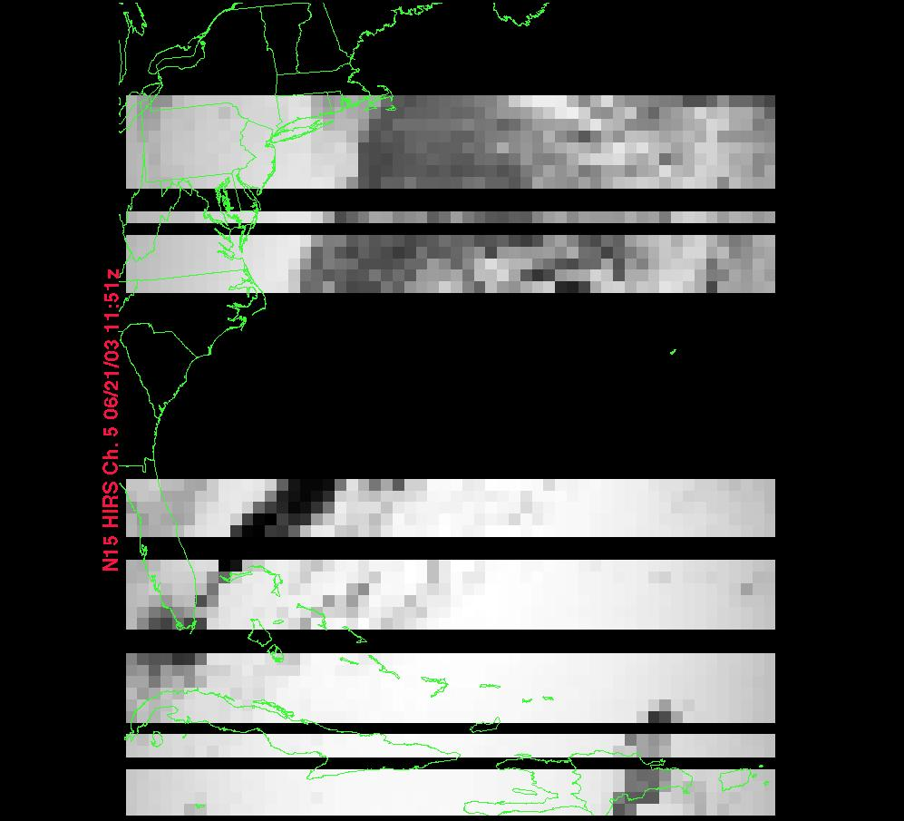
Illustration 6: N15 HIRS Image at Peak of most recent filter motor current surge (21 June 12:00Z)

POLAR SPACECRAFT TIP CLOCK ERROR

WEEK ENDING June 20, 2003
DAY/DATE | NOAA-11 | NOAA-12 | NOAA-14 | NOAA-15 | NOAA-16 | NOAA-17
FRI. 06/13 | -1501 msec | +539 msec | -071 msec | +051 msec | -035 msec | -028 msec
SAT. 06/14 | -1531 msec | +098 msec | -070 msec | +050 msec | -035 msec | -029 msec
SUN. 06/15 | -1661 msec | +092 msec | -069 msec | +049 msec | -035 msec | -029 msec
MON. 06/16 | -1091 msec | +085 msec | -069 msec | +049 msec | -035 msec | -027 msec
TUE. 06/17 | -1321 msec | +081 msec | -069 msec | +048 msec | -036 msec | -026 msec
WED. 06/18 | -1251 msec | +075 msec | -068 msec | +050 msec | -036 msec | -026 msec
THU. 06/19 | -1181 msec | +069 msec | -067 msec | +049 msec | -032 msec | -026 msec

EMOSS POC for this chart is JIM SHEPHERD

NOAA-12: As of 09/03/02 the TIP clock is corrected daily by +70 msec to compensate for drift.
NOAA-14: As of 04/23/03 the TIP clock is corrected daily by –-7.3 msec to compensate for drift.
NOAA-15: As of 04/23/03 the TIP clock is corrected daily by –-8 msec to compensate for drift.
NOAA-16: As of 04/23/03 the TIP clock is corrected daily by –5.1 msec to compensate for drift.
NOAA-17: As of 04/23/03 the TIP clock is corrected daily by -1 msec to compensate for drift.

N12: ADDED 1250 mSecs to spacecraft command clock on 6 June
N14: SUBTRACTED 150 msec from spacecraft command on 10 June.
N15: ADDED 100 msec to spacecraft command clock on 10 June.
N16: SUBTRACTED 100 msec from spacecraft command clock on 10 June.
N17: SUBTRACTED 100 msec from spacecraft command clock on 10 June.
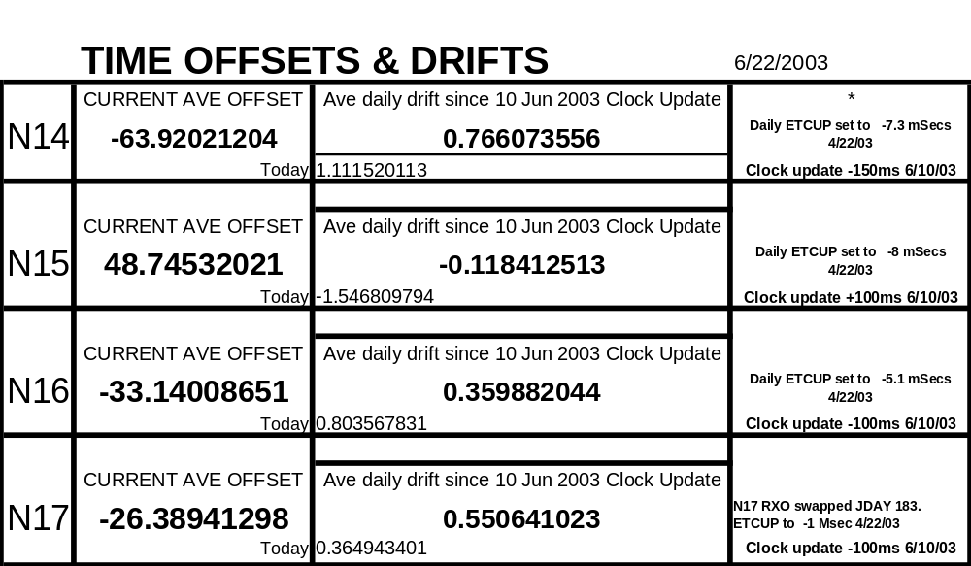

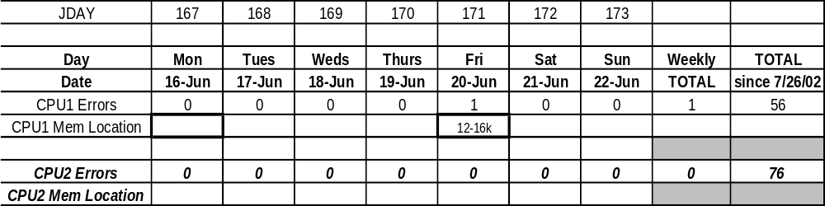
N17 Weekly CPU Scrub Report

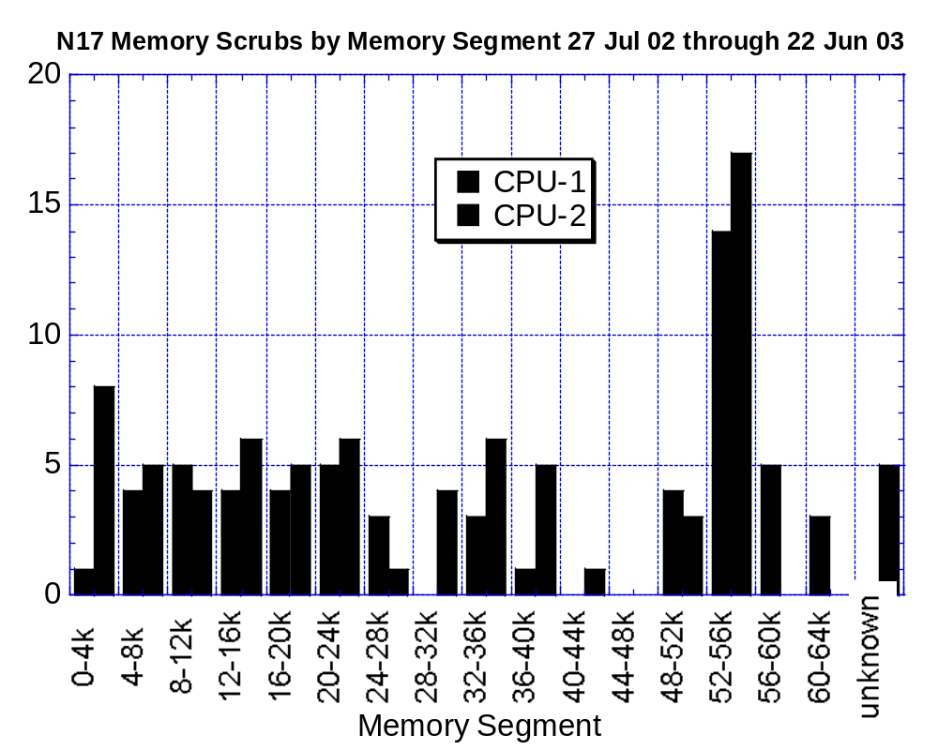

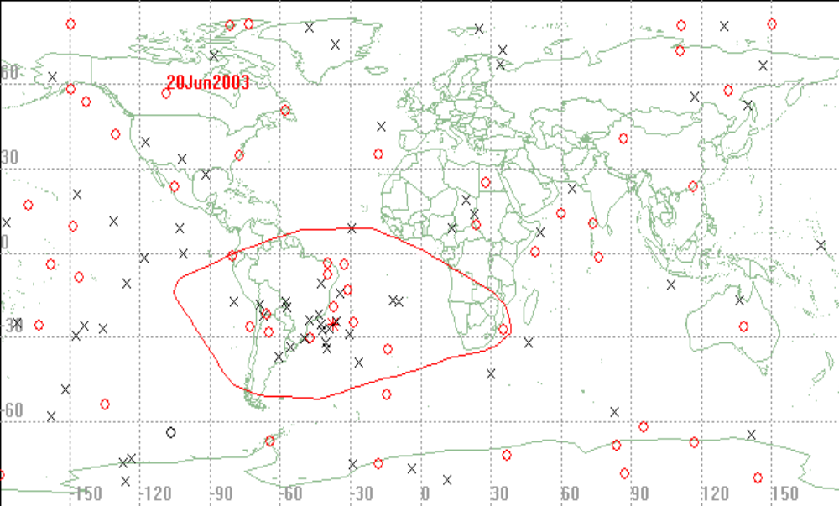

NOAA-17 Scrubber Hits by Geographic Occurrence since 27 Jul 02:

Red/Circle = CPU#1 Black/X = CPU#2
NOAA-17 Scrubber Hits from 16 Jun 2003 through 22 June 2003:

PACS DATA AVAILABILITY (%)
June 13, 2003 through June 19, 2003
JDAY 164-170

 |  |  | NOAA15 | NOAA14 | NOAA11 | NOAA16 | NOAA17
Friday | 06/13 | 164 | 99.9 (a) | 100.0 | 100.0 | 100.0 | 100.0
Saturday | 06/14 | 165 | 100.0 | 100.0 | 100.0 | 100.0 | 100.0
Sunday | 06/15 | 166 | 100.0 | 100.0 | 95.3 (b) | 100.0 | 99.9 (c)
Monday | 06/16 | 167 | 99.9(d) | 100.0 | 90.4 (e) | 100.0 | 100.0
Tuesday | 06/17 | 168 | 94.0 (f) | 85.7 (g) | 86.1(h) | 100.0 | 93.6(i)
Wednesday | 06/18 | 169 | 100.0 | 100.0 | 100.0 | 100.0 | 100.0
Thursday | 06/19 | 170 | 100.0 | 100.0 | 100.0 | 99.9 (j) | 100.0

Comments:

- Rev 26439/W: G4A noisy; 99.9% recovered.
- Rev 75940/F: S3A noisy; 99.4% recovered 3DL 3PE.
- Rev 05056/F: G4B noisy; 99.3% recovered.
- Rev 26461/F: G24A noisy; 99.3% recovered.
- Rev 75940/F: S4A noisy; 98.5% recovered 11DL 15PE.
- Rev 26473/W: G1A noisy; 98.6% recovered.
- Rev 43623/F: S3A noisy; 98.9% recovered 4DL 4PE.
- Rev 75960/F: S1A noisy; 97.5% recovered.
- Rev 05091/W: G3A noisy; 98.6% recovered.
- Rev 14123/F: G4B noisy; 99.9% recovered.
* System “A” losing telemetry, auto track problems.

DTR Inf. (*):
NOAA-11 DTR 1B -Inoperative.
DTR 2A/B -Frequently noisy
DTR 4B -Frequently noisy
DTR 5A/B -Inoperative
NOAA-12 DTR 5A -Inoperative.
DTR 2B -Occasionally noisy and short
NOAA-14 DTR 4A/B -Inoperative.
DTR 3B -Unreliable playbacks, Removed from operations.
DTR 2A -Inoperative, DOY/200
NOAA-15 DTR 5A/B - Inoperative
NOAA-16 DTR 5A/B -Inoperative
DTR 3A -safe state change 1B
DTR 4B –Inoperative 1/12/03
NOAA-17 DTR 5A/B-Inoperative 2/16/03 Anomaly

Acronyms:
DL – Drop lock(s) PE - Parity Error(s) DQR - Data Quality Report
BE - Bit Error(s) DAR - Data Accountability Report MFR - Multi-Function Receiver

