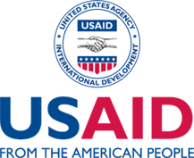

Democracy Fellows Program

INSTRUCTIONS FOR COMPLETING THE APPLICATION
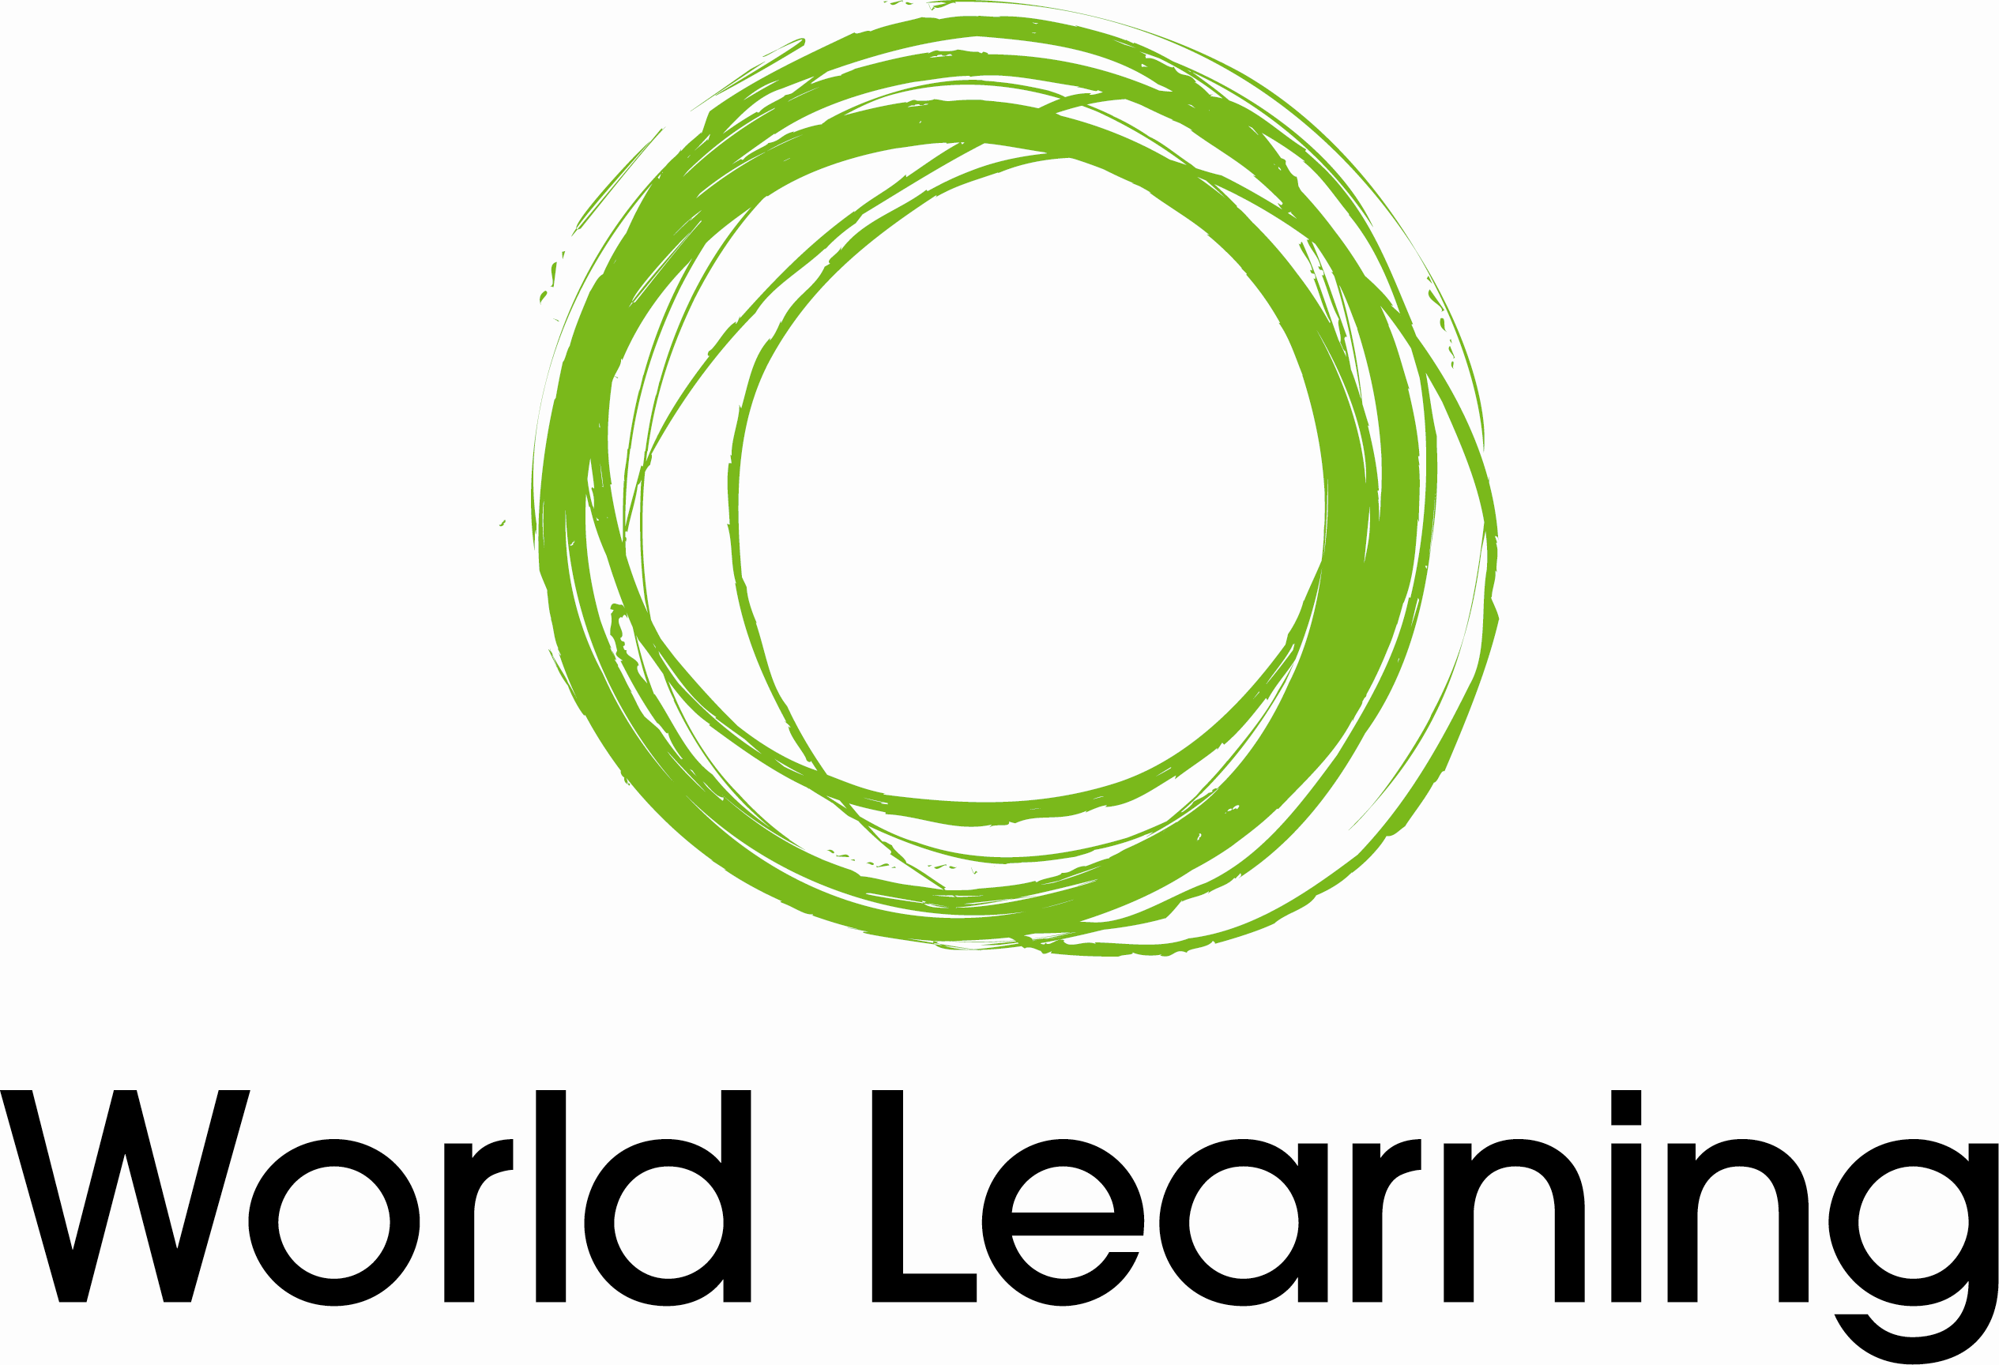
Applications should be submitted as a complete package, including (in order):

- _____ Application Form
- _____ Resume or C.V.
- _____ Personal Statement
- _____ USAID Form 1420 (biographical data sheet)

Applicants are required to include a salary history form (USAID Contractor Employee Biographical Data Sheet – Form 1420) with their applications. On form 1420, please leave items 4 to 7 blank. This information will be used to help determine the appropriate level for the applicant and to establish the fellowship budget.

Applications and supporting materials become the property of World Learning and cannot be returned. If you submit an application electronically, you must still submit a signed original application and USAID form 1420 by mail or fax.

World Learning accepts fellowship applications year-round and processes applications on a rolling basis. We can only process completed applications. We will notify you within 30 days of receiving your completed application whether your application is eligible for further consideration. Applications are considered active for at least one year from the date of receipt.

Please submit completed applications and supporting material to:

Democracy Fellows Program
World Learning for International Development
1015 15th Street, N.W., Suite 750
Washington, DC 20005

Tel: 202-408-5420
Fax: (202) 408-5397

E-mail: dfp.info@worldlearning.org

For additional information about World Learning or the Democracy Fellows Program, we invite you to consult World Learning’s website at http://wlid.usaid.gov or to contact the DFP staff at dfp.info@worldlearning.org.

Democracy Fellows Program

A. BIOGRAPHICAL DATA
1. Name (Title, First, Last):
2. Social Security Number: |  |  |  |  | 3. Date of Birth (mm-dd-yy):
4. Current Address:

5. Contact Information: Please check your preferred method(s) of contact
⁪ Work Phone: |  |  |  |  | ⁪ Fax:
⁪ Home Phone: |  |  |  |  | ⁪ Email Address 1:
⁪ Cell Phone: |  |  |  |  | ⁪ Email Address 2:
Above contact information valid until (mm-dd-yy):
6. Permanent Address (If different from above):

Telephone: |  |  |  |  | Fax:
7. Citizenship: |  |  | 8. Place of Birth (city, state, country):
9. Dependents: Indicate dependents proposed to accompany Fellow to the country of assignment.
Name | Relationship |  |  |  |  | Age
a.
b.
c.
(Attach additional sheet if required)

Please understand that the DFP cannot guarantee any funds for dependent travel or allowances.
These vary depending upon USAID’s needs and available funding.

B. EDUCATION: Please list advanced degrees below.
University/College |  | Degree |  | Major/Program of Study |  |  | Year

C. SKILLS AND EXPERTISE: Please list your current professional skills and areas of expertise using the Occupation Codes from the enclosed list.
1. |  |  | 5. |  | 9.
2. |  |  | 6. |  | 10.
3. |  |  | 7. |  | 11.
4. |  |  | 8. |  | 12.
D. OVERSEAS EXPERIENCE: Please list all pertinent overseas experience (both specific regions and countries), using the codes from the enclosed list, and note how it was obtained (e.g. living overseas, college study abroad, work abroad, etc.) and how long you were there.
Region | Country |  |  | How Obtained |  | Duration of Stay
E. HOW DID YOU LEARN ABOUT THE DFP?
⁪ USAID Website |  |  |  | ⁪ Attendance at Conference:
⁪ World Learning Website |  |  |  | ⁪ Other (please specify):
⁪ Print Advertisement (please specify):
⁪ Online Job Posting (please specify):
F. CERTIFICATION
I certify in submitting this form that the above facts and statements are true, correct, and complete.

Date: |  | Applicant Signature:
Please submit complete application and supporting materials to:
Democracy Fellows Program

World Learning for International Development
1015 15th Street, NW, Suite 750
Washington, DC 20005
Tel: (202) 408-5420 Fax: (202) 408-5397
Email: dfp.info@worldlearning.org
Website: http://wlid.usaid.gov

Democracy Fellows Program

Personal Statement

Please provide a statement that outlines how your fellowship could contribute to USAID’s democracy and governance activities in your area(s) of interest or expertise. Your statement should be no longer than two pages, and should address:
- Your professional interests and related democracy and governance experiences to date;
- Skills that you would bring to a Democracy Fellowship with USAID; and
- How USAID’s democracy and governance strategic goals and program objectives might be advanced if you are selected as a Democracy Fellow.

PROFESSIONAL PROFILE CODE SHEET |  |  | DEMOCRACY FELLOWS PROGRAM
OCCUPATION CODES
AOJ  AED  ADV  ANC  ANT  BPE  BED  CWE  CED  CVM  CSO  COM  CPA  CML  CMP  CMM  CLA  CUR  DEC  DEM  DOL  ECN  ERT  ELE  ENV  FIN  FSE  GEN  GWE  GOV  GPF  GMA  HIV  IME  ICT  ITE  IHR  JOU | Administration of Justice  Adult Education and Literacy  Advocacy  Anti-Corruption  Anti-Trafficking  Basic Primary Education  Bilingual and Inter-Cultural Education  Child Welfare  Civic Education  Civil Military Relations  Civil Society/NGO Development  Communications/Public Relations  Community Participation  Comparative Law  Comparative Politics  Conflict Management and Mitigation  Constitutional Law  Curriculum and Materials Dev.  Decentralization  Democratic Initiatives  Distance/Online Learning  Economics Issues  Education through Radio and Training  Elections  Environment/NRM/Energy  Financial Management  Food Security  Gender  Girl’s and Women’s Education  Governance  Governmental/Public Finance  Grants Management  HIV/AIDS Education  Independent Media  Indicators  Information Technology  International Human Rights  Journalism | JRE  LAB  LST  LGD  MSD  MIC  MIN  MEV  NED  ORG  PPA  PSR  PCR  PSD  PDE  PMA  PAD  PHE  PPG  PPO  QNT  RCT  REL  ROL  SED  SEC  SAC  SPS  SSR  SDE  SPP  TPD  TED  TIN  TTM  WOM  WDV  YOU | Judicial Reform  Labor Issues  Legislative Strengthening  Local Government Development  Media Sector Development  Micro Enterprise Development  Minority Issues  Monitoring and Evaluation  Non-Formal Education  Organizational Behavior  Political Parties  Political Science Research  Post-Conflict Reconstruction  Private Sector Development  Project Design  Project Management  Public Administration  Public Health  Public Participation and Governance  Public Policy  Quantitative Analysis  Refugee and Conflict Transformation Education  Religious/Ethnic Tolerance  Rule of Law  Secondary Education  Security Issues  Social Accountability  Social Protection/Safety Nets  Social Science Research  Strategic Design  Strategic Planning for Poverty Reduction  Teacher Training and Professional Dev.  Tertiary Education  Trade and Investment  Training/Training Management  Women’s Issues  Workforce Development  Youth Issues

PROFFESSIONAL PROFILE CODE SHEET |  | DEMOCRACY FELLOWS PROGRAM
REGIONAL CODES | Caribbean | Western Europe | Central and Eastern Europe
CLA Central America and Mexico | ANT Antigua and Barbuda | AND Andorra | ALB Albania
SHA South America | BHS Bahamas | AUS Austria | BLR Belarus
CAB Caribbean | BAR Barbados | BEL Belgium | BSN Bosnia and Herzegovina
EUR Western Europe | BER Bermuda | DEN Denmark | BUL Bulgaria
CEE Central and Eastern Europe | CAY Cayman Island | FIN Finland | HRV Croatia
MEA Middle East | CUB Cuba | FRA France | CYP Cyprus
NAF North Africa | DMA Dominica | GFR Germany | CZE Czech Republic
CAF Central Africa | DOM Dominican Republic | GRE Greece | EST Estonia
EAF East Africa | GRN Grenada | ICE Iceland | MCD FYR of Macedonia
WAF West Africa | HAI Haiti | IRE Ireland | HUN Hungary
STA Southern Africa | JAM Jamaica | ITA Italy | LVA Latvia
SAS Southern Asia | PUE Puerto Rico | LIE Liechtenstein | LTU Lithuania
CAS Central Asia and the | STK St. Kitts and Nevis | LUX Luxembourg | POL Poland
Caucasus | STV St. Vincent | MTA Malta | MDA Republic of Moldova
SEA East and Southeast Asia | TRI Trinidad & Tobago | MCO Monaco | ROM Romania
PAC Pacific |  | NET Netherlands | RUS Russian Federation
 |  | NOR Norway | YUG Serbia and Montenegro
 |  | POR Portugal | SVK Slovakia
COUNTRY CODES |  | SMA San Marino | SVN Slovenia
 |  | SPA Spain | TUR Turkey
Central America and Mexico | South America | SWE Sweden | UKR Ukraine
BZE Belize | ARG Argentina | SWI Switzerland
COS Costa Rica | BOL Bolivia | GBR United Kingdom
SAL El Salvador | BRA Brazil |  | Middle East
GUA Guatemala | CHL Chile |  | BAH Bahrain
HON Honduras | COL Colombia |  | ARE Egypt
MEX Mexico | ECU Ecuador |  | IRN Islamic Republic of Iran
NIC Nicaragua | FRG French Guiana |  | IRQ Iraq
PAN Panama | GUY Guyana |  | ISR Israel
 | PAR Paraguay |  | JOR Jordan
 | PER Peru |  | KUW Kuwait
 | SRN Suriname |  | LEB Lebanon
 | URU Uruguay |  | OMN Oman
 | VEN Venezuela |  | QAT Qatar
 |  |  | SAU Saudi Arabia
 |  |  | SYR Syria
 |  |  | UAE United Arab Emirates
 |  |  | YEM Yemen

PROFFESSIONAL PROFILE CODE SHEET |  | DEMOCRACY FELLOWS PROGRAM
North Africa | West Africa | Southern Asia | East and Southeast Asia
ALG Algeria | BEN Benin | AFG Afghanistan | BRU Brunei Darussalam
LBY Libya Arab Jamahiriya | BKF Burkina Faso | BAN Bangladesh | CAM Cambodia
MAU Mauritania | CAM Cameroon | BHR Bhutan | CHI China
MOR Morocco | CVI Cape Verde | IND India | KRN Dem. People’s Rep. of Korea
TUN Tunisia | CO Cote d’Ivoire | MDV Maldives | TMP East Timor
WSA Western Sahara | EQG Equatorial Guinea | MYA Myanmar | HNG Hong Kong
 | GAM The Gambia | NEP Nepal | INA Indonesia
 | GHA Ghana | PAK Pakistan | JAP Japan
Central Africa | GUI Guinea | LKA Sri Lanka | KIR Kiribati
BDI Burundi | GUB Guinea Bissau |  | LAO Laos
CAR Central African Republic | LIB Liberia |  | MAC Macau
CHD Chad | MAI Mali | Central Asia and Caucasus | MAY Malaysia
COB Congo | NGR Niger | ARM Armenia | MNG Mongolia
COD Dem. Rep. of Congo | NIG Nigeria | AZE Azerbaijan | PAP Papua New Guinea
GAB Gabon | STP Sao Tome and Principe | GEO Georgia | PHL Philippines
RWA Rwanda | SEN Senegal | KAZ Kazakhstan | KOR Republic of Korea
TAN United Rep. of Tanzania | SIL Sierra Leone | KGZ Kyrgyzstan | SNG Singapore
 | TOG Togo | TJK Tajikistan | THL Thailand
 |  | TKM Turkmenistan | VTN Vietnam
 |  | UZB Uzbekistan
East Africa | Southern Africa |  | Oceania/Pacific
DJB Djibouti | ANG Angola |  | AUL Australia
ERT Eritrea | BOT Botswana |  | FJI Fiji
ETH Ethiopia | COI Comoros |  | FPO French Polynesia
KEN Kenya | LES Lesotho |  | NRU Nauru
SOM Somalia | MAD Madagascar |  | NZL New Zealand
SUD Sudan | MLW Malawi |  | MNS Micronesia
UGA Uganda | MTS Mauritius |  | WES Samoa
 | MOZ Mozambique |  | SOL Solomon Islands
 | NAM Namibia |  | TON Tonga
 | SEY Seychelles |  | TVU Tuvalu
 | RSA Republic of South Africa |  | VAN Vanuatu
 | SWA Swaziland
 | ZAM Zambia
 | ZIM Zimbabwe

