NWS FORM E-19 (COVER)

U.S. DEPARTMENT OF COMMERCE
NATIONAL OCEANIC AND ATMOSPHERIC ADMINISTRATION
NATIONAL WEATHER SERVICE

REPORT ON RIVER GAGE STATION

REVISED, PRINTED DATES: 12/20/2006, 12/20/2006

LOCATION: Scottsboro
STREAM: Tennessee River
BASIN: Tennessee HSA: HUN

REFERENCES:

ABBREVIATIONS:

BM - bench mark EPA - Environmental Protection Agency
DS - downstream IBWC - International Boundary and Water Comm.
US - upstream MSRC - Mississippi River Commission
HW - high water MORC - Missouri River Commission
LW - low water NOAA - National Oceanic and Atmospheric Admin.
RB - right bank NOS - National Ocean Survey
LB - left bank NWS - National Weather Service
MGL - mean gulf level TVA - Tennessee Valley Authority
MLW - mean low water USACE - U.S. Army Corps of Engineers
MSL - mean sea level USBR - U.S. Bureau of Reclamation
MLT - mean low tide USGS - U.S. Geological Survey
MT - mean tide USWB - U.S. Weather Bureau
WQ - water quality NGVD - National Geodetic Vertical Datum
RM - reference mark NAD - North American Datum
RP - reference point

LOCATION IDENTIFICATION: SCRA1
NWS INDEX NUMBER:
USGS NUMBER:
MAP OF GAGE LOCATION

LATITUDE: 34 38 37 SOURCE:
LONGITUDE: 85 58 49

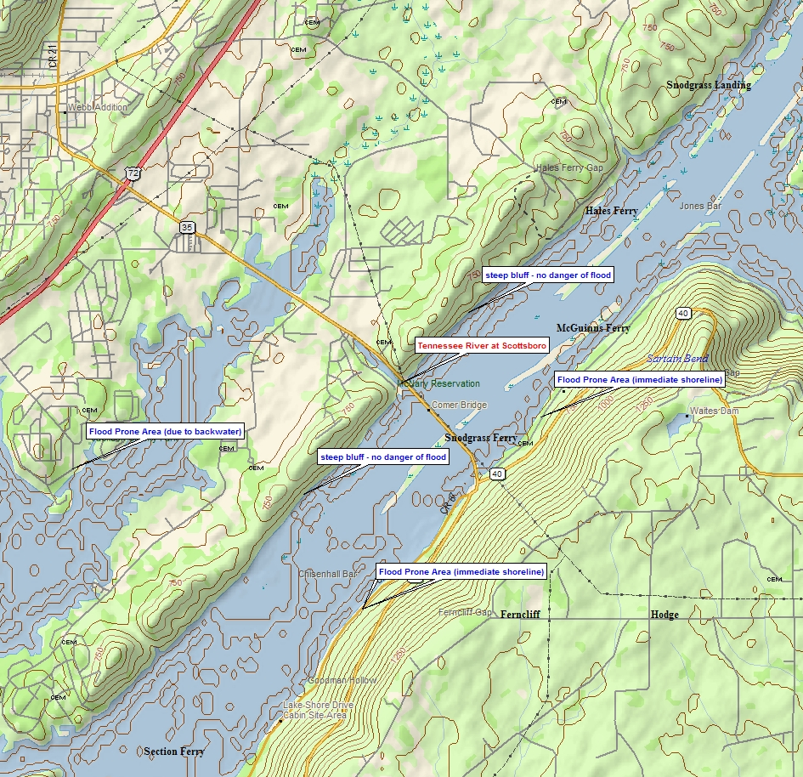

LOCATION: Tennessee River Scottsboro, AL Revised, Printed Dates: 12/20/2006, 12/20/2006
ID: SCRA1 HSA: HUN NWS FORM E-19 PAGE 1: GAGE MAP
BENCHMARKS

ELEVATION OF GAGE ZERO: VERTICAL DATUM:
LEVELING AGENCY AND DATE: CHECKBAR:
RATING AGENCY:

BENCHMARK DESCRIPTION GAGE ZERO DATUM
---------------------------------------------------------------------------------------- --------- -------

LOCATION: Tennessee River Scottsboro, AL Revised, Printed Dates: 12/20/2006, 12/20/2006
ID: SCRA1 HSA: HUN NWS FORM E-19 PAGE 2: BENCHMARKS
GAGES

DCP TELEM

NESS ID: TYPE OF TELEMETRY:
OWNER: OWNER:
REPORT TIME: PHONE NUMBER:
INTERVAL: INTERVAL:
PAYOR/COST OF LINE: / $

GAGE TYPE OWNER MAINTENANCE BEGAN ENDED GAGE LOCATION/REMARKS
----------- ----------- ----------- ---------- ---------- ------------------------------------------------------

LOCATION: Tennessee River Scottsboro, AL Revised, Printed Dates: 12/20/2006, 12/20/2006
ID: SCRA1 HSA: HUN NWS FORM E-19 PAGE 3: GAGES
HISTORY

PUBLICATION/LOCATION OF RECORDS STARTING DATE ENDING DATE
------------------------------- ------------- -----------

TYPE OF GAGE OWNER STARTING DATE ENDING DATE
------------ ----- ------------- -----------

ZERO ELEVATION STARTING DATE
-------------- -------------

LOCATION: Tennessee River Scottsboro, AL Revised, Printed Dates: 12/20/2006, 12/20/2006
ID: SCRA1 HSA: HUN NWS FORM E-19 PAGE 4: HISTORY
CRESTS

FLOOD STAGE: 28.00 ACTION STAGE: 21.50 BANKFULL STAGE:
FLOOD FLOW: ACTION FLOW:

DATE OF TIME CREST FLOW FROM HIGH BASED ON CAUSED BY
CREST LST (ft) (CFS) WATERMARKS OLD DATUM ICE JAM REMARKS
---------- ------ ------ ------ ---------- --------- --------- -----------------------------------------------

LOCATION: Tennessee River Scottsboro, AL Revised, Printed Dates: 12/20/2006, 12/20/2006
ID: SCRA1 HSA: HUN NWS FORM E-19 PAGE 5: CRESTS
LOW WATER RECORDS

DATE OF STAGE FLOW
LOW WATER (ft) (CFS) REMARKS
---------- ------- ------ ---------------------------------------------

LOCATION: Tennessee River Scottsboro, AL Revised, Printed Dates: 12/20/2006, 12/20/2006
ID: SCRA1 HSA: HUN NWS FORM E-19 PAGE 6: LOW WATER
CONDITIONS AFFECTING FLOW

MILES ABOVE MOUTH: DRAINAGE AREA: POOL STAGE:

STREAM BED:

REACH:

REGULATION:

DIVERSION:

WINTER:

TOPOGRAPHY:

REMARKS:

LOCATION: Tennessee River Scottsboro, AL Revised, Printed Dates: 12/20/2006, 12/20/2006
ID: SCRA1 HSA: HUN NWS FORM E-19 PAGE 7: CONDITIONS
DAMAGE

STAGE AREAS AFFECTED
------- ----------------------------------------------------------------------------------------------------
21.50 Boathouses near the river begin to flood...but little or no damage occurs.

28.00 FLOOD STAGE. MINOR FLOODING. Dwellings near Lake Guntersville begin to flood...and an old mill on
the right bank floods. Backwater may be causing high water to approach structures southeast of
Scottsboro.

31.00 MODERATE FLOODING. Portions of Highway 35 between Highway 72 and the river are likely
underwater...along with dwellings and low lying areas near the river. Backwater is likely causing
significant flooding near tributaries...including on the south side of Scottsboro.

35.00 Major flooding is occurring on the south side of Scottsboro...with numerous roads and buildings
flooded.

LOCATION: Tennessee River Scottsboro, AL Revised, Printed Dates: 12/20/2006, 12/20/2006
ID: SCRA1 HSA: HUN NWS FORM E-19 PAGE 8: DAMAGE
RIVER STAGE DATA

| 38-|
|-----|
|-----|
|-----|
|-----|
| 36-|
|-----|
|-----|
35.00 - Major flooding is occurring on the south side of Scottsboro...with numerous roads and |-----|
buildings flooded. |-----|
| 34-|
|-----|
|-----|
|-----|
|-----|
| 32-|
|-----|
|-----|
31.00 - MODERATE FLOODING. Portions of Highway 35 between Highway 72 and the river are likely |-----|
underwater...along with dwellings and low lying areas near the river. Backwater is |-----|
likely causing significant flooding near tributaries...including on the south side | 30-|
of Scottsboro. |-----|
|-----|
|-----|
|-----|
28.00 - FLOOD STAGE. MINOR FLOODING. Dwellings near Lake Guntersville begin to flood...and an | 28-|
old mill on the right bank floods. Backwater may be causing high water to approach |-----|
structures southeast of Scottsboro. |-----|
|-----|
|-----|
| 26-|
|-----|
|-----|
|-----|
|-----|
| 24-|
|-----|
|-----|
|-----|
|-----|
| 22-|
|-----|
21.50 - Boathouses near the river begin to flood...but little or no damage occurs. |-----|
|-----|
|-----|
| 20-|
|-----|
|-----|
|-----|
|-----|
| 18-|

REACH: ELEVATION ZERO: nan

LOCATION: Tennessee River Scottsboro, AL Revised, Printed Dates: 12/20/2006, 12/20/2006
ID: SCRA1 HSA: HUN NWS FORM E-19 PAGE 9: STAFF

CONTACTS

SQ CONTACT/REMARKS PHONE
-- -------------------------------------------------- ------------------

LOCATION: Tennessee River Scottsboro, AL Revised, Printed Dates: 12/20/2006, 12/20/2006
ID: SCRA1 HSA: HUN NWS FORM E-19 PAGE 10: CONTACTS
No pictures available for this site.

