
Alabaugh Canyon Fire
Entrapment and Shelter Deployment

Final Accident Investigation Report

July 8, 2007 Black Hills National Forest

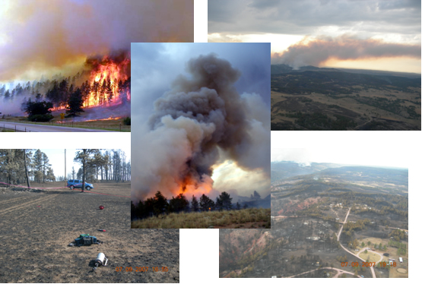

Rocky Mountain Region

Commonly Used Acronyms and Abbreviations

APA Accident Prevention Analysis
BKF Black Hills National Forest
BI Burning Index
DC Division Chief
DIVS Division Supervisor
DP Decision Point
ERC Energy Release Component
E663 Forest Service Wildland Fire Engine 663
E664 Forest Service Wildland Fire Engine 664
FDs City Fire Department
FMO Fire Management Officer
FS Forest Service
FSM Forest Service Manual
GPDC Great Plains Dispatch Center
IC Incident Commander
ICS Incident Command System
ICT3 Incident Command Type 3
IMT Incident Management Team
LCES Lookout(s), Communication(s), Escape Route(s), and Safety Zone(s)
MAID1 Mutual Aid Radio Channel 1
MTDC Missoula Technology and Development Center
NWS National Weather Service
OSC3 Operations Section Chief
RAWS Remote Automatic Weather Station
RFDs Rural Fire Departments
RH Relative Humidity
SEATs Single Engine Air Tankers
SAI Serious Accident Report
TFLD Task Force Leader
USDA United States Department of Agriculture
VFDs Volunteer Fire Departments
WUI Wildland-Urban Interface

Accident Investigation
Report

Accident: Entrapment/Shelter Deployment

Location: Black Hills National Forest, Hot Springs, SD

Date: July 8, 2007

Investigation Team Leader: Charles S. Richmond, Forest Supervisor, GMUG

/s/ Charles S. Richmond 09/04/07
_______________________________ ______________
Signature Date

Investigation Chief Investigator: Ted Moore, R-2 Branch Chief Fire, Safety and Training
Specialist, Lakewood, CO
/s/ Ted Moore 09/04/07
_______________________________ ______________
Signature Date
Investigation Team Members:

Lindon Wiebe, Fire Behavior Specialist, Lakewood, CO

Ted Putnam, Human Factors Specialist, Missoula, MT

Diann Ritschard, Fire Information Officer, Steamboat Springs, CO

Katie Van Alstyne, Documentation, Rapid City, SD

Investigation Technical Consultants:

Tony Petrilli, Equipment Research Specialist - MTDC, Missoula, MT

Liaisons

Carlos Pinto, R-2 Safety Manager, Lakewood, CO

Tim Eggers, Fire Management Officer, SD Division of Wildland Fire Suppression

Roger Pigeon, Safety Manager, Custer, SD

Table of Contents

EXECUTIVE SUMMARY …………………………………………………………………...… 5
Conclusions …………………………………………………………………………….... 6
NARRATIVE …………………………………………………………………………………… 7
FINDINGS ………………………………………………………………………………………15
Environmental ……………………………………………………….…………………..15
Human ………………………………………………………………………………….. 16
Equipment ……………………………………………………………………………… 19
CASUAL FACTORS ………………………………………………………………………….. 20 CONTRIBUTING FACTOR ………………………………………………..…………………. 21
MANAGEMENT EVALUATION REPORT ……………………………….………………… 22
Executive Summary…………………………………………………………………...…22
Recommendations ……………………………………………………………………….22

List of Figures

Figure 1 – Alabaugh Canyon Fire Vicinity Map ……………………………..…………………. 7
Figure 2 – Alabaugh Canyon Fire ICT Organization ……………………….…………………… 8
Figure 3 – 2330 to 2347 hours. Resources arrive at Flyway Saftey Zone, Individual and small group briefings are conducted, and a short discussion occurs regarding a proposed bull dozer line of the west of Flyway Road. The fire intensity increases as it spreads out of
Alabaugh Canyon – creating spot fires to the east of Flyway Road. These new spot fires
Annulled the proposed dozer line strategy……………………………………………….10
Figure 4 – Between 2350 and 2400 hours. OSC3 and DIVS leave Safety Zone for 12523 Flyway Road. They leave this residence at approximately 2400 hours and 0016 hours……………………………………………………………………………………...11
Figure 5 – 2400 to 0016 hours. OSC# and DIVS are enroute to 27891 Cascade Springs Road. They are temporarily delayed by fire crossing Flyway Road. The primary burn out is completed around 0016 at 27891 Cascade Springs Road …………….………….…...…12
Figure 6 – Between 0016 and 0017:30 hours. OSC3 and DIVS arrive at 27891 Cascade Springs Road and initiate secondary burnout …………………………………………………………….12
Figure 7 – 0018 and 0022 hours. Includes the following: the escape from the secondary burnout fire spread; the entrapment; the shelter deployment; and the intense radiant heat ……….……. 13

List of Photos

Photo 1 – Alabaugh Canyon Fire initial attack conditions July 7, 2007 ………………….…….. 9
Photo 2 – Entrapment and shelter deployment site July 9, 2007, 1920 hours ……………..….. 14

Appendices

Appendix A - Chronology……………………………………………………………….……..A-1

Appendix B - Environmental Factors..………………………………………………………....B-1

Appendix C - Human Factors..……………………..…………………………………………..C-1

Appendix D - Equipment Factors..……………………………………………………………..D-1

Appendix E - Photographs of Alabaugh Canyon Fire…………………..……………………...E-1

Appendix F - Glossary……..…………………………………………………………………...F-1

EXECUTIVE SUMMARY

On July 8, 2007 at about 0020 two Black Hills National Forest firefighters assigned to the Alabaugh Canyon Fire were entrapped by the fire and deployed a single fire shelter. At the time of the accident the firefighters were conducting burn out operations around a residence in the wildland urban interface. The two firefighters sustained a range of superficial and significant burns due to a sudden, intense crown fire near their position as they were deploying the fire shelter. The Alabaugh Canyon Fire was located five miles south of Hot Springs, Fall River County in southwest South Dakota,. This incident qualifies as an entrapment according to FSM 5100, Chapter 5130, Section 5130.3 which states:

“entrapments are situations where personnel are unexpectedly caught in a fire-behavior related, life-threatening position where escape routes or safety zones are absent, inadequate, or compromised. An entrapment may or may not include deployment of a fire shelter. These situations may or may not result in injury; and include near misses.”

The USDA Forest Service Washington Office delegated the accident investigation to the Regional Forester, Rocky Mountain Region (R-2). The Regional Office initiated a systematic investigation of the circumstances related to the accident. An investigation team was formed and reported to Rapid City, South Dakota on July 8, 2007. The team consisted of a Team Leader, Chief Investigator, Fire Behavior Specialist, Human Factors Specialist, Fire Information Officer, Documentation Specialist, and Equipment Specialist. Also working with the Team were liaisons to the Black Hills National Forest, State of South Dakota, and the Rocky Mountain Regional Office.

The Serious Accident Investigation (SAI) process was used by the team to identify factors resulting in the entrapment and deployment. Formal accident investigations look at Human Factors, Equipment Factors, and Environmental Factors that contributed to, or were causal to the incident. The team identified these factors in an effort to help the greater wildland fire community learn from this incident and help prevent accidents of this kind in the future. Team members visited the site, interviewed numerous individuals associated with the incident, reviewed records of pre- and post-fire weather/behavior, and examined the written record of events and actions leading up to and immediately following the deployment.

This investigation was also conducted in the spirit of the “Foundational Doctrine” for fire suppression activities. A fundamental difference in how this investigation was conducted, from those of the past, is that the team looked at how the Standard Fire Fighting Orders, Watch Out Situations, LCES, and Downhill Line Construction Checklist were complied with, not as absolute rules, but rather as principles that require sound assessment and reasonable decisions. Consequently, the team sought an understanding of not only what choices were taken, but why individuals made the decisions. The team looked at the actions of the incident command team and individual firefighters with the philosophy that:

“employees are expected and empowered to be creative and decisive, to exercise initiative and accept responsibility, and to use their training, experience, and judgment in decision making to carry out the leader’s intent” Foundational Doctrine, 2006.

However, the Foundational Doctrine does not relieve leaders of accountability.

The overall intent of any accident investigation is to help the Forest Service and other firefighting organizations learn from the incident and improve our safety culture. “Safety is not a goal that an organization can reach. In contrast, safety is continuous employee creativity in response to risks. This can be a challenging paradigm but it has immense implications for how we should value operational accidents. A foundational principle of high-reliability organizing is the commitment to continuous learning. Learning from success is essential but learning from failure is critical. Fidelity to our values demands we treat accidents and near misses as precious learning opportunities and exploit their full value for enhancing system reliability” (APA Briefing Paper). Using this learning approach, the Alabaugh Investigation Team found that many employees were eager to openly report and share their individual lessons learned information.

Conclusions

The Alabaugh Canyon Fire in the late evening of July 7, and early morning hours of July 8, 2007, exhibited extreme fire behavior due to prolonged dry weather patterns and low fuel moistures. The fire was quickly spreading and actively spotting across roads and control lines, making suppression tactics difficult. Forest Service forces dispatched to the fire not only faced erratic fire behavior but were also confronted with: smoky night time conditions; working in unfamiliar country, developing strategies and conducting tactics to protect structures within the wildland-urban interface; dealing with an evolving interagency incident organization; and a mutual aid radio frequency that was jammed with traffic.

These challenging initial attack conditions made situational awareness paramount. The Operations Chief and Division Supervisor made a decision to engage in widening the burnout at 27891 Cascade Springs Road and while implementing the plan an unexpected wall of fire erupted below the two firefighters, blocking their escape route back to a safety zone. The Division Supervisor and Engine Crewman became entrapped.

The ability to assess and assimilate situational awareness and operational risks naturally degrades under extreme and chaotic conditions. The Operations Section Chief and the Division Supervisor are less likely to notice relevant information that may have altered their decisions and the subsequent events. Such conditions are also trigger points for considering disengagement from the fire. Consequently several of the LCES factors, standard firefighting orders and watch out situations were not followed, which led to the entrapment and shelter deployment.

NARRATIVE

The Alabaugh Canyon Fire started in Alabaugh Canyon on private lands during the evening of July 7, 2007. The point of origin was approximately five miles to southwest of the town of Hot Springs, Fall River County, South Dakota. Hot Springs, and adjacent subdivisions to the south and southwest, makeup a wildland-urban interface of dispersed residences on private land (see Vicinity Map below).

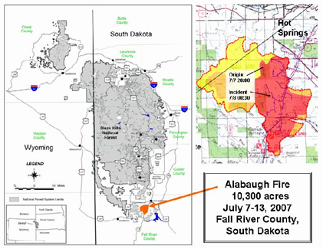
Figure 1 - Alabaugh Canyon Fire Vicinity Map
The Alabaugh Canyon Fire was caused by lightning. First reported to Great Plains Dispatch at 1944 hours on July 7, the fire spread though extremely dry fuels consuming 5,000 acres of grassland and forests over the next 24 hour period, destroying 27 homes, entrapping two firefighters and claiming one homeowner fatality. To emphasize just how quickly fire conditions deteriorated in the late evening of July 7, within the first 20 minutes the fire behavior exceeded direct attack by initial attack resources. The initial attack incident commander (IC) then requested a Type 3 Incident Management Team (IMT) at 2048 hours, only 48 minutes later, a Type 2 IMT was ordered by the initial attack incident commander.

A Fire Weather Watch was issued Friday, July 6, for the southern Black Hills to be in effect Saturday afternoon through Saturday evening, July 7. The Watch predicted high temperatures (100-107˚ F), RHs down to 10% and southwest winds shifting to the northwest. An updated Fire Weather Watch was issued at 1428 hours to include potential dry lightning. The Fire Weather Watch was updated to a Red Flag Warning at 1551 hours, which was in effect until 2100 hours Saturday July 7.

Weather conditions in the southern Black Hills during the early spring and summer months of 2007 were unusually hot and dry. Starting on the first of July, temperatures reached into the 90s and peaked on July 6-7 with high temperatures above 100 and relative humidity (RH) in the 10% range. The Energy Release Component (ERC) as measured at the Red Canyon Remote Automated Weather Station (RAWS) during the same time period exceeded 75 putting the ERC at the 97th percentile at or near an all time high. Precipitation for the general area was 66% of average. The National Weather Service had issued several red flag warnings during the first few days of July. Firefighters had reported extreme fire behavior on other fires in past weeks. Appendix B contains a more complete description and analysis of weather trends. Simply said, the environment around Hot Springs, South Dakota was ripe for the Alabaugh Canyon Fire.

At about 2100 hours on July 7, several Black Hills National Forest fire fighting resources had been dispatched to the incident. Two engine crews (E663 & E664), a hand line crew (Crew 6) and two Division Group Supervisors, were in route to the fire and arrived at the fire at approximately 2240 hours. The seven Forest Service members of Crew 6 were combined with thirteen firefighters from the State of South Dakota’s Bear Mountain Crew to form a complete 20-person crew. The chart below describes the developing Type 3 Incident Management Team organization assembled to fight the fire through the night until the area Type 2 Incident Management Team reported the next day.
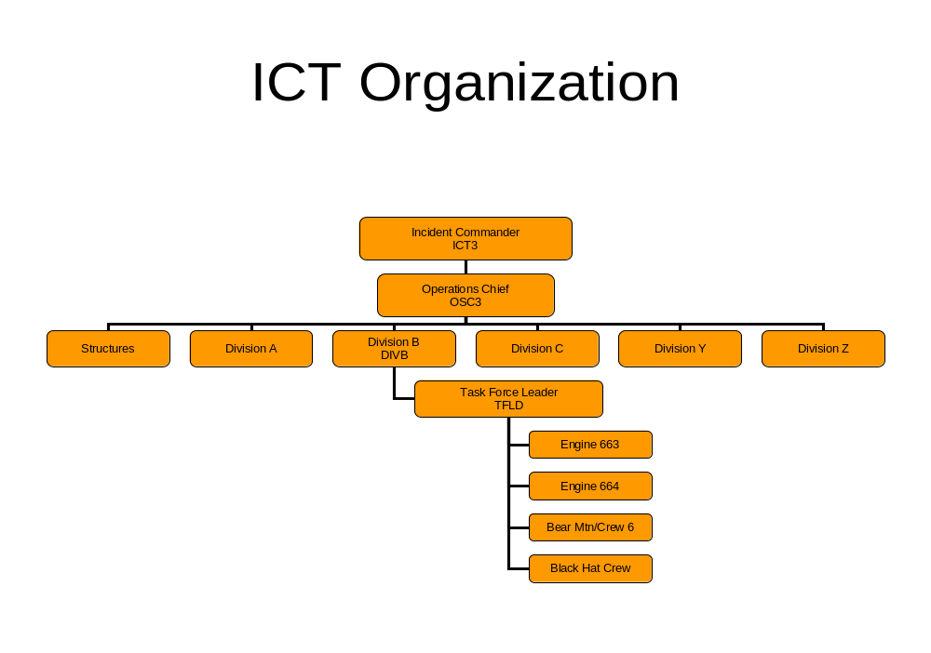
Figure 2 - Alabaugh Canyon Fire ICT organization
What the firefighters found upon arrival at the fire was a wildland-urban interface with intense surface fires rapidly spreading through open meadows, fields as well as in the timber, with patches of timber sustaining significant crown fire and creating spot fires in the lighter fuels ahead of the fire front. The fire intensity and spread was threatening and burning homes. As crews arrived at the scene they encountered people fleeing from the subdivisions which added to the emerging chaotic conditions. Several crew members recalled that winds were erratic and the fire was actively spotting. Flame lengths as reported by firefighters, and noted on the many photos and video clips of the fire, were 100-150 feet in timber stands and 6-8 feet plus in the grass.

Black Hills National Forest resources were assigned to Division B along Flyway Road. In addition to active fire behavior, the crews found radio traffic alive with numerous resources from the Forest Service, the State, Volunteer Fire Departments (VFDS), Rural Fire Departments (RFDs), City Fire Departments (FDs) all vying for air time to communicate on only one tactical mutual aid channel (MAID 1). Flyway Road was also busy with bull dozers and road graders building safe zones, and law enforcement personnel evacuating residents in the area. There were 440 evacuees relocated to the Mueller Community Center in Hot Springs. Three Single Engine Air Tankers (SEATs) and a heavy helicopter were working the fire during the early stages of initial attack. Witnesses on scene described the situation as chaotic and frightening.

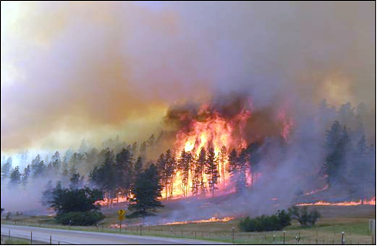

Photo 1 - Alabaugh Canyon Fire initial attack conditions July 7, 2007.
The unassigned Division Supervisors (later to be the OSC3 and DIVS) received a briefing from the Incident Commander (IC). They developed a strategy to construct and burn out a dozer line west of Flyway Road heading south from the Flyway Safety Zone trying to cut the fire off from the rim of Alabaugh Canyon and several threatened structures. The initial plan to construct a dozer line and burnout is shown in Figure 3.

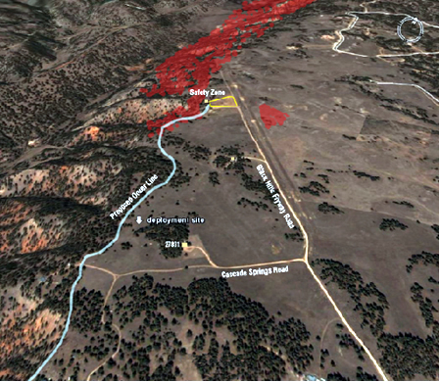
Figure 3 - 2330 to 2347 hours. Resources arrive at Flyway Safety Zone, Individual and small group briefings are conducted, and a short discussion occurs regarding a proposed bull dozer line to the west of Flyway Road. The fire intensity increases as it spreads out of Alabaugh Canyon – creating spot fires to the east of Flyway Road. These new spot fires annulled the proposed dozer line strategy.
This strategy was never executed because the fire spotted across Flyway Road becoming a significant threat to additional houses and the firefighting resources. With the increased fire behavior, the two hand crews, heavy equipment, and VFD engines were moved to a safety zone at the northwest end of Flyway Road to wait out the extreme fire behavior conditions. E663 and E664 were directed by one of the unassigned Division Supervisor to move down Flyway Road. The Engine Captain (E-664) then directed the Engines to 27891 Flyway Road where they would setup and burn out around the house. During a radio briefing at about 2355 hours with the IC, one of the dispatched Black Hills National Forest’s Division Supervisors (DIVS) was field promoted to night Operations Section Chief (OSC3). The Operations Section Chief and the Division Supervisor went to another nearby house (12523 Flyway Road), determined that they could do no more to save this house and directed the three VFD engines and crews at that location to go to Highway 71 and meet with the Strike Team Leader-Engines for another assignment (see Figure 4). The OSC3 then field promoted the Engine Captain of E664 to Task Force Leader (TFLD).

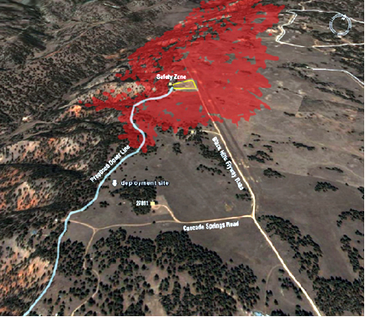
Figure 4 - Between 2350 and 2400 hours. OSC3 and DIVS leave Safety Zone for 12523 Flyway Road. They leave this residence at approximately 2400 hours and 0016 hours.
E663 and E664 moved southeast along Flyway Road arriving at 27891 Cascade Springs Road at 2400 hours. Data from the Red Canyon RAWS (10 miles away) shows an overall increase in northwest winds at about this time, with gusts to 36 miles per hour. The two engines drove up the driveway to the single-story residence and faced the vehicles out towards the way they came in. Crew members reported that there was active fire around the house, particularly to the north and west. The two engine crews held a quick briefing, deciding that their strategy would be three fold: to increase the size of their safety zone (a mowed grassy area to the north and northwest of the driveway); remove fuels that could delay their escape back down the driveway; and to increase the size of the burned out area around the house. E664 pulled the live reel hardline towards the structure and put a wet line over a previously built scratch line. Crew members from E663 began to ignite the primary burnout using the wet scratch line as a control feature to burn from. The primary burnout started at the northwest corner of the house and proceeded to the east through the mowed area and down the driveway for about 150 feet where they intersected the edge of a spot fire at the corner of Flyway Road and Cascade Springs Road. The crew crossed Cascade Springs Road then returned back up the driveway and burned around an old truck worked their way around the house and back to the initial ignition point. The plan was to have the fire back away from the house, removing most of the fine fuels under the pine overstory (to the west and south) near the house. Another objective of the primary burnout was to burn up the fine fuels in the field to the northwest and northeast of the driveway and Cascade Road (see Figure 5).

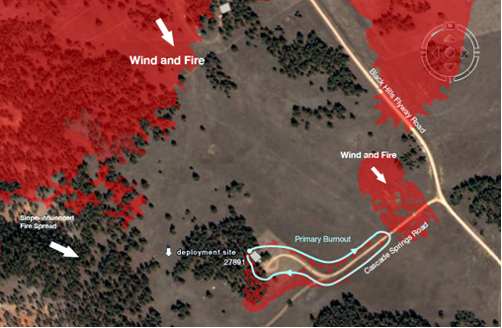
Figure 5 - 2400 to 0016 hours. OSC3 and DIVS are enroute to 27891 Cascade Springs Road. They are temporarily delayed by fire crossing Flyway Road. The primary burn out is completed around 0016 at 27891 Cascade Springs Road.
The OSC3 and the Division B Supervisor traveled southeast on Flyway Road, having to stop four times to allow fire to cross the road. They arrived at 27891 Cascade Springs Road about 0016 and assessed the success of the burnout operations. The OSC3 decided that the black line on the north side of the house should be widened by 5-10 feet to further protect the structure. He asked DIVS to lead one of the E663 crew members in igniting a secondary burnout in the timber to widen the line.

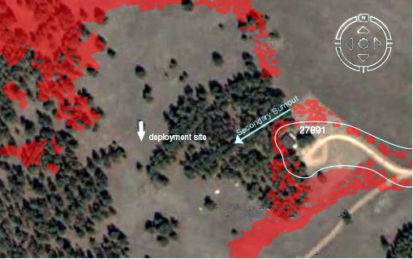
Figure 6 - Between 0016 and 0017:30 hours. OSC3 and DIVS arrive at 27891 Cascade Springs Road and initiate secondary burnout.
The Division Supervisor forgot that he had left his pack in the truck and consequently began the burnout without his radio, headlight and proper personal protective equipment (PPE) including his shelter and gloves. After burning a 10 foot strip up to 100 -120 feet into the timber the two firefighters witnessed an increase in fire behavior, and realized that their escape route back to the safety zone had been compromised. They looked to the north and northeast as an alternate escape route and safety zone and observed the head fire. Moments later a downdraft transitioned the head fire into a rapidly moving fire advancing in both the grass and timber from these directions, which compromised these routes. The firefighters exited the timber in a northwest direction, turning south into an unburned grassy area. At this point they encountered a backing fire with four to six foot flame lengths. They jumped through an area of one to two foot flame lengths in an attempt to reach a previously burned out area. While the grassland on the other side of the backing fire had burned and was now black, the individual and patches of trees to the west were still torching. The high-radiant heat from the torching trees began to burn both individuals, especially on the right side of their bodies. Both firefighters said they could feel their skin sloughing. The DIVS told the E663 crew member it was time to deploy his shelter. The E663 crew member attempted to remove his pack. He had difficulty getting his pack off and deploying the shelter which increased the exposure to the radiant heat from the crowning timber to the west of them. The DIVS helped by grasping the shake handles and shaking the shelter open. The DIVS asked if he could join the engine crewmember in the shelter. Both individuals got in the shelter with the crewmember towards the front and the DIVS sitting cross-legged behind.

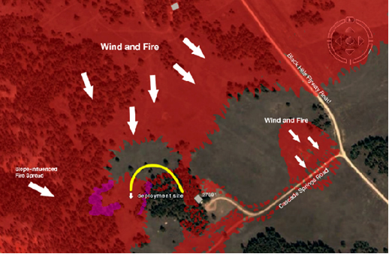
Figure 7 - 0018 to 0022 hours. Includes the following: the escape from the secondary burnout fire spread; the entrapment; the shelter deployment; and the intense radiant heat.
The approximate time of shelter deployment was 0020. They remarked later how much cooler it was once they got inside the shelter. The DIVS estimated that he stayed in the shelter for two minutes. He was concerned that the E663 crew member had inhaled super heated gasses and if this was the case, he needed prompt medical attention or his condition would be fatal. His concern was based on the E663 crew member complaining that his airway was constricting and he was having trouble breathing. Once outside the shelter the Division Supervisor used the E663 crew member’s radio to issue an emergency distress call (MayDay). Radio traffic was heavy and he had trouble broadcasting out. The Task Force Leader, at the house heard the MayDay and ordered people to clear the airway for emergency traffic, which took five minutes. The Division Supervisor was then able to give directions to the Task Force Leader and the Operations Section Chief to their location, a clearing about 50-75 yards from the northwest corner of the house. Within one minutes the Operations Chief and the Task Force Leader located the deployment site (T8S, R5E, SE1/4 SW1/4 Section 8) and loaded the injured firefighters into the OSC3’s vehicle. At about 0033 hours the OSC3 called the South Dakota State Fire Management Officer (FMO), who was on the Alabaugh Canyon Fire scene providing assistance, on the radio for an ambulance. The OSC3 began to drive the burned firefighters to the clinic in Hot Springs. They stopped along the way to pick up a paramedic and oxygen from an Elk Mountain Engine. They continued on to Hot Springs, arriving at Fall River Health Services at 0050 hours.

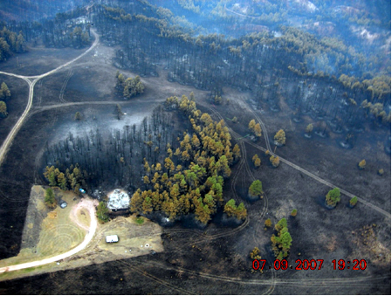
Deployment site
North
Photo 2 - Entrapment and shelter deployment site July 9, 2007, 1920 hours.
After stabilizing both victims and providing initial treatment, both firefighters were taken by ambulance to Rapid City Regional Hospital. At the hospital the E663 crew member was treated and released and the Division Supervisor was admitted for further treatment.

Enroute to the hospital the OSC3 met with the South Dakota State FMO and explained to him the situation and the fire shelter deployment and that he was transporting the injured personnel. At this point he asked the state FMO to assume the roles and responsibilities as the Operations Chief. The State FMO accepted the role and after the injured firefighters had left the scene, he notified Black Hills National Forest and the State of the incident. Once notified, the Black Hills Forest Fire Management Officer (FFMO) briefed individuals at Great Plains Dispatch and in the Regional Office.

FINDINGS

Conclusions of the accident investigation team are based on witness statements, chronological facts, weight of evidence, professional knowledge, and good judgment. They are grouped in the following categories: Environmental, Human, and Equipment.

Environmental

Finding 1
Weather conditions for most of June and the first 6 days of July were unusually warm and dry, resulting in high fire danger. (NWS &BKF FMO, RAWS)

Finding 2
The National Weather Service issued a Red Flag Warning at 1551 for July 7, valid until 2100. Extreme fire behavior occurred throughout the night. (NWS)

Finding 3
The National Weather Service cancelled the Red Flag Warning at 2117 on July 7 just prior to weather conditions worsening. (NWS)

Finding 4
Weather conditions on July 7, were hot and dry with scattered evening thunderstorms. The high for the day was 105 degrees; the minimum relative humidity was 7 percent; peak wind was 36 mph. A trough of low pressure moved through the fire area in the late evening setting the stage for dangerous fire behavior. (NWS)

Finding 5
Low fuel moisture, drought, low ERCs, fuel profiles, high grass, wind, low RH all contributed to extreme fire behavior in the wildland/urban interface. (NWS, RAWS)

Finding 6
The fire started with a lightning strike near the bottom of Alabaugh Canyon. It spread rapidly upslope out of the canyon towards the Pine Shadows subdivision. (ICT3)

Finding 7
There was increased wind activity at about 2345, resulting in erratic fire behavior until the early morning hours of July 8. (NWS & Witness Statements)

Finding 8
There was active fire crowning in the timber and spotting across control lines in flashy fuels. (Witness Statements)

Finding 9
Flame lengths were estimated at 100-150 feet in the timber overstory during crown runs and 6-8 feet in the grass and 3-5 feet in timber surface fuels. (Witness Statements & Video Clips)

Finding 10
Smokey conditions and night time conditions resulted in impaired situational awareness. (Witness Statements)

Finding 11
Division B included wildland/urban interface with numerous homes, making suppression activities more complex. (Maps, BKF)

Finding 12
Strong winds continually blew out the crew member’s drip torch during the primary and secondary burnout at 27891 Cascade Springs Road. (E663 crewmember & DIVS)

Finding 13
A new Operations Chief was assigned after the accident, and he notified the Black Hills National Forest FMO of the incident initiating the emergency notification protocol. (OSC3)

Finding 14
The Black Hills Forest FMO notified Great Plains Dispatch about the accident at 0140 on July 8. (BKF FMO)

Human

Finding 1
It was dark when the Forest Service fire fighters arrived on the incident at about 2230-2240 reducing firefighter situational awareness. (Witness Statements)

Finding 2
The diversity and high number of interagency resources in Division B combined with on-going emergency evacuations, extreme fire behavior and poor radio communications made it more difficult to establish command and control. (Witness Statements)

Finding 3
Interagency fire resources were not using radio protocol, resulting in radio overload, difficulty transmitting and receiving radio communications. (Witness Statements)

Finding 4
The Division B Task Force Leader was unable to contact handcrews under his control, Bear Mountain/Crew 6 and the Black Hat Crew over the radio, jeopardizing command and control. (TFLD)

Finding 5
Immediately prior to implementing a burnout plan the Operations Chief and Division Supervisor thought they had a good, safe, low risk operation planned. (OSC3, DIVS)

Finding 6
The Operations Chief and Division Supervisor observed that the initial burnout was staying on the ground as planned. (OSC3, DIVS)

Finding 7
Within 30 seconds of initiating the secondary burnout operation a wall of flames, erupted below the Division Supervisor and E663 crewmember cutting off their escape route back into the safety zone. (DIVS, E-663 Crewmember)

Finding 8
No firefighter observed the source or ignition sequence of the wall of flames that erupted along the entire eastern edge of the timber stand. (Witness Statements)

Finding 9
No lookout was posted for the firefighters conducting the secondary burnout in a good vantage point to observe the firefighters as well monitor their escape route. (Witness Statements)

Finding 10
Just prior to arriving at the structure at 27891 Cascade Springs Road, the Operations Chief told the Division Supervisor that with the extreme fire behavior and wind there was no opportunity for aggressive action and that we needed to pull down to Highway 71, regroup and come up with a plan. (OSC3, DIVS)

Finding 11
Once it was known that two firefighters were cut off and injured, structure protection ended and search and rescue began. (Witness Statements)

Finding 12
Northern Great Plains Dispatch Center was unable to track the progression of the incident and firefighter resource tracking due to the limited communications with the Incident Management Organization. (GP Dispatch, Witness Statements)

Finding 13
The Division B Supervisor left his radio and fire pack, including his fire shelter, headlamp, and gloves in his vehicle, consequently receiving burns that the PPE could have prevented or reduced. (Equipment Specialist, Team)

Finding 14
The Operations Chief took the E663 crew member away from his crew without notification of his immediate supervisor (Engine Captain) thereby violating the established command and control. (OSC3 & E663 crewmember)

Finding 15
The E663 crew member accepted the assignment from the Operations Chief without conferring with his supervisor thereby violating the established command and control. (E663 crewmember, Team)
Finding 16
Members of Crew 6 / Bear Mountain hand crews staged in the Flyway safety zone stated they did not receive adequate briefings, resulting in confusion about fire suppression strategies and adding to the chaotic atmosphere during initial attack. (Witness Statements)

Finding 17
The unassigned Division Supervisors (later to be the OPS3 and DIVS) received a briefing from the IC shortly after their arrival on the fire. The briefing concerned the overall fire situation, overhead assignments, the organization structure and a strategy for Division B to create and burn out a dozer line. (OSC3 & DIVS)

Finding 18
A spot fire across Flyway Road compromised the initial dozer line and burnout strategy. (TFLD & OSC3)

Finding 19
After the initial dozer line and burnout strategy was compromised, the Bear Mountain/Crew 6 and Black Hat crews were staged in the safety zone, and E663 and E664 were assigned to structure protection. (OSC3 & TFLD)

Finding 20
There was a briefing conducted prior to burning out around the house at 27891 Cascade Springs Road to identify task assignments and the burnout strategy for all E663 and E664 crew members. (TFLD & ENGB)

Finding 21
All Forest Service personnel assigned to Division B were qualified for their assignments. (Team)

Finding 22
The Operations Chief, Division Supervisor, Task Force Leader, Engine Captains, Crew Boss, and the one E663 crew members involved in structure protection at 27891 Cascade Springs Road were in compliance with work/rest guidelines. (Team)

Finding 23
The decision and strategy for widening the burnout on the northwest side of the house, developed by the Operations Chief and Division Supervisor, triggered the sequence of events that led to the entrapment. (OSC3 & DIVS)

Finding 24
There was a lack of communication between Division B Supervisor, Operations Chief, and the E663 crewmember concerning firing technique, resulting in compromise of escape routes back to the safety zone. (Team & OSC3)

Finding 25
While attempting escape, the shelter was not deployed until the firefighters were subjected to intense radiant heat and burns. (DIVS & E663 crewmember)
Finding 26
The Division Supervisor emerged from the fire shelter after only a few minutes, possibly resulting in additional burns. He stated that he was concerned for the life of the E663 crew member who said his airway was constricting. (DIVS & E663 crewmember)

Finding 27
The Operations Chief and Task Force Leader promptly located and evacuated the injured firefighters to the Hot Springs Hospital, picking up a paramedic at Highway 71. (TFLD, & OSC3)

Finding 28
The Incident Commander was notified of an accident but did not know of a shelter deployment until the morning briefing indicating a breakdown in incident communication. (ICT3)

Equipment

Finding 1
There are only two mutual aid frequencies within South Dakota sometimes resulting in saturated radio traffic during large or multiple wildfire incidents (BKF FMO and SD)

Finding 2
On the Alabaugh Fire, there was one Mutual Aid frequency (MAID 1) assigned to Division B, resulting in saturated radio traffic at times. (OSC3, TFLD, Witness Statements)

Finding 3
The Division Supervisor had difficulty airing his distress MayDay call due to the heavy radio traffic which led to delay and confusion in finding the entrapped firefighters. (DIVS, TFLD)

Finding 4
The E663 crew member had difficulty getting the fire shelter open, prolonging the exposure of both firefighters to radiant heat. (DIVS and E663 crewmember)

Finding 5
The E663 member removed his gloves while deploying his shelter resulting in additional radiant heat exposure to his hands. (DIVS, E663 crewmember)

Finding 6
The fire shelter worked as intended, protecting the two firefighters from additional radiant heat, more severe burns and possible death. (Equipment Specialist & Team)

Finding 7
Flame resistant clothing worked as intended, protecting the two firefighters from more severe burns. (Equipment Specialist and Team)

CAUSAL FACTORS

A causal factor is any behavior, omission, or deficiency that if corrected, eliminated, or avoided probably would have prevented the accident.

Causal Factor 1:

The Operations Chief and Division Supervisor made a decision to engage in widening the burnout at 27891 Cascade Springs Road and while implementing the plan an unexpected wall of fire erupted below the DIVS and Engine Crewmember, blocking their escape route back to a safety zone (Human Finding 7, 23).

Causal Factor 2:

The ability to assess and assimilate situational awareness and operational risks by the Operations Section Chief and Division Supervisor was degraded as the incident became more and more chaotic as they were confronted with: smoky night time conditions; working in unfamiliar country, developing strategies and conducting tactics to protect structures within the wildland-urban interface; dealing with an evolving interagency incident organization; and a mutual aid radio frequency that was jammed with traffic. Consequently, as situational awareness declined so did the ability to follow several of the LCES factors, standard firefighting orders and watch out situations (Environmental Finding 1-12, Human Finding 1-3, 6-10, 24).

CONTRIBUTING FACTOR

A contributing factor is any behavior, omission, or deficiency that sets the stage for an accident, or increases the severity of injuries or extent of property damage. Contributing factors can be Environmental, Human, or Equipment related.

Contributing Factor 1:

Operations Chief and Division Supervisor did not follow the Chain of Command nor perform a tactical or safety briefing with crew members prior to implementing the secondary burnout to widen the primary burnout at 27891 Cascade Springs Road (Human Finding 14).

Contributing Factor 2:

FS Engine crews were assigned to structure protection in the WUI (Environmental Finding 11).

Contributing Factor 3:

Engine crew member had difficulty deploying fire shelter. (Equipment Finding 4, 5)

Contributing Factor 4:

Division Supervisor did not have all the required PPE while operating on a fireline (Human Finding 13).

Contributing Factor 5:

No lookout was posted in the safety zone during the burnout operation to guard against compromising the burnout crew’s escape route back to the safety zone. None of the engaged firefighters observed the ignition of the eastern edge of the timber patch which consequentially compromised the escape route (Human Finding 8, 9).

Contributing Factor 6:

Prolonged drought, high fuel loadings, dry thunderstorms, and high winds resulted in extreme and atypical fire behavior which was underestimated during extended attack (Environmental Finding 1-12; Human Finding 1, 2, 7, 8).

MANAGEMENT EVALUATION REPORT

Executive Summary

On July 8, 2007 at about 0020 two Black Hills National Forest firefighters assigned to the Alabaugh Canyon Fire were entrapped by the fire and deployed a single fire shelter. At the time of the accident the firefighters were conducting burn out operations around a residence in the wildland urban interface. The two firefighters sustained a range of superficial and significant burns due to a sudden, intense crown fire near their position as they were deploying the fire shelter.

The Alabaugh Canyon Fire was located in southwest South Dakota, five miles south of Hot Springs, in Fall River County. The Alabaugh Canyon Fire in the late evening of July 7, and early morning hours of July 8, 2007, exhibited extreme fire behavior due to prolonged dry weather patterns and low fuel moistures. The fire was quickly spreading and actively spotting across roads and control lines, making suppression tactics difficult. Forest Service forces dispatched to the fire not only faced erratic fire behavior but were also confronted with smoky night time conditions, working in unfamiliar country, an interagency fire organization that was evolving, emergency evacuations, and a mutual aid radio frequency that was jammed with traffic.

These challenging initial attack conditions made situational awareness paramount. The investigation team determined that the Operations Chief and Division Supervisor made a decision to engage in structure protection at 27891 Cascade Springs Road, under circumstances where situational awareness was difficult to achieve. Consequently, as situational awareness declined so did the ability to follow several of the LCES factors, standard firefighting orders and watch out situations.

The Serious Accident Investigation (SAI) process was used to identify factors resulting in the deployment. Formal accident investigations look at Human Factors, Equipment Factors, and Environmental Factors that contributed to, or were causal to the incident. The Investigation Team identified these factors in an effort to help the greater wildland fire community learn from this incident and help prevent accidents of this kind in the future. Likewise, the Investigation Team developed Recommendations that if implemented should help the Forest Service and other firefighting organizations improve our safety culture.

Recommendations

Recommendation 1:

Emphasize to all firefighters that constantly evaluating risk is critical as fire behavior changes and evolves during an incident. (Causal Factor 2; Contributing Factor 6).

Recommendation 2:

Use Black Hills National Forest personnel to develop an Alabaugh Canyon Fire Staff ride to emphasize ‘Lessons Learned’ and prevent future accidents (Causal Factor 1).

Recommendation 3:

The Region should establish clear expectations for Forest Service involvement in structure protection and strive to build interagency cooperative agreements that will articulate those expectations (Causal Factor 2; Contributing Factor 2).

Recommendation 4:

Briefings need to better emphasize the importance of fire weather effects to extreme fire behavior (Causal Factor 1, 2; Contributing Factor 1, 5).

Recommendation 5:

Encourage the use of face/neck shrouds (Contributing Factor 4).

Recommendation 6:

Improve fire shelter training by integrating deployment in different positions (kneeling, crouching, etc) while wearing full PPE including gloves in a more realistic fire environment (Contributing Factor 3).

