Abstract Title: Raman detection of individual nanowires and carbon nanotubes manipulated using optoelectronic tweezers
User Name: Professor Ming C. Wu (Project Leader), Arash Jamshidi (Primary Researcher)
Affiliation: University of California, Berkeley

Short Description:
Optoelectronic tweezers (OET) is a dynamic, non-invasive optical manipulation tool that works based on the principle of light-induced dielectrophoretic force. OET is capable of trapping many different types of particles including polystyrene beads, cells, metallic and semiconducting nanowires. In addition, it has been demonstrated that OET can create real-time dynamic arrays of nanowires and separate metallic and semiconducting nanowires. In this work, we demonstrate the in-situ Raman measurement of an individual silicon nanowire that is trapped using optoelectronic tweezers.

Presentation Abstract:
In-situ Raman spectroscopy has been used by other manipulation methods such as optical tweezers to study
biological cells, micro and nanostructures. However, OET’s low required optical power density, large working area, and ability to massively manipulate cells in liquid buffer makes it highly biocompatible. Therefore, OET- trapped nanostructures can be used for future non-invasive probing and imaging applications. In addition, in-situ Raman measurements of OET-trapped individual nanowires will be useful for sorting and separating nanowires of different compositions, sizes, and surface functionalities, as well as for creating arrays of single nanowires of alternating properties.
Fig. 1a shows the experimental setup for Raman measurements of trapped silicon nanowires. The liquid
buffer containing the silicon nanowires (100 nm diameter, 10-20 μm in length) was introduced into the OET device. At first, no voltage was applied to the device and the nanowires were undergoing Brownian motion. Once the voltage was applied to the device, a single silicon nanowire was attracted to the laser spot. Upon trapping of the individual silicon nanowire, the silicon Raman peak was observed in the Raman spectra (fig. 1b). The Raman peak, approximately 520 cm⁻¹, agrees with typical reported values for large silicon nanowires.

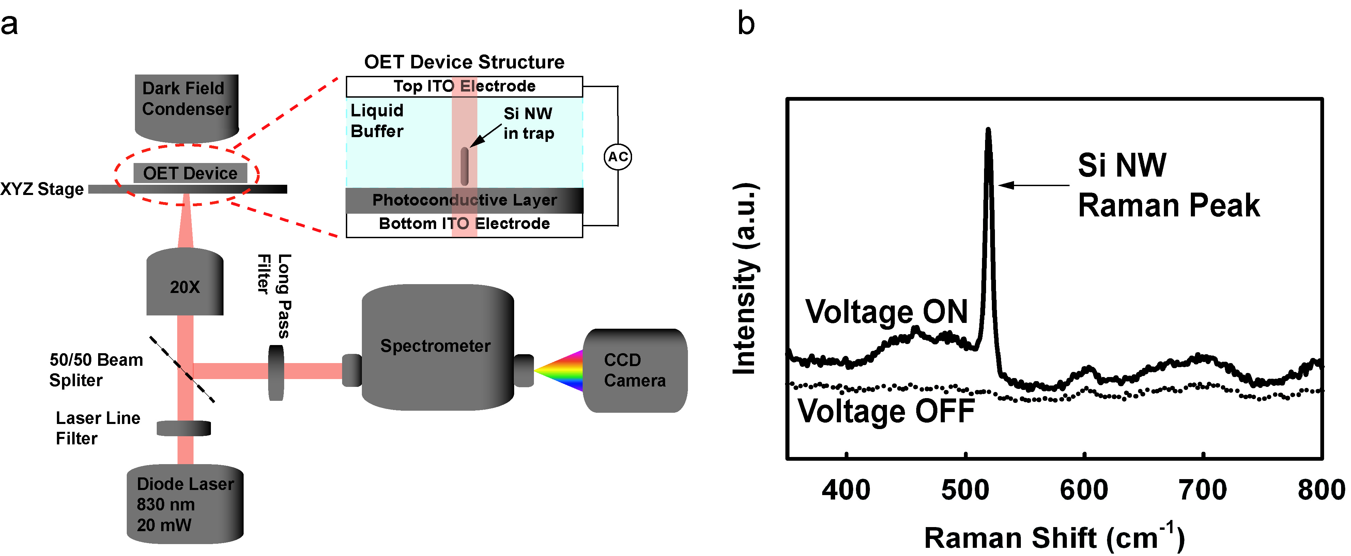
Fig. 1: (a) Experimental setup for Raman measurement of an individual silicon nanowire: a diode laser (830 nm, 20 mW optical power) is focused onto the OET surface using a 20X objective. An AC voltage of 15 Vpp at 100 KHz is applied across the device. The Raman signal is collected using a spectrometer and a CCD camera. (b) No Raman signal was detected in the absence of an AC voltage (dotted line). Once the voltage was applied, an individual silicon nanowire was attracted to the laser and the silicon Raman peak was detected (solid line).

