Transient Thermal and Stress Analysis for TSOP Devices

Mark S. Fan
NASA Technology Validation Assurance Program
Goddard Space Flight Center
Greenbelt, Maryland 20771
301-902-4357
fan@package.gsfc.nasa.gov

Gregory Rose
Electronic Packaging and Processes Branch
Goddard Space Flight Center
Greenbelt, Maryland 20771
301-286-4280
glrose@pop300.gsfc.nasa.gov

Abstract

Plastic Encapsulated Microcircuits (PEMs) are now being used in NASA spaceborne electronic systems mainly for their cost effectiveness. Among those PEMs, thin-small-outline-plastic (TSOP) surface mount devices are of particular interest because of certain benefits associated with light weight and compact volume. In a typical solder reflow process, a TSOP device is subject to a thermal transition from room temperature to 260 °C, and multiple sites of interfacial delamination and cracking have been observed in the plastic and I/O lead interface. This could be critical since moisture diffused through the cracks could cause corrosion in the metallization. The purpose of this study is to understand the mechanical impact of that thermal transition on the TSOP device through transient thermal and stress analyses. It has been revealed that the TSOP device generally has a good heat conduction capacity because of the thin encapsulation. However, excessive shear stresses are induced in the plastic-lead and plastic-die paddle interfaces, which could cause delamination and cracking as have been found during the inspection of reflowed TSOP devices. Due to the complex nature of this problem, a more accurate simulation will need to include plastic creep and nonlinear time-dependent fracture models.

Key words: PEMs, TSOP, FEA, surface mount solder joint, heat conduction, thermal stress, delamination.

1. Introduction

NASA GSFC is currently evaluating TSOP surface mount devices for spaceflight applications. Typical configurations of a 16 MB memory TSOP device are shown in Fig. 1-4 which have been used in the analysis. Although there are many different molding compounds on the market, only one has been selected for this study and it is used by at least one major semiconductor company in USA. This plastic material is labeled Compound X in this paper. Many advantages are associated with the use of the TSOP SMT packaged devices in spaceborne electronic systems, such as compact volume, light weight, low profile PWBs, better vibrational resistance and more efficient heat removal from the chip. In this study, transient temperature and thermal stress distributions during thermal shock from room temperature up to 260 °C are the key interests since the shock response of this ultra-thin package is expected to be quite different from that of the conventional packages. These transient physical processes are modeled with 3-D finite element techniques as part of the evaluation effort.
This work is mainly focused on heat transfer characteristics as well as thermal stresses caused by mismatches between different materials, and assessment of possible damage. Although popcorning is a popular phenomenon in recent studies, it is assumed here that the devices are well baked and dried before the soldering operation [1].



Fig. 1. Top view of the TSOP

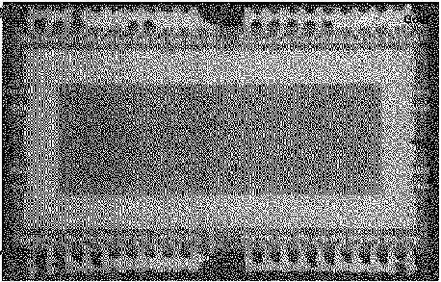

Fig. 2. X-ray top view of the TSOP

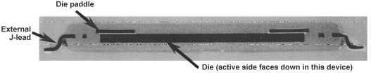

Fig. 3. X-ray side view of the TSOP

Paddle: 6

Die: 14 38
Lead: 6
9

Fig. 4. Internal dimensions (not to scale)
(Units: mil. 1.0 mil=25.4 mm)

2. Material Properties

It is well known that thermal and structural properties of epoxy molding compounds are highly temperature-dependent. For Compound X, the manufacturer only provides very limited property data over the temperature range. FEA modeling results would be unrealistic without using property data covering the full temperature range. In order to fill the gap, GSFC conducted a series of detailed measurements over a large temperature range. Due to measurement hardware limitations, thermal conductivity of the compound was measured only at 22 °C and 50 °C. Fig. 5 shows stress-strain curves from 22 °C to 166 °C, and Fig. 6 gives temperature-dependent failure limit of the stress from 22 °C to 250 °C. In Fig. 7, tensile and flexural moduli are plotted as a function of temperature from 22 °C to 166 °C. The coefficient of thermal expansion (CTE) is shown in Fig. 8 as measured from 20 °C to 260 °C. Temperature-dependent Poisson’s ratio is plotted in Fig. 9. Table 1 lists other property data used in the analyses.

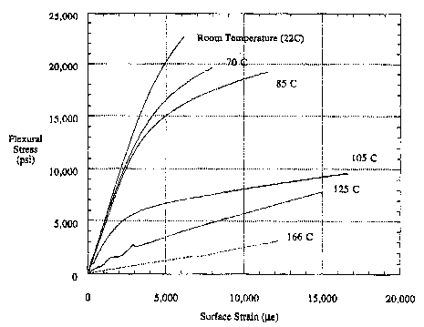
Fig. 5. Stress-strain curves of the plastic

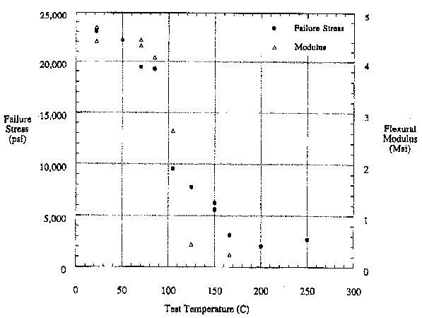 Fig. 6. Stress failure limits of the plastic
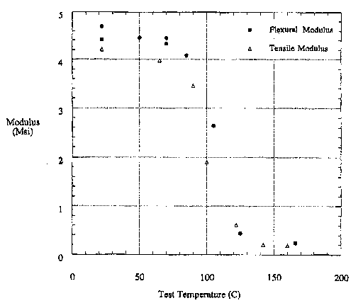

Fig. 7. Moduli of the plastic

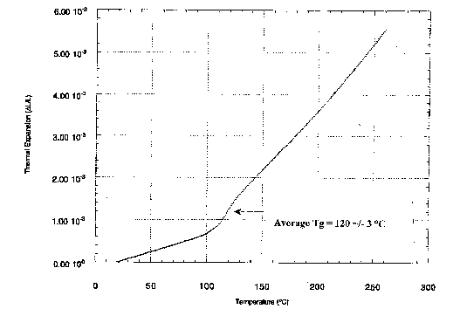

Fig. 8. CTE of the plastic

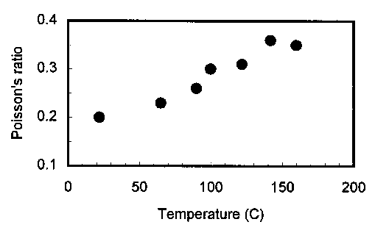

Fig. 9. Poisson’s ratio of the plastic

Materials | Si | Ni/Fe Alloy | Molding
Young’s Modulus  (GPa) | 120 | 145 | See Fig. 6
Poisson’s  Ratio | 0.28 | 0.31 | See Fig. 8
Density (kg/m³) | 2330 | 8110 | -
Specific Gravity | - | - | 2.014
Thermal Conductivity  (W/m°C) | 148 | 129 | 22 °C: 0.86  50 °C: 0.89
Specific Heat (J/kg°C) | 712 | 477 | 882
CTE  (ppm/°C) | 2.6 | 4.45 | See Fig. 7

Table 1. Material properties for analysis

3. FEA Model and Constraints

Because of symmetry, a one-quarter FEA model is created for the TSOP device (Fig. 10). Two types of analysis are conducted: transient thermal shock from 22 °C to 260 °C, and thermal stress induced by thermal shock.

In the thermal shock analysis, the initial temperature of the TSOP device is 22 °C. The environmental temperature surrounding the device is increased to 260 °C using a temperature step function at the time t = 0 sec (Fig. 11). Transient heat conduction starts from that moment and the heat flux moves from the skin towards the center of the device till thermal equilibrium is reached.

Of particular interest in thermal stress analysis is the maximum stress distribution after thermal equilibrium is established. In thermal stress analysis, two symmetric displacement conditions are incorporated along the two symmetric planes of intersection. In addition, the end of each metal lead is constrained to prevent rigid body movement.

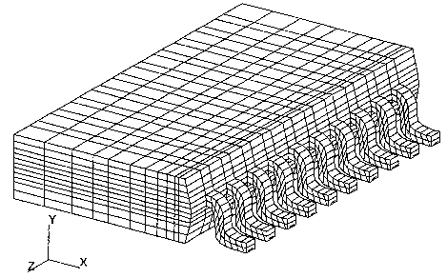
Fig. 10. One-quarter TSOP FEA model

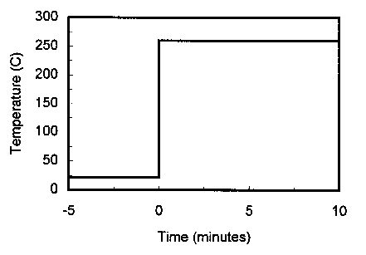
Fig. 11. Thermal shock profile

4. FEA Results

Fig. 12 shows the transient heat conduction process in the silicon chip. After 0.1 sec from the thermal shock, the highest temperature on the chip surface is increased by approximately 55 °C, by 3.4 sec thermal equilibrium is essentially reached. The temperature gradient across the chip is initially small due to constant room temperature (22 °C), but with more and more heat flux, this gradient peaks dramatically and disappears quickly because of rapid thermal equilibrium. Fig. 13 shows this change in temperature gradient.

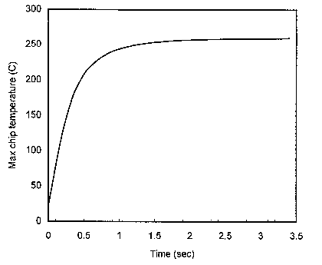
Fig. 12. Chip transient temperature rise
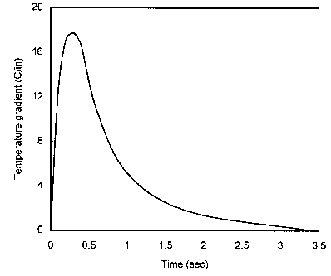
Fig. 13. Transient temperature gradient change in the chip

For the overall TSOP device, the time needed to reach thermal equilibrium is longer than 3.4 sec, because of the differences in thermal diffusivity of the materials. Fig. 14 illustrates this process, and it can be seen that the practical equilibrium time is about 6.6 sec.

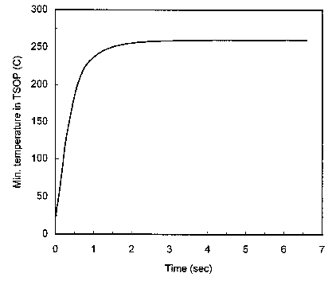
Fig. 14. TSOP transient temperature rise

The distribution of maximum principal stress in the silicon chip at 260 °C is obtained by the transient stress analysis. The peak stress, occurring around the corner of the chip, is 198 MPa. Compared to the averaged fracture strength of 1.0 GPa, this shock-induced stress is well within the safe region. Similarly, the distribution of the maximum shear stress in the plastic molding compound shows a peak value of 66 - 68 MPa occurring at the interface of the plastic and the die paddle, as well as the plastic and the I/O lead. These are considered the likeliest sites for possible interfacial delamination under this thermal shock because the lab shear testing shows that the compound’s failure shear stress (15 - 65 MPa) lies below the actual peak stress in those regions.

Using thermal stress level as a delamination criterion may be inadequate for mainly two reasons. First, mechanical stresses induced by moisture expansion inside the package at high temperature (which is not the concern in this study because of sufficient baking before reflow) could cause more significant damages than thermal stresses during heating up stage in a reflow [2], and a simultaneous solution using FEA for both thermal stress and pressure-induced stress is difficult. Often the total stress effect is underestimated and only thermal stress is taken into consideration. This combined stress issue remains largely unsolved, although evaluating the effect of the two stress fields separately is straightforward. Secondly, due to r^{-1/2} type stress singularity, local stresses around a sharp corner or a crack tip are non-deterministic. Recently several attempts have been made to analyze plastic package delamination/cracking problem with classical linear elastic fracture mechanics [3], or elastic-plastic fracture mechanics ([2], [4] and [5]). Through the use of stress intensity factors and J contour integral, the results of these work provided viable means dealing with internal delamination of plastic packages.

However, there still exist fundamentally unsolved issues in this critical area. First, all the work mentioned above assumed a through-thickness crack mechanism, i.e, plane stress or plane strain. The inspection of reflowed TSOPs revealed that typical delamination/cracking sites were neither plane stress nor plane strain. Secondly and most importantly, fracture behavior of thermoset plastics is quite different from that of metals and other brittle materials, and applying fracture mechanics concepts for metals to plastics may be misleading. A salient feature of thermoset plastic material is the rate-dependent viscoelastic behavior during deformation. Plastics do yield under large strain with a mechanism of shear deformation. Typically, a thermoplastic goes through state transitions when temperature changes significantly. When temperature is close to its glass transition point (T_{g}), the polymer exhibits a “leathery” behavior. At higher temperature, it is in rubbery state. If temperature reaches a certain high level, the polymer will be unable to carry any load and will behave like a viscous fluid. For Compound X, the measured T_{g} is about 125 °C.
To account for the time-dependent viscoelastic behavior, two quantities must be included in the analysis: relaxation modulus E(t) and creep compliance D(t), which can be measured by fixing strain and stress respectively.

E(t) = s(t)/e₀ (1)
D(t) = e(t)/s₀ (2)

Modeling thermal shock of this magnitude could be considered too harsh and unrealistic for practical purposes such as solder reflow process. Realistically, the temperature profile in this reflow process behaves more like a thermal cycle with a gradual change from 22 °C to 260 °C. The difference in the resultant stresses in the compound with a thermal cycle is mainly due to creep, a stress relaxation process. Therefore stresses induced at 260 °C under thermal cycling will be significantly lower. Considering the large shear failure range and the lower bound (15 MPa) for this compound, it is possible that delamination could still occur in those weak interfaces even with creep in the compound. At present, several material-dependent coefficients and exponents in the constitutive model for creep are not available for this compound. A more extensive material testing effort is required in order to obtain those properties.

Let us compare stress change in the chip under the shock condition with that under a gradual temperature change, the latter being closer to actual solder reflow profile. Fig. 15 shows a hypothetical profile which has a ramp time of 5 minutes. The changes of maximum principal stress under the shock profile and the gradual profile are plotted in Fig. 16 and 17 respectively. Without creep effect in the model, resultant peak stresses (198 MPa or 28700 psi) are the same, but the rate of increase is different.

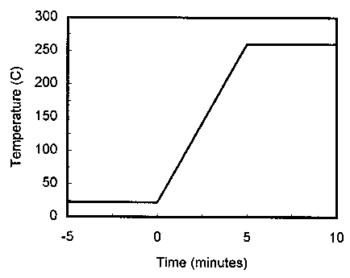
Fig. 15. Hypothetical reflow profile
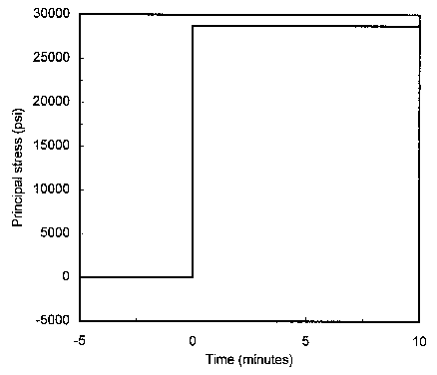

Fig. 16. Transient max. principal stress in the chip under shock profile

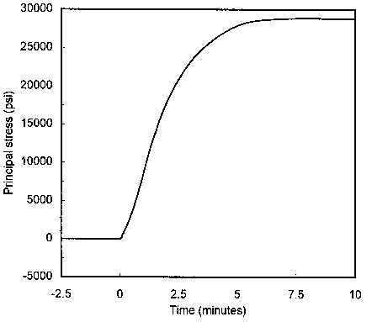

Fig. 17. Transient max. principal stress in the chip under “reflow” profile

5. Conclusions

Finite element transient thermal analysis and thermally induced stress analysis are performed for a TSOP device made with Compound X. It is found that this thin plastic package takes only a few seconds to reach thermal equilibrium in a thermal shock environment from 22 °C to 260 °C. This indicates that this type of device has a good heat conduction capacity.

Several interfacial areas in the device have excessive shear stresses and are susceptible to interfacial delamination under the thermal shock conditions. Due to plastic creep (that has not been taken into account), the possibility of delamination is reduced but not entirely eliminated. A more complete model should account for the viscoelastic behavior of the compound, but this requires far more testing that is ongoing. Analysis incorporating nonlinear creep process, together with 3-D fracture mechanics determining delamination/cracking growth and arrest, will constitute our future endeavor in the TSOP reliability evaluation.

6. Acknowledgment

The authors would like to thank Ann Garrison-Darrin (GSFC code 310) and Jack Shaw (GSFC code 312) for their generous support, and Dr. Henning Leidecker (GSFC code 311) for many useful discussions on behavior of the molding compound material. The testing of Compound X by GSFC code 313 personnel, including Michael Viens, Jackie Townsend, Chuck Powers and T. Van Sant, is also deeply appreciated.

7. References

[1] T. Steiner and D. Suhl, “Investigations of large PLCC package crack during surface mount exposure,” IEEE Trans. Compon., Hybrids and Mfg. Tech., Vol. 10, No. 2, pp. 209-216, 1987.

[2] H. Lee and Y. Y. Earmme, “A fracture mechanics analysis of the effects of material properties and geometries of components on various types of package cracks,” IEEE Trans. Compon., Pkg. and Mfg. Tech., Vol. 19, No. 2, pp. 168-178, 1996.

[3] T. Saitoh, “Numerical stress analysis of resin cracking in LSI plastic packages under temperature cycling loading,” IEEE Trans. Compon., Pkg. and Mfg. Tech., Vol. 19, No. 3, pp. 593-600, 1996.

[4] J. Sauber, et al., “Fracture properties of molding compound materials for IC plastic packaging,” IEEE Trans. Compon., Pkg. and Mfg. Tech., Vol. 17, No. 4, pp. 533-541, 1994.

[5] A. A. O. Tay, et al., “Predicting delamination in plastic IC packages and determining suitable mold compound properties,” IEEE Trans. Compon., Pkg. and Mfg. Tech., Vol. 17, No. 2, pp. 201-208, 1994.

