Title: Further Considerations of Radar Spurious Emission Masks
Written by: John Holloway
Dated: Friday, 13 May 2005

Summary

This paper is an input to JRG meeting to be held in Southampton May 2005

This paper reprises four previous papers presented to the Radar JRG and the previous RCG.

It also presents further thoughts into the applicability of the proposed design objective for the spectrum roll-off in the OOB domain.

Introduction

This paper revisits four previous papers presented to the JRG and the previous RCG. It reappraises the conclusions drawn in the light of the latest information and thinking.

- RCG-17: Preliminary Parametric Study of the Bandwidth Requirements for FM modulated Pulse Radar Waveforms.

- JRG 13 Spectrum of chirped radar pulses using non-linear FM

- JRG 12 Comparison of Methods Used to Predict the Bandwidth of Radar Emissions

- JRG 21 Consideration of the results presented on the relationship between current ITU limits on bandwidth and spectrum shape, to the theoretical and practical radar emission spectra of Trapezoidal or Rectangular type pulses

All the papers are available from the JRG website or by application direct to the author.

Preliminary Parametric Study of the Bandwidth Requirements for FM modulated Pulse Radar Waveforms. (RCG 17)
This paper addresses the bandwidth requirements associated with FM modulated trapezoidal waveforms. It initially dressed the issue of the Necessary Bandwidth (Bw_{-20dB}) in particular the ITU equation for the Bw_{-20dB}
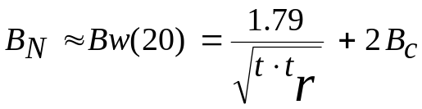
Which over estimates the bandwidth.
In particular when the time x bandwidth product is large when in practice B_{w} (20) → B_{c}.
At the time of writing consideration was being given to using the B_{N} as the fundamental bandwidth for UE specification as opposed to the B_{w}(40)
It discussed an empirical formula for the B_{w}(20) which gave a better result.
This work has been superseded by the work reported in JRG 12 “Preliminary Parametric Study of the Bandwidth Requirements for FM modulated Pulse Radar Waveforms”. In this the work of “Newhouse” was discussed this gives a much better approximation to the B_{w}(20) envelope.

The paper concludes:

- The properties of the pulses are such that even when an accurate assessment of the B_{w}(40) is sued then the current 20 dB/dec roll-off is relatively easily achieved.

- The proposed 40 dB/dec is difficult to achieve just from the natural spectrum of the waveform, particularly for some combinations and especially when the effects of practical distortions are considered. It is known that these can have a great effect at the -60dB level.

- “If the current ITU formula for Bw(-40) is maintained then the 40dB/dec is achievable in all cases considered.” Later work has shed some doubt on this conclusion.

- It must be remembered however that these conclusions are based on theoretical waveforms some allowance for practical implementation will be required.

Spectrum of chirped radar pulses using non-linear FM (JRG 13)

The results of this theoretical initial investigation show that:

- In the majority of cases the theoretical –40 dB bandwidths calculated are less than those allowed in the ITU specification for a equivalent B factor,

- Theoretical spectrums also meet the requirements of the –40 dB/dec roll-off design objective given in ITU-R 1541 Reference 3.

- Non-linear FM using typical weighting gives narrower bandwidths than the linear case in all the cases tested.

In this initial paper only one chirp has been considered further work is necessary to confirm the findings above on other practical radar waveforms.

The ITU formula is based on the pulse length, rise-time and chirp and assumes linear FM. As non-linear FM gives a reduced bandwidth then there is a possible argument that this needs to be taken into account in the formula. The problem with adding a factor for the FM modulation is how one can specify the shape of the chirp curve in a relatively simple manner. A possible way may be just to use a multiplying parameter< 1 based on a “typical” non-linear waveform. This parameter my have to be dependent on pulse length and rise time. Further study would be needed to develop such a parameter.

Comparison of Methods Used to Predict the Bandwidth of Radar Emissions (JRG 14)

Paper “Preliminary Parametric Study of the Bandwidth Requirements for FM modulated Pulse Radar Waveforms” compared the ITU calculation method with results achieved from Fourier analysis. This paper compares the method proposed by Newhouse and concludes it provides a good estimate of the spectrum envelope.

Consideration of the results presented on the relationship between current ITU limits on bandwidth and spectrum shape, to the theoretical and practical radar emission spectra of Trapezoidal or Rectangular type pulses (JRG 21)

The paper concludes:

- On the face of it would seem that the ITU bandwidths are too generous and that there is scope to increase the roll-off towards the theoretical limit of –40 dB/dec of pulses in particular those using FM modulation.

- What must be remembered in this debate is that the waveforms considered are theoretical and that the calculated spectrums based on the ITU defined parameters of t, tr & B are based on a theoretical Trapezoidal or Rectangular shaped pulses with linear frequency shift (non-linear FM is not considered).

- The theoretical analysis takes no account of practical implementation issues associated with these types of pulses. Radar pulses are never truly Trapezoidal or Rectangular. The parameters t, tr & B used to define the pulse shape are only a very limited set and these do not fully represent the pulse shape. For example, the rising and falling edges of a pulse are very rarely truly linear as this requires an infinite rate of change between the edge and the top of the pulse, natural band-limiting will result in a smoothing of the pulse which may in turn result in some further limiting of the spectrum.

As well as not truly representing the pulse the there are other affects that are not represented at all in ITU formula effects related to AM to PM conversion and other sources of noise from amplifying devices are not covered in the theoretical analysis submitted to date.

Conclusions to Date

These conclusions are based on frequency agile radars or active phased array radars in both of these cases it is not possible to use a channel filter to improve the roll-off of the transmitted spectrum. It may be possible to improve the roll-off at the edge of the agile band by using a band-limiting filter (strictly speaking the OOB limits only apply to radars operating in shared bands or at the band edge). It is most likely however that all radar bands will be shared as time progresses so the OOB limits are likely to be applied more and more radars.

Thus for the waveforms under consideration pulse shaping is the only option to control the spectrum.

Linear FM

To date the following conclusions can be drawn theoretical trapezoidal pulses do have the fundamental ability to meet the the requirements of a 40 dB/dec roll-off however when the B_{w}(40) is based on the ITU equations, problems occur when the ITU bandwidth < 1/πt_{r}. The equation tends to over estimate the B_{w}(40) in particular when the high power version is used and this compensates for the fact that the maximum theoretical roll-off is 40 dB/dec which is difficult to achieve in practice.

If an accurate determination of the B_{w}(40) is made then the 40 dB/dec from this bandwidth would be difficult to meet for this class of radar,

There are two issues however that have to be considered.

- Transmitters do not tens to produce purely trapezoidal pulses, as they do not have sharp corners. This tends to reduce the extent of the spectrum.

- Transmitters have other sources of error particularly AM to PM effects that tend to spread the spectrum particularly at the lower levels.

Non Linear FM

The following comments can be made on Non-linear

- Non-linear FM has a narrower B_{N} if the ITU equation is used gives a better margin when the 40 dB/dec is used.

- If an accurate determination of the B_{W}(40) is made then Non-linear FM would find it difficult to meet the 40 dB/dec design aim.

- It may be difficult to generate a simple equation to estimate the B_{w}(40) given the number of variables involved.

More practical results are needed to under write these conclusions BAE Systems will hope to have some measured results later this year.
Annex 1 Further Thoughts on the proposed OOB design aim

Linear FM

In the revision of ITU document 1541 annex 8 a design aim was set which increases the roll-off in the OOB region from 20dB/dec to 40 dB/dec. Several doubts have been raised at the applicability of such a roll-off to practical systems this work indicates that for certain classes of waveform the roll-off cannot be achieved in theory.

Consider the Figure below.

Envelope of Trapezoidal Pulse.

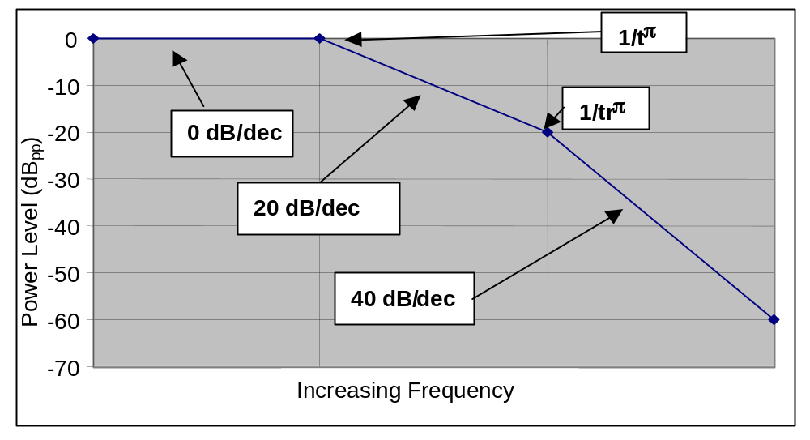

The 40 dB/dec roll-off region starts of at 1/(t_{r}π) in an FM modulated waveform the 1/(t_{r}π) point still controls the start of the 40 dB/dec roll off point all that happens is that the 20dB point → Bc → 40 dB point

50 μs Pulse 50ns rise-time varying chirp

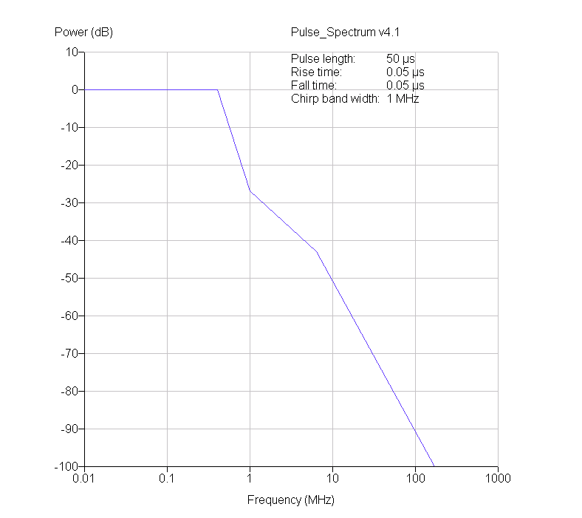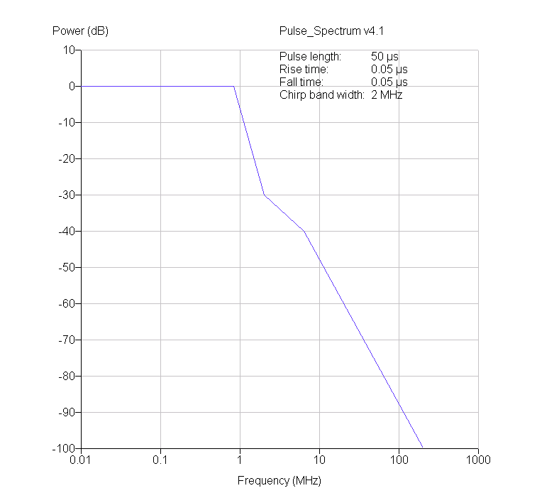
1 MHz 2MHz
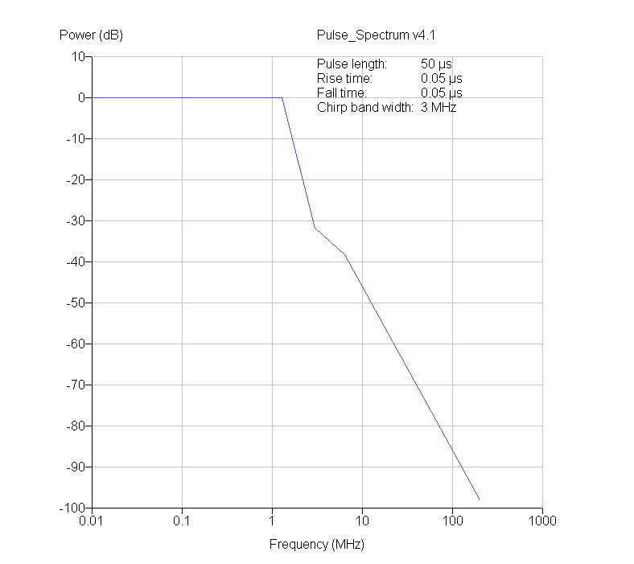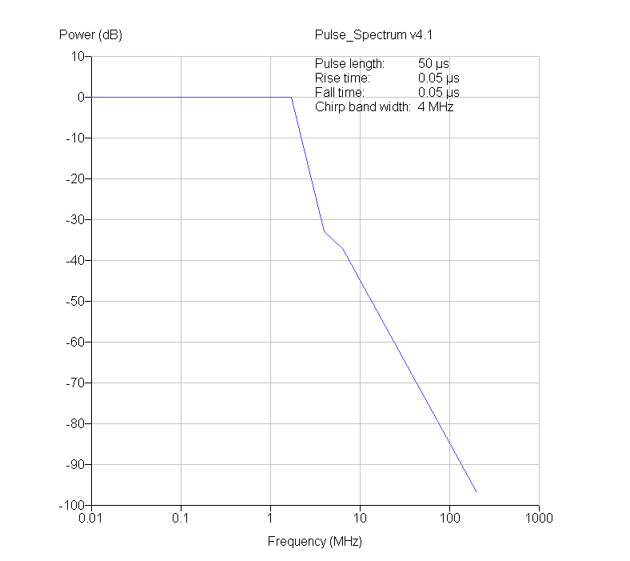
3 MHz 4MHz
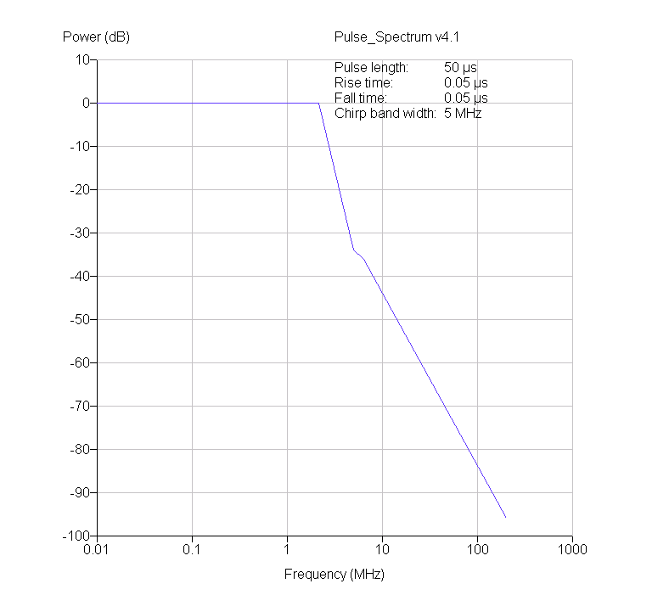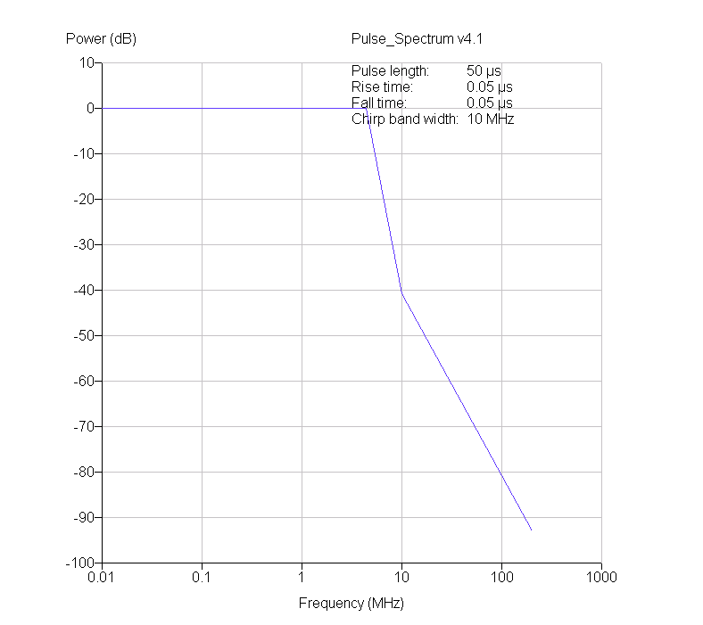
5 MHz 10 MHz

The 40 dB roll off point is fixed as the chirp increases until the point where the 20dB/dec roll-off region has disappeared and the 40 dB point falls within main lobe of spectrum.

This effect then gives a potential issue with the design aim. This occurs when the 40 dB beam width point calculated by the ITU formula is < 1/(t_{r}π) this occurs in the case below. In these curves the Newhouse envelopes are used as they give a god approximations.

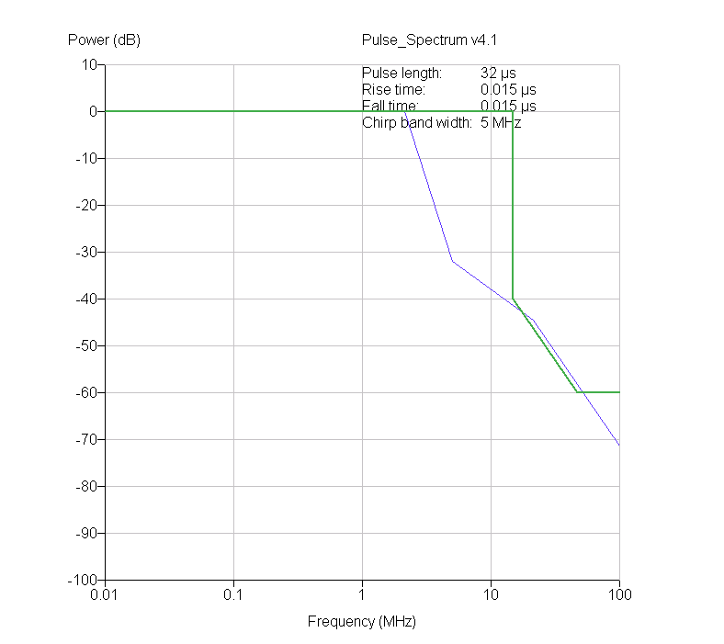
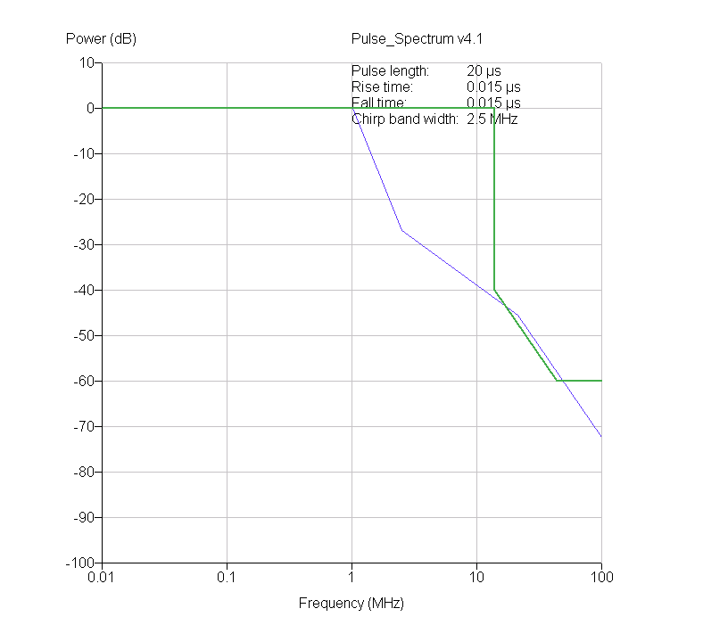

This shows that there is a potential issue with the 40 dB/dec roll off.

Non-linear

Consider the spectrum below, this is a FM modulated pulse radar with 25 mS pulse and a rise time between 15 to 18 ns and a 2.5 MHz chirp. Although this result is noise limited the following bandwidths have been estimated from this measurement. These are compared with those calculated using the ITU equations.

The measured B_{w} (20) is < 50% that calculated, the B_{w} (40) < 50% calculated and the B_{w} (60) » 8 % of that calculated if the new design aim was used then the result would be < 50% of that calculated.

Figure 1 Annex 1

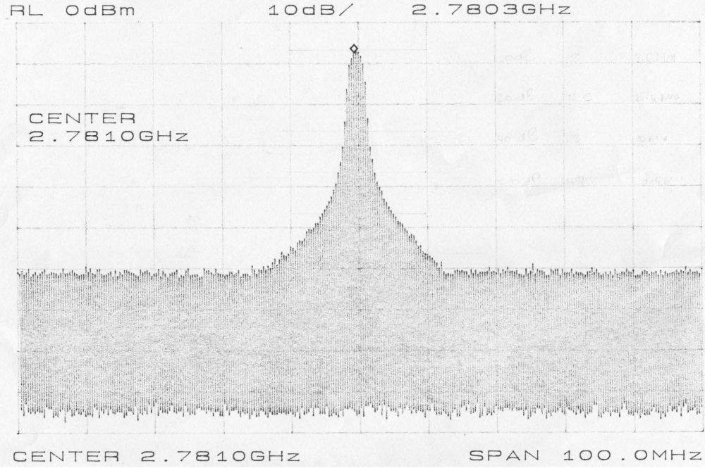

The measured B_{w} (20) is < 50% that calculated, the B_{w} (40) < 50% calculated and the B_{w} (60) » 8 % of that calculated if the new design aim was used then the result would be < 50% of that calculated.

Table 1 Annex 1

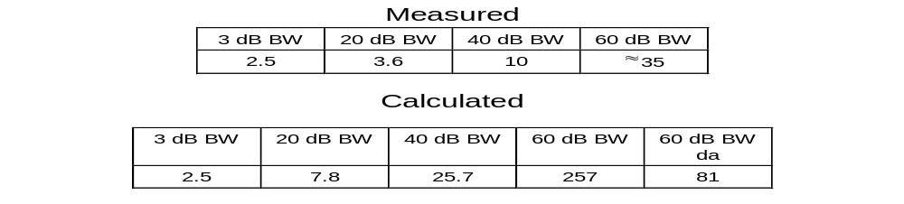

This spectrum well exceeds both the current requirements and the design aim. This is a result of an over estimation of the 20 and 40 dB bandwidths giving rise to a very generous 60 dB requirement. If a more accurate calculation of the B_{w}(40) could be achieved say for example 10 MHz then the B_{w}(60) at » 35 MHz would exceed the 3.2 ratio required by the design aim.

· Section 3 of this paper discusses some further concerns about the 40 dB/dec roll-off
These two pulses may not be equivalent in operational radar terms,

