5022.1TA
BELOW-THE-HOOK LIFTING DEVICE

Engineering Note Cover Page for MD-ENG-073

Lifting Device Numbers:
FNAL Site No/ |  | Div. Specific No. | 154 | Asset No.
 | If applicable |  | If applicable |  | If applicable
ASME B30.20 Group: [X ] Group I Structural and Mechanical Lifting Devices
(check one) [ ] Group II Vacuum Lifting Devices
[ ] Group III Magnets, Close Proximity Operated
[ ] Group IV Magnets, Remote Operated

Device Name or Description | Coil Insert Lifting Fixture for SM3 Disassembly & VM Assembly

Device was | [ ] Purchased from a Commercial Lifting  Device Manufacturer. Mfg Name
(check all applicable) | [ ] Designed and Built at Fermilab
 | [X] Designed by Fermilab and Built by a  Vendor. Assy drawing number | Eng. Drawings: MC- 407784
 | [ ] Provided by a User or other Laboratory
 | [ ] Other: Describe

Engineering Note Prepared by | Edward Chi | Date | January 28, 2005
Engineering Note Reviewed by |  | Date
Lifting Device Data:
Capacity | 6,500 lbs.
Fixture Weight | 180 lbs.
Service: [ X] normal [ ] heavy [ ] severe (refer to B30.20 for definitions)

Duty Cycle | _______ 8, 16 or 24 hour rating (applicable to groups III, and IV)
Inspections Frequency
Rated Load Test by FNAL (if applicable) |  |  | Date |  |  | Load
[ ] Check if Load Test was by Vendor and attach the certificate
Satisfactory Load Test Witnessed by:
Signature (of Load Test Witness)
Notes or Special Information:
See page 8 for rated load test procedures;
page 9 for rated load test setup layout;
page 10 for rated load test site pictures if have any.
 | Fermilab

Particle Physics Division
Mechanical Department Engineering Note

Number: MD-ENG- 073 Date: January 28, 2005

Project Internal Reference:

Project: BTeV, SMTF

Title: Coil Insert Lifting Fixture for SM3 Disassembly & VM Assembly

Author(s): Edward Chi

Reviewer(s): David Pushka

Key Words: Coil, insert lifting fixture, tubing, threaded rod, axial allowable
stresses, critical force, buckling.

Abstract Summary:
The insert lifting fixture is specially designed to lift the sm3 & VM coil (inner, middle and outer coil) vertically from the limited accessed space area, and then move to the designated location. The working stresses of fixture structure; the buckling behavior of the slim tubing with threaded rod; the welding sizes of the lifting lug have been presented for discussion and calculation per the related industrial specifications and codes.

Applicable Codes:
“Allowable Stress Design”, AISC, 9th edition
“Below-the-Hook Lifting Devices”, ASME B30.20
“Structural Welding Code-Steel”, AWS D1.1-90
“Steel structures Design and Behavior” by C. Salmon & J. Johnson, 3rd
edition, 1990

Design the Coil lifting Turning Fixture for SM3 & VM Magnets

Design Criteria and Assumptions:

Total design load:
Lifting capacity: P_{c1} = Pc2 =13,000 lbs / 2 = 6,500 lbs.
Fixture weight W_{d} = 180 lbs. (dead weight)
Gross force to the fixture: P_{ty} = 6,500 lbs + 180 lbs. = 6,680 lbs.
All plates: ASTM A36: F_{u} = 58 ksi, F_{y} = 36 ksi
All tubings: Carbon stl. AISI 1020, F_{u} = 52 ksi, F_{y} = 38 ksi
All bolt materials: Grade 5 steel, F_{u} = 120 ksi
All weld materials: E70, where F_{u} = 70 ksi

Reference Drawings:
LE- 407840, MC-407784, MB-407790, MB-407786, MB-407787, MB-407788

The application of the coil insert lifting fixture:

The coil insert lifting fixture specially designed: lift & move the coil away from the limited access space area as shown on figure 10 of dwg. LE-407840; and then move the coil to the designated area for installing the coil turning fixture as shown on figures 11a to 11c of drawing LE-407840.

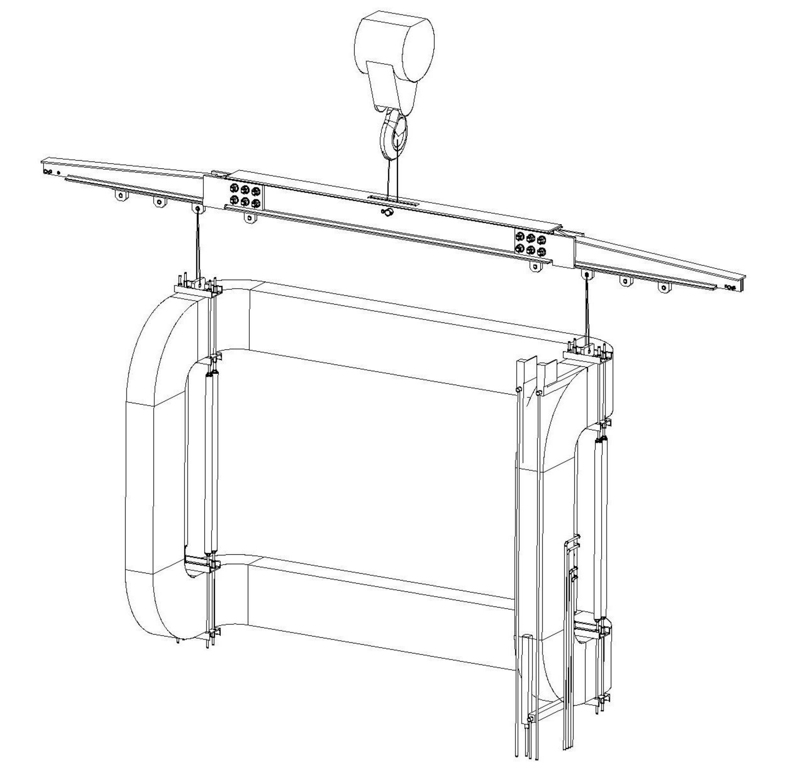
Z
X

Figure 1. Using the coil insert lifting fixture to lift the coil vertically
Figure 1 on page 3 shown the application of the coil insert lifting fixture: two coil insert
lifting fixtures lifted the coil through the coil lifting spreader bar. It is assumed that there
is about 6,680 lbs force (P_{ty}) applying to each coil insert lifting fixture.

Figure 2 is the detail engineering drawing of the coil insert lifting fixture, the coil was supported by upper and bottom decks, there are (4) tubes with threaded rods connected upper and bottom decks together as shown on drawing MC-407784.

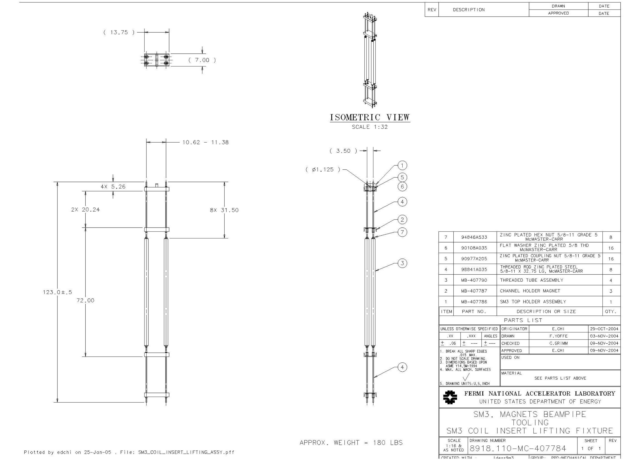

Figure 2. The detail eng. drawing of the coil insert lifting fixture.

I. The discussion of the load condition of the coil insert lifting fixture.

When coil is lifted by the coil insert lifting fixture, it is assuming that the tube with
threaded rod mainly subjected two forces: tension load and compressive load
- Discuss the working tensional load p_{tr} of the threaded rod:
Conservatively assuming that one rod takes whole load p_{t} = 6,680 lbs.= p_{tr}
The specifications of the threaded rod: grade 5 steel, 5/8” – 11, UNC,
F_{u} = 120 ksi,
F_{t} = 0.33 F_{u} = 39.6 ksi, the allowable tensile stress of the threaded rod
(per page 4-3, part 4 of ASD, 9th edition)
P_{t} = Gross area of the threaded rod x allowable tensile stress
= 0.3068 in² x 39.6 ksi
= 12.15 kip > p_{t}= 6.680 kip = p_{tr}
where P_{t} is the allowable tensional load for the thread of 5/8” nominal diameter.

The designated threaded rod has enough capacity to take the subjected
tensional load.

b). Discuss the work condition of the tube with threaded rod subject the axial load
P_{ca}.

P_{ca} = P_{ty} / n, compressive axial load per tubing column
= 6,680 lbs / 4 =1.67 kip,
n: number of the tubing columns per insert lifting fixture

b1).Find out the critical force P_{cr} to cause the column to buckling:
P_{cr} = (Π²E) A_{g}/ (KL/r)²
= [(Π² x 29 x 10⁶ ksi) x 1.215 in²] ÷ (2.0 x 72.0 in / 0.732 in)²
= 8.986 kip > P_{ca}= 1.67 kip
(see section 6.3, Steel Structures Design & Behavior, 3rd edition)

So there is no buckling under the current load conditions.

where: E = 29 x 10⁶ ksi, modulus of elasticity of the subjected member
A_{g}= 1.215 in², for gross cross-section area of the tubing with 2.25” od. and
3/16” wall thickness (see drawing MB-407790 for ref.)

L = 72.0 in, the length of the subjected member conservatively assumed.
K = 2.0, assuming effective length factor
I = 0.651 in⁴, geometrical inertia of the tubing.
r = 0.732 in, radius of gyration

b2). Find out the allowable stresses vs. the computed working stresses:

F_{a1} = 12 Π²E ÷ 23(KL/r)²
= (12 Π² x 29,000 ksi) ÷ 23 x 196.7²
= 3.86 ksi
(see eq. E2-2, Charter E, Part 5, ASD, 9th edition)

where: F_{ai}: the allowable axial stress for the compressive member
KL/r = 2.0 x 72 in/0.732 in = 196.7, the largest effective slenderness ratio
C_{c} = [(2Π²E) / F_{y}]^{1/2} = 122.73 < KL/r = 196.7

F_{y} = 38 ksi, yielding stress for tubing with AISI 1020, carbon stl.
per section 20-1.2.2.2, ASME B30.20
F_{b} = F_{y} /3.0 = 12.67 ksi = F_{v} = F_{a2}
Pick the less value one as allowable stress,
so F_{a} = 3.86 ksi.

f_{a} = P_{c} / A_{g} = 1,670 lbs / 1.215 in²
= 1.375 ksi < F_{a} = 3.86 ksi,

The computed axial working stress is satisfactory subjecting the axial applying
force.

3. Weld Calculations:

The figure 3 is the weld configuration for the lifting lug of the coil insert lifting fixture,
See drawings MB-407788, MB-407786 and MC-407784 for the reference.

Find the geometrical properties of the welds as shown on figure 3:

Where: d = 1.25 inch,
b = 5.0 inch
L = 2b = 10 in, length of the welds
I_{xx} = bd² / 2
= 3.9 in³
S_{xx} = bd
= 6.255 in²
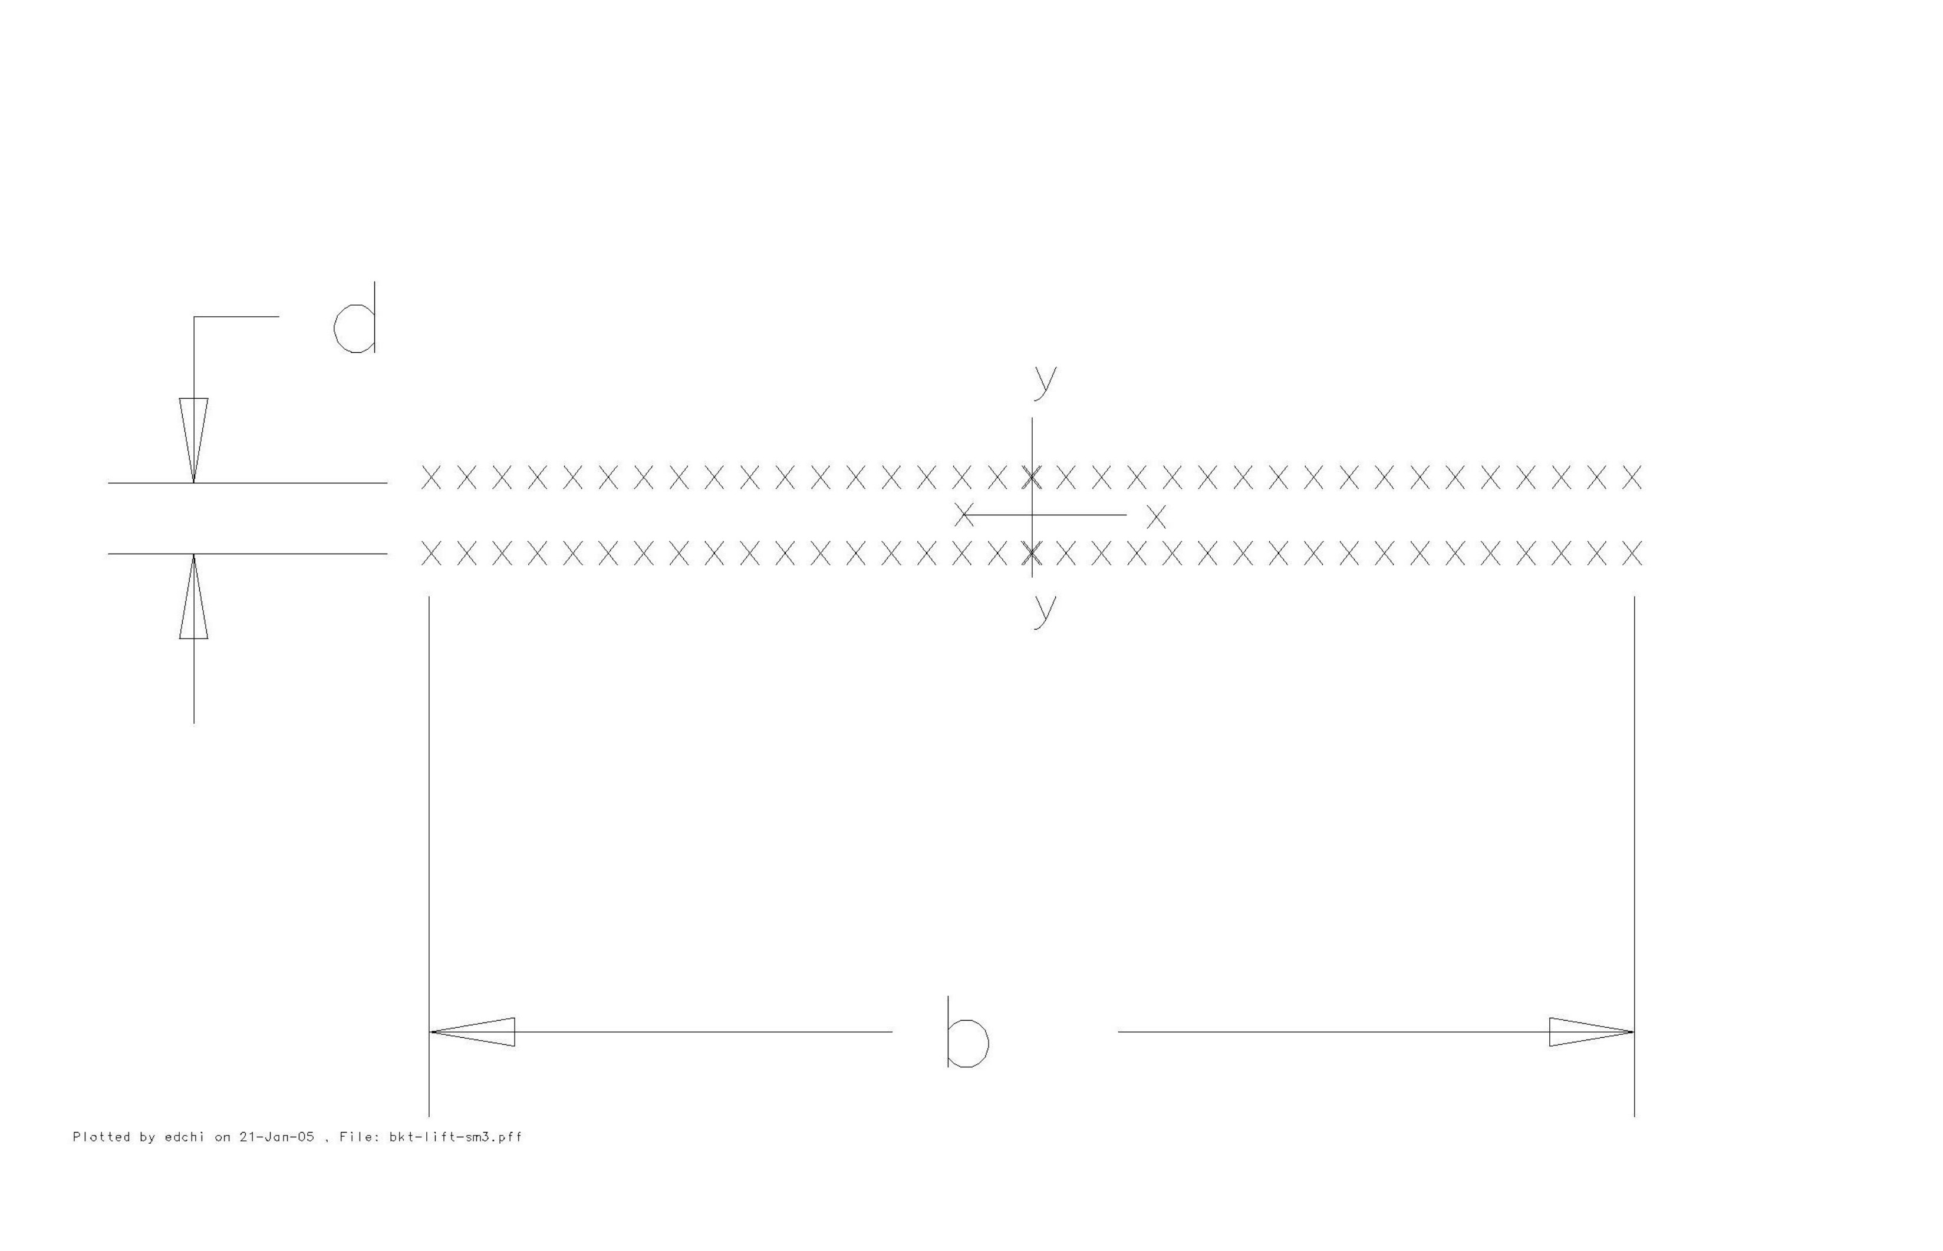
Figure 3. The weld configuration for the lifting lug of the coil insert lifting
fixture (treat as line with unit thickness).

The working load per unit length of the weld subject to the applying load can be found:

f_{v} = P_{ty} / L
= 6.680 lbs ÷ 10 in
= 668 lbs/in
Per figure 1 for the application of the insert lifting fixture, it can be assumed that there is no significant moment to be produced from the subjected applying load.

So: f_{r} = f_{v}
= 668 lbs/in
where: f_{r} is the combined working load per unit length

To find the required weld size C_{I}:
All weld metals are E70,
Where: F_{u} = 70 ksi
The allowable stresses for the weld metals:
F_{t} = F_{v} = 0.30 F_{u} = 21 ksi

C = combined working load per unit length÷ (effective factor × allowable stress)
= (668 lbs/in) ÷ (0.707 x 21 ksi)
= 0.045 in < 0.31 in (the designated weld size in the area per drawing MB-407786)

The designated weld sizes are satisfactory.

Conclusions:

The coil insert lifting fixture has been designed per the related engineering codes after the discussions from several different areas, such discussions were presented by computing the working structural stresses; allowable axial stresses of the slim tubing column; and finally the weld sizes in terms the different applications.

Rated Load Test Procedures for SM3 Coil Insert Lifting Fixture

- Review the load test setup on figure 4 of page 9 and the lifting fixture engineering
drawing MC-407784, call Edward Chi @x2879 for the questions.

- Prepare and move the items to the designated area:
a). Three B shield blocks
b). Two existing steel tubes:
One with sizes of 10” x 12” x ½” with 10’ in length,
Another one with sizes of 10” x 10” x ½” x 120”.
c). Two timber blocks:
One with one sizes of 8” x 8” x 24”
Another one with sizes of 10” x 8” x24”
d). 8 pieces of garden hose (~19” in length) – or equivalent, for threaded rod
protections.
e). 8 pieces of steel angles or equivalent parts for restricting the sling contact
area
f). Slings with spec. as shown on figure 4.
g). Hoist scale
f). One 1” dia, alloy steel anchor shackle

- Assemble all items per load test set up as shown on figure 4 of page 9 (per right side view), uniformly apply the clamping force to the tubes and blocks through the threaded rods, the tight torque to the nut is about 75 ft-lbs. Cross–check the position per the test setup layout and drawing MC-407784.

- Lift up the assembled test fixture slowly, apply the slings per the test setup on figure 4 (see the front view), make sure that both slings stay on the distance of 30” and 60” as shown on the front view of figure 4.

- Gradually, slowly apply load through crane until the scale reading reaches 8,350 lbs, sustain such load up to 10 minutes, observe the fixture to see if there is any irregular mechanical behavior.

- Take the pictures for the load test setup.

- Fill out and sign the form 5022.1TA (page 1) as Load Test Witness

- Remove every item back in order.

- Mark the fixture as:
Number 154
Lifting Capacity: 6,500 lbs.
Fixture weight: 180 lbs.

10. Thanks for finish the project safely and successfully.
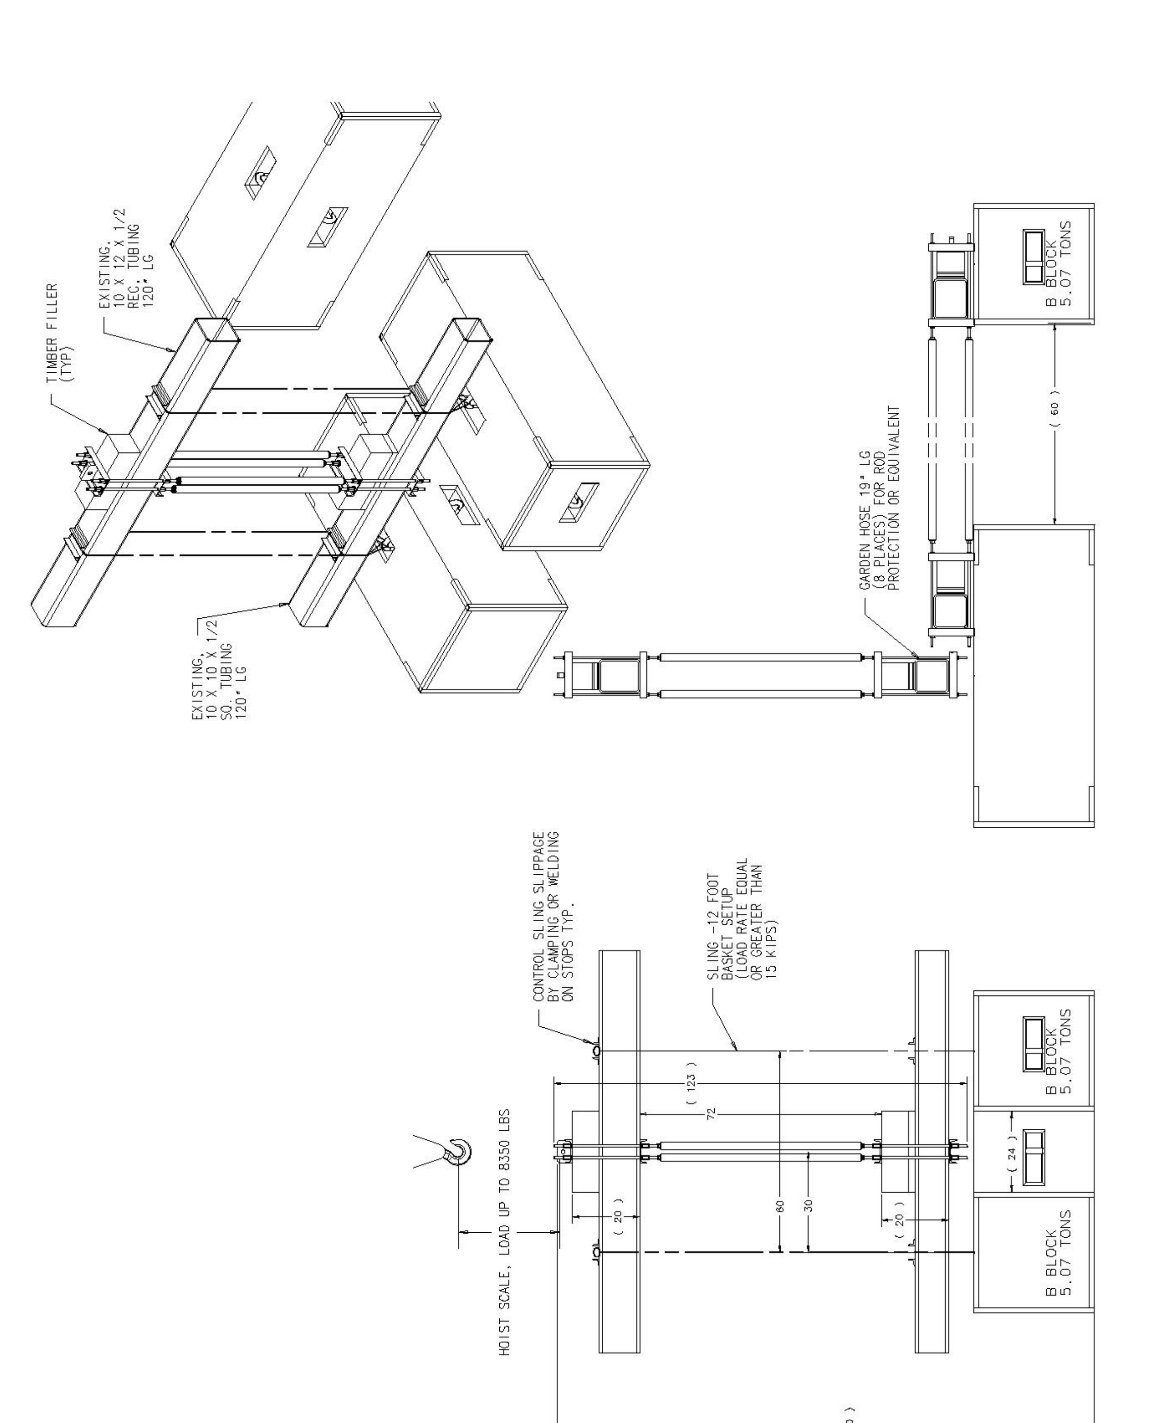

Figure 4. SM3 Coil Insert Lifting Fixture Load Test Setup


