POND DESIGN
User's Guide

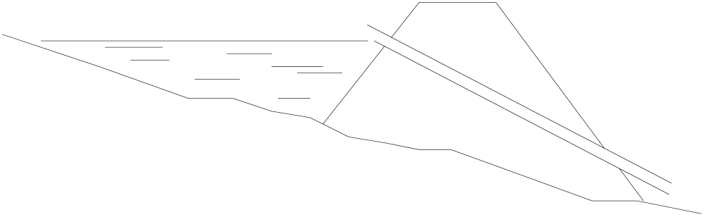

Version 1.0
Released 4/94

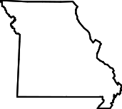


USDA, Natural Resources Conservation Service
Parkade Center, Suite 250
601 Business Loop 70 West
Columbia, Missouri 65203

TABLE OF CONTENTS
PAGE
GETTING STARTED
INTRODUCTION
SYSTEM REQUIREMENTS
LOADING THE PROGRAM TO THE HARD DISK
STARTING THE PROGRAM
PROGRAM CONVENTIONS & ILLUSTRATIONS
KEY CONVENTIONS
STATIONING CONVENTION
ILLUSTRATIONS
MAIN MENU
DESIGN POND
PROJECT NAME
DESIGN MENU
EDIT DESIGN DATA
PROJECT INFORMATION
ELEVATION STORAGE INPUT METHOD
ELEVATION STORAGE DATA
HYDROLOGY INFO
RUNOFF CURVE NUMBER DETERMINATION
SEDIMENT STORAGE INFO
PRINCIPAL SPILLWAY INFO
CONDUIT INFORMATION
PRINCIPAL SPILLWAY ROUTINGS
EMERGENCY SPILLWAY DISCHARGE DETERMINATION
EMERGENCY SPILLWAY INFO
EMERGENCY SPILLWAY ROUTING
FINAL DESIGN CHECK
EDIT EARTHWORK DATA
GROUND PROFILE/CROSS-SECTION DATA
EMBANKMENT CROSS SECTION INFORMATION
GROUND/EMBANKMENT INTERSECTIONS
PRINT DATA
CHANGE DEFAULTS
DEFAULTS FOR POND DESIGN
DEFAULT PRINTER AND PORT
PRINTER COMMANDS
RAINFALL DATA
APPENDIX A - SAMPLE OUTPUT
APPENDIX B - ERROR MESSAGES
APPENDIX C - ADDITIONAL INFORMATION
INITIALIZATION FILE
USER DEFINED STAGE-DISCHARGE FILES
ENVIRONMENT VARIABLES

GETTING STARTED

INTRODUCTION

The Pond Design program is intended to assist engineers and engineering technicians in the design of ponds and structures. The program will assist in determining the emergency spillway and top of dam elevations by floodrouting principal and emergency spillway storms. Up to three pipe trials can be entered to determine an emergency spillway elevation. Earthwork quantities (settled fill, constructed fill, stripping, and core trench) can be computed. A variety of reports can be printed including a construction checkout sheet, conduit details, and a summary sheet.

A few of the features worth mentioning here include : the ability to save and recall design data; the user can create their own default file; moving between screens is very easy; and the user has control over what reports are printed. There are many other features that are discussed in detail later in this manual.

This manual, the Pond Design User's Guide, provides instructions on how to use the program. The accompanying manual, the Pond Design Technical Manual, provides technical details concerning the program (i.e., calculation procedures, file formats, etc.).

SYSTEM REQUIREMENTS

In order to run this program, you will need at a minimum the following:

• IBM or compatible computer (8088 or above)
• Hard disk (with at least 750K of storage space free)
• 640K of memory.
• DOS 2.0 or higher

Optional items include:
• Graphics adapter and monitor (CGA or equivalent)
Used to view centerline profile, cross-sections, and a principal spillway cross-section plot.
• Printer (highly recommended)
If graphics output is desired, you will need a printer capable of printing graphics (i.e., supported by GRAPHICS.COM) .
• GRAPHICS.COM (a program which normally comes with DOS), or a similar program to print graphic screen dumps to a printer.
• 8087 or above math coprocessor

LOADING THE PROGRAM TO THE HARD DISK

An install program is included on Disk Number 1 to assist in installing the program on a hard disk. The steps for using this program are outlined below. If a drive other than A is used for installing, just substitute it wherever drive A is used in the instructions below.

1. Turn computer on and make sure you are at the DOS prompt (e.g., C:\> ).

2. Place Disk #1 in drive A.

3. Enter

A:INSTALL

4. The install program will load and you will be prompted for the source drive and the destination drive and path. Enter the appropriate responses.

5. The install program will then prompt for each disk and will copy the files from each disk. All you need to do is make sure the correct disk is in drive A and press a key when asked.

6. The program will indicate when it is done and will return you to the DOS prompt.

NOTE: If installing from 5.25" disks, the install program MUST be used. If using 3.5" disks, all of the files can be copied to the hard drive instead of using the install program.

STARTING THE PROGRAM

The user should access the Pond Design program by entering (each line should be followed with the <ENTER> key) the following at the DOS prompt.

d:
CD mydir
PDMENU

where d: and mydir are the drive and directory where the program was installed. If the printout of the principal spillway plot is desired, you will need to load GRAPHICS.COM prior to running the program.

PROGRAM CONVENTIONS & ILLUSTRATIONS

SECTION PAGE

Key Conventions 3

Stationing Convention 5

Illustrations 6
Storage Volumes 6
Canopy Inlet Dimensions 7
Hood Inlet Dimensions 8
Elbow Details 9

KEY CONVENTIONS

This manual denotes a single key as <key>, where key is the name of the key (e.g., <F1> refers to function key F1, located either at the left or the top of the keyboard). If two keys are listed together (e.g., <Ctrl><P>), you should hold down the first key while pressing the second key. Several keys and key combinations have specific uses in this program. The main keys used and their respective functions are listed below. A list of the applicable keys is listed at the bottom of each screen. If a key varies from its purpose listed here, that will be noted in the appropriate section of the manual.

arrow keys : These are used to move the cursor or input field in the indicated direction.

<Delete> : The delete key is normally used to delete the data in the current field. Other uses of this key include deleting a field, line, or column. These uses will be detailed in the appropriate section where applicable.

<ENTER> : The ENTER key is denoted differently on some keyboards. The key could indicate Enter, carriage return <CR>, or just a symbol like ×+. This key is used to indicate you are finished entering a value.

<Esc> : The escape key is used to abort the program you are currently in and return to the Main Menu. You will be asked if you really want to quit. If you accidentally pressed the key or you decided you did not want to quit, you would answer N for no. This provides you a way to return to the program. If you had modified any data, you would also be asked if you wish to save the data. If you answer Yes, the data will be saved. If you want to lose the data, answer No.

<F1> : This is the help key. On most input fields, pressing this key will bring up a screen of help including the available keys and their associated functions.

<F2> : This key is normally used to invoke a list of choices which you can select from. An example would be when you are on a field requesting a filename. You can press <F2> to obtain a list of files currently stored on the drive:\path\ specified.

<F3> : This key is used to display a graphical view such as a centerline profile or a cross-sectional view of ground and dam.

<F5> : On the Ground Data screen, pressing <F5> will move to the next station.
The Print screen uses <F5> to begin printing.

<F10> : Use this key to store your data. When you press <F10>, the resulting action depends on the setting of "Filename when F10 pressed?" in your defaults. If "Y", you will be prompted for the filename and description of the file to save. If "N", the data will be saved to the current project name without prompting. Storing your data intermittently would be advised to avoid data loss due to power interruptions. You may also just want to quit and return to this data later.

<Insert> : This is usually used to toggle Insert mode off and on. It also used to insert a line or column in certain tables of data.

<PgDn> : Use the "page down" key to move to the next screen.

<PgUp> : Use the "page up" key to move to the previous screen.

<Ctrl><P> : On some screens, this key combination will allow you to print the displayed information. This is denoted in the appropriate sections.

<PrintScreen> : This key is used to send the current screen to the printer. It may be abbreviated on some keyboards (e.g., PrtSc or PrintScrn). Also, on some keyboards, you will need to use <Shift><PrintScreen> (i.e., while holding down <Shift>, press <PrintScreen>).

NOTE!! In order to print any screen displayed graphically, the program GRAPHICS should have been executed prior to running the program. If it was not loaded, only the text on the screen will be printed (i.e., none of the drawing). If the graphics screens are displayed in VGA mode and you are using a DOS version earlier than 5.0, the graphics screen will not print either. The solution is to either upgrade your DOS or run the program in CGA mode.

STATIONING CONVENTION

The stationing conventions used in this program are illustrated below in 2.

The embankment centerline profile must have stations increase from left to right when looking downstream. Cross sections will be viewed in the direction of increasing station with positive (+) values to the right (upstream) and negative (-) values to the left (downstream).

When stations are entered, do not enter the "+" (e.g., station 2+50 should be entered as 250). The "+" is automatically inserted.

The BL-CL offset is the horizontal distance from the baseline (flagline) to the centerline. If (looking in the direction of increasing station) the centerline is to the left of the baseline, the offset used should be negative; otherwise, it will be positive.

Figure 3. Stationing Convention
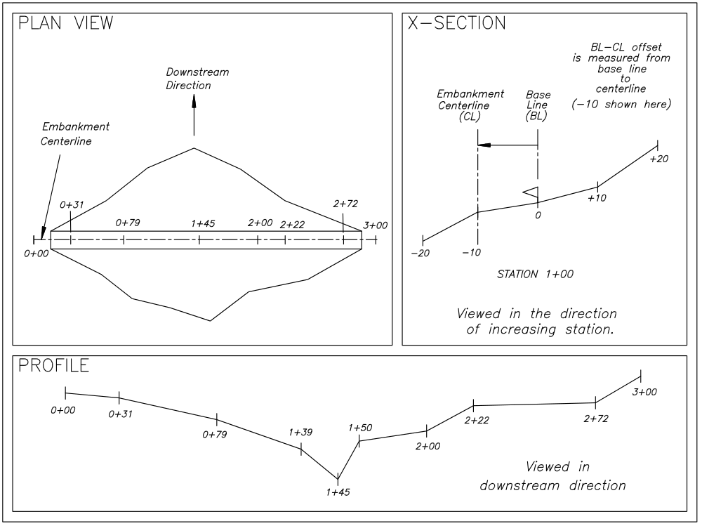

ILLUSTRATIONS

Shown below are a few sketches that should help in defining some terms and dimensions used in this program.

Storage Volumes

4 below shows the various storage volumes figured by the program.

Figure 5. Storage Volumes
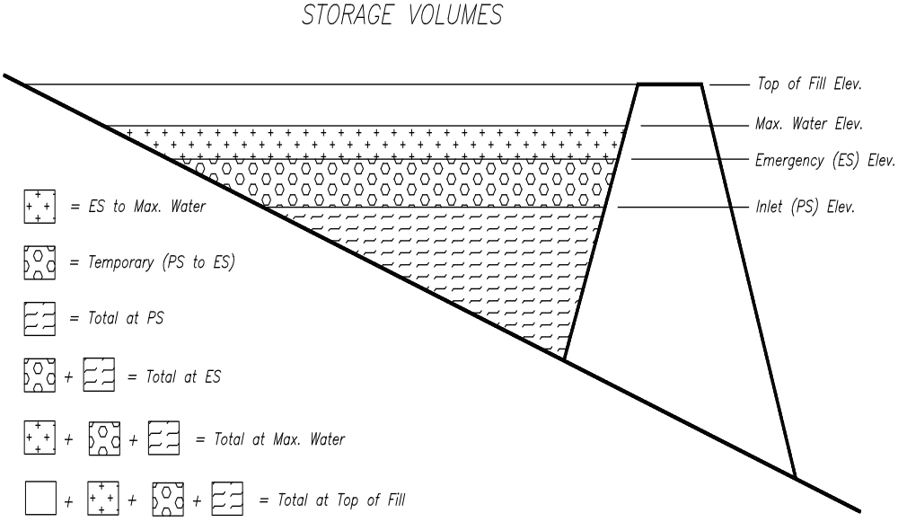
Canopy and Hood Dimensions

The figures shown below show the dimensions given for the canopy and hooded inlets. These values are given in the "Conduit Detail" report of the output.

Figure 6. Canopy Inlet Dimensions
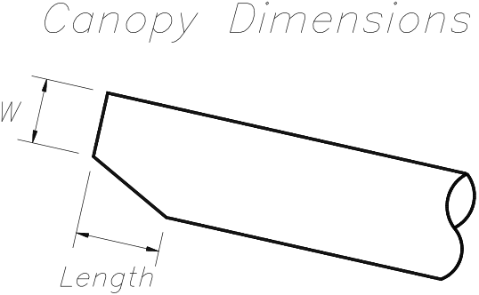

Figure 7. Hooded Inlet Dimensions
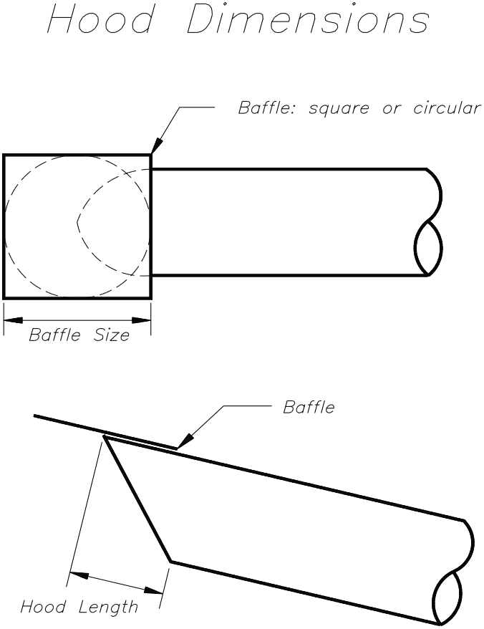
Elbow Dimensions

The figure below depicts the dimensions given in the "Conduit Detail" report related to an elbow. These dimensions are useful when constructing the elbow.

Figure 8. Elbow Details
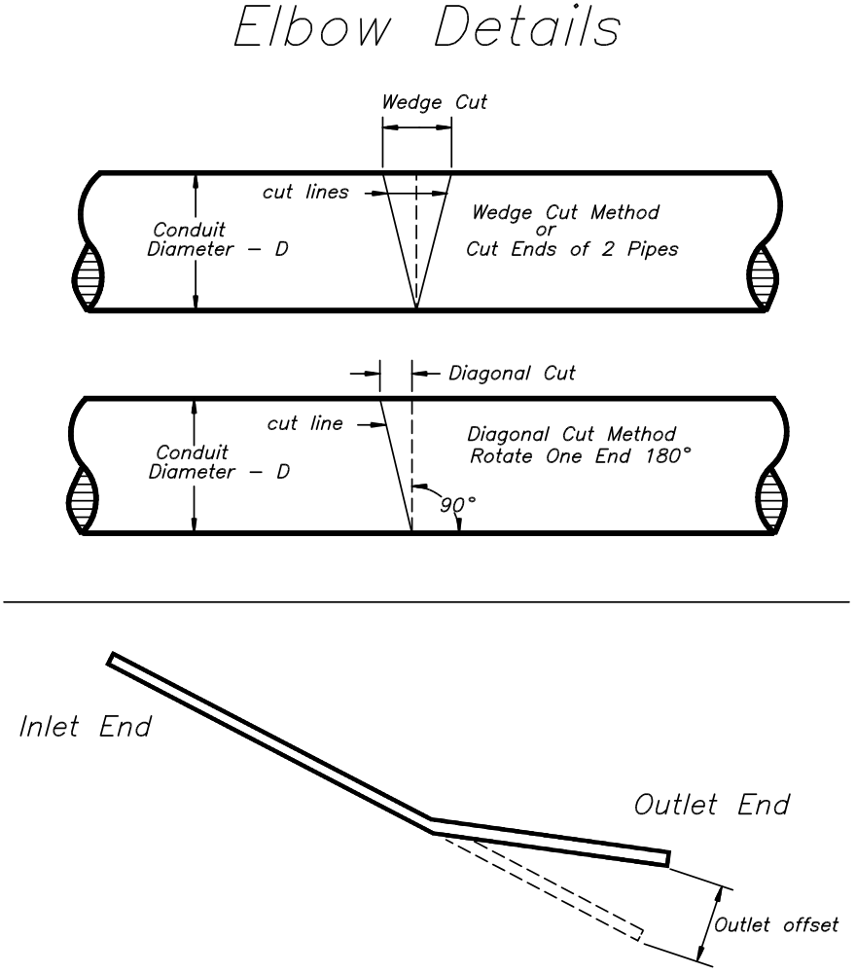
MAIN MENU

This screen displays the Main Menu. Its only purpose is to transfer control to either the "Design" program or the "Change Default" program.

MAIN MENU
+------------------------------------------------+
¦ ¦
¦ Missouri SCS Pond Design Program ¦
¦ ¦
¦ Ver. 1.0, 4/94 ¦
¦ ¦
+------------------------------------------------+

+----------------------------+
¦ POND PROGRAM MAIN MENU ¦
¦----------------------------¦
¦> Design pond ¦
¦ Change defaults ¦
¦ Quit ¦
+----------------------------+

Design : This is the main program where you input your data, perform the design, and print the results.

Change defaults : This program allows you to set your own defaults such as data drive and path, printer, rainfall data, and various other items described later.

Quit : Choose this to quit the program and return to the operating system.

To select the desired program, press the appropriate letter (D, C, or Q) or use arrow keys to highlight the desired choice and press <ENTER>. These programs will be discussed in more detail in the following sections. To return to this menu from either of the above programs, press <Esc>. Returning to this menu will lose any data you have entered, unless you store it before exiting the program you are running.

DESIGN POND

SCREEN DESCRIPTION PAGE

PROJECT NAME 13

DESIGN MENU 15

EDIT DESIGN DATA 17
Project Information 17
Elevation Storage Input Method 19
Elevation Storage Data 19
Hydrology Info 21
Runoff Curve Number Determination 24
Sediment Storage Info 26
Principal Spillway Info 27
Conduit Information 31
Principal Spillway Routings 33
Emergency Spillway Discharge Determination 34
Emergency Spillway Info 36
Emergency Spillway Routing 38
Final Design Check 41

EDIT EARTHWORK DATA 42
Ground Profile/X-Section Data 42
Embankment Cross Section Information 46
Ground/Embankment Intersections 50

PRINT DATA 52

This program is used to input your data (including ground data), perform a design, and print the results. The input values needed are described below in the description of the screens.

DATA CAN BE STORED AT ANYTIME BY PRESSING <F10> !

Storing your data intermittently would be advised to avoid data loss due to power interruptions. For more information on <F10>, see the section on key conventions (page 3).

If the filename prompt appears, the default filename will be the name of the current project you are working on. This allows you to simply press <Enter> to keep the same name and overwrite the old data. If you want a copy of the design or you do not wish to write over the existing file, you can enter a different name. If a different name is entered and that file exists, you are asked to confirm that you wish to overwrite the existing file.

PROJECT NAME

The screen below asks you to enter a project name.

Project Name

+------------------------------------------------+
¦ ¦
¦ Missouri SCS Pond Design Program ¦
¦ ¦
¦ Ver. 1.0, 4/94 ¦
¦ ¦
+------------------------------------------------+

+------------------- Enter PROJECT NAME (new or existing) --------------------+
¦ ¦
¦ Drive:\path : A:\ ¦
¦ Filename -- : SAMPLE .prj ¦
¦ ¦
+-------------------------------------------------F2-pick a file, Esc-cancel--+

DRIVE:\PATH : This value indicates where your data is stored (e.g., A:\ or C:\ENG\POND ). It is retrieved from the default file, but can be changed at this time. If it is left blank, the current drive and directory will be used (normally, the same place the program is stored).

FILENAME : The name of an existing project file or a new project file. If the file exists, data will be read from all the files related to this project. Each project has five files, each with the same filename but different extensions as follows: PRJ for project data, STG for stage-storage data, RCN for runoff curve number data, GRD for ground data, and XSC for cross-section template data. If the file does not exist (i.e., it is new), default values will be read. To edit default values, enter the drive:\path where the program resides and enter a filename of DEFAULT. The filename should be limited to 8 characters. A filename must be entered to continue.

<F2> - PICK A FILE

Pressing <F2> or entering nothing for the filename will display a list of project files a (extension ".PRJ") from which you can choose. You can use the arrow keys, <PgUp>/<PgDn> keys, or enter the first couple of letters to highlight the desired file and then press <Enter> to select it. A few keys worth mentioning that have specific functions here are as follows:

left/right arrows and <TAB>
move between directory and file windows. The directory window allows you to change the directory you want to look in.

<Ctrl><S> - allows you to change how files are sorted (alphabetically by default).
<Ctrl><F> - toggle file display between filename/description and filename/size/date.
<Ctrl><P> - print directory listing of files.

DESIGN MENU

The Design Menu, shown below, is used to choose an appropriate action such as designing, printing, etc. The first three actions are described in detail later in the manual.

Design Menu

+------------------------------------------------+
¦ ¦
¦ Missouri SCS Pond Design Program ¦
¦ ¦
¦ Ver. 1.0, 4/94 ¦
¦ ¦
+------------------------------------------------+

+------------------------------------+
¦> edit Design data ¦
¦ edit Earthwork data ¦
¦ Print data ¦
¦ Save data ¦
¦ Open new or existing project ¦
¦ Quit ¦
+------------------------------------+

Current Project: SAMPLE
Descr. : Sample problem

EDIT DESIGN DATA : Selecting this will start you through the sequence of screens necessary to enter design data and perform a design.

EDIT EARTHWORK DATA : Selecting this will allow you to enter ground data and cross-section templates and compute earthwork quantities. It also assists in locating the emergency spillway.

PRINT DATA : This option is chosen to print the results. Several reports are available including principal spillway trials, a summary, and a construction checkout sheet.

SAVE DATA : This option is the same as pressing <F10> which will prompt you for the filename to save the data. The default filename will be the name of the current project you are working on. This allows you to simply press <Enter> to keep the same name and overwrite the old data. If you want a copy of the design or you do not wish to write over the existing file, you can enter a different name. If a different name is entered and that file exists, you are asked to confirm that you wish to overwrite an existing file.

OPEN NEW OR EXISTING PROJECT : This option allows you to change to a different project. By changing to a different project, you will lose your current data unless you save it. If you have not saved the current data, you are given the opportunity to do so. For more information on entering a new project name, see the Project Name section above.

QUIT : Choosing QUIT will return you to the Main Menu mentioned earlier.

EDIT DESIGN DATA

PROJECT INFORMATION

This screen is used for entering information related to project identification. The screen is shown below.

Project Information
PROJECT INFO for sample
------------------------------------------------------------------------------

Description ---- : Sample problem
State (Abbrev.) : MO
County (F2-pick) : BOONE
Landowner ------ : John Q. Farmer
Township ------- : 47N
Range ---------- : 12W
Section -------- : 25
Field ---------- : 2
Designed by ---- : J.Q. Engineer
Date ---------- : 07-04-1993

Esc-quit, F1-help, F10-save, PgUp/PgDn-change screens

DESCRIPTION : Enter a description of the project. This is useful when trying to find the file at a later date. It is displayed along with the filename when picking a file.

STATE : Enter the two letter abbreviation for your state (e.g., MO). This is used as the file extension for the rainfall data file (e.g., COUNTY.MO ).

COUNTY : Enter the county where the project is located. The complete county name does not have to be entered. Entering enough characters to make it unique is all that is necessary (e.g., entering LAF for Lafayette county). If the county entered is not found in the data file, a selection list of counties appears. The <F2> can also invoke the county selection list. You can then use arrow keys or the first few letters of the county name to highlight the county and press <ENTER> to select it.

The county entered is used to determine the rainfall values to use. The counties and rainfall values can be editted in the "Change Defaults" program.

LANDOWNER : Enter the name of the landowner.

TOWNSHIP, RANGE, SECTION, and FIELD
Enter the appropriate values relating to the location of the project.

DESIGNED BY : The name, initials, or other form of identification of the designer should be entered in this field.

DATE : When you move to this field, the computer's current date is filled in for you. It shows the date the design was done.

ELEVATION STORAGE INPUT METHOD

This screen provides the choice of how to enter your elevation-storage data.

Elevation-Storage Input Method
ELEVATION STORAGE INPUT METHOD
--------------------------------------------------------------------------------

+--- SELECT DESIRED ELEVATION STORAGE INPUT METHOD ---+
¦>Acres ¦
¦ square Inches (e.g., from planimeter) ¦
+-----------------------------------------------------+

Esc-quit, F10-save, PgUp/PgDn-change screens
Select Acres if you will enter the elevation and associated area in acres. If you have planimetered a map of known scale and want the program to convert the areas to acres for you, you can select square Inches. If square Inches is chosen, you will have to enter the scale of the map (e.g., 100 for a 1"=100' scale) and then enter the planimetered areas in square inches.

ELEVATION STORAGE DATA

The elevation (stage) storage data is entered on the screens shown below. The first screen shown is if "acres" is chosen as the input method. The second screen is for the "square inches" method (note the scale is shown in upper right of screen).

Elevation-Storage Data (Acres method)
ELEVATION STORAGE DATA
--------------------------------------------------------------------------------
ELEV POOL AREA INT.STORAGE ACCUM.STORAGE
(ft) (acres) (ac.ft.) (ac.ft.)
98.0 1.20
100.0 1.60 2.80 2.80
102.0 2.30 3.90 6.70
103.0 3.10 2.70 9.40

--------------------------------------------------------------------------------

Esc-quit, F1-help, F3-view, INS-insert elev., DEL-delete elev., F10-save

Elevation-Storage Data (sq. inches method)
ELEVATION STORAGE DATA Scale: 1 in. = 100.0 ft.
--------------------------------------------------------------------------------
ELEV POOL AREA INT.STORAGE ACCUM.STORAGE
(ft) (sq.in.) (acres) (ac.ft.) (ac.ft.)
98.0 5.23 1.20
100.0 6.97 1.60 2.80 2.80
102.0 10.02 2.30 3.90 6.70
103.0 13.50 3.10 2.70 9.40

--------------------------------------------------------------------------------

Esc-quit, F1-help, F3-view, INS-insert elev., DEL-delete elev., F10-save

ELEV : Elevations for which you know the pool areas should be entered in the first column. The easiest way to enter the elevations is in ascending order. It is not necessary, however, since they are sorted as you enter them. If you wish to insert or delete an elevation, use the <INS> and <DEL> keys discussed below.

POOL AREA : Enter the pool area at each corresponding elevation in the second column. This is entered in acres or square inches depending on the method chosen. If the area in square inches is entered, it is converted to acres and displayed in the third column.

INTERVAL STORAGE and
ACCUMULATED STORAGE : These values are calculated and displayed in the last two columns. These values are shown in acre feet and cannot be editted.

<INS> : The insert key is used to insert a line in the table between two existing lines. The current line will move down and a new elevation and area will be created halfway between the two existing lines.

<DEL> : The delete key is used to delete the current line in the table. You will be asked to confirm the deletion. <Ctrl><D> can be used to avoid the confirmation question.

<F3> : A graphical view of the stage-storage curve will be displayed. Refer to the sample screen below.

<F8> : Clear all data in the table.

Elevation-Storage Curve
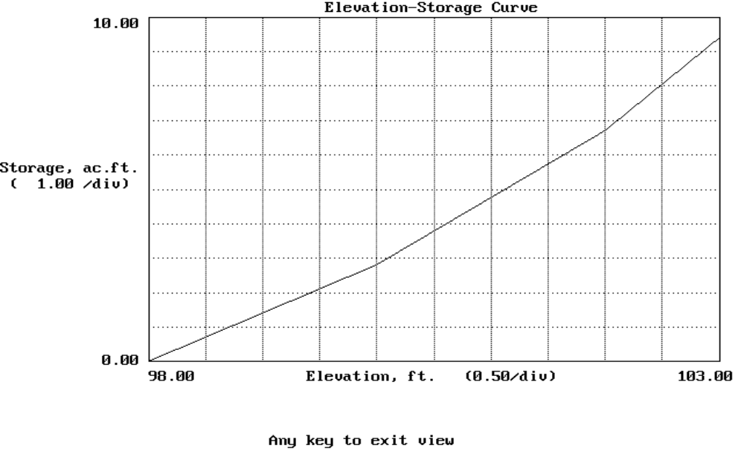

HYDROLOGY INFO

The Hydrology Info screen, shown below, is used to input the data necessary for determining the peak inflows for the principal and emergency spillway storms. Most of these values are defined more thoroughly in Chapter 2 of the Engineering Field Handbook (EFH).

Hydrology Info
HYDROLOGY INFO County: BOONE
-------------------------------------------------------------------------------

Rainfall distribution type : II
Drainage area (acres) ------ : 47.0000
Runoff Curve Number (RCN) -- : 75
Watershed slope (%) -------- : 6.00
Flow length (ft.) --------- : 2950.00
Time of concentration ------ : 0.60 hrs. ( 35.8 min.)
-------------------------------------------------------------------------------
------ Spillway ------ ¦ Freq. 24-Hr Rain Runoff Peak Flow
Principal Emergency ¦ (yrs) (in) (in) (cfs)~
¦ 1 3.0 1.0 30.2
Freq. (yrs) -- : 5 50 ¦ 2 3.5 1.3 42.2
Rainfall (in) : 4.6 6.8 ¦ 5 4.5 2.1 69.3
Runoff (in) -- : 2.1 4.0 ¦ 10 5.2 2.6 90.0
Peak Flow(cfs)~: 72.2 140.6 ¦ 25 5.9 3.2 111.7
¦ 50 6.6 3.8 134.3
~ Peak flows based on EFH, Chp.2 . ¦ 100 7.3 4.4 156.2
-------------------------------------------------------------------------------

Esc-quit, F1-help, F9-RCN, F10-save, PgUp/PgDn-change screens

RAINFALL DISTRIBUTION TYPE : A 24-hour storm distribution of I, IA, II, or III should be displayed here. This value is set in the default file and can not be changed here. A map showing where these distributions occur is shown in Figure 2-1, Chapter 2, EFH.

DRAINAGE AREA (ACRES) : This is simply the watershed drainage area in acres. <F9> can be used to determine area as well as runoff curve number.

RUNOFF CURVE NUMBER (RCN) : If the runoff curve number is known, it can be entered here. If it is not known, you can press <F9> for assistance (see the following section for a description of runoff curve number determination). If <F9> is used, the curve number and the drainage area obtained are returned to this screen.

WATERSHED SLOPE (%) : Enter the average watershed slope in percent as defined in Chapter 2 of EFH. This is the average slope of the land and not the watercourse. A value can be determined using the following relationship:

Y = (100 C I ) / A

where Y = avg. slope (%),
C = total contour length (ft),
I = contour interval (ft), and
A = drainage area (sq.ft.).

FLOW LENGTH (FT.) : The flow length is the longest flow path in the watershed from the watershed divide to the outlet.

TIME OF CONCENTRATION : This is the time it takes for runoff to travel from the hydraulically most distant point of the watershed to the outlet. This value is calculated using the procedure shown in Chapter 2 of EFH. The user has the option of changing the calculated value. If it is changed, an asterisk denotes that it was changed. The time is displayed in minutes as well as hours.

The following input values are needed for both the principal and emergency spillway storms.

FREQ. (YRS) : The desired frequencies should be entered in the appropriate column. The available frequencies along with the associated rainfall, runoff, and peak flow values are displayed in the lower right portion of the screen.

RAINFALL (IN) : When a frequency is entered, an associated rainfall value is retrieved from the data file of county rainfalls. This value can be changed here, however.

RUNOFF (IN) :
PEAK FLOW (CFS) : The inches of runoff and peak flows are computed using the procedure in Chapter 2, EFH. The actual peak flows used in design will be obtained from computing inflow hydrographs. These values can not be editted.

RUNOFF CURVE NUMBER DETERMINATION

The Runoff Curve Number Determination screen, shown below, is used to assist in calculating total drainage area and a weighted curve number. This screen is invoked using <F9> from the Hydrology Info screen described above.

Runoff Curve Number Determination
RUNOFF CURVE NUMBER DETERMINATION Acres & (curve numbers) for
Hydrologic Soil Group
COVER DESCRIPTION A B C D
--------------------------------------------------------------------------------
CULTIVATED AGRICULTURAL LANDS
Fallow Bare soil ---- (77) ....(86) ....(91) ....(94)
Crop residue (CR) poor ....(76) ....(85) ....(90) ....(93)
Crop residue (CR) good ....(74) ....(83) ....(88) ....(90)
Row crops Straight row (SR) poor ....(72) ....(81) ....(88) ....(91)
Straight row (SR) good ....(67) ....(78) ....(85) ....(89)
SR + Crop residue poor ....(71) ....(80) ....(87) ....(90)
SR + Crop residue good ....(64) ....(75) ....(82) ....(85)
Contoured (C) poor ....(70) ....(79) ....(84) ....(88)
Contoured (C) good ....(65) ....(75) ....(82) ....(86)
C + Crop residue poor ....(69) ....(78) ....(83) ....(87)
C + Crop residue good ....(64) ....(74) 25(81) ....(85)
Cont & terraced(C&T)poor ....(66) ....(74) ....(80) ....(82)
Cont & terraced(C&T)good ....(62) ....(71) ....(78) ....(81)
C&T + Crop residue poor ....(65) ....(73) ....(79) ....(81)
C&T + Crop residue good ....(61) ....(70) ....(77) ....(80)

--------------------------------------------------------------------------------
Page 1 of 8 ACCUMULATED: 47.00 Acres WEIGHTED CURVE NUMBER: 76
F1-help, F4-change to percent, F8-clear entries, F9-exit CN, PgUp/PgDn

You should locate the proper cover type, treatment (if applicable), and hydrologic condition (there are 8 screens of choices) using the keys described below. Once found, enter the drainage area in acres or percent under the desired hydrologic soil group. The number in parentheses is the curve number related to the cover and soil group combination. The total accumulated drainage area in acres or percent and the weighted curve number are displayed on the bottom of the screen. These are updated as you enter data. Once data entry is complete, you should press <F9> to return to the Hydrology Info with the resultant values.

<PgUp> or <PgDn> : Move to the previous or next screen of cover descriptions.

<Home> <Home> : Press <Home> twice to move to the first screen of descriptions.

<End> <End> : Press <End> twice to move to the last screen of descriptions.

<Home> or <End> : Move to first or last field on the current screen.

<TAB> : Move cursor to next non-blank entry. This is a quick way to check what values you have entered across all the screens.

<F4> : Toggle between acres and percent mode for the entry of areas.

<F8> : Clear all area entries. This will restart you with a completely blank form.

<Ctrl><P> : This allows you to print the current RCN data to the screen, a printer, or a file.

SEDIMENT STORAGE INFO

The Sediment Storage screen allows you to specify storage volumes required for sediment as explained below.

Sediment Storage Info
SEDIMENT STORAGE INFO
------------------------------------------------------------------------------

Sediment storage req'd (ac.ft.) -
Above inlet ---------------- : 0.00
Below inlet ---------------- : 0.00

Esc-quit, F1-help, F10-save, PgUp/PgDn-change screen

SEDIMENT STORAGE REQ'D (AC.FT.) -

Above inlet : The volume of storage required for sediment above the inlet elevation is entered here. This volume is used during the floodrouting procedure.

Below inlet : The volume required below the inlet elevation for sediment storage is used in determining a minimum inlet elevation. This is determined from the stage-storage data entered previously.

PRINCIPAL SPILLWAY INFO

Data needed to define the cross section at the principal spillway are entered on the Principal Spillway Info screen shown below. This data is used in calculating conduit length, pipe discharge, various storage volumes, and other miscellaneous values. The sketches below depict the values requested for a canopy inlet and a drop inlet.

Figure 9. Principal Spillway Info for a Canopy Inlet.
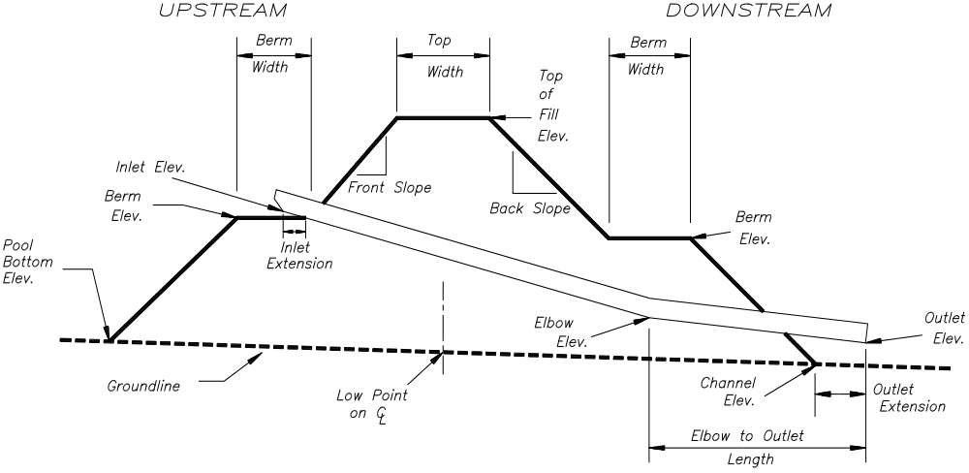

Figure 10. Principal Spillway Info for a Drop Inlet
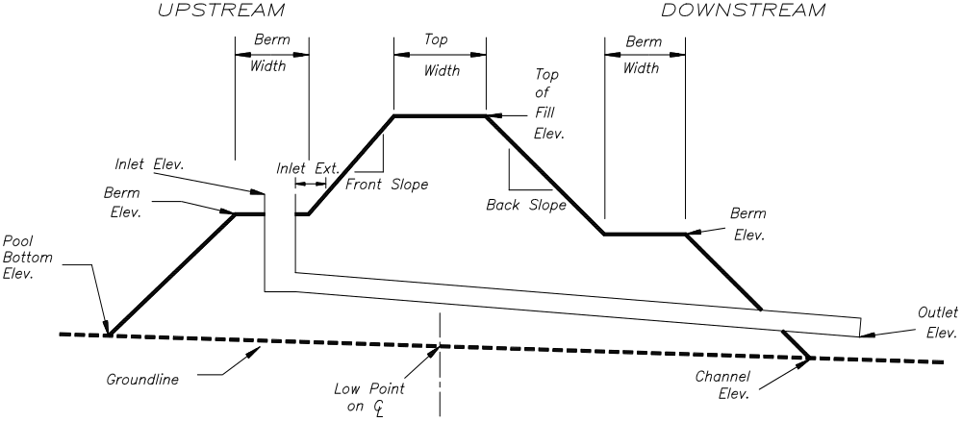

Principal Spillway Info
PRINCIPAL SPILLWAY INFO
-------------------------------------------------------------------------------

Inlet type (F2-pick) ------- : Canopy

ELEVATIONS Inlet ---------- : 98.00
Outlet --------- : 81.00
Channel -------- : 80.00
C/L low pt.----- : 81.00 Elbow --------------- :
Pool bottom ---- : 82.00 Tailwater ------------ :

-------------------------------------------------------------------------------
EMBANKMENT Top width, ft : 12.00 Downstream | Elev. -- :
X-SECTION Front slope, h:1 : 3.00 Berm | Width, ft:
Back slope, h:1 : 2.00 Upstream | Elev. -- :
% Settlement --- : 0.00 Berm | Width, ft:
-------------------------------------------------------------------------------
ACTUAL LENGTH HORIZ. DISTANCE
Elbow to Outlet, ft. : Outlet extension, ft: 6.00

Esc-quit F1-help F4-overfill F10-save PgUp/PgDn-change screens
INLET TYPE : Enter the type of inlet used. The choices are canopy, hood, drop, box (canopy or hood), or user defined. You can either enter the type directly or use <F2> to select from the list. The "user defined" type is used for an inlet type that is not one of the other choices. It prompts for a file that contains stage-discharge data. The first line of the ASCII file should be a description. The remaining lines should each contain two values, stage (ft) and discharge (cfs) separated by a space.

ELEVATIONS -
INLET : Enter the elevation of the principal spillway inlet. This should be the invert of the conduit for a canopy or hood inlet or the top of the riser for a drop or box inlet.

OUTLET : Enter the elevation of the outlet. This should be the invert of the conduit.

CHANNEL : The channel elevation is the elevation at the downstream toe of the embankment at the principal spillway location. It is used in determining conduit length and overall height.

C/L LOW PT. : This is the elevation of the low point in channel at the centerline of the dam.

POOL BOTTOM : Enter the elevation of the pool bottom. This elevation is used to estimate storage volume if the area of the first line in the stage-storage table is not zero.

CONDUIT INVERT (not shown on screen above) : This is the elevation of the conduit coming into the riser for drop and box inlets.

ELBOW : If the conduit has an elbow, you should enter the elevation of the invert of the elbow. You should also enter a value for elbow to outlet length. If there is no elbow, leave this field blank.

TAILWATER : If there is any tailwater over the outlet, enter the elevation here. If not, leave blank.

EMBANKMENT X-SECTION -
TOP WIDTH, FT : The top width of the dam is entered in feet. The width is used in estimating the length of the conduit.

FRONT SLOPE, H:1 : Enter the front (upstream) slope as a ratio of horizontal to vertical distance (e.g., for a 2:1 slope, enter 2).

BACK SLOPE, H:1 : Enter the back (downstream) slope as a ratio of horizontal to vertical distance (e.g., for a 2:1 slope, enter 2).

% SETTLEMENT OR OVERFILL, FT. : Enter the percent of settlement that you expect to occur or the amount of overfill in feet you plan to use. The percent of settlement is computed as follows.

%S = 100 * (E_{c} - E_{s}) / (E_{s} - E_{low})

where: %S = percent settlement,
E_{c} = constructed elevation,
E_{s} = settled elevation, and
E_{low} = centerline low point elevation.

DOWNSTREAM BERM ELEV. and WIDTH, FT : Enter the elevation and width of a downstream berm. If there is no berm, leave blank.

UPSTREAM BERM ELEV. and WIDTH, FT : Enter the elevation and width of an upstream berm. If there is no berm, leave blank.

ACTUAL LENGTH
ELBOW TO OUTLET, FT. : Enter the actual length in feet of the conduit from the elbow to the end of the conduit. If a value is entered here, be sure to enter an elbow elevation. If there is no elbow, enter 0 (zero).

HORIZ. DISTANCE
OUTLET EXTENSION, FT. : Enter the horizontal distance, in feet, the outlet extends beyond the downstream toe.

CONDUIT INFORMATION

Up to three trials of conduit can be defined on the conduit information screen. Two examples of this screen are shown below. The first screen is for a canopy inlet and the second is for a drop inlet. To remove a trial, clear the "Conduit Type" field by using <Delete>.

Conduit Info for Canopy Inlet
CONDUIT INFORMATION FOR Canopy inlet
-------------------------------------------------------------------------------
TRIAL 1 ¦ TRIAL 2 ¦ TRIAL 3
CONDUIT: Type (F2-pick) --- : SSP ¦ SSP ¦ S40-PVC
Diameter, in. ---- : 12.00 ¦ 14.00 ¦ 12.00
Height, in. ------ : ¦ ¦
Width, in. ------- : ¦ ¦
Manning's n ------ : 0.013 ¦ 0.013 ¦ 0.011
Inlet extension,ft. ¦ ¦
horiz. distance : 1.0 ¦ 1.2 ¦ 1.0
Length, lin.ft. -- : 88 ¦ 87 ¦ 87
¦ ¦
Entrance Coefficient, Ke -- : 1.000 ¦ 1.000 ¦ 1.000

Esc-quit, F1-help, F10-save, PgUp/PgDn-change screens

CONDUIT
TYPE : You can enter the conduit type directly or use <F2> to select from the list which is shown below. If you enter something that is not in the list, the list will automatically appear without pressing <F2>.
Available types:
ACMP - Annular Corrugated Metal Pipe
HCMP - Helical Corrugated Metal Pipe
RC - Reinforced Concrete
S40-PVC - PVC Schedule 40 Pipe
S80-PVC - PVC Schedule 80 Pipe
SDR-26 - PVC SDR-26 Pipe
SSP - Smooth Steel Pipe
USER - User defined

DIAMETER, IN. : Enter the diameter of the conduit in inches. If this diameter is found in the conduit data file and the associated flow area is not 0, the flow area given is used. Otherwise, the diameter entered is assumed to be an inside diameter. If the conduit is rectangular, enter 0 for the diameter.

HEIGHT, IN.
WIDTH, IN. : For a rectangular conduit, enter the inside dimensions of height and width in inches.

MANNING'S N : Enter the Manning's n value for the conduit. This is used in computing a friction loss factor. If the conduit entered was found in the conduit data file, the n value from the data file will be placed here.

INLET EXTENSION,FT.
HORIZ. DISTANCE : For canopy and hood inlets, this is the horizontal distance (in feet) the conduit extends from the dam on the upstream side. It does not include the canopy or hood length. For a drop or box inlet, it is the horizontal distance the top of the riser (i.e., the edge nearest the dam centerline) is from the upstream slope of the dam at the inlet elevation. Refer to 11 and 12 for a picture of these dimensions.

LENGTH, LIN.FT. : The total length of the conduit is given in feet. This is the actual length (not horizontal) and includes the inlet and outlet extensions and the canopy length. It does not include the riser length, if any. The calculated length is displayed and cannot be changed.

ENTRANCE COEFFICIENT, Ke : The entrance loss coefficient entered should not include bending losses due to an elbow or friction losses. Suggested values can be found in EFH, MO-3-8 or by pressing <F1>.

Conduit Info for Drop Inlet
CONDUIT INFORMATION FOR Drop inlet
-------------------------------------------------------------------------------
TRIAL 1 ¦ TRIAL 2 ¦ TRIAL 3
CONDUIT: Type (F2-pick) --- : SSP ¦ SSP ¦ S40-PVC
Diameter, in. ---- : 12.00 ¦ 14.00 ¦ 12.00
Height, in. ------ : ¦ ¦
Width, in. ------- : ¦ ¦
Manning's n ------ : 0.013 ¦ 0.013 ¦ 0.011
Inlet extension,ft. ¦ ¦
horiz. distance : 1.0 ¦ 1.2 ¦ 1.0
Length, lin.ft. -- : 86 ¦ 87 ¦ 87
¦ ¦
Entrance Coefficient, Ke -- : 1.000 ¦ 1.000 ¦ 1.000
¦ ¦
RISER : Type (F2-pick) --- : SSP ¦ SSP ¦ S40-PVC
Diameter, in. ---- : 24.00 ¦ 28.00 ¦ 24.00
Length, in. ------ : ¦ ¦
Width, in. ------- : ¦ ¦
Weir length, in. - : 73.83 ¦ 86.39 ¦ 75.40
Crest radius, in. : ¦ ¦

Esc-quit, F1-help, F10-save, PgUp/PgDn-change screens

RISER
TYPE : You can enter the riser type directly or use <F2> to select from the list which is shown above under "Conduit Type". If you enter something that is not in the list, the list will automatically appear without pressing <F2>.

DIAMETER, IN. : Enter the diameter of the riser in inches. If this diameter is found in the conduit data file and the associated flow area is not 0, the flow area given is used. Otherwise, the diameter entered is assumed to be an inside diameter. If the riser is rectangular, enter 0 for the diameter.

LENGTH, IN.
WIDTH, IN. : For a rectangular riser, enter the inside dimensions of length and width in inches.

WEIR LENGTH, IN. : A weir length for the top of the riser will initially be calculated as follows:
circular: weir_length = π ⋅ inside_diameter
rectangular: weir_length = 2 ⋅ (length + width).
You can accept this value or enter your own value.

CREST RADIUS, IN. : This is the corner radius for the weir portion of the riser in inches. Enter 0 for a sharp edge corner.

PRINCIPAL SPILLWAY ROUTINGS

When <PgDn> is pressed on the conduit information screen above, each of the trials will be routed and the results displayed on the Principal Spillway Routings screen below. This screen allows you to raise the routed emergency elevation and to select which trial you wish to use.

Principal Spillway Routings
PRINCIPAL SPILLWAY ROUTINGS FOR Canopy inlet Inlet Elev.: 98.0
-------------------------------------------------------------------------------
TRIAL 1 ¦ TRIAL 2 ¦ TRIAL 3
CONDUIT: Type ------------- : SSP ¦ SSP ¦ S40-PVC
Diameter (in.) --- : 12.00 ¦ 14.00 ¦ 12.00
Height (in.) ----- : ¦ ¦
Width (in.) ------ : ¦ ¦
¦ ¦
Emergency elevation ------- : 100.8 ¦ 100.6 ¦ 100.8
Min. top of fill elevation : 102.8 ¦ 102.6 ¦ 102.8
STORAGE (ac.ft.): ¦ ¦
Temporary ------------- : 4.19 ¦ 3.82 ¦ 4.19
Total at emergency ---- : 11.87 ¦ 11.50 ¦ 11.87
Total at min.top of fill: 16.48 ¦ 15.90 ¦ 16.48
Effective height, ft. ----- : 19.8 ¦ 19.6 ¦ 19.8
Height x storage ---------- : 235 ¦ 225 ¦ 235
Job Class ----------------- : II ¦ III ¦ II
¦ ¦
Drawdown time, days-hrs. -- : 0-18.3 ¦ 0-17.5 ¦ 0-18.8
-------------------------------------------------------------------------------
Trial to use for routing emergency : 1

Esc-quit, F1-help, F10-save, PgUp/PgDn-change screens

CONDUIT
TYPE
DIAMETER (IN.)
HEIGHT (IN.)
WIDTH (IN.) : These values are just repeated from the previous screen.

EMERGENCY ELEVATION : This is the elevation obtained from the routing of the principal spillway. It can only be increased.

MINIMUM TOP OF FILL ELEVATION : This is simply the emergency elevation plus the minimum depth of the emergency spillway (including freeboard). This will not necessarily be the final top of fill elevation which is determined after floodrouting the emergency.

STORAGE (ac.ft.) - These storage volumes are only as accurate as the elevation-storage data entered. Refer to 13 for a sketch of these volumes.
TEMPORARY : The storage between the principal and emergency spillways.
TOTAL AT EMERGENCY : The storage below the emergency spillway elevation.
TOTAL AT MIN. TOP OF FILL : The storage below the minimum top of fill elevation.

NOTE! If the first area entered in the stage-storage data is not zero, storage below the first elevation is approximated by taking 0.4 ⋅ (first area) ⋅ (first elevation - pool bottom elevation).

EFFECTIVE HEIGHT, FT. : This is the elevation difference between the emergency spillway elevation and the lowest ground point along the centerline of the dam.

HEIGHT X STORAGE : This is the product of the effective height times the storage below the emergency elevation (i.e., "Total at emergency").

JOB CLASS : The job class refers to the job approval authority as specified in the National Engineering Manual (§MO501.09) .

DRAWDOWN TIME, DAYS-HRS. : The drawdown time is the amount of time to discharge the principal spillway storm to a level specified in the default file (see "Change Defaults" section).

TRIAL TO USE FOR ROUTING EMERGENCY : You must select which of the three trials to use for routing the emergency spillway.

EMERGENCY SPILLWAY DISCHARGE DETERMINATION

The screen shown below is used to select the method used to compute emergency spillway discharge.

Emergency Spillway Discharge Determination
EMERGENCY SPILLWAY DISCHARGE DETERMINATION
--------------------------------------------------------------------------------

+----- SELECT DESIRED METHOD ----+
¦ Calculated ¦
¦>Qe values from ESFILE ¦
¦ User defined stage-discharge ¦
¦ No emergency spillway ¦
+--------------------------------+

Esc-quit, F1-help, F10-save, PgUp/PgDn-change screens

SELECT DESIRED METHOD : You should choose the method desired for computing emergency spillway discharge. The available choices are as follows:

Calculated - Discharge will be calculated using the same procedure as in the DAMS2 program.
Qe values from ESFILE - Qe (flow/ft. of bottom width) values will be read from the file ESFILE (same format as used in DAMS2 program).
User defined stage-discharge - A file containing stage-discharge data will be read. The first line should contain a description. The following lines should each contain a stage value (ft) and a discharge (cfs) separated by a space.
No emergency spillway - An emergency spillway will not be routed.

EMERGENCY SPILLWAY INFO

Before the emergency storm can be routed, the emergency spillway needs to be defined. This is done on the Emergency Spillway Info screen. Two examples of this screen are shown below. If the "calculated" method of discharge was selected, you will see the first screen below. The second screen shown below will be used if "Qe values from ESFILE" was chosen. Refer to the sketch below detailing dimensions needed, which can also be seen by pressing <F1>.

Sketch of Emergency Spillway Dimensions
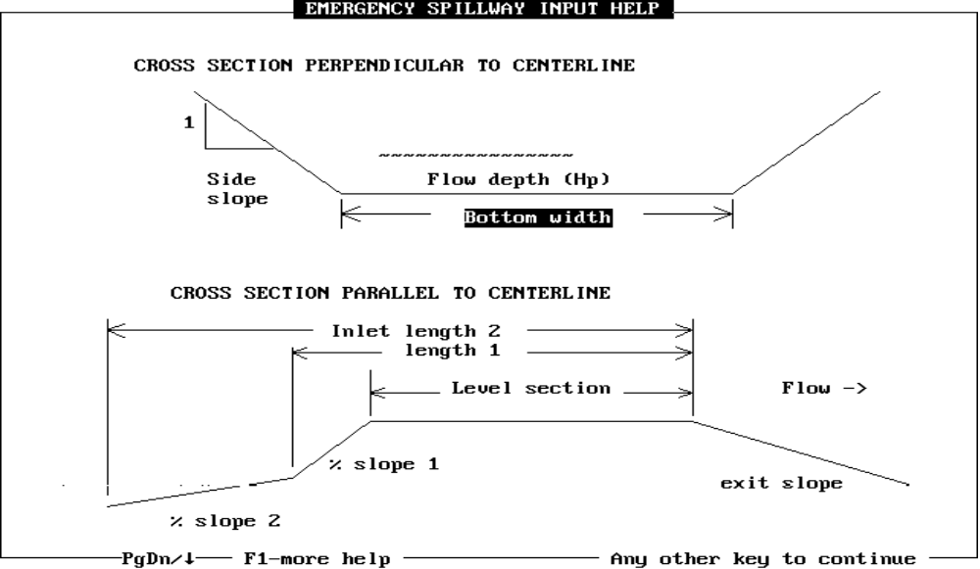

Emergency Spillway Info (calculated method)
EMERGENCY SPILLWAY INFO Inlet Elev.: 98.0
-------------------------------------------------------------------------------
Emergency Elevation -------- : 100.80

Desired bottom width, ft.--- : 14.0000
Desired flow depth (Hp), ft. :

Retardance ----------------- : E <- (A,B,C,D, or E)
Manning's n ---------------- :

Level section length, ft. -- : 25.00
Side slope ratio ----------- : 3.00 :1

EXIT CHANNEL -
Retardance ------------- : E <- (A,B,C,D, or E)
Manning's n ------------ :
Permissible Vel., fps -- : 6.00

INLET CHANNEL - 1 2
Length, ft. ----------- :
Slope, % ------------- :

Esc-quit, F1-help, F10-save, PgUp/PgDn-change screens

Emergency Spillway Info (Qe values from ESFILE)
EMERGENCY SPILLWAY INFO Inlet Elev.: 98.0
-------------------------------------------------------------------------------
Emergency Elevation -------- : 100.80

Desired bottom width, ft.--- : 14.0000
Desired flow depth (Hp), ft. :

Retardance ----------------- : E <- (A,B,C,D, or E)

Level section length, ft. -- : 25.00
Side slope ratio ----------- : 3.00 :1

EXIT CHANNEL -
Retardance ------------- : E <- (A,B,C,D, or E)
Manning's n ------------ :
Permissible Vel., fps -- : 6.00

Esc-quit, F1-help, F10-save, PgUp/PgDn-change screens

EMERGENCY ELEVATION : The emergency elevation is repeated from the previous screen.

DESIRED BOTTOM WIDTH, FT. : Enter the bottom width (in feet) of the emergency spillway control section (i.e., the level section). If you wish to enter the depth, instead, enter 0 here.

DESIRED FLOW DEPTH (H_{P}), FT. : Enter the desired H_{p} depth (feet) for the emergency spillway. This is the maximum pool elevation minus the emergency elevation.
NOTE: Since the routing procedure must iterate to find the desired depth, the routing will take longer than entering a bottom width.

RETARDANCE : Enter a vegetated retardance of A, B, C, D, or E for the control section. If the calculated method of discharge was chosen and you wish to enter a Manning's n value instead, leave this field blank. Some suggested values are displayed by using <F1>.

MANNING'S N : If the calculated method of discharge was chosen, a Manning's n can be entered for the control section.

LEVEL SECTION LENGTH, FT. : This is the length (in the direction of flow) of the level section in feet.

SIDE SLOPE RATIO : The side slope of the level section is entered as the ratio of horizontal to vertical distance. For 3:1 slopes, enter 3.

EXIT CHANNEL -
RETARDANCE : Enter a vegetated retardance of A, B, C, D, or E for the exit channel. To enter a Manning's n value instead, leave this field blank. Some suggested values are displayed by using <F1>.

MANNING'S N : Enter a Manning's n value for the exit channel.

PERMISSIBLE VEL., FPS : Enter the maximum permissible velocity (feet/second) for the exit channel. Examples for vegetated and earth spillways can be displayed by pressing <F1>. This is used in determining maximum exit slope.

INLET CHANNEL - If the calculated method of discharge was chosen, the inlet channel shape can be defined.

LENGTH, FT. : The horizontal distance (in feet) upstream from the control section at which a sloping section back into the pool begins. This distance includes the level section length. If there are two slopes, a second length can be entered.

SLOPE, % : The slope (in percent) of a sloping section back into the pool. If there are two slopes, the slope of the second section should also be entered.

EMERGENCY SPILLWAY ROUTING

When <PgDn> is pressed on the emergency information screen above, the emergency storm will be routed and the results displayed on the Emergency Spillway Routings screen below. This screen allows you to raise the settled top of fill elevation.

Emergency Spillway Routing
EMERGENCY SPILLWAY ROUTINGS Inlet Elev.: 98.0
-------------------------------------------------------------------------------

Emergency Elevation ------ : 100.80
Actual bottom width, ft.-- : 14.00
Actual flow depth (Hp), ft.: 1.15
Water elevation in emerg. : 101.95
Flow in emergency, cfs --- : 50.34
Drawdown time, days-hrs. - : 0-19.8

Minimum exit slope, % ---- : 1.9
Maximum exit slope, % ---- : 3.6

ELEVATIONS: STORAGE (ac.ft.):
Top of fill ----------- : 103.0 ES to max. water --- : 2.40
Channel (downstream toe): 80.0 Temporary (PS to ES) : 4.19
Total at emerg.elev. : 11.87
Overall height, ft. ------ : 23.0 Total at water elev. : 14.27
Total at top of fill : 17.08

Esc-quit, F1-help, F10-save, PgUp/PgDn-change screens

EMERGENCY ELEVATION : This elevation is simply repeated from previous screen.

ACTUAL BOTTOM WIDTH, FT.
ACTUAL FLOW DEPTH (HP), FT. : If bottom width was entered on previous screen, bottom width will be the same as entered and flow depth will be a calculated value. If flow depth was entered, bottom width will be calculated and flow depth should match input if it was possible.

WATER ELEVATION IN EMERG. : This is the maximum pool elevation, which is the emergency elevation plus flow depth.

FLOW IN EMERGENCY, CFS : This is the peak flow through the spillway in cubic feet per second.

DRAWDOWN TIME, DAYS-HRS. : This is the amount of time to discharge the emergency spillway storm. If the principal spillway used is less than 10 inches in diameter, this time is the drawdown time to the emergency elevation; otherwise, it is the drawdown time to the level specified in the default file (see "Change Defaults" section).

MINIMUM EXIT SLOPE, %
MAXIMUM EXIT SLOPE, % : The allowable range of slopes for the exit channel.

ELEVATIONS:
TOP OF FILL : This is the settled elevation of the top of fill. This is the greater of: 1) emergency elevation plus minimum emergency depth, or 2) water elevation plus freeboard. You can increase this value.

CHANNEL (DOWNSTREAM TOE) : The channel elevation is the elevation at the downstream toe of the embankment at the principal spillway location. It is used in determining conduit length and overall height. This value cannot be changed here.

OVERALL HEIGHT, FT. : This is the settled top of fill elevation minus the downstream toe elevation.

STORAGE (AC.FT.) : Refer to 14 for a sketch of these storage volumes.
ES TO MAX. WATER : This is the volume between maximum water and emergency elevations.
TEMPORARY (PS TO ES) : The volume between principal (inlet) and emergency elevations.
TOTAL AT EMERG.ELEV. : Volume below the emergency elevation.
TOTAL AT WATER ELEV. : Volume below the maximum water elevation.
TOTAL AT TOP OF FILL : Volume below the top of fill elevation.

NOTE! If the first area entered in the stage-storage data is not zero, storage below the first elevation is approximated by taking 0.4 ⋅ (first area) ⋅ (first elevation - pool bottom elevation).

FINAL DESIGN CHECK

After the emergency storm has been routed and the top of fill elevation set, the pipe length is recalculated based on the new top of fill elevation. The pipe length (based on estimated top of fill) used in the design and the recalculated pipe length are shown on the final design check screen. The variation between the two lengths is computed by the formula 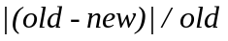.

The actual variation and the allowable variation are displayed (as shown in the screen below). If the variation between these two lengths is greater than allowed, you must then press <Enter> to return to the "Principal Spillway Routings" screen and run through the design with the new pipe length.

If the variation is acceptable, you can press <End> to accept the design and return to the design menu. If <Enter> is pressed, you will be returned to the "Principal Spillway Routings" screen and run through the design with the new pipe length.

Final Design Check
FINAL DESIGN CHECK
------------------------------------------------------------------------------

Pipe length used in floodrouting, lin. ft. : 88

Recalculated pipe length based
on final top of fill elevation, lin. ft. : 118

Variation of the two lengths : 34.1%
Allowable variation -------- : 15.0%

You can press ENTER to return to PRINCIPAL SPILLWAY ROUTINGS screen and
run through design with new pipe length.
PgUp to review/edit the design

Esc-quit, F10-save

EDIT EARTHWORK DATA

GROUND PROFILE/CROSS-SECTION DATA

The Ground Profile/X-Section Data screen is used to enter the ground data to be used in determining earthwork quantities. Upon entering this screen, the cursor is placed on the ELEV or F.S. line. To change STA INCR, H.I., or % GRD.SLOPE, press <TAB> to move to top of screen and then the left or right arrow key to move to appropriate field. You can press <TAB> again or the down arrow to return to the point data. All of the data is edited between the double lines. Refer to 15 on page 5 for the conventions to use in entering data.

Ground Profile/Cross Section Data
GROUND PROFILE/X-SECTION DATA

STA Incr= 0+00 H.I.= % Grd.Slope=
----------------------------------------------------------------- TAB ↓ -------
PRACT.ID STATION POINT NUMBER 1 of 3

DAM 0+58 ELEV 103.0
DIST 0.0
--------------------------------------------------------------------
0+75 ELEV 100.0 101.5 102.3
DIST -20.0 0.0 15.0
====================================================================
X-SECTION 0+90 ELEV 97.0 99.0 100.8
5 of 14 DIST -30.0 0.0 20.0
====================================================================
1+16 ELEV 92.4
DIST 0.0
--------------------------------------------------------------------
1+40 ELEV 85.1
DIST 0.0

F4-repeat dist= YES

ESC-quit, F1-help, F3-view, F10-store data, PgUp/PgDn-change screens

STA INCR : Station increment determines what the next station will be if you are at the last station and move to the next station (i.e., add a station). For example, if the last station is 5+00 and the increment is 50, the next station added will be 5+50. A value of 0+00 will cause the station to increment by 1' and the input cursor to move to the STATION field instead of to the ELEV field when adding a new station. You can then change the station by entering a new value.

H.I. : If a value for height of instrument is entered, then the program assumes foresights are being entered and the input line of ELEV is changed to F.S. It may be changed whenever desired.

% GRD.SLOPE : Entering a percent ground slope here will allow you to enter one ground point and have a second point computed. The second point will be at a default offset (see "Change Defaults" section) from the first point. A positive slope is assumed to be one which rises from left to right while looking in the direction of increasing station. A negative slope would fall from left to right.

PRACT.ID : This ID indicates the current practice you are working on. In this program, there is currently just one which is DAM.
X-SECTION __ OF __ : The first number represents the cross section number you are working on. The second number represents the total number of sections entered. On the screen above, you would be on the fifth cross section of 14. Press <F5> to move to the next station or <F6> to move to the previous station.

STATION : This is the distance along the baseline. Five stations can be seen at one time: the current one, the two preceding, and the two following stations. The station value between the double lines indicates the station you are currently editing. The stations are placed in ascending order as you enter them. When you are on the station field, the following actions can occur:

• Enter a station that exists. The data for that station will be displayed.
• Enter a station that does not exist. If the current station has data, you will be asked if you wish to change the station to the entered value. If it has no data, the station will be changed to the entered value with no confirmation.
• Use up or down arrows (or <F5> or <F6>) to move to previous or next station.
• Use <Home> or <End> keys to move to first or last station.
• Use the <Delete> key to delete all the data for that station. You are asked to confirm this.
• Use the <Ctrl><D> key to delete all the data for that station. You are not asked to confirm this, so be careful.

The above sample shows that you are positioned at station 0+90.

ELEV or F.S. : Data input line for elevations or foresights.

DIST : Distance input line. Distance is measured from the baseline (see the cross-section definition in 16 on page 5). Points to the left (when looking in direction of increasing station) are negative; to the right are positive. The points need not be entered in any order, they will be sorted automatically. You cannot enter two points with the same distance.

POINT NUMBER __ OF __ : The first number represents the point you are working on. The second number represents the number of points entered for this cross section. Only 5 are displayed on the screen at one time. As you enter more than 5 values, they are scrolled horizontally. Press <Home> to move to the first point or <End> to move to the last point.

Entry of only one ground point is allowed. The earthwork calculations will assume flat ground at the cross section.

The screen sample above shows five stations with related data.

<F3> : View the baseline profile and the ground cross-sections. <Ctrl><V> can be used also for this purpose. The particular ground data cross section displayed will be the currently highlighted one. Use the up and down arrow keys, <Home>, and <End> to move through the cross sections. An example of this screen view is shown below.

<F4> : This key is used as a toggle for repeating distances. NO indicates that distances from the previous cross section will not be repeated for a station. YES indicates that the distances will be repeated.

<F9> : <F9> may be used to delete the information of the current station, which is displayed between the double lines.

<Delete> : The delete key may be used to delete the point (ELEV and DIST) at the cursor. At least one point must remain in a cross section. The last point may not be deleted.
If you are on the station field, the data for that station will be deleted with confirmation (same result as using <F9>).

<Ctrl><D> : Same as <Delete> but with no confirmation.

<Ctrl><P> : This allows you to print the ground data to the screen, a printer, or a file.

View of Baseline Profile and Ground Cross Section
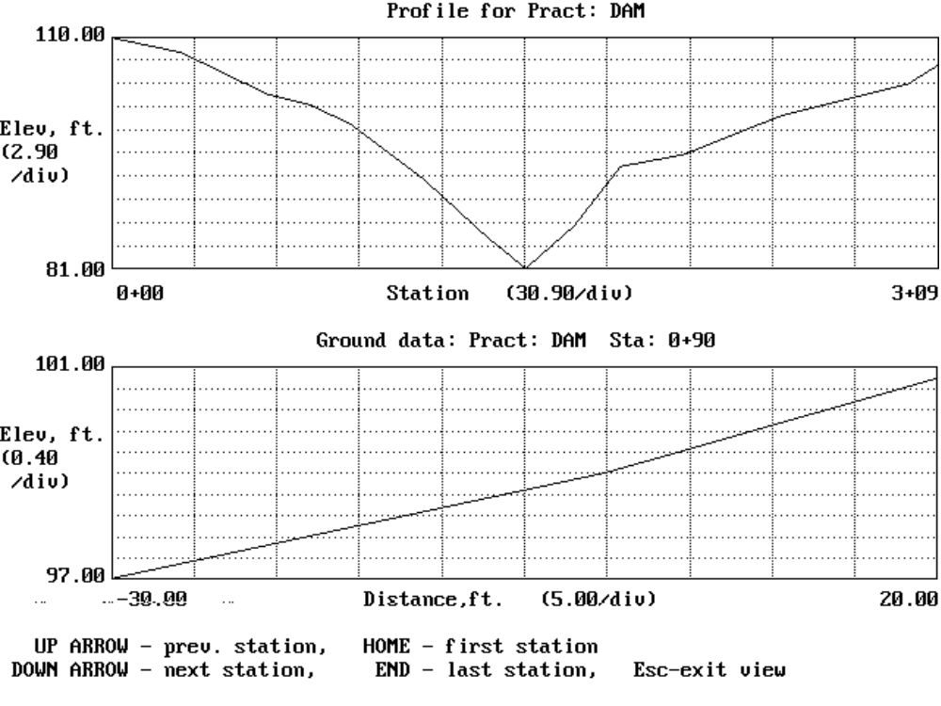

EMBANKMENT CROSS SECTION INFORMATION

After entering the ground data, the embankment cross section template(s) are defined on the screen shown below. 17 below shows a cross section template with the appropriate dimensions defined. You can also press <F1> to display this figure on the screen. When this screen is first displayed, the earthwork quantities (explained below) are calculated and displayed near the bottom of the screen. If any changes are made, you will need to press <F9> to recalculate the volumes. The cross section is viewed in the direction of increasing station.

Figure 18. Cross section template for earthwork
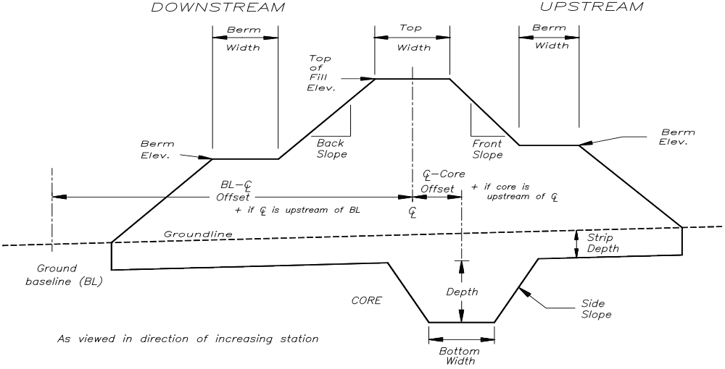

Embankment Cross Section Information
EMBANKMENT CROSS SECTION INFORMATION % Settlement : 0.0
---------------------------------------------------------------------- TAB ↓ -
Template # ---------------- : 1 ¦ ¦ ¦
Station ------------------- : 0+00 ¦ ¦ ¦
Settled top of fill elev. - : 103.00 ¦ ¦ ¦
Top width (ft.) ----------- : 12.00 ¦ ¦ ¦
Upstream berm elev. ------- : ¦ ¦ ¦
berm width (ft.) - : ¦ ¦ ¦
Donwstream berm elev. ----- : ¦ ¦ ¦
berm width (ft.) : ¦ ¦ ¦
Front slope (n:1) --------- : 3.00 ¦ ¦ ¦
Back slope (n:1) ---------- : 2.00 ¦ ¦ ¦
--------------------------------------------------------------------------------
Stripping depth (ft.) ----- : ¦ ¦ ¦
Core bottom width (ft.) --- : ¦ ¦ ¦
depth (ft.) ---------- : ¦ ¦ ¦
side slopes (n:1) ---- : ¦ ¦ ¦
offset (ft) ---------- : ¦ ¦ ¦
BL-CL offset (ft) --------- : 0.00 ¦ ¦ ¦

CU.YDS.: Fill: 3273 S.Fill: 3273 Strip: 0 Core: 0
Esc-quit F1-help F3-view F4-overfill F10-save PgUp/PgDn

% SETTLEMENT OR OVERFILL, FT. : <Tab> is used to move between this field and the other data. Enter the percent of settlement that you expect to occur or the amount of overfill in feet you plan to use. Pressing <F4> will switch between the two methods. The percent of settlement is computed as as follows:

%S = 100 * (E_{c} - E_{s}) / (E_{s} - E_{low})

where: %S = percent settlement,
E_{c} = constructed elevation,
E_{s} = settled elevation, and
E_{low} = ground elevation at centerline.

TEMPLATE # : Up to 20 templates can be entered. Four are shown on the screen with the appropriate template numbers displayed. Using the left and right arrow keys, you can scroll horizontallly through the templates.

STATION : Enter the station at which this template will begin. The template will be used up to the next station entered or to the end of the data (if this is the last template). If you enter a station that has already been entered, you will move to that station's template. The stations are sorted as you enter them.

NOTE: For the input items "Top of Fill" through "Back Slope" listed below, pressing <Space> will use the values from the design.

SETTLED TOP OF FILL ELEV. : Enter the elevation of the settled top of fill.

TOP WIDTH (FT.) : The top width of the dam is entered here in feet.

UPSTREAM
BERM ELEV.
BERM WIDTH (FT.) : Enter the upstream berm elevation and width (feet). This program assumes the berm is level (i.e., no slope). If no berm is used, leave elevation blank and enter 0 for width.

DONWSTREAM
BERM ELEV.
BERM WIDTH (FT.) : Enter the downstream berm elevation and width (feet). This program assumes the berm is level (i.e., no slope). If no berm is used, leave elevation blank and enter 0 for width.

FRONT SLOPE (N:1) : This is the slope of the dam on the upstream side. This should be entered as a ratio of horizontal distance to 1 foot of vertical distance (e.g., for 3:1, enter 3). The program uses this value for the slope above and below the berm (if any).

BACK SLOPE (N:1) : This is the slope of the dam on the downstream side. This should be entered as a ratio of horizontal distance to 1 foot of vertical distance (e.g., for 3:1, enter 3). The program uses this value for the slope above and below the berm (if any).

STRIPPING DEPTH (FT.) : Enter the depth of any stripping in feet. Stripping volume is computed assuming this depth occurs from upstream toe to downstream toe. If no stripping is done, enter 0.
CORE BOTTOM WIDTH (FT.) : Enter the bottom width of the core in feet. If no core, enter 0.
DEPTH (FT.) : Enter the core depth in feet. If no core, enter 0.
SIDE SLOPES (N:1) : Enter the side slope ratio for the sides of the core. This is entered as a ratio of horizontal distance to 1 foot of vertical distance (e.g., 2.5:1, enter 2.5). If no core, enter 0.
OFFSET (FT) : The core offset is the distance from the dam centerline to the core centerline. While looking in the direction of increasing station, the offset value is positive if the core centerline is to the right of the dam centerline, else it is negative.
BL-CL OFFSET (FT) : The ground data baseline (BL) could be considered as the centerline or flagline for the ground data. It is the line joining all the 0 (zero) distances for each ground data cross section. CL is the dam centerline. BL-CL offset is the distance from the ground baseline to the dam centerline. While looking in the direction of increasing station, the offset value is positive if the dam centerline is to the right of the ground baseline, else it is negative. Changing this value shifts the dam upstream or downstream.

CU.YDS. : The earthwork quantities (in cubic yards) are computed and displayed here for the fill (constructed), settled fill, stripping, and core volumes.

The following keys have specific functions on this screen.

<F3> or : Display the cross sections showing the template along with the ground data. The particular
<Ctrl><V> cross section displayed will be the currently highlighted one. Use the up and down arrow keys, <Home>, and <End> to move through the cross sections. An example of this screen view is shown below. The constructed as well as the settled fill lines are shown.

<F4> : This key is used to switch between using % settlement or a fixed overfill amount.

<F9> : Press this key to recalculate earthwork quantities.

<Delete> : The delete key may be used to delete the current template. At least one template must remain. You are asked to confirm the deletion.

<Ctrl><D> : Same as <Delete> but with no confirmation.

<Insert> : This will insert a new template between the previous and current one. The station for the new template is set at halfway between the two and the rest of the data is copied from the current template.

View of Embankment Cross Section
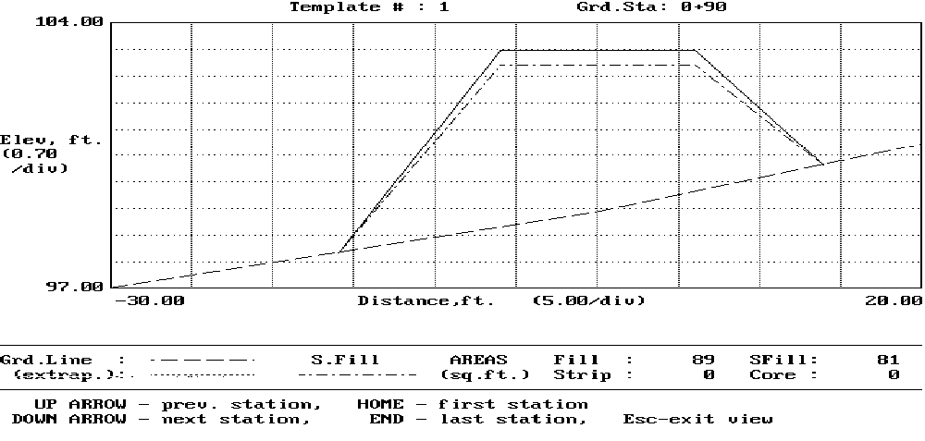
GROUND/EMBANKMENT INTERSECTIONS

The embankment centerline stations where the ground elevation is equal to the settled fill elevation and the emergency spillway elevation are shown on the screen below. If a station is beyond entered ground data, the location is extrapolated from the ground data and a warning issued. The design emergency spillway bottom width is also displayed.

You are then requested to enter the dam centerline station where the emergency spillway centerline crosses (see the figure below). This determines on which side the emergency spillway is located. A station cannot be entered which would result in the bottom of the spillway being in a fill condition. This station is used in printing the embankment centerline profile on the construction checkout sheet.

Ground/Embankment Intersections
GROUND/EMBANKMENT INTERSECTIONS
------------------------------------------------------------------------------

The embankment centerline stations where the ground elevation is equal to
to the settled fill elevation and the emergency spillway elevation are
shown below
-------- LEFT ------- ------- RIGHT -------
Settled fill station : 0+59 station : 2+84
elevation : 102.9 elevation : 102.9

Emerg. Spillway station : 0+80 station : 2+57
elevation : 100.7 elevation : 100.7

Emerg. Spillway bottom width, ft. ------------------------ : 14.00

Enter dam centerline station where E.S. centerline crosses : 65
(must be less than or equal to 0+72
or greater than or equal to 2+64 )

Esc-quit F10-save PgUp/PgDn-prev/next screen

Figure 19. Emergency Spillway Location
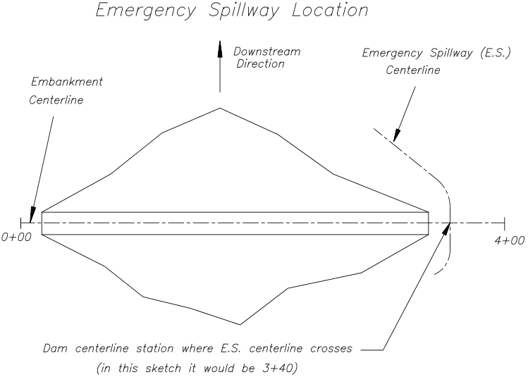
PRINT DATA

When "Print Data" is chosen from the menu, the following report setup screen appears with the available options. An example of each report option is shown in the sample outputs in Appendix A. To select a report option, enter an X or use the <Space Bar> to toggle the X on. To remove a report option, use the <Space Bar> to toggle the X off. Once the report is setup, press <PgDn> or <F5> to start printing. You can then select where to send the output (i.e., screen, printer, or a file).

Report Setup
REPORT SETUP
------------------------------------------------------------------------------

Cover page --------------- : X
Elevation-storage input -- : X
Storage volumes ---------- : X
RCN determination -------- : X
Hydrologic data ---------- : X
Principal spillway trials : X
Emergency spillway details : X
Ground data -------------- : X
Embankment x-section data : X
Conduit details --------- : X
Design elevations -------- : X
Summary ------------------ : X
Earthwork volumes -------- : X
Construction Checkout ---- : X
Principal spillway plot -- : X

printer (F2 to change) --- : epson.prt

Enter X next to desired output or use SPACE BAR to toggle X
Esc,PgUp-menu, F1-help, F6-toggle all X, F10-save, PgDn-Print

NOTE: For the "Principal spillway plot" to print correctly, the program GRAPHICS should have been executed prior to running this program. For more info, see the "PrintScreen" note in the Key Conventions section of this manual.

Additional keys with special functions on this screen are:

<F6> or
<Ctrl><X> : Toggle all the X's on or off.

<Esc> or
<PgUp> : Return to the menu.

<F2> : Allows you to change the type of printer and the port that will receive the output. When this key is pressed, the "Default Printer and Port" screen (shown below) will appear. Use the up and down arrow keys to select the printer and press <Enter>. The default printer port is normally PRN. This should suffice for most situations, so just press <Enter>. You will then be returned to the report setup screen. NOTE: This printer selection is lost when the program is exited. To change the printer permanently, see the "Change Defaults" section of this manual.

Default Printer and Port
DEFAULT PRINTER AND PORT
------------------------------------------------------------------------------
+----------- SELECT PRINTER -----------+
Default printer name --- : ¦>Epson ¦
file --- : ¦ Genicom 3024 (MX+ mode) ¦
¦ Genicom 3024 (Okidata mode) ¦
¦ HP Laserjet ¦
ENTER-select printer ¦ IBM Proprinter ¦
¦ Okidata (IBM mode) ¦
¦ ¦
¦ ¦
+--------------------------------------+

Printer port ----------- : PRN

Esc-cancel

CHANGE DEFAULTS

SCREEN DESCRIPTION PAGE

DEFAULTS FOR POND DESIGN 56

DEFAULT PRINTER AND PORT 60
Printer Commands 62

RAINFALL DATA 63

DEFAULTS CAN BE STORED AT ANYTIME BY PRESSING <F10> !

Storing your data intermittently would be advised to avoid data loss due to power interruptions.

The design defaults changed by the "Change defaults" program will be stored in the file DEFAULT.PND . The default printer and port are stored in the file ENG.INI . The printer commands are stored in the specified printer file. The county names and rainfall data are stored in the file COUNTY.ss, where ss is the state abbreviation (e.g., COUNTY.MO).

NOTE!

Defaults for values entered in the design portion of the program can be changed. This is done by selecting "Design pond" from the main menu and then entering the drive:\path where the program resides (or making it blank) and entering a filename of DEFAULT . You can then go through the screens and edit the default values. Once all changes are made, be sure to save the data back to DEFAULT .

DEFAULTS FOR POND DESIGN

Various defaults and design parameters can be set on the first screen shown below. These are values that you should not have a need to change once you have entered them. Each of the items is described in more detail below.

Defaults for Pond Design
DEFAULTS FOR POND DESIGN
------------------------------------------------------------------------------
Data drive:\path --------- : A:\
Filename when F10 pressed? Y
Footer for cover page ---- : Office Name
Address 1
Address 2
City

EMERG. SPILLWAY - ¦ DRAWDOWN TIME - shortest time of
ES to top of dam,ft. * : 2.00 ¦ these 3 conditions
Freeboard, ft. ------- : 1.00 ¦ ft. above inlet : 0.0
Min. bottom width, ft. : 10.00 ¦ storage drained,% : 85.0
Max. bottom width, ft. : 150.00 ¦ min. flow, cfs : 0.10
¦
GROUND DATA - ¦ EARTHWORK COMPUTATIONS
Station increment, ft. : 0.00 ¦ Slopes? S) Settled, or
Repeat distances? : Y ¦ C) Constructed --- : S
Offset for slope, ft. : 30.00 ¦ Berm Settles? Y/N ------ : N
¦
RAINFALL Distribution Type : II ¦
* Min. elevation difference between E.S. crest and settled top of dam

Esc-quit, F10-save, PgUp/PgDn-prev/next screen
DATA DRIVE:\PATH : You should indicate here the drive and path of where you intend to store your data. This should conform to DOS conventions. A couple of examples are A:\ (the root directory of drive A) or C:\PONDDATA (the directory PONDDATA on drive C).

FILENAME WHEN F10 PRESSED? : Answering "Y" (yes) here will cause the design program to prompt you for a filename whenever you press <F10> to save your data. An "N" (no) will cause the program to save your data to the current project name without prompting. NOTE: Selecting "Save data" from the program menu will prompt you for a filename regardless of this setting.

FOOTER FOR COVER PAGE : Up to four lines of information can be entered here. This could be your office name and address or anything else you might want printed on the bottom of the cover page.

EMERG. SPILLWAY -

ES TO TOP OF DAM : This is the minimum elevation difference (feet) desired between the emergency spillway elevation and the settled top of dam elevation.

FREEBOARD : Enter the minimum freeboard (feet) desired above the maximum water elevation.

MIN. BOTTOM WIDTH : Enter the minimum bottom width (feet) desired for the emergency spillway.

MAX. BOTTOM WIDTH : Enter the maximum bottom width (feet) desired for the emergency spillway.
GROUND DATA - The following values relate to the "Ground Profile/X-Section Data" screen (described elsewhere in this manual).

STATION INCREMENT : The station increment determines what the next station will be if you are at the last station and move to the next station (i.e., add a station). For example, if the last station is 5+00 and the increment is 50, the next station added will be 5+50. A value of 0+00 will increment the last station by 1 and place the cursor on the "Station" field instead of "Elev" field. This allows you to edit the station value without using the left arrow key to move from "Elev" to "Station". The value you enter here is the default value for that screen input field.

REPEAT DISTANCES? : This sets the default value for the repeat distances function. NO indicates that distances from the previous cross section will not be repeated for a station. YES indicates that the distances will be repeated.

OFFSET FOR SLOPE : This determines the distance (feet) at which a second point is created when entering a percent ground slope.

RAINFALL DISTRIBUTION TYPE : The desired 24-hour storm distribution of I, IA, II, or III should be selected here. A map showing where these distributions occur is shown in Figure 2-1, Chapter 2, EFH.

DRAWDOWN TIME - The time to drawdown the water to the following 3 conditions is computed and the shortest time of the 3 is the result displayed.

FT. ABOVE INLET : This is simply a distance in feet above the inlet elevation.

STORAGE DRAINED,% : You can specify a certain percentage of the peak routed volume.

MIN. FLOW, CFS : The last choice allows you to stop computing drawdown time at a desired flow in cubic feet per second.

EARTHWORK COMPUTATIONS - Earthwork quantities are computed based on the following two settings.

SLOPES? S) SETTLED, OR C) CONSTRUCTED : If the front and back slopes entered are settled slopes (constructed slopes will be steeper), enter an S here. If they are constructed slopes (settled slopes will be flatter), enter a C here. Refer to the figure below.

Figure 20. Constructed vs. Settled Slopes
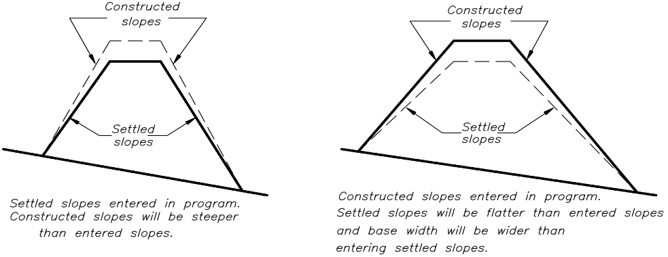

BERM SETTLES? : Do you want quantities computed assuming the upstream and downstream berms settle? If yes, enter Y here, otherwise enter N.

DEFAULT PRINTER AND PORT

The screen shown below is where you define your default printer and printer port. Selecting the correct printer is important in getting the output to print correctly.

Default Printer and Port
DEFAULT PRINTER AND PORT
------------------------------------------------------------------------------
+----------- SELECT PRINTER -----------+
Default printer name --- : ¦>Epson ¦
file --- : ¦ Genicom 3024 (MX+ mode) ¦
¦ Genicom 3024 (Okidata mode) ¦
¦ HP Laserjet ¦
ENTER-select printer ¦ IBM Proprinter ¦
INS-add a printer ¦ Okidata (IBM mode) ¦
DEL-delete printer ¦ ¦
F2-edit printer ¦ ¦
+--------------------------------------+

Printer port ----------- : PRN

Esc-quit, F10-save, PgUp/PgDn-prev/next screen

DEFAULT PRINTER NAME : A list of printer choices is given. You can use the arrow keys or the first few letters of the printer name to highlight the desired printer. Press <Enter> to select it. The following keys can be used to add a printer, remove a printer, or edit an existing printer.

<INS> : The <Insert> key can be used to add a printer. The added printer will be an exact copy of the printer highlighted when the key was pressed. You can then use <F2> to edit the printer name, file, and commands.

<DEL> : The <Delete> key is used to delete (remove) the highlighted printer from the list. Note that this does not remove the associated printer command file from your hard drive.

<F2> : This key allows you to edit the printer name, the associated printer command filename, and the print commands for the highlighted printer. See the Printer Commands screen description below.

PRINTER FILE : Each printer in the list has an associated printer command file. This file contains the commands necessary to perform special formatting functions. The file name is displayed on this screen, but can only be edited by using <F2>.

PRINTER PORT : This determines where to send the printed output. It is simply a port or device name. The default setting is PRN which should work in most cases. Other examples are LPT1, LPT2, and COM1. A filename can also be entered here if you want the output to always go to a file.

PRINTER COMMANDS

The following screen appears when <F2> is pressed when selecting a default printer. It allows you to modify the printer commands to invoke the various print functions. You can also change the printer name and the file for storing the commands. It is advised to give all the printer command files the same extension (e.g., PRT), although it is not required. If a character can not be entered from the keyboard, the ASCII value can be enclosed in <> (e.g., the escape character can be entered as <27> ) . Refer to your printer manual for appropriate commands.

Printer Commands
PRINTER COMMANDS
------------------------------------------------------------------------------
Printer name ------ : Epson
Filename ---------- : epson.prt
PRINT_INIT:
PRINT_EXIT:
NORMAL:
FORM_FEED: <12>
BOLD_OFF: <27>F
BOLD_ON: <27>E
CONDENSED_OFF: <18>
CONDENSED_ON: <15>
LARGE_OFF: <27>W0
LARGE_ON: <27>W1
UNDER_OFF: <27>-0
UNDER_ON: <27>-1
PAGE_LENGTH: 60
PAGE_WIDTH:

Esc-quit

The printer command variables are as follows:

PRINT_INIT: Sent at beginning of print job.
PRINT_EXIT: Sent at end of print job.
NORMAL: Set to normal print.
FORM_FEED: Move paper to top of next page.
BOLD_OFF: Turn bold printing off.
BOLD_ON: Turn bold printing on.
CONDENSED_OFF: Turn condensed (small) printing off.
CONDENSED_ON: Turn condensed (small) printing on.
LARGE_OFF: Turn large (e.g., expanded, double-width) printing off.
LARGE_ON: Turn large (e.g., expanded, double-width) printing on.
UNDER_OFF: Turn underlining off.
UNDER_ON: Turn underlining on.
PAGE_LENGTH: Set page length to specified number of lines.
PAGE_WIDTH: Set page width to specified number of characters.

RAINFALL DATA

The next two screens are used to edit your rainfall data. On the first screen, you simply enter the two letter abbreviation of the state you wish to edit. This abbreviation is used as the file extension for the rainfall data file (e.g., COUNTY.MO). The second screen is where the actual rainfall data is edited. You would move to the desired county by using arrow keys or entering the county name. If a county name is entered that can not be found, you are asked if you wish to change the name. You can then use the arrow keys to move to the appropriate frequency column (1, 2, 5, 10, 25, 50, or 100 years) and edit the 24-hour rainfall amount in inches.

Rainfall Data File

Rainfall data is stored in the file COUNTY.ss,
where ss is the state abbreviation.

Enter state abbreviation : MO

Rainfall Data
RAINFALL DATA IN COUNTY.MO # of counties: 114
Frequencies
County Name 1 2 5 10 25 50 100
--------------------------------------------------------------------------------
ADAIR 2.8 3.3 4.3 5.0 5.7 6.4 7.0
ANDREW 2.8 3.4 4.4 5.1 5.9 6.6 7.3
ATCHISON 2.8 3.3 4.2 5.0 5.7 6.4 7.1
AUDRAIN 2.9 3.4 4.4 5.1 5.8 6.5 7.1
BARRY 3.3 4.0 5.1 5.9 6.9 7.7 8.5
BARTON 3.2 3.9 5.0 5.7 6.7 7.5 8.3
BATES 3.1 3.6 4.8 5.5 6.5 7.2 8.0
BENTON 3.1 3.6 4.7 5.4 6.3 7.0 7.7
BOLLINGER 3.1 3.7 4.5 5.2 5.9 6.6 7.2
BOONE 3.0 3.5 4.5 5.2 5.9 6.6 7.3
BUCHANAN 2.9 3.4 4.4 5.2 6.0 6.7 7.5
BUTLER 3.2 3.8 4.7 5.4 6.1 6.7 7.4
CALDWELL 2.9 3.4 4.5 5.1 6.0 6.7 7.4
CALLAWAY 3.0 3.5 4.5 5.1 5.9 6.6 7.2
CAMDEN 3.1 3.6 4.7 5.4 6.3 7.0 7.7
--------------------------------------------------------------------------------
Edit county name and rainfall data value.
Entering an existing county name will move to that county.

Esc-quit, DEL-delete county, INS-add county, F10-save, PgUp/PgDn
You can add or remove counties using the following keys.

<INS> : The <Insert> key is used to add a county. The new county will be inserted just above the currently highlighted county.

<DEL> : The <Delete> key is used to delete the highlighted county with confirmation.

<Ctrl><D> : Same as <DEL> but with no confirmation.

APPENDIX A - SAMPLE OUTPUT

SECTION PAGE

Cover Page 66

Page Header 66

Elevation-Storage Input Data 67

Storage Volumes 67

RCN Determination 68

Hydrologic Data 68

Principal Spillway Trials 69

Emergency Spillway Details 69

Ground Data 70

Embankment X-Section Data 70

Conduit Details 71

Design Elevations 72

Summary 72

Earthwork Volumes 72

Construction Checkout 73

Principal Spillway Plot 74

Examples of each of the reports available for printout are shown on the following pages. The reports selected on the "Report Setup" screen are printed in the order shown on that same screen.

COVER PAGE
=========================
| POND DESIGN |
=========================

Ver. 1.0, 4/94

PROJECT ---- : sample

Description : Sample

State ------ : MO

County ----- : WORTH

Landowner -- : J.Q. Farmer

Township --- : 10

Range ------ : 20

Section ---- : 2

Field ------ :

Designed by : J.Q. Engineer

Date designed: 3-25-1994

Date printed : 3-25-1994

Approved by : __________________________

Date ------ : __________

PLANNED IN COOPERATION WITH USDA-SCS

Office Name
Address 1
Address 2
City

The page header shown below is printed on every page of the output except the cover page above and the principal spillway plot.

PAGE HEADER
Project --- : sample Page 1
Prepared for: J.Q. Farmer TWP: 10 RNG: 20
Prepared by : J.Q. Engineer SEC: 2 FLD:
Checked by : ________________ Date : __________
The elevation-storage report printed (one of the two below) depends on the method of entry chosen. The first one is for areas entered directly as acres and the second one is for areas entered as square inches and converted to acres via a given scale.

ELEVATION-STORAGE INPUT DATA
******************* ELEVATION-STORAGE INPUT DATA *****************

|==========|====================|==============|===============|
| ELEV | POOL AREA | INT.STORAGE | ACCUM.STORAGE |
| (ft) | (acres) | (ac.ft.) | (ac.ft.) |
|==========|====================|==============|===============|
| 71.1 | 0.00 |--------------| 0.00 |
|----------|--------------------| 32.37 |---------------|
| 96.0 | 2.60 |--------------| 32.37 |
|----------|--------------------| 6.56 |---------------|
| 98.3 | 3.10 |--------------| 38.93 |
|----------|--------------------| 2.20 |---------------|
| 99.0 | 3.20 |--------------| 41.13 |
|----------|--------------------| 4.36 |---------------|
| 100.3 | 3.50 |--------------| 45.49 |
|----------|--------------------| 6.20 |---------------|
| 102.0 | 3.80 |--------------| 51.69 |
|----------|--------------------|--------------|---------------|
ELEVATION-STORAGE INPUT DATA w/area in square inches
******************* ELEVATION-STORAGE INPUT DATA *****************
Scale: 1 in. = 100.0 ft.
|==========|====================|==============|===============|
| ELEV | POOL AREA | INT.STORAGE | ACCUM.STORAGE |
| (ft) | (sq.in.) (acres) | (ac.ft.) | (ac.ft.) |
|==========|====================|==============|===============|
| 71.1 | 0.00 0.00 |--------------| 0.00 |
|----------|--------------------| 32.37 |---------------|
| 96.0 | 11.33 2.60 |--------------| 32.37 |
|----------|--------------------| 6.56 |---------------|
| 98.3 | 13.50 3.10 |--------------| 38.93 |
|----------|--------------------| 2.20 |---------------|
| 99.0 | 13.94 3.20 |--------------| 41.13 |
|----------|--------------------| 4.36 |---------------|
| 100.3 | 15.25 3.50 |--------------| 45.49 |
|----------|--------------------| 6.20 |---------------|
| 102.0 | 16.55 3.80 |--------------| 51.69 |
|----------|--------------------|--------------|---------------|

STORAGE VOLUMES
************************** STORAGE VOLUMES **************************
|=========================|=============|=============|=============|
| | ELEVATION | AREA | STORAGE |
| | (ft) | (acres) | (ac.ft.) |
|=========================|=============|=============|=============|
| Inlet (Princ. spillway) | 98.3 | 3.10 | 38.93 |
| Emerg. spillway | 100.3 | 3.50 | 45.49 |
| Max. water | 101.1 | 3.63 | 48.19 |
| Settled top of fill | 102.3 | 3.85 | 52.84 |
|-------------------------+---------------------------+-------------|
| Sediment - above inlet |---------------------------| 0.00 |
| - below inlet |---------------------------| 0.00 |
| Inlet to Emerg. |---------------------------| 6.56 |
| Emerg. to max. water |---------------------------| 2.70 |
|-------------------------------------------------------------------|
The runoff curve number determination report is only printed if <F9> was used to compute a weighted curve number on the "Hydrology Info" screen.

RUNOFF CURVE NUMBER DETERMINATION
RUNOFF CURVE NUMBER DETERMINATION Acres & (curve numbers) for
Hydrologic Soil Group
COVER DESCRIPTION A B C D
------------------------------------------------------------------------------

CULTIVATED AGRICULTURAL LANDS
Small grain
SR + Crop residue good ............... 42(60)
C + Crop residue poor ............... 42(62)
------------------------------------------------------------------------------
ACCUMULATED: 84.00 Acres WEIGHTED CURVE NUMBER: 61

NOTE: The inflow values on the hydrologic data printout below may not match exactly the values given on the "Hydrology Info" screen.The reason being that the printed values are computed from an inflow hydrograph whereas the "Hydrology Info" screen values are computed by the method in EFH, Chapter 2.

HYDROLOGIC DATA
****************************** HYDROLOGIC DATA ***************************
--------------------------------------------------------------------------
| Rainfall distr. type ----- : II |
| Drainage area, acres ----- : 84.0 Watershed slope, % : 14.0 |
| Runoff curve number ------ : 61 Flow length, ft. - : 2376 |
| Time of concentration, hrs : 0.48 |
| (min.: 28.65) |
|------------------------------------------------------------------------|
| --------- Spillway --------- |
| Principal Emergency |
| Design frequency, yrs.: 10 50 |
| 24 hr. Rainfall, in. : 5.0 6.5 |
| Runoff, in. --------- : 1.4 2.3 |
| Peak inflow, cfs ---- : 90.23 164.75 |
| Peak outflow, cfs --- : 4.68 15.37 E.S. |
--------------------------------------------------------------------------

PRINCIPAL SPILLWAY TRIALS
******************* PRINCIPAL SPILLWAY TRIALS **********************
Inlet type: Canopy Inlet Elevation: 98.3
--------------------------------------------------------------
| | TRIAL 1 | TRIAL 2 | TRIAL 3 |
| CONDUIT: Type ----------- | SSP | SSP | SSP |
| Diameter, in. -- | 8.00 | 10.00 | 12.00 |
| Height, in. ---- | | | |
| Width, in. ----- | | | |
| Manning's n ---- | 0.013 | 0.013 | 0.013 |
| Entrance Coefficient, Ke | 1.000 | 1.000 | 1.000 |
|------------------------------------------------------------|
| Emergency elevation ----- | 100.3 | 100.3 | 100.3 |
| STORAGE (ac.ft.): | | | |
| Temporary (PS-ES) ---- | 6.56 | 6.56 | 6.56 |
| Total at emergency --- | 45.49 | 45.49 | 45.49 |
| Effective height, ft. --- | 29.2 | 29.2 | 29.2 |
| Height x storage -------- | 1328 | 1328 | 1328 |
| Job Class --------------- | IV | IV | IV |
| Drawdown time, days-hrs. | 2- 5.7 | 2- 0.3 | 1-22.4 |
| Trial used -------------- | --- 1 -- | | |
--------------------------------------------------------------
CONDUIT TYPES ----- : SSP - Smooth Steel Pipe

EMERGENCY SPILLWAY DETAILS
********************* EMERGENCY SPILLWAY DETAILS ********************
Discharge determination: Qe values from ESFILE
---------------------------------------------------------------------
| Emergency elev. - : 100.3 ^ Retardance ----------- : E |
| Bottom width, ft. : 10 Level sect. length, ft.: 25 |
| Flow depth, ft. - : 0.76 Side slope ratio, n:1 : 3.00 |
| EXIT CHANNEL - |
| Max. Vel.,fps - : 7.0 Retardance ----------- : E |
|-------------------------------------------------------------------|
| Flow, cfs ------- : 15.37 Exit Slope, % --- Min.: 3 |
| Max.: 23 |
| Settled fill elev.: 102.3 Drawdown time, days-hrs: 1- 6.2 |
| Channel elev. --- : 69.4 Overall height, ft. -- : 32.9 |
| (downstream toe) |
---------------------------------------------------------------------
^ increased by user
If an HI is given for a station, the data for that station is the foresight and distance. If an HI is not given, the data is elevation and distance.

GROUND DATA
=============================== GROUND DATA =============================

STA HI %SLOPE (FS or ELEV)/DIST ------>

***** PRACTICE: DAM *****
0+50 102.3 / 0
0+57 98.3 / 0
0+60 96.4 / 0
0+70 93.5 / 0
0+80 90.5 / 0
0+92 83.1 / 0
1+07 73.1 / 0
1+27 72.5 / 0
1+31 71.1 / 0
1+37 71.1 / 0
1+40 76.1 / 0
1+85 76.6 / 0
2+00 85.4 / 0
2+10 89.4 / 0
2+25 91.0 / 0
2+40 91.9 / 0
2+85 94.8 / 0
3+15 97.1 / 0
3+28 98.3 / 0
3+30 98.5 / 0
3+45 100.3 / 0
The dimensions given in the "Embankment cross section" report below are shown in 21 on page 46.

EMBANKMENT CROSS SECTION DATA
*********************** EMBANKMENT CROSS SECTION DATA ********************
% settlement = 5.0
|=============================|==========|==========|==========|==========|
| Template # ---------------- | 1 | | | |
| Station ------------------- | 0+50 | | | |
| Settled top of fill elev. - | 102.3 | | | |
| Top width, ft. ------------ | 14 | | | |
| Upstream berm elev. ------- | | | | |
| berm width, ft. -- | | | | |
| Downstream berm elev. ----- | 81.0 | | | |
| berm width, ft. | 10 | | | |
| Front slope, n:1 ---------- | 3.0 | | | |
| Back slope, n:1 ----------- | 3.0 | | | |
|-----------------------------|----------|----------|----------|----------|
| Stripping depth, ft. ------ | 0.5 | | | |
| Core bottom width, ft. ---- | 10 | | | |
| depth, ft. ----------- | 5.0 | | | |
| side slopes, n:1 ----- | 1.5 | | | |
| offset, ft. ---------- | | | | |
| BL-CL offset, ft. --------- | | | | |
|-----------------------------|----------|----------|----------|----------|
Two examples of the "Conduit Detail" report are shown below. The only difference is that the second one has an elbow. The dimensions given in this report for a canopy, a hood, and/or an elbow are displayed in figures in the "Illustrations" section. The "maximum fill over pipe" is measured at the downstream edge of the top width. The anti-seep information was obtained from MO-6-9 in the Engineering Field Handbook (EFH).

CONDUIT DETAIL
*************************** CONDUIT DETAIL *****************************
------------------------------------------------------------------------
| Inlet Type ----------- | Canopy |
| Conduit Type --------- | SSP - Smooth Steel Pipe |
| Diameter, in. -------- | 8.00 |
| Length, lin. ft. ----- | 150 Extends 6.0 ft. beyond dnstr.toe |
| Slope, % ------------- | 18.4 |
| Max.fill over pipe, ft.| 10.7 |
| Canopy Length -------- | 8-3/4" |
| W ------------ | 2-3/8" |
|----------------------------------------------------------------------|
| Horizontal Distances (ft.) |
| Upstrm: edge of top width to inlet end of pipe : 18.1 |
| Dnstrm: edge of top width to toe ------------- : 108.7 |
|----------------------------------------------------------------------|
| Anti-seep Number Min. Size Max.Spacing, ft. |
| Collars 2 5'- 4" 32.9 |
| 3 3'-10" 21.9 |
| 4 3'- 0" 16.4 |
|----------------------------------------------------------------------|
CONDUIT DETAIL w/elbow
*************************** CONDUIT DETAIL *****************************
------------------------------------------------------------------------
| Inlet Type ----------- | Canopy |
| Conduit Type --------- | SSP - Smooth Steel Pipe |
| Diameter, in. -------- | 8.00 |
| Length, lin. ft. ----- | 150 Extends 6.0 ft. beyond dnstr.toe |
| Slope, % ------------- | 20.9 |
| Max.fill over pipe, ft.| 11.4 |
| Canopy Length -------- | 8-3/4" |
| W ------------ | 2-3/8" |
|----------------------------------------------------------------------|
| ELBOW Wedge cut ------ | 1-3/8" |--| wedge |-| diagonal |
| Diagonal cut --- | 0-3/4" ---\--/------ ---\---- rotate |
| Outlet offset * | 3'- 6" ____\/_______ ____\___ 180 deg. |
| * Distance to move outlet end of pipe. |
|----------------------------------------------------------------------|
| Horizontal Distances (ft.) |
| Upstrm: edge of top width to inlet end of pipe : 18.1 |
| Dnstrm: edge of top width to toe ------------- : 108.7 |
|----------------------------------------------------------------------|
| Anti-seep Number Min. Size Max.Spacing, ft. |
| Collars 2 5'- 4" 32.9 |
| 3 3'-10" 21.9 |
| 4 3'- 0" 16.4 |
|----------------------------------------------------------------------|

DESIGN ELEVATIONS
************* DESIGN ELEVATIONS (at principal spillway) *************
Inlet type: Canopy NOT TO SCALE
^ increased by user
Constrctd.fill elev.: 103.9 Top width, ft.: 14
Settled fill elev.: 102.3 _____
% settlement : 5 /~~~~~\ Emerg. elev. --- : 100.3^
/_______\ _ Bottom width, ft.: 10
Inlet elev.: 98.3 _ A / \ Dwn.berm elev.: 81.0
o \____ _ width,ft.: 10
/ \
/ o \ 3.0 Back slope
/ \---
/ o \ | 1
Front slope: 3.0 / \
---/ o \
1 | / o Outlet elev.
/ \ C <--- 71.4
__/__________________________ \
Low pt. on C/L : 71.1 \_______\___ Channel elev.
Length(s), ft.- 69.4
Conduit ------- (A to C): 150

SUMMARY
********************************* SUMMARY **********************************
Inlet type: Canopy Inlet Elevation: 98.3
----------------------------------------------------------------------------
| CONDUIT: Type ------------ | SSP - Smooth Steel Pipe |
| Diameter, in. --- | 8.00 |
| Length, lin. ft.- | 150 Extends 6.0 ft. beyond dnstr.toe |
| EMERG. : Elevation ------- | 100.3 |
| Bottom width, ft. | 10 |
| Hp, flow depth,ft.| 0.76 |
| Exit slope, % min.| 3 |
| max.| 23 |
|--------------------------------------------------------------------------|
| Effective height, ft. ---- | 29.2 =ES elev. - low pt. on C/L |
| Height x storage --------- | 1328 |
| Engr. Job Class ---------- | IV |
| Overall height, ft. ------ | 32.9 =Stld. fill elev - chan. elev |
| NOTE --------------------- | ******** INVENTORY SIZE DAM |
----------------------------------------------------------------------------

EARTHWORK VOLUMES
**************************** EARTHWORK VOLUMES *****************************
----------------------------------------------------------------------------
| CONSTRUCTED SETTLED |
| % settlement| 5 |
| EARTHWORK Fill ------ | 13368 12786 |
| QUANTITIES Stripping - | 584 584 |
| (cu.yds.) Core ------ | 945 945 |
| TOTALS | 14897 14315 |
----------------------------------------------------------------------------
The checkout sheet shown below is intended to be filled out in the field. It is basically divided into three sections: profiles and spillway elevations, cross sections, and pipe spillway info. The first section, on the left side of the page, is split into three areas: embankment centerline profile, principal spillway elevations, and the emergency spillway centerline profile. The small e's left of some stations in the embankment CL profile indicate the emergency spillway. Examples of recorded data are shown below as 123 (bold and italic).

CONSTRUCTION CHECKOUT
Project -- : sample Page 7
Prepared by: J.Q. Engineer Prepared for: J.Q. Farmer TWP: 10 RNG: 20
Checked by : ABC Date : 4/15/94 SEC: 2 FLD:
*************************************************** POND CONSTRUCTION CHECKOUT *****************************************************
TBM # : Elev. + B.S. = H.I. TBM Description | TBM # : Elev. + B.S. = H.I. TBM Description |
1 100.0 5.6 105.6 Iron pin by oak tree | 2 70.2 5.3 75.5 top of lower hinge on gate |
====================== CL PROFILES & P.SPILLWAY ELEVS. ===================== =================== CROSS SECTIONS ===================
| | Rod |Constr.| Plan. | || | Rod |Constr.| Plan. | | Take 'x' shots plus any others as needed.
| STA | Rdg. | Elev. | Elev. | Dev. || STA | Rdg. | Elev. | Elev. | Dev. | EMBANKMENT x___x___x Planned:
| | (FS) |(HI-FS)| \1 | (+/-)|| | (FS) |(HI-FS)| \1 | (+/-)| Dwnstrm. / CL \ Up. F.Slope 3.0:1
|======|======|=======|=======|======||======|======|=======|=======|======| x___/ \ B.Slope 3.0:1
| Embankment CL Profile || 3+28| | | 102.5| | / \ T.Width 14
|------+------+-------+-------+------||------|------|-------|-------|------| x____x/ \_____
| | | | | || 3+30| | | 102.5| | STA
|------|------|-------|-------|------||------|------|-------|-------|------| 1+30 Rod 6.5 6.2 24.6 1.7 1.6 1.7 ____ ____ ____
| | | | | |e 3+39| 3.1 | 102.5 | 102.4| +0.1 | Dist.-130 -120 -85 -7 0 7
|------|------|-------|-------|------||------|------|-------|-------|------| ------------------------------------------------------
| 0+50| | | 102.3| |e 3+45| | | 100.3| | Rod ____ ____ ____ ____ ____ ____ ____ ____ ____
|------|------|-------|-------|------||------|------|-------|-------|------| Dist.
| 0+57| | | 102.5| |e 3+55| 5.3 | 100.3 | 100.3| 0 | ------------------------------------------------------
|------|------|-------|-------|------||------|------|-------|-------|------| Rod ____ ____ ____ ____ ____ ____ ____ ____ ____
| 0+60| | | 102.6| |e 3+58| | | 101.3| | Dist.
|------|------|-------|-------|------||------|------|-------|-------|------|
| 0+70| | | 102.7| || | | | | | ******************************************************
|------|------|-------|-------|------||------|------|-------|-------|------| EMERG. ___x x____ Planned:
| 0+80| | | 102.9| || | | | | | SPILLWAY \ CL / S.Slopes 3.0:1
|------|------|-------|-------|------||------|------|-------|-------|------| \x_____x_____x/ B.Width 10
| 0+92| | | 103.3| || | | | | | STA
|------|------|-------|-------|------||======+======+=======+=======+======| 2+00 Rod ____ 3.1 5.2 5.3 5.2 4.2 ____ ____ ____
| 1+07| 1.9 | 103.7 | 103.8| -0.1 || Principal Spillway Elevs. | Dist. -11.3 -5 0 5 8
|------|------|-------|-------|------||------+------+-------+-------+------| ------------------------------------------------------
| 1+27| | | 103.8| ||INLET | 7.2 | 98.4 | 98.3| +0.1 | Rod ____ ____ ____ ____ ____ ____ ____ ____ ____
|------|------|-------|-------|------||------|------|-------|-------|------| Dist.
| 1+31| | | 103.9| ||OUTLET| 4.2 | 71.3 | 71.4| -0.1 | ------------------------------------------------------
|------|------|-------|-------|------||------|------|-------|-------|------| Rod ____ ____ ____ ____ ____ ____ ____ ____ ____
| 1+37| 1.6 | 104.0 | 103.9| +0.1 ||CHANNL| 6.3 | 69.2 | 69.4| -0.2 | Dist.
|------|------|-------|-------|------||======+======+=======+=======+======|
| 1+40| | | 103.6| || Emergency Spillway CL Profile |
|------|------|-------|-------|------||------+------+-------+-------+------|-------- +--------------------------------------------+
| 1+85| | | 103.6| || | | | | | | | PIPE SPILLWAY Planned As Built |
|------|------|-------|-------|------||------|------|-------|-------|------| Inlet | | Pipe Diameter, in. 8 8 |
| 2+00| | | 103.1| || 1+80 | 5.7 | 99.9 | 100.0 | -0.1 | (us) | | Length, ft. 150 155 |
|------|------|-------|-------|------||------|------|-------|-------|------|-------- | |
| 2+10| | | 102.9| || 1+90 | 5.2 | 100.4 | 100.3| -0.2 | Level | | Canopy Length, in. 8-3/4 8-1/2 |
|------|------|-------|-------|------||------|------|-------|-------|------| | | W, in. 2-3/8 2-1/4 |
| 2+25| | | 102.9| || 2+00 | 5.3 | 100.3 | 100.3| 0 |<center| | |
|------|------|-------|-------|------||------|------|-------|-------|------| | | Pipe Type: SSP |
| 2+40| | | 102.8| || 2+10 | 5.5 | 100.1 | 100.3| +0.1 | Sect. | |--------------------------------------------|
|------|------|-------|-------|------||------|------|-------|-------|------|-------- | STOCKWATER PIPE Diameter, in. ________ |
| 2+85| | | 102.7| || 2+50 | 5.6 | 100.0 | 99.9 | +0.1 | | | (if installed) Length, ft. ________ |
|------|------|-------|-------|------||------|------|-------|-------|------| Outlet| |--------------------------------------------|
| 3+15| | | 102.6| || | | | | | (ds) | | Have dam, spillway, & assoc. areas been |
============================================================================-------- | SEEDED ( Y )/( N )? FENCED ( Y )/( N )? |
\1 Planned elevations for top of dam are based on 5 % settlement. | MULCHED ( Y )/( N )? |
+--------------------------------------------+
Notes _____________________________________________________________________________ Does Does Not meet SCS design and
_____________________________________________________________________________ ______ ______ specifications.
_____________________________________________________________________________
_____________________________________________________________________________ By ___________________________________
_____________________________________________________________________________ Title ___________________________________
_____________________________________________________________________________
_____________________________________________________________________________ Date ___________________________________

NOTE: The following printout requires GRAPHICS.COM to have been loaded prior to running the pond design program.

Principal Spillway Plot
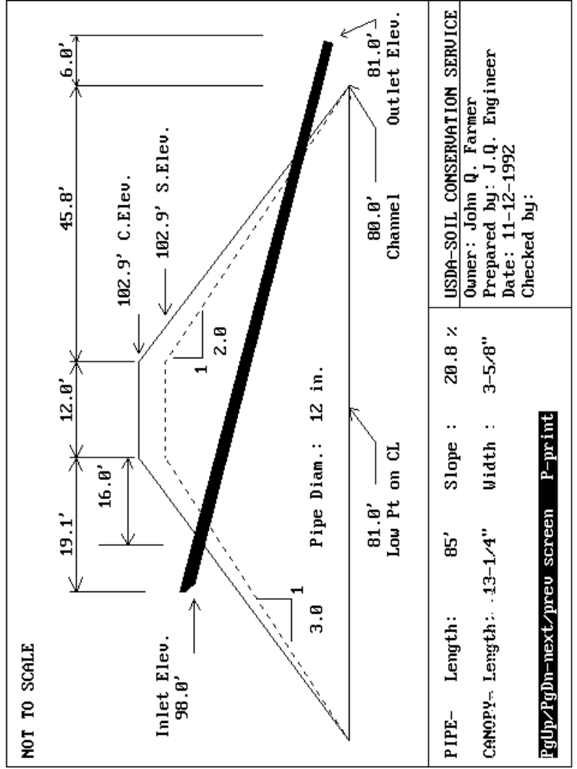
APPENDIX B - ERROR MESSAGES

Listed below are the error messages and warning messages the program will give when an error occurs.

An error was encountered reading file. : ESFILE could not be successfully read. The problem with the file needs to be fixed.

Bottom width restricting. Depth not possible. : Either the minimum or maximum emergency spillway bottom width was exceeded in trying to use a certain flow depth. A different flow depth should be tried.

Cannot delete all cross-sections! : When entering the embankment cross section data, you must have at least one cross section defined.

Cannot load program. : The program could not load for some reason. It may be that it could not find the program or the program file may have become corrupt.

Configuration not found in ESFILE. : The combination of level section length and retardance was not found in the file ESFILE.

Distance value already exists! : When entering ground data, two points with the same distance are not allowed.

Elbow elevation and outlet length must both be entered : If an elbow is used, the elbow elevation and the elbow to outlet length must both have values entered.

ES elevation raised from --------> ###.##
to full pipe flow elevation of --> ###.## : The routed emergency spillway elevation was less than the elevation required for full pipe flow. Thus, the emergency elevation was raised.

ES elevation raised from -----> ###.##
To inlet elev. + #.# ft. ------> ###.## : For drainage areas of 20 or less acres, the emergency elevation must be 0.5 feet above the inlet elevation. For greater than 20 acres, there must be a 1 foot difference.

File AAA could not be saved. : The file AAA could not be saved for some reason. It could be the disk is full, the disk is write protected, or an invalid filename was entered.

Full pipe flow could not be obtained! Riser may be too small. Recheck input. : If a drop inlet was used, too small of a riser may be the problem. It could also be that the hydrologic data entered does not produce enough runoff to obtain full pipe flow.

Incomplete trial. Try again. : You have not selected a pipe type for a trial.

Inlet elevation is now too low. : If a sediment storage below the inlet was entered, this error will result if a pool bottom elevation is entered that causes the minimum inlet elevation to increase. This would occur on the "Principal Spillway Info" screen.

Manning's n must be >0 for trial # : A Manning's n value of 0 or less than 0 is not allowed.

Maximum of 50 elevations! : A maximum of 50 elevations can be entered on the elevation-storage screen.

Min. slope of ###.# > max. slope of ###.# : In some instances, the minimum allowable slope for the exit channel of the emergency spillway is greater than the maximum allowable slope. This is usually due to the permissible velocities and retardances entered for the exit slope.

Must be A, B, C, D, or E or blank ! : A retardance value of A, B, C, D, or E must be entered. If a Manning's n value is allowed as an alternative, a blank can be entered for the retardance.

Must be <= #+## or >= #+## . : The emergency spillway location must be at a station that would require the spillway to be in cut.

Invalid key. : A key was pressed that is not currently valid.

Must be >= ###.# ! : A value greater than or equal to ###.# must be entered.

Must be < ###.## ! : You should enter a value less than the one displayed.

Must be > ###.## ! : You should enter a value greater than the one displayed.

Must be a number. : Only numbers are allowed in this field.

Must be Y or N. : An answer of Yes or No must be given.

Must have a pipe size for trial # : You have not entered a pipe size for the displayed trial.

Must have at least 1 trial. : You cannot delete all of the principal spillway trials. You must run at least one.

No ground data! : You have not entered any ground data. So the program cannot find the intersection points of the embankment and the ground.

No help available : There is no help for the currently highlighted item.

Not enough memory. : The program cannot execute because of lack of memory. The only solution is to somehow free up memory. If you have any TSR's (terminate and stay resident) programs loaded, you could remove those and try again.

Problem finding directories and/or files : A directory or file could not be located. This could be caused by entering a directory or file name that does not exist, a problem reading the file, a disk not in the drive, etc.

Problem saving file. : A problem occurred trying to save a printer file. It could be the disk is full or an invalid filename was entered.

Problem occurred writing data. : The data could not be written to the disk. It could be the disk is full, the disk is write protected, or an invalid filename was entered.

Riser diameter must be > ##.# : You must enter a larger riser diameter.

To use this option, pipe area must be >= 3 sq.ft. : In order to select "No emergency spillway", the principal spillway pipe area must be greater than or equal to 3 square feet.

Total percent must be 100! : When entering the percent values for runoff curve number determination, the total has to be 100.

Trial # - Warning: Slope of outlet section > ##.# ! : The slope of the outlet section of the principal spillway is too steep. You might wish to consider an elbow to flatten the slope.

Value is outside allowable range: ### - ### : A value between the displayed range must be entered.

Warning: Depth > 1.5 : This is simply a warning notifying you of a possibly large flow depth.

Warning: Depth <= 0 : If there is not enough water to create flow through the emergency spillway, you will most likely get this message. You must lower the emergency elevation or route a larger storm through the emergency.

You have reached the maximum number of cross-sections! : The embankment cross section data screen only allows 20 cross section templates to be defined.

APPENDIX C - ADDITIONAL INFORMATION

SECTION PAGE

Initialization File 82

User Defined Stage-Discharge Files 84

Environment Variables 85

This appendix highlights some miscellaneous items that the user might find helpful. More in depth information concerning files, file formats, and so on is available in the Pond Design Technical Manual.

INITIALIZATION FILE

The initialization file ENG.INI contains values related to screen type, screen colors, printer, and miscellaneous other settings. It is a text file (ASCII) and can be editted with any editor or word processor that can read and write text files. Each line of the file is of the format variable=value where the possible variables along with valid values are described below. Order of the variables in the file is not important. All variables do not need to be in the file either. The variable can also be set as an environment variable which will override the value in this file.

Variable Description
BEEP Flag indicating if beep should be sounded for errors or invalid keys ¹
BLINKBG Blink BG²
BLINKFG Blink FG³
BOLDBG Bold BG²
BOLDFG Bold FG³
CONFIRM Flag indicating if ENTER is required for input fields and single key menus. If CONFIRM is no and you reach the end of an input field, it will be as if ENTER was pressed ¹
FASTDISPLAY Flag indicating if display is done directly to video RAM (YES) or through BIOS (NO) ¹
GRAPHMODE Graphics mode [ -1=Auto-detect, 6=CGA (640x200), 8=Hercules (720x348), 15 or 16=EGA (640x350), or 17 or 18=VGA (640x480) ]
INPUTBG Input BG²
INPUTFG Input FG³
INSERT Flag indicates if insert mode is on or off when program starts ¹
MENU_SRCH Method of searching in menus that do not have single key selection. A 0 indicates search will use multiple characters (e.g., entering AB will find first menu option beginning with AB). A 1 indicates search will use only 1 character (e.g., entering AB would first search for an option beginning with A, then an option beginning with B).
MENUBG Menu BG²
MENUFG Menu FG³
MENUOPTBG Highlighted menu option BG²
MENUOPTFG Highlighted menu option FG³
NORMBG Normal BG²
NORMFG Normal FG³
PRINT_PORT Port which printer is connected to (e.g., PRN, LPT1:, etc.). This can be changed in the "Change Defaults" program.
PRINTER The name of a file containing printer commands. This can be changed in the "Change Defaults" program.

¹ flags: valid values are Y, YES, ON, TRUE, N, NO, OFF, and FALSE
² background color: valid values are 0-7 where 0=black, 1=blue, 2=green, 3=cyan, 4=red, 5=magenta, 6=brown, 7=white
³ foreground color: valid values are 0-15. 0-7 are the same as background colors above.
8=gray, 9=bright blue, 10=bright green, 11=bright cyan, 12=bright red, 13=bright magenta, 14=yellow, 15=bright white
Sample Initialization File

NORMFG=7
NORMBG=0
INPUTFG=0
INPUTBG=7
MENUFG=7
MENUBG=0
MENUOPTFG=0
MENUOPTBG=7
BOLDFG=15
BOLDBG=0
BLINKFG=7
BLINKBG=8
FASTDISPLAY=YES
GRAPHMODE=-1
MENU_SRCH=0
BEEP=ON
CONFIRM=ON
INSERT=OFF
PRINTER=epson.prt
PRINT_PORT=PRN

USER DEFINED STAGE-DISCHARGE FILES

On the "Principal Spillway Info" screen, an inlet type of "User Defined" can be chosen. This allows an inlet to be used that has different flow characteristics than the other choices presented. On the "Emergency Spillway Discharge Determination" screen, the "User defined stage-discharge" method can be chosen. This allows an emergency spillway to be used that has different flow characteristics than the program computes. Both of these are accomplished by entering the stage-discharge data in a text (ASCII) file in the format shown below.

Line Contents
1 Description
2 stage in feet and discharge in cfs separated by a space.

Line 2 is repeated for up to 50 stages. The stages should be entered in ascending order.

Sample File

Stage-Discharge for user defined inlet
0.0 0.0
0.5 0.2
0.75 0.5
1.0 1.25
1.25 2.5
1.5 3.0
1.75 3.5
2.0 3.7

ENVIRONMENT VARIABLES

The program checks for the existence of a few environment variables and uses their contents if they do exist. Most of these variables allow you to obtain additional output. The output is performed while the appropriate values are being calculated and not when you print the normal program's reports. An environment variable is defined from the operating system command prompt or in a batch file as follows:

SET variable_name=variable_value

If you plan on using some of these, you will most likely need to increase the memory space available for these variables. This is done in your CONFIG.SYS file in your root directory. If there is a line similar to the following, you can just edit that line. If not, you will need to add the line.

SHELL=C:\COMMAND.COM /E:512/P

The /E:512 allocates 512 bytes to environment variable space. This can be set to any number desired. For more information on this, refer to your DOS manual.

The environment variables available along with the value needed and a description of the variable are shown below. Samples of the resulting output for appropriate variables are also shown below. Whenever a file name is needed, PRN can be used. This will route the output directly to your printer instead of a disk file.

Variable Value Description
ENG_TMP directory Sets up a drive and/or directory where temporary files can be stored (e.g, F:\TMP). The default is to store these in the directory where the program resides.
ESINFLOW file name Outputs inflow values for the emergency spillway storm.
ESOUTFLOW file name Outputs elevation-discharge values for emergency spillway flow.
ESROUTE file name Outputs emergency spillway routing calculations.
PSINFLOW file name¹ Outputs inflow values for the principal spillway storm.
PSOUTFLOW file name¹ Outputs elevation-discharge values for principal spillway flow.
PSROUTE file name¹ Outputs principal spillway routing calculations.
TOESTAKE file name Outputs the station and offsets for the toes (i.e., catch points) of the dam. This is done when volumes are calculated in the earthwork section of the program.

¹ Do not use an extension for these file names. The file name used is appended with an extension of 1, 2, or 3 based on the trial being calculated.

Some examples of setting these variables are as follows:

SET PSINFLOW=PSI
SET ESROUTE=F:\ESROUTE
SET TOESTAKE=C:\TEMP\TOES

ESINFLOW - Example output
Values computed using time incr. of 0.063497
Time Inflow
hrs. cfs
0.00 0.00
...
12.06 134.66
12.13 159.06
12.19 165.97
12.25 156.96
12.32 138.29
12.38 116.60
12.45 96.46
...
25.59 0.00

Values computed using time incr. of 0.100
Time Inflow
hrs. cfs
10.40 0.00
...
12.10 148.33
12.20 164.75
12.30 143.70
12.40 110.86
12.50 83.15
...
25.50 0.00

ESOUTFLOW - Example output
Emergency spillway flow
Bottom width: 10.00
Emergency spillway elevation: 100.30
Elevation Discharge,cfs
100.00 0.000000
100.10 0.000000
100.20 0.000000
100.30 0.000000
100.40 0.073568
100.50 0.529977
100.60 1.701218
100.70 3.920031
100.80 6.256029
100.90 9.203950
101.00 12.862581
101.10 17.236143
101.20 22.331978
101.30 28.210001
101.40 34.952068
101.50 42.567757
101.60 51.058846
101.70 60.492153
101.80 70.882553
101.90 82.287811
102.00 94.799713

ESROUTE - Example output
Time Inflow Outflow Elev. Storage
hrs. cfs cfs ft. ac.ft.
10.40 0.00 0.00 98.35 0.16
...
12.10 148.33 0.00 99.05 2.37
12.20 164.75 0.00 99.45 3.67
12.30 143.70 0.00 99.85 5.01
12.40 110.86 0.00 100.15 6.04
12.50 83.15 0.04 100.36 6.76
12.60 64.91 0.88 100.53 7.37
12.70 51.47 3.04 100.66 7.83
12.80 42.16 5.30 100.76 8.19
12.90 35.47 7.26 100.83 8.45
13.00 30.84 8.95 100.89 8.66
13.10 27.44 10.52 100.94 8.82
13.20 24.82 11.77 100.97 8.95
13.30 22.74 12.74 101.00 9.04
13.40 21.01 13.58 101.02 9.11
13.50 19.69 14.22 101.03 9.17
13.60 18.62 14.69 101.04 9.20
13.70 17.67 15.02 101.05 9.23
13.80 16.80 15.23 101.05 9.25
13.90 16.01 15.34 101.06 9.26
14.00 15.29 15.37 101.06 9.26 <<<--- Peak
14.10 14.62 15.33 101.06 9.26
14.20 14.01 15.23 101.05 9.25
...
25.50 0.00 2.53 100.64 7.75

Drawdown time, hrs.= 30.247890
PSINFLOW - Example output
Values computed using time incr. of 0.063497
Time Inflow
hrs. cfs
0.00 0.00
...
12.06 69.09
12.13 84.76
12.19 90.69
12.25 87.32
12.32 78.05
12.38 66.59
12.45 55.64
12.51 47.16
...
25.59 0.00

Values computed using time incr. of 0.100
Time Inflow
hrs. cfs
11.30 0.00
...
12.10 77.87
12.20 90.23
12.30 80.74
12.40 63.47
12.50 48.35
...
25.50 0.00

PSOUTFLOW - Example output
Canopy/Hood inlet flow
Pipe type: SSP - Smooth Steel Pipe
Diam: 8.00 in.
Elevation Discharge Flow
ft. cfs Type
71.10 0.000
96.00 0.000
98.30 0.000
98.40 0.044 weir
98.50 0.112 weir
98.60 0.201 weir
98.70 0.319 weir
98.80 0.504 weir
98.90 0.682 weir
99.00 0.853 weir
99.06 0.954 slug
99.10 1.540 slug
99.20 3.079 slug
99.30 4.619 full pipe
99.40 4.628 full pipe
99.50 4.636 full pipe
99.60 4.644 full pipe
99.70 4.653 full pipe
99.80 4.661 full pipe
99.90 4.669 full pipe
100.00 4.678 full pipe
100.10 4.686 full pipe
100.20 4.694 full pipe
100.30 4.702 full pipe
...

Point of full pipe flow
99.30 4.619
PSROUTE - Example output
Time Inflow Outflow Elev. Storage
hrs. cfs cfs ft. ac.ft.
11.30 0.00 0.00 98.30 0.00
...
16.50 5.33 4.68 100.03 5.62
16.60 5.27 4.68 100.03 5.62
16.70 5.22 4.68 100.03 5.63
16.80 5.16 4.68 100.03 5.63
16.90 5.10 4.68 100.03 5.63
17.00 5.04 4.68 100.03 5.64
17.10 5.00 4.68 100.03 5.64
17.20 4.95 4.68 100.04 5.64
17.30 4.89 4.68 100.04 5.64
17.40 4.83 4.68 100.04 5.64
17.50 4.77 4.68 100.04 5.65
17.60 4.72 4.68 100.04 5.65
17.70 4.68 4.68 100.04 5.65 <<<--- Peak
17.80 4.64 4.68 100.04 5.65
17.90 4.58 4.68 100.04 5.65
18.00 4.52 4.68 100.04 5.64
...
25.50 0.00 4.65 99.70 4.49

Drawdown time, hrs.= 53.704395

TOESTAKE - Example output
Station Downstream Toe Upstream Toe
dist. elev. dist. elev.
57 -19.0 98.3 19.0 98.3
60 -24.7 96.4 24.7 96.4
70 -33.4 93.5 33.4 93.5
80 -42.4 90.5 42.4 90.5
92 -64.6 83.1 64.6 83.1
107 -104.6 73.1 94.6 73.1
127 -106.4 72.5 96.4 72.5
131 -110.6 71.1 100.6 71.1
137 -110.6 71.1 100.6 71.1
140 -95.6 76.1 85.6 76.1
185 -94.1 76.6 84.1 76.6
200 -57.7 85.4 57.7 85.4
210 -45.7 89.4 45.7 89.4
225 -40.9 91.0 40.9 91.0
240 -38.2 91.9 38.2 91.9
285 -29.5 94.8 29.5 94.8
315 -22.6 97.1 22.6 97.1
328 -19.0 98.3 19.0 98.3
330 -18.4 98.5 18.4 98.5
345 -13.0 100.3 13.0 100.3

RECOMMENDATIONS FOR
ENGINEERING COMPUTER PROGRAM IMPROVEMENT(S)
TO: | USDA  Natural Resources Conservation Service - Missouri | SOFTWARE:  POND Design
FROM: |  | Software Version:  Ver. 1.0 | Software Date:  4/94
 |  | Date:

SUGGESTION(S) FOR IMPROVEMENT
PROBLEM REPORT FOR
ENGINEERING COMPUTER PROGRAMS
TO: | USDA  Natural Resources Conservation Service - Missouri | SOFTWARE:  POND Design
FROM: |  | Software Version:  Ver 1.0 | Software Date:  4/94
 |  | Date:

Module (if applicable): | Screen No. or Title:
Data diskette enclosed (Yes/No)?  If yes, 1) include a default file (if applicable)  2) provide names of data files -----------Ø | Data files:
Error Message (if applicable):

DESCRIPTION OF PROBLEM
(If possible and applicable, attach a printout of the appropriate screen(s) ).

