Statement by

Lisa P. Jackson

Commissioner, New Jersey Department of Environmental Protection
on

"The State of Mercury Regulation, Science, and Technology"

Before the

U.S. Senate Committee On Environment And Public Works
Subcommittee on Clean Air and Nuclear Safety

May 16, 2007

Introduction

Good morning Chairman Carper, Ranking Minority Member Voinovich and members of the subcommittee. I thank you for the opportunity to come before you today and provide New Jersey’s perspective on the threat that the hazardous air pollutant mercury poses to our nation, as well as our state’s efforts to address this threat.

While New Jersey is proud of its leadership role in regulating sources of mercury, in many ways we were forced into that position through a lack of federal leadership. I congratulate this committee on highlighting the continuing impacts of mercury on both public health and the environment and hope that New Jersey’s perspective is beneficial to your efforts.

Mercury Impacts

Mercury is a highly toxic heavy metal and a potent neurotoxin that attacks the nervous system. It is particularly insidious because its human health impacts focus on the most vulnerable members of our society: infants and fetuses developing in their mothers’ wombs. Mercury can cause permanent brain damage to a developing system. It can hurt the ability of children to pay attention, remember, talk, draw, run, see and even play. In New Jersey alone, we estimate that more than 5,000 newborns every year are exposed to dangerous levels of mercury in utero, and our testing has revealed that at least one in ten pregnant women in the State have concentrations of mercury in their hair samples that exceed safe levels. Nationwide, the USEPA has estimated that between 200,000 and 400,000 children are born each year in the United States with pre-natal exposure to mercury sufficient to put them at risk for neurological impairment.

New Jersey and the rest of the mid-Atlantic and northeast regions of the country have been particularly impacted by mercury. Power plants are the single largest source of the country’s mercury emissions, emitting almost 50 tons of the neurotoxin per year. The significant number of power plants, combined with prevailing wind patterns, result in large amounts of mercury being deposited into our soils and watersheds. Recent decades have seen a four- to six-fold increase in the mercury deposited in the northeastern United States.

Human exposure to the most toxic form of mercury comes primarily from eating contaminated fish and shellfish. In aquatic systems, mercury is quickly taken up into larger animals through the food chain, and those animals retain the mercury in their bodies. Levels of methylmercury in fish are typically 100,000 times those in the water in which they swim. High concentrations of mercury in the fish in New Jersey’s waterways has led to 100% of our lakes, streams and reservoirs being placed under either statewide or regional mercury advisories. This totals more than 4,100 waterbodies in New Jersey alone and is indicative of the grave threat we all face.

Much of the mercury deposited from the air in New Jersey is emitted from sources in upwind states. Even in the remote waterways in the Pinelands, a relatively undeveloped area with no localized industry, we have detected significantly high levels of mercury in fish. This underscores the need for comprehensive protections on the national level that address mercury (and other hazardous air pollutants) that can drift beyond localized areas to affect downwind states.

By no means is New Jersey alone in dealing with the impacts of mercury. Nationwide, forty-five states have mercury fish consumption advisories. These advisories cover more than 13 million acres of lakes, and 750,000 miles of rivers. Research has documented the continued existence of “hotspots” of mercury pollution – areas where concentrations of mercury in animals consistently exceeds safe levels. Confirmed or suspected hotspots have been identified throughout the Northeast, in New Jersey, Maine, New Hampshire, Vermont, New York, and Connecticut. It is apparent that these are really “hot regions,” not small areas that might be implied with the term “hot spots.”

Federal Mercury Regulation

Through the 1990 Amendments to the Clean Air Act, Congress sought to address the unique problem of hazardous air pollutants, requiring that EPA set the “most stringent standards achievable” for sources of a specific list of 188 hazardous pollutants, including mercury. The standards must be based on “the maximum reduction in emissions which can be achieved by application of [the] best available control technology” and came to be known as MACT standards, which is short for Maximum Achievable Control Technology. Under the revised hazardous air pollutant section of the Act, Congress required EPA to set such MACT standards for all source categories of the pollutants by the year 2000.

Unfortunately, in 2005 EPA chose to disregard this Congressional mandate and instead exempted power plants from the stringent MACT standards of the Act. EPA’s plan, entitled the “Clean Air Mercury Rule” or “CAMR” has several fundamental problems. First, in violation of the Clean Air Act, CAMR removes power plants from the typical hazardous air pollutant regulations without meeting the clear statutory requirements for such an exemption. Second, CAMR attempts to set up a cap-and-trade system for mercury. Trading a potent neurotoxin has never been done before and is inherently dangerous, as it will allow certain facilities to purchase emission credits and escape any reduction in their mercury emissions. People living nearby such polluters will be exposed to continuing high levels of mercury for decades. Third, CAMR will take decades to implement. Because emission credits can be banked, the Congressional Research Service reported that full implementation may not occur until 2025 or later. This provides little protection to the thousands of newborns suffering from mercury exposure every year. Finally, even at full implementation in 2025, CAMR requires levels of emission reductions that do not even reflect today’s MACT.

State Leadership on Mercury Regulation

Lack of constructive EPA action to address mercury has forced many states to take independent action. In New Jersey, a Mercury Task Force was created in 1992, and a new task force was convened in 1998, to review and study sources of mercury pollution, its impact on health and ecosystem and to develop a mercury pollution reduction plan. The Task Forces were composed of representatives from various sectors, including academia, business and industry, utilities, environmental groups, and federal and local governments. They reviewed mercury emissions data from over 30 source categories in New Jersey.

In the end, the Task Forces recommended a strategic goal of an 85 percent decrease of in-state mercury emissions from 1990 to 2011. This goal was based on the acknowledged threat posed by mercury and the Task Force’s determination that significant reductions of mercury from various sources are achievable in New Jersey. It should be highlighted that the Task Force evaluated the feasibility of addressing the whole range of sources of mercury, from power plants and iron and steel smelters, to mercury switches in automobiles, to amalgam for teeth fillings.

As a result of the Mercury Task Forces’ recommendations, in December 2004, New Jersey established stringent new restrictions on mercury emissions from coal-fired power plants, iron and steel smelters, and medical waste incinerators; and tightened existing requirements for municipal solid waste incinerators. Those rules will reduce in-State mercury emissions by over 1,500 pounds annually, reflecting: (1) over 75 percent reduction from the State's six iron and steel smelters by 2009; and (2) over 95 percent reduction below 1990 levels from the State's five municipal solid waste incinerators by 2011. Details of the iron and steel smelter and municipal solid waste incinerator regulations are attached as an appendix to this testimony.

Coal-Fired Boilers

New Jersey’s power plant mercury regulations apply to the ten coal-fired boilers in the State. These electric generating units in New Jersey emit approximately 700 pounds of mercury per year in the State. The source of the emissions is from the mercury contained in the coal. This industry is the second largest source category of mercury emissions in New Jersey. The new rule gives the New Jersey power plants until December 2007 to begin keeping 90 percent of the mercury in coal from being emitted into the air or to meet a strict regulatory limit (3 milligrams per megawatt hour) that achieves comparable reductions.

Every plant will have to reduce emissions without emissions trading. A company that commits to reducing substantially air pollution that causes smog, soot and acid rain, as well as mercury, will earn an additional five years to comply if mercury emission reductions are phased in with concurrent reductions of particulates, sulfur dioxide and nitrogen oxides. The Department expects the new rule to result in a reduction in mercury emissions from coal-fired boilers of greater than 400 pounds per year by the end of 2013.

I would like to highlight the particulate component of New Jersey’s multipollutant strategy. With the addition of carbon dioxide, New Jersey will have a five pollutant strategy for coal-fired electric generating units (EGUs). Carbon dioxide and particulate distinguish New Jersy’s multipollutant strategy from USEPA’s three pollutant strategy. Coal EGUs are one of the largest source categories of heavy metals and fine particulates. Many coal EGUs have outdated and poorly performing particulate control. This control needs to be upgraded for:
- Mercury Control
- Other toxic heavy metal control
- Fine particulate control

As you debate whether the federal government should adopt regulations that mirror New Jersey’s 90% mercury emission requirement, you of course must examine whether this policy is achievable, both economically and technologically. I am here to state to you unequivocally that, based on New Jersey’s experience, this reduction target is indeed achievable. Our power plants, who it should be noted did not challenge this rule, have not given any indications that they will not be able to meet the requirements.

New Jersey’s mercury rules reflect the ability of currently available control technologies to achieve significant reductions in mercury emissions from the major sources of the pollutant – including power plants. USEPA's Utility MACT Working Group, the Mercury Study Report to Congress and the pilot tests conducted in New Jersey at coal-fired boilers for control of mercury emissions all reflect that mercury reductions exceeding 90% can be achieved by power plants across the country.

Furthermore, while New Jersey's rules are some of the most stringent, comparable standards are being adopted by numerous other states. Massachusetts is now requiring 85 percent reduction by 2008 and 95 percent by 2012. Connecticut is requiring 90 percent reduction by July 2008 while Maryland is calling for reductions of 80 percent by 2010 and 90 percent by 2013. All these states clearly feel that large reductions in mercury from power plants are not only essential to protect public health, but are fully achievable now. Similarly, STAPPA-ALAPCO (now "NACAA"), the association of state and regional air regulators from around the country, came out with a model mercury rule in November 2005, that calls for a 90-95% reduction in mercury from power plants by 2012. The conclusion seems clear, these reductions not only should be implemented, but they in fact can be done. Most telling, EPA’s own database, used in the CAMR rulemaking, acknowledged that the cleanest, currently operating power plants, burning every type of coal, are performing better than CAMR will require them to perform in 2025.

It is now time for the EPA to come to the same conclusion.

Multi-State Challenge to Federal Mercury Regulation

New Jersey did not originally plan to propose New Jersey-only rules for our major sources of mercury emissions. It was only after it became apparent that EPA would be proposing either weak or nonexistent standards for our major emitters that New Jersey and other states were put in a position of having to do their own rules. Numerous other states have decided to opt-out of EPA’s CAMR approach, implementing instead an array of regulations more protective of public health than the EPA’s.

States, however, should not need to expend valuable resources on a problem that is best addressed consistently nationwide, and New Jersey is proud to lead a coalition that is challenging EPA’s failures in court. Seventeen states, including subcommittee members’ states such as Delaware, New York, Connecticut, and Vermont, have filed suit in the U.S. Circuit Court of Appeals for the District of Columbia, asserting that CAMR violates the requirements of the Clean Air Act. It is disappointing that this legal action was required as the flaws with CAMR were repeatedly pointed out by countless commenters during the rulemaking process.

It is even more disappointing that the mercury litigation is just one in a series of actions by the states to compel EPA to meet its basic responsibilities under the Clean Air Act.

Conclusion

New Jersey’s experience with mercury regulation can serve as a model for effective national regulation. Today, a total of approximately 1,800 pounds per year of mercury is being emitted in New Jersey from the 13 municipal solid waste incinerators, three medical waste incinerators, ten coal-burning units, and six iron and steel scrap melting plants. This is down from about 6,200 pounds per year from these sources in 1990 - - a seventy percent reduction already and many of the milestone dates are still to come. We expect emissions to be further reduced to about 300 pounds by 2013, after full implementation of New Jersey’s rules. If New Jersey’s regulations on power plants were applied nationally, mercury emissions from coal-fired power plants would decline from approximately 48 tons to about five tons annually.

The leadership of individual facilities and states around the country has shown that the technology is available to meet the legally required standard today and that power plants can comply with a MACT standard for mercury that protects public health significantly more than EPA’s CAMR. For the sake of the health of our children and communities, a more protective standard is warranted that limits exposure to this hazardous air pollutant as soon as possible. Implementing the real maximum achievable protections is simply the only moral and ethical choice available if we are to meet our responsibility as public officials entrusted to protect the nation’s environment and health for this generation and the generations that follow.

APPENDIX I

New Jersey’s mercury regulations exceed comparable EPA requirements in every category:

New Jersey Performance Mercury Limits vs. USEPA Requirements

Source Category | NJ  Standards | USEPA Requirements  (Using equivalent units) | Ratio
Municipal Solid  Waste Incinerators | 28 µg/dscm or 95% removal | 80 µg/dscm or 85% removal | 2.9 times
Iron and Steel Scrap Melters | 35 mg/ton or 75% removal | No separate mercury emission limits.  Mercury emissions are part of total hazardous air pollutant limits and can remain uncontrolled since the limit is 3632 mg/ton | Up to 100 times
Medical Waste Incinerators | 55 µg/m³ | 550 µg/m³ | 10 times
Coal Fired Boilers | 3 mg/MW-hr or 90% removal  No Mercury Trading | Equivalent to:  9 mg/MW-hr - Bituminous  30 mg/MW-hr - Subbituminous (wet units)  44 mg/MW-hr - Subbituminous (Dry units)  80 mg/MW-hr - Lignite  Mercury Trading | 2.9 times  10 times  15 times  27 times

APPENDIX II

Summary of New Jersey Mercury Regulation Development and Implementation

Background
New Jersey created its first Mercury Task Force in April 1992, to review and study sources of mercury pollution, its impact on health and ecosystem and to develop a mercury pollution reduction plan for municipal solid waste incinerators (MSWIs) in New Jersey.

As a result of the first Task Force recommendations, standards for municipal solid waste incinerators (MSWI) were promulgated in 1994, at NJAC 7:27-27: Control and Prohibition of Mercury Emissions. All of New Jersey's MSWI met the mercury standard within one year. Mercury emissions from MSWIs have been reduced by about 97% over the last twelve years.

In 1998, the Department established a second Mercury Pollution Task Force to develop and recommend a comprehensive multimedia mercury pollution reduction plan for the State of New Jersey, including recommendations on mercury emission controls and standards for major sources. The Task Force was composed of representatives from various sectors, including academia, business and industry, utilities, environmental groups, and federal and local governments. The New Jersey Mercury Pollution Task Force reviewed mercury emissions data from over 30 source categories in New Jersey and developed recommendations for reducing mercury use and emissions. This emissions data is presented in Chart 1. Based on the Task Force recommendations, on December 6, 2004, the Department revised its mercury emission regulations for municipal solid waste incinerators and adopted new mercury emissions limits for coal combustion, the iron and steel industry, and medical waste incinerators. The Department adopted the new rules and amendments to its rules at N.J.A.C. 7:27-27, Control and Prohibition of Mercury Emissions.

The second Mercury Task Force recommended a strategic goal of an 85 percent decrease of in-state mercury emissions from 1990 to 2011. The Task Force found that numerous actions were needed to achieve the New Jersey air emissions reduction milestones. These milestones are based on the Task Force’s assessment that significant reduction of mercury from various sources can be achieved in New Jersey. The Task Force also recommended as a long-term goal the “virtual elimination” of anthropogenic emissions of mercury.

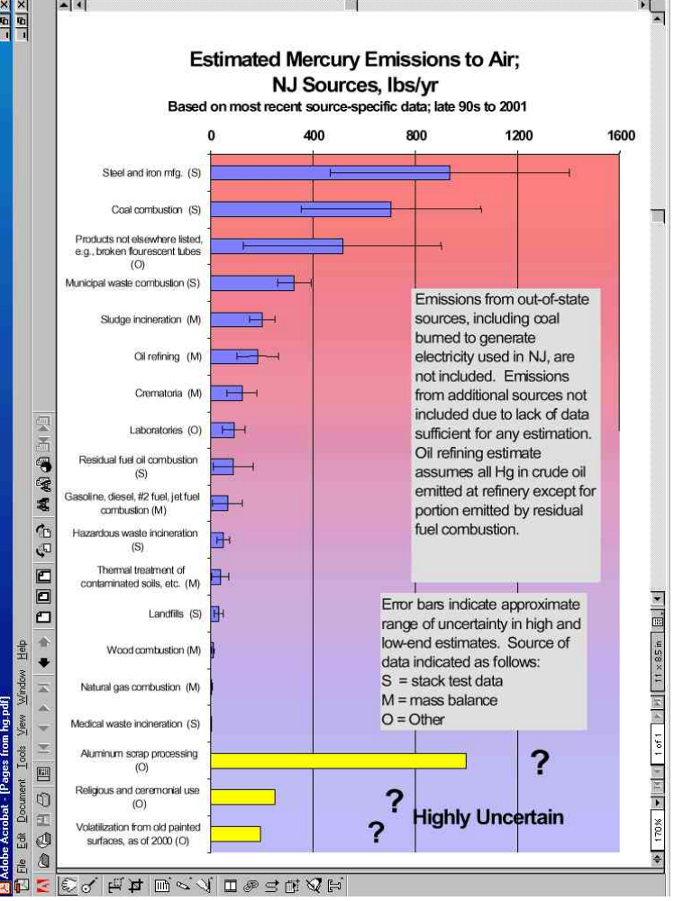Chart 1

Based on stack tests results, it is estimated that today a total of approximately 1,800 pounds per year of mercury is being emitted in New Jersey from the 13 municipal solid waste incinerators (MSWI), three medical waste incinerators, ten coal-burning units, and six iron and steel scrap melting plants. This is down from about 6,200 pounds per year from these sources in 1990. We expect this to be further reduced from these source categories to about 300 pounds per by 2013, after full implementation of New Jersey’s rules.

Municipal Solid Waste Incinerators (MSWI)

The first Mercury Task Force estimated that MSW contained approximately 2 ppm of mercury in 1994. The mercury content of municipal solid waste has declined about 70% in the last decade because of pollution prevention efforts. These included the virtual elimination of mercury in dry cell batteries, packaging, and other items required by the Dry Cell Battery Management Act, N.J.S.A., 13:1E-99.59 through 13:1E-99.81, and the Toxic Packaging Reduction Act, N.J.S.A. 13:1E-99.44 et seq.. Separation of mercury containing items from MSW prior to incineration has also reduced mercury emissions from MSWIs.

When waste is incinerated, the mercury contained in the waste is released. The high temperature involved in the solid waste incineration process vaporizes virtually all of the mercury present in the waste. The best emission controls on New Jersey solid waste incinerators, which primarily consist of the injection of finely-divided carbon prior to fabric filters, remove 95% to 99% of the mercury from the combustion exhaust gas stream. All MSW incinerators installed the carbon injection emission controls within one year of rule promulgation and achieved over 89% mercury reduction in the first year of operation. That has increased to about 97%, as a result of improvement in carbon injection systems, primarily improved distribution of carbon in the flue gas prior to the particulate control device.

New Jersey’s MSW incinerator facilities are required to report results of stack tests of the mercury, which are done quarterly or annually, depending on performance. These results are converted to pounds-per-year of mercury emissions. These calculations provide evidence of a dramatic decline in mercury emissions as shown below in Chart 2.

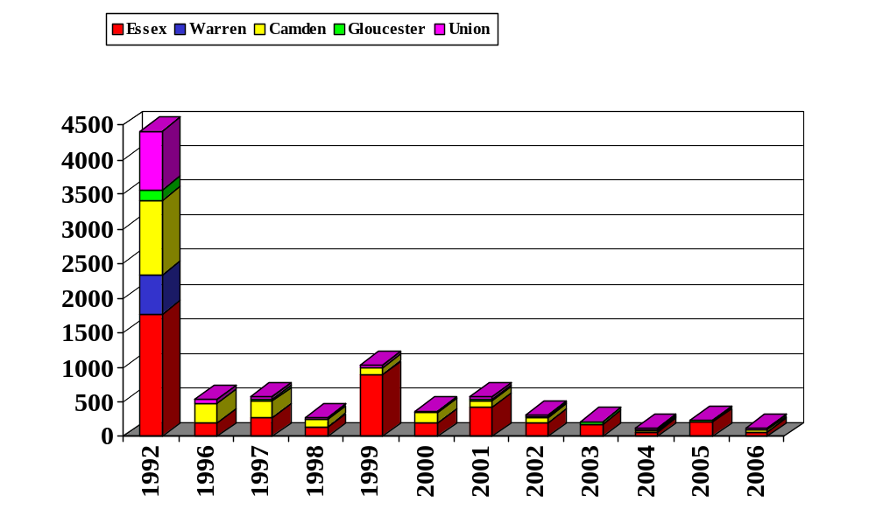
Pounds
Trend of Mercury Emissions from 5 Municipal Waste Incinerator Facilities in N.J.
Based on Average Emissions from stack tests for each facility
Over 97% reduction in actual mercury emissions
Over 99% reduction based on mercury in Waste

Chart 2

The mercury emissions standard of 28 ug/dscm was set in 1994 based on a presumption of at least 80% control with carbon injection and 80 % reduction with source separation/waste stream mercury reduction measures. 80% control was included in NJ first mercury rule as an alternative limit in case source separation was not fully successful.

The resulting installation of carbon injection control devices in 1995, significantly reduced mercury emissions (reducing emissions from about 4,400 pounds per year (lbs/yr) to about 500 lbs/yr in 1996, a reduction of about 89%). Since 1995, carbon injection systems have been very successfully operating on all thirteen units at all five resource recovery facilities in the State of New Jersey. In 2006, mercury emissions were about 3% of 1992 levels.

Testing over the last thirteen years have demonstrated that carbon injection on MSW incinerators can consistently achieve over 95 percent mercury reduction. Based on the demonstrated success of carbon injection, the Department revised the State’s air pollution control regulation governing Municipal Solid Waste Incinerator (MSWI) emissions to further reduce mercury emissions. The 2004 New Jersey rules require an emission standard of 28 micrograms per dry standard cubic meter (ug/dscm) or 95 percent emission reduction as an alternative standard.

The Department estimates that the 2004 amendments will maintain or improve upon the 2006 97% reduction across the control systems because of the compliance margin that results from these performance standards.

MSW Lessons Learned

- Air pollution control systems have been available for over 10 years for mercury control of large combustion sources.
- Carbon injection is proven, low capital cost, and quick to install (less than one year).
- Refinements of carbon injection systems, such as improving carbon distribution, occur after initial installation to improve efficiencies.
- Carbon injection achieves well over 90% removal of mercury, with some systems near 99%.
- Good mercury control requires good particulate control. Fabric filters are better than electrostatic precipitators (ESPs).
- Carbon injection works with a highly variable mercury source. (Mercury in MSW is more variable than mercury in coal.)

Iron and Steel Foundries and Mills

In New Jersey, there are six iron and steel scrap melting facilities, which are the largest mercury emitting source category in the state. Stack tests conducted at five of the facilities indicate that total mercury emissions are in the range of 1000 pounds per year. Mercury emissions are usually in the range 10 to 100 ug/dscm. The second Mercury Task Force recommended mercury emission limits be developed to achieve significant overall mercury emission reduction of at least 75%. Analogous to New Jersey’s Municipal Waste Incinerator rules, a performance standard for iron and steel manufacturers was designed to reduce mercury emissions through a combination of pollution prevention, source separation, and available controls.

The three cupola and three electric arc furnaces in NJ melt scrap, which includes recycled metals from the shredding of motor vehicles, home appliances, and waste metals from demolished building structures. Thermostats, relays, switches, control devices, and measuring devices contain mercury and find its way into this metallic scrap.

Reducing mercury emissions from iron and steel manufacturers requires multi-media, multi-sector pollution prevention approaches, including removal of mercury from feedstock scrap. Mercury switches must be removed from cars when they are dismantled or prior to shredding. In accordance with the New Jersey Mercury Switch Removal Act of 2005, automobile manufacturers are required to implement a program to remove mercury switches from end-of-life motor vehicles in New Jersey. This program is currently underway, and is being monitored by the Department’s Solid and Hazardous Waste Program and by the Enforcement program. The first annual report, submitted by the automobile manufacturers’ representative organization, End of Life Vehicle Solutions (ELVS), has been submitted to the Department and indicates a capture rate of 6% for 2006, which equals approximately 9.84 pounds of mercury collected. Due to the expiration of the one-year waste retention period, ELVS anticipates a much higher capture rate in 2007. In addition, a national program has been developed and is being implemented in a phased approach. Implementation of a strong national program will be beneficial, because mercury-contaminated scrap metal enters New Jersey from other states.

Under the Department's December 2004 new rules, each facility is currently required to stack test quarterly in order to show the impact of any source separation efforts on their emissions. Under the new rules, if source separation does not succeed in achieving the 35 milligram per ton of steel production (mg/ton), iron or steel melters are required to install mercury control technology. The new rules specify that on and after January 3, 2010, each iron or steel melter must reduce its mercury emissions by at least 75 percent as measured at the exit of the mercury control apparatus; or in the alternative, mercury emissions may not exceed 35 mg/ton, based on the average of all tests performed during four consecutive quarters. This 35 mg/ton standard is also based on an overall 75 percent reduction in mercury emissions from iron and steel manufacturers. The Department expects a reduction in mercury emissions of at least 700 pounds per year upon implementation of the new rules for this industry.

Most of the New Jersey melters have taken significant steps to comply with the rules, including both source separation and add on control. For example, Atlantic States iron and steel foundry in New Jersey recently installed an activated carbon injection system and a baghouse on the cupola. Mercury emission test results at this plant show greater than 90% mercury control and less than three mg/ton mercury emissions. The mercury emissions are well below both of the alternative New Jersey mercury rule limits. Other facilities with existing fabric filter control have also tested carbon injection and have reported significant reduction in mercury.

USEPA’s adopted National Emission Standards for Hazardous Air Pollutants (NESHAPs) for Iron and Steel Foundries, that include emission limits of total metal hazardous air pollutants (HAP) for existing iron and steel foundries. Mercury emissions are considered part of total metal HAP emissions. The Department recommended that EPA adopt stand-alone mercury emission standards for iron and steel foundries. EPA’s combined HAP limit will likely result in no control being added for mercury emissions and also fails to set a limit to measure the success of mercury in scrap removal efforts.

Iron and Steel Lessons learned

- Carbon injection appears to work as well on iron and steel scrap melters as on MSW incinerators.
- As with MSW incineration, removal of mercury prior to heating is a helpful component of a mercury reduction plan. However, achieving high levels of mercury reduction (over 90%) is not likely, at least in the near term.
- Setting a performance limit for iron and steel scrap melter is necessary to:
- Determine the success of mercury switch removal programs.
- Ensure that low mercury emissions will be achieved.

Coal-fired power plants

The USEPA adopted mercury trading rules on May 18, 2005, for coal-fired power plants. Because of the inadequacy of EPA’s Clean Air Mercury Rule (CAMR), over 20 states have moved forward with their own mercury regulations for power plants, because they understand that the Federal action was inadequate. New Jersey's rules require the seven coal-fired facilities in the State to install mercury control by December 2007, or December 2012. The control deadline can be extended to December 2012, for a company that commits to major reductions in emissions of NOx, SO2, and particulate, along with mercury, to levels significantly below and sooner than what the Bush Administration's Clear Skies Initiative would attain. Hence, NJ’s mercury rule contains a multipollutant strategy for mercury, nitrogen oxides, sulfur dioxide, and particulates.

The Department’s 2006 rule is applicable to all ten coal-fired boilers in this State. According to the Second Task Force, the coal-fired electric generating units in New Jersey emit approximately 700+300 pounds of mercury per year in the State. The source of the emissions is from the mercury contained in the coal. This industry is the second largest source category of mercury emissions in New Jersey. The new rule specifies that the mercury emissions from any coal-fired boiler shall not exceed 3 milligrams per megawatt hour (mg/MW-hr), based on the annual weighted average of all tests performed during four consecutive quarters; or, in the alternative, the owner or operator of a coal-fired boiler must achieve 90 percent reduction in mercury emissions as measured at the exit of the air pollution control apparatus.

The adopted standards are based on the information from the USEPA's Utility MACT Working Group, the Mercury Study Report to Congress, and pilot tests conducted in New Jersey at coal-fired boilers for control of mercury emissions. The standard is approximately equivalent to an input standard of 0.6 pounds per trillion BTU. New Jersey adopted an output standard to encourage and give credit for energy efficiency.

The New Jersey rules will achieve greater mercury emission reductions in a shorter timeframe than USEPA’s Clean Air Mercury Rules. New Jersey does not allow emission trading. This ensures mercury emission reduction at every plant in New Jersey.

Coal – Looking Forward

- MACT performance standards are appropriate to ensure mercury minimization at every coal-fired power plant.
- Carbon injection systems have been proven on coal as well as MSW incinerators.
- Good particulate control is usually necessary to achieve over 90% mercury removal with carbon injection.
- Emissions trading will likely leave many coal-fired EGUs poorly controlled for mercury.
- Since a portion of, and sometimes a large amount of, mercury falls locally, control of each coal-fired power plant is needed.
- Emissions trading is inappropriate for Hazardous Air Pollutants, including mercury.

Sewage Sludge Incinerators

Industrial pretreatment programs have reduced emissions of mercury from sewage sludge incinerators, and emissions will be further reduced as the dental amalgam rules, discussed below, are implemented.

Domestic treatment works are a recipient of mercury from residential, commercial, and industrial source activities. Sewage sludge typically contains mercury in the low parts per million range (2005 median was 1.13 mg/kg). Using existing authority, domestic treatment works can help reduce influent mercury by limiting concentrations in incoming wastewater streams through the establishment of technically based local pretreatment limits, which they can impose on non-domestic users to achieve compliance with applicable environmental endpoints.
The median mercury concentration in sewage sludge has dropped 70% in the past 20 years. Although data are not readily available to pinpoint all reasons for this decline, the following actions have played a significant role:
- The Industrial Pretreatment Program as noted above has reduced the amount of mercury and other pollutants allowed to be discharged from permitted industries to domestic treatment works.
- The Pollution Prevention Program has provided industries with incentives to reduce the amounts of regulated waste produced through process changes and/or substitution.
- Mercury has been removed from household products (e.g., latex paint) that often found their way into domestic treatment works collection/treatment systems.
- Other products and/or technologies have gradually been substituted for historically mercury based products, e.g., electronic thermometers, blood pressure measuring instruments, etc.
Additionally, the Department has proposed new rules to curtail the release of mercury from dental facilities into the environment. Dental facilities contribute 35 to 45 percent of the mercury entering New Jersey’s domestic treatment works. This large contribution is attributable to the use of dental amalgam as a direct filling material for restoring teeth. Dental amalgam is approximately 50 percent mercury by weight. Amalgam wastes are often rinsed down the drain in dental facilities, usually to a municipal sewer system and then to the domestic treatment works.
New Jersey’s proposed new rules would, under most circumstances, exempt a dental facility from the requirement to obtain an individual permit for its discharge to a domestic treatment works, if it (i) implements best management practices (BMPs) for the handling of dental amalgam waste, and (ii) installs and properly operates an amalgam separator. These measures are expected to prevent 95 percent or more of the dental mercury wastes from being sent to the domestic treatment works. Each facility would have one year from the effective date of the rule to implement the BMPs, and two years to install the separator.
In New Jersey sewage sludge incinerators were estimated to release approximately 150 pounds of mercury in 2005, as compared to approximately 220 pounds in 2002 based on stack testing and monthly sludge quality assurance testing. Depending on the success of the pretreatment program, the Department may set lower mercury limits in sludge or stack emission limits for sludge incinerators in the future.

