


EMERGENCY PLANNING HANDBOOK

PRODUCED BY THE OVERSEAS
SECURITY ADVISORY COUNCIL
FEBRUARY 2007

PURPOSE

The primary purpose of this pamphlet is to assist individuals and organizations in preparing a comprehensive and readily usable plan to handle emergency situations.

An Emergency Handbook should be tailored to the organization, the location and the people using it.

This handbook only provides a starting point, and when completed should include:

- Management responsibilities during emergencies;

- Outline of useful organizational structures for emergency management;

- Highlight the type of information that will be needed to plan for specific emergencies;

- Provide action-oriented checklist that may be followed.

TABLE OF CONTENTS

Safety Drills/Procedures for
        - Fire
        - Bomb
        - Telephone Bomb Threat
        - Chemical/Biological Attack
        - Earthquake
        - Emergency Kits
        - Suspicious Mail and Packages
        - Personal Security
        - Automobile Security
        - Personal Documents Checklist
        - Example of an Emergency Notification System
        - Incident Report Form

FIRE:

Fire awareness and safety should be an everyday practice. Each employee should go through his/her area, cleaning out any accumulation of old papers and boxes paying attention to the storage of flammables; eliminating unnecessary or dangerous extension cords; watching for overloaded circuits and using care when smoking. Employees should know the location of fire extinguishers and hoses in their general area. Most importantly, employees should know the location of fire exits.

In case of an evacuation employees should:

1. Secure sensitive material.
2. Doors and windows should be closed, but unlocked.
3. All electrical items should be unplugged.
4. Visitors should be directed/escorted to the nearest exit.
- The building supervisor will notify everyone where they should gather and notify all personnel when it is safe to re-enter the building.
- ____________________________________________________________________
- ____________________________________________________________________
- ____________________________________________________________________
- ____________________________________________________________________
- ____________________________________________________________________

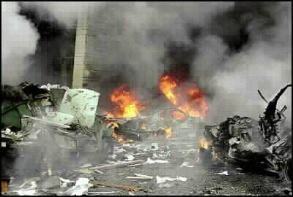
FIRE

BOMB:

Any person who receives a telephone bomb threat of any nature should carefully record the circumstances and notify their immediate supervisor.

The individual receiving the call should stay calm and try to obtain as much information as possible (see attached form).

The objective is to keep the caller on the phone and develop as much information as possible. Obviously, at some point the caller will hang up and at that point, he/she should notify their immediate supervisor.

If an evacuation is ordered, doors and windows should be left open to minimize the blast effect. Personnel should leave only through exits that have been thoroughly searched. Employees will be instructed where to assemble and when they can re-enter the building.

If a search is ordered, each supervisor will dispatch members of his/her section to search their area.

The following is a guide for quick inspection of your area:

• Search the top of chairs, desk, tables and bookcases.
• Inside of bookcases, including behind books.
• Wastepaper baskets. Underneath all furniture. Remainder of room.
• Outside balconies. Storage areas. Rest rooms – inside toilets, trash cans.
• Leave Doors/windows open.
• Report findings to your supervisor or section head.
• Wait for further instructions.
• If an unidentifiable package or object is found,
• DO NOT TOUCH IT. Report the findings immediately to the supervisor or section head.
• If a bomb is found, the local authorities/Explosive Team should be called.

In the event of an explosion in the building, remain in your area. Under no circumstances should you look out your window or proceed to the site of the explosion. Wait for further instructions.
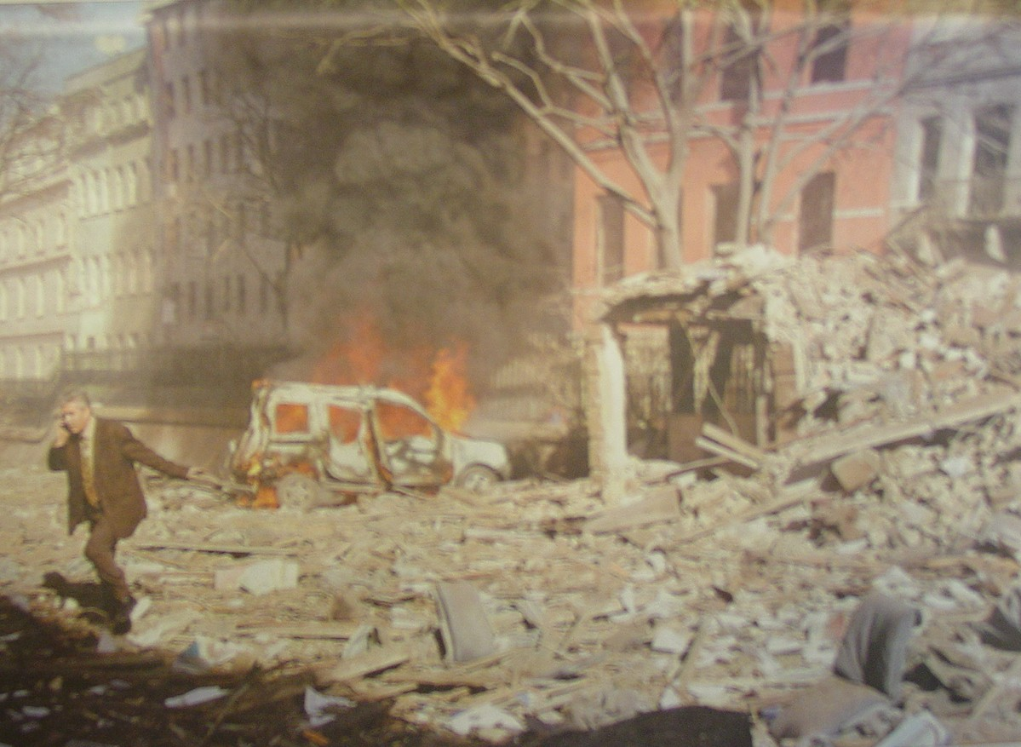

BOMB

TELEPHONE BOMB THREAT

Date:________________
Time call received:_________________
Time caller hung up:_________________
TRY TO ASK THE FOLLOWING QUESTIONS:
WHAT KIND OF BOMB_____________________________________________________
WHEN IS THE BOMB GOING TO EXPLODE__________________________________
WHERE IS THE BOMB LOCATED___________________________________________
WHAT DOES THE BOMB LOOK LIKE_______________________________________

Tell the caller that people are in the building and will be injured. After the caller hangs up, report the details to: RSO, ADMIN, DCM.

Then Circle:
Sex of caller: male female
Age of caller: child teenager adult
Tone of voice: loud soft angry calm hurried
Attitude of caller: serious joking warning threatening
Language/Accent: U.S. other
Background noises: bar party music foreign languages street no noise

Other remarks:___________________________________________________________
_______________________________________________________________________
Keep this near your phone.

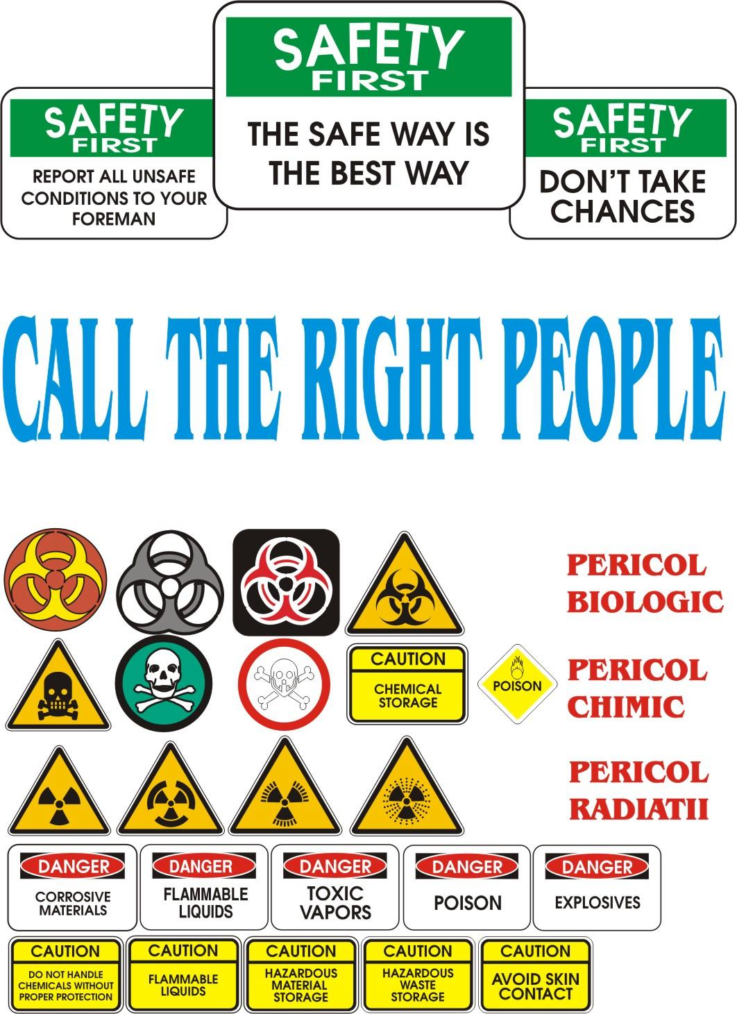
BOMB

CHEM/BIO ATTACK

In the event of a chem./bio attack at home or office:

- Close all windows and doors.
- Turn off any forced air heat/cooling system.
- Move to an interior room with a bathroom and take with you a phone.
- Tape/plug all cracks around the doors/windows and any other openings, don’t forget to cover the bathroom vent.
- Notify your immediate supervisor of your status and wait for further instructions.

_______________________________________________________________________________________________________________________________________________________________________________________________________________________________________________________________________________________________________________________________________________________________________________________

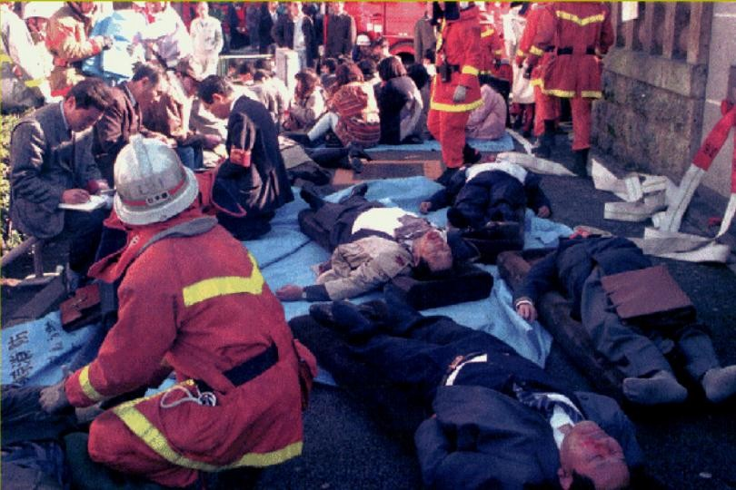

CHEM/BIO

EARTHQUAKE

In the event of an earthquake, whether at home or the office, the following procedures should be followed:

Take cover, stand in a strong door way, or under strong furniture. DO NOT try to run outside.

Once the main event is over, evacuate the area to an open area; there may be additional aftershocks. Report to your supervisor. Assist those who need help.

Do not re-enter buildings until it has been determined that it is safe.

If there is time, turn off all gas appliances, turn off and unplug all electrical appliances.

At home, you should maintain a supply of food, water, blankets, flashlight and other emergency items.

If the structure of your building is damaged, be very careful while making any attempt to assist injured people. The structure is now unstable and may collapse.

Company personnel should gather in a clear, safe area and begin setting up a triage station and a command post (CP). ALL PERSONNEL must report their status to the CP and await further instructions. A combined, organized search of collapsed buildings will be established.

__________________________________________________________________________________________________________________________________________________________________________________________________________________________________________________________________________________________________________________________________________________________________________________________________________________________________________________________________

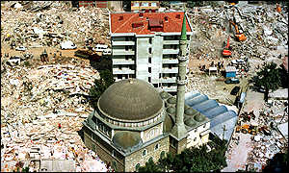
EARTHQUAKE

EMERGENCY KITS

Sustenance Items and Equipment Kit

- First Aid kit and adequate supply of prescription medication.
- Flashlight with fresh batteries and/or candles.
- Small transistor radio with extra batteries.
- Matches, preferably waterproof and windproof.
- Blanket and/or sleeping bag for each family member.
- Supply of current road maps of metropolitan and country areas.
- Dry Food Items to last three days.
- Bottled water.
- Location of kit: ___________________________________________________________________________________________________________________________________________________________________________________________________________________________________________________________________________________________________________________________________________________________________________________________________________________________________________________________________________________________________

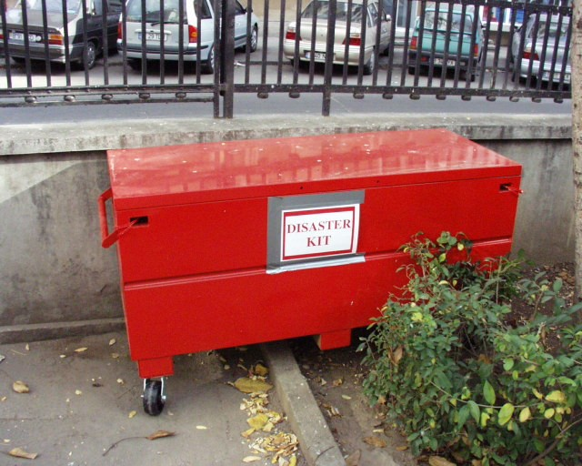
EARTHQUAKE

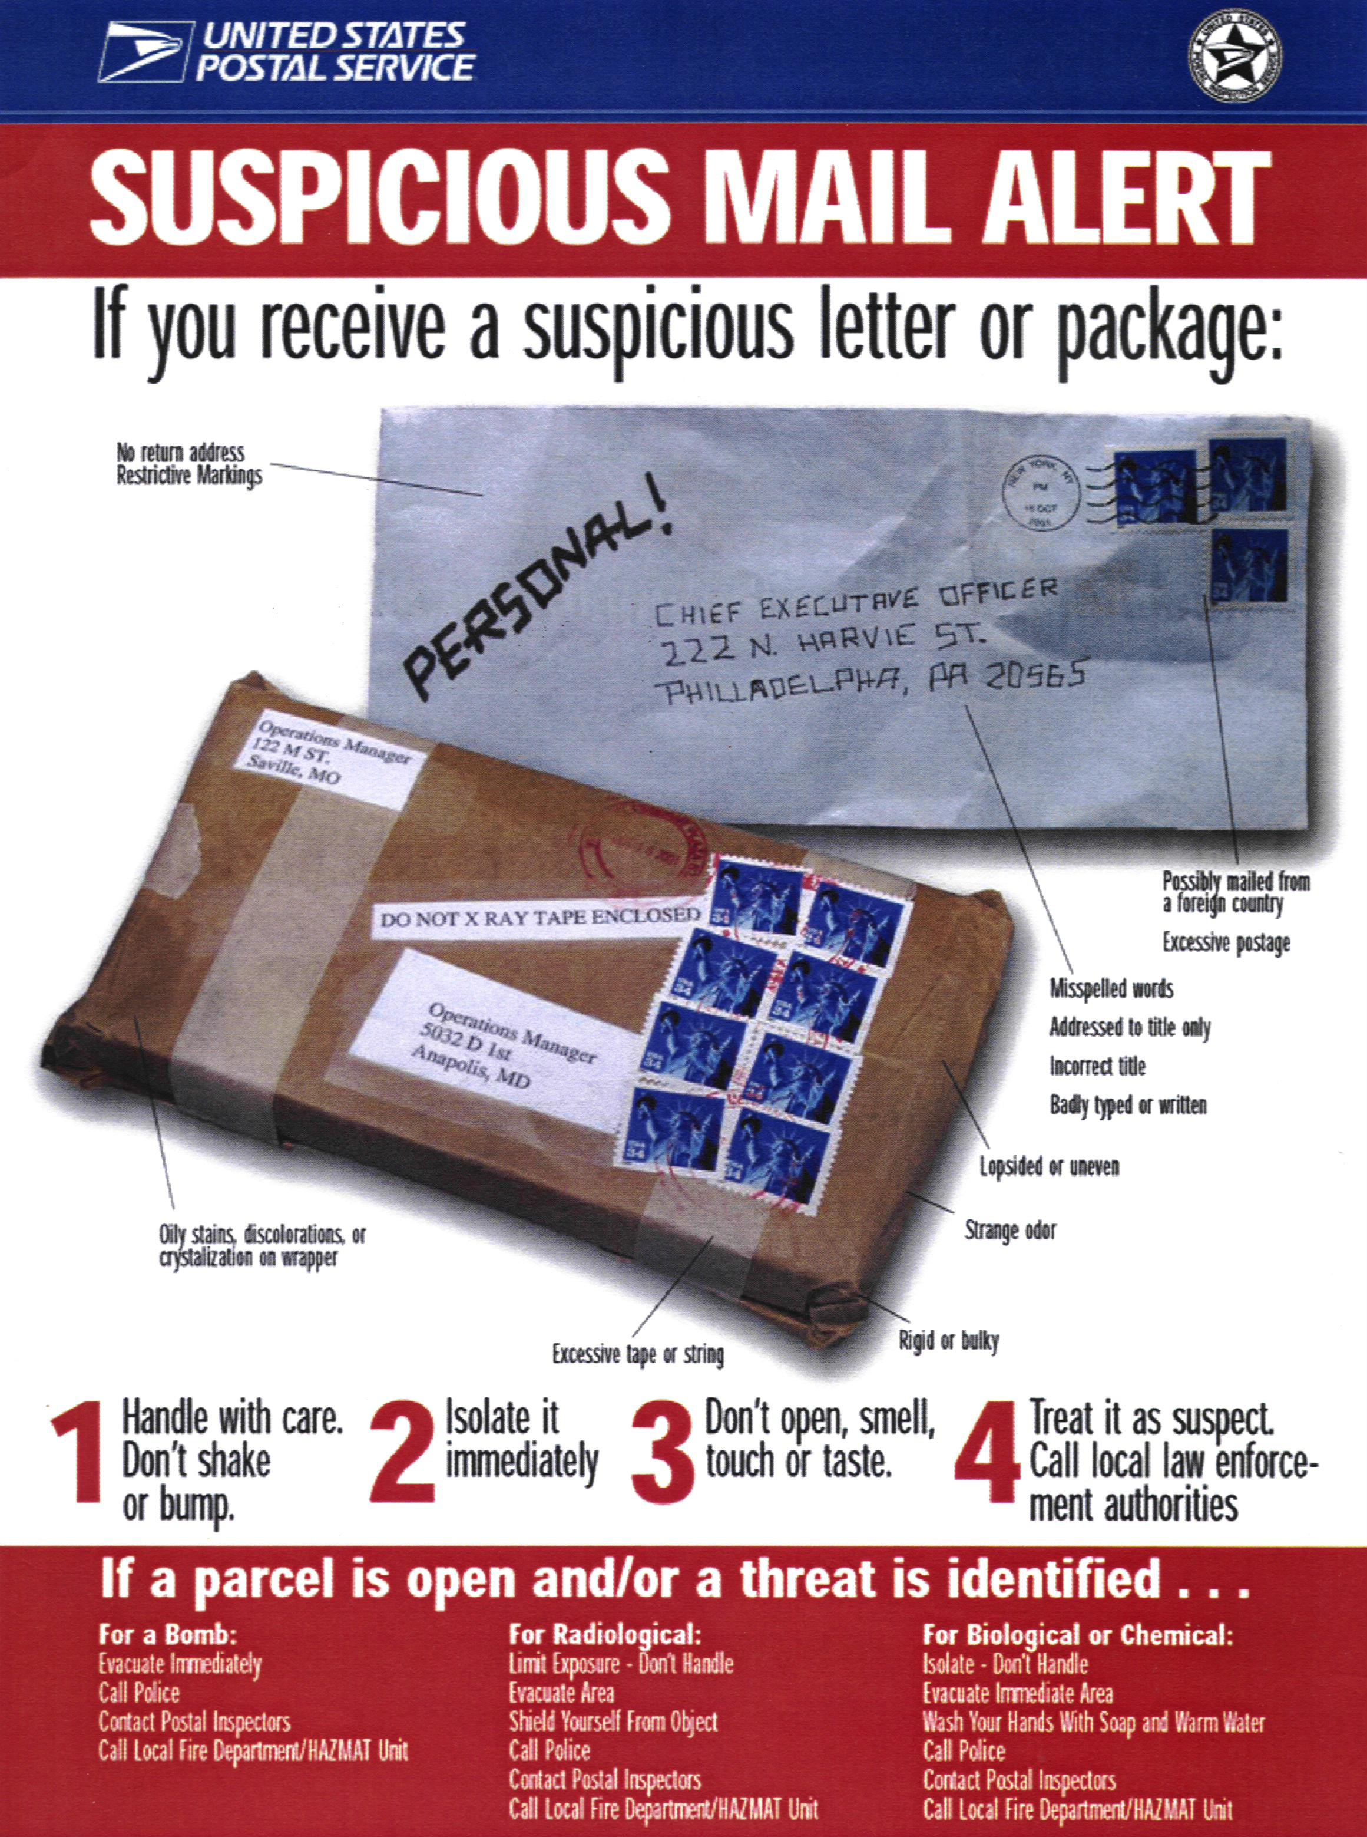
MAIL

PERSONAL SECURITY

Prior to any attack, either criminal or terrorist, there is a period of time that the assailant will devote to survey the target. During this time, the attacker tries to determine routines established by the victim, and locations where the victim is most vulnerable. If the attacker determines that the target maintains good security and varies his routine, it is possible that the assailant will choose another target. In most cases, the individuals doing the surveillance are new to their organization and may make simple mistakes. Here are a few things you can do to help remove your name from their list:

- Change the times you go to work and return home
- (A 30-minute change can drastically impair an attackers plan)
- Change your routes to and from home/work.
- Look outside your home for unusual situations before you leave.
- Before entering your car, walk around it and inspect it for any signs of tampering.
- Know your choke points.

BE AWARE of the following vehicle/individual characteristics that may indicate surveillance:
- Vehicles parked in prohibited zones, the same location for an extended period.
- Vehicles/people that copy your movements.
- Vehicles/people moving too fast/slow, making erratic movements or abrupt stops.
- Vehicles/people that go slow through an intersection or corner – then withdraw.
- Vehicles/people that stop nearby when you stop.
- Vehicles flashing lights.
- People that exit their vehicle when you stop.
- People turning away when observed by you.
- People hesitating or looking around when entering a building that you have entered.
- People running away.

GOLDEN RULE:
IF YOU SEE SOMEONE TWICE, IT COULD BE SURVEILLANCE.

IF YOU SEE SOMEONE THREE TIMES, IT PROBABLY IS SURVEILLANCE!

WHAT TO DO?
TIPS
If you believe you are being followed, do not confront the individual. Drive/walk directly to a police station or gendarme.

RESIDENTIAL SECURITY TIPS

Be alert to suspicious persons in your neighborhood and report them to your supervisor.

Make sure you have good exterior lighting on all sides of your residence. Check lighting regularly and replace burned-out bulbs.

Don’t open your residence doors to strangers. Speak to them through the door. If they claim to be police or other officials, contact the dispatcher and wait for the mobile patrol unit to arrive. Make sure your kids and household staff are briefed on how to answer the door.

Unannounced or unidentified visitors should not be admitted into the home. Vendors, policemen and Embassy repairmen, should be admitted only if they are properly identified and expected. Repairmen should not be left unattended in the residence.

Keep foliage away from your windows/entrances to eliminate hiding places for burglars.

Use your door viewer to identify visitors.

Burglars/terrorists are always on the alert for an easy way to enter a residence. Doors, windows and garages should be closed and locked at all times, especially when the residents are away from home, no matter how short a time.

Never leave doors or windows open when you are sleeping (unless you have grills).

Do not leave money, jewelry or small high-value items out in the open. Take photographs of all valuable items and record serial numbers of valuable items.

Never hide a spare key under a mat or near an entrance to your residence.

Secure all sliding glass doors and windows to prevent them from being lifted out of their tracks.

Have a list of emergency phone numbers easily available. All family members should memorize certain telephone numbers for emergencies and know how to use the local phones.

Keep a low profile in your neighborhood. Avoid displays of affluence, and do not list name, title or ranks on residence signs, doors or doorbell.

Blinds and draperies should be arranged so that movement within the house is not easily observed from the street.

If you leave your residence during the evening, turn on lights and radio or TV.
TIPS
If you plan on being away from your residence on vacation, notify a colleague so he/she can check your residence while you are away.

Do not schedule workmen to be in your house when you cannot be there.

If a disturbance occurs in the vicinity of your residence, alert police and stay away from your windows.

Recommended items for your safe haven are as follows:

Telephone, telephone directory, Emergency numbers, flashlight, candles, Radio-AM/FM, fire extinguisher, miscellaneous tools, food and water.

IMPORTANT: If you encounter a burglary in progress, do not attempt to stop the burglar. If you are in a protected part of the house, call the police.

Frequent points of entry are garage doors and windows. If you make it difficult for a burglar to enter, he will give up and go elsewhere.

Go over these items with your family so they will know what to do in case of an emergency.

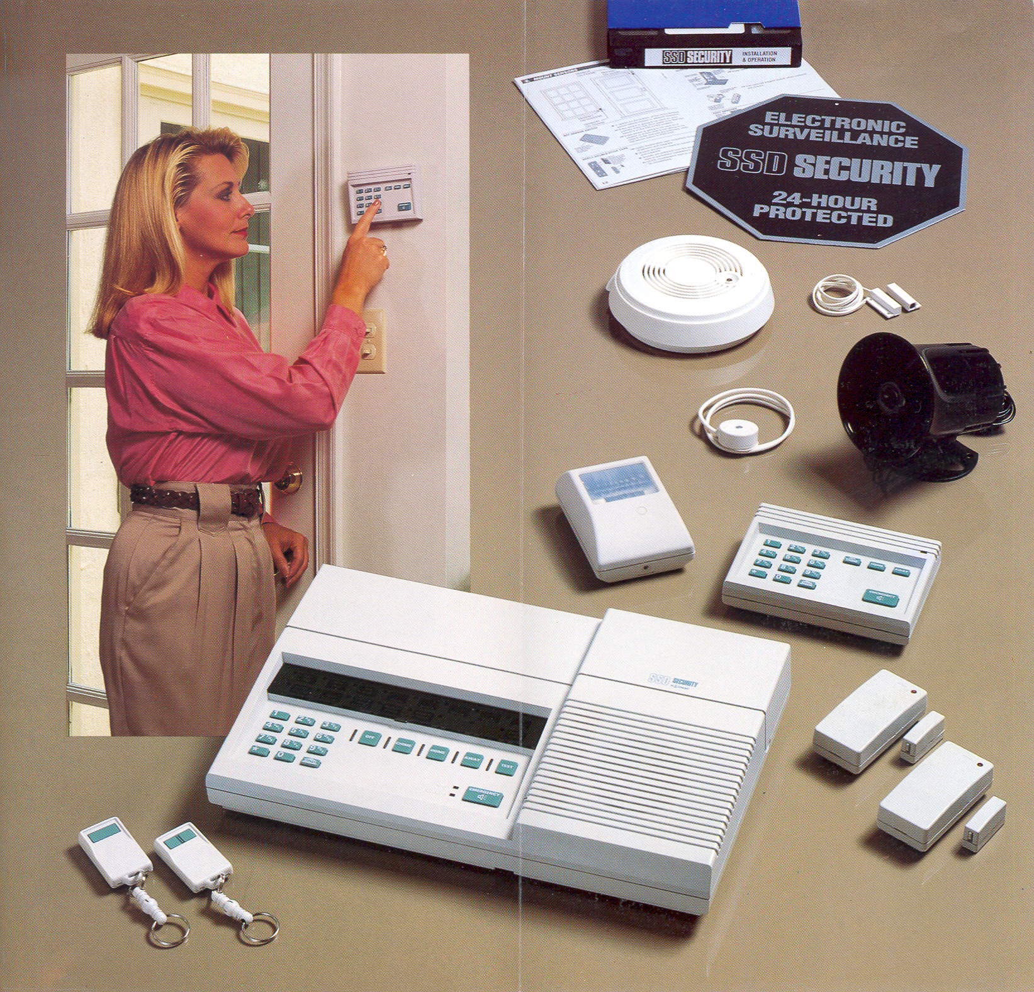
TIPS

SECURITY TIPS FOR HOUSEHOLD HELP

- Have emergency telephone numbers available, on or near the telephone for immediate use.

- Know where the nearest medical facility or hospital is located. You may need to show someone how to get there.

- Do not allow visitors onto the property. Do not permit anyone in the house unless your employer tells you they will be coming. Ask for identification if anyone requests entry.

- Do not permit your friends or family into the home unless your employer gives you permission in advance. You should not discuss personal information about your employer with your friends or family.

- Under no circumstances should any property depart the home without the employer's permission.

- If you notice someone watching the house or acting in a suspicious manner, notify your employer. Note license number and descriptions of any suspicious vehicles and people.

- If you hear an intruder in the house, inform your employer immediately.

- Information about the occupants of the house should not be discussed on the telephone. If you receive telephone calls requesting information about the occupants of the home, hang up and inform your employer.

- All exterior doors should be kept locked - especially when you are upstairs. Gates should be secure.

- Know where the fire extinguishers are and how to use them.

- Know how to report safety hazards (i.e. poor electrical wiring, gas leaks, broken locks) to your employer.

- If you have any questions concerning the safety and security of the occupants of the home where you work, consult your employer.

TIPS

AUTOMOBILE SECURITY

Before getting into your vehicle take a few seconds to inspect your car for signs of tampering.

Vary your routes to and from work and departure and arrival times by approximately 30 minutes. Be systematically unsystematic.

Avoid parking in unsecured areas and places that are unlit at night.

Be aware of your surroundings. Check to see who is pulling up along side of you. Be aware of cars in front and back of you.

Be alert for motorcycles or bicycles stopping next to your car, especially if there is more than one rider.

Remember that your vehicle is a 2,000 pound- weapon and can be used effectively against attackers. Be prepared to take action.

While you’re driving, be prepared to take evasive actions. Play the “what if game” and think of what evasive action you would take if the persons in the car next to you suddenly started shooting at you or made an attempt to approach your vehicle.

RIDING IN A TAXI

Before getting in, make an obvious point of looking at the license plate. If possible, have another person make note of the number before you depart.

Don’t get into the taxi if:
The inside door locks and handles are not working.
It is occupied by anyone else in addition to the driver.
License plates are obscured.

While you are in route:
Establish a rapport with your driver.
Do not allow the driver to pick up unknown passengers.
Stay alert.
Be prepared to take evasive actions.
Be prepared to stop the driver and get out if the driver is not using main streets, if he is driving in the wrong direction, or using alleys and shortcuts and you are unfamiliar with the area.

TIPS

BUSES AND TRAMS

Please be alert on crowded buses and trams where pickpockets abound. Keep handbags/valuables in front of you and watched at all times.

Choose well-lighted, well-traveled areas. If you are stopping to use a public facility such as a pay phone, gas station or restroom, try to park in a well-lighted place.

When returning home, be aware of all vehicles and pedestrians. Keep your house and driveway well-lit Beep your horn and have someone inside turn on lights or open the door.

Leave enough space between cars at a red light or stop sign to pull away if necessary.

Don’t be distracted by eating, drinking or talking while driving. Losing your focus on the road and your surroundings could make you an easy target.

Be careful after a minor rear-end accident. If you are bumped from behind and you do not feel comfortable exiting your vehicle, motion to the other driver and drive to the nearest police station or 24 hours store.

Keep your vehicle locked and keep the windows rolled up.

When approaching your parked car, have your keys in your hand. Check the surrounding area for suspicious persons near your car or following you. If you see a suspicious person, do not attempt to get in your car but walk to the nearest public place and call for help.

Do not leave your purse or valuables in view while driving or parked.

Plan your route in advance and know something about the area you’ll be driving through. There are some areas that are not safe, day or night.

Always keep your car well maintained and make sure you have plenty of gas. You don’t want to be stranded in an unfamiliar place or alone in an area where you can’t get help.

Never roll down your window to answer questions of passersby. This could be a pretext for someone to take your vehicle.

TIPS

Personal Documents/Checklist Kit

- Current passport for each member of family.
- Appropriate visa (s) and accreditation documents.
- Vehicle driver’s license.
- Vehicle technical passport with power of attorney to drive the vehicle.
- Sufficient cash to cover family expenses for reasonable amount of time.
- Credit cards and checkbooks.
- All necessary country of residence identification papers.
- Vaccination records.
- Current inventory of household affects/or video recording of household effects for insurance claim purposes.

DO NOT TAKE:
- valuable or expensive-looking jewelry
- irreplaceable family objects
- all unnecessary credit cards
- Social Security card, library card, and similar items you may routinely carry in your wallet.

TIPS

EXAMPLE OF AN
EMERGENCY NOTIFICATION SYSTEM

Notification system:
TIPS
Once notified, each section is responsible for contacting all staff in their section and the next section in line. If the designated contact is not available, the warden must contact and instruct someone in that section.

Building evacuation warden system:

For building evacuations, the senior staff member of each section will be responsible for notifying once all personnel from that section are accounted for and evacuated.

INCIDENT REPORT

Name/Office:___________________________________Date_____________________
Home Address:__________________________________Phone:___________________

Type of Incident:
_____Robbery/Attempted _____Police Contact/Detention
_____Lost/Missing Personal Item _____Suspected Surveillance
_____Assault _____Threat Letter
_____Homicide _____Telephone Threat
_____Sexual Offense/Harassment _____Suspicious Activity
_____Theft/Personal/Government _____Vandalism/Property
_____Automobile/theft/break-in/Accident _____Burglary/Attempted/Break-in

Location/Date/Time of Incident:___________________________________________
______________________________________________________________________
______________________________________________________________________
______________________________________________________________________
Weapon Involved:_______________________________________________________
Description of Incident:____________________________________________________
_______________________________________________________________________
_______________________________________________________________________
_______________________________________________________________________
_______________________________________________________________________
Physical Injuries: Hospitalized: Yes No

Description of Offender: Sex M F, Ht. Wt. Hair Age Race Scars
_______________________________________________________________________
_______________________________________________________________________
Description of Clothing:_______________________________________________________________
Police Notified: Yes No Station Notified: Yes No Police Report Attached:____________________________________________________

Additional Comments:_____________________________________________________________________________________________________________________________________

- Received by : Date: Time:

