Seattle Help Desk (206) 370-5280 (7:30 am - 5:00 pm M-F) or email ECFHelp_Seattle@wawb.uscourts.gov

Tacoma Help Desk (253) 882-3939 (7:30 am - 5:00 pm M-F) or email ECFHelp_Tacoma@wawb.uscourts.gov

  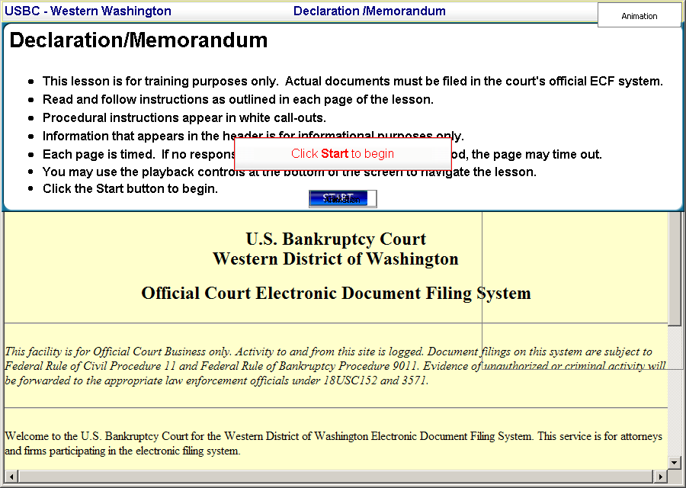
  Slide 1
  This lesson is for training purposes only. Actual documents must be filed in the court's official ECF system. Read and follow instructions as outlined in each page of the lesson. Procedural instructions appear in white call-outs. Information that appears in the header is for informational purposes only. Each page is timed. If no response is made within the allotted time period, the page may time out. You may use the playback controls at the bottom of the screen to navigate the lesson.
  Click the Start button to begin.
  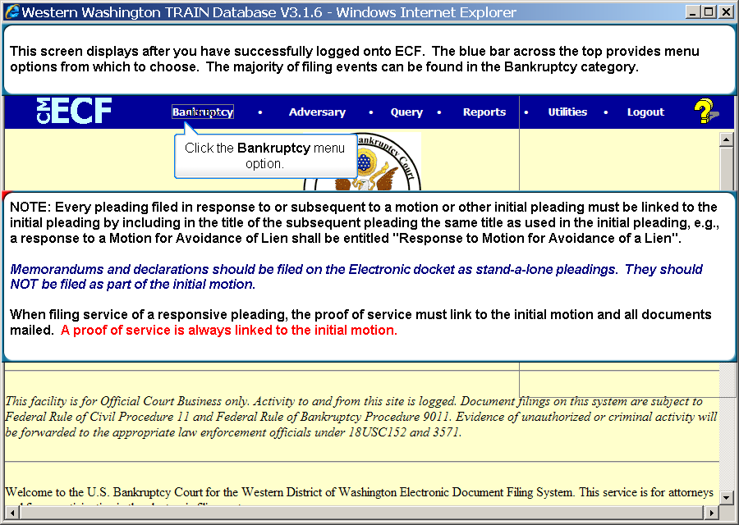
  Slide 2
  Selec the Bankruptcy link. This screen displays after you have successfully logged onto ECF. The blue bar across the top provides menu options from which to choose. The majority of filing events can be found in the Bankruptcy category. Click the Bankruptcy menu option. NOTE: Every pleading filed in response to or subsequent to a motion or other initial pleading must be linked to the initial pleading by including in the title of the subsequent pleading the same title as used in the initial pleading, e.g., a response to a Motion for Avoidance of Lien shall be entitled "Response to Motion for Avoidance of a Lien". Memorandums and declarations should be filed on the Electronic docket as stand-a-lone pleadings. They should NOT be filed as part of the initial motion. When filing service of a responsive pleading, the proof of service must link to the initial motion and all documents mailed. A proof of service is always linked to the initial motion.
  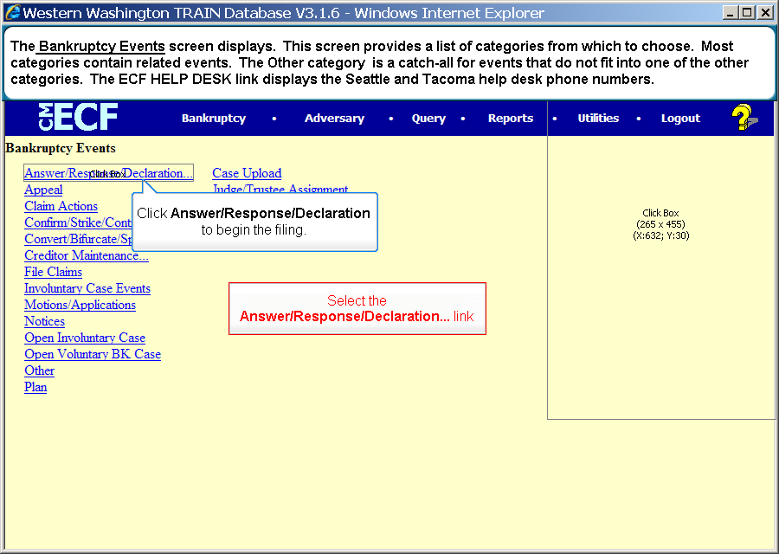
  Slide 3
  Select the Answer/Response/Declaration... link
  The Bankruptcy Events screen displays. This screen provides a list of categories from which to choose. Most categories contain related events. The Other category is a catch-all for events that do not fit into one of the other categories. The ECF HELP DESK link displays the Seattle and Tacoma help desk phone numbers.
  Click Answer/Response/Declaration to begin the filing.
  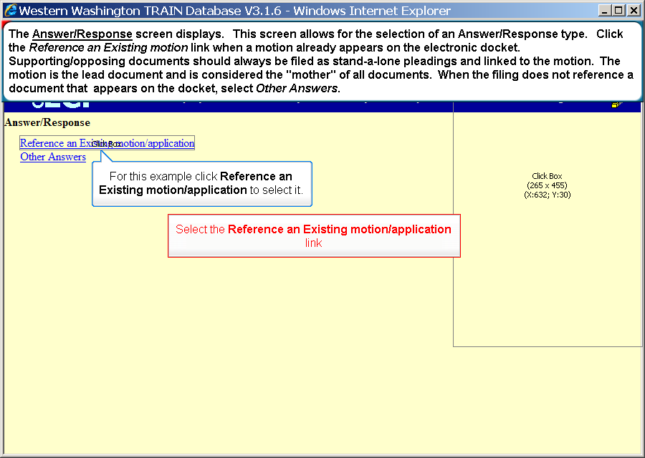
  Slide 4
  Select the Reference an Existing motion/application link
  The Answer/Response screen displays. This screen allows for the selection of an Answer/Response type. Click the Reference an Existing motion link when a motion already appears on the electronic docket. Supporting/opposing documents should always be filed as stand-a-lone pleadings and linked to the motion. The motion is the lead document and is considered the "mother" of all documents. When the filing does not reference a document that appears on the docket, select Other Answers.
  For this example click Reference an Existing motion/application to select it.

  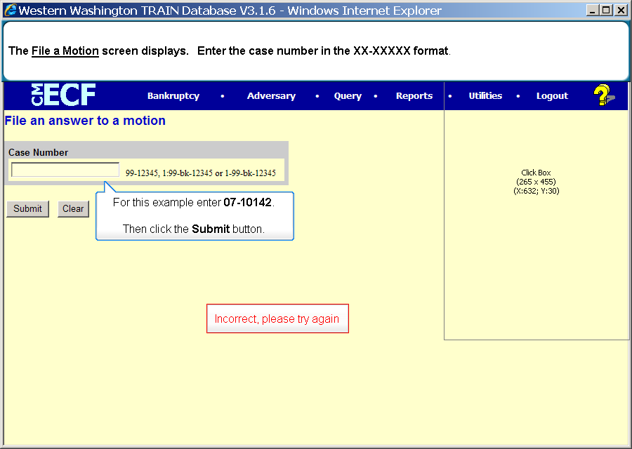
  Slide 5
  Text Captions: Incorrect, please try again
  The File a Motion screen displays. Enter the case number in the XX-XXXXX format.
  For this example enter 07-10142.
  Then click the Submit button.
  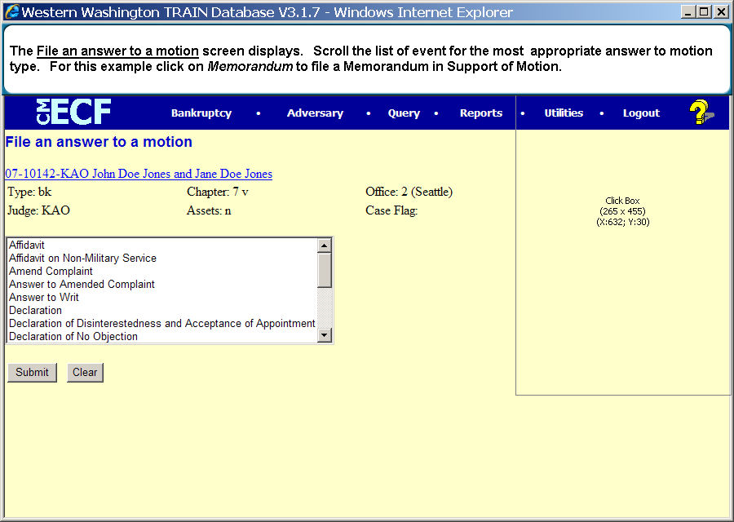
  Slide 6
  Text Captions: The File an answer to a motion screen displays. Scroll the list of event for the most appropriate answer to motion type. For this example click on Memorandum to file a Memorandum in Support of Motion.
  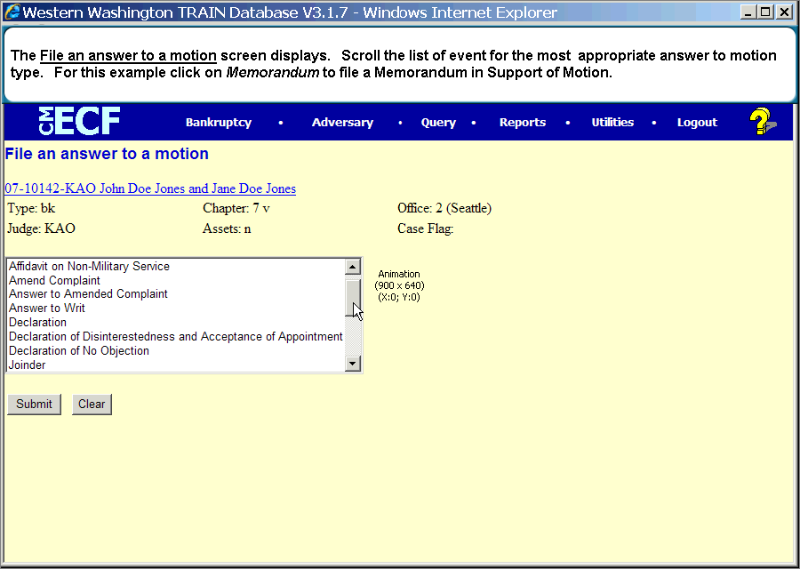
  Slide 7
  Text Captions: The File an answer to a motion screen displays. Scroll the list of event for the most appropriate answer to motion type. For this example click on Memorandum to file a Memorandum in Support of Motion.
  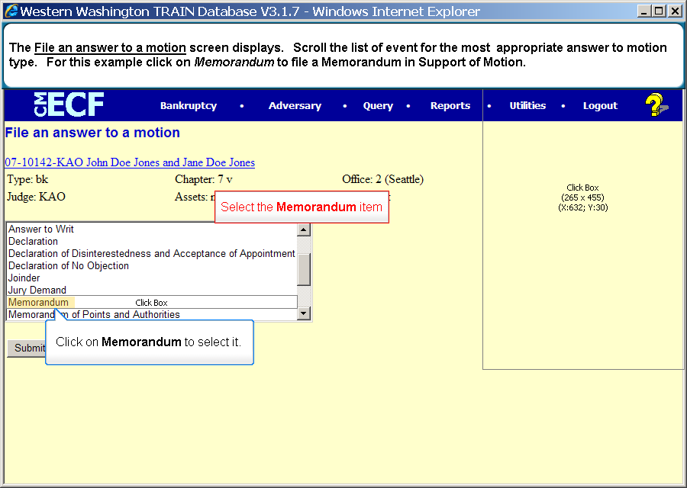
  Slide 8
  Text Captions: Select the Memorandum item
  Click on Memorandum to select it.
  The File an answer to a motion screen displays. Scroll the list of event for the most appropriate answer to motion type. For this example click on Memorandum to file a Memorandum in Support of Motion.

  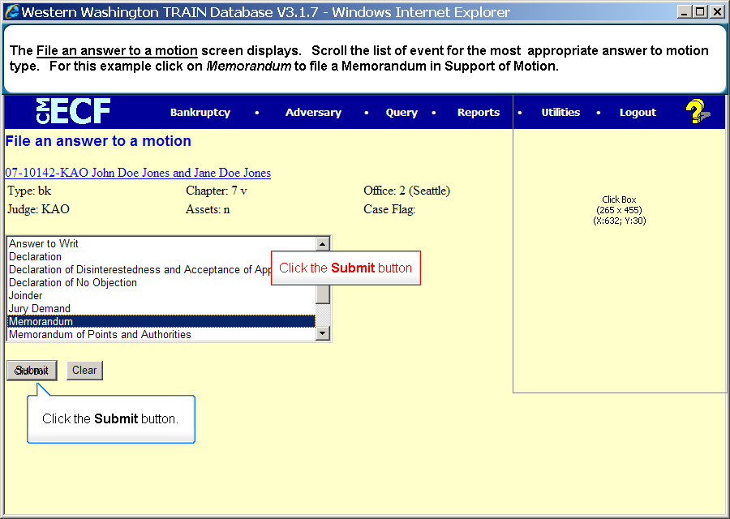
  Slide 9
  Text Captions: Click the Submit button
  The File an answer to a motion screen displays. Scroll the list of event for the most appropriate answer to motion type. For this example click on Memorandum to file a Memorandum in Support of Motion.
  Click the Submit button.
  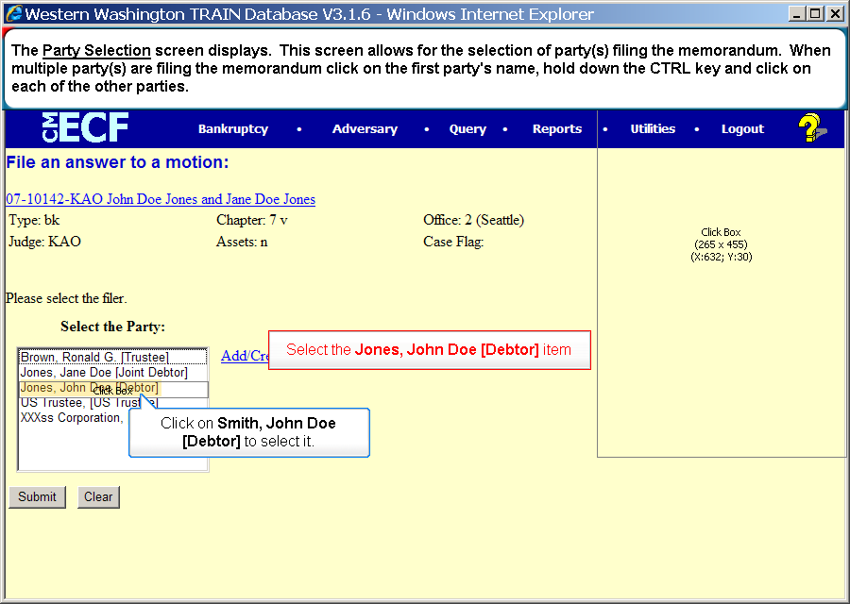
  Slide 10
  Text Captions: Select the Jones, John Doe [Debtor] item
  Click on Smith, John Doe [Debtor] to select it.
  The Party Selection screen displays. This screen allows for the selection of party(s) filing the memorandum. When multiple party(s) are filing the memorandum click on the first party's name, hold down the CTRL key and click on each of the other parties.
  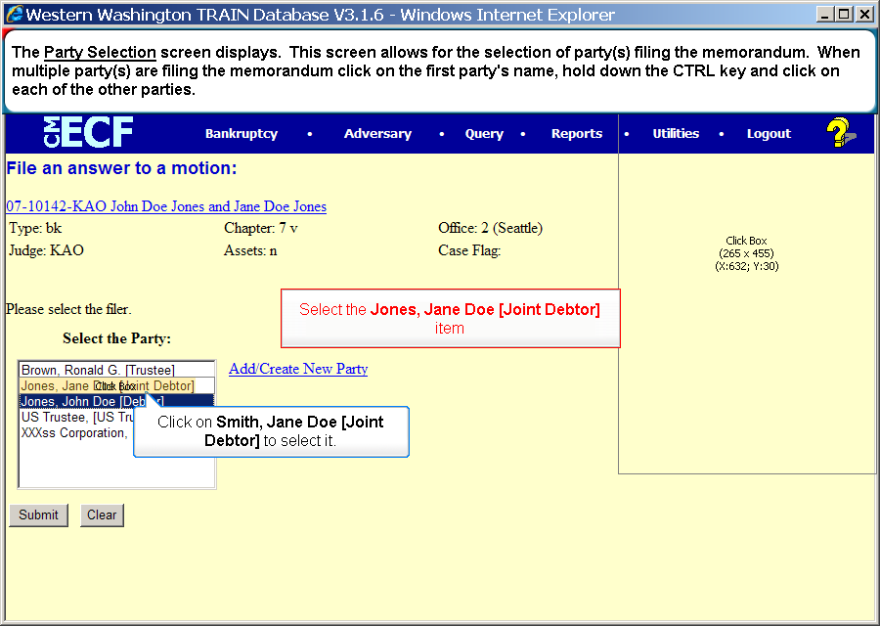
  Slide 11
  Text Captions: Select the Jones, Jane Doe [Joint Debtor] item
  Click on Smith, Jane Doe [Joint Debtor] to select it.
  The Party Selection screen displays. This screen allows for the selection of party(s) filing the memorandum. When multiple party(s) are filing the memorandum click on the first party's name, hold down the CTRL key and click on each of the other parties.
  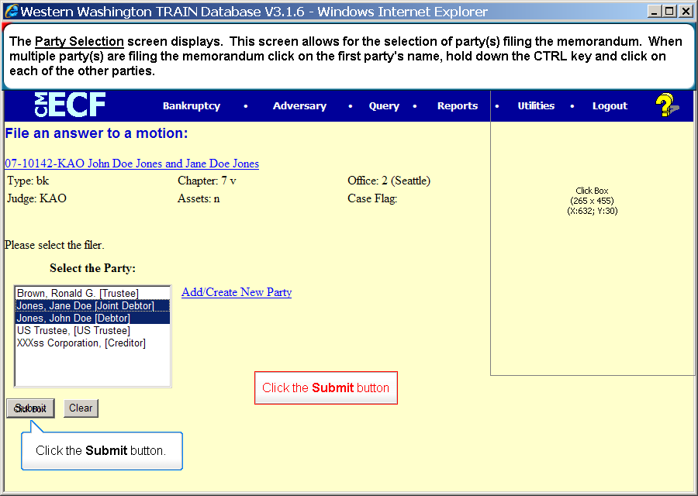
  Slide 12
  Text Captions: Click the Submit button
  The Party Selection screen displays. This screen allows for the selection of party(s) filing the memorandum. When multiple party(s) are filing the memorandum click on the first party's name, hold down the CTRL key and click on each of the other parties.
  Click the Submit button.

  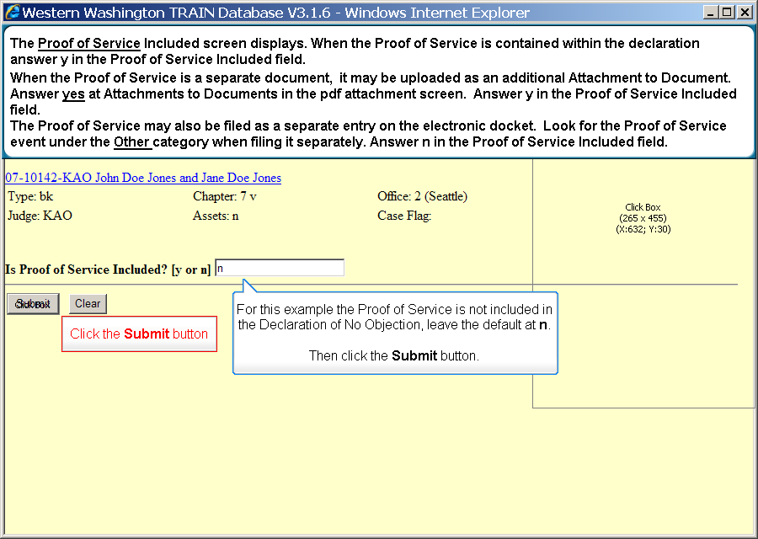
  Slide 13
  Text Captions: Click the Submit button
  The Proof of Service Included screen displays. When the Proof of Service is contained within the declaration answer y in the Proof of Service Included field.
  When the Proof of Service is a separate document, it may be uploaded as an additional Attachment to Document. Answer yes at Attachments to Documents in the pdf attachment screen. Answer y in the Proof of Service Included field.
  The Proof of Service may also be filed as a separate entry on the electronic docket. Look for the Proof of Service event under the Other category when filing it separately. Answer n in the Proof of Service Included field.
  For this example the Proof of Service is not included in the Declaration of No Objection, leave the default at n.
  Then click the Submit button.
  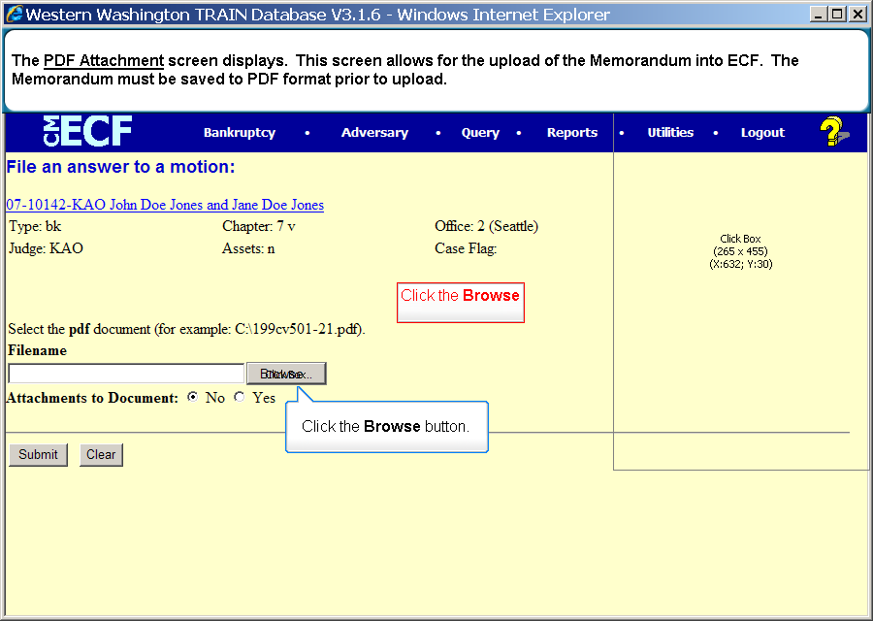
  Slide 14
  Text Captions: Click the Browse button
  The PDF Attachment screen displays. This screen allows for the upload of the Memorandum into ECF. The Memorandum must be saved to PDF format prior to upload.
  Click the Browse button.
  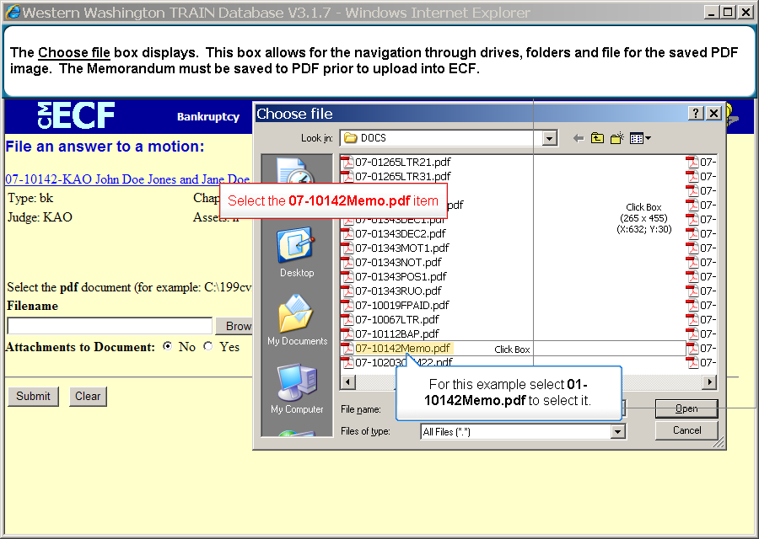
  Slide 15
  Text Captions: Select the 07-10142Memo.pdf item
  The Choose file box displays. This box allows for the navigation through drives, folders and file for the saved PDF image. The Memorandum must be saved to PDF prior to upload into ECF.
  For this example select 01-10142Memo.pdf to select it.
  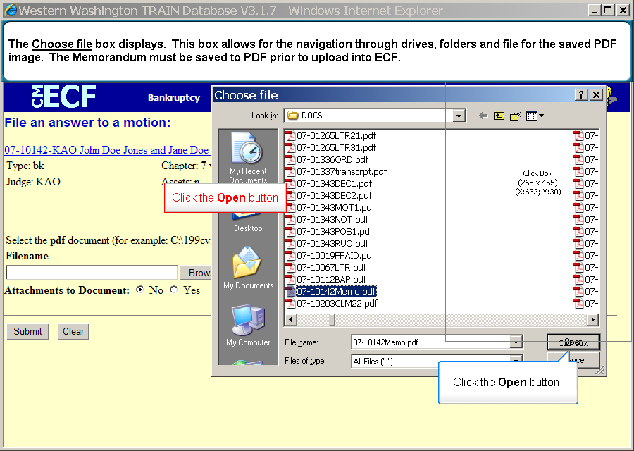
  Slide 16
  Text Captions: Click the Open button
  The Choose file box displays. This box allows for the navigation through drives, folders and file for the saved PDF image. The Memorandum must be saved to PDF prior to upload into ECF.
  Click the Open button.

  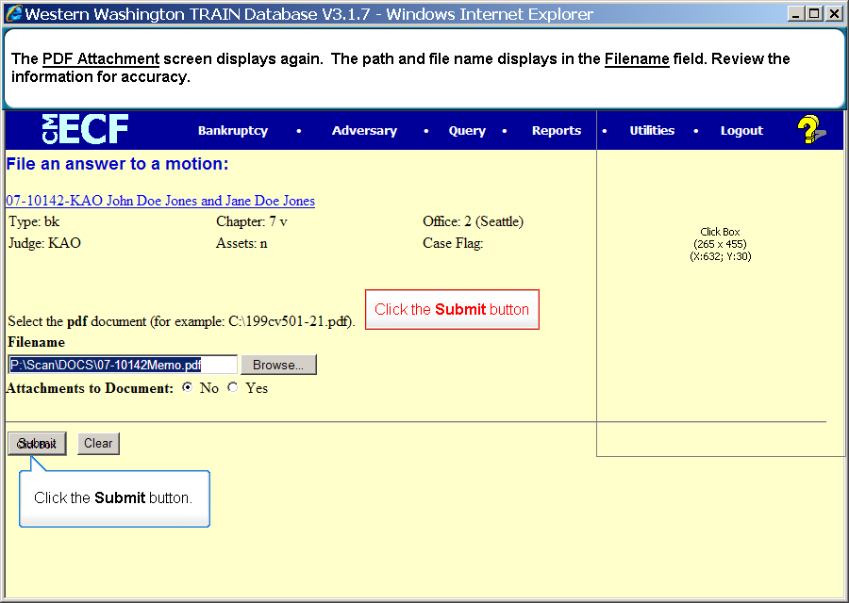
  Slide 17
  Text Captions: Click the Submit button
  The PDF Attachment screen displays again. The path and file name displays in the Filename field. Review the information for accuracy.
  Click the Submit button.
  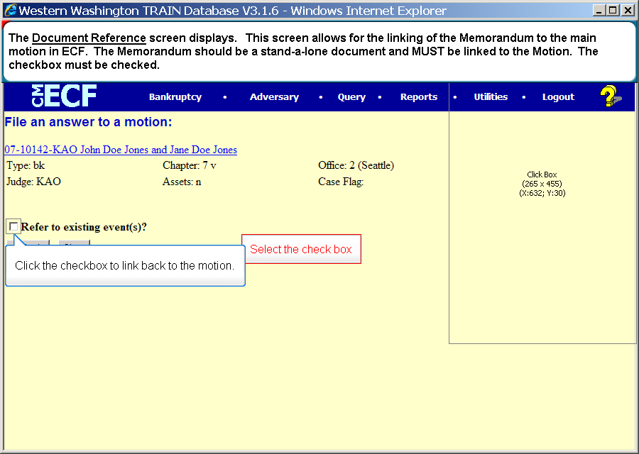
  Slide 18
  Text Captions: Select the check box
  Click the checkbox to link back to the motion.
  The Document Reference screen displays. This screen allows for the linking of the Memorandum to the main motion in ECF. The Memorandum should be a stand-a-lone document and MUST be linked to the Motion. The checkbox must be checked.
  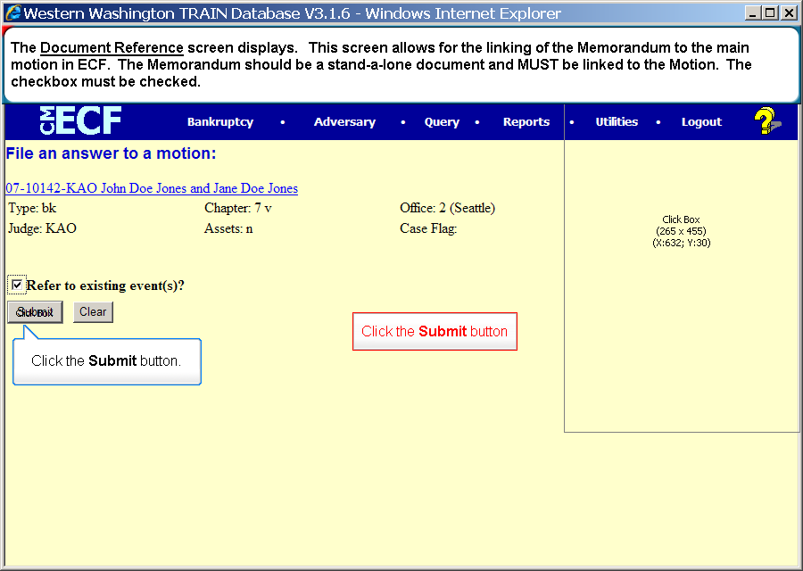
  Slide 19
  Text Captions: Click the Submit button
  The Document Reference screen displays. This screen allows for the linking of the Memorandum to the main motion in ECF. The Memorandum should be a stand-a-lone document and MUST be linked to the Motion. The checkbox must be checked.
  Click the Submit button.
  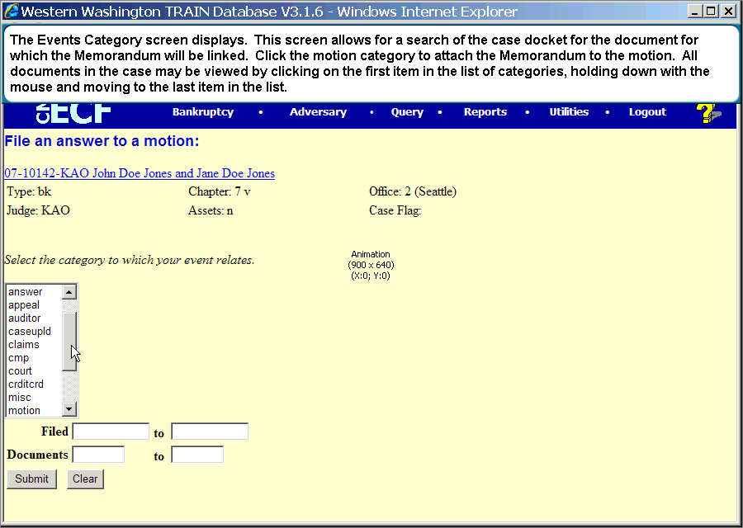
  Slide 20
  Text Captions: The Events Category screen displays. This screen allows for a search of the case docket for the document for which the Memorandum will be linked. Click the motion category to attach the Memorandum to the motion. All documents in the case may be viewed by clicking on the first item in the list of categories, holding down with the mouse and moving to the last item in the list.

  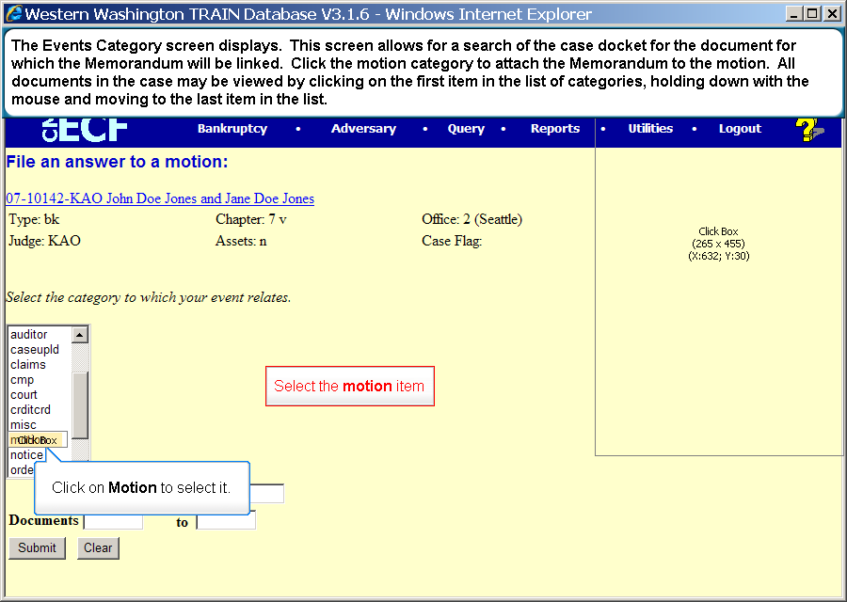
  Slide 21
  Text Captions: Select the motion item
  Click the Submit button.
  The Events Category screen displays. This screen allows for a search of the case docket for the document for which the Memorandum will be linked. Click the motion category to attach the Memorandum to the motion. All documents in the case may be viewed by clicking on the first item in the list of categories, holding down with the mouse and moving to the last item in the list.
  Click on Motion to select it.
  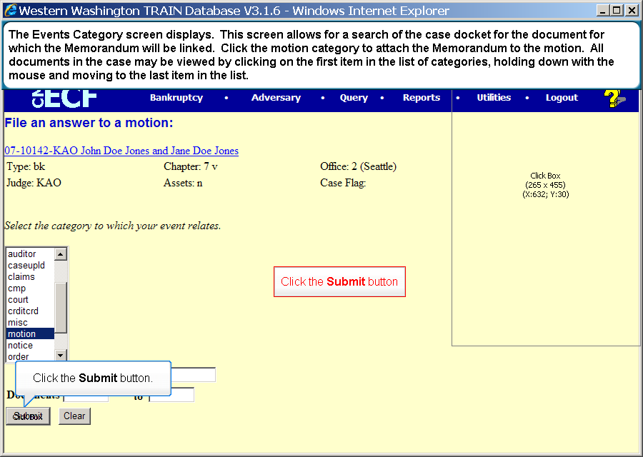
  Slide 22
  Text Captions: Click the Submit button
  The Events Category screen displays. This screen allows for a search of the case docket for the document for which the Memorandum will be linked. Click the motion category to attach the Memorandum to the motion. All documents in the case may be viewed by clicking on the first item in the list of categories, holding down with the mouse and moving to the last item in the list.
  Click the Submit button.
  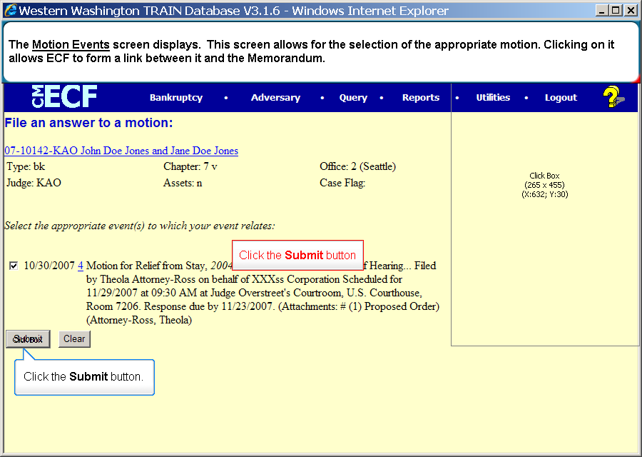
  Slide 23
  Text Captions: Click the Submit button
  Click the Submit button.
  The Motion Events screen displays. This screen allows for the selection of the appropriate motion. Clicking on it allows ECF to form a link between it and the Memorandum.
  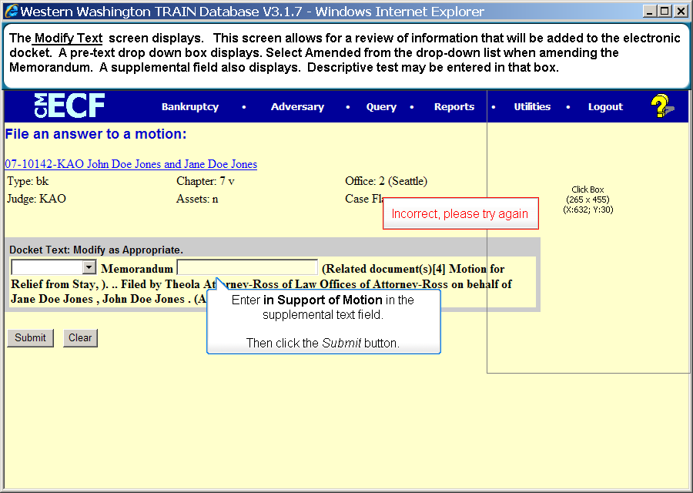
  Slide 24
  Text Captions: Enter in Support of Motion in the supplemental text field.
  Then click the Submit button.
  The Modify Text screen displays. This screen allows for a review of information that will be added to the electronic docket. A pre-text drop down box displays. Select Amended from the drop-down list when amending the Memorandum. A supplemental field also displays. Descriptive test may be entered in that box.
  If errors are discovered as a result of the review, click Bankruptcy to restart the entry.
  Incorrect, please try again

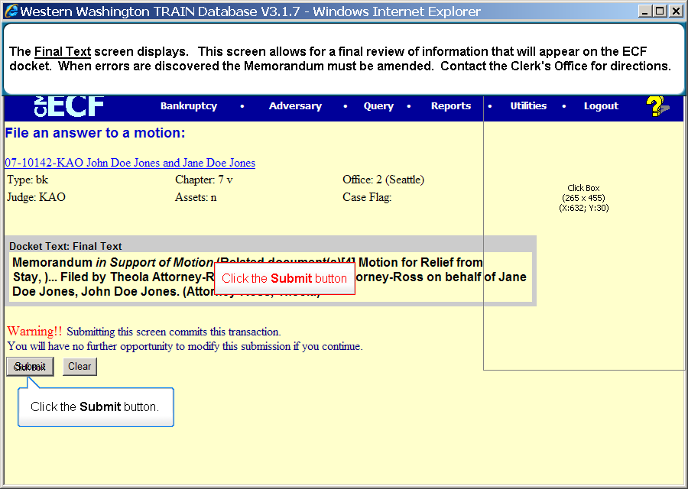
  Slide 25
  Text Captions: Click the Submit button
  The Final Text screen displays. This screen allows for a final review of information that will appear on the ECF docket. When errors are discovered the Memorandum must be amended. Contact the Clerk's Office for directions.
  Click the Submit button.
  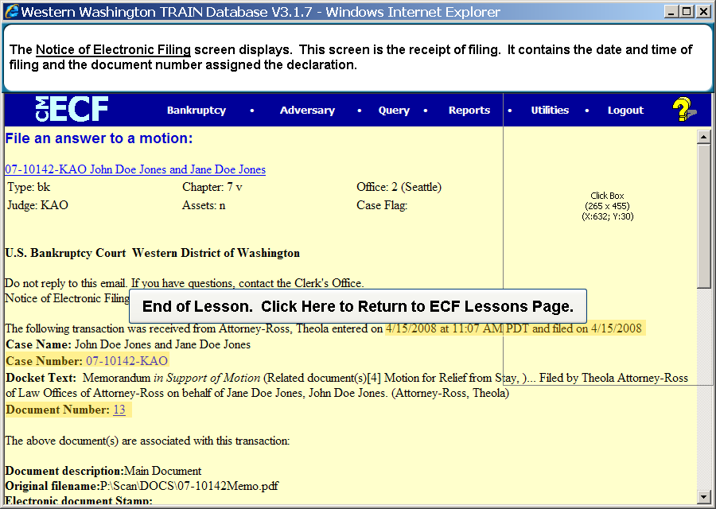
  Slide 26
  Text Captions: The Notice of Electronic Filing screen displays. This screen is the receipt of filing. It contains the date and time of filing and the document number assigned the declaration.

