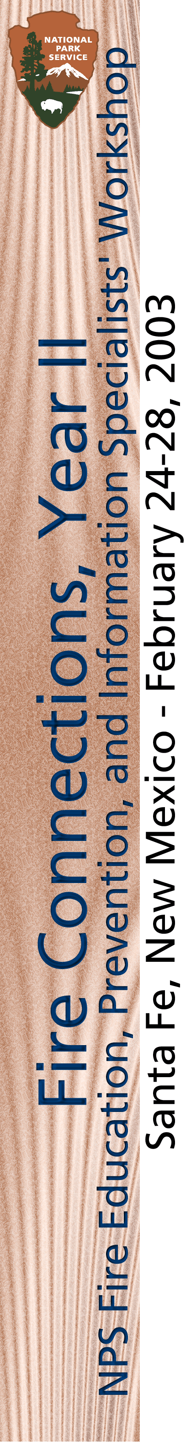
Welcome!
National Park Service

Fire Education, Prevention, and Information Specialists’ Workshop

Fire Connections, Year II
Santa Fe, New Mexico – February 24-28, 2003

MONDAY, FEBRUARY 24, 2003

4:00 p.m. Group meeting. “OPEN HOUSE”

Showcase your program! Since we have so much information to share, this is an informal
opportunity for the group to review and learn about your program before dinner. The
deVargas room will be available for you to display your wares.

Meeting Location: deVargas Room (This is our meeting room all week.)

6:00 p.m. Break
6:30 p.m. Dinner to be in the Hotel St. Francis under “NPS Fire Education”

Southwest style buffet, private room. Cost $18.00 (Includes tax, gratuities, coffee/tea. Other beverages are pay as you go.)

TUESDAY, FEBRUARY 25, 2003 - “NPS Connections”

Today’s objective: To discuss NPS perspectives, programs and issues and how the NPS Fire Communications and Education program “fits” in.

Today’s facilitator and timekeeper, respectively: Roberta D’Amico and David Eaker
Notetaker:
Daily evaluators (two) to be selected:
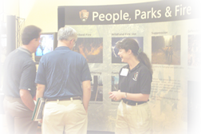
Location: deVargas room
Lunch: On-own

8:00 - 8:25 a.m. Administrivia Roberta D’Amico
Introductions/Welcome IMR committee

8:25 - 8:45 Welcome to Santa Fe Ernest Ortega

8:45 - 9:00 “Open Mike”
Program Overviews and Discussion

9:00 - 9:15 Break

9:15 - 10:15 The Realities of Governmental Rick Frost
Communications -The good, the
bad and the ugly!

TUESDAY, cont.

10:15 - 10:30 Break

10:30 - 11:30 Wildland Fire Program Initiatives & Policies Bryan Swift
Healthy Forests and more!

11:30 - 12:45 p.m. Lunch

12:45 - 1:45 Interpretation, Education and Fire Neil DeJong
Connecting to NPS programs

1:45 - 2:00 Break

2:00 - 3:00 Natural Resources Information Liaison Mike Whatley
The Natural Connection

3:00 - 3:15 Break

3:15 - 4:15 Connecting to the Interagency System
Panel Faciliatator: Jim Whittington
Southwest Interagency Coordination Center Mary Zabinski
Jay Ellington
Santa Fe National Forest Dolores Maese

4:15 - 4:30 “Open Mike” Facilitator
Program Overviews and Discussion

4:30 Review of the day – daily evaluators Facilitator

4:45 Logistics and details for Wednesday’s Field Trip Jim Whittington

5:00 Adjourn

WEDNESDAY, FEBRUARY 26, 2003 - “THERE ARE NO BOUNDARIES IN FIRE
MANGAGEMENT”

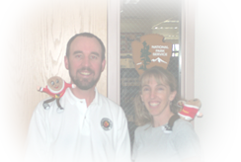

Today’s objective: To learn about post Cerro Grande activities, and today’s Fuels Program.

Today’s facilitator and timekeeper, respectively: Jim Whittington and Lori Iverson
Notetaker:
Daily evaluators (two) to be selected:
Location: deVargas Room and travel day
Lunch: AT THE SCHOOL!

8:00 - 8:15 a.m. Administrivia

8:15 - 10:00 Fuels Overview Dick Bahr
The Gamut Revisited

WEDNESDAY, cont.

10:15 – 10:30 Break

10:30 Reiterate logistical details for afternoon Jim and Lori
travel to Mountain Elementary School

11:30 Arrive at School

11:30 - 12:15 p.m. Lunch at the school combined with an
orientation/presentation

12:15- 12:30 Break

12:30 Los Alamos School John Hogan
Education and Volunteer Program Craig Martin
1:45 - 2:00 Break

2:00 Re-group, board buses

2:00 Cerro Grande Re-visited Jim Whittington
Dean Clark

4:15 Review of the day – daily evaluators Facilitator
(Outside of the busses before boarding.)

4:30 Travel back to Santa Fe – Adjourn upon return

THURSDAY, FEBRUARY 27, 2003 - “FIRE EDUCATION, PREVENTION &
INFORMATION”

Today’s objective: To showcase examples of interagency cooperation, learn from 2002 experiences, and identify needs for future information officers.

Today’s facilitator and timekeeper, respectively: Scott Sticha and David Eaker
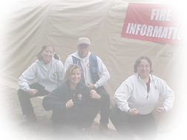
Notetaker:
Daily evalators (two) to be selected:
Location: deVargas Room
Lunch: On-own

8:00 a.m. Administrivia

8:05 - 9:00 Incident Partners
Panel facilitator: Scott Sticha
American Red Cross Matt Bertram
FEMA Ed Conley

9:00 - 9:15 Break

THURSDAY, cont.

9:15 - 10:15 Partners in Prevention and Education
Panel Facilitator: Lori Iverson
Living on the Edge Bequi Livingston Firewise Programming and Coordination Terri Wildermuth
The Nature Conservancy Ed Brunson
10:15 - 10:30 Break

10:30 - 11:45 NPS and the SCA Fire Education Program 2002 NPS liaisons
Panel Facilitator: Marty O’Toole Lori Iverson
Angela Smith
Scott Sticha
Jim Whittington
The 2003-2004 Program Roberta D’Amico
11:45 - 1:00 p.m. Lunch

1:00 - 2:30 The Future of Information
Panel Facilitator: Jim Whittington Jim Paxon
Bob Summerfield
Maureen Brooks

2:30 - 2:45 Break

2:45 - 3:15 NPS Firewise Programs Morgan Miller
Panel Facilitator: Scott Sticha Barb Stewart

3:15 – 3:45 “Open Mike” Facilitator
Program Overviews and Discussion

3:30 - 3:45 Break

3:45 - 4:15 NPS and Project Learning Tree Lori Iverson
Facilitator: Scott Sticha Jody Lyle

4:15 - 4:45 “Open Mike” Facilitator
Program Overviews and Discussion

4:45 Review of the day – daily evaluators Facilitator

5:00 Adjourn
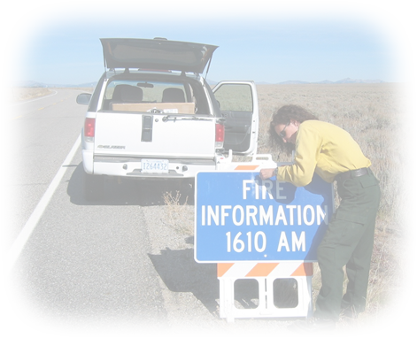
FRIDAY, FEBRUARY 27, 2003 - “WHERE DO WE GO FROM HERE?”

Today’s objective: To discuss program developments and direction.

Today’s facilitator and timekeeper, respectively: David Eaker and Lori Iverson
Notetaker:
Daily evaluators (two) to be selected:
Location: deVargas room
Lunch: On the road…
FRIDAY, cont.

8:00- 8:15 a.m. Administrivia

8:15 - 9:15 Web Connections Tina Boehle

9:15 - 9:30 Break

9:30 - 10:15 Fire Management Strategic Plan Roberta D’Amico
Where do we go from here?

10:15-10:30 Break

10:30 - 11:30 Leading into the Future Steve Frye
(Information and Incident Management, NPS
perspectives and the role of NPS Fire Education,
Prevention and Information Specialists.)

11:30 - 12:00 p.m. Close-out/review/evaluation David and Lori

Safe Travels everyone!


