 The Dryline 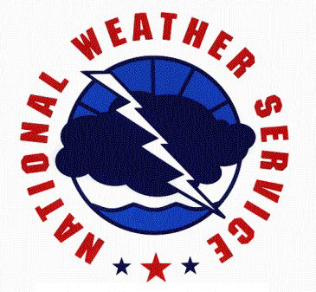
The Official Newsletter of the National Weather Service in Amarillo

Very High Fire Danger Continues for the
2005-2006 Winter Season

By Ken Schneider, Fire Weather Program Leader

The fire danger has been abnormally high this winter due to warm, dry and windy conditions. The unseasonably warm and dry conditions are the result of a persistent ridge of high pressure in the upper atmosphere, that has dominated the weather pattern across the western half of the United States. Many windy days have occurred as strong surface troughs of low pressure have consistently developed in the lee of the Rocky Mountains. Fuels (i.e. native grasses, shrubs, etc.), which go dormant every winter, are even drier than normal due to the windy conditions and the lack of precipitation. The result is a situation where the wildfire potential is very high, and can be particularly dangerous on windy days, when fires can quickly burn out of control, consuming thousands of acres and endangering homes, businesses and other structures in their paths. The winter months (November through February) are normally dry, with just over one-half inch of precipitation typically occurring during each month. However, the dry spell began in October, when a rainfall deficit of 1.08 inches was observed. November was 0.49 inches below normal, December was 0.58 inches below normal, and January was 0.60 inches

(Continued on next page)
Also in this issue:

2005 Weather Review pg. 3

Winter Weather Outlook pg. 4

Co-Op Highlights pg. 5

Weather 101 pg. 6

Science & Technology pg. 7

In Your Community pg. 10

NWS Employee Spotlight pg. 11

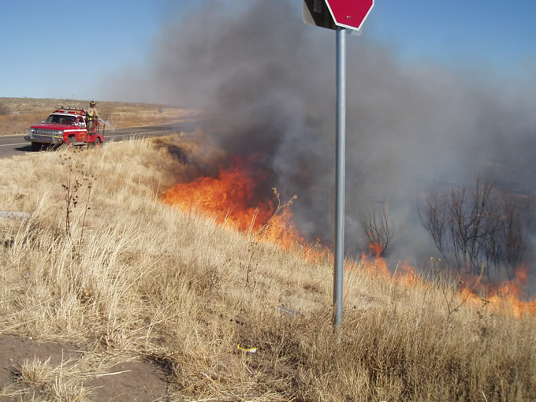

Fig. 1. Grassland fire over northwest Amarillo on January 7, 2006 (Courtesy of NWS Amarillo)

Very High Fire Danger Continues for the 2005-06 Winter Season (continued)

below normal. According to the latest U.S. Drought Monitor, much of the Texas and Oklahoma Panhandles is experiencing a moderate drought. The outlook from the NWS Climate Prediction Center shows little hope for improvement, as the dry and warm weather is expected to continue for the remainder of the winter season.

Several Red Flag fire events have occurred this winter season across all or portions of the Texas and Oklahoma Panhandles. A Red Flag event occurs when specific critieria are met, which include relative humidity values at or below 15 percent and 20-foot (above the ground) winds at or above 20 mph for a period of at least 3 hours. During November, Red Flag events occurred on the 3rd, 4th, and 26th. December resulted in only one Red Flag event, which occurred on the 2nd day of the month. The new year began with active wildfires in the Texas and Oklahoma Panhandles. On New Year’s Day, a wildfire located just northeast of Shamrock burned nearly 3,100 acres. On January 3rd, a large wildfire occurred in Beaver County in the eastern Oklahoma Panhandle. The largest wildfire burned approximately 23,000 acres in Donley County on January 5th. The Amarillo area experienced several wildfires on January 7th (Fig.1). One grassfire occurred just northeast of Amarillo, while the other two occurred just north and northwest of Amarillo. Three wildfires were reported north of Hereford on January 12th, along with several small grassfires in and around the Amarillo area. It is important to note that even if a Red Flag Warning is not issued, the potential for fire ignition remains high due to the extended dry spell and extremely dry fuels.

The Texas Forest Service has declared a high risk of accidental wildfires owing to the drought conditions across much of the state. The Texas Forest Service Director, Mr. Jim Hull, has stated that this winter’s fire season is the worst he’s seen in nearly ten years…[and] is urging Texans to remain on their guard against any actions that could result in additional wildfires in the state, and offers this advice: if a wildfire escapes an initial attack, residents are advised to evacuate immediately for a safe zone. Mayors and county judges in Texas have the authority to issue mandatory evacuations.

All counties in the Texas and Oklahoma Panhandles have burn bans in effect. These burn bans will likely stay in effect for some time, as the outlook for the remainder of the winter season calls for above normal fire potential.

Additional fire weather information can be found on the National Weather Service Amarillo’s Fire Weather Page located at:

http://www.srh.noaa.gov/ama/fire_weather/

or by contacting the Fire Weather Program Leader at:

Ken.Schneider@noaa.gov

2005 Weather Review
By John Brost,
Journeyman Forecaster

The National Weather Service in Amarillo compiled a 2005 summary of notable weather records and events for the Texas and Oklahoma Panhandles. 2005 was an interesting year! Although 2004 was the 9th wettest year on record, 2005 became the 15th driest year since 1892 (when records began in Amarillo). A rare May snowstorm occurred on May 2nd, which was one of the latest measurable snowfalls on record (Fig. 2). The biggest snowstorm occurred in mid- March, when nearly a foot fell in Amarillo. Widespread severe thunderstorms, six tornadoes and flash flooding struck the area on June 11th, including the Amarillo area. There was a total of 15 tornadoes for the year, which was below the average of 21. The year ended slightly warmer than normal, despite the fact that 7 months recorded cooler-than-normal temperatures (Fig. 3). 2005 went on record as the 42nd warmest year on record. In Amarillo, there was only one day when the temperature met or surpassed 100 degrees, and there was only one day when the temperature fell below zero.

2005 Summary for Amarillo:

Highest Temperature = 102° on July 3rd
Lowest Temperature = (-3°) on December 7th
Average High Temperature = 70.5°
Average Low Temperature = 44.4°
Average Temp = 57.5° / Normal is 56.9°
Total Precipitation = 15.00 inches
Normal Yearly Precipitation is 19.71 inches
Total Snowfall for the Year = 22.4 inches
Normal Yearly Snowfall is 15.6 inches

For a detailed report of the 2005 weather summary, go to: 2005 weather review
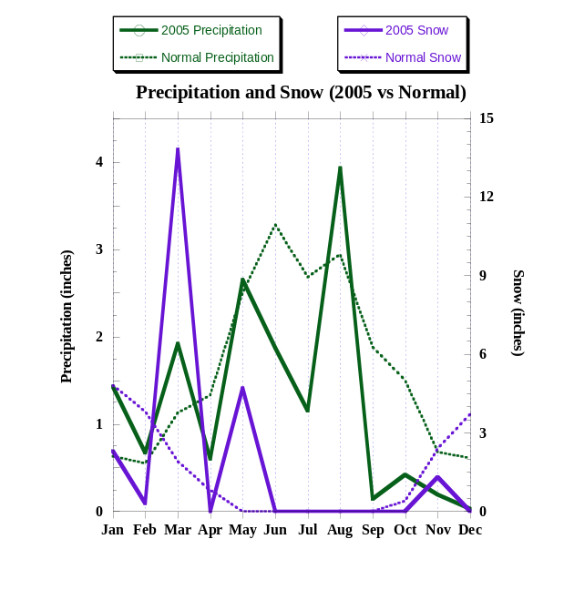
Fig. 2. 2005 Precipitation and Snow vs Normal

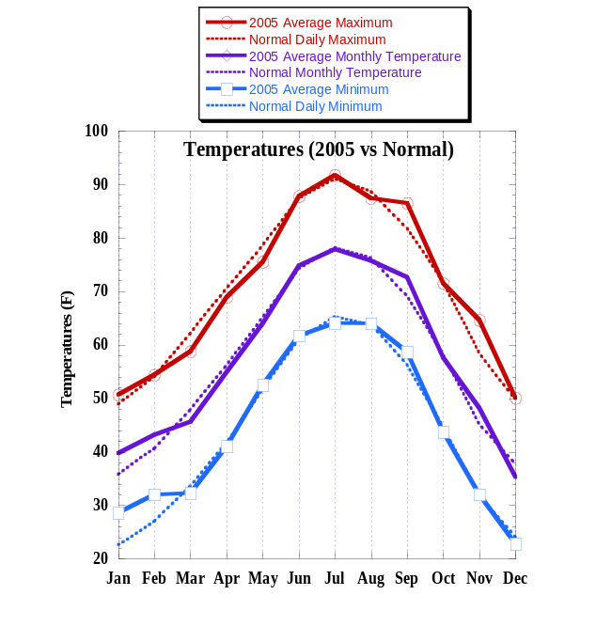
Fig 3. 2005 Temperatures vs Normal

Winter Weather Outlook – Weak La Niña Develops
By Richard Wynne, Science and Operations Officer

Weather scientists, who watch for signs of change that could impact our weather in the coming months, have noticed some trends. The equatorial Pacific waters from the International Date Line to the South American coast have been cooler than normal over the last several months. Winds that usually blow from east to west in this area have been stronger than normal. This increases the upwelling of cold water along the North and South American coasts, which can affect everything from life in the ocean to the weather. The trends have continued long enough for scientists to conclude that we are in a weak La Niña episode.

As far as the weather pattern for the United States is concerned, high pressure forms off the California coast and the path that Pacific weather systems follow is deflected northward. This would tend to leave the Southern Plains dry and warm, especially during the winter months. So far this winter (Fig. 4 and 5), West Texas has been just that – warm and dry!! From September 2005 to January 2006, Amarillo received only 0.81 inches of precipitation. Normally, one would expect around 5.30 inches for the same period. In the northern U.S., cool and wet weather will continue.

The climate computer models point to more of the same for the U.S. in the coming months. Scientists’ confidence in the computer models is high because of how well the models have fit the recent observed weather data. The U.S. Seasonal Drought Outlook indicates dry conditions to persist across West Texas at least through March.

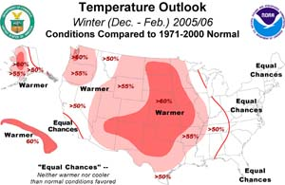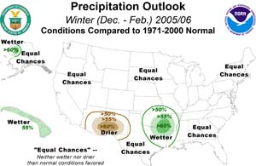

Fig. 4. Winter Temperature Outlook Fig. 5. Winter Precipitation Outlook

Co-Op Highlights

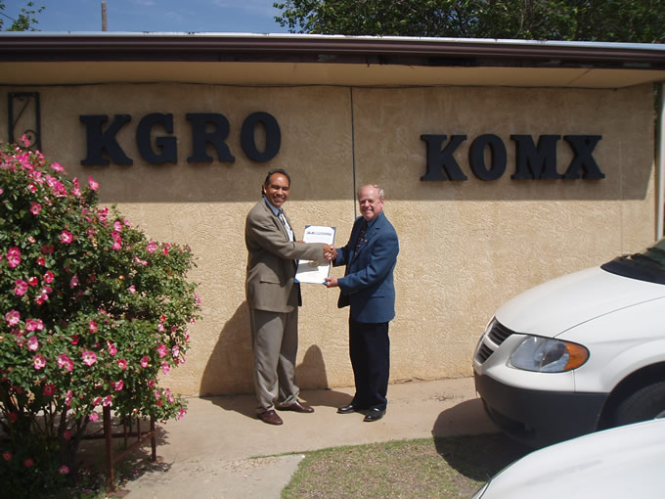

Fig. 6. Darrell Sehorn (right) receives 35-yr Service Award from José Garcia. (Courtesy of NWS Amarillo

Darrell Sehorn – Pampa, Texas
Darrell was recognized by the National Weather Service for 35 years of service in reporting weather observations for Pampa. José Garcia (left), Meteorologist In Charge, presented Darrell with his award. Darrell is also known for his service in warning Pampa residents of the June 8, 1995 tornado, which damaged parts of western Pampa.
◄

Tommy Hudson – Wellington, Texas Tommy was awarded a certificate of appreciation from the National Weather Service for his 20 years of dedication and service as a weather observer. From left, Glen Woodall, Observation Program Leader; José Garcia, Meteorologist In Charge; Tabatha Tripp, Cooperative Program Leader; and John Cockrell, Senior Forecaster were present to honor Tommy (center) on August 25, 2005. ►

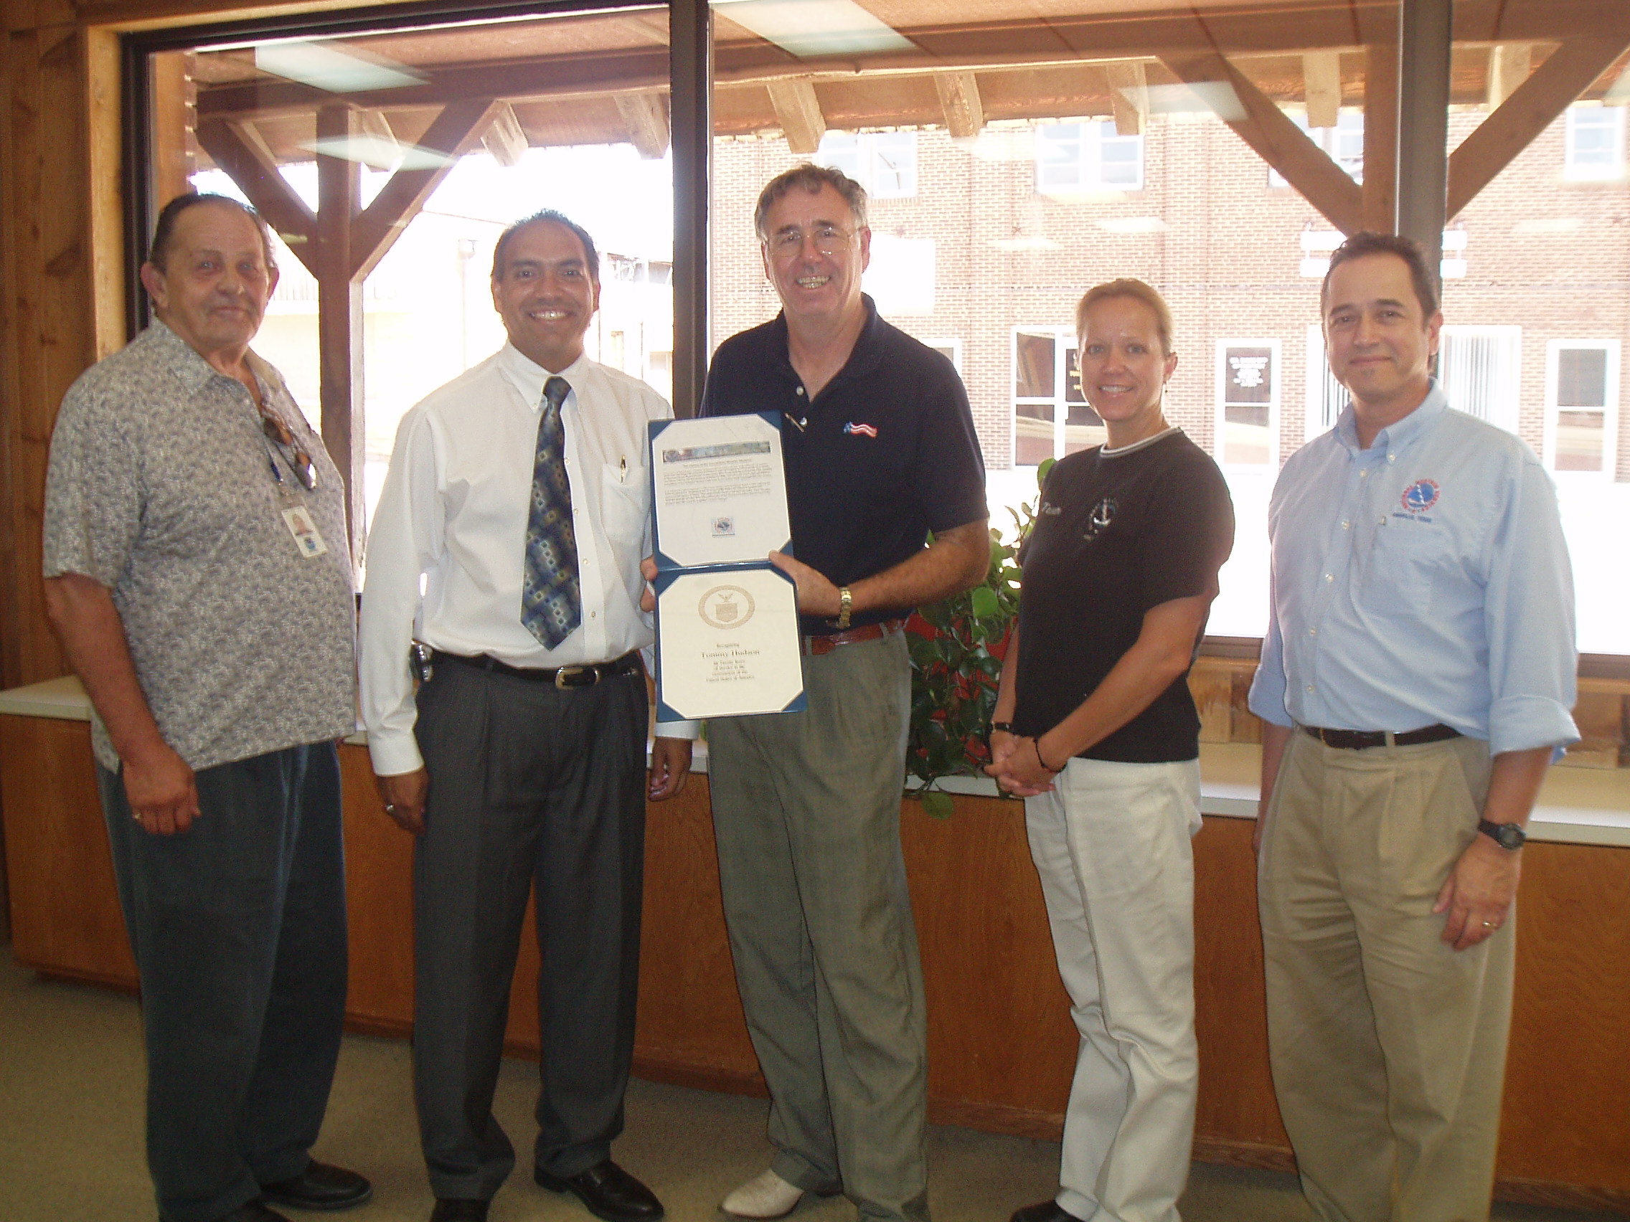

Fig. 7. NWS Staff presents Tommy Hudson (center) 20-yr Service Award. (Courtesy of NWS Amarillo)

Cooperative Weather Program Is Growing!
We have two new cooperative weather observation sites near Hedley and Pampa, TX.

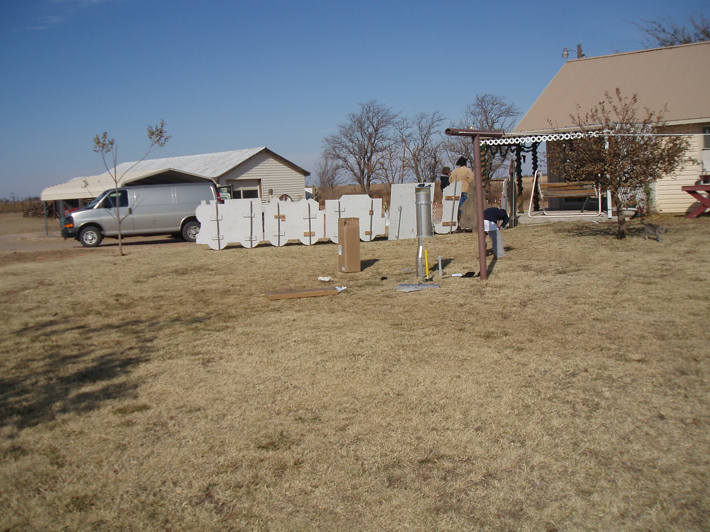

Fig. 8. Hedley, TX - 2 miles east (Courtesy of NWS Amarillo)
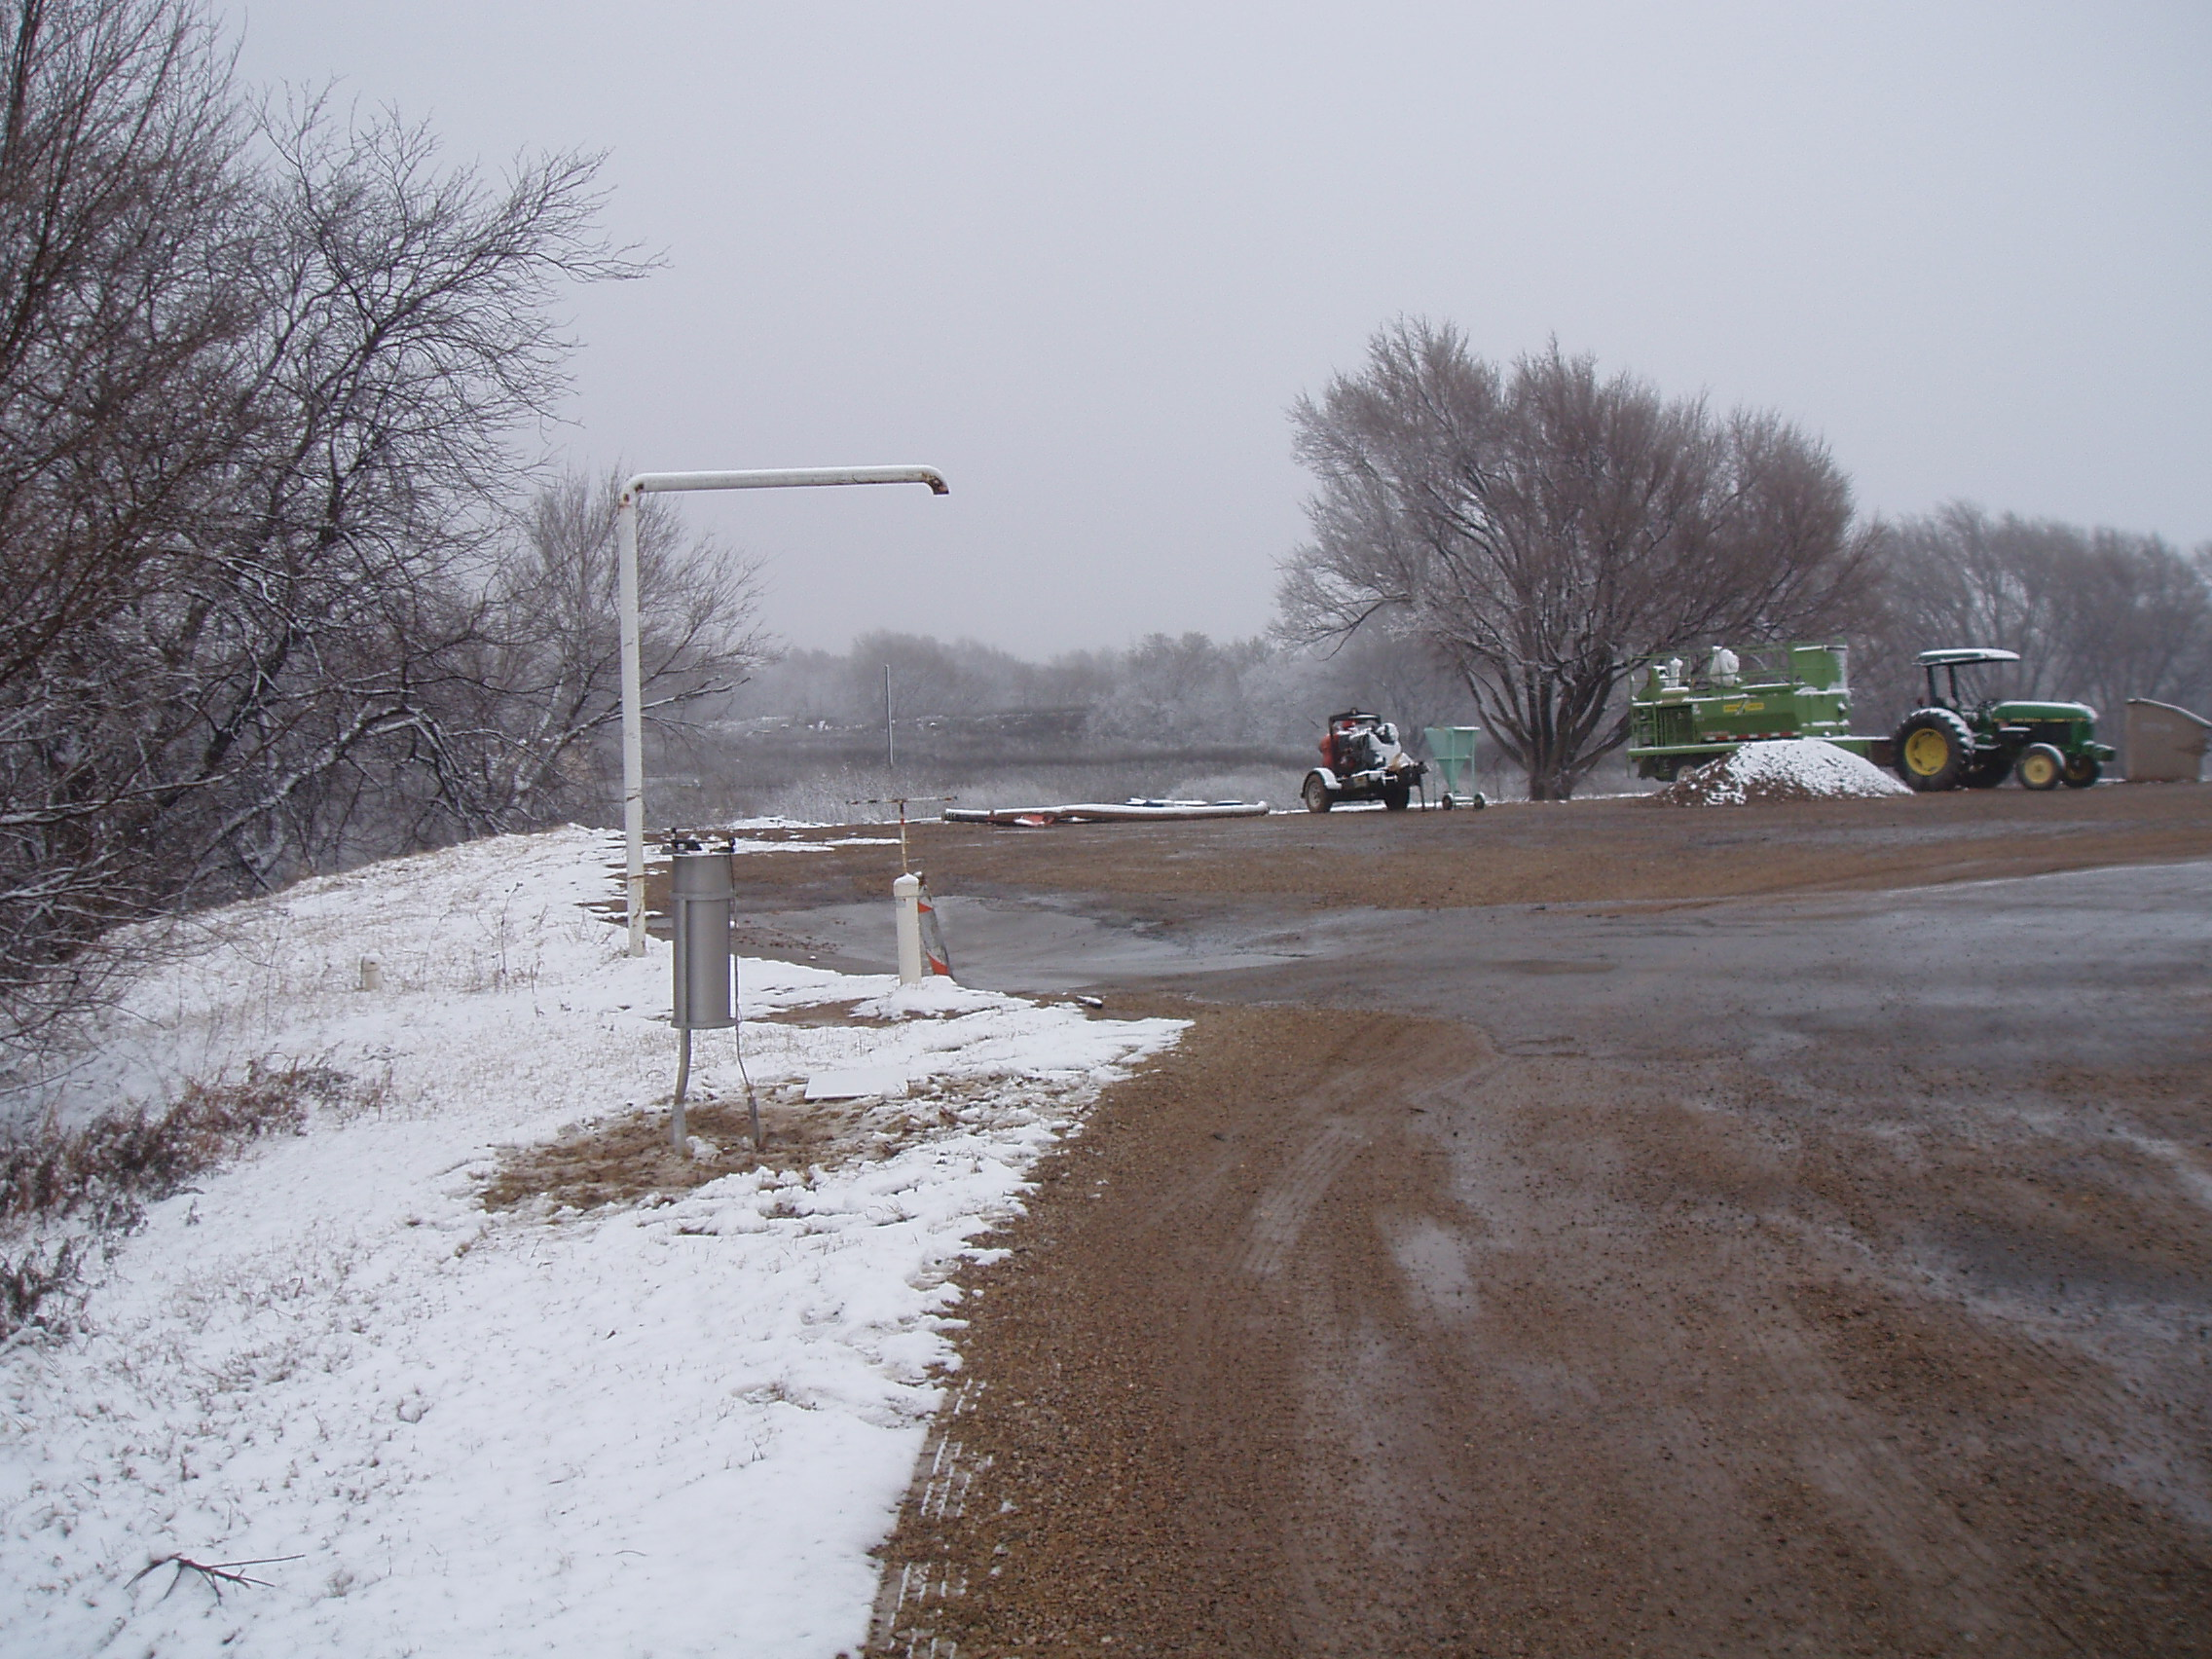

Fig. 9. Pampa, Texas - 3 miles east (Courtesy of NWS Amarillo)

Weather 101 - How does snow form?
By Richard Wynne, Science and Operations Officer

This time of year, a lot of people call to ask us how snow forms. Snow needs certain ingredients in order to form. First of all, ice-forming nuclei must be present. The most common is kaolinite, which is a clay particle. Ice crystals can form on these particles in 3 ways. The most common method is by a process called sublimation. Sublimation occurs when water, in its gaseous phase (water vapor), deposits directly onto the clay particle as a solid ice crystal without going through the liquid phase. Ice crystals can form on particles in other ways. The water droplets that make up clouds are very tiny. These tiny droplets can actually remain in liquid form when cloud temperatures fall below freezing, as what scientists call supercooled water droplets. If there are some particles floating around in the supercooled cloud, another way ice crystals can form is if the droplets come in contact with the particles. A third way is if the supercooled water droplets contain a particle around which the crystal can form. Ice formation can occur starting at cloud temperatures of just under -4˚C (25˚F) depending on the type of particles present. Research shows that by -10˚C (14˚F), half of the clouds contain some ice crystals. At temperatures lower than -18˚C (~ 0˚F) nearly all clouds should contain ice crystals. Crystal shapes depend on the temperature at which they form (Fig. 10).

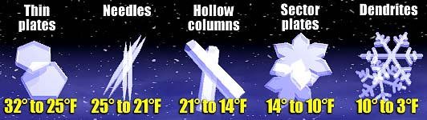

Fig. 10. Correlation between crystal shapes and temperatures in which they are formed. (Source: The Weather Book (USATODAY))

Once the ice crystals start forming, they grow as water vapor encounters ice crystals, quickly turns to liquid water, and then freezes on the ice surfaces. Once the crystals grow large enough, they begin to fall. As they fall, they will grow even more quickly as the ice crystals collide with liquid water droplets, and stick to each other. Eventually, enough of the crystals stick together where they form the familiar flakes that we see. If the temper-atures remain low enough all the way to the surface, the flakes will reach the ground.

Many times, a warm air layer will exist between the cold snow clouds and the ground. If the warm layer allows the snow flakes to melt slightly and then refreeze before they reach the ground, then we may see sleet or perhaps ice pellets, depending on the temperature structure and the depth of the warm layer. Sometimes the ice crystals will melt and reach the surface as liquid, only to freeze instantly when they touch a cold object such as a metal car roof. Then we experience freezing rain.

Reference: http://www.crh.noaa.gov/arx/micro/micrope.php
Science and Technology
By Matthew Kramar, Science and Training Team Leader

As skillful as current forecasts can be, advances in forecasting techniques cannot be made without new meteorological research. Some scientific papers have appeared recently, based on local research, that highlight exciting developments in severe weather forecasting in the Southern Plains.

The “Owl Horn” Radar Signature in Developing Southern Plains Supercells
By Matthew R. Kramar, Howard B. Bluestein, Andrew L. Pazmany and John D. Tuttle

The National Weather Service Doppler radar is a forecaster’s primary tool in diagnosing severe thunderstorms and issuing appropriate warnings. Radar research conducted over countless years has yielded many useful radar signatures that make the diagnostic work of the warning forecaster easier: the BWER (bounded weak-echo region) depicting a strong thunderstorm updraft; the TBSS (three-body scatter spike) implying the presence of large hail; and the hook echo suggesting a very strong mesocyclone and possible future tornado formation. Matthew Kramar, a forecaster with WFO Amarillo, recently published a paper on a new signature that he and a team from the University of Oklahoma discovered, called the “Owl Horn” signature. The signature, which was observed in the reflectivity pattern on the rear side of developing supercell thunderstorms, is so-named because the pattern resembles the profile of a Great Horned Owl (Fig. 11).

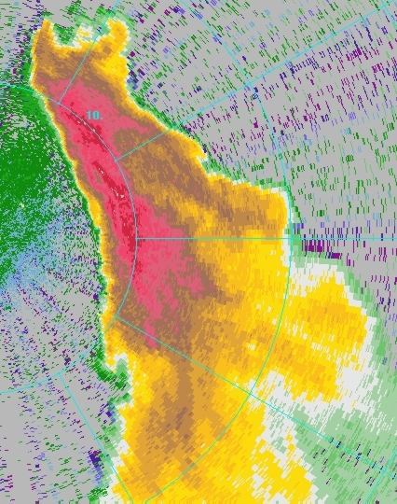
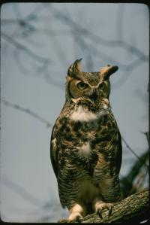

Fig. 11. The "Owl Horn" signature is seen in a low-level Plan Position Indicator (PPI) scan as two reflectivity protrusions at the rear side of an isolated thunderstorm with respect to its motion (top of left image). The storm signature resembles the profile of the Great Horned Owl, seen at right. (Photograph used in accordance with Corel Stock Photograph licensing)

(Continued on next page)
The “Owl Horn” Radar Signature in Developing Southern Plains Supercells (continued)

The signature was determined to be an indication of a splitting thunderstorm (although not every splitting thunderstorm produces the signature) and is a result of highly focused low-level rotation. This information is of use to a warning forecaster, who can then identify the storm as potentially stronger than storms around it and make decisions accordingly. In addition, every storm that produced an “Owl Horn” signature also later produced a funnel cloud or tornado. Although there is only observational evidence to this effect, the signature could also alert the warning forecaster to the possibility of tornado development at a later time in the storm owing to the low-level rotation already in place. The “Owl Horn” signature was observed on storms in the Texas Panhandle on 15 May 2003, as well as 17 and 21 June 2004, all of which became tornadic supercells. For more information on this paper, go to:

W:\web_page\dryline\winter2006\OwlHornFinal.pdf

The Moisture Route of Palo Duro Canyon
By Kevin Walter, Christopher Weiss and Andrew Swift

The Caprock is commonly thought to play a potentially significant role in the movement of the dryline and the development of thunderstorms owing to the elevation changes it provides. But it has long been speculated that the Palo Duro Canyon itself serves as a moisture channel, allowing warm, moist air to be funneled into the Texas Panhandle on southeasterly winds, and subsequently spread onto the Plains as the air reaches the Caprock escarpment.

Kevin Walter, a graduate student of meteorology at Texas Tech University, used a vehicle-mounted mobile mesonet to address this speculation. On two occasions when winds were expected to be from the southeast, Kevin conducted transects of the Palo Duro Canyon by driving across the canyon and measuring, at routine intervals, temperature, dewpoint and wind direction and speed as he moved through. Preliminary evidence showed that higher quantities of moisture were found inside the canyon than outside, which could support the original speculation that the Palo Duro Canyon often serves as an efficient method for moisture return to the Texas Panhandle given appropriate meteorological conditions. These results will no doubt have future implications in the forecasting of dryline movement and subsequent thunderstorm formation. For more information on this research, go to:

W:\web_page\dryline\winter2006\WalterEtAl.pdf
WSR-88 Doppler Radar Upgrade Installed
By John Cockrell, Radar Focal Point

In early December 2005, the latest upgrade to the Amarillo National Weather Service radar was completed. The powerful and highly sensitive NEXRAD (Next Generation Radar), also known as the WSR-88D (Weather Surveillance Radar - Doppler capability, 1988 initial design year) has been improved further, and is ready for the upcoming severe thunderstorm season.
The new Open Radar Data Acquisition (ORDA) upgrade provides improved quality to Base Data (reflectivity, Doppler velocity, and spectrum width). This means that National Weather Service meteorologists will be able to view thunderstorm structure in greater detail due to improved resolution in the data display. The meteorologists will be able to observe thunderstorm processes occurring on a smaller scale, allowing us to detect more subtle features. The information gained from certain nuances will offer the potential to detect severe thunderstorms and tornadoes more readily, and perhaps to provide greater advance notice (longer lead time) to the people of the Texas and Oklahoma Panhandles when a warning is issued.
Other benefits from the ORDA include improved clutter suppression, faster processing speeds in the signal processor, a reduction of certain types of erroneous reflectivity and velocity data (Fig. 12), a better calibrated radar with simplified calibration procedures, and a flexible design which is ready to accept future improvements.

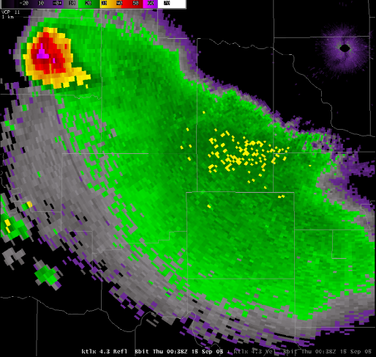
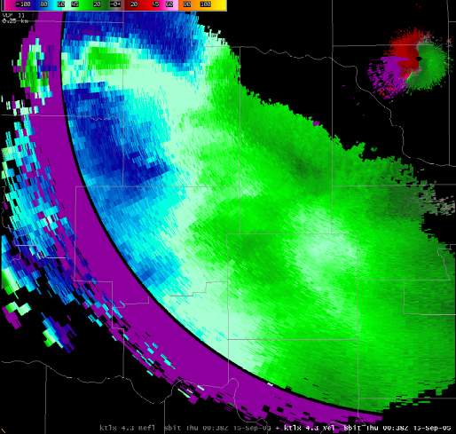

Fig. 12. Batch elevation reflectivity (left) with All Bin suppression applied to the high segement. Note the ring of reduced reflectivity, which is associated with the end of the first trip in the velocity data (right).

In Your Community...

The National Weather Service in Amarillo has participated in numerous outreach events since our last Dryline, issued in November 2005. We would love to participate in an event In Your Community!! To schedule the NWS in your next community event, please email Steve Drillette at steve.drillette@noaa.gov or call 806-335-1121.
Ongoing thru May 2006 | Kids Weather Hour  Texas Panhandle Schools | NWS Meteorologists answer kids questions live on NOAA Weather Radio each Friday at 9 am. To sign up or for more info, visit http://www.srh.noaa.gov/ama/
Nov 16, 2005 | Career Day - Bonham M.S.  Amarillo, TX | NWS Amarillo participated in Career Day activities at local middle school.
Nov 28, 2005 | Canyon Cub Scouts  Canyon, TX | WCM Steve Drillette presented a severe weather program to approximately 200 Cub Scouts.
Nov 29, 2005 | Age Diversity Workshop  Amarillo, TX | WCM Steve Drillette attended an Age Diversity Workshop sponsored by Amarillo College.
Nov 29, 2005 | Career Day - Coronado Elementary School  Amarillo, TX | NWS Amarillo participated in Career Day activities for first grade students at a local elementary school.
Nov 30, 2005 | WTAMU Education Students  Canyon, TX | 50 students from WTAMU toured the NWS Office in Amarillo.
Dec 2, 2005 | Holiday Lights Parade  Amarillo, TX | NWS staff and their families entered and participated in the annual Night of Lights Holiday parade in downtown Amarillo.
Dec 6, 2005 | Winter Weather Awareness Day (WWAD) | NWS staff went on-air to promote WWAD. Interviews were conducted with KGNC-AM, KGNC-FM, & Clearchannel Radio stations in Amarillo, KXDJ in Perryton, and KGYN in Guymon. For more info visit  http://www.nws.noaa.gov/om/winter/index.shtml
Dec 8, 2006 | Potter County Fire & Rescue  Amarillo, TX | Forecaster Jason Jordan trained members of the Potter County Fire & Rescue the basics of how to use handheld GPS equipment.
Dec 12, 2005 | Cub Scouts, Amarillo, TX | A local cub scout group and parents toured the NWS Amarillo office.
Jan 9, 2006 | Rotary Club, Amarillo, TX | Forecaster Ed Andrade spoke to a local Rotary Club on the Spring severe weather season outlook.
Jan 9, 2006 | St. Vincent De Paul School  Pampa, TX | WCM Steve Drillette spoke to 30 students about weather at a local Catholic elementary school.
Jan 9, 2006 | Red Cross Open House  Amarillo, TX | WCM Steve Drillette attended the Amarillo Red Cross Open House and became acquainted with the new Executive Director.
Jan 26, 2006 | Sleepy Hollow Elementary  Amarillo, TX | 24 5th grade students toured the NWS office from a local elementary school.
Feb 2, 2006 | Lions Club  Amarillo, TX | MIC Jose Garcia gave a local Lions Club a presentation on NWS Operations and the ongoing drought.
Feb 3, 2006 | Lakeview Elementary  Canyon, TX | 88 2nd grade students from an elementary school in Canyon toured the NWS office.
Upcoming Events Currently Scheduled
Mid Feb - April 2006 | Severe Storm Spotter Training Courses Texas & Oklahoma Panhandles | WCM Steve Drillette and staff will train local storm spotters. To schedule a class In Your Community, contact Steve at (806) 335-1121 or steve.drillette@noaa.gov Check out the current class schedule at Spotter Training Schedule
Feb 13 - 17, 2006 | Forest Hill Elementary  Amarillo, TX | NWS staff will participate in Career Day activities each day for a different elementary grade.
Feb 26 - Mar 4 2006 | Severe Weather Awareness Week | Public Spotter Training at 11 AM, March 4th at Amarillo College Business & Industry Center on South Polk Street in Amarillo. For other events, see Spotter Training Schedule
Mar 24, 2006 | Fannin Middle School 6th Grade  Amarillo, TX | NWS staff will make a weather presentation to the 6th grade at a local middle school.
Mar 28, 2006 | Yarborough Elementary School  Eva, OK | WCM Steve Drillette will speak to the 4th and 5th graders at an elementary school in the Oklahoma Panhandle.
Mar 30, 2006 | Safety Fair  Clarendon, TX | NWS personnel will staff a booth at a Safety Fair at Clarendon College.
Mar 31, 2006 | Fannin Middle School 8th Grade  Amarillo, TX | NWS staff will make a weather presentation to the 8th grade at a local middle school.
Apr 8, 2006 | Foster Parents Organization  Amarillo, TX | WCM Steve Drillette will speak to a local Foster Parent Organization on Basic Storm Spotting and Severe Weather Safety.
Apr 19 - 20, 2006 | WTAMU Students  Canyon, TX | WTAMU Education Majors will tour the NWS Forecast Office.
May 3, 2006 | Career Fair,  Canyon, TX | NWS Amarillo will participate in the Top Of Texas Career Fair at West Texas A&M University.
May 9, 2006 | BusinessConnection 2006  Amarillo Civic Center  Amarillo, TX | NWS Amarillo will staff a booth at the annual BusinessConnection event sponsored by the Amarillo Chamber of Commerce.

Employee Spotlight

Jason Jordan - January Employee of the Month

Jason has been a Journeyman Forecaster for WFO Amarillo since 2003. He is the focal point for the Aviation and Operational Computer programs, and is a member of our Forecast and Warnings, and Science and Training teams. Jason graduated from the High School for Science and Engineering Professions at Dunbar in Fort Worth, TX (1995), and received a Bachelor of Science in Meteorology from Texas A&M University—College Station (1999) and a Master of Science in Atmospheric Science from Texas Tech University (2003). His hobbies include photography, playing guitar, off-roading, rockclimbing and stormchasing.

Severe Storm Spotter Training has Begun
By Steve Drillette, Warning Coordination Meteorologist

Attention: Emergency Managers, Local Fire and Law Enforcement Departments, HAMS, and other Skywarn Groups

Severe storm season is just around the corner! NOW is the time to schedule your severe storm spotting training sessions.

Once again, this year’s program has been improved based on input we received from you. More graphics and video are part of this year’s program. We will conduct training beginning in mid-February and continue through April. We strongly encourage Skywarn groups to receive training every year, but if you did not receive training last year, it is critical that you schedule this year. If your community has not participated in the past, but you would like to become part of the Skywarn family, please let us know.

To reserve your spot on the calender, contact Steve Drillette at 806-335-1121 or by email at steve.drillette@noaa.gov. Dates fill up fast, so get your requests in quickly! Look for the Skywarn training schedule on our website at Spotter Training Schedule.

Farewell and Welcome

There have been some recent staff changes at your National Weather Service office. Last November, the office bid farewell to longtime Journeyman Forecaster Rob Slattery. Rob had been a forecaster at Amarillo since 1994 and was one of the first forecasters selected when the office modernized and accepted full forecasting and warning responsibilities for the Texas and Oklahoma Panhandles. Rob worked as the office’s first Webmaster and also served as the Aviation program leader. Rob is now pursuing his love of aviation weather at the Center Weather Service Unit in Memphis, TN.

To begin the year, the office welcomed our new Journeyman Forecaster, Mike Johnson. Mike served as an Intern and Journeyman Forecaster at the National Weather Service office in Corpus Christi, TX. We are pleased to have Mike at the Amarillo office, and he offers seasoned forecaster experience to our excellent staff.

At the end of January, we said goodbye to Meteorologist Intern Steven Ippoliti. Steven served at the office for about one year. He worked to update all of our storm spotter contacts and compiled these into software and guides that we can use easily during severe weather. Steven was promoted to a Journeyman Forecaster position at Elko, NV.
The Dryline_________________________1900 English Road, Amarillo, TX 79108
www.srh.noaa.gov/ama 806.335.1121

•José Garcia—Publisher and Meteorologist In Charge

•Roland Nuñez—Editor-in-Chief •Richard Wynne—Science and Operations Officer
•Matthew Kramar—Editor •Steve Drillette—Warning Coordination Meteorologist
•Angela Margrave—Administrative Assistant

