WATERING FACILITY

PRACTICE INTRODUCTION

USDA, Natural Resources Conservation Service—Practice Code 614

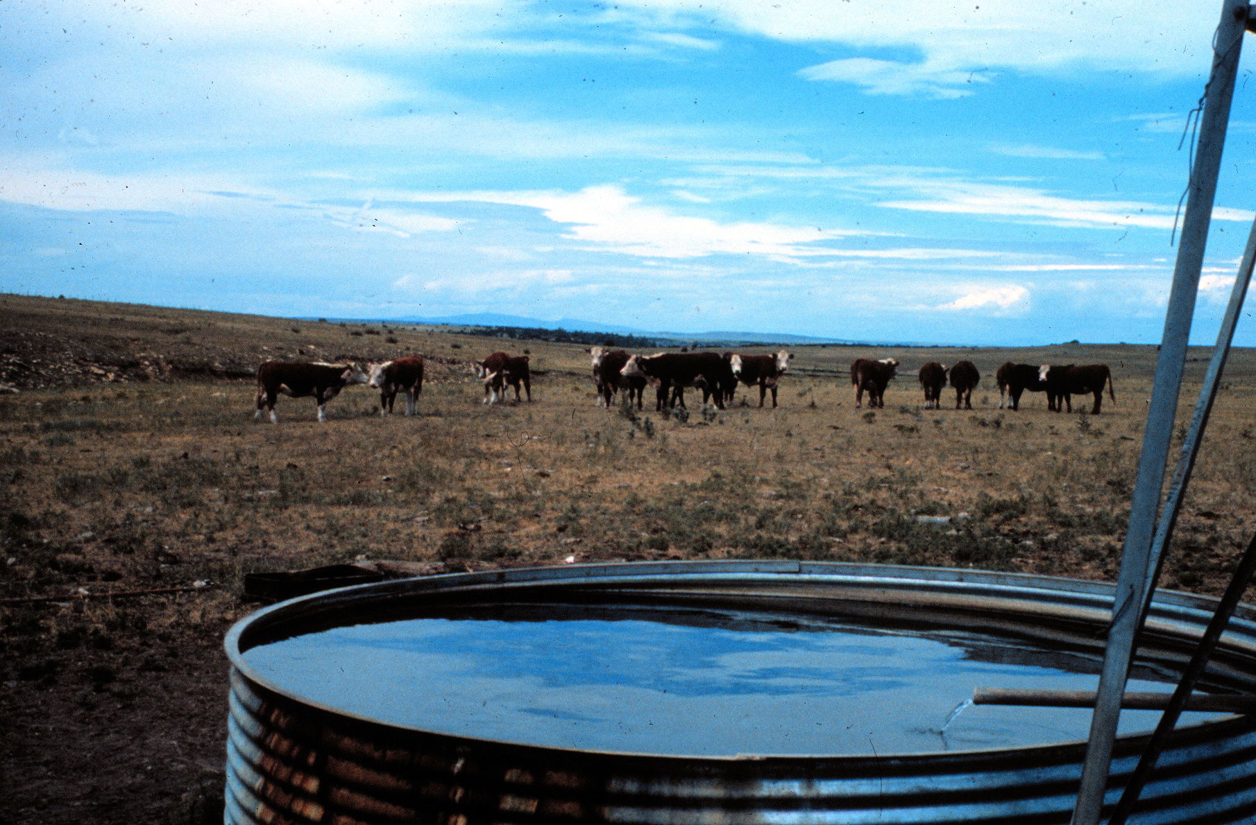

WATERING FACILITY
A watering facility is a trough or tank installed as a livestock watering facility.

PRACTICE INFORMATION
A watering trough or tank provides livestock with drinking water at planned locations that will protect vegetative cover through proper distribution of grazing or other management techniques. The water source(s) may be a well, spring, stream, pond, or other sources including water hauling, in some situations.
In addition to providing livestock water, troughs are sometimes installed to keep cattle out of streams and other surface water areas where water quality is a concern.

COMMON ASSOCIATED PRACTICES
Watering Facility is commonly used as part of a Conservation Management System with practices such as Water Well (642), Pipeline (516), Spring Development (574), and Prescribed Grazing (528).
For further information, refer to the practice standard in the local Field Office Technical Guide and associated specifications and job sheets.

I.2 (-) Overall cost for operator
Watering Facility (614)
D.2 (+) Provide and/or improve water quantity, quality, and distribution for livestock and wildlife
1. Install tanks and troughs
Watering Facility
5/2002
Initial setting: Any area where water is needed for livestock and/or wildlife
C.2 (+) Income and
income stability
(individuals and community)
I.3 (+) Plant productivity and condition
C.3 (+) Health of humans, domestic and wild animals
C.1 (+) Aquatic health of humans, domestic and wild animals
D.1 (+) Control access to streams, ponds, water supplies, and sensitive areas
I.1 (-) Pathogens, sediments, and nutrients to surface waters
I.6 (+) Species diversity
I.4 (+) Livestock food source
Start
LEGEND
#. Created by practice
D. Direct effect
I. Indirect effect
C. Cumulative effect
Pathway
(+) increase; (-) decrease
I.5 (+) Wildlife habitat
Note: Effects are qualified with a plus (+) or minus (-). These symbols indicate only an increase (+) or a decrease (-) in the effect upon the resource, not whether the effect is beneficial or adverse.

