Hopewell Archeology:
The Newsletter of Hopewell Archeology in the Ohio River Valley
Volume 7, Number 1, December 2006
————————————————
1. Excavation of the East Embankment Wall, Hopewell Mound Group: A Preliminary Report
By Mark J. Lynott

There are many famous and well known earthen enclosure sites in southern Ohio, but none has greater name recognition than the Hopewell site itself. With at least 40 mounds, the site is impressive enough, but the presence of more than 4 km of earth and stone embankment walls forming one large enclosure and several smaller ones makes this site clearly worthy of being the type site for this famous epoch in the archaeological record. The site has been greatly modified by nearly two hundred years of cultivation and three major archaeological excavations, but much of the site still has the potential for productive research. This paper summarizes a recent excavation aimed at recording the materials and construction methods of the eastern wall of the main enclosure. Although the embankment walls at the Hopewell Mound Group have fascinated archaeologists for nearly two centuries, this is only the second attempt to document the nature of the earthen wall and ditch.

The first description of the Hopewell Mound Group was provided by Caleb Atwater (1820), who estimated the area within the large enclosure at 110 acres. Atwater observed that it is ”generally twelve feet from the bottom to the summit of the wall, which is of earth. The ditch is about twenty feet wide, and the base of the wall the same. There is no ditch on the side next the river. The small work, on the east side, contains sixteen acres, and the walls are like those of the larger work, but there is no ditch. The largest circular work, which consists of a wall and ditch like those already described, is a sacred enclosure, including within it six mounds, which have been used as cemeteries” (Atwater 1820: 183).

Squier and Davis (1848) described the main enclosure as a parallelogram, 2800 feet by 1800 feet with one rounded corner. They note that the wall along the creek follows the edge of the bank, and contains a lot of water rounded cobbles. The wall along the creek was 4 ft. high in 1846. The north and east walls are 6 feet high and 35 ft. wide at base with an exterior ditch of similar dimensions.

W.K. Moorehead (1922) conducted excavations at the Hopewell Mound Group in 1891 and 1892 for the World’s Columbian Exposition and produced some of the earliest photographs of the site, including this image (Figure 1) of the field camp adjacent to the embankment wall and ditch. Moorehead’s report was not published until 1922, and his published map and description of the mound group rely heavily on the description provided by Squier and Davis (1848).

H.C. Shetrone conducted additional excavations for the Ohio Archaeological and Historical Society from 1922 though 1925. Shetrone described changes in the site since Moorehead’s research, and also discrepancies between what he observed and what previous researchers had reported. Shetrone took note that at the Turner Works near Cincinnati, F.W. Putnam found burials and other features had been incorporated into and under the earthen embankment walls. In addition to excavating mounds, Shetrone conducted exploratory excavations in the walls at the Hopewell Mound Group to determine if similar materials might be present.
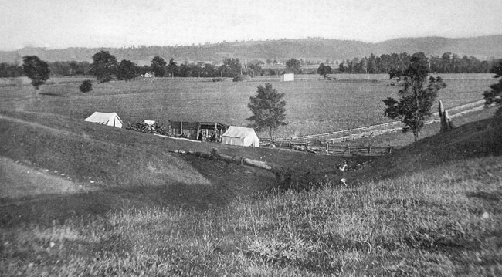
Figure 1. View of Moorehead’s field camp and the main embankment wall and ditch in 1891 or 1892. (Moorehead 1922, plate 38)
Shetrone excavated 200 ft. of the east wall of the main enclosure. He reported that “Upon the original surface were found several unimportant and not well defined fire-beds, which apparently were only incidental to occupation previous to the erection of the wall. Tests at other points revealed nothing” (Shetrone 1926: 112).

After nearly two centuries of cultivation, only the walls of the main enclosure are still visible. Fortunately, geophysical survey has proven to be an effective tool for relocating and mapping earthen walls in this region (Lynott and Weymouth 2002). In 2004, Arlo McKee (2005) conducted a detailed geophysical survey of the area surrounding Mound #23 and the main embankment wall east of Mound #23. McKee surveyed an area 120 m by 60 m with a G858 cesium magnetometer, EM-38 conductivity meter, and RM-15 resistance meter. His data show that although Mound #23 had been thoroughly excavated, the floor at the base of the mound is readily visible (Figure 2). The geophysical data also clearly shows the embankment wall and associated ditch. His study is one of several recent studies of Hopewell earthen enclosure sites in the Scioto Valley which demonstrate that geophysical survey can be an effective tool for relocating earthen architectural features.

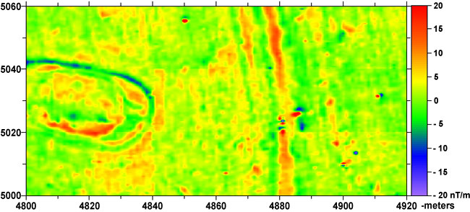
Figure 2. Magnetic map of area surrounding Mound 23 from McKee 2005.
In June 2006, the Midwest Archeological Center excavated a trench across the eastern embankment wall of the main enclosure. The location for the trench was selected after reviewing the geophysical data collected by McKee in 2004. This data indicated that at least part of the earthen wall was intact in this area. An east-west transect across the embankment wall, which runs roughly north-south at this location, was chosen. With assistance from Jennifer Pederson and Kathy Brady-Rawlins, wooden stakes were set to identify the corners for a trench that was potentially 60 m long and 2 m wide.

The width of the trench was excavated as planned, but the length of the trench was reduced to focus our efforts on what remains of the embankment wall and exterior ditch. Consequently, the trench that was actually excavated was 44 m long and 2 m wide. Excavations were done largely with a backhoe (Figure 3). Several small areas of charcoal or discolored soil were identified and left in place for hand excavation (Figure 4). Most of these were later determined to be products of bioturbation, and the two that were probably cultural features do not appear to be related to wall construction activities. One post hole in the wall fill was observed and recorded but it appears to predate the deposition of soils that were used to form the embankment wall.

The north wall of the trench was used to record the soil layers present in the trench, and clearly shows that all of the A horizon and likely much of the B horizon were removed from this area prior to the start of wall construction (Figure 5). This practice would appear to be fairly common in the construction of earthen enclosures in the Scioto River valley, and is well documented from our work at the Hopeton Earthworks (Lynott et al. 2005).

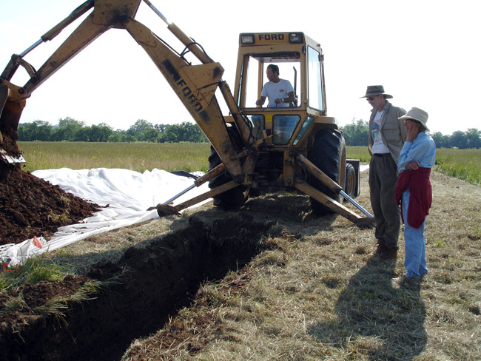
Figure 3. Backhoe excavation of Trench 06-1, June 2006 (photo by Jeanna Boyett).

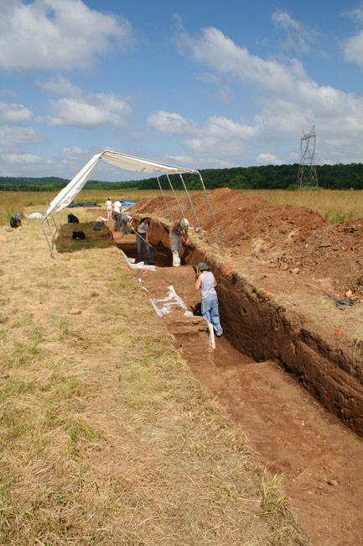
Figure 4. Hand excavation of Trench 06-1, June 2006.

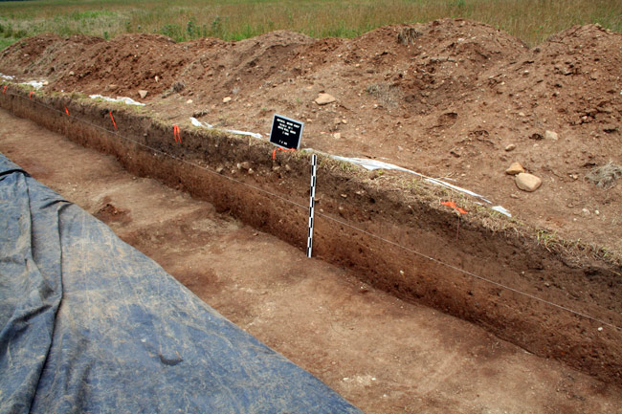
Figure 5. North wall of Trench 06-1 showing basal remnant of the East Embankment wall.

Unfortunately, agricultural activities have severely truncated the wall, so the observations presented here are based totally on the basal remnants of the earthen wall. The primary intact material forming the core of the wall is a yellow-brown loam. This rests on the truncated subsoil and itself has been truncated at the top by plowing. Consequently, it is impossible to determine if this formed the bulk of the wall fill or just the foundation. At the western end of the wall fill, there is a small area of intact wall fill that is comprised of red-brown silt loam with lots of gravel. This layer is quite distinct from the yellow brown wall fill, and the sharp boundary between the two is consistent with the methods of construction that have been recorded in other Scioto River valley embankment walls. We cannot determine if this small remnant of red soil once formed a larger deposit that covered the interior of the embankment wall surface, but this would be consistent with construction approaches at other earthen enclosures in this region.

The western margin of the wall is visible at E4863 as an organic dark gray loam with gravel that is probably a soil that formed on the wall surface and was subsequently covered by wall fill after cultivation was initiated in the nineteenth century. This soil layer rises from west to east and is truncated by the plowzone. A corresponding layer on the eastern side of the wall would have merged with the exterior ditch at about E4874, but evidence of it has been destroyed by cultivation.

The exterior ditch is visible from about E4873.5 to E4878.5. The ditch was excavated down into the loose sand and gravel subsoil on the exterior or east side of the embankment wall (Figure 6). The close proximity to the embankment wall indicates they were likely built at the same time. The sand and gravel subsoil into which the ditch excavated is very loose and unconsolidated. To prevent this material from slumping into the ditch, the builders of this feature lined the ditch surface with a brown clay loam. This was a very tight and stable surface. A dark organic gray loam with charcoal was found on top of the ditch lining. This is a re-deposited layer that likely formed from materials that washed into the ditch after the wall and ditch were built. Soil materials in the ditch above this layer are also re-deposited, possibly after the start of cultivation in the nineteenth century.

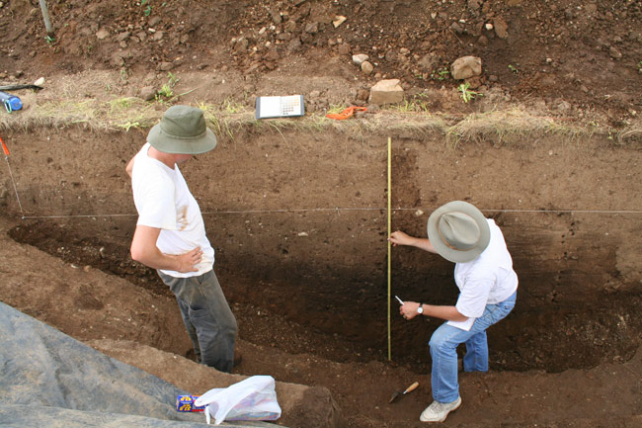
Figure 6. North wall of Trench 06-1 showing Rolfe Mandel and Arlo McKee examining the external ditch in profile.

The great earthen walls that form the enclosures at the Hopewell Mound Group have attracted scientific attention for nearly two hundred years. In 1925, H.C. Shetrone of the Ohio Archaeological and Historical Society excavated 200 feet of the eastern wall of the main enclosure. Shetrone had hoped to discover burials and other features within the fill of the wall. Although he did find features under the earthen wall, they were uninteresting in comparison to the mortuary features he unearthed under the mounds. Shetrone devoted only a few lines in his 1926 report to this wall excavation, and observes that the wall was built with fill from the adjacent ditch.

Years of cultivation have reduced most of the embankment walls at the Hopewell Mound Group to the point where they are barely discernable. Geophysical evidence suggested that at least the base of the wall was preserved in the area near Mound #23, and the test trench excavated in 2006 demonstrated that this is indeed the case. Unfortunately, only the very bottom of the original wall remains undisturbed, but this enough to provide us with some insights into how this portion of the wall was constructed.

The absence of an A horizon under the wall suggests that the top soil from this area was removed before the wall was built (Figure 7). It would seem likely that much of this topsoil was quarried and used in construction of the many mounds at this site. Whether topsoil was quarried across the entire surface of the site is unknown at this time, but it would seem likely that exposing the subsoil was part of the architectural ritual.

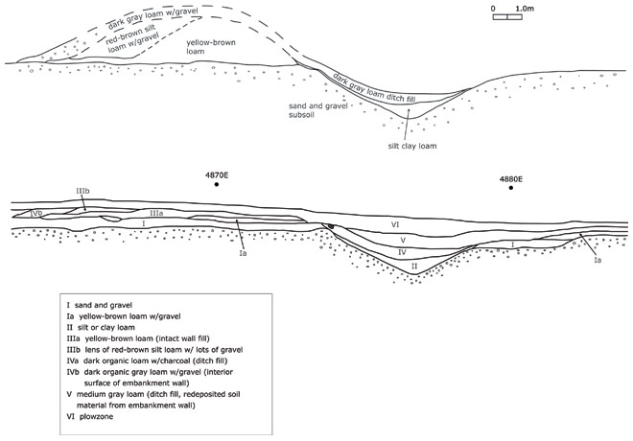
Figure 7. Drawing of north wall of Trench 06-1, and hypothetical reconstruction of original wall strata.

The wall remnant is comprised of two different soils. A yellow-brown loam and a red-brown silt loam with lots of gravel. These two soils do not appear to have been randomly piled together to form the wall, but were kept separate and unmixed. The fill at the base of the mound is definitely not the sand and gravel subsoil material that was quarried from the adjacent ditch. The red-brown silt loam is not present near the ditch and must have been quarried somewhere else nearby. The ditch was dug into loose and unconsolidated sand and gravel subsoil, and the builders lined the ditch with a clay loam to stabilize it. The clay loam also had to have been quarried from somewhere else and brought to this location.

The clay lined ditch is very similar to the ditch recorded by Frank Cowan at the Shriver Circle near Mound City Group (Cowan, Picklesimer and Burks 2006). Cowan believes the clay lining at Shriver was intended to hold water in the ditch, and this may also be the case at the Hopewell site. While analysis is ongoing, the rich soil that formed in the bottom of the ditch may reflect a moist environment. Squier and Davis (1848) speculated that the builders of the earthen walls may have re-directed the flow a stream channel to flow in the ditch of the west wall of the main enclosure. Small springs were present at the base of the hill on the north side of the main enclosure in 1848, and one of these may have been directed to flow in the ditch along the east wall of the main enclosure.

Hopewell earthen enclosures in southern Ohio exhibit many different shapes and the walls vary in size and configuration. Early scholars assumed that walls which were built in association with ditches were built from soil quarried from the ditch. This was likely the case at some sites, but not at the Hopewell Mound Group. While it is likely that the ditch fill was used to build parts of the wall, materials used in the walls appear to have been carefully sorted and not mixed together.

The absence of any dateable features associated with wall construction makes it impossible to determine the absolute age of the embankment wall and ditch. However, it is notable that the removal of the A horizon preceded wall construction at least in the area around Mound #23. If this observation holds true for the entire embankment wall, it is likely that the missing A horizon was used in construction of some or all of the mounds at this site. If that is the case, then the embankment wall and ditch were likely built after mound building was well established at this site. Further research on the embankment walls is clearly needed to determine if the evidence recorded in our 2006 trench is typical of the rest of the site.

References Cited

Atwater, Caleb
1820 Description of Antiquities Discovered in the State of Ohio and Other Western States. Reprinted by AMS Press, Inc. for the Peabody Museum of Archaeology and Ethnology, Harvard University, Cambridge, Massachusetts, 1973.

Cowan, Frank L., John W. Picklesimer II, and Jarrod Burks
2006 The Shriver Circle Earthwork 160 Years After Squier and Davis. Paper presented at the 52 Annual Meeting of the Midwest Archaeological Conference, Urbana, Illinois, October 14, 2006.

Lynott, Mark and John Weymouth
2002 Preliminary Report, 2001 Investigations, Hopeton Earthworks. Hopewell Archaeology, 5:1: 1-7.

Lynott, Mark, John Weymouth, Rolfe Mandel, Rinita Dalan, and Bruce Bevan
2005 Ohio Hopewell Earthen Wall Construction: A View from the Hopeton Earthworks. Paper presented at the 70th Annual Meeting of the Society for American Archaeology, Salt Lake City, Utah.

Warren K. Moorehead
1922 The Hopewell Mound Group of Ohio. Field Museum of Natural History, Publication 211, Anthropological Series, Vol. VI, No. 5, Chicago.

McKee, Arlo
2005 Geophysical Investigations of the Hopewell Earthworks (33Ro27), Ross County, Ohio. Hopewell Archeology 6:2:4.

Shetrone, Henry C.
1926 Exploration of the Hopewell Group of Prehistoric Earthworks. Ohio Archaeological and Historical Quarterly 35: 1-227.

Squier, E.G. and E.H. Davis
1848 Ancient Monuments of the Mississippi Valley. Smithsonian Contributions to Knowledge, Vol. 1, Smithsonian Institution, Washington, D.C.

