residential facilities
United States Government Accountability Office
GAO
Testimony
Before the Committee on Education and Labor, House of Representatives
For Release on Delivery
Expected at 10:00 a.m. EDT
Thursday, April 24, 2008
State and Federal Oversight Gaps May Increase Risk to Youth Well-Being
Statement of Kay E. Brown, Director

Education, Workforce, and Income Security Issues

April 24, 2008
GAO-08-696T

The Honorable George Miller
Chairman
Committee on Education and Labor
House of Representatives

Mr. Chairman and Members of the Committee:

Thank you for inviting me here today to discuss our ongoing work reviewing how state and federal agencies protect the well-being of youth in residential facilities who are receiving services for their behavioral or emotional challenges. Nationwide, federal funding to states supported more than 200,000 youth in government or private facilities in 2004. In addition, an unknown number of youth are placed in facilities by parents or others. These facilities include boarding schools and academies, boot camps, and wilderness camps. Overall, residential facilities play an important role in serving youth who cannot be safely served in their communities while living at home, due to risk of running away or harm to themselves or others. However, recent federal reviews highlighted youth fatalities in residential facilities due to neglect or maltreatment, and ongoing federal investigations continue to document incidents of abuse and neglect in some facilities for youth that in some cases have been severe enough to result in hospitalization or death.

As you know, states are primarily responsible for ensuring the well-being of youth in facilities and other settings, and do so by setting their own standards of care certain facilities must meet to obtain and maintain an operating license. Federal agencies also set requirements for youth well-being that states agree to uphold in exchange for receiving federal program funds, such as those administered by the Department of Health and Human Services (HHS) to support state systems of care for child welfare, mental health, and substance abuse; the Department of Justice (DOJ), for state juvenile justice systems; and the Department of Education (Education), for state education systems. Further, if patterns of maltreatment are identified and found to violate the civil rights of youth in certain facilities that are operated or substantially sponsored by state and local governments, the federal Civil Rights of Institutionalized Persons Act (CRIPA) authorizes the Attorney General of the United States to conduct investigations and bring actions against state and local governments. However, under the current regulatory framework, federal oversight authority does not extend to private facilities that serve only youth placed and funded by parents or other private entities. In some states, safeguarding youth in these facilities is the primary responsibility of parents and facility staff.

My remarks today will focus on the following issues with regard to youth well-being in residential facilities in terms of
(1) what is known about the incidents that adversely affect the well-being of youth in residential facilities,
(2) the extent that state oversight ensures the well-being of youth in residential facilities, and
(3) the factors that affect the ability of federal agencies to hold states accountable for youth well-being in residential facilities.

This testimony was developed using multiple methodologies, and was limited to residential facilities we defined as those that require youth—ages 12 through 17—to reside at the facility and that provide program services for youth with behavioral and emotional challenges. We surveyed three stateagencies—child welfare, health and mental health, and juvenile justice —about residential facilities that were government operated, privately operated that received government funds, and privately operated with no government funding. To further our understanding, we visited four states—California, Florida, Maryland, and Utah—and interviewed relevant officials. These states were selected based on the diversity of their state licensing and monitoring policies for residential programs, reports of child maltreatment, and geographic location. We also obtained data from HHS’s National Child Abuse and Neglect Data System (NCANDS); reviewed federal statutes, regulations, and guidance; and interviewed HHS, DOJ, and Education officials, as well as national association representatives and other experts on residential facilities for youth. The scope of our work did not include the quality of services provided at residential facilities. We performed our work between November 2006 and March 2008, in accordance with generally accepted government auditing standards.

In summary,
- Youth maltreatment and death occurred in government and private residential facilities across the nation, according to states we surveyed; however, data limitations hinder efforts to quantify the full extent of the problem. State-reported data collected by HHS in 2005 showed 1,503 incidents of maltreatment by facility staff in 34 states, including physical abuse, neglect or deprivation of necessities, and sexual abuse. Moreover, 28 states responding to our survey reported at least one death in residential facilities in 2006, with accidents and suicides among the most common types of fatalities. These reported data, however, did not capture information from all facilities. Many states lack authority under state law to collect data on exclusively private facilities, and data that states did report were often incomplete. As a result, the number of adverse incidents was likely more numerous and widespread than reported.
- All states have processes in place to license and monitor certain residential facilities, but states reported oversight gaps that may place youth in some facilities at higher risk for maltreatment and death. Most notably, state agencies exempted some types of government and private facilities from licensing requirements altogether, primarily juvenile justice facilities and private schools and academies. In addition, licensing standards do not always address suicide and other common risks to youth well-being. Although monitoring is key to ensuring facility compliance with standards, agencies in states we visited reported an inability to conduct yearly on-site reviews of conditions at each facility, because of fluctuating levels of staff resources committed by the state. Similarly, although information sharing can strengthen oversight for facilities shared by multiple agencies, many state agencies reported that they did not routinely share information with other state agencies about negative findings or when facility licenses were suspended or revoked.
- HHS, DOJ, and Education all have processes to hold states accountable for the well-being of youth, but federal efforts are hindered by the scope of the agencies’ oversight authority and monitoring practices. Most notably, these agencies do not have the authority to hold states accountable for youth well-being in private residential facilities unless they serve youth in state programs that receive federal funds. For facilities under federal purview, federal requirements did not always address the primary risks to youth well-being, such as suicide, and requirements were inconsistent among programs. In monitoring state compliance, federal agencies did not always include residential facilities in their oversight reviews.

Youth Maltreatment Occurred in Facilities Across the Nation, but Data Are Limited and Not Used to Target Federal Civil Rights Investigations

Nearly all states (49) responding to our survey reported investigating complaints of youth maltreatment in residential facilities in 2006, including facilities operated by government as well as private entities, and located in both urban or rural areas. The types of maltreatment reported by states included physical abuse, neglect or deprivation of necessities, and sexual abuse that sometimes resulted in hospitalization or death. State reported data to NCANDS from 2005 showed that 34 states reported 1,503 incidents of youth maltreatment by facility staff. Of these incidents, neglect or deprivation of necessities was the most frequent cause of youth maltreatment, followed by physical abuse, as shown in figure 1.

Figure 1: Percentage of State-Reported Incidents of Youth Maltreatment by Residential Facility Staff, Fiscal Year 2005

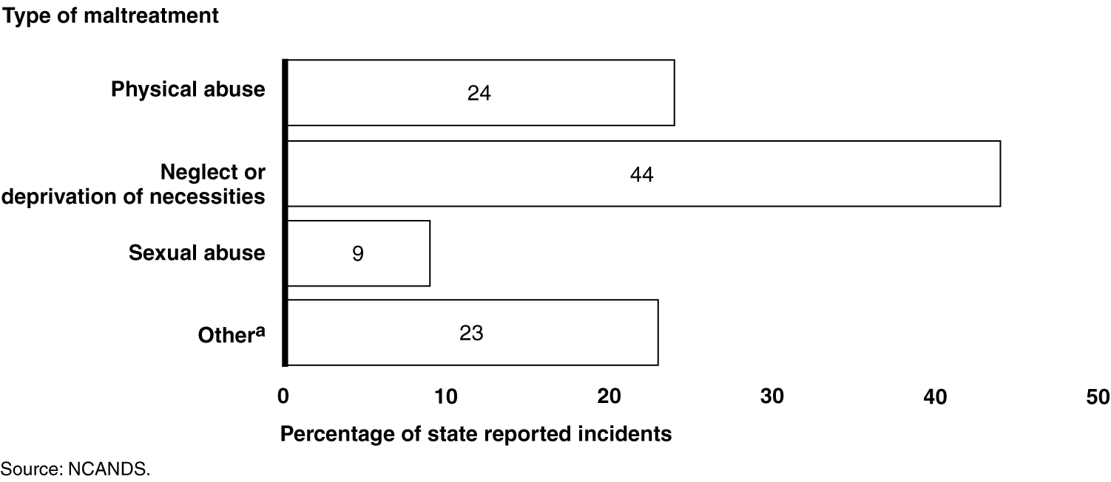
ª“Other” incidents of youth maltreatment states reported to NCANDS include medical neglect and psychological or emotional maltreatment.

Of the states we surveyed, 28 reported that at least one youth had died in a residential facility in 2006. These deaths were primarily due to accidents and suicide, but also due to homicide and application of seclusion and restraint (see fig. 2).

Figure 2: Number of States That Reported Specific Causes of Youth Fatalities in Residential Facilities, 2006

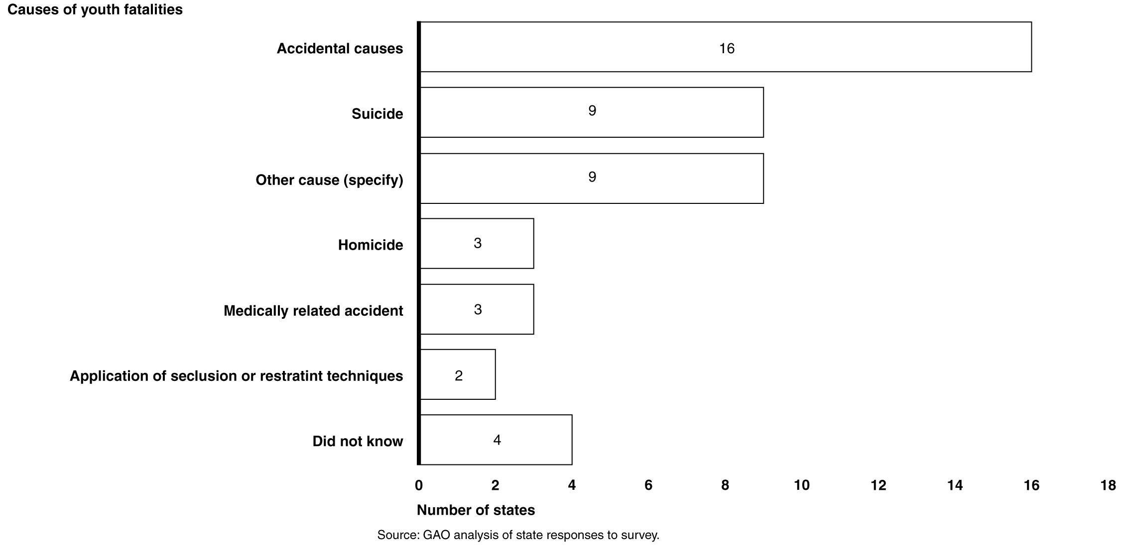
Notes:

The survey question was as follows: Of the total youth deaths that you reported, how many died from each of the following causes: (a) suicide, (b) homicide, (c) application of seclusion and restraint techniques, (d) medically related accident, (e) accident that occurred while in a runaway or absence without leave status, (f) other accidental cause, and (g) other causes?

Other causes of youth fatalities in residential facilities include natural causes, choking, and internal bleeding.

Overall, officials from the states we visited said that the number of maltreatment incidents and deaths was greater than reported due to barriers in collecting and maintaining data. When available, comprehensive reporting of incident data can be used by state and federal agencies to assess the extent of maltreatment in residential facilities, inform risk assessments, target oversight resources, and develop policies to address trends. However, the lack of authority under state law hinders many states from collecting data on certain facilities—such as exclusively private facilities--and expanding oversight to cover them. In addition, states that have such authority reported difficulties sustaining data collection in times of budget shortages. National data in NCANDS for 2005—derived from state reports—suffered from these same limitations, as well as others. First, some states did not report data for residential facilities to NCANDS, so the data may have understated the number of maltreatments and fatalities. Second, many states (37) did not consistently identify whether the individual maltreating youth was facility staff, a parent, or other individual. Last, NCANDS only tracked fatalities resulting from maltreatment, not suicide or accidents that may be an indicator of neglect or other problem that needs resolution.

In the states we visited, youth maltreatment in facilities was attributed to several factors—such as a lack of experienced staff, insufficient staff training, or lack of appropriate supervision—particularly in smaller facilities. For example, county officials in one state told us that adverse incidents were most likely to occur in contractor operated six-bed group homes—frequently used by state probation and child welfare agencies—where the state reimbursement rate is generally not high enough to hire skilled personnel and provide staff with ongoing training, support, and oversight.

However, while in most facilities youth maltreatment may occur infrequently as a result of isolated circumstances, investigations of government and private facilities serving youth conducted under DOJ’s Civil Rights Division (Division) have found a pattern or practice of civil rights violations in some facilities, including physical and sexual abuse, medical neglect, and inadequate education. At the end of fiscal year 2006, the latest year for which data were available, federal investigators reported active cases involving over 175 facilities in 34 states. Annual reports from DOJ over the past several years have documented their findings of youth maltreatment in certain juvenile justice or mental health facilities:

Physical and sexual abuse occurred without management intervention. In one facility, staff hit youth and slammed them to the ground. Staff hog-tied and shackled youth to poles in public places, and girls were forced to eat their own vomit if they threw up while exercising in the hot sun. Staff routinely broke and wired shut the jaws of youth who showed disrespect in another facility. In some facilities, staff engaged in sexual acts with boys. Youth-on-youth violence occurred on an almost daily basis in some facilities, at times resulting in injuries that required hospitalization. Youth were sexually assaulted and threatened with sexual assault by other youth in some facilities, all without effective intervention from management.

Severe neglect resulted in poor education, suffering, and death. In a 1-year period at one facility, three boys committed suicide. In one suicide, staff lacked the appropriate tool to cut the noose from a victim’s neck and also did not have oxygen in the tank they brought to help resuscitate him. The dental clinic at one facility was full of mouse droppings, dead roaches, and cobwebs; medications in the cabinet had expired over 10 years ago. In a state-operated mental health facility used by adolescents, older psychotropic medications, with serious side effects, were administered to sedate patients. One adolescent received 22 such psychotropic sedatives over a 2-month period. In another facility, youth were not provided with special education services as required by federal law.

The Special Litigation Section of DOJ’s Civil Rights Division receives more credible allegations of violations of youth rights than it can investigate. During fiscal year 2006 alone, the Division received approximately 5,000 citizen letters; hundreds of telephone complaints, and 135 inquiries from Congress and the White House. Division officials stated that with additional sources of information, they could better target their scarce investigative resources. Officials said that receiving more detailed information from NCANDS on the incidents of maltreatment and death occurring in specific facilities would be helpful, as would the results of federal agency monitoring reviews of states that highlight findings related to residential facilities. Except in one instance, officials said that no federal agencies—including HHS, Education, and DOJ’s Office of Juvenile Justice and Delinquency Prevention (OJJDP)--were coordinating with the Division to provide pertinent oversight results.

Gaps in State Oversight of Residential Facilities May Place Well-being of Some Youth at Risk

All states have processes in place to license and monitor certain residential facilities, but our survey identified several gaps that allow some of the common causes of youth maltreatment and death to go unaddressed. These gaps include the fact that some types of government and private facilities are exempt from licensing requirements, licensing standards do not always address the primary causes of youth maltreatment and death, and state agencies inconsistently monitor and enforce facility compliance and share their monitoring results.

Certain Facilities Are Exempt from State Licensing Requirements

Licensing all facilities in a state, government or private facilities, can help ensure that residential facilities meet relevant state standards. Among state-operated facilities, however, more than half (28) of juvenile justice agencies reported exempting facilities from licensing. In addition, many state agencies reported that certain types of private facilities were also exempt from licensing, regardless of whether they received some government funding or were exclusively private. Private residential schools and academies—a category that includes boarding schools and training or reform schools—were exempted more often from licensing than other types of private facilities, according to survey respondents. Conversely, treatment facilities were the type most commonly required to have a license. Agencies in 6 states reported they exempted faith-based facilities from licensure. In addition, many agencies reported not knowing the licensing status of certain types of private facilities or reported that they did not have certain types of facilities in their state. Some states are considering laws that would expand their licensing authority for private facilities.

One reason that private residential facilities may be exempt from licensing requirements is that state agencies do not have the necessary statutory or regulatory authority. Regarding residential schools and academies, for example, all agencies in 15 of the 33 states that responded to all three agency surveys reported that they did not have either the authority or the regulatory responsibility to license these facilities.

The lack of licensing for all facilities serving youth has several consequences, in that there are no commonly accepted definitions of facility types. Within individual states, facility operators may bypass state licensing requirements by self-identifying their business as a type that is exempt from state licensing. In Texas, for example, a residential program self-identified as a private boarding school is not regulated by the state licensing agency, but the same facility would require a license if it self-identified as a residential treatment center or therapeutic camp. Inconsistent licensing practices across states can have implications as well. For example, a 2007 directory showed that Utah, which only recently implemented licensing requirements covering wilderness camps, was home to over 25 percent of registered wilderness programs in the United States.

Facility licensing is also important because parents and others considering placing youth in private facilities at their own expense do not always have the information they need to screen facilities and make an informed decision. In our testimony on private facilities last October, we described cases in which program leaders told parents their programs could provide services that they were not qualified to offer, claimed to have credentials in therapy or medicine that they did not have, and led parents to trust them with youth who had serious mental disabilities. One national association for programs serving youth with behavioral and emotional difficulties testified before Congress that state licensing was important because the field does not currently have the capacity to certify facility integrity.

Some states are considering laws that would expand their licensing authority for private facilities, while some use other methods to provide protections for youth. For example, Florida, among other states, include requirements addressing youth well-being in contracts facilities must sign to serve youth under state care. Florida officials estimated that 85 percent of residential facilities in the state’s juvenile justice system are private facilities under contract with the state. The agency uses the contract provisions to help ensure that facilities provide youth with needed services in compliance with agency regulations as well as state statutes.

Accreditation is another method used by some states in lieu of, or to augment, state licensing requirements. For example, Ohio and Wyoming require specific health-related facilities to obtain accreditation instead of licensure as a condition to serving youth under state care. Of the states responding to our survey, a greater number of health and mental health agencies reported requiring facilities to be accredited by private organizations, due in part to conditions of participation for certain federal programs. The accreditation process may require providers to meet higher standards than those required by state licensing bodies; however, accreditation does not necessarily ensure the safety and well-being of youth. Officials from an accrediting organization told us that they do not always inform the state if a facility’s accreditation status has been suspended or limited. In general, fewer states reported requiring accreditation than not across the three agencies we surveyed.

State Licensing Standards Do Not Address Some Primary Risks to Youth Well-being

Our survey results showed that the licensing standards that states have in place for certain government and private residential facilities address many, but not all, of the most common risks to youth well-being that states had identified in our survey. The extent that state licensing standards cover the various aspects of youth well-being is important to safeguard youth from harm. Almost all states reported that when they required licensing, they required facilities to meet standards related to the safety of the physical plant, proper use of seclusion and restraint techniques, reporting of adverse incidents, and qualification requirements and background checks for staff. These standards can help reduce the risk of harm due to accidental causes and staff maltreatment. However, other requirements addressing risks to youth are less often included as a part of licensing. For example, while states reported that almost all juvenile justice facilities are required to have written suicide prevention plans, about a third of state child welfare and health and mental health agencies reported that they do not have similar requirements for government facilities. In addition, most of the agencies in our survey did not require private facilities to have written suicide prevention plans.

State Practices Inconsistent in Monitoring and Enforcing Facility Compliance

State agencies reported monitoring youth well-being in residential facilities, but survey results showed that certain aspects of youth well-being were not included in all monitoring activities, as shown in figure 3. Periodic on-site reviews to monitor and enforce facility compliance helps ensure that licensing standards are taken seriously and that risks to youth well-being are quickly addressed. Among six different aspects of youth well-being we asked about in our survey, the quality of educational programming and use of psychotropic medications were most likely to be reviewed at only some or none of the facilities monitored by child welfare, health and mental health, and juvenile justice agencies. Conversely, staffing issues were most often included in all monitoring reviews of government and private facilities.
Fig. 3: Aspects of Well-Being Monitored by State Agencies in Private Residential
Facilities That Served Youth and Received Government Funding
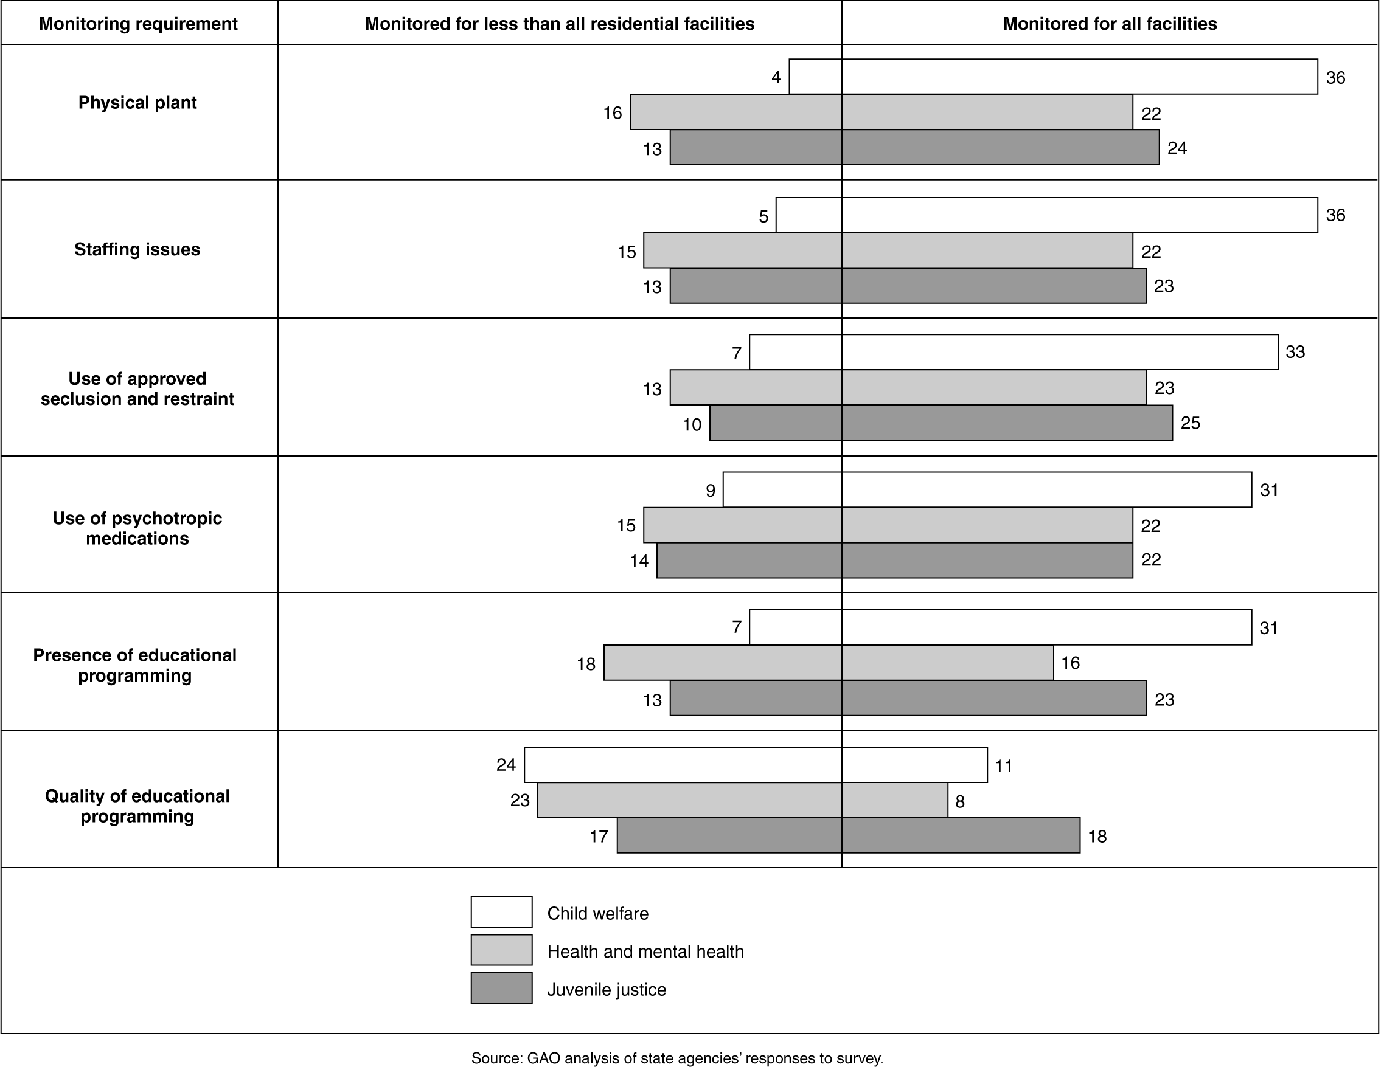
Note: The survey question was as follows: In 2006, did your agency routinely monitor or follow-up, or authorize for monitoring or follow-up, any of the following issues—in the absence of a complaint—at private residential facilities that received government funding providing targeted services for youth? Response options for this question were: (a) yes, monitored for all; (b) yes, monitored for some, (c) no, did not monitor, (d) no such facility in the state, (e) don’t know, (f) no response.

In addition, three of the four states we visited reported that they were unable to meet their goals for conducting annual monitoring visits at residential facilities due to a lack of resources. States reported that visiting facilities was necessary at least once a year, if not more often, to ensure that conditions for youth had not changed due to changes in personnel, ownership, or funding. However, the number of facilities visited each year depended on the fluctuating levels of resources committed by the state. In Maryland, agency officials said that state resources were redirected, as necessary, to meet state goals for monitoring residential facilities for youth. In Florida and Utah, however, agency officials said that imbalances between the current workload and staff resources constrained the state’s capacity to conduct efficient, effective, and timely monitoring of residential facilities. A facility operator in California said that on-site monitoring had been as infrequent as once every 5 years.

State agencies reported taking actions against facilities with identified problems in the last 3 years, but few reported suspending or revoking a facility’s operating license. Options used include increased monitoring or requiring corrective action plans. Maryland state officials said that they may be less likely to close facilities when they fall below state standards if there is a shortage of facilities in the state and closing the facility would limit the state’s ability to serve the youth who would be displaced by a closing. In addition, these officials noted that shutting down a facility is extremely disruptive to the youth who are placed there.

State Agencies Reported a Lack of Coordination to Share Oversight Results

Many state agencies reported that they did not routinely share information with others regarding negative findings from their monitoring reviews. State agency coordination to share monitoring results can strengthen oversight in situations where facilities are used by multiple agencies and can help ensure that youth are not placed in facilities that another agency has already identified as having problems. However, one or more state agencies reported that they did not routinely share reports of adverse incidents (17) or when facility licenses had been suspended or revoked (12).

Improving coordination among agencies across states is also important because almost all states reported in our survey that they placed some youth in out-of-state residential facilities. For example, child welfare agencies in the top 5 states reported placing over 3,500 youth in at least 26 states. Out-of-state placement can be difficult to manage, but may be used when the demand for services exceeds the state’s capacity, particularly for cases requiring highly specialized services--such as therapeutic treatment for youth who committed arson, or who were involved in gangs. State agencies or parents may also place youth in other states where family members reside. Interstate coordination is important is to ensure that agencies sending youth for placement in other states are able to screen out facilities that have had negative findings uncovered during monitoring reviews or have outstanding allegations of maltreatment. Information sharing about adverse conditions in facilities may be particularly important in cases where state licenses cannot serve to help in making appropriate placement decisions. Four of the top 5 states that received the greatest number of out-of-state placements—according to child welfare agencies we surveyed—exempted one or more types of facilities from state licensing requirements.

Federal Agencies Challenged to Address Weaknesses in State Oversight of Residential Facilities

HHS, DOJ, and Education hold states accountable for youth well-being in certain residential facilities, but their scope of authority is limited, and gaps in agency oversight practices result in inconsistent protections for youth. Most notably, these agencies can hold states accountable for conditions in facilities that serve youth through programs supported by federal funds—whether government or private—but cannot hold states accountable for conditions in facilities that are exclusively private. When federal agencies do have oversight authority under certain federal programs, however, they do not always hold states accountable for addressing some of the primary risks to youth well-being. For example, in comparing requirements across HHS, Justice, and Education, only HHS reported requiring states to address abuse and neglect prevention under certain federal programs. (See table 1.)

Table 1: Federal Program Requirements for States that Address Certain Risks to Youth Well-being in Residential Facilities
Agency and program area | Abuse and neglect prevention | Suicide prevention | Use of seclusion and restraint | Education quality
HHS
Child welfare | Yes | No | No | Yes
Medicaid | Yes | Yes | Yes¹ | No
Substance abuse and mental health | Yes | No | No | No
DOJ
Juvenile justice and delinquency prevention | No | No | No | No
Education
Elementary and secondary education | No | No | No | Yes²
Special education and rehabilitative services | No | No | No | Yes²
Source: Analysis of HHS, DOJ, and Education documents.
¹Applies only to psychiatric residential treatment facilities. ²Applies only to public agencies and children placed by public agencies in private facilities.

Federal program requirements are limited even for risks such as suicide, a problem documented by several federal agencies. For example, the Centers for Disease Control and Prevention (CDC)—which is part of HHS—have identified suicide as the third leading cause of death in 2004 among all U.S. youth, and suicide was one of the leading causes of death among youth in residential facilities, as reported by states in this study. In addition, a study commissioned by the Department of Justice recommends increased mental health screening for suicide prevention among incarcerated youth. DOJ officials we spoke with generally agreed with the need to focus on suicide prevention in residential facilities, and suggested that additional federal requirements in this area would be helpful. DOJ and HHS have Web sites that list resources states can use for this purpose, but HHS officials said that states are more responsive to a requirement or more specific agency guidance.

Similarly, federal programs also do not generally require that states ensure the proper use of seclusion and restraint practices, which have come under intense scrutiny in recent years. Researchers and clinicians have chronicled the inherent physical and psychological risks in each use of these types of interventions---including death, disabling physical injuries, and significant trauma. Currently, federal seclusion and restraint requirements cover youth placed in psychiatric residential treatment facilities that receive Medicaid payments. However, requirements do not extend to other types of facilities, and federal officials told us that these techniques continue to be used in ways that sometimes cause injury and death. HHS is preparing a draft notice of proposed rulemaking concerning the use of seclusion and restraint in non-medical community-based children’s facilities.

Federal agencies have several means of oversight for youth well-being, but perhaps one of the most rigorous is unannounced site visits to the youth’s place of residence. According to the federal and state officials we spoke with, only an on-site visit to the facility can reveal whether services in the administrative reports are provided under conditions that ensure youth well-being. For example, DOJ officials observed that students in one of the facilities they visited received their educational instruction while in cages, and reported that it would have been difficult to detect this practice in an administrative review.

Among the federal agencies we reviewed, all included visits to states to ensure compliance with federal requirements, but agencies did not always include visits to residential facilities. DOJ officials target juvenile justice facilities, such as correctional facilities and detention centers, during on-site reviews, but HHS officials do not necessarily include residential facilities in their oversight reviews of state child welfare systems. HHS selects a sample of child case files for site visits, and because most children are in foster home settings, residential facilities are usually not included.

Similarly, while federal programs contain provisions agencies can use to enforce state compliance with federal requirements, these provisions vary in their rigor and use, and only Justice has levied financial penalties. To date, HHS and Education have required state corrective action plans as a method of enforcement, but officials said that they may also assess financial penalties in the future.

Concluding Remarks

As the results of our work show, protecting youth in residential facilities—many of whom are troubled and vulnerable to harm from themselves or from others—requires particular vigilance on the part of parents and responsible government agencies. However, abuse, neglect, and civil rights violations documented in all types of residential facilities—government and private, licensed and unlicensed—show that the current federal-state oversight structure is inadequate to protect youth from maltreatment. Comprehensive results of our work will be included in a report to be released next month. This report will provide some options for action that states, federal agencies, and Congress may consider in any restructuring effort. We anticipate our report will also include recommendations for action that federal agencies can implement now under the existing regulatory structure.

Mr. Chairman, this completes my prepared statement. I would be happy to respond to any questions you or other Members of the committee may have.

Appendix I: GAO Contacts and Acknowledgments

For further information regarding this testimony, please contact me at (202) 512-7215. Individuals making key contributions to this testimony include Lacinda Ayers, Carolyn Boyce, Art Merriam, and Mark Ward.

Our review included facilities that provided services under one or more of the following types of programs: juvenile justice, youth offender, juvenile delinquency, and incorrigibility programs; treatment programs for youth with behavioral, emotional, mental health, and substance abuse issues; homes for pregnant teens; schools for discipline or character education; and therapeutic group homes, such as a home that specializes in supporting and treating youth with severe emotional disorders.
In this report, we use the term states to refer collectively to the 50 states plus the District of Columbia and Puerto Rico. We did not survey state education agencies because they generally do not license residential facilities for youth.
³In fiscal year 2005, 10 states did not submit reports showing the number of fatalities in residential facilities--2 states did not submit a report, 7 states did not track facility incident data in a format that could be shared with NCANDS, and 1 state involved in litigation did not report facility data.
For additional information see U.S. Department of Justice Department of Justice Activities Under the Civil Rights for Institutionalized Persons Act, Fiscal Year 2006, U.S. Department of Justice (Washington, D.C.: 2007).
According to DOJ officials, the Civil Rights Division has been granted access to HHS’s Centers for Medicare and Medicaid Services (CMS) database that contains the annual survey results for CMS oversight of residential facilities.
The survey question was as follows: Which, if any, of the following types of government operated facilities providing residential targeted (child welfare, health mental health, juvenile justice) services for youth are currently exempt from licensing or monitoring in your state by statute or state regulations—state operated facilities? Response options were (a) exempt from licensing by our agency, (b) exempt from routine monitoring by our agency, (c) exempt from both, (d) not exempt from either, (e) no such facility in state (f), don’t know, and (g) no response.
These six states are Arizona, Arkansas, Iowa, Maine, Missouri, and South Carolina. In addition, licensing officials we interviewed in Florida stated that faith-based facilities had the option of being licensed by the state or by a faith-based licensing authority. The survey question was as follows: Which, if any, of the following types of private facilities providing residential targeted services for youth are currently exempt from licensing or routine monitoring in your state by statute or state regulation: Faith-based facilities? (a) exempt from licensure by our agency, (b) exempt from routine monitoring by our agency, (c) exempt from both, (d) not exempt from either, (e) no such facility in state, (f) don’t know, and (g) no response.
Across agencies, states most often responded that they did not have private boot camps, ranches, and wilderness camps. Among state juvenile justice agencies, for example, 25 reported having no private boot camps in their state that received government funding, 22 reported having no ranches, and 17 reported having no wilderness camps. Somewhat fewer states reported not having exclusively private boot camps (19), ranches (17), and wilderness camps (14).
Two of the 15 states—Massachusetts and Utah—have a central agency that is responsible for licensing residential facilities. While we did not receive all three surveys from Texas, it also exempts residential schools and academies from licensing.
GAO, Residential Treatment Programs: Concerns regarding Abuse and Death in Certain Programs for Troubled Youth GAO-08-146T (Washington, D.C.: October 10, 2007)
For example, HHS’s Medicaid program, a federal-state health insurance program for low-income and other specific populations, requires that providers of certain health or mental health services obtain accreditation from an approved accrediting organization to certify that the facility meets standards for safety, quality of care, treatment, and services.
Note: the survey question was as follows: When your agency develops or opens a government-operated residential facility that provides targeted services to youth, is the facility required to meet state standards in any of the following areas? (a) pass inspection of physical plant, (b) provide evidence of safe child care practices, (c) have written procedures for reporting physical or sexual abuse or neglect of youth, (d) meet all staff qualifications requirements, including training, (e) perform staff background checks, (f) meet specified staff-to-child ratios (g) provide evidence of appropriate educational programming, (h) have procedures in place for use of approved seclusion and restraint techniques, and (i) have written suicide prevention plans. A similar question was asked for asked for private facilities.
This derives from Congress’ powers under Article I, Section 8 of the U.S. Constitution and provisions of federal law establishing conditions for state grants. Congress, as part of its spending power, can attach conditions to states’ receipt of federal funds.
National Center on Institutions and Alternatives. Juvenile Suicide in Confinement: A National Survey. February 2004.
This draft notice has been submitted for departmental review and clearance. This rule is being promulgated in response to the Children’s Health Act of 2000 (Pub. L. No. 106-310, tit. XXXII, §3208) (amending Title V of the Public Health Service Act)), which requires that public or private non-medical, community-based facilities for children receiving support in any form from any program supported, in whole or part, with funds appropriated under the Children’s Health Act, shall protect and promote the rights of each resident of a facility, including the right to be free from any restraint or involuntary seclusion imposed for purposes of discipline or convenience. The statute requires HHS to define in regulation the types of facilities covered by this provision’s requirements.
Federal funding was reduced by $1,552,200 among 8 states and territories in 2007.

