A Mesoamerican and Caribbean
Geospatial Alliance
(MACGA)

Project Proposal Presented to the Global Development Alliance
30 April 2003
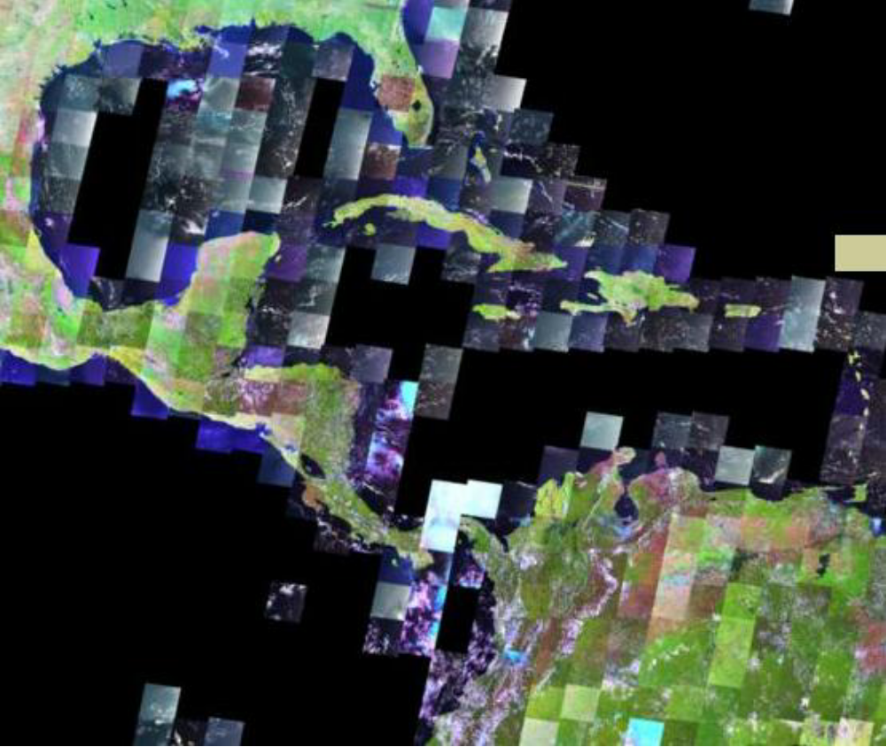
Landsat7 satellite imagery coverage for Mesoamerica and the Caribbean

Eric van Praag, Tom Albright, Diego Pedreros, and Kate Lance
USGS/EROS Data Center and Glenn Hyman CIAT
Submitted by Larry L. Tieszen, EROS Data Center
Tieszen@usgs.gov

April 2003
A Mesoamerican and Caribbean
Geospatial Alliance
(MACGA)

Executive Summary

Most development decisions have a spatial component. Geographic information can greatly assist decision-making and resolve development questions in a wide range of areas, from economic growth, trade, municipal planning and development, and agriculture and food security to humanitarian assistance, environmental conservation, and information technology services.
An important problem confronting decision-makers in the Mesoamerican and Caribbean (MAC) region is that spatial data are often unavailable, generally offer limited geographic coverage, might not be found in usable formats, and in many cases have been developed without the use of consistent standards and in an uncoordinated way. What spatial data that are available are often developed in a project-oriented context and not enough emphasis has been placed on a long-term and sustainable national and regional strategy for building spatial data infrastructure. Moreover, spatial data access is often limited to the highly trained technician, leaving a wide audience of potential users without access.

We propose a Mesoamerican and Caribbean Geospatial Alliance (MACGA), to undertake a concerted region-wide effort, to improve dramatically the return on investment in data collection and to facilitate sustainable networking among alliance members. We will:
- build a regional task force for spatial data infrastructure development in the Mesoamerican and Caribbean (MAC) region and initiate long-term personal and professional networking;
- establish agreements on key standards and practices;
- build and strengthen the capacity of the national and regional organizations to produce, integrate, and share spatial data and incorporate data in Internet map server systems; and
- work through this task force to develop specific national and regional prototype information system products and data sets.
The main objectives of the MACGA are to improve access and distribution of existing and new spatial data sets; foster harmonization and integration of spatial data sets in the region; promote the appropriate use of common standards and methods for spatial data production and sharing; and establish a coordinating mechanism to link data providers among themselves and with data users.
Implementation of the MACGA for the first two years will involve three phases.
- Planning Phase: During this phase a project steering committee and project advisory committees are constituted and plans for capacity-building and product development are put in place.
- Capacity-Building Phase: This phase centers on the organization and hosting of several capacity-building workshops. Participants finalize regional MACGA action plans that guide subsequent work.
- Implementation and Technical Assistance Phase: The U.S. Geological Survey (USGS) EROS Data Center (EDC) and MACGA partners will provide technical support and capacity-building during the life of the project. This will center on providing assistance in the development, implementation, staging, and cataloguing of specific data sets and products described in action plans developed during the capacity-building.
More than twenty partner agencies have announced their commitment to participate. The list includes MAC national mapping and environment agencies, national ministries of agriculture, NGOs, funding agencies, U.N. agencies, research institutions, international development agencies, international agricultural centers, and universities. Each contributes to the alliance objectives in different ways: by funding certain activities, by providing capacity-building, by distributing spatial data sets free of cost, by offering workshop venues, by offering software and training packages, by developing products and deliverables, and by undertaking needed coordination and planning activities. Partners have already pledged to contribute over $2 million in support of the MACGA.

The alliance brings very real and concrete benefits. It provides tools and methodologies for data management to more than 250 MAC specialists, strengthens links among data producing agencies, facilitates data access to a wide audience of non-technical users, offers better data integration and interoperability for regional projects, and assists in the development of specific products such as global map data sets and national Internet map server (IMS) applications.

Our vision is to build a lasting and sustainable spatial data infrastructure in the MAC region that facilitates access and integration of spatial data and through which data duplication is minimized and the incorporation of spatial data into the decision-making process is greatly increased. This project undertakes activities for the first two years of the MACGA to provide the capacity-building, organizational support, and technical assistance needed to sustain this vision and to produce tangible products that demonstrate what this alliance can achieve.

In a few years, a beneficiary of this alliance should be able to sit at a single terminal and call upon the full wealth of spatial data resources collected throughout the region, and indeed, throughout the world!
Table of Contents

A Mesoamerican and Caribbean Geospatial Alliance (MACGA) 1
MACGA: Unleashing the Potential of New Technologies 2
MACGA: USAID Program Synergies 4
MACGA: Implementation Plan 6
MACGA: The Institutional Context 10
MACGA: Expected Outcomes 13
MACGA: Future Plans 14
MACGA: Request for USAID Assistance 15
Appendix A: Key Technologies 17
Appendix B: Capacity Building Technology Topics 18
Appendix C: Capacity Building Associated Presentations 19
Appendix D: Participating Alliance Partners 21
Appendix E: MACGA Global Budget 23
Appendix F: Acronyms. 25

A Mesoamerican and Caribbean Geospatial Alliance (MACGA)

Unprecedented quantities of geographically referenced data are being produced and disseminated in the Caribbean and Mesoamerican (MAC) region, but problems such as limited data accessibility, lack of standards, and a failure to coordinate data management practices mean that the enormous potential value of data is not being fully exploited. Waste occurs when efforts are duplicated to produce the same data over and over again. It is also wasteful when disparate data sources are scattered across the region and rendered effectively inaccessible for decision-making.
At national levels, with donor assistance, substantial efforts are underway to address geospatial data management inefficiencies. These efforts include building capacity, transferring knowledge, and installing technical infrastructure. However, unless and until it is possible to integrate information collected across the region in real time to answer even the most rudimentary transnational analytical questions, much will have been for naught.
We, therefore, propose a concerted effort, regional in scope, to improve dramatically the return on investment in data collection. We will bring together the region’s disparate data collectors and analysts in a common understanding of what is needed to unify their multiple data sources and make them available to wider audiences. We will furnish them the skills and technical assistance to implement their plans. We will help them produce their first unified information products made possible by this newly integrated information infrastructure.
If we are successful:
- An environmental specialist in Guatemala (or even Washington) will call upon data collected in Honduras and El Salvador from multiple agencies in each country, as well as from international satellite data sources, to construct in seconds a color-coded map that at a glance furnishes even the most non-technical policy maker with the latest impacts of deforestation and agricultural production on commerce and family income.
- A public health specialist in Jamaica will be able to call on data on movements of people from immigration services on all the surrounding islands, linked to data on health clinic encounters of new viral infections, as well as environmental factors such as rainfall and hours of sunlight, to develop more effective and immediate strategies to fight epidemics even before they start.
To realize this vision, we propose the following steps:
- Build a Mesoamerican and Caribbean Geospatial Alliance (MACGA) of the region’s key spatial data producers and repositories to coordinate the development of distributed-management, spatially-referenced, and regionally-integrated information systems.
- Through this alliance, establish agreements on the standards and practices for maintaining and sharing data throughout the region so that the desired information systems can be constructed.
- Build and strengthen the capacity of alliance members to implement and conform to the agreed standards and practices necessary for the implementation of the desired regional information systems.
- With standards and practices in place, develop specific prototype information system products. These products will each permit an information consumer in one location to access spatially referenced data maintained on many different servers located throughout the region, all at the same time, in a single query, to produce sophisticated products for enhanced analysis.
More than twenty partner organizations have announced their commitment to participate. The list includes MAC national mapping and environment agencies, national ministries of agriculture, NGOs, funding agencies, UN agencies, research institutions, international development agencies, international agricultural centers, and universities (See Appendix D for a list of participating agencies and Appendix E to review their contributions to the MACGA).

The main objective of the MACGA is to greatly improve access to spatial data, information, and applications to enhance national and regional capacities for better decision-making to face development and environment challenges in the MAC region.

This project has the following specific objectives:
- Provide the capacity-building and technical assistance needed by national and regional agencies and projects to develop specific data sets and applications.
- Facilitate the implementation of integrated national databases for Internet map servers (IMS) in each country.
- Promote the development of public domain digital core data sets at the national and local levels.
- Promote appropriate use of common standards and methods in spatial data production, cataloguing, and dissemination.
- Strengthen existing national spatial data infrastructures (SDI) and cataloguing systems (clearinghouses) and foster the establishment of new ones.
- Help establish a network of peers in the region for professional support and development.
- Improve national capacities for better decision-making and achievement of development objectives.
- Foster harmonization and integration of spatial data sets in the region.

MACGA: Unleashing the Potential of New Technologies

Most development decisions have a spatial component (See Appendix A for a description of each of the key technologies referred to in this proposal). These decisions are related to basic questions about the world around us:
- Which areas are prone to flooding in a municipality? What are the best places to build particular infrastructure?
- Which zones have reported increased encounters with a particular infectious disease in the last 24 hours?
- Which farms produce shade-grown coffee in a particular region?
- What precincts are reporting lower-than-average voter registration in the days leading up to an election?
- How much has the forest cover shrunk in the last 10 years and why?
- Which maize growing areas will see decreased growth due to late rainfall onset?
Answers to these and many other development questions require the use of diverse sets of spatial data. These data sets are typically maintained by different agencies within a country. Truly effective analysis often requires not only the integration of these data sets within a country, but also the incorporation of comparable data across national boundaries.
For example:
- A municipal Geographic Information System (GIS) can assist government staff in locating populated areas prone to flooding and other natural and human hazards, and evaluate economic losses from them, as exemplified by the USGS Mitch municipal GIS product (http://mitchnts1.cr.usgs.gov). The system unites data on population concentrations, historical flood imagery, the location of buildings, roads, power lines, and so on.
- Satellite imagery analysis for detection of forest cover change can be used for biodiversity conservation planning, documentation of carbon dynamics, and certification of low-impact specialty commodity production. EDC has developed a prototype technique for supporting such certification by documenting forest incursion or stability in proximity to specialty coffee production areas. Certification of specialty commodities can help growers and cooperatives obtain premium prices for their crops. The system unites data on coffee production zones, forest cover, the locations of towns and villages, roads, waterways, weather patterns, etc.
- A digital elevation model (DEM) such as that recently developed by the U.S. National Imagery and Mapping Agency (NIMA) under the Shuttle Radar Topographic Mission (SRTM) (a digital map of the world with precise altitude detail) can assist in the planning of infrastructure (i.e. construction of roads, bridges, electric grid, etc.), or in the location of coffee farms in low areas unsuitable for specialty coffee production (www.jpl.nasa.gov/srtm/). High-resolution DEMs can be used to assess landslide risk, define hydrologic basins, estimate sedimentation rates, site facilities, and assist in a host of other development applications. The imagery from the shuttle is linked to data collected on the ground about coffee production and soil types.
- Satellite imagery can be used to detect and monitor harmful invasive species that may have severe economic and environmental consequences. EDC has recently completed a project providing comprehensive monitoring information to assist the efforts of East African governments to combat a destructive water-hyacinth infestation on Lake Victoria. Time series satellite imagery on hyacinth ebbs and flows is linked to data from all three countries around the lake on rainfall and humidity, river flow rates, cloud cover, natural pests, etc.
- Maps with rainfall estimates and other spatial data can provide early warning of flooding hazards or diminished agricultural output, as exemplified by the Famine Early Warning System (FEWS) to be implemented in Central America (http://edcw2ks21.cr.usgs.gov/adds/centralamerica/). Data from orbit will be linked to data collected by field agents who visit communities and inspect covered grain storage, recording anecdotes from farmers about pest infestations, and so forth.
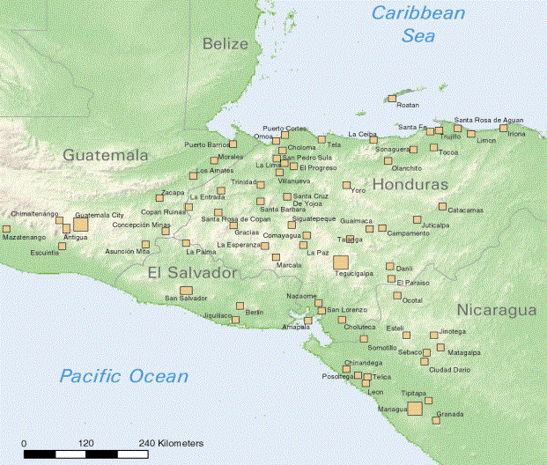
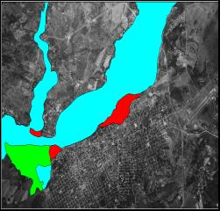
USGS Municipal GIS Project Locations C.A. Municipal GIS hazard map
Note that in each of these solutions, data from a variety of sources, frequently crossing national boundaries, are incorporated in a unified analysis to address complex, multifaceted challenges. These are precisely the kinds of products that will be accessible within the Caribbean and Mesoamerica if we are successful in the present program.
The United States Agency for International Development (USAID) and EDC pioneered the creation of regional spatial data infrastructures (SDI) with their work on the Interamerican Geospatial Data Network (IGDN). More recent developments include a Spatial Data Infrastructure for the Americas (IDEA in Spanish) (www.cpidea.org.co/) and a Global Spatial Data Infrastructure (GSDI) at the global level (www.gsdi.org). The present MACGA program is the logical next step.

MACGA: USAID Program Synergies

The MACGA will complement and enhance USAID programs across multiple sectors:
- In agriculture: by “developing programs which use information and communication technologies to accelerate outreach to farmers, rural communities, agribusiness, and researchers”. For example, an extension agent sitting in a cybercafe in a small town in Honduras should be able to access the latest rainfall data linked to information on pest outbreaks and planting schedules as seasonal weather patterns shift from week to week.
- In conflict relief and humanitarian assistance: by “supporting the capability to provide timely emergency response to disasters worldwide”; and by “strengthening the capacities to prepare for and mitigate vulnerability in disaster situations”. For example, a public health official should be able to call up a map in her office to track a time-series representation of cholera outbreaks in camps for refugees and internally-displaced persons around conflict borders.
- In economic growth and trade capacity building: by “enhancing the capacity of countries to participate in, comply with, and benefit from the global trading system”; by “gaining access and capacity to use new technologies, including information technologies”; and by “supporting innovation and expansion of promising service delivery models, research and dissemination of microenterprise best practices, capacity-building and training activities, and donor coordination”. For example, commodity transporters should be able to identify market opportunities by scanning spot prices in regional markets, linked to data on shipping costs and customs delays through particular transport corridors.
- In environment/energy: by “establishing integrated monitoring and assessment of forest resources to conserve biodiversity and improve forest health”; and by “promoting new initiatives that help communities identify, value, and better manage freshwater and coastal resources under their control”. For example, a forestry monitoring officer should be able to link satellite imagery showing recent forest cuts to region-wide municipal data on legally issued permits, zeroing in on illegal logging.
- In health: by “developing and implementing cost-effective information technology (IT) approaches for addressing global health issues”. For example, a health clinician in one country treating a patient for tuberculosis should be able to call up confidential records (with the patient’s permission as indicated by the patient typing a personal identification number) showing where in the region (even in other countries) that patient was last treated, what drugs were administered, and whether this particular patient has a history of not following long-term treatment regimes.
- In information technology: by developing “pilot programs to demonstrate how information and communication technologies (ICT) can support USAID objectives in education, economic growth, agriculture, democracy and governance, and environment”. This is self-evident from discussions above.

MACGA: Implementation Plan

- Planning Phase

Two regional advisory committees of key, founding MACGA members (one in the Caribbean, the other in Mesoamerica) with their collaborating international partners will identify specific capacity-building needs and establish capacity-building plans. They will convene (physically or virtually) soon after project funding is available.
The committees are directly involved in all project activities: facilitate consensus building, incorporate national and regional needs into the capacity-building, and support the appropriate selection of participants. This point should be emphasized, since it happens frequently, that participants do not meet entry-level technical requirements necessary to benefit from the capacity-building.
The committees issue invitations to the key organizations in their region to join MACGA and participate in the building of specific data sets and applications. These organizations will then be asked to sign a Memorandum of Understanding (MOU) that clarifies the purpose and scope of the Alliance and that incorporates descriptions of the main activities and the parties responsible to undertake them. A first visit to the region by project staff to organize advisory committee meetings will provide an opportunity to discuss and finalize the MOU.
The MOU preparation and approval process provides a valuable opportunity for partners to involve senior management in the project and elevate issues related to spatial data generation and dissemination to a higher political level. Whenever possible, other national institutions not participating directly in the MACGA should be kept informed of project developments.

- Capacity-Building Phase

A series of capacity-building workshops will be implemented. Participants will develop a thorough understanding of the specific needs for regional standards and practices, and agree on appropriate regional protocols (See Appendix B for a description of capacity-building topics and Appendix C for a list of complementary presentations).
The cornerstone of the capacity-building phase for Mesoamerica is a three-week training workshop to be convened at EDC in Sioux Falls, South Dakota. Participants come from national mapping agencies, ministries of environment, ministries of agriculture or national coffee agencies, and regional organizations such as the Central America Commission for Environment and Development (CCAD), the Central American Tropical Research and Training Agricultural Center (CATIE), and the Central American Municipal Federation (FEMICA). Most alliance members will participate in a one or two-day session to illustrate their requirements, evaluate opportunities for data sharing, and conduct a needs assessment for sustainable regional development. All training is to be conducted in Spanish.
The capacity-building phase for the Caribbean rotates around two workshops. A first two-week workshop will be held at EDC facilities, while a second three-day workshop will likely be hosted in association with the Urban and Regional Information Systems Association (URISA) Caribbean GIS conference, to be held in Barbados in January 2003. Participants will be selected from national mapping agencies and national environmental agencies in the Eastern Caribbean and Caribbean Community (CARICOM) countries. U.S. Southern Command (USSOUTHCOM), the Caribbean Disaster Emergency Response Agency (CDERA), and the United Nations Environment Programme (UNEP) -Caribbean Environment Programme (CEP) will consider supporting travel and per diem for their participants. Preliminary details on agenda topics and workshop structure are provided below.
The EDC GIS and remote-sensing training lab has all the facilities and technology required. Twenty-five networked computers allow participants to work individually to enhance their benefits from the training. A guided tour of EDC will provide an opportunity to view one of the key national, as well as international, data centers in operation. Meetings with EDC specialists working on areas of interest to participants can be arranged, as well as remote sensing data and aerial photography acquisition for those interested.
The training venue will offer ample opportunity for colleagues interested in certain topics (e.g. Global Map, clearinghouses, ecosystem maps, Mesoamerican Biological Corridor) to meet and interact. Facilities and equipment will be offered for participants to meet in small ad-hoc groups.
During the workshops, an action plan that clearly delineates activities and deliverables to be produced during the project will be drafted and agreed upon. Direct support will be provided by means of continuous technical assistance and guidance, methodological support, and further capacity building provided by the proposed International Center for Tropical Agriculture (CIAT) - Norwegian Agency for Development Cooperation (NORAD) follow-on workshops.
An important follow-up activity for the MACGA during 2004 is a project to link regional and national geospatial data providers to local users working on the Mesoamerican Biological Corridor (MBC). Project plans also include additional workshops, developing analyses, and providing geospatial data for conservation planning throughout Central America.
Two workshops are being planned in Central America with support of NORAD. The workshops will be direct follow-up activities to the training received in Sioux Falls, including the same Central American officials involved in MACGA. The project includes funding for setting up IMS in the ministries of environment. The IMS servers will focus on providing geospatial information on the Internet to the entire Central American community working on the MBC. This project is currently under review by the Norwegian government.
The CIAT-NORAD proposed project would acquire server computers for participating Central American ministries of environment, solving problems of reduced hardware capacity of national institutions, and complementing the GIS and image analysis software to be provided by the MACGA

- Implementation and Technical Assistance Phase

An action plan that clearly delineates project activities and deliverables will be developed as part of the capacity-building. Mesoamerican and Caribbean participants return to their countries with clear laid-out plans and specific data sets and products to develop. Direct support to action plan activities will be provided by means of continuous technical assistance to be provided by EDC staff, including visits to the region for product review and hands-on training.
This technical assistance facilitates the development of Internet map servers (IMS) that assists data dissemination by initiatives such as USAID’s Quality Coffee Program (QCP), the MBC, and the CCAD Geographic Initiative. It will also facilitate the establishment of a MACGA WEB site and the production of a SDI newsletter for the region.
The MACGA has a long-term vision that includes the establishment of seamless and fully integrated core spatial data sets available on-line, and the creation and/or consolidation of spatial data catalogs (clearinghouses) and spatial data infrastructures.
MACGA partners can work with each country in addressing the institutional and financial barriers to data development. Within a limited budget, the project can provide support for start-up activities, but the countries must develop incentives for all levels of government and the private sector to collaborate in data development and routine updating of data sets.

Time Line

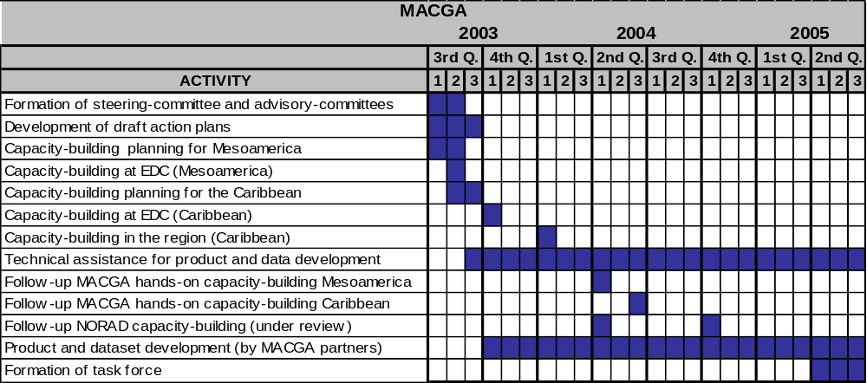
Deliverables

Project deliverables are directly tied to the implementation plan:

- Three training workshops: one for Mesoamerican participants and two for Caribbean participants.
- ESRI Global Spatial Data Infrastructure (GSDI) grant for GIS software and training packages to seven Central American environment agencies (a direct contribution to the MACGA and MBC), similar to those already provided to Central American mapping agencies.
- Global Map prototype data sets produced by all participating countries.
- IMS applications developed by each Central American environment agency working on the Mesoamerican Biological Corridor (MBC).
- New clearinghouse nodes implemented by three participating agencies.
- Upgraded clearinghouse nodes in three participating agencies.
- Three coffee IMS systems and two national IMS applications.
- MACGA action plans (one for Mesoamerica and one for the Caribbean).
- Enhanced Mesoamerican ecosystem map page at EDC International Program Web site.
- SRTM data sets for all participating agencies.
- Landsat data sets for all participating agencies.

Organizational Structure

Project work has been organized in three-levels: a coordination/technical assistance level, an advisory level, and a capacity-building/execution level.

Coordination/Technical Assistance Level: A steering committee, with representation from all MACGA partners, provides overall guidance to the alliance work and supervises this two-year project and subsequent MACGA initiatives. EDC and CIAT provide day-to-day project coordination and guidance, as well as technical assistance to partner agencies developing specific products and data sets. Three EDC specialists and one CIAT specialist with part-time dedication take on these responsibilities, which include: assistance in the formation of the committees, capacity-building organization and planning, technical assistance, preparation of draft project action plans, and establishment of communication channels, among others.

Advisory Level: Two advisory committees are constituted: one for Mesoamerica and one for the Caribbean. The committees provide general advice and feedback, facilitate leveraging of resources and consensus building, and help incorporate national and local needs into the MACGA.

Capacity-Building/Execution Level: Most MACGA agencies participate at this level. Partners select the staff members to represent them in the steering committee and the two advisory committees, select participants for the capacity-building, provide input for the MACGA action plans, coordinate project activities in their own agencies, assist or directly provide training in selected topics, fund project activities, distribute spatial data sets to MACGA members, and develop the applications and data sets agreed-upon during capacity-building and contained in the action plans.

MACGA: The Institutional Context

We propose to build the alliance on a solid foundation. The Mesoamerican and Caribbean region hosts many efforts to take advantage of the kinds of technological developments reviewed above. Several projects undertaken over the last few years have accelerated the production of spatially referenced digital data.
However, most of these projects get to the point of developing data sets, but frequently lack the resources or the mandate to develop them according to agreed-upon standards, to make them interoperable with existing data sets, to integrate them, or to catalog and disseminate them to a wider audience. These projects have laid the foundation. Our challenge is their integration.
In the long run, an analyst should be able to sit at a single terminal and call upon the full wealth of data resources collected throughout the region, and indeed, throughout the world. For this to take place, there must be common ground among all initiatives:
Caribbean Hazard Mitigation Capacity Building Programme (CHAMP)
Implemented by CDERA, the goal of this effort is to develop comprehensive natural hazard vulnerability reduction initiatives through the development of national hazard mitigation policies, creation of appropriate policy implementation programmes through comprehensive hazard mitigation frameworks and the development and implementation of safer building training and certification programmes. (www.oas.org/cdera/champ)

Caribbean Disaster Mitigation Project
The goals of this project being carried out by CDERA include improved flood hazard mapping, enhanced capacity for community disaster management, and the development of disaster information clearinghouse capabilities of CDERA (www.oas.org/en/cdmp).

CarLand Project
The U.S. Forest Service/International Institute for Tropical Forestry (IITF), the Nature Conservancy (TNC), and EDC are collaborating to develop a consistent land use/cover map and database for the insular Caribbean. In Phase II, to be initiated in September 2003, they will begin development of a regional IMS. Landsat data acquired by the project will be distributed to Caribbean participants during the capacity-building process.

CCAD Geographic Information Initiative
This World Bank supported initiative aims to strengthen and integrate GIS systems in Mesoamerica. It will create a regional digital map with 18 thematic layers by digitizing and integrating national data sets, and stage it in an IMS. Its technical committee - with Mesoamerican representatives from national mapping and environmental agencies - has helped design the MACGA and it will provide an appropriate framework for sustaining this initiative and for addressing national and regional needs.

Central American Geographic Information Project (PROCIG)
This regional effort brought together 25 government organizations in Central America to integrate spatial information activities in the ministries of environment and agriculture and the geographical and statistics institutes (www.procig.org). MACGA builds on PROCIG’s focus on spatial data infrastructures.

Global Map
This global initiative is assisting the countries of the world in the production of national GIS data layers: boundaries, transportation, drainage, population centers, elevation, vegetation, land use and land cover; to be integrated into a global map and made available on-line. Central American and Caribbean participation in this effort has suffered due to the difficulty in obtaining the necessary technical capacity required to participate (www.iscgm.org/html4/index.html).

Integrated Decision Support System
USSOUTHCOM, the Pacific Disaster Center, and CDERA are developing an integrated decision support system (IDSS) in the insular Caribbean designed to improve timely spatial data and information access for disaster managers and humanitarian assistance providers.

Interamerican Biodiversity Information Network (IABIN)
This initiative led by the Organization of American States (OAS) is helping establish a continent-wide network of biodiversity information (www.iabin.net).

Land use/cover mapping of the Rio Lempa Basin
Mapping agencies in the Rio Lempa basin (Honduras, Guatemala, El Salvador) with assistance from the French Institut Géographique National have developed a land use/cover map of the Rio Lempa basin.

Mesoamerican Ecosystem Map
The World Bank funded the development of a regional ecosystems map for Mesoamerica in conjunction with local botanists and ministries of environment and intends to integrate it in the future with national and regional data sets. EDC staged the data on the USGS Mitch Program Web site (http://mitchnts1.cr.usgs.gov/data/otheragency.html). The CCAD would like to integrate the new map version produced in 2003 into an IMS.

Projects by the Central American Municipal Federation (FEMICA in Spanish)
The federation sponsors initiatives such as the Central American Archive (Archivo Centroaméricano), e-learning, municipal risk management efforts, cadastral database development, and municipal land use planning that stand to benefit from the MACGA, in particular from the promotion of municipal spatial data development that can be incorporated into GIS tools on the Web.

Regional Centre for Space Science and Technology Education for Latin America and the Caribbean
This UN-affiliated training centre with two campuses, one in São José dos Campos in Brazil and the other in Puebla, Mexico, is responsible for enhancing the capabilities of countries in the region in various disciplines of space science and technology, providing post-graduate level training and also short term training courses in the following four areas: GIS and Remote Sensing, Space and Atmospheric Science, Satellite Meteorology and Global Climate and finally Satellite Communication.

USGS Mitch Program
The Program provided support to Central American countries in the wake of Hurricane Mitch in 1998 (http://mitchnts1.cr.usgs.gov). The USGS and Central American partners produced an array of spatial data sets that MACGA partners can now catalog and incorporate into on-line mapping services. Most data sets were integrated into a municipal GIS package built by the project. More than 70 Central American municipalities received basic GIS training, hardware, and software necessary to operate this system.

USGS-EDC Mitch Clearinghouse project
EDC provided assistance to several national agencies in Honduras, Nicaragua, Guatemala, and El Salvador for setting up national spatial data catalogs and Web sites (review a project site at http://clearinghouse.cnr.gob.sv/metadatos/index.htm).

Other initiatives worth mentioning and that can potentially benefit from or contribute to the MACGA are:
- Mesoamerican Biological Corridor (www.biomeso.net);
- Puebla-Panama Corridor Program;
- Mesoamerican Barrier Reef Program;
- USAID Quality Coffee Program (QCP) – in particular IMS applications now in the planning stages;
- USAID Central American Environment Program (Proarca) (www.proarca.org/sitio/index.php);
- Organization of American States (OAS) Planning for Adaptation to Global Climate Change (CPACC) project (www.cpacc.org).

The proposed MACGA will include governmental and non-governmental agencies working on the Mesoamerican Biological Corridor (MBC) in all seven Central American countries. The MBC is an ambitious regional initiative to link wildlife corridors throughout Central America, enhancing natural habitats, and permitting migration of plants and animals important for biodiversity conservation throughout the region. Under the MACGA umbrella, ESRI will make a major donation of software packages to each of the seven Ministries of Environment responsible for providing geospatial data to the region-wide efforts to develop the MBC.

MACGA’s support for spatial data infrastructures will enhance the efforts of Central Americans to provide vital geospatial data for MBC planning at local, national, and regional levels. Local governments and NGOs need geospatial data for conservation planning in and around protected areas that are part of the MBC, including land use, infrastructure, and settlement planning. National level governments use and provide geospatial data for country-level policy-making related to conservation and sustainable development issues. CCAD is leading the region-wide initiative to link biological corridors, recognizing that conservation planning must account for ecological processes that ignore political boundaries.
Key staff members in all the above-mentioned projects who have been contacted by MACGA coordinators showed considerable support for this initiative and have provided important feedback on the type of capacity-building and technical assistance that will help to sustain their projects – as well as meet wider national needs.

MACGA: Expected Outcomes

The MACGA helps bring spatial data and applications to a wide audience; achieve reduced duplication of effort in spatial data development; lower costs in project data acquisition; increase sophisticated use of spatial data; promote data interoperability; increase use of common standards and methodologies in spatial data production, cataloguing, and dissemination; and improve possibilities for appropriate data integration. Benefits will accrue to the following individuals, organizations, countries and larger communities:
- More than 50 MAC spatial data specialists, by providing them with tools and methodologies necessary for creating and manipulating spatial data sets.
- More than 200 spatial data specialists, by the knowledge and tools acquired by colleagues that attend the training.
- Regional agencies such as FEMICA in promoting generation and integration of spatial data at the municipal level.
- Approximately 14 national geographic institutes and surveying agencies, 14 ministries of environment, and 2 regional institutions, by strengthening links and facilitating common goals and the establishment of a shared vision.
- The Mesoamerican and Caribbean countries, by forging stronger ties among themselves and with leading regional and international institutions.
- The scientific community and the general public, by facilitating the access to data sets that are easily located, of higher quality, correctly catalogued, and accessible.
- National and regional projects producing spatial data, by the possibility of better integrating existing and new spatial data sets.
- Other geographic regions of the world, by serving as a model for regional spatial data harmonization efforts.
- MACGA partner agencies, by achieving and promoting professional relationships that contribute to and advance other initiatives and undertakings.

MACGA: Future Plans

This project lays the foundation for regional integration and interoperability of geographic information in Mesoamerica and the Caribbean. MACGA development continues after this initial period. Partners are already committed to continue working beyond the two-year time frame to make the MACGA vision a reality. Mapping agencies will complete the development of Global Map products and integrate them into IMS systems facilitated by this project; ministries of environment will develop spatial products in support of the MBC; the CCAD will finalize a Central American digital map (eighteen thematic layers) and host it in an IMS; agricultural agencies will consolidate coffee IMS applications as part of the QCP; NORAD and the United Nations Office for Outer Space Affairs (UNOOSA) will offer follow-up capacity-building and technical assistance to MACGA partners, to mention just a few of the initiatives reviewed that continue under the MACGA framework after this project ends.

To facilitate these and other future MACGA initiatives, the steering committee will form a task force consisting of selected on-going geospatial data management initiatives in the MAC region. The task force will have a range of responsibilities:

- Continue and reinforce data management efforts initiated by this project.
- Coordinate follow-up capacity-building and the formation of a network of local trainers.
- Recruit country members for SDI activities.
- Integrate the MACGA with larger SDI initiatives such as IDEA and GSDI.
- Campaign to get political and administrative support by government agencies.
- Develop SDI 'marketing' examples to demonstrate to politicians the benefits of incorporating GIS in planning and policy.
- Investigate and pursue funding opportunities for national and regional NSDI initiatives.
- Monitor data development in the region and help broker partnerships (upon request).
- Issue technical guidelines for data production.
- Keep abreast of and participate in international standards efforts, Internet connectivity and information and communication technologies (ICT) programs in the region, and land administration initiatives in the region.
- Submit bi-monthly report/newsletter to member agencies.
- Seek out new opportunities for collaboration.

If we are successful, the situation in the MAC region could exhibit the following characteristics 10 years from now:

- Spatial data is commonly used to assist decision-making.
- Easy data access is commonplace.
- Basic national and regional digital data sets are available for a nominal cost or free.
- A wide range of map services is available on the Web.
- Any user is able to view and analyze data without the use of specialized software.
- Duplication of effort in data creation is minimal.
- All new data is catalogued and incorporated into on-line catalogs.
- Data development follows common standards and guidelines.
- Governments encourage data production and use.
- The MACGA oversees and coordinates national SDI initiatives.

MACGA: Request for USAID Assistance

Total program cost will be US$ 2,195,250. Of that total, USAID is asked to contribute $229,000. Other participating alliance partners, and the local participating organizations themselves, will cover the remaining costs. See the overall program budget in Appendix E.
USAID specific contributions are for the following:
Planning Phase
- $59,000 for technical assistance to the two regional committees.
Capacity-Building Phase
- $20,000 for capacity-building organization.
- $40,000 for travel costs for the participation of key USAID partners.
- $20,000 for the fees and travel costs of two of the workshop trainers.
Implementation and Technical Assistance Phase:
- $65,000 for the fees and travel costs of several of two experts providing regional onsite and remote technical assistance.
- $25,000 for special assistance in the development of specific regional information products of particular relevance to USAID programs.
We are proposing an enormously complex alliance, with USAID playing a critical and pivotal role in two ways.
First, USAID will provide financial resources for specific activities where USAID has a keen interest and extensive experience. USAID has experience around the world in bringing together stakeholders with diverse interests and backgrounds to develop common frameworks for regional cooperation and development, for example telecommunications regulators in Southern Africa, and energy producers in Eastern Europe. Through the particular participation of USAID’s regional GCAP office, USAID will assure that a key subset of the program’s participants will play critical roles in USAID’s overall development efforts in the region.
Second, USAID is implementing one of the most diverse portfolios of development programs of any donor in the Caribbean and Mesoamerica. USAID is in the unique position of being able to bring together this diversity in ways that assure the maximum usefulness of program outputs, most specifically by focusing on at least one regional information product with particular relevance to USAID programs.
USAID participation is therefore vital to the success of this effort. Although the actual financial contribution requested of USAID is only about 10 per cent of the overall requirement, this contribution simply cannot be replaced by another donor. Financial participation aside, it will not be possible to achieve our ultimate vision without USAID’s institutional contribution to the overall effort.

Appendix A: Key Technologies

The incorporation into the decision-making process of multifaceted data sources, linked through a common spatial reference, has been greatly facilitated by several recent and innovative developments in areas such as geographic information systems (GIS), Internet map servers (IMS), remote sensing, global positioning systems (GPS), aerial photography, videography, spatial data infrastructures (SDI), and information and communication technologies (ICT).
- A GIS is a set of software tools that allow for the creation, printing, editing, combination, analysis, querying, and modeling of spatial data sets and associated tabular data. A GIS provides the tools needed to answer crucial development questions and has become invaluable for decision-makers worldwide. In recent years they have become more common in the MAC region, but lack of technological infrastructure, training, and access to spatial data greatly limit their present use.
- Internet map servers (IMS) are GIS services available directly over the Web that expand the GIS reach from the single user to the multiple users on the Internet (users only need a browser to dynamically make use of and explore geographic information in an IMS). One of its strengths is the capacity to conduct complex queries on GIS spatial and tabular data. The use of IMS is a recent development in the MAC region. Several national agencies have received the software as part of software grants but don’t have the training necessary to put them to good use.
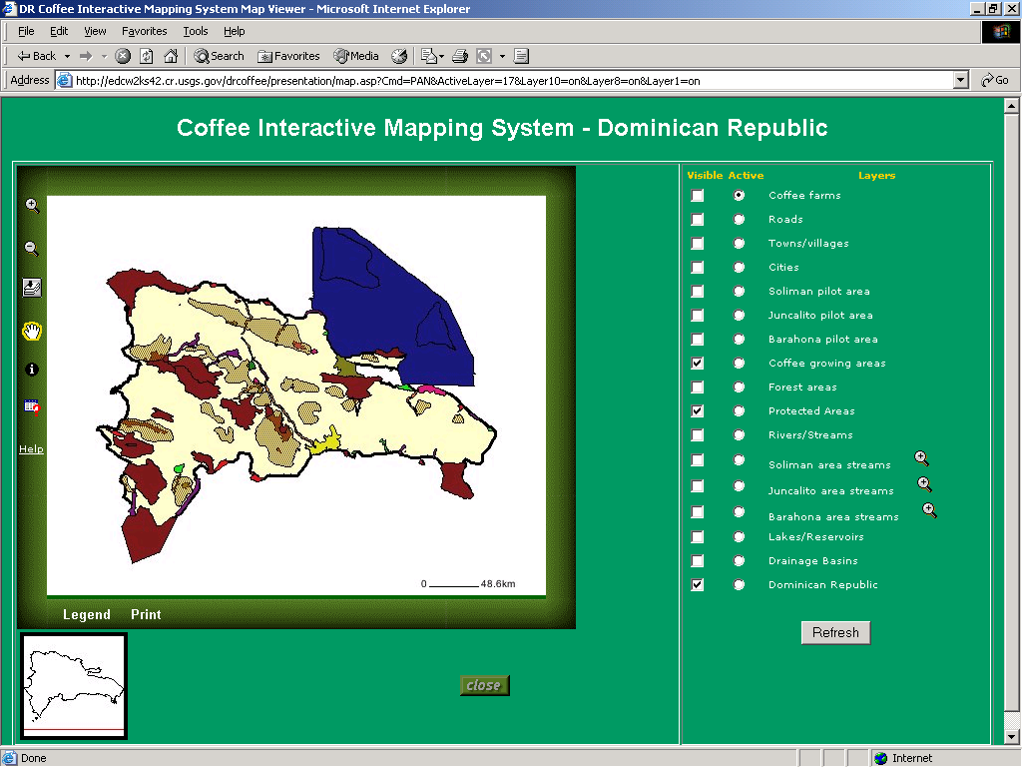
Figure 3. Coffee IMS and query system (www.dominicancoffee.com)
for the Dominican Republic developed by EDC.
- Satellite remote sensing can provide beneficial information for applications in agriculture, urban and regional planning, development, biodiversity conservation, disaster preparedness, and other areas. It offers many advantages as a means of data collection including a synoptic view, consistent and quantified measurements, the ability to detect phenomena not visible to the naked eye, ease of incorporation with GIS, and possibilities for repeat observations.
- Spatial data catalogs complement these technologies by providing mechanisms that facilitate information discovery and retrieval. Spatial data catalogs (also referred to as spatial clearinghouses or clearinghouses for short) contain detailed descriptions (metadata) of spatial data sets searchable by specialized gateways, which provide capabilities that conventional (non-spatial) tools such as Google and Yahoo cannot. Currently, close to 300 clearinghouse servers dot the world and significant advances have been gained in Mesoamerica on this approach.
- A national spatial data infrastructure (NSDI) is a structured and distributed national system for managing geographic information. NSDI encompasses the policies, technologies, standards, laws, and institutional organization for facilitating the acquisition, and use of, and access to geo-referenced information. A good example of this is the U.S. NSDI (www.fgdc.gov/nsdi/nsdi.html), created by executive order 12906. The MACGA will foster the creation of, or the strengthening of, similar mechanisms in the MAC region.

Appendix B: Capacity Building Technology Topics

Topic | Description | Trainer
Global Map | Techniques, methodologies, and tools needed for the development of eight national spatial data layers at 1:1.000.000 scale. Training incorporates basic GIS concepts and an overview of the ArcGIS software package and ESRI line of cartography tools (PLTS). | ESRI
ArcIMS | This three day training session provides an introduction to ArcIMS. During the workshop, participants will review several examples of ArcIMS implementations by EDC, CIAT, and other agencies. It is expected that a few participating agencies implement a local IMS upon return to their countries.  Note: Some agencies such as CCAD and the ministries of environment in El Salvador and Panama have already acquired ArcIMS, and are looking for capacity-building support to develop applications. | ESRI
Minnesota Map Server (MMS) | This public domain IMS offers an alternative for those agencies without access to commercial IMS products. Training covers the basic steps needed to set up and operate MMS. | EDC
Shuttle Radar Topographic Mission (SRTM) | The SRTM data sets consist of global digital elevation models (DEM) at 90 m and 30 m resolution. Some national data sets will be provided during the workshop. The training will cover techniques and methodologies for use of these data and to integrate them with existing digital data sets.  Note: NIMA has agreed to consider providing the 30 m classified data sets to those mapping agencies with active agreements with NIMA as part of the capacity building. | The U.S. National Imagery and Mapping Agency (NIMA)
Spatial data cataloguing | This session covers metadata development, the FGDC and ISO metadata standards, selection of metadata editors, clearinghouse server installation and operation, and clearinghouse node registration.  Participants bring their own data sets and produce metadata for them. Agencies without clearinghouse nodes can choose to register their clearinghouse nodes as part of the training. | EDC
NSDI and  national needs assessments | This session provides an introduction to the NSDI concept and reviews the steps needed to establish an NSDI in participating countries and the challenges of doing so. On-going NSDI initiatives in Mesoamerica and the Caribbean are reviewed to discuss achievements, benefits, and problems. | -EDC  -Federal Geographic Data Committee (FGDC)  -National agencies  -Advisory committees
Spatial Data integration | This open session will offer a chance for participants to discuss regional and national data sets and the steps and challenges faced when integrating them. An emphasis is placed on the CCAD GIS initiative, the Mesoamerican Ecosystem Map and land cover/use mapping in El Salvador and the Caribbean. | Advisory committees
Global Landsat  Data distribution | UNEP/GRID will disseminate the data sets in convenient forms to each country and define a regional center for further distribution and maintenance with the advisory committees and national representatives. Introductory applications focusing on time series comparisons will be presented. | UNEP/Global Resources Information Database (GRID) on behalf of NASA

Appendix C: Capacity Building Associated Presentations

During the capacity-building, participants will have the chance to learn about real applications associated to the agenda topics reviewed above. Daily training sessions will accommodate one or two short presentations on topics of interest to participants, such as the following:

Topic | Description
Conservation planning for the MBC | Country-by-country review by attendees of geospatial data development efforts to support planning of the MBC.
CCAD-NASA-World Bank Geographic Information Initiative | The project is developing and integrating digital maps for Central America. Participants from the region will review current products and plans and discuss deliverables that the MACGA can assist in developing.
EDC and FGDC clearinghouse activities in the MAC region | Review of recent data cataloguing and clearinghouse activities in the region, together with an overview of follow-on activities to recent projects such as PROCIG, Atlas of the Americas (PAIGH), and Mitch Clearinghouse.
Basin and hydrological mapping | EDC has spearheaded global and regional efforts to utilize DEMs and related spatial data sets to delineate river basins and map hydrology, flow, and other hydrological variables.
Methodologies to monitor land cover change | The analysis of multiple dates of satellite imagery offers an unprecedented opportunity to detect and monitor changes in land use and land cover over large areas. This session will provide an overview of the various benefits, issues, and techniques related to this.
Famine Early Warning System Network (FEWS NET) project for Central America | FEWS NET is a multi-disciplinary project that collects, analyzes, and distributes regional, national, and sub-national information to decision-makers about potential or current famine or flood situations.
IMS for the certification of quality coffee farms in MAC | EDC has pioneered the use of GIS, GPS, Web tools, and IMS to map coffee production and provide on-line access and interactive queries of spatial information associated with coffee. EDC projects in the Dominican Republic and Dominica are reviewed, as well as a recent initiative to extend this work into Central America (www.dominicancoffee.com).
Seamless data distribution systems (The National Map) | The National Map is a major USGS initiative offering an interesting long-term model for participating agencies to organize and disseminate spatial data. Seamless data distribution offers on-line access to various themes of spatial data that may be viewed or downloaded for user-defined areas free of charge (http://seamless.usgs.gov).
Fire hazard mapping | Techniques developed at EDC and associated centers help monitor fire hazards by combining various spatial data sets such as vegetation coverage, type, and structure.
Applications of new remote sensors (MODIS, ASTER, IKONOS), | In the past five years, the number and variety of space-borne remote sensors available has increased dramatically. This session will provide an overview of these new sensors and what they have to offer. Most importantly, it will give participants tools to better decide which instruments would be the most appropriate for use in a variety of situations. http://modis.gsfc.nasa.gov/  http://asterweb.jpl.nasa.gov/default.htm
Applications of de-classified satellite images (i.e. Corona) | Not only does the EDC archive offer recently declassified intelligence satellite photography, it is among the foremost users of these data for documenting changes over the past 40 years. This session will describe how these data can be used for historical analyses and documentation of trends in land use/cover (http://edc.usgs.gov/products/satellite/corona.html).
Overview of NSDI activities in the MAC region | MACGA partners such as EDC, CIAT, and CCAD present latest developments in the MAC region on the formation and activities of NSDI committees. A review of successful experiences and the possibilities to replicate them in other countries is undertaken.
Hand-held devices for spatial data collection in the field | EDC staff present the latest developments in tools such as hand-held computers and GPS that can assist spatial data collection in the field.
Interoperability in standards | The FGDC presents the current status of geographic information standards and specifications, issues, available software solutions, and future developments that are necessary for compatible SDI development.

Appendix D: Participating Alliance Partners

This section offers a brief overview of current members of the MACGA. Partners have been directly involved in all aspects of planning and preparation for the project and share MACGA´s goals and objectives:

Caribbean Disaster Emergency Response Agency (CDERA): A regional intergovernmental agency charged with providing an immediate and coordinated response to disastrous events. Among its functions is to establish and maintain response and preparation capabilities within member states (http://www.cdera.org/).

Central America Commission for Environment and Development (CCAD in Spanish): Environmental arm of the Central American Integration System (SICA in Spanish). It coordinates regional initiatives focusing on issues such as climate change, common watershed management, and conservation of protected areas like the Mesoamerican Reef System and the MBC (http://ccad.sgsica.org).

E Team, Inc.: E Team provides enterprise-level collaborative software to public agencies and corporations for use in emergency response management, facility and event security, disaster preparedness and recovery, and business continuity (www.eteam.com).

Environmental agencies: These are the main agencies in each participating country in charge of environmental matters. Most are planning to send representatives for capacity building.

ESRI: Leading provider of GIS and mapping solutions (www.esri.com).

International Center for Tropical Agriculture (CIAT): A Consultative Group on International Agricultural Research (CGIAR) member center based in Colombia and specializing in agricultural productivity and natural resource management. CIAT has ample experience working in the MAC region and has offices in Honduras, Nicaragua, Haiti, and Costa Rica (www.ciat.cgiar.org).

Ministries of Agriculture: Some of these institutions ,together with national coffee boards, will select and send representatives that can benefit from the capacity-building to implement Coffee IMS applications to be developed in conjunction with USAID Quality Coffee Program.

National mapping agencies: Each MAC country has officially tasked a specialized agency for the production and dissemination of spatial data. Each agency will send one representatives for the capacity building associated with MACGA.

National Imagery and Mapping Agency (NIMA): U.S. military agency in charge of cartographic production and spatial data development (www.nima.mil).

Norwegian Agency for Development Cooperation (NORAD): Norway’s agency in charge of international development assistance (www.norad.no/).

Organization of American States (OAS): Regional body working on strengthening democracy, advancing human rights, promoting peace and security, expanding trade, and tackling complex problems caused by poverty, drugs, and corruption (www.oas.org).

The Nature Conservancy (TNC): The goal of TNC is to preserve the plants, animals, and natural communities that represent the diversity of life on Earth by protecting the lands and waters they need to survive. TNC has major involvement in the MAC region and ongoing collaborations with several MACGA partners (www.nature.org).

United Nations Office for Outer Space Affairs: A UN agency within the UN Secretariat responsible for implementing the UN Programme on Space Applications, focusing on helping developing countries take advantage of the benefits of space technology. In particular UNOOSA has been developing since 2000 a Programme on Space Technology and Disaster Management contributing towards countries in the region to incorporate the use of space technology for disaster management.

UNEP GRID Sioux Falls: UNEP GRID Sioux Falls office is a center of remote sensing and land assessment expertise within the United Nations Environment Programme (www.na.unep.net).

USAID: U.S. agency in charge of international development assistance.

U.S. Federal Geographic Data Committee: U.S. interagency committee in charge of developing the NSDI. It promotes the coordinated use, sharing, and dissemination of geospatial data and provides Secretariat support for the GSDI (www.fgdc.gov).

U.S. Forest Service/International Institute for Tropical Forestry (IITF): Part of the U.S. Forest Service, the IITF is dedicated to forestry on an international level. IITF has collaborated with several other MACGA partners and has worked in many of the MAC countries (http://www.fs.usda.gov/global/iitf/).

U.S. Geological Survey/EROS Data Center (EDC): The EDC is designated as a World Data Center for Remotely Sensed Land Data and is a cooperator in several domestic and international programs. EDC has been contributing to projects in the MAC region for several years (http://edc.usgs.gov).

U.S. Southern Command (USSOUTHCOM): The humanitarian assistance program of USSOUTHCOM has a long history of serving the MAC region. It assists states in the region with disaster preparedness and response (www.southcom.mil).

University of the West Indies (UWI) Center for Geospatial Studies: Its mission is to foster multidisciplinary research and development in geospatial studies and to promote the informed utilization of geographic information systems, remote sensing, global positioning systems, and spatial analysis techniques in the Caribbean.

World Bank: Leading global financial institution (www.worldbank.org).

Appendix E. MACGA Global Budget

Organization | Contribution | Valuation (estimates)
CDERA | Airfare and per diem for up to 12 attendees from the CARICOM region (under review) | $36,000
CIAT | Provides ESRI certified instructor for ArcGIS and ArcIMS training at Sioux Falls workshops, participates in strategic planning for the alliance, implements follow-up workshops for MBC under proposed NORAD funding. | $46,250
Dot-ORG (request to USAID/EGAT Information Technology Team) | Pilot activity to build capacity and develop a specific integrated data product of particular relevance to a USAID program. | $50,000
EDC  (USAID/GCAP) | Airfare and per diem for 6 representatives from Central American and Dominican Republic Ministries of Agriculture (or coffee agencies) | $19,000
EDC | Training facility with 25 computers, LAN services, technical support, Landsat 7 ETM+ imagery, EDC speakers. | $50,000
EDC (request to USAID GDA) | Organization of advisory committees,  general workshop organization, trainers, follow-on technical support. An additional $25,000 is anticipated from J. Cochrane for a total of $185,000. | $160,000
ESRI | GSDI grant to approximately 25 participating MACGA institutions. Each grant package includes: a copy of the ArcGIS system (ArcInfo 8.1, ArcSDE 8.1, and ArcIMS), maintenance (technical support and upgrades), free Virtual Campus training for one student for selected classes, course on building and publishing a national base map, one free pass for the annual ESRI International User Conference. (25 institutions, $50,000/institution) | $1,250,000
E-team | Demonstration related to geotechnology and emergency services (under review) | $16,000
National Agencies | Participation, staff salaries, and other support ($5000 per institution)  Note: National agencies include ministries of environment, ministries of agriculture, and mapping agencies. | $250,000
NIMA | Salary, airfare and per diem for one of their trainers to attend two workshops | $12,000
NORAD | Organization of two follow-up workshops for Mesoamerica (under review) | $199,000
UNEP/GRID and NASA | “International Distribution of Landsat Data sets” on hard drives or other media, presentations of applications | $7,000
UNOOSA | Promotion of expert meeting in 2004 on the importance of MACGA in the area of space technology and disaster management. Its regional centre would be available to provide long-term training to MACGA partners (under review). | $20,000
USSOUTHCOM | Airfare and per diem for up to 10 attendees from the Eastern Caribbean (under review) | $30,000
University of the West Indies (UWI) Center for Geospatial Studies | Provide regional and local training, facilitate on-going technical support, and coordinate related Caribbean regional activities. | $30,000
World Bank, CCAD | Airfare and per diem for 8 Mesoamerican representatives | $20,000

Appendix F: Acronyms

ArcIMS Internet map server software developed by ESRI
CARICOM Caribbean Community
CATIE Central American Tropical Research and Training Agricultural Center
CCAD The Central America Commission for Environment and Development
CDERA The Caribbean Disaster Emergency Response Agency
CEP Caribbean Environment Programme
CGIAR Consultative Group on International Agricultural Research
CIAT The International Center for Tropical Agriculture
CPACC Caribbean Planning for Adaptation to Climate Change
CP-IDEA Permanent Committee for the Spatial Data infrastructure for the Americas
DEM Digital Elevation Model
EDC USGS EROS Data Center
ESRI Environmental Systems Research Institute
ETM Enhanced Thematic Mapper
FEMICA Central American Municipal Federation
FGDC U.S. Federal Geographic Data Committee
GIS Geographic Information Systems
GPS Global Positioning System
GSDI Global Spatial Data Infrastructure
IABIN Interamerican Biodiversity Information Network
ICT Information and Communication Technologies
IDEA Spatial Data infrastructure for the Americas
IITF The U.S. Forest Service/International Institute for Tropical Forestry
IMS Internet map server
MAC Mesoamerica and the Caribbean
MACGA Mesoamerican and Caribbean Geospatial Alliance
MBC Mesoamerican Biological Corridor
MODIS Moderate Resolution Imaging Spectroradiometer
NIMA The U.S. National Imagery and Mapping Agency
NORAD The Norwegian Agency for Development Cooperation
NSDI National Spatial Data Infrastructure
OAS Organization of American States
PAIGH Pan American Institute of Geography and History
PROCIG Central American Geographic Information Project
QCP Quality Coffee Program (USAID)
SDI Spatial Data Infrastructure
SIAM Central American Environmental Information System
SRTM Shuttle Radar Topographic Mission
TNC The Nature Conservancy
UNEP United Nations Environment Programme
UNEP/GRID The UNEP/Global Resources Information Database
UNOOSA United Nations Office for Outer Space Affairs
USGS U.S. Geological Survey
USSOUTHCOM U.S. Southern Command
UWI University of the West Indies

Taken from the GDA annual program statement

