SONGBIRD MONITORING - CONSTANT-EFFORT MIST-NETTING

INTRODUCTION

In the past few decades, much concern has been raised about the sharp and widespread population declines of songbirds. In the early 1990s, the Partners in Flight (PIF) program began an attempt to enlist a concerted effort among academic, government, and private sector scientists and managers to understand the causes of, and then reverse, songbird declines. Through this program, many important underlying causes of declines have been identified, followed by successful strategies to protect songbirds and their habitats. The National Park Service has contributed an active role in the PIF program since its inception.

The Lassen region is critical to efforts to protect declining songbirds. The area supports diverse bird communities including half of the PIF-listed Species of Conservation Priority and all the species listed by the Sierra Nevada Ecosystem Project report as declining or likely declining (Graber, 1996). Neotropical migrants are an especially important avian group which are presently well-represented in the Lassen region but continue to show alarming declines elsewhere.

Constant-effort mist-netting data collected during the breeding season provides an annual index of abundance, productivity, and survivorship (DeSante and Guepel 1987). Data can indicate whether populations are sources (reproductive success is sufficient to balance mortality) or sinks (mortality exceeds local production of young), and whether existing conditions are capable of supporting breeding populations (Nur and Geupel, 1993).

PROJECT HISTORY

From 1997-1999, Lassen Volcanic National Park (LVNP), Lassen National Forest (LNF), and the Point Reyes Bird Observatory (PRBO) conducted a 3-year study of the songbird communities in selected areas of the park and the forest. The purpose of this project was to evaluate the health of existing bird populations, identify areas important to sensitive and declining species, and provide recommendations to enhance declining populations. All data collected during these efforts were done so in accordance with standard methodologies and were contributed to national monitoring programs including Monitoring Avian Productivity and Survivorship (MAPS) and Breeding Biology Research and Monitoring Database (BBIRD).

During all years of the project, intensive training in standard methodologies (especially constant-effort mist-netting and point-counting) was provided to LVNP and LNF field staff by PRBO ornithologists to facilitate continuation of the project beyond the 3-year pilot period. At the conclusion of the study in 1999, the Drakesbad mist-netting station was converted to a permanent MAPS station as part of the park's long-term monitoring program. This year marked the tenth full year of constant-effort mist-netting at Drakesbad.

METHODS

Mist-netting procedures were conducted according to the protocols described in Ralph et al. (1993). See Table 3 for a summary of days of operation. Nets were located approximately 50 meters apart and were operated during the breeding season approximately once every 10 days (Figure 4). Nets were opened 15 minutes after local sunrise, checked every 30 to 40 minutes, and operated for five hours. Birds captured were removed from the nets and processed immediately on-site. Each bird captured (except hummingbirds and game birds) received a U.S. Fish and Wildlife Service band for permanent identification and to allow estimates of survival from subsequent recaptures. Age, sex, skull ossification, breeding condition, fat score, molt, flight feather wear and fade, wing length and weight of each bird were recorded as described by Pyle (1997). All data are stored in FOXPRO databases and analysis programs developed by PRBO.

Table 3. Summary of breeding season net results from 1997-2006 at Drakesbad

 | Days of Operation |  |  | No. of Captures¹
Year | Total | Range | Total  Net Hrs. | B | U | R | Birds/ 100 Net Hrs. | Number of  Species
1997 | 6 | 6/16-8/1 | 315 | 169 | 39 | 39 | 78.41 | 20
1998 | 4 | 7/7-8/4 | 200 | 127 | 23 | 37 | 93.5 | 24
1999 | 7 | 6/8-8/5 | 336 | 147 | 38 | 72 | 76.5 | 23
2000 | 7 | 6/5-8/3 | 247 | 143 | 39 | 46 | 92.3 | 27
2001 | 7 | 6/7-8/9 | 313.5 | 190 | 59 | 56 | 97.4 | 27
2002 | 7 | 6/4-8/6 | 350 | 217 | 21 | 71 | 88.3 | 24
2003 | 7 | 6/5-8/7 | 349.5 | 199 | 25 | 66 | 83.0 | 31
2004 | 7 | 6/3-8/5 | 350 | 217 | 43 | 58 | 90.8 | 30
2005 | 7 | 6/10-8/4 | 335 | 171 | 13 | 64 | 74.0 | 26
2006 | 7 | 6/7-8/3 | 350 | 301 | 50 | 53 | 115.4 | 31
¹ B = banded, U = unbanded, R = Recapture

RESULTS

The national average for number of individuals captured per 100 net hours, from 410 MAPS stations, was 37.2 in 1996 (DeSante et al., 1998). Drakesbad consistently has capture rates well above the national average. Productivity indices (juvenile to adult ratio) by species are presented in Table 4. These results indicate high productivity (defined here as ratios ≥ 0.30) for many breeding species, in particular several riparian species such as neotropical migrants MacGillivray's Warbler (Oporornis tolmiei) and Wilson's Warbler (Wilsonia pusilla), in addition to Song Sparrow (Melospiza melodia) (Figure 3). This is noteworthy because two of these species, Wilson’s Warbler (W. pusilla) and Song Sparrow (M. melodia), are showing marked declines throughout their ranges and are both listed by PIF as Species of Concern.

Suvivorship analysis for Drakesbad was conducted in 2004 by PRBO. For Wilson’s Warbler (W .pusilla) the survival rate was 33% for females and 68% for males (Gardali et al. 2004). The MAPS N.W. region estimate for this species was 45% (Gardali et al. 2004). For Song Sparrow (M.melodia) the survival rate was 49% for females and 57% for males (Gardali et al. 2004). The MAPS N.W. region estimate for this species was 47% (Gardali et al.. 2004). MacGillivray’s Warbler (O. tolmiei) had a survival rate of 42% for females and 48% for males (Gardali et al.. 2004). The MAPS N.W. region estimate for this species is 49%. It is interesting to note the difference between male and female survival rates for all three species. The females survival rates for all three species are lower than the males. It is hypothesized that this is due to the stress levels endured by females that take on the majority of the effort during the breeding season in terms of egg production and incubation (Gardali et al. 2004). This data suggests that with the relatively high survival rates for these species, Drakesbad is high quality habitat.

Data continue to show the importance of the Drakesbad area for dispersing hatch year birds, such as Orange-crown Warbler (Vermivora celata) and Rufous Hummingbird (Selasphorus rufus). Neither of these species breeds at Drakesbad but dispersing juveniles use the area to forage. This year 36 hatch year Rufous Hummingbirds and 112 hatch year Orange-crowned Warblers were captured. Six after hatch year Orange-crowned Warblers were also captured this year.

Between year recapture has revealed important data on site fidelity and longevity. One Wison’s Warbler was recaptured that was originally captured in 2000 and aged as an after second year bird. This would mean this bird is at least eight years old. One Warbling Vireo was recaptured in 2006 that was originally banded in 2002 as an after hatch year. This indicates this bird is at least five years old. One Western Wood-pewee was recaptured in 2006 that was originally banded in 2003 as an after second year. This bird would be at least 5 years old. All other birds that were recaptured in 2006 were originally banded in 2004 or 2005 or 2006.

Two new species were also recorded this year. One after hatch year female Brown-headed Cowbird (Molothrus ater) was captured on June 14th and one hatch year House Wren (Troglodytes aedon) was also captured on August 8th. Both of these species may occur in the park during the summer. Brown-headed Cowbirds are usually associated with open disturbed areas in lower elevations throughout the central valley, foothills, and great basin (Burnett et al., 2004). In the park they are found in montane shrub and riparian habitats where it parasitizes the nests of other birds (Burnett et al. 2004). House Wrens use the park for juvenile up mountain dispersal after hatching in lowland areas outside of the park.

FUTURE DIRECTION

Long-term data collection from the Drakesbad station will continue indefinitely as a part of the park’s developing inventory and monitoring program. Development of the Monitoring Concept Plan in 2000 will guide the park in planning comprehensive, long-term programs for monitoring bird populations (Humple et al., 2001). This plan recommended that the park combine mist-net data collection with relative abundance monitoring — using Variable Circular Plot (VCP) point counts — of bird populations in other areas of the park. In addition, recommendations were made to consider the establishment of 1 to 2 more mist-netting stations. This approach is in accordance with direction from the NPS Inventory and Monitoring program which states “the most effective and useful avian monitoring programs will be those that incorporate multiple, complementary approaches — population distribution and trend monitoring through Variable Circular Plot Points Counts, and determination of vital rates through constant-effort mist-netting” (Fancy and Sauer, 2000).

The Lassen National Forest plans to continue operating the Gurnsey Creek mist-net station, companion station to Drakesbad during 1997-2006. Resulting datasets will add greater resolution and value to Drakesbad data.

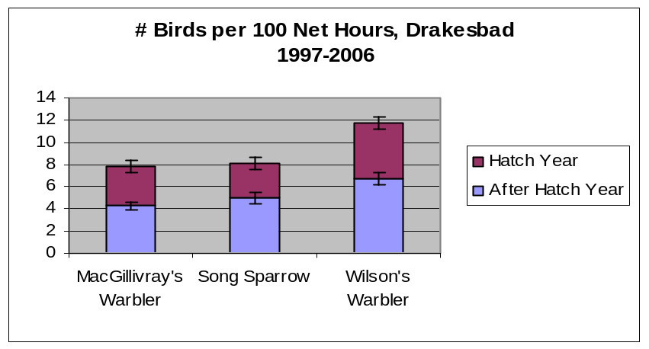

Figure 3. Average + SE of productivity as Expressed in Ratios of Hatch Year to After Hatch Year Birds for Three Species Captured at Drakesbad.
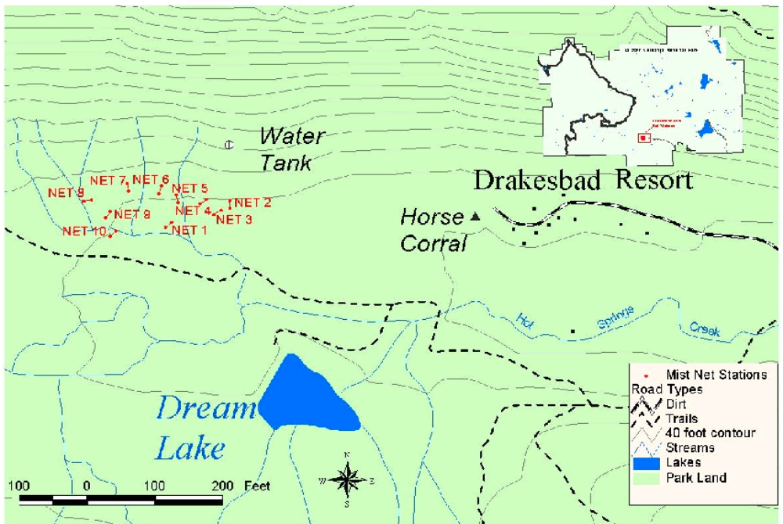 Figure 4. Drakesbad Mist Net Stations
Lassen Volcanic National Park 2004

Table 4. Species and Age Class of Birds Banded at Drakesbad During Constant-Effort Mist-Netting, 1997-2006.

 |  | 1997 |  |  | 1998 |  |  | 1999 |  |  | 2000 |  |  | 2001 |  |  | 2002 |  |  | 2003
Species | HY | AHY | Ratio | HY | AHY | Ratio | HY | AHY | Ratio | HY | AHY | Ratio | HY | AHY | Ratio | HY | AHY | Ratio | HY | AHY | Ratio
American Dipper | 0 | 0 |  | 0 | 0 |  | 0 | 0 |  | 1 | 0 |  | 0 | 0 |  | 0 | 0 |  | 0 | 0
American Robin | 0 | 1 | 0.00 | 0 | 3 | 0.00 | 2 | 5 | 0.40 | 0 | 5 | 0.00 | 0 | 1 | 0.00 | 0 | 2 | 0.00 | 0 | 4 | 0.00
Allen’s Hummingbird | 0 | 0 |  | 0 | 0 |  | 0 | 0 |  | 1 | 0 |  | 0 | 0 |  | 0 | 0 |  | 0 | 1 | 0.00
Anna’s Hummingbird | 2 | 1 | 2.00 | 2 | 0 |  | 0 | 0 |  | 0 | 0 |  | 1 | 0 |  | 0 | 0
Audubon’s Warbler | 0 | 1 | 0.00 | 0 | 3 | 0.00 | 0 | 7 | 0.00 | 0 | 4 | 0.00 | 3 | 8 | 0.37 | 0 | 5 | 0.00 | 0 | 4 | 0.00
Brewer’s Blackbird | 0 | 0 |  | 0 | 1 | 0.00 | 0 | 0 |  | 0 | 0 |  | 0 | 0 |  | 0 | 0 |  | 0 | 0
Brewer’s Sparrow | 0 | 0 |  | 0 | 0 |  | 0 | 0 |  | 1 | 0 |  | 0 | 0 |  | 0 | 0 |  | 0 | 0
Brown Creeper | 0 | 0 |  | 0 | 0 |  | 0 | 0 |  | 0 | 1 | 0.00 | 3 | 0 |  | 0 | 0 |  | 0 | 3 | 0.00
Calliope Hummingbird | 0 | 0 |  | 0 | 0 |  | 0 | 0 |  | 3 | 0 |  | 2 | 1 | 2.00 | 0 | 0 |  | 0 | 0
Cassin’s Finch | 0 | 0 |  | 0 | 1 | 0.00 | 0 | 4 | 0.00 | 0 | 1 | 0.00 | 0 | 0 |  | 0 | 1 | 1.00 | 1 | 12 | 0.08
Cassin’s Vireo | 2 | 0 |  | 0 | 0 |  | 1 | 0 |  | 0 | 0 |  | 0 | 0 |  | 1 | 1 | 1.0 | 2 | 0
Common Snipe | 0 | 0 |  | 0 | 0 |  | 0 | 0 |  | 0 | 0 |  | 0 | 0 |  | 0 | 0 |  | U | U
Dusky Flycatcher | 0 | 0 |  | 0 | 0 |  | 0 | 0 |  | 1 | 0 |  | 3 | 0 |  | 0 | 0 |  | 0 | 1 | 0.00
Evening Grosbeak | 0 | 11 | 0.00 | 0 | 8 | 0.00 | 0 | 3 | 0.00 | 1 | 0 |  | 0 | 4 | 0.00 | 0 | 13 | 0.00 | 0 | 9 | 0.00
Golden-crowned Kinglet | 0 | 0 |  | 0 | 0 |  | 0 | 0 |  | 0 | 0 |  | 1 | 1 | 1.0 | 0 | 0 |  | 0 | 0
Hairy Woodpecker | 0 | 0 |  | 0 | 1 | 0.00 | 0 | 1 | 0.00 | 0 | 0 |  | 0 | 0 |  | 0 | 1 | 0.00 | 0 | 0
Hammond’s Flycatcher | 2 | 0 |  | 0 | 0 |  | 4 | 0 |  | 1 | 0 |  | 1 | 0 |  | 1 | 0 |  | 1 | 0
Hermit Thrush | 0 | 0 |  | 0 | 1 | 0.00 | 0 | 0 |  | 0 | 0 |  | 0 | 0 |  | 0 | 0 |  | 0 | 0
Hermit Warbler | 0 | 0 |  | 0 | 0 |  | 0 | 2 | 0.00 | 2 | 0 |  | 0 | 0 |  | 2 | 0 |  | 0 | 1 | 0.00
House Wren | 0 | 0 |  | 0 | 0 |  | 2 | 0 |  | 1 | 0 |  | 0 | 0 |  | 0 | 0 |  | 0 | 0
Lazuli Bunting | 0 | 0 |  | 0 | 0 |  | 0 | 0 |  | 0 | 0 |  | 0 | 2 | 0.00 | 0 | 0 |  | 0 | 0
Lincoln’s Sparrow | 2 | 3 | 0.67 | 2 | 3 | .067 | 1 | 4 | 0.25 | 2 | 2 | 1.0 | 0 | 1 | 0.00 | 2 | 6 | 0.33 | 0 | 5 | 0.00
MacGillivray’s. Warbler | 14 | 11 | 1.27 | 3 | 9 | 0.33 | 5 | 16 | 0.31 | 14 | 8 | 1.75 | 17 | 12 | 1.42 | 12 | 21 | 0.57 | 10 | 8 | 1.25
Mountain Chickadee | 0 | 0 |  | 0 | 1 | 0.00 | 0 | 2 | 0.00 | 0 | 1 | 0.00 | 2 | 0 |  | 0 | 0 |  | 0 | 2 | 0.00
Nashville Warbler | 1 | 0 |  | 3 | 0 |  | 0 | 2 | 0.00 | 1 | 1 | 1.00 | 0 | 0 |  | 1 | 2 | 0.50 | 0 | 2 | 0.00
Olive-sided Flycatcher | 0 | 0 |  | 0 | 0 |  | 0 | 0 |  | 0 | 0 |  | 0 | 0 |  | 0 | 0 |  | 0 | 1 | 0.00
Orange-crowned Warbler | 39 | 2 | 19.5 | 25 | 2 | 12.5 | 28 | 1 | 28.0 | 28 | 6 | 4.67 | 37 | 9 | 4.11 | 35 | 11 | 3.18 | 27 | 11 | 2.45
Oregon Junco | 1 | 0 |  | 0 | 3 | 0.00 | 0 | 4 | 0.00 | 1 | 4 | 0.25 | 3 | 0 |  | 0 | 2 | 0.00 | 0 | 0
Pine Siskin | 0 | 0 |  | 0 | 1 | 0.00 | 0 | 1 | 0.00 | 0 | 2 | 0.00 | 0 | 2 | 0.00 | 0 | 0 |  | 0 | 1 | 0.00
Purple Finch | 0 | 0 |  | 0 | 0 |  | 0 | 0 |  | 0 | 0 |  | 2 | 1 | 2.00 | 0 | 0 |  | 0 | 0
Red-breasted Nuthatch | 0 | 0 |  | 0 | 0 |  | 0 | 0 |  | 0 | 0 |  | 0 | 0 |  | 0 | 0 |  | 0 | 1 | 0.00
Red-breasted Sapsucker | 0 | 0 |  | 1 | 0 |  | 2 | 1 | 2.00 | 0 | 0 |  | 1 | 2 | 0.50 | 3 | 2 | 1.5 | 0 | 2 | 0.000
Red-shafted Flicker | 0 | 1 | 0.00 | 0 | 0 |  | 0 | 0 |  | 0 | 0 |  | 0 | 0 |  | 0 | 0 |  | 0 | 0
Red-winged Blackbird | 0 | 1 | 0.00 | 0 | 1 | 0.00 | 0 | 0 |  | 0 | 2 | 0.00 | 0 | 2 | 0.00 | 0 | 1 | 0.00 | 0 | 1 | 0.00
Rufous Hummingbird | 27 | 9 | 3.00 | 19 | 1 | 19.0 | 37 | 1 | 37.0 | 29 | 6 | 4.83 | 39 | 16 | 2.44 | 20 | 1 | 20.0 | 22 | 0
Song Sparrow | 17 | 12 | 1.42 | 4 | 17 | 0.24 | 5 | 18 | 0.28 | 16 | 13 | 1.23 | 13 | 16 | 0.81 | 8 | 22 | 0.36 | 6 | 19 | 0.31
Tree Swallow | 0 | 0 |  | 0 | 0 |  | 0 | 0 |  | 0 | 0 |  | 0 | 0 |  | 0 | 0 |  | 0 | 1 | 0.00
Warbling Vireo | 1 | 8 | 0.13 | 0 | 1 | 0.00 | 0 | 7 | 0.00 | 1 | 4 | 0.25 | 1 | 10 | 0.10 | 0 | 8 | 0.00 | 0 | 3 | 0.00
Western Tanager | 0 | 0 |  | 0 | 3 | 0.00 | 1 | 4 | 0.25 | 0 | 2 | 0.00 | 0 | 6 | 0.00 | 0 | 3 | 0.00 | 0 | 3 | 0.00
Western Wood-Peewee | 0 | 2 | 0.00 | 0 | 3 | 0.00 | 0 | 6 | 0.00 | 0 | 0 |  | 0 | 4 | 0.00 | 1 | 1 | 1.0 | 0 | 6 | 0.00
Willow Flycatcher | 0 | 1 | 0.00 | 0 | 1 | 0.00 | 0 | 0 |  | 0 | 0 |  | 0 | 3 | 0.00 | 0 | 1 | 0.00 | 0 | 0
Wilson’s Warbler | 22 | 13 | 1.69 | 12 | 21 | 0.57 | 9 | 19 | 0.47 | 16 | 17 | 0.94 | 20 | 16 | 1.25 | 6 | 28 | 0.21 | 22 | 21 | 1.05
Yellow Warbler | 1 | 0 |  | 0 | 0 |  | 0 | 0 |  | 2 | 0 |  | 1 | 3 | 0.33 | 1 | 4 | 0.25 | 1 | 6 | 0.17
Totals | 131 | 77 |  | 71 | 85 |  | 97 | 108 |  | 122 | 79 |  | 150 | 120 |  | 93 | 136 |  | 92 | 128
U=unknown age.

Table 4 (cont). Species and Age Class of Birds Banded at Drakesbad During Constant-Effort Mist-Netting, 1997-2006.

 |  | 2004 |  |  | 2005 |  |  | 2006
Species | HY | AHY | Ratio | HY | AHY | Ratio | HY | AHY | Ratio
American Dipper | 0 | 0 | 0 | 0 | 0 |  | 0 | 0 | 0
American Robin | 0 | 3 | 0.00 | 0 | 1 | 0.00 | 1 | 2 | 0.50
Allen’s Hummingbird | 0 | 0 |  | 0 | 0 |  | 0 | 0
Anna’s Hummingbird | 1 | 0 | 0.00 | 0 | 0 |  | 11 | 2 | 5.50
Audubon’s Warbler | 4 | 6 | 0.67 | 0 | 2 | 0.00 | 0 | 1 | 0.00
Black-headed Grosbeak | 0 | 0 |  | 1 | 0 |  | 1 | 3 | 0.33
Brewer’s Blackbird | 0 | 0 |  | 0 | 0 |  | 0 | 1 | 0.00
Brewer’s Sparrow | 0 | 0 |  | 0 | 0 |  | 0 | 0
Brown-headed Cowbird | 0 | 0 |  | 0 | 0 |  | 0 | 1 | 0.00
Brown Creeper | 0 | 0 |  | 0 | 0 |  | 2 | 1 | 2.00
Calliope Hummingbird | 5 | 0 | 0.00 | 1 | 0 |  | 0 | 1 | 0.00
Cassin’s Finch | 2 | 4 | 0.50 | 0 | 0 |  | 0 | 8 | 0.00
Cassin’s Vireo | 1 | 0 | 0.00 | 0 | 1 | 0.00 | 0 | 0
Dusky Flycatcher | 0 | 1 | 0.00 | 0 | 0 |  | 0 | 1 | 0.00
Evening Grosbeak | 6 | 13 | 0.46 | 0 | 1 | 0.00 | 0 | 15 | 0.00
Golden-crowned Kinglet | 0 | 0 |  | 0 | 0 |  | 0 | 0
Hairy Woodpecker | 0 | 1 | 0.00 | 0 | 0 |  | 0 | 0
Hammond’s Flycatcher | 0 | 0 |  | 2 | 0 |  | 3 | 1 | 3.00
Hermit Thrush | 0 | 0 |  | 0 | 0 |  | 0 | 0
Hermit Warbler | 1 | 1 | 1.00 | 0 | 0 |  | 1 | 0 | 0.00
House Wren | 0 | 0 |  | 0 | 0 |  | 1 | 0 | 0.00
Lawrence’s Goldfinch | 1 | 0 | 0.00 | 0 | 0 |  | 0 | 0
Lazuli Bunting | 5 | 1 | 5.00 | 0 | 1 | 0.00 | 0 | 3 | 0.00
Lincoln’s Sparrow | 2 | 4 | 0.50 | 4 | 8 | 0.50 | 4 | 2 | 2.00
MacGillivray’s. Warbler | 12 | 19 | 0.63 | 6 | 14 | 050 | 20 | 18 | 1.11
Mountain Chickadee | 0 | 0 |  | 1 | 1 | 1.00 | 0 | 1 | 0.00
Nashville Warbler | 5 | 2 | 2.50 | 2 | 1 | 2.00 | 9 | 2 | 4.50
Olive-sided Flycatcher | 0 | 0 |  | 0 | 2 | 0.00 | 0 | 1 | 0.00
Orange-crowned Warbler | 43 | 7 | 6.14 | 31 | 6 | 5.17 | 102 | 6 | 17.0
Oregon Junco | 0 | 1 | 0.00 | 1 | 1 | 1.00 | 4 | 4 | 1.00
Pine Siskin | 2 | 8 | 0.25 | 0 | 0 |  | 0 | 0
Purple Finch | 0 | 0 |  | 1 | 1 | 1.00 | 0 | 0
Red-breasted Nuthatch | 1 | 0 | 0.00 | 0 | 0 |  | 0 | 0
Red-breasted Sapsucker | 1 | 6 | 0.17 | 0 | 1 | 0.00 | 0 | 1 | 0.00
Red-shafted Flicker | 0 | 0 | 0.00 | 0 | 0 |  | 0 | 0
Red-winged Blackbird | 0 | 0 | 0.00 | 0 | 0 |  | 0 | 0
Rufous Humminbird | 36 | 0 | 0.00 | 8 | 4 | 2.00 | 36 | 0 | 0.00
Song Sparrow | 12 | 9 | 1.33 | 5 | 12 | .417 | 9 | 13 | 0.69
Spotted Sandpiper | U | U | 0 | 0 | 0 |  | 0 | 0
Swainson’s Thrush | 0 | 0 |  | 0 | 1 | 0.00 | 0 | 0
Townsend’s Solitaire | 0 | 0 |  | 0 | 1 | 0.00 | 0 | 0
Warbling Vireo | 2 | 2 | 1.00 | 0 | 12 | 0.00 | 0 | 4 | 0.00
Western Tanager | 0 | 0 |  | 0 | 7 | 0.00 | 1 | 5 | 0.20
Western-Wood Peewee | 0 | 5 | 0.00 | 0 | 6 | 0.00 | 1 | 10 | 0.10
Willow Flycatcher | 0 | 3 | 0.00 | 0 | 0 |  | 0 | 2 | 0.00
Wilson’s Warbler | 14 | 22 | 0.64 | 13 | 29 | .448 | 20 | 21 | 0.95
Yellow Warbler | 4 | 6 | 0.67 | 3 | 10 | 0300 | 1 | 1 | 1.00
Totals | 160 | 124 |  | 79 | 122 |  | 227 | 131

