Travel to Japan

11/23/2004

Dates of Travel: 11/8/04 to 11/19/04

Traveler:
Steve Marks, Mechanical Engineer, EGME12
Frank Zucca, EGME

Organization: Ernest Orlando Lawrence Berkeley National Laboratory
One Cyclotron Rd., Berkeley, CA 94720

Trip Number: Steve Marks: 200500478
Frank Zucca: 200500480

Destination: Spring-8

Purpose of Trip: The purpose of this trip was to observe final assembly, vacuum preparation, and vacuum bake-out of the in-vacuum insertion device (IVID) being built for installation in the ALS.

Contacts: Neomax: Mr. Okada
Spring-8: Dr. Tanaka

Facilities visited: Spring-8.

Abstract: Ten days were spent at Spring-8. During that time we observed final assembly of the IVID vacuum chamber and RF transition, preparation and vacuum bake-out. An ALS procedure document is being prepared for our use should we need to repeat the bake-out process.

Detailed Trip Report

Vacuum Assembly

The vacuum assembly was underway when we arrived on 11/10/04. Fig. 1 shows the state of the IVID when we arrived. Thermocouple wires can be seen in the figure. Fig. 2 shows a close up of the magnetic structure mounted within the vacuum chamber. The Cu/Ni conduction sheet can be seen on the surface of the magnets in. The RF transition had not yet been assembled and mounted.

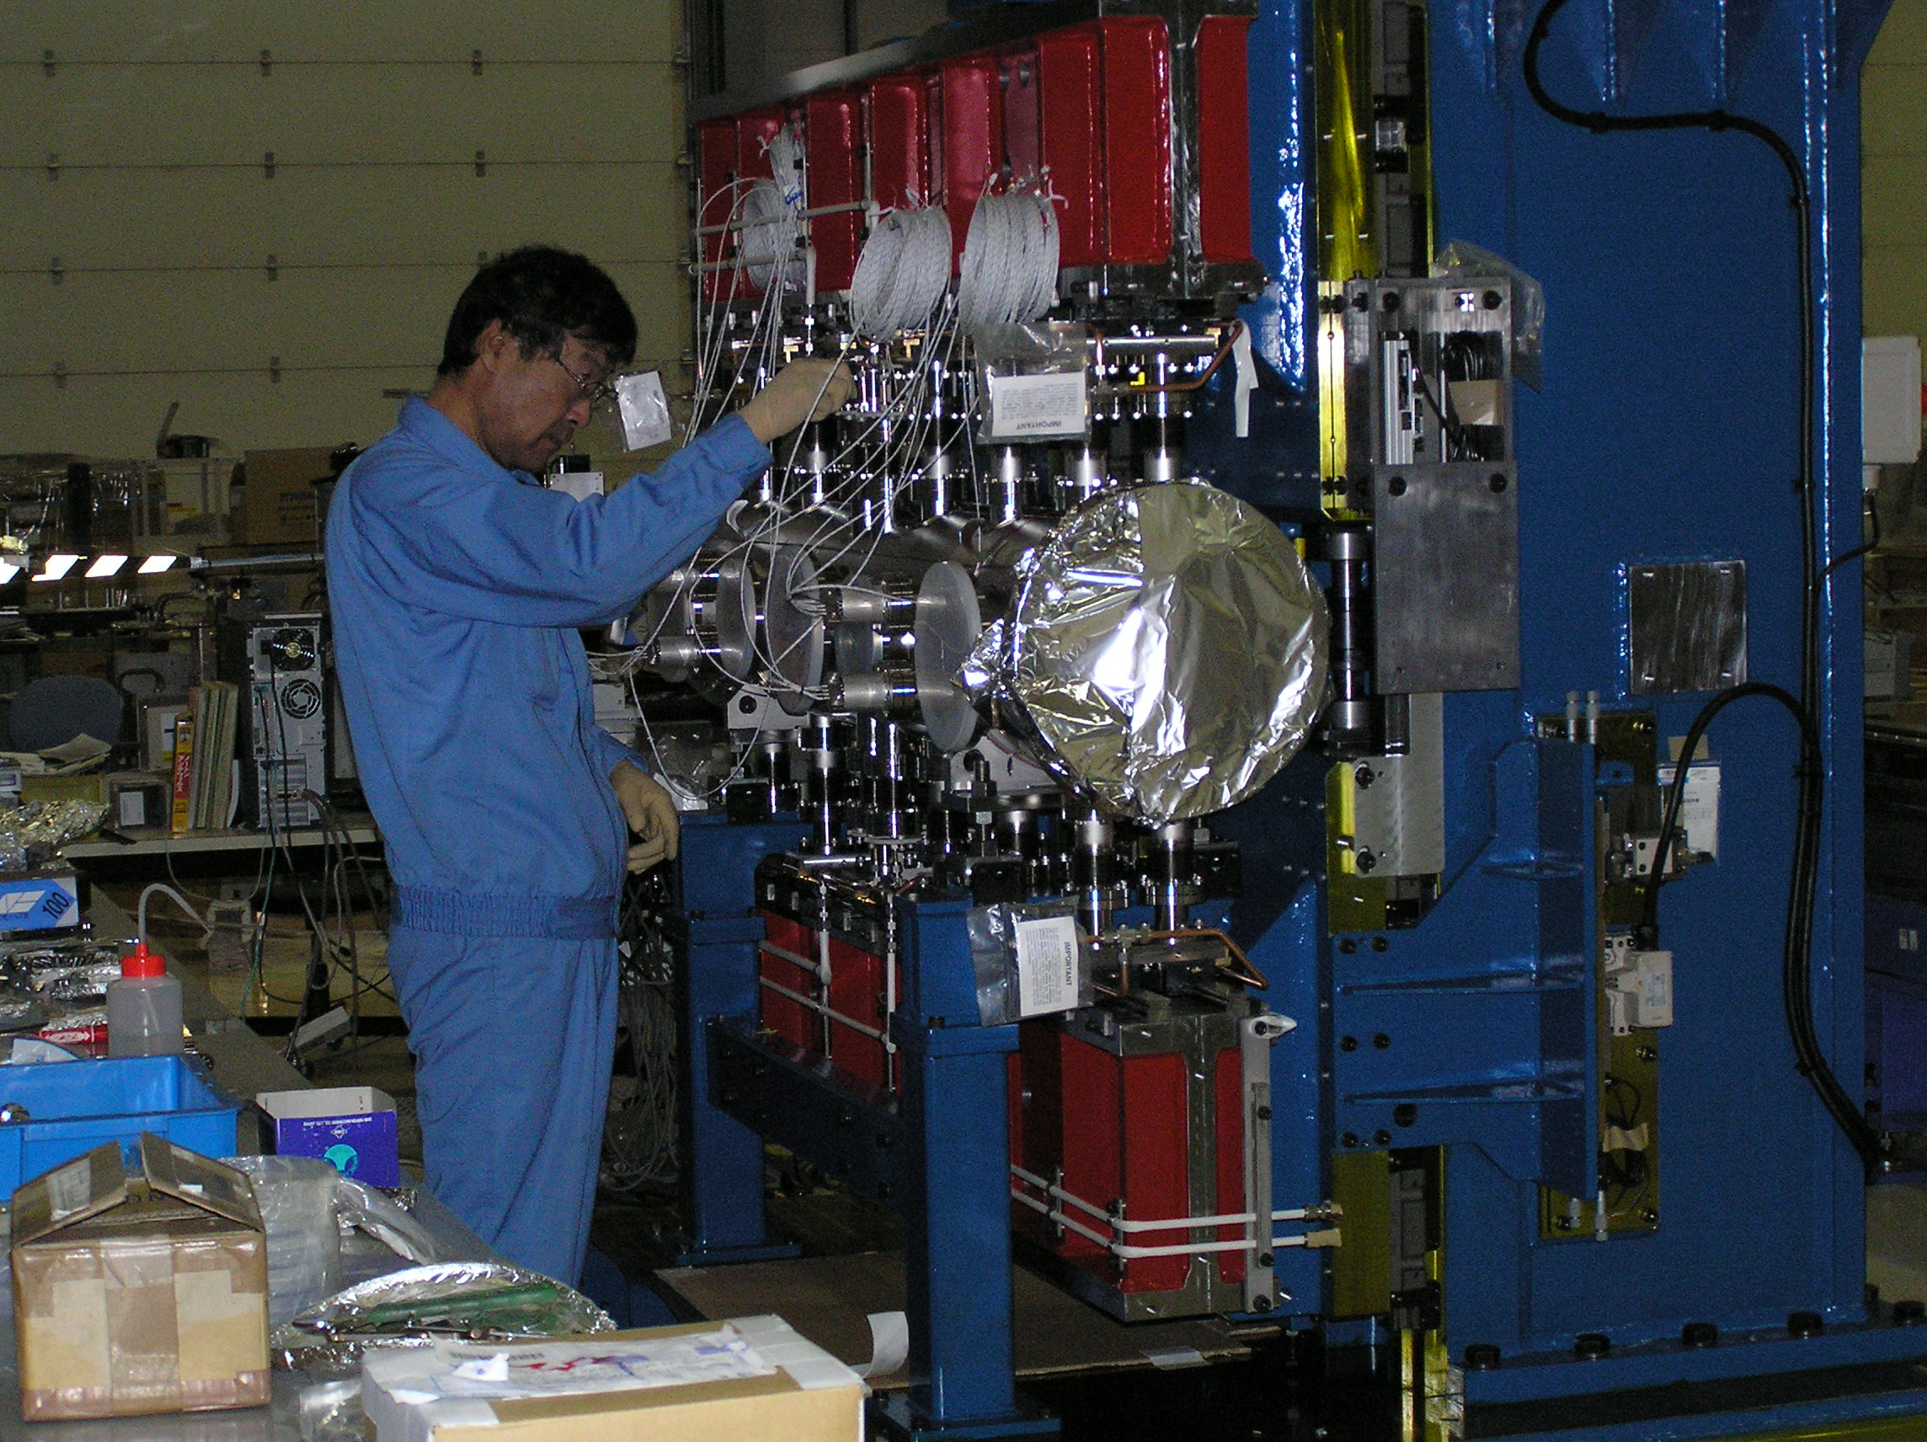
Figure 1. State of vacuum assembly on 11/10/04.
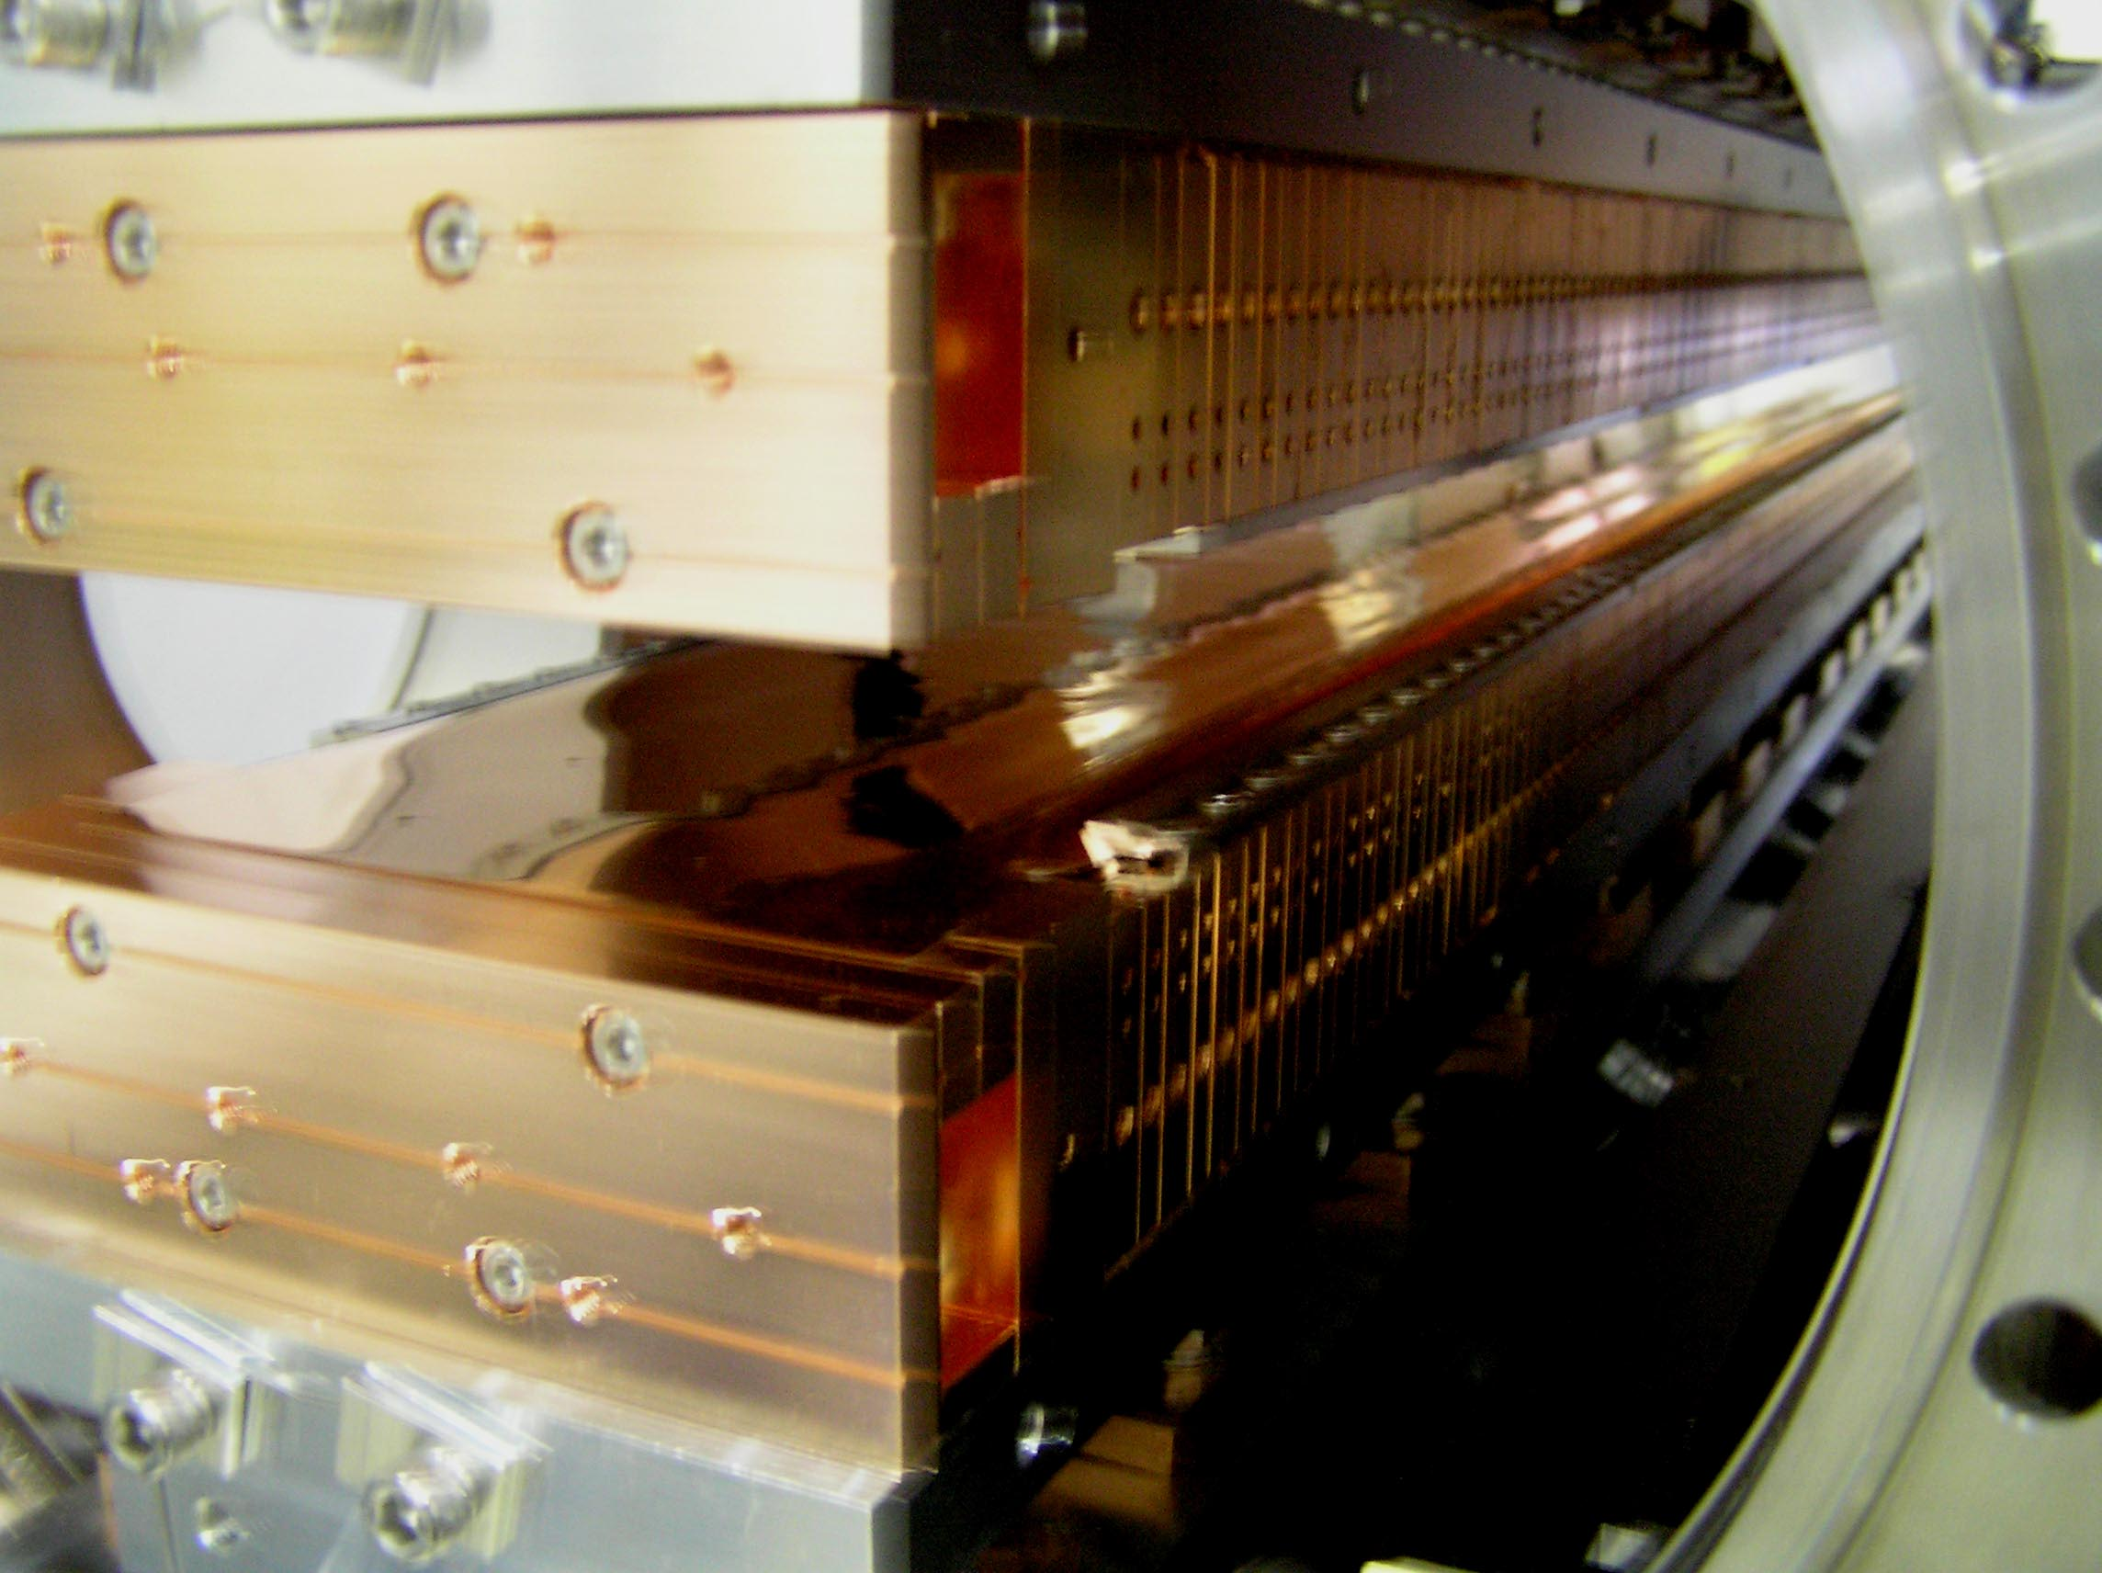
Figure 2. Close up of magnetic structure mounted within the vacuum chamber.
The RF transition was installed on 11/12/04. Fig. 3 shows the RF transition end flange prior to installation. Fig. 4 shows the water cooled flexible sheet installed on to the end of the magnetic structure. The structure shown in Fig. 4 is shimmed on top and bottom so that it mounts square with the end flange. This step is necessary to ensure that all contacts in the conductive path are flush without any gaps throughout the range of gaps. Fig. 5 shows the initial mounting of the end flange. Note the gap along the bottom edge of the opening. The flexible assembly was re-shimmed to remove this gap.

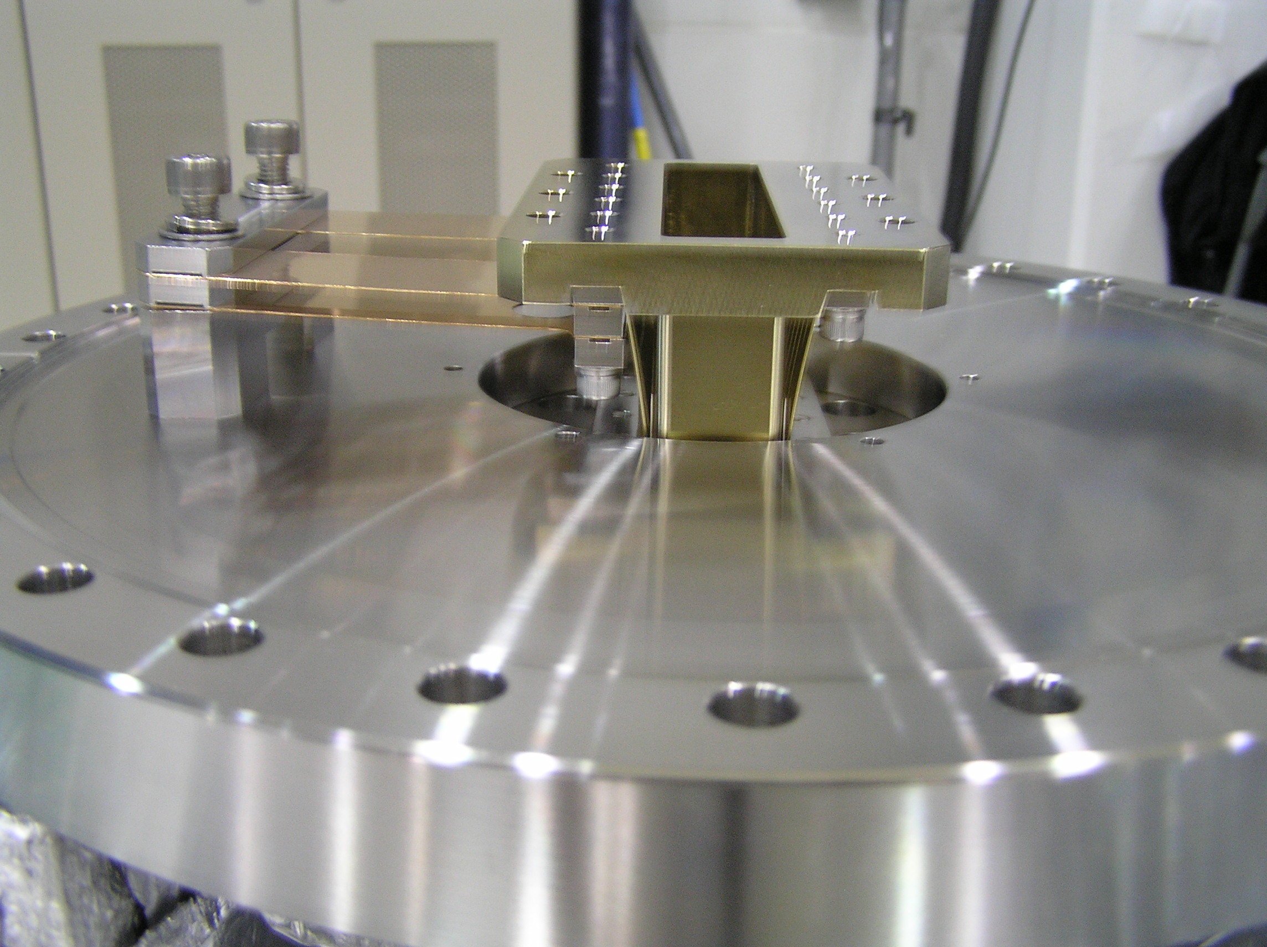
Figure 3. RF transition end flage.
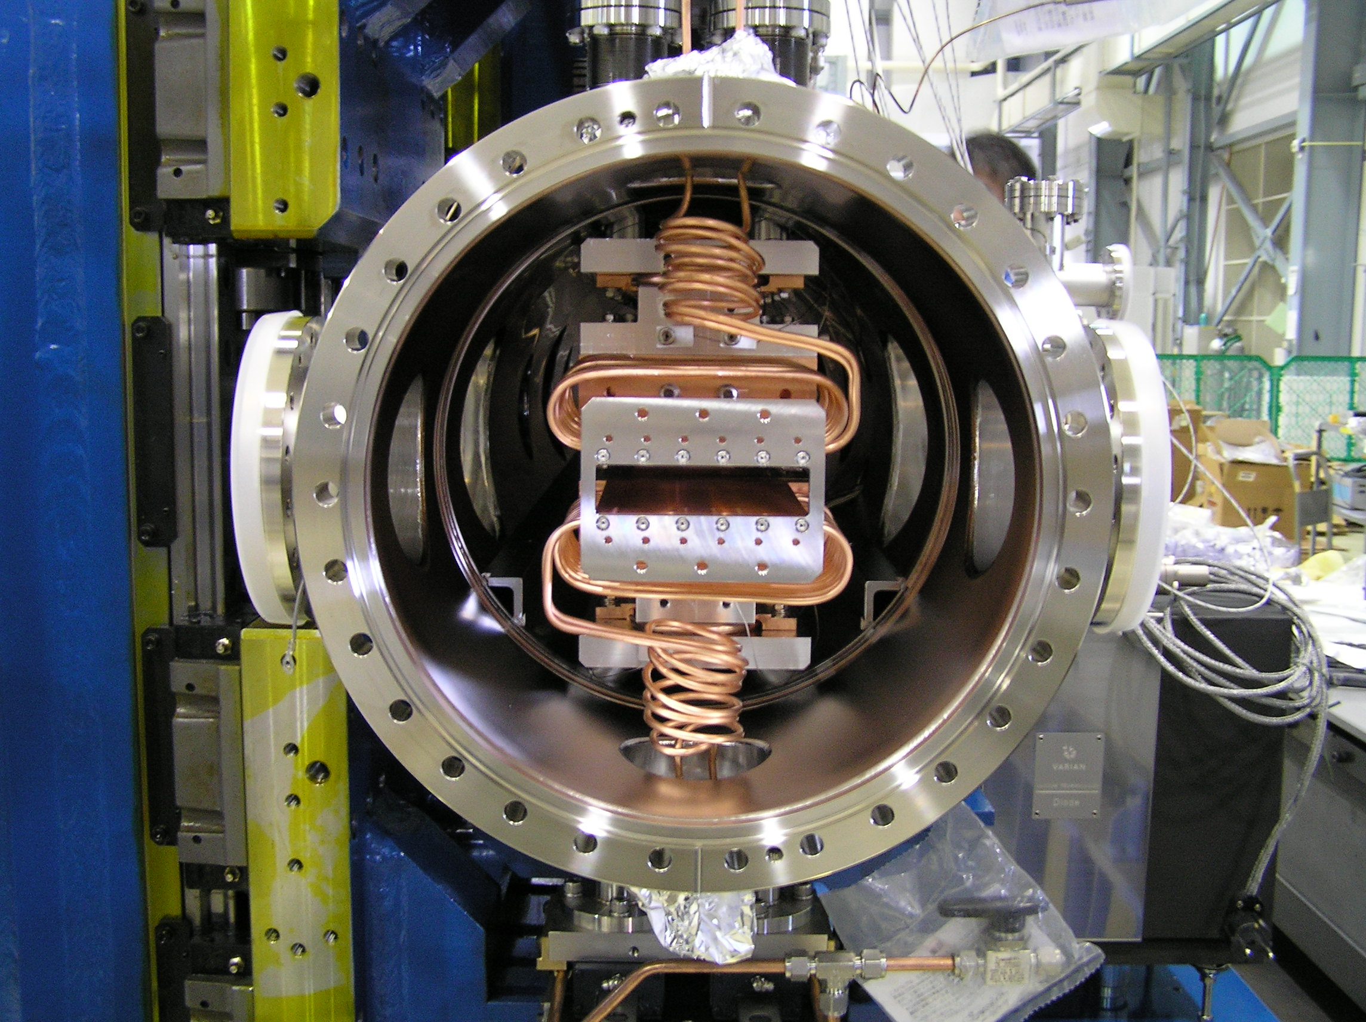
Figure 4. RF transition water cooled flexible sheet.

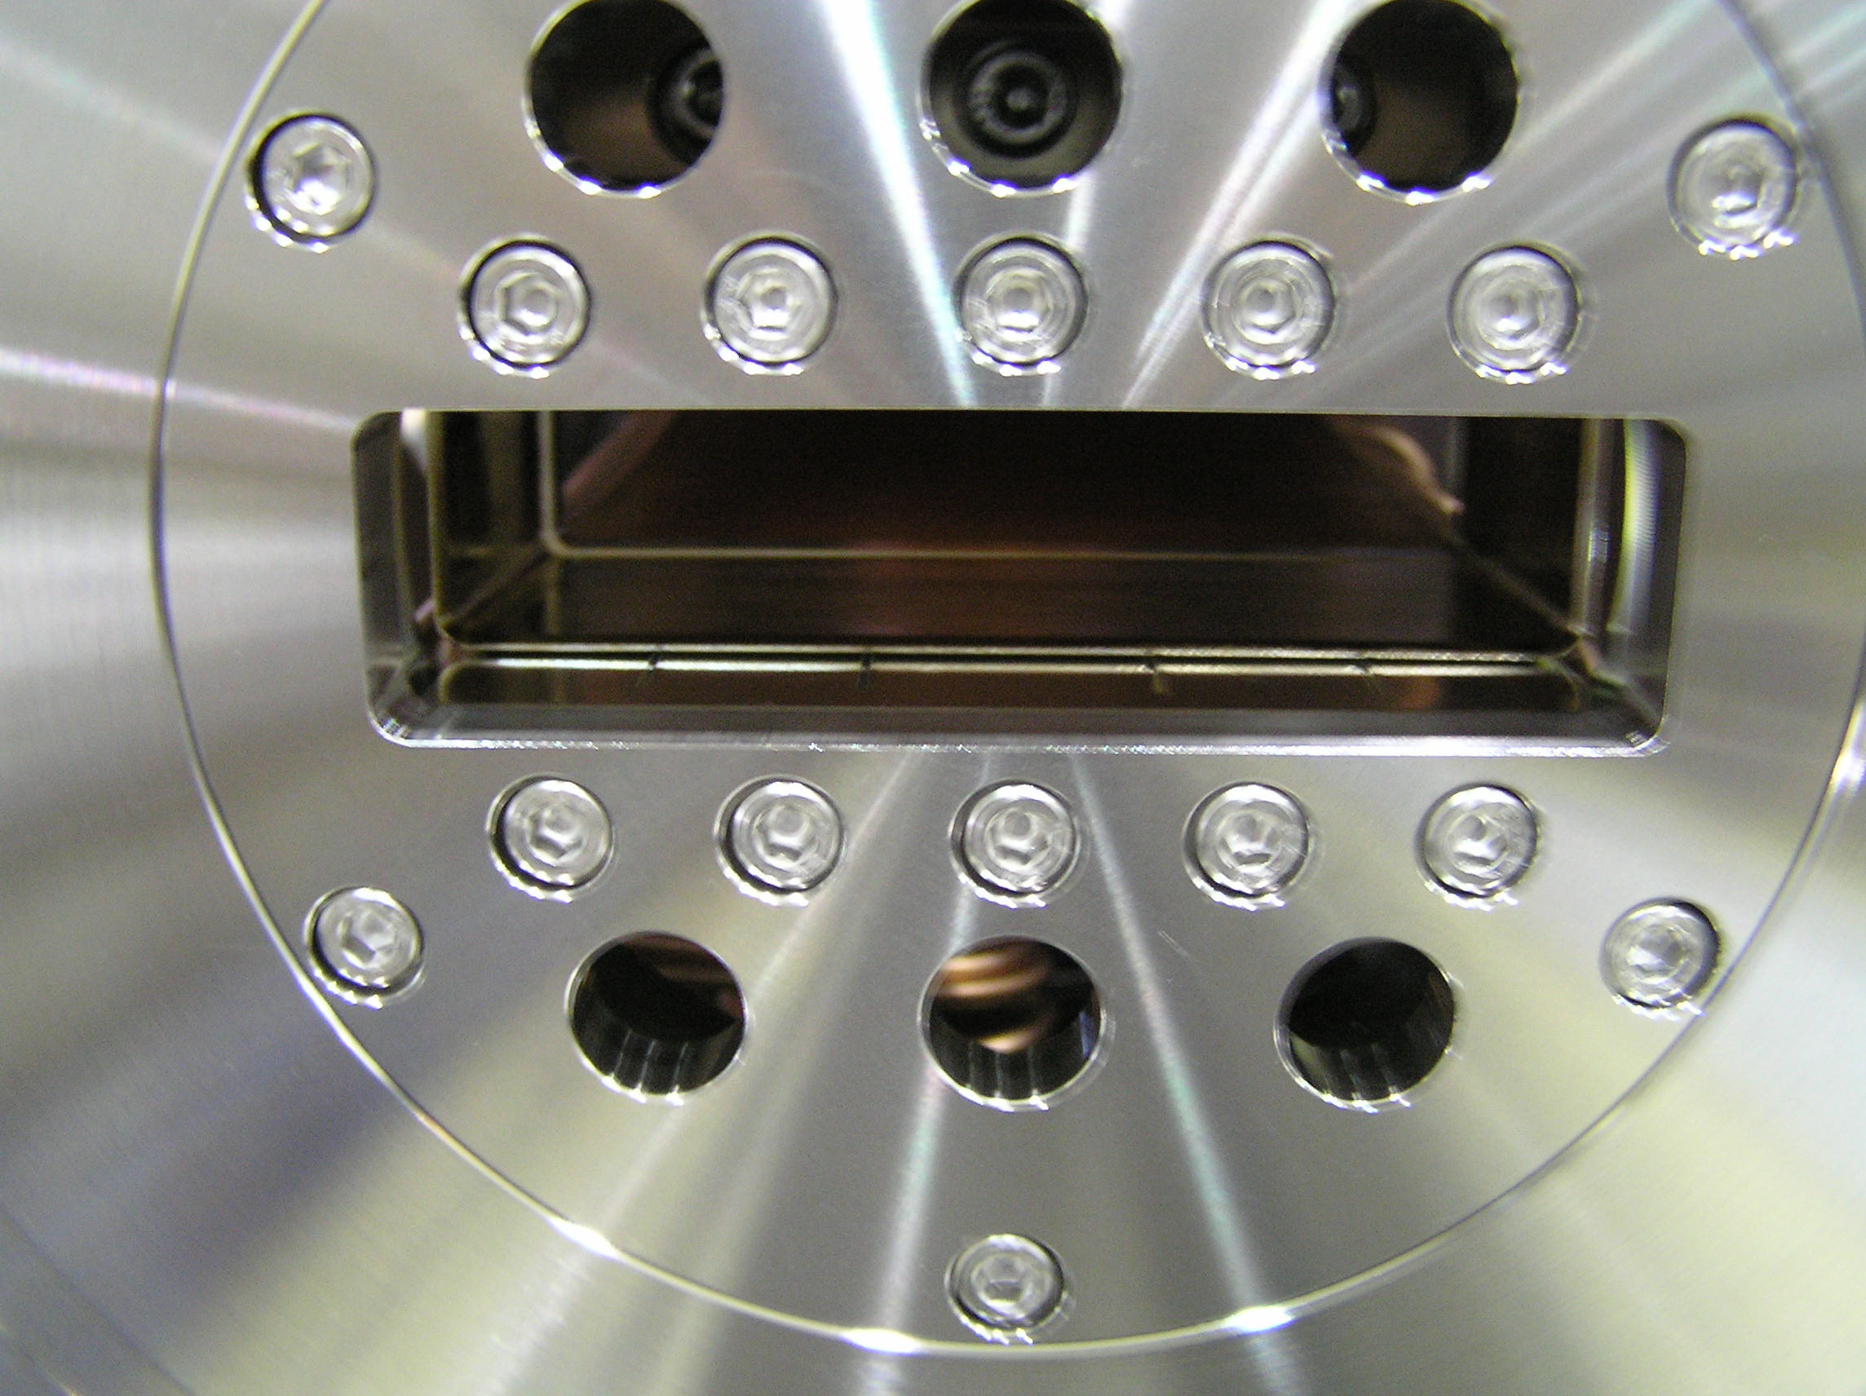
Figure 5. Initial installation of end flange.

Vacuum Bake-out

A brief summary of the vacuum bake-out will be provided here. A detailed bake-out procedure is being prepared as a separate document.

The vacuum bake-out consists of three phases: heating from room temperature to steady state temperature, steady state bake-out, and cool down. Temperature is controlled with two systems: a pressurized hot water system that circulates water through the magnetic structure cooling circuit, and heaters applied to the outer wall of the vacuum vessel. Thermocouples attached to the in-vacuum magnetic structure and the vessel are used for control and monitoring of temperatures during the bake. Digital dial indicators are used to monitor relative expansion between the vessel and the magnetic structure. Fig. 6 shows the system wrapped and ready for bake. Fig. 7 shows the water circulation unit. Fig. 8 shows the power supply rack for vessel heating.
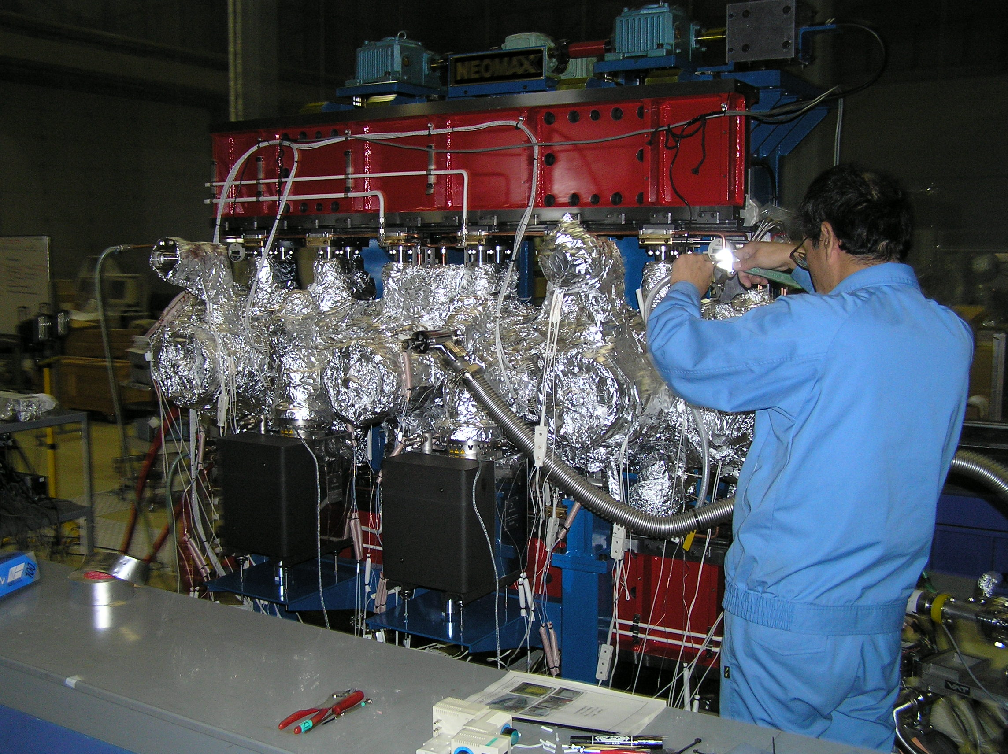
Figure 6. System wrapped for bake-out.
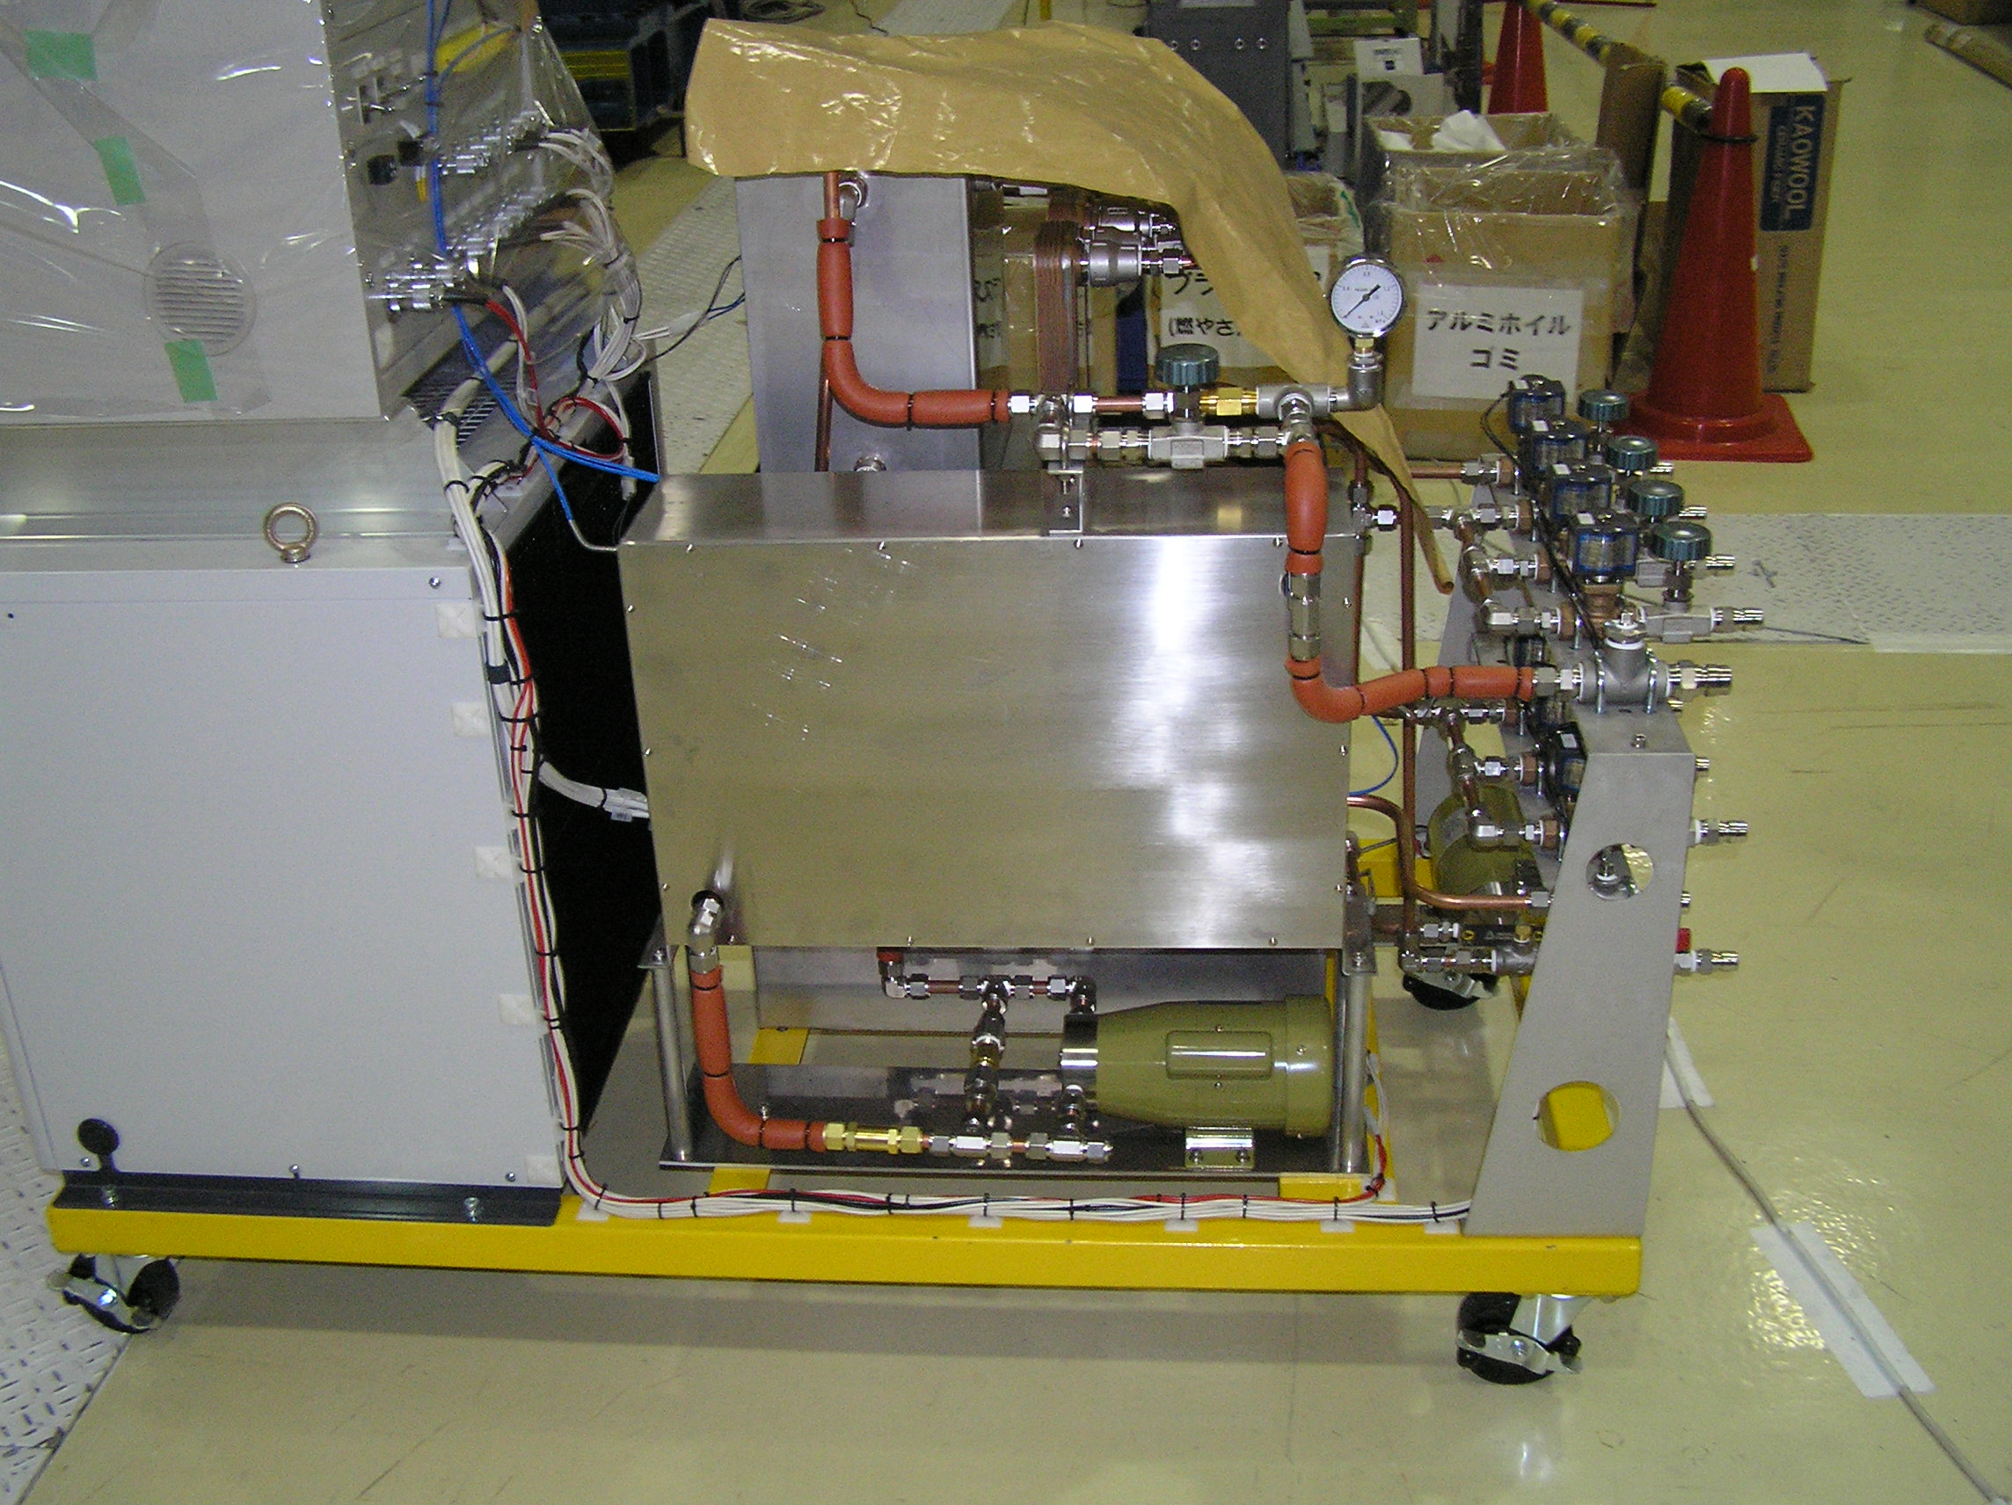
Figure 7. Pressurized hot water circulation unit.
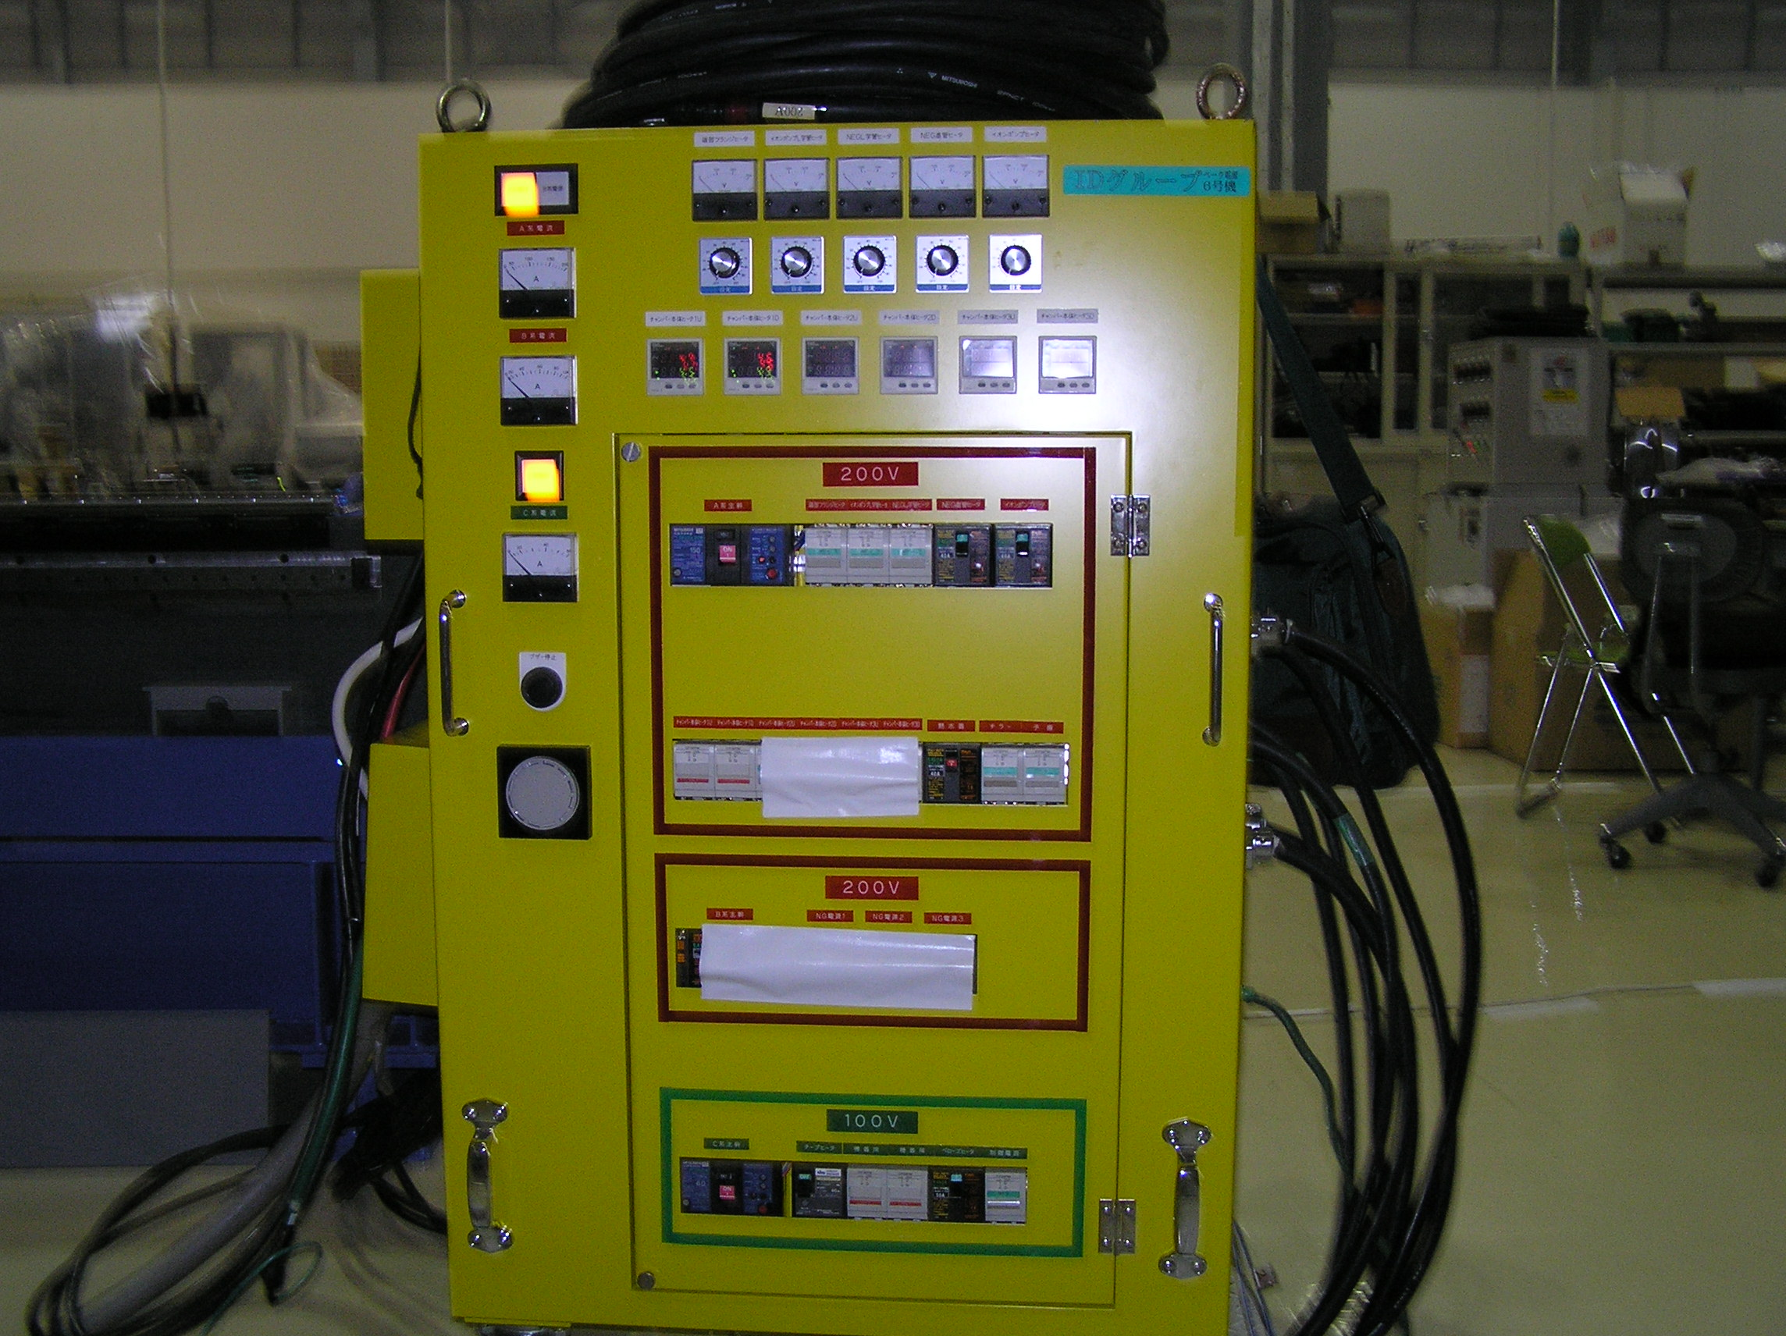
Figure 8. Vessel heater power supply rack.
Initial heating is accomplished by increasing the circulating water temperature. This is followed by increasing the temperature of the vessel. Temperatures are increased by approximately 5°C every five minutes. The rate of temperature rise in the water and the vessel are varied to minimize the relative growth of the vessel versus the magnetic structure. The goal is to keep the relative motion less than 2mm.

Steady state operation was achieved after approximately eight hours. At steady state, the vessel wall temperatures were approximately 185°C, in-vacuum backing beam temperatures were in range between 115°C and 125°C, and supply water temperature was 100°C. Demagnetization occurs at about 140°C, so 125°C was established as the maximum temperature for the magnetic structure. Fig. 9 shows the computer screen monitor of temperatures, pressure, and dial gauge readings.
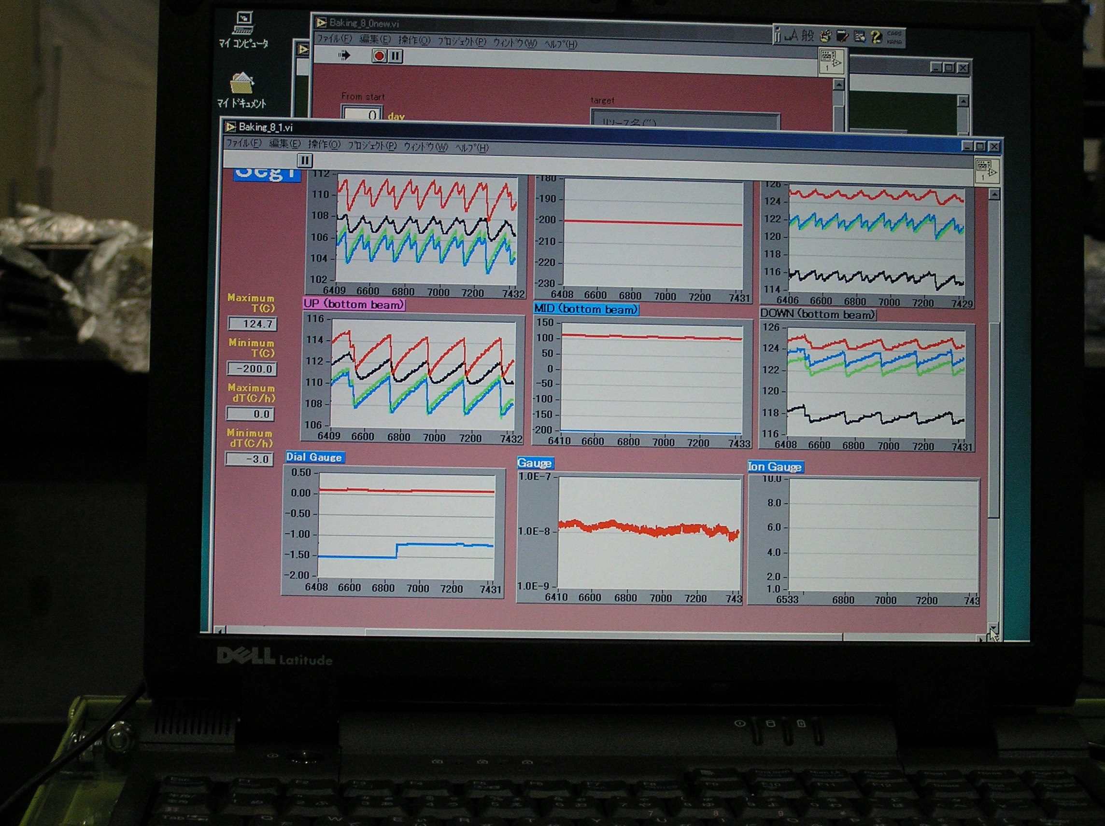
Figure 9. Computer monitor screen.

After three days of bake-out, the system was cooled down. The cool down operation was the reverse of the heating; temperatures were dropped approximately 5°C every five minutes while monitoring the dial gauges. The pressure prior to cool down was ~10⁻⁸ T. During cool down the NEG pumps were activated and the ion pumps and gauges were turned on. NEG activation consisted of heating to 450°C for 30 minutes.

Schedule for Completion

- Keep under vacuum until 12/2/04.
- Purge with dry N 12/3/04.
- Ship 12/10/04.

