3.2.2 Mechanical Support Structure of the ATLAS Pixel Detector

The pixel detector consists of three barrel layers and two End Caps, each with three disk layers. The total active area of silicon is approximately 1.7 m². There are 1456 modules in the barrel region and 288 in the End Caps, for a total of 1744 pixel modules. This section describes the structure of the pixel detector and of the services, including cooling, located within the Inner Detector volume.

The pixel detector and the pixel support tube (PST) within the Inner Detector are shown in Figure 3.2.2.1. The pixel detector, its associated services and the beryllium beam pipe within the Inner Detector are located precisely within the pixel support tube. The pixel services (cooling, power and monitoring) are routed to the ends of the PST.
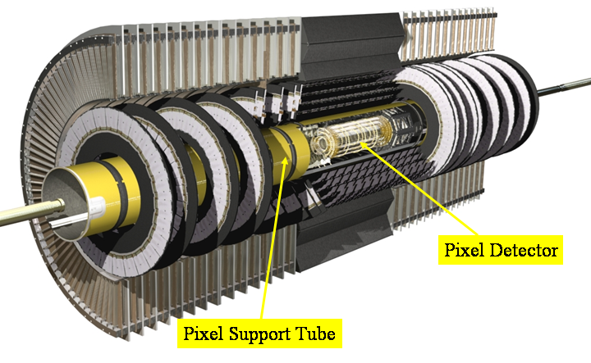
Figure 3.2.2.1 The Pixel Detector and Pixel Support Tube in the ATLAS Inner Detector

The pixel detector, services and beam pipe are assembly as an integrated structure that is inserted from side C of the ATLAS detector into the PST. A perspective view of this integrated unit is shown in Figure 3.2.2.2.
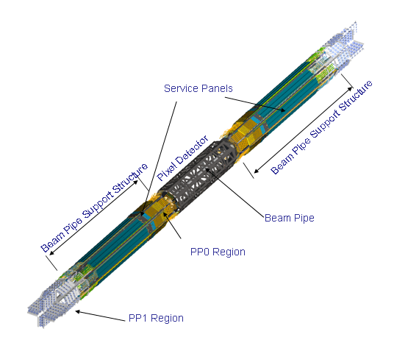
Figure 3.2.2.2 Perspective view of the integrated pixel detector, services and beam pipe.

Pixel Support Tube
The pixel support tube consists of three sections. Each section is a cylinder (with external stiffening rings) with precision rails. The barrel section is composed of carbon-fiber composites. Each end-section is composed of carbon fiber and fiberglass composites. The rails are carbon-fiber composites and are accurately positioned within each cylinder. The cylinders are joined (at each end of the barrel) by bolted flanges (also of carbon-fiber composition). Heater panels (copper-on-kapton printed circuit boards) are glued to the cylinders. These are activated if there is a failure in the dry environment around the pixel detector. A picture of the pixel support tube is shown in Figure 3.2.2.3a. The barrel PST section is precisely located with respect to the barrel SCT structure. The barrel PST in the barrel SCT is shown in Figure 3.2.2.3b. There are mounts on the barrel PST that receive mounts on the pixel detector support frame (described below) and thus locate the pixel detector accurately( to about 100 microns) with respect to the barrel SCT.

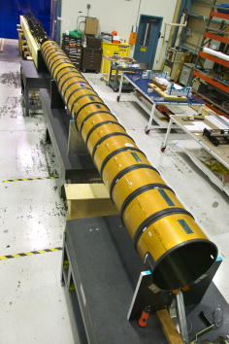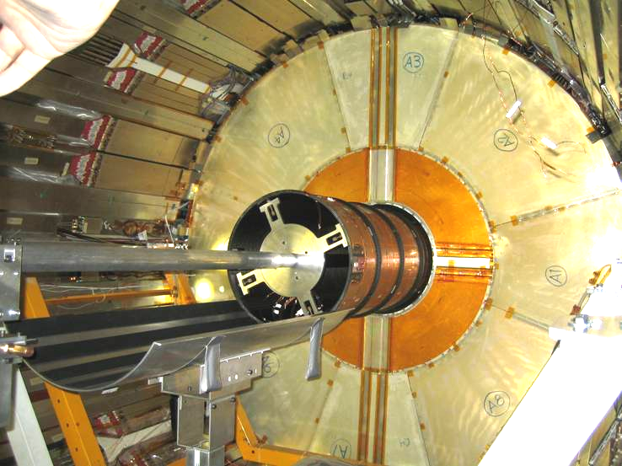
Figure 3.2.2.3 (a) the pixel support tube; (b) ***placeholder for better**

Pixel Detector Structure and Overview
A perspective view of the pixel detector is shown in Figure 3.2.2.4. The basic parameters of the pixel detector are given in Table 3.2.2.1. The barrel radii shown correspond to an average radius since the barrel staves are tilted at 20º with respect to a tangent vector at the given radius. Similarly the Z positions of the disks are nominal, average positions. The total active barrel length is approximately 801mm. The inner radius of a disk is about 89 mm and the outer radius about 150 mm.
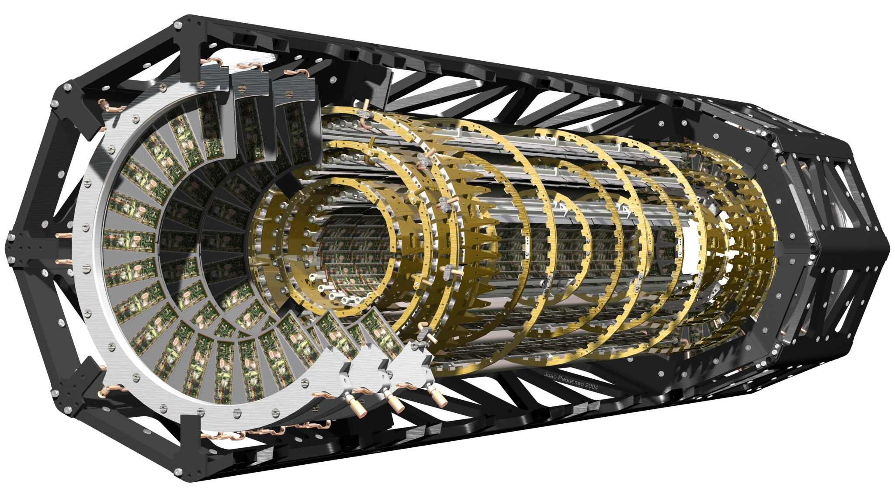
Figure 3.2.2.4 Perspective cut-away view of the pixel detector.

An octagonal, carbon-composite frame supports and positions the barrel region and the two endcaps. The two endcap sections are bolted (with composite bolts) to the barrel frame. Mounts that position the pixel detector within the PST are located on endplates on the endcaps.

Barrel | Radius(mm) | Staves | Modules | Pixels
Layer 0 | 50.5 | 22 | 286 | 13.2 x 10⁶
Layer 1 | 88.5 | 38 | 494 | 22.8 x 10⁶
Layer 2 | 122.5 | 52 | 676 | 31.2 x 10⁶
Endcap(One) | Z(mm) | Sectors | Modules | Pixels
Disk 1 | 495 | 8 | 48 | 2.21 x 10⁶
Disk 2 | 580 | 8 | 48 | 2.21 x 10⁶
Disk 3 | 650 | 8 | 48 | 2.21 x 10⁶
Total Barrel + Both Endcaps |  |  | 1744 | 80.4 x 10⁶

Table 3.2.2.1 Parameters of the pixel detector.

Barrel Region
There are three barrel layers. Each barrel layer is composed of staves each with 13 pixel modules mounted on carbon-composite, half-shells. The half-shells are joined to form a complete barrel layer and then inserted into the octagonal support frame and held with pins and bolts by precision structures (endcones) attached at each end of the frame.

A bare stave consists of machined carbon-carbon plates, an aluminum tube and a carbon-fiber composite piece that captures the aluminum tube and glued to the carbon-carbon pieces. The carbon-carbon pieces are precisely machined in a step pattern and are one-half the length of a stave. They are joined in the middle during the fabrication of a stave. A custom extrusion was used to make an aluminum tube with a flat surface at the interface with the carbon-carbon material. A custom fitting was brazed to the end of the aluminum pipe. A thermal compound was used between the carbon-carbon and the tube. The tube was held in place by a carbon-fiber piece glued to the carbon-carbon. A bare stave is shown in Figure 3.2.2.5.

Significant corrosion of the aluminum tube was observed in some staves, including a substantial number after modules were mounted. These staves with modules were repaired by removing the brazed fitting and inserting a round tube and gluing fittings similar to those used in the End Caps. Staves without modules were dismantled and new shaped aluminum tubes with welded fittings added. In addition, some additional staves were made in this manner to replace those lost whilst reclaiming already fabricated parts.
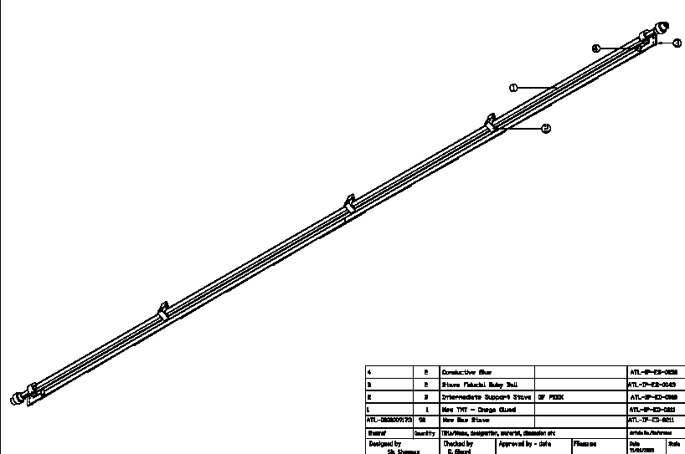
Figure 3.2.2.5 Placeholder until find good picture of bare stave!

Tested barrel modules were mounted on each stave using robotic tools – see Figure 3.2.2.6a. The modules are glued to the stave with SE4445. The modules on each stave were tested electrically, including with radioactive sources and after thermal cycling. The thermal performance of each stave was measured.

Custom, low-mass cables were connected to each stave (Figure 3.2.2.6b) via a connector on each module and attached to the back of the stave to reach the ends of the stave. The staves were then joined to form bi-staves (Figure 3.2.2.6c). A bi-stave is the cooling unit in the barrel region. A custom welded U-link (Figure 3.2.2.7a) was attached to each bi-stave.

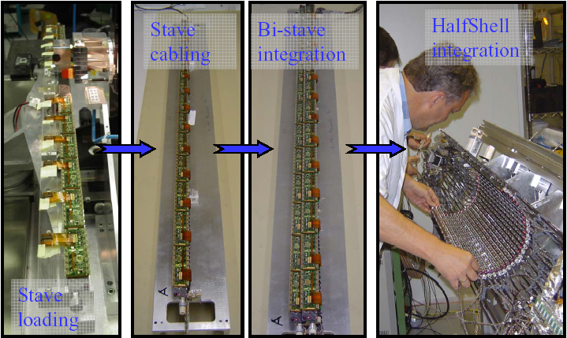
Figure 3.2.2.6 (a) Module loading on a stave; (b) adding low mass cables to stave; (c) integration of staves to form a bi-stave and (d) insertion of bi-staves into a half-shell.

The bi-staves were mounted in half-shells (Figure 3.2.2.6d). Each half-shell is a thin carbon-fiber formed shell (not a cylinder but formed with facets to match the number of staves) with cutouts to reduce mass (Figure 3.2.2.7b) and with mounting rings that attach to the staves at five locations to position the stave. The location of the staves in the half-shells was measured using a coordinate measuring machine to reference the position of modules to known features on the shells.

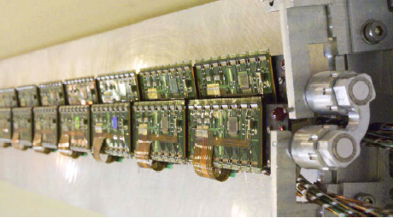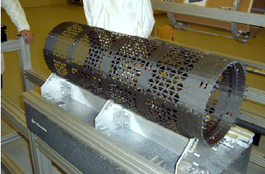
Figure 3.2.2.7 (a) Close up of bi-stave with modules showing U-link cooling connection between staves; (b) two half-shells with cutouts.

Two fully-loaded half-shells were carefully attached to form a barrel layer. Layer 2 after this step is shown in Figure 3.2.2.8.

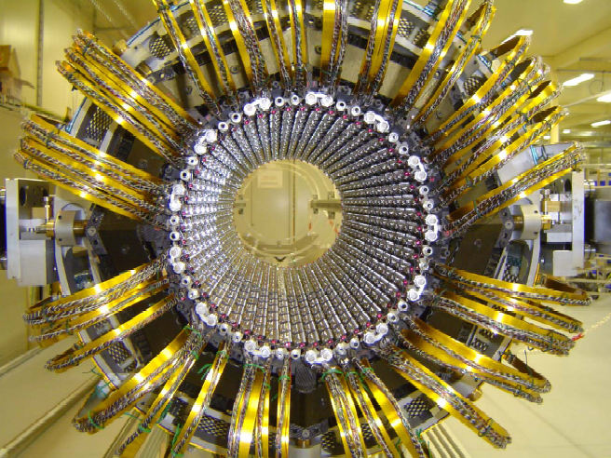
Figure 3.2.2.8 Layer 2 after joining of the half-shells.

Each barrel layer was inserted into the supporting octagonal frame and connected to endcone structures with fingers to mate precisely with mounting brackets on the barrel.
Capilllaries and outlet tube extensions were added and Helium leak checked.

End Cap Region
There are six disks in the pixel detector. All disks are identical in design. A disk is composed of eight sectors on which six pixel modules are mounted – see Figure 3.2.2.9a. Eight sectors are bolted precisely with PEEK bolts/pins to a carbon-composite support ring to form a disk – see Figure 3.2.2.9b. Three disks are held with four mounts within a section of the octagonal support frame to form one endcap.

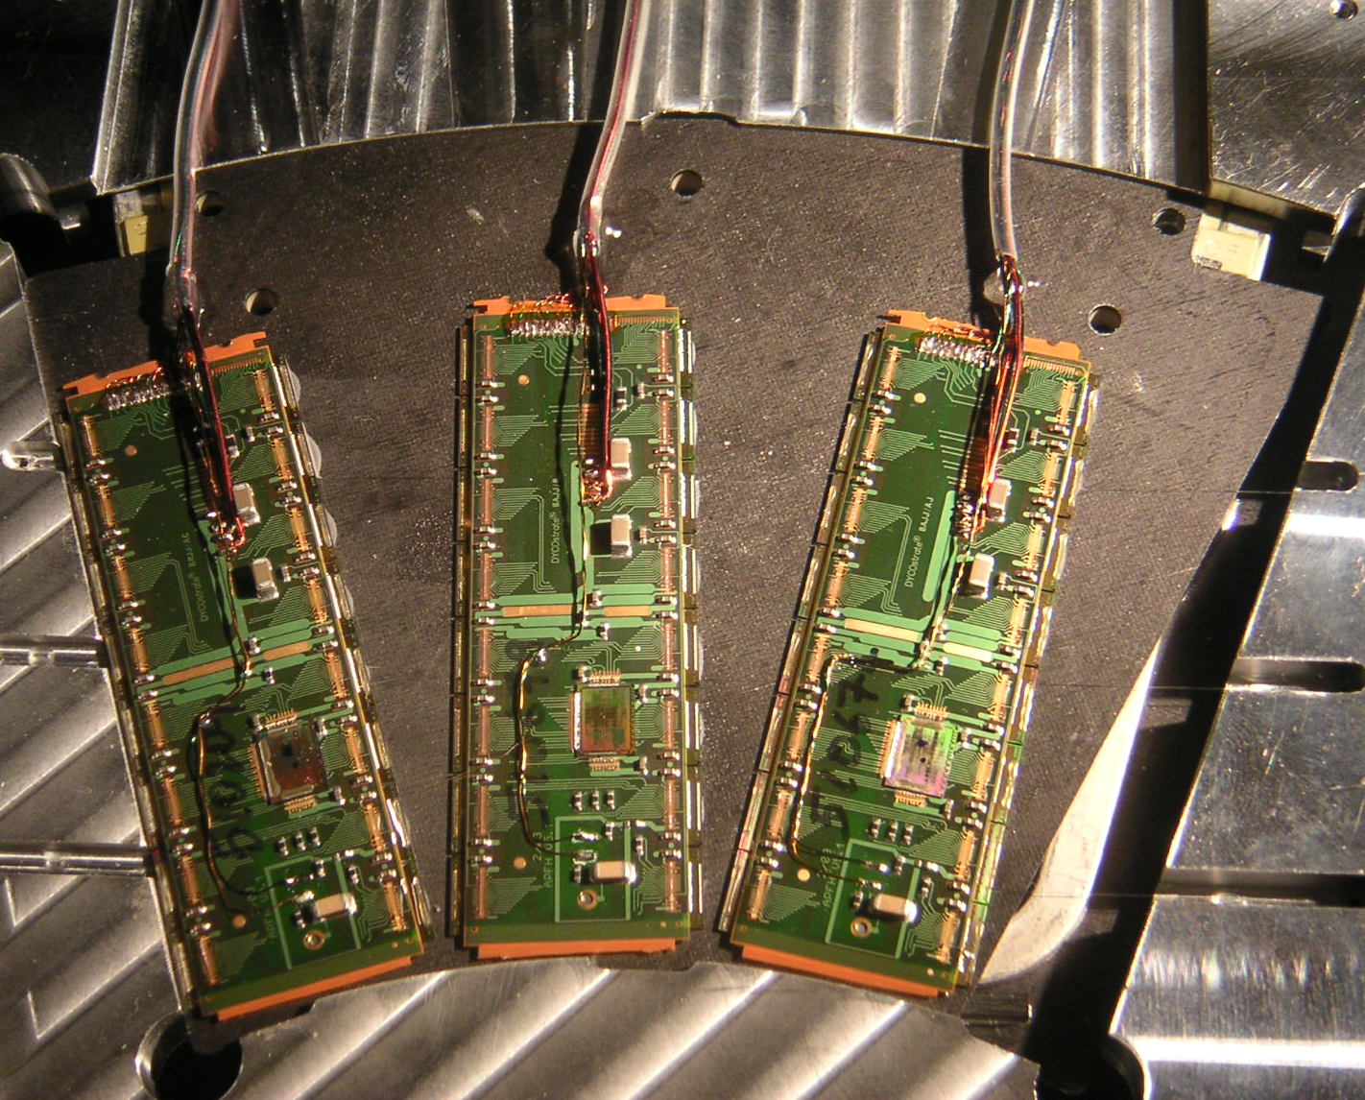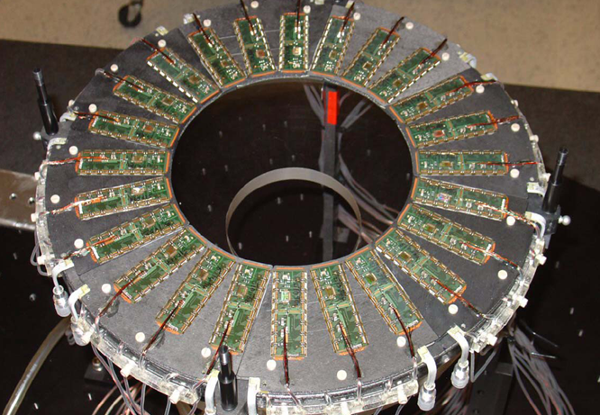

Figure 3.2.2.9 (a) A pixel disk sector. There are also three modules on the back of sector. (b) A complete pixel disk.

Each sector is composed of thin, carbon-carbon faceplates with a rectangular aluminum cooling tube and vitreous carbon foam between the faceplates. The cooling tube is bent into a W-like shape to fit within the sector and makes contact with the faceplates with a thermally conducting, compliant adhesive. The three precision bushings for mounting the sector on a support ring are also carbon-carbon material.

Tested disk modules were positioned on each sector using tooling and precision optical measurements accurate to 1-2 microns in the plane of the module and about 10 microns in the plane perpendicular to the module plane. The disk modules were glued(SE4445) to a sector and the custom micro-cable from each module was also independently glued to the sector. The modules on each sector were tested using the same testing protocols as for individual modules, including thermal cycling and exposure to radioactive sources. The locations of modules on a sector were accurately surveyed (optically) using the fiducial marks in the corners of the pixel sensors and other information. The survey precision with respect to the mounting bushings is estimated to be better than five microns in the plane of the module and about 15 microns in the direction perpendicular to this plane. Survey data were recorded for later use in the alignment of the pixel detector elements

Tested sectors were mounted by hand on the carbon-composite support rings to form complete disks. The modules on the disks were tested for basic electrical performance after the assembly of a complete disk.

A cooling circuit in the disk region consists of two sectors. The two sectors are joined by a custom-bent, U-tube, with welded custom fittings that mate with corresponding custom fittings on each sector. A capillary tube was attached to the inlet end of the circuit and an extension aluminum tube to the outlet to bring all outlet connections to the end of the frame.

Each disk was inserted into the End Cap octagonal frame using tooling to guide the disk insertion and to engage the four mounts holding each disk ring. An End Cap during the final stages of assembly is shown in Figure 3.2.2.10. A quick electrical test of each End Cap was done after final assembly. All cooling circuits were Helium leak checked.
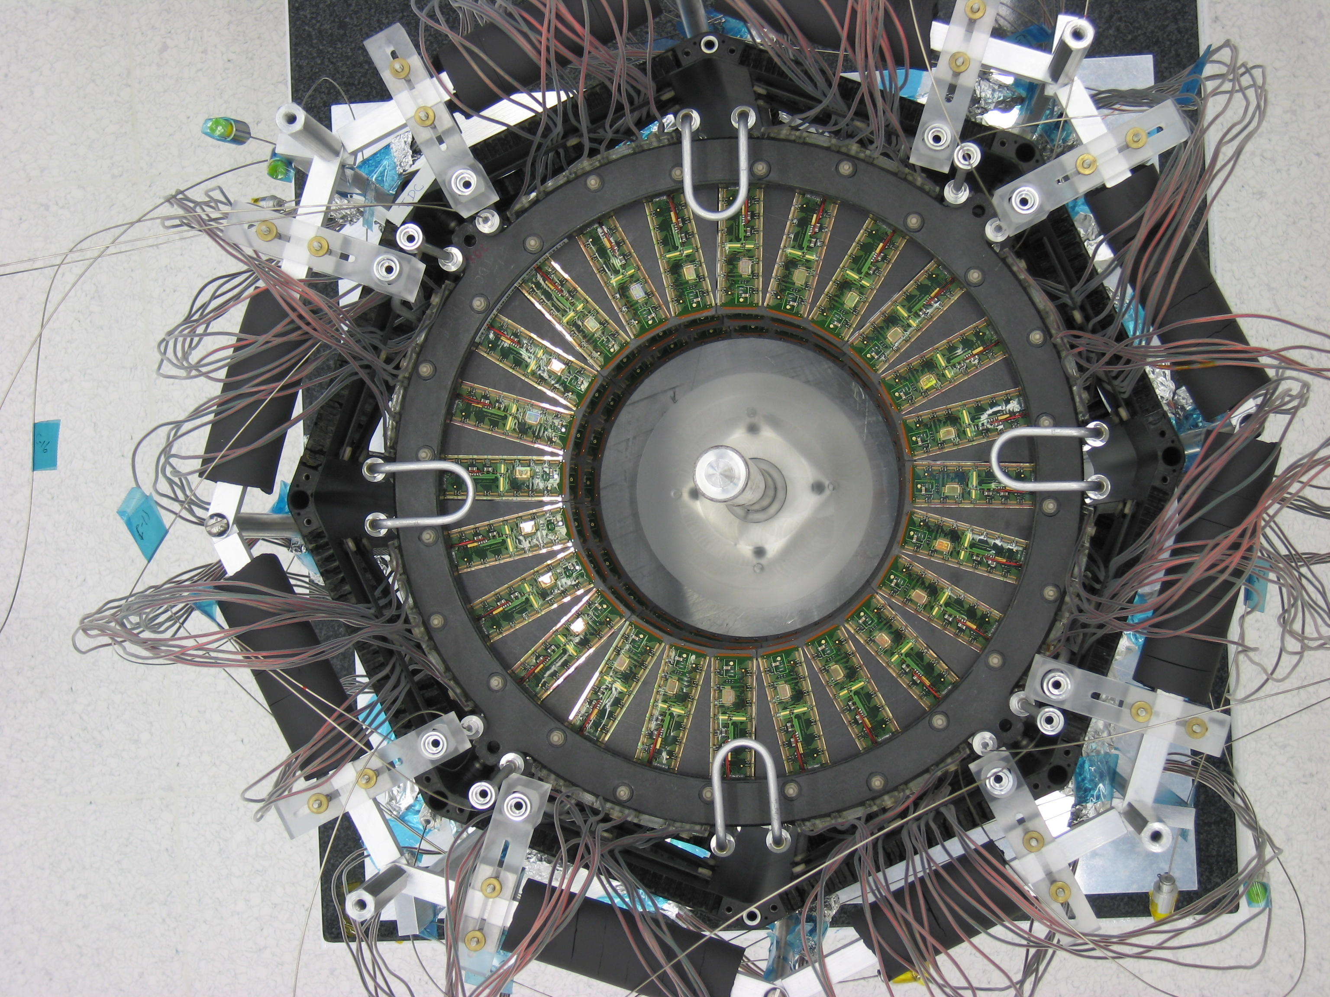
Figure 3.2.2.10 An End Cap at the last stage of assembly.

Overall Integration and Services
The beryllium beam pipe within ATLAS was integrated with the barrel region and supported temporarily. The End Caps were joined to the barrel by pins and bolts at the corners of the octagonal frame. The barrel cooling pipes and cables pass over the outside of the End Cap frame whereas all of the End Cap services are on the inside of this frame. This step is illustrated in Figure 3.2.2.11.
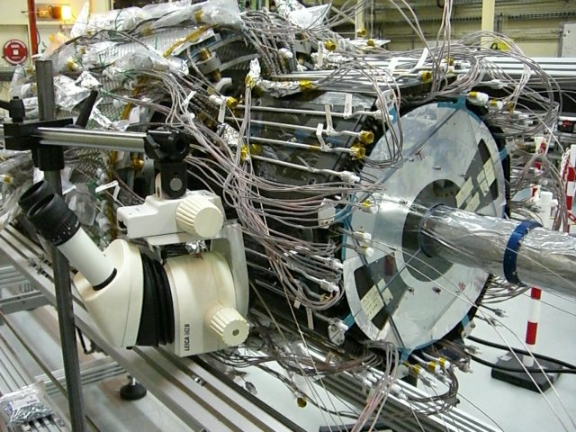
Figure 3.2.2.11 After beryllium and End Cap integration with the barrel.

Each module of the pixel detector is powered individually. There are 88 cooling circuits for the pixel detector. Environmental and other monitoring also requires connections within the pixel detector volume. All of the electrical and cooling connections must pass through the end regions of the PST. And since the pixel detector is inserted from one end, all services, including connectors, must be able to fit within the tight constraints of the PST inner envelope, a radius of about 230 mm.

The electrical services and cooling pipes are contained within service panels that deliver one-quarter of the required services at each end of the pixel detector, hence these are named Service Quarter Panels (SQP). A 3D model of an SQP is shown in Figure 3.2.2.12. Each SQP holds all of the electrical and cooling connections for one quadrant, including a plate with penetrations that connects to the external end of the PST. Power and monitoring wiring is routed by individual twisted pairs, all hand-soldered to printed circuit boards near the active detector (Patch Panel 0 or PP0) that contain miniature connectors. The low-mass cables from each module are plugged into these connectors. At the other end (Patch Panel 1 or PP1) the wires are solder to printed circuit boards to penetrate the sealing plate at the end. There is not enough room for the wires. On the outside of the PP1 region, other twisted pairs are solder to the printed circuit boards and terminated in commercial detectors.

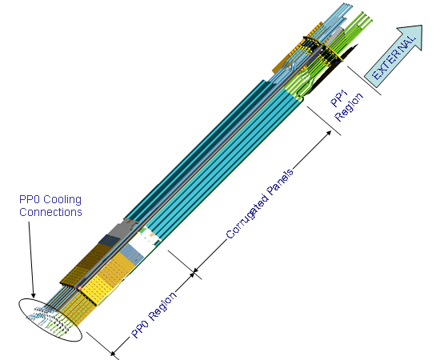
Figure 3.2.2.12 3D model of the internal pixel services, one quadrant.

Each cooling circuit includes a custom heat exchangers that consists of an inlet and an outlet tube glued together along the length of the SQP. These tubes penetrate the plate at PP1 and dry-gas integrity is maintained by a bellows seal that also allows for the 2-3 mm contraction of these aluminum pipes when the detector is operating. Custom cooling connections are made at the PP1 end. Capillaries and outlet extensions are attached at the PP0 end. A picture of the PP1 region of an SQP is shown in Figure 3.2.2.13a and of the PP0 region in Figure 3.2.2.12b.

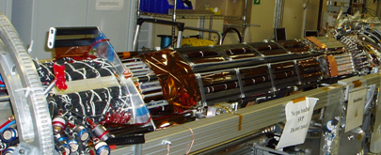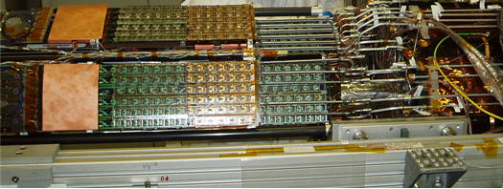
Figure 3.2.2.13 (a) A Service Quarter Panel PP1 end and (b) PP0 end.

The Service Quarter Panels and the beam pipe are supported by composite structures (Beam Pipe Support Structure). The beam pipe supports are adjustable from the ends of the PST in order to position the beam pipe.

The overall detector integration is illustrated in Figure 3.2.2.14.

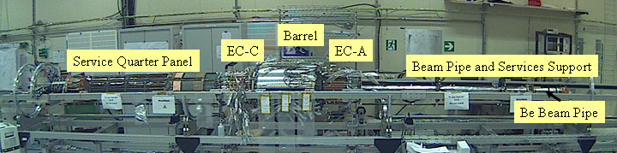
Figure 3.2.2.14 Integration of the pixel detector, beryllium beam pipe and pixel services.

