DISASTER NEWS
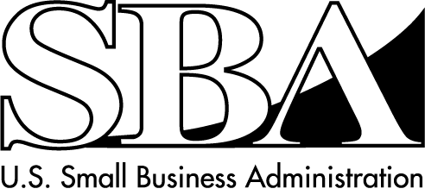
Economic Injury Loans for Small Businesses
SBA Disaster Assistance–Field Operations Center East-One Baltimore Place, Suite 300-Atlanta, GA 30308

Release Date: August 31, 2007 Contact: Michael Lampton
Release Number: 07-673, NY 10770/10771 Phone: 404-347-3771

SBA Deadline To Apply
For Economic Injury Disaster Loans Is September 24

ATLANTA - The U.S. Small Business Administration (SBA) is reminding businesses in the counties of Broome, Chenango, Cortland, Delaware, Madison, Otsego, and Tioga in the state of New York and the contiguous counties of Susquehanna and Wayne in the Commonwealth of Pennsylvania, that Economic Injury Disaster Loans (EIDLs) are still available to small businesses economically impacted by the severe storms and flooding November 16 – 17, 2006.

“Small businesses that suffered economic losses as a result of the disaster and want to apply for
low-interest loans from the SBA are urged to do so before the September 24 deadline,” said Frank Skaggs, Director of SBA Field Operations Center East.

Small businesses may apply for loans up to $l.5 million if they suffered substantial economic injury from the disaster. These working capital loans may be used to pay fixed debts, payroll, accounts payable, and other bills that could have been paid had the disaster not occurred. These loans are not intended to replace lost sales or profits.

The interest rate on these loans is 4 percent, with a maximum term of 30 years. The SBA determines the amount of economic injury and the terms of each loan based on the financial circumstances of each borrower.

Interested business owners should contact SBA’s Customer Service Center by calling 1-800-659-2955
(1-800-877-8339 for the hearing-impaired), Monday through Friday from 8 a.m. to 9 p.m. and Saturday from 9 a.m. to 5:30 p.m. (except for Sunday, September 2 and Monday, September 3 the hours are 9 a.m. to 5:30 p.m.), EDT. Business loan applications can also be downloaded from the SBA’s website at www.sba.gov/services/disasterassistance. Completed applications should be mailed to: U.S. Small Business Administration, Processing and Disbursement Center, 14925 Kingsport Road,
Fort Worth, TX 76155.

The application deadline for economic injury applications is September 24, 2007

# # #

For more information about the SBA’s Disaster Loan Programs, visit our website at www.sba.gov/services/disasterassistance.

