  United States Environmental Protection Agency  Office of Ground Water and Drinking Water  SDWIS Project  Product Control No.  Systalex-SDWIS-01-6.d3a  Deliverable No. 6.d3a  December 20, 2006 |   SDWIS/LabToState 1.0  Installation Guide

SDWIS/LABTOSTATE 1.0 INSTALLATION GUIDE

SDWIS PROJECT

Prepared for:

United States Environmental Protection Agency
Office of Ground Water and Drinking Water
Drinking Water Protection Division
1200 Pennsylvania Ave., NW
Washington, DC 20460

Contracting Officer Representative

Edward Cottrill

Prepared by:

SAIC Solutions Delivery Center
Science Applications International Corporation
6565 Arlington Boulevard
Falls Church, VA 22042

CONTENTS

1.0 Introduction 1
1.1 Document Overview 1
1.2 Software and Hardware Test Environment 1
1.3 User Support 2
2.0 Installation Procedures 3
2.1 Stand alone Client Application Installation 3
2.1.1 Upgrade Installation-Stand Alone Client Application 3
2.1.2 First Time Installation-Stand Alone Client Application 5
2.2 Web based Application Installation 7
2.2.1 Upgrade Installation-Web Based Application 8
2.2.2 First Time Installation-Web Based Application 14
3.0 Support Software Installation Procedures 21
3.1 Application Server Upgrade Installation 21
3.1.1 Archive SDWIS/LabToState Files 22
3.1.2 Remove Current Tomcat Release 23
3.1.3 Remove Java SDK 24
3.1.4 Install Supporting Software 25
3.2 Application Server First Time Installation 25
3.2.1 Download the Java SDK 26
3.2.2 Install the Java SDK 28
3.2.3 Download Tomcat 28
3.2.4 Install Tomcat 30
3.2.5 Increase Tomcat’s Memory Allocation 31
3.2.6 Complete Support Software Installation 32
4.0 Site Customization Procedures 33
4.1 Site Customization Files 33
4.1.1 Site Properties File 33
4.1.2 User Identification XML Document 33
4.1.3 Release Statement File 34
4.2 Data File Content Configuration 34
4.3 Data Source Registration File 37

APPENDIX A System Property File Name Descriptions
APPENDIX B Object and Element Configuration Files
APPENDIX C Element Names by Object
APPENDIX D Interface Specifications

EXHIBITS

Exhibit 1. Hardware and Software Test Environment 2
Exhibit 2. SDWIS/LabToState Upgrade Installation Checklist 4
Exhibit 3. SDWIS/LabToState Files To Archive 4
Exhibit 4. Install SDWIS/LabToState 5
Exhibit 5. Install SDWIS/LabToState 6
Exhibit 6. Stand alone Client Application DOS Window 7
Exhibit 7. SDWIS/LabToState Upgrade Installation Checklist 8
Exhibit 8. SDWIS/LabToState Files To Archive 9
Exhibit 9. Tomcat Administration Home Page 10
Exhibit 10. Tomcat Web Application Manager Page 12
Exhibit 11. Tomcat Web Application Manager Page 13
Exhibit 12. SDWIS/LabToState First Time Installation Checklist 14
Exhibit 13. Tomcat Home Page 16
Exhibit 14. User ID and Password for Tomcat Manager 17
Exhibit 15. Tomcat Web Application Manager — Before Deployment 18
Exhibit 16. Tomcat Web Application Manager Page — After Deployment 19
Exhibit 17. SDWIS/LabToState System Environment Variables 20
Exhibit 18. Supporting Software Upgrade Installation Checklist 22
Exhibit 19. SDWIS/LabToState Files To Archive 22
Exhibit 20. Remove Tomcat — Add or Remove Program Window 24
Exhibit 21. Remove Java SDK — Add or Remove Program Window 25
Exhibit 22. Supporting Software First Time Installation Checklist 26
Exhibit 23. Java SDK Download Page 27
Exhibit 24. Download Tomcat from Apache Web Site 28
Exhibit 25. Download Tomcat from Apache Web Site 29
Exhibit 26. Download Tomcat from Apache Web Site 29
Exhibit 27. Download Tomcat from Apache Web Site 30
Exhibit 28. Apache Icon in the Desktop’s System Tray 31
Exhibit 29. Tomcat Properties Window 32
Exhibit 30. User Authentication XML Document 34
Exhibit 31. Object Configuration File 35
Exhibit 32. Element Configuration Files 36
Exhibit 33. SDWIS/XML Sampling Structure Sets 36
Exhibit 34. Example of CSV File 37
Exhibit 35. Data-Source Plug-In Registration File 37

Introduction
The SDWIS/LabToState 1.0 Installation Guide contains instructions for installing SDWIS/LabToState 1.0. SDWIS/LabToState may be deployed as a web based, platform-independent application or as a stand alone client application. It allows laboratories and other entities to format sample data into XML documents, which are transferred to SDWIS/XML Sampling for additional processing. The software is designed for use by and is available to all laboratories, primacy agencies, and other entities that format sample data for submission to primacy agencies using SDWIS/XML Sampling.

Document Overview
This document contains instructions for installing and administering SDWIS/LabToState 1.0. It comprises the following sections:

- Section 1.0, Introduction, describes the content of the document, the software and hardware test environment, and user support procedures.

- Section 2.0, Installation Procedures, describes the steps required to install SDWIS/LabToState 1.0 as a stand alone client application and as a web based application using a J2EE application server.

- Section 3.0, Support Software Installation Procedures, describes the steps required to install the support software used by SDWIS/LabToState 1.0 when it is installed as a web based application.

- Section 4.0, Site Customization Procedures, describes the steps required to customize SDWIS/LabToState 1.0 at your site.

Software and Hardware Test Environment
SDWIS/LabToState 1.0 was tested using the hardware and supporting software versions listed in Exhibit 1. More recent versions of the supporting software may be available; the application, however, has not been tested with these newer versions.

As a web based application, the SDWIS/LabToState software may reside on an application server or on a network-connected workstation configured as a stand alone server. As a stand alone client application, the SDWIS/LabToState software may be installed on any windows based PC.

SDWIS/LabToState may interface with the site’s local e-mail server. Additionally, for sites using the SQL PlugIn to retrieve sample data, SDWIS/LabToState must have access to the database server from which it is to retrieve data. The SDWIS/LabToState SQL PlugIn was developed and tested using databases deployed on Oracle and Microsoft Access.

Platform | Operating System | Software | Hardware
Application Server / Web Server | WINDOWS NT 4.0 Server | WINDOWS NT Server Software with Service Pack 6  Internet Explorer v6.0 with Service Pack 1  Java 2 SDK, Standard Edition (J2SE), v 1.4.2  Tomcat 5.0.28  SDWIS/XML Sampling v1.0.3 | Dell OptiPlex GX400  (Pentium 4 – 1.4 GHz Processor)  1 GB RAM  Screen Resolution: 1024 x 768 and Small Fonts
Database Server | Windows NT 4 .0 | WINDOWS NT Server Software with Service Pack 6  Oracle 9i Release 2 | Compaq Proliant DL380, Pentium III, 933 MHz CPU, 4 GB Hard Disk
E-Mail Server | Windows 2000 Server | MS Exchange 2000 | Compaq Proliant ML370 G2, two 1.3 MHz CPU, 2 MB of memory
Client Workstation | Windows 2000 | Internet Explorer v6.0 with Service Pack 1 | Dell OptiPlex GX400  (Pentium 4 – 1.4 GHz Processor)  1 GB RAM  Screen Resolution: 1024 x 768 and Small Fonts
Exhibit 1. Hardware and Software Test Environment

User Support
As a representative of a primacy agency, you may call the SDWIS User Support Hotline at (703) 292-6298 or e-mail SDWIS User Support at sdwis@saic-solutions.com. If you represent a laboratory using the SDWIS/LabToState product, you are encouraged to contact the primacy agency to which you are reporting sample data. The primacy agency will in turn contact the SDWIS User Support Hotline on your behalf. The hotline/e-mail account is intended as a technical support tool for the operation and functionality of SDWIS products such as SDWIS/LabToState. A SDWIS team member answers calls to the hotline between 8 a.m. and 5 p.m., Eastern Standard Time (EST), on weekdays (except federal holidays) and offers immediate user support when possible. During evenings, weekends, or those times when the support personnel are temporarily not available, callers may leave a detailed message. Questions requiring the expertise of other team members, such as developers or subject matter experts, are documented in the Events Tracking System, forwarded to those individuals, and answered as soon as possible.

Installation Procedures
SDWIS/LabToState may be deployed as a stand alone client application hosted on a windows-based operating system or as a web based application accessed through a browser-based client. If you are installing it as a stand alone client application, proceed to Section 2.1, Stand alone Client Application Installation. To install it as a web based application, proceed to Section 2.2, Web based Application Installation.

Stand alone Client Application Installation
This section describes procedures for installing SDWIS/LabToState as a stand alone-client application. The SDWIS/LabToState software interfaces with the site’s e-mail server. Therefore, a System Administrator familiar with the e-mail server must be available to you (as the person installing the SDWIS/LabToState application) throughout the installation process. For primacy agencies using the SQL PlugIn, SDWIS/LabToState interfaces with your database and the Database Administrator (DBA) must also be available.

If you are installing SDWIS/LabToState and need to upgrade your current installation, you may proceed to Section 2.1.1, Upgrade Installation-Stand Alone Client Application. If you have never installed it at your site, you should proceed to Section 2.1.2, First Time Installation-Stand Alone Client Application.

Upgrade Installation-Stand Alone Client Application
Exhibit 2 is a checklist of the steps required to upgrade to a new release of SDWIS/LabToState. The remainder of this section further describes each step in the upgrade installation procedures.

SDWIS/LabToState Upgrade Installation Checklist
Installation Step | Installation Activity Description | Installation Guide Reference
1 | Archive SDWIS/LabToState Files | Section 2.1.1.1, Archive SDWIS/LabToState Files
2 | Remove the SDWIS/LabToState Software | Section 2.1.1.2, Remove the SDWIS/LabToState Software
3 | Install SDWIS/LabToState Software | Section 2.1.1.3, Install SDWIS/LabToState Software

Exhibit 2. SDWIS/LabToState Upgrade Installation Checklist

Archive SDWIS/LabToState Files
The first step to upgrading SDWIS/LabToState is to move the files and directories containing SDWIS/LabToState processing information. Otherwise, those files and directories will be deleted during the installation of the new release. The SDWIS/LabToState processing files and directories you need to move are listed in Exhibit 3.

File or Directory | Name | Description
Directory | [InstalledDirectory]\Tomcat\webapps\LabToState\JobFolders | Contains the uploaded sample data, output reports, and generated XML documents for each job processed by SDWIS/LabToState.
Directory | [InstalledDirectory]\Tomcat \webapps\LabToState\WEB-INF\classes\properties | Contains site-specific values used to configure the SDWIS/LabToState software.

Exhibit 3. SDWIS/LabToState Files To Archive

The Job Folders directory is archived to maintain a history of the sample data processed by SDWIS/LabToState at your site. The properties directory is archived so that it may be used as a reference to set the values of the site configuration files during the SDWIS/LabToState installation.

Note: Since the Site Configuration files may have changed since the last installation of SDWIS/LabToState, use the current values as a reference to update values when you install the application again.

Remove the SDWIS/LabToState Software
In Step 2, you remove the SDWIS/LabToState software by deleting the folder in which you originally installed the software.

Install SDWIS/LabToState Software
After the existing release of SDWIS/LabToState is removed, you should install the SDWIS/LabToState software using the installation procedures described in Section 2.1.2, First Time Installation-Stand Alone Client Application.

First Time Installation-Stand Alone Client Application
This section describes procedures to install SDWIS/LabToState as a stand alone-client application for the first time. Exhibit 4 is a checklist of the steps required to install SDWIS/LabToState. The remainder of this section further describes each step in the installation procedures.

SDWIS/LabToState Installation Check List
Installation Step | Installation Activity Description | Installation Guide Reference
1 | Download SDWIS/LabToState Installation Package and documentation | Section 2.1.2.1, Remove the SDWIS/LabToState Software
2 | Install the SDWIS/LabToState software | Section 2.1.2.2, Install the SDWIS/LabToState Software
3 | Start SDWIS/LabToState | Section 2.1.2.3, SDWIS/LabToState Startup
4 | Shut down SDWIS/LabToState | Section 2.1.2.4, SDWIS/LabToState Shut Down
5 | Configure SDWIS/LabToState | Section 2.1.2.5, Configure SDWIS/LabToState

Exhibit 4. Install SDWIS/LabToState

Download SDWIS/LabToState Installation Package
The first step is to download the SDWIS/LabToState 1.0 Installation Package from the SDWIS web site (http://www.epa.gov/safewater/sdwisfed/sdwismod.htm). You should also download the SDWIS/LabToState 1.0 User Guide (Systalex-SDWIS-01-6.d3b, December 20, 2006) and the SDWIS/LabToState 1.0 Release Notes (Systalex-SDWIS-01-6.d1b, December 28, 2006).

Install the SDWIS/LabToState Software
In Step 2, you unzip the installation package to a directory of your choice. To simplify the installation of the stand alone client application, the installation package bundles the required supporting software (e.g., Java SDK and Tomcat server). Exhibit 5 provides an annotated list of the directory structure after unzipping the installation package.

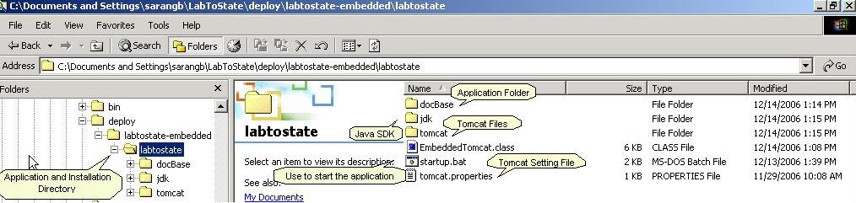
Exhibit 5. Install SDWIS/LabToState

SDWIS/LabToState Startup
In Step 3, you start the application by double clicking on the startup.bat located in the folder in which you installed the application. As depicted in Exhibit 6, this procedure opens a DOS window for the application process. It also opens the default browser pointing to the URL of the application.

Note: You may see warning as depicted in Exhibit 6 – please ignore.

The default hostname is set to “localhost” and the default port is set to “8090”. The URL to the application with these settings is http://localhost:8090/labtostate/jsp/index.jsp. You may change the host name and port number of the embedded Tomcat by changing the tomcat.properties file found in the top folder of the application installation directory.

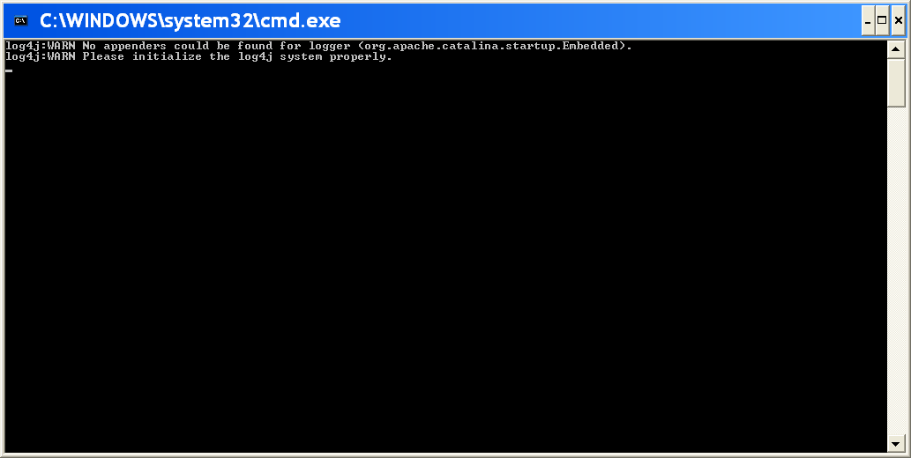
Exhibit 6. Stand alone Client Application DOS Window

SDWIS/LabToState Shut Down
In Step 4, you shut down the application by closing the DOS window. To close the DOS window click the “X” in the upper right corner of the DOS window.

Configure SDWIS/LabToState
After completing the above steps, the installation of SDWIS/LabToState software is complete. You should continue to Section 4.0, Site Customization Procedures of this document to configure the SDWIS/LabToState software for your site.

Web based Application Installation
This section describes procedures for installing SDWIS/LabToState as a web based application. The SDWIS/LabToState software is installed on a web server and interfaces with the e-mail server. Therefore, a System Administrator familiar with the web server, application server, and e-mail server must be available to you (as the person installing the SDWIS/LabToState application) throughout the installation process. For primacy agencies using SQL PlugIn, SDWIS/LabToState interfaces with your database and the Database Administrator (DBA) must also be available.

The installation procedures described in this section include a step for installing the support software required by SDWIS/LabToState. That step refers to Section 3.0, Support Software Installation Procedures, which contains the detailed procedures for installing and upgrading the supporting software.

If you are installing SDWIS/LabToState as a web based application and need to upgrade your current installation, you may proceed to Section 2.2.1, Upgrade Installation-Web Based Application. If you have never installed it at your site, you should proceed to Section 2.2.2, First Time Installation-Web Based Application.

Upgrade Installation-Web Based Application
Exhibit 7 is a checklist of the steps required to upgrade to a new release of SDWIS/LabToState. The remainder of this section further describes each step in the upgrade installation procedures.

SDWIS/LabToState Upgrade Installation Checklist
Installation Step | Installation Activity Description | Installation Guide Reference
1 | Archive SDWIS/LabToState Files | Section 2.2.1.1, Archive SDWIS/LabToState Files
2 | Remove the SDWIS/LabToState Software | Section 2.2.1.2, Remove the SDWIS/LabToState Software
3 | Install SDWIS/LabToState Software | Section 2.2.1.3, Install SDWIS/LabToState Software

Exhibit 7. SDWIS/LabToState Upgrade Installation Checklist

Archive SDWIS/LabToState Files
The first step to upgrading SDWIS/LabToState is to move the files and directories containing SDWIS/LabToState processing information. Otherwise, those files and directories will be deleted during the installation of the new release. The SDWIS/LabToState processing files and directories you need to move are listed in Exhibit 8.

File or Directory | Name | Description
Directory | c:\jakarta-tomcat-5.0.28\webapps\LabToState\JobFolders | Contains the uploaded sample data, output reports, and generated XML documents for each job processed by SDWIS/LabToState.
Directory | c:\jakarta-tomcat-5.0.28\webapps\LabToState\WEB-INF\classes\properties | Contains site-specific values used to configure the SDWIS/LabToState software.

Exhibit 8. SDWIS/LabToState Files To Archive

The Job Folders directory is archived to maintain a history of the XML documents validated and prepared by SDWIS/LabToState at your site. The properties directory is archived so that it may be used as a reference to set the values of the site configuration files during the SDWIS/LabToState installation.

Note: Since the Site Configuration files may have changed since the last release, use the current values as a reference to update values when the new release of the application is installed.

Remove the SDWIS/LabToState Software
In Step 2, you remove the SDWIS/LabToState software from the application server. The following list itemizes the tasks required to remove this software:

- Double-click the startup.bat file in the c:\jakarta-tomcat-5.0.28\bin directory to start Tomcat (assumes Tomcat is running in a DOS window).

- Open a web browser and type http://localhost:8080 in the address bar. The Tomcat home page will be displayed as illustrated in Exhibit 9.

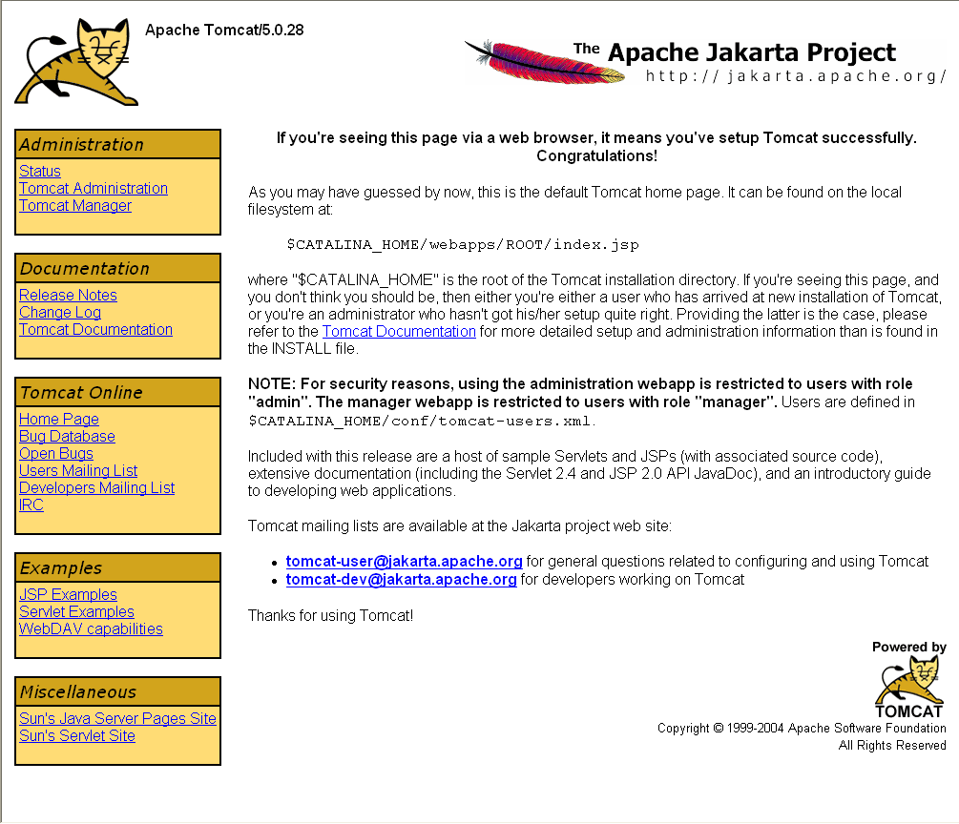
Exhibit 9. Tomcat Administration Home Page

- Click on the Tomcat Manager link, located on the left side of the page in the box titled Administration. You will be prompted for a User ID and Password. Enter the User ID and Password created to manage the Tomcat application server (i.e., the User ID assigned to the role of “admin, manager”). To find the User ID and password, complete the following tasks:

- Open the file tomcat-users.xml, located in the directory c:\jakarta-tomcat-5.0.28\conf\ using a standard text editor.

- Find the User ID and Password assigned to the “admin,manager” roles. If a User ID and Password is not assigned to these roles, enter the following lines in the file before the line “</tomcat-users>” (note the preceding backslash). Replace the italicized words with the desired User ID and Password. Save the file and restart the Tomcat application.

<user username= “AdministratorUser” Password= “AdministratorPassword” roles= “admin,manager” />

- The Tomcat Web Application Manager page is displayed as depicted in Exhibit 10. Click on the Undeploy button in the applications list next to the SDWIS/LabToState application. The arrow in Exhibit 10 illustrates the location of this button on the page.

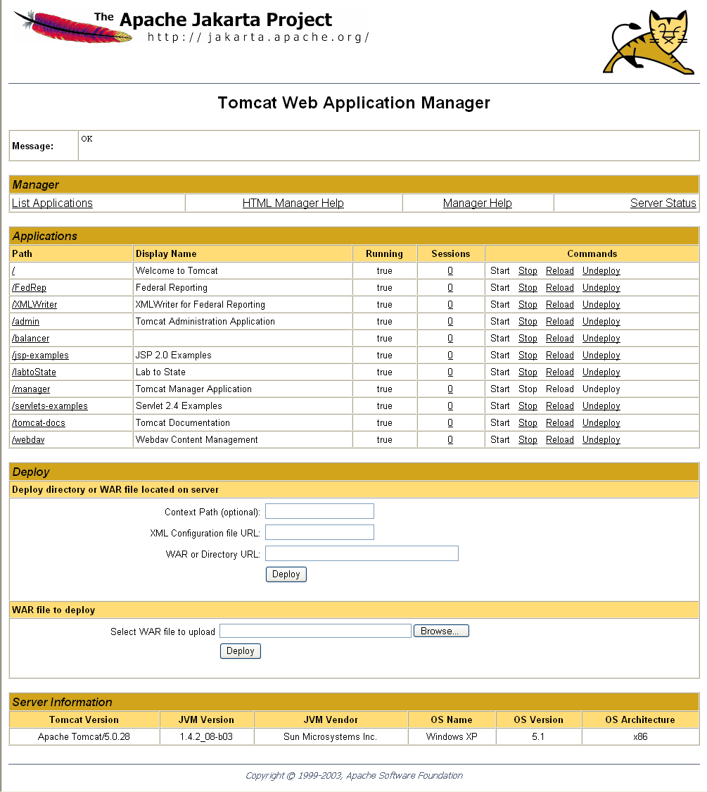
Exhibit 10. Tomcat Web Application Manager Page

- Exhibit 11 depicts the page that is presented after the application is “Undeployed.” The message “OK - Undeployed application at context path /LabToState” is presented in the Message section, which is located directly below the page title of “Tomcat Web Application Manager.” The arrow in Exhibit 11 illustrates the location of this message. Additionally, SDWIS/LabToState is removed from the list of applications in the Applications section of the page.

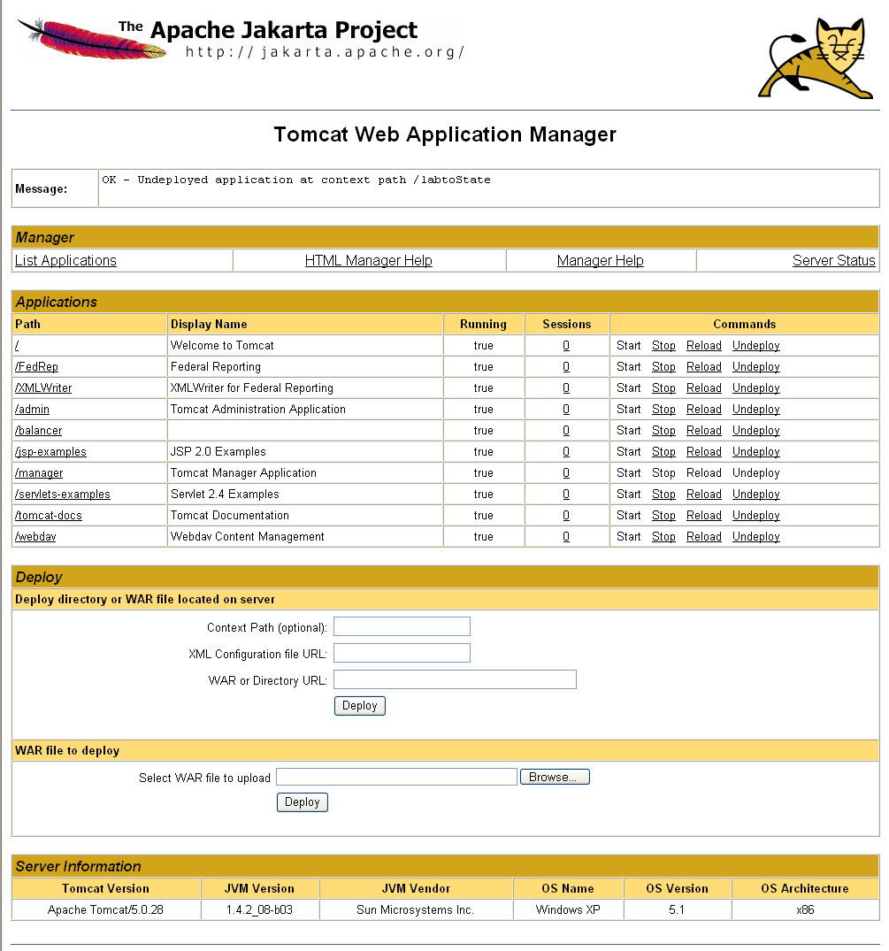
Exhibit 11. Tomcat Web Application Manager Page

Install SDWIS/LabToState Software
After the existing release of SDWIS/LabToState is removed from the application server, you should install the SDWIS/LabToState software using the installation procedures described in Section 2.2.2, First Time Installation-Web Based Application.

First Time Installation-Web Based Application
Exhibit 12 is a checklist of the steps required to install SDWIS/LabToState for the first time. The remainder of this section further describes each step in the first time installation procedures.

SDWIS/LabToState First Time Installation Check List
Installation Step | Installation Activity Description | Installation Guide Reference
1 | Download SDWIS/LabToState Installation Package and documentation | 2.2.2.1 Download SDWIS/LabToState Installation Package
2 | Install support software (i.e., Java SDK and Tomcat application server) used by SDWIS/LabToState | 2.2.2.2 Install Support Software Used by SDWIS/LabToState
3 | Assign User ID and Password on the application server | 2.2.2.3 Assign User Identification and Passwords
4 | Install the SDWIS/LabToState software | 2.2.2.4 Install the SDWIS/LabToState Software
5 | Set Java environment variable | 2.2.2.5 Set Environment Variables
6 | Configure SDWIS/LabToState for deployment at your site | 2.2.2.6 Configure and Start Up SDWIS/LabToState

Exhibit 12. SDWIS/LabToState First Time Installation Checklist

Download SDWIS/LabToState Installation Package
The first step is to download the SDWIS/LabToState 1.0 Installation Package from the SDWIS web site (http://www.epa.gov/safewater/sdwisfed/sdwismod.htm). You should also download the SDWIS/LabToState 1.0 User Guide and the SDWIS/LabToState 1.0 Release Notes.

Install Support Software Used by SDWIS/LabToState
In Step 2, you load the Java 2 Platform Standard Edition, Software Development Kit (SDK), and Tomcat on the application server. If both the Java SDK and Tomcat are already installed on the application server, this step may be skipped. To install or upgrade those components, you should proceed to Section 3.0, Support Software Installation Procedures, which contains detailed instructions for loading these software components. Although the SDWIS/LabToState application may be deployed in any Java 2 Enterprise Edition (J2EE) compliant application server, the installation procedures assume Tomcat is the application server on which SDWIS/LabToState is deployed.

Assign User Identification and Passwords
In this step, you define the User ID and Password that administers the Tomcat server. The administration capability is required to install SDWIS/LabToState.

Note: User IDs and Passwords are case-sensitive.

The following list describes the tasks required to create a User ID and Password to the roles named “admin” and “manager,” which allow the administration of the Tomcat application server.

- Open the file tomcat-users.xml, located in the directory c:\jakarta-tomcat-5.0.28\conf\ using a standard text editor.

- Enter the following line in the file before the line “</tomcat-users>” (note the preceding backslash). Replace the italicized words with the desired User ID and Password.

<user username= “AdministratorUser” Password= “AdministratorPassword” roles= “admin,manager” />

Note: If Tomcat is installed as a service, the User ID and Password for the admin and manager roles were assigned during the installation of the Tomcat service.

- Remember to save the file.

- The next time the Tomcat application is initiated, the User IDs and Passwords are activated.

Note: If Tomcat is running in a DOS window, double-click the startup.bat file in the C:\jakarta-tomcat-5.0.28\bin directory to initiate Tomcat. To shut down Tomcat, double-click the shutdown.bat file in the C:\jakarta-tomcat-5.0.28\bin directory. If Tomcat is running as a service, the Tomcat service is shut down and initiated using the operating systems service administration utilities.

Install the SDWIS/LabToState Software
In Step 4, you load the SDWIS/LabToState software on the Tomcat application server. The installation package delivers the SDWIS/LabToState software as a single packed file format known as a Web Archive (WAR) file. This format is generally used to distribute applications before installation. By completing the following tasks, the WAR file is unpacked into the appropriate file structure.

- Start the Tomcat server. Double-click the startup.bat file in the c:\jakarta-tomcat-5.0.28\bin directory to initiate Tomcat (assumes Tomcat is running in a DOS window).

- Open a web browser and type http://localhost:8080 in the address bar. The Tomcat home page will be displayed as illustrated in Exhibit 13.

Exhibit 13. Tomcat Home Page

- Click on the Tomcat Manager link, located on the left side of the page in the box titled Administration. You will be prompted for a User Name and Password, as depicted in Exhibit 14. Enter the User Name and Password created for the admin and manager roles in Section 2.1.3, Assign User Identification and Passwords.

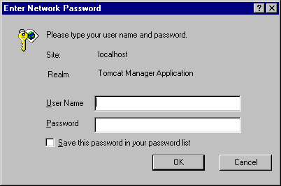
Exhibit 14. User ID and Password for Tomcat Manager

- The Tomcat Web Application Manager page is displayed. In the Deploy section of the page in the text box labeled “Select WAR file to upload,” enter the SDWIS/LabToState WAR file as depicted in Exhibit 15. Use the Browse button to assist with locating the file. The arrow in Exhibit 15 illustrates the location of this link on the page. After the SDWIS/LabToState War file is displayed in the text box, click on the Deploy button.

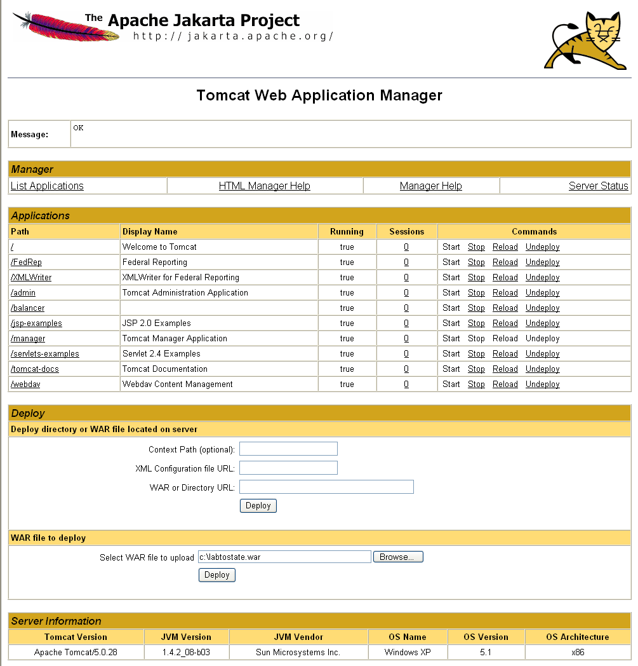
Exhibit 15. Tomcat Web Application Manager — Before Deployment

- Exhibit 16 shows the page that is presented after the application is deployed. The message “OK - Deployed application at context path /LabToState” is presented in the Message section, which is located directly below the page title of “Tomcat Web Application Manager.” Additionally, the SDWIS/LabToState application is listed in the Applications section of the page.

- Shut down the Tomcat server by double-clicking the shutdown.bat file in the c:\jakarta-tomcat-5.0.28\bin directory (assumes Tomcat is running in a DOS window).

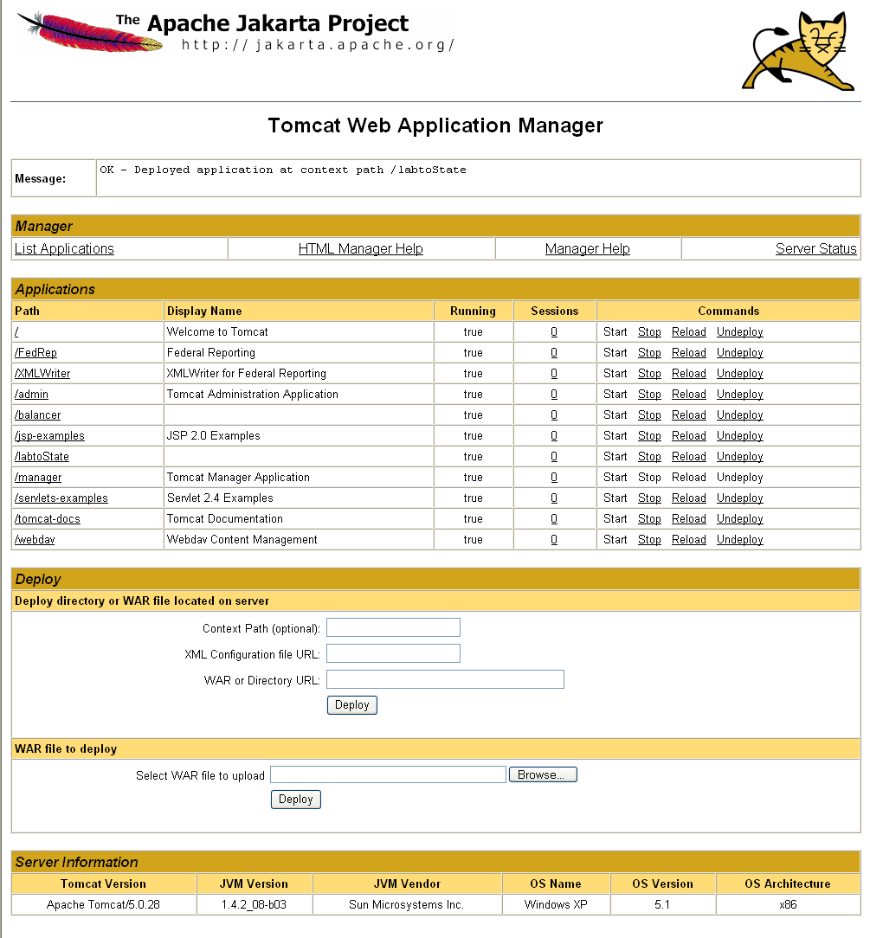
Exhibit 16. Tomcat Web Application Manager Page — After Deployment

Set Environment Variables
In Step 5, you set the environment variable used by the Apache Tomcat. The “JAVA_HOME” variable is set to the location of the java compiler software and is used by the Apache Tomcat server. By completing the following tasks, you set these environment variables:

- From the Window’s Control Panel, click on the System icon.

- Select the Advanced tab.

- Click on Environment Variables button.

- In the Environment Variables window (Exhibit 17), add a system variable named JAVA_HOME with the value of the variable set to the location of the java compiler software (e.g., c:\j2sdk1.4.2_08).

- Restart the Tomcat server by double-clicking the startup.bat file in the c:\jakarta-tomcat-5.0.28\bin directory (assuming Tomcat is running in a DOS window).

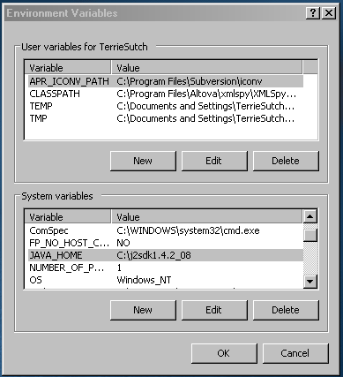
Exhibit 17. SDWIS/LabToState System Environment Variables

Configure and Start Up SDWIS/LabToState
After completing Steps 1 through 5, the installation of SDWIS/LabToState is complete. You should continue to Section 4.0, Site Customization Procedures of this document to configure the SDWIS/LabToState software for your site.

After configuring SDWIS/LabToState, you need to complete the following activities:

- Start the application server.
- Enter URL of the application (e.g., http://localhost:8080/labtoState/jsp)

Support Software Installation Procedures
Prior to installing the SDWIS/LabToState application, you should configure the application server hosting the SDWIS/LabToState application to include the following support software:

- Java 2 Platform Standard Edition, Software Development Kit (SDK). The SDK provides the libraries, Java virtual machine, and other components necessary to run applications written in the Java programming

- Application Server/Web Server. SDWIS/LabToState may be hosted on any J2EE compliant application server. All development and testing was conducted using the Tomcat application server provided by Apache Software Foundation. Tomcat serves as both the application and web server.

SDWIS/LabToState uses Sun Microsystems SDK Version 1.4.2.Tomcat. To upgrade your current releases of the Java SDK and language, proceed to Section 3.1, Application Server Upgrade Installation. If these components are not installed on your server, proceed to Section 3.2, Application Server First Time Installation, which defines procedures for installing the Java SDK and Tomcat software for the first time.

Note: For both a first time and an upgrade installation of the Java SDK and the Tomcat software, SDWIS/LabToState must be re-installed. Therefore, SDWIS/LabToState installation package must be available to you as the application installer.

Note: The Java SDK must be installed before the installation of the Tomcat application server.

Application Server Upgrade Installation
Exhibit 18 is a checklist of the steps required to upgrade to new releases of Java SDK and Tomcat if this software is already installed on your application server. The remainder of this section further describes each step in the installation procedures.

Supporting Software Upgrade Installation Checklist
Installation Step | Installation Activity Description | Installation Guide Reference
1 | Archive SDWIS/LabToState Files | 3.1.1 Archive SDWIS/LabToState Files
2 | Remove Current Tomcat Release | 3.1.2 Remove Current Tomcat Release
3 | Remove Current Java SDK | 3.1.3 Remove Java SDK
4 | Install Supporting Software | 3.1.4 Install Supporting Software

Exhibit 18. Supporting Software Upgrade Installation Checklist

Archive SDWIS/LabToState Files
The first step to upgrading the supporting software is to move the files and directories containing SDWIS/LabToState processing information. Otherwise, those files and directories will be deleted during the installation of the new release. The SDWIS/LabToState processing files and directories that must be moved are listed in Exhibit 19. If these files have already been moved, proceed to Section 3.1.2, Remove Current Tomcat Release.

File or Directory | Name | Description
Directory | C:\jakarta-tomcat-5.0.28\webapps\LabToState\JobFolders | Contains the XML documents generated by each job processed by SDWIS/LabToState.
Directory | C:\jakarta-tomcat-5.0.28\webapps\LabToState\WEB-INF\classes\properties | Contains site-specific values used to configure the SDWIS/LabToState processing.

Exhibit 19. SDWIS/LabToState Files To Archive
The Job Folders directory is archived to maintain a history of the XML documents validated and prepared by SDWIS/LabToState at your site. The properties directory is archived so that it may be used as a reference to set the values during the configuration of SDWIS/LabToState.

Note: Since the values in the files contained in the properties directory may have changed since the last release, use the current values as a reference to update the values when the new release of the application is installed.

Remove Current Tomcat Release
Before installing the new release of Tomcat, the current release must be removed from the application server. The following list describes the tasks required to remove Tomcat from the application server:

- If Tomcat is installed as a batch job, you delete the file containing the Tomcat software. For a default installation of Tomcat, the default directory is c:\jakarta-tomcat-5.0.28.

- If Tomcat is installed as a service, you should remove Tomcat by using Windows standard Add/Remove Programs utility, as described below:

- From the Windows Start menu, select Settings/Control Panel/Add or Remove Programs. Exhibit 20 depicts the window displayed.

- Click on the Apache Tomcat program as illustrated in Exhibit 20 and click the Change/Remove button. Follow the prompts from Window’s Add or Remove Programs utility.

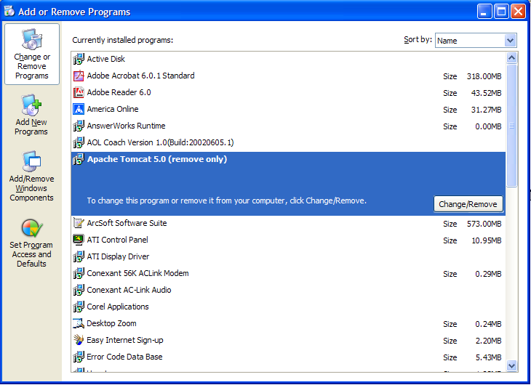
Exhibit 20. Remove Tomcat — Add or Remove Program Window

Remove Java SDK
Before installing the new release of Java SDK, the current release must be removed from the application server. The following list describes the tasks required to remove Java SDK from the application server:

- From the Windows Start menu, select Settings/Control Panel/Add or Remove Programs. Exhibit 21 depicts the window displayed.

- Click on the Java 2 SDK program as illustrated in Exhibit 21 and click the Remove button. Follow the prompts from Window’s Add or Remove Programs utility.

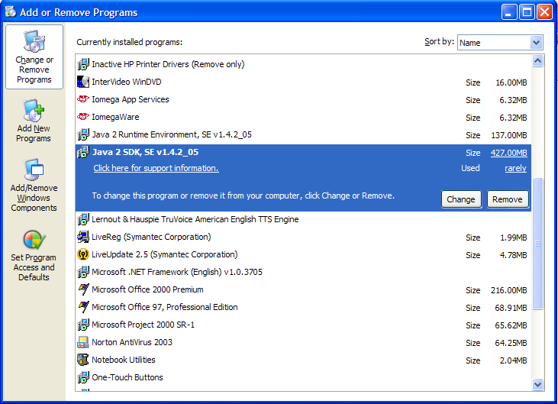
Exhibit 21. Remove Java SDK — Add or Remove Program Window

Install Supporting Software
After the existing versions Java SDK and Tomcat are removed from the application server, the new releases of that software must be installed using the installation procedures described in Section 3.2, Application Server First Time Installation.

Application Server First Time Installation
Exhibit 22 is a checklist of the steps required to install and configure Java SDK and Tomcat for the first time. The remainder of this section further describes each step in the installation procedures.

Supporting Software First Time Installation Checklist
Installation Step | Installation Activity Description | Installation Guide Reference
1 | Download the Java SDK | 3.2.1 Download the Java SDK
2 | Install the Java SDK | 3.2.2 Install the Java SDK
3 | Download Tomcat | 3.2.3 Download Tomcat
4 | Install Tomcat | 3.2.4 Install Tomcat
5 | Increase Tomcat’s Memory Allocation | 3.2.5 Increase Tomcat’s Memory Allocation
6 | Complete Support Software Installation | 3.2.6 Complete Support Software Installation

Exhibit 22. Supporting Software First Time Installation Checklist

Download the Java SDK
In first step of the installation procedures, download the Java 2 SDK, Standard Edition (J2SE) 1.4.x, from Sun Microsystems web site (i.e., http://java.sun.com/j2se/1.4.2/download.html). Exhibit 23 depicts the page that is presented. To download the Java SDK, click on the link that is labeled “Download Windows J2SE SDK.” The arrow in Exhibit 23 illustrates the location of this link on the page.

Note: The page format and navigation may change after publication of this document.

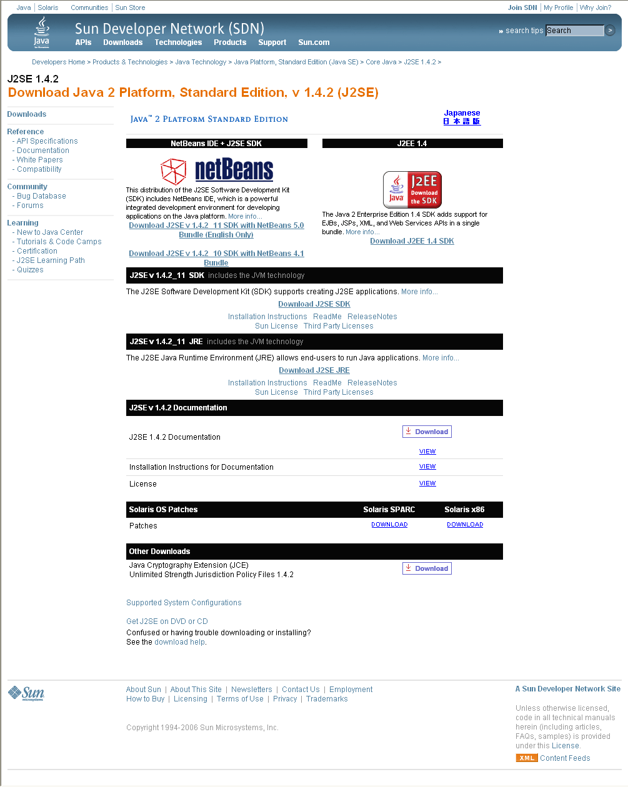

Exhibit 23. Java SDK Download Page

Install the Java SDK
To install the Java SDK, double-click on the installation package downloaded in Step 1. Follow the instructions displayed in the installation package and accept the default options. This installation may take several minutes.

Note: The Java SDK must be installed in file folders that DO NOT contain spaces. Spaces in the file folder or file name will cause errors when calling the software from a DOS prompt.

Download Tomcat
Download a release build of Tomcat 5.0.28 from Apache Software Foundation’s web site
( http://jakarta.apache.org/). The following task list describes the page layout and navigation required to download the Tomcat Release build; this layout and navigation, however, may change after publication of this document:

Click on the link http://jakarta.apache.org/site/binindex.cgi to display the Apache download page as depicted in Exhibit 24.

- Click on the Tomcat link; the location is noted with the arrow in Exhibit 24. Exhibit 25 depicts the page presented.

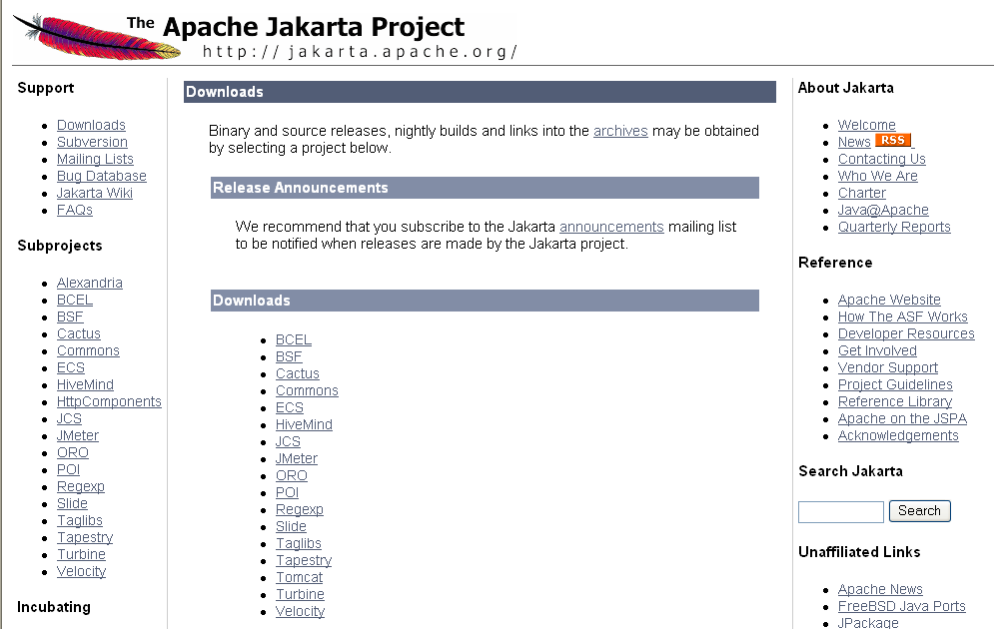

Exhibit 24. Download Tomcat from Apache Web Site
- In Exhibit 24, the Tomcat link is noted with the arrow. Click that link and follow the links labeled Tomcat 5 in the pages presented until the page depicted in Exhibit 26 is presented.

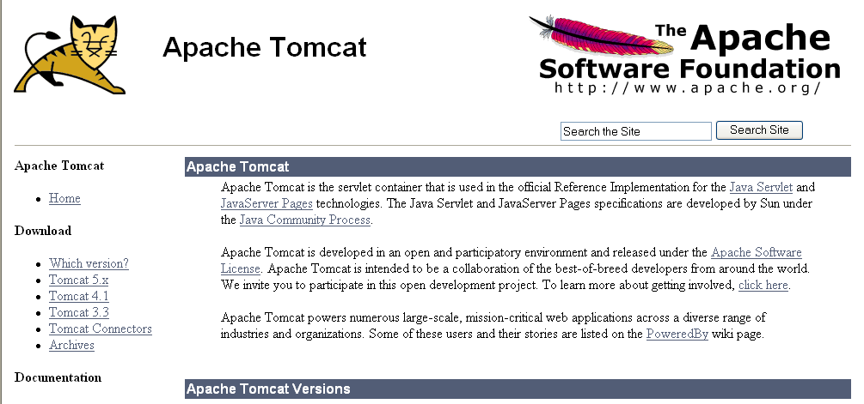

Exhibit 25. Download Tomcat from Apache Web Site

- Click on the link labeled “Tomcat 5.x” located on the left side of the page under the label Download. Exhibit 26 depicts the page presented.

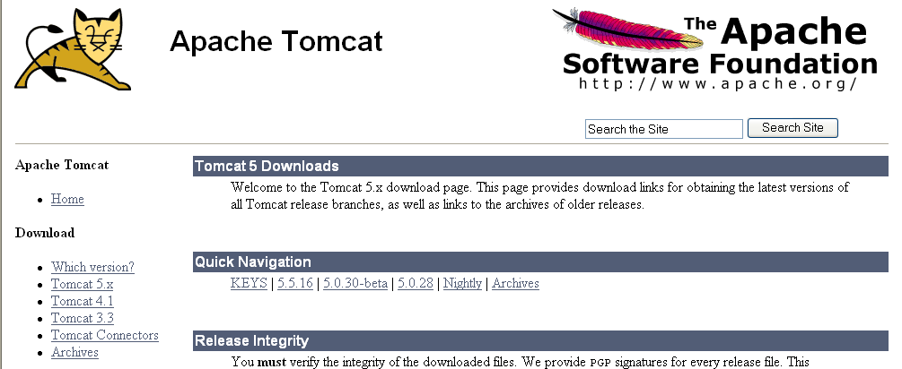

Exhibit 26. Download Tomcat from Apache Web Site

- Click on the link labeled “5.0.28” located under the Quick Navigation section of the page. Exhibit 27 depicts the page presented.

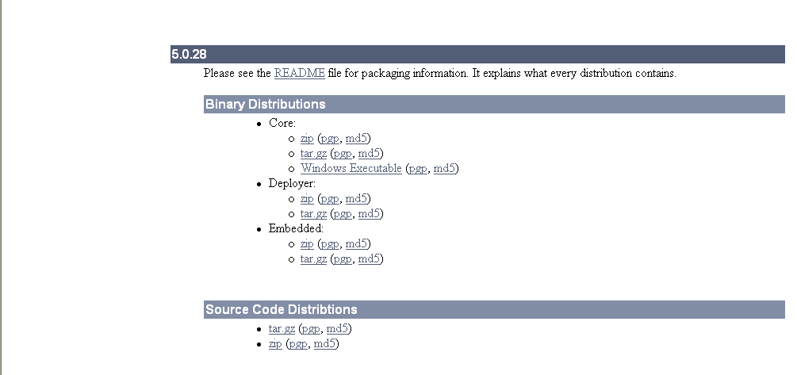

Exhibit 27. Download Tomcat from Apache Web Site

- Click on the link labeled “Windows Executable (pgp md5)” or “zip (pgp md5)” based on whether you want to run Tomcat as a service or in a DOS window. The link labeled “Windows Executable (pgp md5)” downloads a file that installs Tomcat to run as a service. The link labeled “zip (pgp md5)” downloads a file that installs Tomcat to run in a DOS window.

Note: Tomcat may be installed to run as service or as a batch job. If Tomcat is installed as a service, it runs as a background task and must be started and shut down using service utilities. If Tomcat is installed as a batch job, it runs in a DOS window and must be started and stopped using batch files.

Install Tomcat
To install Tomcat to run in a DOS window, double-click on the zip file (downloaded in Step 3) to extract all files to the c drive. Make sure to set the “Use Folder Names” checkbox on the WinZip Extraction window. Failure to select this checkbox results in improper installation.

To install Tomcat as a service, double-click on the exe file (downloaded in Step 3) and follow the installation instructions.

Note: Tomcat MUST be installed in file folders that DO NOT contain spaces. Spaces in the file folder or file name will cause errors when calling the software from a DOS prompt.

Note: The default directory for a Tomcat installation using the exe file MUST be changed to a different directory structure (e.g., c:\Tomcat5_0). Tomcat does not allow a path name sufficiently long enough to support the default path in the Tomcat variables set during SDWIS/LabToState installation.

Increase Tomcat’s Memory Allocation
If Tomcat is running in a DOS window, you increase its memory pool using the Tomcat Monitoring Tool. To increase the memory allocation, complete the following steps:

- From the Windows Start Menu, click Programs, Apache Tomcat, Monitor Tomcat. These actions insert an Apache icon in the System Tray as indicated by the arrow in Exhibit 28.
Apache Icon
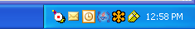
Exhibit 28. Apache Icon in the Desktop’s System Tray

- Right click the Apache icon and select Configure, which displays the Apache Tomcat Properties window as depicted in Exhibit 29.

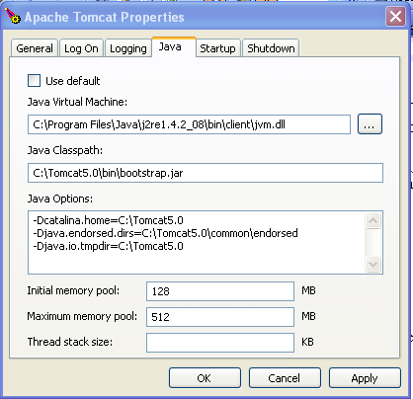
Exhibit 29. Tomcat Properties Window

- Enter 128 for the initial memory pool. Enter 512 for the maximum memory pool. Click OK, which sets the memory allocation parameters.

- Restart Tomcat, which allows the memory parameters to be established.

If Tomcat is running in a DOS window, you increase its memory pool by assigning the following System Environment Variable:

- In the Environment Variables window, add a system variable named JAVA_OPTS with the value of the variable set to -Xms128m -Xmx512m. This variable assigns additional memory to the SDWIS/LabToState java application.

- Restart Tomcat, which allows the memory parameters to be established.

Complete Support Software Installation
After completing the activities described in the above sections, the installation of Java SDK and Tomcat is completed. You should return to Step 3 of the SDWIS/LabToState first time installation procedures in Section 2.2.2.3, Assign User Identification and Passwords.

Site Customization Procedures
This section describes how to configure SDWIS/LabToState at your site. It describes the text files used to assign various installation and run-time parameters. It also describes procedures for constructing the data files for submission to SDWIS/LabToState.

Site Customization Files
To customize its deployment, SDWIS/LabToState uses several text files and XML documents. SDWIS/LabToState does not offer any tools to administer these files. You may use any standard text editor to modify or change the content. All of the various configuration files are located in the following directory:

Stand alone Client Application: [Unzipped Folder]\docBase\web-inf\classes\properties
Web Based Application: [AppServerHome]\webapps\labtostate\web-inf\classes\properties

The following sections describe each configuration file.

Site Properties File
The Site Properties File is a text file formatted as name/value pairs. The System Administrator changes values in this file to reflect the operational environment at a particular site. Appendix A lists the name, description, and initial setting of each name/value pair. Column 2 (Set By) of Appendix A indicates whether the value of the element is “Set By” the software, system administrator, or through delivery (the file is delivered with a value that should not be changed).

Physical File Name: siteProperties.txt

User Identification XML Document
SDWIS/LabToState provides a default implementation of user authentication. It is, however, anticipated that most states will implement their own authentication utility. The default implementation is provided to deliver an “out of the box” solution for initial start up and testing. That default implementation uses an XML document to identify each User ID and assign to it a password, role, PIN number, and laboratory. Exhibit 30 lists the contents of the XML document delivered with SDWIS/LabToState.

Each user is assigned one of two roles. A user assigned to the Lab role is granted access to the sample data submitted by that laboratory. A user assigned to the State role is granted access to all submissions regardless of the laboratory.

To authorize a new user add the User ID, Password, PIN Number, and role to the XML document as depicted in Exhibit 30. A PIN Number and laboratory are not required if the user is assigned to the “State” role.

Physical XML Document File Name: userList.xml

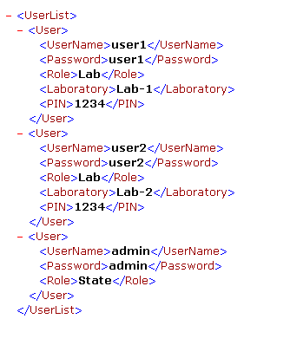
Exhibit 30. User Authentication XML Document

Release Statement File
The Release Statement File is a text file containing the text presented to the user as he/she releases the XML document to SDWIS/XML Sampling. This text will be presented on the Certification page.

Physical File Name: certificationStatement.txt

Data File Content Configuration
SDWIS/LabToState provides a Data-Source Plug-In to receive sample data formatted as comma separated values (CSV). The site configures the content and order of the sample data contained in the CSV file. First, the site identifies logical groupings of sample data referred to as logical objects. Each logical object is based on one of the following SDWIS/XML Sampling structure sets:

- Sample
- Sample Measure
- Result
- Sample Result Measure
- Sample Summary
- Sample Summary Result
- MDBP Summary

The Object Configuration File is a text file that maps logical objects to one and only one structure set. Each structure set, however, may be mapped to multiple logical objects. For example, the site may identify a logical object called TCRSample and map it to the Sample structure set. The site may also identify a logical object called GeneralSample and map it to the same Sample structure set. Even though both logical objects (TCRSample and GeneralSample) map to the same Sample structure set, they may contain different data in a different order. Exhibit 31 lists the content of the Object Configuration File delivered with SDWIS/LabToState.

Physical File Name: master.txt.

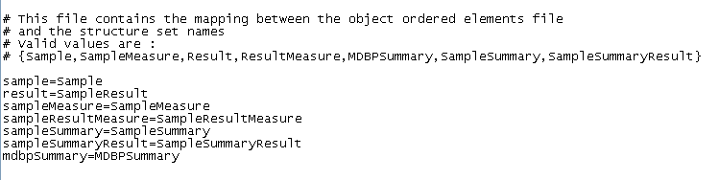
Exhibit 31. Object Configuration File

For each logical object identified in the Object Configuration File, the Element Configuration File lists the elements and their order in the CSV file. The element names are listed in the order in which they are submitted in the CSV file. The name of the element is the Staging Table Column Name as specified in the structure set documentation included in the SDWIS/XML Sampling Mapping Document and Accompanying Schemas Document (GSA-SDWIS-01-8.d4d, December 30, 2005). The Element Configuration File is a text file and the site creates a separate Element Configuration File for each logical object. Using the above example in which the site configured both a TCRSample and a GeneralSample logical object, the site must also configure two Element Configuration Files named TCRSample.txt and GeneralSample.txt. Exhibit 32 lists the Element Configuration Files delivered with SDWIS/LabToState. Appendix B contains a list of the content of each Object and Element Configuration file delivered with SDWIS/LabToState. The physical name of the Element Configuration File is [logical object].txt.

Element Configuration Files
mdbpSummary.txt
result.txt
sample.txt
sampleMeasure.txt
sampleResultMeasure.txt
sampleSummary.txt
sampleSummaryResult.txt

Exhibit 32. Element Configuration Files

Physical File Name: [logicalobject].txt

To configure your own CSV file content and order, you assign a logical name, such as TCRSample, to the data you want to submit. You register the logical name by adding it to the Object Configuration file and assigning it to one of the SDWIS/XML Sampling Structure Sets, listed in Exhibit 33. Then, you create a text file containing the list of elements names representing the data to be submitted with that logical object. Appendix C contains an Microsoft Excel spreadsheet that lists the element names by business object. When you create the CSV file, the first column of the line of text is the name of the object followed by the data values for each of the elements named in the Element Configuration file.

SDWIS/XML Sampling Structure Sets
Sample
SampleResult
MDBPSummary
SampleSummary
SampleSummaryResult
SampleMeasure
SampleResultMeasure

Exhibit 33. SDWIS/XML Sampling Structure Sets
Exhibit 34 depicts an example of a CSV file that conforms to the default configuration delivered with SDWIS/LabToState. The first column in the CSV file is always the name of the logical object being submitted. The remainder of the line is the sample data in the order specified in the Element Configuration File for that logical object. Also, if any alphanumeric data contains spaces, the alphanumeric data must be enclosed in quotation marks as depicted in the first line of Exhibit 34. If the alphanumeric data does not contain spaces, the quotation marks are optional as depicted in the remaining lines of Exhibit 34.

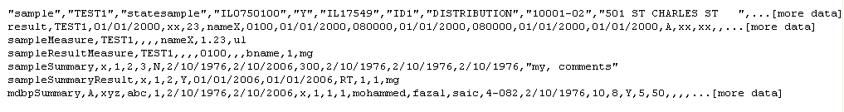
Exhibit 34. Example of CSV File

Data Source Registration File
The Data Registration File is a text file that maps the logical name of each Data-Source Plug-In to the name of the Java class implementing the functionality. The file is formatted as name value pairs. The name is the logical name of the Data-Source Plug-In and is the value listed in the drop-down list on the Upload And Validate Page from which the user selects the data format being uploaded. The logical name is mapped to the Java class implementing the data source specification.

To register your own data source specifications, you must identify a logical name and the Java class implementing your specification. The example depicted in Exhibit 35 registers a new Data-Source Plug-In with a logical name of “NewUserPlugIn.” If this data source is selected from the Upload and Validate page, SDWIS/LabToState invokes the “com.sdwis.labtostate.generator.NewUserPlugIn”. The registered Java class must be copied to the appropriate library in the hierarchy structure. For this example, that directory is [AppServerHome]\webapps\labtostate\web-inf\classes.

The Data-Source Plug-Ins delivered with SDWIS/LabToState and those developed by the site must adhere to the interface specifications documented in Appendix B.

Physical File Name: plugins.txt

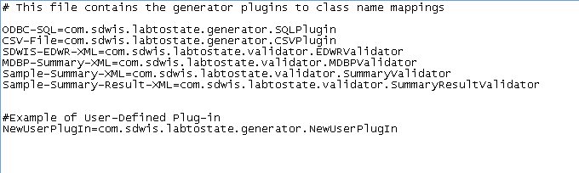
Exhibit 35. Data-Source Plug-In Registration File

This page is intentionally left blank

APPENDIX A

Site Property File Name Descriptions

This page is intentionally left blank.

SDWIS/LabToState Site Property Names and Description
Name | Description | Initial Setting | Set By
TurnOnEmail | Contains an indicator allowing a site to eliminate the delivery of e-mail messages after upload and validation. The permitted values for this property are “true” and “false.” | true | Email Administrator
EmailHost | Contains the IP Address of the SMTP (Simple Mail Transfer Protocol) Mail Server. This value is used to connect to the mail server in automate the delivery of e-mails. This value must be set during installation. | sdc-ex2 | Email Administrator
EmailPort | Contains the port number of the e-mail server. The default value of 25 is used for a standard e-mail server installation. For non-standard e-mail server installations, this value should be changed to the port number of the e-mail server. This value is set during installation and can be changed by the System Administrator. | 25 | Email Administtrator
EmailAuthenticationRequired | Contains an indicator allowing a site to require e-mail authentication. The permitted values for this property are “true” and “false.” This value is set during installation and can be changed by the System Administrator. | false | Email Administrator
EmailUserid | Contains the user name that must be supplied if the e-mail server requires authentication. If e-mail server does not require authentication, the value is set to null. This value is set during installation and can be changed by the System Administrator. | <no value> | Email Administrator
EmailPassword | Contains the Password that must be supplied if the e-mail server requires authentication. If e-mail server does not require authentication, the value is set to null. This value is set during installation and can be changed by the System Administrator. | <no value> | Email Administrator
EmailFromAddress | Contains the e-mail address for the SDWIS/LabToState administrator. This e-mail address is used to send e-mails. | LabToState | Email Administrator
DateFormat | Contains a mask indicating the format in which date values are submitted. The default mask is MM/dd/yyyy. | MM/dd/yyyy | System Administrator
TimeFormat | Contains a mask indicating the format in which time values are submitted. The default mask is hhmmss. | HHmmss | System Administrator
DatabaseDriverClassName | Contains the JDBC-ODBC bridge class name, which connects to the client’s database using the ODBC data source. This value must not be changed. If the site is running on UNIX, this value can be changed to the jdbc driver class name (Refer to your local database manual for “connecting using jdbc”).  sun.jdbc.odbc.JdbcOdbcDriver | sun.jdbc.odbc.JdbcOdbcDriver | This value can be overriden by the Database Administrator
DatabaseConnectionURL | Contains the string used to establish a database connection The default DSN name is set to SDWIS. If the site is using a different DSN then this value must be changed. If the site is running on UNIX, this value can be changed to the jdbc connection url (Refer to your local database manual for “connecting using jdbc”).  jdbc:odbc:SDWIS | jdbc:odbc:SDWIS | This value can be overriden by the Database Administrator
DatabaseUserID | Contains the User ID used to connect to the client’s database schema. This value must be set during installation if the site is using the SQL Plug-in. | XMLSAMPLER10 | Database Administrator
DatabasePassword | Contains the Password used to connect to the client’s database schema. This value must be set during installation if the site is using the SQL Plug-in. | XMLSAMPLER10 | Database Administrator
PasswordAuthenticatorClass | Contains the name of the Java class used to authenticate User IDs and Passwords. If the site implements its own authentication utilities, the implementation must follow the interface specifications documented in the SDWIS/LabToState Installation Guide. SDWIS/LabToState includes a default implementation of user authentication in the Java class com.sdwis.labtostate.utility.DefaultPasswordAuthenticator. | com.sdwis.labtostate.utility.DefaultPasswordAuthenticator | This value can be overriden by the System Administrator
PINAuthenticatorClass | Contains the name of the Java class used to verify a User’s PIN Number. If the site implements its own PIN Number verification utilities, the implementation must follow the interface specifications documented in the SDWIS/LabToState Installation Guide. SDWIS/LabToState includes a default implementation of user PIN Number verification in the Java class com.sdwis.labtostate.utility.DefaultPINAuthenticator. | com.sdwis.labtostate.utility.DefaultPINAuthenticator | This value can be overriden by the System Administrator
NodeURL | Contains the URL to the State Node offering the web services defined by the WSDL document. This parameter must be used when using the State Node for integrating with SDWIS/XMLSampling. | http://localhost:10000/DNC/services/NetworkNodePortType_V10 | Node Administrator
NodeUserId | Contains the UserID required to connect to the State Node. This parameter must be used when using the State Node for integrating with SDWIS/XMLSampling. | <no value> | Node Administrator
NodePassword | Contains the password used to connect to the State Node. This parameter must be used when using the State Node for integrating with SDWIS/XMLSampling. | <no value> | Node Administrator
DataFlowNameForWebService | This value will be used as the dataflow name when invoking the web service. This parameter must be used when using the State Node for integrating with SDWIS/XMLSampling. | XMLSampling | Node Administrator
XMLSamplingIntegratorClass | Contains the name of the Java class that delivers the XML documents to the State Node, which in turn delivers the XML document to SDWIS/XMLSampling. This name/value pair and the name/value pairs that identify the SDWIS/XML Sampling Inbox are mutually exclusive. Therefore, for delivery, this name/value pair is commented. To implement this feature, you remove the comment from this line and comment the lines associated with the SDWIS/XML Sampling Inbox (SDWIS_EDWR_Inbox, Sample_Summary_Inbox, Sample_Summary_Result_Inbox, and MDBP_Summary_Inbox). | com.sdwis.labtostate.utility.XMLSamplingFileSystemIntegrator | System Administrator
SDWIS_EDWR_Inbox | Contains the full path and folder name of the SDWIS eDWR XML Document Inbox used by SDWIS/XML Sampling. This name/value pair and the name/value pair (XMLSamplingIntegratorClass) that identifies the Java Class for the State Node submission are mutually exclusive. Therefore, if you implement the State Node approach to SDWIS/XML Sampling integration, you must comment this line and remove the comment from the XMLSamplingIntegratorClass line. | C:\\jakarta-tomcat-5.0.28\\webapps\\XMLSampling\\SampleFolder | System Administrator
Sample_Summary_Inbox | Contains the full path and folder name of the SDWIS Sample Summary XML Document Inbox used by SDWIS/XML Sampling. This name/value pair and the name/value pair (XMLSamplingIntegratorClass) that identifies the Java Class for the State Node submission are mutually exclusive. Therefore, if you implement the State Node approach to SDWIS/XML Sampling integration, you must comment this line and remove the comment from the XMLSamplingIntegratorClass line. | C:\\jakarta-tomcat-5.0.28\\webapps\\XMLSampling\\SummaryFolder | System Administrator
Sample_Summary_Result_Inbox | Contains the full path and folder name of the SDWIS Summary Result XML Document Inbox used by SDWIS/XML Sampling. This name/value pair and the name/value pair (XMLSamplingIntegratorClass) that identifies the Java Class for the State Node submission are mutually exclusive. Therefore, if you implement the State Node approach to SDWIS/XML Sampling integration, you must comment this line and remove the comment from the XMLSamplingIntegratorClass line. | C:\\jakarta-tomcat-5.0.28\\webapps\\XMLSampling\\SummaryResultFolder | System Administrator
DMBP_Summary_Inbox | Contains the full path and folder name of the SDWIS MDBP Summary XML Document Inbox used by SDWIS/XML Sampling. This name/value pair and the name/value pair (XMLSamplingIntegratorClass) that identifies the Java Class for the State Node submission are mutually exclusive. Therefore, if you implement the State Node approach to SDWIS/XML Sampling integration, you must comment this line and remove the comment from the XMLSamplingIntegratorClass line. | C:\\jakarta-tomcat-5.0.28\\webapps\\XMLSampling\\MDBPSummaryFolder | System Administrator

APPENDIX B

Object and Element Configuration Files

This page is intentionally left blank.

Sample Object

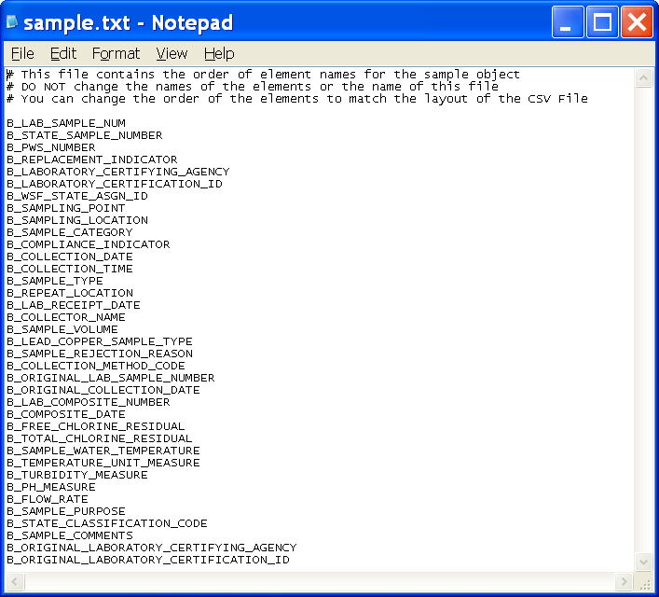

Sample Measure Object

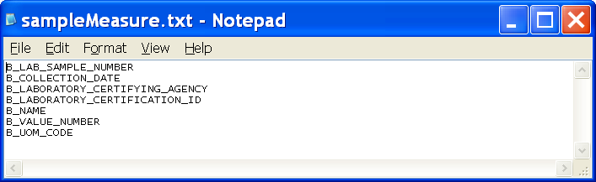
Result Object

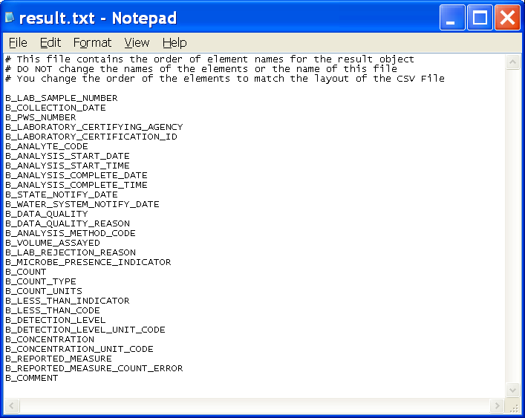
Sample Result Measure Object

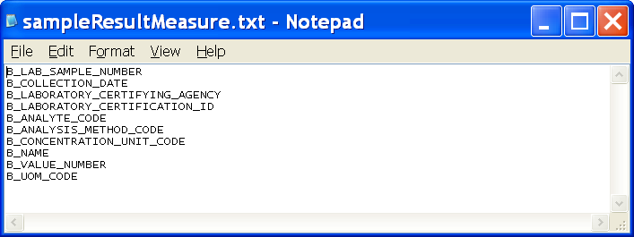
Sample Summary Object

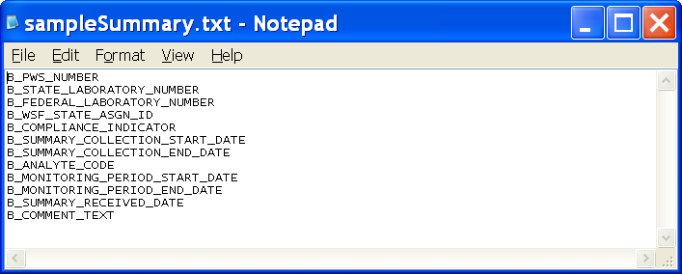
Sample Summary Result Object

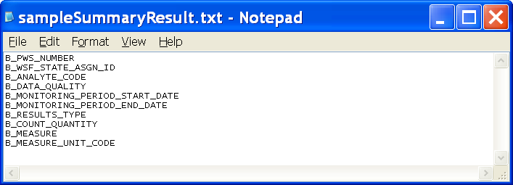

MDBP Summary Object

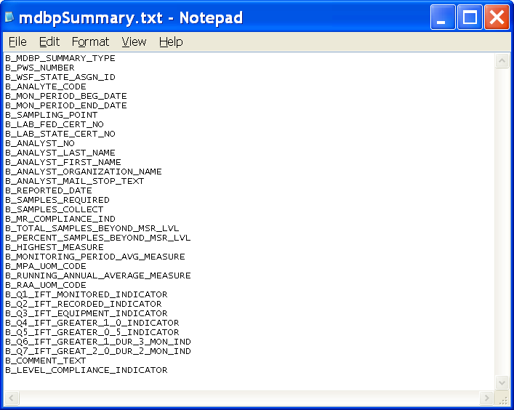

This page is intentionally left blank.

APPENDIX C

Element Names by Object

This page is intentionally left blank.

Click on the icon below to use viewing the electronic file for Appendix C

This page is intentionally left blank.

APPENDIX D

Interface Specifications

This page is intentionally left blank.

Data-Source Plug-Ins Interface Specifications

To implement a Data-Source Plug-In, the implementer will complete the following steps to create, register, and integrate it with SDWIS/LabToState.

STEP 1: Develop a site-specific Data-Source Plug-in

The Java class that implements the site-specific Data-Source Plug-In extends an abstract class delivered with the standard SDWIS/LabToState software. The abstract class is com.sdwis.labtostate.generator.Plugin. The new Java class implements one method with the following signature:

public abstract void execute(UIStructure structure) throws Exception;

The argument passed to this method is the UIStructure class, which contains all the data entered by the user in the upload and validate page. It is the responsibility of the concrete data source plugin class to create the DataObject class for each logical business object for which it is receiving data. The DataObject class contains an attribute command which holds the name of the logical business object and a string array containing the data values in the order specified by the Element Configuration File. The abstract class provides a pointer to the handler, which the custom class uses to invoke the XML Generation tool of the SDWIS/LabToState application. After the new Java class creates the DataObject, it invoked the handler’s processObject method denoted by the following method signature:

abstract public void processObject(DataObject object) throws Exception;

After creating and processing all the DataObjects, the new Java class creates a special DataObject containing the “Marshall” command. This command notifies the handlers to create the XML documents from the in-memory representation of the DataObjects and to invoke the XML Validation tool to check the XML documents against the XML Schemas.

STEP 2: Copy the site-specific Data-Source Plug-in

The user copies the compiled java classes under the WEB-INF/classes folder or creates a jar file from the compiled classes and copies the jar file to the WEB-INF/lib folder. This step makes the site-specific Data-Source Plug-In available to the SDWIS/LabToState application allowing it to dynamically invoke site-specific implementations.

STEP 3: Register the site-specific Data-Source Plug-In

To register the Data-Source Plug-In with SDWIS/LabToState, add a new entry to the plugins.txt file in the properties folder. The new entry contains a user-friendly logical name and the fully qualified java class name of the custom data source implementation. The user-friendly name is listed as a new option under the file format in the upload and validate page.

User Authentication Interface Specifications

To implement a site-specific User Authentication routine, the implementer will complete the following steps to create, register, and integrate it with SDWIS/LabToState.

STEP 1: Create the site-specific User Authentication implementation

The custom user authentication implementation class implements the com.sdwis.labtostate.utility.PasswordAuthenticator interface class. The concrete class implements one method with the following signature:

public boolean authenticate(String userName, String password) throws Exception;

The arguments passed to this method contain the username and password entered by the user in the login page. The implementation class can validate this information using its own logic by accessing the local user repository (eg., Windows NT, LDAP etc). The return type from this method is a boolean indicating whether the user was successfully authenticated.

STEP 2: Copy the site-specific User Authentication implementation

The user copies the compiled java classes under the WEB-INF/classes folder or creates a jar file from the compiled classes and copies the jar file to the WEB-INF/lib folder. This step makes the site-specific User Authentication implementation available to the SDWIS/LabToState application allowing it to dynamically invoke site-specific implementations.

STEP 3: Register the site-specific User Authentication implementation

The user updates the siteProperties.txt file in the properties folder to change the value of the PasswordAuthenticatorClass property to contain the name of the newly created custom class. The value must be the fully qualified java class name of the custom implementation class.

The user changes the value of the PasswordAuthenticatorClass property in the siteProperties.txt file in the properties folder. The value contains the name of the newly created custom class. The value must be the fully qualified java class name of the custom implementation class.

PIN Authentication Interface Specifications

To implement a site-specific PIN Authentication routine, the implementer will complete the following steps to create, register, and integrate it with SDWIS/LabToState.

STEP 1: Create the site-specific PIN authentication implementation

The custom PIN authentication implementation class implements the com.sdwis.labtostate.utility.PasswordAuthenticator interface class. The concrete class implements one method with the following signature:

public boolean validatePIN(String userName, String laboratory, String PIN) throws Exception;

The arguments passed to this method contain the username, laboratory, and the PIN entered by the user on the certification page. The implementation class validates this information using its own logic to verify the PIN number for a specific user. The return type from this method is a boolean indicating whether the PIN was successfully verified.

STEP 2: Copy the site-specific PIN Authentication implementation

The user copies the compiled java classes under the WEB-INF/classes folder or creates a jar file from the compiled classes and copies the jar file to the WEB-INF/lib folder. This step will make the site specific PIN Authentication available to SDWIS/LabToState application allowing it to dynamically invoke site-specific implementation.

STEP 3: Register the custom PIN authentication class to the LabToState application

The user changes the value of the PINAuthenticatorClass property in the siteProperties.txt file in the properties folder. The value contains the name of the newly created custom class. The value must be the fully qualified java class name of the custom implementation class.

