MEMORANDUM

To: Distribution

From: Steve Benson for George R. Neil

Subject: FEL Upgrade Project Weekly Brief – September 3-7, 2007

Date: September 7, 2007

Highlights:
The GTS gun vacuum was completed, and the configuration of a diagnostic test beamline was established. Components for this are now in the test cave.
The advanced drive laser was moved into position and prepared for operations next week so that it could be inspected by the lab laser safety officer.

Management:
George Neil attended the IRMMW-THz Conference in Cardiff this week. George is a member
of the International Organizing Committee.
The BIGLight report for Florida State University was delivered as scheduled.

Beam Physics
CSR simulations of BigLight continue. Tennant has resolved various questions about how elegant models RF cavities (other than "elegantly") and simulated MIR operation. Agreement with DIMAD is good, though elegant's significantly more sophisticated model captures details absent in DIMAD and predicts somewhat (though not excessively) larger impact from CSR. The evaluation is ongoing, with NIR operation next in the queue.

We have encountered an amusing and here-to-fore neglected longitudinal aberration in the course of these studies. Turns out that magnetic compression with curvature correction will unavoidably distort the longitudinal phase space in a manner not dissimilar to the distortion induced on a torso by a corset (Figure 1). We're pondering the implications, and are particularly interested in the impact of the inhomogeneity on processes like CSR.

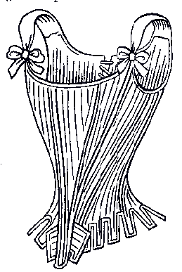

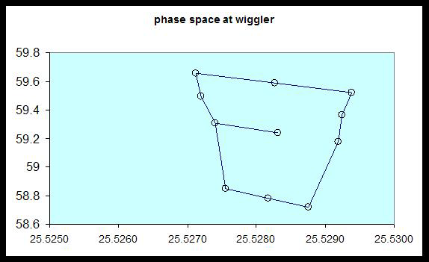

Figure 1a: A corset Figure 1b: A corseted longitudinal phase space

Injector:
We made a lot of progress this week in the final stages of the GTS gun assembly. On Tuesday morning we fixed the gun cart allowing us to attach the gun ceramic stack to the vacuum chamber. The previous week we discovered that the cart hit the gun stand frame leaving a 7/8-inch gap between flanges. Later in the week, the RGA, the extractor gauge and the NEG pumps were installed. On Thursday, the gate valve was bolted down after sliding the Solenoid into position. The valve is just downstream from the solenoid and traps it, so the solenoid had to be installed first. The NF3 tank was cleaned, welded, mounted to the stand and connected to the vacuum chamber leak valve. On Thursday evening we mounted a brand new wafer, but it broke after being pressed down with the tantalum cup. The wafer was a few microns wider than its base on the stalk. Early this morning we mounted a wafer with the proper diameter, but unfortunately it broke when it was inserted into its final position. We know why and we will fix our procedure. We also discovered that the layout for the gun stand floor anchors on the floor was based on a drawing showing the FEL upgrade vacuum chamber, which is shorter than the GTS one. Since the entire gun assembly will have to be shifted along its axis by about 6 inches because of this, we will wait until the gun is in its final position to replace the wafer. The concept of the lightbox integrated into the gun chamber works marvelously.
One can see the wafer perfectly and effortlessly through the various viewports, The oven panels are being modified for the electrical heaters to be used from now on to bake the gun assembly.

Instrumentation and Controls:
We spent time this week checking out systems and gathering parts for the GTS. The beam line hardware has all been gathered in the GTS vault. The two beam viewers required for the beam line have been assembled and are ready for cleaning and then installation. One of these is fitted with a Cromox flag and the other has a phosphor coated flag. This hardware will be installed on girders as soon as they are ready. Work also continues on the GTS SF₆ gas transfer system. The SF₆ system was leak checked successfully after repairing one leaking joint. The compressor's inlet and outlet ports have also been attached to the system with hose. The control box is currently being designed and wired. The front panel is nearing completion. Once this is ready for installation, the interconnects between the PLC and the hardware can be established. The cables coming into the control box were all labeled, stripped, and cut to the proper length. We've also modified one GTS instrument cabinet to prepare for safe routing of instrument connections between the ceiling and floor level of GTS area. As a group we also provided support for transport and mounting of wafer in the GTS Gun.
Progress has been made on the Analog I/O Distribution Module. The routing and layout was completed and the board has been reviewed by the board house. Currently we are working through several details before the order is processed. Some more details were clarified for the crate wiring. The cabling harness for the HVPS crate is making progress. The power supplies have all been mounted and the breakout connections are beginning to be assembled. Once the Analog card goes out we will push forward with the revisions to the 3U General Purpose Processor Card.
To test the operator shutter that will be used with the GTS Drive Laser we setup a simulated control scheme to understand what signals are required to operate this shutter properly. After some simple test it was found that the shutter is extremely easy to control and will perform exactly as expected. To get expert control of the device, remotely we may have to develop a more complicated interface but from the requirements so far there is no need or desire to have this functionality. Everything for the shutter is setup locally on the control unit and then locked in. Also we've been working with the EES group from CEBAF to get a temporary VME crate for testing since our new crate is delayed for another month. We would like to get this installed as soon as possible to begin testing applications and shake out of possible problems.
Progress has been made with the LPSS system. The controller link communication has been established between Labs 3A and 4. The other labs are not currently communicating to each other. This will be established when it is an opportune time to recertify each of these labs. The memory mapping is continuing to take place within the master as we are coming closer to developing the prototype user interface screens. These screens will be checked over and reviewed for functionality and user friendliness.
The PHP code written to input the FLOG on the wiki was tested and debugged. We are in the process of replacing the vacuum pump and valve cables in lab 4 for the beam transport system. Feet for the CO₂ Lab 3a laser were designed and went out for quotes. Further quotes are still being sought after for the fabrication to get a reasonable cost.

Electron Beam Transport:
Improvements and Upgrades
Gun Test Stand (GTS)
• In building the SF₆ Tank system, the JLab Shop continued welding the shells and started welding the flanges of the main vessel. A consultant, hired by the EHS& Q Division, in addition to other duties, performed to role of “Inspector” in observing our calculations and documentation procedures. He will audit the shop’s operations next week.
• The Gun Solenoid was mounted on the gun.
• A leak in the SF₆ Gas Transfer System piping was repaired and work continued on adding the relief valve, adding the connections to the High Voltage Power Supply Tank and the outside bladder. Connections to the vacuum pump and the vane pump were started. Wiring the controls to the solenoid operated valves started.
• The elements of the beam line and dump for the GTS were defined. A number of vacuum parts were put into the Production Chem. Room for cleaning and the shop completed an existing stand needing scallops in a top plate. The Cryogenics Group helped out with supplying some short pieces of 10 inch diameter tubes which will act as the base extenders to bring our standard 27 inch height stands to the 43 inch beam height of the GTS.
SF Sextupole Magnet Testing
• Magnet Test started up the testing of the first sextupole with the new power supply and controls on the Stepper Stand no that the solenoid test is complete.

Optics
Work continues on the optical transport. We have had to vent a short section in order to fix a small leak. The pressure in the transport is slowly falling from the current low 1e-6 torr level. An RGA scan indicates that the new components we installed are still outgassing water. We will reevaluate the situation next week. We have started to work on the Turning Mirror Cassette (TMC). TMC #1 is built up with the excepting of the cooling tube harness. We have had some difficulty in having the harness accommodate the full motion of the door slide. We are looking at anchoring the end of the harness to the slide door instead of the side of the vessel. We are awaiting the 3D drawings from the Mechanical Group.
We have started testing the macor version of the 2nd generation deformable mirror assembly. Initial tests shows that we can change the sagitta enough to warp a 16 meter radius of curvature optic to nearly 18 meters. Unfortunately, while dialing out the astigmatism, we broke the macor back plate. A stainless steel version is in the machine shop for fabrication.

Lasers and Optical Diagnostics:
This week we moved the old Antares laser out of the clean room and replaced it with the Advanced Drive Laser (ADL). The Antares laser has been serving FEL operation for over a decade and was the drive laser for many FEL power records made here at the JLab FEL facility. The installation of ADL will continue for the next a couple of weeks. We will test the new control systems after the installation. In the mean time, we will use Antares laser as a seed laser (with amplification to higher energy) for the Gun Test Stand in the coming months.
High Power Optics Risk Reduction
In the area of optical modeling, the last two weeks have been spent on incorporating the ability to do cold cavity simulations into the user-friendly front end. Recall that what is done in these simulations is to input all the optical element's dimensions, reflectivities, and positions, launch an initial Gaussian beam, and then on each pass, reset the power to the same value, but let the mode evolve to a steady state. Heretofore, this modeling, which is working quite well, was done by creating an input script, not the most user-friendly way to do this work. This added functionality, which we call looping, had some hiccups due to a corrupted file. Since refreshing the source code, it has run without issues since yesterday. We'll continue testing before declaring the issue resolved. We received the input electron beam and wiggler parameters for the IR Upgrade FEL with the optical klystron. We will do a careful comparison, initially with Genesis, of the theoretical behavior of the scraper-outcoupled FEL with the data taken and published several years ago.
I drew up a proposed plan for the optics to be installed for when we start back up. The choice is based on funded programs, which dovetails nicely with our desire to advance the state-of-the-art in both FEL and optical physics. It has been discussed informally, and a proposal to the staff goes out this afternoon.
A paper on the FEL facility, given as an invited talk for me by Steve Benson at the FEL 2007 conference, is going through the publication process. Another is in preparation for presentation and publication at the proceedings of the Boulder Damage Symposium. Costing for the optical subsystems for the FSU "BigLight" FEL was revisited and updated.

Terahertz:
Much of this week was spent assembling, converting, and analyzing the data taken at BNL on both the magneto-optical and the spectroscopy studies. A great deal was learned about the operation and performance of Jiufeng Tu’s (CCNY) magnet installed at U4IR. Numerous tests were run to characterize the repeatability of the entire system throughout a data run and to determine the limitations of the current configuration. One concern is the spectral transmission of the quartz windows of the magnet. These present a high frequency limitation with an absorption resonance at about 130 cm⁻¹ and then a complete cut off above 170 cm⁻¹. Between 130 cm⁻¹ and 170 cm⁻¹, there is usable light, but the signal is quite small, and the error in that region is roughly 5-10%. We may have to consider another window material for the magnet at BNL, but this must be discussed with Jiufeng, Larry Carr (BNL), and our colleagues at LANL. Transmission data for a doped InSb sample are shown in the figure below. The false color depicts transmission. The cyclotron resonance absorption feature can be seen clearly tracking to higher frequencies as the magnetic field is ramped.
The spectroscopy measurements made at U12IR were also quite successful. We have now measured the THz transmission of every laser goggle used at the FEL. A report of these findings is being assembled and will be presented soon to Steve Benson and Patty Hunt. These measurements will determine which laser safety goggles also provide sufficient attenuation of the THz beam in anticipation of FEL and other laser sources being present in the THz lab.
Another important spectroscopy study was the transmission measurement of several different optical components that make up the THz imaging system. One critical element is the window which seals the vacuum of the microbolometer array. The window material of the A10 is Ge, while the newer Photon core that we intend to purchase for future tests uses a Si window. The Photon window is expected to provide better transmission over the A-10, but this had not been measured. The transmission measurements indeed show the Photon window providing superior transmission in the THz region of the spectrum as seen in the figure below.
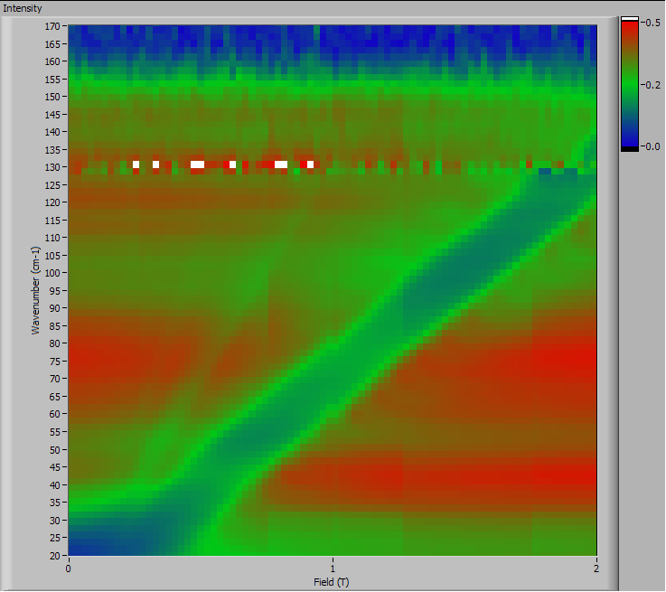

Intensity plot showing transmission as a function of spectral frequency (cm⁻¹) and magnetic field (T). The strong absorption feature crossing the figure diagonally is the cyclotron resonance absorption. The absorption resonance of the quartz windows appears at ~130 cm⁻¹ and the noise at frequencies above that is also apparent.

Other optical elements, such as different THz lenses, band pass filters, and polarizers were also measured during the spectroscopy study at BNL and the data is being analyzed at this time. These data will be shared and discussed with the component manufacturers as part of our ongoing effort to assist in the development of THz imaging technology.

Transmission data for the windows sealing the Photon and A-10 microbolometer arrays. The Photon window (Si) provides significantly better transmission than the A-10 window (Ge).

Word version: FEL Upgrade Project Weekly Brief – September 3-7, 2007

