Electronic Wage Reporting System

AccuWage 2008
Help Guide

For Official Use Only

02/12/2008

Table of Contents

1. Introduction 1
2. Required Configuration 1
2.1 Wage Report Criteria 1
2.2 Minimum System Configuration 1
2.3 AccuWage User Profile 2
3. Using AccuWage with Assistive Devices 2
4. Starting the Application 2
5. Screen Elements 3
6. Setting the Error Limit 4
7. Starting the Test 5
8. Testing Process 5
9. Completed Tests 6
10. Records with Errors Screen 6
11. Viewing Records with Errors 7
11.1 Viewing Additional Data in Columns 8
11.2 Viewing Additional Lines in the List 8
11.3 Using Scroll Buttons 8
11.4 Selecting Records 9
11.5 Changing Column Width 9
12. Tested Records Screen 9
12.1 Viewing Errors on the Tested Records Screen 10
13. Error Report 10
13.1 Viewing the Error Report 10
13.2 Printing the Error Report 12
13.3 Saving the Error Report 12
14. Correcting Errors 12
14.1 Suggested Steps for Correcting Errors Caused by Missing or Incorrect Data 12
14.2 Suggested Steps for Correcting Critical AccuWage Errors 12
15. Opening the Last Report 13
16. Exiting the Program 13
17. Glossary of Terms 14

List of Figures
Figure 2: Set Error Limit Screen 4
Figure 3: File Dialog box – Choosing the Wage Record to Test 5
Figure 4: Records with Errors screen 6
Figure 5: Records with Errors screen 8
Figure 6: Tested Records screen 9
Figure 7: View Error Report screen – Text Option 11
Figure 8: View Error Report screen – HTML Option 11

1. Introduction
The AccuWage application allows the Annual Wage Report (AWR) submitters to test the format accuracy of wage reports prior to sending them to the Social Security Administration (SSA) for processing. The AccuWage application checks the W-2 wage reports to ensure they comply with Publication 42-007: Specifications for Filing Forms W-2 Electronically (EFW2) and provides reports listing all errors found in the wage report. The wage report cannot be edited using the AccuWage software. The submitter can create a new EFW2 test file or correct the existing EFW2 test file that generated the errors. The wage report can be repeatedly retested until all the errors have been corrected.

IMPORTANT: The AccuWage application identifies many, but not all, wage submission errors. For example, AccuWage does not verify names and Social Security Numbers (SSNs). The likelihood of submission rejection, though not eliminated, is greatly reduced when using this application.

2. Required Configuration
SSA recommends that all submitters of wage reports meet the criteria listed in the Wage Report Criteria and Minimum System Configuration sections before using the AccuWage application.

2.1 Wage Report Criteria
- Wage reports must be in EFW2 format.

2.2 Minimum System Configuration
- International Business Machines (IBM) compatible;
- Pentium-class chip equivalent or higher;
- Minimum of 16 MB of RAM; and
- Windows 2000 or XP environment.

2.3 AccuWage User Profile
Some AccuWage users who are part of a network report receiving error messages when downloading and installing the software or when they attempt to run the AccuWage program.

Keep in mind that the profile of the user is an important consideration:
- You must be logged on to a computer with an account that has administrative rights.
A regular user account may not have the necessary permissions to download, install and run the AccuWage software.
- Have your Local Area Network (LAN) coordinator review your access settings.

3. Using AccuWage with Assistive Devices
Section 508 of the Rehabilitation Act requires Federal agencies to make their electronic and information technology accessible to people with disabilities.

SSA recommends that people using assistive devices and keyboard–only users navigate the AccuWage application using pull down menus rather than the command buttons. SSA also recommends that people using assistive devices use the Error Report function (see the Error Reports section) to read errors on the screen. This screen is easier to navigate with assistive devices than the Records with Errors screen (see the Records with Errors Screen section).

4. Starting the Application
The installation process creates a folder for storing the AccuWage application in the Windows Program Files. For systems running Windows 2000/XP, a shortcut icon to the application is created automatically on the desktop and in the Start menu under Programs.

To start the AccuWage application:
- Click on the AccuWage desktop icon for the Welcome screen to appear; or
- Click on the Start menu. Click on the AccuWage application under Programs. The Welcome screen appears.

5. Screen Elements

Title bar
Menu bar
Maximize button
Minimize button

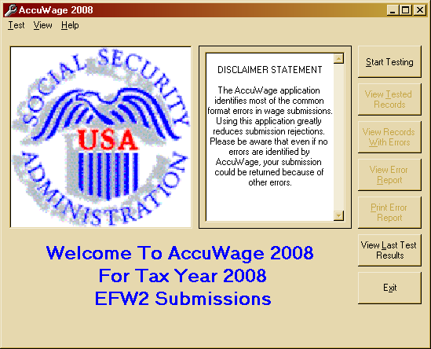
Command buttons

Close button
Figure 1: Welcome screen

Title Bar
The Title bar named AccuWage 2008 is located at the top of the screen. The Title bar identifies the function of the screen and provides access to the Minimize, Maximize and Close buttons.

Minimize Button
The Minimize button reduces the application to its smallest size.

Maximize Button
The Maximize button enlarges the application to its largest size.

Close Button
The Close button closes the application.

Menu Bar
The Menu bar contains the Test, View and Help options. Menu options can be selected two ways:
- Mouse – Point to the desired selection and click the left mouse button one time; or
- Keyboard – Press ALT and the underlined letter of the menu option simultaneously. For example: to access Test, press ALT and T at the same time.

Command Buttons
The Command buttons are located on the right side of the application window. There are
two types of command buttons:
- Enabled – Enabled buttons are available for use and the button text is black; and
- Disabled – Disabled buttons are not available and the button text is light gray.
Command button availability depends on user actions. For example: if wage records have not been tested, the View Tested Records button is disabled.

6. Setting the Error Limit
The number of errors allowed before AccuWage stops testing can be set to a number from 1 to 25,000 by the user with a default setting of 500. The number cannot be less than 1 or greater than 25,000.

To set the error limit:
- Click on Test on the Menu bar of the AccuWage Welcome screen.
- Click on Set Error(s) in the drop-down box.
- In the Set Error Limit dialog box, enter the maximum number of errors that AccuWage will find before the application stops testing.
- Click the OK button to start testing.

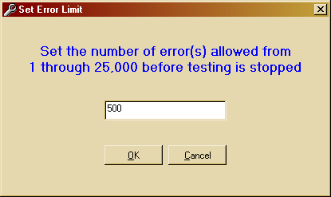
Figure 2: Set Error Limit Screen

7. Starting the Test
- Click the Start Testing button or choose Test and Start New from the drop-down menu.
- The Please enter File Name to be Tested dialog box appears.
- Check the Files of type box. If it does not display All Files (*.*), click the down arrow next to the option and choose All Files (*.*).
- Choose the drive where the wage reports are stored in the Look in box.
- Locate the folder/directory where the wage reports are stored.
- Double click the wage report file when it appears.
- Click the Open button or double-click the file name to open the file.

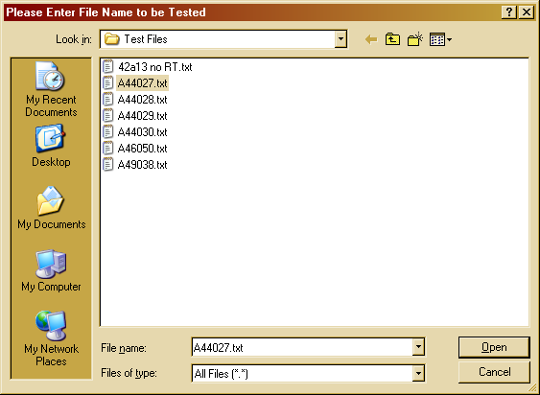
Figure 3: File Dialog box – Choosing the Wage Record to Test

8. Testing Process
After the wage report is selected, testing begins automatically and the Status bar will appear on the bottom of the screen. The Status bar displays the record number currently being processed along with a red progress bar. When the red progress bar reaches the end of the box, testing is complete.

9. Completed Tests
Once AccuWage has completed testing all records, it indicates whether or not there are errors. If no errors are found, a pop-up message box will appear. The pop-up message box will be titled “Results” and the message will read: “Testing Completed. There were no errors found. Would you like to connect to the Business Services Online (BSO) Web Page to submit the wage report?” (This message will not appear until 12/08/2008). There will be the Yes button and the No button on the pop-up message box. If you click the No button, you will be returned to the AccuWage Welcome screen. If you click the Yes button, you will be connected to the BSO Web Page. If no default browser exists or AccuWage cannot find it, you will see one of two error message boxes appear:
- The message box may be titled “Browser Not Found” and have a message that reads “Could not find a default Web Browser.”; or
- The message box may be titled “Connect to Business Services Online” and have a message that reads “Your default browser could not be opened: (The path of your default Web Browser will be displayed)”.

10. Records with Errors Screen
When testing is completed and errors are present, the Records with Errors screen is displayed.
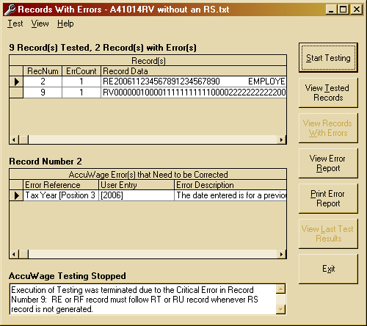
AccuWage Testing Stopped display
AccuWage Errors that Need to be Corrected

Horizontal
scroll bar

Record selector
Record list
Figure 4: Records with Errors screen

Record List

The Record list displays tested records that contain errors. It is used to locate and select records that need further examination.

The Record list contains the following columns:
- RecNum – displays the numbers of the records;
- ErrCount – displays the number of errors in each record;
- RecordData – displays the data in the record, starting with the first position; and
- Record Selector – indicates which record is selected in the Record list. Details of the selected record appear in the AccuWage Errors that Need to be Corrected grid.

AccuWage Errors that Need to be Corrected Grid

The AccuWage Errors that Need to be Corrected grid displays detailed error information for the record selected in the Record list. It contains the following columns:

- Error Reference – displays the field name;
- User Entry – displays the field data inside brackets; and
- Error Description – displays the error message and data specifications.

AccuWage Testing Stopped Display

When a critical AccuWage error is encountered, testing terminates. This error must be corrected in order to continue testing.

Scroll Bars

The Record list, the AccuWage Errors that Need to be Corrected grid and the AccuWage Testing Stopped display contain scroll bars. Scroll bars are used for viewing additional information in these lists. There are two types of scroll bars: horizontal and vertical.

11. Viewing Records with Errors
To quickly view an error message in its entirety, place and hold the mouse pointer over the error description. When the mouse pointer is positioned over the error description, a pop-up box with the full error message appears.

To view additional data (e.g., records, descriptions, data or errors), use the techniques outlined below. The instructions presented can be applied to the Record list and Error Detail list on both the Records with Errors and Tested Records screens.

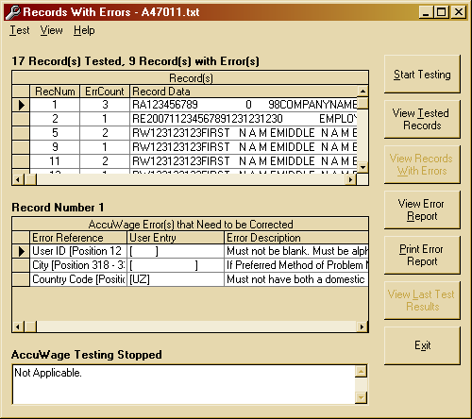
Column divider
Up scroll arrow
Down scroll arrow
Left scroll arrow
Right scroll arrow
Scroll button
Figure 5: Records with Errors screen

11.1 Viewing Additional Data in Columns
- Place the mouse cursor on the right scroll arrow below the list.
- Left-click the mouse. Additional data appears in the last column of the list.

11.2 Viewing Additional Lines in the List
- Place the mouse cursor on the down scroll arrow to the right of the list.
- Left-click the mouse. Another line appears at the bottom of the list.

11.3 Using Scroll Buttons
Use the scroll buttons instead of the scroll arrows to browse through a list quickly. The scroll buttons can be used for both vertical and horizontal movement.
- Place the mouse cursor over the scroll button.
- Left-click the mouse and hold it down.
- Drag the scroll button down the vertical scroll bar or across the horizontal scroll bar.
- Release the mouse when the desired data is visible.

11.4 Selecting Records
- Place the mouse cursor over the RecNum in the Record(s) list.
- Left-click the mouse. The list of errors appears in the AccuWage Errors that Need to be Corrected grid.

11.5 Changing Column Width
If all text is not completely visible in the columns of the Records with Errors screen, the user can increase the column width to make more data visible.
- Place the mouse cursor over the column divider.
- The cursor will change to a thick line flanked by left and right arrows.
- Left-click the mouse and hold it down.
- Drag the column divider to the right and release the mouse when the desired amount of text is visible.

12. Tested Records Screen
If errors are found in the submission, they can be reviewed by selecting the View Tested Records button. The top of the Tested Records screen displays the Record list. The Error Detail list provides a different view of the data that can be helpful in identifying field errors.
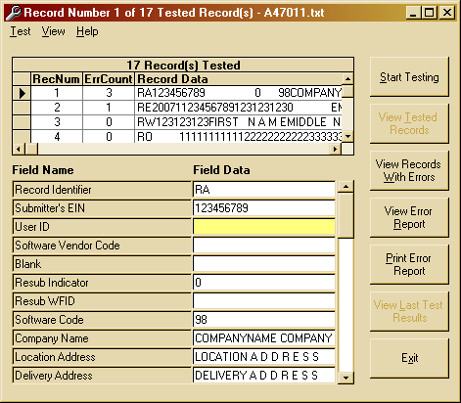
Record list

Error Detail list
Error
Figure 6: Tested Records screen

12.1 Viewing Errors on the Tested Records Screen
When selecting a record, the entire record is displayed in the Error Detail list with errors highlighted in yellow. Review the field name and data to determine fields with errors. It is a good idea to refer back to the EFW2 for field specifications.

13. Error Report
The error report can be viewed or printed. The error report includes:
- The name and path of wage report file being tested;
- Date test was performed;
- Critical error message, if applicable;
- Number of records tested;
- Number of errors;
- Number of records with errors;
- Name of field containing errors;
- Data in field containing errors; and
- Complete error description.

13.1 Viewing the Error Report
- Click the View Error Report button.
- The Report Option dialog box will appear. Choose either Text or Hypertext Markup Language (HTML). Both options allow viewing and printing of the report.

NOTE: If there are too many errors to display in the text option of the report viewer, AccuWage will automatically give the option of saving as a text file. The text file can then be opened to view and/or print.

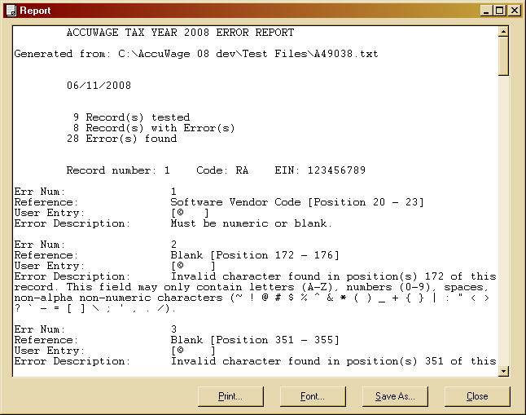
Figure 7: View Error Report screen – Text Option

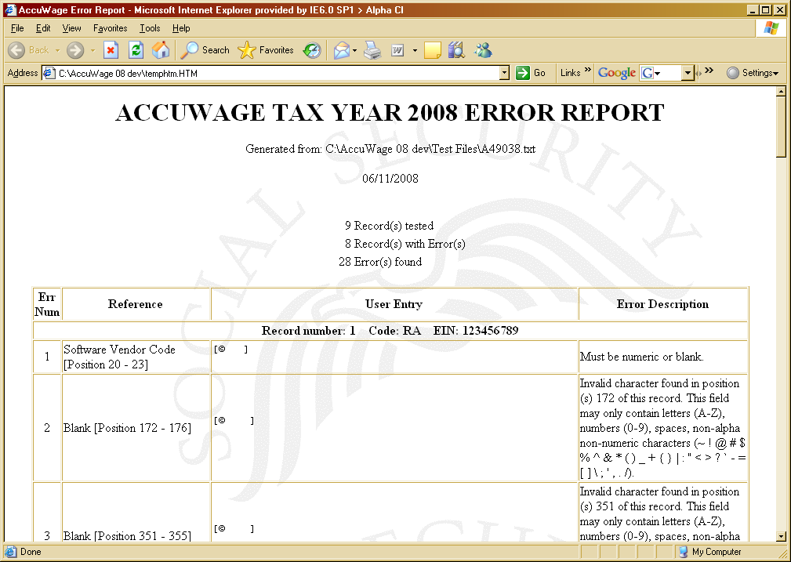
Figure 8: View Error Report screen – HTML Option

13.2 Printing the Error Report
- From the Records with Errors screen or the View Tested Records screen, click the Print Error Report button.
- From the Error Report screen, click the Print button. The Print dialog box opens.
- Select print range and number of copies then click the OK button to print the report.

13.3 Saving the Error Report
The error report can be saved from either the HTML or the text option.

To save from the HTML option, follow the steps below:
- Go to File and click the Save As button while in the HTML option of the report viewer. The Save As window appears.
- Enter the file name and select the file destination.

To save from the text option, follow the steps below:
- Click the Save As button while in the text option of the report viewer. The Save As window appears.
- Enter the file name and select the file destination.

14. Correcting Errors
The AccuWage application is used for testing wage reports and cannot be used to update or modify the original wage report.

14.1 Suggested Steps for Correcting Errors Caused by Missing or Incorrect Data
- View error messages in the Error Detail list or Print the error report.
- Determine which fields need to be changed.
- Access the original file to correct the original data.
- Test again using the amended file.

14.2 Suggested Steps for Correcting Critical AccuWage Errors
Critical AccuWage errors are errors that cause testing to terminate. They are shown in the AccuWage Testing Stopped display located at the bottom of the Records with Errors screen. Critical errors can be corrected by following the steps described in the Suggested Steps for Correcting Errors Caused by Missing or Incorrect Data Section.

15. Opening the Last Report
AccuWage provides the ability to open and view the last report that was tested.

Before a last report can be viewed, the following actions must have occurred:
- AccuWage was started and a wage report with an error was tested.
- AccuWage was exited.
- AccuWage was started.

The View Last Test Results button can only be opened from the Welcome screen. When the View Last Test Results button is clicked, AccuWage opens the last wage report tested if it is still stored on the PC.

16. Exiting the Program
There are three options for exiting AccuWage:
- Click the Exit button located on the right side of the screen; or
- Click the standard Windows close button (the small “x” in the upper right hand corner of the screen); or
- Choose Test and Exit from the Menu bar.

17. Glossary of Terms

AccuWage
The name of the application used to test EFW2 wage reports.

Agent
An organization authorized to submit wage and tax reports for one or more employers.

AWR
Annual Wage Reporting. The process by which employers report the earnings and taxes of their employees.

BSO
Business Services Online. An online service for employers to submit wage data directly to SSA using a PC with an Internet connection.

Byte
A unit of measure for data. One byte contains eight bits and can store one character.

Character
A letter, number or punctuation symbol.

Critical AccuWage Error
An error that causes AccuWage to stop testing a wage report.

EFW2
A publication distributed by SSA containing specifications for the Electronic Filing of W-2 information.

EIN
Employer Identification Number. A nine digit number assigned by the IRS to an organization for federal tax reporting purposes.

HTML
Hypertext Markup Language for publishing hypertext on the World Wide Web.

Internet
An international network of public or private networks that can be used by employers or submitters to download the AccuWage application using a PC with a modem.

IRS
The United States Internal Revenue Service.

IRS Form W-2
Form W-2 Wage and Tax Statement. Used by employers to report wage and tax data for employees.
LAN
Local Area Network. A group of computers and associated devices that share a common communications line or wireless link and typically share the resources of a single processor or server.

Megabyte
A unit of computer storage capacity. Approximately one million bytes.

Mouse Cursor
The arrow on the Windows screen that moves when the mouse is moved.

PC
A small desktop or portable personal computer.

RAM
Random Access Memory. Primary storage of data or program instructions that can directly access any randomly chosen location in the same amount of time.

SSA
The Social Security Administration.

SSN
Social Security Number. A nine-digit number assigned by SSA.

SSN Verification
A process performed against wage reports to verify that names and corresponding SSNs match SSA records.

Submitter
A person, organization or reporting agent submitting wage reports to SSA.

Wage Report
Annual W-2 wage and tax reports submitted to SSA for processing.

