Model 4000

In Reply Refer To: 940-2008-03571

July 3, 2008

Federal Aviation Administration
Attn: Mr. Dan Withers
Wichita Aircraft Certification Office
1801 Airport Road, Room 100
Mid-Continent Airport
Wichita, KS 67209

Subject: Project TD4732WI-T, Revised Petition for Exemption

Reference: 1. HBC Letter 940-2007-03459 dated July 2, 2007
- FAA Letter, Neil Schaleklamp to David Bernstorf, August 8, 2007
- FAA Letter, Dan Withers to David Bernstorf, November 20, 2007
- HBC Letter 940-2007-07062 dated December 21, 2007

Dear Mr. Withers,

This letter transmits a revised petition for exemption and detail information related to the Fuel System and Fastener installation. The initial petition request was submitted on letter reference 1 and receipt acknowledged on letter reference 2. Letter reference 3 requested additional information related to the design which was submitted on letter reference 4. On May 2, 2008, HBC was informed by the Wichita ACO, the Transport Directorate was not in agreement with the petition for exemption submitted on letter reference 1. They indicated that they were available for a meeting to discuss the issue further. On May 20, 2008 a meeting was held with the ACO and TAD to discuss HBC’s plans to show compliance with the requirements of 14 CFR 25.981(a)(3). Following the meeting HBC has conducted certification tests to prove out design concepts for showing compliance relative to the lightning threat for fuel tank fasteners. Given the delay in processing the exemption request for fasteners relative to 14 CFR 25.981(a)(3), HBC is requesting in the attached exemption an extension to the time limited exemption, limited to the lightning aspects related to wing skin fasteners and the fuel tank. Your prompt review of the information provided herein and processing of the exemption request would be appreciated.
The means of protection documented in the petition has been developed in coordination with DER’s Glenn Bailey, Raymond Best, Eric Larson, Jorge Notario, Bruce Stephens and Howard Jordan.

Further engineering questions on this topic may be directed to John Lee telephone (316) 676-7674

Sincerely,

HAWKER BEECHCRAFT CORPORATION

David Bernstorf, Vice President
Airworthiness and Certification

DB:jl

Attachments: Revised Petition for Exemption
Fuel System Description and Schematic


Revised Petition for Exemption

Requestor: Hawker Beechcraft Corporation
9709 East Central
P.O. Box 85
Wichita, KS
67201-0085 USA

Subject: Compliance Relief from 14 CFR 25.981(a)(3) Amendment 102 for Fasteners

Project: Hawker Beechcraft
Model: 4000
Project Number: TD4732WI-T

References:
- FAA Partial Time-Limited Exemption #8761, dated August 7, 2006
- 14 CFR 25.981 Amendment 102
- Issue Paper, Hawker Beechcraft Corporation Model 4000, Project # TC4732WI-T, Item P-1

Issue: Exemption from 14 CFR 25.981(a)(3) Amendment 102 of Title 14, Code of Federal Regulations

Relief from the following regulation is requested:

Section 25.981(a)(3) as amended by Amendment 25-102:
(a) No ignition source may be present at each point in the fuel tank or fuel tank system where catastrophic failure could occur due to ignition of fuel or vapors. This must be shown by:
(1) Determining the highest temperature allowing a safe margin below the lowest expected autoignition temperature of the fuel in the fuel tanks.
(2) Demonstrating that no temperature at each place inside each fuel tank where fuel ignition is possible will exceed the temperature determined under paragraph (a)(I) of this section. This must be verified under all probable operating, failure, and malfunction conditions of each component whose operation, failure, or malfunction could increase the temperature inside the tank.
(3) Demonstrating that an ignition source could not result from each single failure, from each single failure in combination with each latent failure condition not shown to be extremely remote, and from all combinations of failures not shown to be extremely improbable. The effects of manufacturing variability, aging, wear, corrosion, and likely damage must be considered.

General
HBC requests an exemption from compliance with 14 CFR 25.981(a)(3) regarding the structural lightning protection of wing fasteners. The requirements include consideration of factors such as aging, wear, and maintenance errors as well as the existence of latent failures in developing designs that prevent ignition sources in fuel tanks. It should be noted that mitigation is provided by low fuel flammability.

Protection Design
The area of interest for lightning strike on the wing is located in zones 1A and 2A (Figure 1). The wing span is 61 feet 8 inches. The outboard most edge of the wing fuel tank extends 39.38 inches into the lightning zones 1A & 2A. Zone 1A and the Zone 2A combined are approximately the outboard 48 inches of the wing of which Zone 1A is approximately 28 inches.

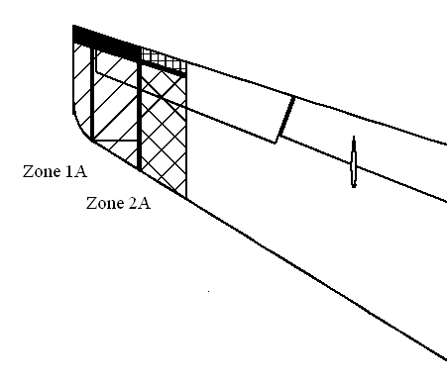
FIGURE 1 ZONE 1A AND OUTBOARD ZONE 2A

Lightning Zone 2A includes approximately 26.2 inches in span, by 96 inches cordwise of the inboard section of the wing (Figure 2).
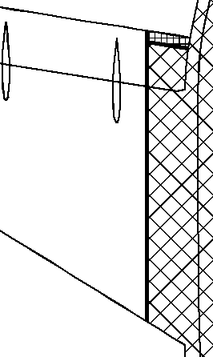
FIGURE 2 INBOARD ZONE 2A
(View of the wing attach to the fuselage – the crosshatched area is the lightning zone 2A )

Production
For production, there are two protective features used. One is the installation of machine driven rivets and collared fasteners. The second is the use of sealant covering on the internal portion of the rivets and collared fasteners. Laboratory testing in accordance with testing requirements for FAA certification was performed on representative test articles, in June of 2008. Test data showed no ignition source for either feature when exposed to lightning. For factory rework or field repair, other methods which maintain the dual protective features are discussed below.

The structure of the wing is comprised of metallic material (aluminum alloy) and is assembled in the zone of interest using collared titanium fasteners with corrosion resistant coating and driven aluminum rivets. Installation is controlled by a company standard at HBC.

The rivets and the collared fasteners both have a corrosion resistant coating. Tank primer is applied over the external head of the rivet and collared fasteners to keep moisture from entering the wing skin interface.

The machine driven rivets and collared fasteners are internally protected by brushed on sealant. In addition, all rivets in outboard lightning zone 1A & 2A are also protected by molded seal caps. The seal caps are made from and filled with MIL-S-8802 Type 2 sealant. Squeeze out of sealer around the entire periphery is required at the seal cap installation. The sealant squeeze out ensures a complete seal. The sealant squeeze out also ensures that the cap still contains adequate dielectric material, which prevents an arc (figure 3).

The rivets are driven “dry”. This minimizes the electrical resistance between the rivets and wing skin, therefore minimizing the voltage differential during a lightning strike.

The collared fasteners are made of titanium and are installed with wet sealer under the head to minimize corrosion. They have a larger diameter shank and are installed in an interference fit hole, thereby having a lower current density than the smaller rivets. A lower current density lowers the chances of arcing and/or sparking.

Lightning protection of previously hand installed rivets in inboard lightning zone 2A has been augmented by removing the hand installed rivets and replacing them with collared fasteners.

Factory Rework and Field Repair
For factory rework or field repair, HBC uses an additional, independent protective feature for hand installed rivets in outboard zones 1A and 2A. The protective feature illustrated in Figure 4 below is composed of multiple layers and has been validated by test. Laboratory testing in accordance with testing requirements for FAA certification was performed on representative test articles, in June of 2008. A layer of dielectric material (fiberglass) is adhesively bonded over the rivet heads on the exterior of the wing in the outboard lightning Zone 1A and 2A sections. Next, a layer of conductive sheet metal is adhesively bonded over the rivet heads in outboard lightning Zone 1A and 2A. Another conductive layer (expanded foil and conductive adhesive) is applied along the perimeter of the .008 sheet metal. The entire modification is faired in with conductive filler for aerodynamic purposes.

This protective feature effectively keeps lightning energy away from rivet heads. When lightning attaches to this area, the energy flows through the conductive layer of sheet metal and is transferred to the wing skin, away from the heads of wing skin rivets. The dielectric layer underneath the sheet metal ensures the energy is not transferred into wing skin rivets. In addition, the conductive layer around the perimeter of the area provides a path for the energy away from the rivet heads (Figure 3).

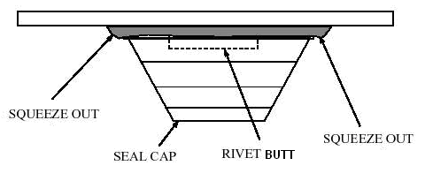
Figure 3 Seal Cap for Rivets

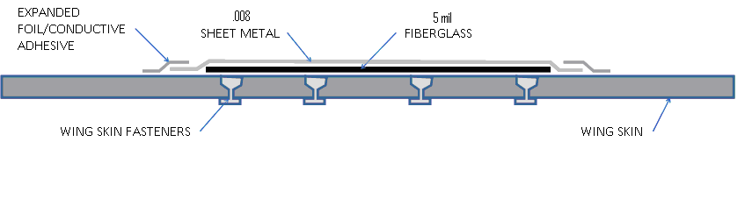
FIGURE 4 EXAMPLE OF PROTECTION FOR HAND DRIVEN RIVETS

Lightning attachment to wing skin rivet heads does not occur in areas covered by this protective feature. In addition to the above factory rework or field repair, the internal sealant protective feature mentioned previously provides the second level of protection.

Fastener Summary
This factory rework or field repair protective feature will only be used on previously fabricated wings (45 wings) with hand driven rivets. For new production wings, no hand driven rivets will be used in lightning zones 1A & 2A during the wing build-up. The protective feature combinations noted above provide two levels of lightning protection for the fuel tanks.

Low Flammability Exposure
The wing tanks are surrounded by cool air during flight. The benefit of the low temperature during flight is the tank flammability exposure is reduced.

Analysis completed during initial certification documents the low flammability of the fuel tank to support compliance with FAA 14 CFR 25.981(c). This low flammability is further being supported with existing certification test data.

Public Interest
Full compliance to 25.981(a)(3), after September 1, 2008, with respect to lightning and the introduction of a third leg of protection for the Model 4000 will require significant redesign and modifications to the fuel tank, with no measurable improvements to aircraft safety. In addition to introducing additional complexity in the manufacturing, quality and maintenance procedures, a redesign of the proven technologies described above will add significant cost and schedule impact to the Model 4000 program and its customers.

FAA requirements against the Model 4000 for with this rule will prevent HBC from certifying the aircraft on a timely and competitive schedule. This puts the Model 4000 at an unfair disadvantage with its competitors. Moreover, several of the major corporations around the US and the world anticipating the delivery of the Hawker 4000 aircraft to meet their business needs would need to find alternatives.

Effect on Safety

The Model 4000 fuel tank system design is intended to fully comply with 14 CFR 25.981 as amended per amendment 102. Fuel tank ignition prevention is ensured through:
- low level of flammability exposure.
- prevention of ignition sources.

The first item is substantiated by the design features on the Model 4000 fuel tanks that include a two tank system with separate left and right systems separated at BL0 by a center rib. The aircraft does not have a center wing tank. Both tanks are vented through two stringer vents that run the length of each tank. The vent lines are connected to a vent tank located at the outboard tip of each wing. The low flammability characteristics have been quantitatively assessed and documented to support compliance with FAA 14 CFR 25.981(c).

The second item, prevention of ignition sources, has been substantiated by a thorough analysis of all ignition sources and the development of critical design configuration control limitations to be submitted as part of the compliance shown for amendment 102

Regarding lightning aspects, the Model 4000 features two independent, effective, and reliable legs of protection:
- fasteners and rivets that inherently protect against arcing and hot spots under lightning strike conditions or a thin conductive layer over the fastener heads
- and the use of inner sealant.
As a result of the design and construction of the wing panel attachments, there are no single failures of the fasteners that would result in ignition due to lightning strike.

Consequently, taking into account all aspects of fuel tank flammability reduction for which the Model 4000 is compliant, and regarding the low flammability exposure as a mitigation factor for the absence of a third protection against lightning, Hawker Beechcraft Corporation believes granting this exemption has no impact on safety.

Timing aspects of request

Hawker Beechcraft Corporation (HBC) petitioned for and was granted a partial, time limited exemption #8761 to 14 CFR 25.981(a)(3), on August 7, 2006 for the Model 4000. The exemption expires on September 1, 2008 for new production aircraft. September 1, 2009 the exemption expires for completing the required Amendment 102 modifications to aircraft that have Certificates of Airworthiness dated prior to September 1, 2008,

Due to workload for both HBC and the FAA and additional time needed to establish a viable design solution for wing fasteners in existing wing structure and new production; HBC requests the following for effective dates in the exemption relative to the structural lightning aspects of the Model 4000 wing fasteners:

- Establish that prior to March 1, 2009, HBC will develop and submit for FAA approval data to show compliance to 14 CFR 25.981(a)(3) as amended by Amendment 25-102 for structural lightning aspects of wing fasteners.

- Establish that the Model 4000 Serial’s inclusive of serial number 45 be exempted from the requirements of 14 CFR 25.981(a)(3) as amended by Amendment 25-102, specific to structural lightning aspects of wing fasteners, to allow time to make the manufacturing changes. Serial 45 is scheduled to obtain a Certificate of Airworthiness on or about July 1, 2009. These aircraft are to be operated without requiring the design modifications to meet the requirements of 14CFR 25.981(a)(3) relative to the structural lightning aspects of wing fasteners until September 1, 2009 or up to a year from the date of the issuance of the Certificate of Airworthiness whichever is longer.

Fuel System Description and Schematic

SYSTEM DESCRIPTION

General description
The Model 4000 fuel system is a two tank system with separate left and right tank groups. Each tank group consists of a wing tank, a collector tank, a feed tank, and a vent tank. The primary feed system consists of an ejector pump powered by the engine-driven high-pressure pump motive supply, and for backup, an AC electric boost pump, in each feed tank. Scavenge ejector pumps driven by the engine high-pressure pump motive supply are provided to reduce the amount of unusable fuel and keep the feed tanks full until the only fuel left is in the feed tanks. A crossfeed valve connects the two feed systems together for emergency and fuel balance use. A transfer pump also provides fuel balance function. A DC start pump (right side only) is provided for Auxiliary Power Unit (APU) operation and engine starting. A single-point pressure refuel and defuel capability is provided in addition to the two overwing gravity fill ports. The wing tank fuel quantity indication function is made up of 12 AC capacitance type fuel quantity probes in each wing. Fuel probes are mounted throughout each wing and in each fuel feed tank. Each wing tank group has discrete low and high fuel level sensors. The fuel temperature indicating function is made up of a resistive type sensor located in the left wing tank and provides temperature data when fuel quantity is above approximately 3000 lbs in that wing.

Storage
The fuel storage subsystem is a two-tank system with separate left and right tank groups. The storage subsystem provides for venting and draining of the fuel tanks. The storage subsystem is capable of being gravity filled or pressure filled. Each tank group consists of a feed tank, collector tank, wing tank, and a vent tank, situated from inboard to outboard (see Figure 1.1). The wing center section has two compartments, a main feed tank where the engine feed pumps are located and a collector tank. The wing tank has three compartments that are interconnected with flapper check valves. The flapper check valves allow fuel to gravity feed from outboard to inboard and prevent fuel from flowing outboard under dynamic conditions. The vent tank is located on the outboard tip of each wing and is connected to the wing tank with two flapper drain check valves and a vent line. The flapper check valves allow fuel to gravity drain from the vent tank into the wing tank and prevent fuel from flowing from the wing tank into the vent tank.

Vent System
The vent system (see Figure 1.2 and Figure 1.3) is an open vent system that allows pressure within the tanks and outside air pressure to equalize under steady state flight conditions. Each left and right tank group has an independent vent system. The system is connected to a NACA ram air scoop located at the aircraft's lower wing surface. The vent system limits tank pressures to between 3.5 psig and -0.5 psig during climb or descent and in the event of a refuel valve failure to close during pressure refueling.

Each wing tank is vented through two stringer vents that run the length of the tank. A float valve is installed on the inboard port to prevent fuel entry into the forward stringer vent during cruise with the tanks near full or during nose down attitude. The outboard port is always open (no float valve). The stringers are connected at the inboard end via a crossover tube equipped with a check valve to prevent syphoning during climb. The forward stringer opens into the vent tank. Any fuel that temporarily enters the aft stringer via the outboard port during climb or other aircraft maneuvers does not enter the vent tank since this requires that the fuel travel outboard-to-inboard through the aft stringer, through the crossover tube into the forward stringer, then inboard-to-outboard through the forward stringer which connects to the vent tank.

The feed tank is not directly connected to the vent system. Each feed tank is vented to the main wing tank by means of a vent overflow tube and a vent orifice on Rib #1. The collector tank is vented to the main tank with vent orifices on Rib #1 as well.

The vent system allows fuel flow overboard from the vent tank through the NACA ram air scoop in the event of a failed open refuel valve during pressurized ground refueling. The system is designed such that tank pressures do not exceed 3.5 psid.

The vent tank is vented to ambient through a flame arrestor. Any fuel that might enter the vent tank from the forward stringer vent will flow back into the wing tank through flapper check valves. Fuel will not flow overboard through the ram air scoop unless the vent tank is completely full. The vent tank volume is approximately 19 gallons. The sum of the vent tank volume, fore and aft stringer vent volumes, and the wing tank volume above high level shutoff comprises the 3 percent expansion space. This total volume is approximately 34 gallons per side.

In the event of a blocked vent system, a vacuum/pressure relief valve located outboard in the main tank will open to ambient if tank pressures exceed 4.5 psid positive or 1.0 psid negative. Fuel loads caused by maneuvers and fuel head are tempered by the slosh ribs, and will not inadvertently open the valve.

Vent Tank
Rib #8
Slosh Rib
Rib #3
Slosh Rib
Feed Tank
(Blue)
62 gals
Main Tank
Collector Tank
(Green)
102 gals
Rib #16

Figure 1.1 Tank Groups – Left Wing Shown

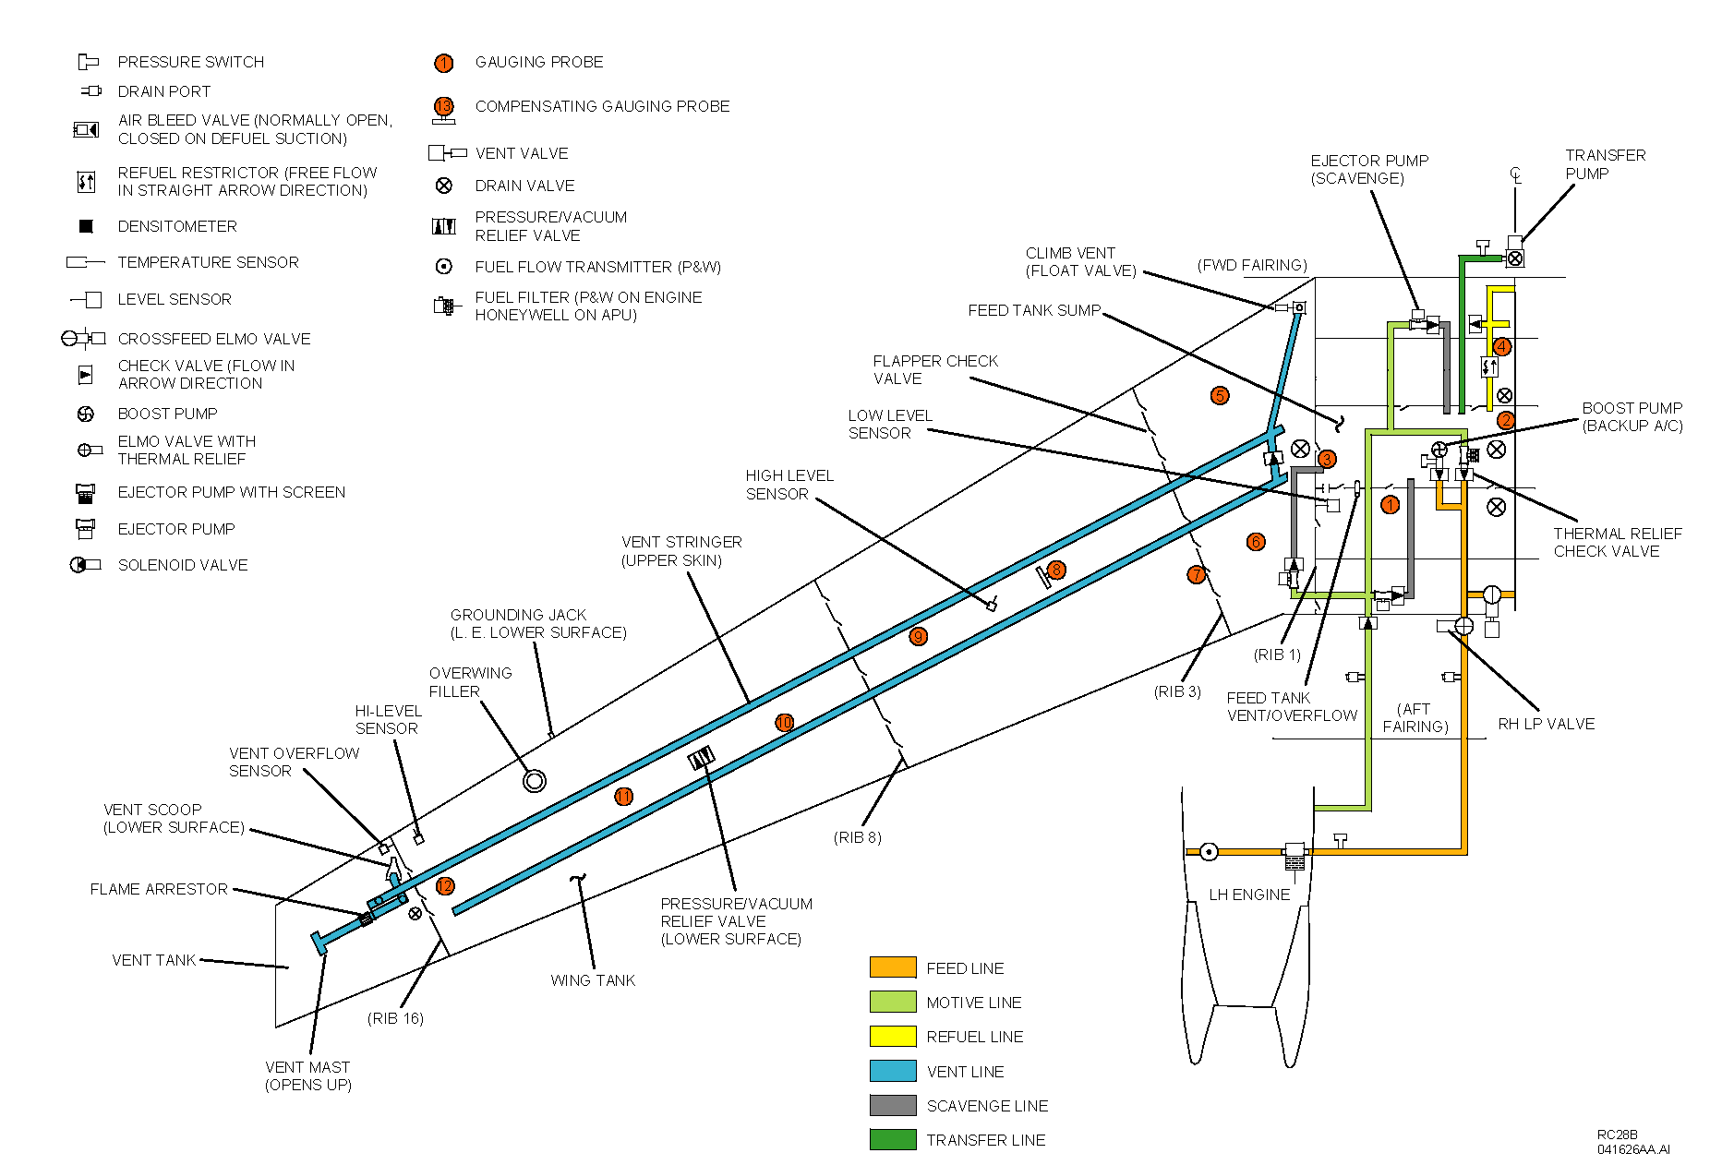
Figure 1.2 Left Side
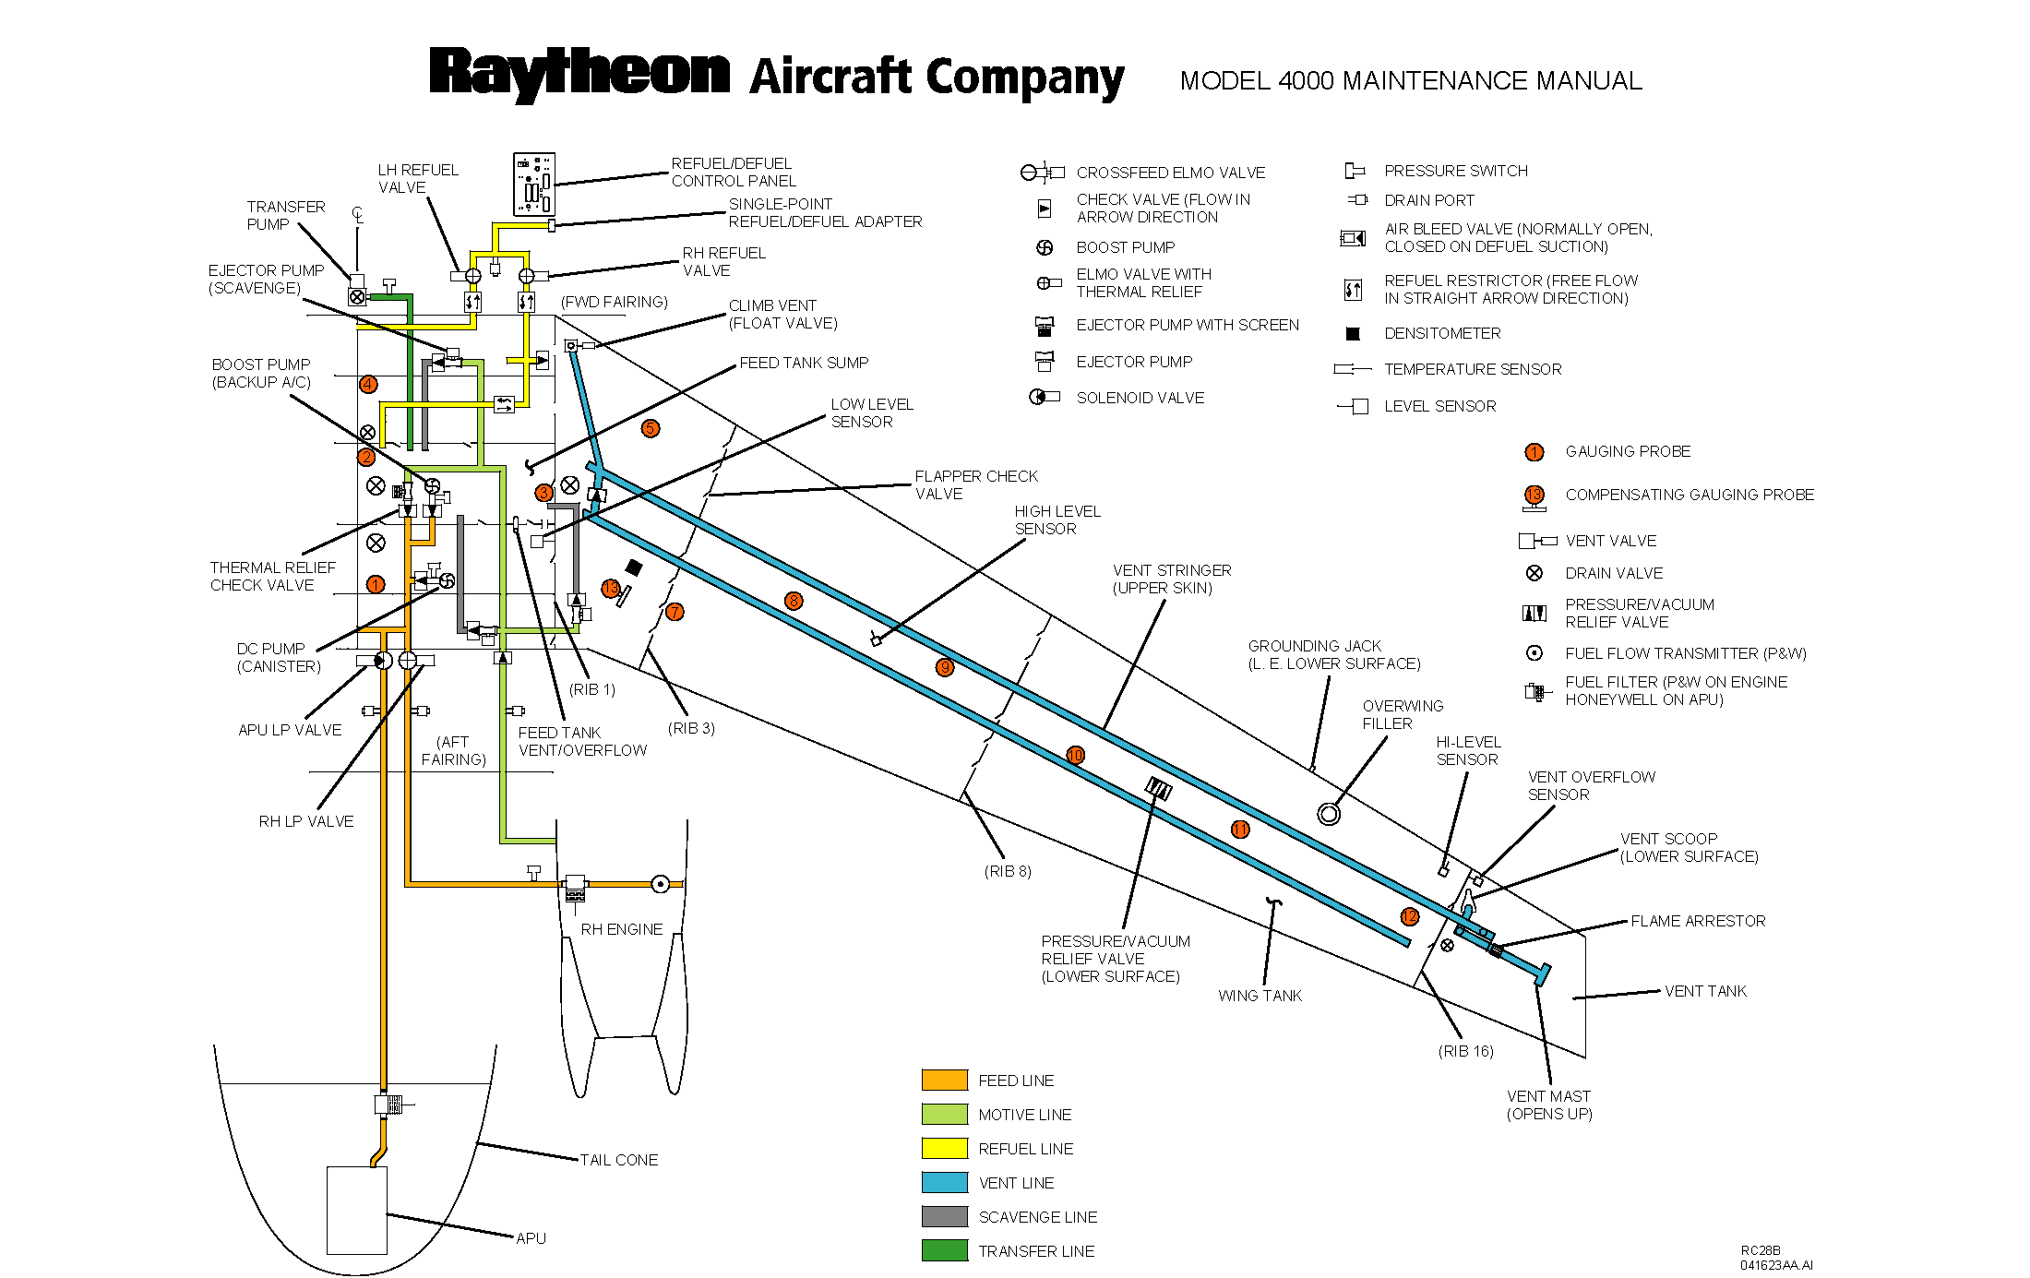
Figure 1.3 Right Side
Supporting Information from 14 CFR 25.981(c)

HBC has shown compliance to 14 CFR 25.981(c) in report 4000E0542, Fuel System Compliance Report for the Model 4000. Below are details from this report that supports that the design is compliant with respect to flammability. This information provides additional details regarding tank temperatures for further clarification above the requirements.

Using AC 25.981-2 as a guide, the following information describes how the Model 4000 has minimized fuel tank flammability. Several factors were reviewed to reduce the formation of flammable vapors including fuel type, fuel temperature including heat induced into the tank and the fuel tank geometry.

Minimizing the Formation of Flammable Vapors
The fuel tank design includes specific baffles to control the location of the fuel and to reduce the amount of sloshing. These anti-slosh ribs include flapper valves in the rib that allows the fuel to migrate inboard to the center of the tank but stops the fuel from outboard migration and sloshing during dynamic maneuvers. Reference Figure 1.1.

In reviewing drawing 401-921102, the SPR discharge point is near the bottom of the tank for defueling purposes. This location also helps reduce the misting of fuel in the tank during fueling. The three scavenge transfer lines pick up fuel and discharge it into the collector tank. The discharge locations are also in the lower portion of the feed tank, below the top of the AC pump further reducing the possibility of misting fuel in the feed tank.

A review of the flow rates and line sizes was conducted to determine the maximum fuel velocity in the lines during refueling and normal operation. This data was extracted from 4000E0075, Refuel/Defuel Venting Test Report, and QTR2970026, Qualification Test Report Hawker 4000 Ejector Pumps. This review produced the following table:
 | Scavenge | Refuel | Refuel (After Split) |  | Refuel (One Line) | Refuel (After Split)
 |  | 2 Lines | 1.5" | 2" | 1 Line | 1.5" | 2"
Inner Diam (in) | 0.694 | 1.944 | 1.444 | 1.944 | 1.944 | 1.444 | 1.944
Tube Area (in²) | 0.378 | 2.968 | 1.638 | 2.968 | 2.968 | 1.638 | 2.968
% Flow | 1.000 | 1.000 | 0.356 | 0.644 | 1.000 | 0.356 | 0.644
Max Flow (gal/min) | 3.730 | 86.400 | 30.721 | 55.679 | 86.000 | 30.721 | 55.421
Flow (in³/sec) | 14.361 | 332.640 | 118.275 | 214.365 | 331.100 | 118.275 | 213.372
Velocity (in/s) | 37.963 | 112.071 | 72.222 | 72.222 | 111.552 | 72.222 | 71.888
Velocity (m/s) | 0.964 | 2.828 | 1.834 | 1.834 | 2.815 | 1.834 | 1.826

HBC has minimized the possibility misting of the fuel within the Model 4000 fuel system by the location and flow velocities of the discharge points.

There is no static charge buildup on the fuel tubes in the system. The maximum velocity acceptable without creating a static charge is 6-7 m/sec as supported by AC 25.981-1C. The maximum velocity in the Model 4000’s fuel system is 2.828 m/s, as listed above.

Fuel Types
High volatile fuels are not approved for use. The only approved fuels for use on the Model 4000 are:
Jet A, Jet A-1 per ASTM D1655
JP-8 per MIL-DTL-83133
JP-5 per MIL-T-5624M-1
Commonwealth of Independent States (CIS) RT and CIS TS-1

The CIS fuel RT and TS-1 have a lower flash point than the other approved fuels. However, the availability of this fuel is limited to specific areas of Asia and Eastern Europe, and cannot be located within the US unless the fuel has been specifically blended for consumption by a given operator. Fuels that have previously been used in other aircraft but have been prone to problems with flammability have not been approved for use on the Model 4000.

Fuel Tank
The Model 4000 fuel tank is located in the wing. As described in AC25.981-2, fuel tanks located in the wings with little heat input from other systems are shown to meet the intent of the regulation.

The Model 4000 fuel tank is a two-tank system with separate left and right tank groups with 1079 gal per side. Each tank group consists of a feed tank, collector tank, wing tank, and a vent tank situated from inboard to outboard (see Figure 6.3). The feed tank (58 gal), collector tank (93 gal) and forward inboard portion of the wing tank (86 gal) is located below the fuselage within the wing fairing. This volume under the fairing is 237 gallons, which is 21 % of the tank volume and is the last to be consumed. This quantity of fuel is not affected by heat transfer from the wing skin due to adiabatic cooling. The collector and feed tanks remain full until all of the remaining fuel is depleted. The forward inboard portion of the main tank starts to reduce in volume as the wing total volume drops to approximately 588 gallons and completely depleted when the quantity drops to approximately 151 gallons per side. Circulation of fuel within the tank is from the wing and collector tank into the feed tank, excess overflows into the collector tank and then wing tank. This circulation assists in stabilizing the fuel temperature in the tank and mitigates any heat effects.

There are no auxiliary tanks in the system, only unheated wing tanks, and there is no source of additional heat to the wing tank. In the Amendment 102 preamble, it states the rule is not intended to prevent the development of flammable vapors in fuel tanks. “The intent of the rule is to require that fuel tanks are not heated, and cool at a rate equivalent to that of a wing tank in the transport airplane being evaluated.” The Model 4000 as stated only has wing tanks.

Managing Heat Transfer into the Tank
Known heat sources are not located next to the wing except for the bleed air for the wing anti-ice system. The wing anti-ice system is only operated when the ambient conditions are below 50º F. Therefore, any heat affects to the wing fuel tank are also mitigated by the lower operating ambient temperature, which is more of an influence on fuel tank temperature than the anti-ice system affects as described below. This anti-ice system duct location is optimized for temperature separation from the fuselage and wing structure. There are no heat sources located below the wing, which would have more of an influence on tank temperature than the above wing routing.

During the cold soak testing, the vent air within the tank stabilized to the same temperature that was recorded from the RAT (Ram Air Temperature). This temperature is consistent knowing the air provided is coming from the ram air NACA scoop. These results are documented in 4000E0555, Fuel Temperature Survey Test Report, and SDD 15298-1, Model 4000 Hawker Horizon Fuel Tank Thermal Analysis. Therefore, the air within the tank is primarily influenced by ambient conditions, not the surrounding systems.

Leading Edge Anti-Ice System
As previously mentioned, the amount of heat introduced into the wing fuel tank through the spar is minimal. During development testing of the wing anti ice system, the temperatures of the spar were shown to increase approximately 100º F. Also, the maximum allowable spar temperature is 250º F. Any heat induced by the spar to the fuel will be rapidly dissipated to the overall fuel mass and out to the wing skins resulting in little or no heating of the fuel. The airflow around the wing skins dissipates the heat and thus the ambient temperature has the highest influence on the fuel temperature.

In 4000E0065, Fuel Tank Skid Test Report, the thermal analysis of the heat transfer into the fuel from the skid, during a gear up landing, shows some local fuel heating, however the heat gradient showed the temperature dropped 100° F in less than 0.2 inches from the heat source. This condition was using fuel at 122° F and the skin contact point was at 400° F. The analysis indicates that heat may be at a tank wall but the overall large volume heat sink of fuel will insure the overall tank temperature remains minimal.

Fairing Area
The fairing area around the inboard portion of the wing includes the wing anti ice bleed air supply, and the wing discharge air. The fairing is also ventilated to minimize the build up of flammable vapors and the air is exchanged in excess of 5 times per minute. The bleed air supply line is insulated and monitored to notify the crew if a bleed air leak occurs so the system can be shut down. The compartment maintains an ambient temperature below 141 ºF (corrected to hot day conditions). This condition is also assuming a failed case with a single engine source of bleed air for both wings. Additional information can be reviewed in 4000E277401, Wing Anti-Ice Compliance Report and Flight Test Report for Support of Engine Ice Protection. This ambient condition would not increase the amount of vapors that would already be within the tank. The bleed air lines for the wing anti-ice system are also insulated so that during operation the maximum external surface touch temperatures are less than 250°F. These lines are also positioned above the wing which also reduces the possibility of heating the wing. The lines are also equipped with a leak detection system that warns the crew that a leak has occurred and the system is shut down. No other heating source is near or below the wing tanks which further minimizes the possibility of hazardous vapors being generated in the tank.

Motive Flow Supply
During Hot Fuel Testing, 4000E0070 Hot Fuel Test Report, 3000 lbs of TS-1 fuel was fueled in the right wing (test wing) at approximately 110º F. Two separate conditions were run, one with motive flow only and one with AC boost pump only. These tests show that after takeoff, fuel temperature drops due to the heat being dissipated by the airflow over the wing fuel tank. The motive flow pump and AC boost pump cannot generate enough heat to counteract the heat loss by the fuel. At the time of landing, fuel temperature stabilized to approximately ambient temperature.

When comparing the results from the hot fuel test conditions, the heat induced into the tank from motive supply cannot be identified. The AC boost pump operation was conducted when the motive supply was capped off at the engine, so that no additional heat was induced to the tank. The data from the test conditions indicates no discernable heat added to the fuel from motive flow within 6 to 9º F of the boost pump data. The tank temperature is influenced more by ambient conditions. Even with hot fuel and additional heat being supplied from the engine, the temperatures start to decrease once the flight was started. This testing supports that the heat being supplied into the tank does not exceed the heat removed by the air along the wing skin to the point of raising the temperatures above starting point of 110°F for the test.

Flammability Exposure of the Wing Tank
As previously discussed, the temperatures within the fuel tank are affected by the ambient air, not the minimal heat sources near the tank. This design is considered acceptable with respect to minimizing the formation of flammable fuel vapors per AC 25.981-2.

Compliance to 25.981(c) has already been shown with the above discussion. An additional analysis was conducted to support the above statements by determining the fuel tank temperature profile during a long duration flight. This fuel tank flammability exposure analysis determined the fuel tank flammability level during aircraft operation. The below graphs were created by using the data from test aircraft RC-2 Flight Number 290 that was used for the Fuel Temperature Survey Certification Tests. The flight consisted of climbing to 45,000 ft and cruising for approximately 5 hours. The total flight time was approximately 7.5 hours. RC-2 has 10 temperature sensors installed throughout the wing for fuel system tests.

Figure 2 plots all 10 temperature sensors in the wing versus the altitude of the aircraft. The maximum and minimum fuel flammability limits are for Jet A. This figure shows the liquid fuel and fuel vapor/air mixture temperature throughout the flight.

Figure 3 is a plot of time versus all 10 temperature sensors. This figure was used to determine at what time in the flight that each of the sensors became uncovered with fuel and started measuring fuel vapor/air temperature. Only five of the sensors became uncovered with fuel during the flight. These five sensors were plotted versus altitude in Figure 4 using only the fuel vapor/air mixture data. When these sensors are uncovered from fuel, the air mixture is cold enough to be outside of the flammability zone.

In conclusion, Figure 2 shows that the aircraft fuel temperature overlaps a portion of the flammability zone. On the other hand, Figure 4 shows that the fuel temperature is in the flammability zone only when the sensors are submerged in liquid fuel, which is not a flammability hazard. When the tank compartments become empty of fuel and a fuel vapor/air mixture occupies the space, the temperature is cold enough to be outside of the flammability zone. Therefore, the fuel tank maintains a non-flammable condition.

Figure 2
Figure 3
Figure 4

