Mesh Tally Plots
Superimposed Over Geometries
Plotted Within MCNPX

MCNPX has had the ability to plot mesh tallies for decades. Mesh tallies are fluxes, heating, source locations, doses, and other tally quantities plotted on a 3-D mesh (rectangular, cylindrical, or spherical) independent of the problem geometry. But in the past the mesh tallies were difficult to use. They required generation of an MDAT file which was then read by the auxiliary code GRIDCONV. GRIDCONV converted the MDAT files into files useable by external graphics packages such as TECPLOT, MORITZ, PAW, and IDL. These packages can still be used for superior graphics. But now MCNPX can plot mesh tallies by itself in two ways. The MCPLOT tally plotter can take MCNPX MCTAL files after a calculation and make 2-D contour plots. Alternatively, the MCNPX geometry plotter can post-process MCNPX RUNTPE files or plot “on-the-fly” mesh tallies superimposed over MCNPX geometry 2-D plot slices.

The following mesh tally plots were all made by MCNPX with the subsequent input file and plot commands.

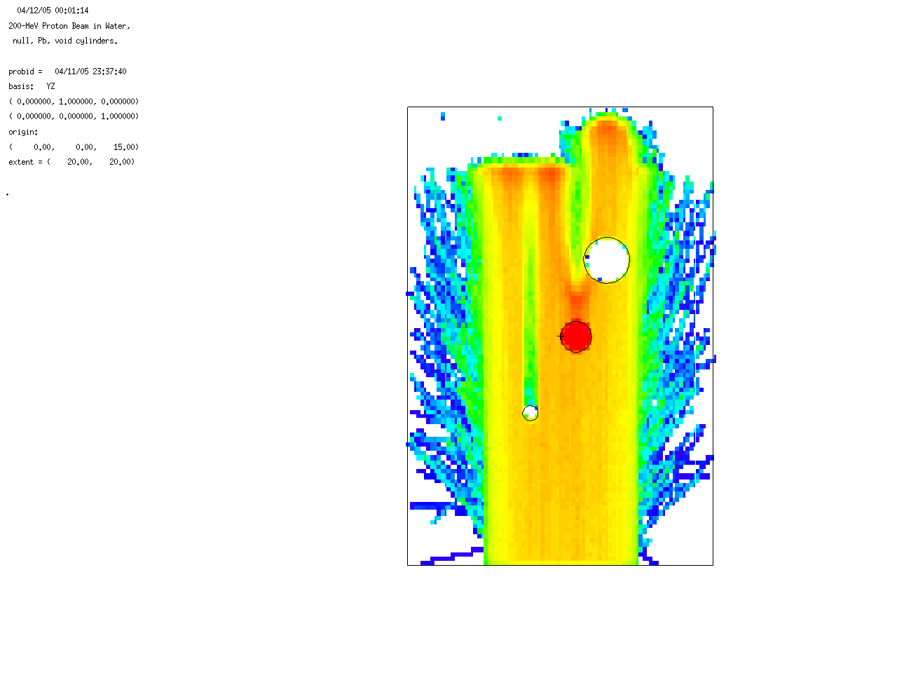
Figure 1. Heating mesh tally of 200-MeV protons entering water, plotted with geometry plotter and popping up at pre-determined times during the calculation. The picture may also be post-processed. The problem is a 200-MeV proton beam (5-cm diameter) entering a 10-cm radius, 30-cm high can of water (vertical z-axis) with 3 small cylinders coming out of the page (x-axis). The x-axis cylinders have (from left to right) (a) zero importance, (b) iron, and (c) void. The large vertical z-axis cylinder and the three smaller x-axis cylinders coming out of the page are outlined with black lines. Red indicates high heating and blue indicates low heating. The proton beam is “killed” by the zero-importance cylinder (a, left) leaving a shadow above it. The iron cylinder (b, center) has the highest heating and also leaves a shadow. The void cylinder (c, right) has no heating and extends the range of heating in water above it.

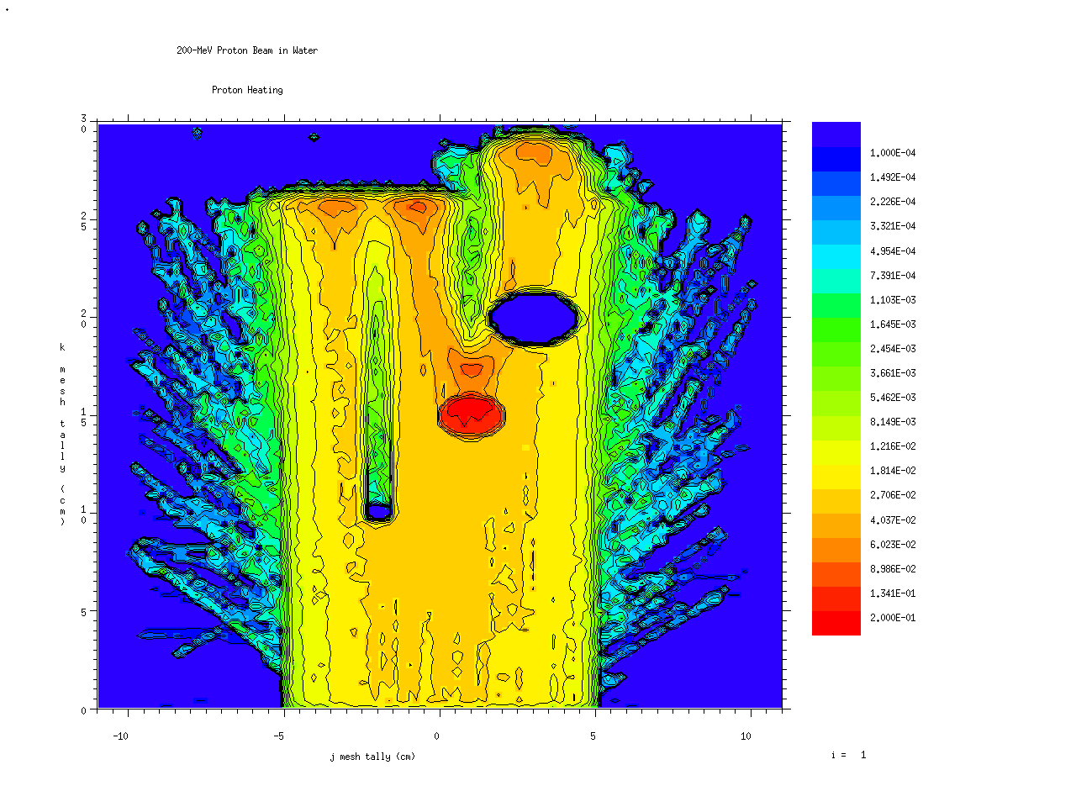
Figure 2. MCPLOT mesh tally of proton heating (same as geometry plot in Figure 1.) The 200-MeV 5-cm radius beam enters upwards from the bottom of the 10-cm radius water can. Normal to the picture are three cylinders coming out of the page. The left cylinder (blue) is zero importance (pure absorber) and thus has no heating. The center (red) is iron and has the greatest heating (red). The right cylinder (large, blue) has no heating. The MCNPX MCPLOT tally plots provide a scale (right) and post-process MCTAL files.

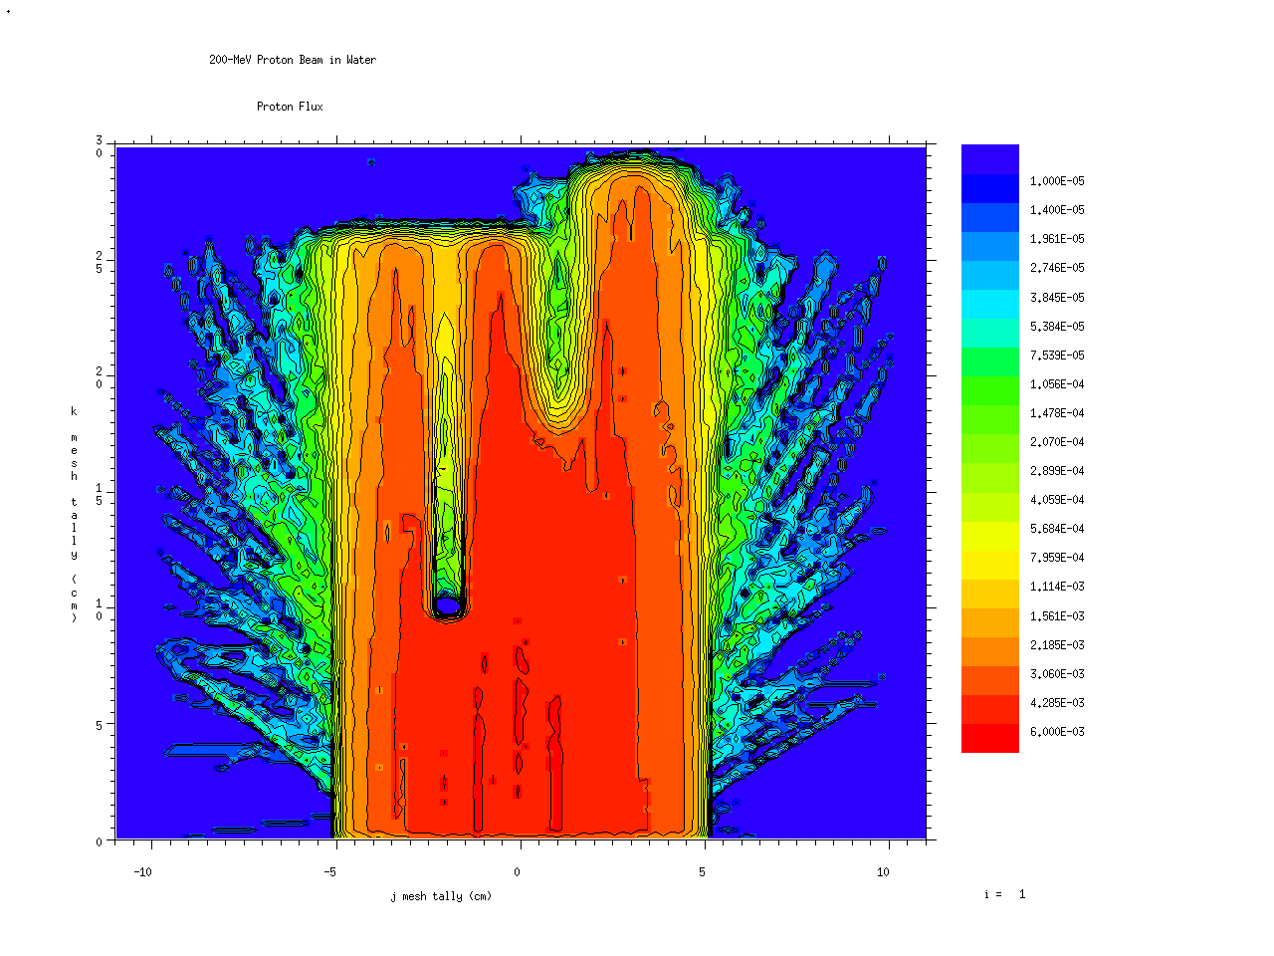
Figure 3. MCPLOT flux tally plot of a 200-MeV proton beam (5-cm diameter) entering a 10-cm radius, 30-cm high can of water with 3 small cylinders coming out of the page having (from left to right) (a) zero importance, (b) iron, and (c) void. The zero importance cylinder causes the blue spot in the center left where the flux goes to zero (blue) and then has a shadow. The iron cylinder in the center reduces the flux above it. The void cylinder on the right allows the proton beam to penetrate further (higher).

The following MCNPX commands were used to run the above problem and make the above pictures:

mcnpx i=prot10 n=jprot. mdata=jprot.d
mcnpx z n=junkh. com=protcom

The MCNPX input file is “prot10”:

200-MeV Proton Beam in Water, null, Pb, void cylinders.
1 1 -1.0 -1 10 20 30 imp:h 1
2 0 1 imp:h 0
10 0 -10 -1 imp:h 0
20 2 -7.5 -20 -1 imp:h 1
30 0 -30 -1 imp:h 1

1 rcc 0 0 0 0 0 30 10
10 c/x -2 10 .5
20 c/x 1 15 1.
30 c/x 3 20 1.5

mode h n
sdef pos 0 0 .1 erg=200 vec 0 0 1 axs 0 0 1 dir 1 ext 0 rad d1 par h
phys:h 200
si1 5
m1 1001 2 8016 1
m2 26056 1 nlib=.24c hlib=.24h
nps 10000
print -160
prdmp 2j 1
c
tmesh
rmesh11:h flux
cora11 -11 11
corb11 -11 99i 11
corc11 0 99i 30
rmesh31:h pedep
cora31 -11 11
corb31 -11 99i 11
corc31 0 99i 30
endmd
mplot freq 1000 plot ex 20 or 0 0 15 px 0 la 0 1 tal31 col on la 0 0 &
con 1e-4 .2 log

The plot command file is “protcom”:

rmc jprot.m tal 11 free jk con 1e-5 .006 20 log &
title 1 "200-MeV Proton Beam in Water" title 2 "Proton Flux"
pause
tal 31 con 1e-4 .2 20 log title 2 "Proton Heating"
pause
run jprot.r plot
ex 20 or 0 0 15 px 0 la 0 1 tal31 col on la 0 0 con 1e-4 .2 log
pause
return
rmc jprot.m tal 21 con 1e-5 .0015 20 log title 2 "Neutron Flux"
pause
tal 41 con 1e-5 .0015 20 log title 2 "Neutron Heating"
pause
end
end

