Mining Amorphous Transporter Explorer (MATE) for Far North Mining Operations

P.E. Clark, Science Lead, Autonomous Tetrahedral Rover Team, Code 695, NASA/GSFC

The Challenge: The Far North has large mineral reserves and has historically had large mining operations. Deep precious material mines, such as those typical of Canada, are productive for a long time but at greater investment cost than surface operations. Greater commitment to environmental quality and worker safety has also added to cost. As a result, the focus of new operations and investments of even Canadian mining companies is shifting to other locations, many of which lack the infrastructure of Canada.
The Goal: Providing a pathway for Canada to reap the benefits of its reserves in precious materials by retaining mining investments while maintaining its commitment to environmental quality and worker safety
The Proposed Solution: The Mining Amorphous Transporter/Explorer (MATE) based on our new space architecture (Addressable Reconfigurable Technology or ART) could provide a pathway to meet this challenge. The first versions of ART, tetrahedral walkers, are now in the prototype stage and being developed as the Autonomous Lunar Manual Assistant ALMA and Autonomous Lunar Investigator ALI (near term) and Lunar Amorphous Rover Antenna LARA (far term) for the NASA Exploration Initiative (Figures 1 and 2).
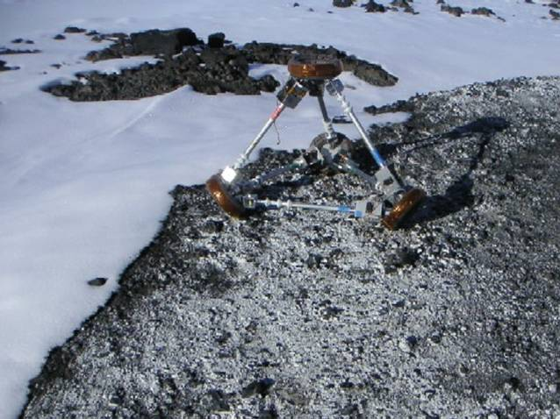
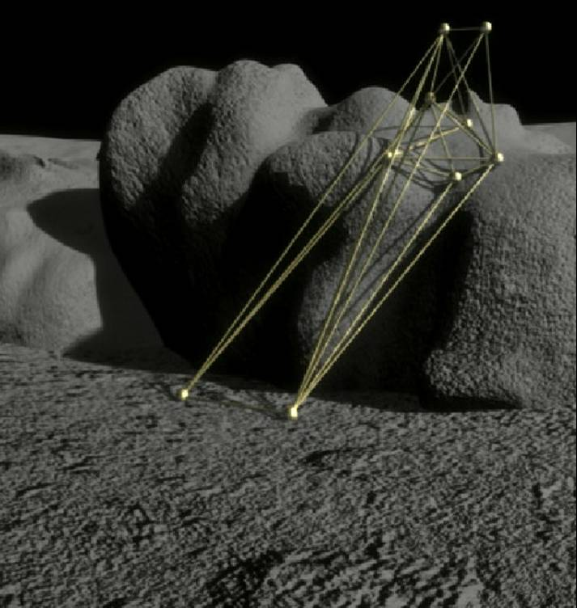
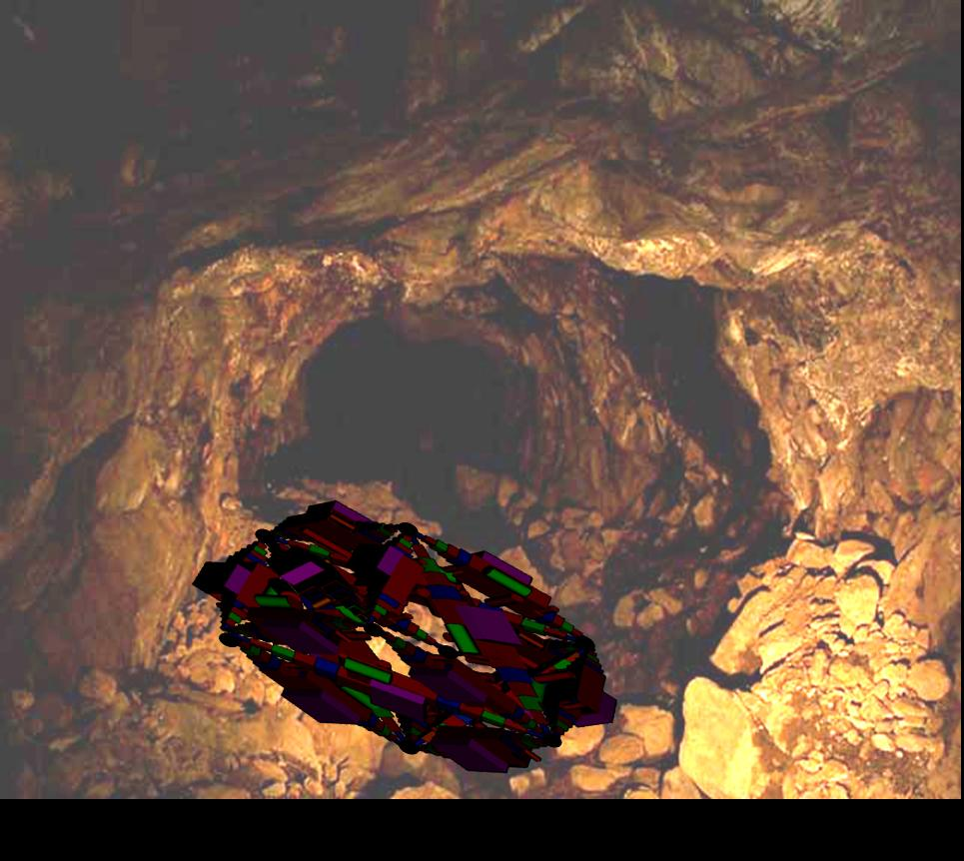
1st Generation:Tetrahedral Walker with struts reversibly deployable from tetrahedral nodes for locomotion over regular surfaces at Goddard and elsewhere. Operational: Now
2nd Generation Field Test Models: 12 TET Walkers and Arms with ruggedized design and payload to perform experiments in cold terrains (e.g., Far North).
Operational: 2005-2007
3rd Generation Multi-functional Mobile 12TET Systems (ALI) capable of fully autonomous complex behaviors and movements with many degrees of freedom.
Operational: 2010-2015

Figure 1: Tet Development from Today to Tomorrow
See animations on our website: http://ants.gsfc.nasa.gov
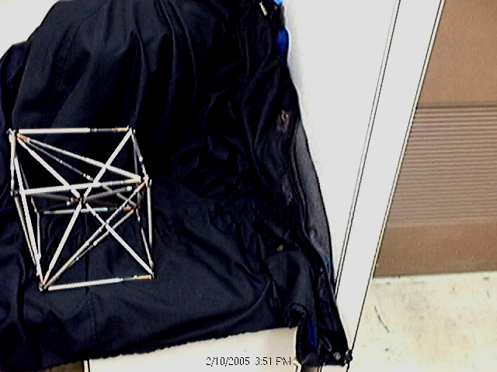
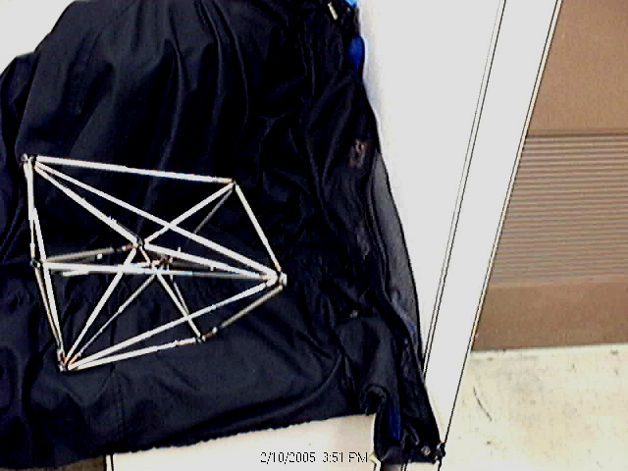
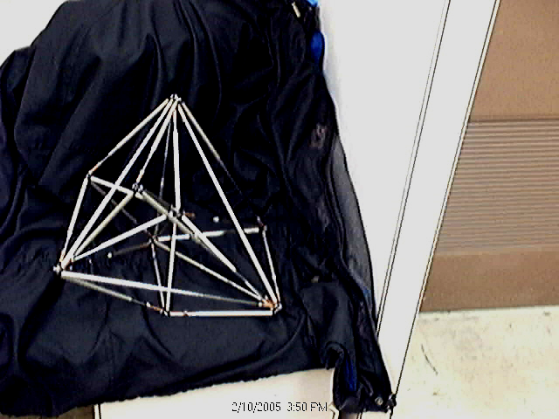
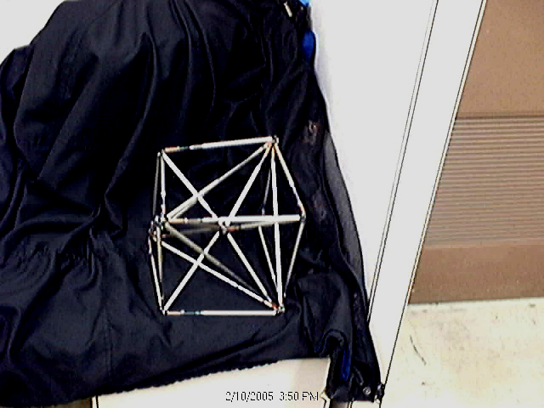
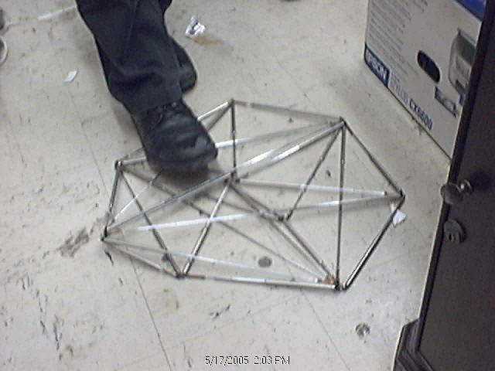
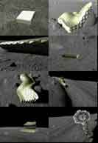
ART Systems are designed for staged development and utilize appropriate technology as available. We are creating autonomic, reusable, reconfigurable, highly redundant, efficient, and thus cost-effective systems which could create the multi-functional infrastructure called for as part of NASA’s Exploration Initiative. ART (Addressable Reconfigurable Technology) architecture, an approach which is realizable in stages at any level of technology and promises to revolutionize space structure design by epitomizing portable ‘form follows function’ at every level. The basic building unit in this architecture is a tetrahedron, the most efficient space-filling form, consisting of nodes interconnected with struts that can be reversibly and/or partially deployed or stowed to allow the tetrahedron to change its size and shape on command in seconds. Struts are formed into tetrahedral units interlinked in one (linear), two (planar), or three (space-filling) dimensions to create conformable objects. As more tetrahedra are interconnected, the degrees of freedom are increased and motions evolve from simple to complex, from stepped to continuous (Figure 2).
Figure 2: Model of 12 Tetrahedral Structure showing transformations in shape and simple locomotion movement from left to right across top. Same 12Tetrahedral model flattened for sliding through narrow places (left). 3D Tetrahedral structures (LARA) in motion (right).
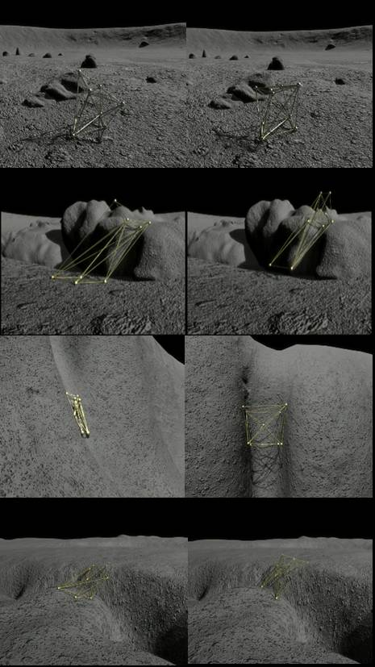
ART can be constructed in principle from any available mechanisms at any level of technology (Table 1). We are currently constructing simple prototypes for mobile units using cable and pulley deployment mechanisms at the electromechanical systems (EMS) level. Heavy duty hydraulic or pneumatic mechanisms could just as easily be used to control telescoping struts. As Micro-EMS (MEMS ART) or nano-EMS (Super Miniaturized ART or SMART) become available, within the next decades, such components could be incorporated to minimize mass and power requirements. The 3D network of actuators and structural elements is composed of nodes that are addressable as are pixels in an LCD screen. Ongoing work on ART prototypes (Tetrahedral Walkers) is providing a basis for understanding performance and conceptual models for hardware and software requirements which could support the architecture proposed here.
Figure 3: Amorphous transformation of simple rover allows locomotion in variety of terrains, from low to high relief, rough to smooth, as seen in movements of 12tetrahedral walker from left to right for each terrain type.
Tetrahedral Locomotion
:Required Form follows Function

Smooth, low relief: Rolling Gait

Rugged, low relief: Climb over

High relief (cliff): Chimney up

High relief (crevasse): Bridge
Table 1: Comparison of Mechanisms
Mechanism | Use in ART Structure
Tetrahedral  Structure | Widely demonstrated (Si and C bonding)  space-filling with greatest variety of  structures and behaviors possible.
Telescoping | Simple, combines well with other  mechanisms, must deal with friction
Cable/Pulley | Currently used. Efficient but less strong.
Compression/  Tension Springs | Strong and efficient when used in pairs  bit doesn’t allow strut to maintain size.
Constant Force  Springs | Efficient, Volume minimizing and strong  if combined with ‘memory’ materials.  Potentially useful to deploy surfaces.
Combined | External telescoping combines well with  other mechanisms
Hydraulic/  Pneumatics | Very strong for large structures.
Extreme Mobility: ART structures are capable of mobility in extremely rugged environments and don’t require the flattened surfaces preferred by wheels. However, ART structures can form bridges or tunnels in particularly rugged terrain (e.g., large ravines) to make that terrain efficiently accessible or usable for other purposes, such as mining operations (Figure 3, Table 2). This could be done without the use of heavy-duty terraforming equipment. Components could deploy themselves for a particular function, then stow and transport themselves to a new location, transform themselves as required for a new function, all with or without a human crew. Structures are also required to operate under extreme cold (such 50 degree K at the lunar poles). The ultimate goal is to create structures capable of routine self servicing, including recharging, retrieving, replacing, recycling its components as required in a cost/effective manner.
Table 2: Scenario Forms and Functions
Function | Form
Transportation | Shape for permanent or temporary bridging, tunneling, covering over terrain, reconfiguring for shifting of shape or position in real-time through addressable smart components for power, communication and control
Communication | Each component addressable, allowing rapid determination of position, navigation, reconfiguration. Structures/surfaces readily deployable allowing formation of antennas singly or in arrays for high bandwidth needs.
Production | Mobile, reconfigurable structures allow gathering (forming cranes, dozers, harvesters, etc.), processing, manufacturing, and delivery
Power | Each component addressable and with built in batteries, allowing off-grid power generation or plugged in arrays for power generation
Progressive Autonomy in Command and Control: Tetrahedral systems are designed to be capable of autonomic movement (low level intelligence), deploying and stowing struts in a ‘gaited’ manner learned in advance to be appropriate for a terrane or application. Feedback is provided by touch and motion sensors on each node combined with the laser vision/navigation system. The highly addressable structure must operate in highly irregular terrain, where locomotion requires an intimate blending of dynamics and statics. Most means of locomotion try to "finesse" the situation by somehow glossing over the complexity of the terrain: typically, rovers have featured wheels or legs that are larger than the terrain scale sizes, or locomotion that is slow to allow expert computer systems time to figure out where to go next. The 12 TET rover will become a moving part of the terrain, its vision system providing volumetric information about its surroundings. With information about the geometry of its environment as well as information about its own geometry, the 12 TET places itself within and moves through its environment. Autonomic control is achieved through a Neural Basis Function (NBF) software architecture used reactively to define, control, and organize the network of actuators responsible for 12 TET motion. NBFs are composed of multiple control systems within an Evolvable Neural Interface (ENI) which acts as an active communication medium between the control elements. Separate behaviors of the 12 TET are typically instantiated as separate NBFs: to add new behaviors the aim is to simply link the ENI of the new behavior into the system and then allow the ENIs to adapt the old and new components to each other.
At present, target or activity selection (high level intelligence) is made through a wireless interface with a human user (telepresence). We are developing a virtual reality model and high level command language for user wireless communication interface. The ultimate goal is to create a system with bilevel intelligence, which would mean carrying high level intelligence capability onboard for entirely robotic operation. The high-level components generally rely on a more symbolic approach to control and may involve planning and schedule and other heuristic control. The NBFs for the 12 TET are built on what we have learned by applying the NBF architecture to a control system for autonomous rendezvous and capture of a chaotically tumbling target, a problem inspired by the Hubble Space Telescope Rescue mission.
Vision/Navigation: Tetrahedral devices require a robust vision/navigation system with minimum power and bandwidth requirements currently under development here. The system will be required to provide feedback rapidly while the vehicle is in motion, locate small obstacles within meters of its immediate path, such as boulders, as well as remote hazards tens of meters away in the direction of motion such as cliffs. The candidate 3-D Vision system that best meets our requirements is already under development for a wide range of deep space, orbital, and surface exploration applications. It is laser-based ‘scannerless’ range imaging system consisting of a laser diode emitter array, low power high-resolution time-of-flight ranging electronics, and a mega-channel fiber-optic based receiver. All of these components are extremely efficient, compact, and robust, and combine together to make a highly reliable 3-D imaging system. Our concept utilizes two distinct imaging systems; one capable of short-range, high-resolution imaging to support local maneuvering and immediate hazard detection; the second a longer range imager for trajectory planning and large-scale hazard avoidance.

Operational Constraints for Canadian Mining: The Far North is still relatively inaccessible and thus unexplored but known to have extensive mineral potential.
1) Tens of kilometers long ultramafic surface deposits from collapsed volcanic structures provide relatively accessible nickel and platinum group metals. MATE could assist in locating these deposits by carrying a geochemical exploration payload over exceedingly rough and variable terrain.
2) In recent years, diamonds have been found in vertical kimberlite pipes exposed at deep-seated fractures in the continental craton. MATE could assist both in locating these deposits and operating in relay fashion to transport equipment and ore in vertical shafts.
3) The continental craton of the far north has extensive hydrothermal veins (metalliferous
lodes), deposits of native gold, silver or other metal sulfides in quartz or calcite. Such veins occur in fault or fissure openings or shear zones within country rock and are characteristically narrow compared to their length and depth. Veins form an irregular plumbing system, generated by fluids made hot by contact with intrusive rock rising through faults, factures, and porous layers of surrounding rock. Veins range from a few centimeters to a few meters but average about a meter in thickness. They may be hundreds of meters longs and deep. Mineralization, or formation of native ore deposits, occurs in shoots within a vein. The highest temperature, richest, least diluted by ground water hypothermal deposits occur at depth. Lower temperature, more diluted, but more accessible epithermal deposits occur nearer the surface. MATE could assist both in locating these deposits and operating in relay fashion to transport equipment and ore in narrow horizontal or vertical shafts.

Operational Requirements for Canadian Mining: MATE could support critical operations at each stage of the mining process (Figure 4).
1) Reconnaissance. This would involve rover exploration to identify a geological of a promising terrane as an outcrop of a potential vein, pipe, or surface deposit.
2) Survey. This would involve using a payload to gather local geochemical and geophysical measurements or samples for more extensive analysis to confirm the presence of a promising ore deposit sufficiently to justify a drilling campaign. Promising hydrothermal vein outcrops may have low concentrations of ore minerals with rich ore shoots may occur below, either down dip or along strike. Therefore, geochemical markers including associated high silica, and sulfur-bearing minerals, and a trace element ‘halo’ including arsenic, antimony, mercury, thallium and selenium.
3) Drilling. MATE vehicles could move along narrow shafts, changing shape, sliding through narrow openings, chimneying up or down vertical faces, conveying ore or equipment in relay fashion.

The Conclusion: The ART architecture under development for lunar exploration has great potential to increase the feasibility and profitability of mining operations in the Far North.

References: 1. Curtis, S.A., Truszkowski,W.F., Rilee, M.L., and Clark, P.E., 2003, ANTS for the Human Exploration and Development of Space. Proceedings of the 2003 IEEE Aerospace Conference; 2. Clark, P.E., Rilee, M.L., Curtis, S.A., Cheung, C.Y., Marr, G., Truszkowski, W., Rudisill, M., LARA: Near Term Reconfigurable concepts and components for lunar exploration and exploitation, IAC Proceedings, 2004a, IAC-04-IAA.3.8.1.08; 3. P.E. Clark, S.A. Curtis, M.L. Rilee, S.R. Floyd (2005) ALI (Autonomous Lunar Investigator): Revolutionary Approach to Exploring the Moon with Addressable Reconfigurable Technology, Lunar and Planetary Science XXXVI; 4. http://ants.gsfc.nasa.gov

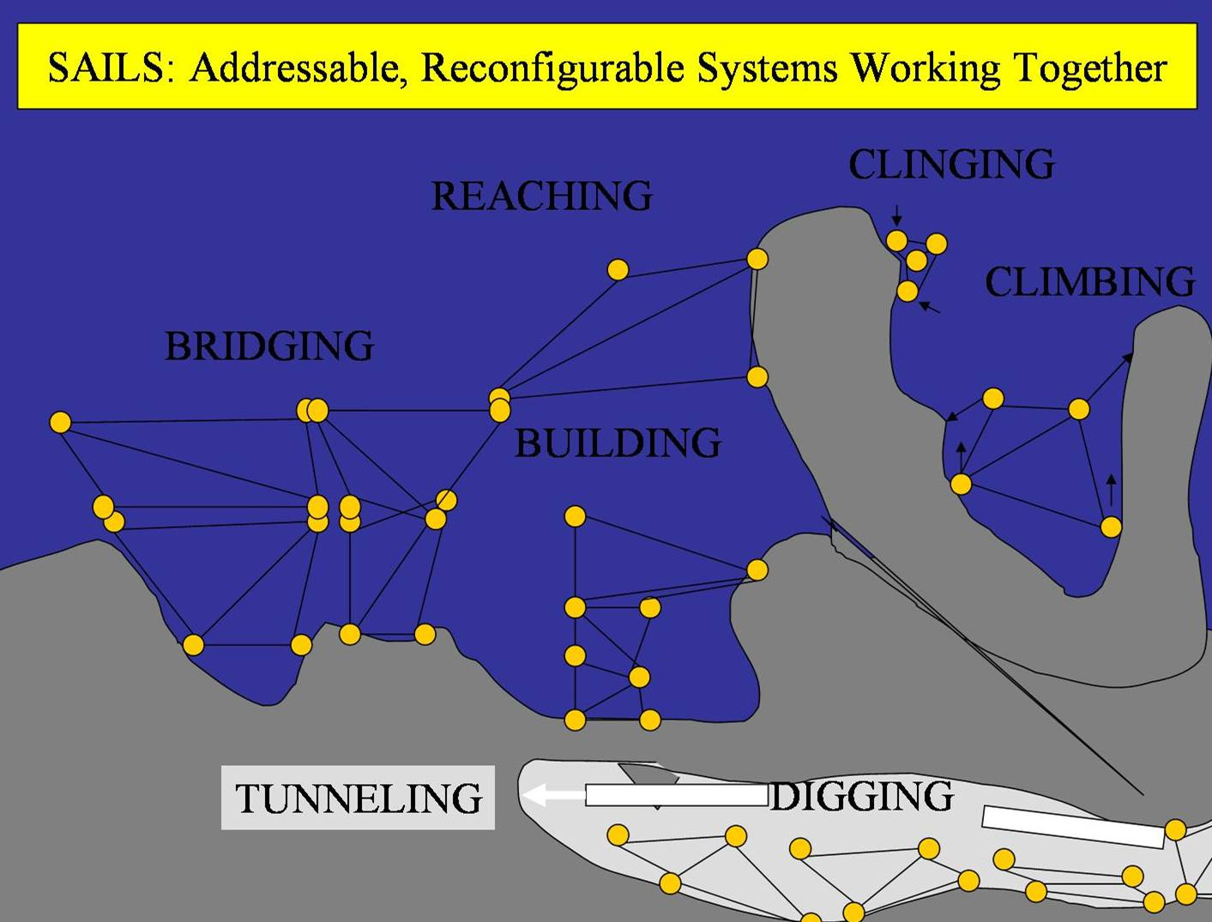
Final Note: All Tetrahedral Technology (ART, ALI, ALMA, LARA, MATE) discussed here is protected by NASA Patent Applications.
Figure 5: ART Tetrahedral Architecture Multi-functionality for Mining

Point of Contact: P.E. Clark, Code 695, NASA/GSFC
301 286 7457 pamela.clark@gsfc.nasas.gov

