HVAC Air Systems

Low Pressure Drop Air Systems

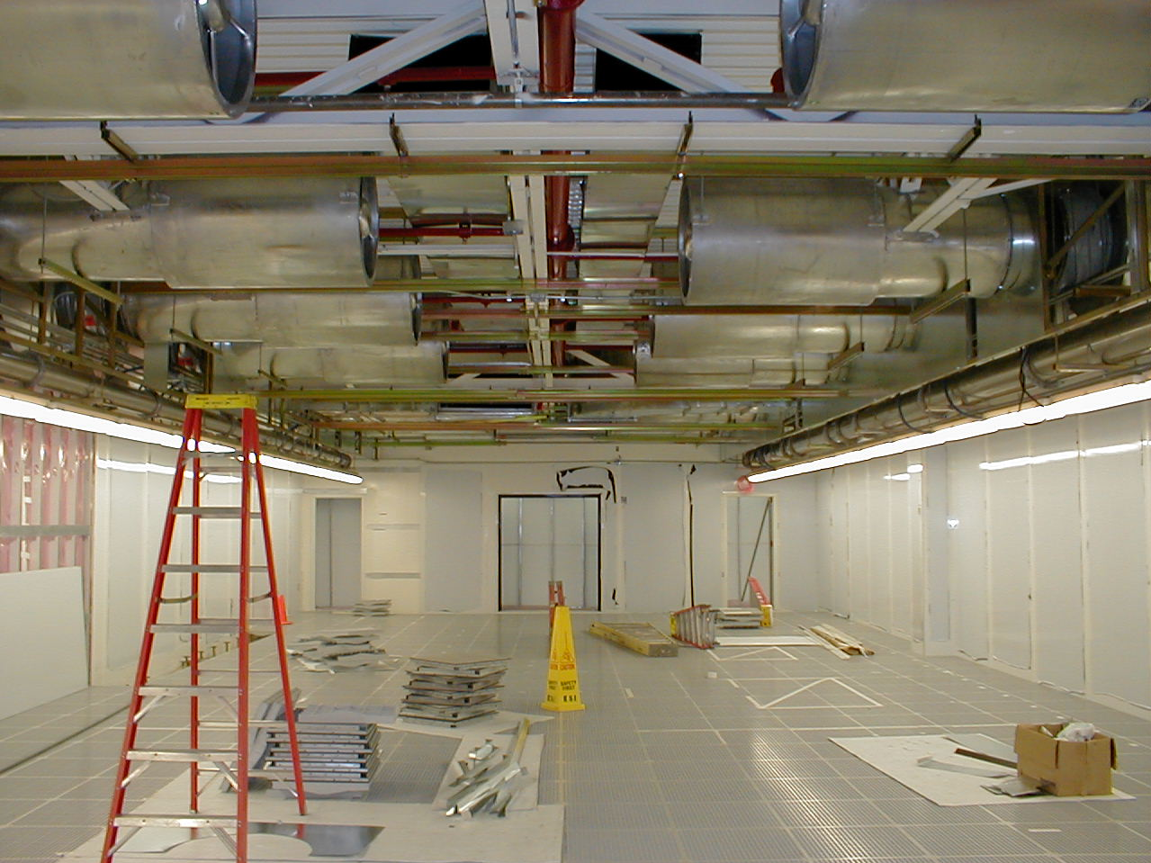
Construction of Pressurized Plenum Recirculation Air Handling System Utilizing Vane Axial Fans

Summary
Fan energy can account for 20 to 40% of total cleanroom energy use. Fan energy use is directly proportional to the pressure drop that the fan is pushing air through. Thus, the more restrictive the supply system, the higher the pressure drop, and the higher the fan energy use. Strategies for lowering the pressure drop include lower face velocity air handling units, low pressure drop filters, optimized design of ducting and air paths, including open plenum and centralized air handler types of configurations. Low pressure drop designs are applicable to all fan systems from recirculation air handler systems to makeup air handlers. Other benefits of low pressure drop systems are less noise, more effective dehumidification, better filter effectiveness, and in some cases lower total first cost (when avoided electrical and noise abatement equipment is included in the cost analysis).
Table 1. Pressure Drop Design Targets
System | Typical Pressure Drop  (Total Static Pressure) | Best Practice Pressure Drop (Total Static Pressure)
Recirculation Air | 1.5 to 3 inches | 0.5 to 1 inch
Makeup Air | 6 to 10 inches | 2 to 5 inches

Principles
- The air handler system power consumption can be estimated by the following equation. Note that the efficiency is the product of the fan, motor, belt and where equipped, variable speed drive efficiencies.
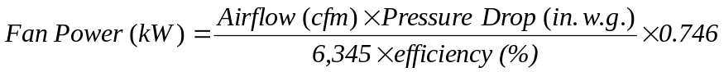
- The pressure drop in a duct or air handler is approximately proportional to the face velocity squared.
- The pressure drop in ductwork is inversely proportional to the fifth power of the duct diameter. For example, substituting a 16” duct for a 12” duct reduces the pressure drop by about 75%.
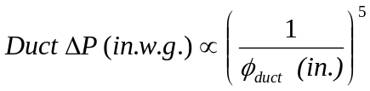

Approach
The pressure drop of an air delivery system is the design parameter with the largest impact on the power required by the system. Reducing pressure drop does not necessarily require new or innovative equipment or design techniques, it simply requires making lower pressure drop design a priority and close coordination between the mechanical engineer and the architect. Most engineers size air handlers with a “rule of thumb” of 500 fpm. This saves time, but increases cost of ownership. Below is a table illustrating the typical pressure drops found in cleanroom recirculation air and makeup air handlers.

Table 2. Typical Recirculation Air Handler Design Pressure Drops¹
Element | Recirculation Air Handler ΔP  (in. w.g)²
Filters | 0.75
Coil | 0.50
External Pressure Drop | 1.0
System Effect | 0.30
Total | 2.55
1. Assumes face velocity of 500 fpm.
2. in. w.g. - inches of water gauge
^{Table 3.} Typical Makeup Air Handler Design Pressure Drops1
Element | Makeup Air Handler ΔP  (in. w.g)²
Pre-filters | 1.0
Pre-heat Coil | 0.50
Cooling Coil | 1.0
Dehumidifying Coil | 1.0
Heating Coil | 0.50
Final Filters | 1.0
External Pressure Drop | 2.5
System Effect | 0.30
Total | 7.80
1. Assumes face velocity of 500 fpm.
2. in. w.g. - inches of water gauge

The air handler is the single greatest pressure drop item due to the coils and filters it contains. To reduce the pressure drop, specify a low face velocity unit in the 250 to 450 fpm range. The fan power requirement decreases approximately as the square of the velocity decrease. The standard arguments against reducing the face velocity are usually refuted by a lifecycle cost analysis that includes the high energy costs of a cleanroom system, the continuous operation, and the additional first costs associated with supplying electrical, fans, motors, drives, and silencers to higher pressure drop systems. The need for additional floor space is a non-issue when rooftop units are used and can be mitigated through close design coordination with the architect in most cases.
Figure 1. Low Face Velocity Concept
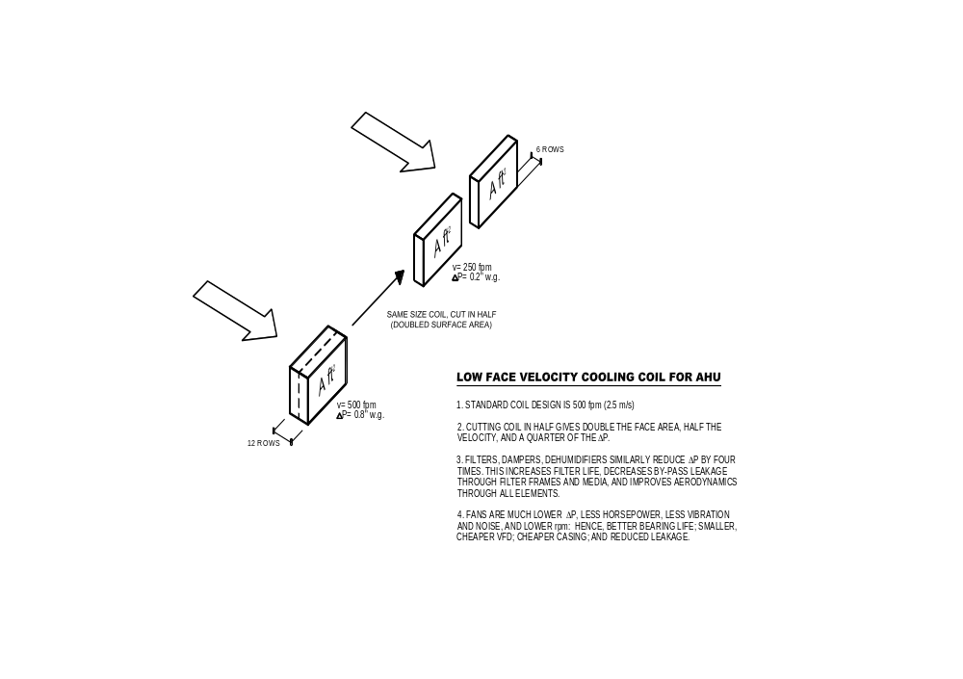
Drawing courtesy of Lee Eng Lock, E-Cube, Pte. LTD. (www.eco-web.com)

The first cost of the coil is typically only increased slightly, since the coil requires fewer rows than in a standard air handler as illustrated in the diagram. The amount of actual coil is not increased so much as it is simply spread out. Additional considerations are that the fan motor size can be reduced 25 to 50% or more, which means a smaller VFD (variable frequency drive, also known as a variable speed drive), electrical wiring and circuits; the larger filter surface area can allow a longer change interval, reducing maintenance requirements and cost. A full system cost analysis that looks beyond the simple air handler box often finds the “cost premium” of a properly sized air handler to be negligible or even negative compared to a typical 500 fpm face velocity system. In one cleanroom cost analysis, a lower face velocity rooftop system was found to have a lower first cost as well as a lower operating cost due to the downsizing of the electrical supply infrastructure that the lower power system allowed.
Lower face velocity reduces the pressure across the filters and the chances of unfiltered air leaking past poor filter rack seals or tears in the media. The use of filters with lower pressure drop, such as extended surface minipleat media, is frequently a drop-in option to reduce energy costs. These filters also have a larger surface area and load up much more slowly.
Airflow path layout is an important factor in determining system pressure drop. For example, a pressurized plenum configuration has lower pressure drop than a ducted HEPA configuration. A ducted HEPA system has multiple branches tapped from a main duct to connect individual HEPA filters. Numerous taps and the amount of smaller sized ducting in ducted HEPA systems result in consistently high pressure drops. A pressurized plenum offers a much larger air path by eliminating the ducting. The cost associated with a reduction in ducting can be used to offset .

Real World Experiences (Benchmarking Findings/Case Studies)
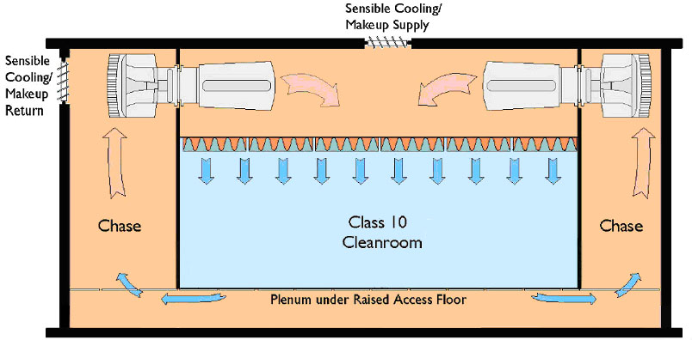
Figure 2. Recirculation Air Handling System Design Schematic at Facility C
The recirculation fan system shown above (referred to as Facility C in a recent benchmarking study) uses VFD controlled vane axial fans to pressurize a large plenum. This design is inherently low in pressure drop. Air return and supply are both via large plenum chambers, under the floor and above the ceiling. The large airflow paths mean negligible pressure drops compared to a ducted supply and/or return system. Multiple large diameter axial vane fans are controlled by VFDs and provide optimal efficiency at the low design pressure rise of 1” w.g. The fans run at a low rpm, so no silencers are required to maintain a low noise cleanroom environment. The only significant pressure drop in the system is through the HEPA filters, resulting in low required static pressure.
The design power consumption per airflow delivered from the system was 5,000 cfm/kW. However, the system was measured as performing at an impressive 10,140 cfm/kW. The large difference is due to the numerous design conservatisms inherent in air movement systems, such as oversizing for future build out and the use of fully loaded filter conditions. The use of VFD fans allowed the safety factors included to account for unpredictable system to be converted into ongoing operating savings after construction. The capability to convert design conservatism and safety factors into operational savings is a hallmark of good low pressure drop design. Oversizing ducts rather than fans provides a safety factor on the fan size that lowers operating costs and, in the case of makeup or ducted systems, provides far more flexibility for future expansions.
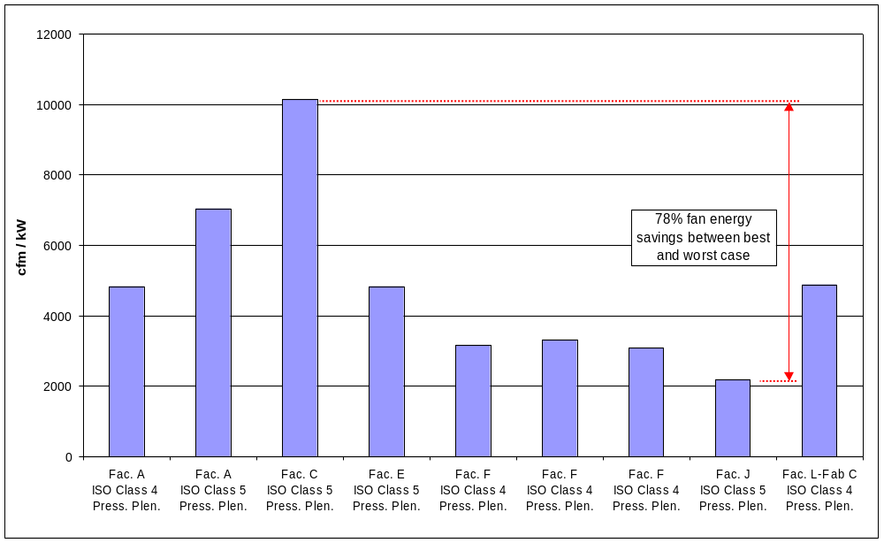
Figure 3. LBNL Benchmarking Study - Measured Pressurized Plenum Recirculation Air Handling Performance
The figure above shows the variation in performance between pressurized plenum recirculation air systems as found in the LBNL Benchmarking project. The worst performer was the cleanroom in Facility J at 2185 cfm/kW. The best performer was the cleanroom in Facility C. The best performer saved 78% of the fan energy of the worst performer. The significant difference is due to the air pressure drop of the recirculation air handling system. The total operating pressure drop for the recirculation fan system at Facility J was 1.9 inches w.g. as compared to 0.45 inches w.g. for Facility C.

Related Best Practices
Recirculation System Types Demand Controlled Filtration
Air Change Rates Right Sizing
Fan Filter Efficiency

References

Resources
- Xu, Tengfang, “Considerations for Efficient Airflow Design in Cleanrooms,” Journal of the IEST, Volume 47, 2004.
- Xu, Tengfang, “Performance Evaluation of Cleanroom Environmental Systems,” Journal of the IEST, Volume 46, August 2003.
- Jaisinghani, Raj, “New ways of thinking about air handling,” Cleanrooms magazine, January 2001.
- http://hightech.lbl.gov/
- Clean Spaces, Chapter 16, ASHRAE HVAC Applications handbook, 2003.

