Importing Geometry into Thermal Desktop From Different Formats
Pulling in IGES
Pulling in STEP
To break surfaces up
To make Thermal Desktop surfaces
General notes on working with imported geometry
Importing from NASTRAN
Importing Pro/Mechanica (NASTRAN) mesh of a Pro/E part
Importing Nastran Bulk Data into Thermal Desktop: Lessons Learned
General geometry import from Pro/E gives you only surfaces that you cannot then re-mesh – you have to snap native Thermal Desktop surfaces on to them to re-mesh. If you want a fine mesh, the method described under the section “Importing from NASTRAN” may be preferred.

Pulling in IGES

This pulls in boxes and flat surfaces nicely but doesn’t handle surface orientation. That has to be changed manually.
- Set model to correct units for imported geometry (e.g. mm)
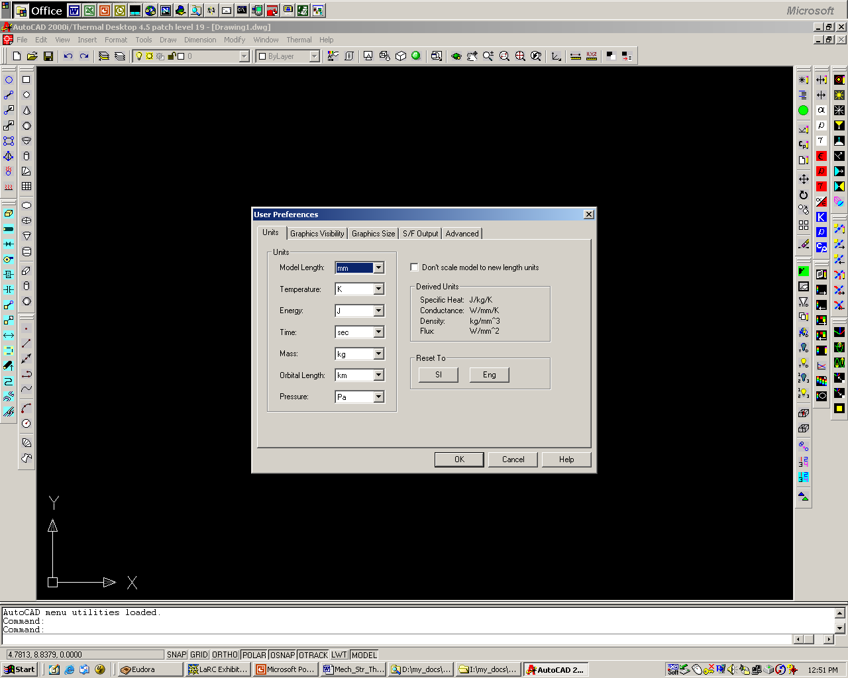

Type igesin (Import geometry)
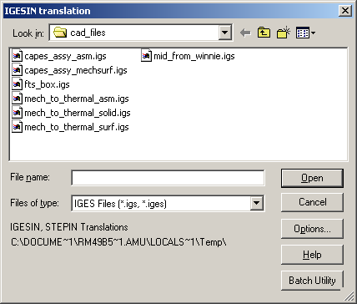
Set options as desired (for surfaces, default options work fine)
Select desired file
This is too detailed on a curved surface….
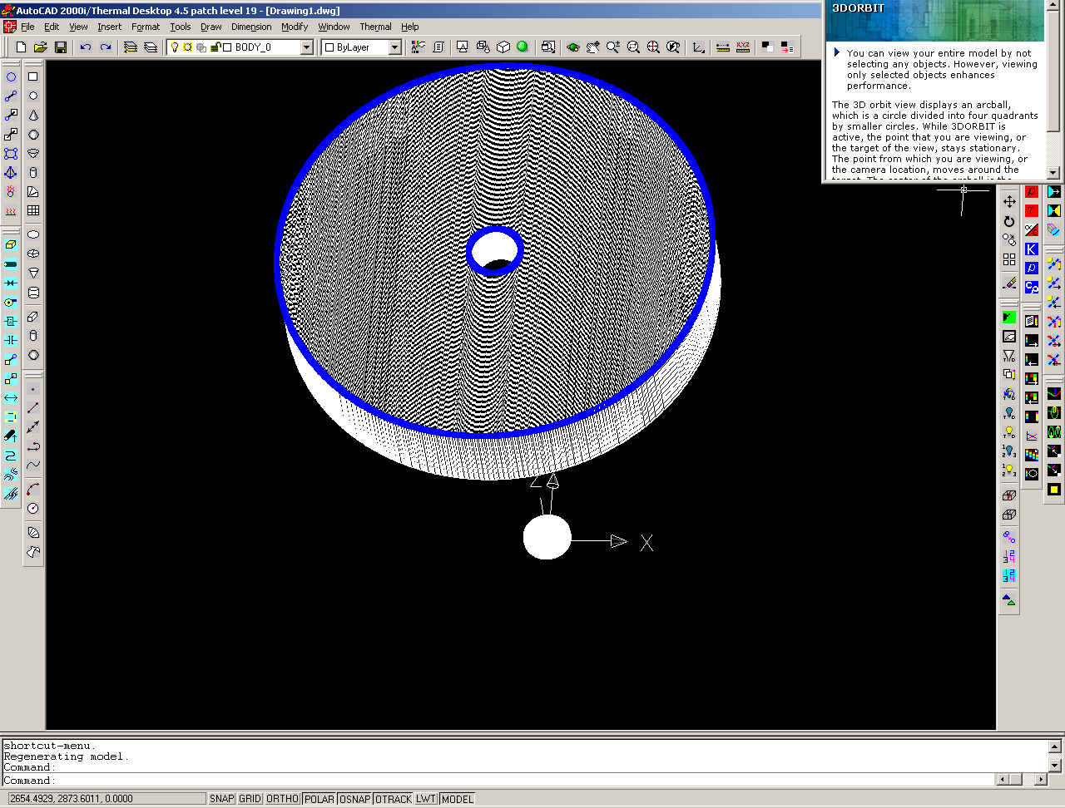
Set model back to desired units (e.g. m) (uncheck “Do not rescale model to new units”)

This works well on flat simple surfaces (capes_assy_asm.igs):
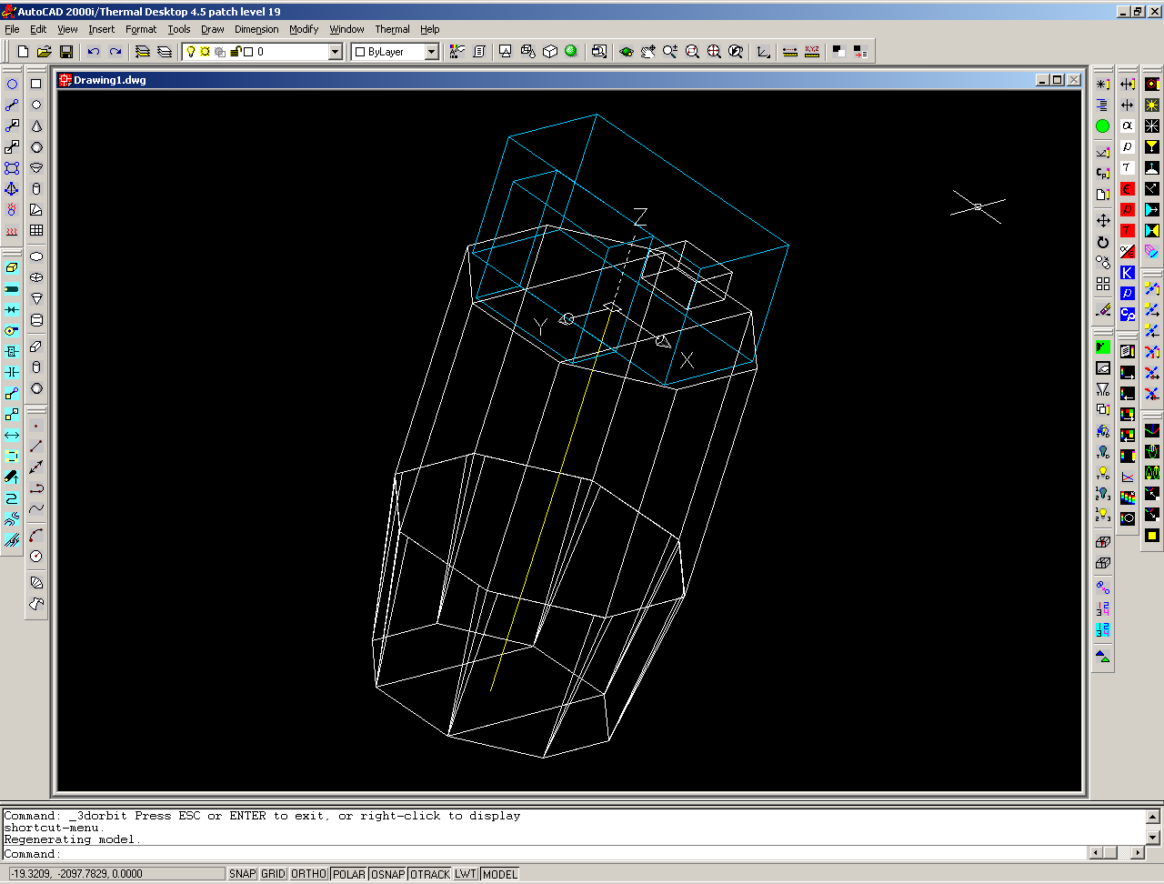
After bringing in the geometry, you have to go through the below process under “To make Thermal Desktop surfaces” to make them into Thermal Desktop surfaces.
However, the surface normals will not necessarily all point the same way, so if you are setting properties by side, or having surfaces active on one side only, this requires hand-work to change:
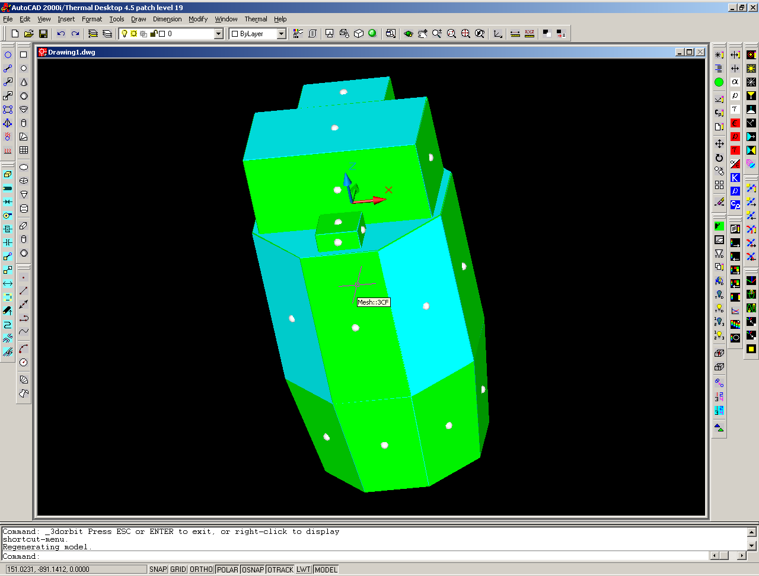

Another method is to bring in mid-plane IGES surfaces as created by the structural analyst in PATRAN:
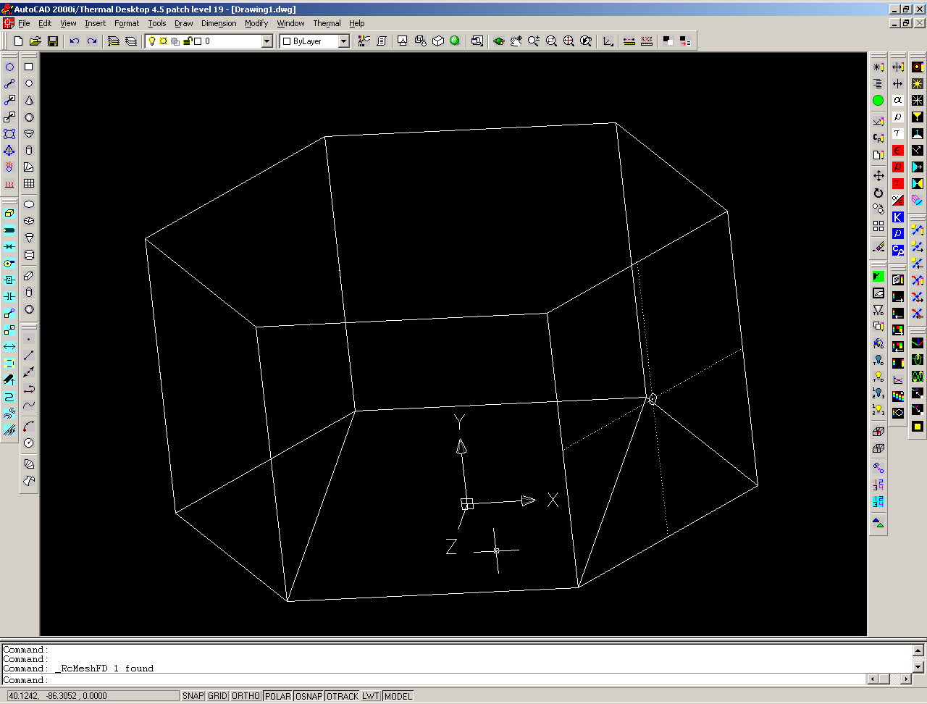
After bringing in the geometry, you have to go through the below process under “To break surfaces up” and “To make Thermal Desktop surfaces” to make them into Thermal Desktop surfaces.

Try ACIS in future – when Pro set up for that

Pulling in STEP

This pulls in curved surfaces but makes them all triangle surfaces. Triangles cannot be meshed more finely. Active surfaces appear to be all in same direction on the outside of a solid.
Set model to correct units for imported geometry (e.g. mm)
Type stepin (Import geo) – pull in STEP 203 file from Pro (no difference between 214 to 203 setting in Pro):
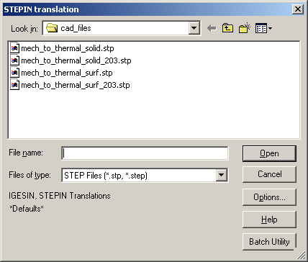
mech_to_thermal_solid_203.stp
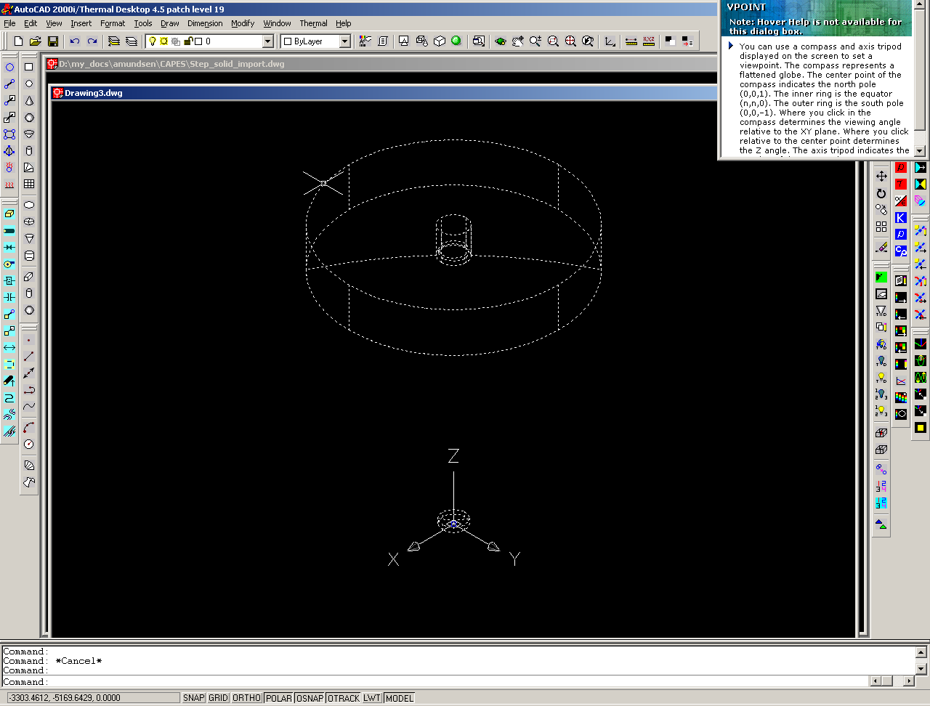
Set model back to desired units (e.g. m) (uncheck “Do not rescale model to new units”)

After bringing in the geometry, you have to go through the below process under “To break surfaces up” and “To make Thermal Desktop surfaces” to make them into Thermal Desktop surfaces.
after three explode iterations:
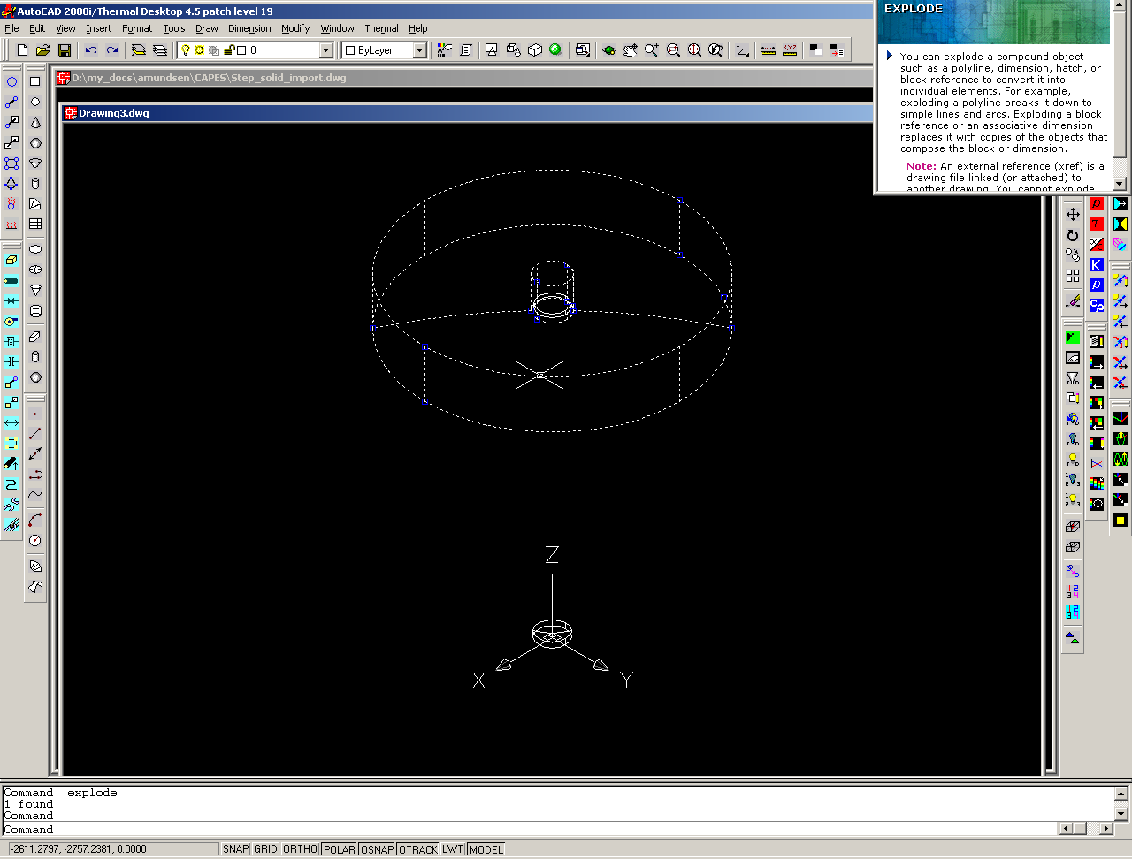

To break surfaces up
Select everything
Modify… Explode (until I have surfaces)
If original model is not in desired units, easiest way will usually be to change unit sets at this point:
Set model back to desired units (e.g. m): Thermal…Preferences, set length to “m” (uncheck “Do not rescale model to new units”)
Export… to 3DS (3ds out)
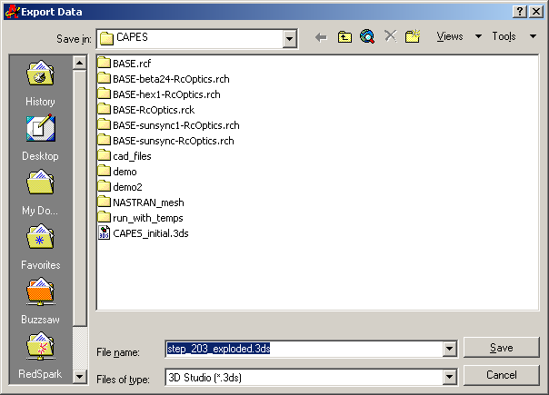
Select all (or type “all” at prompt)
ACI, chg Auto-smoothing if necessary
Close drawing
Open new drawing
(Change unit preferences if necessary – or change unit preferences before making the 3ds file)
Insert…3DStudio file
Add All
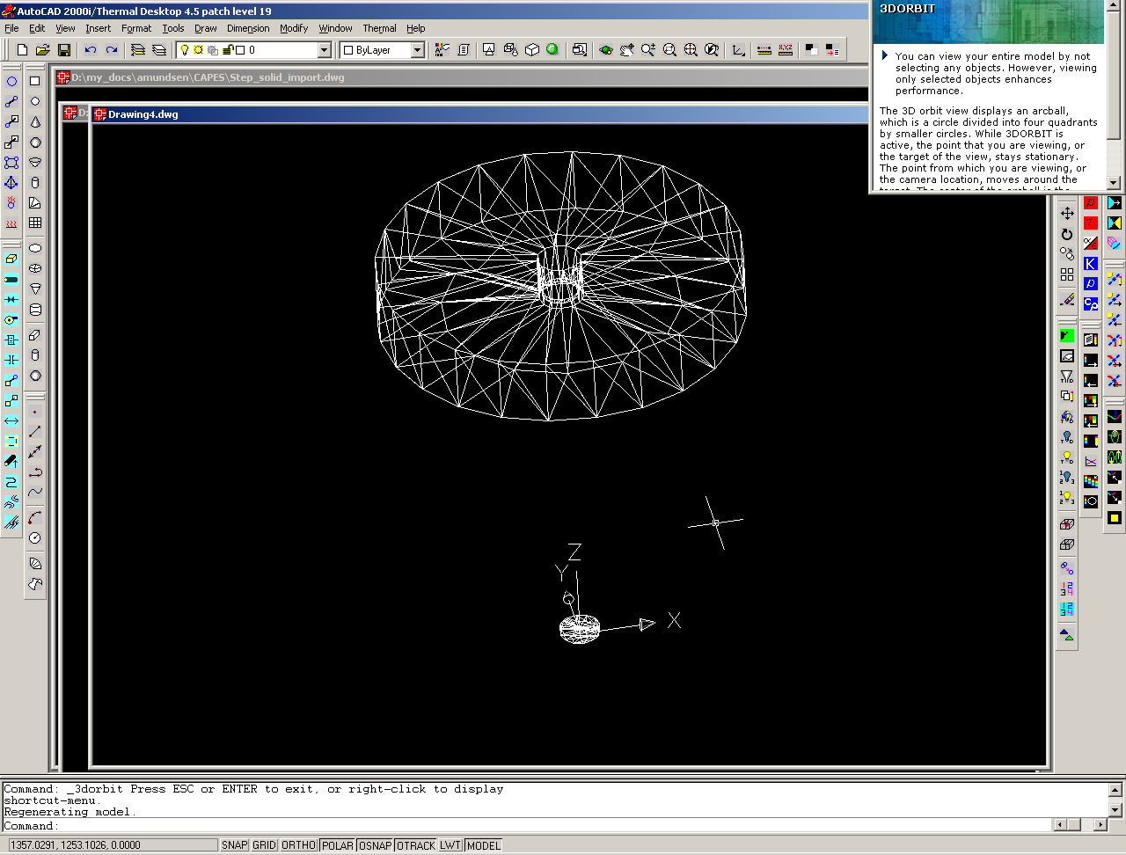
Modify…Explode (all) before making TD surface
Then follow below under “To make Thermal Desktop surfaces”
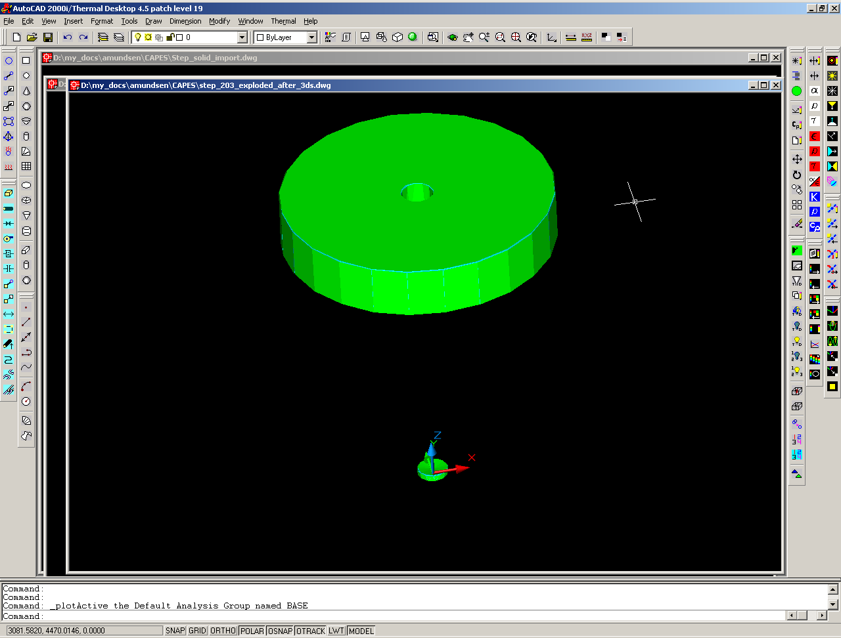

To make Thermal Desktop surfaces
Thermal…Surfaces/Solids…From AutoCAD surface
Select all
For single-sided, check “Use same Ids both sides”, then have active Top/Out
Give it thickness, material, optical material

Re-sequence Node Ids – make sure you have all elements posted so that all actually get selected

General notes on working with imported geometry
Convert surfaces/boxes in groups:
- Grab everything you want to be 2-sided surfaces with the same thickness, and convert them together to TD surfaces.
- Grab everything you want to be 1-sided surfaces with the same thickness, and convert them together to TD surfaces.

If you need to grab several surfaces and change a variable on them that is not already the same (e.g., you want to change them all to be single nodes, i.e. use the same node number for both sides), then grab them all, do Thermal…Edit, and uncheck the box, then grab them all again and then check the box.

Importing from NASTRAN
A preferred method in many cases will be to take the meshed geometry from the structural station. This avoids all the manual steps of re-orienting surface normals, exploding grouped geometry, creating Thermal Desktop surfaces, and meshing.

Importing from NASTRAN: Steps
Set model to correct units for imported geometry (e.g. mm)
Thermal…Import…NASTRAN
Check “Import FE Model as a thermal model” (default)
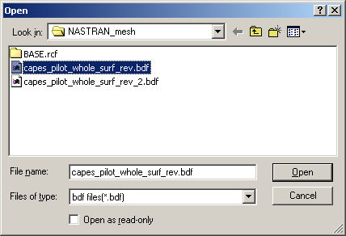
Find desired NASTRAN .bdf file (may have to chg file extension)
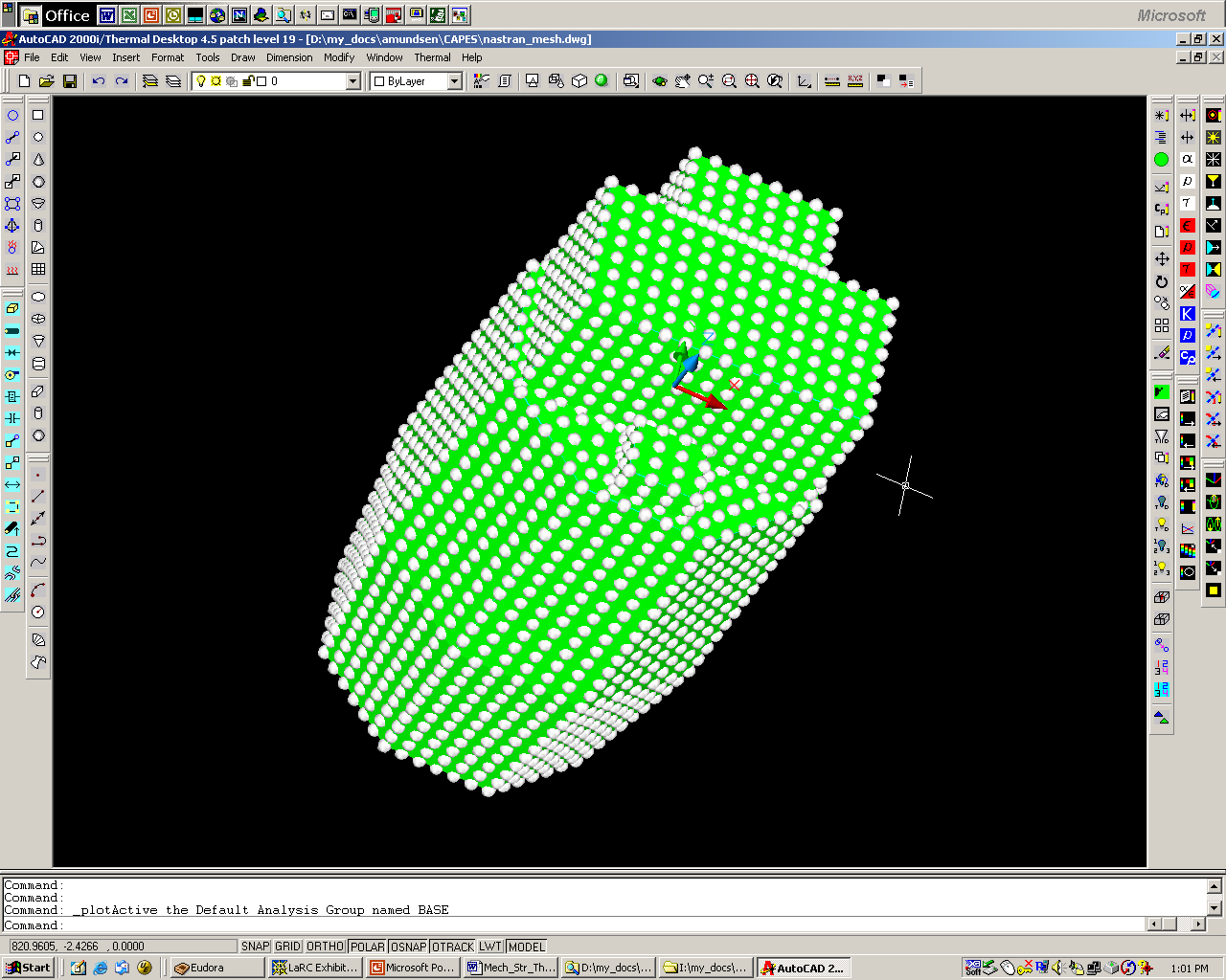
Set model back to desired units (uncheck “Do not rescale model to new units”)
If surface normals are oriented correctly in NASTRAN, and only one side is desired in Thermal Desktop, this leaves all the active surfaces in the same direction. The model, however, can now not be remeshed by the thermal analyst (which is true anyway for most imported geometry). Thicknesses of surfaces come in correctly.
Calculations can be run on this imported model directly:
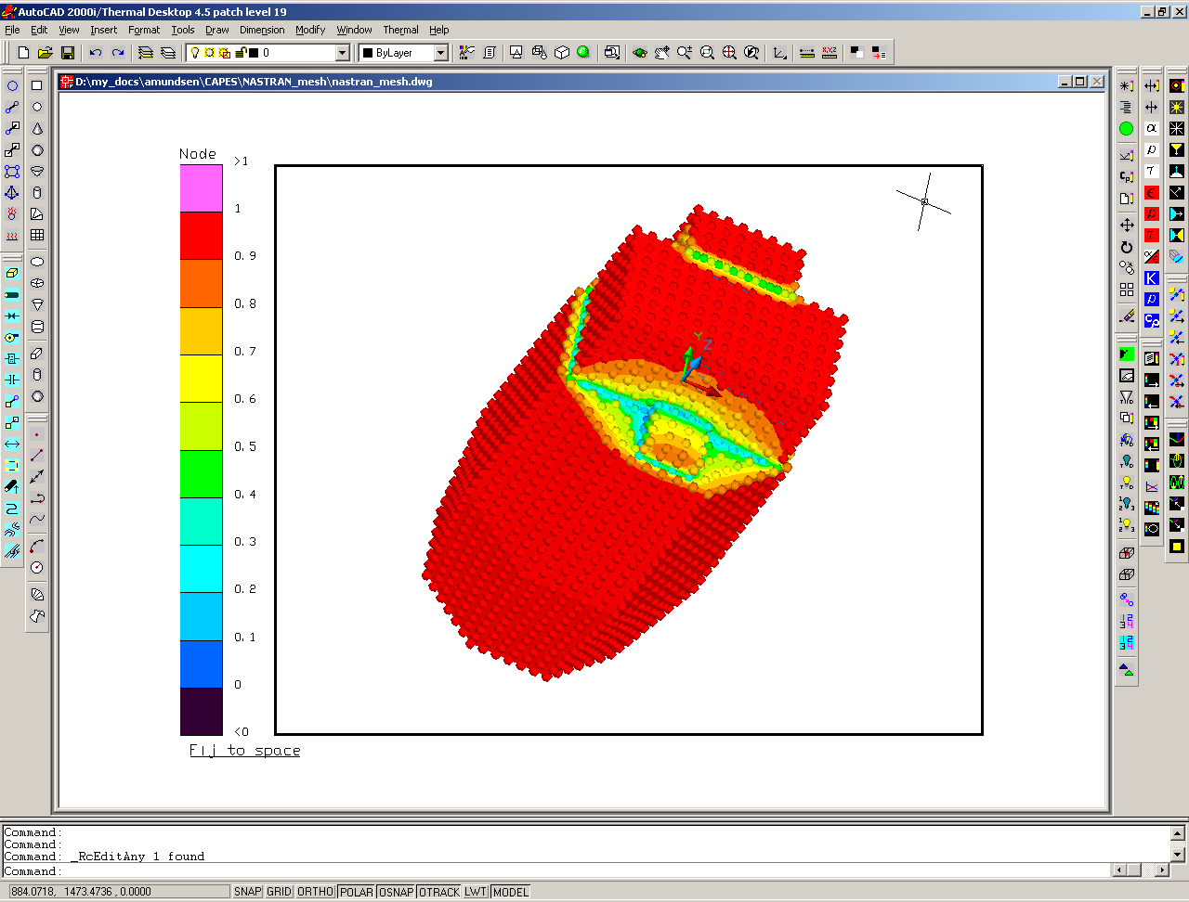

It will be the easiest to work with the components if they are brought in separate files from NASTRAN (Structural person can save as groups from PATRAN). To do this, make a new layer for each part and make it current before the file is brought in (remember new items will only go on the layer that is current). Then that entire part mesh will be on a single layer, which will make display and selection by part much easier.

A similar method to this is to import an ANSYS mesh.

These meshes can be created by pulling the geometry into Patran and meshing for NASTRAN or ANSYS, or via another tool such as FEMAP.

Importing Pro/Mechanica (NASTRAN) mesh of a Pro/E part
Open Pro/E Wildfire
Open part (or assy) file
Do Applications…Mechanica (you must have Mechanica installed)
Check on “FEM Mode”
Go to Thermal (can also do in Structural)
Select Mesh, Create, Solid, Start
It will create the mesh (check it or change it if you want to) -- it only does tet for solids
Select Run, under SOLVER pick NASTRAN
Under Analysis leave it on Structural
Leave it on Output to File
Hit OK – it will export the NASTRAN mesh file
Close Pro/E

Edit the NASTRAN file to have each of the following lines not carry over to a second line:
$ Global Coordinate System of the model
CORD2R,1,0,0.,0.,0.,0.,0.,1.,
,1.,0.,0.
$ Coordinate System for grid coordinates
CORD2R,2,1,0.,0.,0.,0.,0.,1.,
,1.,0.,0.
$ Coordinate System for default grid displacement
CORD2R,3,2,0.,0.,0.,0.,0.,1.,
,1.,0.,0.

Open a Thermal Desktop file
Go to Thermal…Import…NASTRAN (make sure you set units first)
Select file by changing to *.nas files – pick your desired file
You have a meshed model!

Right now display of a complex model is pretty slow, but I think it will be better in Mechanical Desktop or AutoCAD 2005.

Importing Nastran Bulk Data into Thermal Desktop: Lessons Learned
This section is courtesy of deborah.m.lemons@nasa.gov at NASA JSC.
Integrated structural/thermal analysis is facilitated by model sharing between disciplines, particularly FEMs. Thermal Desktop is one of several thermal analysis programs that are capable of importing finite element networks and converting them into thermal networks. (Other such programs include SINDA/ATM, FEMAP TMG, and IDEAS TMG.) MSC.Nastran is a widely used stress analyzer whose FEMs, compiled in “bulk data” format, are recognized by the Thermal Desktop translator. (Other recognized, but less-widely used, formats include FEMAP neutral, IDEAS universal, and STEP-209.) Following a successful thermal analysis in Thermal Desktop, temperature results for FEMs that are also used for mechanical stress analysis can be fed back into the Nastran solver, thus closing the loop on an integrated structural/thermal stress analysis.
During translation, network grid locations and many Nastran element types are retained. However, due to inherent differences between thermal and structural analysis methods, discontinuities are likely to occur when translating an FEM that was specifically created for modeling mechanical stress. (In other words, certain modeling practices suited to mechanical analysis do not appropriately treat thermal phenomena). Furthermore, because model translators must struggle to support ever-changing technology, they suffer from a perpetual need to become increasingly robust, seamless, and user-friendly. This report, based on user experience, contains helpful information for addressing these kinds of difficulties encountered upon importing Nastran bulk data into Thermal Desktop. The intent is to promote correct and efficient translation and, ultimately, a better final product.

Getting Started
Analysts can increase the odds of a successful translation by becoming familiar with common Nastran element types and bulk data entry formatting (see Reference 1). (Examples of Nastran element types that are relevant to thermal modelers include CTRIA3, CQUAD, CTETRA, CPENTA, CHEXA, CBAR, CROD, PSHELL, PBAR, PROD, PCOMP, PSOLID, RBE2/RBE3, MAT[n].) Users should also refer to the Thermal Desktop User’s Manual (Reference 2) regarding which Nastran element types are recognized, and which types are deliberately altered during translation.
Armed with basic knowledge of both programs, analysts are advised to conduct a review of the Nastran bulk data set prior to translation in order to learn which specific element types are used and to identify potential translation problems. As will be discussed in this report, many of these problems are more easily resolved up front—by editing the bulk data file—rather than by editing the translated geometry within Thermal Desktop.
Analysts may also benefit from considering whether symmetry of geometry and environment permit adequate thermal characterization based on a section (e.g. half) of the original FEM, thus reducing labor and model size. Such decisions should be based on informed consultations with designers and other structural or thermal analysts. Ideally, the original model is truncated before translation via changes to the bulk data file; a modular organizational scheme facilitates this process. (Owners of the Nastran model are best equipped to perform the actual truncation at this point in the process.) Otherwise, unneeded sections can be deleted from the translated geometry within Thermal Desktop, although this method might be tedious and error-prone if the mesh is very fine.
Throughout this preliminary stage, analysts are encouraged to take advantage of ongoing consultations with mechanical designers and the stress analysts who developed the original model.

Element Translation
- Several of the Nastran element types that are recognized by Thermal Desktop represent elongated shapes (CBAR, CROD, and CONROD). Thermal Desktop automatically converts each of these “beam” elements into a linear SINDA conductor with one SINDA node on each end. The analyst should carefully consider whether the new configuration is significant and/or appropriate for a specific thermal model, then modify conductor and node definitions accordingly. In many cases, it is acceptable to delete all instances of reconfigured beam elements. However, the possibility exists that a beam represents a significant energy path, and thus should be represented with a user conductor or some alternate configuration within the thermal model.
- Thermal Desktop does not recognize several potentially significant Nastran element types. Because their omission may compromise the thermal model, analysts should carefully consider whether and how to represent their thermal effects.
  - CBEAM is an unrecognized element type, but has the same physical configuration as CBAR, CROD, and CONROD; indeed, all of the beam elements are thermally equivalent. If missing CBEAMs are needed for thermal reasons, they can be retained by changing them into CBARs in the bulk data file according to the formatting guidelines in the MSC.Nastran Quick Reference Guide (Reference 1).
  - So-called “Multi-Point Constraint” (MPC) elements—RBE1, RBE2, RBE3, RBAR, RSPLINE—and “spring” elements—CELAS1/CELAS2—are also unrecognized by Thermal Desktop. These “connective” elements impose mechanical constraints between planar elements, but their loss during translation results in a lack of thermal coupling. Such breaks between adjacent planar elements in the thermal network may not be readily visible; elements may appear to be thermally coupled when they are not, with obvious thermal implications. The Show Free Edges command in Thermal Desktop can be used to locate disconnected areas, and the Merge Coincident Nodes option is one way to reconnect them.
  - A CONM2 element, which is used in Nastran to represent a point mass with zero mechanical load, is not recognized by Thermal Desktop but may contribute thermally significant mass and/or surface area. Analysts should assess and, if necessary, compensate for the thermal effects of CONM2 elements.
- The Thermal Desktop translator does not recognize any Nastran bulk data entries in “large-field” format. A large-field entry occupies multiple text lines in the Nastran bulk data file; it is denoted by an asterisk appended to the end of the element type (e.g. CQUAD4*) on the first line, then another asterisk at the beginning of the second line. If access to Patran is available, the analyst select the small-field format option and re-output the bulk data file. Alternatively, the analyst can examine the bulk data file for any large-field entries and manually convert them to “small field” format according to guidelines in Reference 1.
- Experience has demonstrated the possibility of unpredictable behavior by isolated planar elements after translation. (Evidence suggests that this phenomenon may occur after the thermal analyst has modified the original mesh within MSC.Patran.) For example, a bad element may indicate an ambiguous Active Side definition for purposes of radiation modeling in Thermal Desktop: the active side(s) as indicated by the Display Active Sides tool does not agree with the element’s thermal model definition. Discoloration of the element’s surface in comparison to other elements may also indicate a bad element. The impact of bad elements on analysis results is unpredictable, so analysts are encouraged to visually inspect the model and use the Display Active Sides tool to identify bad elements that may need to be redefined and/or re-imported in order to function properly.

Materials and Properties
- Generally, the translation of property values (e.g. density) from Nastran to Thermal Desktop is not reliable. Depending on how the material element is referenced by the Nastran model (e.g. via property elements PSHELL, PBAR, or PCOMP), newly created Thermal Desktop materials may take on zero or default property values after translation. The Color by Property Value function is useful for visually detecting incorrect values such as density and conductivity (of planar and solid elements only). The best way to solve discrepancies is to determine the correct material compositions by referring to mechanical design documentation and/or Nastran bulk data, and then create and assign the correct materials in Thermal Desktop.
- Thermal Desktop does recognize use of the Nastran property element PCOMP for composite planar elements; the translator creates and assigns the material name P#, where # is the Nastran PCOMP identifier (PID). However, thickness values of PCOMP elements are not correctly retained, and property values of the newly created materials are erroneous. The Color by Property Value function is useful for visually detecting incorrect thicknesses and property values, after which the analyst may need to calculate thermally effective thicknesses and/or properties and assign them accordingly.

Geometry
- Experience has shown that planar elements may unpredictably, and incorrectly, translate with zero thickness. The Color by Property Value function is useful for visually detecting incorrect surface thicknesses. Thermal analysts can consult with designers and/or stress analysts to identify correct element thicknesses, then edit the model accordingly.
- Due to the nature of Nastran modeling, translated geometry may contain areas where multiple planar elements are coincident in the same plane. This phenomenon is a product of techniques that are valid for mechanical stress analysis, but that might compromise a thermal model. Elements located in that same plane, but whose edges are offset, are detectable within the AutoCAD interface by relatively close inspection. However, precisely overlapping elements, whose edges line up perfectly, are virtually invisible; their coincidence is apparent when the user selects what looks like one planar element, but the AutoCAD Text Window reports the selection of two (or more) objects. Analysts should exercise great caution when deciding whether to retain coincident elements, because their inclusion in a single Radiation Analysis Group causes unpredictable and erroneous results during the ray tracing process.
- In order to achieve the desired orientation and location for the imported geometry in Thermal Desktop, it may be necessary to first re-orient and/or re-locate the meshed model within MSC.Patran. However, the process of creating new coordinate systems and/or translating between multiple coordinate systems within Patran may introduce confusion as to which system(s) will be referenced by the resulting bulk data set and by Thermal Desktop. (For example, the inclusion of a CORD[n] element within the bulk data file may have the effect of re-orienting or moving geometry upon importation into Thermal Desktop, so that the imported grid locations may not match the grid locations as printed in the bulk data file.) Analysts are encouraged to verify location and orientation after importing geometry Thermal Desktop, consulting References 1 and 3 as necessary.
[References:
1. MSC.Nastran 2001 Quick Reference Guide, MSC.Software Corporation.
2. Thermal Desktop User’s Manual Version 4.4, C&R Technologies, August 2001.
3. MSC.Patran 2001 Reference Guide, MSC.Software Corporation.]

