

Real Property Management

Training Guide

for the

Agriculture Research Service (ARS)

July 2007

User Access
To obtain system access, an AD-1143, Corporate Systems User Access Request Form, must be prepared and signed by the user, manager, and Agency’s designated Real Property Management (RPM) approver before forwarding to the Firm Foundation Information System (FFIS) Security Administrator to assign a User ID/Login and forward to the CPAIS Security Officer at the National Finance Center. Users should be sure to read the CPAIS Security Rules.

The User should request access to his/her assigned Org Codes within the “Special Instructions” block of the AD-1143.

Once an AD-1143 for Real Property Management (RPM) access is signed by the User and the User’s supervisor, the form is processed through the Real Property Management Branch (RPMB); forms may be faxed to RPMB’s at 301-504-1236. After the RPM Approver signs the AD-1143, the form is hand carried to the Agency FFIS Security Administrator to assign a User ID and then faxed to the CPAIS Security Officer at the National Finance Center to establish system access.

Once your account is established, you will be provided a corporate User ID and a CPAIS password.

Roles

There are various user roles within the RPM side of CPAIS. Each role permits a level of access to various modules or forms within the database. It will be necessary to request one or more roles for entry in Block 19 of the AD-1143. An overview of the available roles along with each role’s level of access is covered in the CPAIS Power Point Overview.

Getting Set Up To Use CPAIS

Your Area Information Technology Specialist should be contacted to install CPAIS. To run CPAIS on a desktop PC, a Java plug-in (JInitiator) is required. This plug-in will be downloaded to the desktop from the CPAIS server the first time you login. Your computer must also have Internet Explorer 5.5 (or newer) and a memory of 256 MB of is recommended.

Getting Started
Initial Login and Password Changes

Launch Internet Explorer and enter the following URL into the address field: https://cpais.ocfo.usda.gov/ (note this is the Live/Production Database---please use the Training Database link that will be provided along with your User ID and Password for the training exercises.
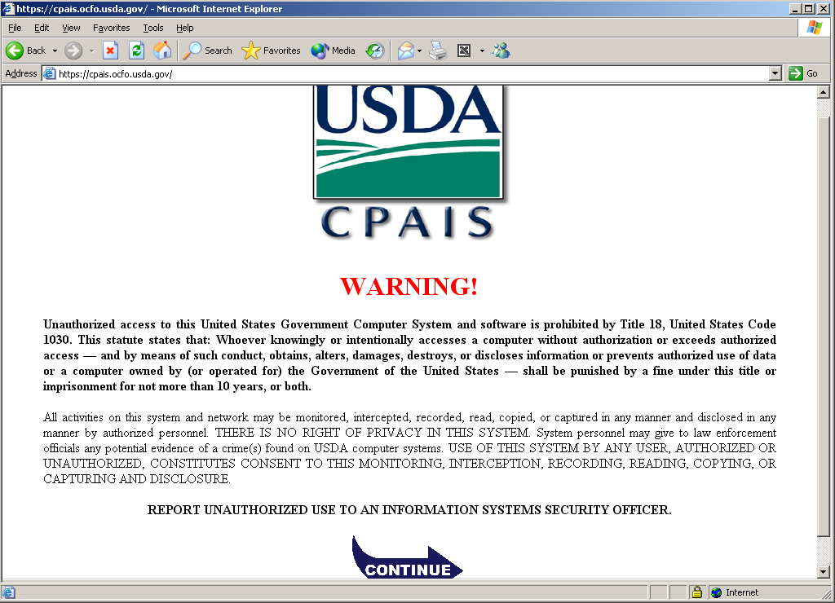

Once CPAIS is installed, the above WARNING screen will appear each time you access the system. After clicking on the “CONTINUE” arrow, the login screen below will appear. Upon initial login, users are prompted to change the initial password issued to a more personalized password. Please follow the password reset steps detailed within the screens on the next page to help you reset your password.

Please note that it is possible to lock yourself out of the CPAIS system if multiple attempts are made to login with an incorrect Username and/or Password. Should you receive a message indicating that your account has been locked, a Help Desk ticket to reset your password will be required. Password resets usually take between 48 - 72 hours.

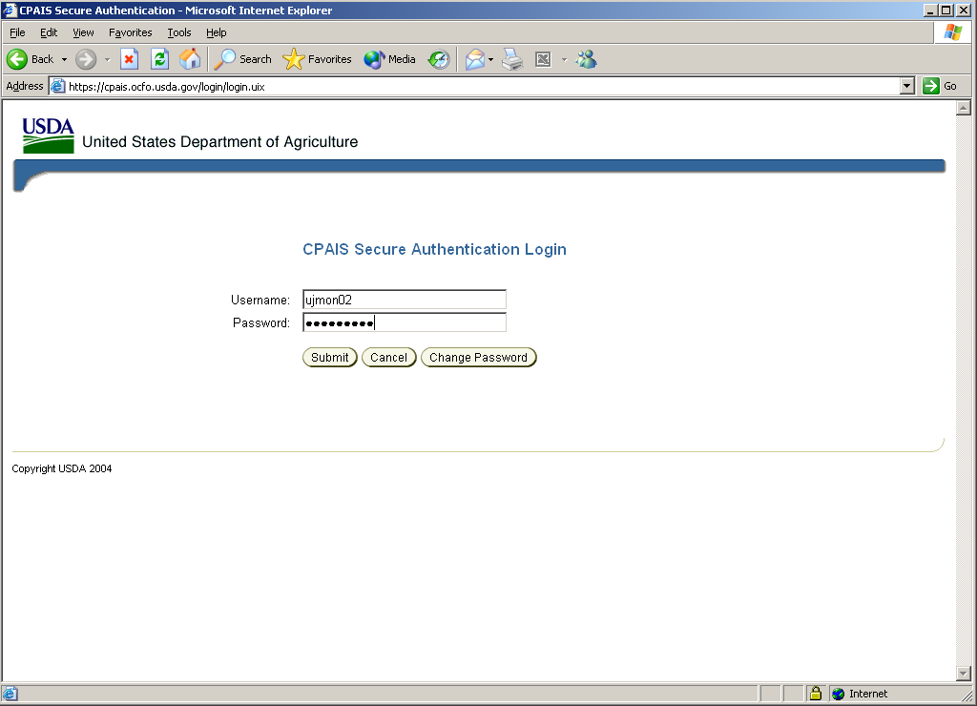
Enter your Username and Password; then click the “Change Password”.

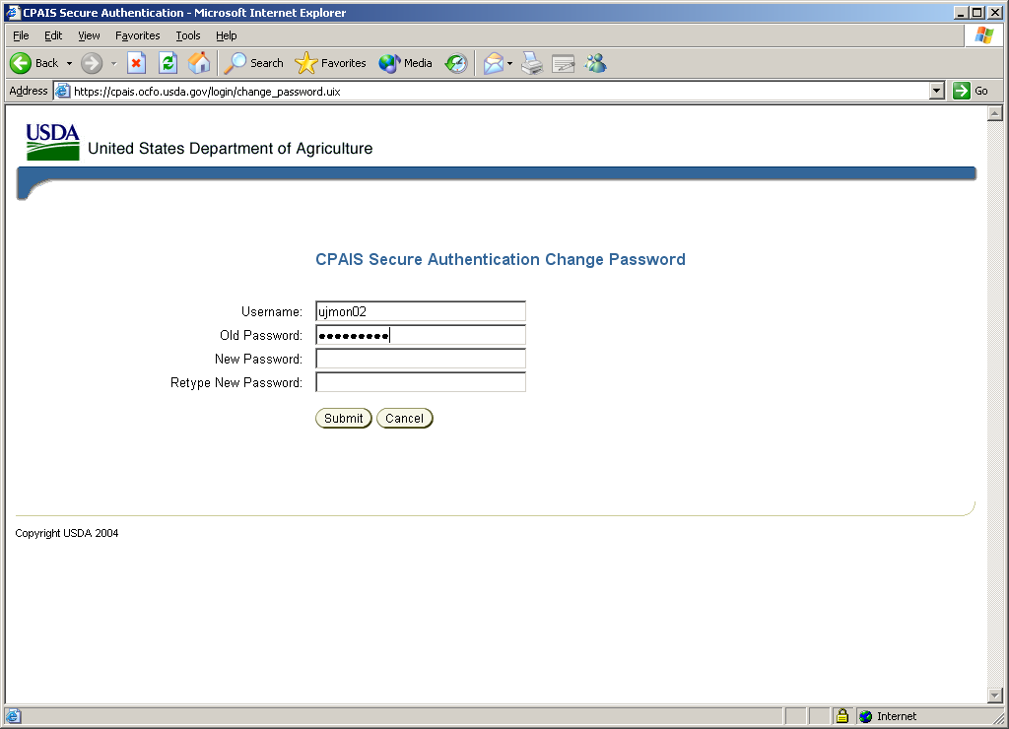
Passwords must be 8-14 characters long, begin with an alpha character, contain at least 2 letters and at least 2 numbers. No special characters are required.

Enter your newly created password and then retype your new password and click on the “Submit” button.

A message confirming the password change should appear upon successful completion of this task. .

Passwords are active for 60 days with a 10-day grace notification, so long as the system is
accessed within the last 10 days of the 60-day period.

Online Help

Online Help is available within each CPAIS Form. The question mark icon will launch this tool. Since CPAIS was created from the Forest Service INFRA System many references are geared toward the Forest Service data, lists of values, etc.

The following is a quick overview of how to navigate through a Form.

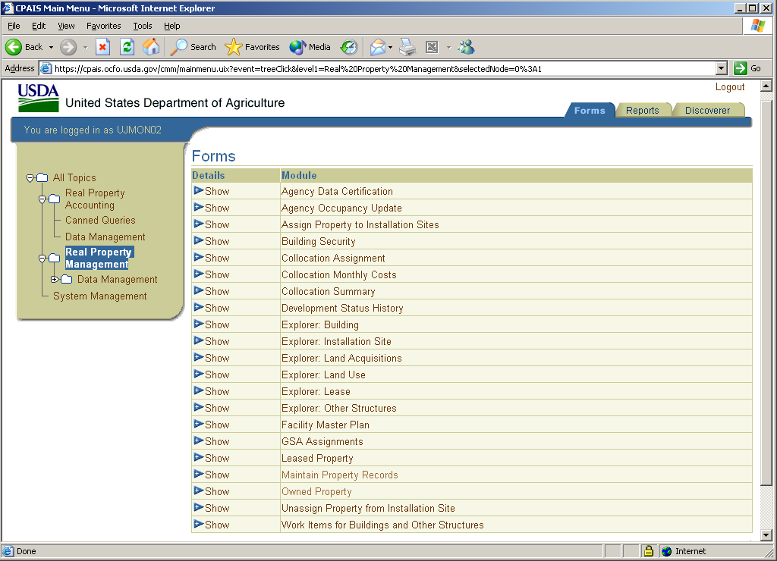
Be sure to select which “Tab” you wish to work within. Updates and entries are performed within the Forms Screen.
This is the task list pane or Navigation Panel.
By clicking on the “Show” button, a description of the Module will be expanded.
From the Main Menu, the topics outlined may be expanded by double clicking on either the Real Property Accounting (RPA) or RPM task.

The Forms screen above reflects the various menu options within the RPM side. There are also three tabbed options with RPM: Forms (screen above), Reports and Discoverer. The Forms Module is for entering new data records, as well as retrieving and editing existing records. Most CPAIS forms share a common layout and tool bars. The Reports Module contains predefined reports that are intended to meet common Department needs. The Discoverer Module is a reporting tool that permits users to create customized reports within the parameters available and export the results to an electronic file.

Each of these available Tabs (Forms, Reports and Discoverer) contains a list of Modules. To view a brief description of any module, click on the “Show” button for details of that Module’s function.
Accessing a Module

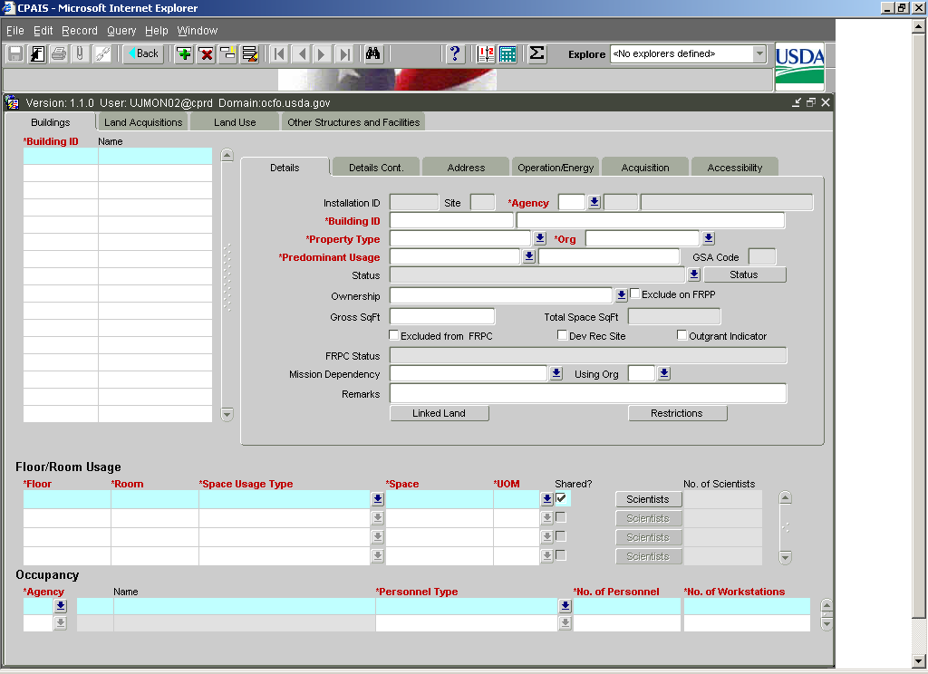
Asset Details Tab
Asset Information
Floor/Room Usage
Occupancy
Scientists
Restrictions
Status
Mission Dependency
Outgrant Indicator

Maintain Property Records Form.

Red, bolded fields are required fields. There are 24 data elements required for the annual Federal Real Property Profile (FRPP). For additional information, see the 2007 Guidance for Real Property Inventory Reporting, published by the GSA Office of Governmentwide Policy. All of these data elements aren’t necessarily coded as required, therefore, you may receive error message if these “required” data elements aren’t entered. The call-out boxes identify the general information areas:

- Asset Information – Buildings, Land Acquisitions, Land Use and Other Structures and Facilities Tabs

- Asset Detail Tabs

- Floor/Room Usage

- Occupancy

- Scientists

Menu Bar

The Menu Bar contains drop downs that are common to all Forms: File, Edit, Query, Help, etc. There are both shortcut keys and alternative avenues for the toolbar options contained within the Menu Bar.

Field Definitions

As you work within the system, you will gain familiarity with the fields within each Form and Sub-tab. Below are definitions of some of these fields along with a notation of “Required”, if the field is mandatory for FRPP Reporting. There are 24 data elements associated with CPAIS fields that are required.

Details Tab:

Building ID, Land Unit, or Feature ID – This is a unique identifier for the asset. Required.

Installation ID – Properties are organized by Installation. Installation ID’s were previously assigned by GSA; however, RPMB now issues new Installation ID’s for ARS. Typically an Installation does not cross state boundaries and is specific to an ARS Location. Installations can be sub-divided by site. An Installation ID is required for all Owned and Leased records. Required.

Site – This is a 2-digit suffix that identifies the specific Installation Site where assets are located. In the previous property system (FIRM) used by ARS, sites were identified as “00” Main Site, “01”, “02”, etc. FIRM also required that Owned and Leased sites be entered separately. Required.

Property Type – This equates to “Legal Interest” within the Data Dictionary. The field is populated from a list of values: Owned, Leased, Other/Trust. The Data Dictionary clearly states that properties otherwise managed by the Federal Government should be reported. Required.

Org – This is based on the 4-digit organization code from the Mode Code. There is a list of values to select from. Required.

Predominant Usage – This equates to “Real Property Use” and reflects the use to which the greatest portion of the asset is currently put. Required.

Status – To populate this field, the status button must be used. The status of a building is entered on nested screen along with supporting documentation. Required.

Ownership – This is a Forest Service field; not populated within ARS.

Exclude on FRPP – this is a check box to code assets that are not reportable during the annual FRPP reporting. Assets that have a status of “Under Construction” should automatically be excluded; however, the “Exclude on FRPP” check box may also be checked. When an asset is placed in service; however, this check mark should be removed. ARS properties that are “Other” or “Trust” properties should also have this check mark selected. For example, properties that are owned by another Federal entity but occupied by ARS should be excluded.

Remarks – This field permits users to enter any associated remarks such as a contract number, contractor, etc.

Gross Square Foot – This should be the building’s gross square footage total. Required.

Total Space – This reflects the total space from the *Space fields entered within Floor/Room Usage section of the Details Tab. Required for leases and owned buildings classified as Office, Laboratory, Hospital, Housing and Warehouse.

Mission Dependency – This field is selected from a list of values and reflects the value an asset brings to the performance of the mission. Required.

Restrictions – This button links to a nested screen which permits entry of limitations on the use of the asset. This includes environmental, natural resources, cultural resource, zoning, easements, etc. Required.

Detail Cont. Tab:

Historical Status – Select from the list of values. This reflects if there is historical significance for the building, asset or feature or if this has not yet been evaluated. Required.

Historical District – This is a check on/off box that should be marked with a check mark if an asset is within a historic district or historic quadrangle.

Year Constructed – This reflects the asset’s year of construction. This should typically be before the Acquisition Date on the Acquisition Sub-Tab.

Design Capacity SqFt – This field is to be populated for both Warehouse and Housing Predominant Use Codes. This field should reflect the gross square footage of Warehouse or Housing space. Required for Warehouse or Family Housing/Dormitories/Barracks.

Occupied Units SqFt – This field corresponds to the Design Capacity Sq Ft and is to be populated with the actual number of square feet that is occupied as Warehouse or Housing. Required for Warehouse or Family Housing/Dormitories/Barracks.

Hazards – This button links to a nested screen which allows entry of hazards associated with the asset.

Toolbar

The toolbar contains various icons which are also common to all Forms. The chart on the following page is defines each tool, its associated icon and related function.

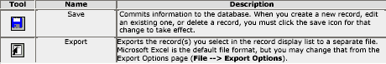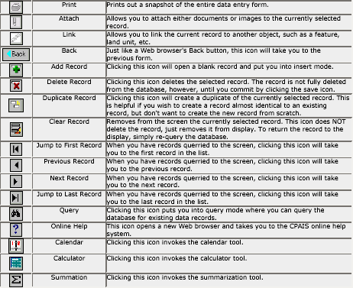

Data Gaps
Periodially the FRPP Data Gaps Form should be launched and a query run. If the query results in “no gaps found”, no action is required. If gaps are identified, these should be researched and corrected. The FRPP Data Gaps Form will only identify gaps for fields that are required for FRPP reporting.

Should you require assistance in correcting data gaps, please contact the Real Property Management Branch.

For the quarterly Management Initiatives Tracking System Quarterly Scorecards, Headquarters does run data gaps. If gaps result in your Area, you may be contacted to provide information to ensure all gaps are cleared prior to the Agency Self-Score being submitted.

Status Bar

This bar appears at the bottom of the Form. It provides hint text for fields or error messages when encountered. The status bar is your first source of help—reflects no queries found, record updated, number of records within a query, etc..

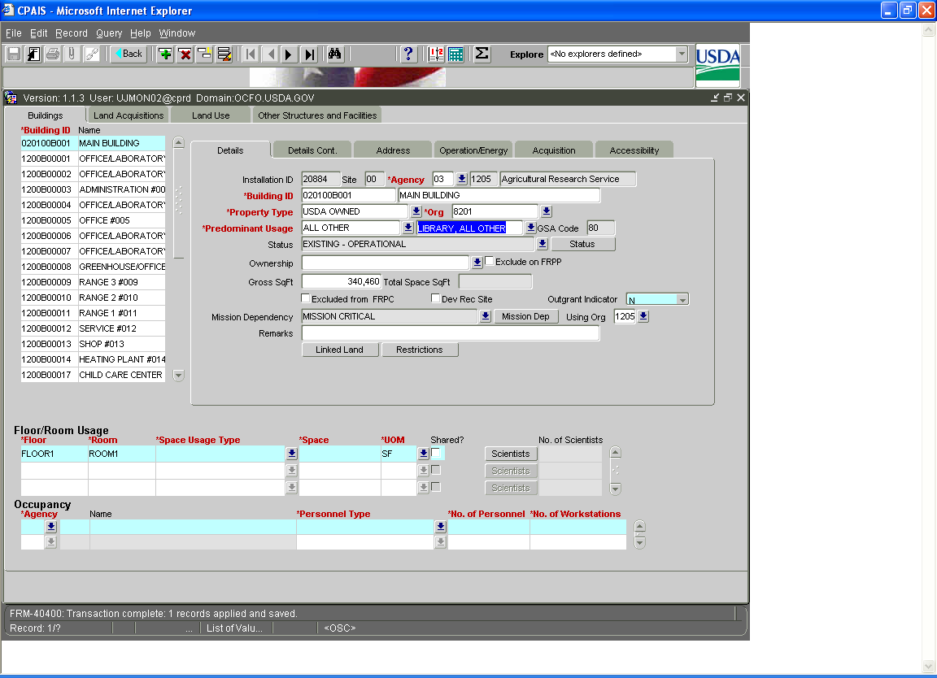
This status bar reflects that the transaction is complete and 1 record has been applied and saved.

Annual Operating Costs

In FY 2007 the annual operating costs for assets should be manually entered based on the Area or Location methodology developed to distributed operations and maintenance costs captured in the 966 accounts (see Bulletin 07-240-ARS).

Reports

There are several ways to review your data and extract usable reports:
1. Exporting the data to an Excel file.
2. Extracting a report from the Reports Tab and associated Modules.
3. Generating Discoverer reports which allow some customization.

Data Export

At the selected CPAIS screen, highlight the first line of data. Hold Shift key and scroll down or use page down to the last line. Be patient, highlighting all lines selected will take time. Once all the selected data is highlighted, go to File, Export or use the Export button on the toolbar. A dialogue box appears that asks, do you want to open this file from the current location or do you want to save it to disk? Once you have opened the file, you can save it as an Excel file. This allows you to sort the data any way you would like.

Reports Tab
Reports have been created that will return specific data in a specific format. Some reports provide parameters that allow users to specify specific data to be displayed – but basically, the standard reports are not ‘customizable’ – what you see is what you get!

From the Main Menu use the Reports tab to display the list of available reports.
As you highlight each report, it shows the description below. If you want to see what the report looks like and what it contains, hit the Preview button. This is just a sample and not linked to the database that you are working on.

Discoverer
Whereas standard reports are created to satisfy a specific business need and have a fixed output format, Discoverer reports allow users to customize a data export within defined parameters to suit the user’s specific needs.

TRAINING EXERCISES (Independent Study) Access to the Training Database should be requested through RPMB to perform these exercises.

1. Maintain Property Records
Accessing a Form and Querying/Editing a Record

2. Government Owned Property
Querying and Creating an Owned Building Record

3. Space Utilization
Adding Space and Occupancy Data

Maintain Property Records

From the CPAIS Main Menu, select:
Real Property Management
Data Management
Maintain Property Records

The Maintain Property Records Form can be used as a short cut to view and update all asset records; and can be used to create and edit GSA Assignments.

When updating a shell record for an asset that is to be placed in service, be sure to go through all of the sub-tabs to enter all data fields. Blank fields may later result in an error message during the annual FRPP reporting process.

Exercise: Accessing a Form and Querying/Editing a Record
Objective: – The objective of this exercise is to practice navigating through a basic CPAIS Form, querying and editing existing records.

Scenario: – The details for a building managed within your Area changed; the changes need to be captured within building record.

1) Launch the Maintain Property Records Form.
2) Initiate a query by clicking on the binoculars within the toolbar. Within query mode (yellowed fields) enter the specific <Agency 03> and click the EXECUTE button. Select a single building and then edit the record. Note the Building ID that you use.
3) Save the change by clicking on the blue disk within the toolbar.

4) Scroll down to view the informational status section of this Form to ensure the record is updated.

5) A second way to ensure the change has been accepted is to re-query the same record to make sure the change was accepted. Re-query the same record to verify your edits.

Government Owned Property

Querying and Creating an Owned Building
Objective: – The objective of this exercise is to practice querying, creating, and deleting owned property records.
Scenario: – You have recently received budget advice that includes funding for a new Administrative Office building. Now that funding has been provided, it is time to start the design phase of the project. In CPAIS, this is the time the building record needs to be created so that details of the property can be stored in the database. If this is to be a capitalized project, the accounting personnel must have the asset record in CPAIS to create associated accounting data and FFIS accounting codes. Without the record in the database, funding cannot be spent appropriately for this project.

The first step in creating a new property occurs outside of CPAIS. The REWO coordinates with the Contracting Officer and Area Engineer to complete a UAI Request Form. Before establishing a shell record, the REWO performs a search within CPAIS to verify that the proposed Asset ID is not duplicative within the Agency. Although the digits that comprise a UAI are unique to each asset, the first step is to verify that the Asset ID is and will remain unique.

Once RPMB receives a copy of UAI Request Form, the Headquarters Realty Specialist will review both the form and the shell record as a cross-check. The UAI Form will then be forwarded electronically by Headquarters to the CPAIS Financial Analyst.

The RPA FA establishes the UAI on the UAI Table (UAIT). The updated UAIT permits the link between CPAIS and the FFIS and allows the linking of the job number in FFIS and the entry of accounting data. Only one UAI per job number can be used.
Second, you will query on the Installation and Site where the new asset will be constructed. To add a record, place your cursor within the Record Display List and then click on the icon to add a shell record. Enter the full building details that are known to date. These details will need to be updated as the project moves forward from design to construction and finally to being placed in service.

Querying and Creating an Owned Building

Step | Description
1. | Query by Agency or Org Code; Select and Installation and Site.
2. | Click on the Buildings tab to access that page of the Owned Property form. CPAIS will automatically display any building records that already are associated with this Installation and Site.
3. | Make sure your cursor is in the top block and create () a new building record. Note:  - Populate all Mandatory fields.  - Enter information on a few of the six sub-tabs.  - Create at least two floor/room usage records.  - Create at least two occupancy records.
4. | Save () this new record.
5. | Re-query () this new record from the database and verify that the Total Space SqFt field accurately reflects the sum of all floor/room usage records.
6. | Click on the Installation tab to access that page. Verify that this new building record and its square footage both are reflected in the Property Counts block.
7. | Click on the Buildings tab to return to the Buildings page.
8. | Create () a new building record. This time, however, you do NOT need to create floor/room usage records or enter any further details.
9. | Save () this second record.
10. | Click on the Installation tab to return to that page. Verify that this second building appears in the Property Counts block.

Space Utilization

Select Real Property Management
Select Data Management
Click on the Maintain Property Records Form

Adding Space and Occupancy Data
Objective: – The objective of this exercise is to practice adding space and occupancy data to a building record.
Scenario: – You have recently received occupancy information for the building you edited in the first exercise. This information needs to be entered. At a minimum, this information will need to be updated annually.

First, query building record you noted in the first exercise. Then enter Floor/Room records using the example below.
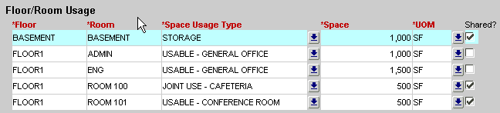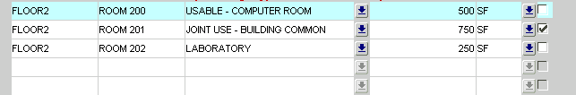

Next, create at least two (2) occupancy records for one or more of the floor/room usage records that has ‘Usable - General Office’ as the space usage type. You may use the example below.
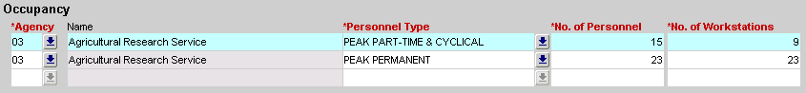
Adding Space and Occupancy Data
Create Floor/Room Usage Records

Step | Description
1. |  | Query building record that you created in Exercise 3.2.
2. |  | Create floor/room usage records using the included example. The () tool within the toolbar will permit you to add additional floor/room records.
3. |  | Save () to commit these new records to the database.
Create Occupancy Records

Step | Description
1. |  | Continue using building record that you created in Exercise 3.2.
2. |  | Select one of the floor/room usage records that has ‘Usable - General Office’ as the space usage type.
3. |  | In the Occupancy block, create at least two records that depict how your agency occupies that space.
4. |  | Save () to commit these new records to the database.

Run a Discoverer Report
Step | Description
1. | From the CPAIS main menu, select the Real Property Management topic in the Navigation Panel to the left.
2. | Click the Discoverer Tab to see a list of the CPAIS Discoverer reports available.
3. | Click on the name of the desired report. CPAIS will open the Discoverer reporting tool in a new window and display parameters for the report you selected.
4. | Enter parameters. Agency (Starts With) <03>.
5. | Click the Apply Parameters button to run the report.  CPAIS will run the Discoverer report and display the output onscreen.
6. | Although this report can be manipulated to some extent within Discoverer, it is best to export the report and manipulate it in Excel.

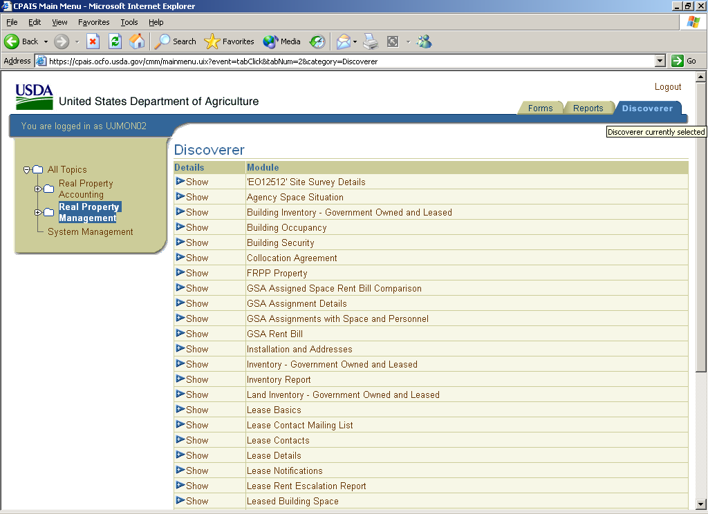
First, select the Discoverer Tab;
Then select
Inventory Report
There are a variety of Discoverer queries than can be extracted from CPAIS. We will use the “Inventory Report” option for our example. Once this option is selected the following screen will appear with the search criteria fields available for this query.

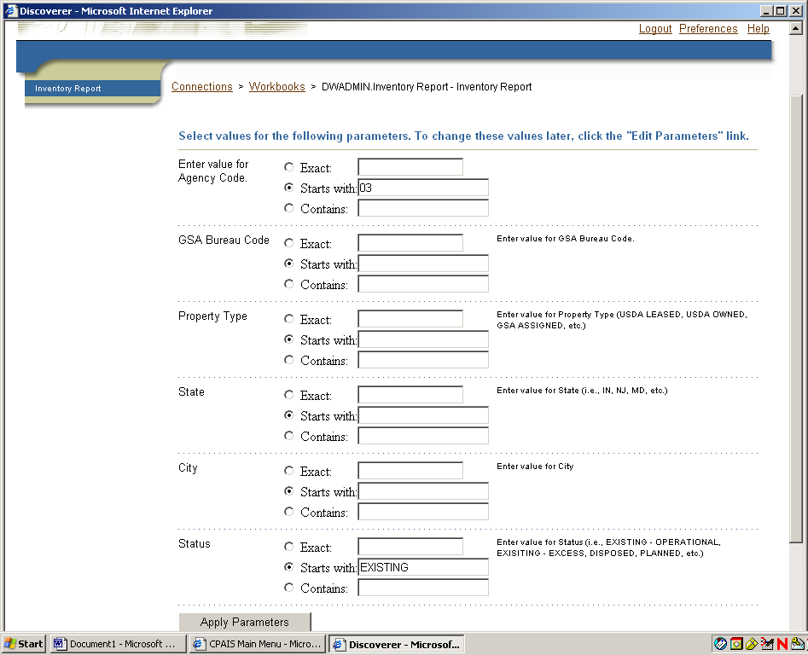

After entering the values for the search, the “Apply Parameters” button should be selected to execute the search.

The following screen will then appear.
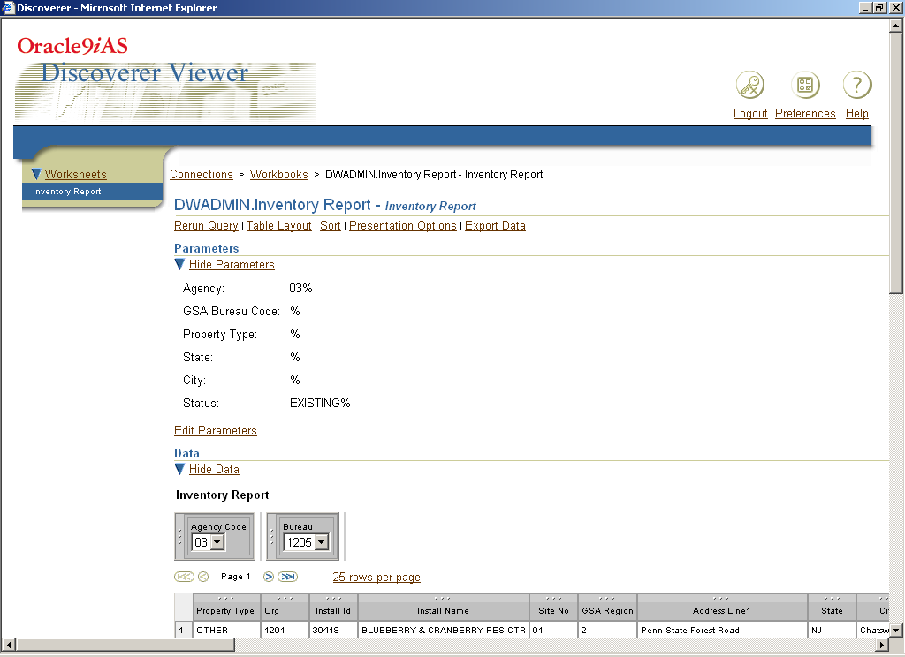
This selection permits one to edit the criteria here versus re-querying.
The parameters of the search can be displayed or hidden.

The results of the query are displayed within the lower portion of the above screen and the screen below.

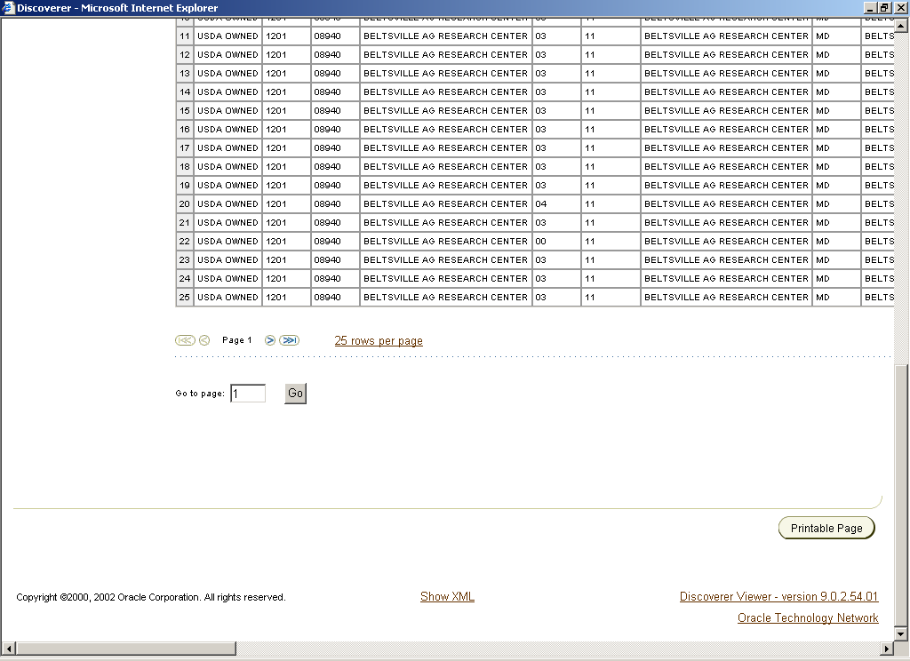
It is best to “export” Discover queries in Excel versus printing here, due to the file size. To export, the “Export Data” option within the toolbar must be selected.
To manipulate the data for individual needs, the Export option will permit the information to be exported to Microsoft Excel.

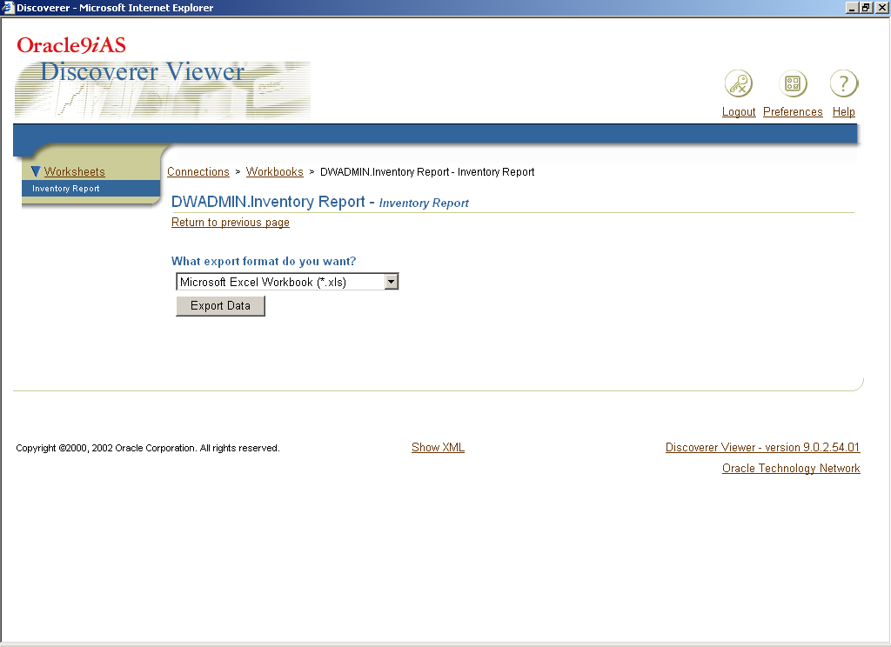
After selecting “Export Data”, this screen will appear; verify the format desired and click on the “Export Data” button.

The following prompt will then appear:

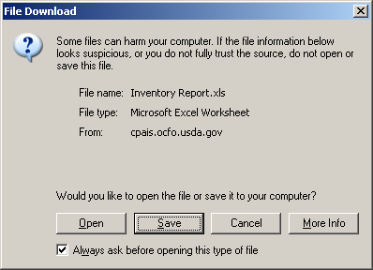

“Open” or “Save” the exported worksheet. If “Open” is selected, the following prompt will also appear.

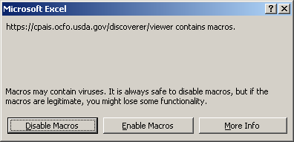

Select “Enable Macros” and proceed with manipulating the exported spreadsheet within Excel before saving.

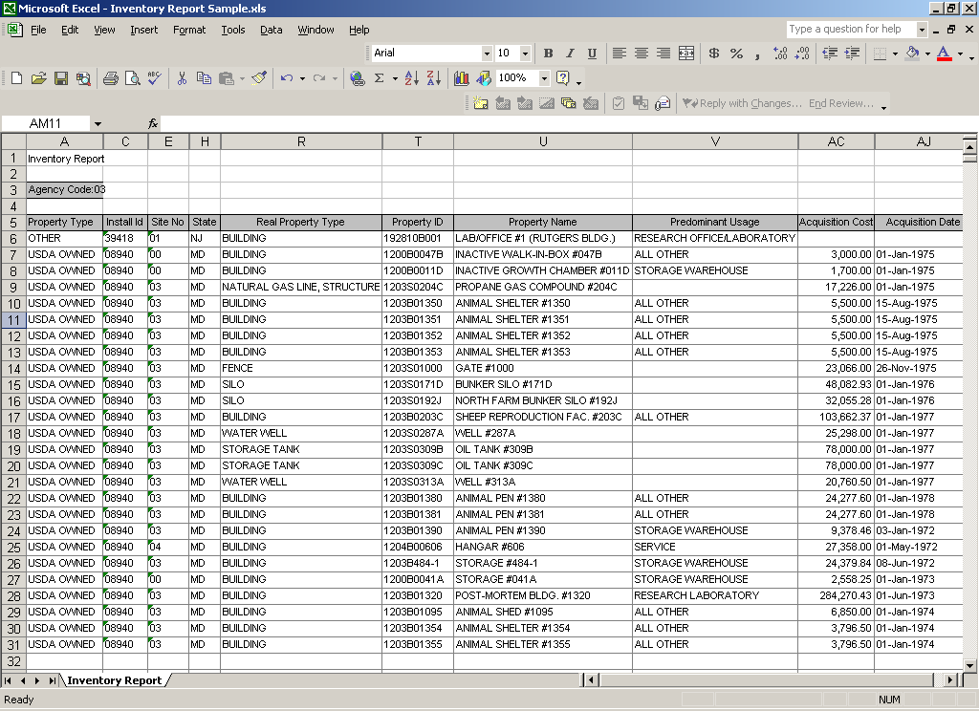

Your export will need to be formatted and saved, but should resemble the above.

