Before the
Federal Communications Commission
Washington, D.C. 20554

In the Matters of )
)
EchoStar Satellite LLC ) File Nos. SAT-STA-20050321-00068
) Call Sign: S2621
Application for Special Temporary Authority )
to Conduct Telemetry, Tracking, and Command )
Operations during the Relocation of EchoStar 4 )
To the 77º W.L. Orbital Location; )
)
EchoStar Satellite LLC ) File Nos. SAT-STA-20060126-00010
) SAT-STA-20060303-00020
Special Temporary Authority to Conduct Tracking, ) SAT-STA-20060331-00037
Telemetry, and Command Necessary to Maintain )
the EchoStar 4 satellite at the 77º W.L. Orbital Location )
)
EchoStar Satellite LLC ) File Nos. SES-LFS-20050701-00852
) SES-AMD-20051118-01603
Application for Blanket Authorization Of 1,000,000 ) Call Sign: E050196
Receive-Only Earth Stations to Provide DBS Service )
in the U.S. Using the Mexican-Authorized Satellite )
EchoStar 4 at 77° W.L. )

ORDER AND AUTHORIZATION

Adopted: April 18, 2006 Released: April 18, 2006

By the Chief, Satellite Division, International Bureau:

INTRODUCTION
- In this Order, we grant in part the request for special temporary authority filed by EchoStar Satellite LLC (EchoStar) insofar as it seeks authority to transfer control of EchoStar 4 to QuetzSat, S. de R.L. de C.V. (QuetzSat) in connection with the operation of the satellite at the 77º W.L. orbital location. QuetzSat holds a concession from Mexico to operate a satellite at the 77º W.L. orbital location, and would control the satellite pursuant to that concession. By this action, we support cooperation between U.S. and Mexican satellite operators in meeting capacity needs. We also grant an application for blanket authorization of 1,000,000 receive-only earth stations that will allow EchoStar to provide DBS service in the U.S. using the Mexican-authorized satellite EchoStar 4 at 77° W.L.

BACKGROUND

The Transaction Between EchoStar and SES
- Under an agreement between EchoStar and SES GLOBAL Latin America, S.A. and SES GLOBAL, S.A. (collectively SES), EchoStar has agreed to move the EchoStar 4 satellite to the 77° W.L. orbital location, subject to necessary governmental approvals, pending the launch and placement of a new satellite (QuetzSat 1) at the 77° W.L. orbital location. The agreement provides that the service term for EchoStar 4 at the 77° W.L. orbital location will run from the date that EchoStar 4 begins service at the 77° W.L. orbital location (the "in-service" date) until the earliest of: (1) the End-of-Life of EchoStar 4; (2) the date that EchoStar 4 fails; (3) the in-service date of QuetzSat 1 at the orbital location; (4) the date that EchoStar removes EchoStar 4 from the 77° W.L. location to replace capacity of its fleet lost due to catastrophic failure in its fleet; or, (5) upon certain events related to the future operations of QuetzSat 1.
- The agreement contemplates that, once EchoStar 4 is at the 77° W.L. orbital location, it will be under the direction and control of SES/QuetzSat. EchoStar will perform telemetry, tracking, and control functions, under the direction and control of SES/QuetzSat, for the entire Service Term at the 77° W.L. orbital location.

Procedural History
- EchoStar filed its STA Request on March 21, 2005. On May 13, 2005, EchoStar also filed a request to modify its authorization for the 157° W.L. orbital location, so that, despite the removal of the EchoStar 4 satellite from that location, EchoStar’s license would not automatically lapse. On May 23, 2005, the comment period closed on the EchoStar STA request. The only comment filed was a letter from DIRECTV dated May 4, 2005, requesting additional technical information concerning the planned operations of EchoStar 4 at the 77° W.L. orbital position. EchoStar filed a response providing additional information on May 10, 2005. On May 27, 2005, EchoStar filed a request to modify an earth station authorization to list the EchoStar 4 satellite at the 77° W.L. orbital location as an authorized point of communication. On June 3, 2005, the International Bureau (Bureau) denied EchoStar’s STA Request and dismissed both the application to permit long-term cessation and the application for modification of earth station authorization. The Bureau concluded that moving EchoStar 4 to the 77° W.L. orbital location to meet an ITU deadline was not a sufficient public interest reason to grant the request.
- On June 8, 2005, EchoStar filed its petition for reconsideration of the Bureau’s Denial Order. The petition for reconsideration noted that (1) the Secretaria de Comunicaciones y Transportes (SCT) would grant a license to QuetzSat Directo, an affiliate of SES GLOBAL Latin America S.A., to provide Direct-to-Home (DTH) service to the Mexican public from EchoStar 4, and (2) that EchoStar 4 could provide service to parts of the U.S. as well. On June 9, 2005, Mexico’s SCT and Comision Federal de Telecomunicaciones (COFETEL) submitted a letter supporting EchoStar’s request. EchoStar then filed a Supplement to the Petition for Reconsideration on June 14, 2005. On June 14, 2005, EchoStar also filed an STA request to begin drifting EchoStar 4 from its licensed position at 157° W.L. toward the 61.35° W.L. orbital position. The Bureau granted this request on June 17, 2005. DIRECTV filed comments on the Petition for Reconsideration on June 20, 2005, and EchoStar replied to DIRECTV’s comments on June 22, 2005. On July 1, 2005, EchoStar filed a second Supplement to the Petition for Reconsideration and filed an application for blanket receive-only earth station authorization, to receive signals from the EchoStar 4 satellite at the 77° W.L. orbital location to provide DTH service to U.S. subscribers. Also on July 1, 2005, EchoStar filed a request to alter the drift of EchoStar 4, and to place it at the 77° W.L. orbital location and operate it under a U.S. license pending action on the STA Request. This July 1, 2005 request was granted on July 6, 2005.
- On July 20, 2005, the Bureau reinstated EchoStar’s request to transfer control of the operation of EchoStar 4 at the 77° W.L. orbital location to QuetzSat. The Bureau also reinstated EchoStar’s application for modification of the EchoStar 4 space station license and the application for modification of an earth station authorization, concluding that the additional information provided in the petition for reconsideration warranted further consideration of the three applications. DIRECTV filed comments on August 26, 2005, to which EchoStar replied on September 6, 2005. On September 21, 2005, EchoStar withdrew the modification application and relinquished the underlying space station authorization that allowed EchoStar 4 to operate at the 157° W.L. orbital location on channels 1, 7, and 11. On November 18, 2005, EchoStar filed an amendment to its blanket earth station application to include an orbital debris mitigation plan. On December 1, 2005, Mexico’s SCT issued a concession to QuetzSat Directo to provide DTH service to the Mexican public from EchoStar 4.

DISCUSSION
- We find that both EchoStar’s STA request and request for a blanket earth station authorization are in the public interest. In order to grant a request for authority, the Commission must find that such a grant would serve the public interest. When EchoStar submitted the STA Request, EchoStar proposed to relocate the EchoStar 4 satellite to 77º W.L. but did not propose to provide service to the United States. EchoStar 4 was also unable to provide DTH service to Mexico, since further authorization from the Mexican government would have been required before service to Mexico could be provided. Further information is now available to indicate that EchoStar 4 will be able to provide service to both the United States and Mexico from the 77º W.L. orbital location.
- Issuing authorizations that will facilitate consumers receiving transmissions from EchoStar 4 at the 77º W.L. orbital location could serve the public interest by providing service to areas in the Southern U.S., including additional Spanish language programming to areas with significant Spanish-speaking populations. This authorization is consistent with the Commission’s action in the DIRECTV 5 Order. Moving the DIRECTV 5 satellite to the 72.5º W.L. orbital location was determined to be in the public interest because of the benefits associated with increasing the number of U.S. markets able to receive local-into-local programming. We further note that in EchoStar 4’s case, the U.S. and Mexico have a relevant bilateral agreement in place related to the provision of DTH services.
- Exchange of Letters with SCT. We have exchanged letters with SCT in order to ensure that there is a mutual understanding regarding the operation of the EchoStar 4 satellite. The understandings, and the factual background for these understandings, are provided as Annex A and are material considerations for the authorization contained in this Order. In general, the exchange of letters indicates that EchoStar 4 space station operations at the 77° W.L. orbital location will be pursuant to authorization of QuetzSat by SCT.

CONCLUSION AND ORDERING CLAUSES
- Based on the foregoing, we find that the granting of EchoStar’s application will serve the public interest by providing additional competitive telecommunications services in both the U.S. and Mexico.
- Accordingly, IT IS ORDERED, that EchoStar Satellite L.L.C.’s application, File No. SAT-STA-20050321-00068 (Call Sign S2621), IS GRANTED, and EchoStar Satellite L.L.C. is authorized to transfer control of EchoStar 4 to QuetzSat, S. de R.L. de C.V.
- IT IS FURTHER ORDERED that the applications for Special Temporary Authority to operate Telemetry, Tracking, and Command necessary to maintain the EchoStar 4 satellite at the 77º W.L. orbital location, File Nos. SAT-STA-20060126-00010, SAT-STA-20060303-00020, and SAT-STA-20060331-00037, ARE GRANTED.
- IT IS FURTHER ORDERED, that, pursuant to Section 25.137 (c) of the Commission’s rules, the application of EchoStar Satellite L.L.C. File No. SES-LFS-20050701-00852 (Call Sign E050196), as amended by File No. SES-AMD-20051118-01603, IS GRANTED, and EchoStar Satellite L.L.C. IS AUTHORIZED to use 1,000,000 receive-only Earth stations to receive transmissions in the 12.2-12.7 GHz frequency band from the EchoStar 4 satellite at the 77° W.L. orbital location, which is authorized to QuetzSat, S. de R.L. de C.V. by SCT, consistent with the technical parameters specified in its application, and subject to the following condition:
Operations shall be consistent with applicable coordination agreements; to the extent such agreements have not been reached, operations:
- shall not exceed, under any conditions and taking into account all variations in satellite attitude, the parameters specified in Attachment A of the Letter, dated May 10, 2005, from Pantelis Michalopoulos to the Secretary, FCC,
- shall be on a non-harmful interference basis, i.e., operations of the EchoStar 4 satellite shall not cause interference to, and shall not claim protection from, interference caused to it by any other lawfully operating satellites.
- EchoStar Satellite LLC is afforded thirty days to decline this authorization as conditioned. Failure to respond within this period will constitute formal acceptance of the authorizations as conditioned.
- This Order is issued pursuant to Section 0.261 of the Commission’s rules, 47 C.F.R. §0.261 and is effective upon release.

FEDERAL COMMUNICATIONS COMMISSION

Robert G. Nelson
Chief, Satellite Division
International Bureau

Appendix A

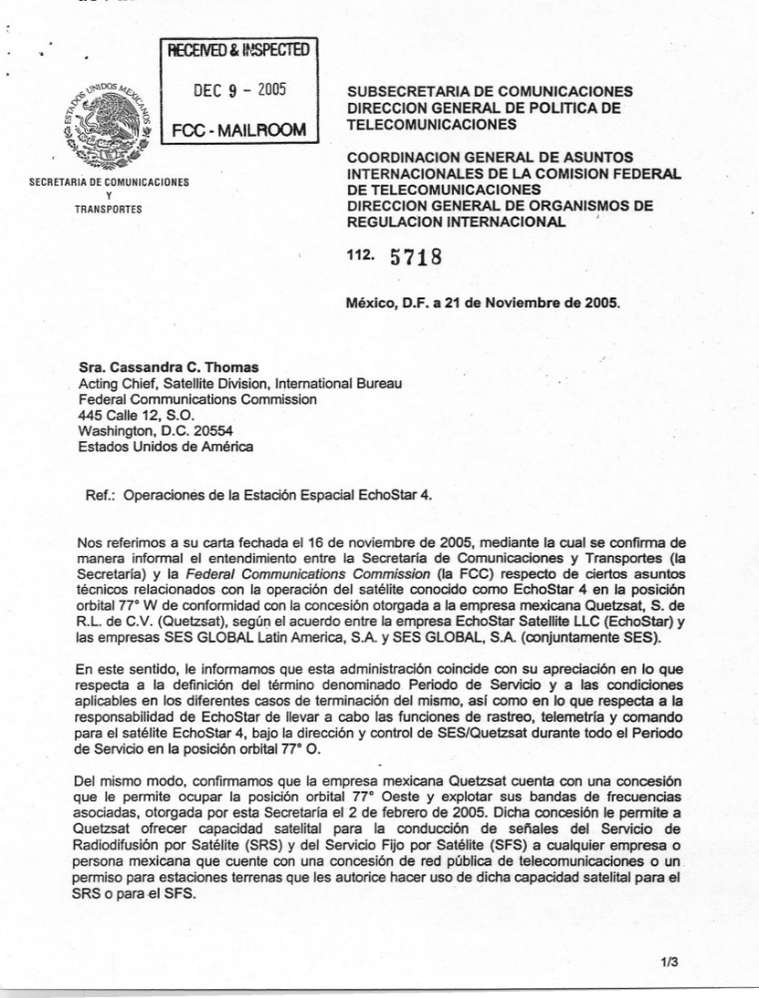
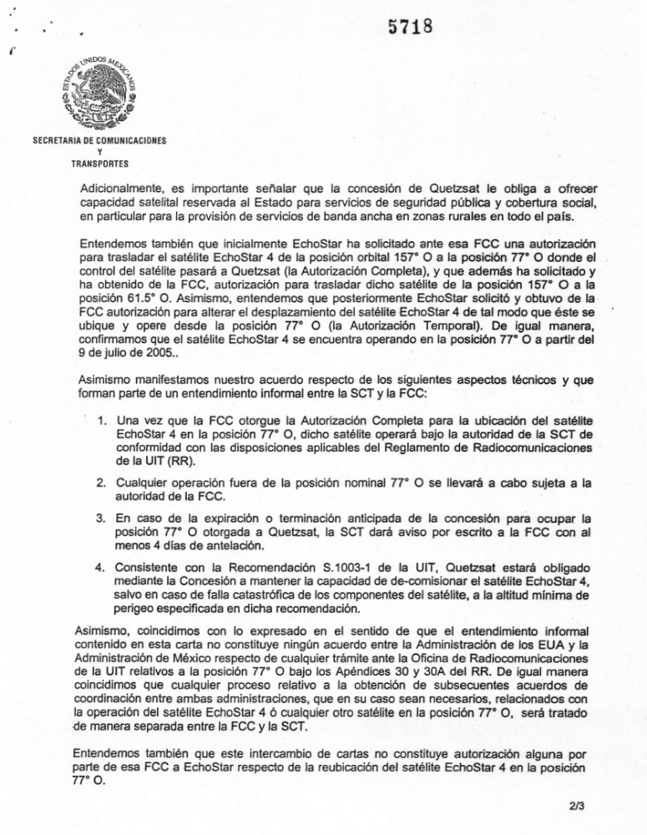
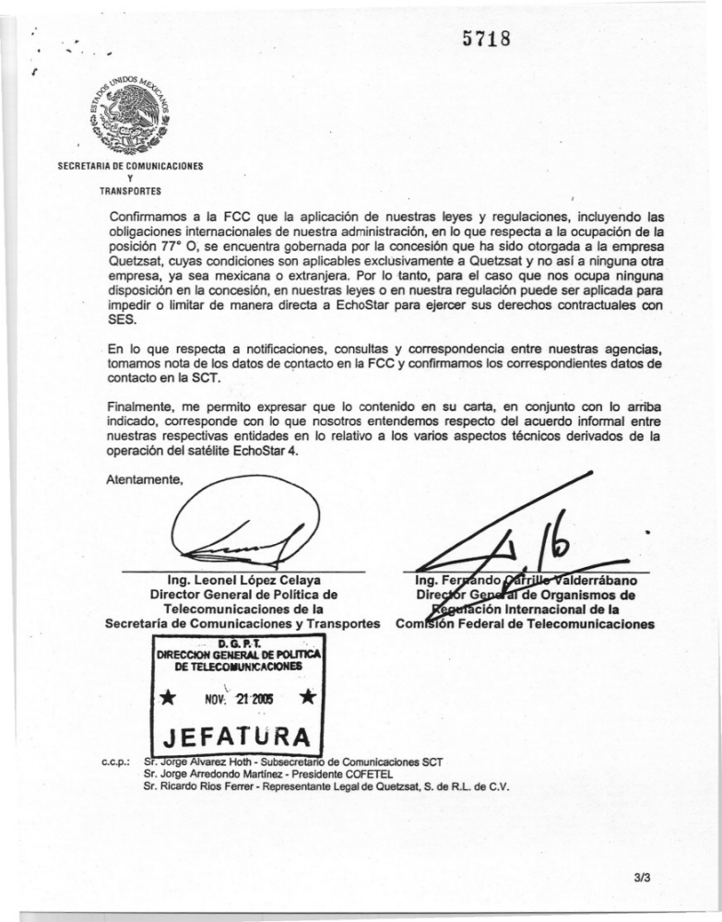
[N.B.: This english translation is provided by the FCC as an aid to english speakers in understanding the preceding letter from Mexico. This translation has not been reviewed or approved by either the SCT or COFETEL.]

[seal:] MEXICAN UNITED STATES FORM C.G.2
SECRETARIAT OF COMMUNICATION
& TRANSPORTATION
UNDERSECRETARY OF COMMUNICATIONS
RECEIVED & INSPECTED

DEC 9 2005

FCC MAILROOM
TELECOMMUNICATIONS POLICY DIVISION

COORDINATION OF INTERNATIONAL MATTERS OF THE FEDERAL COMMUNICATIONS COMMISSION
DIVISION OF INTERNATIONAL REGULATIONS OF AGENCIES
112. 5718

Mexico, D.F., November 21, 2005

Ms. Cassandra C. Thomas
Acting Chief, Satellite Division
International Bureau
Federal Communications Commission
445 12th Street SW
Washington, D.C. 20554
U.S.A.

Re: Operations of EchoStar 4 Space Station

We make reference to your letter dated the 16th of November of 2005 in which you informally confirm the understanding between the Secretariat of Communications and Transportation (the Secretariat) and the Federal Communications Commission (the FCC) with respect to certain technical matters related to the operation of the satellite known as EchoStar 4 in orbital position 77º W.L. pursuant to the license granted the Mexican company Quetzsat, S de R.L. de C.V. (Quetzsat), in accordance with the agreement between the company Echo Star Satellite LLC (EchoStar) and the companies SES GLOBAL Latin America, S.A. and SES GLOBAL, S.A. (jointly SES).

In this regard, this Administration wishes to inform you that it concurs with your appraisal regarding the definition of the term Service Period and the conditions applicable to the different cases of termination thereof; we also concur with respect to EchoStar's responsibility to perform the duties of tracking, telemetry and control for the EchoStar 4 satellite, under the direction and control of SES/Quetzsat during the entire Service Period in orbital position 77º W.L.

Similarly, we confirm that the Mexican company Quetzsat has a concession that allows it to occupy orbital position 77º W.L. and to exploit the associated frequency bands, granted by this Secretariat on the 2nd of February of 2005. Said concession allows Quetzsat to offer satellite capability for the conduction of signals of the Broadcasting-Satellite Service (BSS) and of the Fixed-Satellite Service (FSS) to any Mexican company or person that has a public telecommunications network license or a land station permit that authorizes the use of said satellite capability for the BSS or the FSS.

1/3

5718
[seal:] MEXICAN UNITED STATES
SECRETARIAT OF COMMUNICATION
& TRANSPORTATION

Additionally, it is important to point out that Quetzsat's license obligates it to offer satellite capability reserved for the State for services of public safety and social coverage, specifically in order to provide wide band services to rural zones throughout the country.

We also understand that initially EchoStar had requested authorization from the FCC to transfer the EchoStar 4 satellite from orbital position 157º W.L. to position 77º W.L. where control of the satellite would go to Quetzsat (the Complete Authorization) and in addition, it has requested and obtained from the FCC, authorization to move said satellite from position 157º W.L. to position 61.5º W.L. Similarly, we understand that subsequently EchoStar requested and obtained FCC authorization to modify the displacement of the EchoStar 4 satellite in such a way that it would be located and operate from position 77º W.L. (the Temporary Authorization). Similarly, we confirm that the Echo Star 4 satellite has been operating in position 77º W.L. since the 9th of July of 2005.

We also state our agreement with respect to the following technical aspects that form part of the informal understanding between the SCT and FCC:

- Once the FCC authorizes the Complete Authorization for the EchoStar 4 satellite to be located in position 77º W.L., said satellite will be operating under the authority of the SCT in accordance with the applicable provisions of the ITU Radio Regulations (RR).

- Any operation outside its normal position of 77º W.L. shall be carried out subject to FCC authority.

- In the event of expiration or early termination of the license to occupy position 77º W.L. granted to Quetzsat, the SCT will give written notification to the FCC a minimum of 4 days prior to such action.

- In accordance with Recommendation S.1003-1 of the ITU, Quetzsat will be obligated through its Concession to maintain the capability to decommission the EchoStar 4 satellite, except in the event of a catastrophic failure of the satellite components to the minimum height of perigee specified in said recommendation.

Similarly, we agree with your statements regarding the fact that the informal understanding contained in this letter does not constitute any agreement between the Administration of the U.S.A. and the Administration of Mexico with respect to any matter being processed before the Radiocommunication Bureau of the ITU related to position 77º W.L. under Appendices 30 and 30A of the RR. Additionally, we agree that any procedure related to the obtainment of subsequent coordination agreements between both administrations, should they be needed, related to the operation of the EchoStar 4 satellite or any other satellite in position 77º W.L. shall be treated as a separate matter between the FCC and SCT.

We also understand that this exchange of letters does not constitute any authorization by the FCC to EchoStar with respect to the relocation of the EchoStar 4 satellite to position 77º W.L.
2/3

5718
[seal:] MEXICAN UNITED STATES
SECRETARIAT OF COMMUNICATION
& TRANSPORTATION

We confirm to the FCC that the application of our laws and regulations, including the international obligations of our administration, in regard to the occupation of position 77º W.L. is governed by the license that has been granted to the company Quetzsat, conditions which are applicable exclusively to Quetzsat and not to any other company, be it Mexican or foreign. Therefore, in this case there are no provisions in the license, in our laws or in our regulation that may be applied to directly hinder or limit EchoStar from exercising its contractual rights with SES.

With respect to notifications, consultations and correspondence between our agencies, we take note of the contact information for the FCC and confirm the corresponding contact information for the SCT.

Finally, allow me to express that the contents of your letter, together with what has been stated above, correspond to our understanding of the informal agreement between our respective agencies in relation to the various technical aspects related to the operation of the EchoStar 4 satellite.

Sincerely,

[Signature- illegible] [Signature- illegible]

Ing. Leonel Lopez Celaya Ing. Fernando Carillo Valderrabano
General Director of General Director of International Telecommunications Policy Regulation of Agencies
Secretariat of Communication & Transportation Federal Telecommunications Commission

D.G.P.T.
TELECOMMUNICATIONS POLICY DIVISION

* NOV. 21 2005 *

OFFICE

CC: Mr. Jorge Alvarez Hoth - Deputy Secretary of Communications SCT
Mr. Jorge Arredondo Martinez - President COFETEL
Mr. Ricardo Rios Ferrer - Legal Representative of Quetzsat, S. de R.L. of C.V.

3/3

File No. SAT-STA-20050321-00068 (“EchoStar STA Request”). The portion of the STA requesting authority to move EchoStar 4 to the 77° W.L. orbital position is moot in light of a separate action, granted on July 6, 2005, under File No. SAT-STA-20050701-00142, as described in detail below.
QuetzSat, a Mexican entity, obtained the concession from the Mexican Secretariat of Communications and Transportation (SCT) on February 2, 2005.
See 47 C.F.R. § 25.161(c) (providing for the automatic termination of a station authorization upon “[t]he removal or modification of the facilities which renders the station not operational for more than 90 days, unless specific authority is requested”).
EchoStar Satellite LLC, Memorandum Opinion and Order, DA 05-1581 (rel. June 3, 2005) (Denial Order).
Denial Order at ¶ 6.
Letter from Jorge Alvarez Hoth, Subsecretario de Comunicaciones, SCT and Jorge Aredondo Martinez, Presidente, COFETEL to Kevin J. Martin, Chairman, FCC (June 9, 2005).
SAT-STA-20050614-00124.
File No. SES-LFS-20050701-00852.
SAT-STA-20050701-00142, for a 30-day period. This STA has since been renewed. See Stamp Grant, SAT-STA-20050803-00157 (granted August 5, 2005), Stamp Grant, SAT-STA-20050826-00167 (granted September 10, 2005), and Stamp Grant, SAT-STA-20051018-00202 (granted October 27, 2005). See also SAT-STA-20051027-00207, SAT-STA-20051128-00255, and SAT-STA-20051222-00268 (requesting further renewals of this STA grant).
EchoStar Satellite LLC, Order on Reconsideration, DA 05-2067 (Reconsideration Order).
Id.
Comments of DIRECTV Enterprises, LLC, filed August 26, 2005; EchoStar Satellite L.L.C. Reply Comments, filed September 6, 2005. In its comments, DIRECTV states that even though EchoStar 4’s location at 77° W.L. is within 4.5 degrees of DIRECTV’s current satellite at 72.5° W.L., neither its satellite nor EchoStar 4 is capable of operating on all 32 DBS channels. DIRECTV states that as long as it can coordinate with EchoStar 4, there should be no interference concern in this particular circumstance even though DIRECTV generally opposes DBS satellites being separated by only 4.5 degrees. EchoStar responds that it is optimistic that an informal agreement can be reached with DIRECTV concerning the operation of EchoStar 4 at 77° W.L.
See File No. SAT-MOD-20031219-00372.
File No. SES-AMD-20051118-01603.
See Concesión par instalar, operar y explotar una red pública de telecomunicaciones, que otorga el Gobierno Federal por conducto de la Secretaria de Comunicaciones y Transportes, en lo sucesivo la Secretaria, a favor de QUETZSAT DIRECTO, S. DE R.L. DE C.V., al tenor de siguientes antecedentes y conditiones, dated December 1, 2005 (QuetzSat Directo Concession).
47 U.S.C. § 309; 47 C.F.R. § 25.120.
See EchoStar Supplement to Petition for Reconsideration, at 5.
DIRECTV, Inc., Order and Authorization, 19 FCC Rcd 15529 (2004) (DIRECTV 5 Order).
Id. at ¶ 8.
Agreement between the Government of the United States of American and the Government of the United Mexican States Concerning the Transmission and Reception from Satellites for the Provision of Satellite Services to Users in the United States of America and the United Mexican States, April 28, 1996, Article I and Protocol Concerning the Transmission and Reception of Signals from Satellites for the Provision of Direct-to-Home Satellite Services in the United States of America and the United Mexican States, November 8, 1996. Generally, in evaluating requests by U.S. earth station operators to access a non-U.S.-licensed space station, the Commission adopted a public interest framework that considers the effect on competition in the United States and assesses reciprocal “market access” to the other nation by the U.S. See Amendment of the Commission's Regulatory Policies to Allow Non-U.S. Licensed Satellites Providing Domestic and International Service in the U.S., Report and Order, IB Docket No. 96-111, 12 FCC Rcd 24094, 24107-56 (¶¶ 30-145) (1997) (DISCO II). However, DISCO II contemplates that a bilateral agreement, as is present here, “ . . . acts as a gateway to, and a guarantee of, increased competition in the two countries at both ends of the agreement.” DISCO II, 12 FCC Rcd at 24157 (para. 143). Thus no further market access analysis is required.

