5. LEAF - COMPUTER PROGRAM FOR LAYERED ELASTIC ANALYSIS

5.1 Introduction.
A complete derivation of the basic layered elastic equations is given in Appendix A and reference [Huang, Y.H., Pavement Analysis and Design, Englewood Cliffs, New Jersey, Prentice-Hall, 1993.] and only a brief introduction is given here. Cylindrical coordinates are used with no response variation in the circumferential direction. The coordinates are z downwards, r radially outward from the vertical z axis, and t tangent to a circumference at radius r. Stresses, strains, and displacements within a given layer are computed by integrals of the form:

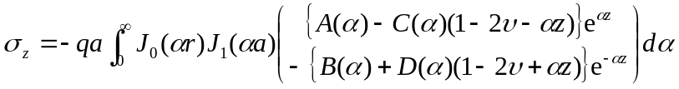 (5-1)
a | = tire radius
r | = evaluation point radius
z | = depth from top of layer
q | = tire pressure
α | = Hankel domain variable

Vertical stress, σ_{z}, is shown for illustration. Load is applied at the top surface of the top layer in a multi-layer system. The load is a uniform compressive traction, of pressure q, applied over a circular area of radius a. The stress computation point is at a distance z from the top of the layer and a distance r from the center of the vertical axis passing through the center of the load. J₀ and J₁ are Bessel functions and α is the integration variable (strictly the Hankel domain variable). In the following, the integrands are referred to as “elemental” stresses and displacements to signify that the complete response is composed of the summation of a large number of small, elemental, components.
z
h_{i}
r
a
Evaluation Point
Load
Evaluation Layer

FIGURE 5-1. NOMENCLATURE AND COORDINATES
The coefficients A(α), B(α), C(α), and D(α) are determined by the boundary conditions for the layer (usually specified at the top and bottom surfaces of the layer). They are functions of α, as indicated by the parentheses. In the following the α and the parentheses are dropped, but it should be remembered that the coefficients are functions of α and must be recomputed whenever α changes. Also, because the coefficients are functions of α, the terms in braces in equation 5-1 can be multiplied by any function of α, provided only that the multiplier is consistently applied to all integrands used to set up the boundary conditions.

Derivation of the equilibrium equations for a multi-layered system with fully bonded interfaces is described first, followed by derivation of the equilibrium equations for a system with partially bonded interfaces. Computer implementation of the integrations to compute system responses is then described. Methods for solving the equations are described last. Numerical test cases and comparisons with other methods complete the chapter.

5.2 Derivation of the Interface Equilibrium Equations
The 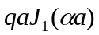 term represents the applied circular load at the top surface and always cancels when formulating the equilibrium equations. Therefore, from Appendix A, and ignoring the load term, the complete set of elemental stresses and displacements is:

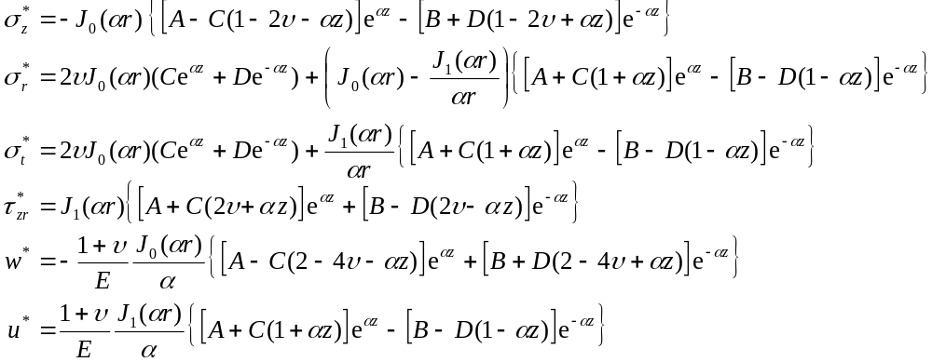 (5-2)

Vertical, radial, and tangential stresses are denoted by σ_{z}, σ_{r}, and σ_{t} respectively.

Shear stress in the vertical-radial plane is denoted by τ_{zr}.

Vertical and radial displacements are denoted by w and u respectively.

Layers are numbered downward starting at 1 for the top layer. Interface i is the interface at the bottom of layer i. See figure 5-2.

FIGURE 5-2. LAYER AND INTERFACE NUMBERING

For a circular load and zero shear stress at the surface, the equilibrium equations for the surface plane (interface 0) are:
Layer 1
Interface 1
Interface 2
Layer 2
Layer 3
Interface 3
Infinity
Interface 0

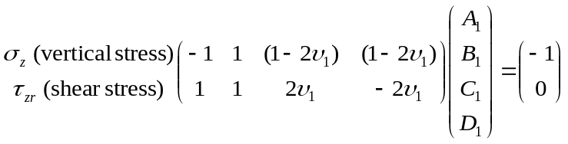

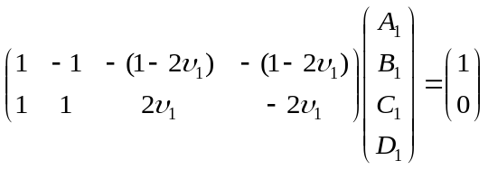 (5-3)

The minus one (–1) term in the right hand side vector in the first set of equations represents the compressive stress applied by the circular load (the stress intensity qa appears in the response equations). The signs are changed to make the load vector positive just for convenience. The left hand side of the equations is found by setting z in layer 1 (the top layer) equal to zero for the vertical and shear stress elemental equations.

For two layers fully bonded at a common interface, the boundary conditions are determined by equilibrium and continuity at the interface. Therefore, at the interface, the stresses and displacements are equal in the two layers. The equilibrium equations are set up by equating, in turn, vertical stress, shear stress, vertical displacement, and radial displacement for the two layers bounding the interface. The appropriate values of vertical distance, z, are substituted into the elemental equations for two adjacent layers i and i+1. Interface i is at the bottom of layer i and at the top of layer i+1. The distance, z, from the top of layer i to the interface is the thickness of layer i, h_{i}. Therefore, set z = h_{i} in the elemental equations to obtain the left hand side of the equation. The distance, z, from the top of layer i+1 to the interface is zero. Therefore, set z = 0 in the elemental equations to obtain the right hand side of the equation. Also set:

E_{i} | = Young’s modulus of layer i
E_{i+1} | = Young’s modulus of layer i+1
ν_{i} | = Poisson’s ratio of layer i
ν_{i+1} | = Poisson’s ratio of layer i+1
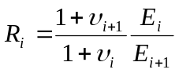

Then:
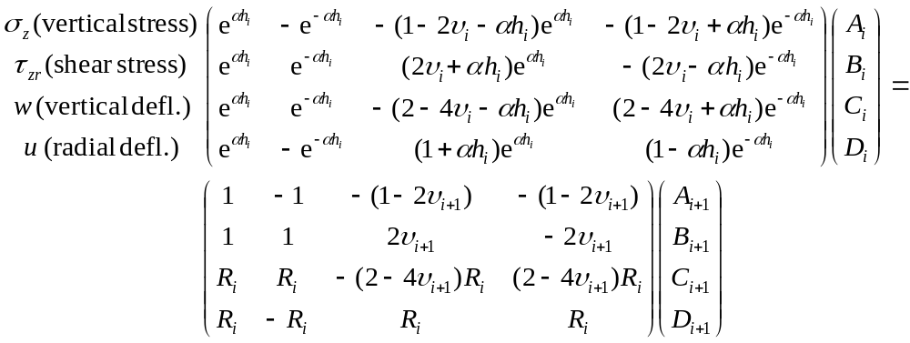 (5-4)

5.2.1 Equilibrium Equations with Arbitrary Interface Bonding.
In order to allow relative horizontal movement between two layers at an interface, a uniformly distributed shear spring is assumed to connect the layers. The spring acts in the radial direction and has the following law:

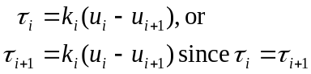 (5-5)

where:
τ_{i} | = radial shear stress at the interface between layers i and i+1.
(u_{i} – u_{i+1}) | = relative radial displacement across the interface.
k_{i} | = interface spring stiffness, with units of lb / inch relative radial displacement / inch along the radius / inch along the circumference at radius r (lb/in³). That is, a radial spring connects elemental areas either side of the interface. The spring resists relative radial displacement across the interface.

To reduce numerical complications, the computer implementation can use the relationship:

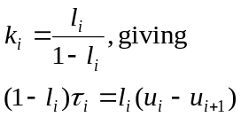 (5-6)

This change of variable is used in JULEA, with a further logarithmic transformation in the input data parameter. LEAF uses the same variable, l, both within the computational routines and as the input data parameter.

For fully bonded layers, 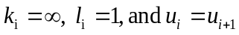.
For fully unbonded layers, 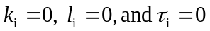.

For reference, the transformation in JULEA is as follows:

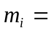input parameter for interface i.
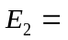modulus of layer 2 (directly below the surface layer).

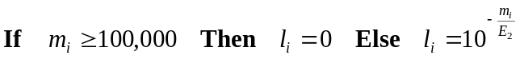

Note that l is a parameter. It does not have units and it has no physical significance other than the manner in which it varies the spring stiffness. It has a value from 0 to 1 (fully unbonded to fully bonded).

Writing out the elemental equations for shear stress and radial deflection in full, a new equilibrium equation for arbitrary interface bonding is derived as follows.

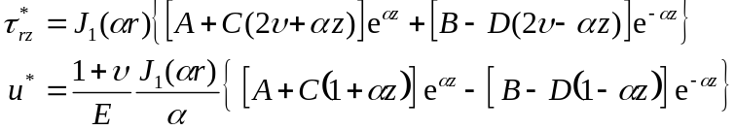

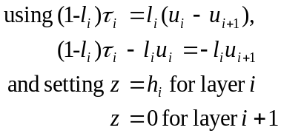

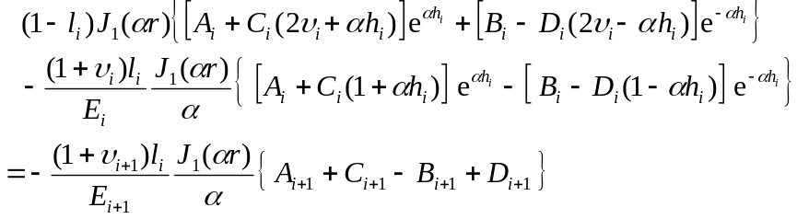
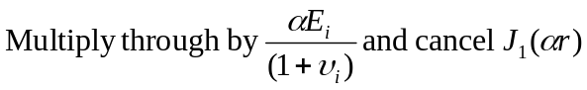

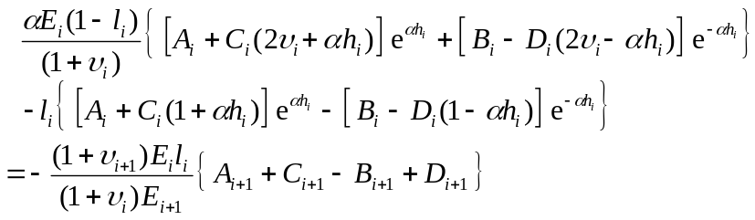

Setting 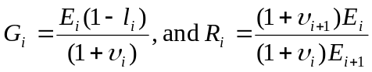 (as before), and rearranging the equation:

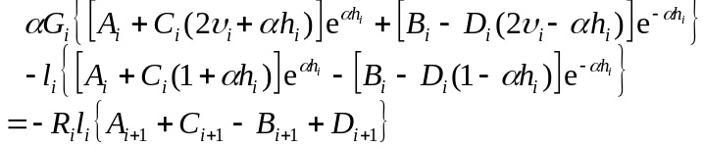 (5-7)

Setting l_{i} = 1, G_{i} = 0, reduces the equation to the radial deflection continuity equation derived for a fully bonded interface. Setting l_{i} to zero decouples the coefficients in layer i from those in layer i+1. This causes numerical difficulties with a fully unbonded interface, as discussed later.

Replacing the radial deflection continuity equation with the new spring equilibrium equation (relating shear stress to radial deflection).

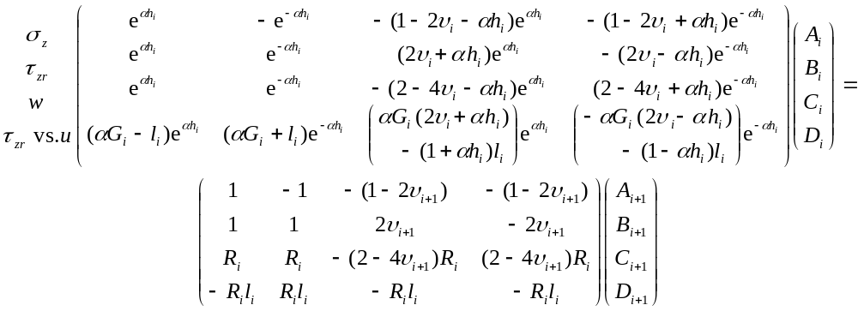 (5-8)

For a subgrade of infinite depth, the coefficients A_{N} and C_{N} are zero because the responses must decay to zero at infinity and the 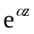 terms increase unbounded as z increases (see, also, Appendix A). The equation for the interface above the subgrade is then:

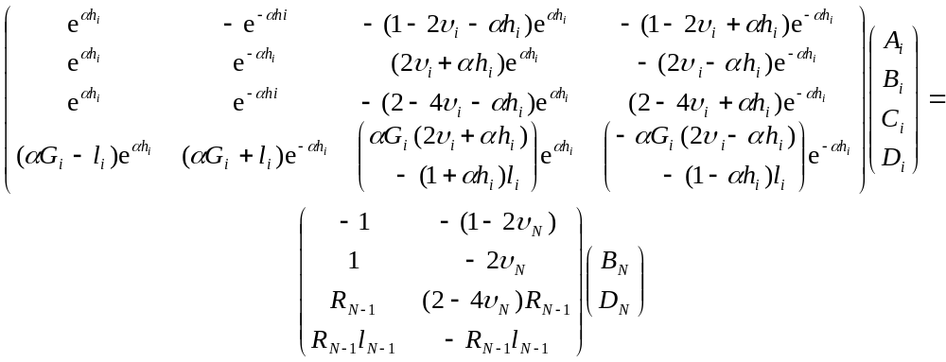 (5-9)

where:
N | = the subgrade (last) layer, and
i | = N-1

Assembling the equilibrium equations 5-3, 5-4, and 5-9, for a sample structure having three layers with fully bonded interfaces gives the matrix equation 5-10. The same banded structure is repeated as more layers are added.

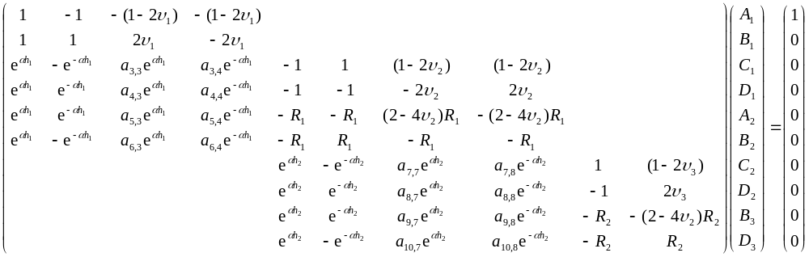 (5-10)

The presence of exponentials in the equations can lead to very large and very small numbers and consequent numerical difficulties due to underflow and overflow. Introducing additional exponential functions can reduce such difficulties. For example, multiplying each element in a single column in the matrix by a given value divides the value of the corresponding coefficient (A, B, C, or D) by the same amount. Some control is thus given over the magnitudes of the elements of the matrix and the magnitudes of the coefficients A, B, C, and D, provided a corresponding adjustment is made in the elemental equations. The procedure used in LEAF is to multiply the first and second columns of the left hand side of each equilibrium equation by 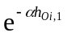and multiply the second and fourth columns of the left hand side by 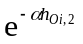. Columns in the right hand sides are multiplied by 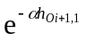 and 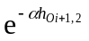. That is, the multiplying factor in the right hand side is that for the left hand side of the next lower layer. These operations are equivalent to shifting the origin of the z coordinate, as discussed later. The procedure for selecting the values of the exponents is given after describing how the equations are solved for the coefficients A, B, C, and D.

The corresponding change in the response equation for σ_{z}, for example, is:

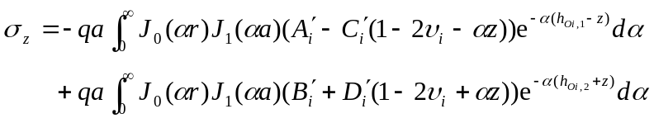 (5-11)
where:
σ_{z} | = vertical stress in layer i.
z | = distance from the top of layer i and the primes denote that the numerical values of the As, Bs, Cs, and Ds are different after the multiplications.

Making the indicated changes in the equilibrium equations 5-8 gives.

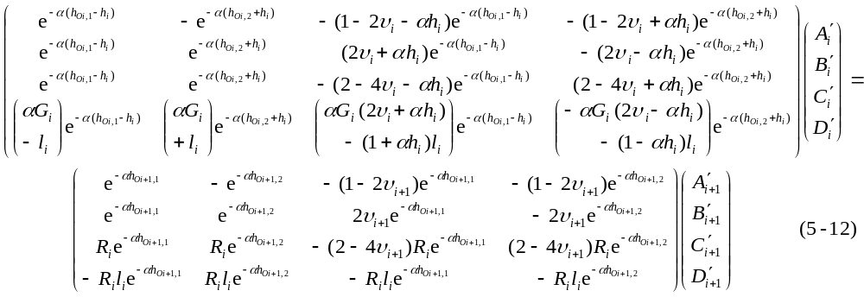
Now assembling the previously used three-layer system with the multiplying factors above the columns they are multiplied into shows how the left and right sides of the equilibrium equations are associated with the current and next lower layers, respectively. (The equation should be read as if the multiplying factors are within the elements of the full matrix. The matrix was not written out fully to keep it at a reasonable size for display on a single page.)

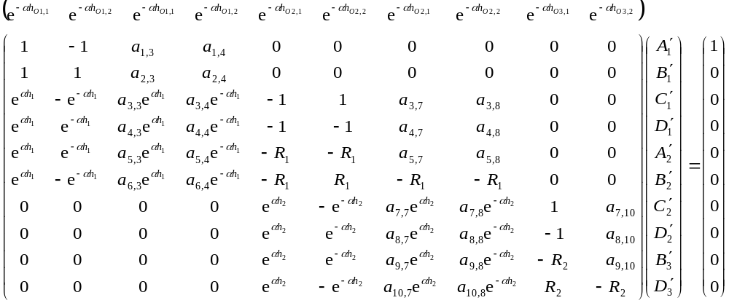 (5-13)

Multiplying the As, Bs, Cs, and Ds by the inverse of the multiplying factors gives

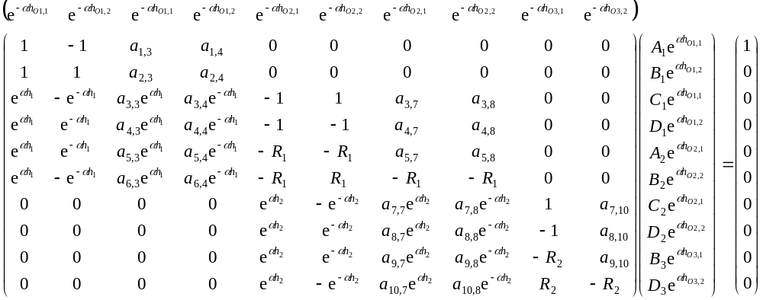 (5-14)

and shows that .

An alternative derivation is

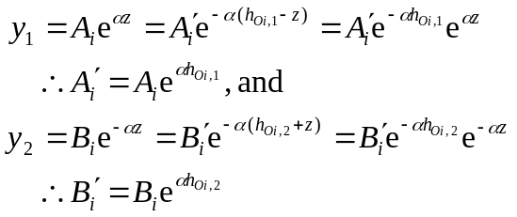 (5-15)

Applying the multiplying factors therefore corresponds to changes in the independent variable of

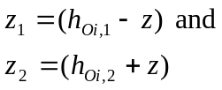 (5-16)

with origin shifts of h_{Oi,1} and –h_{Oi,2}, respectively. The same relationships hold for C_{i} and D_{i}. Figures 5-3 and 5-4 illustrate the relationships between the original and transformed variables.
z
layer i
thickness = h_{i}
h_{Oi,1}
A´
y₁
original
origin
new
origin
z₁
y₁ = Ae^{αz}
FIGURE 5-3. ORIGIN SHIFT FOR POSITIVE EXPONENTS, 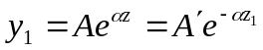

FIGURE 5-4. ORIGIN SHIFT FOR NEGATIVE EXPONENTS, 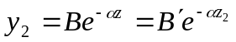
B
z
z₂
y₂ = Be^{-αz}
h_{Oi,2}
layer i
thickness = h_{i}
original
origin
new
origin
B´
y₂

5.2.2 Final Manipulation of the Equilibrium Equations.
The left hand side of the equilibrium equation 5-12 has a simple analytic inverse. The complete equation is rewritten in equation 5-17 with the left and right hand sides premultiplied by the inverse of the left hand side. (The first matrix on the right hand side of 5-17 is the inverse of the left hand side of 5-12.)

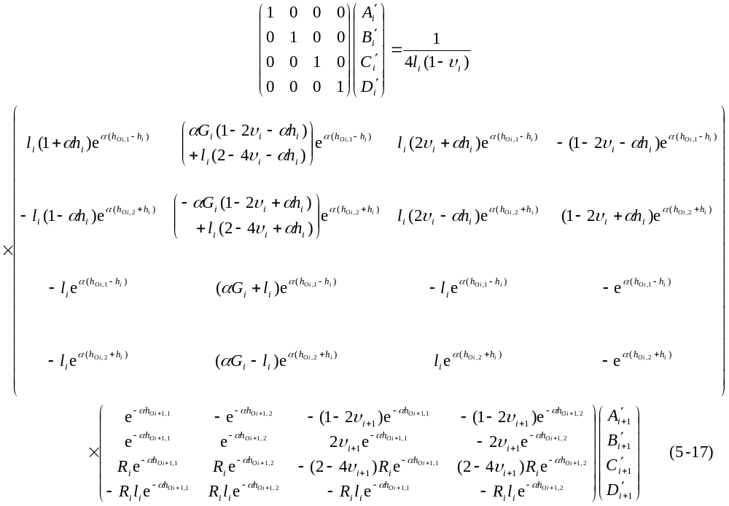

Multiplying the two 4x4 matrices gives terms in the elements of the product matrix of:

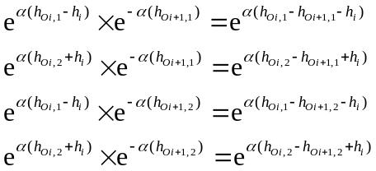 (5-18)

To stop these terms from increasing with α, the following conditions must hold:

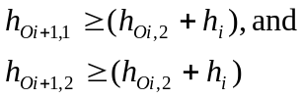 (5-19)

The current condition used in LEAF is that equality be satisfied for the above two equations. However, the conditions required to minimize numerical difficulties are very poorly understood. Suitable conditions probably vary with different configurations of the structure (number and thickness of layers, material properties, and interface parameter) and different coordinate values for the evaluation point, particularly when numerical stability has to be traded off against solution time.

5.3 Solution of the Interface Equilibrium Equations.
Because of the simple banded nature of the equations for a complete multi-layered system and, secondarily, the existence of a simple analytic inverse for the left hand side of the equilibrium equations, the equations can be solved more efficiently than by the use of a typical linear equation solver. Using a three-layer system for illustration, assembly of the complete system of equations gives:

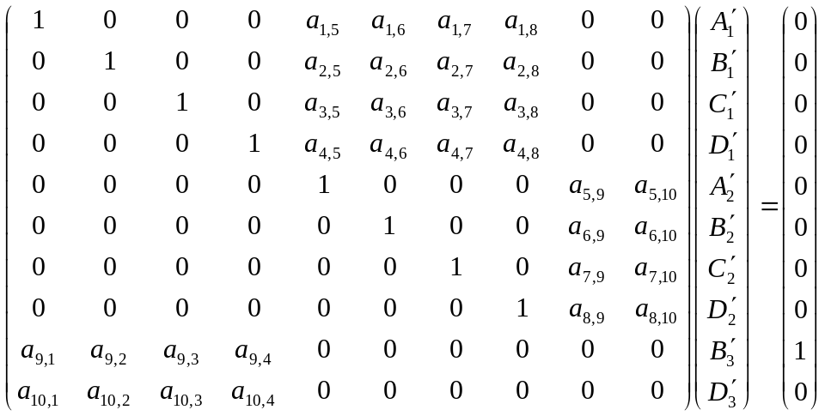 (5-20)

The vertical and shear stress equations for the top surface have been moved to the bottom of the coefficients matrix. The matrix can now be partitioned for part inversion [].

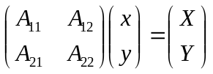

where A₁₁ is the top left 8×8 partition, A₂₂ is the bottom right 2×2 partition (all zeros), and the remaining two partitions (2x8 and 8x2 respectively) are the rectangular matrices representing the top surface and the subgrade layer. Also:

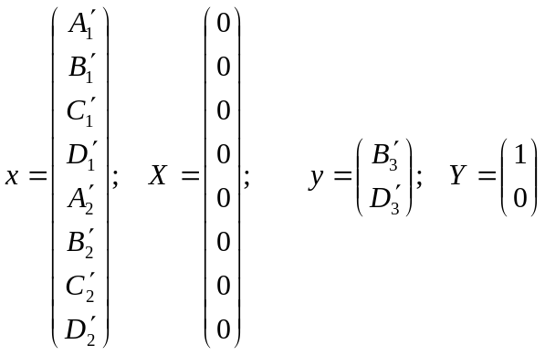

Expanding the matrix equation:

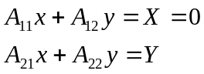

and part inverting:

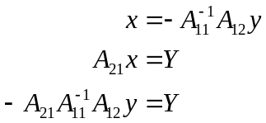

The product 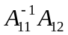 is an 8×2 matrix which can be formed by back substitution of the columns of 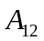 into 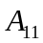.

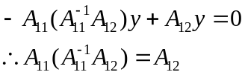

The structure of the equation 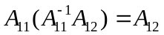for a three layer system is:

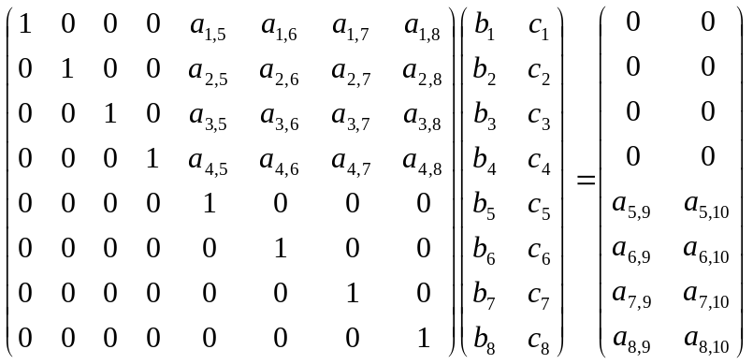 (5-21)

Where the right hand side is and b and c are the columns of .

Full inversion of A₁₁, or, equivalently, equation solution, is not necessary because the lower triangle is already zero. (Numerical efficiency can be further improved because the diagonal elements are unity and the upper triangle contains zeros.) Multiplication by A₂₁, a 2×8 matrix, gives a 2×2 matrix, 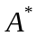, and a set of 2 equations in 2 unknowns:

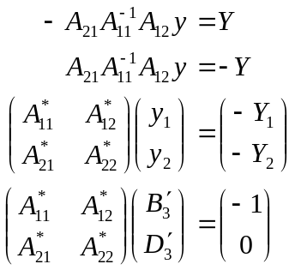 (5-22)

with solution

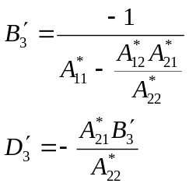 (5-23)

The rest of the constants for solving the layered elastic equations are found directly from 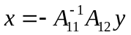. The product is stored in a separate array and the computation of each constant requires 2 multiplications and 2 additions.

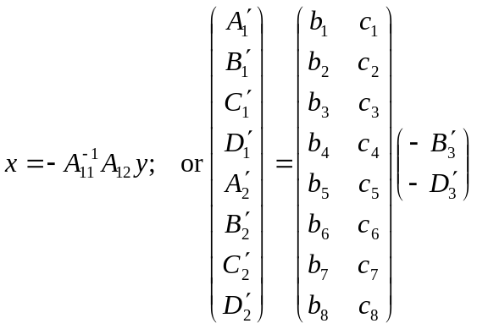 (5-24)

5.4 Integration of the Elemental Response Equations.
After solving the boundary condition equations for the constants A, B, C, and D, the elemental response equations are integrated. (The primes are dropped in the following although it should still be assumed that the origin shift is applied as necessary). Analytic integrals do not exist for the general form of the response equations and numerical integration must be used. Gauss-Laguerre integration was selected for LEAF. Using, as before, the response equation for vertical stress as an example:

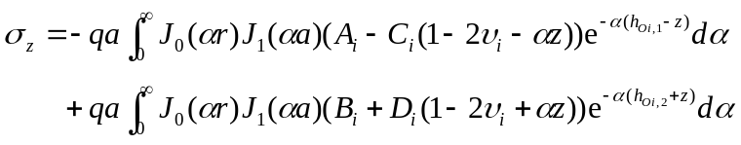 (5-24)

Defining new variables (see also equations 5-16):

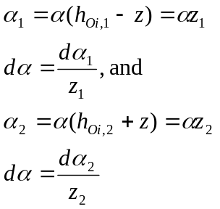 (5-25)

and substituting into the full integral gives:

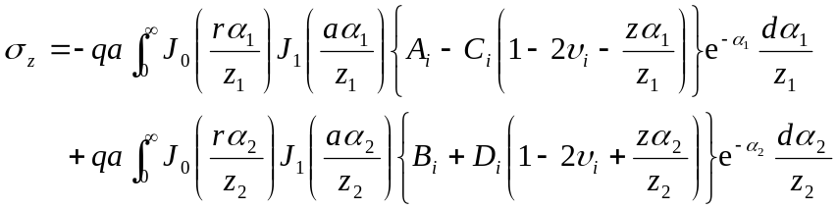 (5-26)

The Gauss-Laguerre method replaces an integral over an infinite range with a summation over a finite range (see, for example, Numerical Methods). By this method, the integral is evaluated with the expression:

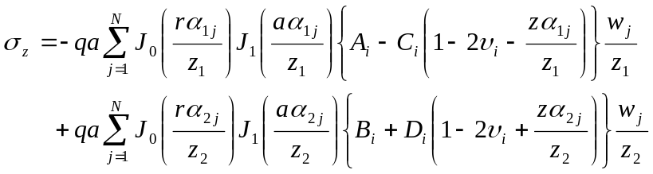 (5-27)

Where α_{1j} and α_{2j} are the abscissa values for the summation of N points and w_{j} are weights corresponding to the α_{1j} and α_{2j} values.

One of the conditions for proper convergence of the integrals is that, since the Bessel functions are periodic, the increment in the α_{j} values must be small enough to put more than two samples in each period to avoid aliasing. Figures 5-5 through 5-7 illustrate the problem. Figure 5-5 shows plots of J₀ and J₁. Figures 5-6 and 5-7 show the components of the integral of vertical strain for an extreme set of structure and load conditions. The evaluation point is at the top of the subgrade and a radius of 150 inches (3.81 m) from the center of the load. Load radius is 9.4 inches (239 mm), load pressure is 180 psi (1,240 kPa), and all interfaces are fully bonded. The material properties for the layers are shown in table 5-1.

TABLE 5-1. STRUCTURE LAYER PROPERTIES USED TO ILLUSTRATE ALIASING IN INTEGRATION OF THE BESSEL FUNCTIONS.

Layer Number | Thickness, in | Modulus, psi | Poisson’s Ratio
1 | 5 | 200,000 | 0.35
2 | 6.25 | 73,690 | 0.35
3 | 6.25 | 47,220 | 0.35
4 | 1 | 25,000 | 0.35
5 | Infinite | 22,500 | 0.35

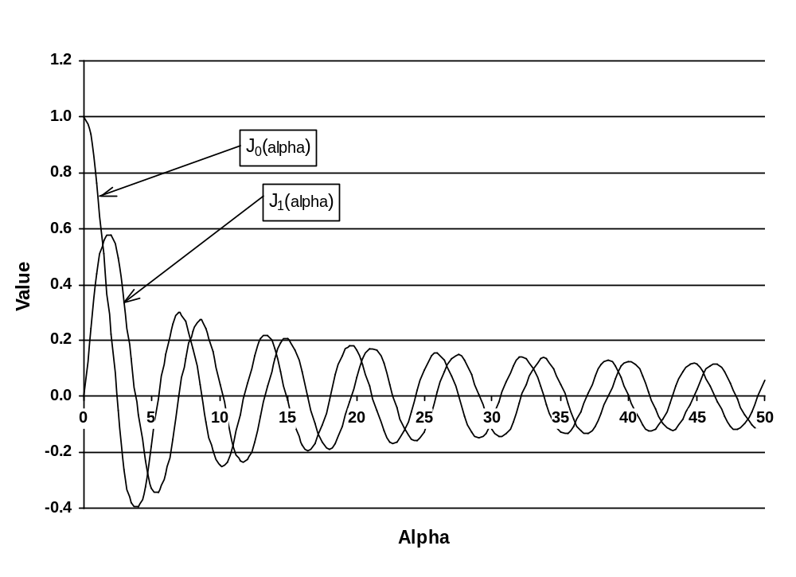
FIGURE 5-5. PLOTS OF ZERO AND FIRST ORDER BESSEL FUNCTIONS

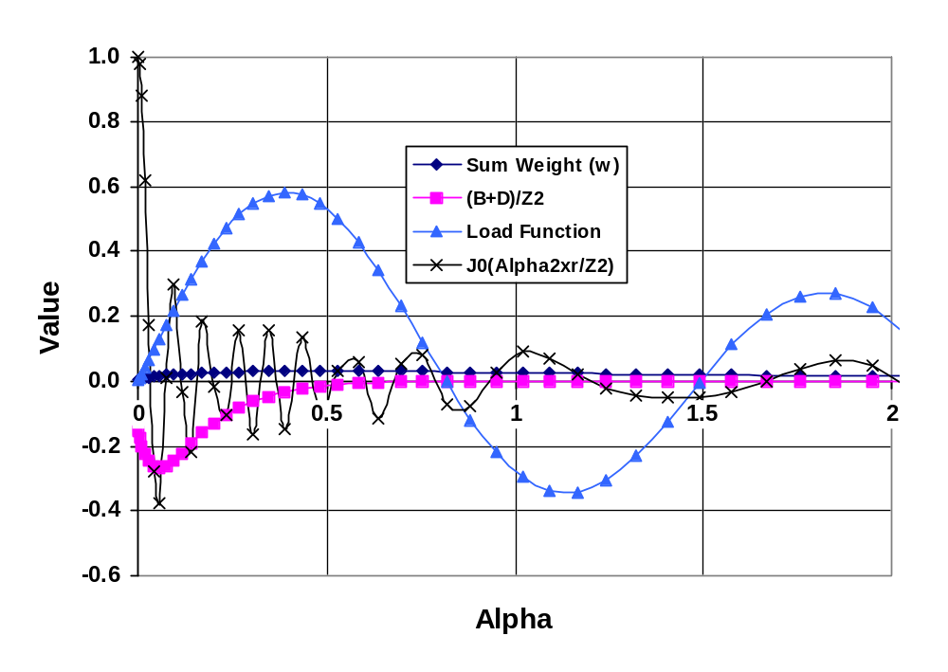
FIGURE 5-6. PLOTS OF w_{j}, (B+D)/z₂, LOAD FUNCTION J₁(αa/z₂), AND J₀(αr/z₂) FOR r = 150 INCHES AND N = 2,000

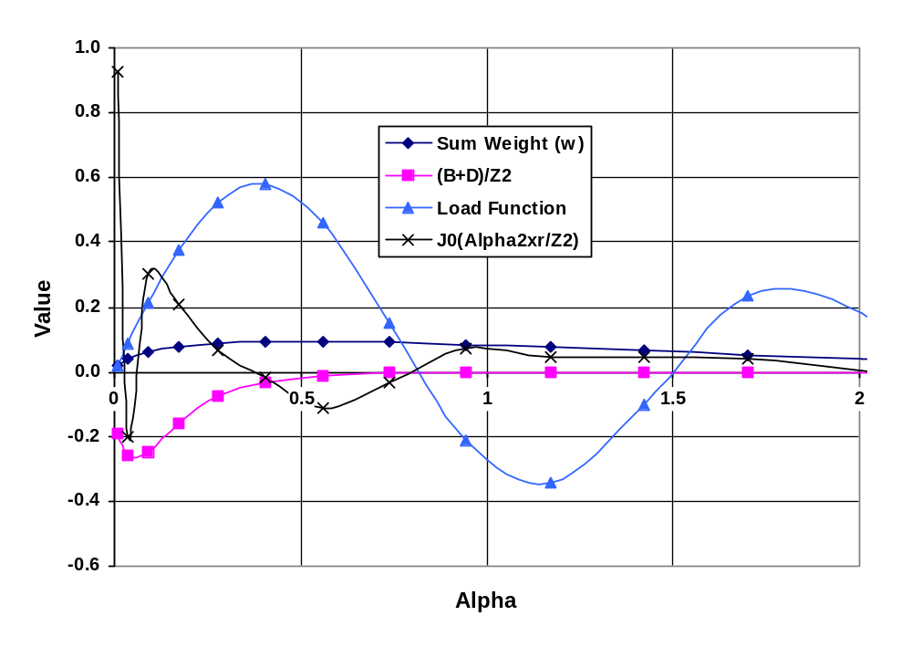
FIGURE 5-7. PLOTS OF w_{j}, (B+D)/z₂, LOAD FUNCTION J₁(αa/z₂), AND J₀(αr/z₂) FOR r = 150 INCHES AND N = 200

Each marker in the plots in figures 5-6 and 5-7 corresponds to one sample value α_{j}. In figure 5-6, with N = 2,000, it can be seen that up to α = 0.5 there are two or more sample points in each period of J₀(α₂r/z₂). Thereafter, the increments in α increase in magnitude and aliasing occurs. The aliasing would clearly cause a significant error in the summation, but the (B+D)/z₂ term decays rapidly past α = 0.5. At α = 0.48, (B+D)/z₂ = -0.018, and at α = 0.95, (B+D)/z₂ = -0.00057. In figure 5-7, with N = 200, aliasing occurs as early as the second period and the error in the full summation is unacceptably large, despite the rapid decay in the (B+D)/z₂ term. (Values for A and C are not given because they are zero when the evaluation point is located in the subgrade.)

Instead of increasing the value of N when required to achieve the desired accuracy, the strategy used in LEAF is to change the values of z₁ and z₂ by changing the values of h_{O,1} and h_{O,2} for the layer in which the evaluation point is located (see equations 5-16). The condition is that the number of sample points in one period should always be greater than 3 to 4. At the current writing, the settings in LEAF are:

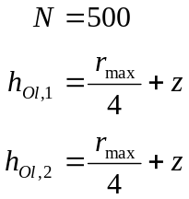 (5-28)

where:
l | refers to the evaluation layer.
z | = the distance from the top of the evaluation layer to the evaluation point.
r_{max} | = the greater of the load radius, a, and the radius to the evaluation point, r.

The value of h_{Ol,1} is changed only if the new value is greater than the existing value found from equations 5-19. If h_{Ol,1} is changed, then the values of h_{Oi,1} and h_{Oi,2} for all other layers are changed to satisfy equations 5-19 in relation to the new values in the evaluation layer.

5.5 Computer program implementation of the integrations.
Computer program implementation of Gauss-Laguerre integration is basically the same for stresses, strains, and displacements. The only difference is that the equations evaluated in the program loops are different. A primary objective was to reduce the run-time for the pavement thickness design procedures implemented in the computer program LEDFAA. These implementations require the computation of one, or, at most, two responses for a single pavement structure of rigid or flexible type with or without an overlay and with many landing gear configurations in the design aircraft mix. The strategy adopted was based on the following.

- Allow for independent computation of only those responses required for a particular type of pavement design. For example, new flexible design requires computation of only vertical strain at the top of the subgrade in order to iterate to the design thickness.

- Arrange the program loops so that individual elements of the integrand are computed the minimum number of times.

- Assume that wheel loads and tire pressures are the same for each wheel in an individual landing gear wheel-group.

An outline of the program code for vertical strain computation is given below to illustrate the implementation of the integration subroutines.

An elemental equation has not so far been derived for vertical strain. The required equation is derived from the set of equations 5-2 in either of two ways: 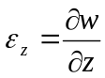 or 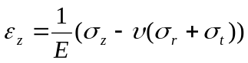. The resulting integral for computing vertical strain is:

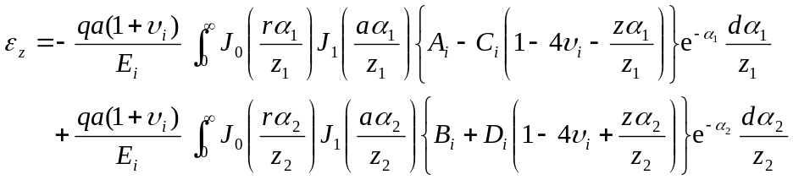 (5-29)

and the Gauss-Laguerre summation is:

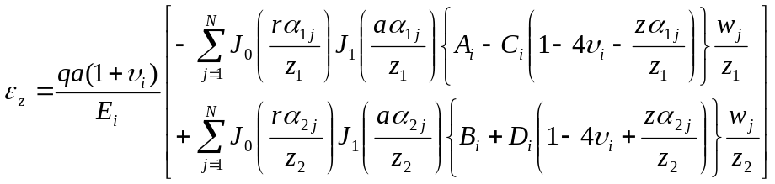 (5-30)

Data is passed to the subroutine for a single structure and a complete traffic mix. The traffic mix has NAC aircraft. An “aircraft” is a group of NTires wheels, usually representing a landing gear, but not necessarily. For example, all sixteen main landing gear wheels on a B-747 could be defined as a wheel-group. Each wheel in an aircraft wheel-group has the same wheel load and tire pressure. Each aircraft wheel-group has NevalPoints evaluation points at a single depth measured from the top of the pavement structure. Vertical strain is to be calculated at each evaluation point for each aircraft.

The expression to be summed can be split into four levels. The levels are, in decreasing order in the hierarchy:

- Under the assumption that all wheels on a landing gear have the same load and the same tire pressure, the term 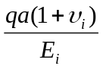 only needs to be computed once. If pressure and/or load are different on one or more of the wheels the qa multiplier would have to be moved to level 3.

- Terms like 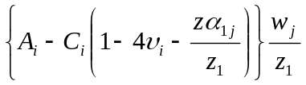 only need to be computed once every integration point. That is, they are common to every evaluation point on every wheel. These terms are also the most expensive to compute because the coefficients A, B, C, and D, must be computed from the interface equations each time. Special cases can also apply to these terms. For example, in the computation of vertical strain at the top of the subgrade only the term containing B and D needs to be computed because A and C are zero in the subgrade layer.

- Terms like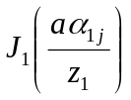, containing aα, where a is the tire radius, only need to be computed once for each wheel. That is, they are common to every evaluation point on each wheel taken separately. However, if both load and pressure are the same on all of the wheels on a gear then the J₁ terms can be shifted up to level 2.

- Terms like 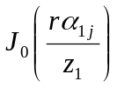 and 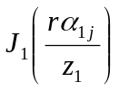must be calculated for every evaluation point on every wheel.

Computation loops in the program are therefore ordered as shown in the Visual Basic code fragment below.

‘ Depth from top of layer to evaluation point.
ZLayer = ZEval - ZInterface(I - 1)
‘ RMax = maximum of evaluation point radius or load radius.
Call SetOShifts(OShift(), I, ZLayer, RMax)

Z1 = OShift(I, 1) - ZLayer
Z2 = OShift(I, 2) + ZLayer

ZLayer1 = ZLayer / Z1
ZLayer2 = ZLayer / Z2
Poisx2 = Poissons(EvalLayer) * 2

IConstants = (EvalLayer - 1) * 4

‘ GLAlpha() = Gauss-Laguerre abscissa values.
‘ GLWeight() = Gauss-Laguerre weight values.
For IG = 1 To GLNGauss ‘ Gauss-Laguerre integration points.
StrainWIGforConverge = 0 ‘ Initialize convergence criterion.
If EvalLayer < NLayers Then ‘ A and C are zero for subgrade.
‘ Put constants for all layers in B().
Call FindConstants(GLAlpha(IG) / Z1, B(), OShift(), BadCondition)
AK = B(IConstants + 1) ‘ A for evaluation layer.
AlphaZ = GLAlpha(IG) * ZLayer1
CK = B(IConstants + 3) * (1 - Poisx2 * 2 - AlphaZ)
StrainWIG1 = -(AK - CK) * GLWeight(IG) / Z1
=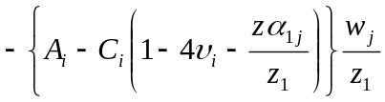
StrainWIGforConverge = (Abs(AK) + Abs(CK)) * GLWeight(IG) / Z1
End If
‘ Do the same for constants B and D.
Call FindConstants(GLAlpha(IG) / Z2, B(), OShift(), BadCondition)
BK = B(IConstants + 2)
AlphaZ = GLAlpha(IG) * ZLayer2
DK = B(IConstants + 4) * (1 - Poisx2 * 2 + AlphaZ)
StrainWIG2 = (BK + DK) * GLWeight(IG) / Z2
= 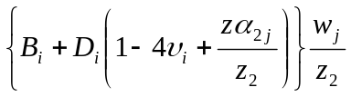
StrainWIGforConverge = StrainWIGforConverge _
+ (Abs(BK) + Abs(DK)) * GLWeight(IG) / Z2
‘ Loop over all aircraft.
For IAC = 1 To NAC
If Not ACConverged(IAC) Then
‘ Skip if all evaluation points for aircraft IAC have converged.
A2 = TireRadius(IAC, 1) ' Move down 1 loop for varying pressures.
A1 = A2 / Z1
A2 = A2 / Z2
If EvalLayer < NLayers Then
‘ First line below is load function for uniform pressure.
‘ Second line is for selectable load functions. Parabolic is currently
‘ available as an alternative to uniform pressure.
‘ J1AlphaA1 = bessj1(GLAlpha(IG) * A1) * StrainWIG1
J1AlphaA1 = LoadFunction(GLAlpha(IG) * A1) * StrainWIG1
=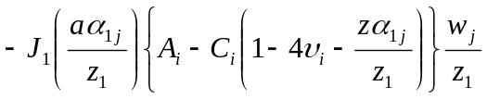
End If
J1AlphaA2 = LoadFunction(GLAlpha(IG) * A2) * StrainWIG2
=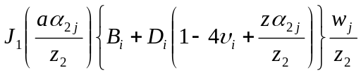
‘ Loop over all tires on each gear (aircraft).
For ITire = 1 To NTires(IAC)
‘ Loop over all evaluation points on each gear (aircraft).
For IEval = 1 To NEvalPoints(IAC)
‘ R2 is Horizontal distance between evaluation point and center of
‘ tire. Previously computed.
R2 = Radius(IAC, ITire, IEval)
R1 = R2 / Z1
R2 = R2 / Z2
If EvalLayer < NLayers Then
J0AlphaR1 = bessj0(GLAlpha(IG) * R1)
=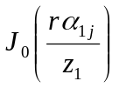
End If
J0AlphaR2 = bessj0(GLAlpha(IG) * R2)
=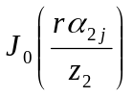
‘ StrainWI = elemental strain for current integration point.
StrainWI = J0AlphaR1 * J1AlphaA1 + J0AlphaR2 * J1AlphaA2
‘ Accumulate sum at each evaluation point for each gear.
StrainW(IAC, IEval) = StrainW(IAC, IEval) + StrainWI
‘ Convergence criterion always greater than zero and conservative.
If Abs(StrainWIGforConverge / StrainW(IAC, IEval)) < 0.00001 Then
If Not Converged(IAC, ITire, IEval) Then
‘ Keep track of the number of evaluation points which have
‘ converged.
NEvalsConverged(IAC, ITire) = NEvalsConverged(IAC, ITire) + 1
If NEvalsConverged(IAC, ITire) = NEvalPoints(IAC) Then
‘ All evaluation points for tire Itire on aircraft IAC have
‘ converged.
NtiresConverged(IAC) = NtiresConverged(IAC) + 1
IterationstoConverge = IG
End If
Converged(IAC, Itire, IEval) = True
If NtiresConverged(IAC) = Ntires(IAC) Then
ACConverged(IAC) = True
NACConverged = NACConverged + 1
End If
End If
End If
Next IEval
Next ITire
End If
Next IAC
If NACConverged = NAC Then
‘ All evaluation points on all aircraft have converged.
NConverge = IG
Exit For ‘ Quit integration.
Next IG

For IAC = 1 To NAC
Factor = TirePress(IAC, 1) * TireRadius(IAC, 1)
Factor = Factor * (1 + Poissons(EvalLayer)) / Youngs(EvalLayer)
=
For IEval = 1 To NEvalPoints(IAC)
‘ Apply final factor to compute strains at all evaluation points.
StrainW(IAC, IEval) = StrainW(IAC, IEval) * Factor
If StrainW(IAC, IEval) > StrainWmax(IAC) Then
‘ Maximum strain for each gear (aircraft).
StrainWmax(IAC) = StrainW(IAC, IEval)
End If
Next Ieval
Next IAC

The second IAC loop is more complicated when computing horizontal responses because the responses at a single evaluation point from each tire must be transformed into rectangular coordinates before they can be summed. Vertical responses can be summed directly in the first loop as shown.

For the vertical strain integral, convergence is determined from the expression:

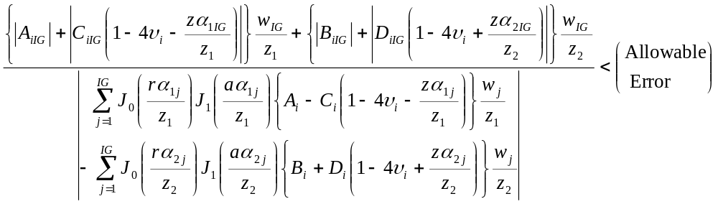 (5-31)

Where IG is the current integration step number. Convergence is assumed when the inequality is satisfied. Similar expressions are derived for the other integrals.

The convergence criterion is based on the following observations:

The Bessel functions are oscillatory functions and including them in the convergence criterion can lead to a zero of a Bessel function prematurely terminating the integration unless some kind of running total is used. All Bessel functions have a decaying envelope which is always between +/- 1. An asymptotic approximation is 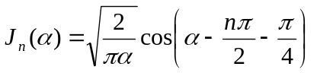for α > 25. The multiplying factor 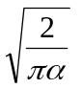 has values of 0.16 and 0.08 for α = 25 and 100 respectively. The envelope therefore decays slowly and has very little influence on convergence of the integrals except when the evaluation depth is close to the top of the top layer. Since the absolute value of the magnitude of the bessel functions is always less than 1, ignoring the Bessel functions in convergence is always conservative.
It is likely that the factors 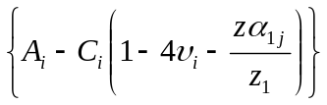 and 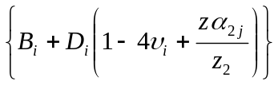 are never zero, but this has not been proved. Taking the sum of the absolute values will, under this assumption, therefore guarantee that false termination of the integration will not occur, and also gives a conservative convergence criterion.

5.6 Fully Unbonded Interfaces.
With a fully unbonded interface, the interface stiffness is zero. Radial/vertical shear stress is therefore zero and the contacting layers are uncoupled in the boundary condition equations. Physically, the layers are completely free to slide across each other and one of the conditions for response in one of the layers must be independent of the corresponding response condition in the other layer.

Solution of the boundary condition equations using an equation solver with full pivoting works, but is slow. For an efficient solution, the offending equations must be eliminated from the boundary condition equations for each interface. That is, rewrite the equations as three equations in six unknowns and reformulate for solution. But this would give a special condition in the implementation and consequent complication in the computer program.

Setting the interface stiffness to a large enough value in the equations as formulated above gives a numerically stable solution and is also more reasonable physically (concrete pavement slabs do not freely slide on the supporting layers except in exceptional circumstances). However, selecting a standard interface stiffness for “fully unbonded” is difficult because physical conditions are generally unknown for this construction method and the spring model is probably a poor representation of the physical conditions. Tests were run with the layered elastic formulation given above for new rigid and unbonded overlaid rigid pavement structures. Results for a typical new rigid case (table 5-2), with a single load of 50,000 pounds (222.4 kN) (radius of 9.4 inches (239 mm) and pressure of 180 psi (1,240 kPa )) are shown in table 5-3.

TABLE 5-2. RIGID PAVEMENT STRUCTURE LAYER PROPERTIES USED TO ILLUSTRATE EFFECTS OF INTERFACE PROPERTIES WITH ONE UNBONDED INTERFACE

Layer Number | Thickness, in | Modulus, psi | Poisson’s Ratio | Interface
1 | 14 | 4,000,000 | 0.15 | fully unbonded
2 | 6 | 700,000 | 0.20 | fully bonded
3 | 6 | 35,430 | 0.35 | fully bonded
4 | Infinite | 15,000 | 0.35

TABLE 5-3. HORIZONTAL AND SHEAR STRESSES WITH DIFFERENT PARAMETERS AT INTERFACE 1 FOR TWO DIFFERENT EVALUATION POINT RADII

Interface  Stiffness, k, psi | Interface Parameter, l | X_{E}* = 0, Y_{E} = 10, Z_{E} = 14** |  | X_{E} = 0, Y_{E} = 100, Z_{E} = 14*
Interface  Stiffness, k, psi | Interface Parameter, l | Horizontal Stress, σ_{x}, psi | Shear Stress, τ_{yz}, psi | Horizontal Stress, σ_{x}, psi | Shear Stress, τ_{yz}, psi
10⁻¹² | 10⁻¹² | 6.59 | 8.45×10⁰ | 10.04 | 1.61×10⁰
10⁻¹¹ | 10⁻¹¹ | 41.47 | 4.89×10² | 53.44 | -1.11×10²
10⁻¹⁰ | 10⁻¹⁰ | 280.09 | -4.84×10⁰ | 24.21 | -1.19×10⁰
10⁻⁹ | 10⁻⁹ | 260.56 | 1.06×10⁻¹ | 22.80 | -9.77×10⁻³
10⁻⁸ | 10⁻⁸ | 258.18 | -9.55×10⁻³ | 23.02 | -1.81×10⁻²
10⁻⁷ | 10⁻⁷ | 258.02 | 1.95×10⁻³ | 23.01 | 8.79×10⁻⁴
10⁻⁶ | 10⁻⁶ | 258.01 | -1.04×10⁻⁴ | 23.01 | -1.91×10⁻⁵
10⁻⁵ | 10⁻⁵ | 258.01 | -2.81×10⁻⁴ | 23.01 | -2.93×10⁻⁶
10⁻⁴ | 10⁻⁴ | 258.01 | -2.86×10⁻⁴ | 23.01 | -6.58×10⁻⁶
0.0010 | 10⁻³ | 258.01 | -2.86×10⁻⁴ | 23.01 | -5.07×10⁻⁶
0.0101 | 10⁻² | 258.02 | -2.78×10⁻⁴ | 23.01 | 6.34×10⁻⁶
0.1111 | 10⁻¹ | 258.02 | -1.86×10⁻⁴ | 23.02 | 1.32×10⁻⁴
1.0 | 0.50 | 258.04 | 6.17×10⁻⁴ | 23.03 | 1.24×10⁻³
3.0 | 0.75 | 258.16 | 2.43×10⁻³ | 23.12 | 3.77×10⁻³
infinity | 1.00 | 166.21 | -1.49×10¹ | 16.15 | 8.74×10⁻¹
** X_{E}, Y_{E}, and Z_{E} are the coordinates of the evaluation point
* Nominal value. Value used = 13.999986

Good numerical stability is shown for all values of the interface parameter in the range 10⁻¹ to 10⁻⁷. A default value of l = 0.01 is currently used as the default for new rigid pavements, which have one unbonded interface under the concrete slab (layer 1).

The value of the evaluation depth, Z_{E}, determines which layer will be selected for computing the responses. For the example given, input values less than 14 inches (355.6 mm) would be expected to select layer 1 and input values greater than 14 inches (355.6 mm) would be expected to select layer 2. However, due to numerical round off effects, this is not necessarily so. Table 5-4 shows the layer selected and the shear stress at the evaluation depth for evaluation depths close to 14 inches (355.6 mm) and with the interface parameter set to a value of 0.01.

TABLE 5-4. COMPARISON OF INTERFACE SHEAR STRESSES FOR FULLY SLIDING AND FULLY BONDED INTERFACE PARAMETER VALUES

Evaluation Depth | Evaluation Layer | τ_{yz} with l = 0.01 | τ_{yz} with l = 1.0
13.999900 | 1 | -2.04×10⁻³ | -14.8810
13.999986 | 1 | -2.78×10⁻⁴ | -14.8798
13.999987 | 2 | 2.59×10⁻⁵ | -14.8798
14.000072 | 2 | 8.26×10⁻⁵ | -14.8795

Shear stress is also shown with the interface parameter set to a value of one. Good continuity of shear stress is shown at the transition from layer 1 to layer 2.

Rigid pavements with an unbonded overlay are represented in the current LEDFAA design procedure as structures with two unbonded interfaces; one under the new slab and one under the existing concrete layer. With this condition in the layered elastic equations, stiffnesses of close to 1.0 are required at both interfaces in order to obtain reasonable numerical stability combined with sufficiently accurate stress computation (the interface parameter has a value of 0.5 when stiffness has a value of 1.0). Shear stresses at the interfaces are of the order of 10⁻³ psi (6.9 Pa) with k = 1.0. The current default value in LEDFAA of k for rigid-over-rigid overlay pavements is 1.0 lb/in³ (271 kN/m³).

Results for a typical overlay structure (table 5-5) are shown in table 5-6.

TABLE 5-5. RIGID PAVEMENT STRUCTURE LAYER PROPERTIES USED TO ILLUSTRATE EFFECTS OF INTERFACE PROPERTIES WITH TWO UNBONDED INTERFACES

Layer Number | Thickness, in | Modulus, psi | Poisson’s Ratio | Interface
1 | 12 | 4,000,000 | 0.15 | fully unbonded
2 | 14 | 1,500,000 | 0.15 | fully unbonded
3 | 6 | 250,000 | 0.35 | fully bonded
4 | 6 | 35,430 | 0.35 | fully bonded
5 | Infinite | 6,000 | 0.35

TABLE 5-6. HORIZONTAL AND SHEAR STRESSES WITH DIFFERENT PARAMETERS AT INTERFACES 1 AND 2

Interface  Stiffness, k, lb/in³ | Interface Parameter, l | X_{E} = 0, Y_{E} = 10, Z_{E} = 12* |  | X_{E} = 0, Y_{E} = 10, Z_{E} = 26**
Interface  Stiffness, k, lb/in³ | Interface Parameter, l | Horizontal Stress, psi | Shear Stress, psi | Horizontal Stress, psi | Shear Stress, psi
10⁻⁵ | 10⁻⁵ | 442.57 | 6.67×10¹ | -0.17 | 1.50×10⁻⁸
10⁻⁴ | 10⁻⁴ | -89.62 | 2.61×10¹ | 425.63 | 1.15×10⁻⁵
0.0010 | 10⁻³ | 253.43 | 2.18×10¹ | 83.94 | -6.32×10⁻⁵
0.0101 | 10⁻² | 261.55 | 7.65×10⁻¹ | 103.92 | 1.35×10⁻⁴
0.1111 | 10⁻¹ | 268.36 | 3.91×10⁻³ | 104.06 | -1.94×10⁻⁵
1.0 | 0.50 | 269.04 | 5.41×10⁻³ | 103.04 | 8.60×10⁻⁴
3.0 | 0.75 | 269.30 | 3.50×10⁻³ | 102.97 | 2.85×10⁻³
infinity | 1.00 | 468.92 | -2.77×10⁻³ | 61.56 | -2.53×10⁰
* Nominal value. Value used = 11.999988
** Nominal value. Value used = 25.999774

5.7 Computation of Responses.

5.7.1 LEDFAA and Backcalculation Responses.
LEDFAA currently requires the computation of three individual responses in the thickness design procedures.

- Vertical strain at the top of the subgrade as the criterion of shear failure in the subgrade of a flexible pavement.

- Horizontal strain at the bottom of the surface asphalt layer as the criterion of fatigue failure in the surface asphalt layer of a flexible pavement.

- Horizontal stress at the bottom of the surface PCC layer as the criterion of fatigue failure in the surface PCC layer of a new rigid pavement and horizontal stress at the bottom of the existing PCC layer as the criterion of fatigue deterioration in the existing PCC layer of an overlaid rigid pavement.

However, elemental equations for responses of the axi-symmetric layered elastic system include only vertical stress, σ_{z}, radial stress, σ_{r}, tangential stress, σ_{t}, vertical-radial shear stress, τ_{zr}, vertical deflection, w, and radial deflection, u. The desired responses have to be computed indirectly from the available response equations.

The derivation of the integral equation for vertical strain has already been given:

and a subroutine listed for independent computation of vertical strain.

Horizontal stress is computed from the X and Y components of the radial and tangential stresses, σ_{r} and σ_{t}.

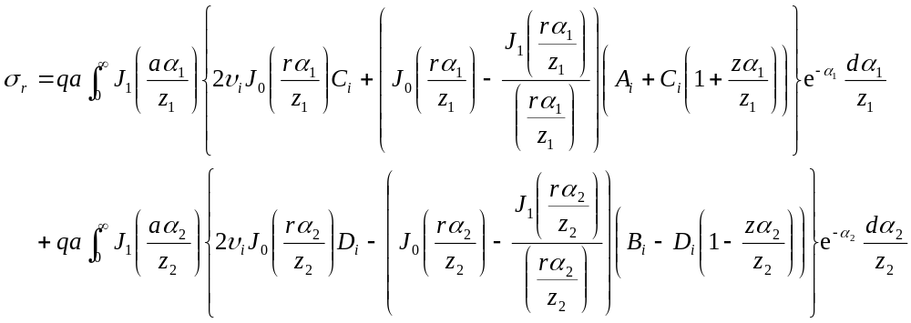 (5-32)

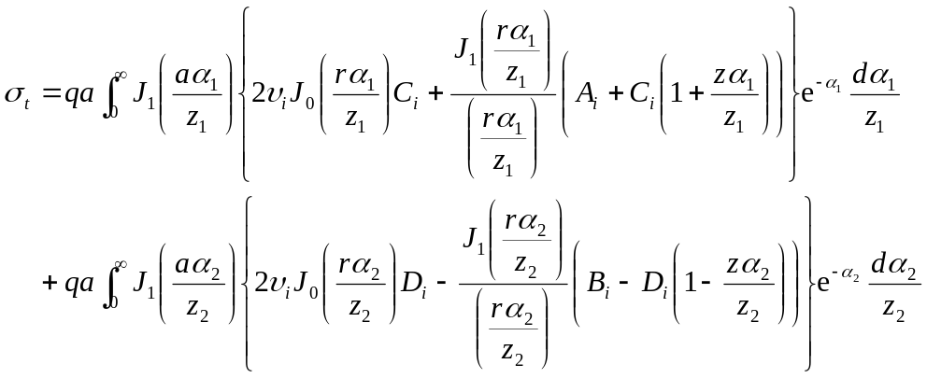 (5-33)

If
x_{E} , y_{E} | = X and Y coordinates of the evaluation point
x_{T} , y_{T} | = X and Y coordinates of the center of the tire load
R | = ((x_{E} - x_{T})² + (y_{E} - y_{T})²)^{1/2}
 | = radius from the center of the tire load to the evaluation point
cos θ | = (x_{E} - x_{T}) / R
sin θ | = (y_{E} - y_{T}) / R

Then
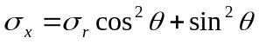
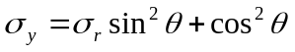
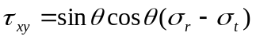
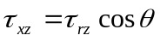
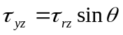
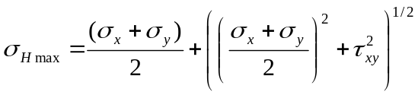= maximum horizontal stress
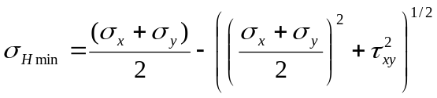= minimum horizontal stress

The subroutine for horizontal stress sums the σ_{x}, σ_{y}, and τ_{xy} components at each evaluation point for all of the tires in a wheel group. The total sum for each evaluation point is then converted to the maximum horizontal stress at that evaluation point.

Horizontal strain is, currently, only required once per design as a check for fatigue failure of the asphalt surface layer. This response is therefore computed from the components of “all responses” as described below (see equation 5-34 below).

Computation of vertical deflection is also required in a separate backcalculation computer program. This is directly computed from the integration of the elemental equation for vertical deflection.

5.7.2 All Responses.
The final step in any design in LEDFAA is to compute all structural responses at each evaluation point for each aircraft wheel group and to write these responses to a text file for reference by the designer. LEAF therefore has an option to compute, and return, all stress, strain, and deflection components in rectangular coordinates and all principal stresses and strains.

First, σ_{x}, σ_{y}, τ_{xy}, τ_{xz}, τ_{yz}, and ε_{z} are computed from the dedicated subroutines. The remaining stress and strain components are then computed from the following expressions.

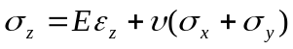
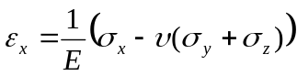
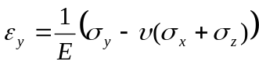
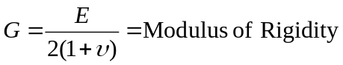
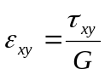
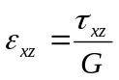
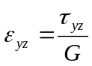

Principal stresses and strains are computed using the procedures given in Irons [Error: Reference source not found].

Vertical deflection, δ_{z}, is computed using the dedicated subroutine.

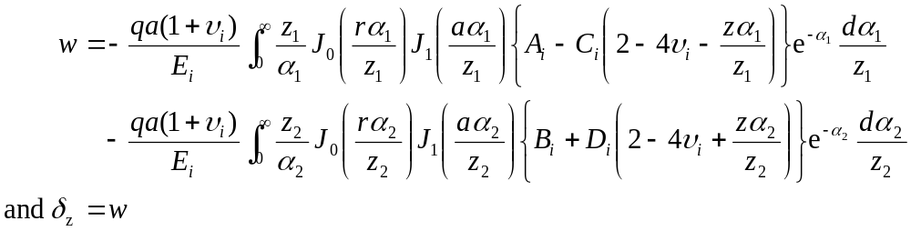 (5-34)

Horizontal deflection is computed with another dedicated subroutine (finding horizontal deflection as a component in all of the responses is its only use). Radial deflection, u, is computed first and then transformed to rectangular coordinates.

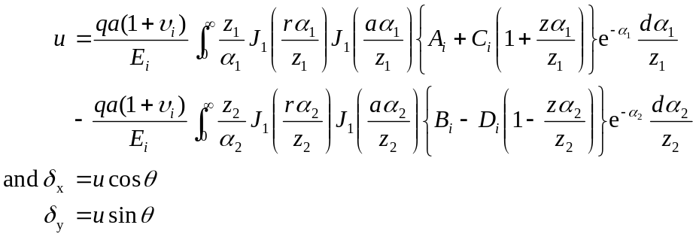 (5-35)
The equations for w and u both have α as a divisor inside the integral sign. The equations for stress and strain do not. This probably accounts for the better convergence of the displacement equations for small values of z_{eval} as demonstrated below.

5.8 Testing Against Other Methods.
Considering the wide range of load and structural conditions encountered in airport pavement structures, it is very difficult to comprehensively test a layered elastic computer program for accuracy and stability. Tests are described in this section covering performance when simulating a uniform half-space, with and without interface bonding, and when simulating a new rigid pavement structure. A run time comparison with JULEA is also described.

5.8.1 Response Comparisons.
The first concern is with convergence when the evaluation point is close to the surface. The uniform pressure circular load is a discontinuous function applied to the surface and causes slow decays in the transform domain. (Rapid changes in a function with respect to radius have slow changes with respect to the Hankel domain variable α. The same kind of reciprocal behavior is also true of Laplace and Fourier transforms.) JULEA uses an extrapolation technique to sidestep the poor convergence when the evaluation point is close to the surface. However, the offsets added in LEAF improve convergence under these circumstances and the inaccuracies in response computation are not serious, particularly for the computations made within the top layer for use in LEDFAA or for FWD backcalculation. A contrived structure (table 5-7) representing a uniform half-space is used to compare LEAF computations with Boussinesq analytic solutions for responses under the load center.

TABLE 5-7. STRUCTURE LAYER PROPERTIES USED TO ILLUSTRATE COMPARISON BETWEEN BOUSSINESQ HALF-SPACE RESPONSES AND LEAF RESPONSES

Layer Number | Modulus, psi | Thickness, in | Poisson’s Ratio | Interface
1 | 2,000 | 5 | 0.25 | fully-bonded
2 | 2,000 | 18 | 0.25 | fully-bonded
3 | 2,000 | 1 | 0.25 | fully-bonded
4 | 2,000 | infinite | 0.25

The load is 5 psi (34.5 kPa) on a radius of 10 inches (254 mm). The results are shown in tables 5-8 through 5-10.

TABLE 5-8. COMPARISON BETWEEN BOUSSINESQ AND LEAF – VERTICAL DEFLECTION

z_{eval} | Boussinesq | LEAF | % Difference
0.0 | 0.0468750 | 0.0468960 | 0.045
0.01 | 0.0468593 | 0.0468791 | 0.042
0.1 | 0.0467190 | 0.0467262 | 0.018
0.2 | 0.0465594 | 0.0465564 | -0.0064
0.5 | 0.0460743 | 0.0460744 | 0.00022
1.0 | 0.0452353 | 0.0452355 | 0.00044

TABLE 5-9. COMPARISON BETWEEN BOUSSINESQ AND LEAF – VERTICAL STRESS

z_{eval} | Boussinesq | LEAF | % Difference
0.0 | -5.00000 | -5.38574 | 7.715
0.01 | -4.99999 | -5.38065 | 7.613
0.1 | -4.99999 | -5.18782 | 3.757
0.2 | -4.99996 | -4.92312 | -1.537
0.5 | -4.99938 | -4.99854 | -0.096
1.0 | -4.99507 | -4.99507 | 0.0

TABLE 5-10. COMPARISON BETWEEN BOUSSINESQ AND LEAF – HORIZONTAL STRESS

z_{eval} | Boussinesq | LEAF | % Difference
0.0 | -3.75000 | -4.03931 | 7.715
0.01 | -3.74375 | -3.95939 | 5.760
0.1 | -3.74375 | -3.67988 | -0.207
0.2 | -3.62504 | -3.64225 | 0.475
0.5 | -3.43820 | -3.43851 | 0.009
1.0 | -3.13056 | -3.13056 | 0.0

The accuracy of vertical deflection at the surface is very good and can be used with confidence in FWD backcalculations. Comparison with JULEA and BISAR also shows that vertical deflections computed at the surface by LEAF are accurate to the same degree for arbitrary horizontal offsets of the evaluation point.

Reasonably large errors are present for stresses computed at the surface. Although these errors are less than 10 percent, it is not known how the errors may change for different configurations of the structure. The error is very small one half of an inch (13 mm) below the surface. LEDFAA does not require the computation of any stress or strain response in the upper half of the top layer and the inaccuracy is not of significance for the LEDFAA application. FWD backcalculation requires only vertical deflection at the surface, and this response is accurate with LEAF.

Tables 5-11 through 5-13 show additional comparisons with Boussinesq and JULEA for evaluation points deeper in the structure. Particular attention is paid to performance close to the interfaces. The structure and load are the same as above.

TABLE 5-11. COMPARISON BETWEEN BOUSSINESQ, LEAF, AND JULEA, FULLY BONDED INTERFACES, VERTICAL DISPLACEMENT, INCHES

z_{eval} | Boussinesq | LEAF | JULEA
0.00 | 0.0468750 | 0.0468960 | 0.0470
4.99 | 0.0376274 | 0.0376276 | 0.0376
5.01 | 0.0375878 | 0.0375880 | 0.0376
10.00 | 0.0285692 | 0.0285693 | 0.0186
22.99 | 0.0157157 | 0.0157159 | 0.0157
23.01 | 0.0157041 | 0.0157042 | 0.0157
23.99 | 0.0151497 | 0.0151497 | 0.0151
24.01 | 0.0151387 | 0.0151388 | 0.0151

TABLE 5-12. COMPARISON BETWEEN BOUSSINESQ, LEAF, AND JULEA, FULLY BONDED INTERFACES, HORIZONTAL STRESS, PSI

z_{eval} | Boussinesq | LEAF | JULEA
0.00 | -3.750000 | -4.03931 | -3.75
4.99 | -1.18192 | -1.18192 | -1.18
5.01 | -1.17513 | -1.17513 | -1.16
10.00 | -0.214466 | -0.214466 | -0.215
22.99 | 0.0535116 | 0.0535116 | 0.0534
23.01 | 0.0535043 | 0.0535043 | 0.0534
23.99 | 0.0529210 | 0.0529210 | 0.0527
24.01 | 0.0529050 | 0.0529050 | 0.0527

TABLE 5-13. COMPARISON WITH BOUSSINESQ AND JULEA, FULLY BONDED INTERFACES, VERTICAL STRAIN, MILLI-STRAIN

z_{eval} | Boussinesq | LEAF | JULEA
0.00 | -1.56250 | -1.68304 | -1.57
4.99 | -1.98198 | -1.98198 | -1.98
5.01 | -1.98154 | -1.98154 | -2.00
10.00 | -1.56250 | -1.56250 | -1.56
22.99 | -0.585598 | -0.585598 | -0.585
23.01 | -0.584797 | -0.584796 | -0.584
23.99 | -0.547276 | -0.547276 | -0.546
24.01 | -0.546545 | -0.546545 | -0.546

LEAF shows good performance for this test case.

Tables 5-14 through 5-16 show comparisons with JULEA for the first interface (between the first and second layers) fully unbonded. Otherwise the test case is the same as above.

TABLE 5-14. COMPARISON WITH JULEA, FIRST INTERFACE FULLY UNBONDED, VERTICAL DISPLACEMENT, INCHES

z_{eval} | LEAF | JULEA
0.00 | 0.0571609 | 0.0572
4.99 | 0.0452916 | 0.0453
5.01 | 0.0452456 | 0.0453
10.00 | 0.0359154 | 0.0359
22.99 | 0.0188570 | 0.0189
23.01 | 0.0188411 | 0.0188
23.99 | 0.0180932 | 0.0181
24.01 | 0.0180784 | 0.0181

TABLE 5-15. COMPARISON WITH JULEA, FIRST INTERFACE FULLY UNBONDED, HORIZONTAL STRESS, PSI

z_{eval} | LEAF | JULEA
0.00 | -3.28587 | -3.02
4.99 | 1.64421 | 1.63
5.01 | -3.83583 | -3.86
10.00 | -1.06495 | -1.07
22.99 | 0.0253571 | 0.0261
23.01 | 0.0255122 | 0.0262
23.99 | 0.0319912 | 0.0324
24.01 | 0.0321025 | 0.0325

TABLE 5-16. COMPARISON BETWEEN LEAF AND JULEA, FIRST INTERFACE FULLY UNBONDED, VERTICAL STRAIN, MILLI-STRAIN

z_{eval} | LEAF | JULEA
0.00 | -1.87157 | -1.75
4.99 | -2.97356 | -2.96
5.01 | -1.60355 | -1.62
10.00 | -1.90294 | -1.90
22.99 | -0.79165 | -0.792
23.01 | -0.79051 | -0.791
23.99 | -0.73696 | -0.737
24.01 | -0.73591 | -0.736

The comparison with JULEA is good except for stress and strain at the surface. This error is ignored as discussed above.

The structure used in the above comparisons is representative of a uniform half-space. Rigid pavement structures represent the extreme in non-uniform layered systems. Table 5-17 gives the parameter values for a typical rigid pavement structure. A 50,000 lb (222 kN) load with 180 psi (1,240 kPa) contact pressure was applied to the structure. Vertical and horizontal responses in the top (PCC) layer are shown in figures 5-8 through 5-11 for LEAF, JULEA, and Bisar.

TABLE 5-17. TYPICAL RIGID PAVEMENT STRUCTURE USED TO ILLUSTRATE TOP LAYER STRESS DISTRIBUTION

Layer Number | Modulus, psi | Thickness, in | Poisson’s Ratio | Interface
1 | 4,000,000 | 14 | 0.15 | fully-unbonded
2 | 700,000 | 6 | 0.20 | fully-bonded
3 | 35,430 | 6 | 0.35 | fully-bonded
4 | 15,000 | infinite | 0.35

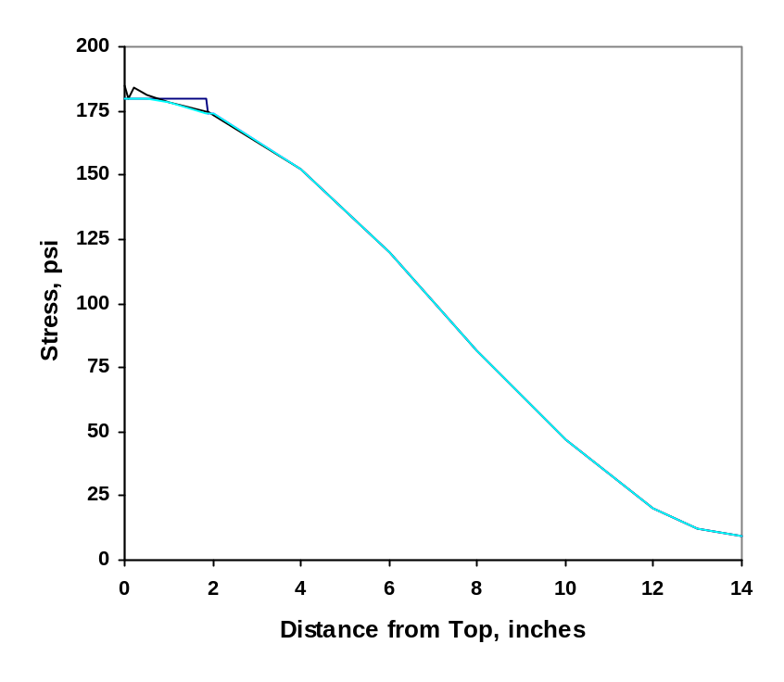
FIGURE 5-8. VERTICAL STRESS IN THE TOP LAYER OF A RIGID PAVEMENT STRUCTURE (see figure 5-9 for legend)

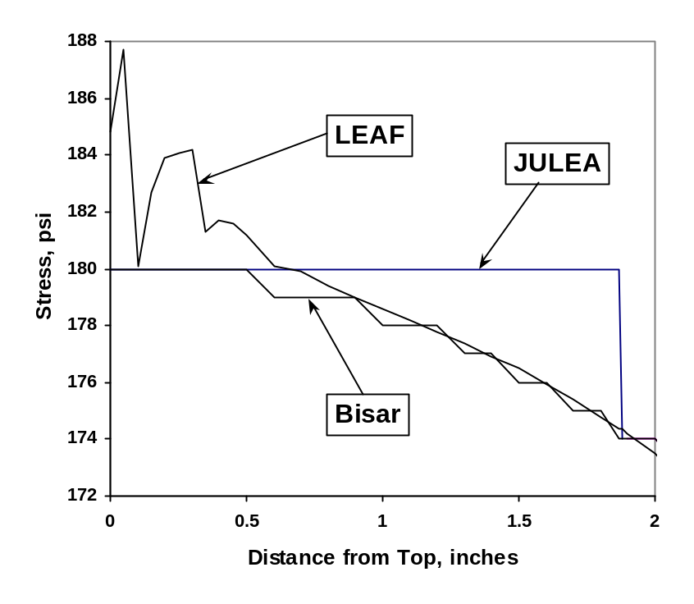
FIGURE 5-9. FIGURE 5-8 EXPANDED OVER THE TOP 2 INCHES

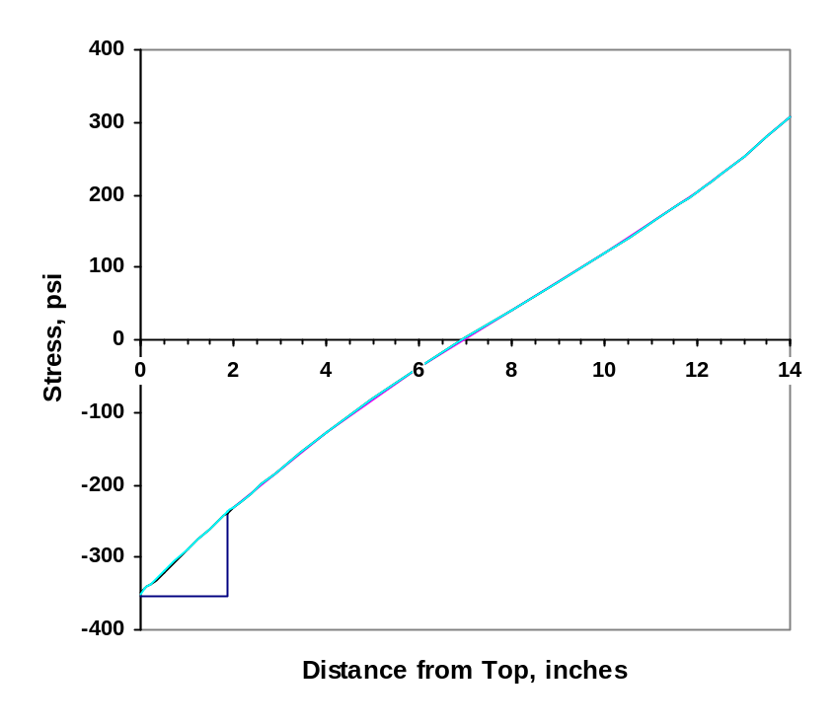
FIGURE 5-10. HORIZONTAL STRESS IN THE TOP LAYER OF A RIGID PAVEMENT STRUCTURE(see figure 5-11 for legend)

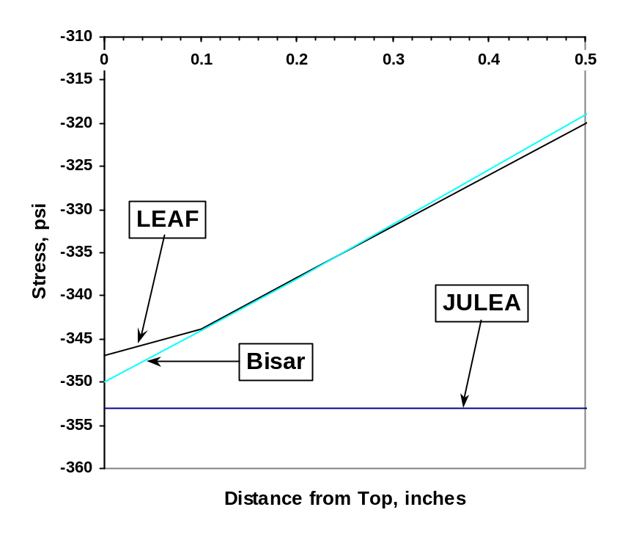
FIGURE 5-11. FIGURE 5-10 EXPANDED OVER THE TOP 0.5 INCHES

5.8.2 Run time Comparison.
A run time comparison was made against JULEA using a modified version of LEDFAA which has JULEA and leaf selectable as the layered elastic computational routine. The version of leaf used in the comparison did not have the additional offsets and run times were probably less than they will be with the version of leaf described in this document. However, the trends shown in the results are still valid. New runtime tests will be made when the new version of leaf has been fully integrated into LEDFAA.

Figure 5-12 shows complete run times for execution of the “Life” button in LEDFAA for a set of test cases with 20 B-777 aircraft in the traffic mix. The test cases included up to 16 layers in a flexible pavement structure with all interfaces fully bonded. The version of JULEA used in the comparison was in Fortran compiled as a Windows dynamic link library. LEAF was fully integrated into the Visual Basic code for LEDFAA and the complete program compiled into native code under VB 5.0. Times shown are for total runtime, including all LEDFAA housekeeping and CDF computation, etc.

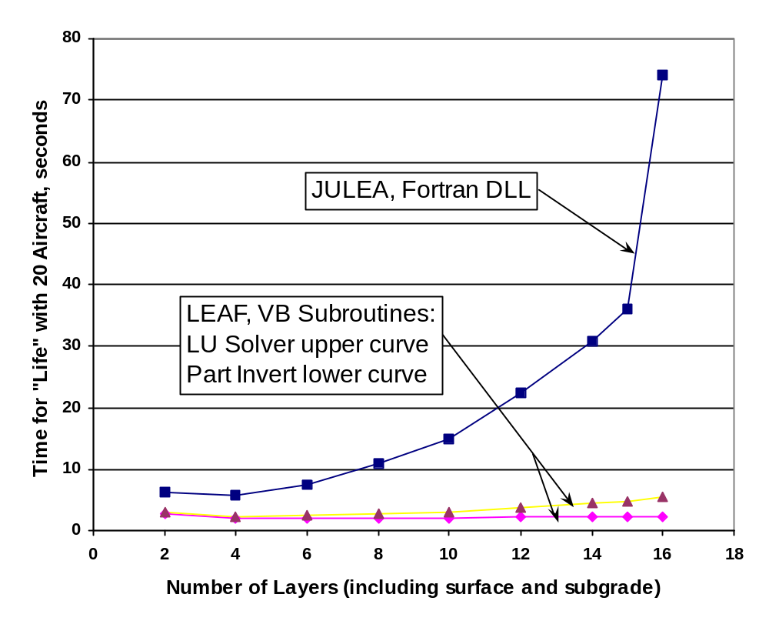
FIGURE 5-12. RUNTIME COMPARISON BETWEEN JULEA AND LEAF – TIMES FOR LEDFAA SOLUTIONS

General observations are:

- LEAF is more efficient than JULEA for all configurations tested (although it is not known in detail what influence the Fortran versus Visual Basic implementations had on runtimes).

- Runtimes for JULEA increase significantly as the number of layers increase.

- Part inversion gives significant benefit only with large numbers of layers.

. Irons, Bruce, and Ahmad, Sohrab, Techniques of Finite Elements, Prentice Hall, 1981.

