Statement of
Henri Bisson, Deputy Director
Bureau of Land Management
Before the House Committee on Natural Resources
Subcommittee on National Parks, Forest and Public Lands
“The Impacts of Unmanaged Off-Road Vehicles on Federal Land”
March 13, 2008

Introduction
Thank you for inviting me to testify regarding motorized recreational use on the public lands. My testimony today will highlight the ongoing efforts within the Bureau of Land Management (BLM) and the National Park Service (NPS) to manage off-highway vehicle (OHV) use. These two agencies within the Department of the Interior operate under separate mandates, and must therefore manage this use of the public lands differently. Accordingly, I will address the BLM and NPS approaches separately.

OHV Use on BLM-Managed Public Lands
The BLM strives to preserve and protect resources for use and enjoyment of future generations while meeting the needs of motorized recreational access today. With more than 57 million people living within 25 miles of BLM administered public lands, motorized recreation on the 258 million acres of public land is managed consistent with the multiple-use mandate of the Federal Land Policy and Management Act of 1976 (FLPMA). Wise management of OHVs and balancing the needs of all the users of the public lands is our continuing challenge.

This challenge has been building over time. What was once the vast and spacious public land of the West that few knew about and fewer actively used for recreational purposes has now become something quite different. Today, with the suburban sprawl of many western cities and the increased pressure for more outdoor recreational opportunities, the BLM has had to adjust its management of these lands to ensure their health for future generations.

Challenges
Some facts and figures help to illustrate the reality of our management challenges: OHV use has been a major recreational activity across the West for the past four decades. The BLM-administered public lands will host 58 million recreation visits from across the country and other nations this year, a number that has nearly doubled in the last 25 years. Many of these visitors will be responsibly riding ATVs or motorcycles. The Motorcycle Industry Council conservatively estimates there are four times more OHVs in the West than there were a decade ago.

The extensive network of roads and trails, now primarily associated with motorized and non-motorized recreation use, has largely been inherited from historical access patterns dating back nearly 200 years. The majority of roads and trails in use today were originally developed for trade, mineral exploration, ranching, forestry and many other purposes.

The combined effect of population increase in the West, unauthorized user-created roads, explosive growth in the use of OHVs, advances in motorized technology, and intense industry marketing have generated increased social conflicts and resource impacts on the public land. The BLM faces many challenges--protecting resources, minimizing user conflicts, safeguarding visitor safety, and providing reasonable and appropriate access.

Over the last decade, increasing recreational demand has led to an increase in legislation, litigation and intense public interest regarding BLM’s management of OHV travel. As a result, the BLM is addressing travel management as part of a comprehensive approach that considers public access needs for all modes of transportation. BLM has sought extensive public participation and input to designate a travel network that is thoughtfully designed and properly managed and makes the best use of resources. Public participation is essential to the BLM planning process and serves to improve communication, develop enhanced understanding of different perspectives, and identify solutions to issues and problems.

Additionally, in order to help address increased use of BLM lands, the 2009 Budget proposes directing approximately $8 million from field offices experiencing little or no population growth to field offices in or adjacent to expanding communities. Recreation and law enforcement are among the programs in which these funding shifts will occur.

BLM Management and Policy
In 2001, the BLM issued its National Management Strategy for Motorized OHV Use on Public Lands to improve our management of this recreation activity. This strategy sets comprehensive direction for planning and managing motorized recreational use in full compliance with Executive Orders, existing regulations, and policy guidance. Through the planning and travel management process, public lands are designated as “open”, “limited”, or “closed” to OHV use. Open areas are areas where all types of vehicle use are permitted at all times, anywhere in the area. Limited areas are lands where OHV use is restricted at certain times or use is only authorized on designated routes, and closed areas are lands where OHV use is prohibited. This 2001 strategy recognizes motorized recreational use as a legitimate use of public land wherever it is compatible with established resource management objectives.

Building on this strategy, in 2005 the BLM issued a revised “Land Use Planning Handbook,” which included specific guidance for “Comprehensive Travel and Transportation Management.” It ensures that all new land use plans developed by the BLM will address public access, travel management and OHV area designations. These land use plans guide the management of all of the 258 million acres for which the BLM is responsible.

Finally, in December 2007, the BLM sent guidance to its field offices to further clarify travel management decisions in the planning process. Specifically, the guidance affirmed that continued designation of large areas that remain open to unregulated “cross-country travel” is not a practical management strategy. Instead, field offices are directed to focus OHV travel on designated roads and trails. Field offices still can and have designated open areas, where unrestricted OHV play is permissible. Additionally, this guidance addresses route planning, inventory and evaluation, innovative partnerships, user education, mapping, signing, and law enforcement. The guidance will result in establishing rational and well-analyzed travel networks, permitting OHV users with continued opportunity to recreate on public lands.

With the completion of new or updated plans, the amount of land designated as limited has increased and the number of acres of open areas has decreased. For example, in the Ely, Nevada, Resource Management Plan (RMP) (2008), the number of acres open to cross-country OHV use declined from 9.8 million acres to zero acres under the preferred management alternative. More than a million acres in the District are closed to OHV use. The closed areas consist of congressionally designated wilderness and Wilderness Study Areas, which is in accordance with the Wilderness Act of 1964 and FLPMA. OHV use on the remaining 10.3 million acres in the planning area is limited to designated roads and trails. This particular area also benefits from a congressionally designated trail system for OHV users.

Open areas have been retained in other RMPs where historical OHV play areas have existed for many years and resource conflicts are minimal. Open areas are appropriate for intensive OHV use where there are no compelling resource protection needs or public safety issues to warrant limiting cross-country use. Examples of areas open to motorized recreational use include El Mirage OHV Area in the Mojave Desert of California, 12,000 acres of flat lakebed used for land sailing and OHV riding, and Hackberry Lake OHV Area in New Mexico, offering 55,000 acres of rolling dunes used for OHV play. These open areas are extremely important local and regional destinations for OHV play with minimal impact.

Closures are sometimes necessary to protect and conserve resources or for public safety in a particular area. Closures can be very controversial. The BLM frequently attempts to work with affected or interested parties to reach agreement on options to address a particular challenge before issuing notices of motorized travel restrictions or temporary closures. Most closures remain in effect until conditions change, impact is reduced or a new decision is addressed in a plan.

For example, in September 2006, the BLM issued a notice of OHV Travel Restriction for the Factory Butte Area in Utah. This decision was made after months of discussion by a group of citizens organized by the BLM Utah Resource Advisory Council. The group could not reach consensus, so the BLM issued an order restricting motorized travel to designated routes on a little over 142,000 acres of public land in order to protect threatened and endangered species that had been adversely impacted. A small OHV open area was also left in place. This restriction will remain in effect until a new Richfield Resource Management Plan becomes final later this year.

As part of the BLM’s commitment to implementing its land use plans and protecting resources, the agency deploys 195 law enforcement rangers and 56 special agents across the public lands, about 1 for every 1.2 million acres. High-use recreation areas, such as sand dunes in Southern California, Utah, Idaho and Nevada, continue to be a challenge, especially on long holiday weekends and during major events, and are a primary focus of BLM law enforcement. Imperial Sand Dunes in California typically has more than 150,000 visitors during winter holidays such as Thanksgiving, New Year’s and President’s Day. Over the New Year’s weekend this year, law enforcement issued 630 citations, arrested 25 individuals. Emergency Medical Services responded to 129 calls. The BLM works closely with local law enforcement agencies on patrols, safety, enforcement and emergency medical responses. We greatly benefit from the strong support of many County Sheriffs and State Highway Patrol organizations throughout the West. The use of short-term work details of BLM officers from other states and officers from other agencies, as well as continued support from local law enforcement agencies through assistance agreements, has proven invaluable.

Partnerships
The vast majority of OHV users are responsible riders. They share the BLM’s commitment to the protection of natural and cultural resources and leave no lasting trace on the land. Working with local, state and national OHV groups, we have improved our ability to inform, train and educate the riding public. Partner organizations such as Tread Lightly! and Leave No Trace have worked to develop and disseminate stewardship education materials and have worked with industry to encourage responsible use marketing and messaging.

Collaboration with our stakeholders and partners continues to be a crucial piece of BLM’s OHV management strategy. In Colorado, OHV groups have stepped forward to assist in the education of OHV users by promoting responsible recreation use. The Stay the Trail program, a joint project between the Colorado Off-Highway Vehicle Coalition and Federal agencies, reinforces and highlights responsible OHV use and seeks to reduce irresponsible use, thus minimizing resource damage. In Idaho, BLM partners with the state Fish and Game agency to implement the CARE/SHARE program to build awareness and user ethics regarding public access across private lands or ranching allotments.

I would like to share with you some before-and-after photos of restoration work being done in Southern California with the Student Conservation Association and the BLM. The projects are primarily focused on restoring areas defined by travel management implementation decisions. The emphasis is to protect the habitat of several endangered species, including the desert tortoise, as well as to ensure the viability of the designated travel network. As you can see, the efforts have been a success. By using a variety of techniques, including vertical mulching and re-texturing the ground surface to erase the impacts, these crews are successfully restoring habitat and rehabilitating degraded trails to prevent erosion.

The BLM is dedicated to improving the health of the land by reducing OHV impacts. Defining a rational network of roads and trails on over 258 million acres of land is an enormously complex task. Over the next decade, the BLM will work with the public to continue mapping the West’s public access travel networks. The BLM will continue to prioritize and target resources and funding to develop and implement travel management plans.

Through public land user education, law enforcement, resource monitoring, public-private partnerships, and continued public involvement in the land-use planning process, the BLM will move closer toward this goal.

OHV Use within the National Park System
The National Park System contains 391 units comprising approximately 79 million acres. The National Park Service’s visitor use objective is to provide opportunities for recreational activities that enable visitors to experience the resources and values for which the park was established while conserving park resources for future generations.

Under current regulations, motorized vehicle use occurs on park roads, in parking areas and on routes specifically designated for off-road vehicle use. The NPS currently administers over 8,000 miles of roads within the National Park System that are open to the public.

In recent years the National Park Service has devoted substantial resources to the study of appropriate methods of managing OHV use in national parks. Given the wide variety of park units, the appropriateness of OHV use will vary from park to park. An appropriate park use is based upon the park’s enabling legislation, as well as the sensitivity of resources, values and visitor access.

NPS Management and Policy
Generally, off-road motor vehicle use in national park units is governed by NPS regulations adopted consistent with Executive Order 11644 (Use of Off -road Vehicles on Public Lands, as amended by Executive Order 11989). The regulations found at Title 36 CFR 4.10, provide that OHV routes and areas may be designated only in four types of park areas; national recreation areas, national seashores, national lakeshores, and national preserves, and only by special regulation. In accordance with the executive order, OHV use may be allowed only in locations where there will be no adverse impacts on the area’s natural, cultural, scenic, and esthetic values, and in consideration of other existing or proposed recreational uses. As required by the executive order and the NPS Organic Act, superintendents must close a designated OHV route whenever the use is causing or will cause unacceptable impacts on the soil, vegetation, wildlife, wildlife habitat, or cultural and historic resources.

Visitor Safety and Resource Protection
Of primary concern to park managers in providing for OHV access are visitor safety and protection of park resources. Education and public involvement are the cornerstones of Park Service management regarding OHV use. Most parks use education as the initial compliance tool. This is achieved by such means as making contact with individuals in parks, developing interpretive and regulatory signage, enhancing website development, as well as using outreach and partnerships with local communities and user groups. Public involvement is also actively pursued and emphasized during planning, the environmental compliance process, and rulemaking for NPS areas with OHV use.

Park specific regulations provide for trail or area designation as well as increased visitor safety and resource protection. Superintendents manage OHV use through a designation or permit system, which may include terms and conditions to control activities, restrict the level or season of use, or the class of authorized vehicle. National Park Service staff inventory impacts of OHV use and survey and monitor park resources to assess conditions to ensure resource protection. Recreational access in specific areas has been managed to protect and conserve park resources and values such as historic and cultural resources, threatened and endangered species, wetlands and water quality.

Current Status
OHV use is associated with a wide range of recreational activities such as sport hunting, fishing, and backcountry access. In most cases, OHV use predates the establishment of the unit in which it occurs. Hence, there is an established culture and traditional use pattern that must be understood and integrated into management of OHVs. Modification and/or control of a human activity with a pre-existing use pattern, such as OHVs, is a challenge to park managers. The management of ORV use has become more challenging due in part to increased park visitation and an increased number of OHVs with technically improved operational capabilities that allow them to access places never before available to the general public.

Eight National Park areas with OHV use have park specific regulations. There are an additional six parks that have initiated a planning process and environmental compliance to promulgate special regulations to authorize OHV use. The six units are: Cape Hatteras National Seashore, Cape Lookout National Seashore, Wrangell-St. Elias National Preserve, Glen Canyon National Recreation Area, Curecanti National Recreation Area and Lake Meredith National Recreation Area. Rulemaking is expected to be completed within the next four-year period for most these units. The agency is presently allocating a significant portion of available park resources to manage the planning and compliance in these areas.

Thank you again for the opportunity to testify on this significant issue. I would be happy to answer any questions.
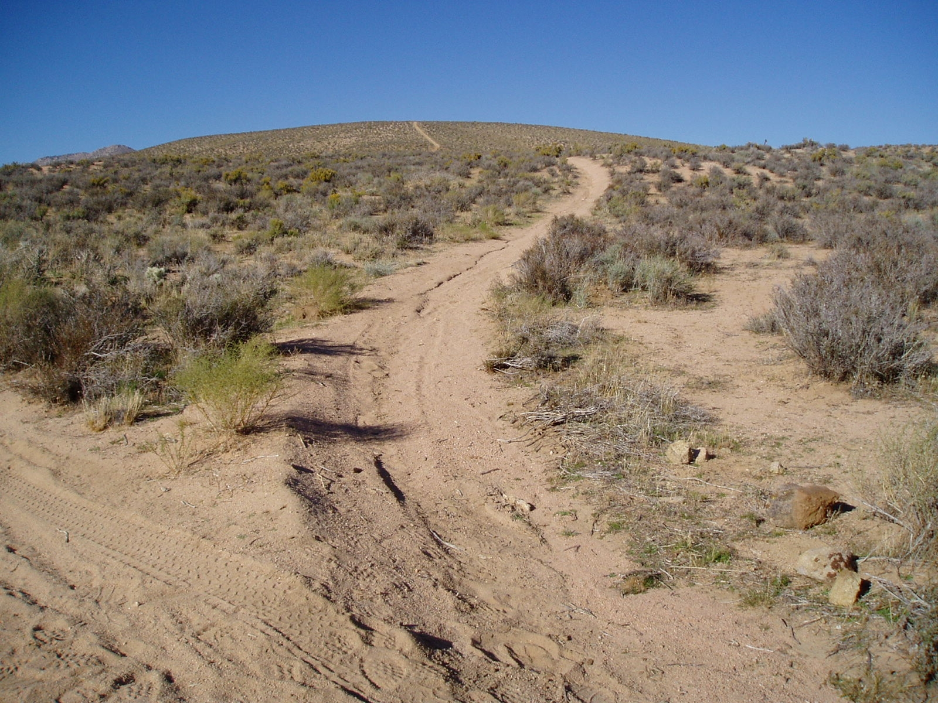
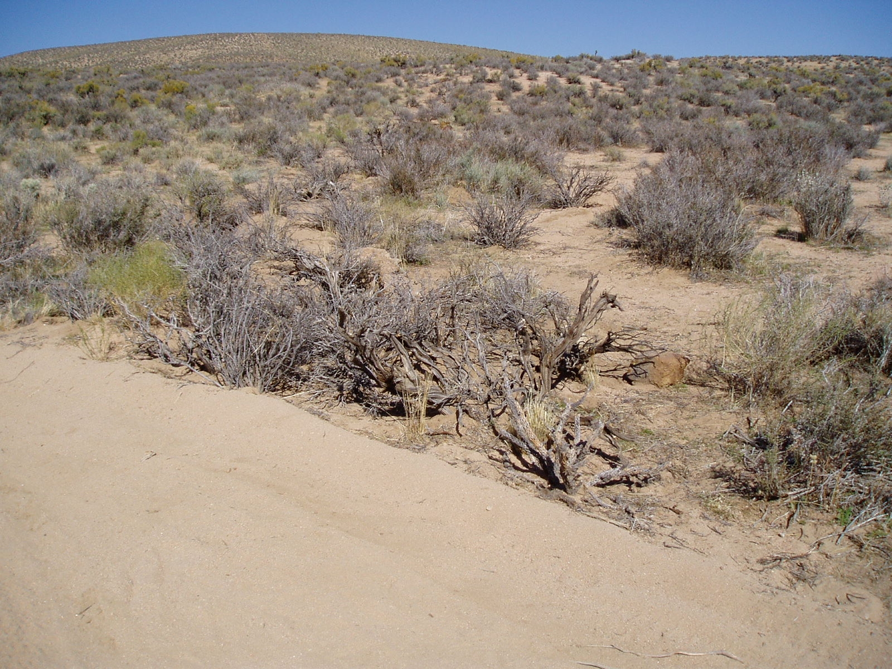
Jawbone-Butterbredt ACEC
Ridgecrest Field Office
California
Before
After

