STATEMENT OF DONALD N. FURMAN, IBERDROLA RENEWABLES
COMMITTEE ON ENERGY AND NATURAL RESOURCES
UNITED STATES SENATE
JUNE 17, 2008

Introduction
Mr. Chairman and members of the Committee, thank you for the opportunity to appear before you today and thank you for holding this important hearing. My name is Donald N. Furman. I am Senior Vice President of Business Development, Transmission and Policy for Iberdrola Renewables, an energy company that, among other things, is engaged in the development and operation of wind and solar electric generating facilities. Iberdrola Renewables is the leading generator of wind energy worldwide and is the second largest wind energy generator in the United States. Assuming that Congress acts to further extend renewable energy tax credits, Iberdrola Renewables plans to invest at least $8 billion between now and 2010 in wind and solar energy projects located in the United States. I am also appearing here today on behalf of the American Wind Energy Association where I serve on the Board of Directors and as Chairman of the Transmission Committee. In a prior job, I ran the transmission business for a large, multistate utility in the West. As a result, I have had the opportunity to view transmission issues from the perspective of both a transmission developer/operator and a transmission customer.

The purpose of my testimony is to discuss the essential link between a robust, properly functioning electric grid and the ability of emerging renewable energy technologies, such as wind, solar, and geothermal, to meet a substantial portion of the nation’s demand for electricity.

According to a report released last month by the Department of Energy, wind power on its own could supply twenty percent of all the electricity consumed in the United States by 2030. The benefits would be enormous:

- Electric sector greenhouse gas emissions would be reduced by 25 percent;
- The amount of natural gas required to generate electricity would be cut by 50 percent and United States gas consumption would be 11 percent lower overall – helping to limit our reliance on energy imports and reducing consumer energy costs;
- Because water is not required to operate wind farms, water consumption would be reduced by 4 trillion gallons;
- Approximately 500,000 new jobs would be created; and
- Local tax revenues would rise by more than $1.5 billion.

The Department of Energy report analyzed the barriers that must be addressed to reach the twenty percent target and concluded that two distinct, but related, transmission barriers are critical. The first is transmission infrastructure. Many of the best sites for the development of renewable energy facilities are located in remote areas, some distance from population centers where most electricity is consumed or in places that the existing transmission grid does not reach. Without sufficient levels of transmission capacity many good wind and other renewable energy sites will not be developed. I would note that there are a number of potential wind, solar and other renewable energy projects in most of the states represented by members of this Committee, including New Mexico, North Dakota, South Dakota, Oregon, Washington, Colorado, Montana, Idaho and Wyoming, which are not being developed today because of transmission constraints.

The second key barrier is power system operation with high levels of variable resources, such as wind, given our current system of balkanized electricity grids. The Department of Energy report concluded that twenty percent wind is feasible if each of the three electric grids – the Eastern Interconnect, the Western Interconnect and Texas – operate more like single large power pools instead of the current system of 140 independent balancing areas. This would also improve the efficiency and reliability of the system.

Before discussing the policy options for addressing these transmission barriers, I would like to emphasize that the lack of a long-term stable policy structure has hampered the environment for investments in new renewable energy facilities and the transmission to connect them to the grid. With the renewable energy production tax credit (“PTC”) currently scheduled to expire on December 31, 2008 and the current uncertain legislative environment, projects representing thousands of megawatts of renewable energy expected to be installed next year are now in question. The PTC, since its enactment, has expired on three separate occasions and has never been extended for longer than a three year period. The stop-start nature of the PTC has impeded development of a domestic manufacturing base and has raised significantly the capital cost of a wind power project. It is important for Congress to extend the PTC as soon as possible for as long as possible. Congress should also consider more stable long-term policies, including the adoption of a national renewable portfolio standard (“RPS”). We applaud Chairman Bingaman’s leadership on this issue and hope that Congress will adopt RPS legislation soon.

Background

As a nation, we are facing a potentially serious transmission crisis. Between the mid-1970’s and the late-1990’s investments in new electric transmission capacity dropped from an average of $5.5 billion per year to less than $3 billion per year (adjusted for inflation). Although transmission investments have risen in recent years, the United States faces the prospect of not having sufficient transmission infrastructure to meet the growing demand for electricity in a carbon-constrained environment. According to Richard Sergel, the President and CEO of the North American Electric Reliability Corporation (NERC): “[T]he grid will be threatened unless we build the transmission infrastructure that is necessary to support renewable resources like wind, that will enable us to locate new clean coal facilities – or even gas facilities . . . It doesn’t matter if it’s going to be the clean coal plant or the nuclear plant or the wind project or the solar project. The common denominator is that they are going to require transmission to move it from where it is toward the load centers.”

The lack of sufficient transmission capacity not only challenges the ability of utilities to keep the lights on, it also increases the price of electricity. Transmission congestion limits the ability of utilities to access cheaper sources of generation that may be located some distance away. Congestion also limits fuel diversity. If there is not sufficient transmission capacity to access electricity generated at remote locations, utilities will be forced to rely increasingly on natural gas-fired electric generation facilities which are easier to site closer to load centers. There are legitimate concerns that a dramatic rise in the reliance on natural gas for electric generation will further increase U.S. demand for energy imports and will increase the pressure on gas prices.

Although the level of investment that will be required for new transmission facilities is substantial, the costs of doing nothing are far greater, both in terms of reliability and overall electricity prices. Transmission typically makes up less than ten percent of the delivered cost of electricity. New transmission capacity typically enables a utility to access lower cost generation – which makes up a much larger portion of consumer electric costs -- and thereby the transmission more than pays for itself. The Midwest Independent System Operator (“MISO”) recently examined the costs and benefits of developing 16,000 megawatts of wind energy on the MISO system and 5,000 miles of new 765 kv transmission lines to enable the transmission of wind energy generated in North and South Dakota to the New York City area. Even though the generation and transmission costs would amount to approximately $13 billion, the study determined that, on a net basis, consumers would save approximately $600 million per year because the new transmission would enable utilities to acquire lower cost electricity.

In the 1950’s this country united to create the national interstate highway system in order to address an increasingly antiquated transportation system. I believe that a similar effort for interstate transmission highways would bring substantial benefits, prevent blackouts, and enable the nation to reduce its greenhouse gas emissions and promote energy security through the use of domestic renewable resources.

Transmission and Renewable Energy

As the attached map demonstrates, the United States is blessed with substantial wind resources. However, it also identifies the challenge -- significant transmission investments will be required to access these remote resources. According to the Department of Energy, an investment of $60 billion in new transmission capacity is needed between now and 2030 to enable wind power to supply twenty percent of our electricity. This would amount to approximately $3 billion per year, a modest addition to the $8 billion that has been spent in recent years on transmission infrastructure. This is a small price to pay given the plethora of benefits that would result from reaching the twenty percent target. Congress, federal and state regulators and industry all need to work toward this goal.

The U.S. electric grid was not originally designed to be operated on a large integrated basis. Instead, the grid was initially built primarily to enable individual utilities to meet customer needs with locally generated electricity. There was not much need to accommodate transactions spanning several state borders or across regions. Regulatory oversight was set up accordingly, at the state level, with limited authority provided to the Federal Energy Regulatory Commission (“FERC”).

The two main barriers to transmission development are cost allocation and siting of transmission lines. Cost allocation is a challenge because of the incentive to free ride. Many states, utilities, and end users across a wide region and over a long time period benefit from interstate transmission, and it is not in any of their interests to pay for something that benefits so many others. With jurisdiction largely at the state level, where state public utility commissions (“PUCs”) generally permit cost recovery of only those costs that provide direct benefits to that state’s ratepayers, it is difficult to gain approval for the recovery of costs associated with interstate transmission. The situation with siting is similar. State siting approvals are based on demonstrations of need where “need” is defined as impacts within the state. Interstate lines that benefit a region and the nation can be prevented from being built by individual states. States may also fail to consider regional needs when approving the location of specific transmission lines.

Moreover, utilities have little regulatory incentive to build transmission facilities of the appropriate size. A 765 kv backbone transmission facility can transmit much more electricity more efficiently than a 345 kv line which might be of sufficient size for a utility to serve its traditional customers. State regulators are unlikely to permit utilities to recover the costs of these larger lines which provide broader benefits.

FERC has limited jurisdiction and has been given little encouragement by Congress to address regional and national objectives. The Commission has no authority over utility decisions to build transmission or, generally, over a utility’s ability to recover transmission investments. Even in areas where most transmission has been placed into FERC-jurisdictional Regional Transmission Organizations (“RTOs”), utility members of RTOs can change their membership status to avoid assignment of costs. Moreover, FERC has been too deferential to state wishes on cost allocation.

The Energy Policy Act of 2005 did provide FERC with limited siting authority. However, given the tremendous controversy surrounding the Commission’s siting authority and the limited areas where FERC is authorized to approve a transmission line, there is considerable uncertainty whether this authority will yield significant new transmission investments.

There are some innovative state-based solutions that should be commended. Several states, including Texas, Minnesota, California and Colorado are pro-actively planning to access renewable energy. In addition, the Western Governors Association has initiated a four-phase regional transmission development and cost-allocation strategy with the intention of unlocking the region’s vast supplies of wind, solar, geothermal, biomass and wave power. The Midwest Governors Association has also initiated a wide ranging process to promote regional transmission for renewable energy. While these state-based efforts will help, there are limitations to what they can accomplish. There is a significant national interest in the proper development of the transmission grid to access renewable energy resources that only Congress can adequately address.

Integrating Variable Resources

In addition to ensuring that there is sufficient transmission capacity to access our country’s enormous renewable energy resources, it is equally important that the electric grid functions effectively. Wind, solar and certain other resources generate power on a variable basis. For instance, wind power fluctuates depending on the wind speed where the wind project is located. Electric systems need to accommodate this variability just as they accommodate constantly changing levels of consumer demand. This is easier to do in regions served by RTOs because generation and demand is balanced over a broad geographic region. Wind generation tends to be less variable the broader the region – the wind may die-down in one area and pick up in another at the same time. The breadth of RTO regions also provides greater access to conventional sources of electric generation that can ramp up and ramp down to address the variability of wind and certain other renewable resources.

I recognize that some regions have put RTO development on hold and it is unlikely that new RTOs will be established in those regions any time soon. In the absence of RTOs, utilities need to work together to achieve some of the same benefits of reliability, efficiency, and integration of non-dispatchable resources. These actions should include the consolidation of balancing areas and the sharing of generation across balancing areas to address variability issues.

Transmission Policies Required to Promote Renewable Energy Development

It is essential that Congress and the Federal government act to help promote a more robust and effectively functioning electric grid, if we are going to reap the full benefits associated with the nation’s renewable energy resources. As I have discussed, the current regulatory structure is not well-suited to the challenges of the future. Unless Congress makes it easier for utilities and other entities to build the transmission necessary to access our renewable resources, consumers, the economy and the environment will suffer. It is imperative that Congress remove these barriers to help meet our national goals of reducing greenhouse gas emissions, enhancing our national energy security, providing consumers with reasonably-priced electricity and growing the economy. More specifically, Congress should ensure that:

- There are sufficient incentives to encourage investments in the transmission facilities necessary to fully develop our renewable resources;
- The costs of new transmission facilities are fairly allocated to take into account regional and national benefits, including the development of renewable electric generation;
- Utilities are able to recover the costs of reasonable transmission investments;
- States cannot unfairly inhibit the development of transmission that will provide multi-state benefits;
- U.S. power marketing agencies, the Department of Energy, and FERC are encouraged to promote regional transmission infrastructure and system operations in support of renewable energy development; and
- Legislation regulating greenhouse gas emissions recognizes the contributions transmission can make to reducing emissions in the electric generation sector.

I want to commend Senator Reid for his leadership in introducing S. 2076, the Clean Renewable Energy and Economic Development Act. This legislation would establish national renewable energy zones, encourage regional cost allocation for transmission built to serve renewable generation, enable utilities building transmission in renewable energy zones to recover their costs from ratepayers, and fund Federal utility construction of transmission in renewable energy zones if private entities fail to make their own investments. The Reid bill also would require the Bonneville Power Administration (“BPA”) and the Western Area Power Administration (“WAPA”) to use their transmission systems to aid in the integration of wind and solar power. These are all remedies that would prove extremely helpful.

Senator Reid’s legislation wisely recognizes that the Federal utilities can play an important role in promoting the development of renewable energy. BPA and WAPA, in particular, are two of the largest transmission owners in the Western United States. Both serve regions with substantial wind and solar resources. Both are able to build transmission without some of the barriers faced by utilities subject to state regulation. In particular, through its Open Season process, BPA is helping utilities in the Pacific Northwest access renewable energy and other remotely located electric generation by engaging in a program designed to build additional transmission capacity. We encourage Congress to provide similar authority to WAPA, to help promote the development of renewable resources in North Dakota, South Dakota, Colorado and other states served by WAPA.

Mr. Chairman, this concludes my prepared presentation. I am happy to respond to any questions you and members of the Committee may have.

ATTACHMENT A

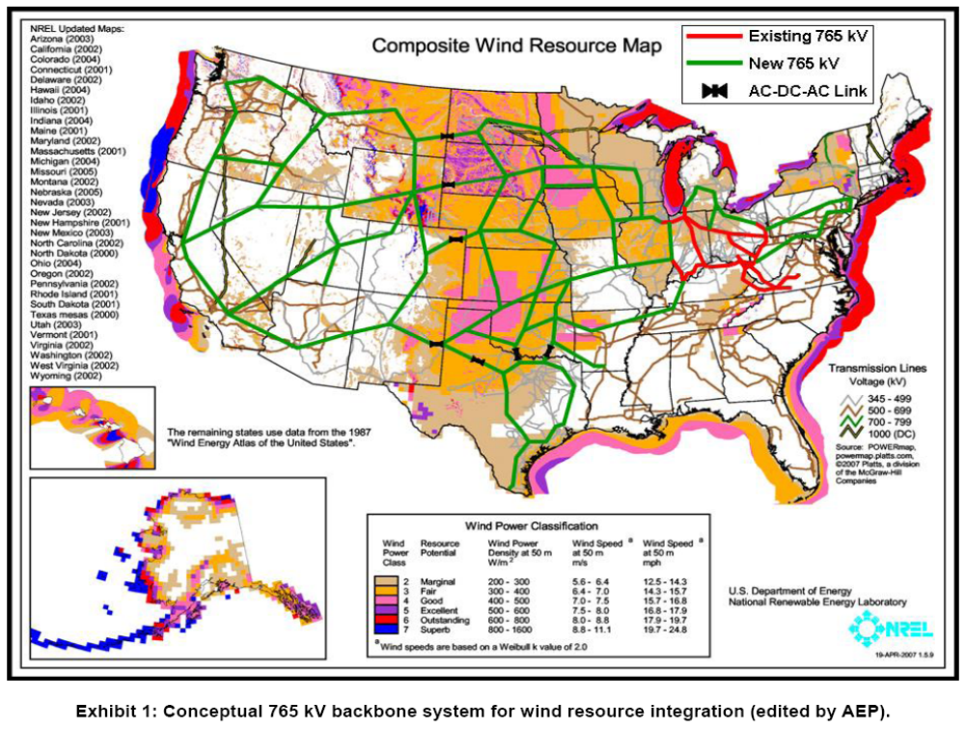

Iberdrola Renewables is also represented on the Board of Directors of the Solar Energy Industries Association, which shares many of the same transmission-related concerns as the American Wind Energy Association.
“20 Percent Wind Energy by 2030 – Increasing Wind Energy’s Contribution to U.S. Electric Supply” (“20 Percent Wind Energy Report”), U.S. Department of Energy (May, 2008).
In addition, there are over 6,800 gigawatts of solar energy resources that could, potentially, be tapped in seven southwestern states alone. “Analysis of Concentrating Solar Power Plant Siting Opportunities: Discussion Paper for WGA Central Station Solar Working Group”, M. Mahos, National Renewable Energy Laboratory, July, 2005 at page 2.
Id. at pages 12-18.
26 U.S.C. §45. The PTC is currently available for the production of electricity from wind, geothermal, biomass, small irrigation, landfill gas, trash combustion facilities and certain type of hydropower facilities. Solar power facilities are eligible for an investment tax credit, in lieu of the PTC, which is also scheduled to expire on December 31, 2008. 26 U.S.C. §48.
“Using the Federal Production Tax Credit to Build a Durable Market for Wind Power in the United States”, Ryan Wiser, Mark Bolinger, and Galen Barbose, Lawrence Berkeley National Laboratory (November, 2007) at page 9.
“20 Percent Wind Energy Report” at page 94.
Statement of Richard Sergel, President and CEO of the North American Electric Reliability Corporation, American Wind Energy Association Press Conference (March 19, 2008).
“20 Percent Wind Energy Report at pages 12-17.
Energy Information Administration Annual Energy Outlook (2005).
Ibid.
“20 Percent Wind Energy Report” at page 96.
Id. at page 98.
Id. at 94.
Section 1221 of the Energy Policy Act of 2005 authorizes FERC to consider the approval of a transmission line proposed to be located in a National Interest Electric Transmission Corridor as designated by the Department of Energy if state regulators fail to approve the line.
“Facilitating Wind Development: The Importance of Electric Industry Structure”, B. Kirby and M. Milligan, National Renewable Energy Laboratory (May, 2008).
Congressmen Jay Inslee and Earl Blumenauer have introduced a similar bill – H.R. 4059, “The Rural Clean Energy Superhighways Act”.

