

FEDERAL AVIATION ADMINISTRATION
William J. Hughes Technical Center, ACB-430

LAAS GROUND FACILITY SITING
TEST PROGRAM

RRA HEIGHT RANGE REQUIREMENT VALIDATION REPORT

May 20, 2003
Table of Contents
1. INTRODUCTION 1
1.1 Background 1
1.2 Test Objective 1
1.3 Applicable Specification Requirement Language 1
2. Test Setup 1
3. Data Collection 3
4. Data Analysis 3
4.1 Data Reduction Method 3
4.2 Data Analysis Method 4
4.3 Areas of Evaluation 4
5. Results/Discussion 5
5.1 GPS 5
5.1.1 Dipole Array 5
5.1.2 High Zenith Antenna 14
5.2 SBAS 22
5.2.1 Ionospheric Error Removal 22
5.2.2 Performance Comparison 23
6. Conclusions 25

INTRODUCTION

Background
The FAA is responsible for the development and validation of the LAAS Ground Facility (LGF) Specification, FAA-E-2937A. The FAA William J. Hughes Technical Center, ACB-430, has been given the responsibility for validation of a subset of the specification requirements. The analysis performed in this report is an outgrowth of work accomplished in support of LAAS Test Prototype (LTP) test activities and LAAS siting studies.

Test Objective
The purpose of this test is to validate LGF specification (FAA-E-2937A) antenna height range requirements contained in the GPS and SBAS Sigma Pseudorange Accuracy paragraphs (3.2.1.2.8.7.1 and 3.2.1.2.8.7.2). Specifically, this test will evaluate the requirement by comparing antenna performance of an antenna installed at the lower and upper height requirements.

The primary areas of evaluation will be a comparison of the estimated pseudorange error standard deviation and tracking performance at the two antenna heights. This will be accomplished to determine if there is an unacceptable degradation of performance at the upper height. It is understood that the limited data set precludes the determination of a statistically significant sigma overbound. However, a comparison of the sigma performance to the requirements curve, Ground Accuracy Designator (GAD) – C, is presented in the data analysis and is useful for understanding the magnitude of the estimated errors.

Applicable Specification Requirement Language
“The accuracy requirement shall be met at RR Antenna phase-center heights between 10 and 50 ft.” “Note: In cases of dual antennas, the phase-center height of the upper element shall be used.”

Test Setup
The antenna under test (AUT) was the dB Systems Integrated Multipath Limiting Antenna (IMLA). The IMLA is a two-antenna system consisting of the dBs-200, a 14-element dipole array and the dBs-200A, a Cross-V dipole High Zenith Antenna (HZA). The HZA is mounted on top of the dipole array. For the purpose of this evaluation, the dipole array phase center was chosen as the midpoint of the dipole array. The HZA phase center was chosen as the base of the antenna. This places the HZA phase center approximately five feet above the dipole array phase center.
The test was conducted at a site located in proximity to Building 279 on the ACY airfield. For the tests at the lower height, the AUT was mounted on a temporary antenna mount. For the test at the upper height, the AUT was mounted on an adjustable height tower. Figure 1 shows a photograph of the test setup with the antenna mounted at the upper height.
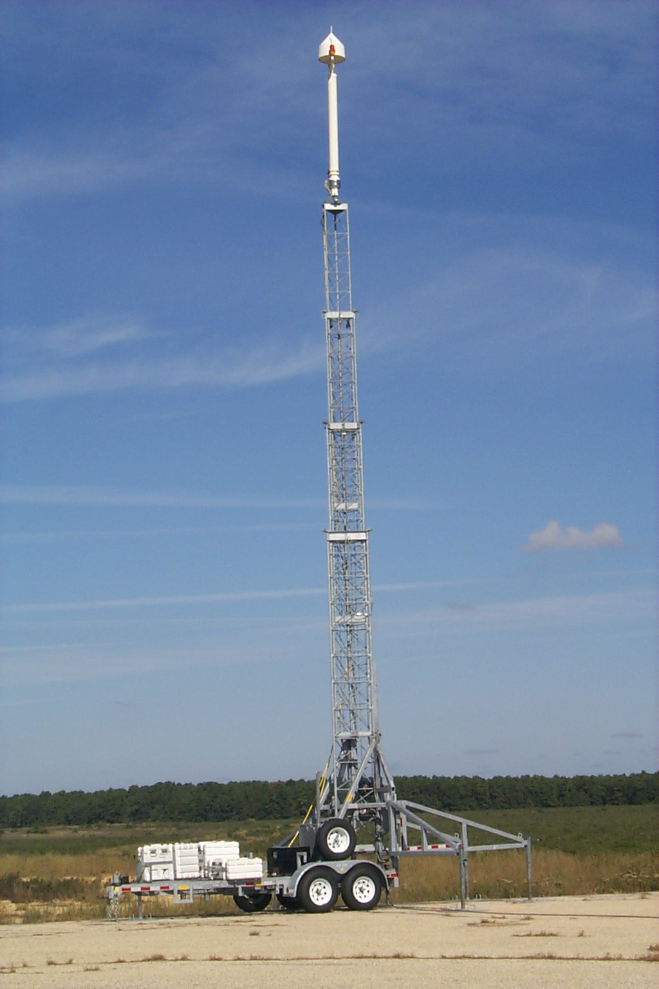
Figure 1. Test Setup

Two reference receivers were operated concurrently during the tests: the Novatel Millennium and the Novatel OEM-4 receiver. The Millenium was the primary receiver for GPS data collection and was configured with a 0.1 chip correlator. The OEM-4 was the primary receiver for SBAS data collection and was configured with a 1.0 chip correlator for SBAS tracking. The OEM-4 was also used as the secondary receiver for GPS data collection and was configured with a pulse aperture correlator (PAC). The data was collected at a 1 Hz rate. The receivers and data collection equipment were housed in the portable equipment enclosures located at the base of the antenna mount. Identical RF cables and splitters were used for the lower and upper height tests.
An L1/L2 data collection system was installed in proximity to the test site. The existing L1/L2 data collection system installed at the LAAS Test Prototype site was used a backup. The L1/L2 data collection system consists of an Ashtech Z-XII GPS receiver, an Ashtech ground plane survey antenna, and a data collection computer. The L1/L2 carrier phase data is necessary for CMC processing to estimate and remove the ionospheric errors for each SV.
The test consisted of six days of data collection. Table 1 shows the test schedule.
Table 1. Test Schedule
Date | Dipole Array  Phase Center Height (ft) | HZA  Phase Center Height (ft)
9/20/02 | 10 | 15
9/21/02 | 10 | 15
9/22/02 | 10 | 15
9/30/02 | 45 | 50
10/01/02 | 45 | 50
10/03/02 | 45 | 50

Data Collection
Data was collected from the Millenium, OEM-4, and Ashtech receivers onto an industrial PC. The Novatel data logging program (GPS Solution) was used for logging of binary Novatel data logs onto the PC. The Millennium logs collected were SATB, RGEB, and REPB. The OEM-4 logs collected were SATVISB, RANGEB, RAWEPHEMB, and AGCDATAB. The Ashtech data logger was used for logging of binary Ashtech data onto the PC. The Ashtech logs were the B-file and E-file. Data was collected in 24-hour periods to allow for observation of the full GPS constellation.
The Novatel and Ashtech data logs were selected in order to provide the data necessary to compute an estimation of code multipath, and to allow for troubleshooting and identification of possible errors with any of the test components.

Data Analysis

Data Reduction Method
The binary receiver data was converted to ASCII files for individual SVs. The Novatel data was merged with the Ashtech data. CMC was computed using the merge files as the input. The output of the CMC program is a CMC file which includes time, SVID, SV azimuth, SV elevation, C/No, raw iono estimate, smoothed iono estimate, raw CMC, and smoothed CMC.
All receiver data was checked for quality using FAA-developed software. These checks include the following:
- C/No
- Cycle Slip
- Loss of Lock
- Receiver Status Word
- Ashtech Clock Correction

Data Analysis Method
CMC techniques were used to estimate the code multipath and noise. The 1 Hz data was sampled at .05 Hz and binned in 2 degree elevation bins from 4 to 40 degrees for the dipole array and from 30 to 90 degrees for the HZA. The sample rate was chosen in order to facilitate data processing and to graphically represent the ensemble data. Based on the limited amount of data collected for each antenna height, no attempt was made to compute a statistically meaningful sigma overbound.

Areas of Evaluation
There are three areas of evaluation for the test:
- Is the sigma performance at the upper height comparable to the performance at the lower height?
- Is the tracking performance at the upper height comparable to the performance at the lower height?
- How do the binned statistics compare to the sigma pseudorange accuracy requirements? [spec. para. 3.2.1.2.8.7.1.(GPS), 3.2.1.2.8.7.2(SBAS)].

Results/Discussion

GPS

Dipole Array

Performance Analysis (Millennium).
Figure 3 shows the ensemble data plots for data collected on the Novatel Millennium with the dipole phase center at the 10 ft. height on 9/21/02. This data is representative of the two other data sets collected at the 10 ft. height. The left two plots show C/No vs. Elevation and C/No vs Time. The right two plots show CMC vs. Elevation and CMC vs. Time. All plots show data from twenty-seven SVs in view over a 24-hour data collection period. Note: SV 21 is not included in this analysis since it was not available during the upper height data collection.
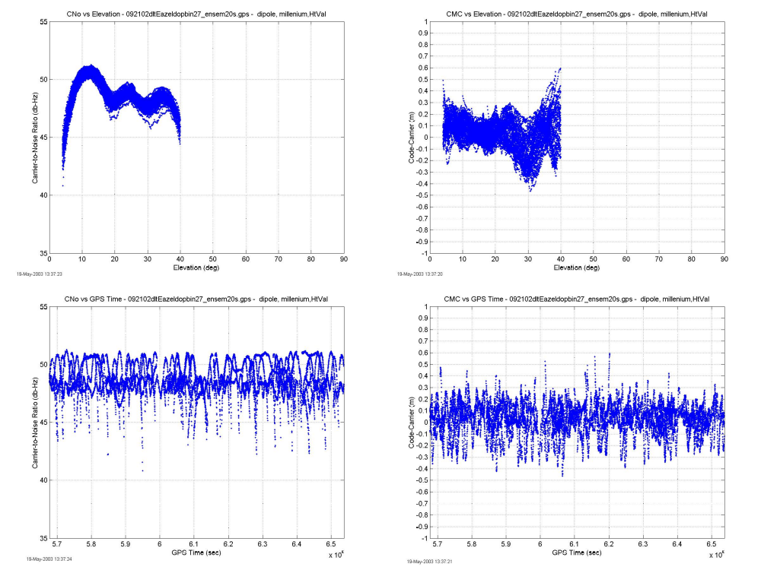
Figure 3. dBs-200 Dipole Array Ensemble Plots-10’ Height (9/21/02)
The ensemble CMC data shows a systematic trend that is related to SV elevation. This trend has been observed in all previously processed dipole array/Millennium data at the LTP antenna sites. All of the height validation test results showed a similar systematic trend. A detailed analysis of this phenomenon is not within the scope of this report.
Figure 4 shows the mean and standard deviation for the 2-degree elevation bins.

Figure 4. dBs-200 Dipole Array Performance Plot- 10’ Height (9/21/02)
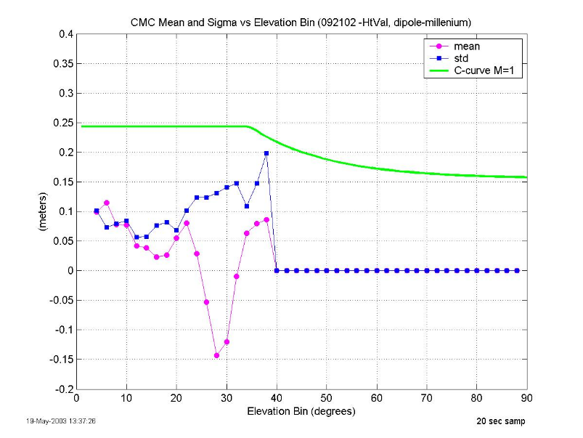
The dipole array is designed to operate in the elevation range from 4 to 35 degrees. Within this range, the standard deviation is between 5 and 10 cm from the 4 degree bin to the 24 degree bin, and between 10 and 15 cm from the 24 degree bin to the 36 degree bin. The standard deviation is under the C-Curve with a margin of approximately 10 cm at the worst-case elevation bin in the 4 to 35 degree range.
Figure 5 shows the ensemble data plots for data collected with the dipole phase center at the 45 ft. height on 9/30/02. This data is representative of the two other data sets collected at the 45 ft. height. All plots show data from all twenty-seven SVs in view over a 24 hour data collection period.
Figure 5. dBs-200 Dipole Array Ensemble Plots-45’ Height (9/30/02)
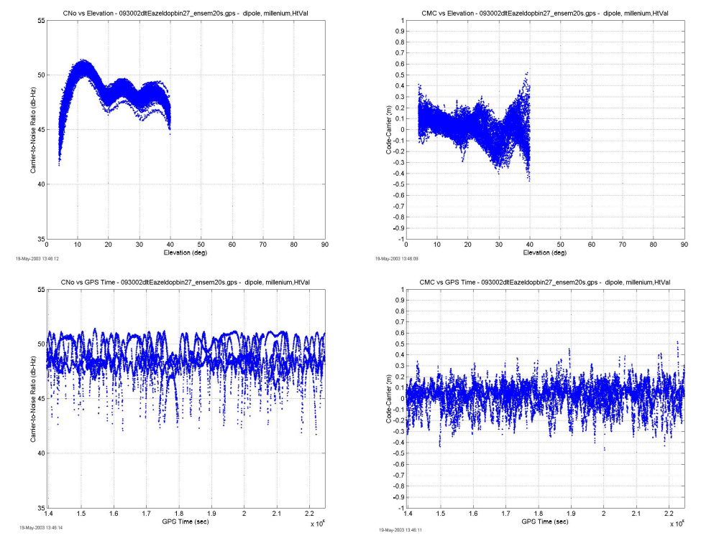
Figure 6 shows the mean and standard deviation for the 2-degree elevation bins.
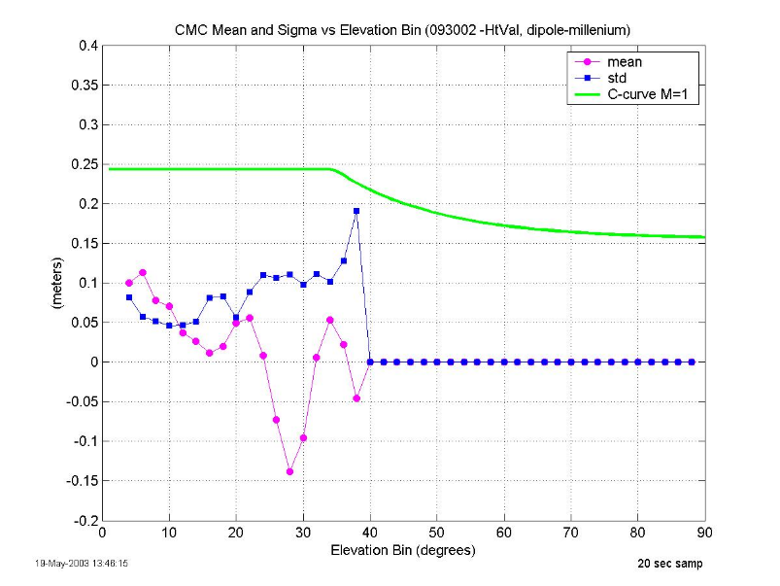
Figure 6. dBs-200 Dipole Array Performance Plot- 45’ Height (9/30/02)
The CMC standard deviation is below the GAD C-curve in all elevation bins. Within this range, the standard deviation is between 5 and 10 cm from the 4 degree bin to the 24 degree bin, and between 10 and 13 cm from the 24 degree bin to the 36 degree bin. The standard deviation is under the C-Curve with a margin of approximately 13 cm at the worst-case elevation bin in the 4 to 35 degree range. The standard deviation is comparable to that achieved at the 10 ft. height, and is lower in most of the bins.

Millennium Tracking Performance
The tracking performance was measured by counting the occurences of receiver loss-of-lock for the 24-hour data set. This method was used to preclude inclusion of Ashtech dropouts in the tracking performance analysis. Figure 7 shows that the Millennium receiver had a significant number of loss-of-lock throughout the elevation region of interest on all of the test days. The plot on the left shows instances of loss-of-lock on the dipole array from 2 to 40 degrees elevation. The plot on the right shows instances of loss-of-lock on the HZA from 25 to 40 degrees elevation. This poor tracking performance is atypical for the Millennium and indicates that the receiver may have been in a degraded state. Several months after this test was conducted, the receiver failed and had to be returned to the manufacturer for service.
For this reason, the secondary GPS receiver, OEM-4, was also used for the comparison of antenna performance at the two heights. The OEM-4 was configured with a pulse-aperture correlator which is allowed for in the LGF Specification.

Figure 7. IMLA/Millennium Tracking Performance
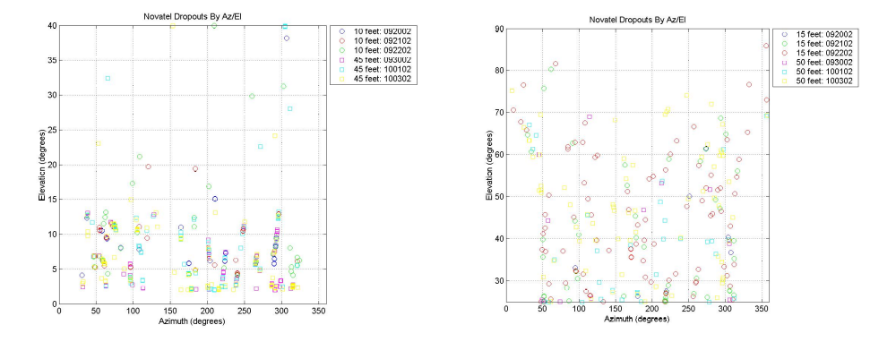

Performance Analysis (OEM-4).

Figure 8 shows the ensemble data plots for data collected on the Novatel OEM-4 with the dipole phase center at the 10 ft. height on 9/20/02. This data is representative of the two other data sets collected at the 10 ft. height. All plots show data from twenty-seven SVs in view over a 24-hour data collection period. Note: SV 21 is not included in this analysis since it was not available during the upper height data collection.
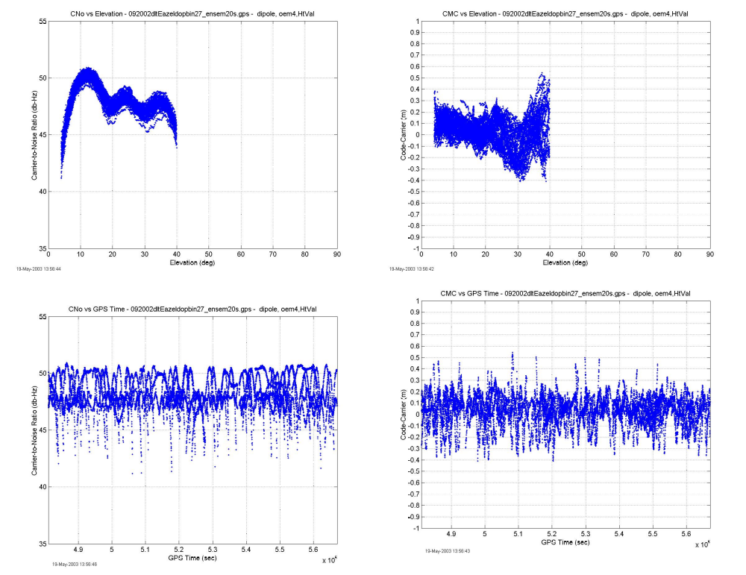
Figure 8. OEM-4/dBs-200 Dipole Array Ensemble Plots-10’ Height (9/20/02)
Figure 9 shows the mean and standard deviation for the 2-degree elevation bins
Figure 9. OEM-4/dBs-200 Dipole Array Performance Plot- 10’ Height (9/20/02)
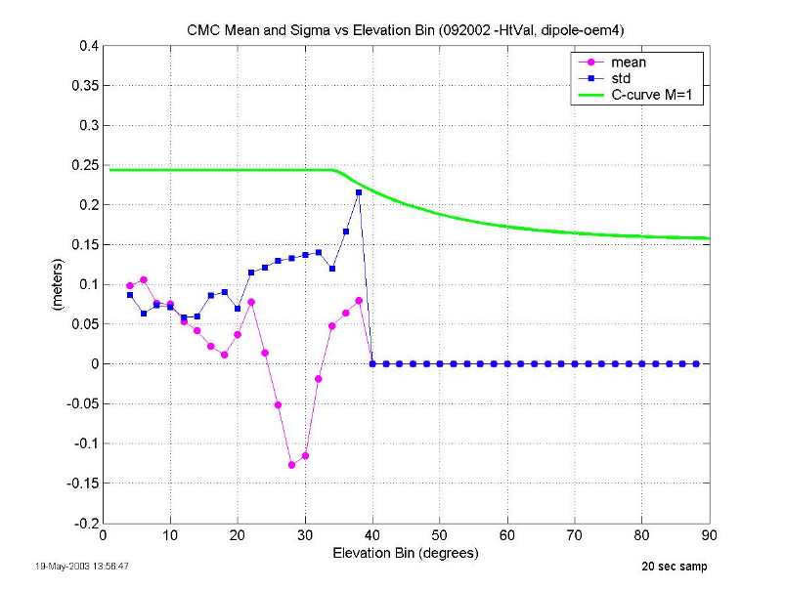
The dipole array is designed to operate in the elevation range from 4 to 35 degrees. Within this range, the standard deviation is between 5 and 10 cm from the 4 degree bin to the 22 degree bin, and between 10 and 15 cm from the 22 degree bin to the 36 degree bin. The standard deviation is under the C-Curve with a margin of approximately 11 cm at the worst-case elevation bin in the 4 to 35 degree range.
Figure 10 shows the ensemble data plots for data collected with the dipole phase center at the 45 ft. height on 9/30/02. This data is representative of the two other data sets collected at the 45 ft. height. All plots show data from all twenty-seven SVs in view over a 24 hour data collection period.
Figure 10. OEM-4/dBs-200 Dipole Array Ensemble Plots-45’ Height (9/30/02)
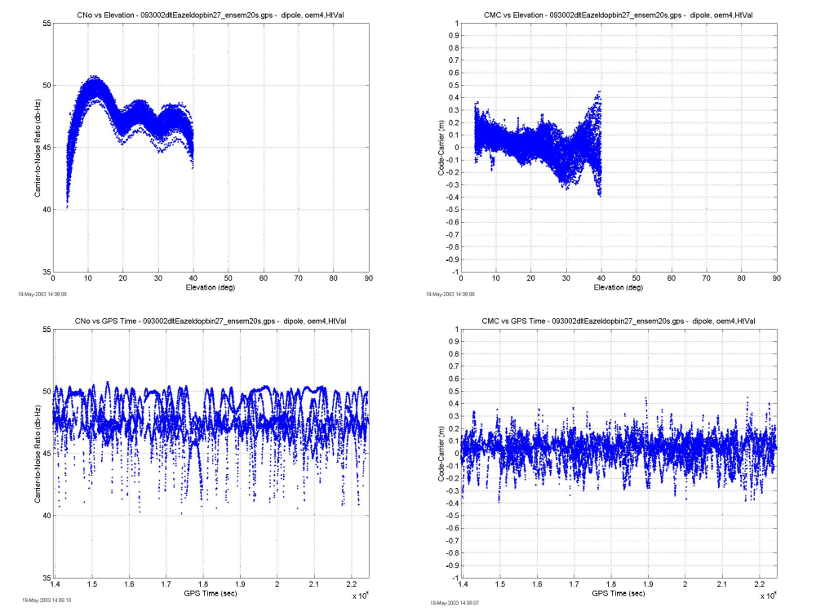
Figure 11 shows the mean and standard deviation for the 2-degree elevation bins.
Figure 11. OEM-4/dBs-200 Dipole Array Performance Plot- 45’ Height (9/30/02)
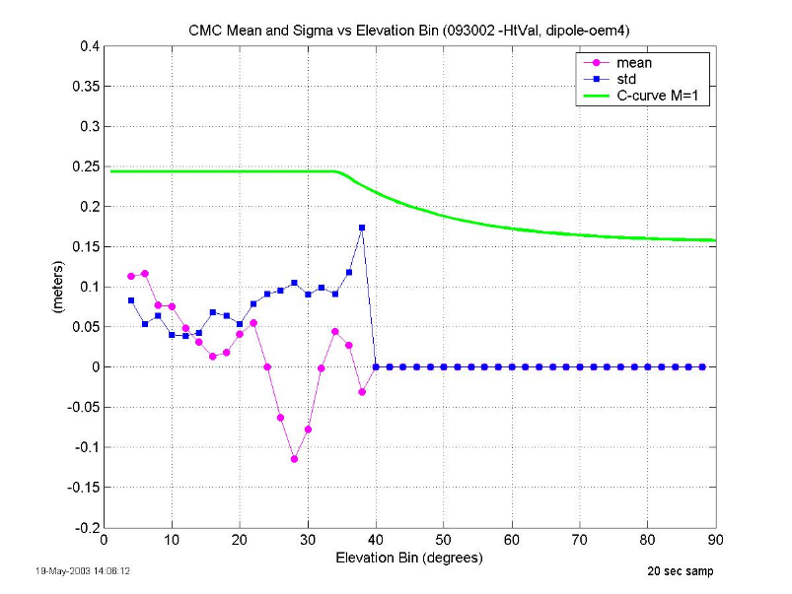
Within the elevation range of interest, the standard deviation is below 10 cm in all but the 28 to 30 degree bin. The standard deviation is under the C-Curve with a margin of approximately 14 cm at the worst-case elevation bin in the 4 to 35 degree range. The standard deviation is comparable to that achieved at the 10 ft. height, and is lower in all of the bins.

OEM-4 Tracking Performance
The tracking performance was measured by counting the occurences of receiver loss-of-lock for the 24-hour data set. This method was used to preclude inclusion of Ashtech dropouts in the tracking performance analysis. Figure 12 shows that the OEM-4 receiver had few number of loss-of-lock’s throughout the elevation region of interest on all of the test days. The plot on the left shows instances of loss-of-lock on the dipole array from 2 to 40 degrees elevation. The plot on the right shows instances of loss-of-lock on the HZA from 25 to 40 degrees elevation. There is little difference in the tracking performance of both antennas at the lower and upper heights.
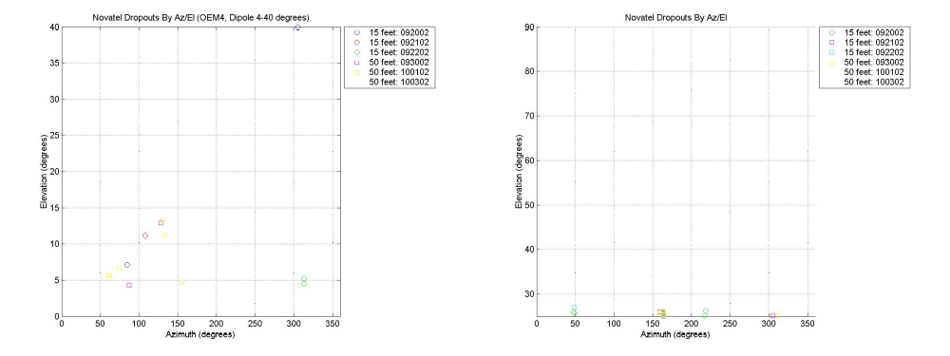
Figure 12. IMLA/OEM-4 Tracking Performance
Although the OEM-4 had minimal loss-of-lock’s, the receiver did experience a number of receiver status flags. These flags were due to an insufficient availability of satellites which resulted in an invalid receiver clock model. There were significantly more flags for the OEM-4 that was connected to the dipole array. This is due to the dipole array’s poor tracking above 40 degrees. The OEM-4 connected to the HZA had many more flags at the upper height because SV 21 was not available. Figure 13 shows the number of SV’s tracked on the OEM-4 connected to the dipole array on 9/30/02. Almost all of the flags were experienced where the number of SV’s drops to three, just prior to time 150000 seconds.
Figure 13. OEM-4/Dipole Array Number of SV’s Tracked (9/30/02)
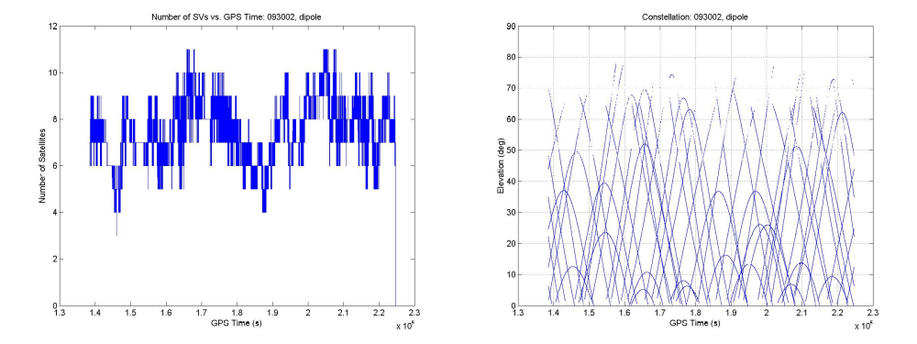

High Zenith Antenna
The tracking performance of the Millennium and OEM-4 receivers when connected to the HZA is discussed in Sections 5.1.1.2 and 5.1.1.4.

Performance Analysis (Millennium)
Figure 14 shows the ensemble data plots for data collected on the Novatel Millennium with the HZA phase center at the 15 ft. height on 9/21/02. This data is representative of the two other data sets collected at the 15 ft. height.
Figure 14. dBs-200A HZA Ensemble Plots-15’ Height (9/21/02)
Figure 15 shows the mean and standard deviation for the 2-degree elevation bins.
Figure 15. dBs-200A HZA Performance Plot- 15’ Height (9/21/02)
The HZA is designed to operate in the elevation range from 30 to 90 degrees. Within this range, the standard deviation is between 13 and 20 cm from the 30 degree bin to the 40 degree bin, and between 3 and 8 cm from the 40 degree bin to the 90 degree bin. The standard deviation is under the C-Curve with a margin of approximately 3 cm at the worst-case elevation bin in the 30 to 90 degree range.
Figure 16 shows the ensemble data plots for data collected on the Novatel Millennium with the HZA phase center at the 50 ft. height on 9/30/02. This data is representative of the two other data sets collected at the 50 ft. height.
Figure 16. dBs-200A HZA Ensemble Plots-50’ Height (9/30/02)
Figure 17 shows the mean and standard deviation for the 2-degree elevation bins.
Figure 17. dBs-200A HZA Performance Plot- 50’ Height (9/30/02)
Within the 30 to 90 degree range of interest, the standard deviation is between 10 and 16 cm from the 30 degree bin to the 40 degree bin, and between 3 and 8 cm from the 40 degree bin to the 90 degree bin. The standard deviation is under the C-Curve with a margin of approximately 8 cm at the worst-case elevation bin in the 30 to 90 degree range. The standard deviation is comparable to that achieved at the 15 ft. height. Also of interest is the introduction of a significant mean below 40 degrees at the upper height.

Performance Analysis (OEM-4)
Figure 18 shows the ensemble data plots for data collected on the Novatel OEM-4 with the HZA phase center at the 15 ft. height on 9/21/02. This data is representative of the two other data sets collected at the 15 ft. height.
Figure 18. OEM-4/dBs-200A HZA Ensemble Plots-15’ Height (9/21/02)
Figure 19 shows the mean and standard deviation for the 2-degree elevation bins.
Figure 19. OEM-4/dBs-200A HZA Performance Plot- 15’ Height (9/21/02)
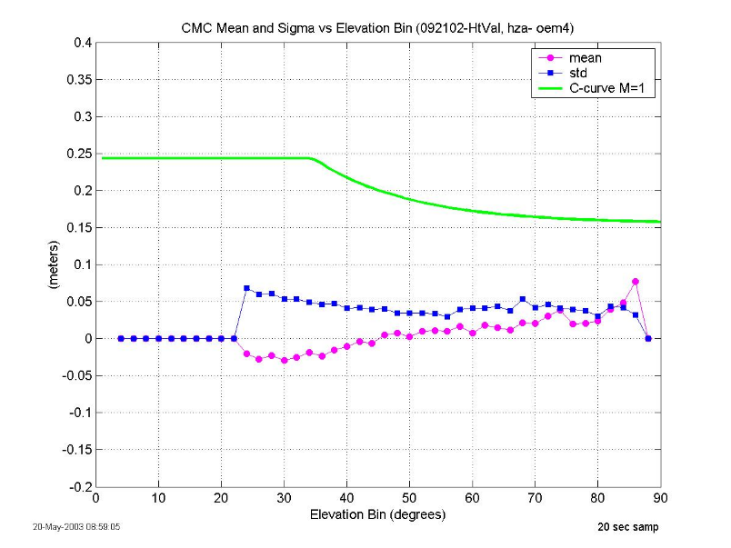
The CMC standard deviation meets the GAD C-curve in all elevation bins. Within the 30 to 90 degree range of interest, the standard deviation is below 7 cm. The standard deviation is under the C-Curve with a margin of approximately 19 cm at the worst-case elevation bin in the 30 to 90 degree range. The low standard deviation throughout the elevation range of interest can be attributed to the PAC which has a tighter multipath envelope than a 0.1 chip correlator.
Figure 20 shows the ensemble data plots for data collected on the Novatel OEM-4 with the HZA phase center at the 50 ft. height on 9/30/02. This data is representative of the two other data sets collected at the 50 ft. height.
Figure 20. OEM-4/dBs-200A HZA Ensemble Plots-50’ Height (9/30/02)
Figure 21 shows the mean and standard deviation for the 2-degree elevation bins.
Figure 21. OEM-4/dBs-200A HZA Performance Plot- 50’ Height (9/30/02)
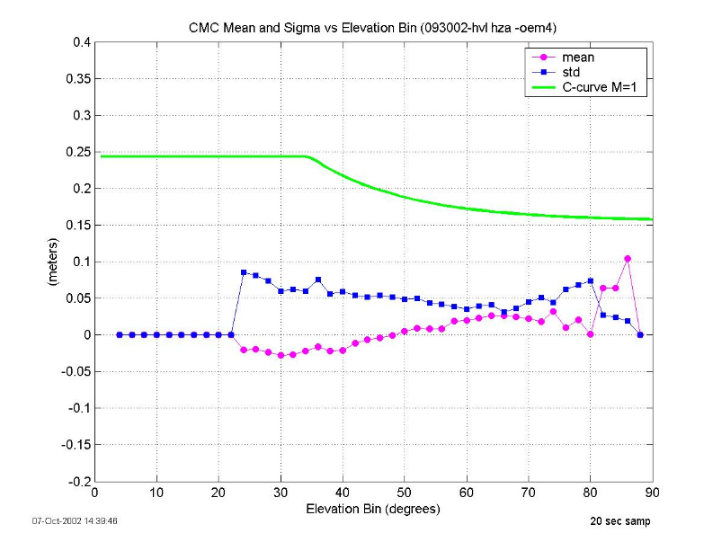
The CMC standard deviation meets the GAD C-curve in all elevation bins. Within the 30 to 90 degree range of interest, the standard deviation is below 7 cm. The standard deviation is under the C-Curve with a margin of approximately 17 cm at the worst-case elevation bin in the 30 to 90 degree range. The standard deviation is comparable to that achieved at the 15 ft. height. Also of interest is the absence of the significant mean observed in the Millennium data at the upper antenna height.

SBAS
The SBAS geostationary (GEO) satellite, PRN 122, was tracked by the OEM-4 on all of the test days. The GEO has an elevation of approximately 39 degrees relative to the test site at ACY. The HZA was used as the primary antenna for the evaluation since the GEO elevation falls within the HZA operating range. Dipole array data was also collected for comparison purposes.

Ionospheric Error Removal
The CMC process requires the removal of the ionospheric divergence between the code and carrier to allow for observation of code multipath and noise. This removal is straightforward in the GPS analysis by using dual frequency techniques. Since the GEO does not transmit on a second frequency, an alternate technique is required.
The WAAS ionospheric correction was evaluated and was determined to not have the required accuracy for this application. The WAAS ionospheric correction is typically +/- 1 meter and is much less accurate during ionospheric events.
Curve-fitting and high-pass filtering were also evaluated. The risk of removing low frequency multipath when using these techniques must be considered. This was addressed through comparison of the HZA and the dipole array results. Since the antenna gain patterns are significantly different, the two antennas should not experience the same low frequency multipath events at the same time. Through inspection of the HZA and dipole array unadjusted CMC data, (i.e., no ionospheric error removal), a curve-fit and/or filtering technique can be evaluated.
Figure 22 shows unadjusted GEO CMC for the HZA and dipole array on 9/20/02. The plot shows similar low frequency trends in the data. The break in the dipole array data was caused by a loss-of-lock in the OEM-4. The CMC process removes the mean from the continuous data segment, which causes the discontinuity observed in the plot. Note also that the dipole array data is noisier than the HZA data, which is expected, based on the elevation of the GEO.
Figure 22. Unadjusted CMC (no ionospheric error removal)
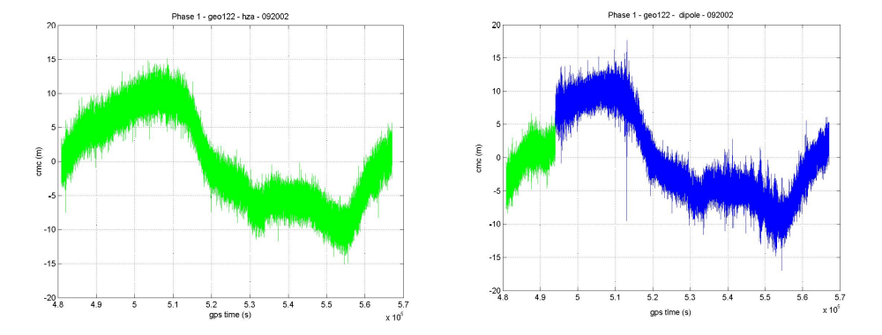
It was determined that a high-pass filter would be the most accurate technique for this application. The filter cut-off frequency was chosen to filter out signals with periods greater than one hour. Polynomial fitting was not used since multiple polynomials would be required to fit the data.

Performance Comparison
Figure 23 shows the GEO elevation trace. The elevation varies by approximately .035 degrees over a 24 hour period.
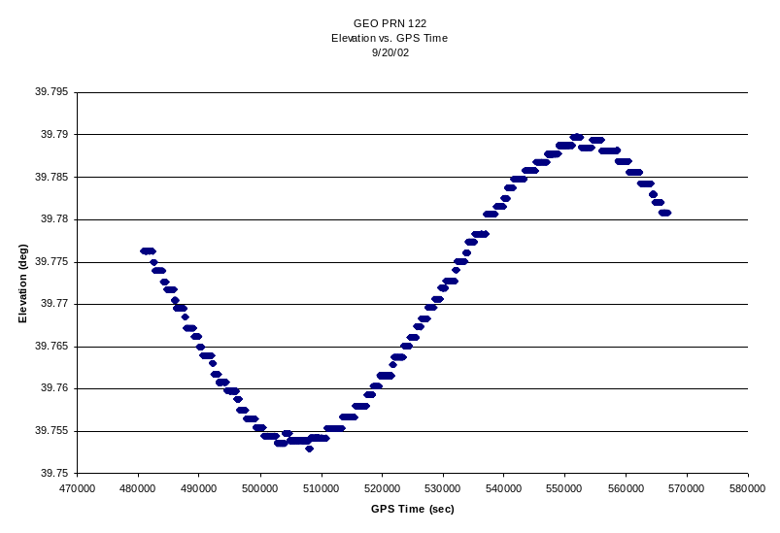
Figure 23. GEO PRN 122 Elevation Trace
Figure 24 shows the smoothed CMC for a day at the lower height and a day at the upper height. This data is representative of the other data sets. The data from the upper height has been shifted in time to align the elevation peaks of the data sets.
Figure 24. GEO PRN122 Smoothed CMC, 9/20/02 and 10/03/02
The standard deviation at the lower height was 12 cm. The standard deviation at the upper height was 15 cm. This value is well under the 1.8-meter requirement. It is important to note that any mean that is present over the duration of the 24 hour data set will be removed by the CMC processing.
Figure 25 shows a 10,000 second interval in the above plot to better observe a multipath event at approximately 530000 seconds.
Figure 25. GEO PRN 122 Smoothed CMC, 9/20/02 and 10/03/02 –Multipath Event
It is interesting that a significant multipath event would be repeatable at the two different heights. A review of panoramic photographs taken at the antenna site did not identify any significant scatterers at this azimuth.

Conclusions
Both of the antennas that make up the dB Systems Integrated Multipath Limiting Antenna; the dBs-200 14-element dipole array, and the dBs-200A Cross-V dipole High Zenith Antenna (HZA) performed comparably at the lower and upper antenna heights in these tests. The standard deviations of the GPS and pseudorange error estimates were comparable on all of the test days. The tracking performance of the Millennium receiver was atypical for this receiver connected to these antennas. The tracking performance of the OEM-4 was significantly better and there was little difference in tracking performance at the lower and upper heights.

