Date: August 8, 2004
Subject: Quarterly Technical Status Report, February through April 2004
THIN-FILM PHOTOVOLTAICS PARTNERSHIP PROGRAM
Process R&D for CIS-Based Thin-Film PV
NREL Letter Subcontract # ZDJ-2-30630-16
To: Harin Ullal, NREL Contract Monitor
From: Dale E. Tarrant
cc: Vicki Riddell, Subcontract Administrator
Ken Zweibel, Manager of TFPPP
Robert R. Gay, SSI
David Jeffrey, SSI
Robert Wieting, SSI

The primary objectives of this subcontract are to:
- Address key near-term technical R&D issues for continued improvement in thin-film PV products
- Continue process development for increased production capacity
- Develop processes capable of significantly contributing to the DOE goals for PV shipments in the year 2020
- Advance mid- and longer-term thin-film R&D needed by industry for future product competitiveness including improving module performance, decreasing production process costs per watt produced, and improving reliability of CIS thin-film technology
- Perform aggressive module lifetime R&D directed at developing packages that address the DOE goal for modules that should last up to 30 years while retaining 80% of initial power
Process and capacity development during this subcontract period emphasized scale-up of minimodule production capacity. Process changes for increase capacity were explored for depositions, precursor reaction and patterning. The impact of new encapsulation methods on transient effects was explored. In turn, measurement and production protocols were developed considering the impact of transient effects and the need for 100% testing of a much higher volume of smaller circuits. New patterning approaches based on depositing a line of material that inhibits ZnO growth are under development. Syringe based and inkjet printing development addressed writing multiple lines, automation, pattern width, thickness and alignment.
SSI is developing “glass/glass” package designs that eliminate the TPAT backsheet primarily to decrease packaging costs. Simplification of the package and decreased operating temperature are additional potential advantages. Figure 1 is a sketch comparing the present production package and a glass/glass package. In addition to decreased cost, simplification of the package may increase yield. Decreasing the operating temperature will lead to higher efficiency for modules in the field.

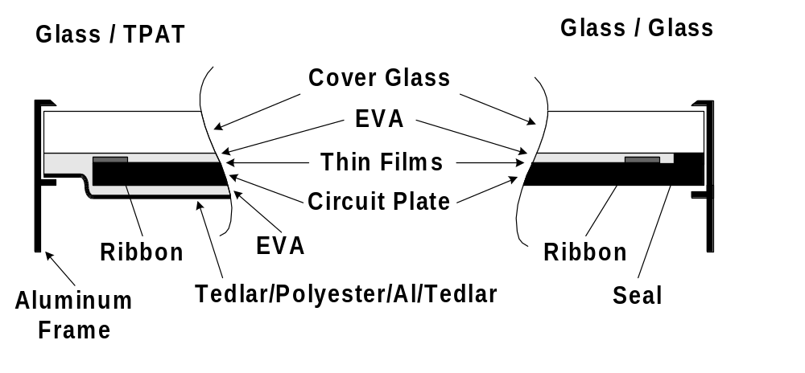
Figure 1. “TPAT” and “glass/glass” package designs.

Progress developing and testing glass/glass packages using a single 40W circuit plates is being extended to a new higher power, ST80, product. Figure 2 is a sketch of the proposed ST80 glass/glass package which is designed for cost reduction and marketability. Two nominally 40W circuit plates are laminated to a common tempered glass front sheet. Laser edge deletion, removal of all films forming an approximately 1 cm boarder, provides electrical isolation from the frame. An edge seal developed in collaboration with the NREL sponsored National Thin-Film PV Module Reliability Team (TFMRT) is used at the perimeter of both plates. A screen in front of the ribbons is included to achieve an aesthetically pleasing uniform black appearance.
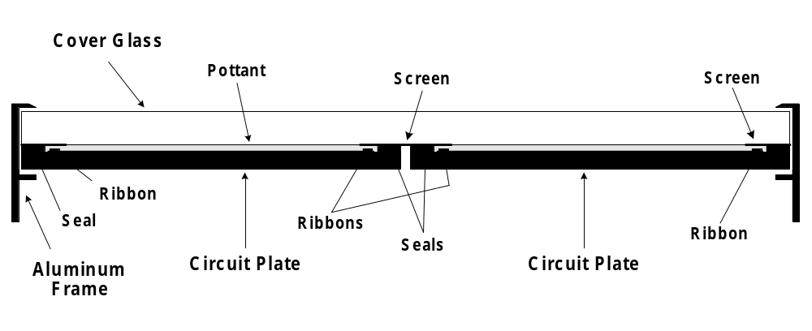
Figure 2. Proposed ST80 glass/glass package.

Humidity penetration during accelerated tests was observed during testing of initial glass/glass package designs. Very promising results have now been demonstrated for prototype packages with the edge seal developed in collaboration with the TFMRT. In addition to a barrier to humidity ingress, this edge seal solved problems during lamination - breakage of the circuit plate due to compression of the laminate edges. Various package design options were explored including variation in edge seal type, edge seal width, EVA thickness and lead routing. Prototype 40W circuit plates packages incorporating an edge seal have passed accelerated tests, including the damp heat test, after outdoor recovery from thermally induced transients.
PVB as an alternative to EVA as a pottant was tested. Package failures occurred during damp heat accelerated testing of a package with EVA as the pottant and without an edge seal. Previous testing indicated that water vapor ingress for small EVA packages was primarily due to diffusion along the EVA/glass interfaces rather than through the EVA. PVB was tested because it may have lower interface diffusion than EVA. Initial damp heat tests using 10W modules indicated potentially lower losses and less humidity ingress during damp heat testing. However, at least part of the lower losses was due to lower initial efficiencies after lamination with PVB. Including an edge seal with EVA as the pottant addresses the water vapor ingress issue thereby making exploration of the PVB option less important. Also, there are several potential issues with the use of PVB:
- PVB is hygroscopic making it particularly sensitive to handling during manufacturing.
- PVB is stiff and tends to shrink nonuniformly which may make lamination lay-up particularly difficult for ST80 configurations.
- The lamination temperature is high and the cycle time potentially long thereby exacerbating transient effects and potentially limiting the use of low temperature solders.
- Softening may complicates accelerated testing by making laminates stick to the fixturing within the environmental chambers.
- High conductivity may make packages more susceptible to corrosion or high voltage failure.
Accelerated testing beyond the normal damp heat test, 1000 hours of exposure to 85ºC and 85% relative humidity, has been pursued to identify potential weaknesses in the glass/glass package design, particularly the impact of humidity. Accelerated environmental testing in the dark introduces thermally induced transients that recover with light exposure. Control modules were exposed for the same duration at 85ºC but without high humidity thereby allowing distinction between humidity induced effects and solely transient thermal effects. All measurements for control and test modules were made after a two hour outdoor exposure.
In previous testing of glass/glass packages without edge seals (Annual Technical Report, 2002 – 2003), electrical performance differences between controls and modules exposed to damp heat occurred at the onset of visible corrosion - darkening and broadening of the interconnects at the edge of the circuit plates. In the current testing using an edge seal, there was no significant difference in electrical performance between controls and modules exposed to high humidity and no visible corrosion after 1000 hours of exposure. Corrosion was not observed for 2300 hours of exposure to high humidity. However, the electrical performance seems to be slightly lower than for the controls. This observation is supported by trends in the electrical performance data but the number of modules tested is inadequate to claim statistical significance at a 95% confidence level. Corrosion is visible on most modules after 3000 hours of damp heat exposure. Lower electrical performance with no visible corrosion is observed for one module. Typically, corrosion of the interconnects is observed along the short edge of the 1x4 ft. module from the edge into the package for up to 3 cm (Figure 3, short edge to the right). Corrosion along the long edge of a module may be as far inboard as the first interconnect and varies from unobservable through sporadic to continuous. One module failed catastrophically after 3500 hours due to failure of solder connections to a printed circuit board that extends the circuit plate buss ribbons and routes power to the back of the module. The majority of modules failed after 4000 hours due to this failure mechanism and breakage. These results indicate that the glass/glass package design with an edge seal provides protection from humidity ingress well beyond the standard 1000 hours at 85ºC and 85% relative humidity.
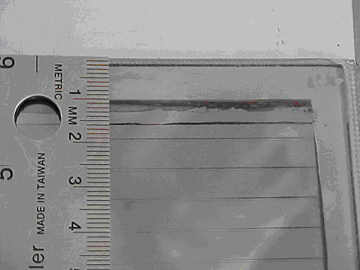
Figure 3. Corrosion at the corner of a glass/glass laminate after 3000 hours of damp heat exposure.

Both minimodules and circuit plates have subjective aesthetic requirements making features that are sometimes seen after selenization, “dark spots”, a potential yield issue. CIS has an aesthetically pleasing uniform black appearance. This uniformity may be disrupted by dark spots if the product is viewed close up; the dark spots typically aren’t visible from a few feet away.
Optically, dark spots appear as differences in surface texture typically around a “dark core” (Figure 4). Surface texture differences range from barely noticeable to dramatic and there may be concentric rings with differences in surface texture. When present, the size of the dark core varies from barley noticeable at the magnification used for Figure 4 to about 0.04 mm. Dark cores are practically invisible because of their small size and the visibility of dark spots varies from virtually undetectable to a variation in shades of very dark gray. With few exceptions, dark cores are observed at the center of a dark spot; however, dark cores are often observed with no surrounding dark spot. Dark spots at times appear centered on the Mo patterning typically with no dark core.

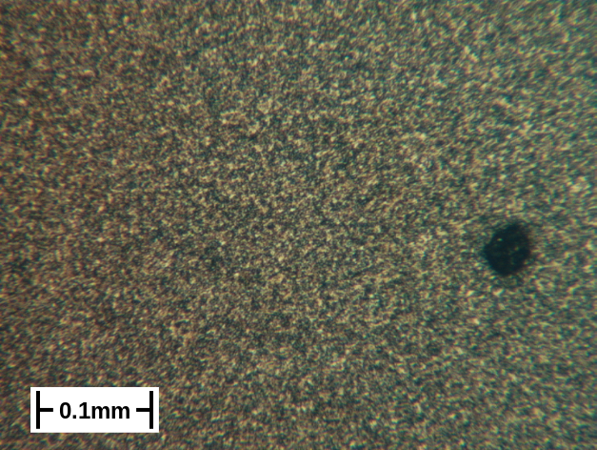
Figure 4. Optically micrograph of a dark spots
Sally Asher, NREL, coordinated analysis of samples with dark spots in parallel with analysis of the absorber structures for standard production processes and for process variations; these particular process variations were not defined to explore dark spot generation but samples with dark spots were included in the sample set. NREL has identified the dark cores, or minimally some dark cores, as In rich regions reacted with S and Se. Figure 5 is a SEM image of a dark core and Figure 6 is an AES In map of the same area. These results are consistent with nonuniform In sputter deposition, “spits”, as the source for some but not all dark cores and dark spots. Specifically, spits are at times seen on precursors with a density of about 20/cm², whereas the density of dark cores and dark spots in some locations is much higher.

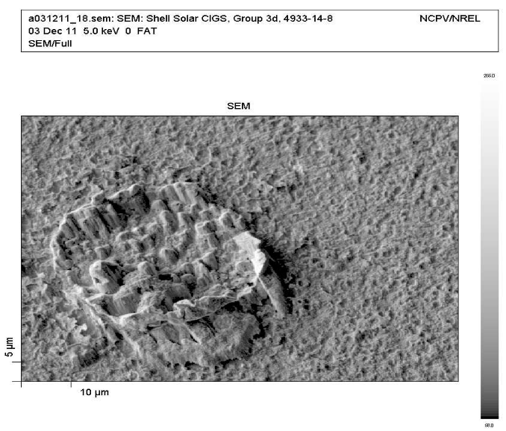
Figure 5. SEM image of a dark core (NREL).

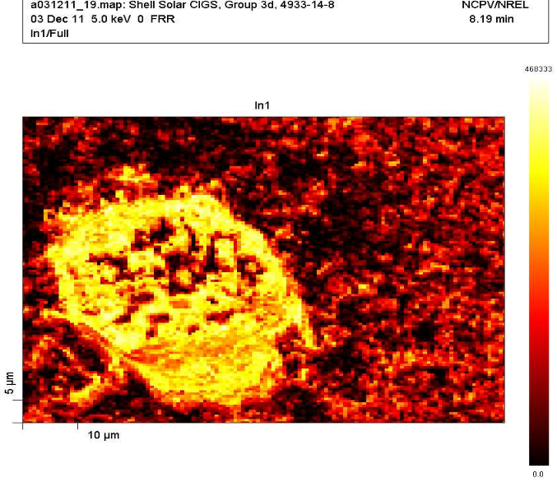
Figure 6. AES In map of a dark core (NREL).

Present understanding is that dark spots do not have a significant impact on performance although the probability of generating dark spots may correlate with process parameters that do have an impact on performance or adhesion. This is consistent with initial results from NREL indicating that the elemental profiles are nearly identical for the area of a dark spots and typical areas. Although dark spots do not have a significant impact on performance, process R&D is being pursued because of the aesthetics issue and to gain understanding of the limits of process options. Changes in both precursor and absorber formation processes have been shown to decrease the number or visibility of dark spots potentially at the expense of adding additional processing or compromises in other production criteria. Exploration of process options will continue. The appearance of Mo after removing the CIG (for example using tape) is different in the immediate area a spots and for regions that tend to generate high or low spot densities. Also, improved adhesion may be indicated for the same changes in the precursor formation processes that decreased the number or visibility of dark spots. Therefore, cross-sectional SEM and analysis of the CIS/Mo interface will be explored at NREL.

Additional Highlights:
- SSI deposited CVD ZnO on glass substrates and multiple sets of experimental absorbers for Unisun.
- SSI supplied about 70 minimodules to Larry Olsen’s group at PNNL for testing multi layer barrier coatings.
- SSI supplied twenty six minimodules with wider than standard boarders (~5 mm) to Larry Olsen’s group at PNNL for testing multi layer barrier coatings.
- Bill Shafarman, IEC, visited and toured the facilities.
- About 60 Mo coated 10x10 cm glass substrates were sent to Ryan Kaczynski, a graduate student working with Tim Anderson at the University of Florida, for CIS studies in conjunction with TFPPP team activities.
- Harin Ullal requested modules for the “Hot and Humid” test program that will go to Texas A&M University.
- SSI sent a CIS module and a list of module components to Vasilis Fthenakis for fire-simulating experiments; Vasilis Fthenakis, Brookhaven National Laboratory, National Photovoltaic EH&S Assistance Center.
- Process development has included the analysis and upgrade of mass flow controllers that tend to corrode when used with H₂Se.
- Vivian Alberts, Physics Department, of the Rand Afrikaans University, has made single phase absorbers using SSI precursors with sulfur content, S/(S+Se), as high as 0.7. Additional work is required to produce lower bandgap absorbers and efficient devices.

