The Leadership Development Initiative of the
National Wildfire Coordinating Group

5 Year Report

Learning from history…Preparing for the future

September 2006

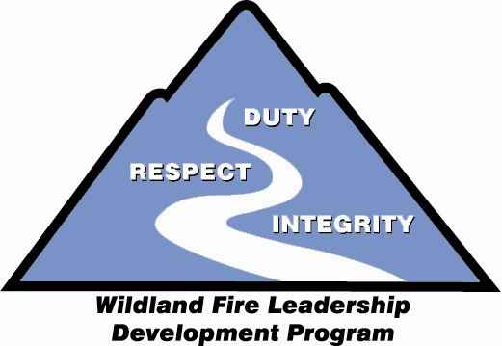

Executive Summary
The most essential element for success in the wildland fire service is competent and confident leadership. The importance of developing effective leaders has been echoed in many venues. In recent years the 1995 Findings from the Human Factors Workshop, the 1998 Wildland Firefighter Safety Awareness Study, and the 2004 U.S. Fire Administration Firefighter Life Safety Summit have all identified leadership development as an issue that wildland fire agencies need to address.
From 1995 to 2000 a number of independent initiatives were generated within the wildland fire service that revolved around the topics of human factors, decision making, and leadership (see Appendix A). However, this increased awareness regarding leadership was not equally communicated in all sectors of the wildland fire service.
Consequently, the members of the National Wildfire Coordinating Group (NWCG) determined that an interagency strategy was needed for improving the ability to develop new leaders in the wildland fire service. In September 2000, the NWCG Training Working Team commissioned an interagency task group to analyze the existing wildland fire training curriculum for leadership content, identify alternatives, and make recommendations. In February 2001, that task group provided the Report of the Leadership Task Group to the Training Working Team. The report contained 14 specific recommendations regarding leadership development for wildland fire agencies (see Appendix B). In November 2001, the NWCG directed the Training Working Team to charter a committee to implement those 14 recommendations (see Appendix C). In January 2002, the Leadership Committee of the Training Working Team began the process of building the Wildland Fire Leadership Development Program (WFLDP).
The mission of the Wildland Fire Leadership Development Program is to promote cultural change in the work force and to emphasize the vital importance of leadership concepts in the wildland fire service by providing educational and leadership development opportunities. In order to meet this expectation, three program components were developed:

- Core value set that supports principle-centered leadership actions in a high-risk work environment.
- Formal curriculum that provides leadership skills training and education at all stages of an individual’s career.
- Non-traditional leadership development opportunities that allow individuals to strive for a higher performance level as a leader through self-directed continuous learning.
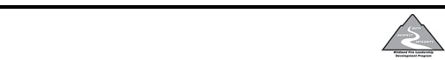
In the five years since the program’s inception in 2001, most of the recommended actions have been implemented and the program has made noticeable impact within the wildland fire service. These first five years have taught us much about the art and science of

In the five years since the program’s inception in 2001, most of the 14 recommended actions have been implemented and the program has made noticeable impact within the wildland fire service. These first five years have taught us much about the art and science of leader development. With an eye to what has been learned in the past, the wildland fire service now has a vehicle to meet the challenge of developing future leaders for an increasingly complex and high-tempo work environment.
This report is divided into five sections: Role of the Leadership Committee, Training and Education, Self-development Opportunities, Organizational Integration, Lessons Learned and Eyes Forward. You are invited to explore this report and learn about the evolution of the Wildland Fire Leadership Development Program over the past five years.

Role of the Leadership Committee
Conduit: Ideas to Action
The NWCG Leadership Committee (LC) has a membership base that provides representation for all participating agencies in the National Wildfire Coordination Group. The Committee was charted in November 2001 to implement the findings of the Report of the Leadership Task Group to the Training Working Team.
With the overarching vision to build a high-quality, integrated leadership development process that firefighters could follow from the entry level to the senior leader level, the LC began its work with an intensive research effort. This entailed examining best practices from a number of organizations that operate in high tempo work environments including the U.S. Marine Corps University, the Wharton Center for Leadership and Change Management at the University of Pennsylvania, the U.S. Air Force Human Factors Research Lab, the U.S. Army Training and Doctrine Command, the NASA Astronaut Development Center, the National Fire Academy, the Institute of Nuclear Powerplant Operators, and various commercial aviation crew resource management programs. This benchmarking and adapting of best practices allowed the wildland fire service to implement proven leadership development techniques along a relatively quick timeline.
Following this research phase, the LC set out to work closely with individuals from the field in order to build a leadership development program that was relevant to the wildland fire service. In many cases this meant establishing ad hoc task groups to develop the specific products within the WFLDP. All involvement from the field level was funded by the local units, bearing witness to the strong buy-in at the field level for this program.
Guiding Principles
The LC research experience provided an exposure to a wide array of techniques, but it also provided an opportunity to distill the higher level common denominators that contributed to the success of leadership development programs in these various organizations. Based on those common denominators, the LC established guiding principles that continue to steer decisions regarding where to invest limited resources for the WFLDP:
- Establish a set of leadership values and principles to provide a model of what is right.
- Invest early in development opportunities for junior leaders.
- Provide formal training that is relevant and gives firefighters an opportunity to practice and develop their leadership skills.
- Recognize that risk and human error are an integral part of working in the wildland fire service and prepare leaders for those decision-making challenges.
- Foster a student-of-leadership attitude by providing self-directed development resources.
- Work with and learn from outside organizations.
Information Resource
The LC serves as an information source using several different communication avenues. The primary communication resource is the WFLDP website (www.fireleadership.gov). First and foremost, this website provides the Leadership Toolbox, which is a menu of online self-development “tools” available to all users. The website also provides support for the formal L-course training curriculum, updates on new initiatives within the WFLDP, links to other leadership websites, as well as program description and administrative information. This website is hosted at the National Interagency Fire Center and has become one of the most visited wildland fire websites (see Appendix D) with as many as 150,000 hits and 15,000 visits during a busy month.

The LC has a communication specialist who manages webmaster duties and an array of informational outreach efforts. There is also a logistics coordinator who handles information inquiries from the field or finds the correct person to answer questions if they are unable to answer those questions.

Lastly, the LC has recruited a number of individuals to serve as ad hoc advisors for ongoing initiatives ranging from formal course development to the design of online self-development tools to representing the committee with other work groups such as the NWCG Training Development Unit.

Advocate
The LC plays the important role of promoting cultural change within the wildland fire service. Through speaking presentations at conferences and participation in various meetings, committee members work to inform stakeholders in the fire business about the benefits of developing leaders whose values and character enable them to influence others by providing purpose, direction, and motivation, in order to accomplish the incident response mission and improve their organization.

Within the NWCG team arena, the LC worked to get the L-courses in the leadership curriculum identified in the 2006 revision of the Wildland Fire Qualification System Guide (PMS 310-1). The LC has also engaged in collaborative efforts with a variety of programs to further the implementation of the WFLDP:
- Working with the state wildfire academy network to provide high quality L-course cadres for a number of these academies around the country.
- Developing the After Action Review training package in cooperation with the Wildand Fire Lessons Learned Center.
- Providing staff support to the NWCG Refresher Training Steering Committee.
- Assisting the “Advancing Fire Training for Rural Departments” initiative in order to help establish leadership training for the eight pilot states identified in this program.
- Exploring a potential partnership with the National Fire Academy’s “Firefighter Life Safety Initiative.” In the initial stages, this has led the LC into working directly with several municipal fire departments to help them implement their own leadership development programs (San Diego City Fire Department, San Ramon Valley Fire Protection District, and Los Angeles County Fire Department).

Training and Education
Recommendations #1, 3, 4, 6, 7, and 8 from the Report of the Leadership Task Group to the Training Working Team addressed training and education issues related to the WFLDP. Only Recommendation #1 remains uncompleted as of September 2006. The following is the current accomplishment status for these six recommendations:
Recommendation 1: Establish a distinct leadership curriculum of courses that are connected conceptually from the least complex (follower) level to the most complex (organizational leader) level. This curriculum should have its own designator (e.g., L-courses) to set it apart from technical courses:
- The L-course training curriculum, consisting of six courses, has been established. The curriculum has established course designators, L-180, Human Factors on the Fireline; L-280, Followership to Leadership; L-380, Fireline Leadership; L-381, Incident Leadership; L-480, IMT Leadership; and L-580, Advanced Leadership Seminar.
- The first and most basic course, L-180, Human Factors on the Fireline, has been completed and is available through the NWCG Publication Management System as a stand-alone course. An adapted version of this course is also embedded into the 2004 version of the S-130 course, so that all new wildland firefighters are now exposed to this information.
- L-280, Followership to Leadership, has been completed and is available through the NWCG Publications Management System (PMS). This course replaces the old S-201/281 course which is no longer a part of the NWCG curriculum. The course has been successfully delivered by local units in many field locations since 2003.
- L-380, Fireline Leadership, was initially developed through a partnership between the U.S. Forest Service and a private contractor in 2000. Subsequently, course design criteria and delivery standards have been developed that will enable all agencies and other vendors to develop and deliver the course without relying on a sole-source provider. This course replaces S-301/381, which is no longer available in the NWCG curriculum. To date there are four approved providers that have successfully delivered this course: Mission-Centered Solutions, National Outdoor Leadership School, ICI Training, and an internal agency cadre sponsored by U.S. Forest Service, Region 6. It is estimated that more than 7,000 wildland firefighters have attended the L-380 course since 2001.
- L-381, Incident Leadership, is currently being delivered by one provider, Mission-Centered Solutions. Course design criteria and delivery standards have been developed that enable all agencies and other vendors to develop and deliver the course without relying on a sole-source provider. This course has been delivered since 2004.

- A steering committee consisting of six IMT subject matter experts from the field, one representative from the LC, and a project leader from the National Advanced Fire & Resource Institute (NAFRI) was established in 2004 to provide oversight for the development of the senior leader level L-courses. The L-480 Incident Management Team Leadership course was designed in a collaborative effort with a performance training contractor, the Institute for Advanced Development. The L-480 course was delivered three times during 2005 and 2006, completing the alpha and beta test phases. The long-term sustainment strategy for the L-480 course is currently being considered by the LC and NAFRI.
- The development of the L-580, Advanced Leadership Seminar course was put on hold in January 2006 while the NWCG Training Working Team considers proposed changes in the overall Incident Management Team (IMT) training requirements.

Recommendation 3 - COMPLETED: The "Human Factors" course and the "Followership to Leadership" course should be in the NWCG Publication Management System (PMS) as Level III courses under the NWCG Course Development and Format Standards guidelines.

- Both the L-180, Human Factors on the Fireline course and the L-280, Followership to Leadership course are available in the NWCG Publication Management System.

Recommendation 4 - COMPLETED: The "Primary Leadership" course and the "Incident Leadership" course should be exempted from the requirements included in the NWCG Course Development and Format Standards guidelines. These standards were developed primarily for the in-house development of technical courses in the cognitive domain to be delivered by agency personnel. These two leadership courses are in the affective domain and will be developed and presented by vendors - at least initially. Adhering to the NWCG standards will likely slow the development and delivery of these courses and is not likely to enhance course effectiveness.
- The course name for Primary Leadership has been changed to "Fireline Leadership."
- These two courses have been developed in conjunction with contractors who have expertise in leadership development training methodology.
- These products are not off-the-shelf course packages; they consist of specific course design criteria and delivery standards to allow wider latitude for wildland fire organizations to implement a complete leadership development program by avoiding a one-size-fits-all approach. Agencies have the option to outsource or develop their own training course based on the most advantageous method for their organization.

Recommendation 6 – COMPLETED: Eliminate the current S-201 and S-301 courses from the NWCG training curriculum. Examine whether the supervision and management skills training that exists in those courses needs to be presented within the wildland fire curriculum or whether those training needs can best be satisfied by other agency-required training that is already available.

- Both the S-201/281 and the S-301/381 courses were evaluated to determine whether the supervision and management skills addressed within those courses would be covered elsewhere. The evaluation of these courses determined that all the significant skills are covered in the new L-280 and L-380 courses or in standard agency-specific supervision training.
- L-280 has replaced S-201/281, Supervisory Concepts and Techniques.
- L-380 has replaced S-301/381, Leadership and Organizational Development.

Recommendation 7 - COMPLETED: Incorporate the Human Factors course into the NWCG S-130 Firefighter training course. This will allow all entry-level firefighters to receive information on follower responsibilities. The Human Factors course will also exist as a stand-alone course, for those who are not required to take S-130.
- An adapted version of L-180, Human Factors on the Fireline has been incorporated into the 2004 version of the S-130, Basic Firefighter course. The L-180 course can also be ordered and delivered as a stand-alone course for personnel who are not required to take the S-130 course.

Recommendation 8 - COMPLETED: Eliminate the S-131 course. Make the Followership to Leadership course a requirement for the FFT1 position. Both are 8-hour courses, so this change results in no net increase of required training for the squad boss position. S-131 was developed in response to the South Canyon Fire tragedy, yet it does little to address leadership issues at the squad boss level. Since the Followership to Leadership course does address precisely those leadership issues, it should be the required course at the FFT1 level. The more cognitive, technical content of the existing S-131 course could be developed into a Job Aid.
- The Report of the Leadership Task Group to the Training Working Team recommended eliminating the S-131 course. The LC has since received approval from the NWCG Training Working Team to rescind this recommendation.
- The S-131 course has been revised to have a more tactical focus. The new S-131 course features extensive use of Sand Table Exercises (STEX) and Tactical Decision Games (TDGS), which are training techniques developed through the partnership between the LC and Marine Corps University.
- The end result still insured no net increase in training hours at the single resource boss level (as envisioned in the original recommendation), since the L-280 course replaced the old S-201/281 course.
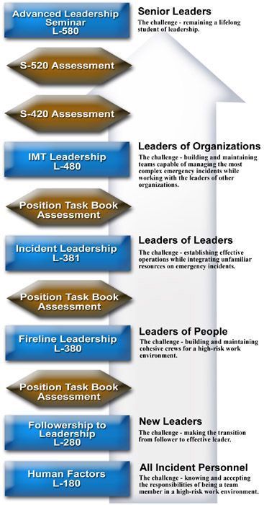

Self-development Opportunities
Recommendations #10, 11, and 12 from the Report of the Leadership Task Group to the Training Working Team addressed self-development opportunities within the WFLDP. Only Recommendation #11 remains uncompleted as of September 2006. The following is the current accomplishment status for these three recommendations:
Recommendation 10 - COMPLETED: Adopt a specific set of desired leadership principles and values that are common to all our organizations. Communicate these principles and values to our work force and incorporate them in leadership training.
- One of the LC's first accomplishments was to adopt, on an interagency basis, the leadership values and principles as described in the Report of the Leadership Task Group to the Training Working Team. This was completed in January 2002.
- The values and principles have been integrated into all of the L-courses during the development phase.
- A communication plan has been developed that includes a description and discussion of the leadership values and principles and how they relate to leadership development. This plan is used by the committee and others to communicate the leadership values and principles to the field.
- The WFLDP website devotes an entire section to the leadership values and principles. This website is linked prominently off the National Interagency Fire Center's web page.
- One of the WFLDP self-development tools, the Leadership in Cinema program, is specifically designed to provide local units with an easy to use training technique that is focused on the integration of leadership values and principles at the first-line leader level.
- A series of bookmarks that display the WFLDP website address along with the leadership values and principles have been developed and disseminated widely among fire personnel in the field; thousands of these bookmarks have been distributed. A wall poster that displays the values and principles for use in the L-courses is available in the NWCG Publication Management System.
- In 2003 the LC established the “Paul Gleason Lead by Example Award” to recognize those in the wildland fire service who exemplify the leadership values and principles. Six awards in three categories are given each year to individuals or work groups from across the wildland fire service.

Recommendation 11: Develop a self-study component of the leadership curriculum that allows people to study leadership concepts and principles outside the context of formal classroom training. For example, establish a leadership-themed website and publish a "Book of Books" of recommended reading materials that will help people develop as leaders.
- A "Leadership Toolbox" has been developed for the WFLDP website. This toolbox offers self-development tools that are designed to assist fire managers, fire support staff, and firefighters in efforts to enhance their leadership knowledge and skills. Many of these tools were adapted from other work environments such as the military, academia, and business. The intent is to foster a lifelong student-of-leadership culture in the wildland fire service.
- The Leadership Toolbox includes a wide range of self-development tools that can be utilized by individuals and local units. Some of the more significant tools include the Professional Reading Program, the Staff Ride Library, the Tactical Decision Game Library, the Leadership in Cinema program, a series of interviews with retired leaders in fire business called Leaders We Would Like to Meet, training support for the After Action Review technique, an individual self-development plan referenced in several of the L-courses, and a Crew Cohesion Assessment reference.
- The LC has sponsored workshops in various geographic areas to foster the implementation of Staff Rides, After Action Reviews, Tactical Decision Games and Sandtable Exercises at the field unit level.
- The LC sponsored a leadership development exchange with the Marine Corps University from 2001 through 2004. This exchange was supported by a Memorandum of Understanding between the Marine Corps University, the Bureau of Land Management, and the U.S. Forest Service. This exchange enabled over 150 wildland firefighters to attend week-long, hands-on workshops at the U.S. Marine Corps center for training and education in Quantico, Virginia. These individuals have formed the core group for the implementation of Tactical Decision Games and Staff Ride techniques within the wildland fire service, as well as working in subject matter expert roles during the development process of the various L-courses.
- A leadership doctrine publication is currently under development. This publication will be a small-format book based in part on the U.S. Marine Corps publication entitled Leading Marines and on the U.S. Army publication entitled Army Leadership: Be, Know Do. The intent of the publication is to offer a framework for wildland fire leaders to consider when assessing and developing themselves, their people, and their organizations. The goal is to make it available as an L-course reference in the NWCG Publication Management System.
- This recommendation may never reach "completed" status due to the wide range of possibilities encompassed in self-development and self-study. The LC will continue to work with ad hoc advisors from the field to identify desired Leadership Toolbox products and follow through to implementation of those products.

Recommendation 12 - COMPLETED: Institute the use of leadership skills assessment tools within the framework of the leadership curriculum. The primary intent in using assessment tools is to enable people to identify which leadership traits they need to improve. The intent is not to use these assessment tools for disciplinary action. Some results could be used to determine whether or not individuals are ready to advance to higher-level Incident Command leadership positions.
- A basic leadership self-development plan and worksheet have been developed as a reference and are available in the Leadership Toolbox.
- A basic self-assessment process is initiated in the L-280, Followership to Leadership course and reinforced in the L-380, Fireline Leadership course.
- A complex, commercial self-assessment instrument is utilized in the L-480, Incident Leadership course.

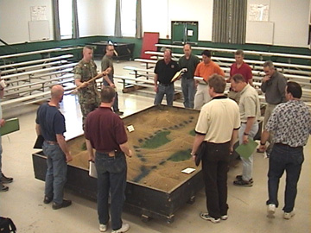
Firefighters learning about Tactical Decision Games and Sandtables
at the Marine Corps University in May 2002.

Organizational Integration
Recommendations #2, 5, 9, 13, and 14 from the Report of the Leadership Task Group to the Training Working Team addressed the need to integrate the WFLDP into the various organizations that comprise the wildland fire service. Only Recommendations #5 and #14 remain uncompleted as of September 2006. The following is the current accomplishment status for these five recommendations:
Recommendation 2 - COMPLETED: Develop a strategy for accomplishing new course development, including a time line for completion, delivery strategy and cost analysis. Some existing leadership courses can be used, and some new course development will be required in order to meet the leadership development needs of all levels of our organizations. Delivery strategy needs to include a plan for developing agency employees as instructors for the more advanced leadership courses; initially these courses will only be deliverable by a vendor with expertise in leadership development.
- Each L-course has been addressed individually to determine content, delivery strategy, cost, completion timeline, designator number, and whether to include in the NWCG Publication Management System. These considerations have been documented in issue papers available on the WFLDP website. In many cases, the leadership courses have replaced existing courses to enhance development opportunities for new and experienced leaders.
- The entry-level L-courses in the curriculum are designed to be delivered by local instructors, while the other L-courses are designed to be delivered by dedicated cadres that undergo an agency approval process in order to maintain high-quality instructors for the mid-level and advanced courses.
- An analysis of the objectives for the first four L-courses has been completed. This analysis has resulted in a tiered hierarchy for all course objectives to insure that there are no gaps or overlaps in the objective set for the entire curriculum. This insures that complex objectives in the more advanced courses are supported with basic enabling objectives in the entry-level courses.

Recommendation 5: Establish a mechanism for evaluating the effectiveness of leadership training. Such a mechanism might involve the use of contractors and agency personnel conducting field interviews and observing job performance on fires, months or years after training is presented. The idea is to accurately assess how the training impacted performance on the job.
- All of the currently available L-courses have gone through a test course protocol during their development cycle.
- Members of the LC have attended all of the currently available L-courses in order to have first-hand knowledge of the curriculum and to evaluate the courses as part of an ongoing quality control effort.
- The Bureau of Land Management in Utah and the U.S. Forest Service, Region 4 conducted a combined follow-up review with graduates of L-380 courses, their subordinates, and their supervisors. This review was completed in the fall of 2003 and is available on the WFLDP website.
- The LC has established a contract with The Guidance Group to design and test an evaluation methodology for the leadership curriculum. This work is expected to be completed by 2007.

Recommendation 9 – COMPLETED: Revise the Wildland and Prescribed Fire Qualification System Guide (PMS 310-1) to make specific leadership courses "required training" for certain key positions and "additional training" recommended for other positions. Incident Operations Standards Working Team (IOSWT) to review, modify as needed, and approve changes to the 310-1 recommended in this document. Suggested completion date, fall of 2001.
- IOSWT time frames for revision of the PMS 310-1 did not allow for the fall of 2001 suggested completion date to be met.
- All WFLDP training products have been assigned course identification numbers within the Incident Qualifications and Certification System (IQCS).
- Subject matter experts were brought together in a workshop to address the “required” versus “recommended” training considerations for L-courses in the PMS 310-1. Their observations guided the LC recommendations to the NWCG Training Working Team (TWT) on changes to the PMS 310-1.
- A detailed proposal for both “required” and “recommended” training was submitted to the TWT and IOSWT at their joint February 2004 meeting. This proposal pertained to the L-180, L-280 and L-380 courses, since other courses in the curriculum were still under development at that time.
- Of the 105 ICS positions in the PMS 310-1, “required training” was proposed for 13 positions (all in Command or Operations). L-380 was proposed as “required training” for 6 positions, while L-280 was proposed as “required training” for 7 positions. Another 37 positions were identified for “recommended training” (17 for L-380 and 20 for L-180).
- Additional recommendations for the L-381 and L-480 courses were given to the IOSWT in May 2005. L-381 was proposed as “required training” for 3 positions and L-480 was proposed as “required training” for 7 positions.
- The IOSWT has determined that none of the L-courses would be identified as “required training” for any position in the 2006 revision of the Wildland Fire Qualification System Guide (PMS 310-1).
- The LC submitted a final briefing paper regarding the status of this issue to the NWCG parent group via the TWT in June 2005. The TWT elected not to forward the briefing paper to the NWCG parent group.

Recommendation 13 - COMPLETED: Establish a standing group (e.g., Steering Committee) that will be responsible for overseeing the implementation of the recommendations in this report. It is widely recognized that, regardless of their quality, reports alone do not accomplish change in an organization.
- The Leadership Committee (LC) was established and met for the first time in January 2002. The committee, consisting of individuals representing each federal wildland fire agency, the National Association of State Foresters, local and municipal fire departments, meets twice per year to review and assign action items.
- Actions have been taken on each of the 14 recommendations, and in many cases, a significant amount of work has been accomplished. As of September 2006, only 4 of the original 14 recommendations are incomplete.
- A communication plan was developed for the WFLDP. Resources developed to support the communication plan include a standard PowerPoint presentation about the program, annual status reports, informational brochures for distribution at conferences and academies, a logo to increase program recognition among firefighters, a series of bookmarks that communicates the WFLDP website address along with the values and principles, several program description and FAQ features on the WFLDP website, and a contact link on the WFLDP website so that users can easily provide comments or ask questions of the various members on the LC.
- A number of articles showcasing various aspects of the WFLDP have been authored by members of the LC in publications that include Wildland Firefighter, Wildfire, Fire Management Today, California Fire Service, Wharton Digest, and Academy of Management Learning & Education.

Recommendation 14: During the ongoing NWCG course revision process, analyze each course within the "S" curriculum to determine if leadership content is appropriate in the course given the nature of the position for which the course is targeted (e.g., Crew Boss). The creation of a separate leadership curriculum will not eliminate the need for the "context-specific" practice of leadership competencies.

- Members of the NWCG Training Development Group have attended many of the leadership courses so they are better able to determine how to reinforce these concepts as project leaders for their S-course revision assignments.
- An individual from the NWCG's Training Development Group is tasked with briefing each new S-course revision team on the relevant aspects of the WFLDP.
- The NWCG Training Development Group has created a content analysis tool to guide project leaders and subject matter experts through the process of identifying critical leadership/human factor concepts. For each revision, this tool provides a lens to view course material and position task books regarding relevant leadership skills.
- Significant changes are occurring within the NWCG curriculum during the S-course revision cycle. The shift is to a more experiential learning approach to give students a chance to practice job skills. Leadership content has been added to courses such as S-131, S-230, S-336, and RX-410. Due to the time frames involved in revising the NWCG curriculum, this process will not be complete until at least 2009.

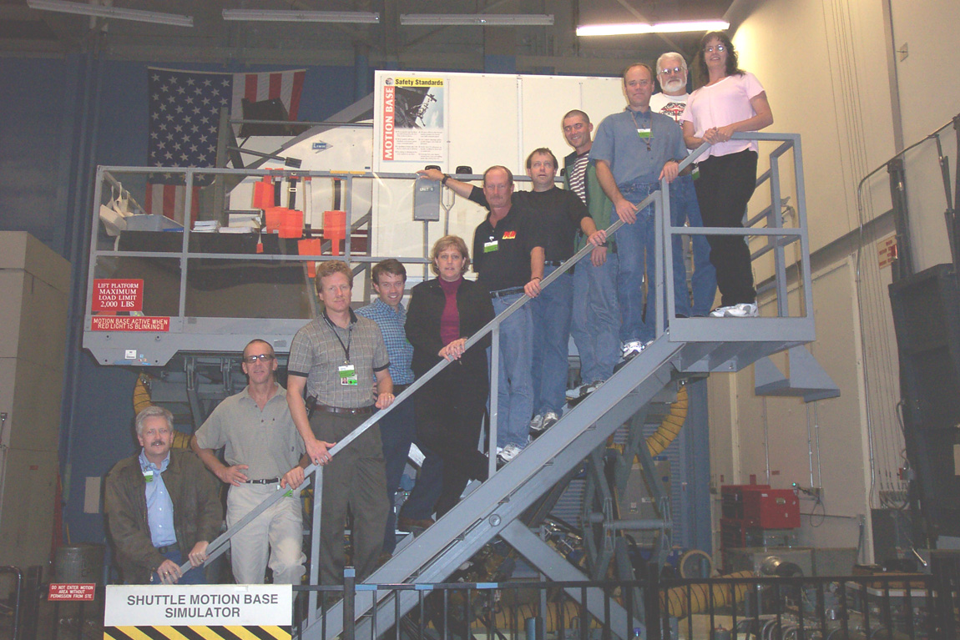
The Leadership Committee at the NASA Astronaut Development Center
in October 2003.

Lessons Learned and Eyes Forward

LESSONS LEARNED - As the title of this report suggests, and as one of the basic leadership techniques advocates, learning from past actions is a key to future success. Some of those lessons from the Wildland Fire Leadership Development Program’s first five years include:

Recruit and empower ad hoc advisors.
The WFLDP has very limited resources. Bringing field users together as small teams in order to facilitate the development phase on new products has paid off in many ways. Continuing this strategy will insure that new products are relevant to the field, will assist in succession planning for LC continuity, and create an ever bigger corps of advocates for the WFLDP.

Develop partners outside the wildland fire service.
There is a wealth of information and experience regarding leadership development outside the wildland fire service. The WFLDP should continue to work with other organizations for idea sources and to utilize targeted outsourcing opportunities to accomplish specific projects where there is a lack of staffing capacity.

Utilize the power of the Web.
Using the Web to consolidate and share leadership information has been very effective. The WFLDP website provides a one-stop-shopping place for leaders at every level and is also an excellent briefing tool for anyone interested in leadership. This on-line resource organizes information and provides useful tools to field users. The high volume of use speaks for the value of this website.

Work on many fronts to achieve organizational integration.
While the initial spark for the WFLDP came from grassroots initiatives, bringing mid-level management and senior level leadership onboard will be the key to an optimum end state. The LC must continue to build an understanding of the WFLDP at the strategic levels in the wildland fire service.
EYES FORWARD - Looking to the future, important work remains to insure that the Wildland Fire Leadership Development Program continues as a dynamic part of wildland fire training and does not become another checkmark on a bureaucratic “to do” list.

Initiate an evaluation process for the L-course curriculum.
A contract to develop an evaluation process has been established. The intent for this initiative is to determine the long-term impact of the L-courses. This would involve a formal evaluation system to measure behavior changes by gathering post training feedback from both participants and supervisors. This effort will be the first time this has been attempted for any part of the NWCG training curriculum.

Work with various stakeholders to craft an effective IMT development process.
The development of the senior level leader courses (L-480 and L-580) has encountered challenges due to uncertainty surrounding the future path of IMT training. A number of factors have converged to bring the current model of IMT training into question. The LC will need to work closely with the TWT, NAFRI, and others to resolve this issue successfully.

Integrate leadership concepts into other NWCG efforts.
As the mission and expectations of the wildland fire service expand, so to will the need to insure the WFLDP stays integrated with new NWCG efforts, especially in the area of training. Continued attention to course crosswalk initiatives and course revision work should remain a priority focus for the LC.

Provide engaging and current self-development opportunities.
The Leadership Toolbox is the most universally accessible application of the WFLDP. It is widely used throughout the wildland fire service as well as being cited for use by outside organizations, the military, and by academia. Currently, the Staff Ride Library and the leadership doctrine publication are the primary products under development. As the field identifies needs for other tools and products in the Leadership Toolbox, the LC should be prepared to support that development need.

Enable local cooperators to participate in the WFLDP.
Access to NWCG training is a challenge for some state and local fire organizations. Good leadership on the fireground is a must no matter where firefighters work. The LC should continue to seek innovative ways to make leadership development opportunities available for the many entities that make up the wildland fire service.

Appendix A

An Abridged History
of Leadership Development Initiatives
in the Wildland Fire Service
1995 to 2001

1995
Missoula Technology Development Center hosts a Human Factors Workshop in Missoula, Montana. The focus is on decision making and group dynamics.

Significance - The workshop was the first time that the wildland fire service at the national level collaborated with experts from other high-risk work environments regarding the human elements of decision making and crew cohesion.

1995
Smokejumper community begins using Cockpit Resource Management (CRM) training for spotters and pilots.

Significance – Introduction of CRM training concepts of the aviation industry within the wildland fire service.

1996
A training course in human factors is developed for wildland firefighters. This course is tested and then delivered for the next three years at the National Park Service’s Western Region Crew Boss Academy.

Significance – This was the first attempt to apply CRM concepts to wildland firefighting ground resources. This provided an opportunity to assess the CRM concepts in context…many became the foundation for the leadership program, others were determined to be specific to the aviation environment.

1996-1998
A number of articles are authored in wildland fire publications and other professional journals regarding decision-making and group dynamics in wildland firefighting.

Significance – These articles raised the profile of wildland firefighting in outside circles and raised awareness within the wildland fire service for the issue of improving how firefighters are prepared for fireground decision making.

1996-1998
The TriData Corporation is contracted by the five federal fire agencies to conduct a survey regarding the current state of wildland firefighter safety.

Significance – Over 1,000 wildland firefighters provide feedback. Over 280 individual findings are returned to the clients. Improving training for leadership and decision making was a major emphasis area in the findings. The five federal fire agencies created a shared national-level position to address the findings from the study. This position was vacated after two years and never restaffed.

1998
The NWCG Safety and Health Working Team sponsors an interagency effort to develop a course called Human Factors on the Fireline.

Significance – This was the first formal human factors training within the NWCG curriculum. Mission-Centered Solutions was contracted to provide CRM consulting services for the project. This course was published in 2000 and eventually became L-180, the entry level course for the leadership curriculum.

1998
A proposal is submitted to the national fire and aviation offices of both the U.S. Forest Service and National Park Service for a 40-hour leadership development training course targeted at crew level supervisors.

Significance – This proposal reinforced the need identified in the TriData report for robust leadership development opportunities early in a firefighter’s career.

1999
The Lincoln National Forest sponsors a leader development program focusing on CRM and leadership skills, titled Fireline Leadership. The Lincoln National Forest works in partnership with Mission-Centered Solutions: the Lincoln National Forest provides technical expertise and funding; Mission-Centered Solutions provides design and development resources.

Significance – Grassroots effort pushed leadership development from an idea to a reality. The high level of acceptance for this prototype course encouraged the U.S. Forest Service to initiate a wider trial effort in the following year.

1999
The NWCG parent group supports a leadership training initiative aimed at the Incident Management Team level to be delivered at NARTC (now known as NAFRI).

Significance – The leadership development issue emerged on NWCG’s radar screen.

1999
The Fire Behavior Analyst Workshop held in Phoenix, Arizona organizes a Staff Ride to the 1990 Dude Fire site on the Tonto National Forest.

Significance - First use of a formal Staff Ride in the wildland fire service. The Staff Ride is an educational technique that focuses on the human element and decision making.

2000
The U.S. Forest Service office at NIFC initiates a trial of Mission-Centered Solution’s Fireline Leadership course to be delivered to Interagency Hotshot Crew supervisors for assessment of the product. Three sessions are conducted on the Prescott National Forest, the Sierra National Forest, and at the Redmond Training Center.

Significance – Funding for leadership development training was provided directly from a national-level budget. This course eventually became the blueprint for the L-380, the third level course in the current leadership curriculum.

2000
The Leadership Task Group is assembled by NWCG in September 2000 and tasked with providing a report within 6 months.

Significance – NWCG recognized the need to address leadership development for all wildland firefighters.

2001
The Report of the Leadership Task Group to the Training Working Team is submitted in February 2001.

Significance – The strategy of the task group was to benchmark a wide variety of outside organizations in order to present the current state of leadership development techniques to NWCG decision makers. Two organizations provided extensive support to this benchmarking effort - the Marine Corps University and the Wharton Center for Leadership and Change Management at the University of Pennsylvania.

2001
The Fireline Leadership national training initiative for the U.S. Forest Service is expanded to all Type 1 resources. This initiative continues to be funded at the national level.

Significance – Widespread involvement of the hotshot crews and smokejumpers in the program brought higher awareness to the entire wildland fire service.

2001
U.S. Forest Service, Region 3 funds Fireline Leadership courses for their engine module leaders, fire management officers, and helicopter managers.

Significance – The Fireline Leadership course is adapted and proven effective outside the hotshot and smokejumper communities.

2001
The Bureau of Land Management in Colorado and Wyoming provide Fireline Leadership courses to their engine module leaders.

Significance – First use of the Fireline Leadership course in the wider interagency community.

2001
The Fireline Leadership course is granted equivalency by the U.S. Forest Service and the Bureau of Land Management for the S-301, Leadership and Organizational Development course.

Significance – Agency recognition of what good leadership development training looks like; opens new avenues for providing that training.

2001
NWCG Leadership Committee is chartered in November 2001 and work on the Wildland Fire Leadership Development Program is initiated at the first meeting in January 2002.

Significance – Interagency commitment to improve how wildland firefighters are prepared for the leadership and decision-making demands they will face on the fireground.

Appendix B

Executive Summary from the

Report of the Leadership Task Group
to the Training Working Team
February 2001

EXECUTIVE SUMMARY

The Leadership Task Group to the Training Working Team believes that new approaches are called for in addressing the leadership issues that face wildland fire organizations. These leadership issues are very complex, defying simple explanation or easy understanding. Solutions to these issues will by necessity be complex as well.

Although our group was tasked with analyzing the NWCG training curriculum and making recommendations on leadership training issues, we ended up concluding that training alone is not enough. We feel strongly that what our organizations need is to institutionalize leadership development, which means we need to do a lot more than just provide classroom training.

During the analysis phase of our work, we examined a number of different types of organizations that attempt to address leadership issues in their work forces for a variety of reasons. In the private sector, leaders are needed to enhance the company's bottom line. In government, leaders are needed to accomplish agency missions. In the military, leaders are needed to fight battles and win wars. Benchmarking a variety of organizations gave us some perspectives on our own organizations and some ideas for dealing with our own leadership challenges.

We found that there is no such thing as a "military model" or a "corporate model" for leadership. There are many different leadership concepts and practices in both the public and private sectors. The task for the wildland fire community is to sift through all of these and come up with some combination that will work best for us, given the challenges our organizations face.

In examining our operational environment and comparing it to that of other organizations, the largest number of similarities are found in the military and in other emergency service organizations. These organizations all operate in high risk environments where decisions must be made within compressed time frames, often by people under a great deal of stress. By and large, we found that many of the leadership development concepts and techniques practiced in the military have some applicability in the world of wildland fire. We're not suggesting that our operations mimic those of military organizations; we are suggesting that we use ideas that make the most sense and have the best chance of working.

One consideration that we made in our analysis was that there are some marked differences between temporary organizations and permanent organizations. Temporary organizations are those that are put together as needed, such as any incident management organization. Permanent organizations are "standing" structures that are more or less always in place, for example the fire management organization at a local unit. The differences in the relative permanence of an organization have a variety of impacts on the exercise of leadership. Our recommendations primarily focus on leadership in temporary organizations. The following is a summary of the recommendations contained in this report:
1. Establish a distinct Leadership curriculum of courses that are connected conceptually from the least complex (follower) level to the most complex (organizational leader) level. This curriculum should have its own designator (e.g., L-courses) to set it apart from technical courses.

2. Develop a strategy for accomplishing new course development, including a time line for completion, delivery strategy and cost analysis. Some existing leadership courses can be used, and some new course development will be required in order to meet the leadership development needs of all levels of our organizations. Delivery strategy needs to include a plan for developing agency employees as instructors for the more advanced leadership courses; initially these courses will only be deliverable by a vendor with expertise in leadership development.

3. The "Human Factors" course and the "Followership to Leadership" course should be in the NWCG Publication Management System (PMS) as Level III courses under the NWCG Course Development and Format Standards guidelines. The Human Factors course is currently in the PMS; Followership to Leadership is currently under development and needs to be reviewed by the NWCG Standards Unit upon completion.

4. The "Primary Leadership" course and the "Incident Leadership" course should be
exempted from the requirements included in the NWCG Course Development and Format Standards guidelines. These standards were developed primarily for the in-house development of technical courses in the cognitive domain to be delivered by agency personnel. These two leadership courses are in the affective domain and will be developed and presented by vendors – at least initially. Adhering to the NWCG standards will likely slow the development and delivery of these courses and is not likely to enhance course effectiveness.

5. Establish a mechanism for evaluating the effectiveness of leadership training. Such a mechanism might involve the use of contractors and agency personnel conducting field interviews and observing job performance on fires, months or years after training is presented. The idea is to accurately assess how the training impacted performance on the job.

6. Eliminate the current S-201 and S-301 courses from the NWCG training curriculum. Examine whether the supervision and management skills training that exists in those courses needs to be presented within the wildland fire curriculum, or whether those training needs can best be satisfied by other agency-required training that is already available.

7. Incorporate the Human Factors course into the NWCG S-130 Firefighter training
course. This will allow all entry-level firefighters to receive information on follower responsibilities. The Human Factors course will also exist as a stand-alone course, for those who are not required to take S-130.

8. Eliminate the S-131 course. Make the Followership to Leadership course a requirement for the FFT1 position. Both are 8-hour courses, so this change results in no net increase of required training for the squad boss position. S-131 was developed in response to the South Canyon Fire tragedy, yet it does little to address leadership issues at the squad boss level. Since Followership to Leadership does address precisely those leadership issues, it should be the required course at the FFT1 level. The more cognitive, technical content of the existing S-131 course could be developed into a Job Aid.

9. Revise the Wildland and Prescribed Fire Qualification System Guide (PMS 310-1) to make specific leadership courses "required training" for certain key positions and “additional training" recommended for other positions. Incident Operations Standards Working Team (IOSWT) to review, modify as needed, and approve changes to the 310-1 recommended in this document. Suggested completion date, fall of 2001.

10. Adopt a specific set of desired leadership principles and values that are common to all our organizations. Communicate these principles and values to our work force and incorporate them in leadership training.

11. Develop a self-study component of the leadership curriculum that allows people to study leadership concepts and principles outside the context of formal classroom training. For example, establish a leadership-themed website and publish a "Book of Books" of recommended reading materials that will help people develop as leaders.

12. Institute the use of leadership skills assessment tools within the framework of the leadership curriculum. The primary intent in using assessment tools is to enable people to identify which leadership traits they need to improve. The intent is not to use these assessment tools for disciplinary action. Some results could be used to determine whether or not individuals are ready to advance to higher-level Incident Command leadership positions.

13. Establish a standing group (e.g., Steering Committee) that will be responsible for overseeing the implementation of the recommendations in this report. It is widely recognized that, regardless of their quality, reports alone do not accomplish change in an organization.

14. During the ongoing NWCG course revision process, analyze each course within the "S" curriculum to determine if leadership content is appropriate in the course given the nature of the position for which the course is targeted (e.g., Crew Boss). The creation of a separate leadership curriculum will not eliminate the need for the "context-specific" practice of leadership competencies.

There is no single magic bullet for leadership in wildland fire, no quick fix, no easy answer. The creation of an environment where leaders are developed in an organized way is likely to take years, which seems like a good reason to get started right away.

Appendix C

Charter for the NWCG Leadership Committee
of the Training Working Team

Established 2001
Revised 2004

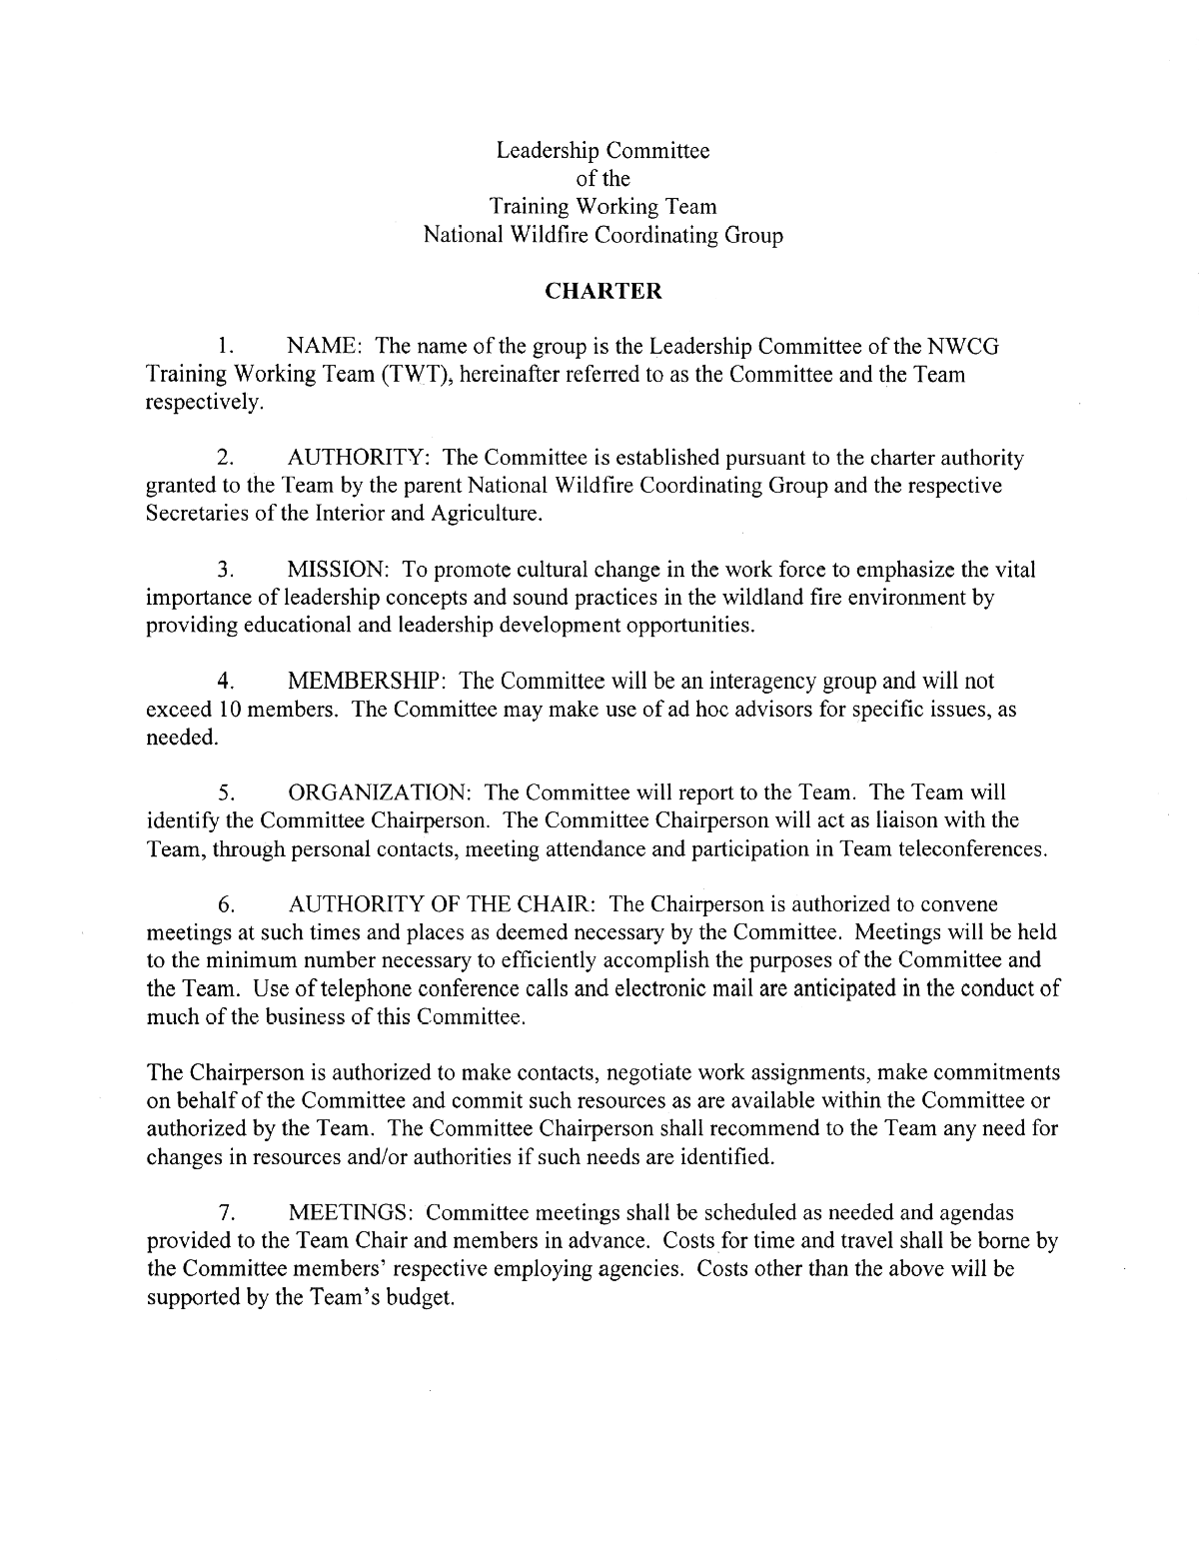

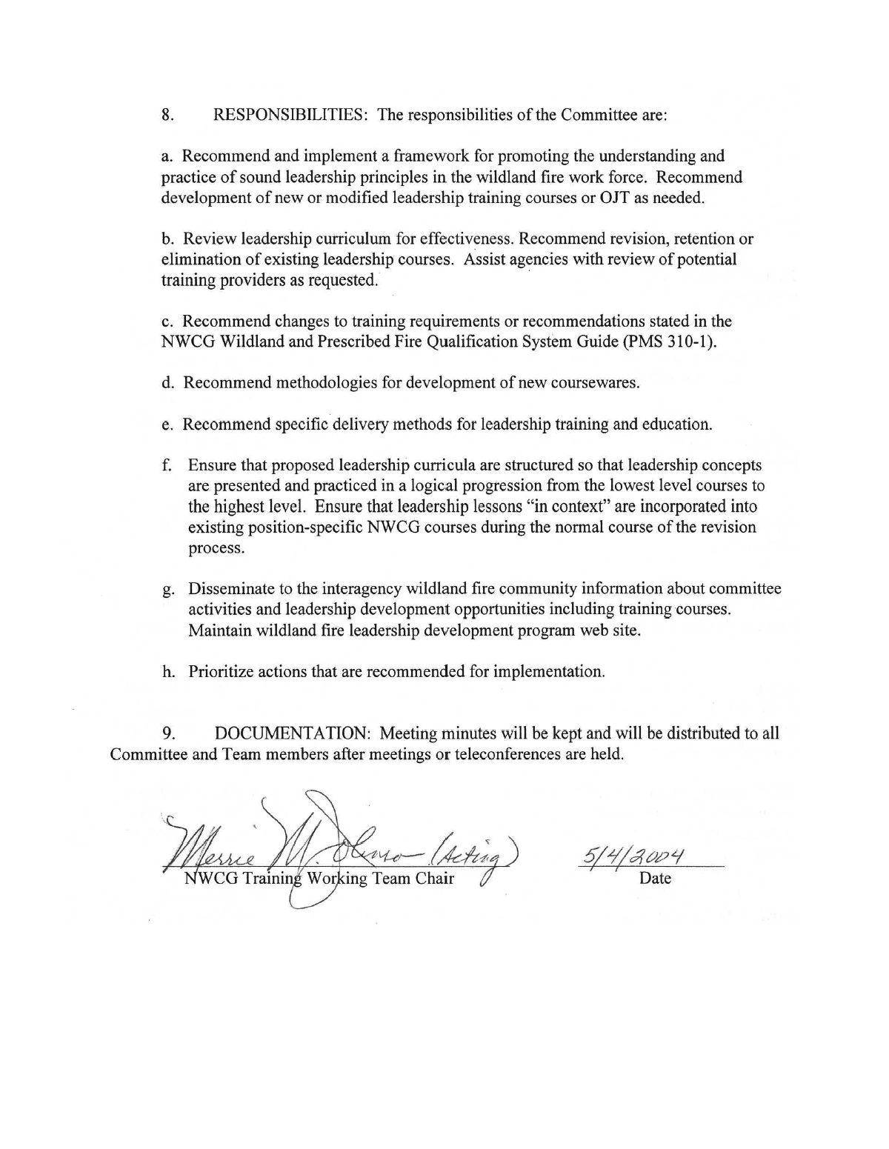

Appendix D

Wildland Fire Leadership Development Program
Website Statistics

www.fireleadership.gov

Hits / Month www.fireleadership.gov

Hit – The retrieval of any item, like a page or a graphic, from a web server.

* Department of Interior websites shutdown during March 2004.

Visits / Month www.fireleadership.gov

Visit - A web page that has been viewed by one visitor.

* Department of Interior websites shutdown during March 2004.

