Board of Directors
Interim Report

Don Onwiler
Program Manager, Division of Weights and Measures
Nebraska Department of Agriculture

100 INTRODUCTION

The Board of Directors held its quarterly meeting on Saturday, January 21, 2006, and continued meeting during work periods throughout the remainder of the Interim Meetings. The Board of Directors and NTEP Committee invited members to dialogue with the Board on the following issues: conformity assessment, NCWM voting procedures, the use of work groups, the National Training Program, and participation internationally, i.e., International Organization on Legal Metrology (OIML), the OIML Mutual Acceptance Arrangement (MAA), the Canadian Forum on Trade Measurement (CFTM), the Asia-Pacific Legal Metrology Forum (APLMF), and U.S. National Work Groups (USNWG).

Table A
Table of Contents
Subject Page

INTRODUCTION 1
1. Improving Standards Development 2
2. Marketplace Surveys 2
3. Meetings 2
4. Membership Marketing 2
5. NCWM Website – www.ncwm.net 3
6. Mutual Acceptance Arrangements 3
7. Participation in International Standard Setting 3
8. Increasing the Value and Attendance at Meetings 3
9. Treasurer’s Report 3

Table B
Appendices
Appendix Title Page

A NCWM National Survey A1
B National Random Market Survey 2006 B1
C Auditor’s Report for 2006 C1
D Report on the Activities of the International Organization of Legal Metrology (OIML) and Regional Legal Metrology Organizations D1
E Meeting Minutes of the Associate Membership Committee (AMC) E1

Details of all Items
(In order by Reference Key Number)

1. Improving Standards Development

Judy Cardin continued her efforts with instructing members on the use of Form 15 and made presentations to the remaining regional associations. The Board reviewed this item in an effort to ensure that the process is simple, clear, and transparent. The next step in the process is to incorporate the feedback received from the regional associations into a “How To” submit a Form 15. The intent is also to develop an online form for submittal.

In addition, the Board is recommending to the standing committees that they encourage members to submit written comments to the appropriate standing committee chair. The standing committee chair, if appropriate, will read the comments during the open hearing. This would include comments from members who are uncomfortable speaking at the microphone.

2. Marketplace Surveys

Roger Macey, Branch Chief, California Division of Measurement Standards gave a PowerPoint presentation of the basic initial data from the recent national marketplace survey. Additional in-depth data will be presented at a later time. The Board welcomes any input from the general membership on the use of the data. The PowerPoint presentation and survey results are contained in Appendices A and B to the Board Report. Once the work on this survey is completed, the Board will consider future surveys.

3. Meetings

Interim Meetings
January 27 - 30, 2008 Hyatt Regency Albuquerque, Albuquerque, New Mexico

Annual Meetings
July 8 - 12, 2007 Snowbird Resort, Salt Lake City, Utah
July 13 - 17, 2008 Sheraton Burlington Hotel & Conference Center, Burlington, Vermont

The Board is looking at meeting locations for 2009 and 2010. The meeting locations will be announced as contracts are finalized.

4. Membership Marketing

The outreach efforts have begun to pay dividends. Membership is at its highest point in over four years. The Board has been involved in the following activities:

  - Lapsed member letter sent by Mike Cleary
  - E-mail campaign
  - New membership application has been developed. It is available on the NCWM website as a downloadable PDF or in hard copy from the NCWM office.
  - First-timer mentoring by Board at 2006 Annual Meeting
  - Redesigned presentation for first-timers orientation at the Annual Meeting is in the works
  - On-line membership applications and renewals
  - The Board will develop a first-timer’s information packet
  - Dreaded first-timer ribbons have been banished

5. NCWM Website – www.ncwm.net

The following website enhancements have been completed:

  - On-line meeting registration
  - On-line membership application and renewal

The Board would like to thank the AMC for a generous financial donation to help defray the cost of the website enhancements.

New enhancement suggestions included:

  - Photo library
  - Online NTEP applications
  - Posting presentations from the Interim and Annual Meetings.

6. Mutual Acceptance Arrangements

This item has been moved to the NTEP Report.

7. Participation in International Standard Setting

Chuck Ehrlich briefed the Board on key activities of OIML and regional legal metrology organizations (see Appendix D).

8. Increasing the Value and Attendance at Meetings

Continued Use of Training Sessions: The Board recognized the value that training sessions bring to the Annual Meeting and would like to continue to facilitate these during any available time. To accomplish this, the process will be that the PDC make recommendations to the Chairman for topics. The Chairman will select the presenters.

The use of Roundtables: The Board recognizes the value of a roundtable discussion format and will try to incorporate it into the first-timers’ orientation session at the Annual Meeting.

Specifications & Tolerances Committee (S&T) – The S&T Committee will go first during the open hearings. Their addendum sheet will not be due until 6:00 p.m. on Tuesday.

The Board has recognized the value of posting electronic versions of the presentations made at the Interim and Annual meetings on the NCWM website. These presentations will be posted on the Conferences page.

9. Treasurer’s Report

A brief Treasurer’s Report will be included in the Board’s agenda during the Annual Meeting. The 2006 audit report is included in Appendix C of this report.

Michael Cleary, California, NCWM Chairman
Judy Cardin, Wisconsin, NCWM Chairman-Elect
Don Onwiler, Nebraska, NTEP Chair
Charles Carroll, Massachusetts
Joe Gomez, New Mexico
Jack Kane, Montana
Randy Jennings, Tennessee
Steven Malone, Nebraska
Richard Wotthlie, Maryland
Christopher B. Guay, Procter & Gamble Co.
Darrell Flocken, Mettler-Toledo, Inc.
NCWM Staff: Beth Palys, CAE
NIST: Carol Hockert, Chief, Weights and Measures Division

Board of Directors
Appendix A

NCWM National Survey
Survey of Prepackaged Meat and Poultry

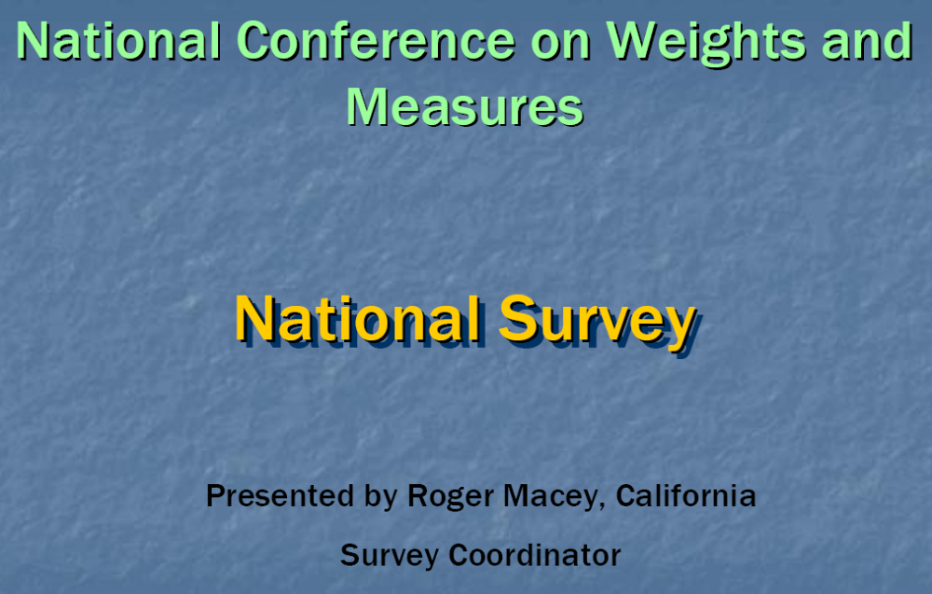

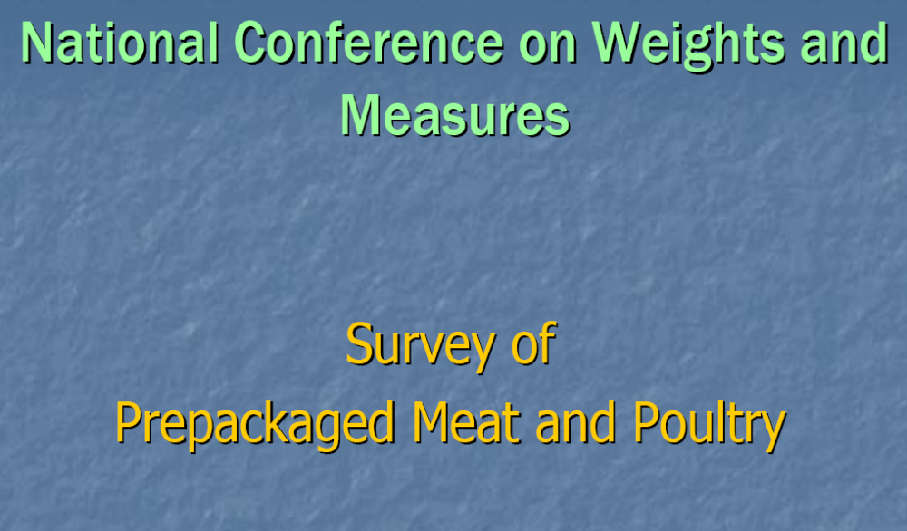
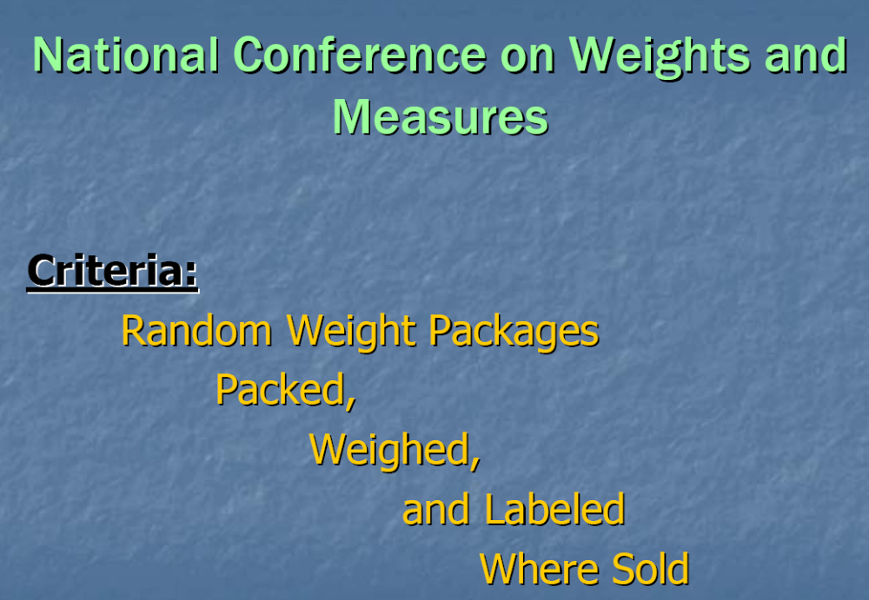

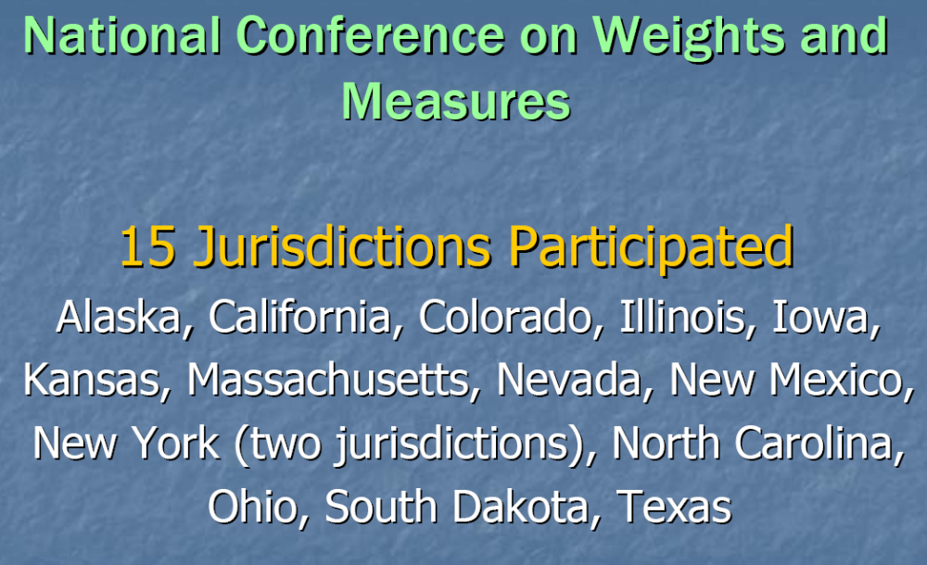
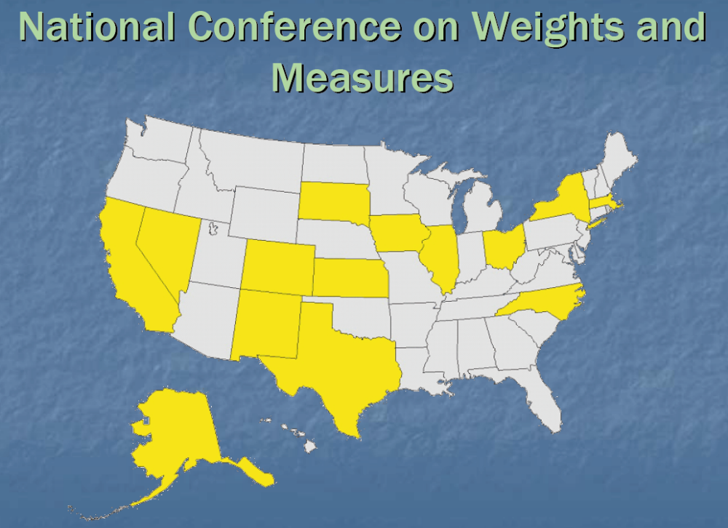

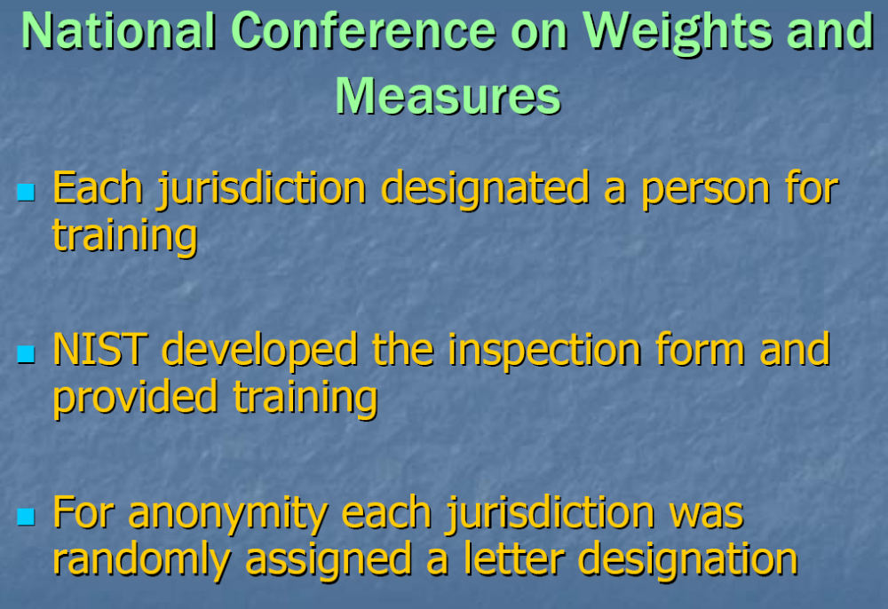

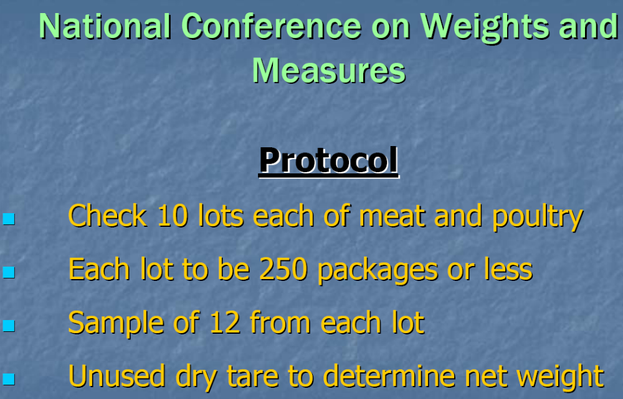

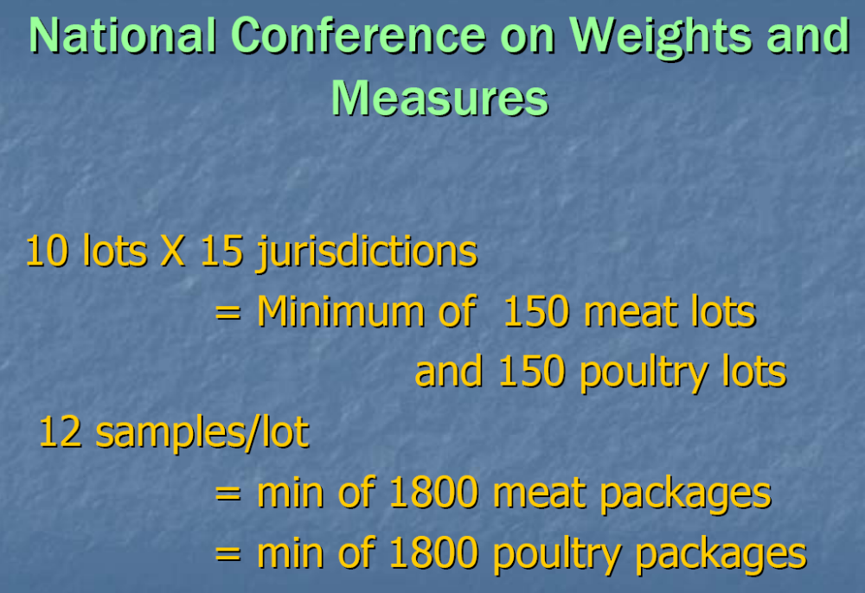
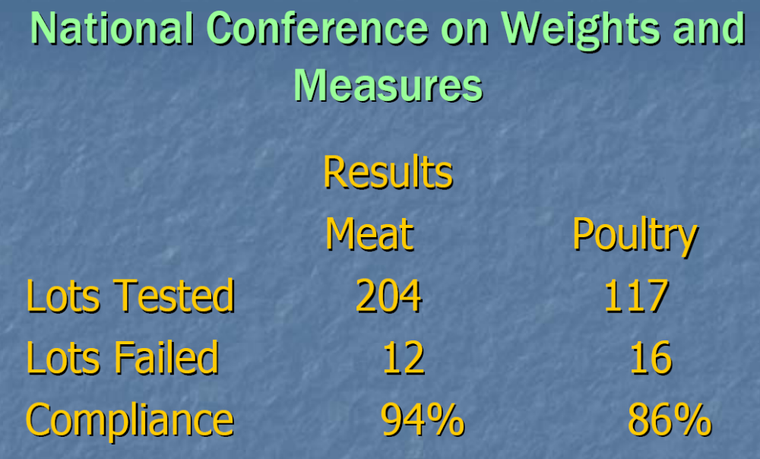

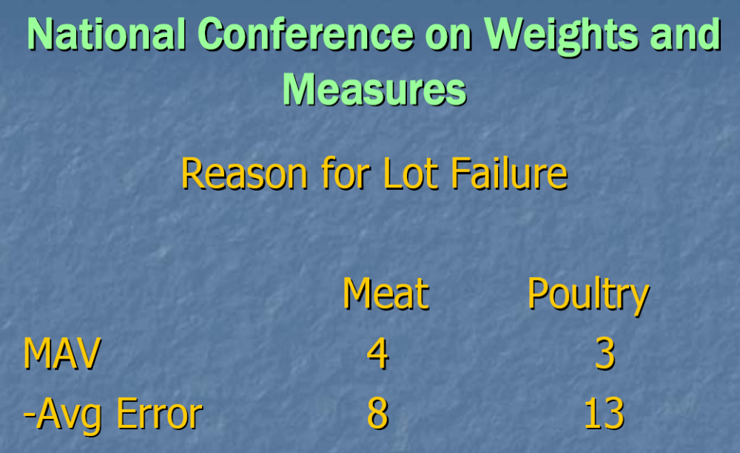

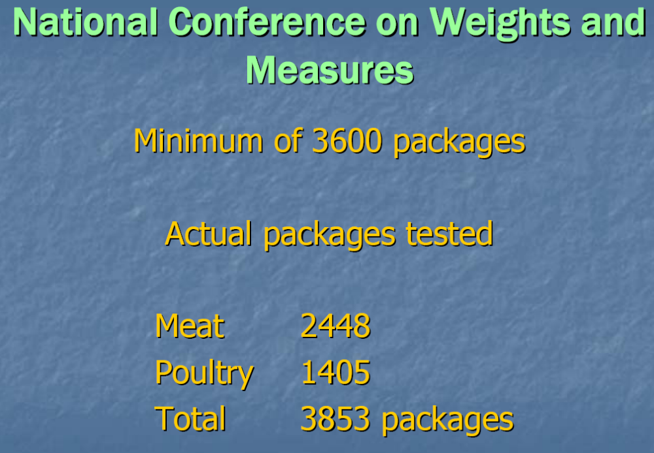

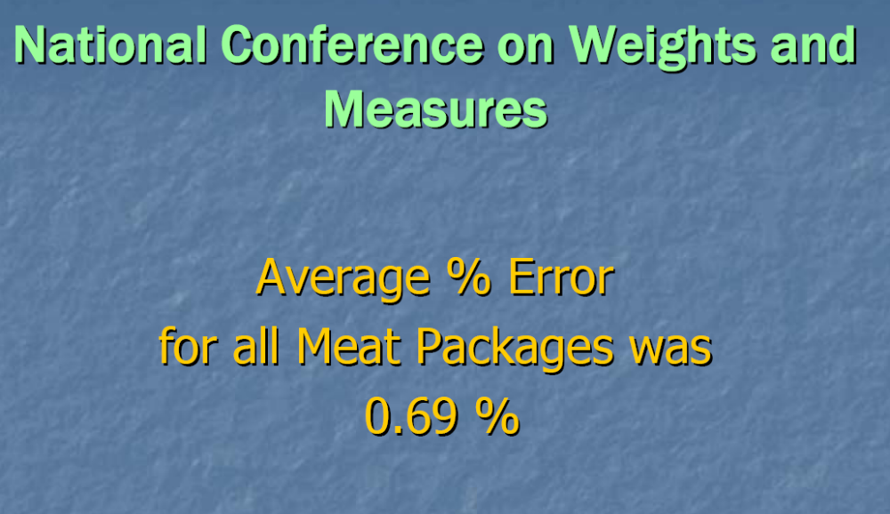
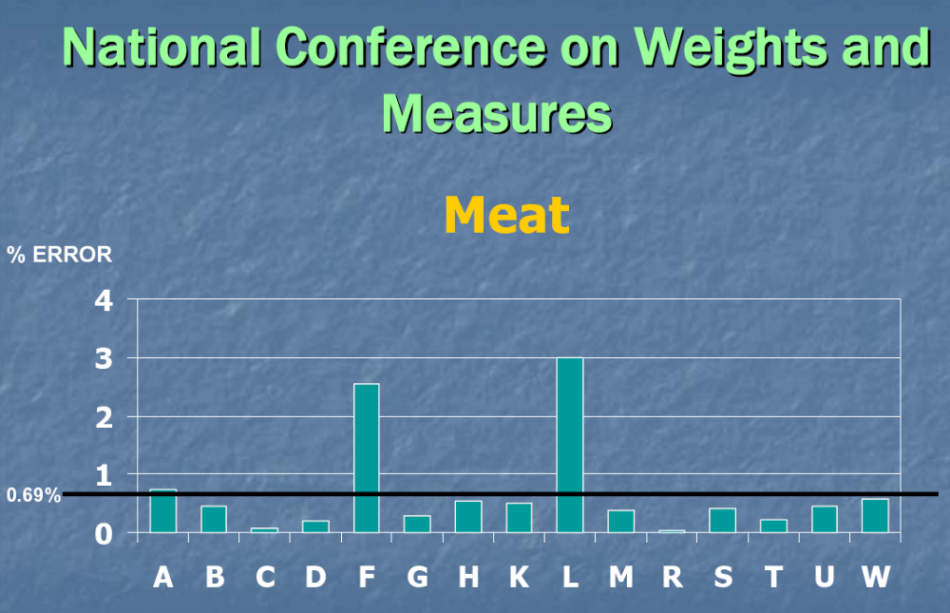

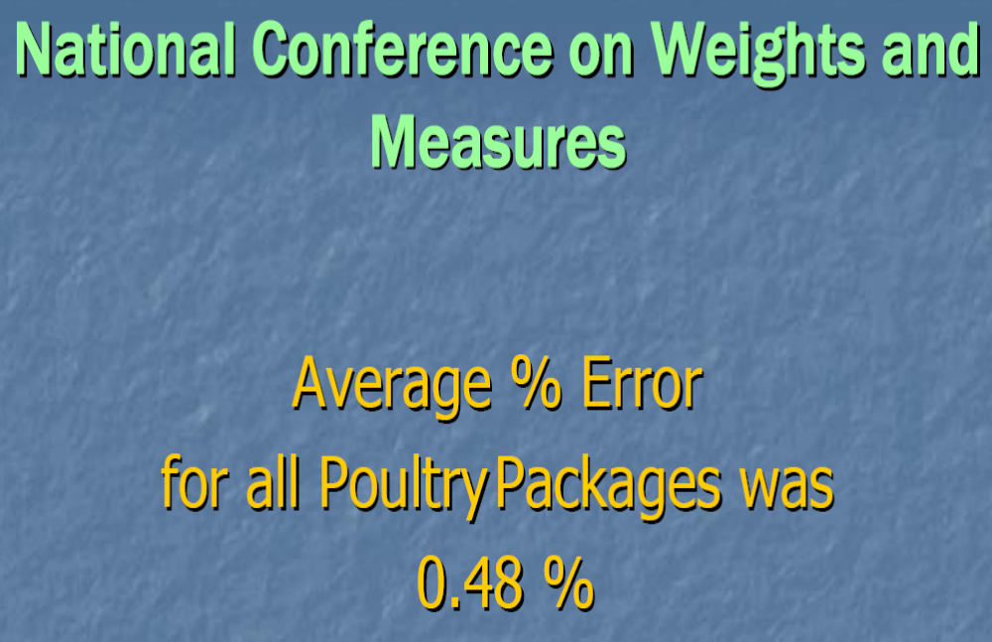
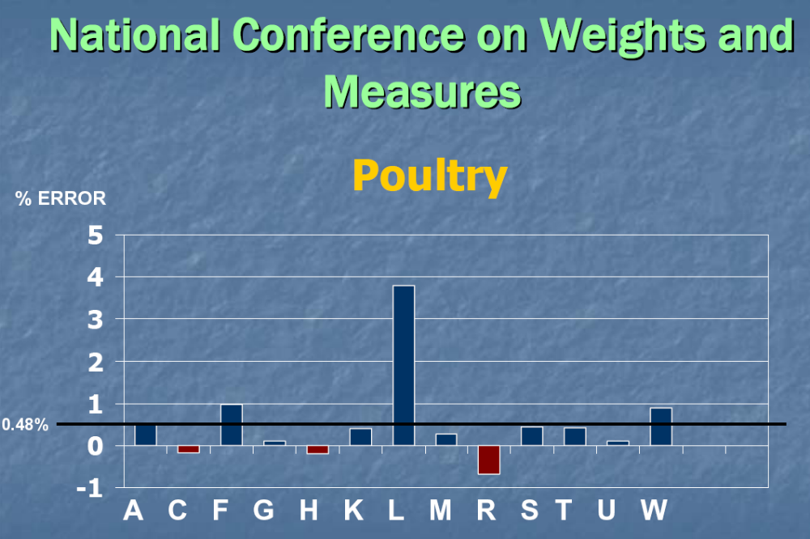

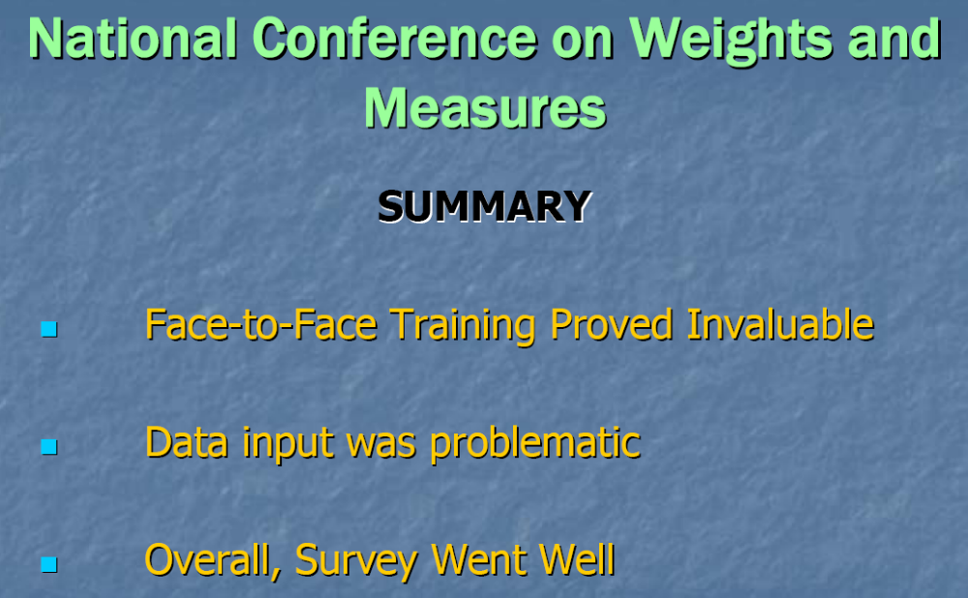
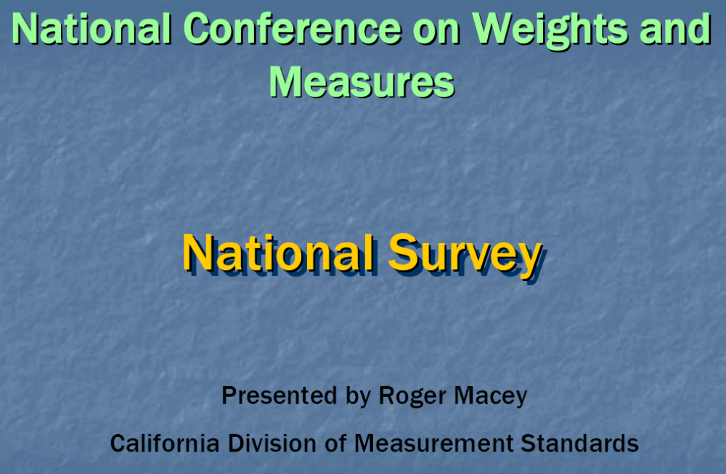

THIS PAGE INTENTIONALLY LEFT BLANK
Appendix B
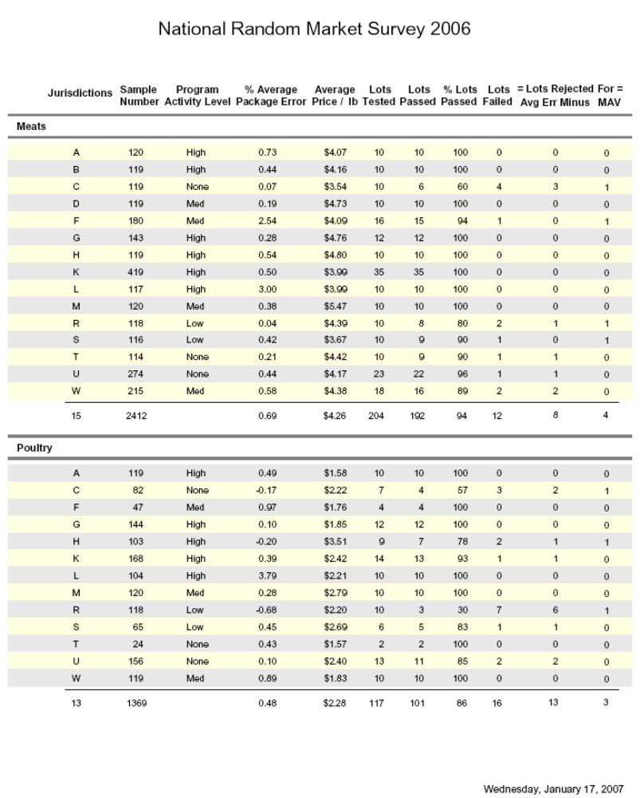

THIS PAGE INTENTIONALLY LEFT BLANK
Appendix C

Auditor’s Report for 2006

The Board reviewed the Auditor’s report from the 2006 audit year ended September 30, 2006.

Statement of Activities Ending September 30, 2006

2006 Actual AMC Fund 2006 Budget

Revenue & Support
Government Dues $102,450 $102,210
Associate Dues $ 67,740 $ 66,215
National Type Evaluation Program $458,100 $462,750
Interim Meeting Fees $ 18,374 $ 21,250
Annual Meeting Fees $ 64,783 $ 69,600
Publications $ 22,428 $ 24,200
Advertising $ 750 $ 850
Investment Return $ 28,094 $ 7,500
Associate Member Fund $ 13,440
Total Revenue & Support $762,719 $ 13,440 $754,575

Expenses
Programs
Membership $ 13,091 $ 12,101
National Type Evaluation Program $443,826 $455,739
Interim Meeting $ 45,324 $ 50,488
Annual Meeting $ 85,800 $ 90,556
Publications $ 11,847 $ 16,140
Newsletter $ 14,927 $ 15,107
Refunds $ 625
Total Programs $615,440 $640,131

Management & General
Management Fees $ 51,267 $ 51,267
Board of Directors $ 24,121 $ 29,700
Bank Fees $ 10,897 $ 10,200
Website $ 12,350 $ 10,679
Legal & Accounting $ 5,861 $ 6,525
Committee Contingency Fund $ 4,227 $ 5,500
Committee Travel $ 1,691 $ 0
Insurance $ 2,057 $ 2,500
Office Supplies $ 2,455 $ 1,800
Telephone $ 576 $ 1,200
Technology Fee $ 1,960 $ 0
Printing & Duplicating $ 1,443 $ 650
Marketing $ 311 $ 0
Miscellaneous $ 600 $ 0
Postage $ 87 $ 50
Broadcast e-mail $ 33 $ 0
Associate Member Fund $ 13,991
Total Management & General $119,936 $120,071
Total Expenses $735,376 $ 13,991 $760,202
Change in net assets $ 27,343 (551)

2006 Actual AMC Fund 2006 Budget

Net Assets, beginning of year $604,928 $5,425
Net Assets, end of year $632,271 $4,874

Assets

Current Assets
Cash & Cash Equivalents $210,511
Certificates of Deposit $584,992
Accounts Receivable $ 736
Prepaid Expenses $ 2,165
Interest Receivable $ 3,997

Total Assets $802,401

Liabilities & Net Assets
Accounts Payable $ 8,271
Deferred Dues Revenue $156,985

Total Liabilities $165,256

Net Assets
Unrestricted $637,145

Total Liabilities and Net Assets $802,401

Michael Cleary, California, NCWM Chairman
Judy Cardin, Wisconsin, NCWM Chairman-Elect
Don Onwiler, Nebraska, NTEP Chair
Charles Carroll, Massachusetts
Joe Gomez, New Mexico
Jack Kane, Montana
Randy Jennings, Tennessee
Steven Malone, Nebraska
Richard Wotthlie, Maryland
Christopher B. Guay, Procter & Gamble Co.
Darrell Flocken, Mettler-Toledo, Inc.
NCWM Staff: Beth Palys, CAE
NIST: Carol Hockert, Chief, Weights and Measures Division

Board of Directors
Appendix D

Report on the Activities of the
International Organization of Legal Metrology (OIML)
and Regional Legal Metrology Organizations

Weights and Measures Division, NIST

The Weights and Measures Division (WMD) of the National Institute of Standards and Technology (NIST) is responsible for coordinating U.S. participation in OIML and other international legal metrology organizations. Learn more about OIML at the OIML website at http://www.oiml.org and the WMD website at http://www.nist.gov/owm on the Internet. Dr. Charles Ehrlich, Group Leader of the International Legal Metrology Group (ILMG), can be contacted at charles.ehrlich@nist.gov or at (301) 975-4834 or by fax at (301) 926-0647.

Please note: OIML publications are available without cost at http://www.oiml.org.

Table A
Table of Contents
Subject Page
I. Report on the Activities of the OIML Technical Committees D2
II. Report on the 41st CIML Meeting in Cape Town, South Africa, October 18 - 20, 2006 D4
III. Future CIML Meetings D6
IV. Regional Legal Metrology Organizations D6

Table B
Glossary of Acronyms

BIML | International Bureau of Legal Metrology | IR | International Recommendation
CD | Committee Draft¹ | MAA | Mutual Acceptance Arrangement
CIML | International Committee of Legal Metrology | OIML | International Organization of Legal Metrology
CPR | Committee on Participation Review | PTB | Physikalisch-Technischen Bundsanstalt
DD | Draft Document² | R | Recommendation
DR | Draft Recommendation² | SC | Technical Subcommittee
DV | Draft Vocabulary² | TC | Technical Committee
DoMC | Declaration of Mutual Confidence | WD | Working Draft³
¹ CD: a draft at the stage of development within a technical committee or subcommittee; in this document, successive drafts are numbered 1 CD, 2 CD, etc.

² DD and DR: draft documents approved at the level of the technical committee or subcommittee concerned and sent to BIML for approval by CIML.

³ WD: precedes the development of a CD; in this document, successive drafts are number 1 WD, 2 WD, etc.

* Explanation of acronyms provided by OIML.

Details of All Items
(In Order by Reference Key Number)

Report on the Activities of the OIML Technical Committees

This section reports on recent activities and the status of work in OIML Technical Committees (TCs) and Technical Subcommittees (SCs) of specific interest to members of NCWM. Also included are schedules of future activities of the Secretariats, the U.S. National Work Groups (USNWGs), and the International Work Groups (IWGs) of the Committees and Subcommittees.

TC 3/SC 1 “Pattern Approval and Evaluation” (United States)
The subcommittee approved the U.S. proposal for a combined revision of OIML D 19 “Pattern evaluation and pattern approval” and D 20 “Initial and subsequent verification of measuring instruments and processes” into a single document entitled “Principles of metrological control of measuring instruments: type approval and verification.” Key elements of OIML D 3 “Legal Qualification of Measuring Instruments,” R 34 “Accuracy Classes of Measuring Instruments,” and R 42 “Metal Stamps for Verification Officers” will also be incorporated into the combined revision of OIML D 19 and D 20. The revised documents will incorporate recent developments such as the OIML certificate system, D 27 “Initial verification of measuring instruments utilizing the manufacturer's quality management system,” and the “Framework for a mutual acceptance arrangement (MAA) on OIML type evaluations.” Consideration will be given to the appropriate conformity assessment options developed by the ISO Council Committee on Conformity Assessment (ISO CASCO), including quality systems, product certification, and accreditation. Consideration will be given also to information technology and statistical methods to increase or decrease verification intervals based upon proven instrument performance. For more information on this activity, contact Dr. Ambler Thompson at (301) 975-2333 or at ambler@nist.gov.

TC 5/SC 2 Software (Germany and BIML)
All OIML Documents and Recommendations published since 1990 have been reviewed for terms and requirements related to software. The ILMG submitted U.S. comments on a working draft of the document “Software in Legal Metrology” in June 2006. When complete, this document will serve as guidance for OIML technical committees addressing software requirements in Recommendations for software-controlled instruments. The ILMG participated in meetings of the NCWM Software Sector in Annapolis, Maryland, in October 2006. Please contact Dr. Ambler Thompson at (301) 975-2333 or at ambler@nist.gov if you would like a copy of the OIML working draft or to participate in this project.

TC 8/SC 1 “Static Volume and Mass Measurement” (Austria and Germany)
The Secretariat submitted 2 CD revisions in January 2006 for OIML R 71 “Fixed Storage Tanks,” R 80 “Road and Rail Tankers,” and R 85 “Automatic Level Gages for Measuring the Level of Liquid in Fixed Storage Tanks.” U.S. comments, including those of the American Petroleum Institute, on all three of these documents were sent in April 2006. The Secretariat held a subcommittee meeting in May 2006 in Hamburg, Germany. The United States provided a “no” vote with comments on the 2 CD for R 71 and comments on the 2 CDs of R 80 and R 85. The Secretariat circulated a 3 CD for R 80 in November 2006, a 3 CD of R 85 in December 2006, and a 3 CD of R 71 in February 2007. U.S. vote and comments on R 80 and R 85 were returned in February 2007, and a subcommittee meeting is scheduled for March 2007 in Vienna, Austria. Please contact Ralph Richter at (301) 975-3997 or at ralph.richter@nist.gov if you would like copies of the documents or to participate in these projects.

TC 8/SC 3 “Dynamic Volume and Mass Measurement for Liquids other than Water” (United States and Germany)
OIML R 117 “Measuring Instruments for Liquids other than Water” has undergone an extensive revision, incorporating new instrument technologies and merging the document with OIML Recommendations R 86 “Drum Meters” and R 105 “Mass Flowmeters.” This is a high priority project for OIML. ILMG is working with the USNWG on flowmeters, Germany, and the Netherlands on this effort. Meetings of the USNWG on flowmeters were held during the NCWM Annual Meeting in July 2006 in Chicago, Illinois, and the NCWM Interim Meeting in January 2007 in Jacksonville, Florida. Measurement Canada has been a strong contributor to this effort. A 2 CD of R 117 was circulated to the two international subcommittees and received over 90 % international “yes” votes. In October 2006, the CIML approved the merger of TC 8/SC 3 and TC 8/SC 4; the United States and Germany are now the co-secretariats of the combined TC 8/SC 3. Following the merger, the old subcommittee TC 8/SC 4 was disbanded. Work on R 117-2 “Test Methods” and R 117-3 “Test Report Format” has begun.

OIML member nations are voting on the Draft Recommendation (DR) of R 117-1 by postal ballot with an objective of receiving full CIML approval on R 117-1 in 2007. U.S. comments on R 117-1 are strongly encouraged and are due by May 15, 2007. An electronic link to the document can be found on the WMD website http://www.nist.gov/WeightsAndMeasures/owmhome.cfm. If you have any questions, would like a hard-copy of the R 117-1 draft recommendation to review, have comments to submit, or would like to participate in the next phases of this project or would like to become involved in this effort, please contact Ralph Richter at (301) 975-3997 or ralph.richter@nist.gov.

TC 8/SC 7 “Gas Metering” (Belgium and France)
The Secretariat circulated a 3 CD of the Recommendation “Measuring Systems for Compressed Natural Gas (CNG) for Vehicles” and annexes covering performance tests for electronic devices and basic test procedures. In April 2003, the United States cast a negative ballot on the 3 CD because the testing requirements were considered to be unrealistic. A 4 CD/DR is being prepared by the Secretariat and should be ready for vote and comment in 2007.

A ballot was circulated on the 4 CD “Measuring Systems for Gaseous Fuel” and U.S. comments were returned in November 2005. This Recommendation is intended for large pipelines with large flowrates and high operating pressures, or systems not fitted with diaphragm gas meters. Different types of measuring systems are covered by the Recommendation: measuring systems providing indications of volume at base conditions or mass converted from a volume of gas determined at metering conditions, measuring systems providing directly the mass of gas, and measuring systems providing indication of energy corresponding to a volume at base conditions or a mass of gas. The United States voted “no” on the 4 CD of this document. A DR of this document is being prepared by the Secretariat and should be ready for vote and comment in 2007. Please contact Ralph Richter at (301) 975-3997 or ralph.richter@nist.gov if you would like to obtain a copy of these documents or to participate in these TC 8/SC 7 projects.

TC 8/SC 8 “Gas Meters” (Netherlands)
Three recommendations in this subcommittee: R 6 “General provisions for gas volume meters,” R 31 “Diaphragm Gas Meters”, and R 32 “Rotary Piston Gas Meters and Turbine Gas Meters” have been combined into a single revised Recommendation. The United States voted “yes” with comments on the 3 CD of this document in January 2006. The final DR was approved by CIML at their October 2006 meeting in Cape Town and will be published with the new designation of R 137-1 “Gas Meters.” Development of R 137-2 “Test Methods” is now underway. Please contact Ralph Richter at (301) 975-3997 or ralph.richter@nist.gov if you would like to participate in the R 137-2 project.

TC 9 “Instruments for Measuring Mass” (United States)
Now that the revision of R 76 “Non-automatic Weighing Instruments” is complete, the United States will send an inquiry in 2007 to TC 9 members about revising R 60 “Load Cells”. If you would like to participate in the revision of R 60, please contact Steve Cook at (301) 975-4003 or steven.cook@nist.gov.

TC 9/SC 1 “Nonautomatic Weighing Instruments” (Germany and France)
The revision of R 76 “Non-automatic Weighing Instruments” is of major importance to U.S. interests because the Recommendation serves as the foundation for a majority of the laws and regulations that govern weighing instruments around the world. The revision includes new language addressing metrological controls for type evaluations, conformity, initial and subsequent inspections, suitability of separable components and requirements for metrological software. The USNWG held a meeting in July 2005, and it is being consulted concerning proposals to harmonize Handbook 44 and R 76. The United States voted “yes” on the 2 CD of R 76 in January 2006 and voted “yes” on the 3 CD of R 76 in June 2006. The DR of R 76-1 was approved by the CIML in October 2006. An effort to revise R 76-2 is now underway. For more information on this effort, please contact Steve Cook at (301) 975-4003 or steven.cook@nist.gov.

TC 9/SC 2 “Automatic Weighing Instruments” (United Kingdom)
The Recommendation R 134-1 “Automatic Instruments for Weighing Road Vehicles in Motion – Total Load and Axle Weighing” was approved by CIML in October 2006 with the agreement that U.S. comments concerning terminology and document scope were to be incorporated before publication. The test report format of this document, R 134-2, has been approved by the subcommittee and is going through a final editorial process at the BIML. Two other documents in this subcommittee are now under revision. The United States returned comments on the 2 CD of R 106 “Automatic Rail-weighbridges” in November 2006. The recent draft of R 107 “Discontinuous Totalizing Automatic Weighing Instruments (Totalizing Hopper Weighers)” was approved by subcommittee, and the secretariat is producing the DR. If you would like to receive copies of these documents or work on these projects, Richard Harshman is the contact at (301) 975-8107 or at harshman@nist.gov.

TC 17/SC 1 “Humidity” (China)
The Secretariat (China) is working closely with the United States and a small IWG to revise OIML R 59 "Moisture Meters for Cereal Grains and Oilseeds.” All drafts have been distributed to the USNWG, which for the most part is a subset of the NTEP Grain Sector. In October 2003, China hosted a meeting of the TC 17/SC 1 subcommittee in Beijing, China to review and discuss this revised document. A 2 CD that incorporated U.S. comments was circulated in May 2004 by the Secretariat. A meeting of the IWG was held in Paris, France in September 2004 to resolve conflicts on the document. U.S. comments on the 3 CD of R 59 were returned to the Secretariat in August 2005. A 4 CD was circulated to the IWG in August 2006. U.S. comments on the 4 CD were returned to the Secretariat in November 2006. Please contact Diane Lee at (301) 975-4405 or at diane.lee@nist.gov if you would like to participate in this work group.

TC 17/SC 8 “Quality Analysis of Agricultural Products” (Australia)
A new subcommittee has been formed to study the issues and write a working draft document “Measuring Instruments for Protein Determination in Grains.” Australia is the Secretariat for this new subcommittee. A work group meeting was held in May 2004 in Sydney, Australia. A 2 WD of this document was received in August 2004, and a 3 WD was received in May 2005. A work group meeting was held in June 2005 in Berlin, Germany, to discuss the latest round of comments on the 3 WD. A 1 CD was circulated to the IWG in May 2006. U.S. comments on the 1 CD were returned to the Secretariat in August 2006. A work group meeting was held in September 2006 in Ottawa, Canada to discuss comments on the 1 CD. Please contact Diane Lee at (301) 975-4405 or at diane.lee@nist.gov if you would like to participate in this work group.

OIML Mutual Acceptance Arrangement (MAA)
Note: The report on the OIML Mutual Acceptance Arrangement (MAA) has moved; it can now be found in Item 1 of the NTEP Section of Pub 16. For further information on the MAA and its implementation, please contact Dr. Charles Ehrlich at charles.ehrlich@nist.gov or at (301) 975-4834 or by fax at (301) 926-0647.

Report on the 41st CIML Meeting in Cape Town, South Africa, October 18 - 20, 2006

The CIML gave final approval to the following Recommendations in South Africa:

- R 39 Rockwell hardness machines;
- R 49-1 Water meters intended for the metering of cold potable water and hot water.
  - Part 1: Metrological and technical requirements;
- R 49-2 Water meters intended for the metering of cold potable water and hot water.
  - Part 2: Test methods;
- R 51-1 Automatic catchweighing instruments.
  - Part 1: Metrological and technical requirements – Tests
- R 65 Force measuring system of uniaxial material testing machines;
- R 76-1 Non-automatic weighing instruments.
  - Part 1: Metrological and technical requirements – Tests
- R 82 Gas chromatographic systems for the measuring pollution from pesticides and other toxic substances;
- R 83 Gas chromatograph/mass spectrometer systems for the analysis of organic pollutants in water;
- R 116 Inductively coupled plasma atomic emission spectrometers for the measurement of metal pollutants in water;
- R 134-1 Automatic instruments for weighing road vehicles in motion and axle-load measuring.
  - Part 1: Metrological and technical requirements – Tests.
- R 137-1 Gas Meters.
  - Part 1: Requirements (new Recommendation).

The Committee also approved the withdrawal of R 74 Electronic weighing instruments.

The CIML approved the following new work projects:
- New projects of TC 3/SC 5:
  - Revision of B 3 OIML Certificate System for Measuring Instruments;
  - Revision of B 10-1 Framework for a Mutual Acceptance Arrangement on OIML Type Evaluations (MAA);
  - Revision of B 10-2 Checklists for Issuing Authorities and Testing Laboratories Carrying Out OIML Type Evaluations;
- New projects to be allocated by the CIML President to the appropriate TC or SC, based on BIML proposals:
  - Guide for the application of ISO/IEC Guide 62 to the assessment of quality system certification bodies in the field of legal metrology;
  - Guide for the application of ISO 9001 to legal metrology controls.
- New project of TC 16/SC 1
  - Revision of ISO 3930/OIML R 99 Instruments for measuring vehicle exhaust emissions.

The following work project was withdrawn:
- Project P 6 of TC 3/SC 5: OIML procedure for the review of laboratories to enable mutual acceptance of test results and OIML Certificates of Conformity;

The Committee approved the following proposals:
- When a revision of a publication is published, the previous version remains available on the OIML website, but with an indication that this version has been superseded;
- As long as all the parts of a revised Recommendation included in the Certificate System have not been published, the version referenced in the Certificate System remains applicable;
- When the Certificate System references a revised Recommendation, Certificates may still be issued by reference to the previous version provided that the application for a Certificate has been lodged before the publication of the revised version.

MAA Resolutions approved by the CIML in South Africa:

- MAA Resolution 2006-1: The BIML will bear the costs of peer assessments and will subsequently invoice the peer-assessed bodies with a lump sum equal to 1500 € per assessor-day.
- MAA Resolution 2006-2: During the period of transition to the MAA for R 60 and R 76 (provisionally set to end December 31, 2008), Issuing Authorities under the OIML Certificate System for Measuring Instruments (OIML Document B 3) are authorized to continue to issue OIML Certificates of Conformity according to OIML B 3.
  - Issuing Participants in the R 60 and R 76 DoMCs are not authorized to continue to issue basic OIML Certificates for OIML type evaluations unless the application was received before the publication of the DoMC (September 2006).
  - The date that this transition period will end will be reviewed by the CIML at its 43rd Meeting based on a BIML report on operation, experience, and feedback from industry.
- MAA Resolution 2006-3: The R 49 DoMC will continue to move forward despite the fact that for the moment there is only one potential Issuing Participant.

The CIML instructed TC 3/SC 5 to consider the rules for appointing new Issuing Authorities after the transition period mentioned in the MAA Resolution 2006-2 above, and to propose an appropriate solution for approval by the Committee.

Report of the Work Group on “Conformity to Type”

The Committee took note of the report given by Mr. Grahame G. Harvey, WG Convenor, on the meeting held on October 14, 2006, and instructed the WG to continue its work as proposed during the meeting.

The Committee instructed the Bureau and the TC 3 Secretariat (Metrological control) to review the work and organizational structure of TC 3, including that of its subcommittees and the WG on Conformity to type.

Positions filled:

The Committee elected Mr. Grahame Harvey (Australia) as CIML Second Vice-President. He will take over his duties immediately.

On the proposal of the CIML President, the Committee appointed Mr. Willem Kool as BIML Assistant Director to fill the position of the retiring Mr. Szilvássy in 2007.

Future CIML Meetings

The 42nd CIML Meeting will be hosted by the People’s Republic of China in October 2007 in Shanghai, China. The CIML accepted Australia’s invitation to hold the 13th Conference and 43rd CIML Meeting in Sydney, Australia, in 2008.

Regional Legal Metrology Organizations

SIM Workshop on Fuel Dispensers

Wayne Stiefel participated in the workshop and made presentations on audit trail security and software developments in OIML and the U.S. NWCM. The workshop was held September 15, 2006, at INMETRO Brazil and attended by 32 representatives from 16 countries: Antigua & Barbuda, Brazil, Chile, Costa Rica, Haiti, Honduras, Jamaica, Mexico, Nicaragua, Paraguai, St. Kitts & Nevis, St. Lucia, St. Vincent, Trinidad & Tobago, United States, and Uruguay. Other topics covered included The Mercosul Draft Directive on Fuel Dispensers – based on OIML R 117 and the Mexican process for prototype fuel dispenser hardware and software approval by CENAM.

Meeting of the SIM General Assembly

ILMG participated in the SIM General Assembly which convened September 16 - 17, 2006, in Rio de Janeiro, Brazil. Dr. Huberto S. Brandi, Director of Scientific and Industrial Metrology at INMETRO Brazil, was elected President.

APLMF Meeting

The 13th APLMF Meeting was held November 15 - 17, 2006, in Singapore. The United States was represented by Dr. Charles Ehrlich, who serves as Chairman of the APLMF Work Group on Mutual Recognition Arrangements. APLMF conducted six training courses/seminars in 2006, including one on the verification of CNG Fuel Dispensers at which the two instructors were from the California Division of Measurement Standards. A Seminar on the Singapore Authorized Verifier Scheme was held to announce and describe this new program in Singapore, where private organizations are empowered to conduct verifications under the supervision of the Singapore regulatory authority, SPRING Singapore. A Workshop on Metrology of Agricultural Products and Foods is planned to be held February 7 - 9, 2007, in Thailand. The Peoples Republic of China announced that it would take over the Presidency and Secretariat of APLMF in 2007. The next meeting of APLMF will be in late October 2007, in Shanghai, China.

Appendix E

NCWM Associate Member Committee (AMC)

January 21, 2007 Jacksonville, Florida
Minutes

The following individuals were in attendance:

Stephen Langford - Cardinal Scale, Chairman
Paul Lewis - Rice Lake Weighing Systems, Secretary-Treasurer
Darrell Flocken - Mettler-Toledo
Jim Dawson - Shell Oil
Lou Straub - Fairbanks Scales
Bob Murnane - Seraphin Test Measures
Pete O’Bryan - Foster Farms
Steven Steinborn - Hogon & Hartron
Gale Prince - Kroger
Mike Belue - Belue Associates
Chris Guay - Procter & Gamble
Tom Herrington - Nestle Foods
Beth Palys, CAE - NCWM Headquarters

Chairman Langford called the meeting to order at 11:07 a.m.

MINUTES

The minutes of the July 10, 2006, meeting was approved.

FINANCIAL CONDITION

Chairman Langford reported a current balance of $17,969.91. The amount of $3,990.56 was expended for training reimbursements last year. There was revenue of $13,095 this fiscal year generated from the $15 per member fee, which equates to 873 Associate Members.

BOARD OF DIRECTORS REPORT

Darrell Flocken, the Associate Membership Representative on the NCWM Board of Directors gave a report about Board activities:
- Associate members are asked to participate in the NCWM Newsletter. Darrell encouraged everyone to consider sending in articles to the editors.
- There are 135 registered attendees at this Interim Meeting while there were 107 registered attendees at the 2006 Interim Meeting
- NCWM budget is on track.
- NIST is concerned about funding and concerned about training funds.
- During the July meeting of the NCWM, the Specifications and Tolerances Committee will be given until Tuesday evening to complete their work. Addendum sheets will be turned in by 6:00 p.m. on Tuesday.
- In the future Publication 15 will be available only on the NIST and NCWM websites. The CD will no longer be sent out as it has in the past and hardcopy will only be available at the Interim Meeting.
- Michael Sarachman (Kraft Foods) changed duties and can no longer be on the PDC. Vince Orr (ConAgra) is no longer able to serve on the L&R Committee because of a position change within his company. Darrell Flocken’s (Mettler-Toledo) three-year term on the NCWM Board of Directors expires in July. The AMC needs to make recommendations to the Nominating Committee for these vacancies.

AMC Fund Disbursement Reports

Chairman Langford made a motion that the AMC donate $2500 to NCWM for website enhancements which would allow on-line meeting registration and membership renewal. This motion also proposed a $4000 reserve for anticipated training requests. The motion was adopted.

Training Request

One request was submitted by the State of Colorado. The request was for $1500 to be used for training – two-day class on Handbook 44 and a one-day class on grain moisture meters for a total of 38 to 45 people. The Committee voted to approve this request.

Special Event

There were discussions for increasing the Association Membership dues, to be able to increase the funding of the NCWM annual outing. Due to the limited number of members present, it was decided to postpone this issue until the NCWM Annual Meeting in July 2007.

AMC Reserve

AMC reserve funds are taken to zero at the end of each fiscal year.

OLD BUSINESS

No old business

NEW BUSINESS

It was suggested by Chairman Langford that the position of Vice-Chair for the AMC be filled by someone that has held the Chairman position before. This is consistent with past NCWM policy. Chris Guay volunteered to fill this position.

Pete O’Bryan, Foster Farms volunteered to fill the position on the L&R Committee.

Bob Murnane, Seraphin Test Measures was nominated as the AMC representative on the NCWM Board of Directors. There was no nominee for an AMC member representative on the PDC. The committee approved the recommendation of these individuals to the Nominating Committee.

ADJOURNMENT

The meeting was adjourned at 12:15 p.m.

Respectfully submitted,
Stephen Langford, Chair
Paul Lewis, Secretary-Treasurer

