SAVE-IT

A Final Report of
SAfety VEhicles using adaptive Interface Technology (Phase II: Task 7C):
Visual Distraction

Prepared by
Harry Zhang
Matthew Smith
Robert Dufour

Delphi Electronics and Safety
Phone: (765) 451-9816
Email: matt.smith@delphi com

February 2008
Table of Contents

7.0 EXECUTIVE SUMMARY 3
7.1. PROGRAM OVERVIEW 7
7.2. Introduction 7
7.2. Method 10
7.2.1. Subjects 10
7.2.2. Design 10
7.2.3. Procedure 13
7.3. Results 15
7.3.1. Variables 15
7.3.2. ANOVA and Correlation Results 17
7.3.3. Subject-by-Subject Analyses 28
7.3.4. Across-Conditions Analyses 32
7.4. Discussion 37
7.5. References 41

7.0 EXECUTIVE SUMMARY

The objective of Task 7 was to investigate how visual distraction impacts driving performance. Drivers have the ability to allocate their attention to various activities besides driving. Their attention to the driving task fluctuates as a function of the demand of the road and the demands of competing tasks, which distract from the main task. Given that drivers alternate between attentive driving and distracted driving, safety systems dedicated to Distraction Mitigation will require monitoring of the driver state. One of the goals of this research is to determine how drivers allocate their visual attention from one point of focus to another and to isolate a few measures which could be used to inform various countermeasure systems that the driver’s attention is away from the main driving task.

In Phase I, the research focused on determining the effects of visual distraction on drivers’ reaction times and driving performance. Two simulator experiments revealed several real-time eye-glance measures that correlate highly with accelerator release reaction time (ART) and standard deviation of lane position (SDLP). Two such measures, Eye Gaze Variability and Eye Gaze Vector (calculated over a time window), require precise eye gaze measurements that are not readily available in automotive-grade eye tracking systems. Given this limitation, these measures will not be pursued further. A third measure, Proportion of Eyes-Off-Road Glance Time, is highly correlated with driving performance (ART and SDLP) and can be measured by automotive-grade eye tracking systems. The eyes-off-road proportion is calculated as the ratio of total eyes-off-road glance time over a time window (e.g., 5 seconds). Phase I research yielded strong correlations between eyes-off-road proportion and driving performance measures. However, these correlations were computed using across-subjects data summation due to the rarity of the target events (i.e., braking to avoid collision with a lead vehicle). For real-time implementation of such a system, the research has to show that the strong correlations between these measures hold for most individual drivers.

Phase II focused on demonstrating that eyes-off-road proportion is a reliable within-subject measure that can be correlated with individual driving performance. The new experiment consisted of two 3-hour sessions and generated as many as sixteen target events for each of the subjects tested. Three other issues were also investigated: Finding threshold values for eyes-off-road proportion, exploring other diagnostic measures and further investigating display eccentricity effect (i.e., how distance away from the optical focus of expansion leads to poorer driving performance).

Method
Twelve middle-aged subjects were tested in twelve different distraction conditions. The primary task consisted of following a lead vehicle while the secondary task (distraction task) consisted of reading a varied number of words aloud. The words were presented in either the forward location (five conditions) simulating information processing from the environment (e.g., street sign or license plate reading) or the words were presented in common areas that may require visual attention: high-mounted cluster, console, rearview mirror, and left and right mirrors. Figure 7.1 illustrates the display locations. The words were changed every five seconds, an auditory beep alerted subjects to the change in display. The console display had three distinct conditions: 1, 3, or 5 words. A baseline condition with no distraction task completed the experimental design.
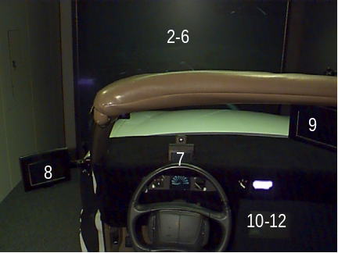

Figure 7.1. Display Locations.

Analysis & Results
As indicated by the NASA Task Load Index measure of task difficulty (NASA-TLX), driving while performing a secondary task was more difficult than baseline (condition 1) (Figure 7.2). The distraction conditions with forward and high-mount cluster displays were rated as equally difficult. The remaining displays were rated as equally difficult to one another, but were rated as more difficult than the high-mount cluster display showing that subjects experienced display eccentricity effect when reporting on task difficulty. Finally, the console display (5-words) (condition 12) was rated as the most difficult. To sum up, it was more difficult to complete the primary task of driving if the secondary task required that the visual attention be shifted further away from the focus of expansion and if it required more or longer look-away (1-word< 3-words < 5-words).

Given that the eyes-off-road proportion measure can be calculated using any time window, a large number of time windows ranging from one to thirty seconds were computed. All generated similar results and a computationally efficient time window of 4.3 seconds was implemented for all analyses. As Figure 7.2 shows there was a clear effect of display location on the eyes-off-road proportion. The non-forward displays (8, 9 & 11) generated greater eyes-off-road proportion than forward displays (2-7). This difference between forward and non-forward displays illustrates the effect of display eccentricity. Increasing the number of words displayed on the console (10-12) also yielded greater eyes-off-road proportion. Distraction presented in the mirror locations and console generated eyes-off-road proportion of 0.5, whereas the console presentation of 5 words (12) generated a proportion of 0.62 and was rated as most difficult. These findings suggest that a threshold of 0.5 be used for determining that visual distraction is occurring. Furthermore, these results show that this measure does relate to visual distraction in a manner that can be quantified.
As Figure 7.3 illustrates, the pattern of results found for standard deviation of lane position (SDLP) was similar to the one described for eyes-off-road proportion. The non-forward displays (8, 9 & 11) generated greater SDLP than forward displays (2-7). This shared pattern by the two measures suggests that they are associated to one another. The high correlation coefficient (r = .843) supports this conclusion. As the eyes-off-road proportion increased so did SDLP.

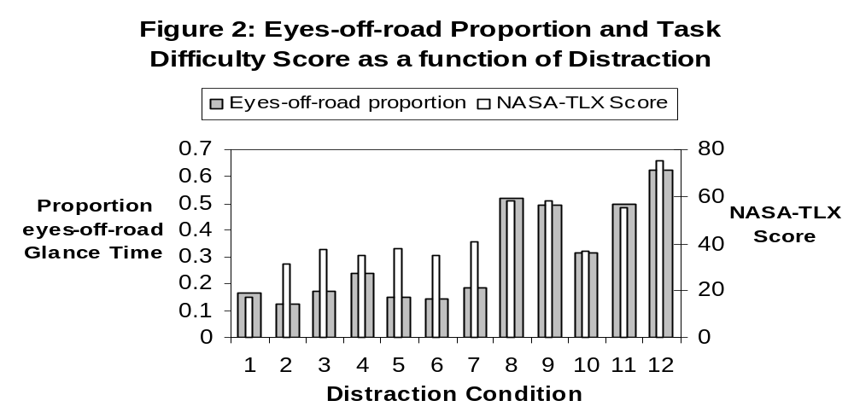
Figure 7.2. Eyes-off-road Proportion and Task Difficulty Score as a function of Distraction

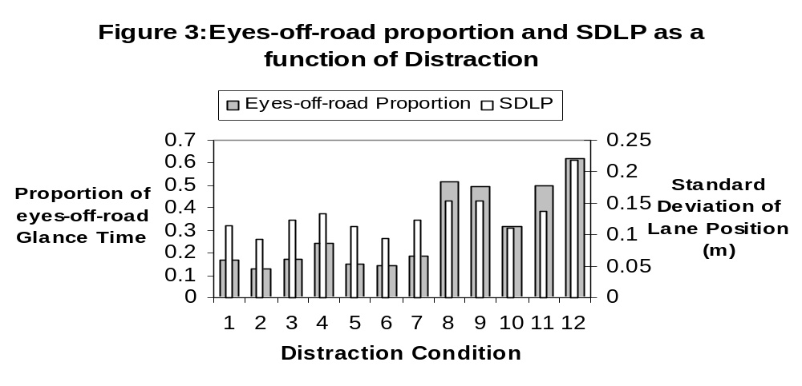
Figure 7.3. Eyes-off-road Proportion and SDLP as a function of Distraction

The results for Accelerator Release Reaction Time (ART) were not as clear. There was a strong correlation between eyes-off-road proportion and ART (r = .869) if the data for forward displays (2-6) are removed from the analysis. The reason for this finding may have to do with the manner by which the distraction task was presented in the forward displays. Otherwise, as the eyes-off-road proportion increased so did ART.

To summarize, the results indicate that the measure of Visual Distraction (eyes-off-road proportion) does correspond to driving performance associated with distracted driving (e.g., lane departure). A key goal of this research was to show that this finding applies to most subjects. The within-subject analysis yielded correlation between eyes-off-road proportion and SDLP (r = .857) and 11 of 12 subjects had relatively high correlation coefficients (r > .5). This finding indicates that eyes-off-road proportion is a reasonable diagnostic of visual distraction for most individuals.

Another key goal of this research was to investigate alternative diagnostic measures. Two such measures did emerge: Eye gaze gamma is based on the instantaneous eyes-off-road glance duration at the moment of lead vehicle braking and proportion of head-off-road glance time which is a corollary measure related to eyes-off-road proportion and is the ratio of total head-off-road glance time over a time window. Both these measures yielded strong correlation with SDLP (r_{egg} =.922 and r_{horp} = .841) and reliable within-subjects correlations (11 of 12 and 7 of 12 subjects had r > .5). Head-based measures are advantageous as they are easier to measure with automotive-grade eye tracking equipment.

Conclusions
Reliable measures of visual distraction can be linked to distracted-driving and can be used to inform safety countermeasure sub-systems. A short time window (4.3 seconds) was used and it yielded timely and reliable information as to the state of the driver. However, other time windows could be implemented. Although the eye-based measures have slightly higher correlations with the performance measures than the head-based measures, the sensors that are required to sense head pose are more robust and more affordable than the sensors required to measure eye gaze. Furthermore, the more severe distractions, that last for a longer duration or are directed further away from forward, are more likely to involve a head pose component. Given some of the limitations associated with eye-based measures (e.g., eyes sometimes occluded by eyewear), optimizing a head-based measure should become a goal.

7.1. PROGRAM OVERVIEW

Driver distraction is a major contributing factor to automobile crashes. National Highway Traffic Safety Administration (NHTSA) has estimated that approximately 25% of crashes are attributed to driver distraction and inattention (Wang, Knipling, & Goodman, 1996). The issue of driver distraction may become worse in the next few years because more electronic devices (e.g., cell phones, navigation systems, wireless Internet and email devices) are brought into vehicles that can potentially create more distraction. In response to this situation, the John A. Volpe National Transportation Systems Center (VNTSC), in support of NHTSA's Office of Vehicle Safety Research, awarded a contract to Delphi Electronics & Safety to develop, demonstrate, and evaluate the potential safety benefits of adaptive interface technologies that manage the information from various in-vehicle systems based on real-time monitoring of the roadway conditions and the driver's capabilities. The contract, known as SAfety VEhicle(s) using adaptive Interface Technology (SAVE-IT), is designed to mitigate distraction with effective countermeasures and enhance the effectiveness of safety warning systems.
The SAVE-IT program serves several important objectives. Perhaps the most important objective is demonstrating a viable proof of concept that is capable of reducing distraction-related crashes and enhancing the effectiveness of safety warning systems. Program success is dependent on integrated closed-loop principles that, not only include sophisticated telematics, mobile office, entertainment and safety warning systems, but also incorporate the state of the driver. This revolutionary closed-loop vehicle environment will be achieved by measuring the driver’s state, assessing the situational threat, prioritizing information presentation, providing adaptive countermeasures to minimize distraction, and optimizing advanced collision warning.

7.2. Introduction

In Phase I research of the SAVE-IT program, two simulator experiments have been performed to determine the effects of visual distraction on reaction times and driving performance (Zhang & Smith, 2004a, 2004b; Zhang, Smith, & Witt, 2006). Several real-time eye glance measures have been discovered to correlate highly with accelerator release reaction time and standard deviation of lane position. Two potential measures include eye gaze variability and eye gaze vector that are calculated over a time window (e.g., 5 seconds). Eye gaze variability is the product of the standard deviations of gaze yaw angle and pitch angle multiplied by 4. It is used in Recarte and Nunes (2000). Eye gaze vector reflects the distance of eye gaze from the focus of expansion and is the square root of the sum of squared gaze yaw angle and pitch angle. These two measures have been shown to correlate strongly with accelerator release reaction time and SDLP using a large window (e.g., 30 or 60 seconds) or a small window (e.g., 1 second). These measures require precise measurements of eye gaze. Because precise measurements of eye gaze are not readily available in automotive-grade eye tracking systems such as Delphi's Driver State Monitor (Edenborough, Hammoud, Harbach, Ingold, Kisačanin, Malawey, Newman, Scharenbroch, Skiver, Smith, Wilhelm, Witt, Yoder, & Zhang, 2004), eye gaze variability and eye gaze vector will not be implemented and evaluated in Task 14 of the SAVE-IT program.

Another diagnostic measure of visual distraction is the proportion of eyes-off-road glance time that is calculated over a time window (e.g., 5 seconds). High correlations have been reliably acquired between eyes-off-road proportion and accelerator release reaction time or SDLP using either a small time window (e.g., 1 second) or a large time window (e.g., 30 or 60 seconds). The eyes-off-road proportion requires a binary classification of eye gaze into forward or non-forward area (e.g., beyond a 24x24-deg square around the focus of expansion), which is achievable using automatic eye tracking systems such as Seeing Machines' Facelab eye tracking system (www.seeingmachines.com; Heinzmann & Zelinsky, 1998; Victor, Blomberg & Zelinsky, 2001) and Delphi's Driver State Monitor (Edenborough, Hammoud et al., 2004). Because it does not require precise measurements of eye gaze and has a strong correlation with driving performance, eyes-off-road proportion has been recommended as a real-time diagnostic of visual distraction that will be implemented and evaluated in Task 14.

In Phase I (Zhang & Smith, 2004b), the strong correlations for eyes-off-road proportion were obtained after averaging across subjects. Across-subjects averaging is necessary to achieve data reliability because each subject experienced only two or three non-imminent lead vehicle braking events per condition. Reaction times can vary randomly within a particular distribution and averaging across a number of reaction time values is a typical method employed in human factors to acquire reliable results. In real-time implementations, though, eyes-off-road proportion will be computed using eye gaze information from one single driver rather than from across-subjects averages. To bridge the gap, a new simulator experiment is performed to produce a larger number of lead vehicle braking events per subject. The new experiment consists of two 3-hr sessions and generates as many as sixteen lead vehicle braking events per subject per condition. Reaction times can be averaged across these sixteen braking events to obtain reliable results.

More research is also needed to determine threshold values for eyes-off-road proportion. When visual distraction thresholds are exceeded, distraction feedback can be provided to drivers to re-direct their attention back to the forward road (Donmez,
Boyle, Lee, & McGehee, 2004a, 2004b). Because this experiment produces a large number of lead vehicle braking events, the relationship between eyes-off-road proportion and reaction time will be investigated more fully to determine the thresholds.

The use of a large number of reaction time events also provides opportunities to explore other diagnostic measures. Donmez, Boyle, Lee, and Scott (2005) have shown that eye gaze gamma, which is defined as (weight)X(instantaneous eye gaze duration)+(1-weight)X(total eyes-off-road glance duration) within a time window (e.g., 5-s), is a promising measure of visual distraction. In this experiment, the effect of eye gaze gamma on accelerator release reaction time and SDLP will be investigated.

Although Phase I (Zhang & Smith, 2004b) showed a display eccentricity effect, some common vehicle locations (e.g., left mirror or rearview mirror) were not investigated. In this experiment, several new values of display eccentricity are added. Subjects are asked to read aloud words that are presented at locations such as the left mirror, rearview mirror, high-mounted head-down display, and center console monitor. Words are also presented in the forward road area to simulate distractions such as reading license plates of forward vehicles and street signs. Five forward locations include: the focus of expansion, the left side of the forward screen, the right side of the forward screen, the top of the forward screen, and the bottom of the forward screen (near the typical location of a head-up display). All these locations are within a 24x24-deg square and eye gaze to these locations is therefore classified as forward. Using these display locations, driving performance and reaction time will be assessed for both small and large display eccentricities.

7.2. Method

7.2.1. Subjects

Twelve subjects (seven males and five females) were recruited from the salaried employee pool at Delphi Electronics and Safety at Kokomo, Indiana. They were required to be in the range of 35-55 years old and possess a valid driver's license. One subject wore thin eyeglasses, two subjects wore contact lenses, and nine subjects did not wear eyeglasses or contact lenses. Subjects had a minimum vision of 20/40 (vision correction with eyeglasses permitted) as tested with the Snellen Eye Chart. The actual age for the twelve subjects ranged between 35-53, averaged 45, and had a standard deviation of 7. They were paid a $100 Wal-Mart gift card for their participation in the 6-h experiment.

7.2.2. Design

7.2.2.1. Delphi Driving Simulator and Display Monitors

The experiment was performed in the Delphi Driving Simulator at Kokomo, Indiana. It was a fixed-base, one forward channel DriveSafety system (www.drivesafety.com). The simulator projected a 1024x768-pixel 50x40-deg forward field-of-view image located at the front bumper of the vehicle cab. The vehicle handling system was configured to represent a mid-size front wheel drive sedan, such as a Ford Taurus. Steering feedback was presented with a force-feedback torque motor, to reproduce the feel of the road at the steering wheel, as well as the forces on the front tires during evasive maneuvers. The vehicle cab consisted of the front half of a 1995 Pontiac Bonneville exterior (with doors and roof removed), with a 1996 Buick Park Avenue instrument cluster and dashboard.

Distraction words were presented on the displays to create various distraction conditions. As shown in Figure 7.1, a 21-in. CRT monitor was placed in the center console at 27 deg to the right of the focus of expansion and 26 deg below the horizon (with a diagonal eccentricity of 37 deg). Two 7-in. LCD displays were used as the left-side mirror (36 deg to the left of the focus of expansion and 13 deg below the horizon with a diagonal eccentricity of 38 deg) and the rearview mirror (35 deg to the right of the focus of expansion and 6 deg above the horizon with a diagonal eccentricity of 36 deg), respectively. Another 7-in. LCD display was placed sideways on the top of the instrument cluster at 10 deg below the focus of expansion.

7.2.2.2. Experimental Design

The amount of distraction was the major independent variable. The following twelve distraction conditions were created,
- 1. Baseline: no distraction was introduced.
- 2. Center: Subjects were asked to read a row of 3 words presented at the center of the forward screen (the words were centered at 0 deg horizontally and 0 deg vertically).
- 3. Left: Subjects were asked to read a row of 3 words presented at the left side of the forward screen (the words were centered at -12 deg horizontally, 0 deg vertically).
- 4. Right: Subjects were asked to read a row of 3 words presented at the right side of the forward screen (the words were centered at 12 deg horizontally, 0 deg vertically).
- 5. Top: Subjects were asked to read a row of 3 words presented near the top of the forward screen (the words were centered at 0 deg horizontally, 9 deg vertically).
- 6. Down: Subjects were asked to read a row of 3 words presented near the bottom of the forward screen (the words were centered at 0 deg horizontally,
-6.5 deg vertically). This location corresponded to typical projection locations for head-up displays (HUD).
- 7. Cluster: Subjects were asked to read a row of 3 words presented at the high-mounted cluster display (the words were centered at 0 deg horizontally,
-9.5 deg vertically).
- 8. Left Mirror: Subjects were asked to read a row of 3 words presented at the left mirror (the words were centered at -36.5 deg horizontally, -13 deg vertically).
- 9. Rearview Mirror: Subjects were asked to read a row of 3 words presented at the rearview mirror (the words were centered at 35 deg horizontally, 5.5 deg vertically).
- 10. One Word at Console: Subjects were asked to read 1 word presented at the center console monitor (the word was centered at 27 deg horizontally,
-25.5 deg vertically).
- 11. Three Words at Console: Subjects were asked to read a row of 3 words presented at the center console monitor (the words were centered at 27 deg horizontally, -25.5 deg vertically).
- 12. Five Words at Console: Subjects were asked to read a row of 5 words presented at the center console monitor (the words were centered at 27 deg horizontally, -25.5 deg vertically).

For distraction conditions 2-12, words were updated once every 5 seconds. The words were in a sans serif font extending a visual angle of approximately 25 minute of arc on all displays.

The dependent variables included performance variables such as positions of the accelerator pedal and the brake pedal, steering wheel angles, lane positions, and vehicle speeds. These variables were used to generate performance variables that were commonly investigated in the literature. For example, lane positions were used to produce the standard deviation of lane positions (SDLP) and number and duration of lane departures.

Eye glance variables included head orientations, eye gaze coordinates, and attention coordinates that were based on weighted head orientations and gaze coordinates. Eye closures, blinks and saccades were also recorded. These variables were used to produce eye glance measures that are commonly examined in the literature. For example, attention coordinates were used to determine the eyes-off-road glance duration and glance frequency.

7.2.2.3. FaceLab Eye Tracking System from Seeing Machines, Inc.

Eye glance variables were measured and recorded with the FaceLab eye tracking system (Version 2.0.1) developed by Seeing Machines, Inc. (Heinzmann & Zelinsky, 1998; Victor, Blomberg, & Zelinsky, 2001). The FaceLab system consisted of a stereo head with two Sony cameras for image capturing, and a Dell computer for image processing and gaze coordinate determination. The stereo head was installed above the dashboard and centered horizontally with respect to the subject. The simulator room was dimly illuminated to minimize glares and reflections. A 9x4 infrared LED array with a peak emission of 880 nm was placed between the two cameras to provide a high level of illumination to the subject's face area.

The method of image processing with template matching feature tracking was used by the FaceLab system to track both the head and eye movements. An initial calibration was required to mark the salient facial features including the eye corners and mouth corners. Once calibrated, the system operated automatically without subjects' interventions. It generated output measures such as head position and orientation, eye gaze coordinate (e.g., pitch and yaw), attention pitch and yaw angle (combining head orientation and eye gaze coordinate), eye blink, eye closure, and associated confidence levels with a sampling rate of 60 Hz. The reported accuracy for eye gaze coordinates was +/-3 deg (Victor, Blomberg, & Zelinsky, 2001). Graphic depictions of head orientation and eye gaze were provided by the FaceLab system for easy operations by the experimenter.

7.2.2.4. NASA-TLX

The NASA Task Load Index (TLX) was used to measure the workload and perceived task difficulty associated with various experimental conditions (Hart & Staveland, 1988). It was a multi-dimensional rating procedure that provided an overall workload score based on a weighted average of ratings on six sub-scales: Mental demands, physical demands, temporal demands, performance, effort, and frustration. The score on each sub-scale ranged from 0 to 100. The overall workload score varied from 0 to 100, with a higher score indicating a higher level of subjective workload and perceived task difficulty.

7.2.3. Procedure

Each subject ran two 3-hour sessions. All twelve distraction conditions were run within each session. In order to obtain a sufficient number of braking events to afford a subject-by-subject analysis, each subject was exposed to approximately eight braking events per session (or a total of sixteen braking events over two sessions).

Upon arrival at the laboratory, subjects were given a brief description of the study and requested to read and sign an informed consent form. They were given the vision test (Snellen Eye Chart) and required to pass the test before proceeding (eyeglasses were permitted). The calibration procedure was then completed for the eye tracking system. Five snapshots of the subject's face were taken, one with the subject facing forward, one facing slightly left, one facing slightly right, one facing 90 deg left, and one facing 90 deg right. For each snapshot, salient features such as eye corners, mouth corners, eyebrows, and nostrils were selected and marked. Afterward, the FaceLab system began to track a subject's head and eye movements automatically.

For the simulator driving, subjects were given two five-minute practice blocks. During the first practice block, subjects were asked to drive without introducing any visual distraction. During the second practice, subjects were asked to drive while reading words on the center console monitor. After the practice block, subjects ran 12 experimental blocks. For each experimental block, subjects were informed about the desired speed (65 MPH) and the nature of visual distraction (e.g., display location). When subjects shifted the gear to "D", the lead vehicle began to move forward and gradually reach the desired speed. Subjects were asked to follow the lead vehicle with a close and safe distance. They were instructed to maintain good lane positions and avoid crashes.

In the distraction conditions, subjects were presented with a display of new words every 5 s. When the new words appeared on the display, a beep was sounded to alert the subjects. Subjects were asked to read aloud as many words as possible without sacrificing safety. The manner in which subjects shared their visual attention between the forward driving scene and the visual display was not controlled. Approximately 15-20 seconds into the experimental block a software program was activated that automatically accelerated or decelerated the lead vehicle so that the time headway between the lead subject and the subject vehicle was gradually changed to a constant value of 1.8 s. The previous studies have shown that time headways influenced the measurement of reaction times, consequently a constant value was used in order to minimize any confounding. At a randomly chosen moment, the lead vehicle braked slowly for 5 s (at a deceleration rate of –2.7 m/s²). When the lead vehicle began to brake, the time headway control program was deactivated so that the subject vehicle gradually closed in with the lead vehicle. This procedure is similar to one that was deployed in previous research (e.g., Lee, Caven, Haake, and Brown, 2001; Lee, McGehee, Brown, and Reyes, 2002; Zhang and Smith, 2004b). A few seconds later, subjects responded to the situation by releasing the accelerator pedal and depressing the brake pedal. The times at which the lead vehicle began to brake and the subjects responded to the braking lead vehicle were recorded in order to calculate the reaction times. After the braking event, the lead vehicle gradually accelerated to the desired speed and subjects again followed the lead vehicle. Approximately 15-20 seconds later, the time headway control program was reactivated so that the time headway was gradually changed to 1.8 s. The lead vehicle braked at -2.7 m/s² for 5 s at another randomly chosen moment. Within each 10-minute block, subjects experienced approximately eight braking events. The braking events were separated by a minimum of 50 s so that subjects engaged in distraction tasks (except for the baseline conditions) for at least 30 s before each braking event in order to afford data analysis with a time window as large as 30 s.

After each experimental block, subjects were given the NASA-TLX scale and asked to rate the task difficulty and workload for the condition that was just completed.

7.3. Results

7.3.1. Variables

Consistent with Zhang and Smith (2004b), a 24X24-deg rectangular area around the focus of expansion was defined as the forward road area. Like Zhang and Smith (2004b), the attention pitch and yaw angles from Facelab were used to determine whether or not eye gaze was on a forward road area or away from the forward road. The head direction pitch and yaw angles were used to determine whether or not the driver's head pose was on the forward area or away from the forward area.

Figure 7.4 illustrated the sequence of events. The moment that the lead vehicle braked was designated as the zero time point (t = 0). The time interval between the moment that the lead vehicle braked (t = 0) and the moment that the subject completely released the accelerator pedal (when the simulator variable for the accelerator pedal position was zero) was defined as the accelerator release reaction time (ART). The time interval between the moment that the lead vehicle braked (t = 0) and the moment that the subject began to depress the brake pedal (when the simulator variable for the brake pedal position was non-zero) was defined as the brake reaction time (BRT). These variables were used by Lee et al. (2001, 2002) and Zhang and Smith (2004b). Eye glance variables and performance variables were computed within a time window that preceded the zero time point (t = 0). The time window was re-configurable within the range of 1-30 s. As in Phase I, the results from various time windows were similar. Because it was simpler to implement a 4.3-s time window in a binary system (4.3 s by 30 Hz can be implemented in 7 bits), this time window was adopted for subsequent analyses.
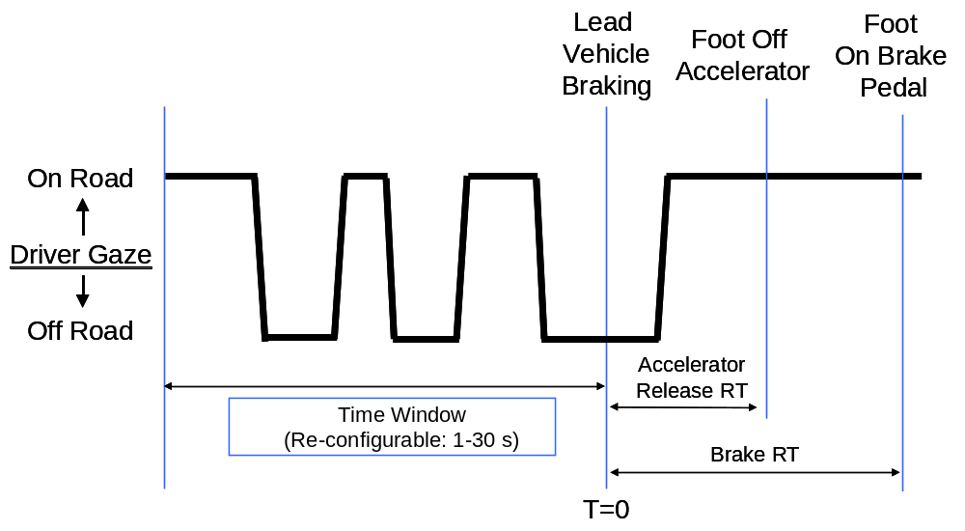

Figure 7.4. Sequence of events and definition of variables

For each reaction time event, one value each was computed for ART, BRT, steering entropy, eye glance variables (e.g., glance frequency), and performance variables (e.g., SDLP). Up to 16 reaction time events occurred for each distraction condition. The values from the same distraction condition were averaged to obtain a mean value for each of the 12 subjects and each of the 12 conditions.

The computations were repeated using a re-configurable time window (between 1-30 s). As shown in Figure 7.4, a time window always ended at the zero time point at which the lead vehicle began to brake. Depending on the time window that was used in the analysis, a window began at 1-30 s before the zero time point. Note that the time windows were not sampled continuously from end to end. Because reaction time events were separated by a minimum of 45 s, over 45 s of data were available for a reaction time event. However, data beyond a time window were not included in the analysis. If the time window was 4.3 s, for example, only 4.3 s of data were sampled from the database for a reaction time event and remaining data (over 40 s, or 45-4.3 s) were not analyzed. Of course, there was some overlap between the time windows. For example, data from the second half of a 30-s window were exactly identical to data from a 15-s time window.

The results from different time windows were similar. To reflect real-time representation of visual distraction and facilitate the implementation of visual distraction algorithm in the embedded environment, 4.3-s was adopted as the time window in the following analyses. The following eye glance variables were computed over a 4.3-s time window. The attention pitch and yaw angles produced by the FaceLab system were used for the computation of all eye glance variables. Note that all variables were time-based rather than task-based. Separate computations were carried out for different time windows.
- Mean glance duration (s): It was defined as the mean amount of time of all off-road glances (beyond a 24X24-deg rectangular forward area) over a time window.

- Glance frequency (number of glances): It was defined as the total number of off-road glances (beyond a 24X24-deg rectangular forward area) in a time window.

- Total eyes-off-road glance time (s): It was defined as the cumulative time elapsed for all eyes-off-road glance (beyond a 24X24-deg square) over a time window. A related measure is total head-off-road time, which was defined as the cumulative time elapsed for all head-off-road glance (beyond a 24X24-deg square) over a time window.
- Proportion of eyes-off-road glance time: It was defined as the ratio of total eyes-off-road glance time over a time window. A related measure is proportion of head-off-road glance time, which was the ratio of total head-off-road glance time over a time window.
- Eye gaze vector (deg): It was defined as the square root of the sum of the squared attention yaw angle and squared attention pitch angle from Facelab. This reflected the distance between the focus of expansion and the attention coordinates (a combination of head orientation and eye gaze).
- Eye gaze variability (deg²): Following the definition of visual inspection window (Recarte & Nunus, 2000), it was defined as 4 X (standard deviation of attention yaw angle) X (standard deviation of attention pitch angle).

- Eye gaze gamma (s): Following Donmez, Boyle, Lee, and Scott (2005), it was defined as (weight)X(instantaneous eyes-off-road glance duration at the moment of lead vehicle braking)+(1-weight)X(total eyes-off-road glance duration). A related measure is head pose gamma, which was defined as (weight)X(instantaneous head-off-road glance duration at the moment of lead vehicle braking)+(1-weight)X(total head-off-road glance duration).

The following performance variables were computed over a 4.3-s time window preceding the zero time point. Again, separate computations were carried out for different time windows.
- Standard deviation of lane position (SDLP, m): The statistical formula for standard deviation was applied to the lane positions produced by the DriveSafety simulator to determine the SDLP in a time window.
- Number of lane departures: A lane departure occurred if any part of the subject vehicle crossed the left or right lane boundary. In the present study, this occurred if the lane position was greater than 1.022 m or less than –1.022 m. The total number of lane departures in a time window was tallied.

The definition of steering entropy was provided by Nakayama, Futami, Nakamura, and Boer (1999) and Boer (2001). First, steering wheel angles from three preceding time steps were used to compute the predicted steering angle. Because the steering angles were produced by the simulator at 60 Hz, each time step was 1/60 ms (16.7 ms). Second, the predicted steering angle was compared with the actual steering angle and their difference was calculated as the prediction error. Third, the prediction errors within a time window were divided into nine bins, and the proportion of prediction errors in each bin, p_{i}, was calculated. Finally, -pi log₉(pi) was computed for each bin and summed across nine bins to derive the steering entropy measure.

7.3.2. ANOVA and Correlation Results

7.3.2.1. NASA-TLX

Figure 7.5 presents mean NASA-TLX scores and standard errors for various distraction conditions. An ANOVA analysis with all 12 conditions indicated a main effect of distraction, F(11, 121)=27.05, p<.001. Post-hoc analyses revealed a significantly smaller TLX score for the baseline condition than for other distraction conditions. There was no significant difference among conditions 2-6, F(4, 44)=1.78, p=0.15, indicating similar workload for reading words at the different locations on the forward screen. Conditions 10-12 were statistically different from one another, F(2, 22)=32.15, p<.001, indicating that reaction times lengthened as the number of words increased. Conditions 7-9 and 11 were statistically different from one another, F(3, 33)=7.39, p<.001. Additional analyses revealed smaller TLX scores for condition 7 than for conditions 8, 9, and 11, and no difference among conditions 8, 9, and 11, indicating the effect of display eccentricity.

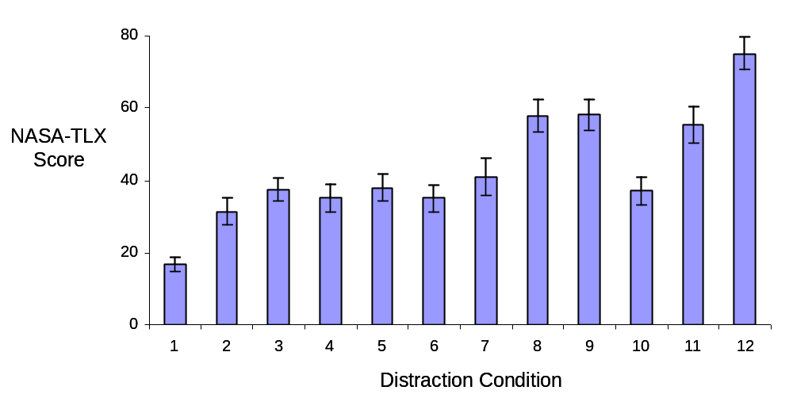

Figure 7.5. Mean NASA-TLX scores (+/-standard error as error bar)
for various distraction conditions.

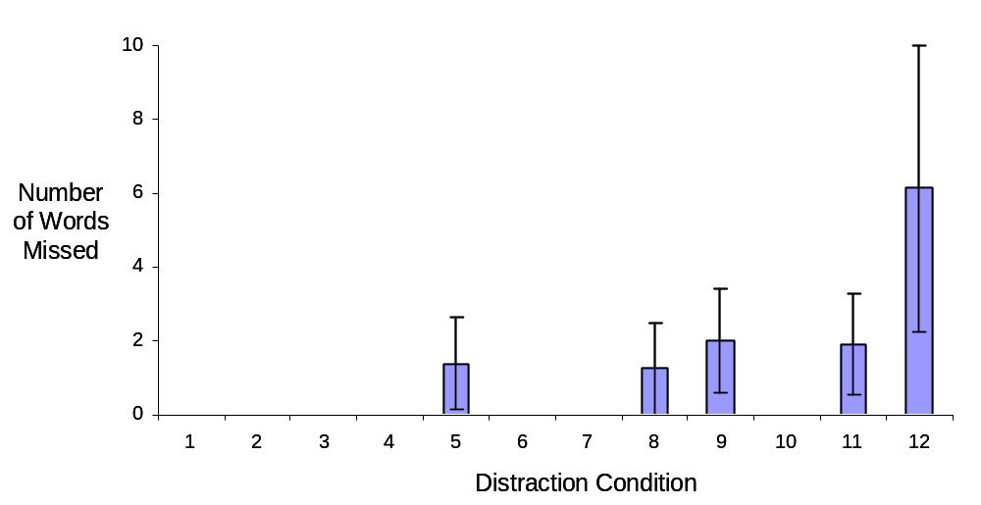

Figure 7.6. Mean number of missed words (+/-standard error as error bar)
for various distraction conditions.

7.3.2.2. Reading Performance

Figure 7.6 presents mean number of words missed for various distraction conditions. There was a main effect of distraction, F(11, 121)=2.21, p<.05. Post-hoc analyses revealed that condition 12 was statistically different from every other condition (p<0.05), but there was no other difference. This finding illustrated that subjects had difficulties finishing reading 5 words in 5 seconds while driving.

7.3.2.3. Mean Eyes-Off-Road Glance Duration

Figure 7.7 presents mean eyes-off-road glance duration averaged across 4.3-s time windows prior to lead vehicle braking for various distraction conditions. There was a main effect of distraction, F(11, 121)=17.34, p<.001. There was no difference among conditions 1-6, F(5, 55)=1.95, p=.10. There was a statistically significant difference among conditions 1, 10-12, F(3, 33)=11.5, p<.001, indicating an increased glance duration with an increased number of words. Condition 7 had a shorter glance duration than did conditions 8, 9, and 11, reflecting the effect of display eccentricity.
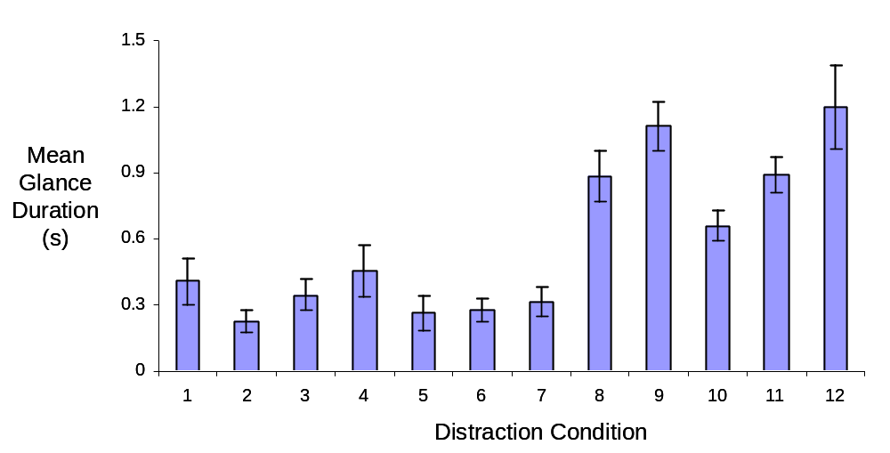

Figure 7.7. Mean eye glance duration within a 4.3-s time window
(+/-standard error as error bar) for various distraction conditions

7.3.2.4. Glance Frequency

Figure 7.8 presents eyes-off-road glance frequency within a 4.3-s time window prior to lead vehicle braking. There was an overall main effect of distraction, F(11, 121)=4.81, p<.001. Post-hoc analyses revealed that the baseline condition had significantly fewer eyes-off-road glances than all other conditions (p<.05) except conditions 2 (words at the center of the forward screen) and 5 (words near the top of the forward screen). There was no statistical difference among conditions 2-6, F(4, 44)=2.11, p=0.10. No difference was found among conditions 10-12, F(2, 22)=0.05, p=0.96, indicating that subjects did not make more eyes-off-road glances with an increased number of words on the display.

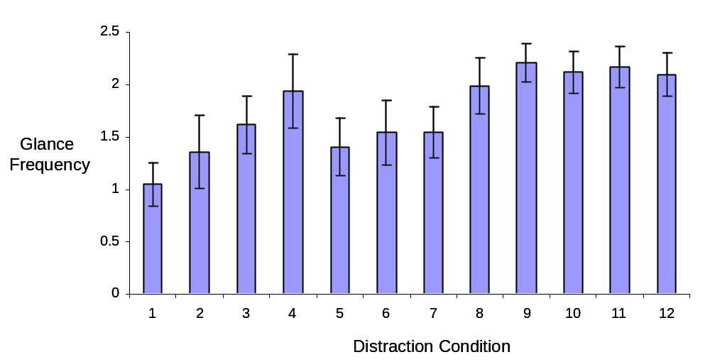

Figure 7.8. Eyes-off-road glance frequency within a 4.3-s time window
(+/-standard error as error bar) for various distraction conditions

7.3.2.5. Proportion of eyes-off-road glance time

Figure 7.9 presents the proportion of eyes-off-road glance time within 4.3-s time windows. This measure is calculated by dividing the total time that the subject's eye glance was off the forward road by the time window (e.g., 4.3). There was an overall main effect of distraction, F(11, 121)=30.33, p<.001. There was no significant difference among conditions 1-6, F(5, 55)=2.20, p=0.07. Additional analyses revealed significant differences among conditions 1 and 10-12, F(3, 33)=30.76, p<.001, and significant pair-wise differences among these conditions (p<.05), reflecting increased eyes-off-road glance proportion with increased number of words. There was a significant difference among conditions 7-9 and 11, F(3, 33)=26.78, p<.001, specifically a smaller proportion for condition 7 than for conditions 8, 9, and 11 (p<.05), reflecting an effect of display eccentricity.

7.3.2.6. Eye Gaze Variability

Figure 7.10 presents eye gaze variability within 4.3-s time windows. There was a main effect of distraction, F(11, 121)=10.32, p<.001. Post-hoc analyses revealed essentially two different groups: conditions 1-7 vs. conditions 8-12. Condition 10 was smaller than conditions 9 and 11.

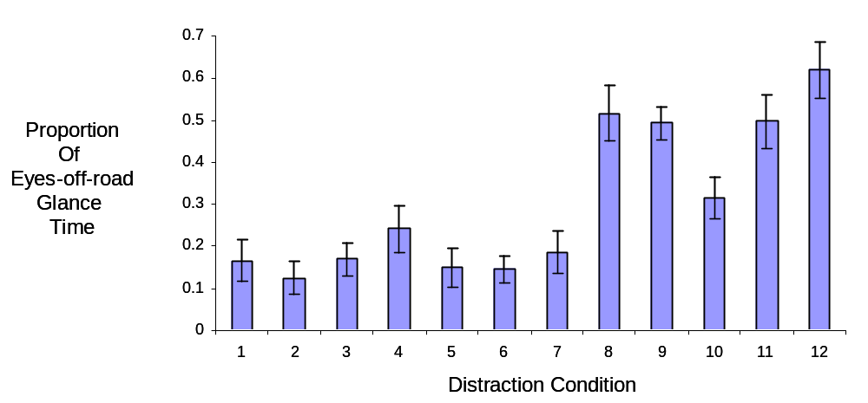

Figure 7.9. Proportion of eyes-off-road glance time within a 4.3-s time window
(+/-standard error as error bar) for various distraction conditions

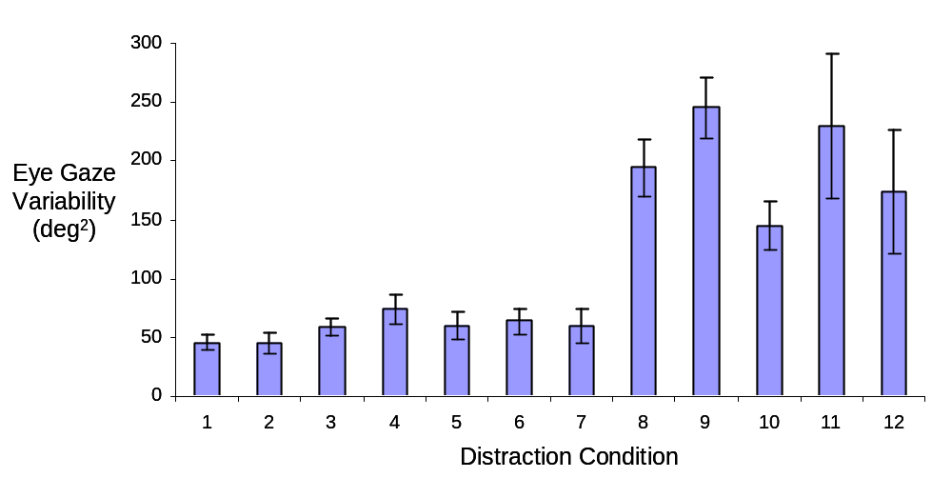

Figure 7.10. Eye gaze variability within a 4.3-s time window
(+/-standard error as error bar) for various distraction conditions

7.3.2.7. Eye Gaze Vector

Figure 7.11 presents eye gaze vector within 4.3-s time windows. There was a main effect of distraction, F(11, 121)=24.15, p<.001. Conditions 1-7 were smaller than conditions 8-12 (p<.05). Condition 10 was smaller than conditions 8-9 and 11-12.
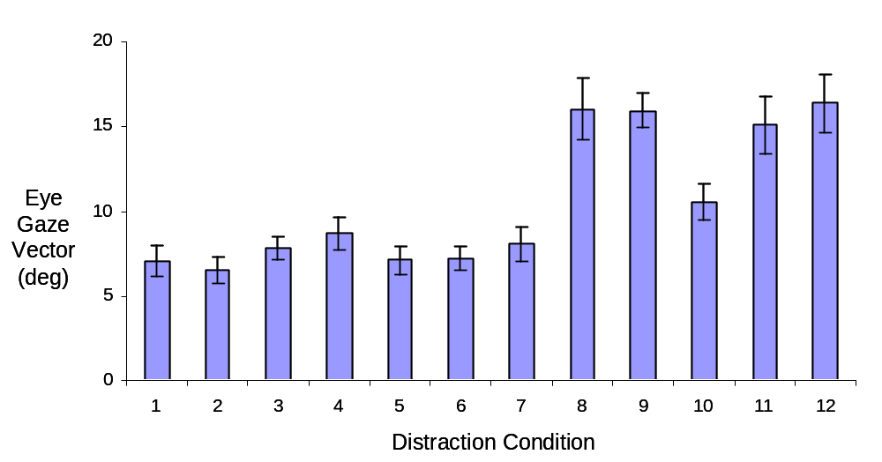

Figure 7.11. Eye gaze vector within a 4.3-s time window
(+/-standard error as error bar) for various distraction conditions
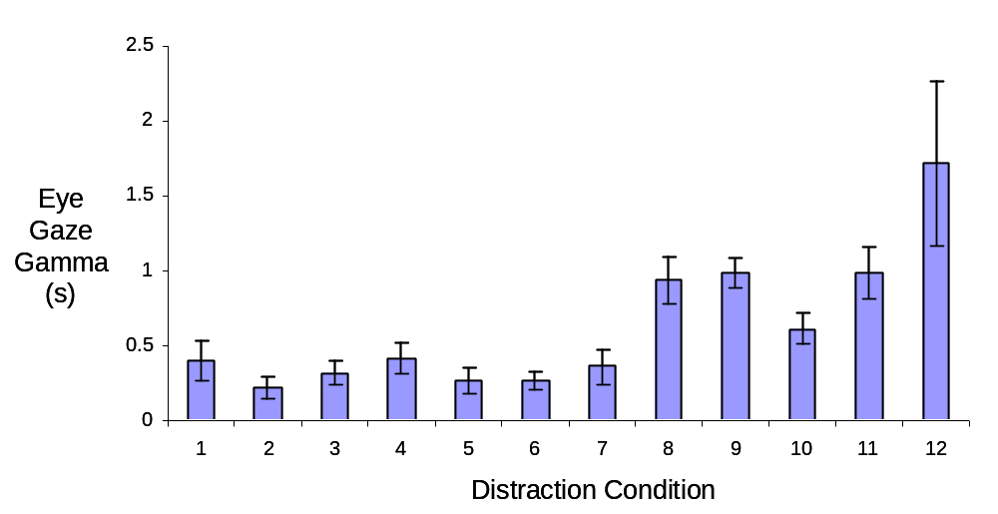

Figure 7.12. Eye gaze gamma within a 4.3-s time window
(+/-standard error as error bar) for various distraction conditions

7.3.2.8. Glance Gamma

Figure 7.12 presents eye gaze gamma within 4.3-s time windows. There was a main effect of distraction, F(11, 121)=22.6, p<.001. Additional analyses revealed that there was no difference among conditions 1-6, F(5, 55)=1.82, p=.12. There was a significant pair-wise difference among conditions 1 and 10-12 (p<.05), indicating an increased eye gaze gamma with an increased number of words. There was a significant difference among conditions 7, 8, 9, and 11, F(3, 33)=17.69, p<.001, and a smaller gamma for condition 7 than for conditions 8, 9, and 11 (p<.05) indicating the effect of display eccentricity.

7.3.2.9. Standard deviation of lane position (SDLP)

Figure 7.13 presents standard deviations of lane position within 4.3-s time windows. There was a main effect of distraction, F(11, 121)=15.27, p<.001. Post-hoc tests revealed that there was no significant difference between the baseline condition and conditions 2-6, indicating no degradation in lane keeping performance for reading words on the forward screen. Conditions 1 and 10-12 were different, F(3, 33)=26.76, p<.001, reflecting an increased SDLP with an increased number of words. The pattern of SDLP results (Figure 7.13) was very similar to that of eyes-off-road proportion (Figure 7.9), indicating the close association between these two variables.

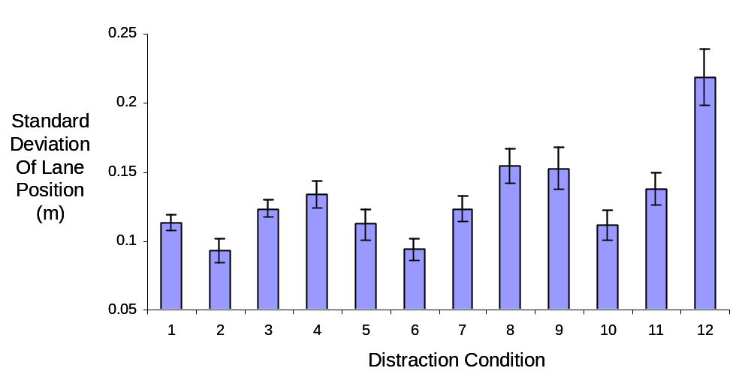

Figure 7.13. Standard deviation of lane position (SDLP) within a 4.3-s time window
(+/-standard error as error bar) for various distraction conditions

7.3.2.10. Number of Lane Departures

Figure 7.14 presents the number of lane departures within 4.3-s time windows. There was a main effect of distraction, F(11, 121)=4.49, p<.001. Post-hoc tests revealed a significantly larger number of lane departures for condition 12 than conditions 1-11, indicating marked degradation in lane keeping performance while reading 5 words on the center console display. There was no difference among conditions 1-6, F(5, 55)=1.02, p=0.41, indicating no degradation in lane keeping performance while reading words on the forward screen.
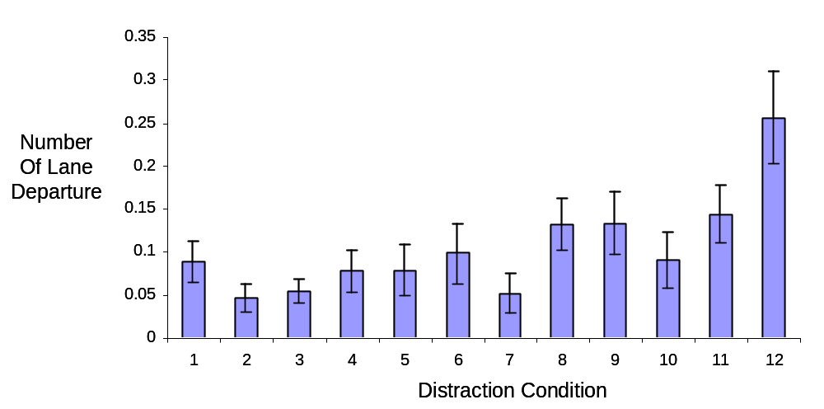

Figure 7.14. Number of lane departures within a 4.3-s time window
(+/-standard error as error bar) for various distraction conditions

7.3.2.11. Steering Entropy

Figure 7.15 presents steering entropy within 4.3-s time windows prior to lead vehicle braking. Although there was a main effect of distraction condition, F(11, 121)=2.81, p<.01, steering entropy did not vary systematically with distraction. Figure 7.15 showed smaller steering entropy values when subjects were asked to read words on the high-mounted cluster display, right mirror, and center console display in comparison with the baseline condition.

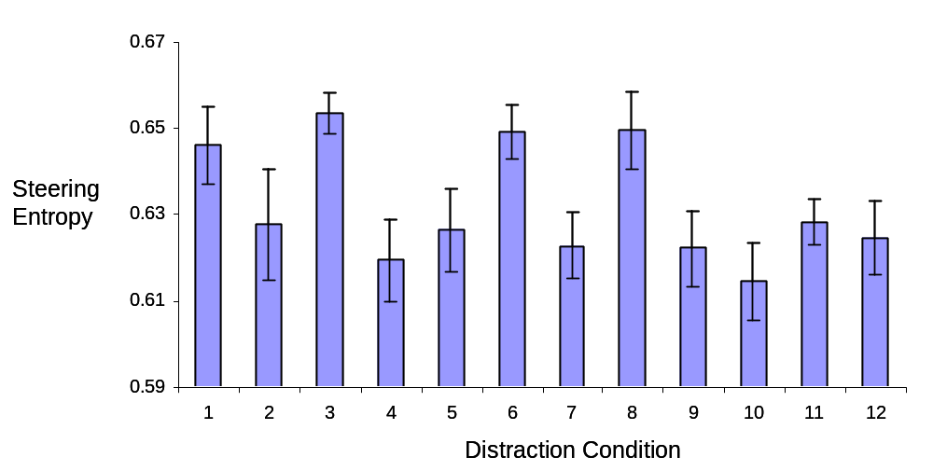

Figure 7.15. Steering entropy within a 4.3-s time window
(+/-standard error as error bar) for various distraction conditions

7.3.2.12. Accelerator Release Reaction Time

Although both accelerator release reaction time and brake reaction time were acquired, only accelerator release reaction time was reported here because these two reaction times were highly correlated (see also Zhang, Smith, & Witt, 2006). Figure 7.16 presents the accelerator release reaction times for 12 distraction conditions. There was a main effect of distraction, F(11, 121)=5.92, p<.001. Additional analysis indicated that the baseline condition produced significantly shorter reaction time than did the other distraction conditions (p<.05). A comparison among distraction conditions 1, 10, 11, and 12 illustrated that the reaction time increased with the number of words, F(3, 33)=12.04, p<.001. This reaction time result resembled that of eyes-off-road proportion (Figure 7.9), indicating close association between eyes-off-road proportion and accelerator release reaction time.

It was important to note that the reaction time was significantly shorter for the baseline than for distraction conditions 2-6 in which subjects were asked to read aloud words on the forward screen. As presented earlier, however, there was no difference in eyes-off-road proportion among conditions 1-6 (Figure 7.9). The discrepancy between eyes-off-road proportion (Figure 7.9) and accelerator release reaction time (Figure 7.16) for conditions 1-6 indicates a dissociation between these two variables. Even when visual distraction was not detectably higher (in conditions 2-6) than the baseline, accelerator release reaction time was slower if subjects were asked to engage in a distracting task (e.g., reading words on the forward screen). This finding was similar to the "change blindness" phenomenon (Rensink, O'Regan, & Clark, 1997). Subjects failed to notice the activation of the lead vehicle brake light even though their visual glance was in the forward area.

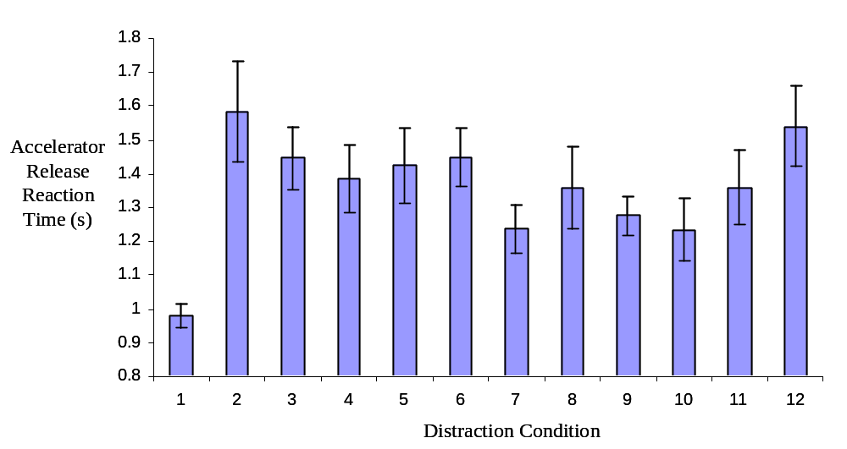

Figure 7.16. Accelerator release reaction times (standard errors as error bars)
for various distraction conditions.

7.3.2.13. Correlation Analysis With All 12 Conditions

Correlation analysis can be employed to demonstrate the associations among different variables. First, means were computed for every subject, condition, and variable. Second, grand mean values were obtained for every condition and variable by averaging across twelve subjects. Third, Pearson correlation coefficients were computed using the grand mean values. Table 7.1 presents Pearson correlation coefficients among accelerator release reaction time, SDLP, number of lane departures, steering entropy, TLX, and several eye glance measures. It was clear that all eye glance measures were strongly correlated with each other, and they were highly correlated with TLX, SDLP, and number of lane departures. Steering entropy had a low and negative correlation with all other variables, probably because steering entropy did not show a clear trend of distraction effect (see Figure 7.15).

Table 7.1. Pearson correlation coefficients using twelve distraction conditions (N=12)

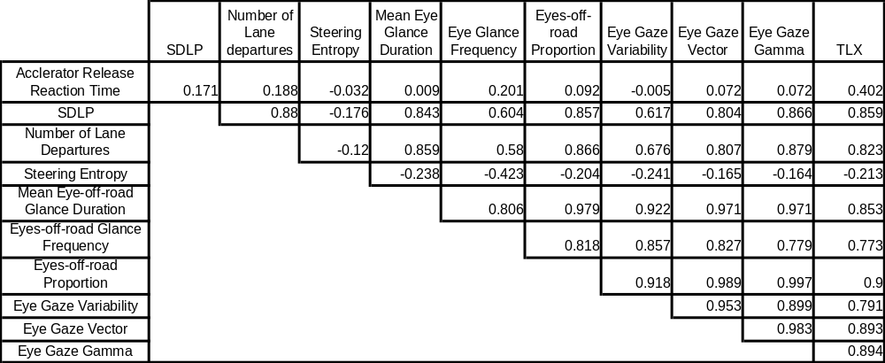

7.3.2.14. Correlation Analysis With Conditions 1, 7-12

Accelerator release reaction time had a low correlation with all other variables. This low correlation could have been caused by the aforementioned dissociation between accelerator release reaction time and eye-off-road proportion among conditions 1-6. To verify this hypothesis, Pearson correlation coefficients were calculated for accelerator release reaction time after excluding conditions 2-6. Table 7.2 presents the results. It was evident that accelerator release reaction time was highly correlated with TLX, SDLP, number of lane departures, and all eye glance measures. This supported the hypothesis that low correlations for accelerator release reaction time in Table 7.1 were mainly due to the dissociation between accelerator release reaction time and eyes-off-road proportion for conditions 1-6. This dissociation will be discussed in more detail later. Conditions 1 and 7-12 will be used for all subsequent analyses with accelerator release reaction time.

Table 7.2. Pearson correlation coefficients using distraction conditions 1 and 7-12 (N=7).

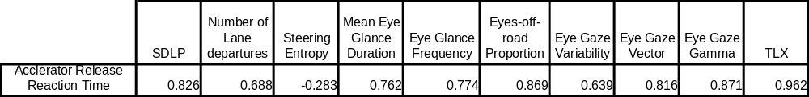

7.3.2.15. Diagnostic Measures

Table 7.1 illustrates that several eye glance measures, including mean eye glance duration, eyes-off-road proportion, eye gaze vector, and eye gaze gamma, were highly correlated with SDLP and lane departures and therefore could be reasonable diagnostic measures of visual distraction. Table 7.2 indicates that these eye glance measures were strongly correlated with accelerator release reaction time, excluding Tasks 2-6.

Similarly, Zhang and Smith (2004b) discovered that eyes-off-road proportion and eye gaze vector were potential diagnostic measures of visual distraction. However, eye gaze vector requires a very precise eye tracking system that may be available for on-road evaluation in the SAVE-IT program (Task 14). Eyes-off-road proportion does not require precise determination of eye gaze. The only information that is required is whether the eye gaze is forward or not, which is feasible in automotive-grade eye tracking systems such as Delphi's Driver State Monitor. Eye gaze gamma is a promising measure that warrants further examinations.

From the preceding discussion, it appears that eyes-off-road proportion and eye gaze gamma are most promising measures of visual distraction. Because it is more difficult to determine eye gaze than head pose, some researchers have proposed the use of head pose measures. To assess the effect of head pose-based glance measures, Pearson correlation coefficients were computed between head pose-based glance measures (e.g., head-off-road proportion and head pose gamma) and accelerator release reaction time or SDLP. As shown in Table 7.3, head-off-road proportion or head pose gamma is highly correlated with accelerator release reaction time or SDLP, supporting the claim of using head pose-based measures to detect visual distraction.

Table 7.3. Pearson correlation coefficients between head pose measures and accelerator release reaction time or SDLP.

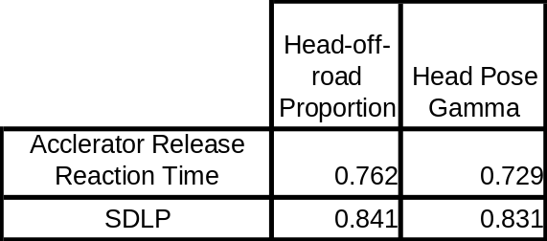

7.3.3. Subject-by-Subject Analyses

A major emphasis of Task 7C is to determine whether diagnostic measures of visual distraction apply to individual subjects. A subject-by-subject analysis is therefore performed between eye glance measures and accelerator release reaction time or SDLP. We analyzed two eye glance measures (i.e., eyes-off-road proportion and eye gaze gamma) and two corresponding head pose-based measures (i.e., head-off-road proportion and head pose gamma).

7.3.3.1. Eyes-off-road proportion

Table 7.3 presents Pearson correlation coefficients between eyes-off-road proportion and accelerator reaction time or SDLP for each of the twelve subjects. Conditions 1 and 7-12 were used in the calculations for accelerator release reaction time, and all twelve conditions were used in the SDLP calculations. For accelerator release reaction time, ten out of twelve subjects had a moderate or high correlation, with Pearson correlation coefficients larger than 0.30. For eight subjects, the correlation coefficients were greater than 0.50. For two subjects (subjects 3 and 8), the correlation coefficients were negative. A further examination of these two subjects revealed noisy accelerator release reaction times. Even though as many as sixteen reaction time events were presented for every distraction condition, reliable reaction times were not obtained.

There was no established threshold in the literature for a reliable correlation coefficient value. For SDLP, all correlation coefficients were positive. With the exception of one subject (subject 6), all correlation coefficients exceeded 0.50. Overall, these results suggested that eyes-off-road proportion was a reasonable diagnostic for nearly all individuals.

Table 7.3. Pearson correlation coefficients between eyes-off-road proportion and accelerator release reaction time or SDLP

Subject
Accelerator
Release RT
(n=7)
SDLP
(n=12)
1 (F, 35, Contact)
0.847
0.729
2 (F, 53)
0.512
0.64
3 (M, 37, Contact)
-0.248
0.682
4 (M, 44)
0.805
0.77
5 (F, 52)
0.95
0.516
6 (M, 43)
0.734
0.106
7 (F, 43, Glasses)
0.728
0.506
8 (M, 54)
-0.172
0.615
9 (M, 39)
0.307
0.548
10 (F, 47)
0.813
0.796
11 (M, 52)
0.604
0.812
12 (M, 39)
0.437
0.641
Overall
0.869
0.857

7.3.3.2. Head-off-road proportion

Table 7.4 presents Pearson correlation coefficients between head-off-road proportion and accelerator release reaction time or SDLP. Ten out of twelve subjects had a positive correlation and two subjects (subjects 3 and 8) had a negative correlation, which was likely due to noisy reaction times. Eight subjects had a correlation coefficient of 0.30 or higher, and five subjects had a correlation coefficient of 0.5 or higher. For SDLP, eleven out of twelve subjects had a positive correlation, and eight subjects had a correlation coefficient of 0.35 or higher. Because these correlation coefficients were smaller than those for eyes-off-road proportion (see Table 7.3), it was preferable to use eyes-off-road proportion as a diagnostic measure when eye gaze information was available.

Table 7.4. Pearson correlation between head-off-road proportion and accelerator release reaction time or SDLP

Subject
Accelerator
Release RT
(n=7)
SDLP
(n=12)
1 (F, 35, Contact)
0.123
0.357
2 (F, 53)
0.281
0.114
3 (M, 37, Contact)
-0.35
0.634
4 (M, 44)
0.676
0.634
5 (F, 52)
0.853
0.512
6 (M, 43)
0.563
-0.024
7 (F, 43, Glasses)
0.399
0.368
8 (M, 54)
-0.693
0.096
9 (M, 39)
0.301
0.122
10 (F, 47)
0.621
0.898
11 (M, 52)
0.657
0.839
12 (M, 39)
0.386
0.686
Overall
0.762
0.841

7.3.3.3. Eye gaze gamma

Table 7.5 presents Pearson correlation coefficients between eye gaze gamma and accelerator release reaction time or SDLP for each of the twelve subjects. Again, reaction time calculations used conditions 1 and 7-12 and SDLP calculations used all twelve conditions. For accelerator release reaction time, ten out of twelve subjects had a correlation coefficient of 0.25 or higher, and eight subjects had a correlation coefficient of 0.50 or higher. Again, two subjects (subjects 3 and 8) had a negative correlation coefficient, largely because of noisy reaction times. For SDLP, all but one subject (subject 6) had a correlation coefficient of 0.5 or higher. These results indicated that eye gaze gamma was a reasonable diagnostic of visual distraction for nearly all individuals.

7.3.3.4. Head pose gamma

Table 7.6 presents Pearson correlation coefficients between head pose gamma and accelerator release reaction or SDLP. For accelerator release reaction time, nine out of twelve subjects had a positive correlation, and six subjects had a correlation coefficient of 0.5 or higher. For SDLP, eleven out of twelve subjects had a positive correlation, and six subjects had a correlation coefficient of 0.35 or higher. These coefficients were smaller than those for eye gaze gamma (see Table 7.5), suggesting the use of eye gaze gamma as a diagnostic measure when it was available.

Table 7.5. Pearson correlation coefficients between eye gaze gamma and accelerator release reaction time or SDLP

Subject
Accelerator
Release RT
(n=7)
SDLP
(n=12)
1 (F, 35, Contact)
0.766
0.635
2 (F, 53)
0.534
0.612
3 (M, 37, Contact)
-0.263
0.665
4 (M, 44)
0.83
0.783
5 (F, 52)
0.757
0.527
6 (M, 43)
0.761
0.154
7 (F, 43, Glasses)
0.712
0.5
8 (M, 54)
-0.379
0.556
9 (M, 39)
0.372
0.547
10 (F, 47)
0.735
0.707
11 (M, 52)
0.578
0.824
12 (M, 39)
0.25
0.611
Overall
0.585
0.922

Table 7.6. Pearson correlation coefficients between head pose gamma and accelerator release reaction time or SDLP

Subject
Accelerator
Release RT
(n=7)
SDLP
(n=12)
1 (F, 35, Contact)
-0.044
0.191
2 (F, 53)
0.277
0.099
3 (M, 37, Contact)
-0.337
0.617
4 (M, 44)
0.612
0.602
5 (F, 52)
0.78
0.37
6 (M, 43)
0.566
-0.011
7 (F, 43, Glasses)
0.664
0.27
8 (M, 54)
-0.703
0.024
9 (M, 39)
0.243
0.036
10 (F, 47)
0.529
0.917
11 (M, 52)
0.637
0.854
12 (M, 39)
0.321
0.653
Overall
0.3
0.39

7.3.4. Across-Conditions Analyses

7.3.4.1. Eyes-off-road proportion

Because we have collected a large amount of data in this experiment, next we collapsed data across twelve subjects and seven conditions (conditions 1 and 7-12) to further investigate the relations between eyes-off-road proportion and reaction times. Figure 7.17 presents accelerator release reaction time as a function of eyes-off-road proportion. The data were grouped into 5 bins, each with approximately 20% of the data points. The reaction time increase was small when eyes-off-road proportion was below 0.50, and the increase was considerable when eyes-off-road proportion exceeded 0.50. Therefore it appeared that the threshold value should be set at 0.5.

The instantaneous eye gaze at the moment of lead vehicle braking was classified into "forward" and "not forward". Accelerator release reaction times were plotted against eyes-off-road proportions for forward (green line in Figure 7.17) and non-forward eye gaze separately (red line in Figure 7.17). When the instantaneous eye gaze was forward (green line), the accelerator release reaction time increased with the eyes-off-road proportion. The increase was smaller initially, and large when eyes-off-road proportion exceeded 0.50. When the instantaneous eye gaze was not forward (red line), the accelerator release reaction time was long when eyes-off-road proportion was small (0-0.1) or large (>0.5) and short when eyes-off-road proportion was intermediate (0.3-0.5).
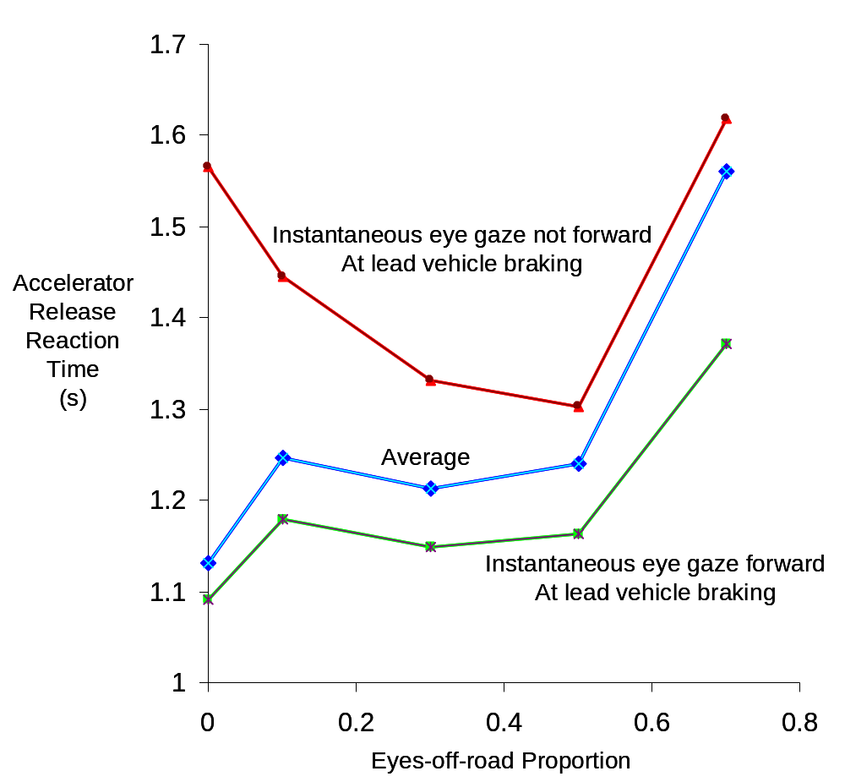

Figure 7.17. Accelerator release reaction time as a function of eyes-off-road proportion

7.3.4.2. Head-off-road proportion

Figure 7.18 presents accelerator release reaction time averaged across conditions 1 and 7-12 as a function of head-off-road proportion. The average results illustrated that accelerator release reaction time increased with head-off-road proportion. Reaction time increase was more marked when head-off-road proportion exceeded 0.5. A value of 0.5 seemed to be a reasonable threshold.

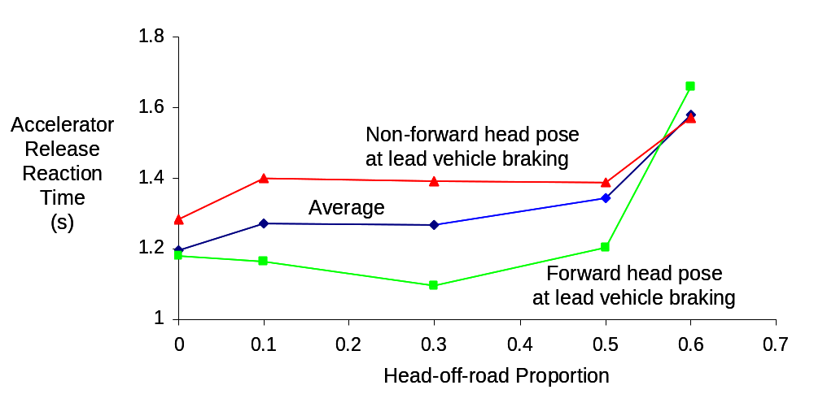

Figure 7.18. Accelerator release reaction time as a function of head-off-road proportion

7.3.4.3. Eye gaze gamma

Eye gaze gamma seems to be a reasonable diagnostic because it combines eyes-off-road proportion and instantaneous eye gaze. The weighting factor for instantaneous eye gaze was varied to investigate its effect on reaction time. Figure 7.19 presents accelerator release reaction time as a function of eye gaze gamma and scaling weight for instantaneous eye gaze. When the scaling weight was 0.6 or smaller, reaction time increased with eye gaze gamma. When the scaling weight was 0.8 or larger, reaction time increased with eye gaze gamma initially, decreased in the middle, and then increased at large gamma values. In order to use eye gaze gamma as a diagnostic measure, a monotonic function would be preferred. Therefore, the scaling weight should not be larger than 0.60.

Accelerator release reaction time was considerably larger when eye gaze gamma exceeded 2. It appeared that the threshold value should be set at 2.

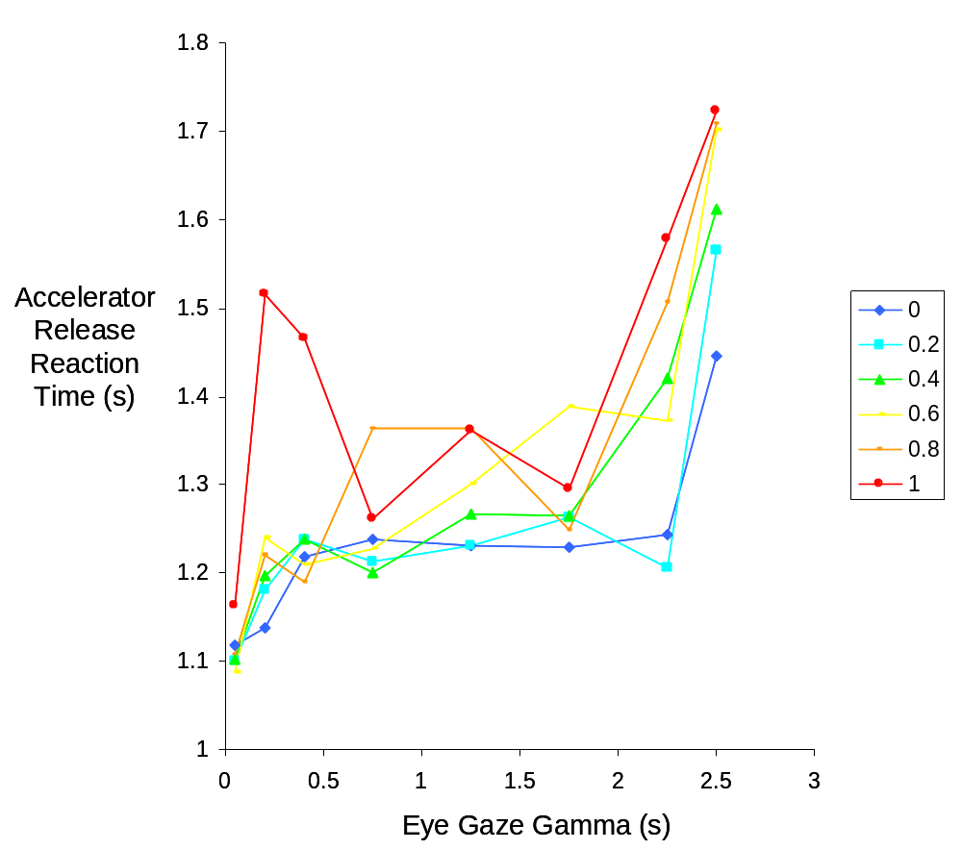

Figure 7.19. Accelerator release reaction time as a function of eye gaze gamma and scaling weight for instantaneous eye gaze

7.3.4.4. Head pose gamma

Figure 7.20 presents accelerator release reaction time as a function of head pose gamma and various scaling factors. When the scaling factor was 0-0.4, accelerator release reaction time increased gradually with head pose gamma. When the scaling factor was 0.6-1, however, the reaction time increase was not monotonic. Because a monotonic increase of reaction time as a function of head pose gamma was preferred, the scaling factor should be no larger than 0.6. Because accelerator release reaction time jumped when head pose gamma exceeded 2, a value of 2 should be adopted as the threshold.

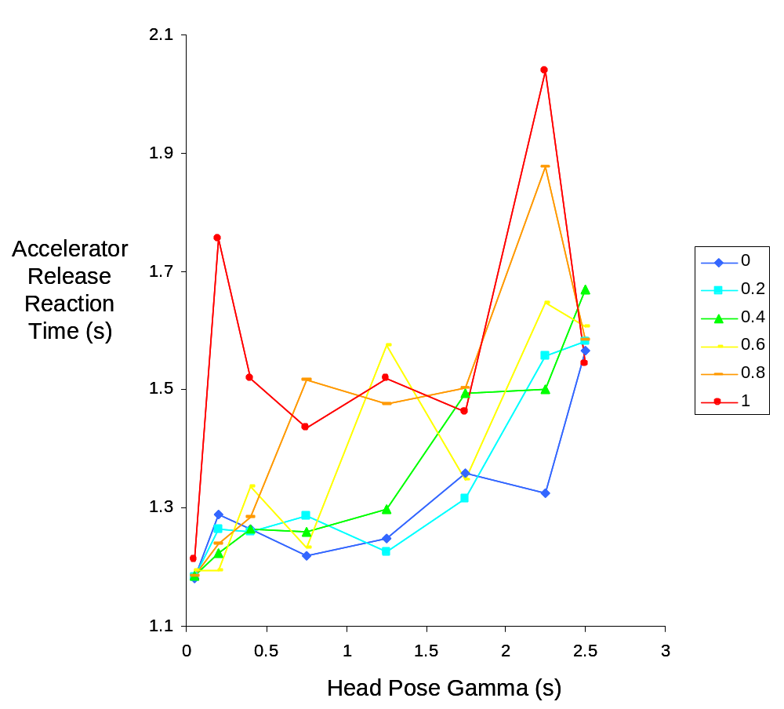

Figure 7.20. Accelerator release reaction time as a function of head pose gamma and scaling weight for instantaneous eye gaze

7.4. Discussion

In this simulator experiment, twelve subjects took part in two 3-hr. sessions in which they followed a lead vehicle that braked non-imminently at random points. Twelve experimental conditions were employed in which subjects were asked to read aloud words that were presented at different locations including the left mirror, rearview mirror, high-mounted head-down display, center console display, and forward screen of the simulator. Reading words on the forward screen did not produce different eye glance behaviors (except for eyes-off-road glance frequency) than did the baseline condition. The eyes-off-road proportion, mean eyes-off-road glance duration, eye gaze variability, eye gaze vector, and eye gaze gamma did not vary depending on whether or not subjects read words on the forward screen. Except using eyes-off-road glance frequency, it is difficult to discriminate reading in the forward area from the baseline condition using an automatic eye tracking system. The lane keeping performance resembled the eye glance behaviors. The standard deviation of lane position (SDLP) and number of lane departures did not vary depending on whether or not subjects read aloud words on the forward screen. The similarity between eye glance measures and lane keeping variables substantiate the claim that driving is mainly a visual-manual task and lateral vehicle control is largely determined by visual attention or lack of it (visual distraction).

The accelerator release reaction time was markedly longer when subjects read aloud words on the forward screen than the baseline condition. This pattern appears to correspond to the NASA-TLX results, indicating that reaction time results are associated with subjective workload ratings. The reaction time results did not match the eye glance measures that were investigated in this experiment, however, indicating a dissociation between reaction times and these eye glance measures and between reaction times and lane keeping performance. There are several possible explanations for this dissociation. One explanation is that detecting a lead vehicle braking event may require foveal vision whereas lane keeping may be sufficient with peripheral vision (Horrey, & Wickens, 2004a). When the eye glance is not at the focus of expansion but in general near the forward area (e.g., when reading words in conditions 2-6), the peripheral vision is sufficient for maintaining lane positions but insufficient for responding to a lead vehicle braking event. Changes in eye glance behaviors associated with reading words near the focus of expansion may be too small to be detected by non-contact eye tracking systems such as Facelab. A more accurate and precise eye tracking system that can detect smaller changes in eye glance behaviors may require physical contact with subjects' head and is beyond the scope of the SAVE-IT program. Change blindness is another explanation (Rensink, O'Regan, & Clark, 1997). Because attention was directed at a reading task, subjects did not notice the activation of the lead vehicle braking light that ultimately slowed down subjects' reaction times to the lead vehicle braking event. Related to change blindness is cognitive distraction. In reality, visual distraction and cognitive distraction are related to each other. When subjects read aloud words in the forward area, they are processing the word information and cognitively distracted from the driving task. Cognitive distraction has been shown to slow down reaction times in driving (Horrey, & Wickens, 2004b; Lee, Caven, Haake, & Brown, 2001; Lee, Reyes, Smyser, Liang, & Thornburg, 2004). The practical implication of this dissociation is that distraction cannot always be detected using a non-contact eye tracking system.

Excluding the forward distraction conditions, the reaction time pattern is similar to that of eye glance measures or lane keeping performance. Eye glance measures including eyes-off-road proportion, mean eyes-off-road glance duration, eye gaze vector, and eye gaze gamma increase as the number of words increases. So do the number of lane departures, SDLP, and accelerator release reaction time. The similarity was captured in Pearson correlation coefficients. High correlations were reliably obtained between eye glance measures and SDLP or accelerator release reaction time. This result validated eyes-off-road proportion and eye gaze vector as real-time diagnostic measures of visual distraction. It supported the use of eye gaze gamma as a potential diagnostic measure of visual distraction.

Eyes-off-road proportion and eye gaze gamma are especially attractive because they do not require highly precise measurements of eye gaze. They only require a binary classification in terms of forward and non-forward eye gaze that is feasible in automotive-grade eye tracking system including Delphi's Driver State Monitor (Edenborough, Hammoud, et al., 2004). Because the eyes may be sometimes occluded due to sunglasses or head movements, it may be advantageous to use head pose to detect visual distraction. Both eye gaze-based and head pose-based versions of these two eye glance measures have been investigated in detail in this experiment.

A subject-by-subject analysis was performed for eyes-off-road proportion, head-off-road proportion, eye gaze gamma, and head pose gamma. For a majority of subjects, there was a positive correlation between these glance measures and accelerator release reaction time (excluding the forward distraction conditions) or SDLP. This indicates that these glance measures may be used as diagnostic measures of visual distraction for most subjects. For some subjects, the correlations were negative or small. We have not been able to determine subject profiles for high-correlation and low-correlation groups. Such a determination may require a sample size larger than that is employed in this experiment (12 subjects). In general, eye-gaze-based measures had more positive and higher correlations than did head-pose-based measures. In addition, eyes-off-road proportion had more positive and higher correlations than did eye gaze gamma, and head-off-road proportion had more positive and higher correlations than did head pose gamma.

Although many research-intent driver monitoring technologies are able to monitor eye gaze, detecting eye-gaze is a difficult task using affordable automotive-grade technology. Figure 7.21 demonstrates how head pose and eye-gaze measures correlate with the driver performance measures: accelerator release time (ART) and standard deviation of lane position (SDLP)⁷. Although the eye-gaze measures are able to capture slightly more of the variance than head-pose measures, head pose still provides a good estimate of driver distraction, especially for SDLP. Furthermore, it is likely that non-forward glances that cannot be detected using head pose only, are likely to be less severe than non-forward glances that produce a detectable deviation in head pose too. For either prolonged or large-eccentricity head poses, because it is more comfortable, most drivers are likely to use a combination of head and eye movements to direct their gaze to the target. Therefore, because monitoring the head pose is more feasible from a technology perspective than monitoring eye gazes, and because monitoring the head pose is likely to be able to detect the worst-case visual distractions, the SAVE-IT program utilized the head-pose-monitoring DSM system.

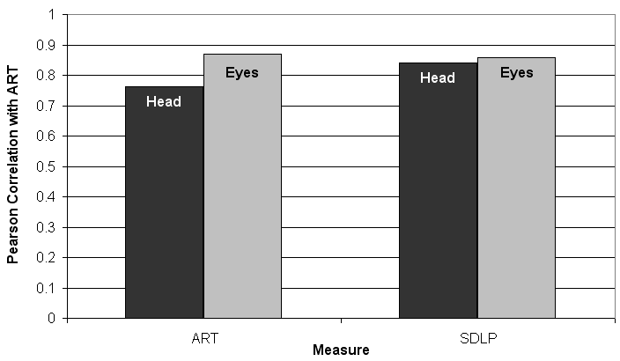
Figure 7.21 Correlations between head pose or eye gaze and performance measures: Accelerator Release Time (ART) and Standard Deviation of Lane Position (SDLP).

In this experiment, these glance measures were computed over a 4.3-s time window. It is simpler to implement this time window in a binary computing environment that is running at 30 Hz such as Delphi's Driver State Monitor (Edenborough, Hammoud, et al., 2004). This time window seems to strike a reasonable balance between timeliness and reliability.

For eye gaze gamma and head pose gamma, it seems important to use a small scaling factor for the instantaneous eye glace (or head pose). With a small scaling factor (e.g., <0.6), accelerator release reaction time increases with eye gaze gamma and head pose gamma monotonically. With a larger scaling factor, the monotonic pattern disappears. Because accelerator release reaction time is markedly longer when eye gaze gamma or head pose gamma exceeds 2, a value of 2 is a reasonable threshold. When eye gaze gamma or head pose gamma exceeds this threshold, distraction feedback should be provided to re-direct more of a driver's attention to the forward road.
Averaging across seven distraction conditions (excluding the forward distraction conditions), both eyes-off-road proportion and head-off-road proportion yield an increase in accelerator release reaction time. The increase was small (150 ms or smaller) when the proportion was 0.5 or lower, and considerable (400 ms or larger) when the proportion exceeded 0.5. This reaction time pattern suggests that the threshold for both eyes-off-road proportion and head-off-road proportion be set around 0.5. Distraction feedback should be provided to drivers when eyes-off-road or head-off-road proportion exceeds 0.5 to re-direct driver attention to the forward road.

It is important that distraction feedback does not create a new source of distraction. If a driver is looking forward already, it may be annoying and of little benefit to provide distraction feedback even if eyes-off-road or head-off-road proportion exceeds a threshold value. Therefore, distraction feedback should be provided only if eyes-off-road or head-off-road proportion exceeds a threshold and instantaneous eye gaze or head pose is non-forward. This experiment has shown that accelerator release reaction time was larger when eye gaze or head pose is non-forward than forward. If it is done carefully, distraction feedback will reduce eyes-off-road or head-off-road glance and speed up reaction times to lead vehicle braking events and enhance traffic safety.

This experiment has been carried out to validate diagnostic measures of visual distraction. Several promising glance measures have been identified. This experiment does not provide any distraction feedback to evaluate the safety effectiveness and driver acceptance issues. Preliminary assessments have been performed in SAVE-IT Task 4 (Donmez, Boyle, Lee, & McGehee, 2004b). These issues will be further investigated in subsequent tasks in the SAVE-IT program (Task 14).

7.5. References

Boer, E. R. (2001). Behavioral entropy as a measure of driving performance.
Proceedings of the First International Driving Symposium on Human Factors in
Driver Assessment, Training and Vehicle Design, 225-229.
Donmez, B., Boyle, L., Lee, J. D., & McGehee, D. V. (2004a). SAfety VEhicles using
adaptive Interface Technology (Task 4): A Literature Review of Distraction
Mitigation Strategies. http://www.volpe.dot.gov/opsad/saveit/docs.html.
Donmez, B., Boyle, L., Lee, J. D., & McGehee, D. V. (2004b). SAfety VEhicles using
adaptive Interface Technology (Task 4): Experiments for Distraction Mitigation
Strategies. http://www.volpe.dot.gov/opsad/saveit/docs.html.
Donmez, B., Boyle, L., Lee, J. D., & Scott, G. (2005). Assessing differences in young
drivers’ engagement in distractions. Unpublished manuscript.
Edenborough, N., Hammoud, R., Harbach, A., Ingold, A., Kisačanin, B., Malawey, P.,
Newman, T., Scharenbroch, G., Skiver, S., Smith, M., Wilhelm, A., Witt, G.,
Yoder, E., & Zhang, H. (2004). Drowsy driver monitor from Delphi. Proceedings
of IEEE CVPR 2004, Washington, D.C., June 2004.
Hart, S. G., & Staveland, L. E. (1988). Development of NASA-TLX (Task Load Index):
Results of experimental and theoretical research. In P. A. Hancock & N. Meshkati
(Eds.), Human mental workload (pp. 139-183). Amsterdam: North Holland.
Heinzmann, J., & Zelinsky, A. (1998). 3-D facial pose and gaze point estimation using a robust real-time tracking paradigm (pp. 142-147). Proceedings of the
International Conference on Automatic Face and Gesture Recognition.
Horrey, W. J., & Wickens, C. (2004a). Driving and side task performance: The effects of
display clutter, separation, and modality. Technical Report AHFD-02-13/GM-02-
2.
Horrey, W. J., & Wickens, C. (2004b). The impact of cell phone conversations on
driving: A meta-analytic approach. Technical Report AHFD-04-02/GM-04-1.
Lee, J. D., Caven, B., Haake, S., & Brown, T. (2001). Speech-based interaction with in-
vehicle computers: The effect of speech-based e-mail on drivers' attention to the
roadway. Human Factors, 43, 631-640.
Lee, J. D., McGehee, D. V., Brown, T. L., & Reyes, M. (2002). Collision warning timing,
driver distraction, and driver response to imminent rear-end collisions in a high-
fidelity driving simulator. Human Factors, 44, 314-334.
Lee, J., Reyes, M., Smyser, T., Liang, Y., & Thornburg, K. (2004). SAfety VEhicles
using adaptive Interface Technology (Task 5). Final Report: Phase 1.
http://www.volpe.dot.gov/opsad/saveit/docs/dec04/finalrep_5b.pdf.
Nakayama, O., Futami, T., Nakamura, T., & Boer, E. R. (1999). Development of a
steering entropy method for evaluating driver workload. SAE 1999-01-0892.
Recarte, M. A., & Nunes, L. M. (2000): Effects of verbal and spatial–imagery tasks on
eye fixations while driving. Journal of Experimental Psychology: Applied
, 6,
31-43
- .
Rensink, R. A., O'Regan, J. K., & Clark, J. J. (1997). To see or not to see: The need for
attention to perceive changes in scenes. Psychological Science, 5, 368-373.
Victor, T., Blomberg, O., & Zelinsky, A. (2001). Automating driver visual. In A. G. Gales,
et al. (Editors). Vision in Vehicles–VIIII, Elsevier Science Publishers B. V. (North
Holland).
Wang, J.-S., Knipling, R. R., & Goodman, M. J. (1996). The role of driver inattention in
crashes; New statistics from the 1995 crashworthiness data system (pp. 377-
39). 40th Annual Proceedings of the Association for the Advancement of
Automotive Medicine. Vancouver, British Columbia.
Zhang, H. & Smith, M. (2004a). SAfety VEhicles using adaptive Interface Technology
(Task 7): A literature review of visual distraction research. http://www.volpe.dot.gov/opsad/saveit/docs.html.
Zhang, H. & Smith, M. (2004b). A Final Report of SAfety VEhicles using adaptive
Interface Technology (Phase I: Task 7): Visual Distraction Research. http://www.volpe.dot.gov/opsad/saveit/docs.html.
Zhang, H., Smith, M. R. H., & Witt, G. J. (2006). Identification of real-time diagnostic
measures of visual distraction with an automatic eye tracking system. Human
Factors, 48, 805-821.

Forward is defined as 24x24 deg² around the focus of expansion.

