REVERSE ENGINEERING AND AUTOMATIC SYNTHESIS OF METABOLIC PATHWAYS FROM OBSERVED DATA USING GENETIC PROGRAMMING

Symposium ON COMPUTATIONAL DISCOVERY OF COMMUNICATABLE KNOWLEGDE

SUNDAY MARCh 25, 2001
CSLI Stanford

John R. Koza
Stanford Biomedical Informatics, Department of Medicine
Department of Electrical Engineering
Stanford University, Stanford, California
koza@stanford.edu

William Mydlowec
Genetic Programming Inc., Los Altos, California
bill@pharmix.com

Guido Lanza
Genetic Programming Inc., Los Altos, California
guido@pharmix.com

Jessen Yu
Genetic Programming Inc., Los Altos, California
jyu@cs.stanford.edu
Martin A. Keane
Econometrics Inc., Chicago, Illinois
makeane@ix.netcom.com
From CHAPTER 1 OF Genetic Programming III: Darwinian Invention and Problem SolviNG (Koza, BENNETT, ANDRE, KEANE 1999)

"Most techniques of artificial intelligence, machine learning, neural networks, adaptive systems, reinforcement learning, or automated logic employ specialized structures in lieu of ordinary computer programs.
"These surrogate structures include if-then production rules, Horn clauses, decision trees, Bayesian networks, propositional logic, formal grammars, binary decision diagrams, frames, conceptual clusters, concept sets, numerical weight vectors (for neural nets), vectors of numerical coefficients for polynomials or other fixed expressions (for adaptive systems), genetic classifier system rules, fixed tables of values (as in reinforcement learning), or linear chromosome strings (as in the conventional genetic algorithm).
From CHAPTER 1 OF Genetic Programming III ⎯ CONTINUED

"Tellingly, except in unusual situations, the world's several million computer programmers do not use any of these surrogate structures for writing computer programs.
"Instead, for five decades, human programmers have persisted in writing computer programs that intermix a multiplicity of types of computations (e.g., arithmetic and logical) operating on a multiplicity of types of variables (e.g., integer, floating-point, and Boolean). Programmers have persisted in using internal memory to store the results of intermediate calculations in order to avoid repeating the calculation on each occasion when the result is needed. They have persisted in using iterations and recursions. They have similarly persisted for five decades in organizing useful sequences of operations into reusable groups (subroutines) so that they avoid reinventing the wheel on each occasion when they need a particular sequence of operations. Moreover, they have persisted in passing parameters to subroutines so that they can reuse their subroutines with different instantiations of values. And, they have persisted in organizing their subroutines into hierarchies.
From CHAPTER 1 OF Genetic Programming III ⎯ CONTINUED

"All of the above tools of ordinary computer programming have been in use since the beginning of the era of electronic computers in the l940s. Significantly, none has fallen into disuse by human programmers. Yet, in spite of the manifest utility of these everyday tools of computer programming, these tools are largely absent from existing techniques of automated machine learning, neural networks, artificial intelligence, adaptive systems, reinforcement learning, and automated logic.
"On one of the relatively rare occasions when one or two of these everyday tools of computer programming is available within the context of one of these automated techniques, they are usually available only in a hobbled and barely recognizable form.
"In contrast, genetic programming draws on the full arsenal of tools that human programmers have found useful for five decades. It conducts its search for a solution to a problem overtly in the space of computer programs.
"Our view is that computer programs are the best representation of computer programs. We believe that the search for a solution to the challenge of getting computers to solve problems without explicitly programming them should be conducted in the space of computer programs.
The topology of a network of chemical reactions

• the total number of reactions in the network,
• the number of substrate(s) consumed by each reaction,
• the number of product(s) produced by each reaction,
• the pathways supplying the substrate(s) (either from external sources or other reactions in the network) to each reaction,
• the pathways dispersing each reaction's product(s) (either to other reactions or external outputs), and
• an indication of which enzyme (if any) acts as a catalyst for a particular reaction

The sizing for a network of chemical reactions
• all the numerical values associated with the network (e.g., the rates of each reaction)
Our approach

• establishing a representation for chemical networks involving symbolic expressions (S-expressions) and program trees that can be progressively bred (and improved) by means of genetic programming,
• converting each individual program tree in the population into an analog electrical circuit representing the network of chemical reactions,
• obtaining the behavior of the individual network of chemical reactions by simulating the corresponding electrical circuit,
• defining a fitness measure that measures how well the behavior of an individual network matches the observed time-domain data concerning concentrations of final product substance(s), and
• using the fitness measure to enable genetic programming to breed an improved population of program trees.
Five different representations

• Reaction Network: The blocks represent chemical reactions and the directed lines represent flows of substances between reactions.
• Program Tree: A network of chemical reactions can also be represented as a program tree whose internal points are functions and external points are terminals. This representation enables genetic programming to breed a population of programs in a search for a network of chemical reactions whose time-domain behavior concerning concentrations of final product substance(s) closely matches observed data.
• Symbolic Expression: A network of chemical reactions can also be represented as a symbolic expression (S-expression) in the style of the LISP programming language. This representation is used internally by the run of genetic programming.
• System of Non-Linear Differential Equations: A network of chemical reactions can also be represented as a system of non-linear differential equations.
• Analog Electrical Circuit: A network of chemical reactions can also be represented as an analog electrical circuit. Representation of a network of chemical reactions as a circuit facilitates simulation of the network's time-domain behavior.
Illustrative Problem No. 1 ⎯ phospholipid cycle

• 4 reactions that are part of the phospholipid cycle, as presented in the E-CELL cell simulation model
• External inputs
• glycerol (C00116)
• fatty acid (C00162).
• cofactor ATP(C00002)
• Network's final product
• diacyl-glycerol (C00165)
• Catalysts
• Glycerol kinase (EC2.7.1.30),
• Glycerol-1-phosphatase (EC3.1.3.21),
• Acylglycerol lipase (EC3.1.1.23), and
• Triacylglycerol lipase (EC3.1.1.3)
• 2 intermediate substances
• sn-Glycerol-3-Phosphate (C00093)
• Monoacyl-glycerol (C01885)
Illustrative Problem No. 1 ⎯ phospholipid cycle

INTERESTING TOPOLOGY

• 2 instances of a bifurcation point (where one substance is distributed to two different reactions)
• External supply of fatty acid (C00162) is distributed
• External supply of glycerol (C00116) is distributed
• 1 instance of an accumulation point (where one substance is accumulated from two sources)
• glycerol (C00116) is externally supplied and
• glycerol (C00116) is produced by the reaction catalyzed by Glycerol-1-phosphatase (EC3.1.3.21)
• 1 internal feedback loop (in which a substance is both consumed and produced)
• Glycerol (C00116) is consumed (in part) by the reaction catalyzed by Glycerol kinase (EC2.7.1.30).
• This reaction, in turn, produces an intermediate substance, sn-Glycerol-3-Phosphate (C00093).
• This intermediate substance is, in turn, consumed by the reaction catalyzed by Glycerol-1-phosphatase (EC3.1.3.21).
• That reaction, in turn, produces glycerol (C00116).
Four reactions from the phospholipid cycle

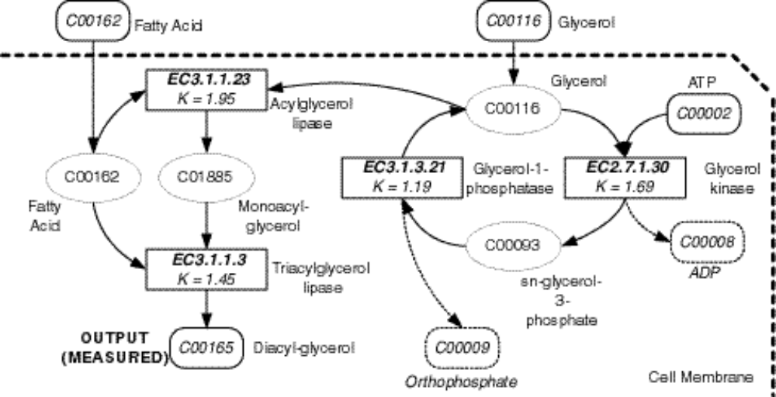

Illustrative Problem No. 2 ⎯ synthesis and degradation of ketone bodies

• 3 reactions
• External inputs
• Acetoacetyl-CoA
• Acetyl-CoA
• Final product
• Acetoacetate.
• Catalysts
• 3-oxoacid CoA-transferase (EC 2.8.3.5)
• Hydroxymethylglutaryl-CoA synthase (EC 4.1.3.5)
• Hydroxymethylglutaryl-CoA lyase (EC 4.1.3.4)
• 1 intermediate substance
• INT-1
llustrative Problem No. 2 ⎯ synthesis and degradation of ketone bodies

3 NOTEWORHTY TOPOLOGICAL FEATURES

• 1 instance of a bifurcation point (where one substance is distributed to two different reactions)
• Acetoacetyl-CoA
• 2 accumulation points
• Acetyl-CoA is an externally supplied substance and is produced by the reaction catalyzed by Hydroxymethylglutaryl-CoA lyase (EC 4.1.3.4)
• Acetoacetate is produced by the reaction catalyzed by 3-oxoacid CoA-transferase (EC 2.8.3.5) and by the reaction catalyzed by Hydroxymethylglutaryl-CoA lyase (EC 4.1.3.4)
• 1 internal feedback loop (in which a substance is both consumed and produced) • Acetyl-CoA is consumed by the reaction catalyzed by Hydroxymethylglutaryl-CoA synthase (EC 4.1.3.5).
• This reaction, in turn, produces an intermediate substance (INT-1)
• This intermediate substance is, in turn, consumed by the reaction catalyzed by Hydroxymethylglutaryl-CoA lyase (EC 4.1.3.4).
• That reaction, in turn, produces Acetyl-CoA.
Three reactions involved in the synthesis and degradation of ketone bodies

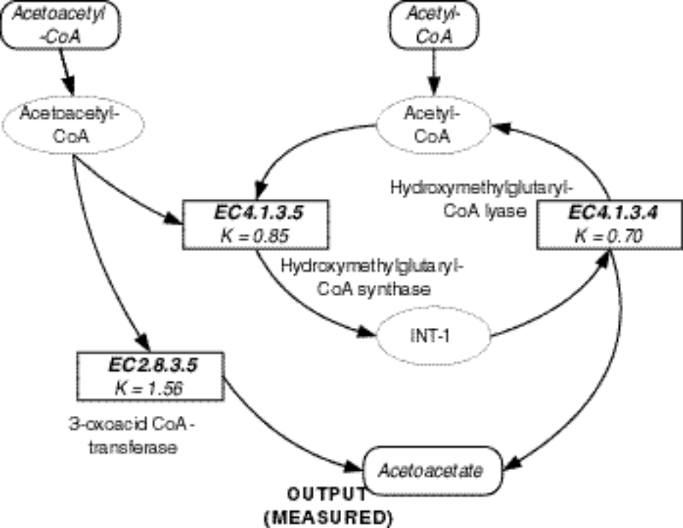

GENETIC PROGRAMMING
(1) Generate an initial population of compositions (typically random) of the functions and terminals of the problem.
(2) Iteratively perform the following substeps (referred to herein as a generation) on the population of programs until the termination criterion has been satisfied:
(A) Execute each program in the population and assign it a fitness value using the fitness measure.
(B) Create a new population of programs by applying the following operations. The operations are applied to program(s) selected from the population with a probability based on fitness (with reselection allowed).
(i) Reproduction
(ii) Crossover (Sexual recombination)
(iii) Mutation
(iv) Architecture-altering operations
(3) Designate the individual program that is identified by result designation (e.g., the best-so-far individual) as the result of the run of genetic programming. This result may be a solution (or an approximate solution) to the problem.
ARCHITECTURE-ALTERING OPERATIONS
• The individual programs that are evolved by genetic programming are typically multi-branch programs consisting of one or more result-producing branches and zero, one, or more automatically defined functions (subroutines).

• The architecture of such a multi-branch program involves
• the total number of automatically defined functions,
• the number of arguments (if any) possessed by each automatically defined function, and
• if there is more than one automatically defined function in a program, the nature of the hierarchical references (including recursive references), if any, allowed among the automatically defined functions.

• Architecture-altering operations enable genetic programming to automatically determine
• the number of automatically defined functions,
• the number of arguments that each possesses, and
• the nature of the hierarchical references, if any, among such automatically defined functions.
Automatic Synthesis of Analog Electrical Circuits

Lowpass Filter Circuit

Time domain behavior of a lowpass filter to a 1,000 Hz sinusoidal input signal

Time domain behavior of a lowpass filter to a 2,000 Hz sinusoidal input signal

Frequency domain behavior of a lowpass filter

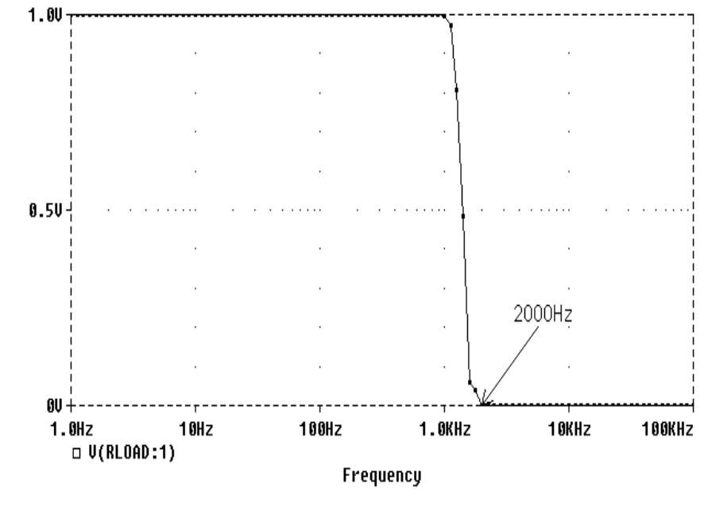

Lowpass filter created by genetic programming that infringes on GEORGE Campbell's patent

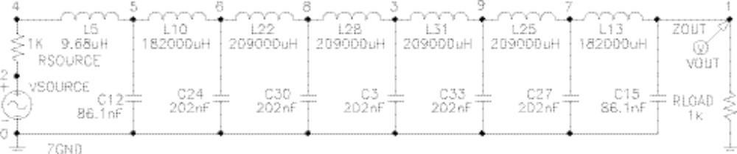

Squaring Computational Circuit created by genetic programming

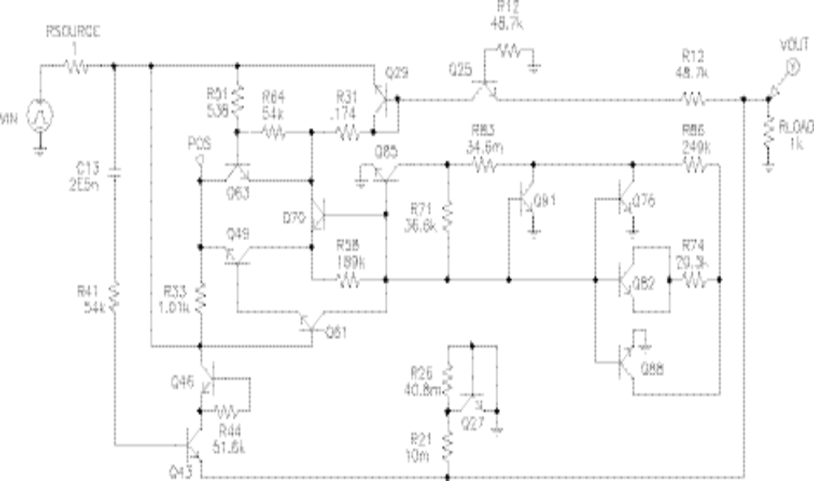

Rising ramp ⎯ 1 of 4 time-domain signals used to create squaring computational circuit

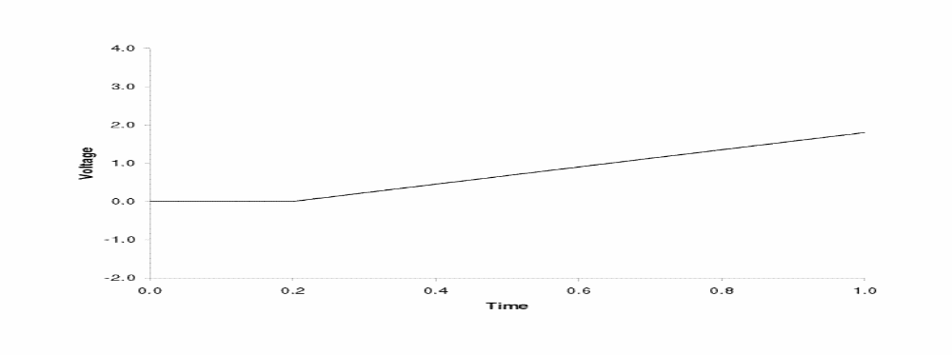

Output for rising ramp input for squaring circuit
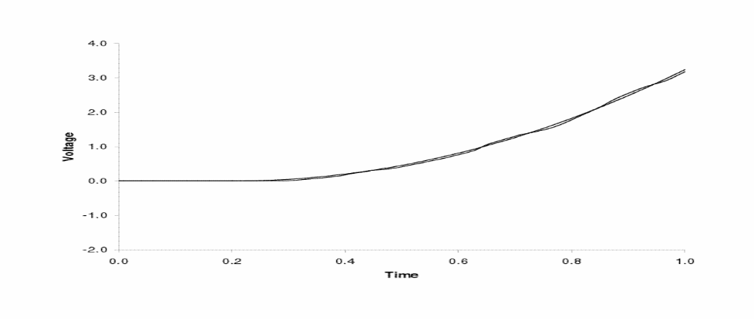

Automatic Synthesis of Controllers

Evolved controller that infringes on Jones' patent

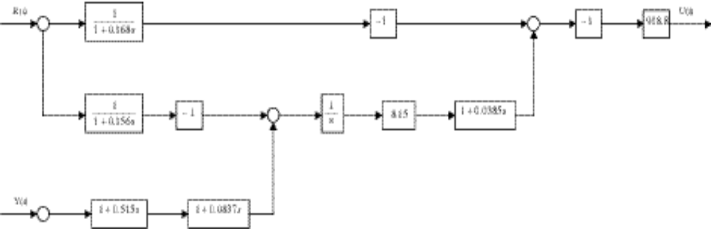

Automatic Synthesis of Antennas

Antenna design created by genetic programming

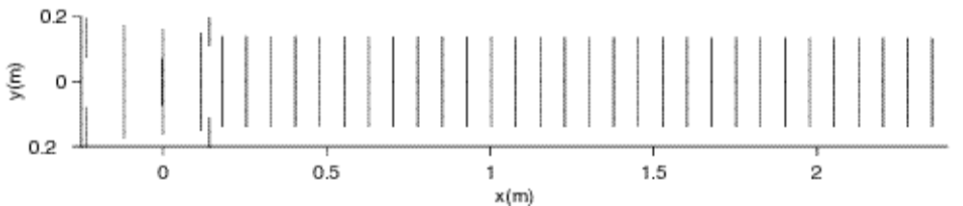

One-substrate, one-product chemical reaction

• One chemical (the substrate) is transformed into another chemical (the product) under control of a catalyst

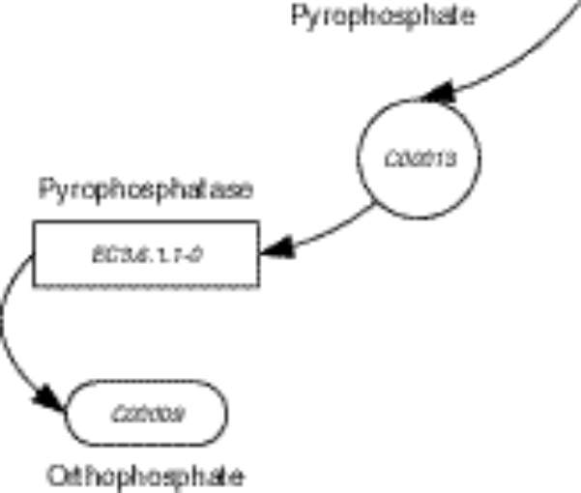

Changing concentrations of substances in an illustrative one-substrate, one-product reaction

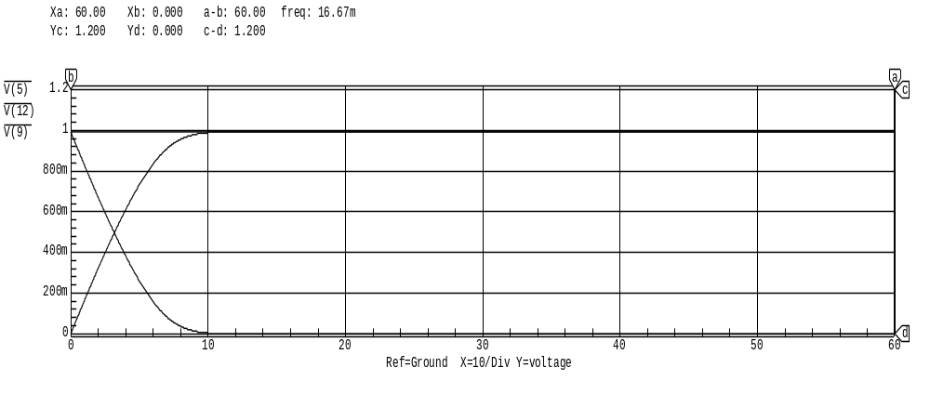
Chemical reactions

• The action of an enzyme (catalyst) in a one-substrate chemical reaction can be viewed as two-step process in which the enzyme E first binds with the substrate S at a rate k₁ to form ES. The formation of the product P from ES then occurs at a rate k₂. The reverse reaction (for the binding of E with S) in which ES dissociates into E and S, occurs at a rate of k₋₁.
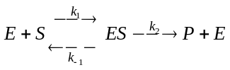
• The concentrations of substrates, products, intermediate substances, and catalysts participating in reactions are modeled by various rate laws, including
• first-order rate laws,
• second-order rate laws, power laws, and
• Michaelis-Menten equations
• Michaelis-Menten rate law for a one-substrate chemical reaction is
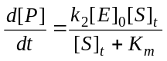.
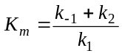.
• Psuedo-first-order rate law
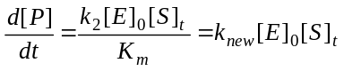,
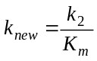.
E lectrical circuit representing the illustrative one-substrate-one-product enzymatic reaction

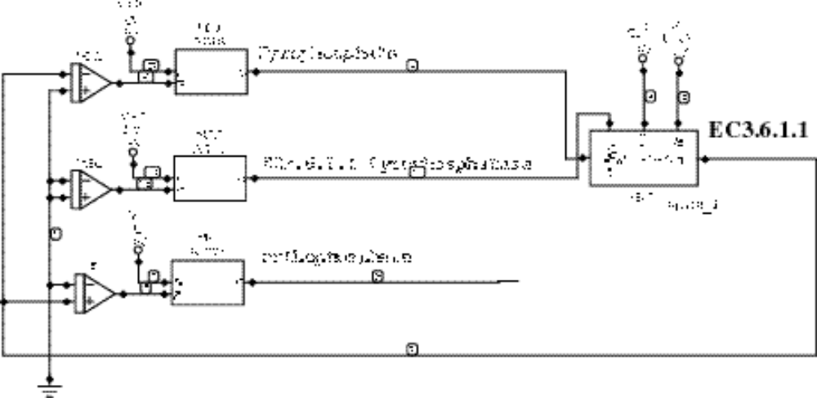

Sum-integrator

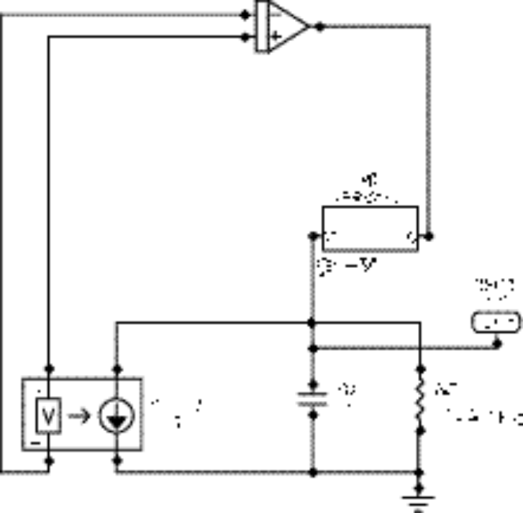

Subcircuit for one-substrate Michaelis-Menten equation MICH_1

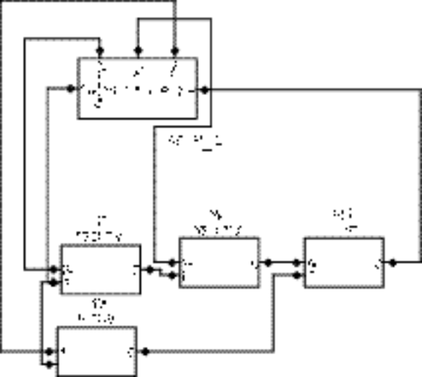

Subcircuit definition in SPICE for the one-substrate Michaelis-Menten equation MICH_1
*NETLIST FOR MICHAELIS-MENTEN MICH_1
XXM4 4 3 2 XDIVV
XXM3 6 5 3 XADDV
XXM2 7 8 4 XMULTV
XXM1 9 5 8 XMULTV
.SAVE V(2) V(3) V(4) V(5) V(6) V(7) V(8) V(9)
.END
One-Substrate, Two-Product Reaction

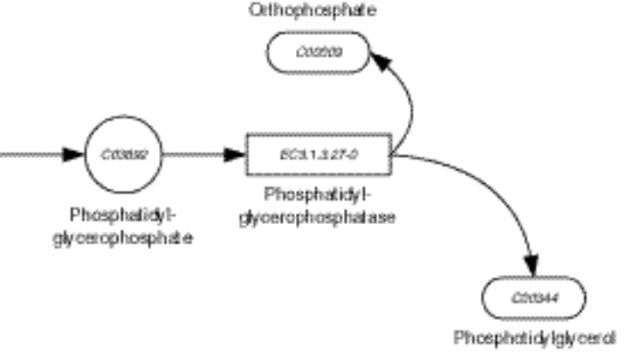
Circuit for illustrative one-substrate, two-product chemical reaction

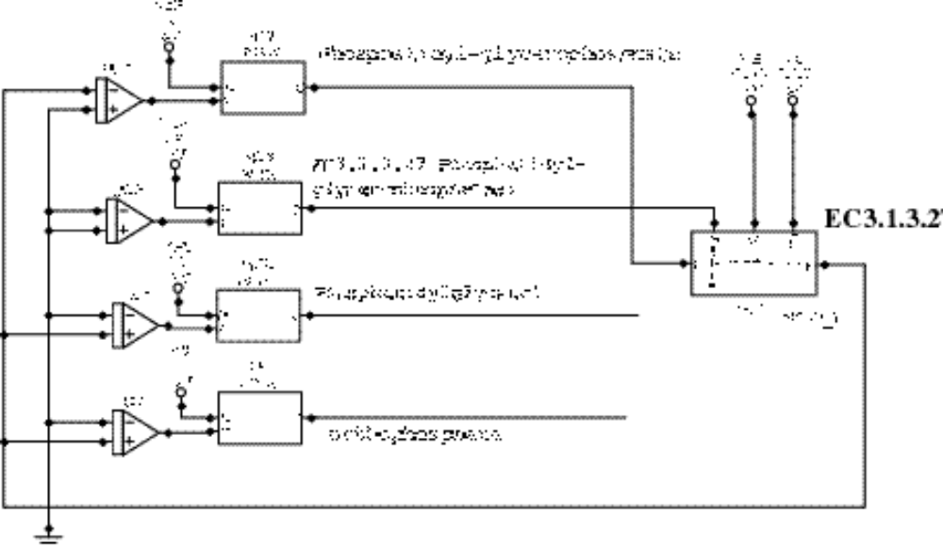

Two-Substrate, One-Product Reaction

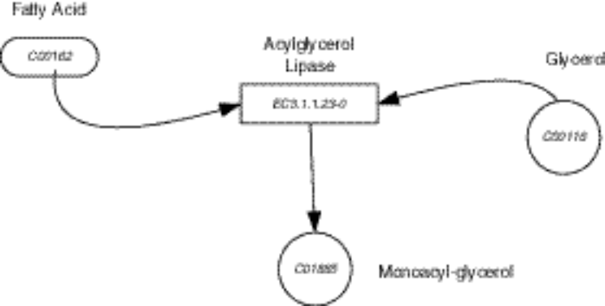

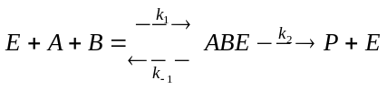

• Michaelis-Menten rate law for a two-substrate chemical reaction is
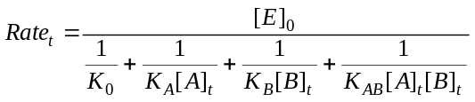.
• When k₋₁ ~ 0 and k₋₁ << k₁ << k₂, it is often satisfactory to use a psuedo-second-order rate law such as
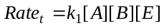
Circuit for two-substrate, one-product chemical reaction

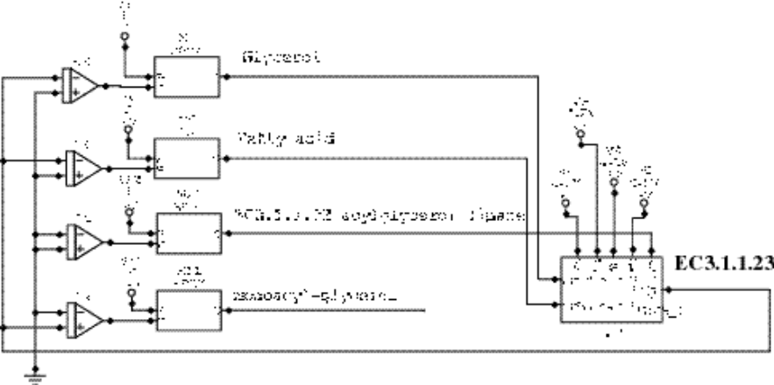

Two-substrate Michaelis-Menten equation MICH_2
.
Subcircuit for two-substrate Michaelis-Menten equation MICH_2
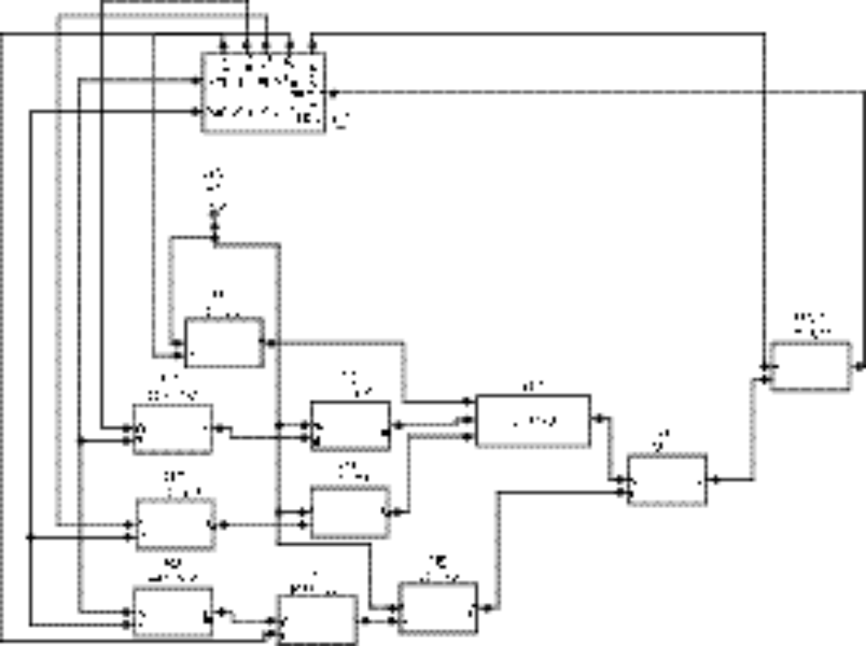

Two-Substrate, Two-Product Reaction

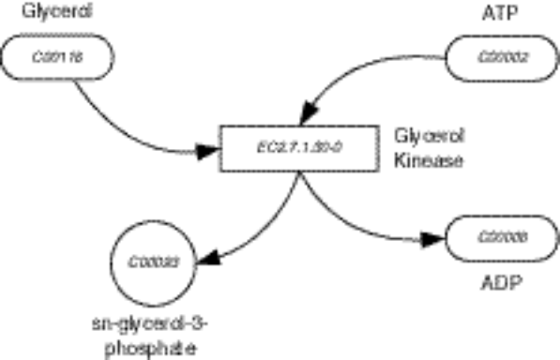

Electrical circuit representing a two-substrate, two-product enzymatic reaction
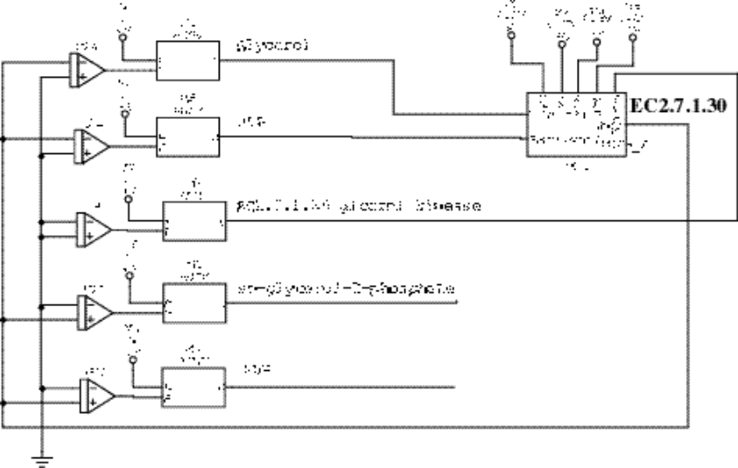

Repertoire of Functions in Program Tree

Four chemical reaction functions
Function | Substrates | Products | Arity
CR_1_1 | 1 | 1 | 4
CR_1_2 | 1 | 2 | 5
CR_2_1 | 2 | 1 | 5
CR_2_2 | 2 | 2 | 6

• Each chemical reaction function returns a list (of length 1 or 2) composed of the reaction's one or two products.
• The one-argument FIRST-PRODUCT function returns the first of the one or two products produced by the chemical reaction function designated by its argument.
• The one-argument SECOND-PRODUCT function returns the second of the two products (or, the first product, if the reaction produces only one product).

Repertoire of Terminals in the Program Tree

• Substances
• externally supplied input substances
• intermediate substances created by reactions
• output substances
• Enzymes
• Numerical constants for the rate of the reactions
Program tree corresponding to metabolic pathway for phospholipid cycle

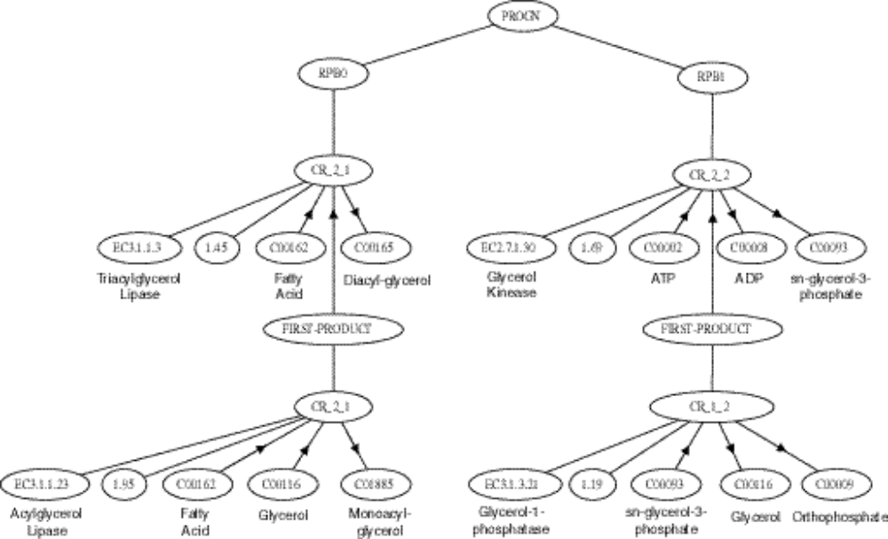

Representation OF phospholipid cycle as a Symbolic Expression

(PROGn
(CR_2_1
EC3_1_1_3
1.45
C00162
(FIRST-PRODUCT
(CR_2_1
EC3_1_1_23
1.95
C00162
C00116
C01885
)
)
C00165
)
(CR_2_2
EC2_7_1_30
1.69
C00002
(FIRST-PRODUCT
(CR_1_2
EC3_1_3_21
C00093
C00116
C00009
)
)
C00008
C00093
)
)
Representation OF phospholipid cycle as a System of Non-Linear Differential Equations

• Supply of the network's final product, diacyl-glycerol (C00165)
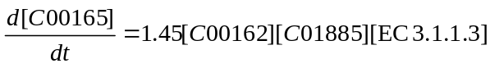
• Supply and consumption of the intermediate substance Monoacyl-glycerol (C01885)
• Supply and consumption of the intermediate substance sn-Glycerol-3-Phosphate (C00093) in the internal feedback loop
• Supply and consumption of cofactor ATP (C00002)
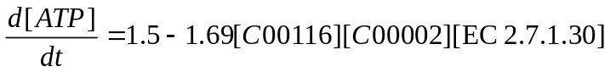
• Supply and consumption of fatty acid (C00162)
• Supply, consumption, and production of glycerol (C00116)
Electrical circuit corresponding to the metabolic pathway FOR phospholipid cycle

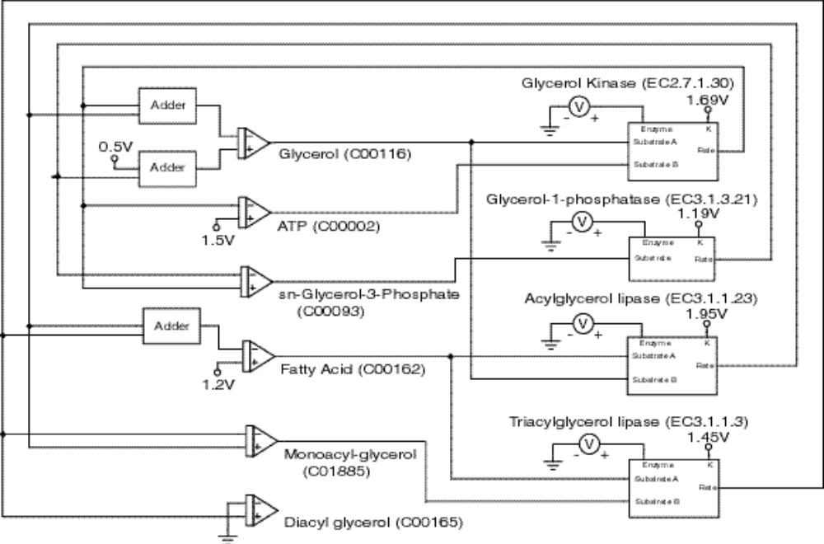

Preparatory Steps For genetic programming

Program Architecture
• Each program tree in the initial random population (generation 0) has one result-producing branch.
• In subsequent generations, the architecture-altering operations (patterned after gene duplication and gene deletion in nature) may add and delete result-producing branches to particular individual program trees in the population.
• Each program tree may have four result-producing branches.

Function Set
F = {CR_1_1, CR_1_2, CR_2_1, CR_2_2, FIRST-PRODUCT, SECOND-PRODUCT}.
Terminal Set
T = {ℜ, INT_1, INT_2, INT_3, C00116, C00162, C00002, C00165, EC2_7_1_30, EC3_1_3_21, EC3_1_1_23, }.
Fitness Measure
• Concentrations of each of the four enzymes (EC2.7.1.30, EC3.1.3.21, EC3.1.1.23, and EC3.1.1.3) are varied in accordance with 6 different time series patterns over 30 half-second time steps:
• Each individual chemical reaction network is exposed to 9 test cases. Thus, there are 270 fitness cases (9 test cases, each consisting of 30 time steps).
• Each of the nine test cases is constructed by choosing four different time series from the above set of six time series as the concentration for the four enzymes (EC2.7.1.30, EC3.1.3.21, EC3.1.1.23, and EC3.1.1.3)
Variation in the levels of the four enzymes for the nine test cases.
Test case | EC2.7.1.30 | EC3.1.3.21 | EC3.1.1.23 | EC3.1.1.3
1 | Slope-Up | Sawtooth | Step-Down | Step-Up
2 | Slope-Down | Step-Up | Sawtooth | Step-Down
3 | Step-Down | Slope-Up | Slope-Down | Step-Up
4 | Step-Up | Slope-Down | Step-Up | Step-Down
5 | Sawtooth | Step-Down | Slope-Up | Step-Up
6 | Sawtooth | Step-Down | Knock-Out | Slope-Up
7 | Sawtooth | Knock-Out | Slope-Up | Step-Down
8 | Knock-Out | Step-Down | Slope-Up | Sawtooth
9 | Step-Down | Slope-Up | Sawtooth | Knock-Out

Fitness Measure ⎯ CONTINUED
• There is a total of 270 data points. The data was obtained from the E-CELL cell simulation model
• The concentrations of all intermediate substances and the network's final product are 0 at time step 0.
• Glycerol (C00116), Fatty acid (C00162), and ATP (C00002) are externally supplied at a constant rate that is not subject to evolutionary change during the run

Rates for three externally supplied substances
Substance | Rate
Glycerol (C00116) | 0.5
Fatty acid (C00162) | 1.2
ATP (C00002) | 1.5
• Fitness is the sum, over the 270 fitness cases, of the absolute value of the difference between the concentration of the end product of the individual reaction network (diacyl-glycerol C00165 for the first network and Acetoacetate for the second network) and the observed concentration (data). The smaller the fitness, the better.
• An individual that cannot be simulated by SPICE is assigned a high penalty value of fitness (10⁸)

Control Parameters for the Run
The population size, M, is 100,000.
A maximum size of 500 points (for functions and terminals) was established for each result-producing branch.
Results Phospholipid Cycle

• The fitness of the median individual from the population at generation 0 is 297.3. This individual scores 17 hits (out of 270)

Median individual of generation 0
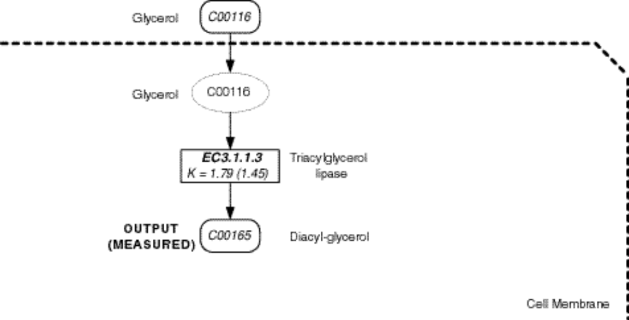

Results Phospholipid Cycle

Best of generation 0
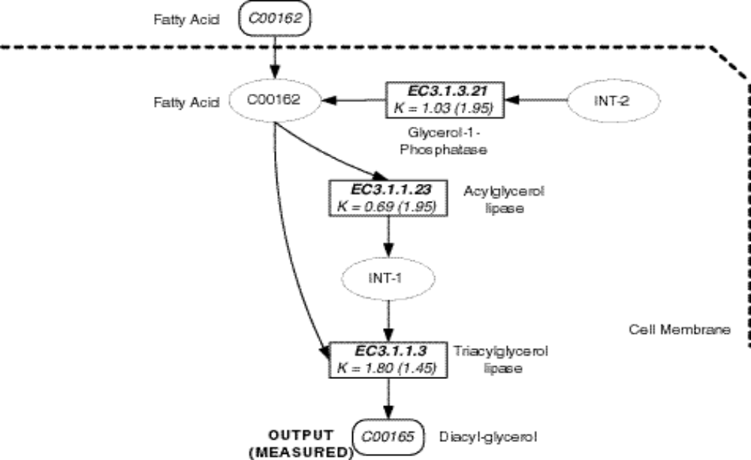

Results Phospholipid Cycle

Best of generation 10
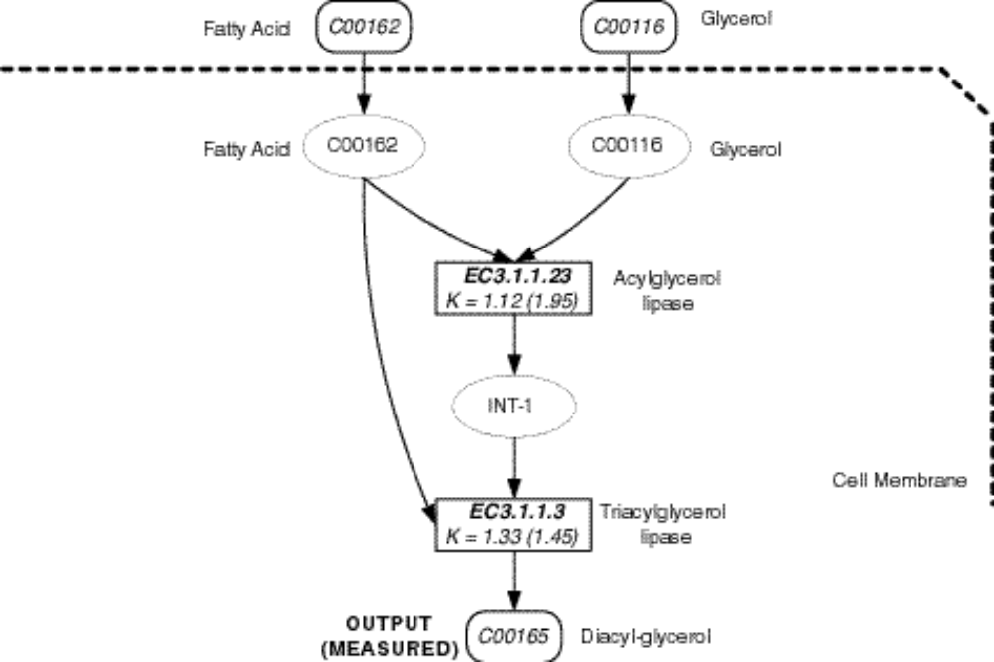

Results Phospholipid Cycle

Best of generation 25
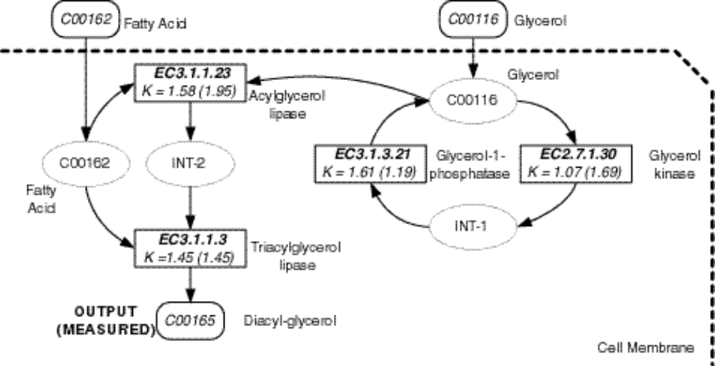

Results Phospholipid Cycle

Best of generation 120
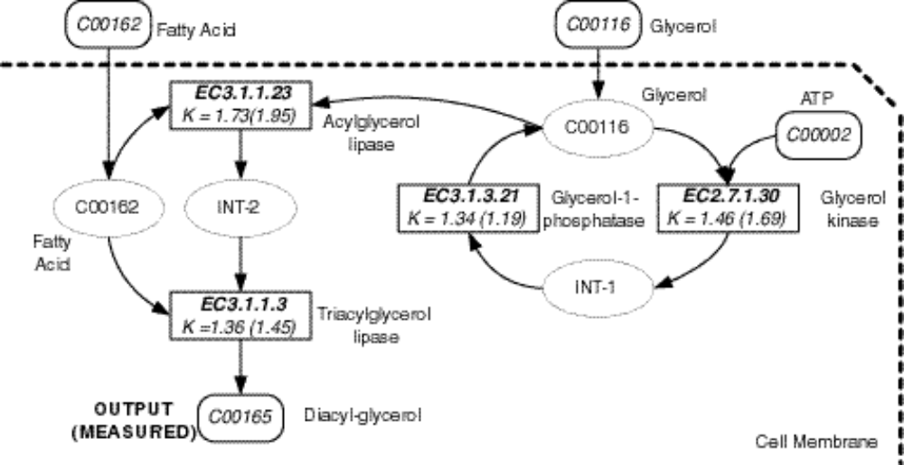

Results Phospholipid Cycle

• The best-of-run individual has fitness of almost zero (0.054). This individual scores 270 hits (out of 270).
• Correct topology
• The rate constants of three of the four reactions of this network match the correct rates (to three significant digits).

Network of chemical reactions for the best-of-run individual from generation 225
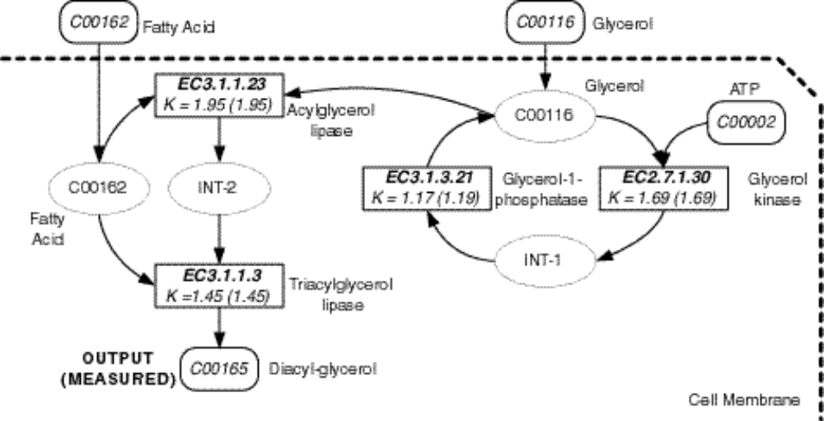

Results Phospholipid Cycle

Electrical circuit for the best-of-run individual from generation 225
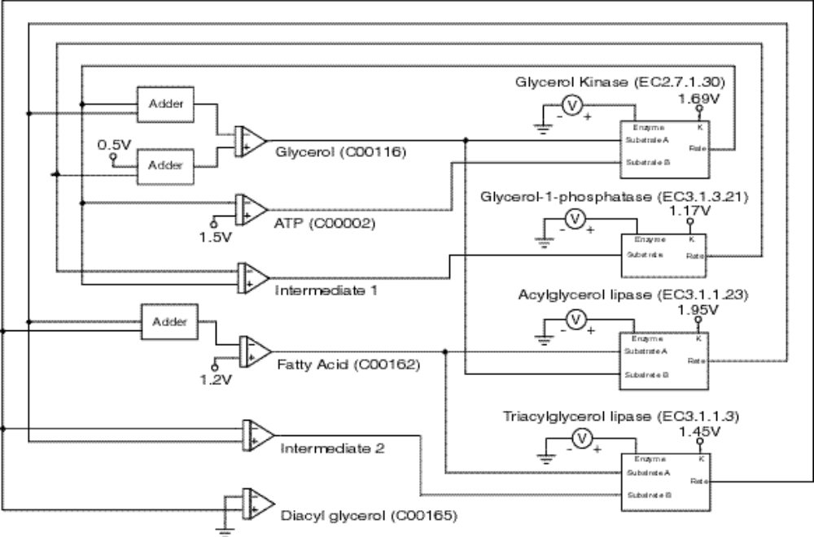

Results Phospholipid Cycle

• Rate of production of the network's final product, diacyl-glycerol (C00165)
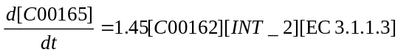.
• Rate of production and consumption of the intermediate substance INT_2
.
• Rate of production and consumption of the intermediate substance INT_1 in the internal feedback loop
.
• Rate of supply and consumption of ATP (C00002)
• Rrate of supply and consumption of fatty acid (C00162) in the best-of-run network
.
• Rate of supply, consumption, and production of glycerol (C00116) in the best-of-run network
• Internal feedback loop in which C00116 is both consumed and produced
Results Phospholipid Cycle

In summary, driven only by the time-domain concentration values of the final product C00165 (diacyl-glycerol), genetic programming created both the topology and sizing for an entire metabolic pathway whose time-domain behavior closely matches that of naturally occurring pathway, including
• the total number of reactions in the network,
• the number of substrate(s) consumed by each reaction,
• the number of product(s) produced by each reaction,
• an indication of which enzyme (if any) acts as a catalyst for each reaction,
• the pathways supplying the substrate(s) (either from external sources or other reactions in the network) to each reaction,
• the pathways dispersing each reaction's product(s) (either to other reactions or external outputs),
• the number of intermediate substances in the network,
• emergent topological features such as
• internal feedback loops,
• bifurcation points,
• accumulation points, and
• numerical rates (sizing) for all reactions.
• Genetic programming did this using only the 270 time-domain concentration values of the final product C00165 (diacyl-glycerol,).
Results ⎯ Synthesis and Degradation of Ketone Bodies

One individual from generation 0 with several noteworthy topological features
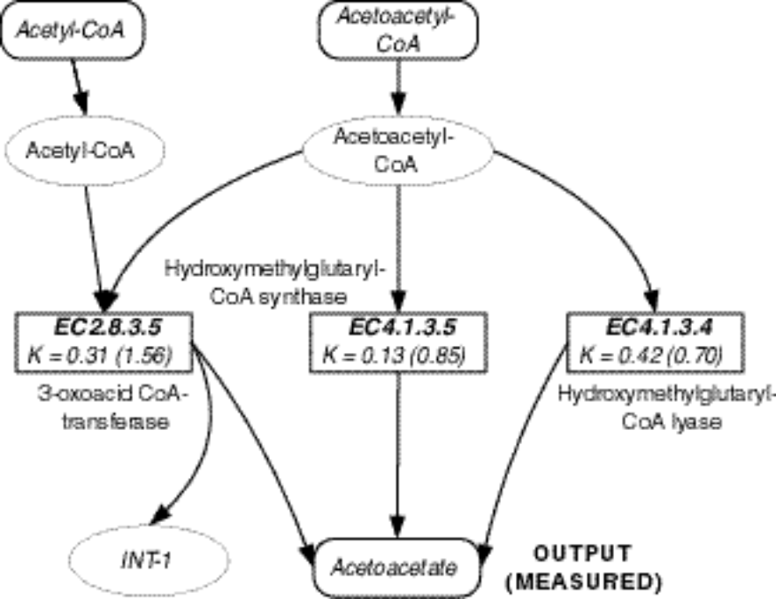

Results ⎯ Synthesis and Degradation of Ketone Bodies

Best network of generation 0
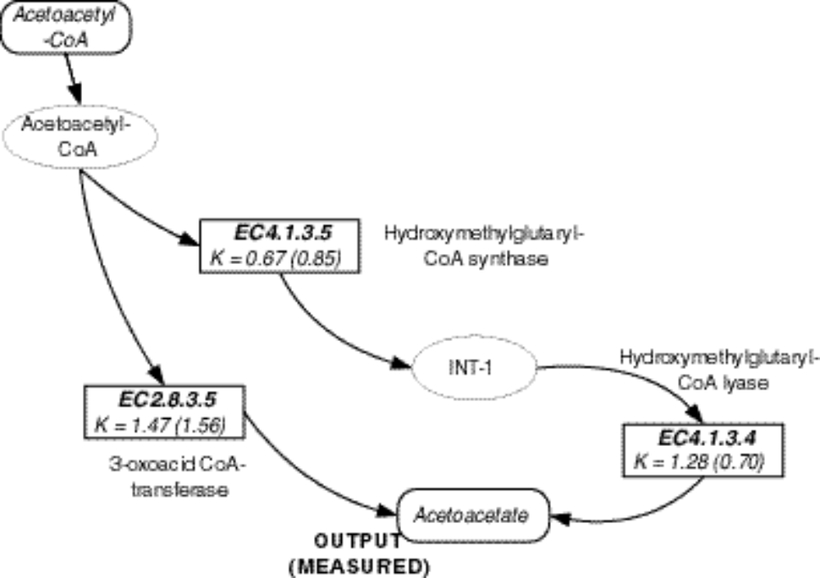

Results ⎯ Synthesis and Degradation of Ketone Bodies

Best network of generation 5
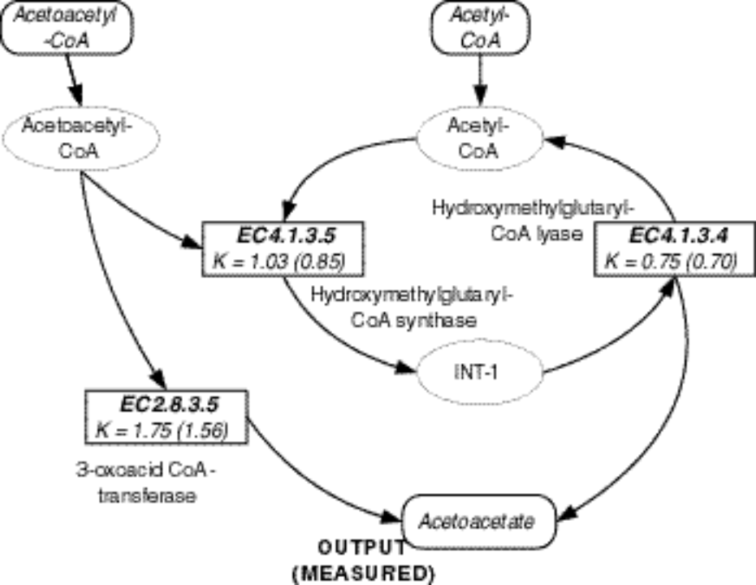

Results ⎯ Synthesis and Degradation of Ketone Bodies

Best-of-run network of generation 97
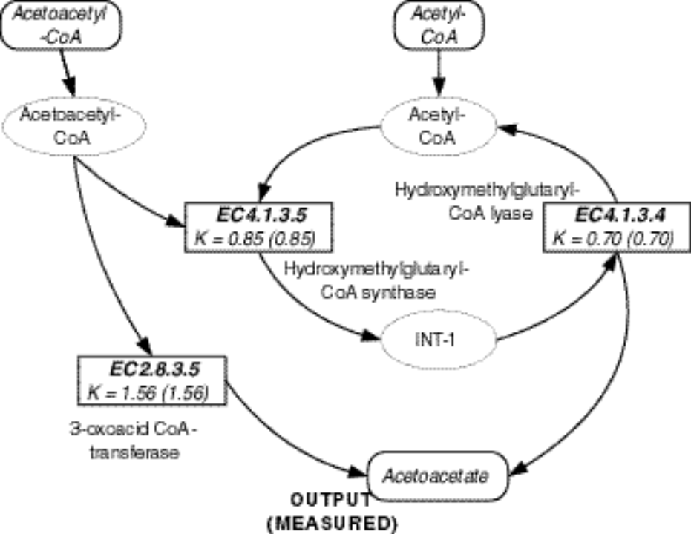

Future Work

• Improved Program Tree Representation
• Multiplication and Division Functions
• Null Enzyme
• Minimum Amount of Data Needed
• Opportunities to Use Knowledge
• Designing Alternative Metabolisms

