A RARE F-2 TORNADO EVENT IN BEAR, IDAHO

Melissa M. Hurlbut
WFO Jacksonville, Florida (former affiliation WFO Boise, Idaho)
November 2006

ABSTRACT

A variety of real time and model data were studied to properly assess the evolution of a significant microburst and tornado event in the Boise County Warning Forecast Area (CWFA). A squall line that formed along a cold front produced damaging winds and severe hail across Baker County, Oregon. As the southern end of this squall line continued to evolve, a strong F2 tornado was spawned over Adams County, Idaho, which damaged structures, destroyed 5,000 acres of a national forest, and caused one injury. Data limitations in the West, including terrain induced beam blockage, significant radar spacing and limited real time surface data, make severe weather decision making particularly challenging. Climatological records show that tornadic events in the Intermountain West are rare. Therefore, with limited data available for storm interrogation and the rarity of tornadic events in the Intermountain West, proper pre-storm environmental analysis and utilization of available data sets throughout the event are especially crucial. This paper documents the pre-storm environment and the evolution of a tornadic cell through Bear, Idaho.

- Introduction

On 4 June 2006, a quickly developing squall line swept across central Oregon and Idaho, which caused one injury and extensive damage to structures and a national forest. The southern portion of the line produced significant microburst damage across Baker and Adams counties, quarter sized hail in Cuprum, Idaho, and a strong F2 tornado in Bear, Idaho.

Aerial surveys of the tornado damage conducted by the Payette National Forest Service revealed that up to 5,000 acres of timber were blown down, snapped in half, or uprooted. The path was 21 kilometers (13 miles) long with a 0.8 kilometer (half mile) width in some locations (figure 1). Houses in Bear, Idaho, where the tornado first touched down, suffered substantial roof damage. The extensive damage, and the length and width of the path, indicated that this tornado was at least F2 intensity (Fujita, 1981) and could have reached weak F3 strength in some locations. Climate records show this tornado was the strongest known tornado in Idaho since 1940 (NCDC 2006).

Forecasting tornadic events in Western locations can be particularly challenging. Data available to a warning forecaster is lacking due to several factors. Lower elevation angles from the WSR-88D radar are often blocked by terrain. This is especially problematic at larger distances where storm structure cannot be viewed below three kilometers (approximately 10,000 ft) above ground level (AGL). Radar data from neighboring offices are often limited due to the distance between radars. Over complex terrain, surface observation sensors are placed far apart as well. Furthermore, in sparsely populated areas, fewer “ground truth” reports from storm spotters are available (Fujita 1989 et al).

Climate records indicate an average of three tornadoes are reported per year in Idaho, most of which are below F2 strength. Many of these reports come from the populated Snake River Valley. While tornadoes likely occur over the higher terrain, many of these events are not seen or reported due to sparse populations.

Records from 1880-2000 (www.tornadoproject.com) indicate that no tornadoes in Idaho history have reached F4 or greater strength. In addition, only two F3 tornadoes and nine F2 tornadoes have been recorded. National Climactic Data Center (NCDC) records from 1950 through the end of April 2006 indicate nine tornadoes in Idaho have reached F2 strength. NCDC records show an increase in reports over the past 50 years. This is likely due to an increase in population rather than strictly an increase in the occurrence of these events. In addition, developments in technology, such as the introduction of the WSR-88D, have also led to an increase in detection of severe events (Fujita 1989 et al).

Most Idaho tornado events occur in the late spring and summer during the late afternoon when surface instability is usually at its highest. Since damaging winds are the most common severe storm threat in the West, it is also possible that many of the tornadoes are “gustnadoes”; short-lived, shallow vortices that develop along a gust front as it coincides with a strong updraft (Wakimoto, R., and J.W. Wilson, 1989).

Given that tornadic events in the West are rare, a warning meteorologist must carefully examine and understand the environment prior to event onset and monitor environmental changes over time. Potential impacts of terrain (figure 2) on the near storm environment are also vital to know. These impacts may enhance or decrease tornado potential.

2. Synoptic and Mesoscale Environment

On the morning of 4 June 2006, a negatively-tilted short wave trough moved across central Washington and Oregon (figure 3). A vorticity maximum advected over central Oregon, with convection already developing ahead of this maximum as early as 1200 UTC (all times in UTC). A jet streak quickly moved northeast across Oregon, which placed Baker County and the West Central mountains in the favorable left exit region (figure 4). A northwest to southeast oriented 850 mb thermal ridge stretched across the Snake River valley ahead of the cold front.

AMSU Satellite data showed that precipitable water (PW) values were over an inch off the coast, while the 1200 sounding at Boise showed 0.88 inches (22.352 mm), which was 160% of normal. Strong southwesterly flow ahead of the short wave trough enabled the transfer of mid-level moisture over the higher terrain.

Surface dew points indicated low-level moisture was ample for convection, with most locations reporting mid 40s to lower 50s throughout the morning (figure 5). Dew points in the area of interest were mainly in the lower 50s. The unmodified 1200 sounding at Boise suggested 711 J/kg of CAPE and a lifted index of -3 could be achieved at the time of maximum surface heating. However, 1800 model data suggested that over 1,500 J/kg of CAPE could be realized in association with the upper trough.

The modified sounding at KBOI (figure 6) showed that the environment was already favorable for hail formation with mid-level shear and sufficient CAPE in the hail growth zone. Ample CAPE throughout the entire layer existed. Additionally, daytime heating in combination with the rapid cooling aloft associated with the passing upper trough would create very steep lapse rates later in the day, which would further increase the threat of large hail and strong downburst winds.

A strong veering wind profile with 0-6 km bulk shear values of 60-70 kt was also suggested in model data. The hodograph from 0-6 km showed a turning of the shear vector that would favor right moving supercells. Further analysis of the hodograph showed that any increase in southeasterly to southwesterly wind speeds, or backing of the low-level winds, would more than double the helicities (figure 7).

Previous studies in the northwestern United States (Evenson and Johns, 1995) have shown that a 500 mb negatively tilted trough and a northwest to southeast oriented 850 mb thermal ridge are favorable conditions for a significant severe weather event. On this day, the best moisture associated with the incoming short wave would be placed across the northern halves of Oregon and Idaho.

3. Storm Evolution

As the cold front progressed across central Washington and Oregon, a squall line formed along the boundary. By approximately 1605 this line began to move into Baker County (figure 8). Radar limitations at this distance and over complex terrain affected storm interrogation. The southern end of the squall line was located 115 nm from the radar and the lowest slice, 0.5º, was sampling at four kilometers (approximately 13,000 ft) above ground level (AGL). Therefore, the evolution of the lowest portions of the storm below this elevation could not be detected by radar.

Velocity data at the 0.5 degree elevation angle showed indications of weak mid-level rotation, while storm structure shown on reflectivity data may have been unrepresentative of the severity (figure 9). Reflectivity cores were below 50 dBZ at the freezing level and above. Dew points at this time were still in the lower 50s which would favor severe weather due to instability. The strongest reflectivities of the storm were located in the valley near Sumpter, Oregon. At 1630, two separate calls from trained spotters in this location revealed that the line was producing estimated winds of 60 mph and 0.75 inch hail.

By 1650 a rear-inflow notch (RIN) and bow echo first became apparent, supporting spotter reports of severe winds (figure 10). Mesonet and METAR data showed local temperatures in the mid to upper 60s with dew points in the lower 50s. Surface winds were still from a southeasterly to southerly direction, which supported increased helicities. Velocity data revealed a tightening couplet in the mid levels of the storm.

By 1717, reflectivity data began to show the first indication of large hail with 60 to 65 dBZ cores at 4.7 km (15,300 ft) above sea level (ASL), and 55 to 60 dBZ cores 6.9 km (22,500 ft) ASL (figure 11). Outbound velocities at the 0.5 degree level had increased to nearly 30 kt while storm top divergence had increased to 70 kt.

By 1734, this storm core continued to grow and suggested increased severity. 60 to 65 dBZ cores (figure 12) were observed at 7.3 km (24,000 ft). At this point the storm began to deviate to the right. The 50 dBZ core extended to nearly 9.1 km (30,000 ft).

Five minutes later, outbound velocities at the 0.5 degree level increased to nearly 40 kt and expanded in area (figure 13). Storm top divergence increased to 80 kt. The storm maintained this magnitude of storm top divergence over the next hour. A damaging downburst was soon reported by a spotter located 6.2 km (10 miles) north of Halfway, Oregon.

By 1805, outbound velocities at the 0.5 degree level again increased, with speeds near 50 kt. The storm began to show an increase in rotational velocities while strong outbound velocities had been maintained (figure 14). The Velocity Azimuth Display (VAD) wind profile at KBOI showed that winds had increased from a south to southwest direction (figure 15). Mesonet data from a valley to the east indicated surface winds from the southeast, which would create a veering profile ahead of the storm. Adjusting the hodograph with these winds more than doubled the SRH to 250 m²/s², which led to increased tornado potential. The storm approached Hells Canyon, where it could encounter channeling moisture (Monteverdi, Doswell, and Lipari, 2003). Temperatures in this area were in the upper 50s with dew points in the lower 50s. At this time, a Remote Automated Wind Sensor (RAWS) station at Flagstaff Hill reported a wind gust to 80 mph.

As the storm moved over the canyon around 1809 to 1814, the detected rotation appeared to weaken. However, outbound velocities remained strong (figure 16), and for the first time in the storm's existence, 50 to 55 dBZ cores extended up to 10.4 km (34,000 ft) (figure 17). From here the storm progressed quickly. At 1827, the storm displayed a clear RIN and rotational velocities jumped up to 40 kt (figure 18). Within the next few minutes, rotational velocities increased to 45 kt. Eyewitness reports indicated the tornado touchdown time was near 1830. Quarter sized hail was also reported from Cuprum, Idaho. Ten minutes after touchdown, the storm finally began to weaken.

4. Summary and Conclusions

In the Bear tornado case, environmental analysis showed that conditions were favorable for damaging winds, large hail, and tornado formation. Utilizing all datasets, a forecaster could continue to evaluate how this near-storm environment progressed.

In this case, Mesonet data showed that dew points remained high while temperatures were increasing. VAD wind profile data showed an increase in south to southwest winds and, an increase in southeasterly winds at the surface ahead of the storm would increase the SRH.

Widespread cloud cover inhibited satellite utility. Although radar data were unavailable beneath three kilometers (approx. 10,000 ft), there were indications of the storm’s increasing severity. Persistent rotation in SRM and base velocity data and continual ground truth reports of severe weather indicated that the storm was maintaining strength. The storm was relatively unimpeded by rough terrain as it traversed across a valley. An increase in storm inflow and a rapid increase in reflectivity values as the storm passed over Hell’s Canyon were noted shortly before the cell became tornadic.

Examining these important near-storm environmental clues where data sources are limited is vital in severe weather episodes. By utilizing all datasets and keeping a constant state of awareness of how the environment is evolving, a forecaster can use the information available to make better warning decisions.

5. Acknowledgements

The author would like to thank Peter Wolf for his constructive criticism and valuable insights into this case. The author would also like to thank Angela Enyedi, Jay Breidenbach, George Skari, and Charles Redman for their helpful insights as well. Additional thanks goes to Timothy Barker for archiving and providing data for this case.

6. References

Evenson, E.C., and Johns, R.H., 1995: Some Climatological and Synoptic Aspects of Severe Weather Development in the Northwestern United States. National Weather Digest, 20, 1, 34-50.

Fujita, T.T., 1981: Tornadoes and downbursts in the context of generalized planetary scales. J. Atmos. Sci., 38, 1511-1634.

Fujita, T.T., 1989: The Teton-Yellowstone Tornado of 21 July 1987. Monthly Weather Review, 117, 1913-1940.

Monteverdi, J.P., Doswell, C.A., Lipari, G.S., 2003: Shear Parameter Thresholds for Forecasting Tornadic Thunderstorms in Northern and Central California. Monthly Weather Review, 18, 357-370.

NCDC, 2006: Storm data. http://www4.ncdc.noaa.gov/cgi-win/wwcgi.dll?wwevent~storms.

Tornado Project: http://www.tornadoproject.com/, tornadoes by state: Idaho.

Wakimoto, R., and J.W. Wilson, 1989: Nonsupercell tornadoes. Mon. Wea. Rev., 117, 113-1140.

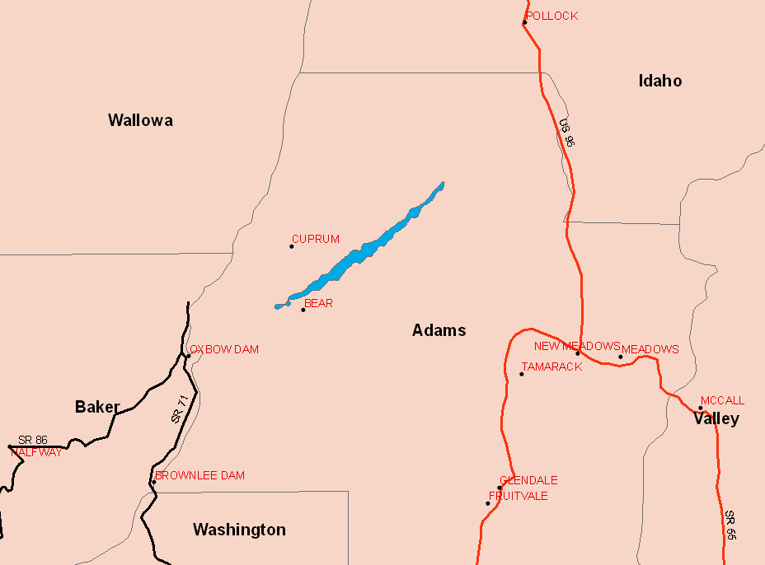
Figure 1: The blue outlines the tornado path through Adams County.

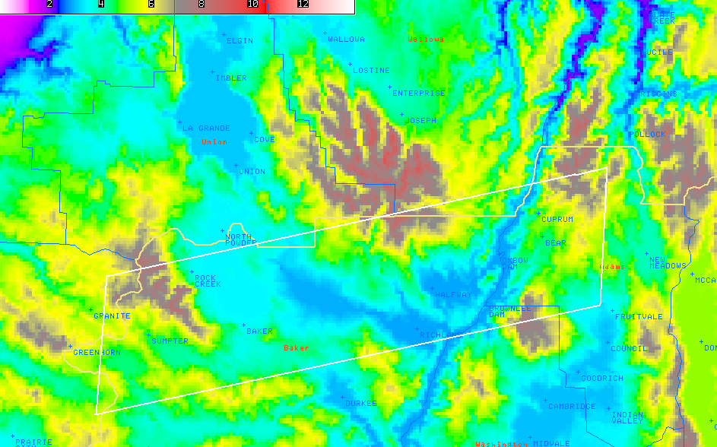
Figure 2: High resolution topography image. The area of interest is outlined by a white polygon, which includes Baker and Adams Counties (labeled in red).

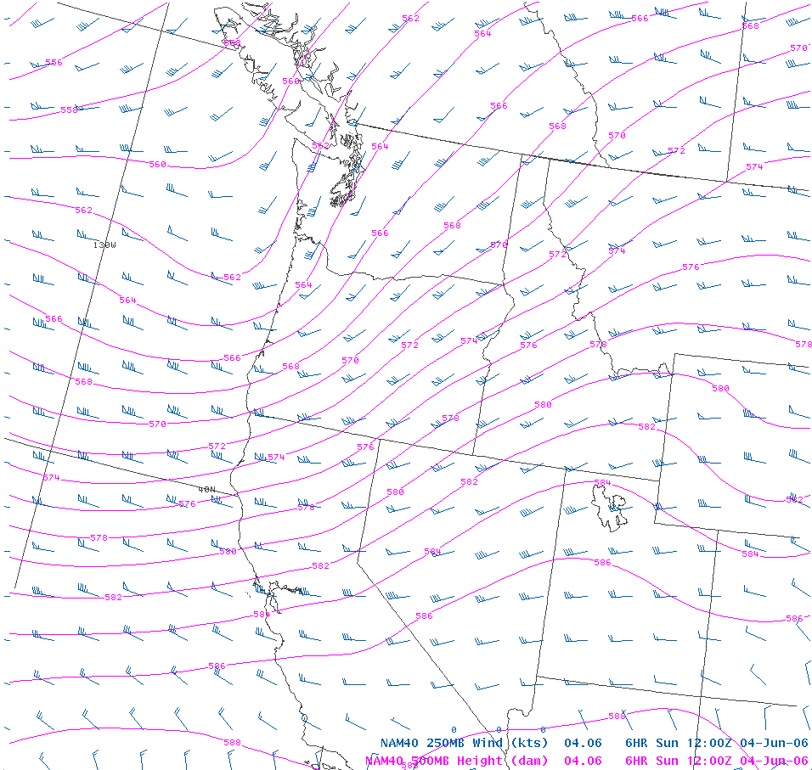

Figure 3: Map of the northwest displaying 500 mb heights, shown in pink, and 250 mb winds at 1200 UTC, shown in blue.

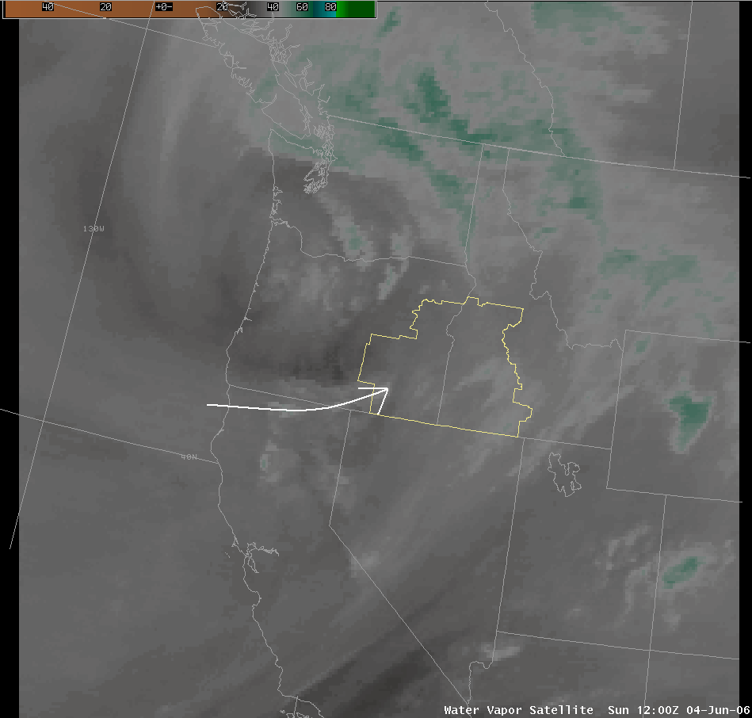
Figure 4: 1200 UTC water vapor image of jet streak moving across southern Oregon, shown by the white arrow. The area outlined in yellow is the Boise County Warning Area.

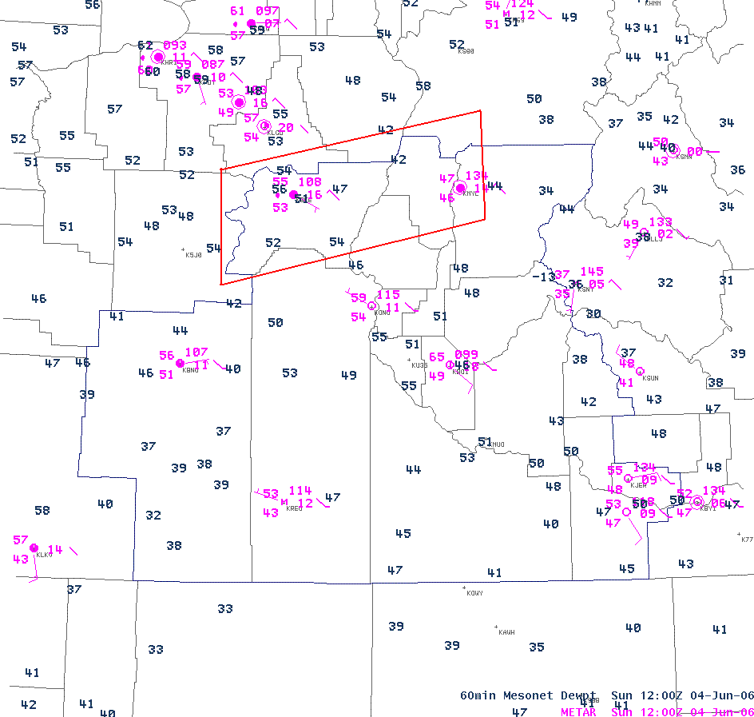
Figure 5: 1200 UTC ASOS plot, shown in pink, and Mesonet dew point temperatures, shown in blue. The area of interest is outlined in red.
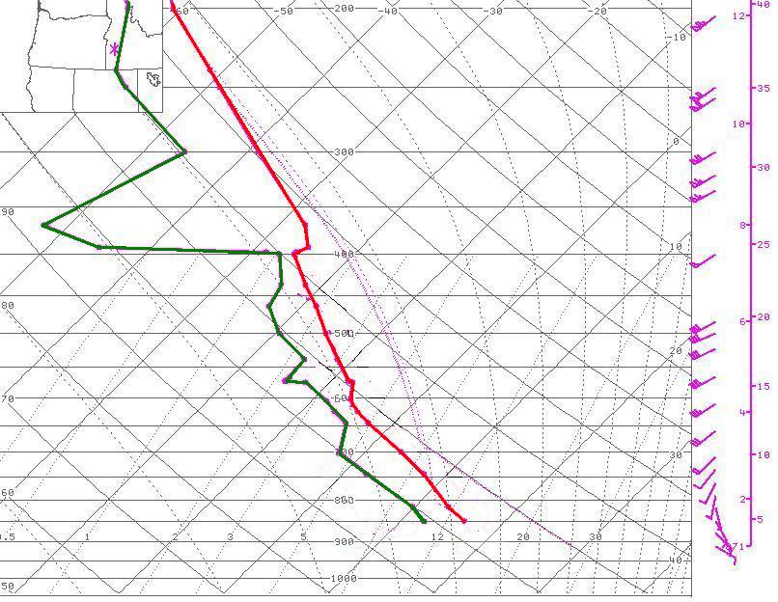
Figure 6: Modified 1200 UTC sounding at KBOI.

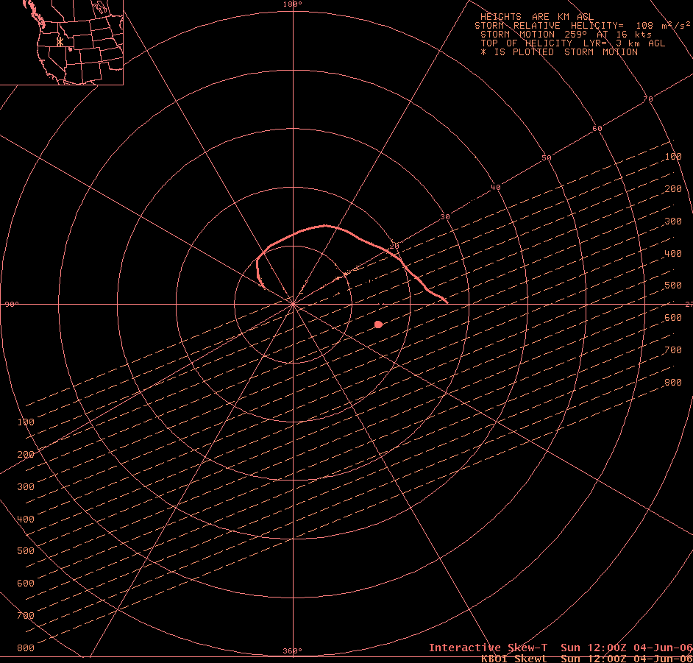
Figure 7: 1200 UTC Hodograph at KBOI modified with VAD winds at 1815 UTC.
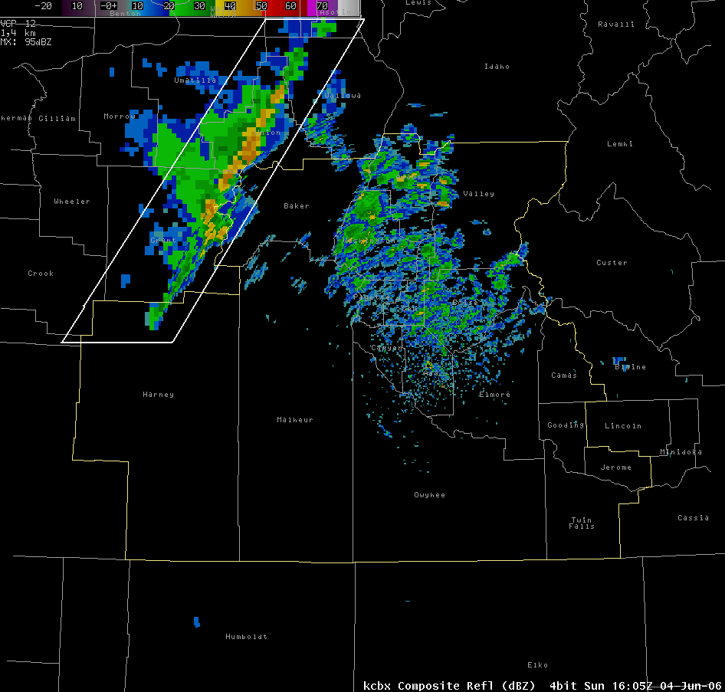
Figure 8: kcbx Composite Reflectivity of the squall line moving into Baker County at 1605 UTC, which is outlined by the white polygon.
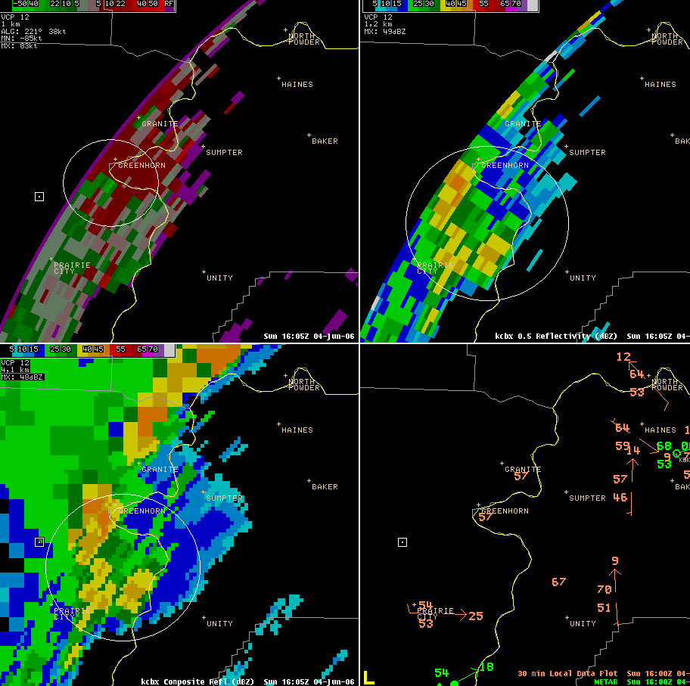
Figure 9: 1605 UTC showing kcbx 0.5 degree SRM, 0.5 degree reflectivity, Mesonet dew point data (shown in orange), and composite reflectivity. The area of interest is outlined in white.
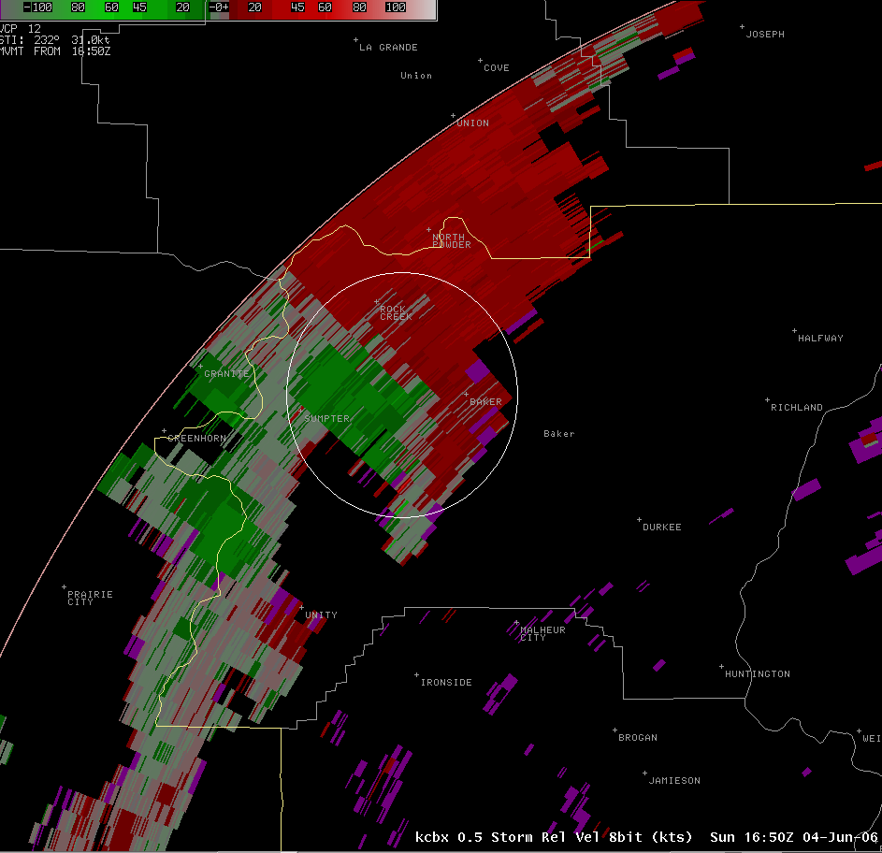
Figure 10: kcbx 0.5 degree SRM image at 1650 UTC showing the RIN and a tightening rotation.
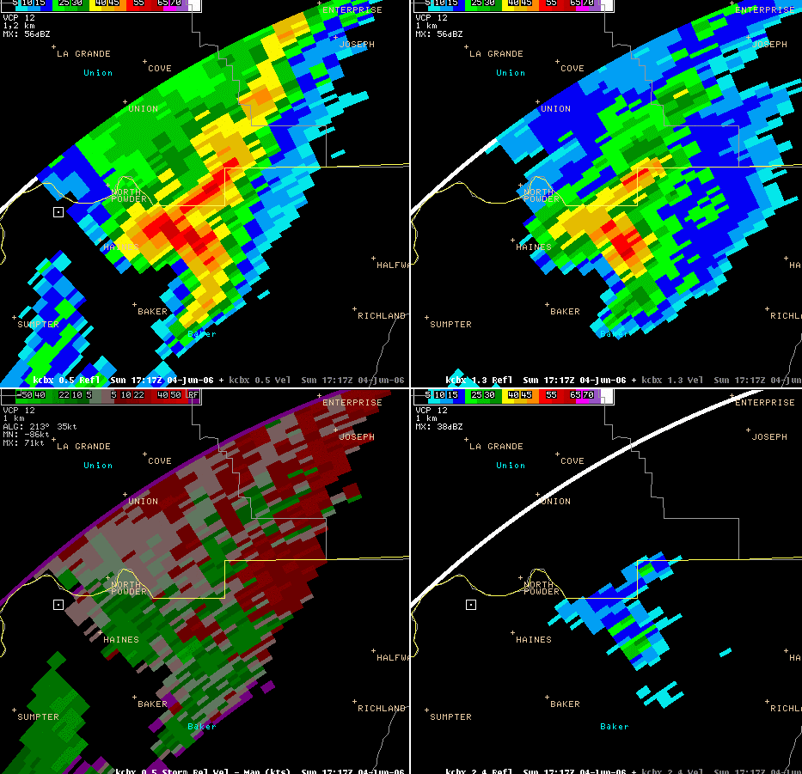
Figure 11: 1717 UTC displaying the RIN and increase in reflectivities. Shown are the kcbx 0.5, 1.3, and 2.4 degree reflectivities, and the 0.5 degree SRM.
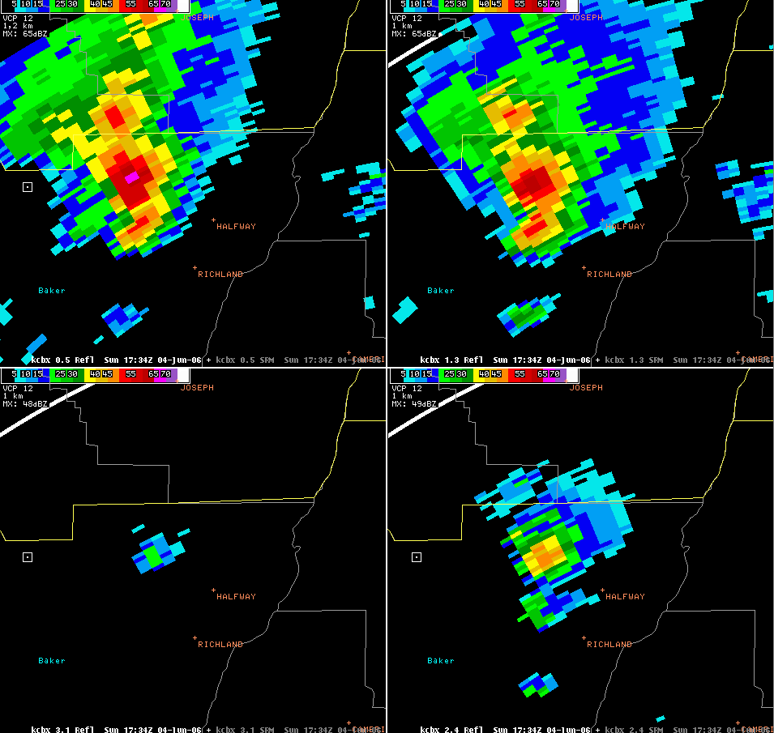
Figure 12: 1734 UTC kcbx 0.5, 1.3, 2.4, and 3.1 degree slices, displaying an increase in reflectivities.

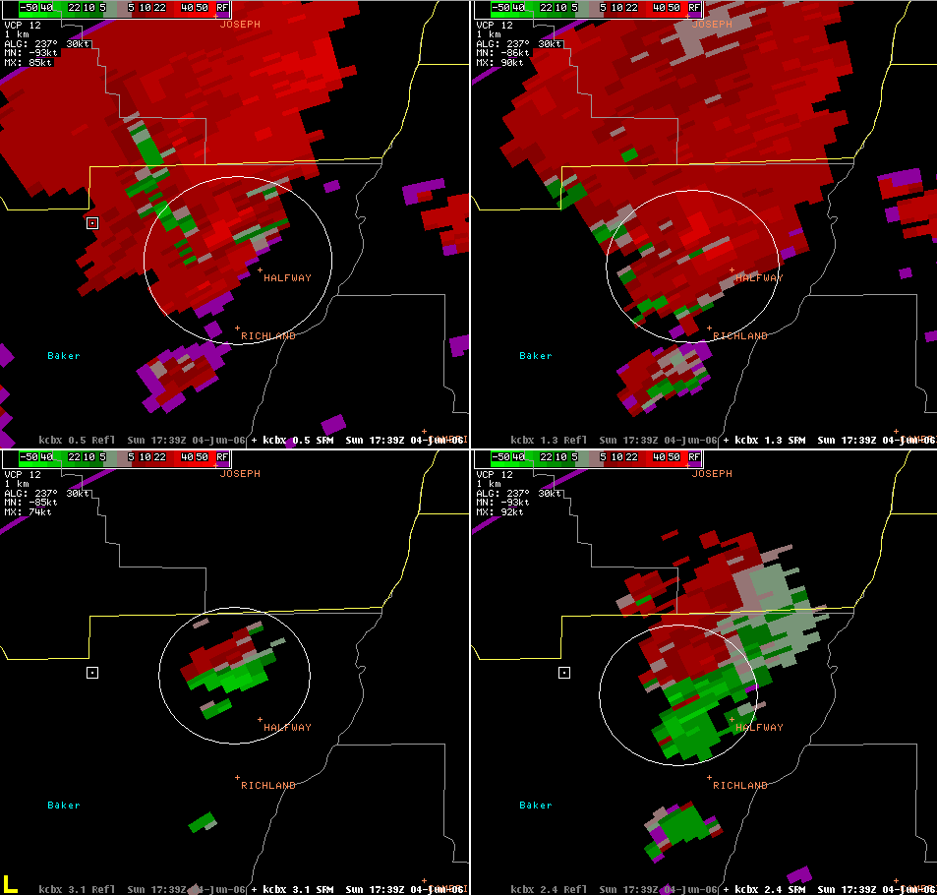
Figure 13: 1739 UTC kcbx 0.5, 1.3, 2.4, and 3.1 degree SRM showing a large area of strong outbound velocities and increased storm top divergence, which are outlined in a white circle.

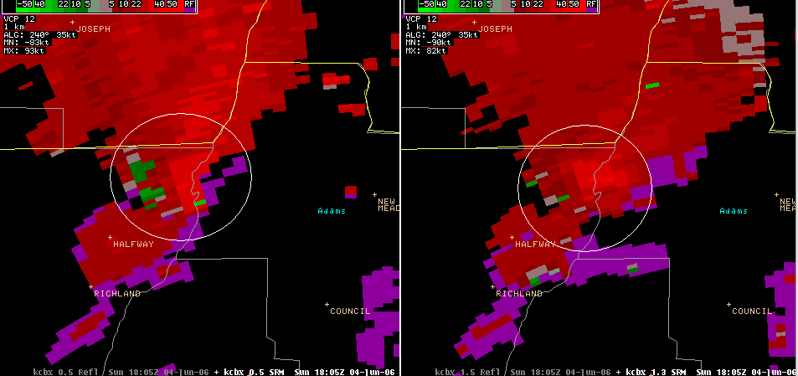
Figure 14: 1805 UTC kcbx 0.5 and 1.5 degree SRM showing increase in rotational velocities, which is outlined in white.

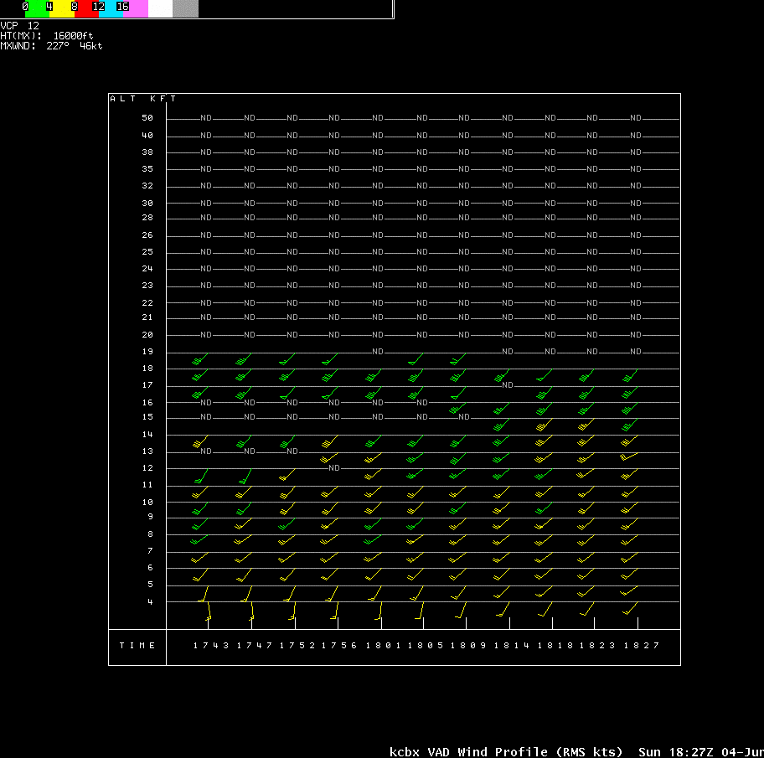
Figure 15: kcbx VAD Wind profile from 1743 UTC through 1827 UTC showing an increase in south to southwest winds.

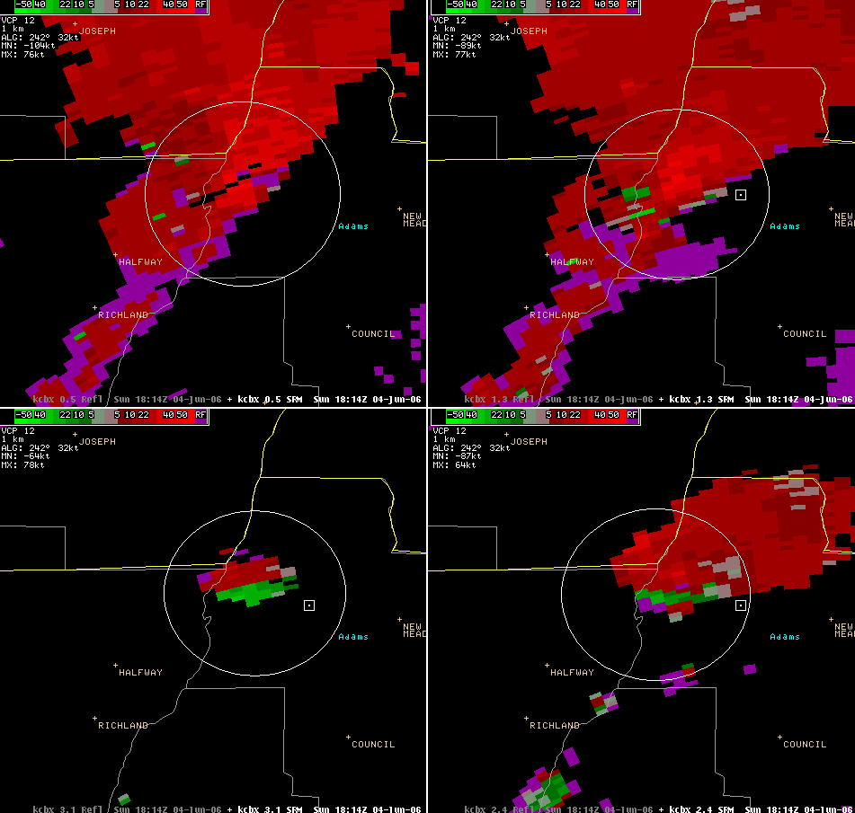
Figure 16: 1814 UTC kcbx 0.5, 1.3, 2.4, and 3.1 degree SRM showing increased outbound velocities and storm top divergence, which are outlined in white.

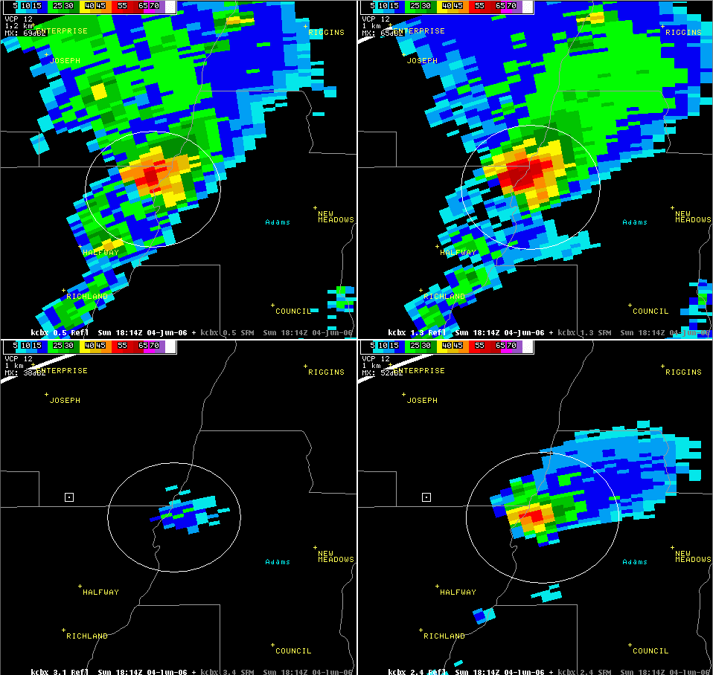
Figure 17: 1827 UTC kcbx display of 50 to 55 dBZ cores extending up to 10.4 km.
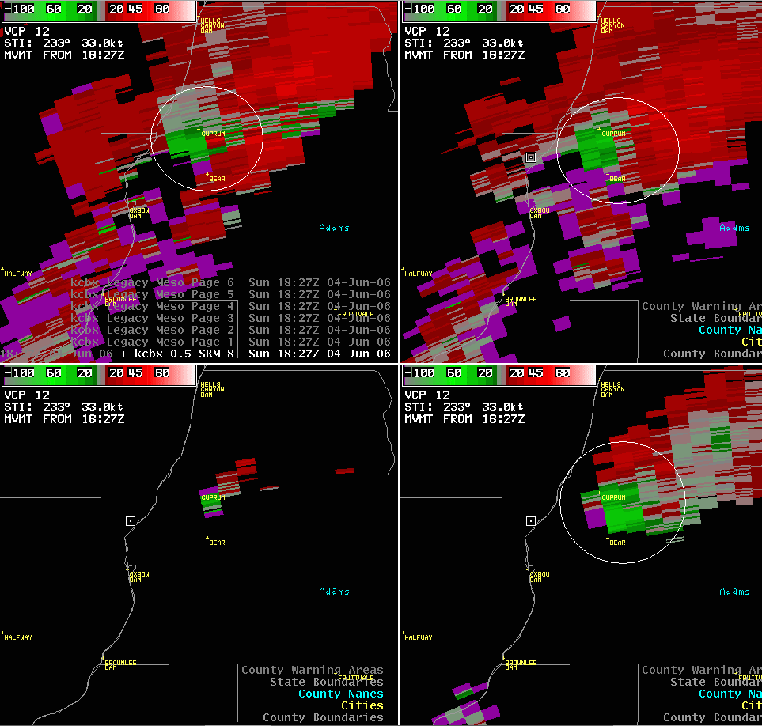
Figure 18: 1827 UTC kcbx 0.5, 1.3, 2.4, and 3.1 degree SRM showing a rapid increase in rotational velocity and storm top divergence

