DRAFT Supplemental Environmental Assessment: FEMA-1203-DR-CA
Federal Emergency Management Agency, Region IX

Project Name: Laguna Creek Pipeline Access Road Repair Project
Subgrantee: City of Santa Cruz
DSR or HMGP Number(s): DSR #02174
Date: August 6, 2002
Project Location: Smith Grade Road within the Upper Laguna Creek watershed in the County of Santa Cruz, California.

1.0 Introduction

The City of Santa Cruz (the City), through the California Office of Emergency Services (OES), has applied to the Federal Emergency Management Agency (FEMA) Public Assistance (PA) Program for funding to repair an access road that was damaged in three sections during the winter storms of 1998. The project site is located within the upper Laguna Creek watershed on an existing dirt roadway adjacent to Laguna Creek. The road is used to access and maintain a 14-inch diameter water supply pipeline, which is located beneath the road right-of-way. The pipeline is part of the “North Coast” water supply component of the City’s water supply, which provides nearly 25 percent of the raw water supply for the City of Santa Cruz. The storm event caused two sections of the dirt roadway to fail and a third with the potential to fail. Consequently, the road can no longer accommodate vehicular traffic, including maintenance vehicles, and the supply line has been exposed and is vulnerable to failure. The roadway is approximately 8 to 10 feet in width and is elevated approximately 20 to 50 feet above the Laguna Creek streambed. The project site is within the Laguna Creek drainage, a fairly steep-sided drainage, which flows south to the Pacific Ocean.

Components of the Proposed Action include the following: repair of the damaged sections of the access road, temporary shoring of two wooden bridges to provide safe passage for construction equipment, and the installation of drainage improvements to prevent future damage to the access road. The Proposed Action area is located on an easement within a privately owned parcel in the western portion of Santa Cruz County (Figure 1 and Figure 2).

1.1 Scope of Document
This Supplemental Environmental Assessment (SEA) tiers from the Final Programmatic Environmental Assessment for Typical Recurring Actions Resulting from Flood Disasters in California as Proposed by FEMA (PEA) (FEMA 1998b) and hereby incorporates the PEA by reference, in accordance with 40 CFR Part 1508.28.

1.2 Purpose of and Need for Action
The purpose of and need for the action is described in Section 1.4 of the PEA. As discussed previously, the Laguna pipeline access road failed in two sections during the storm event in 1998, making the roadway unusable for vehicular traffic, including maintenance vehicles, and making a third section of roadway and the water supply line vulnerable to failure. Therefore, the City of Santa Cruz has determined that action is needed to repair the roadway to protect public health and safety and address the risk of future flood damage, as the steep and unprotected slopes are vulnerable to continued erosion and failure.
________________________________________________________________________

2.0 ALTERNATIVE ANALYSIS
As discussed in Section 2.5.2.1 of the PEA, under the No Action Alternative, the repairs to the failed bank slopes would not be conducted along the dirt roadway adjacent to Laguna Creek. The banks in this part of the creek would continue to be vulnerable to continued failure and erosion.
The Proposed Action Alternative is described in Section 2.5.2.3 of the PEA. The Proposed Action Alternative would involve roadway repair in three locations along the Laguna Creek pipeline roadway. Details of project repairs are described below:

The Proposed Action Alternative consists of four components: (1) construct three (two downhill and one uphill) soldier pile retaining walls; (2) repair the two sections of roadway that have already failed; (3) install temporary shoring of two bridges along the access road in order to bring equipment to the repair sites; and (4) provide overall drainage improvements at all three damaged locations. The three repair sites are referred to as Sites C, B, and A, with Site C at the northern portion of the project area and Site A at the southern end. Because Site A would be inaccessible until repairs are made at Sites B and C, the repairs for Site A would be conducted last.

Site C
Site C has experienced some erosion to the downhill side of the road, and is at risk of further failure due to lack of drainage and subsequent ponding on the uphill edge. The proposed repair at this location includes construction of a rock-lined V-ditch along the uphill side of the road along with some minor grading of the road to ensure proper drainage. The V-ditch at this location would extend from Site C southward to approximately 80 feet past Site B. The total length of the V-ditch to be constructed for both Sites B and C is approximately 290 feet (see Figure 3).

Site B
Repairs proposed for Site B include the following: (1) construction of two soldier pile retaining walls (one on the uphill side and one on the downhill side of the roadway); (2) installation of a rock-lined V-ditch on the uphill side of the road (described above under Site C); (3) installation of a slope drain (approximately 40 feet long and 18-inches in diameter) beneath and perpendicular to the roadway (downslope); (4) installation of a gabion mattress energy dissipater at the toe of the slope to prevent scour from the new slope drain discharge; (5) installation of a new inlet and discharge structure at the southern end of the V-ditch; and (6) backfilling of the road to provide a drivable, unpaved surface (see Figure 3).

The downhill soldier pile wall is approximately 60 linear feet and the uphill wall is approximately 50 linear feet. The downhill wall consists of nine concrete piers/soldier piles. Wood lagging would be installed between the soldier piles from the existing road surface, and the roadway would be backfilled with engineered fill to approximately 6 inches below the top of the wall. The uphill wall consists of seven concrete piers/soldier piles. Wood lagging would be installed between the piles and the final wall would be approximately 10 feet above the road surface. The new slope drain, which would capture runoff from the V-ditch described above, would be installed beneath the roadway at Site B, and would discharge to a new gabion mattress energy dissipater installed approximately 35 feet downslope of Site B. The new inlet and discharge structure at the southern end of Site B would also capture runoff from the V-ditch, and would discharge downslope to a second, new energy dissipator. Both energy dissipaters would be located outside of the 100-year floodplain elevation, and would not require work within Laguna Creek. Once the retaining walls and drainage structures are in place, the roadway would be backfilled using clean imported fill to provide an unpaved, drivable surface. Laguna Creek is approximately 50 feet below the roadway at Site B.

Site A
Repairs at Site A would consist of a similar soldier pile retaining wall as used for Site B. Eight soldier piles/concrete piers with wood lagging would be constructed on the downhill side of the road for a distance of approximately 50 linear feet. Approximately 120 feet of rock-lined V-ditch would be also be constructed at Site A, along the uphill side of the roadway. Water from this collection system would discharge through an existing culvert onto a new energy dissipator. The energy dissipator at Site A would be located outside of the 100-year floodplain, and would not require work within Laguna Creek. Laguna Creek is approximately 25 feet below the roadway at Site A (see Figure 4).

Temporary Bridge Shoring
Currently, there are two wood bridges over Laguna Creek that provide access to the repair sites. Both of these bridges would be temporarily shored in order to provide equipment access. The first bridge is located approximately 1,100 feet south of the Smith Grade Road access gate and is a single span of approximately 25 feet supported on two steel I beams. One of the steel beam flanges is deformed (Mesiti-Miller Engineering, Inc., June 2000). The second bridge is located approximately 1,900 feet south of the Smith Grade Road gate and is supported by wooden members with 12 by 12-inch wooden piles and pile caps. The spans are approximately 12 and 26 feet. One of the bridge abutments appears to have rotated and moved, requiring replacement (Ibid.).

The bridges would require shoring near the center to reduce the span length and provide support to the center of the bridge. Shoring would include one large timber or footer slightly wider than the bridge to be placed at mid-span in the creek perpendicular to the bridge, and two or three vertical members or posts resting on this footer to support a horizontal beam directly under the bridge structure. Most of this would be delivered to the site in a small truck and placed by hand with several workers. None of the wood to be placed in Laguna Creek would be treated, and the shoring would be completely removed when the project is complete. The area of the creek that would be temporarily affected by the shoring is approximately 28 square feet. Access and staging for the project would be along the existing dirt roadway.

3.0 AFFECTED ENVIRONMENT AND ENVIRONMENTAL CONSEQUENCES

3.1 Geology, Geohazards, and Soils
The affected environment is described in Section 3.1 of the PEA. Impacts of the No Action Alternative are described in Section 4.1.1.1 of the PEA. Impacts of Proposed Action Alternative are described in Sections 4.2.1.3 of the PEA.
Two soil types are predominant within the project area. Ben Lomond sandy loam and Felton sandy loam. The Ben Lomond and Felton soils are deep and well drained, and located on 30 to 50 percent slopes. These soils support timber growth, and provide recreation, wildlife habitat, and watershed benefits. These soils present a high erosion hazard due to the occurrence of rapid runoff (USDA 1980).
Under the No Action Alternative, roadway bank repairs along Laguna Creek would not be performed. If the roadway banks are not repaired, future failure to the roadway and pipeline may be exacerbated and could result in soil erosion and aggravated bank instability along this area of Laguna Creek.
The Proposed Action Alternative is not anticipated to have any adverse impacts to geology or geohazards, however, these activities have the potential to cause the disruption and displacement of soils. To minimize erosion impacts associated with the Proposed Action Alternative, the project applicant would develop and implement erosion control measures during and after construction to prevent inadvertent erosion and offsite transport of sediment into Laguna Creek. The initial study prepared by Strelow Consulting in 2001 proposed the following control measures including, but not limited to:
- Install well-anchored silt fences below the retaining wall construction zones at each slipout site to contain sandy soil from the construction zone before it reaches Laguna Creek;
- Limit ground disturbance and vegetation removal during construction;
- Complete work prior to the onset of the rainy season (generally November 1); and
- After construction and prior to November 1, all disturbed soils at each site should undergo erosion control treatment consisting of temporary seeding, straw mulch or other measures. Any disturbed slopes over 30% should also have an erosion control blanket installed. Permanent revegetation or tree replanting should then take place in small openings in the erosion control blanket, with suitable species that are compatible with existing native vegetation.

3.2 Air Quality
The affected environment is described in Section 3.2 of the PEA. Impacts of the Proposed Action Alternative and the No Action Alternative are described in Section 4.1.2 of the PEA. The use of construction vehicles, including backhoes, graders, and trucks, would increase air pollutants; however, their impacts would be temporary and negligible.
The project area is located within the Monterey Bay Air Pollution Control District (MBUAPCD), which has jurisdiction over the North Central Coast Air Basin (NCCAB) that includes Santa Cruz, Monterey and San Benito Counties. The NCCAB is in attainment for the federal PM₁₀ (particulate less than 10 microns in diameter) standards and state and federal nitrogen dioxide, sulfur dioxide and carbon monoxide standards. In March 1997, the air basin was redesignated from a “moderate non-attainment” area for the federal ozone standards to a “maintenance/attainment” area. The NCCAB is classified as a non-attainment area for the state ozone and PM₁₀ standards (Strelow Consulting 2001)

3.3 Hydrology and Water Quality
The affected environment is described in Section 3.3 of the PEA. Impacts of the No Action Alternative are described in Section 4.2.3.1 of the PEA. Impacts of the Proposed Action Alternative are described in Section 4.2.3.3 of the PEA.
Under the No Action Alternative, hydrology and water quality has the potential to be negatively affected by future erosion and sedimentation in Laguna Creek if no action is taken to repair the damage roadway.
Under the Proposed Action Alternative, hydrology is not anticipated to be adversely impacted as a result of project activities. Planned project erosion controls, as referenced in Section 3.1, will prevent erosion and sedimentation into Laguna Creek during and after construction. The proposed drainage improvements would improve water quality and aquatic habitat due to decreased sedimentation associated with erosion along the roadway.

3.4 Floodplain Management
The affected environment is described in Section 3.4 of the PEA. Impacts of the No Action Alternative are described in Section 4.2.4.1 of the PEA. Impacts of the Proposed Action Alternative are described in Section 4.2.4.3 of the PEA.
The project area is shown on panels 195 and 215 of the Flood Insurance Rate Map for unincorporated Santa Cruz County, dated April 15, 1986. The map does not show an identified Special Flood Hazard Area for Laguna Creek within the project area. The area is shown as Zone C, defined as an area of minimal flood risk, and is outside the 100-year floodplain. Therefore, neither the No Action Alternative or Proposed Action Alternative would have any impact on a floodplain.

Biological Resources
The affected environment is described in Section 3.5 of the PEA. Impacts of the No Action Alternative are described in Section 4.2.5.1 of the PEA. Impacts of the Proposed Action Alternative are described in Section 4.2.5.3 of the PEA.

The project site is within the Laguna Creek drainage, which is a fairly steep-sided drainage that flows south to the Pacific Ocean. At the time of the site reconnaissance survey on November 6, 2001, the active channel bed ranged from approximately 6- to 12-feet in width, and the water depths varied from approximately 4-inches to 4-feet. The substrate in Laguna Creek is dominated by boulders and large cobbles, with a few of the lower flow areas containing a higher fraction of smaller cobbles and silt. A natural sandstone ledge approximately 15-20 feet high exists approximately 500 feet downstream of the project area.

The project area is characterized as a second-growth redwood forest-alder riparian community, intermixed with a coast live oak-mixed evergreen woodland community. The coast live oak community is found primarily on the upper slopes and ridgelines above the Laguna Creek riparian corridor. Dominant plant species in the project area include redwood, red alder (Alnus rubra), big leaf maple (Acer macrophyllum), tan oak (Lithocarpus densiflora), bay laurel (Umbellularia californica), coast live oak (Quercus agrifolia), hedge nettle (Stachys bullata), Solomon’s seal (Smilacina stellata), California blackberry (Rubus ursinus), thimbleberry (Rubus parviflorus), swordfern (Polystichum munitum), giant chain fern (Woodwardia fimbriata), redwood sorrel (Oxalis oregana), and horsetail (Equisetum arvense). Vegetative cover in the project area was approximately 70 to 75 percent, with a heavy litter layer covering most of the ground surface.
The City of Santa Cruz will obtain a streambed alteration agreement prior to the commencement of work. In compliance with Executive Order 11990, Protection of Wetlands, and 44 CFR Part 9, no alternatives involve the destruction, loss, or degradation of wetlands. Therefore, no wetlands would be impacted by any alternative and the City of Santa Cruz would not be required to obtain a Section 404 Permit from the U.S. Army Corps of Engineers (USACE).

3.6 Threatened and Endangered Species
The affected environment is described in Section 3.6 of the PEA. Impacts of the No Action Alternative are described in Section 4.2.6.1 of the PEA. Impacts of the Proposed Action Alternative are described in Section 4.2.6.3 of the PEA.
Information concerning threatened, endangered, or other special status species that may occur in the project area was obtained from the U.S. Fish and Wildlife Service (USFWS) Ventura Office on December 26, 2001. Additionally, the California Department of Fish and Game’s (CDFG’s) Natural Diversity Database was searched for known occurrences of special status species within the USGS 7.5-minute quadrangles of Felton, Davenport, and Santa Cruz (CDFG 2001).
A field reconnaissance survey of the project area was conducted on November 6, 2001, to identify habitats in the study area and vicinity. Finally, a literature review was conducted to identify habitat requirement/distribution for listed species, and persons knowledgeable about the project area and species were contacted for information regarding selected species.
After the literature review, site reconnaissance, communication with experts, and consideration of the activities associated with the Proposed Action, it was determined that two species have the potential to be impacted:
- California red-legged frog (Rana aurora draytonii)
- Marbled murrelet (Brachyramphus marmoratus)

California Red-Legged Frog
The California red-legged frog is a federally listed species within the jurisdiction of the USFWS. The proposed project area is not located within designated Critical Habitat for California red-legged frog (USFWS 2001), nor is it located within a Core Recovery Area identified in the Draft Recovery Plan for the species (USFWS 2000a). A detailed description of California red-legged frog and its habitat requirements are provided below.

Within approximately 2-miles from the project area, red-legged frogs have been documented in Wilder Creek, Baldwin Creek, and various farm ponds on the lower agricultural benchlands on the north coast (Mori 1997 in John Gilchrist & Associates 2001). Red-legged frogs have also been observed on several coastal streams in the Santa Cruz area including Wilder, Liddell, and Waddell Creeks. In 1997, Entrix, Inc. conducted a red-legged frog survey for the Santa Cruz Water Department along part of Laguna Creek. This survey extended from 0.75 mile down stream and 1.25 miles upstream of the project area. No red-legged frogs were detected during the survey, and Entrix biologists indicated there was no breeding habitat in Laguna Creek due to the high flow velocities during winter months (John Gilchrist & Associates 2001). However, due to the presence of California red-legged frogs in the lower reaches of coastal streams in the vicinity of Laguna Creek, it is possible that red-legged frogs could utilize the project area as dispersal or summer foraging habitat. Therefore, FEMA has determined that the project could potentially affect red-legged frogs or their habitat.

Due to the Proposed Action’s potential to adversely affect red-legged frogs, FEMA initiated formal consultation with USFWS under the Endangered Species Act of 1973 (as amended). Potential impacts to red-legged frogs include death, injury, or displacement from construction-related activities. No permanent/post-construction impacts are expected.

On July 16, 2002, USFWS issued a Biological Opinion (BO) and Incidental Take Statement (Appendix B) in response to FEMA’s request. The City of Santa Cruz would be responsible for ensuring that all avoidance and minimization measures and terms and conditions of the BO would be implemented to avoid, to the extent possible, adverse effects to California red-legged frogs under the Proposed Action. USFWS issued the opinion that the Proposed Action “is not likely to jeopardize the continued existence of the California red-legged frog and that it would not adversely modify critical habitat,” provided the stipulations and minimization measures described below are implemented. A summary of the terms and conditions for the California red-legged frog from the BO and the Incidental Take Statement are provided below:

- At least five (5) days prior to the onset of activities, the City of Santa Cruz shall submit the name(s) and credentials of the biologist(s) who will conduct activities specified in the following measures. No project activities shall begin until the City of Santa Cruz has received approval from the USFWS that the biologist(s) are qualified to conduct the work.
- A USFWS-approved biologist shall conduct one nighttime survey the evening preceding the beginning of construction activities. The biologist shall also conduct one daytime survey of the project site on the morning construction begins.
- If California red-legged frogs are identified during the pre-construction survey, USFWS and the City of Santa Cruz Water Department would be notified, and a USFWS-approved biologist would move red-legged frogs to a suitable location in the project vicinity. Sufficient time to move the red-legged frogs shall be allowed before work activities begin.
- A training session for all construction workers shall be conducted by a USFWS-approved biologist prior to the onset of construction activities. At a minimum, the training would include a description of red-legged frogs and their habitat, the importance of red-legged frogs and their habitat, the general measures that are being implemented to conserve red-legged frogs as they relate to the project, and the boundaries within which the project will be accomplished.
- A USFWS-approved biologist shall be present at the work site until such time as all removal of red-legged frogs, instruction of workers, and red-legged frog habitat disturbance has been completed. After this time, the contractor or project proponent shall designate a person to monitor on-site compliance with all minimization measures. The USFWS-approved biologist shall ensure that this individual receives the training outlined above and in the identification of California red-legged frogs. The monitor and the USFWS-approved biologist shall have the authority to halt any action that might result in impacts that exceed the levels anticipated by FEMA and the USFWS during review of the proposed action. If work is stopped, the City of Santa Cruz, FEMA and the USFWS shall be notified immediately by the biological monitor.
- Upon locating dead or injured California red-legged frogs, initial notification must be made by telephone and writing to the Ventura Fish and Wildlife Office, 2493 Portola Road, Suite B, Ventura, California 93003, (805) 644-1766, within three working days of its finding. The report shall include the date, time, location of the injured or dead animal, a photograph, cause of injury or death, if known, and any other pertinent information. Care shall be taken in handling dead specimens to preserve biological material in the best possible state for later analysis. The remains of red-legged frogs shall be placed with the California Academy of Sciences Herpetology Department (Contact: Jens Vindum, Collections Manager, California Academy of Sciences Herpetology Department, 55 Concourse Drive, Golden Gate Park, San Francisco, California 94118, (415) 750-7037.
- Exclusion fencing should not be used in the attempt to keep California red-legged frogs out of the project area. Exclusion fencing has been shown to cause undue harm to California red-legged frogs that may be moving through the project area.
- If a work site is to be temporarily dewatered by pumping, intakes shall be completely screened with wire mesh not larger than 5 millimeters (mm) to prevent California red-legged frogs from entering the pump system. Water shall be released or pumped downstream at an appropriate rate to maintain downstream flows during construction. Upon completion of construction activities, any barriers to flow shall be removed in a manner that would allow flow to resume with the least disturbance to the substrate.
- A USFWS-approved biologist shall permanently remove from the wild any individuals of exotic species, such as bullfrogs, crayfish, and centrarchid fishes. The City of Santa Cruz shall have the responsibility to ensure that their activities are in compliance with the California Fish and Game Code.
- For the effects to the California red-legged frog, the City of Santa Cruz shall provide a report to the USFWS within 30 days after the project is implemented that includes the following details about the project: 1) total acres of California red-legged frog habitat impacted with description of habitat; 2) start and end dates of project activities; 3) list of measures implemented to prevent impacts; 4) the number of California red-legged frogs that were killed, injured, or otherwise disturbed during the completion of the project; 5) a description of the relative success in meeting project minimization and compensation measures; and 6) a description of where the project was unsuccessful at meeting avoidance, minimization and compensation measures.

Other potential impacts to red-legged frogs from project implementation include a temporary increase in turbidity and downstream sedimentation during bridge shoring activities. Localized sedimentation and turbidity are particularly likely when workers are in the wetted channel for installation or removal of the footers and vertical supports for the bridges. Similarly, turbidity and sediment could occur from construction and backfilling of retaining walls at Sites A and B, or from transporting uncovered soil to the repair sites. If these sources are not contained, soil and debris could move downslope into the Laguna Creek drainage, impacting water quality and red-legged frog habitat. Sediment and turbidity can adversely affect red-legged frog by impacting gills and respiratory functions, burying food sources, altering pool-riffle habitats, and impacting smaller riparian and instream vegetation.
To minimize the impacts of increased turbidity and introduced sediment to Laguna Creek from the proposed project, the City (or the City’s contractor) would implement the following minimization measures:

- The only work that would be allowed in the Laguna Creek channel is the installation and removal of temporary bridge shoring. During shoring activities, the City would require the use of wooden planks across Laguna Creek in areas where workers will access the creek to minimize channel bottom disturbance.
- Well-anchored silt fences would be installed below the retaining wall construction zones at each slipout site to contain any soil from the construction zone before it reaches Laguna Creek.
- All construction materials and fill will be stored and contained in a designated area that is located away from channel areas to prevent inadvertent transport of materials into the adjacent stream channel.
- Fueling, cleaning or maintenance of equipment would be prohibited except in designated areas located at least 25 yards from any riparian habitat or water body. The City of Santa Cruz shall ensure that contamination of habitat does not occur during such operations. Prior to the onset of work, the City of Santa Cruz shall prepare a plan to allow a prompt and effective response to any accidental spills. In addition, the contractor would maintain adequate materials onsite for containment and cleanup of any spills. All workers shall be informed of the importance of preventing spills and of the appropriate measures to take should a spill occur.
- A USFWS-approved biologist shall ensure that the spread or introduction of invasive, exotic plant species shall be avoided to the maximum extent possible. When practicable, invasive, exotic plants in the project areas shall be removed.
- Stream contours shall be returned to their original condition at the end of project activities, unless consultation with the USFWS has determined that it is not beneficial to the species or feasible.
- The number of access routes, number and size of staging areas, and the total area of the activity shall be limited to the minimum necessary to achieve the project goal. Routes and boundaries shall be clearly demarcated. Where impacts occur in these staging areas and access routes, restoration shall occur as identified in the previous two measures.
- To control erosion during and after project implementation, the City of Santa Cruz shall implement best management practices, as identified by the appropriate Regional Water Quality Control Board.
- Ground disturbance and vegetation removal would be limited during construction.
- Work would be completed prior to the onset of the rainy season (November 1). Should the City of Santa Cruz demonstrate a need to conduct activities outside this period, FEMA may authorize such activities after obtaining approval from the USFWS.
- After construction and prior to November 1, all disturbed soils at each site should undergo erosion control treatment consisting of temporary seeding, straw mulch, or other measures pursuant to an approved erosion control plan. Any disturbed soils on a gradient of over 30 percent should also have an erosion control blanket installed. Permanent revegetation or tree replanting should then take place in small openings in the erosion control blanket, with suitable species that are compatible with native vegetation.
In addition to implementing the avoidance and minimization measures listed above for the red-legged frog, the City shall notify FEMA to re-initiate consultation if any of the following occur: (1) the amount or extent of incidental take is exceeded; (2) new information reveals that the Proposed Action may affect a listed species or critical habitat in a manner or to an extent not considered in the BO; (3) the Proposed Action is subsequently modified in a manner that causes an effect to the listed or critical habitat that was not considered in the BO; or (4) a new species is listed or critical habitat designated that may be affected by the action. In instances where the amount or extent of incidental take is exceeded, any operation causing such take must cease pending reinitiating with USFWS.

Marbled Murrelet
The marbled murrelet is a federally listed species within the jurisdiction of USFWS. The proposed project area is not located within the designated critical habitat for marbled murrelet. The nearest delineated critical habitat to the project area is located within Unit CA-15, at Township 10S, Range 02W, Section 20, which is approximately 2 miles north northeast of the project area.

Recently, marbled murrelets have been observed within Henry Cowell Redwoods State Park, which is approximately 4 miles north and northeast of the project area. In addition, there is documentation of a Fall 1993 detection of murrelet vocalizations within the Laguna Creek drainage upstream of Smith Grade Road (Mori 2002). The nearest recorded occurrence of marbled murrelet in the California Department of Fish and Game Natural Diversity Database (CNDDB) is located in Big Basin Redwoods State Park, which is approximately 7 miles northwest of the project area. No occurrences of murrelet have been recorded within 4 miles of the project area.

A preliminary evaluation of the project area by Mr. Bryan Mori, a biologist with approximately 10 years of experience with marbled murrelet, found that the project area only provides marginal habitat for the species due to the structure and composition of the forest. Focused surveys for murrelets were not recommended. The distribution of coniferous trees in the project vicinity is patchy, and is primarily a second growth stand intermixed with oak-bay woodland.

Nonetheless, because marbled murrelets have been detected in the vicinity of the project area, it is feasible that marbled murrelet could utilize the area as a dispersal corridor. Thus, construction noise could disturb murrelets passing through or resting within the immediate project area. In addition, human presence in the project area could potentially attract opportunistic wildlife to the area, thereby increasing the risk of predation on murrelets if they are nearby.

In addition to disturbance associated with construction noise and attraction of murrelet predators, one large redwood, approximately 44 inches diameter breast height (dbh), is proposed for removal as part of the project. However, this tree is located immediately adjacent (upgradient) of the roadway, and the roots are considerably undercut and exposed. Therefore, the tree poses a safety hazard to construction workers and must be removed. This tree contains a platform suitable for murrelet nesting activities, and no data exists to state whether or not the tree is being utilized by murrelet for nesting this season. However, Bryan Mori has concluded, “in the overall context of murrelet nesting habitat, this tree occurs within a stand that does not appear to be suitable for nesting murrelets, due to the patchy distribution of conifers and general lack of old-growth and mature second-growth trees.”. After careful analysis, the City, FEMA, and USFWS concluded that the City of Santa Cruz cannot avoid potential impacts to murrelet due to the removal of the tree, therefore they will provide mitigation for the tree at a ratio of 3:1 with 5-gallon saplings upon completion of the construction activities. The replacement trees would be planted in the area where the tree is to be removed, and would be irrigated during the dry season during the first 2 to 3 years.

Due to the proposed Action’s potential to adversely affect marbled murrelet, FEMA initiated consultation with USFWS under the Endangered Species Act of 1973 (as amended). On July 16, 2002, USFWS issued a BO and Incidental Take Statement (Appendix B) in response to FEMA’s request. The City of Santa Cruz would be responsible for ensuring that all avoidance and minimization measures and terms and conditions of the BO would be implemented to avoid, to the extent possible, adverse effects to marbled murrelet under the Proposed Action. USFWS issued the opinion that the Proposed Action “is not likely to jeopardize the continued existence of the Marbled murrelet and that it would not adversely modify critical habitat,” provided the stipulations and minimization measures described below are implemented. To minimize potential impacts to marbled murrelet from construction noise and increased predation, the City of Santa Cruz Water Department would implement the following avoidance and minimization measures:

- Work conducted during the later portion of the breeding season (July 15 – September 15) would not begin until two (2) hours after sunrise, and would end two (2) hours before sunset each day to avoid the time period when murrelets would be most likely to travel through the project area (dawn and dusk).
- All trash and construction-related debris shall be properly contained and regularly removed from the project site to avoid opportunistic predators of murrelets (e.g., ravens, jays). Following construction, all trash and construction debris shall be removed from work areas.
- When not in use, motorized equipment shall be shut down.
- Upon locating dead or injured marbled murrelets, initial notification must be made by telephone and writing to the Ventura Fish and Wildlife Office, 2493 Portola Road, Suite B, Ventura, California 93003, (805) 644-1766, within three working days of its finding. The report shall include the date, time, location of the injured or dead animal, a photograph, cause of injury or death, if known, and any other pertinent information. Injured marbled murrelets should be taken by the USFWS-approved biologist to the nearest state-licensed wildlife rehabilitation center with experience in caring for marbled murrelets. Injured animals may be released to the wild only after receipt of concurrence from the USFWS. Care shall be taken in handling dead specimens to preserve biological material in the best possible state for later analysis. The remains of marbled murrelets shall be placed with the California Academy of Sciences Department of Ornithology and Mammology (Contact: Lise Thomsen, Senior Preparator, California Academy of Sciences Department of Ornithology and Mammology, 55 Concourse Drive, Golden Gate Park, San Francisco, California 94118, (415)750-7176).
- For the effects of the project to marbled murrelets, the City of Santa Cruz shall provide a report on the following details about the completed project to the USFWS within 30 days after the project is implemented: 1) total acres of marbled murrelet habitat disturbed (any suitable marbled murrelet habitat within 0.25 mile of an activity generated noise); 2) assessment of the quality of suitable habitat disturbed; 3) summary of the amount of time motorized equipment was used at each site within 0.25 mile of suitable marbled murrelet habitat; and 4) the existence and nature of any evidence of marbled murrelets using the 44 inches diameter breast height (bdh) redwood tree that was removed (described below). Such evidence may consist of egg shell fragments, feathers, bones, prey items, or bodies of fledgling or adult marbled murrelets.
In addition to implementing the avoidance and minimization measures listed above for the marbled murrelet, the City would notify FEMA to re-initiate consultation if any of the following occur: (1) the amount or extent of incidental take is exceeded; (2) new information reveals that the Proposed Action may affect a listed species or critical habitat in a manner or to an extent not considered in the BO; (3) the Proposed Action is subsequently modified in a manner that causes an effect to the listed or critical habitat that was not considered in the BO; or (4) a new species is listed or critical habitat designated that may be affected by the action. In instances where the amount or extent of incidental take is exceeded, any operation causing such take must cease pending reinitiating with USFWS.

3.7 Cultural Resources
The affected environment is described in Section 3.7 of the PEA. Impacts of the No Action Alternative are described in Section 4.1.7.1 of the PEA. Impacts of the Proposed Action Alternative are described in Sections 4.1.7.3 of the PEA.
FEMA has reviewed the Proposed Action Alternative as required under Section 106 of the National Historic Preservation Act (NHPA), as amended, and the Programmatic Agreement for FEMA-1203-DR-CA (PA; FEMA 1998b).
FEMA conducted an archaeological field survey for the area of potential effect (APE). FEMA did not identify any prehistoric archaeological resources or built environment features within the project area. Heidi Luckenbach, an Associate Engineer with the City of Santa Cruz Water Department reports that the roadway and bridges were constructed in the early 1960s (Heidi Luckenbach, personal communication 11/19/01). Therefore, FEMA determined that no effect to historic properties would be expected from the Proposed Action. No records search or Native American consultation was conducted since the project repairs constitute a replacement in kind. Pursuant to the provisions of the Programmatic Agreement for Disaster 1203, Appendix 1: Programmatic Exclusions, I.A and B, the proposed action does not require review by the SHPO or the Council. The information and resulting conclusions were placed in a memo to file dated December 11, 2001.
In the event of an unanticipated discovery, the City of Santa Cruz would stop work and notify FEMA immediately. FEMA would then consult with the SHPO in accordance with Section VII of the Programmatic Agreement for Disaster FEMA-1203-DR-CA. Should human remains be encountered, work in the vicinity would halt and the City of Santa Cruz would also notify the County Coroner immediately. If the remains were determined to be Native American, the coroner would contact the NAHC.

Socioeconomics and Public Safety
The affected environment is described in Section 3.8 of the PEA. Impacts of the No Action Alternative are described in Section 4.1.8.1 of the PEA. Impacts of Proposed Action Alternative are described in Section 4.1.8.3 of the PEA.
In compliance with Executive Order 12898 (Environmental Justice), FEMA determined that neither the implementation of the No Action Alternative nor the Proposed Action Alternative is expected to result in any adverse and/or disproportionate impacts on minority or low-income persons.

3.9 Land Use and Zoning
The affected environment is described in Section 3.9 of the PEA. Impacts of the No Action Alternative are described in Sections 4.1.9.1. Impacts of the Proposed Action Alternative are described in Section 4.1.9.3 of the PEA.
No impact to land use or zoning would result from the Proposed Action Alternative. All project activities would occur within the existing City of Santa Cruz property boundaries.

3.10 Public Services
The affected environment is described in Section 3.10 of the PEA. Impacts of the No Action Alternative are described in Section 4.1.10.1. Impacts of the Proposed Action Alternative are described in Section 4.1.10.3 of the PEA.
Under the No Action Alternative, no reparations to the roadway along Laguna Creek would be performed. While the No Actin Alternative is not anticipated to cause any immediate and direct impacts to public services, it is possible that future erosion could result in failure of the pipeline and continued failure of the roadway. Due to the current roadway failures the pipeline is difficult to access for repairs and maintenance, which could disrupt the water supply to the City of Santa Cruz if the pipeline failed.
The Proposed Action Alternative is anticipated to prevent adverse impacts by reducing the risk of pipeline failure. No impacts to police, fire, emergency services, or public utilities are anticipated as a result of the Proposed Action Alternative.

3.11 Transportation
The affected environment is described in Section 3.11 of the PEA. Impacts of the No Action Alternative are described in Section 4.1.11.1. Impacts of the Proposed Action Alternative are described in Section 4.1.11.3 of the PEA.
The Proposed Action Alternative is not anticipated to have any permanent adverse impacts to transportation in the project vicinity. The access road would have a temporary increase in traffic related to construction equipment and workers. Since the work would be performed on private property, there would be no need for road closures or traffic detours during construction activities. The Proposed Action Alternative would be expected to have a long-term beneficial impact for maintenance of the pipeline by making the access road safe and accessible.

3.12 Noise
The affected environment is described in Section 3.12 of the PEA. Impacts of the No Action Alternative are described in Section 4.1.12.1. Impacts of the Proposed Action Alternative are described in Section 4.1.12.3 of the PEA.
The Proposed Action Alternative would result in temporary noise impacts during construction not exceeding safe levels. However, construction activities would be restricted to daylight hours, and the project area is located in an undeveloped area. There are no residential or other uses in the immediate vicinity that would be affected by the short-term, temporary noise increases. There are 1 to 2 houses located at least one quarter to one half mile away (Strelow Consulting, 2001).

3.13 Hazardous Materials and Wastes
The affected environment is described in Section 3.13 of the PEA. Impacts of the No Action Alternative are described in Section 4.1.13.1 of the PEA. Impacts of Proposed Action Alternative are described in Section 4.1.13.3 of the PEA.
Hazardous materials and wastes are not expected to be present in the project area because the project does not involve the transport, use or disposal of hazardous materials or wastes and would not result in creation of a public health hazard (Strelow Consulting 2001). Neither the No Action Alternative nor the Proposed Action would result in any new impacts to hazardous materials and wastes at the project site.

4.0 References

_____. 2001. Rarefind 2, a program allowing access to the California Natural Diversity Database. Visited November 6.

Entrix Inc. 1997. Red-Legged Frog habitat Surveys for the City of Santa Cruz Diversion Sites. Prepared for City of Santa Cruz Water Dept.

Federal Emergency Management Agency (FEMA). 1998b. Final Programmatic Environmental Assessment (PEA) for Typical Recurring Actions Resulting from Flood Disasters in California as Proposed by the Federal Emergency Management Agency. April 16, 1998. FEMA 1203-DR-CA.

John Gilchrist & Associates. 2001. Biotic Assessment Laguna Creek Pipeline Repair. Prepared for Stephanie Strelow. September.

Luckenbach, Heidi. 2001. Personal communication with Heidi Luckenbach, City of Santa Cruz Water Department. November 19, 2001.

Mesiti-Miller Engineering, Inc. 2000. Letter to City of Santa Cruz Water Department regarding: Laguna Creek Pipeline Access Roadway. June.

Mori, B.M. 1997. Terrace Point California Red-Legged Frog Assessment, Santa Cruz, CA. Prepared for ATC Realty Sixteen.

_____. 2002. Laguna Creek Pipeline – Marbled Murrelet Habitat Assessment. Prepared for Santa Cruz Water Department. May.

Strelow Consulting. 2001. Laguna Creek Pipeline Access Road Storm Damage Repair Initial Study and Mitigated Negative Declaration. October.

United States Department of Agriculture (USDA 1980). Soil Survey of Santa Cruz County, California. United States Department of Agriculture. Soil Conservation Service in Cooperation with California Agricultural Experiment Station.

U.S. Fish and Wildlife Service (USFWS). 2000a. Draft Recovery Plan for the California Red-Legged Frog (Rana aurora draytonii). Region 1. Portland, Oregon. January.

_____. 2001. Notice of Final Designation of Critical Habitat for the Threatened California Red-legged Frog. Correspondence to interested parties. March 14.

5.0 LIST OF PERSONS AND AGENCIES CONSULTED

Diane Noda, Amy Deweerd and Debra Kirkland
Ventura Fish and Wildlife Office

U.S. Fish and Wildlife Service
2493 Portola Rd., Suite B
Ventura, California 93003

Bryan M. Mori
Biological Consulting Services
1016 Brewington Avenue
Watsonville, CA 95076

Heidi Luckenbach
Associate Engineer
City of Santa Cruz Water Department
809 Center Street, Room 102
Santa Cruz, CA 95060

Appendix A – Figures

Figure 1 Project Vicinity
Figure 2 Project Area

Figure 3 Repair “Site B” and “Site C” Site Plan

Figure 4 Repair “Site A” Site Plan

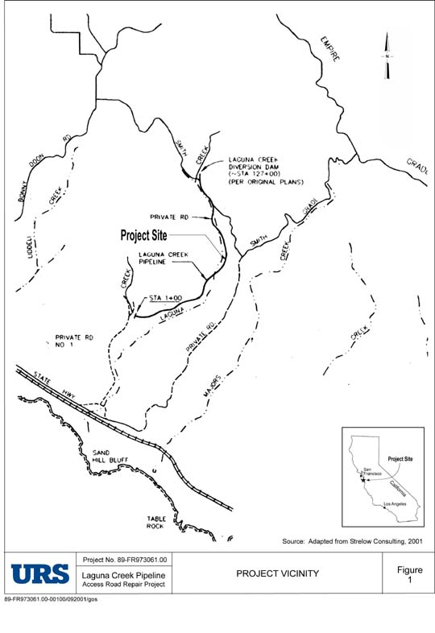
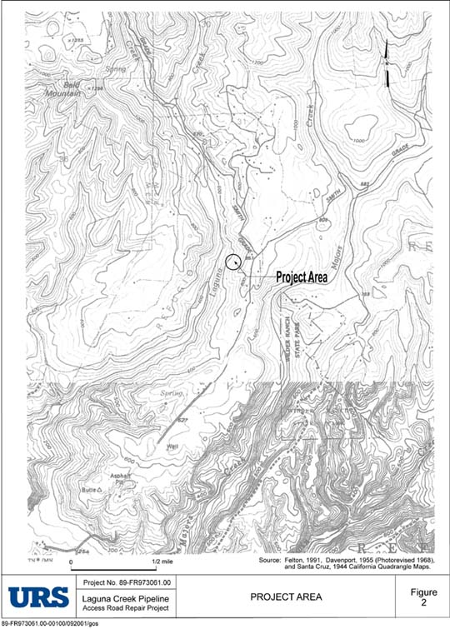
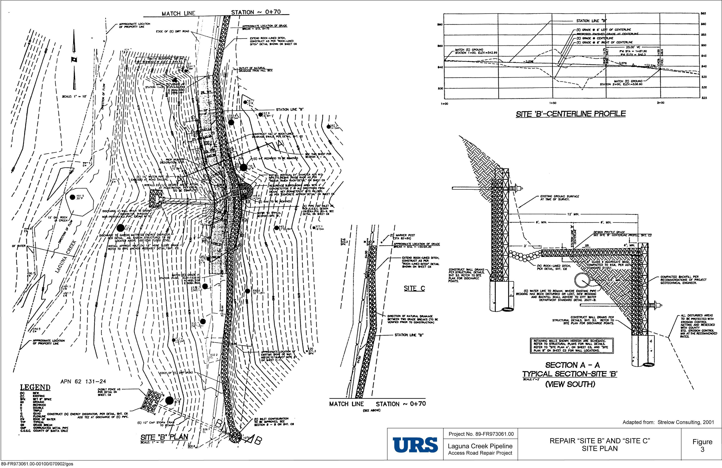
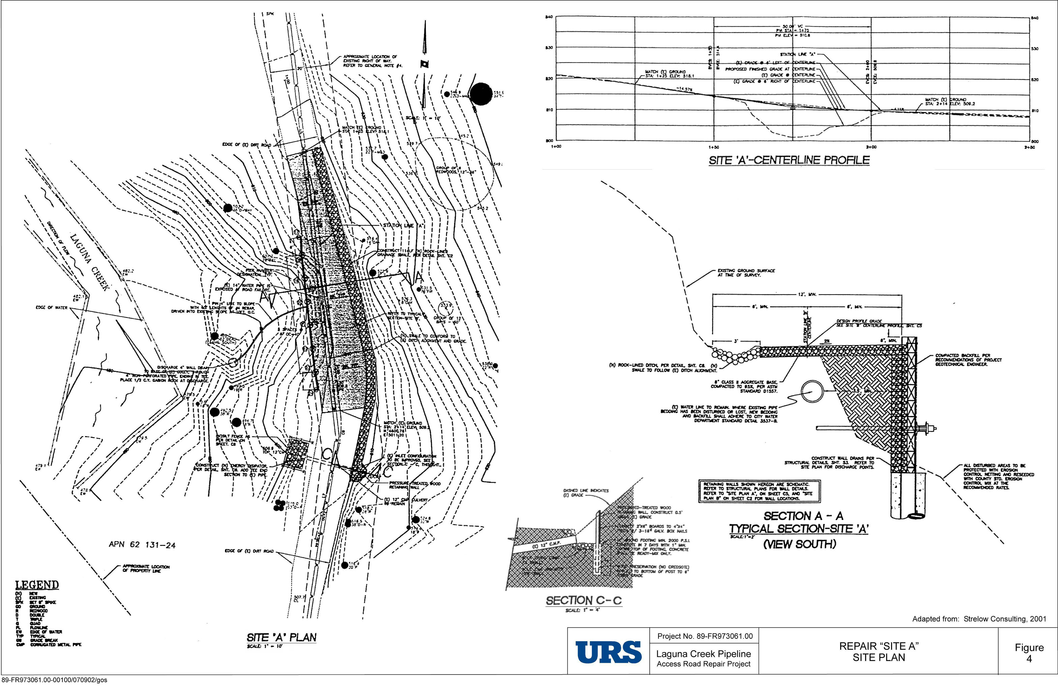

Appendix B – Agency Correspondence

To review correspondence from the Fish and Wildlife Service, including letters received on December 21, 2001 regarding the species list in Santa Cruz County, and the Biological Opinion dated July 16, 2002, as well as Bryon Mori’s Marbled Murrelet Habitat Assessment, please contact Sandro Amaglio, Region IX Environmental Officer, at (510) 627-7027 to request a hard copy.

