NSA BARROW METEOROLOGICAL TOWER USERS MANUAL

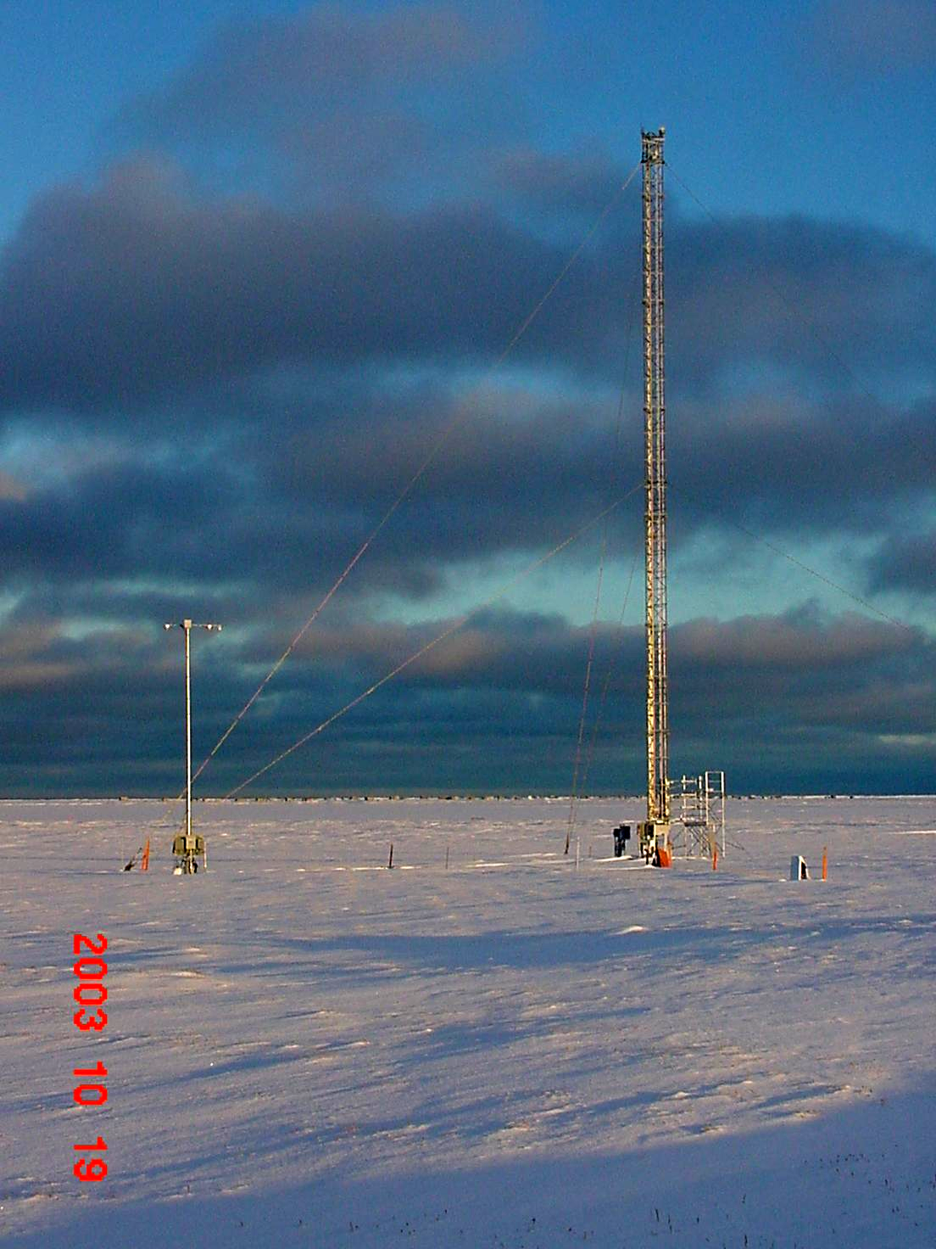

TABLE OF CONTENTS

SYSTEM MAINTENANCE AND CALIBRATION

Daily Checks 3

Monthly Checks 4

6-Month Checks 5

Annual Checks 6

Two-Year Checks and Replacement 7

BARROW METEOROLOGY TOWER DAILY PM PROCEDURE 8

CALIBRATION PROCEDURES FOR THE FD12P PRESENT

WEATHER SENSOR 13

PRESENT WEATHER CHECK SHEET 16

PRESENT WEATHER SENSOR SET-UP 17

TEMPERATURE AND RELATIVE HUMIDITY CHECK PROCEDURES 18

NSA TEMPERATURE SENSOR VERIFICATION 19

WIND SPEED AND DIRECTION CHECKS AND PROCEDURES 20

WIND SPEED AND DIRECTION VERIFICATION 21

CHILLED MIRROR CLEANING & CLAIBRATION 22

WIRING DIAGRAMS 24

KNOWN ISSUES AND PROBLEMS NOT NOTED ELSEWHERE 30

System Maintenance and Calibration

Daily Checks

The data from the tower should be checked each day during daily rounds. Temperature and relative humidity data from the 2m level and the CMH should be compared to determine if the data appear reasonable. The T/RH data between the difference levels should be compared also to determine if the data appear to be reasonable. Any discrepancies should be noted on the daily rounds forms. The wind speed and direction data should be compared and checked against local conditions. The barometric and present weather data should be checked to determine if what is being reported also appears reasonable. For example, if the present weather sensor is reporting 100m visibility and heavy snow when it is clear and sunny out, this indicates a problem with the present weather sensor and should be noted. The present weather sensor also has an alarm value:

The error or warning from PWS could be any of the following:
00,
01,
02
10,
11,
12,
20,
21,
22
First digit 1 = visibility alarm higher, 2 = visibility alarm lower, 0 = all ok
Second digit 1 = hardware error, 2 = hardware warning, 0 = all ok.
So when we get a 0, 1 or 2 it is really 00, 01, and 02.
A value of 1 means hardware error and a value of 2 means hardware warning. Continual values (more than a few hours) of 1, 11 or 21 are of concern and should be noted on the daily rounds form.

Data from the barometer should be between 800 and 1100 hPa. If the barometric data is outside of these values then this should be noted on the daily forms. An RTMC Overview screen has been built which displays 24 hours of data graphed along with text values for the current readings. The graphs will allow checks of the data to be made to determine if problems have occurred during the most recent 24 hours. Long gaps in data, long periods of or many data spikes, and flat line data (no change in values over extended periods) will be apparent and should be noted on the form.

Monthly Checks

Once a month the auto balance dial reading should be taken for the CMH. The auto balance reading is an indication of the contamination on the surface of the mirror. To obtain a reading, open the control box and locate the auto balance dial in the upper right hand corner of the control box. It resembles a typical gym locker dial. The knob has increments of two and numerals in increments of 10 starting at 0 and going through 90. The window has numerals of 1 through 10 in increments of one. To take readings use the window value to read hundreds and the dial to read the tens and ones. For example, if the window has the numeral 0 and the dial is on the third division between 0 and 10, then the reading is 6. If the window has the numeral 1 and the dial is on 60, then the reading is 160. This value should be recorded once a month on the daily forms. When the reading reaches or exceeds 500, the mirror will need to be cleaned and the entire sensor will have to be recalibrated. See CHILLED MIRROR CLEANING & CALIBRATION PROCEDURES on page 22 of this manual, or sections 2-3.3 through 2-4.3 of the manual for the procedures to clean and recalibrate the sensor.
Six-Month Checks

Present Weather Sensor

The lenses of the present weather sensor need to be cleaned every six months. Remove any condensed water, ice or snow that may be on the hoods or lenses. Wipe away any dust from the inner and outer surfaces of the hoods. Using a clean, lint-free cloth and isopropyl alcohol, moisten the cloth with alcohol and gently wipe the lenses. Clean the capacitive rain detector every six months using a soft, lint-free cloth moistened with mild detergent. The date and time of cleaning should be entered into the daily rounds forms.

Chilled Mirror Hygrometer

The CMH should be cleaned and recalibrated every six months to ensure proper functioning and that reasonable data is returned from the sensor. See CHILLED MIRROR CLEANING & CALIBRATION on page 22 of this manual or sections 2-3.3 through 2-4.3 of the CMH manual for the procedures to clean and recalibrate the sensor. The date and time of cleaning should be entered into the daily rounds forms.

Annual Checks

Cup Anemometers and Wind Direction Vanes

The bearings in these sensors need to be checked once a year. These checks should not be made when the air temperature is below –17.5°C (0°F) at any level of the tower. The tower carriages will have to be lowered to access the wind speed and direction sensors (see NSA Barrow 40 Meter Tower.doc for procedures). Scaffolding will be needed to access the sensors on the carriages (see scaffold users manual and safety documentation). Carefully remove the cups from the anemometers or the vane from the wind direction sensors and spin the shafts. They should spin freely. Slowly turn the shafts with ungloved fingers to sense anything irregular such as dirt or a flat spot on a bearing or a rubbing disk. Also inspect the cups and vane for any signs of damage. If any irregularity is observed, replace the respective anemometer or wind direction sensor.

HMP45D Temperature and Relative Humidity Probes

The filters on the probes need to be checked once a year and replaced if dirty. These checks should not be made when the air temperature is below –17.5°C (0°F) at any level of the tower. The tower carriages will have to be lowered to access the sensors (see NSA Barrow 40 Meter Tower.doc for procedures). Scaffolding will be needed to access the sensors on the carriages (see scaffold users manual and safety documentation). Remove the air intake from the aspirated radiation shield by unscrewing it. Remove the protective cover from the probe and inspect the filter. Replace the filter if it is dirty. Reassemble the probe and aspirator.

PTB201 or PTB220 Digital Barometer

Compare the reading of the digital barometer with the reference digital barometer. Record both readings on the daily forms.

FD12P Present Weather Sensor

Check the visibility calibration once a year using the FDA12 calibration kit. See CALIBRATION PROCEDURES FOR THE FD12P PRESENT WEATHER SENSOR on page 13 of this manual for the procedures to clean and calibrate the present weather sensor.
Two-Year Checks and Replacement

Wind Speed and Direction Sensors

Check the calibration of the current cup anemometers and the frequency measuring portion of the QLI50 Sensor Collectors by using the R. M. Young Model 18810 Anemometer Drive to spin the anemometer shafts for at least one minute at the different rpms. Check the calibration of the current wind vanes and decoding portion of the QLI50 Sensor Collector. Obtain the readings from either the RTMC Overview screen or by directly connecting to the logger and viewing the Input Location data. Remove and replace the anemometer and direction sensors. Check the calibration of the newly replaced sensors. See WIND SPEED AND DIRECTION CHECKS on page 20 of this manual for procedures and page 21 of this manual for the forms.

Temperature and Relative Humidity Sensors

Check the calibration of the current temperature and relative humidity probes by comparing them to the reference probe. Ensure that there is proper flow over both the reference and the current probes and that little or no direct solar radiation influences the reading. Replace the probes with ones that have a current calibration. Check the calibration of the newly replaced probes before returning to service. See TEMPERATURE AND RELATIVE HUMIDITY CHECK PROCEDURES on page 18 of this manual for procedures and page 19 for the forms.

BARROW METEOROLOGICAL TOWER
DAILY PM PROCEDURE

This document describes the daily PM procedures to be conducted at the NSA C1 Barrow site.

The following items that are not included in the daily rounds forms or on the LoggerNet RTMC Overview screen are to be verified. Any discrepancy will be noted in the comments section of any of the Daily Rounds forms.

- Verify operation of the computer by checking the time and making sure it is correct and changing. This can be done by use of the computer’s task bar or any of the LoggerNet RTMC screens that have a date and time display.
- Verify that LoggerNet is running. Verifying that the LoggerNet task bar is up and available or verifying the RTMC screens are live and updating can do this.

The below images have circles and numerals on them. The numerals located on the Daily Rounds form have a corresponding numeral on the RTMC Overview screen. These corresponding numerals on the RTMC highlight where information is found to answer the questions on the Daily Rounds form. The corresponding numerals work for all portions of the Daily Rounds form except for the Ground Visual Checks and the Monthly CMH Autobalance Reading sections. The Ground Visual Checks are accomplished by visually checking the tower, and opening the CMH and reading the values off the dial accomplish the Autobalance Reading (see MONTHLY CHECKS on page four of this manual for Autobalance reading procedures).

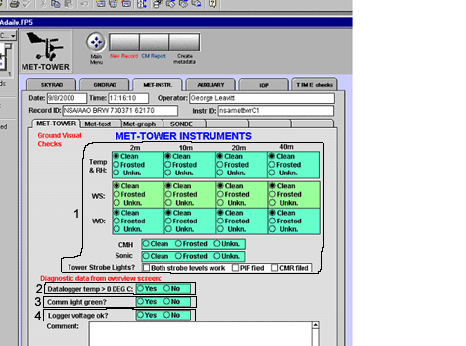

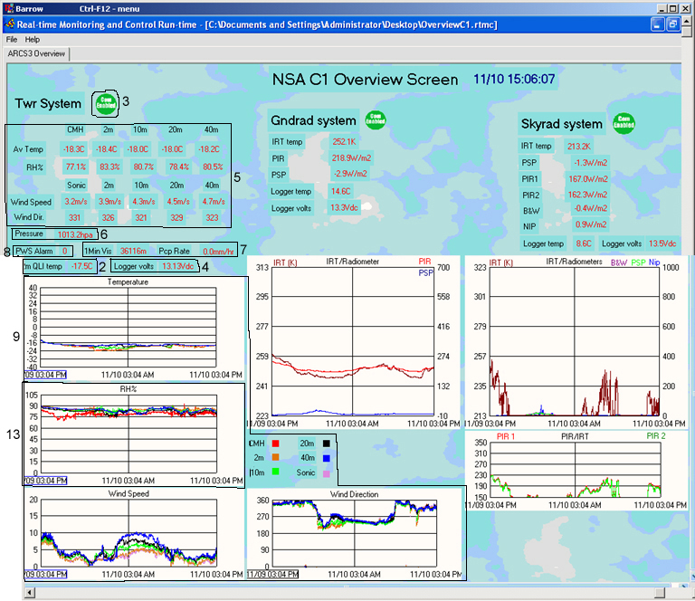

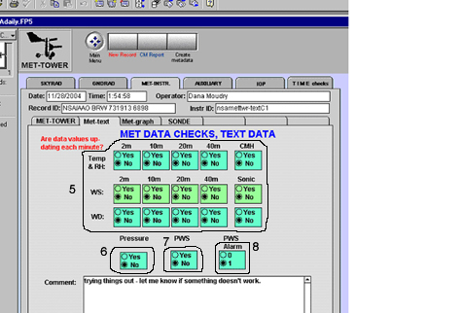

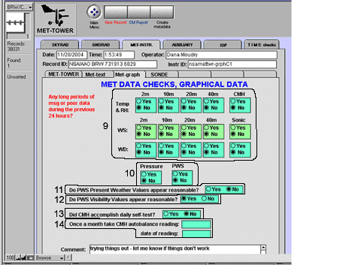

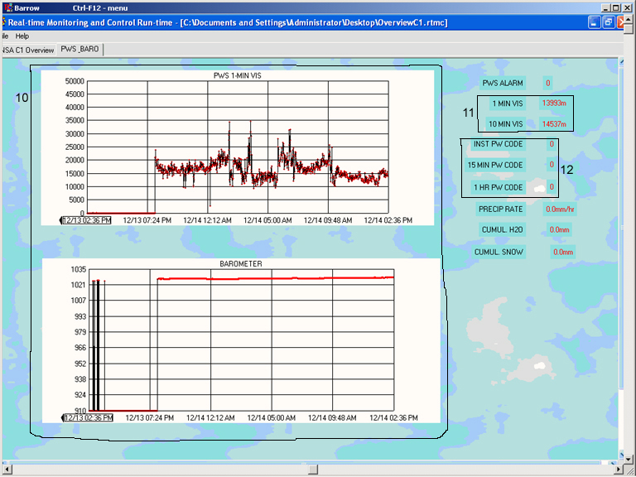

CALIBRATION PROCEDURES FOR THE
FD12P PRESENT WEATHER SENSOR

- Remove the current serial line from the Control Unit (note the colors of the wires and to what terminal they are connected) and connect another serial cable to the terminals.
- Start HyperTerminal.
- Set CAPS LOCK ON (PWS commands are all capitals)
- In HyperTerminal go to FILE>Properties
  - Under “CONNECT TO” tab Connect using: COM 1
  - Under “CONFIGURE” button:
    - Bits = 1200
    - Data Bits = 7
    - Parity = even
    - Stop bits = 1
    - Flow Control = none
  - Under “SETTINGS” tab
    - Terminal keys: on
    - Emulation: ANSI
    - Back Scroll Buffer Lines: 500
    - Terminal Settings: underline and blink
  - Under “ASCII SETUP” button
    - Under Sending:
      - Echo Typed Characters Locally: no
      - Line Delay: 0
      - Character Delay: 0
    - Under Receiving:
      - Append Line Feeds: yes
      - Wrap Lines: yes
- Connect (using file>connect, call>call, or phone icon) to the present weather sensor. Name the file PWSCALxx/xx/xx where the x’s stand for month, date, and year.
- Clean the PWS transmitter windows with the spray and soft cloths in the Visibility Calibrator Set FDA 12. Allow the windows to dry for about 5 minutes.
- Hit return a few times to get a prompt.
- Type OPEN ^C (^ indicates control key) then hit ENTER
- Type CLEAN then hit ENTER
- Record the Transmitter and Receiver settings
- Insert the Black Blocking plate tightly into the right shield of the sensor (small disk toward the inside of shield, plate handle hanging down)
- Type CHEC then hit ENTER
- Wait until the reading stabilizes around a small range of values (about 5 minutes or so, usually)
- Record the value. The actual value should be less than +/- 0.1 Hz.
- Hit ESC key to end the check.
- Install the opaque calibration plates. See installation instructions in the calibration case. The mounting clamp is on the sensor horizontal tube. The plates are labeled “Right” and “Left”. Be careful with them, they are glass. Do not get fingerprints on them. Clean them with the cloth and spray if necessary.
- Type CHEC then hit ENTER
- Wait for readings to stabilize around a small range of values (usually about 5 minutes or so)
- Record the value (should be +/- 39 Hz of the calibration plate value 1287 Hz).
- If values do not fall in this range, move the mounting clamp up or down slightly. This step may take some time as the mounting clamp allows for quite a bit of play.
- Hit ESC to end the check.
- Type CAL 1287 then hit ENTER.
- Type CHEC then hit ENTER.
- Write down the “scaled frequency average”
- Hit ESC to end check.
- Type TCAL then hit ENTER.
- Record the TS (third value)
- Type CLOSE then hit ENTER.
- Disconnect and close out HyperTerminal, you should save the entire session and email the .TRM session to the mentor for recording.
- Remove serial connector from the back of the PC and the Control Unit terminals and reconnect the serial cable that goes to the SDM_SI04 located in the Met Logger Enclosure.
- Wait a few minutes to see if the PWS data shows up on the Met program.
- If the data does not show up after a minimum of 10 minutes, it may be necessary to clean the lenses again. Follow steps 1 through 9 again. Although you may use the original saved HyperTerminal session.
- Type CLOSE then hit ENTER.
- Follow steps 29 – 31 again to reconnect PWS to collector system.
If data does not show up after a few minutes, contact the mentor.

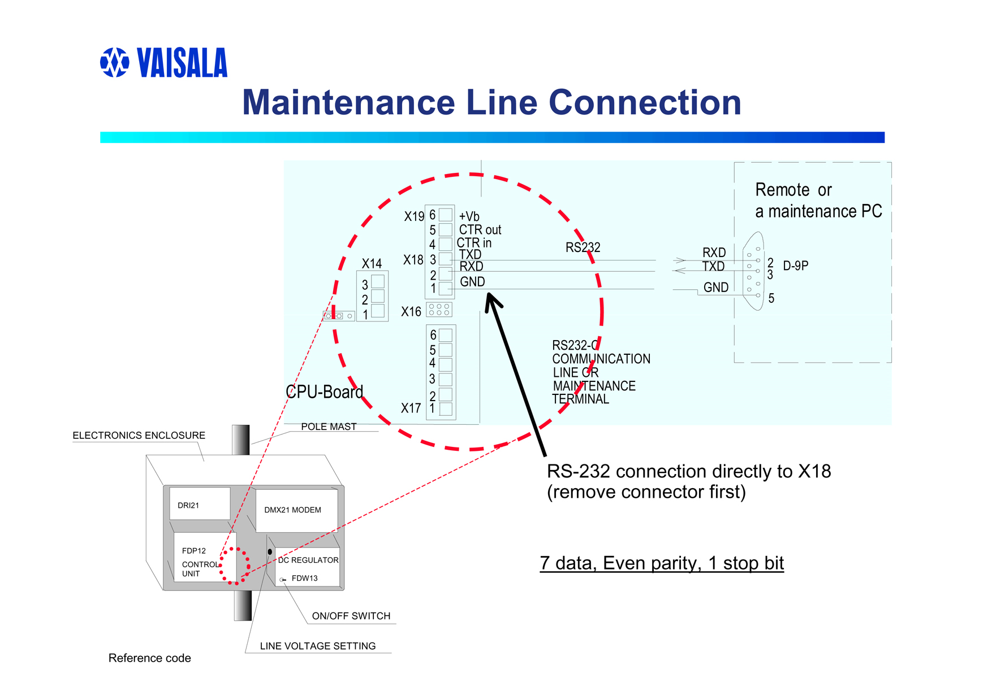

PRESENT WEATHER CHECK SHEET

Tested by:_________________________ Date:___________________

Time began:_______________ Time ended:___________________

General Weather Conditions:

Clean
Transmitter:____________

Receiver:_______________

Block Plate Check

Scaled Frequency Average:__________________

Calibration Plate Check

Scaled Frequency Average:__________________

Is Calibration required? Yes/No

If so, CAL final value:______________________

TCAL Check

TS value (last value on right):_________________

CMH Temperature:_________________________

2m T/RH Temperature:______________________

Is reported one-minute visibility value reasonable? Yes/No

PRESENT WEATHER SENSOR
SET-UP

- Remove the current serial line from the Control Unit (note the colors of the wires and to what terminal they are connected) and connect another serial cable to the terminals.
2. Start HyperTerminal.
- Set CAPS LOCK ON (PWS commands are all capitals)
- In HyperTerminal go to FILE>Properties
  - Under “CONNECT TO” tab Connect using: COM 1
  - Under “CONFIGURE” button:
    - Bits = 1200 (unless first time then 300)
    - Data Bits = 7
    - Parity = even
    - Stop bits = 1
    - Flow Control = none
  - Under “SETTINGS” tab
    - Terminal keys: on
    - Emulation: ANSI
    - Back Scroll Buffer Lines: 500
    - Terminal Settings: underline and blink
  - Under “ASCII SETUP” button
    - Under Sending:
      - Echo Typed Characters Locally: no
      - Line Delay: 0
      - Character Delay: 0
    - Under Receiving:
      - Append Line Feeds: yes
      - Wrap Lines: yes
- Connect (using file>connect, call>call, or phone icon) to the present weather sensor. Name the file PWSCALxx/xx/xx where the x’s stand for month, date, and year.
- Type OPEN^C then hit ENTER.
- Type AMES 2 then hit ENTER.
- Type BAUD 1200 then hit ENTER. Only do this step if baud is not 1200.
- Type CLOSE then hit ENTER.
- Before typing CLOSE you can enter in other maintenance commands to check operation of the PWS:
  - STA – returns result of built-in test.
  - PAR – returns current system parameters.
***MUST TYPE CLOSE AT END OR PWS WILL NOT RESPOND TO REGULAR COMMANDS FOR DATA.

Temperature and Relative Humidity
Check Procedures

This check requires two people, one person outside taking readings using the VTP6 Field Calibration probe and one person inside collecting readings from the installed sensors using the RTMC programs or by directly connecting to the logger and viewing the raw input data. Two-way radios will need to be used to communicate information. Scaffolding will be needed to access the sensors on the carriages (see scaffold users manual and safety documentation).

- Lower carriages to access the T/RH probes at other levels (see NSA Barrow 40 Meter Tower.doc for procedures). Repeat the following steps for each level.
- Place the VTP6 Field Calibration probe outside in the ambient air and turn it on. Do not place in direct sunlight; try to find a shaded area for it to equilibrate to ambient temperatures.
- Rotate the aspirator units so the intake points toward the ground, this will prevent any solar influence to the probe.
- Once the VTP6 has equilibrated (this may take some time), place the probe into the opening of the aspirator intake as close to the T/RH probe as possible without allowing any contact. View the temperature and RH on the VTP6 readout. When values become stable, take the reading and transmit the data to the person inside for comparison and recording.
- Unscrew the intake tube to gain access to the sensor. The measurement head of the HMP-45D’s is removable so that rewiring is not necessary. Grasp the sensor body and pull downwards. Do not grasp by the filter as it can pull off and damage the sensors. Once the sensor is removed, make note of the S/N number and transmit it to the person inside.
- If not already done, make note of and transmit the S/N of the recently calibrated probe to be installed to the person inside.
- Place the new sensor into the main body of the sensor. Replace the intake tube by screwing it back into the aspirator unit. Wait about 5 minutes or so for the new sensor to equilibrate to being in the aspirator unit. Do not allow the VTP6 to sit in the sunlight during this time.
- Once the new sensor has equilibrated, repeat step 4 with the new sensor installed.
- If readings do not agree, allow a longer period of time for the new sensor to equilibrate and ensure the VTP6 is kept in a shaded area during this additional time.
- If readings still do not agree, replace the sensor with another recently calibrated probe. If none are available, leave the new probe installed and contact the mentor.
- Repeat all steps above for all levels.
- The VTP6 requires a 9-volt battery; if problems are occurring with the VTP6 try replacing the battery, if problems continue, contact the mentor.
NSA
TEMPERATURE SENSOR VERIFICATION

Tested by: Date:________________

Time began_________________ Time ended___________________

LOCATION:__________________ LEVEL: _____M

TEMPERATURE

VTP6 OLD HMP-45D

_________ ______________

NEW HMP-45D

_________ ______________

Do the readings from the HMP-45D’s agree within +/- .5 deg C of the VTP6?

Yes / No

Comments:_____________________________________

RELATIVE HUMIDITY

VTP6 OLD HMP-45D

__________ ______________

NEW HMP-45D

__________ ______________

Do the readings from the HMP-45D’s agree within +/- 3% of the VTP6?

Yes / No

Comments:____________________________________

S/N old HMP-45D:_________________________

S/N new HMP-45D:________________________
WIND SPEED AND DIRECTION
CHECKS AND PROCEDURES

This check requires two people, one person outside taking readings using the RM YOUNG RPM Generator and one person inside collecting readings from the installed sensors, using the RTMC programs or by directly connecting to the logger and viewing the raw input data. Two-way radios will need to be used to communicate information.
Scaffolding will be needed to access the sensors on the carriages (see scaffold users manual and safety documentation).

- Lower the carriages to access the wind speed and direction sensors (see NSA Barrow 40 Meter Tower.doc for procedures). Repeat the following steps for each level.
- Grasp the wind speed sensor shaft and cups to determine if the heater is working (only works when ambient temperatures are below 32º F). Grasp the shaft of the wind direction sensor to determine if the heater is working.
- Remove the cups from the anemometer and install the RPM Generator. Start the generator and using the arrows change the RPM’s to each of the required settings. Let the RPM generator stabilize at each setting and allow it to run at least 2-minutes before taking the reading inside.
- Once all RPM readings have been taken, remove the wind speed sensor and install the new one. Follow step 3 above to take RPM readings for the new sensor. Transmit the S/N of both the old and new sensor if not already done.
- Re-install the cups and if temperatures are low enough, grasp the shaft and cups to determine if the heater is working for the newly installed sensors.
- If it is too windy to firmly hold the wind vane steady, remove it before checking the direction values.
- Hold the vane or the shaft steady along the four quadrants (N, S, E, W) and wait at least 2-minutes before taking a reading for each quadrant.
- Remove the wind direction sensor and install the new one. Follow step 7 above to take the readings for the new sensor. Transmit the serial numbers of both the old and new sensors if not already done.
- Re-install the wind vane and if the temperatures are low enough grasp the shaft to determine if the heater is working.
- Once all sensors have been replaced and verified to be working correctly the carriages may be raised back into position.

WIND SENSOR VERIFICATION

Tested by: Date:

Time began_____________________ Time ended____________________

LOCATION_____________ LEVEL______M WIND SPEED CHECKS

S/N Old Sensor:____________________ S/N New Sensor_________________

RPM Calculated speed m/s Measured speed
Old sensor New sensor

200 4.67 – 4.81 m/s _________ __________

300 7.00 – 7.10 m/s _________ __________

400 9.33 – 9.38 m/s _________ __________

500 11.67 +/- 0.2 m/s _________ __________

Are values acceptable for new sensor: Yes / No

______M WIND DIRECTION CHECKS (accuracy +/- 5 deg, resolution 1.0 deg)

Quadrant Measured Value
Old sensor New Sensor S/N Old Sensor

_______ _________ _________ ______________________

_______ _________ _________ S/N New Sensor

_______ _________ _________ ______________________

_______ _________ _________

Are values acceptable for new sensor: Yes / No

Chilled Mirror Cleaning & calibration

It is best to do the recalibration and cleaning in an indoor environment. Stable temperatures and dew points are needed. If the unit is outdoors or in an environment where temperature and dew point is fluctuating during the recalibration, the settling time of the unit will take much longer.

Items needed: Fluke meter able to read 0 – 5 V DC, distilled water, lacquer thinner, isopropyl alcohol, cotton swabs.

- Remove CMH unit from the tower and take inside the GW or back to the duplex.
- Leave power disconnected from unit at this time.
- Turn Auto balance dial to 000 so that 0 is read in the “window” and 0 is set to the mark below the window.
- Remove mirror assembly from the sensor housing assembly (white mushroom).
  - Remove retaining screw from side of housing assembly.
  - Grab sensor (from the bottom) by the handle and pull assembly out, you may want to disconnect the sensor data cable. The unit connects through two banana connectors and slides in and out of assembly only one way.

- Once unit is removed, you can begin the cleaning of the mirror. Begin by taking a clean cotton swab and distilled water, thoroughly wet mirror surface using a moistened swab. Once mirror is wet, wash with a gentle circular motion.
- Wipe the surface with a clean dry swab until dry and all loosened material is removed.
- Repeat steps 4 and 5 until the cleaning has no further effect, i.e. dry swab is clean after drying sequence.
- Repeat steps 4 & 5 using lacquer thinner.
- Continue lacquer thinner cleaning until it has no further effect.
- Repeat steps 4 & 5 using Isopropyl Alcohol.
- Continue alcohol cleaning until it has no further effect.
- NEVER use soap or any other detergent to wash mirror.
- Re-install mirror assembly into the sensor housing assembly. Ensure the banana connectors line up before seating mirror assembly. Tighten retaining screw and ensure the grounding cable is connected between the assembly cap and retaining screw.
- Reconnect the sensor data cable to the main housing unit.
- Apply AC power to the unit.
- Turn the Mode Selector Switch to HEAT, and leave on for one minute. This will ensure a dry mirror after following the cleaning steps above. Turn mode Selector Switch to OPR position after one minute time period is up.
- Remove AC power.
- Connect a digital voltmeter set to read 0 – 5 V DC to the transmit logic board. Connect the positive lead to the left side of R3 (junction of R8, R3, and C2) on the transmit logic board and the negative lead to ground.
- Reapply AC power.
- THE FOLLOWING STEPS MUST BE DONE WITH A COMPLETELY DRY MIRROR. TO INSURE A DRY MIRROR CHECK THAT THE DEW POINT IS ABOVE THE AMBIENT AIR TEMPERATURE BY TOGGLING THE MONITOR SELECTOR SWITCH BETWEEN Ta and Td AND PUSHING THE MONITOR DISPLAY SWITCH TO READ THE VALUES. NEED TO KEEP Td ABOVE Ta. THE FOLLOWING ADJUSTMENTS MUST NOT BE MADE WHILE HEATING THE MIRROR. YOU MUST MONITOR THE Td, AND HEAT AS NECESARRY. MAKE MEASUREMENTS AND ADJUSTMENTS IN BETWEEN HEATING CYCLES. THE SELECTOR SWITCH SHOULD BE IN OPR POSITION WHEN MAKING ADJUSTMENTS
- Turn the Sd gain adjustment (R21) clockwise until the Sd LED (CR5) just goes on. This is the threshold level. The voltmeter should read approximately 4.9 Volts.
- Adjust the Si gain adjustment (R22) Clockwise until the Si LED (CR9) goes on then let system stabilize then turn the Si gain adjustment Counterclockwise until the Si LED (CR9) just goes off.
- Turn the MODE SELECTOR switch to 0, check the Ta and Td readings by depressing the display switch for both. If necessary, adjust the TA0 and TD0 trimpots to achieve 32.0 with a +/- 0.1 accuracy.
- Turn the MODE SELECTOR switch to 50, check the Ta and Td readings by depressing the display switch for both. If necessary, adjust the TA+ and TD+ trimpots to achieve 22.0 with a +/- 0.1 accuracy.
- Adjust the FAN FAIL trimpot counterclockwise until the FAN FAIL LED comes on. Turn the trimpot slowly clockwise until the LED just goes off, then one full turn clockwise. Verify operation of the FAN FAIL LED by blocking the aspirator intake. Within 30 seconds the light should come on, and after removal of blockage the LED should extinguish within 30 seconds.

WIRING DIAGRAMS

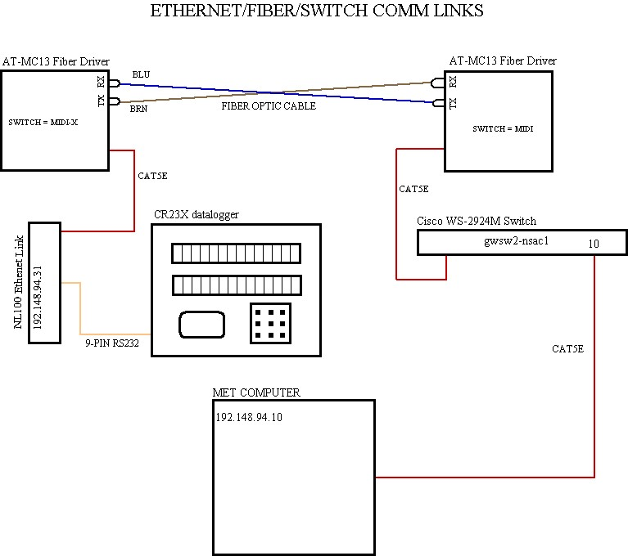

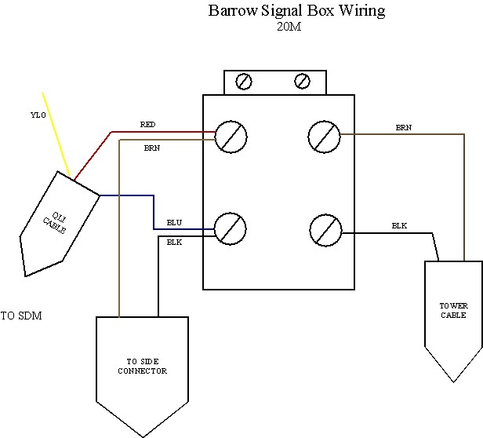

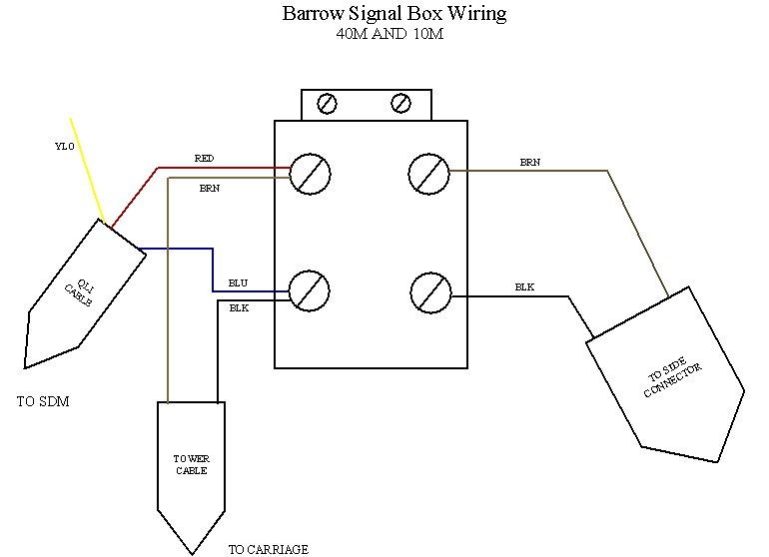

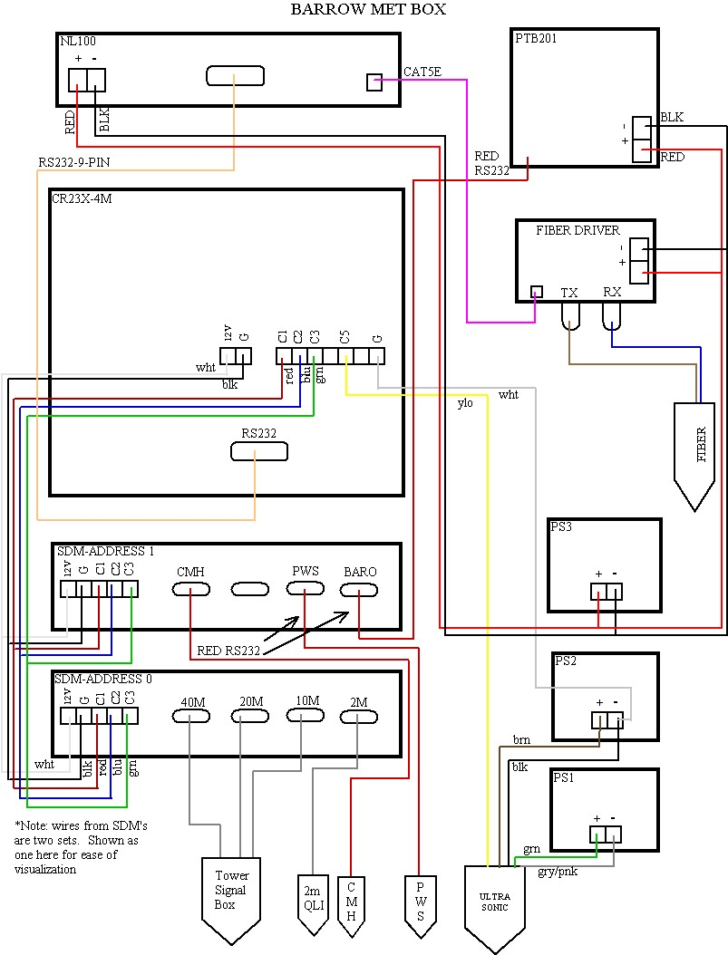
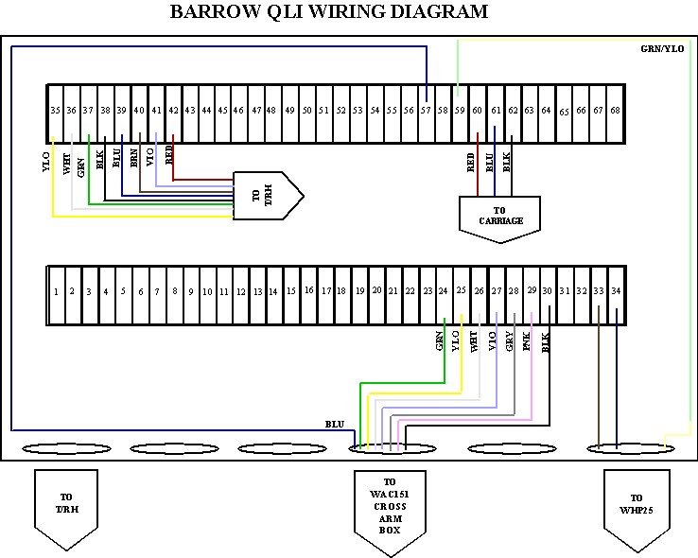

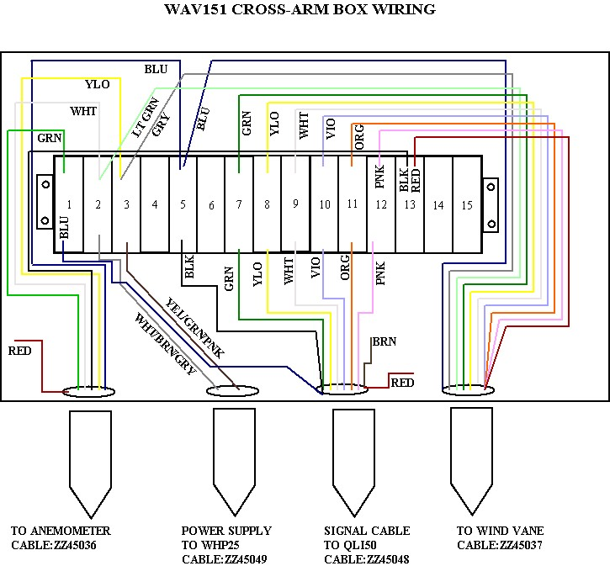
KNOWN ISSUES/PROBLEMS NOT NOTED ELSEWHERE

1. The CMH does not accomplish a self-test at temperatures below 0º C/ -17º F. This prevents a measure of the amount of contamination on the mirror. As long as 6-month calibration procedures are accomplished, problems with a dirty mirror should be alleviated.

2. The connections on the CR23X datalogger are pinch-type connections. Tightening of the connection is accomplished through a small screw. Fluctuations in temperature cause the expansion and contraction of the metal, which can cause a loosening of the connector. Periodically the connections should be checked and/or tightened to insure a good connection.

3. Oxidation on contacts of the logger enclosure thermostats prevents the heater/thermostat from working correctly. Periodically the thermostat should be cycled on and off to arc the oxidation off of the contacts to insure proper operation.

